Secretary Bird Optimised Support Vector Machine Model for Adire Fabric Defect Classification
ABSTRACT
The primary objective of this study is to classify defective Adire fabrics, allowing quality control to prevent economic loss. In Adire production, common defects include stains, tears, colour variation, colour smear, colour bleeding, shade variation, pattern misalignments and colour crocking. Defect classification in Adire production is critical for ensuring high product quality are churned out to meet the needs of end users and reduce wastages. The use of Machine Learning models to automatically classify defective Adire fabrics proffer solution to the ineffective and time-consuming manual methods. A total of 234 Adire fabric images were captured at Itoku Abeokuta, Ogun state with a Redmi 14C 50MP digital camera and augmented to 884. Among the data collected, 396 images represented defective while 488 were non-defective (Normal). Preprocessing involved Gaussian filtering and Contrast Limited Adaptive Histogram Equalisation (CLAHE), while Gray-Level Co-occurrence Matrix (GLCM) was used for texture-based feature extraction. SBOA was applied to optimise SVM hyperparameters (penalty factor 𝑪, kernel type, gamma (𝜸), and polynomial degree) yielding the SBOA-SVM model, implemented in MATLAB R2023a. The visible results obtained from the optimised model in comparison with standard SVM confirms that SBOA-SVM model outperformed the standard SVM across all evaluation metrics. The aggregate classification accuracy improved from 92.87% (SVM) to 94.68% (SBOA-SVM), Sensitivity increased from 91.67% to 93.69%, Specificity also rose from 93.85% to 95.49%, while the false positive rate decreased from 6.15% to 4.51%, confirming fewer normal fabrics were incorrectly classified as defective. Importantly, the computation time of SBOA-SVM model (116.22 s) was slightly lower than that of the standard SVM (122.36 s) without additional computational burden. These findings underscore SBOA-SVM potential for replacing manual inspection processes in real-world fabric inspection processes, where precision and speed are critical.
Keywords: Adire, Defect, Automated classification, Fabric, Metaheuristics, Secretary bird optimisation algorithm, Support vector machine
- Introduction
Fabrics constitute an integral part of human life, serving various functions such as clothing, upholstery, curtains, and household materials. These fabrics are derived from both natural and synthetic fibers, including cotton, wool, silk, polyester, and nylon. Beyond their functional role, fabrics hold deep cultural and historical significance, often representing the identity and craftsmanship of specific regions. For instance, Adire fabric from the Yoruba people of Nigeria in Africa (BYJU’S, 2025; Zhang, 2024). Adire is a unique, patterned, hand-dyed fabric that uses resist-dyeing techniques. The resist dyeing techniques used in the production of Adire fabrics utilises different methods such as Raffia Resist (Adire Oniko), Stitch Resist (Adire Alabere), Wax Resist (Adire Alabela), and Starch Resist (Adire Eleko) (Ojelade et al., 2018) though, Adire Alabela and Adire Eleko are contemporarily referred to as Batik. All these four methods are utilised locally with the hand thus, the handcrafted nature of these techniques, however, makes Adire fabrics highly susceptible to defects.
Fabric defects are imperfections that deviate from the expected visual properties of the fabric. These defects can be major, which affects usability and durability or minor, which may not impair functionality but reduce aesthetic appeal and market value. In Adire production, common defects include stains, tears, colour variation, colour smear, colour bleeding, shade variation, pattern misalignments and colour crocking. Such defects often result from inadequate pre-treatment, impure dye solutions, fabric mal-handling, or inconsistent manual dyeing processes (Khalil, 2020). The current inspection process in the production of Adire fabrics is manual, relying on artisans’ visual judgment. This approach is error-prone, subjective and inefficient as many defects are ignored or concealed during inspection and subsequently passed onto retailers or end-users, thereby transferring the burden of quality shortcomings along the value chain and resulting in significant economic losses.

Automated defect classification systems using image processing and machine learning techniques offers a more reliable alternative. Techniques such as Feedforward Neural Networks (FFNN), Convolutional Neural Networks (CNN), Recurrent Neural Networks (RNN), and Support Vector Machines (SVMs) have been successfully applied in defect inspection tasks (Charkraborty et al., 2021; Goyal, 2025). Among these, SVM is particularly effective for binary classification problems such as distinguishing defective from non-defective fabrics. It achieves this by constructing an optimal hyperplane that separates two classes with maximum margin (Awad and Khanna, 2015). However, the performance of SVM depends heavily on selecting appropriate parameters such as the kernel type, regularization parameter (C), and kernel parameters (gamma - γ). Poor parameter tuning can lead to suboptimal detection accuracy and slow convergence.

In order to improve SVM performance, metaheuristic optimization algorithms such as Grey Wolf Optimization (GWO), Whale Optimization Algorithm (WOA), and Secretary Bird Optimization Algorithm (SBOA) have been employed (Abbaszadeh et al., 2023). SBOA mimics the unique hunting and escape strategies of the secretary bird, balancing exploration and exploitation to efficiently locate optimal solutions (Huohuo, 2026). Its robustness, fast convergence, and adaptability make it suitable for optimizing SVM parameters in classification tasks. SBOA has demonstrated promising results in domains such as image classification, fault diagnosis, and biomedical signal processing (Fu, 2024).

This study, therefore, designs a Secretary Bird Optimised Support Vector Machine (SBOA-SVM) model for automated fabric defect classification in Adire fabrics. SBOA was selected specifically for its documented outstanding performance regarding convergence speed, accuracy, and efficient balance between exploration and exploitation tasks. The proposed model aims to accurately differentiate between defective and non-defective Adire fabrics by optimising the SVM parameters using SBOA, thereby, improving reliability over manual inspection.
The proposed technique has the following contributions:
- The study acquired defective and non – defective Adire fabric images from Adire artisans with a Redmi 14C 50MP digital camera and created a dataset for it;
- The study designed an optimised SVM model for fabric (Adire) defect classification using SBOA;
- The designed model was implemented using MATLAB R (2023a) software;
- The performance evaluation of the model was carried out in comparison with a standard SVM using accuracy, sensitivity, specificity, false positive rate, and computational time as metrics;

REVIEW OF RELATED WORKS
This section presents few of several studies that have contributed to the advancement of Machine Learning techniques and Artificial Intelligence methods in defect identification and classification. Basu et al. (2012) focused on the challenge of classifying different types of defects in woven fabrics, where visual inspection often fails to distinguish between similar defect types. The main objective was to develop a supervised learning model using SVM for effective defect classification. The authors used statistical features derived from texture and intensity variations in fabric images and trained an SVM model to recognise various defect classes. The system achieved high classification accuracy, validating the strength of SVM in controlled fabric environments. The limitation, however, was the model’s sensitivity to environmental noise and its reduced performance when tested on patterned or highly textured fabrics.
Patel and Mehta (2016) addressed the growing need for automated inspection in textile manufacturing, where manual visual methods are inconsistent and inefficient. The key problem identified was the low accuracy and reliability of human inspectors in detecting subtle fabric defects. The objective of the study was to develop a machine learning-based system for classifying and detecting defects in fabric images. The methodology involved preprocessing fabric images, extracting texture-based features, and applying a Support Vector Machine (SVM) classifier to distinguish between defective and non-defective areas. The results demonstrated improved accuracy and reduced inspection time compared to manual methods. However, the performance of the system was highly dependent on the quality of the input images and required significant manual feature engineering.

Kim and Lee (2024) proposed an artificial intelligence-based approach for automated fabric defect detection to improve quality control in textile manufacturing. The study addressed the problem of inefficiency, inaccuracy, and high labor cost associated with manual inspection methods. Its objective was to enhance detection accuracy and efficiency using an improved YOLO-based deep learning model. The authors implemented a modified YOLO algorithm incorporating attention mechanisms, focal loss, and data augmentation techniques, and evaluated it using publicly available fabric defect datasets. Results showed that the proposed model achieved high accuracy, improved recall, and faster prediction time compared to conventional methods. A limitation of the study was the challenge of handling imbalanced and limited datasets, as well as difficulties in generalizing across diverse fabric textures and defect types.
Metin and Bilgin (2024) explored the application of Automated Machine Learning (AutoML) systems for predicting fabric quality, aimed at improving automation in textile inspection amid growing Industry 4.0 demands. The study tackled the problem of inefficiency and inconsistency in manual and traditional ML-based quality prediction systems. Its objective was to evaluate and compare the performance of multiple open source AutoML tools in optimizing fabric inspection processes. The authors tested platforms like AutoGluon, EvalML, and H2OAutoML using metrics such as MAE, RMSE, and inference time on IoT-collected fabric data. Results revealed EvalML delivered the most accurate predictions, while AutoGluon performed best across several regression metrics despite its slower inference time. A limitation of this study was the computational overhead and complexity of AutoML systems, as well as the reliance on extensive, high-quality datasets for optimal performance.
Rizkallah (2025) investigated the use of metaheuristic algorithms for optimising Support Vector Machine (SVM) parameters in satellite image classification to enhance classification performance. The study addressed the problem of suboptimal accuracy caused by improper parameter selection in standard SVM models. Its objective was to evaluate and compare multiple optimisation techniques, including Particle Swarm Optimisation, Genetic Algorithm, Simulated Annealing, and Cuckoo Search, in improving SVM effectiveness. The methodology involved applying these metaheuristic algorithms to tune SVM hyperparameters and assessing performance using metrics such as accuracy, precision, recall, and F1-score on image datasets. Results showed that metaheuristic-optimised SVM models significantly outperformed standard SVM in terms of classification accuracy and robustness. A limitation of the study was the high computational cost associated with running multiple optimisation algorithms on large datasets.
Zhang et al. (2025) proposed an enhanced Support Vector Machine model integrated with Differential Evolution (DE) for improved image classification performance. The study addressed the challenge of reduced accuracy of conventional SVM when applied to complex and imbalanced datasets. Its objective was to improve classification robustness and accuracy by optimising SVM parameters using a metaheuristic approach. The authors employed Differential Evolution to iteratively tune SVM hyperparameters and refine decision boundaries for better classification. Results indicated that the hybrid SVM-DE model achieved superior performance compared to standard SVM methods across multiple evaluation metrics. A limitation of the study was the increased computational complexity and processing time due to iterative optimisation procedures.

- METHODOLOGY
The steps involved in the development of Secretary Bird Optimised Algorithm based Support Vector Machine (SBOA-SVM) model for Adire fabric defect classification are data acquisition, preprocessing, feature extraction, defect classification and performance evaluation.
2.1 Data Acquisition
The dataset utilised in this study were acquired from the artisans and sellers of Adire fabrics at Itoku Abeokuta, Ogun State using a Redmi 14C 50MP digital camera. A total of 234 images were captured, after which data augmentation was performed to increase the dataset size. Augmentation techniques included horizontal and vertical flipping, as well as rotational transformations, resulting in an expanded dataset of 884 images. These augmentation strategies were introduced to increase the robustness of the model by creating diverse variations of the same fabric samples, thereby reducing the risk of overfitting and enhance the model generalization. Out of the total dataset, 396 images represented defective fabrics while 488 samples corresponded to non-defective fabrics, serving as the baseline class. For model training and testing, the K-fold cross-validation approach was employed with K (number of folds) = 10 to ensure an unbiased partitioning of the dataset into training and testing subsets.

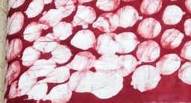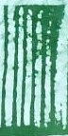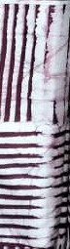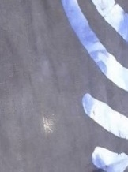
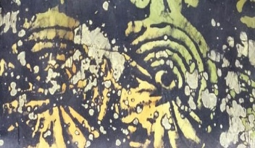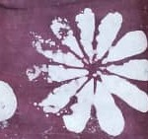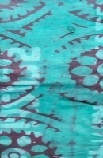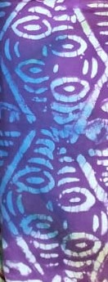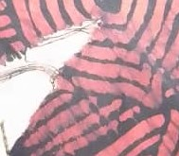
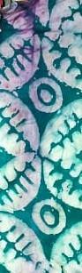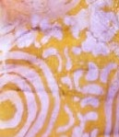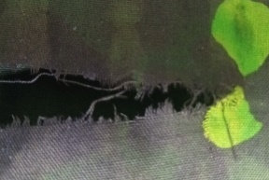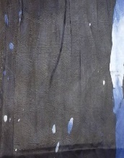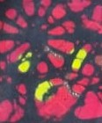
Figure 1: Sample Images of Defective Adire Images

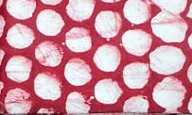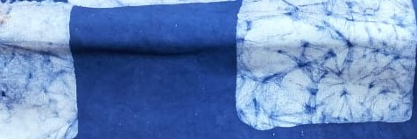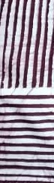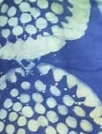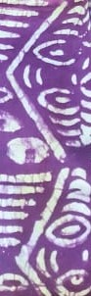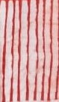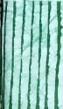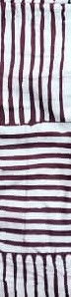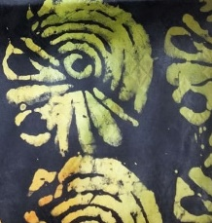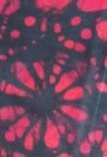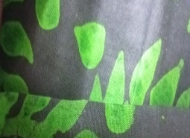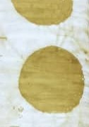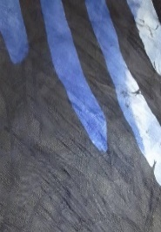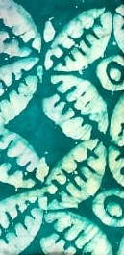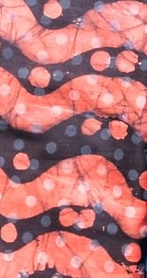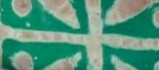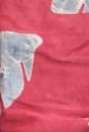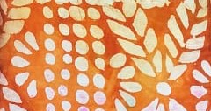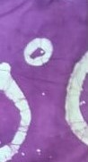

Figure 2: Sample Images of Non-Defective (Normal) Adire Fabrics

2.2 Preprocessing
The region of interest (ROI) in each acquired raw image is segmented from each image and enhanced to improve visibility of defect regions before being used as input for feature extraction. A Gaussian filter was used to smoothen the images and eliminate unwanted noise. Subsequently, Contrast Limited Adaptive Histogram Equalization (CLAHE) was employed to enhance the contrast of the fabric textures, making defects more distinguishable from non-defective regions. CLAHE is an enhanced version of histogram Equalization (HE), which is a simple and effective image enhancement method that can increase the contrast of images by adjusting the image’s gray distribution in order to improve the classification accuracy.

2.3 Feature Extraction
Gray-Level Co-occurrence Matrix (GLCM) was used to extract second-order texture features, such as contrast, correlation, energy and homogeneity in the fabric images. GLCM enhances the accuracy and robustness of the classification process by reducing the complexity of the image data and retaining only the most discriminative information. GLCM is highly suitable for identifying irregularities in fabrics where repetitive patterns are common such as in Adire by, evaluating the spatial relationships between pairs of pixel intensity values to quantify the texture of an image. The resulting matrix, was then used to extract statistical features that describe texture properties that the machine learning model used to classify defects efficiently. The extracted features serve as the input for the classification stage.

2.4 Design of SBOA-Optimised SVM for Defect Classification
The Secretary Bird Optimised Support Vector Machine (SBOA-SVM) model was designed to enhance the classification of fabric defects by optimally tuning the hyperparameters of the Support Vector Machine (SVM) using the Secretary Bird Optimization Algorithm (SBOA). The SVM algorithm aims to construct an optimal hyperplane that separates defective from non-defective samples. However, the performance of SVM is highly sensitive to its parameters such as the penalty factor (C), kernel type, and kernel-specific parameters (e.g., gamma and polynomial degree). Improper tuning of these parameters can lead to underfitting or overfitting. SBOA addresses this challenge by employing a bio-inspired search mechanism that adaptively explores the parameter space for optimal configurations.
Formally, the SVM minimizes the cost function:
$\min_{w,b,ξ} \frac{1}{2}‖w‖^{2}+C\sum_{i=1}^{n}{ }ξ_{i}$(1)
Subject to:
$y_{i}\left(w^{T}φ\left(x_{i}\right)+b\right)≥1-ξ_{i}, ξ_{i}≥0$ (2)
where $φ(x)$ is the kernel transformation, $C$ is the penalty parameter, and $ξ_{i}$ are slack variables allowing soft-margin classification.
The kernel functions employed include:
- Linear: $K\left(x,x^{'}\right)=x^{T}x^{'}$
- RBF: $K\left(x,x^{'}\right)=exp⁡\left(-γ{\left\|x-x^{'}\right\|}^{2}\right)$
- Polynomial: $K\left(x,x^{'}\right)={\left(γx^{T}x^{'}+r\right)}^{d}$
- Sigmoid: $K\left(x,x^{'}\right)=tanh⁡\left(γx^{T}x^{'}+r\right)$

2.4.1 Secretary Bird Optimisation Algorithm (SBOA)
The Secretary Bird Optimization Algorithm (SBOA) is inspired by the hunting behavior of the secretary bird, which exhibits precise and adaptive attacks. In this study, each bird represents a candidate solution (parameter set) consisting of SVM hyperparameters. The algorithm iteratively refines these parameters to maximize detection accuracy.
A population of birds is initialized within defined parameter bounds:
- $C∈[0.1,1000]$
- $γ∈[0.0001,1]$
- Kernel type $∈\{$ linear, RBF, polynomial, sigmoid $\}$
- Degree $∈\{2,3,4,5\}$
Each bird's fitness is evaluated using cross-validation accuracy from the SVM model trained on the current parameters:
$$Fitness\left(X_{i}\right)=CVAccuracy\left(X_{i}\right) (3)$$
The birds' positions are updated using the SBOA position update rule:
${ X}_{i}^{(t+1)}=X_{i}^{t}+α⋅sin⁡(ϕ)⋅\left(X_{\text{best }}^{t}-X_{i}^{t}\right)+β⋅r⋅\left(X_{i}^{t}-X_{j}^{t}\right)$ (4)
where $ϕ∈[0,2π],r∈[0,1]$, and $α,β$ control exploration and exploitation through $α=A(1-t/T)$ and $β=B(t/T)$, typically with $A=B=2$.
Through iterative updates, the algorithm converges on the optimal SVM parameter set
$X_{\text{best }}=\left[C^{*},K^{*},γ^{*},d^{*}\right]$, which maximizes the classification performance. The resulting SBOA-SVM model is then trained on the complete training dataset and evaluated using performance metrics such as sensitivity, specificity, accuracy, false positive rate, and computational time.

Algorithm 1
Step 1: Initialization
N: number of birds (population size)
D: number of parameters to optimize (C, kernel type, $γ$, degree)
$X_{i}∈R^{D}$ : position vector of bird $i$
T: maximum number of iterations
Bounds for parameters:
$$\begin{matrix} & C∈[0.1,1000] \\ & Y∈[0.0001,1]\end{matrix}$$
kernel type $∈\{0,1,2,3\}$
degree $∈\{2,3,4,5\}$
Randomly initialize positions $X_{i},i=1,…, N$
Step 2: Fitness Function
Each bird (solution) represents:
$$X_{i}=\left[C_{i},K_{i},γ_{i},d_{i}\right]$$
Train an SVM using parameters decoded from $X_{i}$ and evaluate classification as:
$$\text{ Fitness }\left(X_{i}\right)=\text{ Classification Accuracy }\left(X_{i}\right)$$
Step 3: Secretary Bird Position Update Equation
$$X_{i}∧(t+1)=X_{i}∧t+α⋅sin⁡(ϕ)⋅\left(X_{i}\text{ best }∧t-X_{i}∧t\right)+β⋅r⋅\left(X_{i}∧t-X_{j}∧t\right)$$
Where:
$ϕ∈[0,2π]$ : random angle
$r∈[0,1]$ : random scalar
X_best^t: best bird at iteration $t$
$X_{j}∧t$ : randomly chosen neighbor of $i$
$$α=A⋅(1-t/T), β=B⋅(t/T), A=B=2$$
Step 4: Parameter Decoding and Handling Discrete Variables
Kernel type $K$ : rounded to nearest integer $∈\{0,1,2,3\}$
Polynomial degree $d$ : rounded $∈\{2,3,4,5\}$
Gamma $γ$ is only active for RBF, polynomi $↓$ nd sigmoid kernels Apply bounding rules after update:
$X_{i}∧(t+1)=min\left(max\left(X_{i}∧(t+1)\right.\right.$, lower_bound), upper_bound)
Step 5: Termination Criteria
Repeat Steps 2-4 until:
Maximum iterations reached ( $t=T$ ), or
No improvement for $K$ generations
Step 6: Output
Best solution: X_best = [ $\left.C^{*},{ K}^{*},γ^{*},{ d}^{*}\right]$
Train final SVM model using optimized parameters
Evaluate detection performance on the test dataset

2.5 Implementation of Optimised SVM Using SBOA
An interactive GUI application with Adire datasets was designed using MATLAB’s GUI toolbox in MATLAB (R2022) on window 10 ultimate 64bit operating system, intel core i7 CPU with a speed of 4.4GHz, 8GB RAM and 1 Terabyte hard disk drive to classify the fabric defects and evaluate the performance of the system. The implementation was designed to automatically detect defective regions on Adire fabric images by learning discriminative texture patterns that separate defective from non-defective fabric samples. The GUI displayed essential functionalities such as dataset selection, threshold adjustment, feature extraction, and result presentation. It provided a side-by side comparison of standard SVM and the optimised SBOA-SVM. The inclusion of real-time parameter monitoring and accuracy feedback in the GUI demonstrated not only the practicality of the developed system but also its potential industrial adaptability. The trained SBOA–SVM model outputs a binary classification result indicating whether a given fabric sample contains a defect or not.
2.6 Performance Evaluation for Detection
The final phase of the system development involved evaluating the performance of the SBOA–SVM model for defect classification and comparing it with a standard SVM model. The evaluation metrics used were False Positive Rate (FPR), Specificity, Sensitivity, Accuracy, and Computational time. These metrics collectively assess the ability of the model to correctly classify defective fabrics while minimising false alarms.
Specificity (True Negative Rate): It is the ability of the model to correctly recognise the presence of non – defective Adire when it is truly present as it is indicated in equation 5.
Specificity$=\frac{TN}{TN+FN}*100\%$ (5)
Accuracy: This measures the total number of correct defective and non - defective Adire divided by the total number of dataset as it is indicated in Equation 6.
Accuracy = $\frac{TN+TP }{FN+FP+TN+TP}*100\%$ (6)
Sensitivity: This measures the total number of defective Adire divided by the overall total number of actual defectives. It is indicated in equation 7.
Sensitivity = $\frac{TP}{TP+FN}*100\%$ (7)
Computational time: is typically measured in seconds (s) or milliseconds (ms) per image. It represents the average time (in seconds or milliseconds) required by the model to process and classify a defect in a single fabric image.
3. RESULTS AND DISCUSSION
3.1 Analytical Results
The experimental results of the Secretary Bird Optimization Algorithm-based Support Vector Machine (SBOA-SVM) model were presented through a custom-built Adire Fabric Defect Classification model. The model has functionalities such as dataset selection, threshold adjustment, feature extraction, and result visualization which enabled the training and testing of the classification model in an interactive environment. It also provided a side-by-side comparison between the standard SVM and the optimised SBOA-SVM, allowing for clear visualization of performance improvements achieved by the optimization process. The dataset was partitioned using the K-fold cross-validation approach (k = 10) to ensure reliability and unbiased model evaluation during defect classification. The SBOA-SVM model effectively differentiated between defective and non-defective fabrics, ensuring accurate classification even for subtle and overlapping defect patterns. Moreover, the GUI-based model bridges the gap between advanced machine learning techniques and practical textile applications, promoting automation and reducing human inspection errors. This capability underscores its potential for use in real-world textile inspection processes, where precision and speed are critical.

Table 1: Comparative Classification Results of SVM and SBOA-SVM

Technique | TP | FN | FP | TN | FPR (%) | SPEC (%) | SEN (%) | ACC (%) | Time (sec)
SVM | 363 | 33 | 30 | 458 | 6.15 | 93.85 | 91.67 | 92.87 | 122.36
SBOA-SVM | 371 | 25 | 22 | 466 | 4.51 | 95.49 | 93.69 | 94.68 | 116.22
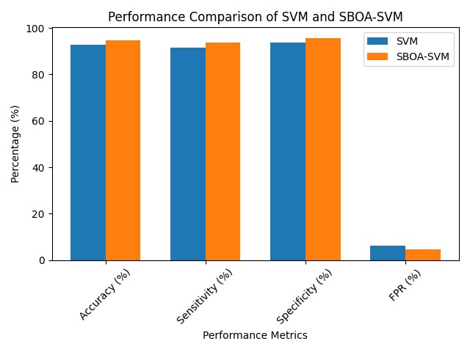
Figure 3 Comparative Classification Results of SVM and SBOA-SVM for Adire fabrics

3.2 Comparative Classification Results of SBOA-SVM and SVM
The comparative analysis between standard Support Vector Machine (SVM) and the Secretary Bird Optimisation Algorithm optimised SVM (SBOA-SVM) highlights the impact of metaheuristic optimisation on fabric defect classification. As shown in Table 1, that the SBOA-SVM outperformed the standard SVM across all evaluation metrics. The aggregate classification accuracy improved from 92.87% (SVM) to 94.68% (SBOA-SVM), demonstrating enhanced reliability of the optimized model. Sensitivity which measures the model’s ability to correctly classify defective Adire fabrics increased from 91.67% to 93.69%, indicating improved classification of defective fabrics and a reduction in false negatives. Specificity also rose from 93.85% to 95.49%, while the false positive rate decreased from 6.15% to 4.51%, confirming fewer normal fabrics were incorrectly classified as defective. Importantly, the computation time of SBOA-SVM model (116.22 s) was slightly lower than that of the standard SVM (122.36 s), indicating performance 57 gains without additional computational burden. These findings establish SBOA-SVM as a more accurate, balanced, and computationally efficient model for automated Adire fabric defect classification. Collectively, this capability underscores SBOA-SVM potential for use in real-world fabric inspection processes, where precision and speed are critical.

- CONCLUSION
The comparative evaluation demonstrates that the SBOA-SVM model is superior to the conventional SVM for Adire fabric defect classification. Although the standard SVM provided a reasonable baseline performance, its relatively lower sensitivity particularly in detecting subtle defects underscores its limitations in addressing the complexities of automated fabric inspection. In contrast, the SBOA-SVM achieved improved accuracy, sensitivity, and specificity, resulting in a more reliable and robust classification model. The improved performance can be attributed to the effective optimization of SVM hyperparameters, including the penalty parameter (C), kernel coefficient (γ), and kernel-related parameters, through the Secretary Bird Optimization Algorithm. This optimization enabled more discriminative feature mapping, improved class boundary separation, faster convergence, and stronger generalization capability, particularly for subtle texture irregularities inherent in Adire fabrics. Furthermore, the improved classification performance was achieved alongside reduced computational time, highlighting the model’s practical efficiency. Conclusively, the comparative analysis confirms that integrating Secretary Bird Optimisation with SVM yields a highly effective approach and scalable solution for industrial fabric defect classification with strong potential of replacing manual inspection processes.
The main contributions of this study are highlighted as follows:
- Creation of Adire dataset
- Integration of SBOA into SVM for optimising SVM parameters, leading to a better model performance in handling the intricate pattern characteristic of Adire fabrics for defect classification.
- The performance evaluation of SBOA-SVM using Accuracy, Sensitivity, Specificity, False Positive Rate (FPR), and Computation Time (CT) as metrics, and compared with that of standard SVM.

COMPETING INTERESTS DISCLAIMER:
Authors have declared that they have no known competing financial interests OR non-financial interests OR personal relationships that could have appeared to influence the work reported in this paper.
Disclaimer (Artificial intelligence)
Author(s) hereby declare that NO generative AI technologies such as Large Language Models (ChatGPT, COPILOT, etc.) and text-to-image generators have been used during the writing or editing of this manuscript.

References
- Abbaszadeh, H., Soltani-Mohammadi, A., and Ahmed, M. (2023). Improving The Reliability of Support Vector Machines In Pattern Recognition Tasks By Addressing the Issue of Manual Hyperparameter Tuning, Using Metaheuristic Algorithms. Journal of Artificial Intelligence Research, 3(2), 52–66.
- Adio, J. E., Falohun, A. S., Adio, M. O., Okediran, O. O., Ola, B. O., Fatokun, E. O., and Awodoye, O. O. (2024). Development of an Optimised Deep Learning Technique for Fabric Defect Classification Using Osprey Optimisation Algorithm. FUOYE Journal of Engineering and Technology, https://dx.doi.org/10.4314/fuoyejet.v9i4.12, 9(4), 643-648.
- Awad, M., and Khanna, R. (2015). Efficient Learning Machines: Theories, Concepts, and Applications for Engineers and System Designers. Springer.
- Awad, M., and Khanna, R. (2015). Support Vector Machines for Classification. In: Efficient Learning Machines. Apress, Berkeley, CA. https://doi.org/10.1007/978-1-4302-5990-9_3
- BYJU'S. (2025). History of clothing material. https://byjus.com/biology/history-of-clothing-material/
- Chakraborty, S., Moore, M., and Chapman, L. (2021). Automatic defect detection of print fabric using convolutional neural network [Preprint]. Digital Fashion Innovation e-Symposium 2020 https://doi.org/10.48550/arXiv.2101.00703
- Fu, Y., Liu, D., Chen, J., and He, L. (2024). Secretary bird optimisation algorithm: A new metaheuristic for solving global optimisation problems. https://doi.org/10.1007/s10462-024-10729-y, Artificial Intelligence Review, 57, (123).
- Goyal, K. (2025). 9 key types of artificial neural networks for ML engineers. UpGrad. https://www.upgrad.com/blog/types-artificial-neural-networks-in-machine-language/
- Huohuo (2026). Secretary Bird Optimization Algorithm (SBOA) (https://www.mathworks.com/matlabcentral/fileexchange/164456-secretary-bird-optimisation-algorithm-sboa), MATLAB Central File Exchange. Retrieved March 31, 2026.
- Metin, A., and Bilgin, T. T. (2024). Automated machine learning for fabric quality prediction: A comparative analysis. PeerJ Computer Science, 10, e2188. https://doi.org/10.7717/peerj-cs.2188.
- Ojelade, L. O., Bashir, M. O., and Oyeniyi, T. F. (2018). Adire in Osogbo Nigeria: Its uniqueness, technology and significance. The International Journal of Humanities and Social Studies, 6(11), 133–134.
- Kim, D., and Lee, D. (2024). Fabric defect detection based on artificial intelligence. International Journal of Intelligent Systems and Applications in Engineering, 11(5s), 1–7.
- Rizkallah, M. (2025). Optimization of support vector machine parameters using metaheuristic algorithms for satellite image classification. Soft Computing. https://doi.org/10.1007/s41060-025-00762-7
- Zhang, Y., Liu, H., and Chen, X. (2025). An improved support vector machine based on differential evolution for classification tasks. arXiv Preprint. https://arxiv.org/abs/2502.14597

