Optimizing Urban Electric Concrete Mixer Truck Routing with an Improved Ant Colony Algorithm: Balancing Costs and Discharge Profits

Abstract
Urban traffic restrictions and the growing demand for low-carbon logistics have created new challenges for the routing of electric concrete mixer trucks in urban distribution. To address this issue, this study investigates the route planning problem of electric concrete mixer trucks under constraints related to customer demand, battery capacity, and vehicle load. A mixed-integer programming model is developed for a one-to-many urban distribution scenario with the objective of minimizing total distribution cost, including fixed vehicle cost, driver time cost, and charging cost. On the basis of the model structure, an improved ant colony algorithm incorporating enhanced search and pheromone-update strategies is designed to solve the problem efficiently. To examine the effectiveness of the proposed approach, numerical experiments are conducted on randomly generated test instances representing radial and circular customer distribution patterns. The computational results show that fixed vehicle usage cost and time-based usage cost are the dominant components of total distribution cost, accounting on average for 56.03% and 42.47%, respectively, whereas charging cost contributes only 1.50%. In addition, the results suggest that discharge behavior during the distribution process may provide supplementary economic benefits under time-dependent electricity pricing conditions, with average discharge profit reaching 57.22 yuan. The improved ant colony algorithm is able to generate feasible route plans for different spatial distribution scenarios within acceptable computation time, with an average runtime of 252.10 s. Overall, this study provides a useful modeling and solution framework for the cost-oriented planning of electric concrete mixer truck routing in urban logistics.
Keywords: Urban distribution; Electric concrete mixer truck routing problem; Multi-objective optimization; Improved ant colony algorithm

Introduction
In the development of low-carbon logistics transportation, the key lies in planning vehicle routes to achieve the dual satisfaction of economy and environmental protection, i.e., solving the Vehicle Routing Problem (VRP) in logistics transportation [1]. Numerous scholars have primarily studied VRP for fuel vehicles, establishing models aiming at minimizing total distribution cost, total travel distance, or total travel time to solve the VRP problem [2-5]. Liu Changshi et al. [6] studied a low-carbon VRP model under time-varying network conditions with the objective of minimizing carbon emissions. Silva et al.[7] studied a dynamic VRP model with time windows aiming at minimizing total cost. Elgharably et al.[8] studied a hybrid search multi-objective algorithm for a stochastic multi-objective VRP in a green environment and analyzed the potential impact of relaxing customer time windows. The aforementioned literature provides effective solutions for fuel vehicle route planning in urban logistics and offers significant reference value for subsequent research.
With technological advancements, electric vehicles (EVs) have been introduced by automotive companies in recent years. As zero-emission vehicles, EVs can effectively reduce environmental pollution, leading many enterprises to adopt them for logistics distribution. Consequently, some scholars have begun researching the Electric Vehicle Routing Problem (EVRP). Erdoğan et al. [9] studied an EVRP model with charging stations aiming at minimizing travel distance. Jie Wanchen et al. [10] comprehensively considered factors such as vehicle range limitations, vehicle number constraints, and split deliveries to establish an EVRP model. Ge Xianlong et al. [11] constructed an EVRP model with soft time windows aiming at minimizing total cost. As research deepens, considering factors like insufficient EV range and long charging times, scholars have studied EVRP under different charging strategies. Keskin et al. [12] studied the EVRP with time windows under conventional and fast charging modes. Zhang Pengwei et al. [13] constructed a mathematical model for a multi-depot EVRP with limited charging facilities. Ge Xianlong et al. [14] established a partial charging strategy EVRP model and designed a hybrid simulated annealing algorithm for solution. Hulagu et al. [15] proposed an electric vehicle route optimization method based on a mixed-integer programming model, which comprehensively considers road networks, passenger demand, and vehicle characteristics to minimize operational and charging costs. Jia et al. [16] proposed a Bi-level Ant Colony Optimization (BACO) algorithm for solving the Capacitated Electric Vehicle Routing Problem (CEVRP). This algorithm decomposes the problem into two subproblems: the Capacitated VRP (CVRP) and the Fixed Route Vehicle Charging Problem (FRVCP), improving solution performance through cooperative optimization. Stodola et al. [17] proposed a metaheuristic algorithm based on ant colony optimization principles, introducing techniques like node clustering and adaptive pheromone evaporation to solve the Multi-Depot VRP (MDVRP).In addition, some scholars have explored other approaches to address the Electric Vehicle Routing Problem (EMVRP). Lifeng Mu al. [18] proposed a novel urban logistics model involving the collaboration between electric vehicles and autonomous delivery vehicles, which innovatively introduced battery swapping stations as a rapid recharging solution. Sinem Bozkurt Keser al. [19] conducted a comparative study on the impact of three different charging strategies—full charging, partial charging, and 20%-80% partial charging—on last-mile delivery route planning. Recent studies have further extended EVRP research toward more realistic operating environments. Bruglieri et al. developed a matheuristic for the electric vehicle routing problem with time windows using a realistic energy-consumption model that explicitly considers payload and vehicle speed, which improves the practical relevance of route optimization models (Bruglieri et al., 2023). Lera-Romero et al. proposed a branch-cut-and-price algorithm for the time-dependent electric vehicle routing problem with time windows, showing the importance of incorporating congestion-sensitive travel times and energy consumption into routing decisions (Lera-Romero et al., 2024). Jeong et al. introduced an adaptive robust optimization framework for EV routing under energy-consumption uncertainty, highlighting the value of uncertainty-aware planning in electric logistics systems (Jeong et al., 2024). Çatay and Sadati studied synchronized mobile charging and battery-swapping strategies in EVRP with time windows, demonstrating that flexible en-route energy support can improve routing performance (Çatay & Sadati, 2023). Xiao et al. further examined delivery routing with en-route mobile battery swapping and showed that mobile energy replenishment can enhance operational flexibility in electric delivery systems (Xiao et al., 2024). Woo et al. validated energy-saving EV fleet routing in a real traffic network, providing empirical evidence that eco-routing can reduce fleet energy consumption under practical traffic conditions (Woo et al., 2024). Wang et al. investigated the heterogeneous-fleet electric vehicle routing problem with nonlinear charging functions and waiting times at charging stations, reflecting the increasing attention to more realistic charging operations in EVRP research (Wang et al., 2025). Han et al. also considered simultaneous uncertainty in travel time and energy consumption, further enriching robust optimization research in electric vehicle routing (Han et al., 2025). These studies show that recent EVRP research is moving toward integrated modeling of realistic energy use, uncertainty, heterogeneous fleets, and flexible charging strategies, while application-specific studies on electric concrete mixer trucks are still relatively limited.
Existing achievements provide a good foundation for in-depth research on EVRP, but several research gaps remain: 1) Most existing studies assume that distribution costs are only related to the vehicle itself, such as travel distance, fuel/electricity consumption, vehicle cost, etc., which is not sufficiently close to actual fleet distribution scenarios, e.g., driver wages, maximum vehicle energy consumption, peak/off-peak electricity price differences, etc., requiring comprehensive consideration. 2) Most studies assume the carrier has unlimited capacity and do not consider round-trip routing issues, e.g., one construction site requires 95 units of engineering materials, each vehicle can only carry 10 units, the first 9 vehicles make normal round trips, but the 10th vehicle needs to proceed to the next location, etc. This paper constructs an EVRP model with the objective of minimizing the sum of vehicle fixed costs, electric vehicle driver wages, and electric vehicle charging costs, and uses an improved ant colony algorithm for solution to achieve this objective.

Description of the Ready-Mixed Concrete Electric Distribution Problem
This paper primarily studies the scenario where ready-mixed concrete electric distribution vehicles deliver from distribution stations to multiple customer points within an urban area. Therefore, this EVRP can be described as reasonably optimizing vehicle distribution routes under the constraints of node demands, battery energy, and load capacity, to achieve goals such as reducing distribution costs and improving distribution efficiency. To achieve this goal, the complexity of real-world distribution is simplified with the following assumptions:
1. Interference from external factors such as wind speed and road conditions is not considered.
2.As it is an EVRP primarily for urban distribution, this paper assumes a one-to-many distribution pattern mostly within the city. Furthermore, concrete setting time issues are not considered, making it closer to reality.
3. After each delivery, electric distribution vehicles return to the depot for replenishment and standby for the next delivery. Internal energy consumption from electronic devices like air conditioning during standby is not considered, i.e., no energy is consumed during standby.
4. This paper focuses more on the algorithmic aspect, neglecting changes in the vehicle body itself, treating the vehicle as a rigid body.
5. Since electric energy consumption varies significantly at different speeds, and the research target is urban areas, energy consumption is calculated based on speeds below 100 km/h.
6. Customer locations are known, and as the goal is to find the optimal route solution, all delivery customers are static.
2. Methodology
EVRP Mathematical Model
2.1 Definition of Symbols and Variables
1)Sets: Let M be the set of customers; O be the logistics center; K be the set of electric vehicles; $P_{c}$ be the set of charging stations; P be the set of all nodes, i.e., $P=M⋃P_{c}⋃O$.
2)Parameters: C is the battery capacity of the electric vehicle; $d_{ij}$ is the distance from node i to j; $Q_{ij}$ is the cargo capacity of the electric vehicle when traveling from i to j; $Q$ is the rated capacity of the electric vehicle; $R_{m}$ is the demand of customer m, $∀m∈M$; k is an electric vehicle, $∀k∈K$. $R_{im}$ is the remaining demand of customer m yet to be delivered, with $R_{im}<Q$; $E_{ik}^{a、l}$ is the current energy level of vehicle k upon arrival at or departure from node i.
3) Decision Variables: $x_{ijk}∈\{0，1\}$, equals 1 if vehicle k travels from i to j, otherwise 0;$y_{mk}∈\{0，1\}$, equals 1 if customer m is served by vehicle k, otherwise 0; $Y_{mk}∈\{0，1\}$, equals 1 if vehicle k serves customer m and R_m ≥ 0, otherwise 0.
2.2 Model Formulation
The electric vehicle distribution route model is constructed as follows:
Min = C₁ + C₂ + C₃ (1)
Equation (1) is the objective function of the model, where C₁ is the vehicle fixed cost, C₂ is the driver cost, and C₃ is the vehicle charging cost.
$C_{1}$=$τ_{1}\sum_{m=0}{\sum_{jϵP}{\sum_{kϵK}{x_{ijk}}}}$#(2)
$C_{2}=τ_{2}\sum_{iϵP}{\sum_{jϵP}{\sum_{kϵK}{d_{ijk}}}}$#(3)
$C_{3}=τ_{3}\sum_{iϵP}{\sum_{jϵP}{\sum_{kϵK}{d_{ijk}}}}$#(4)
Equations (2), (3), and (4) define the vehicle fixed cost, driver cost, and vehicle charging cost, respectively; where τ₁ is the fixed cost per electric vehicle, τ₂ is the wage cost per unit time, and τ₃ is the electricity cost per kilometer.
$R_{im}=R_{m}-kQ$#(5)
Equation (5) defines the remaining demand of a customer when it is less than the vehicle's rated capacity.
$Q_{ij}=Q-R_{im}$#(6)
Equation (6) defines the remaining cargo capacity of the vehicle after serving the previous customer with its rated capacity.
$E_{ik}^{a}=C-τ_{4}d_{0i}$,$E_{ik}^{a}<C$#(7)
Equation (7) constrains the electric vehicle's energy level, where τ₄ is the energy consumption per kilometer.
$\sum_{i∈M⋃P_{c}}{x_{0ik}}≤1，∀k∈K$#(8)
Equation (8) constrains each electric vehicle to be dispatched only once from the depot.
$\sum_{i∈M⋃P_{c}}{x_{0ik}}=\sum_{j∈M⋃P_{c}}{x_{j0k}}，∀k∈K$#(9)
Equation (9) constrains each electric vehicle to start and end its route at the logistics center.
2.3 Construction of the Improved Ant Colony Algorithm
The Ant Colony Algorithm (ACA) is a heuristic algorithm with advantages such as heuristic search, positive feedback, and distributed computation. For problems like EVRP where finding the optimal solution is difficult, ACA, simulating nature's efficient pathfinding mechanism, possessing strong global optimization capability, adaptability to complex constraints and dynamic environments, inherent distributed parallel characteristics, and good robustness, becomes a powerful tool for solving path planning problems. This paper compares the traditional ant colony algorithm by introducing the elite ant strategy and the rank-based ant strategy.The improved design approach is as follows:
Step 1: Initialization. Set iter_Max as the maximum number of iterations; BestRoute as the optimal route; K as the number of ants; iter as the current iteration count, iter=1; pheromone importance factor α; heuristic function importance factor β; pheromone evaporation factor ρ; total pheromone released Q; e as the elite ant weight.
Step 2: Path Construction, Finding Feasible Solutions. Place all ants at the same starting point, the logistics center 0. For each ant k (k=1, 2, ..., K), calculate its next node to visit until all ants have visited all nodes. Ants determine their next node based on pheromone concentration. Let $P_{ij}^{k}$(t) denote the probability of ant k transitioning from node i to node j at time t, calculated as follows:
$P_{ij}^{k}=\left\{\begin{aligned}\frac{{[τ_{ij}^{k}(t)]}^{α}*{[η_{ij}^{k}(t)]}^{β}}{\sum_{s∈{allow}_{k}}{{[τ_{is}^{k}(t)]}^{α}*{[η_{is}^{k}(t)]}^{β}}}, &s∈{allow}_{k} \\ 0, &&s∉{allow}_{k}\end{aligned}\right.$#(10)
Here, $η_{ij}^{k}(t)$is the heuristic function, $η_{ij}^{k}(t)$=$\frac{1}{d_{ijk}}$, representing the desirability of moving from node i to j. ${allow}_{k}$(k=1，2，…，K) is the set of nodes not yet visited by ant k. Initially, ${allow}_{k}$ contains (m-1) elements, i.e., all nodes except the starting node. As time progresses, elements in ${allow}_{k}$ decrease until it is empty, meaning all nodes have been visited.
Step 3: Pheromone Update. Calculate the path length d_{ij} traversed by each ant, record the best solution in the current iteration. Simultaneously, update the pheromone concentration on the paths connecting the nodes. While ants release pheromone, the pheromone on the paths between cities gradually evaporates. Let parameter ρ (0<ρ<1) represent the degree of pheromone evaporation. Therefore, after all ants complete one cycle, the pheromone concentration on the paths connecting the cities needs to be updated in real-time using the following formula:
$\left\{\begin{aligned}τ_{ij}(t+1)=(1-ρ)*τ_{ij}(t)+△τ_{ij} \\ △τ_{ij}=\sum_{k=1}^{K}{△τ_{ij}^{k}}\end{aligned}\right.$，(0<ρ<1)#(11)
Here, $△τ_{ij}^{k}$ represents the amount of pheromone deposited by the k-th ant on the path connecting city i and city j, and $△τ_{ij}$ represents the total amount of pheromone deposited by all ants on that path.
Step 4: Termination Check. If iter < iter_Max, then set iter = iter+1, clear the record of paths taken by ants, and return to Step 2. Otherwise, terminate the computation and output the optimal solution.
The flowchart is as follows:
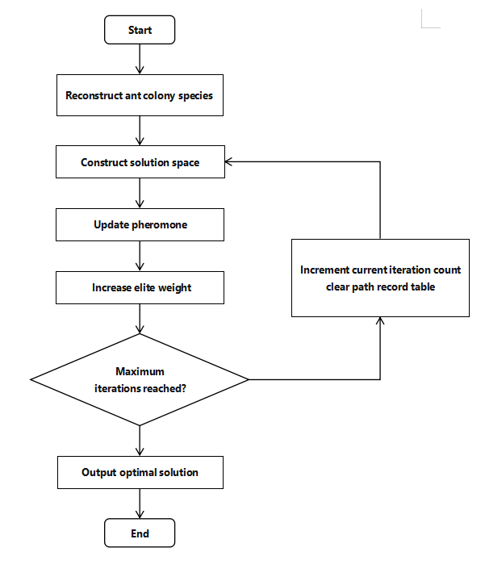

Figure 1. Flowchart of the Improved Ant Colony Algorithm
3. EVRP Case Study Analysis & Discussion
3.1 Experimental Setup
As there are currently no standard test instances for EVRP, this paper uses randomly generated instances. Considering the main customer distributions within a city, analyses are performed for radial and circular distribution types, as shown in Figure 2.
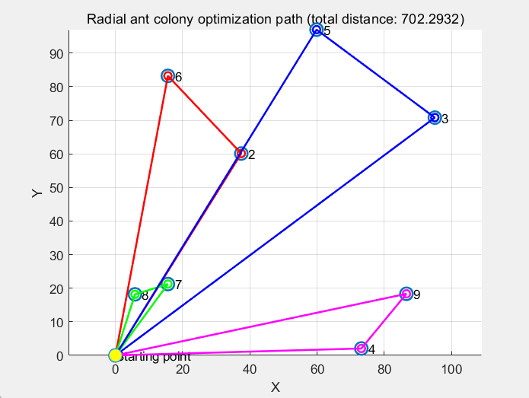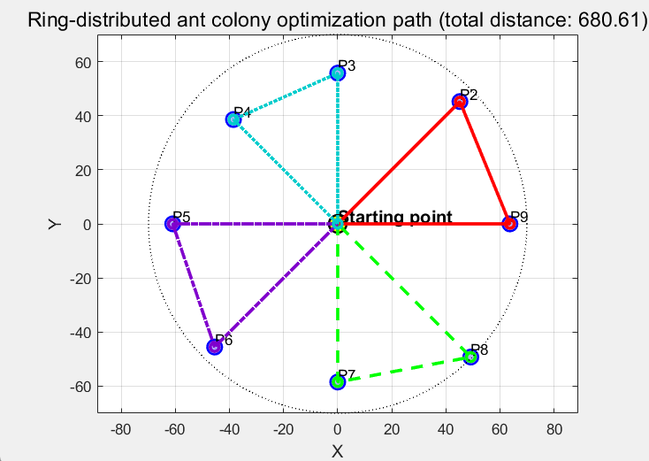

Figure 2. Different Types of Route Planning
Based on reference [20], the parameters are set as: $C$=80kwh，$Q$=2500kg，$τ_{1}$=220 yuan/vehicle, τ₂ = 18 yuan/h, τ₃ = 1 yuan/km, τ₄ = 0.6 kWh/km. According to reference [21], the charging prices and discharge benefits during different time periods are shown in Table 1.
Table 1. Charging Prices and Discharge Benefits During Different Time Periods
Electricity Price Period | Off-Peak | Peak | Super Off-Peak
Time | 08：00~09：00  13：00~17：00  22：00~23：00 | 09：00~13：00  17：00~22：00 | 23：00~next day08：00
Charging Price (yuan/kWh) | 1.887 | 2.235 | 0.665
Discharge Benefit (yuan/kWh) | 1.787 | 2.135 | 0.565
3.2 Experimental Analysis
Various types of test instances were used to validate the effectiveness of the proposed model and algorithm. The experimental results are shown in Table 2. Where: IN is the instance name, SC is the total distribution cost (unit: yuan), FC is the fixed vehicle usage cost (unit: yuan), TC is the vehicle time-based usage cost (unit: yuan), CC is the charging cost during distribution (unit: yuan), DE is the vehicle discharge revenue (unit: yuan), DC is the electricity cost for discharge (unit: yuan), DT is the time cost for discharge (unit: yuan), SP is the total discharge profit (unit: yuan), RT is the program runtime (unit: s), AVE denotes the average value.
Table 2. Experimental Results for Multiple Test Instances
IN | SC | FC | TC | CC | DE | DC | DT | SP | RT
C101  RC101  R101  C201  RC201  R201  AVE | 777.20  799.63  848.95  766.89  799.24  826.90  803.14 | 450  450  450  450  450  450  450 | 327.20  349.63  356.73  316.89  349.24  346.68  341.06 | 0  0  42.21  0  0  30.22  12.07 | 146.42  32.89  120.90  181.35  54.69  130.06  111.05 | 47.95  10.77  38.15  57.79  20.88  42.50  36.31 | 22.68  5.35  17.63  27.29  11.07  20.93  17.49 | 75.79  16.77  65.12  96.27  22.74  66.63  57.22 | 249.94  252.17  243.28  236.62  260.14  270.47  252.10

1) From the numerical distribution of SC, FC, TC, and CC, the proportions of fixed vehicle usage cost, time-based usage cost, and charging cost in the total distribution cost are 56.03%, 42.47%, and 1.50%, respectively. This result indicates that fixed vehicle usage cost and time-based usage cost are the main components of the total distribution cost, together accounting for over 98%. Therefore, logistics enterprises should focus on optimizing the usage efficiency of electric vehicles in actual operations by rationally planning distribution routes to minimize the number of vehicles required and effectively reduce travel time, thereby achieving effective control over these two core costs.
2) Analyzing the values of DE, DC, DT, and SP, the average discharge cost per delivery is 53.83 yuan (DC+DT=36.31+17.49), and the average discharge profit is 57.22 yuan, accounting for 48.47% and 51.53% of the discharge revenue (DE), respectively. This indicates that discharge cost significantly impacts the final discharge profit. Further decomposing the discharge cost structure reveals that the discharge time cost accounts for 67.51% (17.49/(36.31+17.49)) and the electricity cost accounts for 32.49%. To improve overall discharge profit, logistics enterprises could consider using electric vehicles with larger battery capacities for distribution, increasing the amount of electricity available for discharge, thereby enhancing the profitability of the discharge process.
3) Comparing the relationship between SC and SP, the profit obtained from discharging during the distribution process accounts for about 7.12% (57.22/803.14) of the total distribution cost. This proportion shows that considering discharge behavior while performing distribution tasks can create certain additional benefits, indicating good economic potential and development prospects for this model in practical applications.
4) From the RT indicator, the average runtime of the improved ant colony algorithm is 252.10 seconds, indicating that the algorithm can generate electric vehicle distribution route plans that comprehensively consider cost and profit within a relatively short time, verifying its feasibility and reasonableness in practical applications. Furthermore, combined with the route planning results in Figure 2, it can be seen that the algorithm can meet the requirements of constraints (8) and (9) in the model, reflecting the high quality of the generated Pareto front solutions and their good distribution and diversity. Figure 3 shows the optimization process of route planning. For the "radial" distribution case, the solution set distribution is relatively concentrated, and the algorithm stabilizes after about 30 iterations, showing strong convergence performance. In the "circular distribution" case, although the algorithm finds a relatively good solution early in the iterations, with the help of its built-in elite strategy, it effectively avoids getting stuck in local optima and re-explores around iterations 140-150, finally achieving results consistent with the initial phase. This further proves that the improved ant colony algorithm not only has strong global optimization capability but also a good mechanism for avoiding local optima when facing circular distribution scenarios.
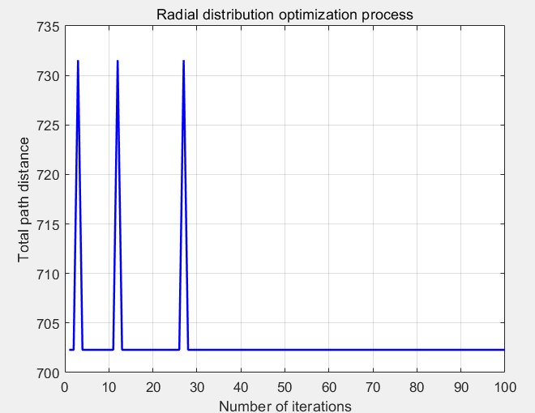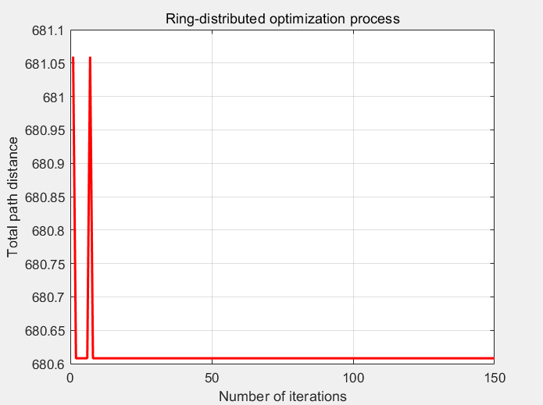
Figure 3. Optimization Process for Different Types of Route Planning
4. Conclusion
This paper examined the route planning problem of electric concrete mixer trucks in urban distribution with the objective of reducing overall distribution cost while also considering the potential economic value of vehicle discharge behavior. A mixed-integer programming model was developed by incorporating vehicle fixed costs, driver time costs, and charging costs, and an improved ant colony algorithm was designed to solve the problem according to the characteristics of the proposed distribution scenario. Based on the test instances considered in this study, the results suggest that the proposed approach can provide a useful framework for analyzing the routing performance of electric concrete mixer trucks under urban delivery conditions.
The numerical analysis indicates that fixed vehicle usage cost and time-based usage cost are the dominant components of total distribution cost, while charging cost accounts for a relatively small proportion. In addition, the results suggest that discharge behavior may create supplementary economic benefits under appropriate electricity pricing conditions. From the computational results, the improved ant colony algorithm appears capable of generating feasible route plans for both radial and circular customer distribution patterns within acceptable runtime under the tested settings.
At the same time, the conclusions of this study should be interpreted with caution. The model is established under several simplifying assumptions, including the exclusion of traffic variability, road-condition effects, standby energy consumption, and concrete setting-time constraints. In addition, the validation is based on randomly generated instances rather than real operational datasets, and no comparison is provided with benchmark algorithms or exact optimization methods. Therefore, the present study should be viewed as an initial exploratory attempt rather than a definitive demonstration of practical superiority.
Overall, this research offers a preliminary modeling and algorithmic reference for the urban distribution of electric concrete mixer trucks and may provide useful support for future studies on low-carbon logistics. Further work is needed to incorporate more realistic operational constraints, test the method on real-world data, and benchmark its performance against alternative solution approaches before stronger claims about practical applicability can be made.
Limitations and Future Research
This study has several limitations that should be acknowledged. First, the model is validated only on randomly generated radial and circular test instances rather than on real operational data from concrete distribution enterprises, which limits the practical generalizability of the findings. Second, to simplify the problem, several real-world factors are excluded, including traffic congestion variability, road conditions, wind speed, standby energy consumption, and concrete setting-time constraints. These assumptions improve tractability but reduce realism for actual urban concrete delivery operations. Third, the cost structure mainly considers fixed vehicle cost, driver time cost, and charging cost, while other important factors such as battery degradation, maintenance cost, service reliability, and carbon-emission accounting are not incorporated. Fourth, although the improved ant colony algorithm shows promising convergence behavior, the study does not compare its performance against other advanced metaheuristics or exact optimization methods on benchmark instances.
Future research can extend this work by using real-world delivery datasets, incorporating time windows and concrete perishability constraints, modeling dynamic traffic conditions and battery degradation, and comparing the proposed algorithm with alternative solution methods. It would also be valuable to study multi-depot settings, heterogeneous fleets, and robust or stochastic optimization frameworks for uncertain urban logistics environments.

COMPETING INTERESTS DISCLAIMER:
Authors have declared that they have no known competing financial interests OR non-financial interests OR personal relationships that could have appeared to influence the work reported in this paper.
Disclaimer (Artificial intelligence)
Author(s) hereby declare that NO generative AI technologies such as Large Language Models (ChatGPT, COPILOT, etc.) and text-to-image generators have been used during the writing or editing of this manuscript.

References

1. Dantzig, George B., and John H. Ramser. "The truck dispatching problem." *Management science* 6.1 (1959): 80-91.
2. Zhang Jianyong, Li Jun, Guo Yaohuang. A Hybrid Genetic Algorithm for VRP with Fuzzy Due Times [J]. Journal of Management Sciences in China, 2005, (03): 64-71.
3. Zhang Tao, She Chuoya, Liu Lan, et al. Methodology for Vehicle Routing Problem with Simultaneous Delivery and Pick-up and Stochastic Travel Time [J]. Systems Engineering - Theory & Practice, 2011, 31(10): 1912-1920.
4. Pan Zhendong, Tang Jiafu, Han Yi. Vehicle Routing Problem with Goods Weight and Genetic Algorithm [J]. Journal of Management Sciences in China, 2007, (03): 23-29.
5. Chen Ping, Huang Houkuan, Dong Xingye. A Hybrid Heuristic Algorithm for the Vehicle Routing Problem with Loading and Unloading Integration [J]. Chinese Journal of Computers, 2008, (04): 565-573.
6. Liu Changshi, Shen Lizhi, Sheng Huyi, et al. Research on Low-carbon Time-dependent Vehicle Routing Problem Considering Traffic Congestion Avoidance [J]. Control and Decision, 2020, 35(10): 2486-2496. DOI:10.13195/j.kzyjc.2019.0257.
7. da Silva Junior, Orivalde Soares, José Eugênio Leal, and Marc Reimann. "A multiple ant colony system with random variable neighborhood descent for the dynamic vehicle routing problem with time windows." Soft Computing 25.4 (2021): 2935-2948.
8. Elgharably, Nayera, et al. "Stochastic multi-objective vehicle routing model in green environment with customer satisfaction." IEEE Transactions on Intelligent Transportation Systems 24.1 (2022): 1337-1355.
9. Erdoğan, Sevgi, and Elise Miller-Hooks. "A green vehicle routing problem." Transportation research part E: logistics and transportation review 48.1 (2012): 100-114.
10. Jie Wanchen, Yang Jun, Lu Jianyi. Electric Vehicle Routing Problem Based on Branch-and-Price Algorithm [J]. Operations Research and Management Science, 2016, 25(04): 93-100.
11. Ge Xianlong, Zhu Ziqiang. Electric Vehicle Routing Optimization Problem with Soft Time Windows [J]. Industrial Engineering and Management, 2019, 24(04): 96-104+112. DOI:10.19495/j.cnki.1007-5429.2019.04.013.
12. Keskin, Merve, and Bülent Çatay. "A matheuristic method for the electric vehicle routing problem with time windows and fast chargers." Computers & operations research 100 (2018): 172-188.
13. Zhang Pengwei, Li Ying, Cheng Qi. Research on Multi-Depot Electric Vehicle Routing Problem with Limited Charging Facilities [J]. Industrial Engineering and Management, 2019, 24(05): 97-105. DOI:10.19495/j.cnki.1007-5429.2019.05.013.
14. Ge Xianlong, Li Zuwei, Ge Xiaobo. Research on Logistics Distribution Route Optimization with Time Windows Considering Flexible Charging Strategy [J]. Control Theory & Applications, 2020, 37(06): 1293-1301.
15. Hulagu, Selin, and Hilmi Berk Celikoglu. "An electric vehicle routing problem with intermediate nodes for shuttle fleets." IEEE Transactions on Intelligent Transportation Systems 23.2 (2020): 1223-1235.
16. Jia, Ya-Hui, Yi Mei, and Mengjie Zhang. "A bilevel ant colony optimization algorithm for capacitated electric vehicle routing problem." IEEE transactions on cybernetics 52.10 (2021): 10855-10868.
17. Stodola, Petr, and Jan Nohel. "Adaptive ant colony optimization with node clustering for the multidepot vehicle routing problem." IEEE Transactions on Evolutionary Computation 27.6 (2022): 1866-1880.
18.Mu, Lifeng, et al. "Optimization model and algorithm for coordinated delivery of autonomous delivery vehicles and electric vehicles with battery swapping consideration." Computers & Industrial Engineering 207 (2025): 111265.
19. Keser, S.B., Sarıçiçek, İ. and Yazıcı, A. (2025), Electric Vehicle Routing With Recharging Stations: Trade-Offs in Last-Mile Delivery. IET Intell. Transp. Syst., 19: e70052.
20. Guo Fang, Yang Jun, Yang Chao. Research on Electric Vehicle Routing Problem Considering Charging Strategy and Battery Degradation [J]. Chinese Journal of Management Science, 2018, 26(09): 106-118.
21. Yang, Hongming, et al. "Electric vehicle route selection and charging navigation strategy based on crowd sensing." IEEE Transactions on Industrial Informatics 13.5 (2017): 2214-2226.
Bruglieri, M., Paolucci, M., & Pisacane, O. (2023). A matheuristic for the electric vehicle routing problem with time windows and a realistic energy consumption model. Computers & Operations Research, 157, 106261. https://doi.org/10.1016/j.cor.2023.106261
Çatay, B., & Sadati, İ. (2023). An improved matheuristic for solving the electric vehicle routing problem with time windows and synchronized mobile charging/battery swapping. Computers & Operations Research, 159, 106310. https://doi.org/10.1016/j.cor.2023.106310
Jeong, J., Ghaddar, B., Zufferey, N., & Nathwani, J. (2024). Adaptive robust electric vehicle routing under energy consumption uncertainty. Transportation Research Part C: Emerging Technologies, 160, 104529. https://doi.org/10.1016/j.trc.2024.104529
Lera-Romero, G., Miranda Bront, J. J., & Soulignac, F. J. (2024). A branch-cut-and-price algorithm for the time-dependent electric vehicle routing problem with time windows. European Journal of Operational Research, 312(3), 978–995. https://doi.org/10.1016/j.ejor.2023.06.037
Woo, S., Choi, E. Y., Moura, S. J., & Borrelli, F. (2024). Saving energy with eco-friendly routing of an electric vehicle fleet. Transportation Research Part E: Logistics and Transportation Review, 189, 103644. https://doi.org/10.1016/j.tre.2024.103644
Xiao, J., Wang, S., Xiao, J., & Huang, G. Q. (2024). Delivery routing for electric vehicles with en-route mobile battery swapping. Transportation Research Part E: Logistics and Transportation Review, 192, 103838. https://doi.org/10.1016/j.tre.2024.103838
Wang, W., Adulyasak, Y., Cordeau, J.-F., & He, G. (2025). The heterogeneous-fleet electric vehicle routing problem with nonlinear charging functions. Transportation Research Part C: Emerging Technologies, 170, 104932. https://doi.org/10.1016/j.trc.2024.104932
Han, B., Yan, Y., Chi, T., & Park, Y. (2025). The electric vehicle routing problem with travel time and energy consumption uncertainty. Transportation Research Part E: Logistics and Transportation Review, 202, 104211. https://doi.org/10.1016/j.tre.2025.104211

