Optimizing Urban Electric Concrete Mixer Truck Routing with an Improved Ant Colony Algorithm: Balancing Costs and Discharge Profits

Abstract: Addressing the issue of urban traffic restrictions for engineering material concrete mixer truck logistics and transportation, this paper proposes an improved ant colony algorithm for electric vehicle urban distribution. Firstly, aiming at minimizing distribution cost, a one-to-many distribution mixed-integer programming model for electric vehicle urban route planning is established. Secondly, based on the model characteristics, an improved ant colony algorithm is designed for solution. Thirdly, experiments are conducted using various types of test instances. Finally, validation through these instances reveals that, regardless of radial or circular distribution patterns, the proportions of fixed vehicle usage cost, time-based usage cost, and charging cost in the total distribution cost for electric vehicles are 56.03%, 42.47%, and 1.50%, respectively. The results indicate that in the scientific planning of electric concrete mixer truck routes for urban areas over short periods, fixed usage cost and time-based usage cost are the primary factors influencing total distribution cost. Through the design of the improved ant colony algorithm, not only can the total distribution cost be effectively reduced, but the discharge profitability of electric concrete mixer trucks can also be enhanced. This lays a foundation for promoting urban logistics and transportation.
Keywords: Urban distribution; Electric concrete mixer truck routing problem; Multi-objective optimization; Improved ant colony algorithm

Introduction
In the development of low-carbon logistics transportation, the key lies in planning vehicle routes to achieve the dual satisfaction of economy and environmental protection, i.e., solving the Vehicle Routing Problem (VRP) in logistics transportation [1]. Numerous scholars have primarily studied VRP for fuel vehicles, establishing models aiming at minimizing total distribution cost, total travel distance, or total travel time to solve the VRP problem [2-5]. Liu Changshi et al. [6] studied a low-carbon VRP model under time-varying network conditions with the objective of minimizing carbon emissions. Silva et al.[7] studied a dynamic VRP model with time windows aiming at minimizing total cost. Elgharably et al.[8] studied a hybrid search multi-objective algorithm for a stochastic multi-objective VRP in a green environment and analyzed the potential impact of relaxing customer time windows. The aforementioned literature provides effective solutions for fuel vehicle route planning in urban logistics and offers significant reference value for subsequent research.
With technological advancements, electric vehicles (EVs) have been introduced by automotive companies in recent years. As zero-emission vehicles, EVs can effectively reduce environmental pollution, leading many enterprises to adopt them for logistics distribution. Consequently, some scholars have begun researching the Electric Vehicle Routing Problem (EVRP). Erdoğan et al. [9] studied an EVRP model with charging stations aiming at minimizing travel distance. Jie Wanchen et al. [10] comprehensively considered factors such as vehicle range limitations, vehicle number constraints, and split deliveries to establish an EVRP model. Ge Xianlong et al. [11] constructed an EVRP model with soft time windows aiming at minimizing total cost. As research deepens, considering factors like insufficient EV range and long charging times, scholars have studied EVRP under different charging strategies. Keskin et al. [12] studied the EVRP with time windows under conventional and fast charging modes. Zhang Pengwei et al. [13] constructed a mathematical model for a multi-depot EVRP with limited charging facilities. Ge Xianlong et al. [14] established a partial charging strategy EVRP model and designed a hybrid simulated annealing algorithm for solution. Hulagu et al. [15] proposed an electric vehicle route optimization method based on a mixed-integer programming model, which comprehensively considers road networks, passenger demand, and vehicle characteristics to minimize operational and charging costs. Jia et al. [16] proposed a Bi-level Ant Colony Optimization (BACO) algorithm for solving the Capacitated Electric Vehicle Routing Problem (CEVRP). This algorithm decomposes the problem into two subproblems: the Capacitated VRP (CVRP) and the Fixed Route Vehicle Charging Problem (FRVCP), improving solution performance through cooperative optimization. Stodola et al. [17] proposed a metaheuristic algorithm based on ant colony optimization principles, introducing techniques like node clustering and adaptive pheromone evaporation to solve the Multi-Depot VRP (MDVRP).In addition, some scholars have explored other approaches to address the Electric Vehicle Routing Problem (EMVRP). Lifeng Mu al. [18] proposed a novel urban logistics model involving the collaboration between electric vehicles and autonomous delivery vehicles, which innovatively introduced battery swapping stations as a rapid recharging solution. Sinem Bozkurt Keser al. [19]conducted a comparative study on the impact of three different charging strategies—full charging, partial charging, and 20%-80% partial charging—on last-mile delivery route planning.
Existing achievements provide a good foundation for in-depth research on EVRP, but several research gaps remain: 1) Most existing studies assume that distribution costs are only related to the vehicle itself, such as travel distance, fuel/electricity consumption, vehicle cost, etc., which is not sufficiently close to actual fleet distribution scenarios, e.g., driver wages, maximum vehicle energy consumption, peak/off-peak electricity price differences, etc., requiring comprehensive consideration. 2) Most studies assume the carrier has unlimited capacity and do not consider round-trip routing issues, e.g., one construction site requires 95 units of engineering materials, each vehicle can only carry 10 units, the first 9 vehicles make normal round trips, but the 10th vehicle needs to proceed to the next location, etc. This paper constructs an EVRP model with the objective of minimizing the sum of vehicle fixed costs, electric vehicle driver wages, and electric vehicle charging costs, and uses an improved ant colony algorithm for solution to achieve this objective.

Description of the Ready-Mixed Concrete Electric Distribution Problem
This paper primarily studies the scenario where ready-mixed concrete electric distribution vehicles deliver from distribution stations to multiple customer points within an urban area. Therefore, this EVRP can be described as reasonably optimizing vehicle distribution routes under the constraints of node demands, battery energy, and load capacity, to achieve goals such as reducing distribution costs and improving distribution efficiency. To achieve this goal, the complexity of real-world distribution is simplified with the following assumptions:
1. Interference from external factors such as wind speed and road conditions is not considered.
2.As it is an EVRP primarily for urban distribution, this paper assumes a one-to-many distribution pattern mostly within the city. Furthermore, concrete setting time issues are not considered, making it closer to reality.
3. After each delivery, electric distribution vehicles return to the depot for replenishment and standby for the next delivery. Internal energy consumption from electronic devices like air conditioning during standby is not considered, i.e., no energy is consumed during standby.
4. This paper focuses more on the algorithmic aspect, neglecting changes in the vehicle body itself, treating the vehicle as a rigid body.
5. Since electric energy consumption varies significantly at different speeds, and the research target is urban areas, energy consumption is calculated based on speeds below 100 km/h.
6. Customer locations are known, and as the goal is to find the optimal route solution, all delivery customers are static.
2. Methodology
EVRP Mathematical Model
2.1 Definition of Symbols and Variables
1)Sets: Let M be the set of customers; O be the logistics center; K be the set of electric vehicles; $P_{c}$ be the set of charging stations; P be the set of all nodes, i.e., $P=M⋃P_{c}⋃O$.
2)Parameters: C is the battery capacity of the electric vehicle; $d_{ij}$ is the distance from node i to j; $Q_{ij}$ is the cargo capacity of the electric vehicle when traveling from i to j; $Q$ is the rated capacity of the electric vehicle; $R_{m}$ is the demand of customer m, $∀m∈M$; k is an electric vehicle, $∀k∈K$. $R_{im}$ is the remaining demand of customer m yet to be delivered, with $R_{im}<Q$; $E_{ik}^{a、l}$ is the current energy level of vehicle k upon arrival at or departure from node i.
3) Decision Variables: $x_{ijk}∈\{0，1\}$, equals 1 if vehicle k travels from i to j, otherwise 0;$y_{mk}∈\{0，1\}$, equals 1 if customer m is served by vehicle k, otherwise 0; $Y_{mk}∈\{0，1\}$, equals 1 if vehicle k serves customer m and R_m ≥ 0, otherwise 0.
2.2 Model Formulation
The electric vehicle distribution route model is constructed as follows:
Min = C₁ + C₂ + C₃ (1)
Equation (1) is the objective function of the model, where C₁ is the vehicle fixed cost, C₂ is the driver cost, and C₃ is the vehicle charging cost.
$C_{1}$=$τ_{1}\sum_{m=0}{\sum_{jϵP}{\sum_{kϵK}{x_{ijk}}}}$#(2)
$C_{2}=τ_{2}\sum_{iϵP}{\sum_{jϵP}{\sum_{kϵK}{d_{ijk}}}}$#(3)
$C_{3}=τ_{3}\sum_{iϵP}{\sum_{jϵP}{\sum_{kϵK}{d_{ijk}}}}$#(4)
Equations (2), (3), and (4) define the vehicle fixed cost, driver cost, and vehicle charging cost, respectively; where τ₁ is the fixed cost per electric vehicle, τ₂ is the wage cost per unit time, and τ₃ is the electricity cost per kilometer.
$R_{im}=R_{m}−kQ$#(5)
Equation (5) defines the remaining demand of a customer when it is less than the vehicle's rated capacity.
$Q_{ij}=Q−R_{im}$#(6)
Equation (6) defines the remaining cargo capacity of the vehicle after serving the previous customer with its rated capacity.
$E_{ik}^{a}=C−τ_{4}d_{0i}$,$E_{ik}^{a}<C$#(7)
Equation (7) constrains the electric vehicle's energy level, where τ₄ is the energy consumption per kilometer.
$\sum_{i∈M⋃P_{c}}{x_{0ik}}≤1，∀k∈K$#(8)
Equation (8) constrains each electric vehicle to be dispatched only once from the depot.
$\sum_{i∈M⋃P_{c}}{x_{0ik}}=\sum_{j∈M⋃P_{c}}{x_{j0k}}，∀k∈K$#(9)
Equation (9) constrains each electric vehicle to start and end its route at the logistics center.
2.3 Construction of the Improved Ant Colony Algorithm
The Ant Colony Algorithm (ACA) is a heuristic algorithm with advantages such as heuristic search, positive feedback, and distributed computation. For problems like EVRP where finding the optimal solution is difficult, ACA, simulating nature's efficient pathfinding mechanism, possessing strong global optimization capability, adaptability to complex constraints and dynamic environments, inherent distributed parallel characteristics, and good robustness, becomes a powerful tool for solving path planning problems. This paper compares the traditional ant colony algorithm by introducing the elite ant strategy and the rank-based ant strategy.The improved design approach is as follows:
Step 1: Initialization. Set iter_Max as the maximum number of iterations; BestRoute as the optimal route; K as the number of ants; iter as the current iteration count, iter=1; pheromone importance factor α; heuristic function importance factor β; pheromone evaporation factor ρ; total pheromone released Q; e as the elite ant weight.
Step 2: Path Construction, Finding Feasible Solutions. Place all ants at the same starting point, the logistics center 0. For each ant k (k=1, 2, ..., K), calculate its next node to visit until all ants have visited all nodes. Ants determine their next node based on pheromone concentration. Let $P_{ij}^{k}$(t) denote the probability of ant k transitioning from node i to node j at time t, calculated as follows:
$P_{ij}^{k}=\left\{\begin{aligned}\frac{{[τ_{ij}^{k}(t)]}^{α}∗{[η_{ij}^{k}(t)]}^{β}}{\sum_{s∈{allow}_{k}}{{[τ_{is}^{k}(t)]}^{α}∗{[η_{is}^{k}(t)]}^{β}}}, &s∈{allow}_{k} \\ 0, &&s∉{allow}_{k}\end{aligned}\right.$#(10)
Here, $η_{ij}^{k}(t)$is the heuristic function, $η_{ij}^{k}(t)$=$\frac{1}{d_{ijk}}$, representing the desirability of moving from node i to j. ${allow}_{k}$(k=1，2，…，K) is the set of nodes not yet visited by ant k. Initially, ${allow}_{k}$ contains (m-1) elements, i.e., all nodes except the starting node. As time progresses, elements in ${allow}_{k}$ decrease until it is empty, meaning all nodes have been visited.
Step 3: Pheromone Update. Calculate the path length d_{ij} traversed by each ant, record the best solution in the current iteration. Simultaneously, update the pheromone concentration on the paths connecting the nodes. While ants release pheromone, the pheromone on the paths between cities gradually evaporates. Let parameter ρ (0<ρ<1) represent the degree of pheromone evaporation. Therefore, after all ants complete one cycle, the pheromone concentration on the paths connecting the cities needs to be updated in real-time using the following formula:
$\left\{\begin{aligned}τ_{ij}(t+1)=(1−ρ)∗τ_{ij}(t)+△τ_{ij} \\ △τ_{ij}=\sum_{k=1}^{K}{△τ_{ij}^{k}}\end{aligned}\right.$，(0<ρ<1)#(11)
Here, $△τ_{ij}^{k}$ represents the amount of pheromone deposited by the k-th ant on the path connecting city i and city j, and $△τ_{ij}$ represents the total amount of pheromone deposited by all ants on that path.
Step 4: Termination Check. If iter < iter_Max, then set iter = iter+1, clear the record of paths taken by ants, and return to Step 2. Otherwise, terminate the computation and output the optimal solution.
The flowchart is as follows:
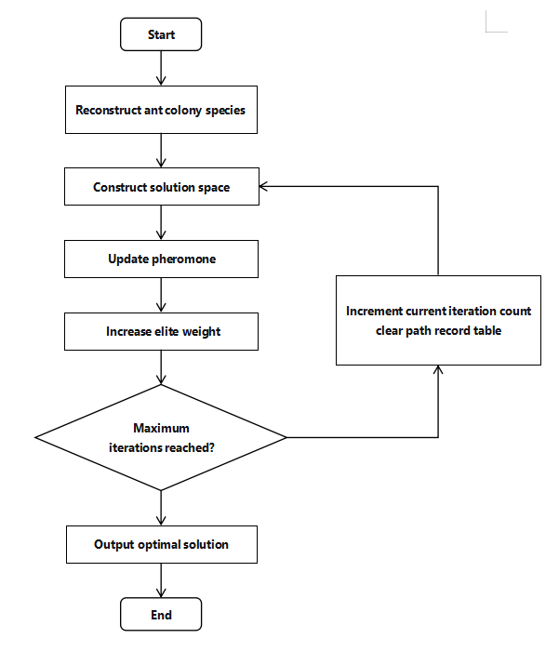

Figure 1. Flowchart of the Improved Ant Colony Algorithm
3. EVRP Case Study Analysis & Discussion
3.1 Experimental Setup
As there are currently no standard test instances for EVRP, this paper uses randomly generated instances. Considering the main customer distributions within a city, analyses are performed for radial and circular distribution types, as shown in Figure 2.
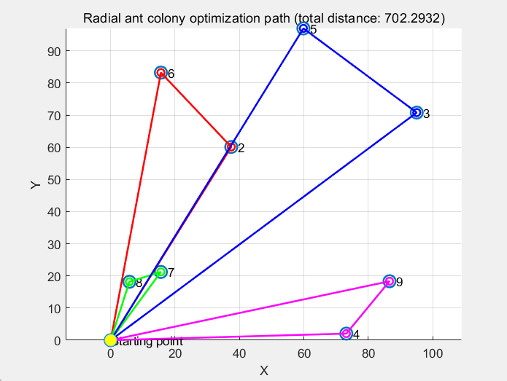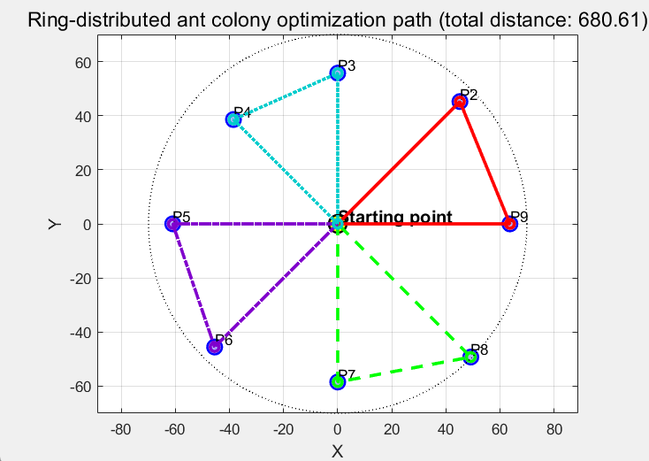

Figure 2. Different Types of Route Planning
Based on reference [20], the parameters are set as: $C$=80kwh，$Q$=2500kg，$τ_{1}$=220 yuan/vehicle, τ₂ = 18 yuan/h, τ₃ = 1 yuan/km, τ₄ = 0.6 kWh/km. According to reference [21], the charging prices and discharge benefits during different time periods are shown in Table 1.
Table 1. Charging Prices and Discharge Benefits During Different Time Periods
Electricity Price Period | Off-Peak | Peak | Super Off-Peak
Time | 08：00~09：00  13：00~17：00  22：00~23：00 | 09：00~13：00  17：00~22：00 | 23：00~next day08：00
Charging Price (yuan/kWh) | 1.887 | 2.235 | 0.665
Discharge Benefit (yuan/kWh) | 1.787 | 2.135 | 0.565
3.2 Experimental Analysis
Various types of test instances were used to validate the effectiveness of the proposed model and algorithm. The experimental results are shown in Table 2. Where: IN is the instance name, SC is the total distribution cost (unit: yuan), FC is the fixed vehicle usage cost (unit: yuan), TC is the vehicle time-based usage cost (unit: yuan), CC is the charging cost during distribution (unit: yuan), DE is the vehicle discharge revenue (unit: yuan), DC is the electricity cost for discharge (unit: yuan), DT is the time cost for discharge (unit: yuan), SP is the total discharge profit (unit: yuan), RT is the program runtime (unit: s), AVE denotes the average value.
Table 2. Experimental Results for Multiple Test Instances
IN | SC | FC | TC | CC | DE | DC | DT | SP | RT
C101  RC101  R101  C201  RC201  R201  AVE | 777.20  799.63  848.95  766.89  799.24  826.90  803.14 | 450  450  450  450  450  450  450 | 327.20  349.63  356.73  316.89  349.24  346.68  341.06 | 0  0  42.21  0  0  30.22  12.07 | 146.42  32.89  120.90  181.35  54.69  130.06  111.05 | 47.95  10.77  38.15  57.79  20.88  42.50  36.31 | 22.68  5.35  17.63  27.29  11.07  20.93  17.49 | 75.79  16.77  65.12  96.27  22.74  66.63  57.22 | 249.94  252.17  243.28  236.62  260.14  270.47  252.10

1) From the numerical distribution of SC, FC, TC, and CC, the proportions of fixed vehicle usage cost, time-based usage cost, and charging cost in the total distribution cost are 56.03%, 42.47%, and 1.50%, respectively. This result indicates that fixed vehicle usage cost and time-based usage cost are the main components of the total distribution cost, together accounting for over 98%. Therefore, logistics enterprises should focus on optimizing the usage efficiency of electric vehicles in actual operations by rationally planning distribution routes to minimize the number of vehicles required and effectively reduce travel time, thereby achieving effective control over these two core costs.
2) Analyzing the values of DE, DC, DT, and SP, the average discharge cost per delivery is 53.83 yuan (DC+DT=36.31+17.49), and the average discharge profit is 57.22 yuan, accounting for 48.47% and 51.53% of the discharge revenue (DE), respectively. This indicates that discharge cost significantly impacts the final discharge profit. Further decomposing the discharge cost structure reveals that the discharge time cost accounts for 67.51% (17.49/(36.31+17.49)) and the electricity cost accounts for 32.49%. To improve overall discharge profit, logistics enterprises could consider using electric vehicles with larger battery capacities for distribution, increasing the amount of electricity available for discharge, thereby enhancing the profitability of the discharge process.
3) Comparing the relationship between SC and SP, the profit obtained from discharging during the distribution process accounts for about 7.12% (57.22/803.14) of the total distribution cost. This proportion shows that considering discharge behavior while performing distribution tasks can create certain additional benefits, indicating good economic potential and development prospects for this model in practical applications.
4) From the RT indicator, the average runtime of the improved ant colony algorithm is 252.10 seconds, indicating that the algorithm can generate electric vehicle distribution route plans that comprehensively consider cost and profit within a relatively short time, verifying its feasibility and reasonableness in practical applications. Furthermore, combined with the route planning results in Figure 2, it can be seen that the algorithm can meet the requirements of constraints (8) and (9) in the model, reflecting the high quality of the generated Pareto front solutions and their good distribution and diversity. Figure 3 shows the optimization process of route planning. For the "radial" distribution case, the solution set distribution is relatively concentrated, and the algorithm stabilizes after about 30 iterations, showing strong convergence performance. In the "circular distribution" case, although the algorithm finds a relatively good solution early in the iterations, with the help of its built-in elite strategy, it effectively avoids getting stuck in local optima and re-explores around iterations 140-150, finally achieving results consistent with the initial phase. This further proves that the improved ant colony algorithm not only has strong global optimization capability but also a good mechanism for avoiding local optima when facing circular distribution scenarios.
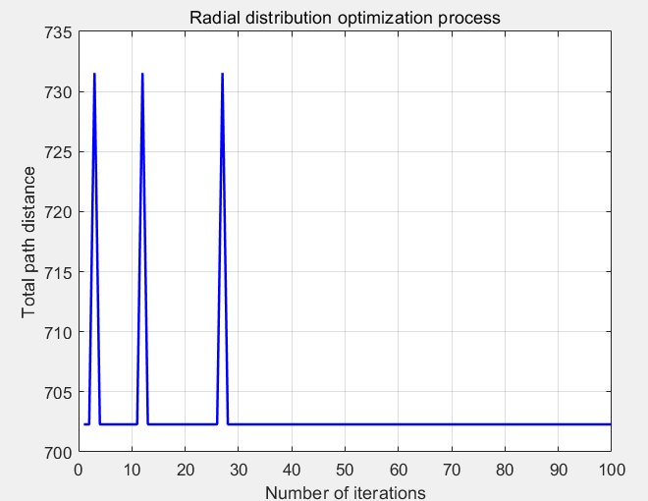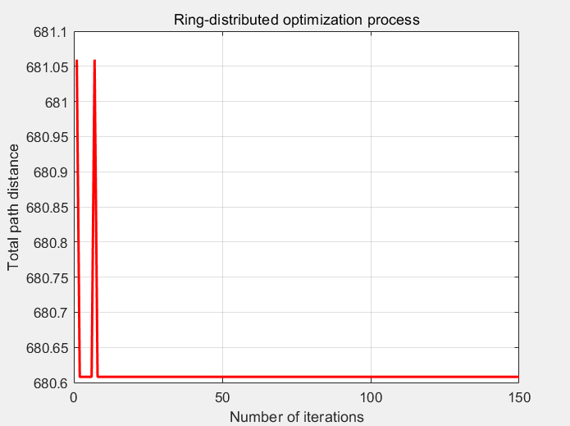
Figure 3. Optimization Process for Different Types of Route Planning
4. Conclusion
This paper focused on the route planning problem of electric concrete mixer trucks in urban distribution, aiming to reduce the total distribution cost. A multi-objective mixed-integer programming model considering vehicle fixed costs, driver time costs, and charging costs was constructed. An improved ant colony algorithm was designed to solve the model based on its characteristics, and its effectiveness was validated through various test instances.
The results show that: 1) In the analysis of the distribution cost structure, the fixed vehicle usage cost and time-based usage cost of electric vehicles are the main components of the total distribution cost, together accounting for over 98%, while the charging cost proportion is small. Therefore, in actual operations, focus should be placed on optimizing vehicle usage efficiency and rationally planning routes to reduce the number of vehicles and usage time.
2) Discharge profit analysis: Electric vehicles can obtain certain profits through discharging during the distribution process. The discharge profit is mainly affected by electricity cost and discharge time cost. It is recommended that logistics enterprises charge during off-peak/valley periods and discharge during peak periods to reduce electricity costs and increase discharge profit.
3) Algorithm performance verification: The improved ant colony algorithm can generate high-quality route plans satisfying the constraints within a relatively short time, demonstrating good convergence and global optimization capabilities. It is suitable for different customer distribution scenarios (such as radial and circular distributions) and possesses strong practicality and promotion value.
This research provides effective model and algorithm support for the low-carbon route planning of electric concrete mixer trucks in urban logistics, holding certain theoretical significance and practical reference value for promoting the development of urban green logistics.

COMPETING INTERESTS DISCLAIMER:
Authors have declared that they have no known competing financial interests OR non-financial interests OR personal relationships that could have appeared to influence the work reported in this paper.
Disclaimer (Artificial intelligence)
Author(s) hereby declare that NO generative AI technologies such as Large Language Models (ChatGPT, COPILOT, etc.) and text-to-image generators have been used during the writing or editing of this manuscript.

References

1. Dantzig, George B., and John H. Ramser. "The truck dispatching problem." *Management science* 6.1 (1959): 80-91.
2. Zhang Jianyong, Li Jun, Guo Yaohuang. A Hybrid Genetic Algorithm for VRP with Fuzzy Due Times [J]. Journal of Management Sciences in China, 2005, (03): 64-71.
3. Zhang Tao, She Chuoya, Liu Lan, et al. Methodology for Vehicle Routing Problem with Simultaneous Delivery and Pick-up and Stochastic Travel Time [J]. Systems Engineering - Theory & Practice, 2011, 31(10): 1912-1920.
4. Pan Zhendong, Tang Jiafu, Han Yi. Vehicle Routing Problem with Goods Weight and Genetic Algorithm [J]. Journal of Management Sciences in China, 2007, (03): 23-29.
5. Chen Ping, Huang Houkuan, Dong Xingye. A Hybrid Heuristic Algorithm for the Vehicle Routing Problem with Loading and Unloading Integration [J]. Chinese Journal of Computers, 2008, (04): 565-573.
6. Liu Changshi, Shen Lizhi, Sheng Huyi, et al. Research on Low-carbon Time-dependent Vehicle Routing Problem Considering Traffic Congestion Avoidance [J]. Control and Decision, 2020, 35(10): 2486-2496. DOI:10.13195/j.kzyjc.2019.0257.
7. da Silva Junior, Orivalde Soares, José Eugênio Leal, and Marc Reimann. "A multiple ant colony system with random variable neighborhood descent for the dynamic vehicle routing problem with time windows." Soft Computing 25.4 (2021): 2935-2948.
8. Elgharably, Nayera, et al. "Stochastic multi-objective vehicle routing model in green environment with customer satisfaction." IEEE Transactions on Intelligent Transportation Systems 24.1 (2022): 1337-1355.
9. Erdoğan, Sevgi, and Elise Miller-Hooks. "A green vehicle routing problem." Transportation research part E: logistics and transportation review 48.1 (2012): 100-114.
10. Jie Wanchen, Yang Jun, Lu Jianyi. Electric Vehicle Routing Problem Based on Branch-and-Price Algorithm [J]. Operations Research and Management Science, 2016, 25(04): 93-100.
11. Ge Xianlong, Zhu Ziqiang. Electric Vehicle Routing Optimization Problem with Soft Time Windows [J]. Industrial Engineering and Management, 2019, 24(04): 96-104+112. DOI:10.19495/j.cnki.1007-5429.2019.04.013.
12. Keskin, Merve, and Bülent Çatay. "A matheuristic method for the electric vehicle routing problem with time windows and fast chargers." Computers & operations research 100 (2018): 172-188.
13. Zhang Pengwei, Li Ying, Cheng Qi. Research on Multi-Depot Electric Vehicle Routing Problem with Limited Charging Facilities [J]. Industrial Engineering and Management, 2019, 24(05): 97-105. DOI:10.19495/j.cnki.1007-5429.2019.05.013.
14. Ge Xianlong, Li Zuwei, Ge Xiaobo. Research on Logistics Distribution Route Optimization with Time Windows Considering Flexible Charging Strategy [J]. Control Theory & Applications, 2020, 37(06): 1293-1301.
15. Hulagu, Selin, and Hilmi Berk Celikoglu. "An electric vehicle routing problem with intermediate nodes for shuttle fleets." IEEE Transactions on Intelligent Transportation Systems 23.2 (2020): 1223-1235.
16. Jia, Ya-Hui, Yi Mei, and Mengjie Zhang. "A bilevel ant colony optimization algorithm for capacitated electric vehicle routing problem." IEEE transactions on cybernetics 52.10 (2021): 10855-10868.
17. Stodola, Petr, and Jan Nohel. "Adaptive ant colony optimization with node clustering for the multidepot vehicle routing problem." IEEE Transactions on Evolutionary Computation 27.6 (2022): 1866-1880.
18.Mu, Lifeng, et al. "Optimization model and algorithm for coordinated delivery of autonomous delivery vehicles and electric vehicles with battery swapping consideration." Computers & Industrial Engineering 207 (2025): 111265.
19. Keser, S.B., Sarıçiçek, İ. and Yazıcı, A. (2025), Electric Vehicle Routing With Recharging Stations: Trade-Offs in Last-Mile Delivery. IET Intell. Transp. Syst., 19: e70052.
20. Guo Fang, Yang Jun, Yang Chao. Research on Electric Vehicle Routing Problem Considering Charging Strategy and Battery Degradation [J]. Chinese Journal of Management Science, 2018, 26(09): 106-118.
21. Yang, Hongming, et al. "Electric vehicle route selection and charging navigation strategy based on crowd sensing." IEEE Transactions on Industrial Informatics 13.5 (2017): 2214-2226.

