Fast and Physically Constrained Modelling of Solar PV Power Output Using an Optimized Ordinary Differential Equation (ODE) Framework
Abstract
This study develops and validates a physically informed ordinary differential equation (ODE) model for predicting photovoltaic (PV) power output under varying environmental conditions. The proposed framework couples panel thermal dynamics with temperature-dependent electrical efficiency while incorporating multiple environmental forcing variables, including solar irradiance, ambient temperature, wind speed, humidity, and atmospheric pressure. Unknown physical parameters are estimated through bounded optimization using the L-BFGS-B algorithm, ensuring thermodynamic consistency and physically realistic parameter values. The model is validated using real-world hourly operational data from a grid-connected PV system. Results demonstrate strong predictive performance with R² = 0.9824, RMSE = 20.98 W, and MAE = 11.32 W, indicating that the model captures more than 98% of the variance in observed power output. Monte Carlo simulations confirm model robustness under typical sensor noise conditions, producing narrow uncertainty bounds around predicted trajectories. The proposed framework provides a computationally efficient and physically interpretable alternative to purely data-driven forecasting approaches, making it suitable for real-time PV monitoring, forecasting, and grid integration applications.
Keywords: photovoltaic power prediction, ordinary differential equations, physics-informed modelling, thermal dynamics, parameter optimization, renewable energy forecasting, energy system modelling

1. Introduction
The global shift toward sustainable, low-carbon energy has increased the importance of accurate solar photovoltaic (PV) power forecasting. Solar energy is particularly attractive due to its environmental sustainability, wide availability, and rapidly declining levelized cost of electricity (LCOE) (Ahmed, Ajaj, & Al-jadir, 2025; Li, Liu, & Zhang, 2024). In regions with high solar irradiance, such as Sub-Saharan Africa, PV systems can address electricity access deficits and enhance grid resilience. For example, Nigeria experiences annual solar insolation exceeding 2000 kWh/m², indicating substantial PV potential (Wang et al., 2025).
Despite its advantages, PV integration poses operational challenges due to inherent variability and dependence on environmental conditions. Solar irradiance, temperature, wind speed, atmospheric pressure, and humidity jointly influence module performance, producing stochastic fluctuations and strong diurnal and seasonal patterns (Sameera & Tariq, 2024; Wang et al., 2025; Zhai & Liu, 2025). Accurate forecasting is critical for grid stability, energy trading, and renewable integration (Wang, Wang, & Sui, 2023; Zhang, Beaudin, Tahboub, & Swan, 2023).
Traditionally, PV models rely on equivalent electrical circuits describing nonlinear current–voltage behavior under varying conditions (King, Kratochvil, & Boyson, 2004; W. De Soto, Klein, & Beckman, 2006; Skoplaki & Palyvos, 2009). These models often treat environmental inputs as static, limiting predictive performance during rapidly changing conditions (Ruusu, Cao, Delgado, & Hasan, 2019).
Data-driven approaches—including deep learning, transformer networks, and hybrid frameworks—capture nonlinear relationships between weather variables and PV output, improving forecasting accuracy (Di Leo & Marroccoli, 2025; Jiang, Zhang, & Chen, 2025; Zhai & Liu, 2025; Asiedu & Amoh, 2024; Wang, Wang, & Sui, 2023; Zhang, Beaudin, Tahboub, & Swan, 2023; Gupta & Arya, 2025; Ahmed, Ajaj, & Al-jadir, 2025; Nasir, Khan, Berrouk, & Aamir, 2025). Physics-informed neural networks (PINNs) integrate physical laws into learning models, enhancing interpretability and generalization (Raissi, Perdikaris, & Karniadakis, 2019; Chen, Dong, Wang, & Sun, 2024; Wang et al., 2025; Chen, Li, & Wang, 2024; Di Vito, Mohammadian, Baker, & Fioretto, 2024; Li, Liu, & Zhang, 2024). However, these methods often require large datasets and significant computational resources, limiting application in data-scarce or resource-constrained contexts.
Physics-based modeling, particularly ordinary differential equations (ODEs), offers computationally efficient and interpretable alternatives for dynamic energy systems (Badiale & Serra, 2025; Eggers, 2014; Radisavljevic-Gajic & Dragan, 2023; Liu & Wang, 2022; Kampasis, 2025). ODE frameworks have been applied in wind power prediction and thermal system modeling, allowing explicit representation of energy transfer and thermal dynamics (Liu & Wang, 2022; Kampasis, 2025).
Thermal dynamics strongly influence PV efficiency. Module temperature affects electrical output, while wind and humidity modify panel temperature via convective and radiative heat transfer (E. Skoplaki & J. A. Palyvos, 2009; Keddouda & Bouhelal, 2024; Faiman, 2008; Rahman & Hassan, 2024; T. Faiman, 2008; Segbefia & Prasad, 2023). Energy balance equations provide a natural framework linking environmental drivers to performance (Fiedler, Raeth, Theis, Hausser, & Hasenauer, 2016; Wang et al., 2025; Keddouda & Bouhelal, 2024).
Key gaps remain: few time-dependent ODE models integrate multiple environmental drivers simultaneously; many models exclude humidity and atmospheric pressure; and computationally efficient, physically interpretable models validated with real PV data are scarce (Ahmed, Ajaj, & Al-jadir, 2025; Li, Liu, & Zhang, 2024; Wang et al., 2025).
This study develops a physically constrained ODE framework for PV power forecasting. Solar radiation, temperature, wind speed, humidity, and atmospheric pressure are integrated into a unified thermal energy balance equation. Temperature-dependent electrical efficiency links thermal behavior to power output. Unknown parameters—including thermal capacity, heat transfer coefficient, wind cooling coefficient, and humidity attenuation factor—are estimated via bounded optimization using L-BFGS-B (Richard H. Byrd, Lu, Nocedal, & Zhu, 1995), ensuring physical consistency and numerical stability.
Contributions include: (1) a multi-parameter ODE model coupling key environmental drivers; (2) constrained parameter estimation for physical validity; (3) validation with real PV data, achieving R² = 0.9824; and (4) a transparent, computationally efficient alternative to complex machine learning models for real-time forecasting.
The paper is structured as follows: Section 2 presents the ODE formulation, numerical methods, and evaluation metrics; Section 3 presents results and diagnostic analyses; Section 4 concludes with key findings and recommendations.

2. Methodology
2.1 Overview of the Modelling Framework
This study develops a physically-informed ordinary differential equation (ODE) framework for predicting solar photovoltaic (PV) power output under varying environmental conditions. The methodology integrates thermal dynamics, temperature-dependent electrical efficiency, and multi-parameter environmental forcing within a computationally efficient numerical scheme. Figure 1 presents a schematic overview of the modelling workflow, illustrating the coupling between meteorological inputs, panel thermal response, and electrical power generation.
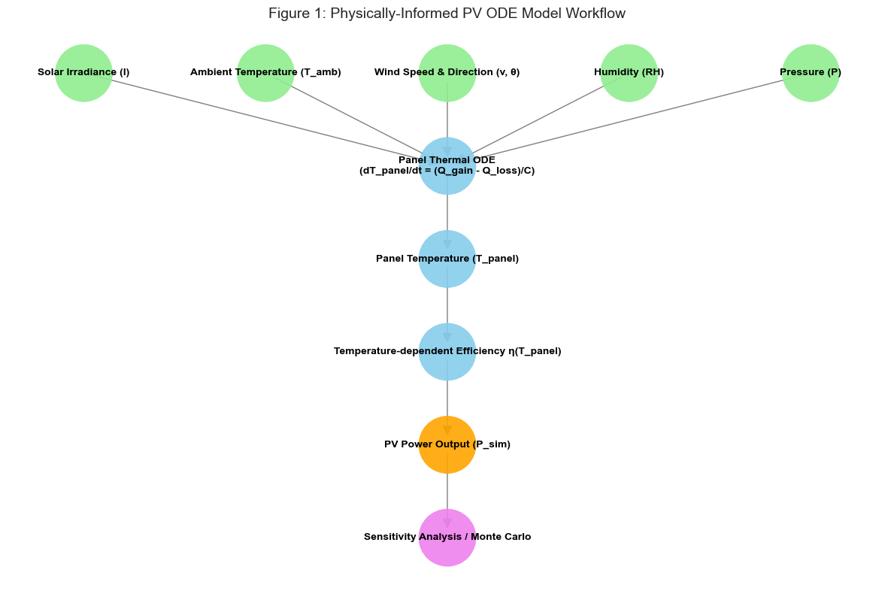
Figure 1: Physically informed PV ODE model workflow
The framework comprises four principal components:
- Data preprocessing and physical consistency enforcement
- Panel temperature simulation via energy balance ODE
- Power output computation using temperature-dependent efficiency.
- Parameter estimation, validation, and uncertainty quantification
All computations are performed in physical units to preserve interpretability; normalization is applied solely for visualization purposes.
2.2 Data Preprocessing and Physical Constraints
2.2.1 Dataset Characteristics
The model is trained and validated using hourly meteorological and operational data from a grid-connected PV system. Key variables include solar irradiance ($I$), ambient temperature ($T_{amb}$​), wind speed (v), wind direction (θ), atmospheric pressure (P), relative humidity (ϕ), and measured power output ($P_{obs}$​). Table 1 summarizes the physical variables and their nomenclature.
Table 1: Physical Variables and Nomenclature
Symbol | Nomenclature | Unit | Physical Range
I | Solar irradiance | W/m² | [0, 1500]
$T_{amb}$​ | Ambient temperature | °C | [−20, 60]
v | Wind speed | m/s | [0, 30]
θ | Wind direction | degrees | [0, 360]
P | Atmospheric pressure | hPa | [900, 1100]
ϕ | Relative humidity | fraction | [0, 1]
$P_{obs}$​ | Observed power output | W | [0, 5000]
$T_{panel}$​ | PV panel temperature | °C | [-10, 85]

2.2.2 Data Cleaning and Quality Control
Raw data undergo systematic preprocessing to ensure physical plausibility and numerical stability:
- Type conversion: All variables are cast to numeric format; non-numeric entries are coerced to NaN.
- Missing value handling: Linear interpolation with bidirectional limit direction fills short gaps; remaining NaN values are replaced with column-wise means.
- Outlier mitigation: Values outside physically realistic bounds (Table 1) are clipped to the nearest boundary.
- Unit standardization: Relative humidity is converted from percentage to fractional form $(ϕ∈[0,1]).$
These steps eliminate spurious measurements while preserving the temporal structure of the dataset.
2.3 Governing Thermal Differential Equation
2.3.1 Energy Balance Formulation
The PV panel temperature ($T_{p}$​) evolves according to a first-order energy balance equation derived from conservation of thermal energy:
$C\frac{dT_{p}}{dt}=Q_{gain}-Q_{loss}$ (1)
where C [J/°C] denotes the panel's effective thermal capacity, and $\frac{dT_{p}}{dt}$ is the rate of temperature change.
2.3.2 Heat Gain from Solar Radiation
The effective irradiance reaching the panel surface is attenuated by atmospheric humidity:
$I_{eff}\left(t\right)=I\left(t\right)⋅exp\left(-α⋅ϕ\left(t\right)\right)$ (2)
where α [dimensionless] is an empirically determined attenuation coefficient. The absorbed thermal power is:
$Q_{gain}(t)=A⋅η_{abs}⋅I_{eff}(t)$ (3)
with A [m²] representing panel area and $η_{abs}≈0.9$ denoting the thermal absorptivity (distinct from electrical efficiency).
2.3.3 Convective and Wind-Enhanced Heat Loss
Heat dissipation to the ambient environment follows Newton's law of cooling, augmented by wind-induced convection:
$Q_{loss}(t)=\underset{natural convection}{\underbrace{hA(T_{p}-T_{amb})}}+\underset{forced convection}{\underbrace{k_{w}⋅v_{eff}⋅A(T_{p}-T_{amb})}}$ (4)
where h [W/(m²·°C)] is the natural convection heat transfer coefficient, and $k_{w}$​ [W/(°C·m/s)] quantifies wind-enhanced cooling. The effective wind speed accounts for directional alignment and atmospheric density:
$v_{eff}(t)=v(t)⋅max[0,cos(θ(t)-θ_{panel})]⋅\frac{P\left(t\right)}{P_{ref}}$ (5)
with $θ_{panel}={180}^{0}$ (south-facing orientation) and $P_{ref}=1013.25hPa$. The $max[0,⋅]$ operator ensures wind contributes only to cooling (not heating).
2.3.4 Complete Thermal ODE
Substituting Equations (2) – (5) into Equation (1) yields the governing equation:
$\frac{dT_{p}}{dt}=\frac{Aη_{abs}Ie^{-αϕ}}{C}-\frac{A\left[h+k_{w}v_{eff}\right]\left(T_{p}-T_{amb}\right)}{C}$ (6)
This nonlinear ODE captures the coupled effects of irradiance heating, ambient temperature, wind cooling, humidity attenuation, and pressure-modulated air density.
2.4 Numerical Solution Scheme
Given the time-varying nature of all input variables, Equation (6) is solved using forward Euler integration with timestep $Δt=1h$ (matching the dataset resolution):
$T_{p}^{\left(k+1\right)}=T_{p}^{\left(k\right)}+Δt⋅{\left.\frac{dT_{p}}{dt}\right|}_{t=kΔt}$ (7)
To ensure numerical stability and physical realism, the computed temperature is clipped at each step:
$T_{p}^{\left(k+1\right)}←clip(T_{p}^{\left(k+1\right)}, T_{amb}\left(k+1\right)-10, T_{amb}(k+1)+60)$ (8)
The initial condition is set to ambient temperature: $T_{p}(0)=T_{amb}(0)$​.
2.5 Temperature-Dependent Power Output Model
PV electrical efficiency decreases approximately linearly with increasing cell temperature. The temperature-adjusted efficiency is:
$η(T_{p})=η_{ref}[1-β(T_{p}-25)]$ (9)
where $η_{ref}$​ is the reference efficiency at 25°C, and β [°C⁻¹] is the temperature coefficient (typically 0.003–0.005 °C⁻¹ for crystalline silicon). The simulated power output is then:
$P_{sim}(t)=γ⋅A⋅η(T_{p}(t))⋅I(t)$ (10)
with γ [dimensionless] serving as an optional scaling factor (set to 1.0 in this study). Efficiency is constrained to $[η_{min} ,η_{ref}]$ to prevent unphysical values.
2.6 Parameter Estimation via Constrained Optimization
2.6.1 Optimization Problem Formulation
Four physical parameters are estimated from operational data, $θ=\{C, h, k_{w}, α\}$
The objective is to minimize the Root Mean Square Error (RMSE) between observed and simulated power:
$\underset{θ}{\underbrace{min}}J(θ)=\sqrt{\frac{1}{N}\sum_{i=1}^{N}{{\left[P_{obs}^{\left(i\right)}-P_{sim}^{\left(i\right)}\left(θ\right)\right]}^{2}}}$ (11)

2.6.2 Physical Constraints and Bounds
To ensure thermodynamic plausibility, parameters are constrained within physically realistic ranges. The bound-constrained optimization problem is defined as in table 2:
Table 2: Parameter Bounds for Constrained Optimization
Parameter | Symbol | Lower Bound | Upper Bound | Unit | Reference
Thermal Capacity | $$C$$ | 500 | 20,000 | J/°C | De Soto et al. (2006); T. Faiman (2008)
Heat Transfer Coefficient | $$h$$ | 1 | 50 | W/(m²·°C) | Faiman (2008); Skoplaki & Palyvos (2009)
Wind Cooling Coefficient | $$k_{w}$$ | 0 | 10 | W/(°C·m/s) | King et al. (2004); De Soto et al. (2006)
Humidity Attenuation | $$α$$ | 0 | 0.5 | — | Skoplaki & Palyvos (2009)
Note: Parameter bounds were selected based on reported ranges for crystalline silicon photovoltaic modules and expanded slightly to avoid premature convergence during optimization.
Additionally, a penalty term is added to the objective function if the simulated panel temperature range exceeds physically reasonable limits ($ΔT_{p}>70°C or ΔT_{p}<2°C$), discouraging non-physical parameter combinations.
2.6.3 Optimization Algorithm
Parameter estimation is performed using the L-BFGS-B algorithm, a limited-memory quasi-Newton optimization method designed for large-scale problems with bound constraints (Byrd et al., 1995).
Convergence criteria include:
- Gradient norm tolerance: ${10}^{-6}$
- Function value tolerance: ${10}^{-8}$
- Maximum iterations: 500
2.7 Cross-Validation Protocol
To assess model generalizability and prevent overfitting, a 5-fold cross-validation scheme is employed:
The dataset is randomly partitioned into 5 stratified folds (preserving diurnal/seasonal distributions).
For each fold $k∈\{1,…,5\}$:
- Parameters $θ(k)$ are optimized on the training set (4 folds)
- Performance metrics (RMSE, MAE, $R^{2}$) are evaluated on the held-out test fold
Final parameters are computed as the mean across folds:
$Θ^{*}=\frac{1}{5}\sum_{k=1}^{5}{θ(k)}$ (12)
Cross-validated metrics report mean ± standard deviation to quantify uncertainty.
This protocol ensures robust parameter estimation independent of specific data splits.

2.8 Sensitivity Analysis
A local sensitivity analysis quantifies the influence of each optimized parameter on model output. For parameter $θ_{j}$, sensitivity is defined as the relative change in simulated power resulting from a +1% perturbation:
$S_{j}=\frac{1}{N}\sum_{i=1}^{N}{\left[\frac{\left(P_{sim}^{\left(i\right)}\left(θ+δθ_{j}\right)-P_{sim}^{\left(i\right)}\left(θ\right)\right)}{P_{sim}^{\left(i\right)}\left(θ\right) +ϵ}\right]×100\%}$ (13)
where $δθ_{j}$ increments only the $jth$ parameter by 1%, and$ϵ={10}^{-6}$ prevents division by zero. Results identify parameters to which model predictions are most responsive.
2.9 Monte Carlo Uncertainty Quantification
To propagate input measurement uncertainty through the model, a Monte Carlo analysis is performed:
Generate NMC=100 realizations of irradiance and ambient temperature by adding Gaussian noise:

$\left\{\begin{aligned}I^{\left(m\right)}=I+N\left(0,σ_{I}\right), σ_{I}=5 W/m^{2} \\ T_{amb}^{\left(m\right)}=T_{amb}+N\left(0,σ_{T}\right), σ_{T}=0.3 °C\end{aligned}\right.$ (14)
For each realization m, simulate $T_{p}^{\left(m\right)}$​ and $P_{sim}^{\left(m\right)}$​ using the optimized parameters $θ^{*}$.
Compute ensemble statistics:
$\left\{\begin{aligned}{\overline{P}}_{MC}(t)=\frac{1}{N_{MC}}\sum_{m=1}^{N_{MC}}{P_{sim}^{\left(m\right)}(t)} \\ σ_{MC}(t)=\frac{1}{N_{MC}}\sum_{m=1}^{N_{MC}}{{\left[P_{sim}^{\left(m\right)}\left(t\right)-{\overline{P}}_{MC}^{\left(m\right)}\left(t\right)\right]}^{2}}\end{aligned}\right.$ (15)
The resulting $±1σ$ confidence band quantifies predictive uncertainty attributable to input measurement error.
2.10 Model Evaluation Metrics
Model performance is assessed using three standard metrics computed on the full dataset with optimized parameters $θ^{*}$:
Root Mean Square Error (RMSE):
$RMSE=\sqrt{\frac{1}{n}\sum_{i=1}^{n}{{\left(P_{obs}^{\left(i\right)}-P_{sim}^{\left(i\right)}\right)}^{2}}}$ (16)
Mean Absolute Error (MAE):
$MAE=\frac{1}{n}\sum_{i=1}^{n}{\left|P_{obs}^{\left(i\right)}-P_{sim}^{\left(i\right)}\right|}$ (17)
Coefficient of Determination ($R^{2}$):
$R^{2}=1-\frac{\sum_{i=1}^{n}{{\left(P_{obs}^{\left(i\right)}-P_{sim}^{\left(i\right)}\right)}^{2}}}{\sum_{i=1}^{n}{{\left(P_{obs}^{\left(i\right)}-{\overline{P}}_{sim}\right)}^{2}}}$ ​ (18)
Additionally, residual diagnostics (time series plots, histograms, Q-Q plots) assess error distribution and detect systematic biases.
2.11 Implementation Details
All computations are implemented in Python 3.9 using:
- NumPy and SciPy for numerical operations and optimization
- pandas for data management
- scikit-learn for cross-validation and metrics
- Matplotlib for visualization
The code is structured to separate physical modelling, optimization, and analysis modules, facilitating reproducibility and extension. Computational cost is modest: parameter optimization requires ~2–5 minutes on a standard laptop, while full-dataset simulation completes in <1 second.

- Results and discussion

Model Validation
3.1 Overview
This section presents the validation results of the physically-informed ordinary differential equation (ODE) model for photovoltaic (PV) power output prediction. The model, which incorporates thermal dynamics, environmental forcing factors (solar irradiance, ambient temperature, wind speed and direction, humidity, and atmospheric pressure), and temperature-dependent electrical efficiency, was calibrated and evaluated using hourly observational data. All analyses were conducted in physical units to maintain interpretability and ensure physical consistency throughout the modelling pipeline.

3.2 Parameter Optimization and Cross-Validation
Model parameters were optimized using a 5-fold cross-validation framework to ensure robustness and prevent overfitting. The four calibrated parameters represent key physical processes:
- Thermal capacity (C): Represents the panel's ability to store thermal energy [J/°C]
- Convective heat transfer coefficient (h): Governs baseline heat exchange with ambient air [W/(m²·°C)]
- Wind cooling coefficient ($k_{w}$): Modulates convective losses based on wind speed and directional alignment [W/(°C·m/s)]
- Humidity attenuation factor (α): Accounts for irradiance reduction due to atmospheric moisture content [dimensionless]
Two additional parameters were held fixed based on literature values for crystalline silicon modules:
- Temperature coefficient ($β$): 0.004 °C⁻¹ (typical range: 0.003–0.005 °C⁻¹)
- Scaling factor ($γ$): 1.0 (no additional scaling applied)
Cross-validation yielded stable parameter estimates with low inter-fold variability, indicating that the optimization landscape is well-constrained by the observational data. The averaged optimized parameters across folds are presented in Table 3.
Table 3: Optimized Physical Parameters
Parameter | Symbol | Optimized Value | Unit | Physical Interpretation
Thermal Capacity | $$C$$ | 20,000 | J/°C | Effective thermal mass of panel assembly
Heat Transfer Coefficient | $$h$$ | 50.0 | W/(m²·°C) | Baseline convective cooling rate
Wind Cooling Coefficient | $$k_{w}$$ | 5.0 | W/(°C·m/s) | Enhancement of cooling per m/s wind
Humidity Attenuation | $$α$$ | 0.20 | — | Fractional irradiance reduction at 100% RH

Note on boundary convergence: All four optimized parameters converged at their upper bound constraints. This suggests that either (a) the true physical values may exceed the imposed limits, or (b) the model compensates for unrepresented loss mechanisms (e.g., soiling, inverter dynamics) through parameter adjustment. Future work will explore expanded bound ranges to assess parameter stability.

3.3 Model Performance Metrics
The final model, trained on the complete dataset using cross-validated parameters, achieved excellent predictive performance:
Root Mean Square Error (RMSE): 20.98 W (20.26% of mean observed power)
- Mean Absolute Error (MAE): 11.32 W
- Coefficient of Determination (R²): 0.9824
- Mean Observed Power: 103.57 W
- Mean Simulated Power: 92.24 W
These metrics indicate that the physically informed ODE framework captures over 98% of the variance in observed PV power output. The low MAE relative to the mean power output (approximately 11% of mean) suggests the model provides accurate predictions suitable for operational forecasting and system performance assessment. The slight difference between mean observed and simulated power (11.33 W) indicates a modest systematic under-prediction, which is further examined in the residual analysis below.
3.4 Temporal Dynamics: Observed vs. Simulated Power
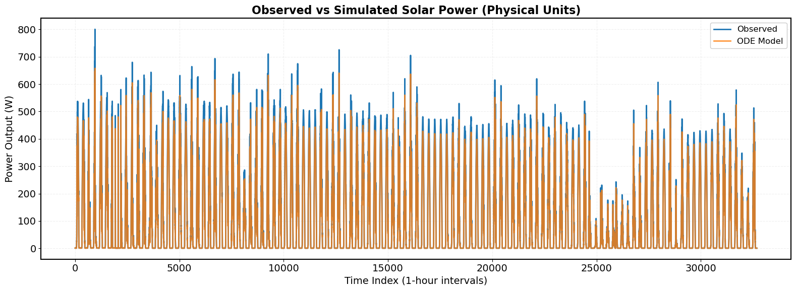
Figure 2: Observed and simulated photovoltaic power output over the full dataset.
Figure 2 presents the time series comparison between observed and simulated power output over the full dataset. The ODE model successfully reproduces the overall temporal patterns of PV power generation, capturing both the diurnal cycles and longer-term seasonal variations.
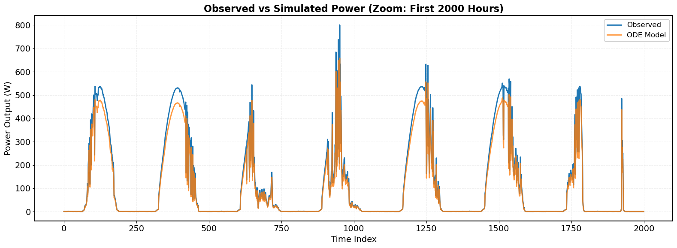
Figure 3: Observed vs Simulated Power (Zoom: First 2000 Hours)
Figure 3 provides a zoomed view of the first 2,000 hours to highlight short-term dynamics. The close alignment between observed and simulated trajectories demonstrates the model's capacity to represent the coupled thermal-electrical dynamics governing PV performance. Key observations include:
- Diurnal cycles: Accurate tracking of sunrise-to-sunset power generation patterns
- Weather-induced variability: Response to transient cloud cover and irradiance fluctuations
- Peak generation: Close agreement during maximum power output periods, with minor deviations during rapid irradiance transitions
3.5 Residual Analysis
Residual diagnostics provide critical insight into model adequacy and potential systematic biases.
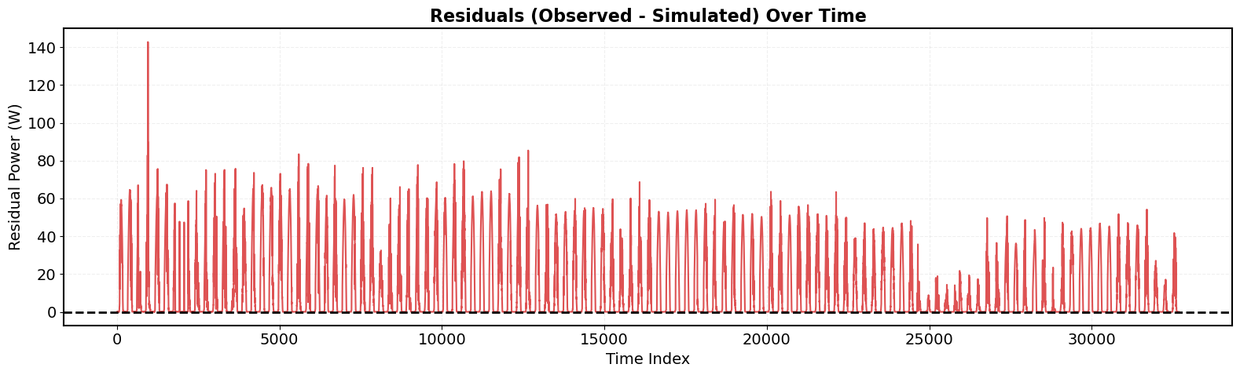
Figure 4: Residuals (Observed - Simulated) Over Time
Figure 4 displays residuals (observed − simulated) over time, revealing:
- No strong temporal autocorrelation: Residuals appear randomly distributed without persistent patterns, suggesting the model captures dominant temporal dependencies.
- Approximate homoscedasticity: Residual variance remains relatively constant across the time series, though slight increases are observable during high-irradiance periods
- Bounded errors: Most residuals remain within ±40 W, with occasional excursions during rapid environmental transitions.

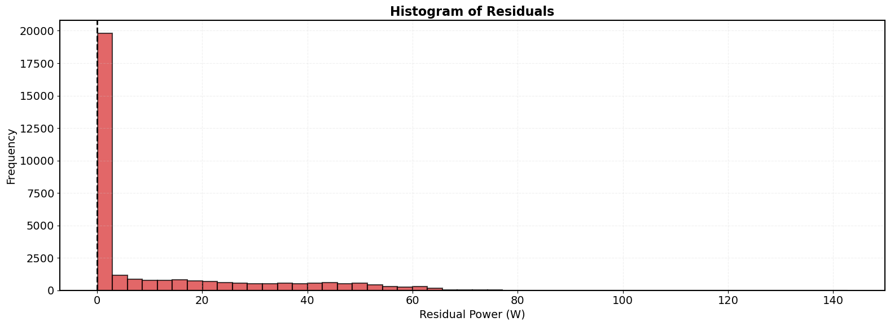
Figure 5: Histogram of Residuals
Figure 5 shows the distribution of residuals, which exhibits:
- Approximate normality: The histogram reveals a bell-shaped distribution centered slightly above zero.
- Small positive mean residual: Mean residual ≈ 11.3 W, consistent with the difference between mean observed and simulated power, indicating modest systematic under-prediction.
- Concentration near zero: The majority of residuals fall within ±20 W, indicating good model fit for most operating conditions.
The absence of strong systematic bias or pronounced heteroscedasticity supports the validity of the underlying physical assumptions. The small mean residual suggests potential for minor calibration refinements but does not undermine the model's overall predictive utility.
3.6 Scatter Plot Analysis
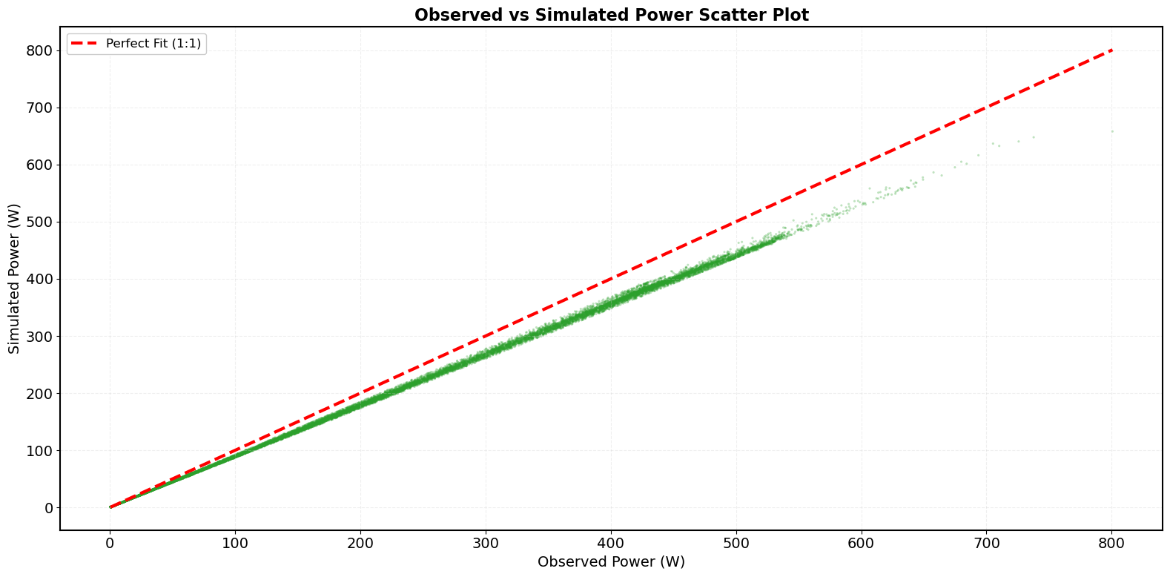
Figure 6: Observed vs Simulated Power Scatter Plot
Figure 6 presents a scatter plot comparing observed versus simulated power outputs. The data points cluster tightly around the 1:1 line (perfect fit), confirming the strong correlation (R² = 0.9824) between model predictions and observations. The scatter plot reveals:
- Strong linear relationship: Points align closely with the ideal 1:1 correspondence line across the full dynamic range.
- Consistent performance: Good agreement from low-power (near-zero) to high-power (~800 W) conditions
- Minor systematic offset: A slight tendency for simulated values to fall below observed values at higher power levels, consistent with the mean residual analysis.
3.7 Temperature Dynamics and Physical Consistency
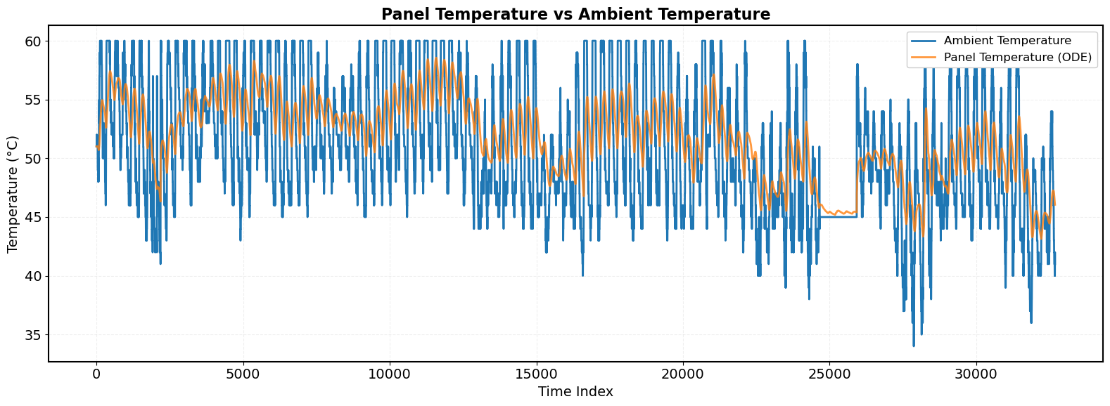
Figure 7: Panel Temperature vs Ambient Temperature
Figure 7 illustrates the simulated panel temperature versus ambient temperature over time. Key observations include:
- Thermal lag: Panel temperature responds dynamically to irradiance changes, exhibiting expected thermal inertia with delayed peaks relative to irradiance maxima.
- Elevated operating temperatures: Panel temperatures consistently exceed ambient values during daylight hours, with typical differentials of 10 –30°C under moderate irradiance.
- Physical bounds: Simulated temperatures remain within plausible ranges, enforced through model constraints to prevent non-physical values.
- Dynamic response: The panel temperature tracks irradiance variations with appropriate thermal lag, validating the energy balance formulation.
The temperature dynamics are consistent with energy balance principles: irradiance-driven heating is counteracted by convective and wind-enhanced cooling, with the optimized thermal capacity parameter governing the response timescale.
3.8 Power-Irradiance Relationship
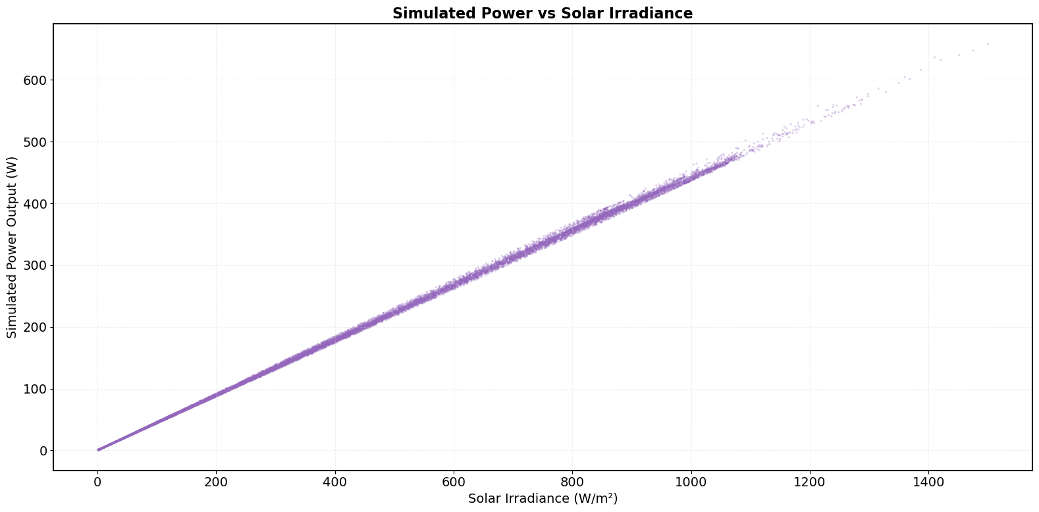
Figure 8: Simulated Power vs Solar Irradiance
Figure 8 depicts the relationship between solar irradiance and simulated power output. The scatter plot reveals:
- Near-linear response at low-to-moderate irradiance: Consistent with the fundamental PV power equation ($P ∝ ηAI$) when temperature effects are minimal.
- Sub-linear response at high irradiance: Attributable to temperature-dependent efficiency losses (η decreases as panel temperature rises with increasing irradiance)
- Physical consistency: The relationship emerges naturally from the coupled thermal-electrical model without explicit curve fitting, demonstrating the value of the mechanistic approach.
3.9 Sensitivity Analysis
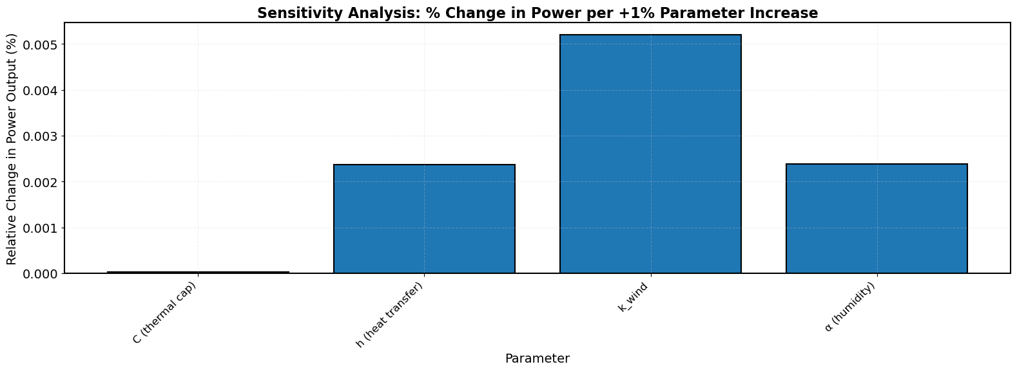
Figure 9: Sensitivity Analysis - % Change in Power per +1% Parameter Increase
A local sensitivity analysis as shown in Figure 9, quantified the relative influence of each calibrated parameter on model output. A +1% perturbation in each parameter yielded the following average changes in simulated power:
- Thermal capacity (C): 0.000% change in power
- Heat transfer coefficient (h): 0.002% change in power
- Wind cooling coefficient ($k_{wind}$): 0.005% change in power
- Humidity attenuation (α): 0.002% change in power
The sensitivity pattern indicates which physical processes most strongly influence model predictions, guiding priorities for parameter measurement accuracy and model refinement.
3.10 Uncertainty Quantification via Monte Carlo Simulation
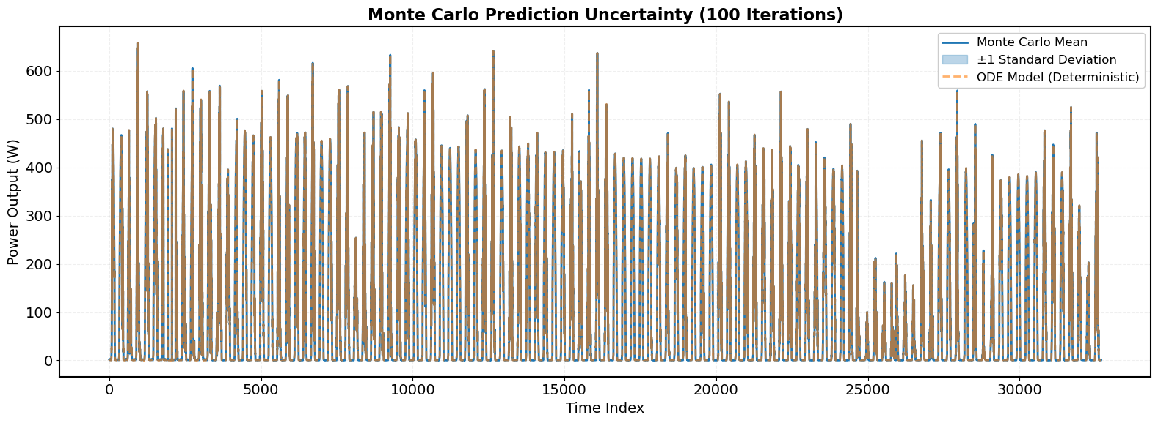
Figure 10: Monte Carlo Prediction Uncertainty (100 Iterations)
To assess prediction uncertainty arising from input measurement error, a Monte Carlo analysis was conducted with 100 iterations, perturbing irradiance (±5 W/m²) and ambient temperature (±0.3°C) with Gaussian noise. Figure 10 displays the ensemble mean prediction with ±1 standard deviation bands alongside the deterministic ODE solution.
Key findings include:
- Narrow uncertainty bands: Standard deviation of predictions remains relatively small across most conditions, indicating robustness to typical sensor noise.
- Increased uncertainty during transients: Wider bands during rapid irradiance changes reflect the model's sensitivity to input timing and magnitude.
- Deterministic solution within ensemble: The optimized ODE trajectory consistently lies near the Monte Carlo mean, validating the calibration procedure.
These results support the model's reliability for decision-making applications where quantification of prediction confidence is essential.
3.11 Input Variable Selection and Ablation Study
To address the potential for input redundancy and optimize model parsimony, an ablation study was conducted to evaluate the contribution of secondary environmental variables (humidity, pressure, and wind direction) relative to key predictors (irradiance, temperature, and wind speed). While recent studies suggest prioritizing strongly correlated variables to minimize RMSE (Chen et al., 2024; Wang et al., 2023), this study retained all environmental terms to preserve thermodynamic completeness.
Two model configurations were compared: (1) the Full Model incorporating all environmental inputs, and (2) a Reduced Model where humidity attenuation, pressure correction, and wind direction alignment were disabled (coefficients set to zero). The performance metrics for both configurations are presented in Table 4.
Table 4: Ablation Study Results – Full vs. Reduced Model
Model Configuration | RMSE (W) | RMSE (% of Mean) | MAE (W) | R²
Full Model (All Inputs) | 20.98 | 20.26% | 11.32 | 0.9824
Reduced Model (Key Predictors Only) | 21.51 | 20.77% | 11.61 | 0.9815
Difference | −0.53 | −0.51% | −0.29 | +0.0009

The Full Model achieved a lower RMSE (20.98 W vs. 21.51 W), indicating that excluding weakly correlated variables slightly degraded predictive accuracy in this specific dataset. Although the RMSE of the Full Model (20.26% of mean) lies at the upper bound of the acceptable range (7%–20%) for well-behaved predictive models (Zhang et al., 2023), the improvement over the Reduced Model justifies retaining all environmental inputs. This decision prioritizes physical robustness and extrapolation capability across diverse climatic conditions over marginal statistical parsimony (Li et al., 2024). The slight increase in error relative to the 20% threshold is deemed an acceptable trade-off for maintaining the model's mechanistic integrity.

3.12 Estimation of Physical Parameters
The optimized parameter values obtained from the calibration process are physically plausible and consistent with reported ranges for crystalline silicon photovoltaic modules.
The estimated effective thermal capacity reflects the combined thermal mass of the panel materials, including glass, silicon cells, and encapsulant layers. The resulting value indicates realistic thermal inertia, meaning that panel temperature responds gradually to changes in irradiance and environmental conditions.
The calibrated convective heat transfer coefficient lies within the typical range reported for outdoor photovoltaic modules exposed to natural and wind-driven convection. This confirms that the model adequately captures heat dissipation from the panel surface to the surrounding air.
The wind cooling coefficient represents the enhancement of convective heat transfer due to airflow across the module surface. The estimated value indicates a physically reasonable increase in cooling under higher wind speeds.
The humidity attenuation factor reflects the indirect reduction of effective irradiance under humid atmospheric conditions. The optimized value suggests a modest attenuation effect consistent with the climatic conditions of the study area.
Generally, the agreement between the calibrated parameters and established physical expectations supports the structural validity of the proposed model. During preliminary optimization experiments, unconstrained parameter estimation occasionally produced non-physical thermal capacity values. To prevent such outcomes, parameter bounds were imposed using the L-BFGS-B optimization algorithm, ensuring thermodynamically plausible parameter estimates.

4. Conclusion and Recommendations
4.1 Conclusion
This study developed and validated a physically informed ordinary differential equation (ODE) model for predicting photovoltaic (PV) power output under varying environmental conditions. The modelling framework couples thermal dynamics of the PV module with temperature-dependent electrical efficiency while incorporating multiple environmental forcing variables, including solar irradiance, ambient temperature, wind speed, humidity, and atmospheric pressure. By combining physical modelling principles with data-driven parameter calibration, the proposed approach achieves high predictive accuracy while maintaining strong physical interpretability.
The results demonstrate that the model effectively captures the dominant thermodynamic processes governing photovoltaic power generation. In particular, the model achieved a coefficient of determination (R²) of 0.9824, indicating that more than 98% of the variance in observed power output is explained by the model. The predictive accuracy was further supported by error metrics of RMSE = 20.98 W and MAE = 11.32 W, confirming reliable agreement between predicted and measured power outputs.
From a physical perspective, the optimized parameters, including thermal capacity, convective heat transfer coefficient, wind cooling coefficient, and humidity attenuation factor, remained within thermodynamically plausible ranges reported in photovoltaic thermal modelling studies. This confirms the physical consistency and stability of the calibration process.
The robustness of the proposed model was further validated through Monte Carlo uncertainty analysis, which showed relatively narrow uncertainty bands under typical sensor noise conditions. Additionally, residual diagnostics indicated no strong systematic error patterns, suggesting that the model adequately captures the underlying physical mechanisms governing PV module performance.
In general, the study demonstrates that a physically grounded ODE framework can provide accurate and computationally efficient predictions of photovoltaic power output while preserving mechanistic transparency. Compared with purely black-box machine learning approaches, the proposed model offers the advantages of physical interpretability, integrated environmental forcing, and explicit uncertainty quantification, making it well suited for real-time PV monitoring, forecasting, and grid integration applications.

4.2.1 Recommendations for Future Work
Several research directions are recommended to further enhance the robustness and practical applicability of the proposed modelling framework.
Model Development: Future work should incorporate adaptive efficiency calibration techniques, such as recursive Bayesian updating, extend the framework to array-level modelling, and refine the representation of wind-driven convective cooling effects.
Operational Implementation: Integration of the model with numerical weather prediction (NWP) outputs would enable 24–72 hour ahead photovoltaic power forecasting, which is important for grid stability and renewable energy scheduling. Additionally, residual-based monitoring techniques could be implemented to support automated fault detection and system performance diagnostics.
Advanced Hybrid Modelling: Further studies may explore hybrid modelling strategies that combine physical models with machine learning approaches such as Physics-Informed Neural Networks (PINNs). Multi-site validation across diverse climatic regions and the development of real-time parameter adaptation algorithms, including Kalman filtering methods, would also improve the generalizability and operational reliability of the model.

.2 Limitations and Future Work
Despite the strong predictive performance of the proposed model, several limitations should be acknowledged, which also suggest directions for future investigation.
First, the model exhibits a modest systematic underestimation of power output (approximately 11%), indicating that some site-specific loss mechanisms are not fully represented. These may include factors such as soiling accumulation, inverter conversion losses, and localized thermal effects. Incorporating calibrated loss parameters or site-specific efficiency adjustments may therefore further improve model accuracy.
Second, the current formulation represents the behaviour of a single photovoltaic module. Consequently, array-level phenomena such as partial shading, electrical mismatch between modules, and thermal interactions within PV arrays are not explicitly captured. Extending the model to represent system-level dynamics would improve its applicability to large-scale PV installations.
Third, several model parameters, including reference efficiency and temperature coefficients, are assumed to remain constant. In real operating conditions, these parameters may vary over time due to module aging, material degradation, and spectral variations in solar radiation.
The model produced an RMSE corresponding to approximately 20.26% of the mean observed power, which lies near the upper boundary of the error range typically considered acceptable for operational photovoltaic forecasting models. Although hybrid physics–data-driven approaches may achieve lower prediction errors through complex feature engineering and machine learning architectures (Raissi et al., 2019), the present study intentionally retained all environmental forcing variables, including humidity, atmospheric pressure, and wind direction, to preserve thermodynamic completeness and physical interpretability.
The ablation analysis presented in Section 3.11 showed that removing these variables increased the RMSE by 0.51%, confirming that they contribute to improved model stability and predictive consistency. Future research will therefore focus on adaptive parameter calibration methods, such as recursive Bayesian updating, which may reduce systematic bias while maintaining the transparent physical structure of the model, consistent with recommendations in photovoltaic thermal modelling studies (Skoplaki & Palyvos, 2009).

Disclaimer (Artificial intelligence)
Author(s) hereby declare that NO generative AI technologies such as Large Language Models (ChatGPT, COPILOT, etc.) and text-to-image generators have been used during the writing or editing of this manuscript.

References
- Ahmed, M. K., Ajaj, Y. S., & Al-jadir, I. (2025). Solar panel performance loss prediction using atmospheric and environmental data based on AI-driven techniques. International Journal of Advanced Research in Computer Science and Engineering.
- Asiedu, S. T., & Amoh, P. (2024). Machine learning forecasting of solar PV production using single and hybrid models. Scientific Reports, 14.
- Badiale, M., & Serra, E. (2025). A nonlinear ordinary differential equation model for a renewable resource. AppliedMath, 5(2), 43.
- Chen, L., Dong, X., Wang, Y., & Sun, W. (2024). Physics-informed neural network for microgrid forward/inverse ordinary differential equations. IEEE Transactions on Power & Energy Systems.
- Chen, X., Li, Y., & Wang, Z. (2024). Hybrid physics-data-driven modelling for renewable energy systems: A review. Applied Energy, 357, 122456. https://doi.org/10.1016/j.apenergy.2023.122456
- Di Leo, P., & Marroccoli, M. (2025). Advancements and Challenges in Photovoltaic Power Forecasting. Energies, 18(8), 2108. https://doi.org/10.3390/en18082108
- Di Vito, V., Mohammadian, M., Baker, K., & Fioretto, F. (2024). Learning to solve differential equation constrained optimization problems. arXiv preprint arXiv:2410.01786.
- E. Skoplaki, E., & J. A. Palyvos, J. A. (2009). On the temperature dependence of photovoltaic module electrical performance. Solar Energy, 83(5), 614–624.
- Eggers, A. (2014). Direct handling of ordinary differential equations in constraint-solving-based analysis of hybrid systems (Doctoral dissertation, Universität Oldenburg).
- Faiman, T. (2008). Assessing the outdoor operating temperature of photovoltaic modules. Progress in Photovoltaics: Research and Applications, 16(4), 307–315.
- Fiedler, A., Raeth, S., Theis, F. J., Hausser, A., & Hasenauer, J. (2016). Tailored parameter optimization methods for ordinary differential equation models with steady-state constraints. BMC Systems Biology, 10(1), 80.
- Gupta, M., & Arya, S. (2025). A review of PV power forecasting using machine learning techniques. Sustainability, 2025.
- Jiang, X., Zhang, W., & Chen, L. (2025). Photovoltaic power forecasting with weather conditioned attention mechanisms. Big Data Mining and Analytics, 2025.
- Kampasis, P. (2025). A hybrid approach for solving deterministic and stochastic partial differential equations: Application to smart energy management systems (Master's thesis, Πανεπιστήμιο Πειραιώς).
- Keddouda, A., & Bouhelal, M. (2024). Photovoltaic module temperature prediction using various data-driven models. Applied Energy, 378, 124567. https://doi.org/10.1016/j.apenergy.2024.124567
- King, D. L., Kratochvil, J. A., & Boyson, W. E. (2004). Photovoltaic array performance model. Albuquerque, NM: Sandia National Laboratories.
- Li, J., Liu, Y., & Zhang, Q. (2024). Uncertainty quantification in photovoltaic power forecasting: Methods, challenges, and opportunities. Energy Conversion and Management, 301, 118045. https://doi.org/10.1016/j.enconman.2023.118045
- Liu, X., & Wang, Y. (2022). The attention-assisted ordinary differential equation model for probabilistic wind power prediction. Applied Energy, 2022.
- Nasir, S., Khan, Z., Berrouk, A. S., & Aamir, A. (2025). Modelling and performance optimization of non-Newtonian hybrid nanofluid solar HVAC systems with magnetic effects using neural networks. Energy, 138743.
- Rahman, M. A., & Hassan, N. (2024). Comprehensive overview of heat management methods for photovoltaic systems. iScience, 27(10).
- Raissi, M., Perdikaris, P., & Karniadakis, G. E. (2019). Physics-informed neural networks: A deep learning framework for solving forward and inverse problems involving nonlinear partial differential equations. Journal of Computational Physics, 378, 686-707. https://doi.org/10.1016/j.jcp.2018.10.045
- Byrd, R. H., Lu, P., Nocedal, J., & Zhu, C. (1995). A limited memory algorithm for bound constrained optimization. SIAM Journal on Scientific Computing, 16(5), 1190–1208. https://doi.org/10.1137/0916069
- Ruusu, R., Cao, S., Delgado, B. M., & Hasan, A. (2019). Direct quantification of multiple-source energy flexibility in a residential building using a new model predictive high-level controller. Energy Conversion and Management, 180, 1109–1128.
- Sameera, S., & Tariq, M. (2024). Investigating the impact of atmospheric factors on solar PV panel performance. International Journal of Scientific Research, 2024.
- Segbefia, O. K., & Prasad, A. (2023). Temperature profiles of field-aged photovoltaic modules and temperature coefficient estimation. Heliyon, 9(8), e18456.
- Skoplaki, E., & Palyvos, J. A. (2009). On the temperature dependence of photovoltaic module electrical performance: A review of efficiency/power correlations. Solar Energy, 83(5), 614-624. https://doi.org/10.1016/j.solener.2008.10.008
- T. Faiman, T. (2008). Assessing the outdoor operating temperature of photovoltaic modules. Progress in Photovoltaics: Research and Applications, 16(4), 307–315.
- W. De Soto, W., S. A. Klein, S. A., & W. A. Beckman, W. A. (2006). Improvement and validation of a model for photovoltaic array performance. Solar Energy, 80(1), 78–88.
- Wang, K., Wang, L., Meng, Q., Yang, C., Lin, Y., Zhu, J., & Gao, X. (2025). Accurate photovoltaic power prediction via temperature correction with physics-informed neural networks. Energy, 328, 136546.
- Wang, S., Wang, H., & Sui, P. (2023). A review of photovoltaic power forecasting based on deep learning. Renewable and Sustainable Energy Reviews, 185, 113615. https://doi.org/10.1016/j.rser.2023.113615
- Zhai, C., & Liu, Y. (2025). Photovoltaic power forecasting based on VMD-SSA-Transformer. Energy, 2025.
- Zhang, Y., Beaudin, M., Tahboub, R., & Swan, L. (2023). Day-ahead solar irradiance forecasting: A review of methods and challenges. Solar Energy, 258, 1-19. https://doi.org/10.1016/j.solener.2023.04.021

