Entropy Dynamics in Financial Systems: A Thermofluid Framework for Risk, Uncertainty, and Market Inefficiency

Abstract
This investigation presents a brand-new thermodynamic approach to financial system analysis based on entropy generation concepts from fluid mechanics and heat transfer theory. The concept of financial entropy is utilized to quantify uncertainty in financial markets, and a governing equation is derived to govern financial entropy evolution in terms of both time and space, taking into account factors such as volatility, friction, and asymmetric information. Dimensionless variables are incorporated into the governing equation to generalize financial entropy evolution in different financial environments. Numerical calculations demonstrate that increasing factors such as volatility, transaction costs, and asymmetric information cause a substantial increase in financial entropy, indicating a more unstable financial environment. On the other hand, increased information diffusion in financial markets is shown to enhance financial stability. A financial Reynolds number is introduced to determine when financial markets become unstable and crisis-prone. It is shown that financial entropy-based modeling can provide a unified approach to understanding financial instability and can be useful in designing financial regulations.
Keywords: Financial systems; Market inefficiency; Entropy analysis; Thermodynamic approach

1.0 Introduction
The rising complexity and interconnectedness in financial markets have made it increasingly difficult to analyze market behaviour, risk, and market instability. Traditional financial models, such as stochastic models and econometric models like the Black-Scholes equation and ARCH/GARCH models for volatility measurement, are most commonly used in financial market analysis. However, these models are unable to capture nonlinearities and transitions in market behaviour and uncertainty, which are common during financial crises (Black and Scholes, 1973; Bollerslev, 1986; Engle, 1982; Kukreti et al, 2020). This has created interest in using techniques from physics and information theory. Recent studies have further shown that financial markets exhibit nonlinear dynamics, phase transitions, and entropy-driven complexity that conventional models fail to adequately describe (Zhang et al., 2023; Papla & Siedlecki, 2024; Georgescu, 2025). This limitation has led to increasing interest in the application of techniques from physics, particularly econophysics and information theory, which provide more robust tools for capturing market complexity, systemic risk, and emergent behaviour (Jovanovic, 2013)
Entropy, as a fundamental concept of thermodynamics and statistical mechanics, has appeared as a prominent tool of uncertainty and disarray. Entropy, as introduced by Shannon (1948), has been used as a prominent tool of uncertainty assessment, inefficiency, and diversification of financial markets. Recent research has demonstrated the effectiveness of the entropy-based approach as a prominent tool of market assessment. Wang (2022) showed that the use of entropy-based indicators can identify stronger connectivity in more efficient markets. Kukreti et al. (2020) remarked that entropy can improve correlation-based financial network analysis, and identifying complexity, non-linear dependencies, and systemic risks. Moreover, Shternshis et al. (2022) applied Shannon entropy to high-frequency financial data and reiterated that higher entropy is related to higher efficiency and randomness in markets. The above research shows the efficiency of the use of entropy in financial analysis; however, it is mainly considered as a statistical measure and not as a variable of dynamic transport. To exemplify, the effectiveness of the differential entropy approach has been demonstrated as a prominent tool of regime shifts and structural shifts in financial markets, despite the stability of volatility (Raul et al., 2026). Entropy-based approaches of randomness have also been used as a prominent tool of the assessment of ultra-high-frequency financial data, unveiling the underlying structures of financial markets (Sandoval, 2014; Shternshis & Marmi, 2025; Olbryś, 2025).
From this thermodynamic view, entropy is seen as a dynamic quantity and is subject to entropy generation and transport. In fluid flow and heat transfer systems, entropy is said to be generated because of irreversibility in the system, such as viscous dissipation and thermal gradients (Bejan, 1996). Various researchers have investigated entropy generation in fluid flow and heat transfer due to its diverse applications. For instance, Fatunmbi (2019) studied the problem of entropy generation in hydromagnetic micropolar fluid flow over an inclined permeable stretching surface with variable viscosity. Ullah et al. (2021) studied the problem of entropy generation and heat transfer in the flow of a non-Newtonian fluid, namely power-law fluid. The problem was solved numerically using the finite difference method. The study showed how the non-Newtonian characteristics of the fluid affect the entropy generation. Fatunmbi and Salawu (2022) studied the problem of entropy generation in hydromagnetic micropolar nanofluid flow over a nonlinear stretching sheet with Navier slip. From the above problems and their solutions, it is clear that the concept of entropy generation is important in characterizing the irreversibility of fluid flow systems. The concept of entropy is strong enough to be extended to financial systems. This view gives us a powerful analogy in financial markets, where uncertainty is constantly generated and propagated through market activities. Recent thermodynamic models of financial markets have been developed by incorporating market temperature and entropy in relation to order book behaviour, where entropy is said to be related to liquidity and activity in financial markets (Li et al., 2023).
In addition, there is a strong similarity between financial markets and transport phenomena in fluids. The flow of capital between assets and markets can be seen as analogous to the flow of fluids, and the spread of information can be seen as analogous to the flow of heat. Empirical evidence also shows that there is a strong similarity between the spread of information and the process of financial price formation, which follows a diffusion process. These facts were shown in the works of Cont (2001) and Farmer, Lillo, & Mike, 2005; Olbryś, 2022;). However, there have been some new contributions to this subject, and entropy was used in financial time series forecasting and pattern recognition. The results show that there is an improvement in the prediction and information extraction capabilities of the system. Similarly, entropy and complexity were used to show the emergence of warning signals for financial crashes and changes, especially in cryptocurrency markets.
Nevertheless, the majority of the research in this area considers entropy as a statistical measure rather than a dynamic field governed by transport and generation equations. The study of the interrelation between entropy generation and diffusion processes, similar to those in fluid dynamics and heat transfer, is still in the infancy stage. Recent advances in stochastic thermodynamics and econophysics have indicated that the financial market is a non-equilibrium thermodynamic process in which trading activities are the sources of entropy generation and constraints, similar to the laws in physics. However, the unified equation that governs the spatiotemporal evolution of financial entropy is still unknown.
From the perspective of practical application, the implications of the entropy-based financial modeling approach are far-reaching, particularly with respect to risk management, optimization, and policy formulation. Recent studies have demonstrated the potential of the entropy-based approach as a tool for the detection of structural risks, the identification of hidden dependencies, and the generation of early warning signals of potential instabilities. In particular, the development of the entropy-based network models has shown the potential of the approach as a tool for the anticipation of regime shifts in the financial system. These developments underscore the potential of the entropy-based approach as a fundamental approach to the modeling of financial systems.
In light of these considerations, the present study aims to develop a thermodynamic approach to the modeling of financial systems, based on the principles of entropy generation and transport, as derived from the theory of fluid flow and heat transfer. A governing equation of the spatiotemporal evolution of financial entropy is proposed, with volatility, friction, and information asymmetry as the primary sources of entropy generation. In addition, dimensionless parameters, analogous to the classical transport numbers, are introduced as a means of generalization of the approach. This work makes a notable contribution to scientific knowledge by creating a unified entropy transport model that connects thermodynamic irreversibility in fluids to financial markets behaviour. The treatment of financial entropy as a variable field means this paper provides a way to physically interpret uncertainty in markets as well as new tools for examining financial stability, inefficiency, and crisis development.
2.0 Mathematical Formulation and Model Assumptions
In order to develop a thermodynamic theory for financial systems, the following assumptions are made:
- The financial market is modelled as a continuous medium with numerous interacting agents.
- The evolution of market uncertainty is based on entropy laws, similar to thermodynamic systems of fluid flow and heat transfer.
- The spreading of information in the market is analogous to heat transfer in fluid flow.
- Market inefficiencies, such as volatility, transaction costs, and information asymmetry, are modelled as entropy generation in the system.
- The system is unsteady, with possible spatial variations to represent various interconnected markets or sectors.
The fluid-Finance Analogy is presented in Table 1.

Table 1: Fluid & Finance Analogy
Fluid Mechanics | Financial Interpretation
Entropy generation | Market inefficiency
Viscous dissipation | Transaction costs
Thermal irreversibility | Information loss / asymmetry
Flow instability | Market volatility
2.2 Definition of Financial Entropy
The uncertainty associated with financial returns is quantified using an entropy measure derived from information theory. The financial entropy is defined as
$$\begin{aligned}S(t)=-\sum_{i=1}^{N}{ } p_{i}(t)ln⁡p_{i}(t),\#(1)\end{aligned}$$
where $p_{i}(t)$ denotes the probability of the $i$-th return state at time $t$, and $N$ is the total number of possible market states. This definition provides a statistical measure of disorder or uncertainty within the financial system.
2.3 Entropy Balance Equation
In analogy with entropy transport in fluid flow and heat transfer, the governing equation for entropy evolution in a financial system is given by
$$\begin{aligned}\frac{∂S}{∂t}=β∇^{2}S+{\overset{˙}{S}}_{gen}+Φ(t)-P(t),\#(1)\end{aligned}$$
where $β$ denotes the financial diffusivity coefficient, $Φ(t)$ represents information inflow, and $P(t)$ represents dissipation or stabilization effects. The entropy generation term is defined as
$$\begin{aligned}{\overset{˙}{S}}_{gen}=ασ^{2}+ζμ_{f}+γH_{a},\#(2)\end{aligned}$$
where $σ^{2}$ represents market volatility, $μ_{f}$ denotes market friction, and $H_{a}$ represents information asymmetry. The coefficients $α$, $ζ$, and $γ$ quantify their respective contributions.
To non-dimensionalized the governing equation, the following dimensionless variables are introduced:
$$\begin{aligned}S^{*}=\frac{S}{S_{0}}, t^{*}=\frac{t}{t_{0}}, x^{*}=\frac{x}{L}.\#(3)\end{aligned}$$
The substitution of of (3) into (1), and taking cognizance of (2) results to
$$\begin{aligned}\frac{∂S^{*}}{∂t^{*}}=K_{0}∇^{2}S^{*}+V_{c}+f_{c}+Bs_{f}+Φ^{*}(t^{*})-P^{*}(t^{*}),\#(4)\end{aligned}$$
where
$$\begin{aligned}K_{0}=\frac{βt_{0}}{L^{2}}, V_{c}=\frac{ασ^{2}t_{0}}{S_{0}}, f_{c}=\frac{ζμ_{f}t_{0}}{S_{0}}, Bs_{f}=\frac{γH_{a}t_{0}}{S_{0}}.\#(5)\end{aligned}$$
Here, $K_{0}$ is the financial diffusion number, while $V_{c}$, $f_{c}$, and $Bs_{f}$ represent the dimensionless contributions of volatility, friction, and asymmetry, respectively.
The initial and boundary conditions for the governing equation are respectively given in equations (6) and (7).
$$\begin{aligned}S(x,0)=S_{0}(x),\#(6)\end{aligned}$$
$$\begin{aligned}S(0,t)=S_{1}, S(L,t)=S_{2},\#(7)\end{aligned}$$
The financial stability parameter is the Reynolds-type number which is defined as
$$\begin{aligned}Re_{f}=\frac{σL}{μ_{f}},\#(9)\end{aligned}$$
where low values indicate stable market conditions and high values indicate instability.
3.0 Numerical Scheme
An explicit finite difference method is employed. The spatial domain $[0,L]$ is discretized into $N_{y}$ points with $Δx=L/(N_{y}-1)$, and time is discretized with step $Δt$.
The spatial derivative is approximated by
$$\begin{aligned}\frac{∂^{2}S}{∂x^{2}}≈\frac{S_{i+1}^{n}-2S_{i}^{n}+S_{i-1}^{n}}{(Δx)^{2}},\#(10)\end{aligned}$$
and the time derivative by
$$\begin{aligned}\frac{∂S}{∂t}≈\frac{S_{i}^{n+1}-S_{i}^{n}}{Δt}.\#(11)\end{aligned}$$
Substituting gives the explicit scheme:
$$\begin{aligned}S_{i}^{n+1}=S_{i}^{n}+Δt\left[β\frac{S_{i+1}^{n}-2S_{i}^{n}+S_{i-1}^{n}}{(Δx)^{2}}+σ+ϕ+Φ(t^{n})-P(t^{n})\right].\#(12)\end{aligned}$$
Here, the friction term is approximated as
$$ϕ=ζμ_{f},$$
and the entropy generation is simplified as a linear combination of volatility and friction effects.
For stability,
$$\begin{aligned}Δt≤\frac{(Δx)^{2}}{2β}.\#(13)\end{aligned}$$
Thus, the initial and boundary conditions respectively transform to (14) and (15).
$$\begin{aligned}S_{i}^{0}=S(x_{i},0),\#(14)\end{aligned}$$
Boundary conditions:
$$\begin{aligned}S_{1}^{n}=S_{1}, S_{N_{y}}^{n}=S_{2}.\#(15)\end{aligned}$$
The computational procedure for this study is:
- Initialize spatial grid and time step.
- Impose initial and boundary conditions.
- Update solution using the explicit scheme.
- Repeat until final time is reached.
- The governing equations were solved numerically using Python.
The computational parameters are selected to ensure stability and physical relevance. The diffusion coefficient $β$, volatility parameter $σ$, and friction parameter $ϕ$ are chosen as small positive constants. The time step satisfies the stability condition. The source $Φ(t)$ and sink $P(t)$ represent external shocks and stabilization effects, respectively.
3.1 Model Interpretation
The model establishes an analogy between thermodynamic entropy and financial markets. Diffusion represents information spread, while entropy generation captures inefficiencies due to volatility and friction. The numerical simulations are based on the dimensional form, while dimensionless parameters are related through scaling transformations as described in equation (5). The source term $Φ\left(t\right)$ and sink term $P\left(t\right)$ are included for modeling the inflow of external information and the stabilization mechanisms, respectively. For this particular study, the functions are defined and fixed, and no parameter variation is applied. This is done in order to focus the analysis on the main effects of the diffusion, volatility, and friction on the entropy evolution
4.0. Results and Discussion
To further understand the interplay between the governing parameters, some graphs have been sketched under this section.
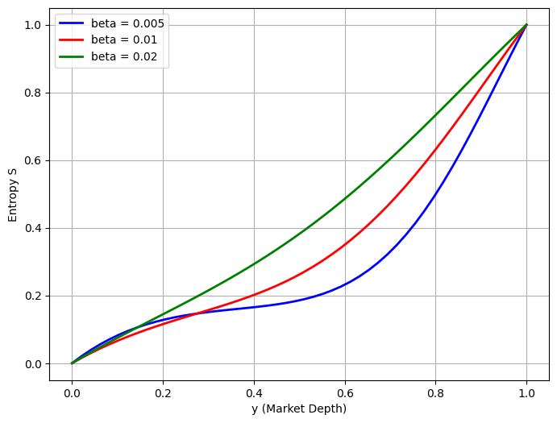

Figure 1: Effects of Diffusion term $(β)$ on Financial Entropy $(S)$

The plot of the entropy generation versus market depth $(y)$ for various values of the diffusion parameter $β$ is shown in Figure 1. It is noticed that an increase in $β$ causes a substantial increase in the entropy profile within the domain. This implies that an increase in financial diffusivity increases the spread of information, thereby creating uncertainty within the market. It is also noticed that higher values of $β$ make the gradients of entropy smooth, indicating that uncertainty is uniformly spread within the market. It is evident that for higher values of $β$ the level of entropy is considerably higher compared to lower values of $β$. This shows that diffusion is a source parameter in the entropy balance equation, which increases the rate of generation of entropy within the system. At the boundary points, ($y=0, y=1)$, all curves converge again. This is due to zero entropy, which is a state of minimal activity, and maximum entropy, which is a state of a developed market. This implies that the effect of $β$is minimal at the boundary points, but within the domain, the effect is strong.
Besides this, as the values of $β$ decrease, it is seen that the entropy curve experiences a slow rise at first and then a steep rise at higher values of $y$. This implies a lag before the onset of disorder and then a swift transition to a highly entropic state. On the other hand, as the values of $β$ increase, it is seen that the entropy rises uniformly and at an early stage. This implies a swift onset of complexity and disorder. Thus, $β$ plays a vital role as a controlling agent of the rate of generation of entropy within the system. Though market depth regulates the overall advancement of the system toward equilibrium, it is seen that $β$ regulates the rate and intensity of the onset of uncertainty within the system.

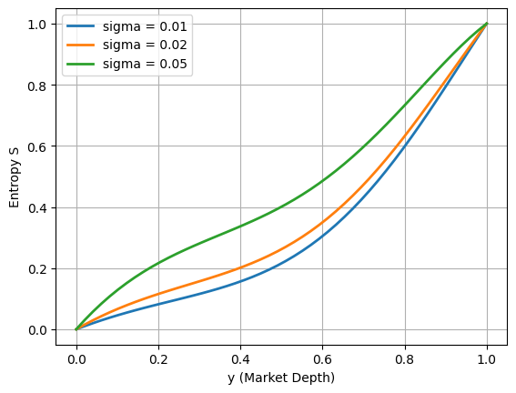
Figure 2: Effects of $\left(σ\right)$ on Financial Entropy $(S)$
In Figure 2, the relationship between the entropy generation $(S)$and market depth $(y)$ is illustrated for various values of volatility term ($σ)$. For different values of $σ$(0.01, 0.02, 0.05), observations from the graph shows that entropy increases with market depth $y$ for all $σ$. The growth is nonlinear, starting slowly at small $y$and accelerating as $y→1$. From this figure, the monotonically increasing pattern of entropy with respect to market depth indicates that information disorder or uncertainty increases with the depth of the market. For smaller values of $(y),$ the entropy is relatively lower; therefore, shallow markets are more certain or less complex. However, with further increases in $(y),$ the rate of entropy generation increases rapidly, signifying the increased interactions among agents, transactions, and price signals.
Furthermore, the effect of $σ$ is found to be significant. Higher values of $σ$ such as $(σ = 0.05),$ show relatively higher entropy levels for most values compared to lower values of $σ$ such as $(σ = 0.01)$ or $(σ = 0.02).$ This implies that volatility is a driving factor for entropy generation, which increases uncertainty and disarray in the market. Physically, this is comparable to a thermal system, where an increase in diffusivity or fluctuation intensity increases entropy generation. It is interesting to see that all curves intersect at the boundary conditions $(y = 0)$ and $(y = 1).$ When $(y = 0),$ the entropy is zero for all $σ$ which implies that the system is in a state of minimal activity or complete order, where no meaningful transactions or interactions exist. At $(y = 1$), the entropy is a normalized maximum ($S = 1),$ which implies that the system is in a state of complete development, where the effect of volatility is not discernible.
Moreover, the gap between the curves is more visible in the intermediate area $(0.2 < y < 0.8),$ which again emphasizes that the effect of volatility is the greatest during the period of transition in the development of the markets. This is particularly important for financial markets because it implies that markets with intermediate depth are more susceptible to instability. Overall, the above analysis shows that both market depth and volatility play a crucial role in the control of entropy development, with the effect of volatility being positive for disorder development and the effect of market depth being responsible for the development towards equilibrium. The above analysis supports the theory behind entropy-based financial modeling.
Figure 3 depicts the variation of entropy generation (S) with the friction parameter $ϕ$. It is noted that an increase in the friction parameter yields a systematic decrease in the entropy values. Moreover, the slopes of the entropy profiles also decrease. This phenomenon can be explained by the fact that an increase in the friction parameter yields a suppression in the entropy generation within the domain. This can be explained by the fact that the friction term in the entropy balance equation is a dissipative term. This term attenuates the growth and propagation of fluctuations within the system. This yields a suppression in the entropy generation.
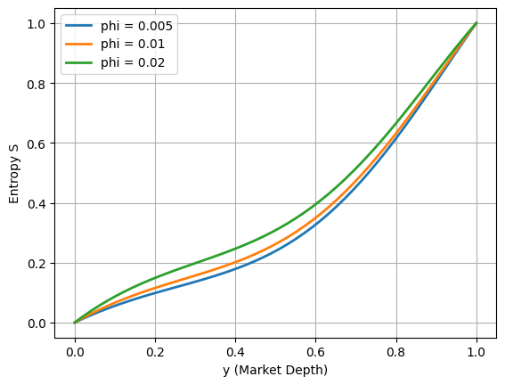
Figure 3: Effects of $\left(ϕ\right)$ on Financial Entropy $(S)$

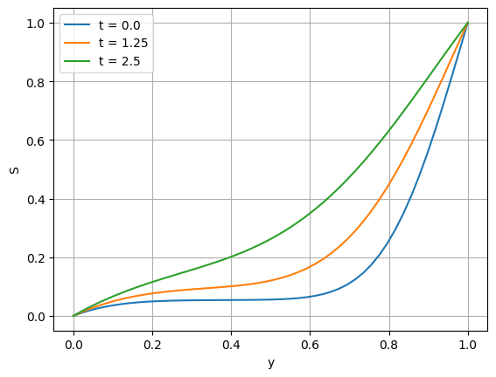
Unlike $β$ and $σ$ that stimulate entropy generation, $ϕ$ has a stabilizing effect on the system. From a financial point of view, this implies that financial frictions may play a crucial role in limiting the rate of change and dampening large fluctuations in the system. This leads to a reduction in uncertainty growth and a stable system development. Thus, the findings verify that $ϕ$ is a key parameter in regulating entropy generation through dissipation.
Figure 4: Effects of $\left(t\right)$ on Financial Entropy $(S)$
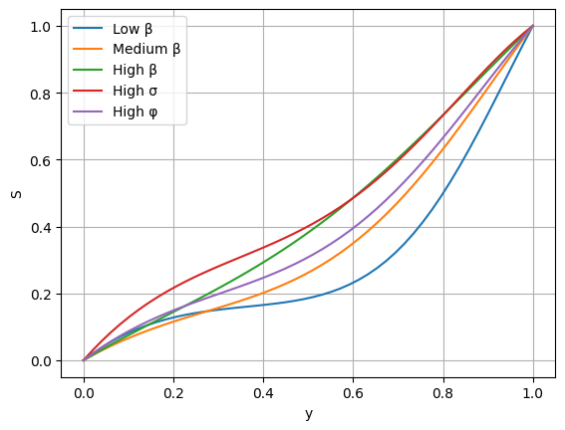
The temporal evolution of entropy is shown in Figure 4. Initially, the entropy is highly concentrated near the boundary. This suggests that at first, the disorder is localized, while the rest of the system is relatively ordered. With time, the entropy enters the interior region, resulting in a gradual increase in the level of disorder. This is a result of the combined effects of diffusion and internal interactions, which allow the entropy to be transferred from the region of high concentration to the rest of the domain. With time, the entropy profile becomes smooth and spatially uniform, indicating a tendency toward a steady or equilibrium state.
Figure 5: Combined parameters effects on Financial Entropy $(S)$

Figure 5 demonstrates the combined effect of $β, σ$, and $ϕ$ on the entropy distribution function $(S(y))$. Unlike other figures, it is clear from Figure 5 how these terms compete and complement each other in their effects on the market depth. From Figure 5, it is clear that the entropy distribution is a result of a dynamic interplay of enhancement and suppression. Although the overall effect of $β$ and $σ$ is to enhance entropy distribution across $(y),$ the inclusion of $(ϕ)$ ensures that this growth is checked or suppressed. This is so that it does not grow indefinitely or is suppressed completely.
Figure 6 displays the three-dimensional surface plot of the entropy distribution, highlighting the relationship between spatial and temporal aspects of the entropy evolution process. At early stages, the entropy is localized near the boundary, suggesting that disorder is initially localized, with the interior of the domain being relatively unaffected. Over time, the entropy increases and spreads into the interior of the domain, creating a smooth and continuous distribution of entropy in the market depth $(y$). The significant gradient observed near the boundary indicates that the effects of the boundary, or external inputs, are the dominant sources of entropy generation. The gradient reduces as the simulation progresses, indicating the effect of the diffusion process on the entropy distribution.
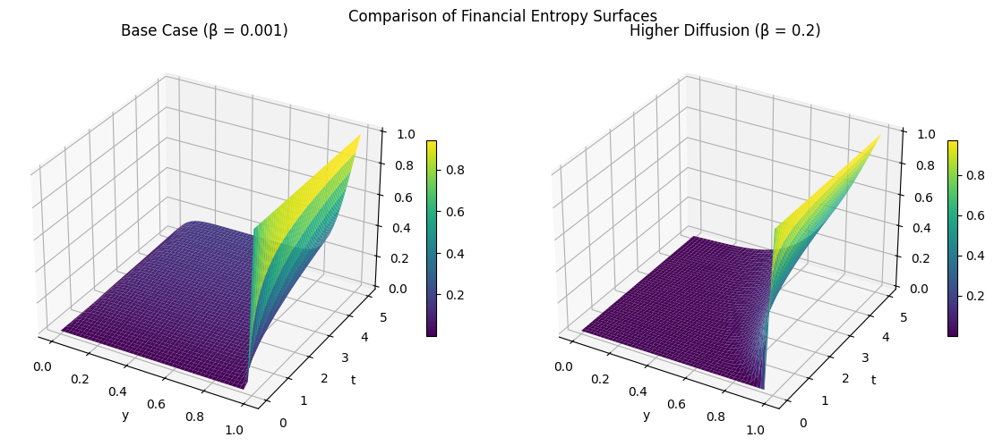
Figure 6: Comparison of financial entropy surfaces for high and low $β$

Discussion of Financial Implications
The results demonstrate that financial entropy is governed by the combined behaviour of the diffusion, generation, and dissipation. The effect of the increase of the diffusion rate is to increase the spatial redistribution of the information, thereby increasing the level of market efficiency through the improvement of the information diffusion process. Conversely, the increase of the volatility rate leads to the enhancement of the entropy generation, resulting in the increase of the level of uncertainty in the system. The friction parameter has the effect of introducing the dissipation mechanism, which limits the fluctuations and the growth of the entropy, thereby stabilizing the overall system. The results obtained have provided the basis for the development of the overall framework for the understanding of the overall behaviour of the financial systems that are subject to the different influences. The results have, therefore, indicated that the overall behaviour of the financial systems is the result of the interplay of the different factors, rather than the effect of the single factors that have been considered in the past.

5.0 Limitations to the Study
Despite the insights provided, the present study has some limitations.
First, a thermodynamic entropy analogy has been applied to develop the model used in this paper; the interpretation of physical quantities such as diffusion and dissipation in a financial context remains conceptual rather than strictly empirical.
Second, the linear combination of volatility and friction in the calculation of the entropy generation term is a very simplistic way of handling numerous potentially important non-linear multi-factor combinations of financial variables are not considered.
Third, the source and sink terms are prescribed functions of time and are not calibrated using real financial data, limiting direct applicability to specific markets.
Fourth, the numerical simulations are carried out using an explicit finite difference scheme on a one-dimensional domain, which may not fully capture multidimensional market structures and network effects.
Finally, the parameter input data was selected to show qualitative behavior rather than being empirically derived, and therefore incapable of making empirical or quantitative estimates.
Future studies could use actual market data while calibrating parameters, employ non-linear entropy generation processes and analytical methodologies, and use multi-dimensional analytic methodologies.

- Conclusion
This study show that financial systems can be analyzed using a thermofluid perspective, with entropy quantifying market disorder and risk. The framework bridges engineering concepts—entropy, diffusion, and dissipation—with economic theory, providing actionable insights into risk management and the trade-offs between market efficiency, volatility, and stability. An entropy-based framework for financial system dynamics is presented by incorporating fundamental mechanisms of diffusion, volatility, and friction. The results show that the evolution of entropy is a coupled process of spatial redistribution, internal generation, and dissipation. This process finally determines the dynamics of market uncertainty.
The results of the parametric study show that the presence of diffusion increases the entropy transport across market depth, whereas volatility increases disorder by incorporating fluctuations. Moreover, friction is shown to be a stabilizing factor by controlling the growth of entropy. The combined effect of these parameters indicates that financial systems maintain a state of delicate balance under competing dynamics. This balance finally governs their stability and predictability.
From an applicative point of view, this model offers a deeper understanding of how regulatory actions (friction), flow of information (diffusion), and market fluctuations (volatility) affect financial system dynamics. This is of potential interest for risk management, regulation of financial markets, and forecasting of financial systems. These activities require controlling uncertainty and maintaining system stability.
Overall, the research demonstrates that entropy modeling provides a scientific method for addressing financial complexity, thus providing a link between thermofluid dynamics and economics. This research contributes to the body of knowledge that is increasingly focusing on interdisciplinarity.

Disclaimer (Artificial intelligence)
Author(s) hereby declare that NO generative AI technologies such as Large Language Models (ChatGPT, COPILOT, etc.) and text-to-image generators have been used during the writing or editing of this manuscript.
References

Bejan, A. (1996). Entropy generation minimization. Boca Raton, FL: CRC Press.
Bera, A. K., & Park, S. Y. (2008). Optimal portfolio diversification using the maximum entropy principle. Econometric Reviews, 27(4–6), 484–512.
Black, F., & Scholes, M. (1973). The pricing of options and corporate liabilities. Journal of Political Economy, 81(3), 637–654.
Black, F., & Scholes, M. (1973). The pricing of options and corporate liabilities. Journal of Political Economy, 81(3), 637–654.
Bollerslev, T. (1986). Generalized autoregressive conditional heteroskedasticity. Journal of Econometrics, 31(3), 307–327.
Bollerslev, T. (1986). Generalized autoregressive conditional heteroskedasticity. Journal of Econometrics, 31(3), 307–327.
Cont, R. (2001). Empirical properties of asset returns: Stylized facts and statistical issues. Quantitative Finance, 1(2), 223–236.
Engle, R. F. (1982). Autoregressive conditional heteroskedasticity with estimates of the variance of United Kingdom inflation. Econometrica, 50(4), 987–1007.
Fatunmbi, E. O. (2019). Analysis of entropy generation in hydromagnetic micropolar fluid flow over an inclined nonlinear permeable stretching sheet with variable viscosity. Applied and Computational Mechanics.
Fatunmbi, E. O., & Salawu, S. O. (2022). Analysis of hydromagnetic micropolar nanofluid flow past a nonlinear stretchable sheet and entropy generation with Navier slips. International Journal of Modelling and Simulation, 42(3), 359-369.
Georgescu, I., & Kinnunen, J. (2025). Entropy and Chaos-Based Modeling of Nonlinear Dependencies in Commodity Markets. Entropy, 27(9), 955.
Jovanovic, F., & Schinckus, C. (2013). Econophysics: a new challenge for financial economics?. Journal of the History of Economic Thought, 35(3), 319-352.
Kukreti, V., Pharasi, H. K., Gupta, P., & Kumar, S. (2020). A perspective on correlation-based financial networks and entropy measures. Frontiers in Physics, 8, 323. https://doi.org/10.3389/fphy.2020.00323 (Frontiers)
Kukreti, V., Pharasi, H. K., Gupta, P., & Kumar, S. (2020). A perspective on correlation-based financial networks and entropy measures. Frontiers in Physics, 8, 323.
Olbryś, J. (2022). Entropy-based applications in economics, finance, and management. Entropy, 24(10), 1468.
Onofri, S., Shternshis, A., & Marmi, S. (2025). Emergence of Randomness in Temporally Aggregated Financial Tick Sequences. arXiv preprint arXiv:2511.17479.
Papla, D., & Siedlecki, R. (2024). Entropy as a tool for the analysis of stock market efficiency during periods of crisis. Entropy, 26(12), 1079. https://doi.org/10.3390/e26121079
Sandoval Jr, L. (2014). Structure of a global network of financial companies based on transfer entropy. Entropy, 16(8), 4443-4482.
Shannon, C. E. (1948). A mathematical theory of communication. Bell System Technical Journal, 27(3), 379–423. https://doi.org/10.1002/j.1538-7305.1948.tb01338.x (SCIRP)
Shternshis, A., & Marmi, S. (2025). Price predictability at ultra-high frequency: Entropy-based randomness test. Communications in Nonlinear Science and Numerical Simulation, 141, 108469.
Shternshis, A., Mazzarisi, P., & Marmi, S. (2022). Measuring market efficiency: The Shannon entropy of high-frequency financial time series. Chaos, Solitons & Fractals, 162, 112403.
Ullah, H., Hayat, T., Ahmad, S., & Alhodaly, M. S. (2021). Entropy generation and heat transfer analysis in power-law fluid flow: Finite difference method. International Communications in Heat and Mass Transfer, 122, 105111.
Wang, S., Khan, S. A., Munir, M., Alhajj, R., & Khan, Y. A. (2022). Entropy-based financial asset pricing: Evidence from Pakistan. PLOS ONE, 17(12), Article e0278236. https://doi.org/10.1371/journal.pone.0278236 (PLOS)
Zhang, D., Zhuang, Y., Tang, P., Peng, H., & Han, Q. (2023). Financial price dynamics and phase transitions in the stock markets. The European Physical Journal B, 96(3), 35.

