Survey and isolation of Colletotrichum gossypii causing cotton anthracnose disease from different regions of Rajasthan, India

ABSTRACT
Cotton (Gossypium spp.) is a major cash crop in India, with Rajasthan being one of the key producing states, though it is heavily affected by fungal diseases such as anthracnose that can severely reduce yield. Accurate identification of Colletotrichum species causing anthracnose is essential, requiring integrated morphological and molecular approaches due to their taxonomic complexity. In the present study, a roving survey was conducted during Kharif 2021–22 in different cotton-growing regions of Rajasthan to assess the occurrence of anthracnose incidence on cotton (Gossypium hirsutum L.) caused by Colletotrichum gossypii. A total of five diseased samples showing typical symptoms such as leaf lesions and boll spots were collected for isolation and detailed examination. The results revealed that the disease was endemic in all surveyed regions. The maximum mean disease severity was recorded in Hanumangarh district (42.25%), followed by Sri Ganganagar district (38.00%). Among the five isolates, isolate RJCG-3 was found to be the most virulent. The pathogen produced hyaline, smooth-walled, falcate to curved conidia with brownish to yellowish acervuli. The length and width of conidia varied from 20.25–28.92 µm and 3.35–3.91 µm respectively in different isolates. The fungal colony exhibited dull white to greyish-white mycelial growth on PDA medium and recorded maximum radial growth (90.00 mm) with profuse sporulation on the seventh day after inoculation.
Keywords: Anthracnose, Colletotrichum gossypii, cotton, isolates and roving survey.
- INTRODUCTION
Cotton is a tropical shrub and belongs to Malvaceae family (Tariq et al. 2018). It is an important cash crop of India, known as ‘White gold’ and it plays a dominant role as leading raw material in textile industries and agriculture economy of country. Rajasthan ranked fourth in area with annual production of cotton after Maharashtra (4.29 million hectares, 9.59 million bales), Gujarat (2.27 million hectares, 7.27 million bales) and Telangana (2.36 million hectares, 5.99 million bales). It occupies an area around of 0.81 million hectares and production of 3.21 million bales with 675 kg/ha productivity ((Anonymous, 2020-2021). Among major cotton growing districts of Rajasthan, Hanumangarh occupies the first position in both area (0.21 mh) and production (0.75 million bales) (Anonymous, 2021). Among the pathogens, the fungal pathogens are more dominant on this crop and have been found to be very destructive. The major diseases occurring on cotton include damping-off (Pythium spp.), Fusarium wilt (Fusarium oxysporum f. sp. vasinfectum), seedling blight (Rhizoctonia solani), root rot (Macrophomina phaseolina), bacterial blight (Xanthomonas campestris pv. malvacearum), Verticillium wilt (Verticillium dahliae) and anthracnose/leaf spot (Colletotrichum gossypii). Anthracnose disease is known to reduce marketable yield from 10 to 80 % of the crop production in some developing countries (Poonpolgul and Kumphai 2007). Accurate identification of the causal pathogen is essential for effective disease management. Traditionally, Colletotrichum species have been identified based on morphological and cultural characteristics such as colony features, conidial morphology and appressoria formation (Barnett and Hunter, 1998; Sutton, 1980). However, due to similarities among species, modern approaches now integrate morphological and molecular tools for precise identification (Hyde et al. 2009; Cannon et al. 2012; Talhinhas and Baroncelli, 2021; Jayawardena et al. 2021). Recent studies further highlight the extensive diversity and taxonomic complexity within the genus (Sui et al. 2024; Usman et al. 2026).
Considering the economic importance of cotton and the losses caused by anthracnose, the present investigation was undertaken to survey disease incidence in major cotton-growing regions of Rajasthan. The study also focuses on the isolation and morphological characterization of Colletotrichum gossypii using standard taxonomic approaches.
- MATERIALS AND METHODS

Survey and collection of disease samples
During the Kharif season of 2021–22, a roving survey was conducted in different cotton-growing regions of Rajasthan. At each location, three fields were selected and surveyed to assess the incidence of anthracnose disease. Cotton plants exhibiting typical symptoms, such as leaf lesions and boll spots, were collected for further study. The infected leaf samples were brought to the laboratory for examination. Small sections from the diseased portions were carefully excised using a sterilized razor blade and subjected to microscopic observation. A total of five isolates were obtained and designated as RJCG-1, RJCG-2, RJCG-3, RJCG-4, and RJCG-5. Disease incidence in the surveyed fields was recorded and the per cent disease incidence (PDI) was calculated using the standard formula given by Wheeler (1969).
Sum of all individual disease rating
Percent Disease = x 100
Index (PDI) Total number of plants assessed × Maximum disease rating

During survey the symptoms and signs on infected cotton leaves were critically observed using disease rating scale 0-9 given by Mayee and Datar (1986).

List 1: Disease severity rating scale for survey the symptoms and signs on infected cotton leaves

Scale | Disease Severity
0 | No symptoms on plant
1 | Small spots on leaves, less than 1 percent of leaf area diseased.
3 | Medium six spots on leaves covering 1-10 percent infected area
5 | Spots big; coalescing covering 11-25 percent of leaf area
7 | Spots large; coalescing covering 26-50 percent of leaf area
9 | Spots on leaves covering above 51 percent of leaf area

2.2 Isolation of pathogen
The pathogen causing anthracnose of cotton, Colletotrichum gossypii Southworth, was isolated from diseased leaf samples collected from the Agronomy Farm, Rajasthan College of Agriculture, Udaipur. The infected leaf tissues were cut into small bits of approximately 4–5 mm in size and surface sterilized with 0.1% mercuric chloride for 60 seconds. The sterilized bits were then rinsed three times with sterile distilled water to remove any traces of the sterilant. The surface-sterilized tissue pieces were aseptically transferred onto sterilized Potato Dextrose Agar (PDA) medium plates and incubated at 28 ± 2°C to allow mycelial growth of the pathogen. The emerging fungal colonies were purified by repeated sub-culturing on fresh PDA plates and maintained on PDA slants. The pure cultures were stored at 4°C in a BOD incubator for further experimental use.
2.3 Pathogenicity test
A susceptible cotton cultivar, ‘RG-8’, was grown in pots under controlled conditions for conducting the pathogenicity test. Two-month-old seedlings were inoculated with a spore suspension (3 × 10⁶ spores/ml) of Colletotrichum gossypii. Plants treated with sterile distilled water served as control. Both inoculated and control plants were maintained in a polyhouse to facilitate the development of disease symptoms. Typical symptoms began to appear on the leaves 6–8 days after inoculation. Initially, small dull brown lesions developed, which later enlarged and turned dark brown. The pathogen was re-isolated from the infected leaves of inoculated plants and the resulting culture was compared with the original culture. The re-isolated pathogen exhibited similar cultural and morphological characteristics and the symptoms produced were consistent with those observed under field conditions. Thus, Koch’s postulates were successfully fulfilled, confirming the pathogenicity of the test fungus (Agrios, 2005).
3. RESULTS AND DISCUSSION
Results
3.1.1 Distribution and incidence of the anthracnose
The survey data revealed that the maximum average incidence of anthracnose was recorded in Hanumangarh district (42.25%) followed by Sri Ganganagar (38.00%), Udaipur (36.00%) and Chittorgarh (28.60%). The lowest incidence (27.00%) was observed in Rajsamand district (Table 1; Fig. 1). Within Udaipur district, the highest disease incidence
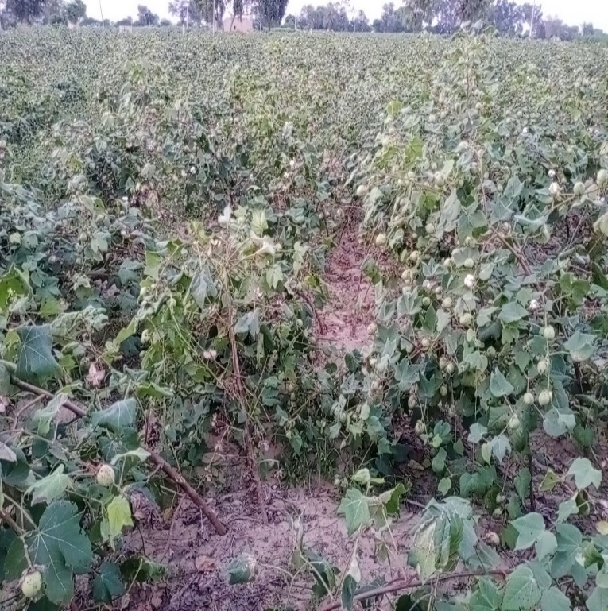
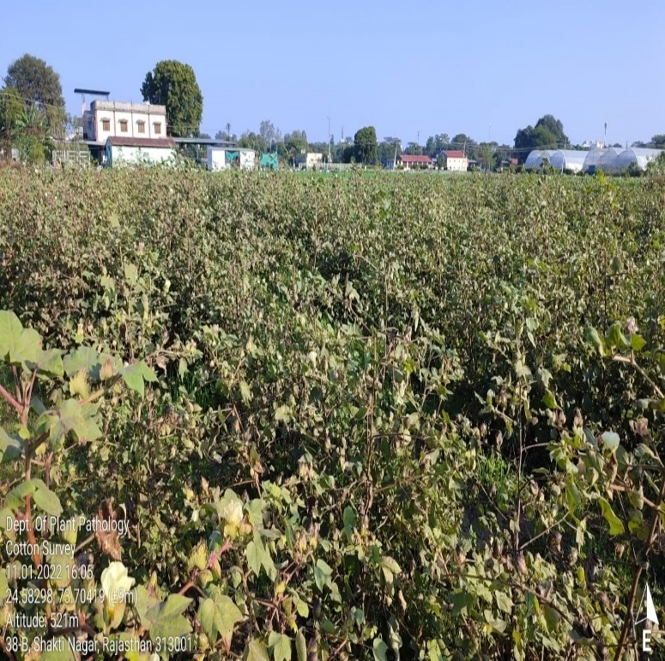
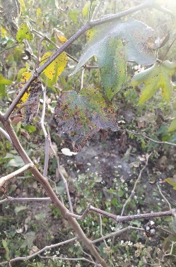
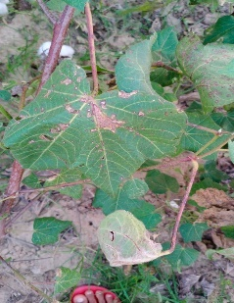

UDAIPUR CHITTORGARH
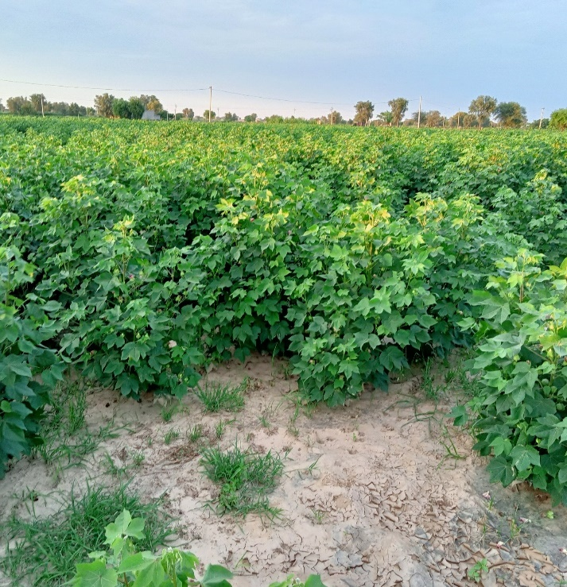
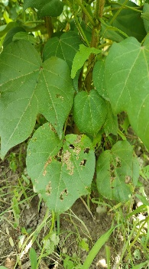
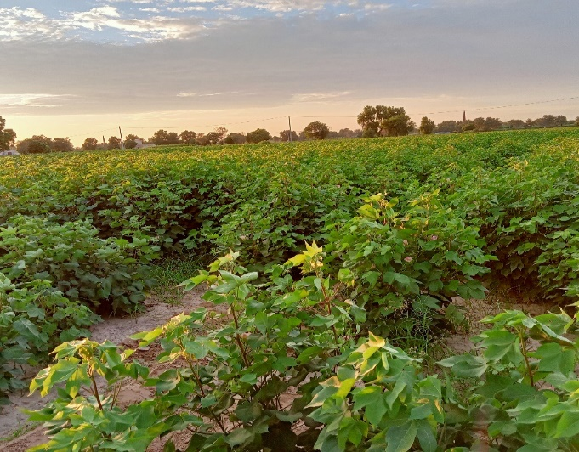
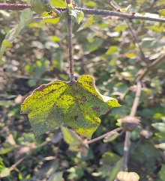

HANUMANGARH SRI GANGANAGAR

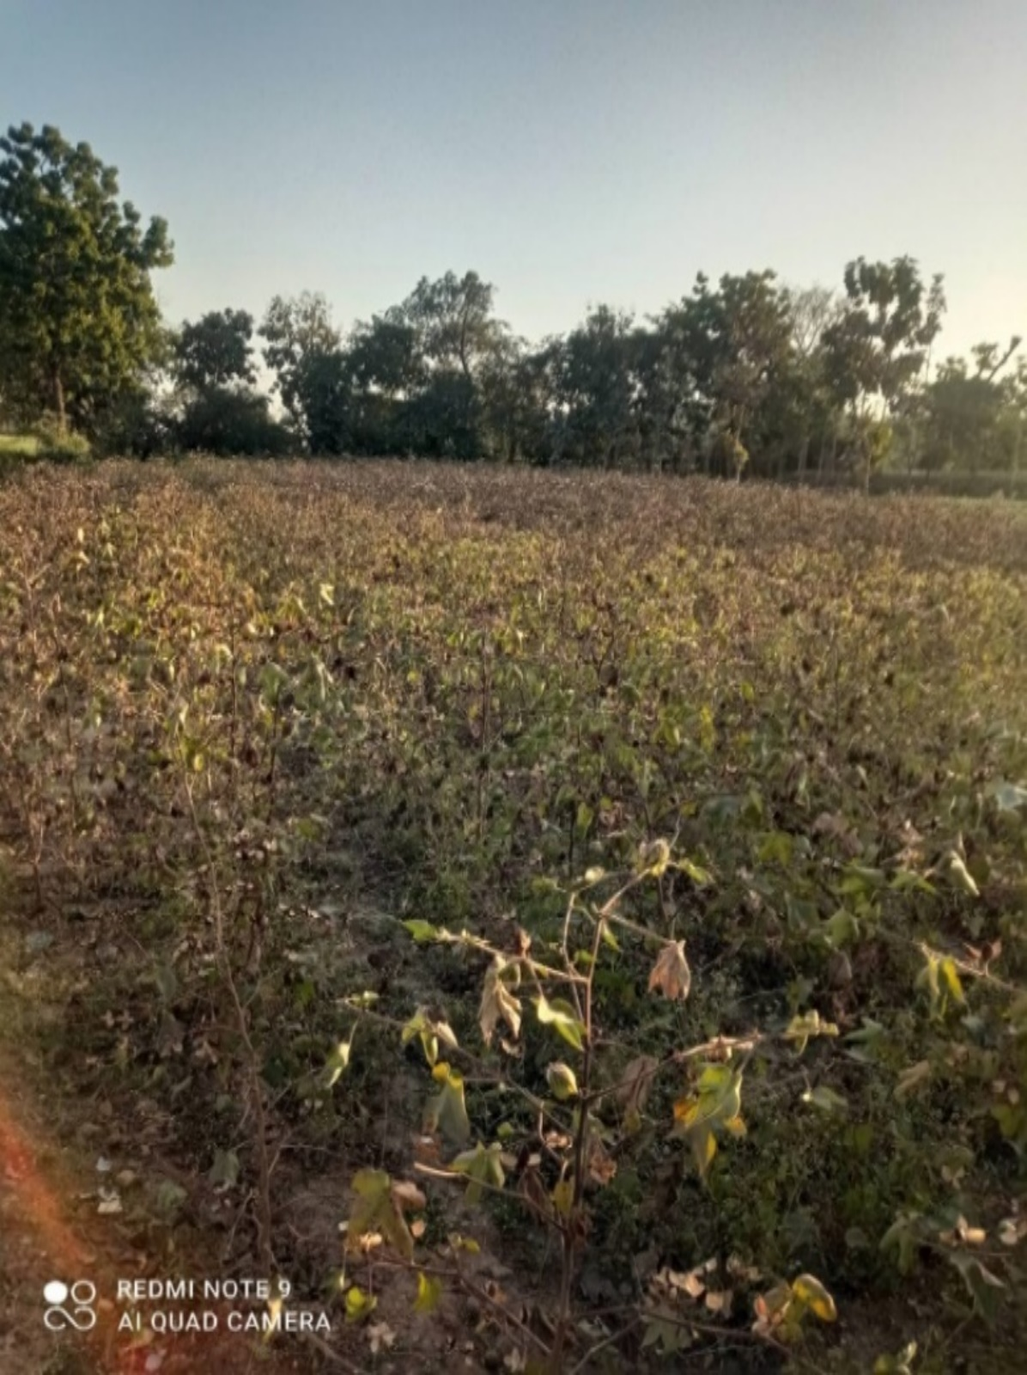
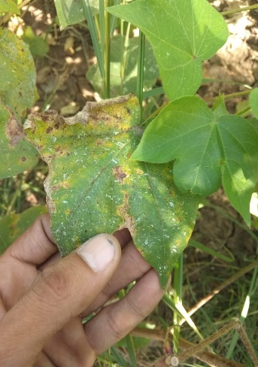

RAJSAMAND
Plate 1: Field view of surveyed cotton fields in different districts of Rajasthan during Kharif 2021-22.
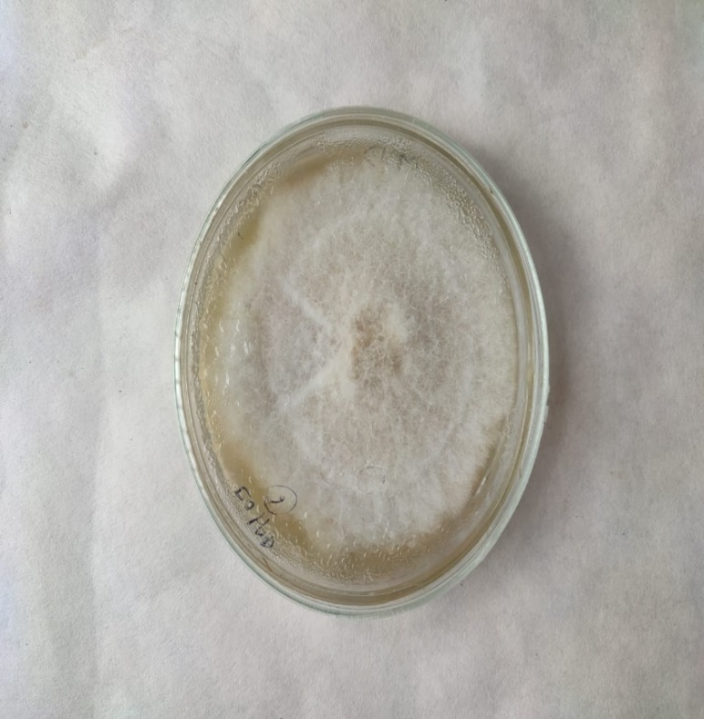
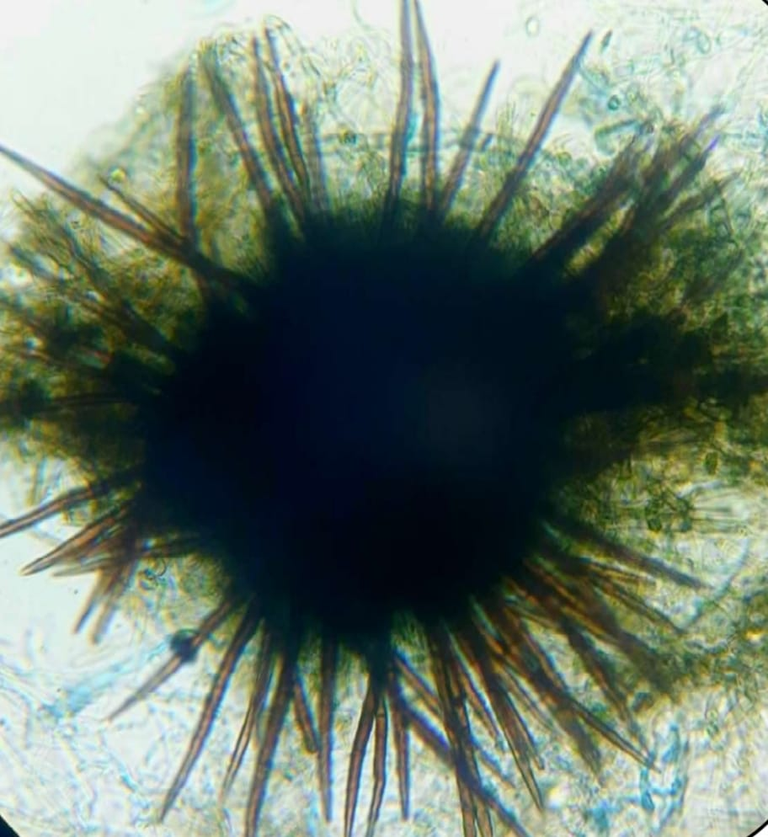
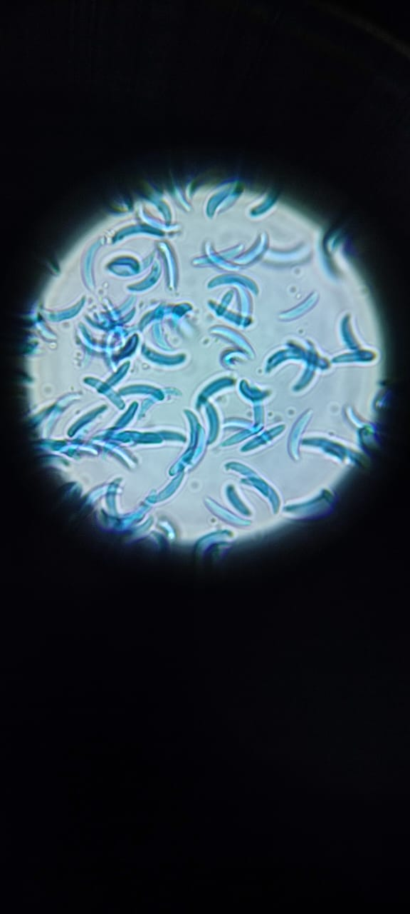

Plate 2: Microscopic structure of culture, spores, acervuli and setae of Colletotrichum gossypii

(36.90%) was observed at the Agronomy Farm, RCA, Udaipur, followed by Mavli (35.80%) while the lowest incidence was recorded in Fatehnagar (35.30%). In Chittorgarh district, maximum incidence was observed in Chikarda village (29.00%) followed by Mangalwad (28.80%) whereas the minimum incidence was recorded in Mandpiya (28.00%). In Hanumangarh district, the highest disease incidence was observed in Chohilanwali village (43.00%) followed by Mainawali (42.50%) while the lowest incidence was recorded in Devnagar (41.51%). Similarly, in Sri Ganganagar district, the maximum incidence was recorded in 15Z village (39.00%) followed by Suratgarh (38.12%) and the minimum incidence was observed in Piperan (36.88%). In Rajsamand district, the highest disease incidence was observed in Kuraj (28.00%) whereas the lowest incidence was recorded in Gilund (25.95%). The incidence in Gogathala village was found to be 27.05%.
Overall, the incidence of cotton anthracnose across different cotton-growing regions of Rajasthan ranged from 25.95% to 43.00%, with a mean incidence of 34.37%. The highest disease incidence (43.00%) was recorded in Chohilanwali village (Hanumangarh) while the lowest (25.95%) was observed in Gilund village (Rajsamand district).
Disease symptomatology
Typical symptoms of anthracnose on cotton leaves (Plate 1) were observed as elliptical to oblong lesions of varying sizes on leaves and bolls. Initially, the spots appeared small but gradually enlarged over time. As the disease progressed, many lesions expanded to approximately 2–4 cm in length and 1–2 cm in width. Each lesion developed a characteristic appearance, with a greyish-white center surrounded by numerous black dots representing acervuli, often arranged in concentric rings on both leaf surfaces. A distinct yellowish halo was observed around the lesions. In advanced stages, infected leaves became thin and papery, leading to easy tearing and premature defoliation.
Discussion
During the survey, the average anthracnose disease incidence was varied from 27 to 42.25% in different regions of cotton growing areas of Rajasthan (Table 1 and Fig. 1). In Hanumangarh district, the maximum anthracnose incidence (42.25%) was recorded followed by Sri Ganganagar (38.00%), Udaipur (36.00%), Chittorgarh (28.60%) districts. The minimum anthracnose incidence was recorded in Rajsamand district (27.00 %). The per cent disease incidence may also increase under favourable weather conditions, the disease development was
Table 1: Data on incidence and severity of anthracnose of cotton caused by Colletotrichum gossypii in different cotton growing regions of Rajasthan during Kharif 2021-22
Sr. No. | Isolates code | Districts | Location | Coordinates | Variety | Percent disease incidence (PDI) | Average Percent disease incidence
1 | RJCG-1 | Udaipur | Agronomy farm, RCA, Udaipur | 24.5829 ̊ N, 73.70442 ̊ E | RG-8 | 36.90  (37.41) | 36  (36.87)
1 | RJCG-1 | Udaipur | Mavli | 24.7902 ̊ N, 73.9742 ̊ E | Ajeet 155 BG- II | 35.80  (36.75) | 36  (36.87)
1 | RJCG-1 | Udaipur | Fatehnagar | 24.8062 ̊ N, 74.0946 ̊ E | Super Raksha BG-II | 35.30  (36.45) | 36  (36.87)
2 | RJCG-2 | Chittorgarh | Chikarda | 24.5949 ̊ N, 74.4145 ̊ E | Ajeet 155 BG- II | 29.00  (32.58) | 28.60  (32.33)
2 | RJCG-2 | Chittorgarh | Mangalwad | 24.6075 ̊ N, 74.3016 ̊ E | Super Raksha BG- II | 28.80  (32.46) | 28.60  (32.33)
2 | RJCG-2 | Chittorgarh | Mandpiya, Gangrar tehsil | 25.2616 ̊ N, 74.6386 ̊ E | Super Raksha BG- II | 28.00  (31.95) | 28.60  (32.33)
3 | RJCG-3 | Hanumangarh | Chohilanwali | 29.3846 ̊ N, 74.2760 ̊ E | RCH-776  (Rashi-776) | 43.00  (40.98) | 42.25  (40.54)
3 | RJCG-3 | Hanumangarh | Mainawali | 29.3718 ̊ N, 74.3368 ̊ E | RCH-773 | 42.50  (40.69) | 42.25  (40.54)
3 | RJCG-3 | Hanumangarh | Devnagar | 29.488796 ̊ N, 74.074799 ̊ E | RCH-773 | 41.51  (40.11) | 42.25  (40.54)
4 | RJCG-4 | Sri Ganganagar | 15z | 29.8949 ̊ N, 73.7779 ̊ E | PCH-877 Bt 2 | 39.00  (38.64) | 38  (38.06)
4 | RJCG-4 | Sri Ganganagar | Suratgarh | 29.3219 ̊ N, 73.9009 ̊ E | ACH-945-2  BG- II | 38.12  (38.13) | 38  (38.06)
4 | RJCG-4 | Sri Ganganagar | Piperan | 29.2345 ̊ N, 73.9051 ̊ E | ACH-945-2  BG- II | 36.88  (37.39) | 38  (38.06)
5 | RJCG-5 | Rajsamand | Kuraj | 25.0749 ̊ N, 74.0976 ̊ E | Ajeet 155 BG- II | 28.00  (31.95) | 27  (31.31)
5 | RJCG-5 | Rajsamand | Gogathala | 25.0704 ̊ N, 74.0564 ̊ E | Super Raksha BG-II | 27.05  (31.34) | 27  (31.31)
5 | RJCG-5 | Rajsamand | Gilund | 25.0139 ̊ N, 74.2531 ̊ E | Ajeet 33 BG- II | 25.95  (30.62) | 27  (31.31)
 | SEm± |  |  |  |  |  | 0.45
 | CD at 5% |  |  |  |  |  | 1.48
 | CV % |  |  |  |  |  | 2.25

Fig.1: Graph showing the Data on incidence and severity of anthracnose of cotton caused by Colletotrichum gossypii in different cotton growing regions of Rajasthan during Kharif 2021-22.
fast, which ultimately affect the crop and yield. The overall data revealed that the anthracnose incidence in different cotton growing areas of Rajasthan was varied from 25.95 per cent to 43.00 per cent, with an average of 34.37 per cent. The highest severity (43.00%) of anthracnose was noticed from the Chohilanwali village of Hanumangarh district and the minimum 25.95% incidence was recorded from Gilund village of Rajsamand disrict.
The survey data on anthracnose of cotton disease were found to be in agreement with earlier reports. Similar observations were reported by Yadav et al. (2017) who conducted surveys at four locations in Jaipur district and reported 60.33 per cent disease incidence. Badgujar et al. (2019) carried out an extensive roving survey during the year 2017-18 and 2018-19 in eight districts of the Marathwada region to assess anthracnose of chilli and reported higher disease intensity during 2018-19 (36.11%) compared to 2017-18 (31.29%). Likewise, K. Sanjeev Kumar et al. (2019) reported maximum disease severity (36.15%) in Kaveripattinam (Krishnagiri district) followed by Vadakumangudi (34.12%) in Cuddalore district of Tamil Nadu. Ragul et al. (2021) also observed high disease incidence (55.19%) in Subramaniapuram village of Thoothukudi district and Pudhupatti village (50.17%) of Virudhunagar district of Tamil Nadu. Patidar and Tomar (2022) recorded maximum per cent disease intensity (50.69%) in the Ashta block of Sehore district, Madhya Pradesh. Recent studies further support the widespread occurrence and variability of anthracnose incidence under different agro-climatic conditions (Dada et al. 2025).
Typical symptoms of anthracnose on cotton leaves appeared as elliptical to oblong spots of variable size on leaves and bolls. These lesions often coalesced to form irregular necrotic patches, leading to drying and defoliation. Similar symptomatology has been described in recent studies on Colletotrichum infections in cotton and other crops (Machado et al. 2024; Talhinhas and Baroncelli, 2021). The infected leaves became papery and brittle, and severe infection resulted in premature leaf fall. The pathogen also infected petioles and stems, leading to stunted growth and abnormal branching, ultimately affecting boll formation (Puia et al. 2020; Sui et al. 2024). Additionally, infection resulted in reduced boll weight and deterioration in fibre quality, including reduced length and strength (Weir et al. 2012; Jayawardena et al. 2021).
The pathogen was successfully isolated from infected plant parts showing typical anthracnose symptoms. Based on cultural, morphological and microscopic characteristics, the fungus was identified as Colletotrichum gossypii Southworth. On Potato Dextrose Agar (PDA) medium, the colony appeared initially white and cottony, later transitioning to a greyish hue with abundant sporulation (Plate 2). These cultural characteristics are consistent with earlier and recent descriptions of Colletotrichum species (Cannon et al. 2012; Damm et al. 2012). Microscopic examination revealed the presence of acervuli appearing as dark, sub-epidermal fruiting bodies bearing prominent, septate, dark brown setae. The pathogen produced hyaline, smooth-walled and predominantly falcate to curved conidia with rounded ends. The dimensions of the conidia were recorded as 20.25–28.92 µm in length and 3.35–3.91 µm in width which closely matched standard descriptions of Colletotrichum gossypii (Sutton, 1980; Talhinhas and Baroncelli, 2021). These microscopic observations were documented and are presented in plate 2. The identification of the pathogen was further confirmed by comparing morphological characteristics with standard taxonomic descriptions (Cannon et al. 2012; Jayawardena et al. 2021). Pathogenicity was established through successful re-isolation of the pathogen from artificially inoculated plants, thereby fulfilling Koch’s postulates (Agrios, 2005). Recent studies have emphasized the importance of integrating morphological observations with molecular tools for accurate identification of Colletotrichum species due to the presence of species complexes (Dutta et al. 2024; Sui et al. 2024; Zhang et al. 2023). In the present study, however, identification was based on morphological and cultural characteristics.
Conclusion
The present study established that anthracnose of cotton, caused by Colletotrichum gossypii, is widely prevalent and endemic in major cotton-growing regions of Rajasthan. The survey revealed significant variation in disease severity, with the highest incidence in Hanumangarh followed by Sri Ganganagar, highlighting the role of environmental factors in disease development. The pathogen was successfully isolated and identified based on cultural and morphological characteristics, including hyaline, falcate conidia and acervuli.
The identification of a highly virulent isolate (RJCG-3) indicates variability within the pathogen population, which has important implications for disease management and resistance breeding. The study provides a baseline for future research and emphasizes the need for continuous monitoring and integrated disease management practices, including the use of healthy planting material and resistant varieties, to reduce yield losses in cotton.
Disclaimer (Artificial Intelligence)
The author(s) hereby declare that NO generative (AI) tools, AI technologies such as Large Language Models (ChatGPT, COPILOT, etc.) and text-to-image generators have been used during the writing or editing of this manuscript.
Acknowledgements
The authors acknowledge with gratitude the support extended by the Head, Department of Plant Pathology and the Dean, Rajasthan College of Agriculture, MPUAT, Udaipur, Rajasthan, in providing essential laboratory infrastructure for this research.
References
Agrios GN. 2005. Plant Pathology. 5th ed. Elsevier Academic Press, pp. 69-75, 385-400.
Anonymous. 2020-21(b). Agricultural statics at glance. Government of India, Ministry of Agriculture & Farmers Welfare (Directorate of Economics and Statistics, (DAC&FW), pp. 95.
Anonymous. 2021(a). Government of Rajasthan, Department of Agriculture, Rajasthan. (Commissionerate of Agriculture, Rajasthan- Jaipur), pp. 1 & 6.
Badgujar SL, Dhutraj DN and Ambadkar CV. 2019. Cultural and morphological variability amongst Colletotrichum capsici isolates collected from Marathwada region of Maharashtra state. International Journal of Chemical Studies 7 (5): 4364-4367.
Barnett HL and Hunter BB. 1998. Illustrated Genera of Imperfect Fungi (4th ed.). APS Press, St. Paul, Minnesota, USA, pp. 218.
Cannon PF, Damm U, Johnston PR and Weir BS. 2012. Colletotrichum: current status and future directions. Studies in Mycology 73 (1): 181-213.
Dada AO, Dania VO, Oyatomi OA, Abberton M and Ortega-Beltran A. 2025. Studies of Colletotrichum species causing cowpea anthracnose in Nigeria reveal two first-time reports globally. Journal of Plant Pathology 107: 701–710.
Damm U, Cannon PF, Woudenberg JHC and Crous PW. 2012. The Colletotrichum acutatum species complex. Studies in Mycology 73 (1): 37-113.
Dutta R, Jayalakshmi K, Kumar S, Radhakrishna A, Sharath MN, Gurav VS and Mahajan V. 2024. Insights into the cumulative effect of Colletotrichum gloeosporioides and Fusarium acutatum causing anthracnose-twister disease complex of onion. Scientific Reports 14: 9374.
Hyde KD, Cai L, Cannon PF, Crouch JA, Crous PW, Damm U, Goodwin PH, Chen H, Johnston PR, Jones EBG, Liu ZY, McKenzie EHC, Moriwaki J, Noireung P, Pennycook SR, Pfenning LH, Prihastuti H, Sato T, Shivas RG, Tan YP, Taylor PWJ, Weir BS, Yang YL and Zhang JZ. 2009. Colletotrichum: names in current use. Fungal Diversity 39: 147–182.
Jayawardena RS, Bhunjun CS, Hyde KD, Gentekaki E and Itthayakorn P. 2021. Colletotrichum: lifestyles, biology, morpho-species, species complexes and accepted species. Mycosphere 12 (1): 519–669.
Machado SCS, Veloso JS, Câmara MPS, Vieira WAS, Jumbo LOV, Anguiar RWS, Cangussu ASR, Giongo MV, Moraes CB, Campos FS, Araujo SHC, Oliveira EE and Santos GRD. 2024. Diversity, prevalence and virulence of Colletotrichum species causing anthracnose on cassava leaves in the Northern region of Brazil. Journal of Fungi 10 (6): 367.
Patidar S and Tomar DS. 2022. Survey for disease severity of anthracnose of chilli cause by Colletotrichum capsici in Sehore district of Madhya Pradesh. The Pharma Innovation Journal 11 (2): 698-700.
Poonpolgul S and Kumphai S. 2007. Chilli pepper anthracnose in Thailand. Country report. In: Oh DG, Kim KT, editors. Abstracts of the first international symposium on chilli anthracnose. Republic of Korea: National Horticultural Research Institute, Rural Development of Administration, pp. 23.
Puia JD, Martins BR, Hoshino AT, Borsato LC, Ferreira MGDB, Carvalho MA de, Machado JA, Mehta YR and Vigo SC. 2020. Colletotrichum gossypii f. sp. cephalosporioides: Differential behaviour of cotton strains. Brazilian Journal of Animal and environmental Research 3: 738-746.
Ragul S, Sheela J, Ebenezar EG and Prabina BJ. 2021. Survey and isolation of Colletotrichum capsici causing chilli anthracnose disease from Southern districts of Tamil Nadu. The Pharma Innovation Journal 10 (11): 1190-1194.
Sanjeev Kumar K, Balabaskar P, Kumar S, Siva Kumar T and Muthukumar A. 2019. Isolates of Colletotrichum capsici (syd.) butler and bisby causing anthracnose fruit rot incidence of chilli. Plant Archives 19 (2): 3295-3299.
Sui XN, Guo MJ, Wang QT, Wang HQ, Zhou H, Huang XB, Yu ZF and Hou CL. 2024. Taxonomy and phylogeny of Colletotrichum species associated with forest plants. Mycosphere 15 (1): 4569–4743.
Sutton BC. 1980. The Coelomycetes: Fungi Imperfecti with Pycnidia, Acervuli and Stromata. Commonwealth Mycological Institute, Kew, UK, pp. 1-696.
Talhinhas P and Baroncelli R. 2021. Colletotrichum species and complexes: geographic distribution, host range and conservation status. Fungal Diversity 110: 109–198.
Tariq M, Afzal MN, Muhammad D, Ahmad S, Shahzad AN, Kiran A and Wakeel A. 2018. Relationship of tissue potassium content with yield and fiber quality components of Bt cotton as influenced by potassium application methods. Field Crops Research 229: 37-43.
Usman HM, Hussain MD, Karim MM, Nizamani MM, Mubeen M, Hussain S, Kamran A, Wang Y and Liu FQ. 2026. Colletotrichum: a versatile fungal genus with diverse infection strategies, host interactions and management challenges. Phytopathology Research 8, 6.
Weir BS, Johnston PR and Damm U. 2012. The Colletotrichum gloeosporioides species complex. Studies in Mycology 73: 115–180.
Yadav A L, Ghasolia R P, Choudhary S and Yadav V K. 2017. Survey of chilli fruit rot; potential threat to chilli crops a focus on Jaipur district. International Journal of Chemical Studies 5 (4): 1556-1557.
Zhang YX, Chen JW, Manawasinghe IS, Lin YH, Jayawardena RS, McKenzie EHC, Hyde KD and Xiang MM. 2023. Identification and characterization of Colletotrichum species associated with ornamental plants in Southern China. Mycosphere 14 (2): 262-302.

