Temporal Dynamics and Weather-Based Predictive Modeling of Powdery Mildew (Leveillula taurica) in Chilli (Capsicum annuum L.)

Abstract
Powdery mildew, incited by the endophytic fungus Leveillula taurica (Lev.) Arn., is a major foliar constraint in chilli cultivation. To quantify the epidemiological progression of the disease and establish a predictive relationship with microclimatic variables, a field study was conducted using 35-day-old transplanted seedlings. Disease monitoring began upon the first natural appearance of powdery mildew symptoms and continued for an active observation period of thirteen Standard Meteorological Weeks (SMW 48 to SMW 8). The disease initiated at a baseline PDI of 4.44% during SMW 48 and entered a rapid logarithmic phase, reaching a peak severity of 68.88% by SMW 4 (January 22 – 28). The cumulative disease pressure, measured as the Area Under the Disease Progress Curve (AUDPC), was 3204.21. The maximum apparent rate of infection (r) reached 0.14 units/day during the initial outbreak phase between SMW 48 and 49. Correlation analysis revealed that wind speed (r = 0.80) and maximum temperature (r = 0.60) acted as strong positive drivers for disease progression, whereas rainfall exhibited a deterrent effect (r = -0.50). An Ordinary Least Squares (OLS) multiple linear regression model was developed (R² = 0.88, Adjusted R² = 0.79), indicating that weather variables collectively explained a highly significant portion of the variance in disease severity (P = 0.0043). This weather-based forecasting model provides a crucial decision-support tool for optimizing integrated disease management (IDM) strategies.
Keywords: Capsicum annuum, epidemiology, Leveillula taurica, apparent rate of infection, AUDPC, multiple linear regression.
1. Introduction
Chilli (Capsicum annuum L.) is a globally significant commercial spice and vegetable crop, deeply embedded in the agricultural economy. Despite its wide adaptability, chilli productivity is persistently threatened by various biotic stresses, with powdery mildew emerging as a primary concern [1, 2]. Among the fungal pathogens, powdery mildew caused by Leveillula taurica (Lev.) Arn. has emerged as a highly destructive disease, often causing yield loss exceeding 50% in untreated fields [3, 4].
Unlike conventional ectophytic powdery mildews, L. taurica is uniquely characterized by its endophytic mycelial colonization. The pathogen invades the mesophyll tissues prior to extruding conidiophores through the stomata [5]. This pathogenesis causes severe chlorosis, premature defoliation, and ultimately exposes the developing fruits to sunscald [6].
The onset, severity, and spatial distribution of powdery mildew are strongly influenced by microclimatic factors. Field observations consistently indicate that L. taurica thrives under specific thermoperiodic combinations primarily moderate daytime warmth coupled with cool, humid nights [7]. Because contemporary climate shifts make traditional, calendar-based fungicide scheduling unreliable [8, 9,], understanding the precise temporal progression of the pathogen in relation to real-time meteorological variables is highly necessary [10, 11, 12].
Consequently, the current investigation was designed to track the apparent rate of infection, quantify the cumulative disease burden via AUDPC, and formulate a reliable weather-based multiple linear regression model to predict powdery mildew outbreaks in chilli.
This research provides a practical, field-tested forecasting model that helps the agricultural community predict exact outbreak windows for powdery mildew in chilli crops. By demonstrating that severe day-to-night temperature swings rather than just high humidity are the true triggers for infection, it clarifies how this specific endophytic fungus interacts with the microclimate. For researchers and extension workers, this mathematical framework bridges the gap between raw meteorological data and on-the-ground disease management. Ultimately, it equips agronomists with the precise weather thresholds needed to replace calendar-based spraying with targeted interventions, which reduces both crop loss and unnecessary chemical use.
2. Materials and Methods
2.1 Field Experimentation and Disease Scoring
The epidemiological field trial was conducted during the Rabi 2025-26 using the highly susceptible chilli cultivar Byadagi Kaddi. Healthy, 35-day-old seedlings were transplanted into experimental plots (5 × 3 m²) under natural epiphytotic conditions. To allow for uninterrupted disease development, these plots were kept completely free of any fungicidal sprays. Meteorological data were collected from the Automatic Weather Station, Department of Agronomy, SOAS, MRU (Latitude: 17°19'16.4'' N, Longitude: 78°24'43'' E, Altitude: 542.3 m).
Disease severity was visually evaluated on 20 randomly tagged plants at weekly intervals. Importantly, data collection began only after the first natural appearance of disease symptoms in the field. Because observations were triggered by this natural onset, the active monitoring period spanned 13 weeks, starting in late November during SMW 48 (November 26 – December 2) and ending as the crop matured in late February during SMW 8 (February 19 – 25). A standard 0-9 grading scale [13] was used to score the percentage of leaf area showing characteristic chlorotic patches and whitish fungal sporulation.
The Per cent Disease Index (PDI) was mathematically derived using Wheeler's formula [14]:
$$PDI= \frac{Sum of individual disease ratings}{Total number of plants observed} × \frac{100}{Maximum disease scale}$$

2.2 Epidemiological Computations
To determine the speed of the epidemic between successive weekly observations, the apparent rate of infection (r) was computed utilizing the equation given by Van der Plank [15]:

$$r=\frac{2.3}{t_{2}-t_{1}}[\log_{10}{\frac{X_{2}}{{1-X}_{2}}-\log_{10}{\frac{X_{1}}{1-X_{1}}}}]$$

Where t₁ and t₂ represent consecutive observation dates, and X₁ and X₂ represent the disease proportions (PDI / 100) at those specific times.
The total cumulative disease pressure experienced by the crop over the season was quantified by calculating the Area Under the Disease Progress Curve (AUDPC) via the trapezoidal integration method:
$$AUDPC=\sum_{i=1}^{K-1}{1/2(S_{i}+S_{i-1})(t_{2}-t_{1})}$$
Where, S_{i} = Amount of disease at ith time, S_{i-1} = Amount of disease at (i – 1)th time,
t₂ – t₁= Number of days between two observations and K = Number of successive evaluation of disease
2.3 Meteorological Data and Statistical Modeling
Daily weather parameters—Maximum Temperature, Minimum Temperature, Relative Humidity (RH), Wind Speed, and Rainfall—were collected and converted into weekly averages corresponding to the specific dates of the SMWs. Pearson’s correlation coefficients (r) were calculated to establish the linear association between the weekly PDI and the prevailing weather variables. Finally, an Ordinary Least Squares (OLS) multiple linear regression analysis was executed to generate a forecasting equation, evaluating the significance (P-value) of each independent microclimatic variable. All advanced statistical computations, including the generation of the correlation matrix and the multivariable regression model, were systematically executed using the Data Analysis Toolpak in Microsoft Excel, in accordance with standard agricultural statistical procedures [16].
3. Results and Discussion
3.1 Disease Progression, Infection Velocity, and AUDPC
The field data (Table 1) revealed that powdery mildew initiated during SMW 48 (November 26 – December 2) with a basal PDI of 4.44%. The disease rapidly transitioned into a logarithmic multiplication phase throughout December and January. The highest apparent rate of infection (r = 0.14 units/day) was documented at the very onset of the epidemic between SMW 48 and SMW 49 (December 3 – 9). A subsequent major infection surge (r = 0.10 units/day) was noted between SMW 1 (January 1 – 7) and SMW 2 (January 8 – 14).
Although trace precipitation (2.5 – 2.8 mm) was recorded during this initial logarithmic phase (SMW 49 and 50), the volume was insufficient to physically wash the inoculum from the phyllosphere; instead, this minimal moisture likely helps the initial conidial germination, resulting in the highest r values of the season before the canopy became saturated with disease.
The timing of this outbreak matches other recent observations in the region. Sheetal et al. [3] also noted that L. taurica in chilli hits peak severity early in the fruiting stage, which is consistent with the rapid logarithmic phase we saw in January. Additionally, Saha et al. [12] showed that early infections in late November lead to high cumulative disease pressure if not managed quickly [12, 17]. Our AUDPC and infection rate data closely follow this expected Rabi season pattern.
Table 1: Meteorological data and temporal progression of chilli powdery mildew (PDI) with apparent rate of infection (r)
SMW | Calendar Dates | Max Temp (°C) | Min Temp (°C) | RH (%) | Wind Speed (km/h) | Rainfall (mm) | PDI (%) | Infection Rate (r)
48 | Nov 26 - Dec 2 | 24.6 | 14.1 | 83.4 | 0.8 | 0.0 | 4.44 | -
49 | Dec 3 - Dec 9 | 25.0 | 13.7 | 83.4 | 0.6 | 2.8 | 11.11 | 0.14
50 | Dec 10 -Dec 16 | 25.0 | 13.4 | 83.1 | 0.6 | 2.5 | 17.77 | 0.08
51 | Dec 17- Dec 23 | 25.1 | 12.9 | 82.9 | 0.7 | 0.0 | 19.98 | 0.02
52 | Dec 24- Dec 31 | 25.1 | 13.4 | 82.5 | 0.7 | 0.0 | 28.88 | 0.07
1 | Jan 1 - Jan 7 | 28.3 | 15.6 | 86.6 | 1.1 | 0.0 | 37.77 | 0.06
2 | Jan 8 - Jan 14 | 27.6 | 16.9 | 86.9 | 1.6 | 0.0 | 55.55 | 0.10
3 | Jan 15 - Jan 21 | 28.0 | 15.3 | 87.1 | 1.4 | 0.0 | 59.99 | 0.03
4 | Jan 22 - Jan 28 | 30.6 | 16.7 | 87.4 | 1.2 | 0.0 | 68.88 | 0.06
5 | Jan 29 - Feb 4 | 31.9 | 19.4 | 88.7 | 1.2 | 0.0 | 51.10 | -0.11
6 | Feb 5 - Feb 11 | 32.9 | 20.0 | 86.0 | 0.9 | 0.0 | 46.62 | -0.03
7 | Feb 12 - Feb 18 | 33.3 | 20.6 | 78.6 | 1.2 | 0.0 | 41.21 | -0.03
8 | Feb 19 - Feb 25 | 33.7 | 21.4 | 88.7 | 1.2 | 0.0 | 33.33 | -0.05

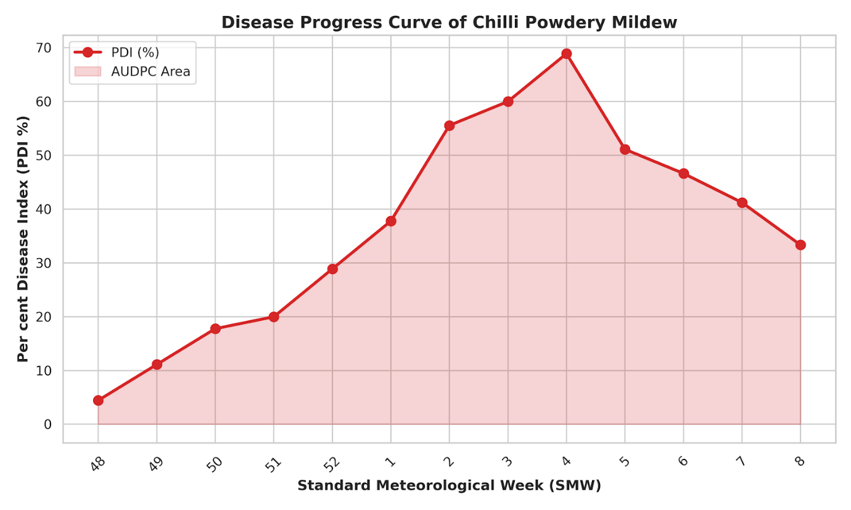
Figure 1: Disease Progress Curve of chilli powdery mildew (Leveillula taurica) indicating the Area Under Disease Progress Curve (AUDPC) during the 2025-26 cropping season.

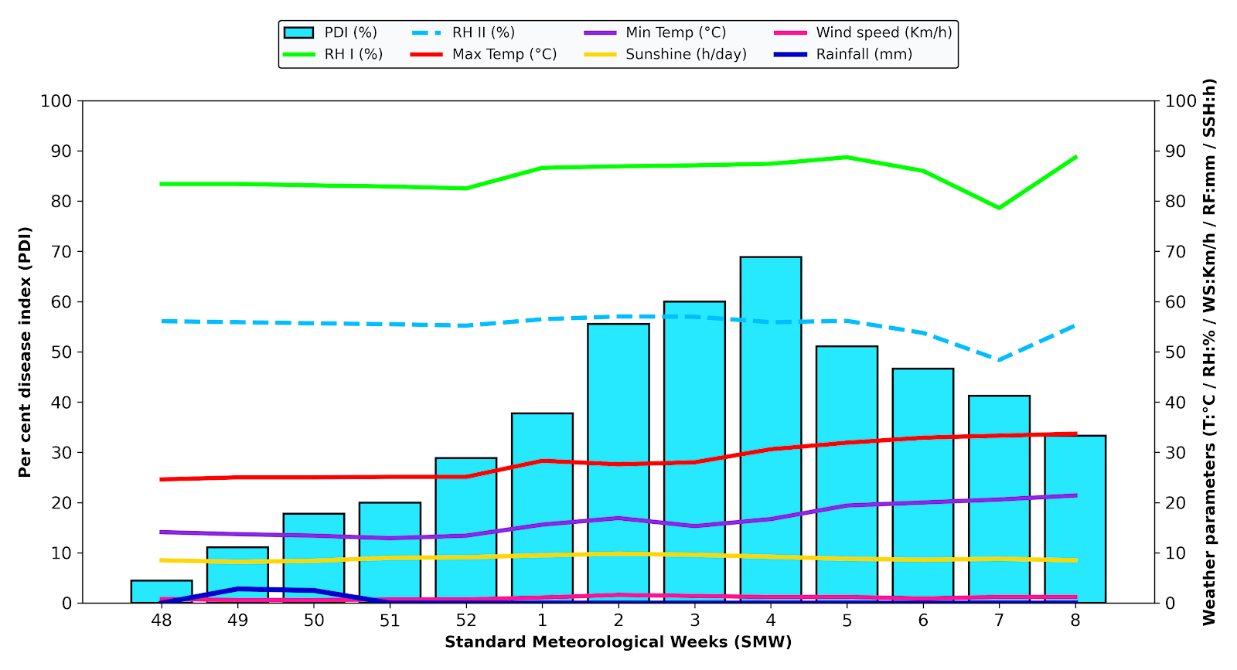
Figure 2: Interrelated temporal progression of chilli powdery mildew severity (PDI %) against key microclimatic parameters across Standard Meteorological Weeks.

3.2 Correlation of Microclimatic Factors with Disease Severity
The fluctuations in disease severity were closely followed the weekly weather patterns. A Pearson's correlation analysis was conducted to establish these linear relationships (Table 2 and Figure 3).
Table 2: Pearson’s correlation coefficients between chilli powdery mildew (PDI) and meteorological variables
Weather Parameter | Correlation Coefficient (r) | Relationship Nature
Maximum Temperature (°C) | 0.60 | Positive
Minimum Temperature (°C) | 0.50 | Positive
Relative Humidity (%) | 0.53 | Positive
Wind Speed (km/h) | 0.80 | Strong Positive
Rainfall (mm) | -0.50 | Negative

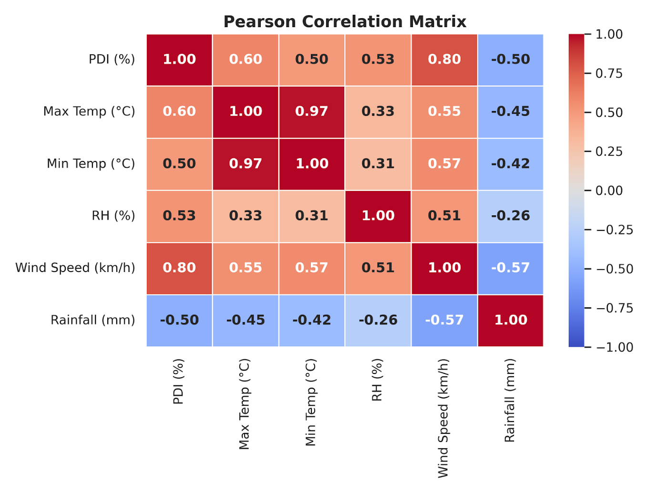
Figure 3: Pearson correlation heat-map demonstrating the linear relationship between meteorological variables and Per cent Disease Index (PDI).
Wind speed acted as the strongest positive driver (r = 0.80, Figure 4), playing a critical role in the secondary dissemination of airborne conidia across the crop canopy. Both maximum and minimum temperatures, as well as relative humidity, maintained a moderate positive correlation with the PDI during the active growth phase. In contrast, rainfall exhibited a distinct negative correlation (r = -0.50). This inverse relationship reflects standard epidemiological behaviour, as free surface moisture limits conidial germination and physically washes the inoculum off the foliage [6] .
These weather correlations agree with existing dispersal models for powdery mildew and recent field observations in similar agro-climatic zones [18]. The negative effect of rainfall supports the findings of Vineeth et al. [6], who noted that heavy moisture disrupts the dispersal of Leveillula. On the other hand, the high correlation with wind speed (r = 0.80) highlights that dry air currents are the primary way these conidia move across the crop canopy, rather than rain splash.
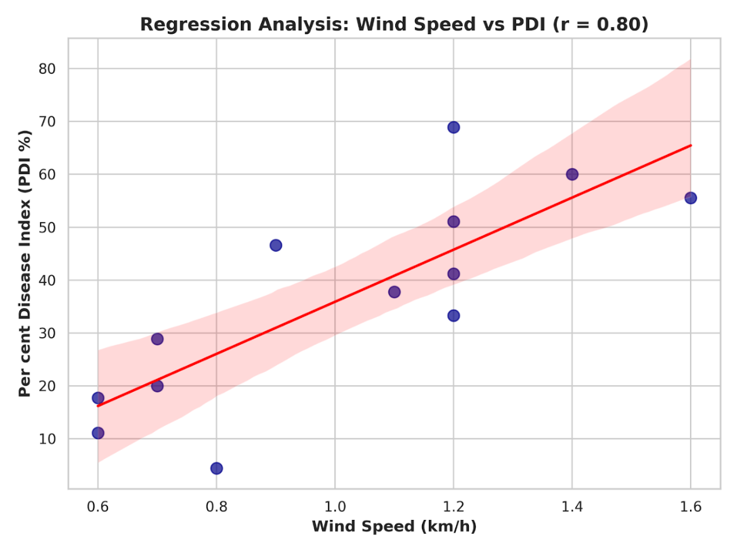
Figure 4: Scatter plot and linear regression trendline depicting the strong positive correlation (r = 0.80) between prevailing wind speed and powdery mildew severity.
3.3 Multiple Linear Regression and Disease Forecasting
To translate these environmental interactions into a practical forecasting tool, a stepwise multiple linear regression model was developed using Ordinary Least Squares (OLS) analysis. The dependent variable (PDI) was regressed against the independent microclimatic parameters to determine their specific weight and statistical significance in driving the epidemic (Table 3).
Table 3: Multiple linear regression coefficients for the effect of weather parameters on chilli powdery mildew severity
Weather Parameter | Coefficient (β) | Standard Error (SE) | t-value | P-value | Significance
Intercept | -165.70 | 85.68 | -1.93 | 0.094 | NS
Max Temperature (X₁) | 10.92 | 3.15 | 3.46 | 0.011 | *
Min Temperature (X₂) | -11.89 | 3.68 | -3.23 | 0.014 | *
Relative Humidity (X₃) | 0.45 | 1.04 | 0.44 | 0.676 | NS
Wind Speed (X₄) | 46.16 | 12.22 | 3.78 | 0.007 | **
Rainfall (X₅) | 1.02 | 3.30 | 0.31 | 0.765 | NS

Model Statistics: R² = 0.88; Adjusted R² = 0.79; F-statistic = 9.99; Overall Model P-value = 0.0043.
( * = Significant at P < 0.05; ** = Significant at P < 0.01; NS = Non-Significant )
The regression analysis yielded an excellent coefficient of determination (R² = 0.88, Adjusted R²= 0.79). The high Adjusted R² confirms that even accounting for the sample size across the thirteen-week observation period, 79% of the variance in disease severity is definitively explained by these meteorological inputs. The overall model proved highly significant (P = 0.0043).
The resulting predictive equation derived from the coefficients is:
Y = -165.70 + 10.92(X₁) - 11.89(X₂) + 0.45(X₃) + 46.16(X₄) + 1.02(X₅)
When evaluating the total seasonal impact, maximum and minimum temperatures actually emerged as the primary drivers of disease variance. Although wind speed generated the highest mathematical coefficient (+46.16, P = 0.007), this is largely due to its very narrow range of fluctuation (0.6 to 1.6 km/h) throughout the season. This highly significant coefficient confirms that even a slight breeze is enough to trigger the secondary spread of conidia across the canopy. While Rainfall showed a negative correlation individually, its effect was Non-Significant (NS) in the combined regression model (P = 0.765), likely due to the limited number of rainy days (only two weeks recorded minimal precipitation) during the severe epiphytotic window.
Interestingly, while Relative Humidity (RH) maintained a positive individual correlation (r = 0.53) with disease progression, it emerged as non-significant (P = 0.676) in the multivariable regression matrix. This is attributed to the endophytic pathogenesis of L. taurica. Once initial stomatal penetration occurs, the internal mycelium is protected from outside moisture changes. Furthermore, ambient RH remained consistently optimal (82%–88%) throughout the epiphytotic window, acting as a stable baseline condition rather than a dynamic variable driving the sudden variance in disease severity.
Consequently, the regression model naturally assigned more weight to the variables that actively fluctuated: wind speed and minimum temperature. The strong negative coefficient for minimum temperature (-11.89, P = 0.014) perfectly captures the unique day-night requirements of L. taurica. While warm, dry daytime conditions are necessary to scatter the spores in the air, actual infection depends on the night. When nighttime temperatures drop (to 13°C–16°C), a fine layer of dew forms on the leaves, giving the spores just enough moisture to germinate. Furthermore, this cooler nighttime microclimate coincides with physiological stomatal opening, thereby granting the germ tubes physical access to the internal mesophyll. Consequently, this precise diurnal oscillation plays a critical role in disease development, which explains why the regression model identified minimum temperature as a highly significant factor.
An interesting takeaway from the regression model is that relative humidity was not significant, while the day-to-night temperature shifts were. This fits well with the endophytic nature of L. taurica described by Anne et al. [5]. Once inside the leaf, the fungus is largely protected from changes in outside humidity. By statistically capturing this dynamic, our field model supports earlier controlled-environment work by Elad et al. [7], showing that cool nights rather than just high ambient humidity are the actual biological trigger for germination, a dynamic increasingly supported by recent predictive models and diurnal temperature studies noted by Ganesha Naik [19], Sabeena [20], and original severity assessments by Ashtaputre [17].
4. Conclusion
The epidemiological progression of Leveillula taurica in chilli demonstrates a highly predictable dependency on specific microclimatic windows, which is critical for mitigating severe crop losses [17, 20]. The epidemic, resulting in a substantial AUDPC of 3204.21, was predominantly fueled by moderate temperatures, steady relative humidity, and wind velocities that aided secondary spread. The highly significant multiple linear regression model established in this study (Adjusted R²= 0.79, P = 0.0043) provides a robust forecasting mechanism. By integrating this equation with localized weekly weather forecasts, plant pathologists and extension workers can accurately predict PDI spikes, thereby allowing farmers to execute timely, targeted fungicidal applications before the pathogen breaches the economic injury level. While this single-season model provides a highly significant baseline for predicting epiphytotic outbreaks, future multi-location and multi-year temporal validation will further refine the precision of the microclimatic coefficients for broader regional applicability.
5. Limitations
It should be noted that this is a single-season, single-location study. As a result, the regression model relies on a limited dataset, making the microclimatic coefficients highly specific to this area. Future multi-year and multi-location testing is necessary to validate this forecasting model for broader use.

Disclaimer (Artificial intelligence)

Author(s) hereby declare that NO generative AI technologies such as Large Language Models (ChatGPT, COPILOT, etc.) and text-to-image generators have been used during the writing or editing of this manuscript.

6. References
- Bademiyya SI, Ashtaputre SA. Integrated management strategies in chilli powdery mildew (Leveillula taurica). International Journal of Chemical Studies. 2020;8(4):899-902.
- Jiménez-Pérez O, et al. Potential of Chitosan for the Control of Powdery Mildew (Leveillula taurica) in a Jalapeño Pepper Cultivar. Plants. 2024;13(7):915.
- Sheetal A, Govindappa MR, Mallikarjun K, Sreenivas AG. Severity and status of chilli powdery mildew in North Eastern Karnataka. Journal of Farm Sciences. 2021;34(3):278-282.
- Peshaman MH, Kadam V, Bhalerao S. Survey of chilli powdery mildew in Latur and Nanded districts. International Journal of Current Microbiology and Applied Sciences. 2017;6(12):1-8.
- Anne M, et al. Powdery mildew caused by Leveillula taurica: A global challenge for pepper production. Molecular Plant Pathology. 2025;26(7):e70128.
- Vineeth M, et al. Influence of weather parameters on powdery mildew disease development caused by Leveillula taurica. Biological Forum – An International Journal. 2023;15(10):1547-1553.
- Elad Y, et al. Effect of microclimate on Leveillula taurica powdery mildew of sweet pepper. Phytopathology. 2007;97(7):813-824.
- Juroszek P, et al. Overview on the review articles relating to potential climate change effects on crop disease risks. Plant Pathology. 2020;69(2):179-193.
- Fones HN, et al. Threats to global food security from emerging fungal crop pathogens. Nature Food. 2020;1(6):332-342.
- Bademiyya SI, Ashtaputre SA. Morphological Variability of Conidia of Leveillula taurica Causing Chilli Powdery Mildew. International Journal of Current Microbiology and Applied Sciences. 2019;8(4):2965-2968.
- Raju J, et al. Management of powdery mildew of capsicum under protected cultivation. International Journal of Chemical Studies. 2017;5(5):1213-1215.
- Saha P, Rizal S, Datta J. Impact of weather parameters on chilli powdery mildew and its management. Journal of Agricultural Science and Technology. 2025;27(4):879-894.
- Mayee CD, Datar VV. Phytopathometry. Technical Bulletin-1, Marathwada Agricultural University, Parbhani; 1986.
- Wheeler BEJ. An Introduction to Plant Diseases. John Wiley and Sons Ltd., London; 1969.
- Van der Plank JE. Plant Diseases: Epidemics and Control. Academic Press, New York; 1963.
- Panse VG, Sukhatme PV. Statistical Methods for Agricultural Workers. ICAR, New Delhi; 1985.
- Ashtaputre SA. Studies on loss assessment, epidemiology and management of powdery mildew of chilli. PhD Thesis, University of Agricultural Sciences, Dharwad. 2006.
- Shrivastava A, Chouhan P. Bio-efficacy studies of new fungicides against powdery mildew of chilli. Journal of Plant Disease Sciences. 2020;15(1):12-16.
- Ganesha Naik, Jayalakshmi K. Efficacy of bioagents, plant extracts and fungicides against chilli powdery mildew. Journal of Pure and Applied Microbiology. 2016;10(4):3105-3109.
- Sabeena I, Bademiyya SI, Ashtaputre SA. Estimation of Yield Loss Due To Powdery Mildew of Chilli. International Journal of Pure & Applied Bioscience. 2019;7(1):323-326.

