Assessment of Socio-Economic Status and Production-Marketing Constraints of Pineapple Farmers: A Cross-District Analysis of Thoubal and Imphal East, Manipur, India
ABSTRACT
Background: In Manipur, pineapple farming is important but yields are low due to traditional methods. Farmers face poor storage, weak markets, high transport costs, and labour shortages, leading to low profits.
Aims: To examine the socio-economic status of pineapple farmers and identify the major production and marketing constraints in Thoubal and Imphal East districts of Manipur through a comparative analysis.
Study Design: Descriptive and analytical research design based on primary survey data.
Place and Duration of Study: The study was conducted in Thoubal and Imphal East districts of Manipur, India, during 2024–2025.
Methodology: A multistage stratified random sampling technique was used to select 240 pineapple growers from 11 villages across the two districts. Farmers were categorized into marginal, small, and semi-medium groups. Primary data were collected through personal interviews using a structured schedule. Socio-economic variables such as age, education, occupation, and landholding size were analyzed using tabular methods and percentages. Garrett’s Ranking Technique was applied to identify and prioritize production and marketing constraints.
Results: Marginal farmers formed the majority in both Thoubal (50.97%) and Imphal East (57.65%) districts. Most farmers belonged to the 31–40 age group and relied on a combination of agriculture and labour for their livelihood. In Thoubal district, transportation (60.65) and high maintenance costs (60.25) were the most significant production constraints. In Imphal East, labour shortage during the peak season (68.76) and high maintenance costs (67.56) were the major challenges. Marketing constraints in both districts were dominated by lack of transportation, high price spread between farmers and consumers, and the perishability of pineapple, which forced farmers into quick and often low-value sales.
Conclusion: Pineapple cultivation remains an important source of livelihood but is constrained by labour shortages, inadequate infrastructure, and weak marketing systems. Strengthening transportation, post-harvest facilities, and market linkages is essential to improve farmer income and ensure sustainable development.
Keywords: Socio-economic, Production constraints, Marketing constraints, Pineapple cultivation, Manipur

INTRODUCTION
The economy of Manipur depends on agriculture as a source of livelihood to majority of population. Pineapple (Ananas comosus) is one of the major among many horticultural crops grown in the state. The agro-climatic conditions of the state’s valley and the foothills make a perfect habitat to grow pineapples that makes the state one of the largest producers in India (National Horticultural Board, 2024; Singh et al., 2023). In particular, the “Kew” and “Queen” are cultivated in this area due to its high quality, high fibre content and its sweetness (MOMA, 2023). Even with the strong geographical potential, the yields farmers actually achieve are often lower than the national average, mainly because traditional practices are widely used (Singh et al., 2016).
The pineapple value chains in Manipur face different systemic inefficiencies. One of the biggest challenges is the lack of proper post-harvest infrastructure such as cold storage and processing facilities (Ministry of Agriculture & Farmers Welfare, 2024; NINGOMBAM et al., 2019). Since the pineapple is highly perishable and organised marketing systems are weak, marginal and small pineapple growers are often compelled to sell their produce quickly at low prices (Devi et al., 2018). In districts like Thoubal and Imphal East, these challenges are further increase by differences in labour availability and high transportation cost. Recent empirical evidence suggests that farmers are frequently hampered by high transportation costs and acute labour shortages during the peak season (Devi et al., 2023; Singh et al., 2024).
Since there are limited facilities for value addition, such as grading, waxing, or processing into pulp, the quality of the fruit starts deteriorating soon after harvest. As a result, even though farmers in these areas may have relatively high literacy levels, this advantage does not fully translate into better outcomes. The lack of proper infrastructure leaves them dependent on traditional and unorganized market systems, where they have little control over pricing and sales.
RESEARCH METHODOLOGY
For the present study, a multistage stratified random sampling approach has been used to determine the final sample unit. Two districts, Thoubal and Imphal East were selected purposively for the study as it is major location for producing pineapple in Manipur and it has the highest area and production of pineapple cultivation in the valley region. One block from each district i.e., Thoubal CD block and Keirao Bitra CD block, with the highest pineapple production was selected purposively. A list of Pineapple growing villages in Thouba and Keirao Bitra blocks have been obtained from the office of Krishi Vigyan Kendra of Thoubal and Imphal East districts. Then all the villages are arranged in descending order based on the cultivated area of pineapple, and approximately 15% i.e., 6 villages in Thoubal CD block and 5 villages in Imphal east block were selected randomly from combined list of villages growing pineapple from these two blocks of the Thoubal and Imphal East district. List of all farmers were gathered with the help of village pradhan. Respondents were categorized into groups on the basis of their land holding according to Ministry of Agriculture & Farmers Welfare, GOI. Out of that, 10% respondents, i.e., 240 respondents were selected at random proportionate to the various size groups on the basis of pineapple cultivation for the study.
The information pertaining to the present study were collected and gathered during the year 2024-25. Primary data were collected through personal interviews using a pre-structured interview schedule and secondary data were collected from block office, agricultural department and also published sources. The published sources are internet, published journals, articles, research papers, and census report etc.
2.1. Analytical tools:
The following analytical tools and techniques were used to meet the study's specific goals, which were determined by the nature and amount of data.
2.1.2. Tabular analysis and Percentages:
Simple tabular analysis with averages and percentages and various analytical tools which come under production of pineapple cultivation and marketing problems were used.
2.1.3 Evaluation of socio-economic status:
The following components have been included to measure socioeconomic status:
- Age distribution
- Education
- Occupation
- Size of Farms groups
- Annual Income
The total of these factors as determined by the socioeconomic standing of the respondents were done.
2.1.4 Chi-Square Test
A chi-square (χ²) statistic is a test that measures how a model compares to actual observed data. The data used in calculating a chi-square statistic must be random, raw, mutually exclusive, drawn from a large enough sample. The chi-square statistic compares the size of any discrepancies between the expected results and the actual results, given the size of the sample and the number of variables in the relationship.
$$x^{2}\text{=}∑\frac{{\text{(}O_{i}-E_{i})}^{2}}{E_{i}}$$
where, χ²= Chi-squared
O_{i}= Observed value
E_{i}= Expected value
2.1.5. Garrett’s Ranking Technique
To identify the constraints and challenges in production and export Performance of pineapple Garrett’s Ranking technique will be used.
$$Percent position=\frac{(Rij-0.5)}{Nj}*100$$
Where, Rij= Rank given for the i^{th} item by the j^{th} individual
Nj= No. of items ranked by j^{th} individuals.

RESULTS AND DISCUSSION
3.1. Age group of respondents
There are significant differences in the proportion of marginal, small, and semi-medium farmers between Thoubal District and Imphal East District when examining their landholding patterns. Marginal farmers make up the majority of all holdings in Thoubal District (50.97%), while they make up an even higher percentage in Imphal East (57.65%). This indicates that Imphal East has a greater concentration of smaller farmers. Thoubal, on the other hand, displays a more uniform distribution, with 23.23% of holdings falling under semi-medium farmers and 25.81% under small farmers. In comparison, Imphal East has a slightly smaller percentage of medium-sized landholders than Thoubal, with 19.99% of farmers having small and 22.36% having semi-medium. Farmers in the 31-40 and 41-50 age groups are the most prominent in both districts, irrespective of other age groups or holding ranges. Particularly, Thoubal has the highest percentage in the 31-40 range (32.90%), followed by the 41-50 range (28.39%). Imphal East shares the same percentage in the 31-40 range (36.47%) and the 41-50 range (28.24%). The under-20 group is very low in both areas, indicating that extremely small or very young landholders are not greatly involved. Overall, the data shows that while marginal farmers are more prominent in both districts, Thoubal's distribution across landholding sizes appears to be slightly more diverse and balanced, whereas Imphal East's is more significantly dominated by marginal holdings. This indicates that the two regions differ in terms of farming intensity, fragmentation, or land access.
Table 1: Age-wise comparison of pineapple farmers between Thoubal and Imphal East districts.
Thoubal District |  |  |  |  |  | Imphal East District
S. No | Particulars | Marginal | Small | Semi medium | Total | Marginal | Small | Semi medium | Total
1 | Under 20 | 4  (2.58) | 3  (1.94) | 2  (1.29) | 9  (5.81) | 2  (2.35) | 1  (1.18) | 0  (0.00) | 3  (3.53)
2 | 21-30 | 12  (7.74) | 7  (4.52) | 8  (5.16) | 27  (17.42) | 5  (5.88) | 3  (3.53) | 3  (3.53) | 11  (12.94)
3 | 31-40 | 28  (18.06) | 10  (6.45) | 13  (8.39) | 51  (32.90) | 18  (21.18) | 5  (5.88) | 8  (9.41) | 31  (36.24)
4 | 41-50 | 21  (33.55) | 13  (8.39) | 10  (6.45) | 44  (28.39) | 17  (20.00) | 4  (4.71) | 3  (3.53) | 24  (28.24)
5 | Above 51 | 14  (9.03) | 7  (4.52) | 3  (1.94) | 24  (15.48) | 7  (8.24) | 4  (4.71) | 5  (5.88) | 16  (18.82)
 | Total | 79  (50.97) | 40  (25.81) | 36  (23.23) | 155  (100) | 49  (57.65) | 17  (19.99) | 19  (22.36) | 85  (100)
(Figures in parentheses represent a percentage)
(Primary survey data)
3.2. Chi-square Test between Farm Size and Age groups
The Chi-square test showed no significant association between farm size and age group category p = 0.86 for Thoubal and 0.72 for Imphal East. It implies that farm size and group category are independent of each other.
Table 2: Results of Chi-square Test between Farm Size and Age groups
S. No | District | p-value | Significance
1 | Thoubal district | 0.86 | Not significant
2 | Imphal East district | 0.72 | Not significant

3.3. Occupation based distribution of respondents.
The occupational patterns of pineapple growers in Thoubal and Imphal East districts indicate a significant dependence on different livelihood methods. In both districts, most farmers contribute in both agricultural and wage labour, showing that farming alone is not enough for sustaining household incomes. In Thoubal district, 49.03% of farmers are categorized as (Agri + Labour) whereas in Imphal East, this category comprises 45.88% of farmers. This development shows the extensive need on extra labour to sustain agricultural livelihoods, particularly among small and marginal farmers. The second most significant occupation category is (Agri + Labour + Business) which makes up 27.10% in Thoubal and a little higher 31.76% in Imphal East. A higher percentage in Imphal East indicates a more significant transition towards entrepreneurship and small scale business endeavours as supplementary income sources. On the contrary, farmers dependent entirely on agriculture constitute the smallest demographic in districts, 23.87% in Thoubal and 22.35% in Imphal East, indicating a diminishing dependence on farming alone, perhaps due to inadequate returns from pineapple cultivation and small landholdings. Marginal farmers dominate in farm size, accounting for 50.97% of the total in Thoubal and an even higher 57.65% in Imphal East. This implies that the majority of farmers cultivate small plots of land, leading to economic uncertainty and the necessity for income diversification.
Table 3: Occupation based comparison of pineapple farmers between Thoubal and Imphal East districts.
Thoubal District |  |  |  |  |  | Imphal East District
S. No | Occupation | Marginal | Small | Semi medium | Total | Marginal | Small | Semi medium | Total
1 | Agriculture | 23  (14.84) | 7  (4.52) | 7  (4.52) | 37  (23.87) | 11  (12.94) | 4  (4.71) | 4  (4.71) | 19  (22.35)
2 | Agriculture + Labour | 34  (21.94) | 22  (14.19) | 20  (12.90) | 76  (49.03) | 23  (27.06) | 7  (8.24) | 9  (10.59) | 39  (45.88)
3 | Agriculture + Labour + Business | 22  (14.19) | 11  (7.10) | 9  (5.81) | 42  (27.10) | 15  (17.65) | 6  (7.06) | 6  (7.06) | 27  (31.76)
 | Total | 79  (50.97) | 40  (25.81) | 36  (23.23) | 155  (100) | 49  (57.65) | 17  (20.00) | 19  (22.35) | 85  (100)
(Figures in parentheses represent a percentage)
(Primary survey data)

3.4. Chi-square Test between Farm Size and Occupation.
The Chi-square test showed no significant association between farm size and age group category both in Thoubal (p = 0.53) and Imphal east (p = 0.99), additionally, the total outcome was not significant (p = 0.75). It implies that farm size and group category are independent of each other.
Table 4: Results of Chi-square Test between Farm Size and Occupation.
S. No | District | p-value | Significance
1 | Thoubal District | 0.53 | Not significant
2 | Imphal East | 0.99 | Not significant

3.5. Education based distribution of respondents.
The educational status of pineapple cultivators in Thoubal and Imphal East districts shows a moderate to high literacy rate, with most of them having at least secondary education. In Thoubal District, 39.35% of farmers have a secondary level education, indicating it the most prominent educational qualification among the respondents. Following that, 25.81% are graduates, while 20.65% have primary education. A lesser percentage, 12.26%, have engaged in post-graduate courses, whilst only 1.94% are illiterate. This distribution indicates that a significant number of farmers in Thoubal are highly educated, with approximately 38% holding a graduate or post-graduate degree.
On the other hand, Imphal East District shows a similar trend, but with relatively reduced percentage of farmers possessing higher education. In this context, 34.12% of the respondents have completed secondary education, while 24.71% secure a graduate degree. A post-graduate degree is obtained by 11.76%, while 23.53% have just completed primary school. The percentage of illiterate farmers is marginally more than in Thoubal, at 5.88%, suggesting a somewhat more varied educational background with a tiny yet significant portion lacking formal education. The data indicates that marginal farmers constitute the predominant share across each educational category across both districts, particularly at the secondary and graduate levels. This indicates that even farmers with limited landholdings possess a considerable level of education, perhaps enhancing their willingness to embrace innovative agricultural approaches or diversify their revenue streams.
Both districts largely consist of a literate agricultural community, with Thoubal demonstrating a little superior educational profile compared to Imphal East. This educational advantage may influence the adoption of contemporary farming techniques, decision-making in agricultural management, and participation in related industries such as agribusiness.
Table 5: Literacy based comparison of pineapple farmers between Thoubal and Imphal East districts.
Thoubal District |  |  |  |  |  | Imphal East District
S. no | Education | Marginal | Small | Semi medium | Total | Marginal | Small | Semi medium | Total
1 | Illiterate | 0  (0.00) | 2  (1.29) | 1  (0.65) | 3  (1.94) | 3  (3.53) | 1  (1.18) | 1  (1.18) | 5  (5.88)
2 | Primary | 12  (7.74) | 11  (7.10) | 9  (5.81) | 32  (20.65) | 10  (11.76) | 5  (5.88) | 5  (5.88) | 20  (23.53)
3 | Secondary | 32  (20.65) | 16  (10.32) | 13  (8.39) | 61  (39.35) | 14  (16.47) | 7  (8.24) | 8  (9.41) | 29  (34.12)
4 | Graduate | 23  (14.84) | 8  (5.16) | 9  (5.81) | 40  (25.81) | 16  (18.82) | 2  (2.35) | 3  (3.53) | 21  (24.71)
5 | Post Graduate | 12  (7.74) | 3  (1.94) | 4  (2.58) | 19  (12.26) | 6  (7.06) | 2  (2.35) | 2  (2.35) | 10  (11.76)
 | Total | 79  (50.97) | 40  (25.81) | 36  (23.23) | 155  (100) | 49  (57.65) | 17  (20.00) | 19  (22.35) | 85  (100)
(Figures in parentheses represent a percentage)
(Primary survey data)

3.6. Chi-square test between farm size and education.
Thoubal (p = 0.79) and Imphal East (p = 0.40) did not exhibit any significant association, according to the statistical test. Additionally, there was no significance in the total analysis (p = 0.45). This suggests that the results are independent between farm size and education.
Table 6: Results of chi-square test between farm size and education.
S.No | District | p-value | Significance
1 | Thoubal District | 0.79 | Not significant
2 | Imphal East District | 0.40 | Not significant

3.7. Constraints in Production in Thoubal district
An analysis of production constraints in Thoubal district, the most significant challenge faced by pineapple farmers is the transportation, which ranked first with a Garret Mean Score of 60.65. This is closely followed by the issue of high maintenance and weeding requirements, which ranked second. Other major hurdles include shortage of labour in pineapple season (Rank III) and inaccessible hilly terrain (Rank IV). Interestingly, factors that are often considered primary agricultural challenges, such as high cost of inputs (Rank VII), poor soil fertility (Rank VIII), and inadequate credit (Rank IX), were perceived as less critical in this region. The findings indicate that labor availability, maintenance, and technical guidance are the primary barriers to pineapple production, rather than financial or input-related constraints.
Table 7: Constraints in Production in Thoubal district
S.No. | Particulars | Garret Mean Score | Ranking
1 | Transportation | 60.65 | I
2 | High maintenance or weeding | 60.25 | II
3 | Shortage of Labour in pineapple season | 54.99 | III
4 | Inaccessible Hilly Terrain | 53.76 | IV
5 | Uncertain weather | 52.07 | V
6 | High incidence of disease | 50.47 | VI
7 | High cost of input | 49.94 | VII
8 | Poor soil fertility | 49.05 | VIII
9 | Inadequate credit | 46.78 | IX
10 | Fragmented Landholding Inefficiency | 18.00 | X

3.8: Constraints in Production in Imphal East district
In Imphal East district, the analysis of production constraints reveals that the shortage of labor during the peak pineapple season is the most severe problem for farmers, ranking first with a Garret Mean Score of 68.76. This is very closely followed by the challenge of high maintenance and weeding costs, which ranked second. The next tier of significant obstacles includes transportation (Rank III) and fragmented landholding inefficiency (Rank IV). Financial issues were perceived as far less critical, with the high cost of inputs (Rank VIII) and inadequate credit (Rank IX) being ranked among the least significant constraints. These findings strongly suggest that the primary hurdles for pineapple production in the district are related to labor availability and access to technical expertise, rather than capital or input costs.
Table 8: Constraints in Production in Imphal East district.
S.No. | Particulars | Garret Mean Score | Ranking
1 | Shortage of Labour in pineapple season | 68.76 | I
2 | High maintenance or weeding | 67.56 | II
3 | Transportation | 60.92 | III
4 | Fragmented Landholding Inefficiency | 56.29 | IV
5 | Uncertain weather | 50.89 | V
6 | High incidence of disease | 50.09 | VI
7 | Poor soil fertility | 49.11 | VII
8 | High cost of input | 38.50 | VIII
9 | Inadequate credit | 37.83 | IX
10 | Others | 18.00 | X

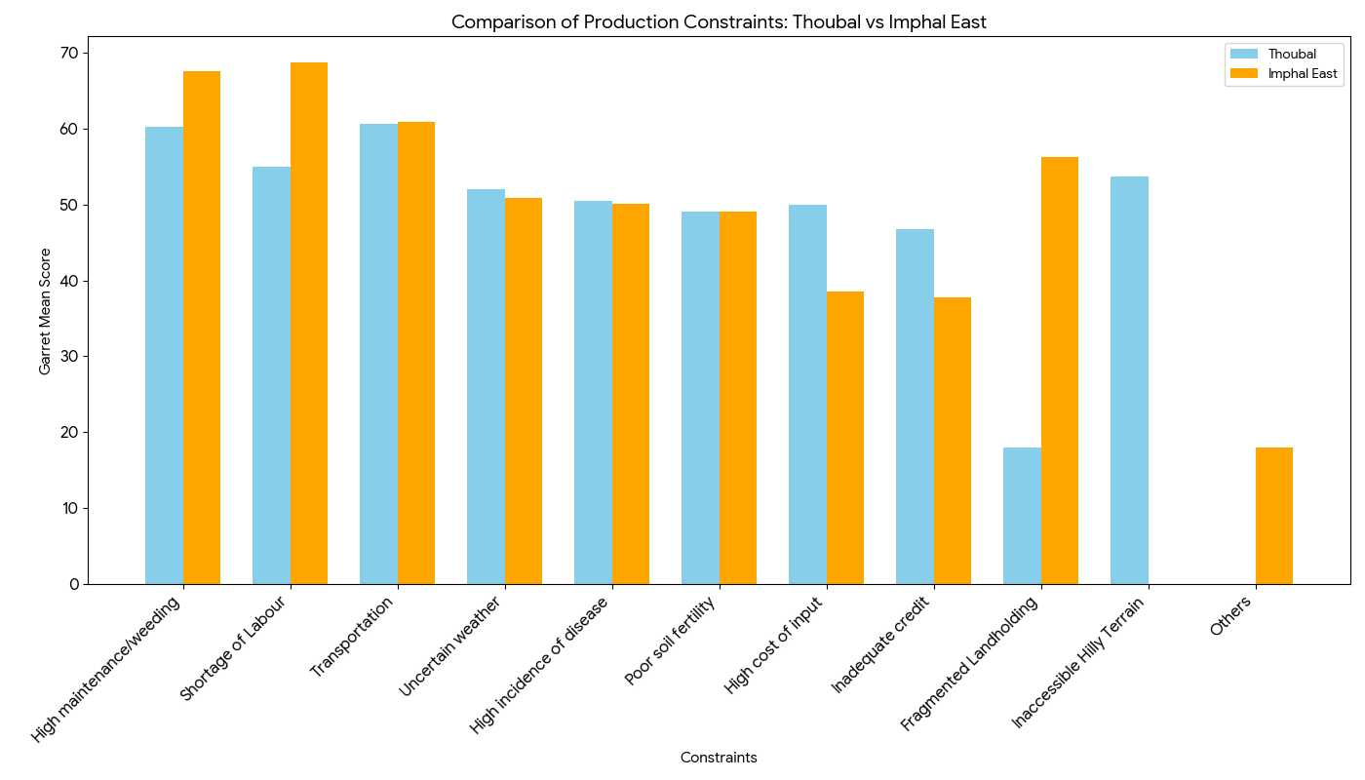
Figure 1: Comparative analysis of constraints in production in Thoubal and Imphal East district.
3.9. Constraints in marketing of Thoubal district
An analysis of pineapple marketing constraints in Thoubal district identifies lack of transportation the lack of transportation is now identified as the most critical constraint (Rank I) with a score of 56.86. This indicates that the physical movement of pineapple from rural farms to secondary market is the primary constrain. This is followed closely by the high difference in final consumers' price and farmer realization (Rank II, 56.29), suggesting a significant disconnect in the value chain where intermediaries or logistical costs swallow the majority of the profit. The biological nature of the pineapple remains a persistent threat, as Perishability is ranked III (54.98). This risk is aggravated by a lack of storage and warehouses (Rank IV, 54.01), which forces farmers to sell their harvests immediately regardless of market conditions. Additionally, a lack of marketing information (Rank V, 53.30) and constant Price fluctuation (Rank VI, 52.29) create an environment of uncertainty, making it difficult for growers to time their sales for maximum profit. Interestingly, while structural issues dominate the top of the list, capacity and competition are viewed as less severe. absence of block-level processing units (Rank VII, 51.73) and High wastage along the supply chain (Rank VIII, 51.31) appear lower in priority. Finally, Market Competitions received the lowest score (Rank IX, 49.43), indicating that the farmers' struggle is not against one another, but rather against a system that lacks the necessary infrastructure to support their produce.
Table 9: Constraints in marketing of Thoubal district.
S.No. | Particulars | Garret Mean Score | Ranking
1 | Lack of transportation | 56.86 | I
2 | High difference in final consumers price and farmer realization | 56.29 | II
3 | Perishability | 54.98 | III
4 | Lack of storage and warehouses | 54.01 | IV
5 | Lack of marketing information | 53.30 | V
6 | Price fluctuation | 52.29 | VI
7 | Absence of Block-level Processing Units | 51.73 | VII
8 | High wastage along supply chain | 51.31 | VIII
9 | Market Competitions | 49.43 | IX

3.10. Constraints in marketing of Imphal east district
In Imphal East district, the marketing constraints for pineapple farmers are primarily centered on the nature of the product and the sellers' capabilities. According to the Garrett Mean Score rankings, Perishability emerged as the most critical constraint (Rank I) with a score of 54.78, highlighting the extreme pressure farmers face to sell their produce quickly before it spoils. This physical vulnerability is increased by systemic infrastructure issues, with a lack of transportation (Rank II, 54.47) and price fluctuation (Rank III, 53.60), which together create a high-risk environment for the growers. The financial gap in the value chain is also a major concern, as the high difference between final consumer prices and farmer realization ranked IV (53.51). This suggests that while consumers pay a premium, the farmers are not seeing a proportional return, likely due to the high wastage along the supply chain (Rank V, 53.40) and a significant lack of storage and warehouses (Rank VI, 53.00). Furthermore, the data indicates a gap in market intelligence and capacity building. Farmers identified a lack of marketing information (Rank VII, 52.82) and absence of block-level processing units (Rank VIII, 52.40) as notable hurdles. Interestingly, Market Competition was ranked as the least significant constraint (Rank IX, 52.12).
Table 10: Constraints in marketing of Imphal east district
S.No. | Particulars | Garret Mean Score | Ranking
1 | Perishability | 54.78 | I
2 | Lack of transportation | 54.47 | II
3 | Price fluctuation | 53.60 | III
4 | High difference in final consumers price and farmer realization | 53.51 | IV
5 | High wastage along supply chain | 53.40 | V
6 | Lack of storage and warehouses | 53.00 | VI
7 | Lack of marketing information | 52.82 | VII
8 | Absence of Block-level Processing Units | 52.40 | VIII
9 | Market Competitions | 52.12 | IX

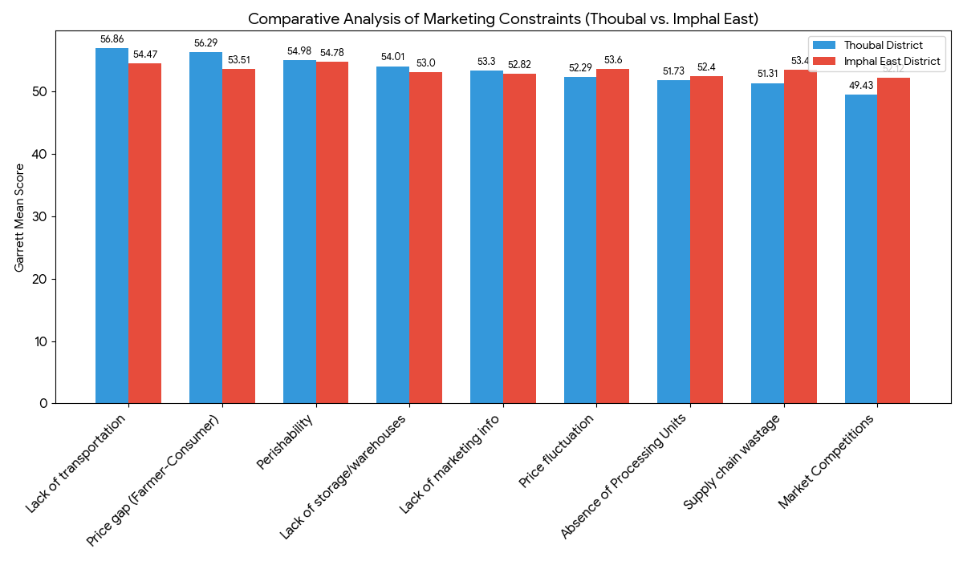
Figure 2: Comparative analysis of constraints in marketing in Thoubal and Imphal East districts.
CONCLUSION
This study offers a comparative understanding of the socio-economic conditions of pineapple farmers in Thoubal and Imphal East districts of Manipur, along with the key challenges they face in production and marketing. The findings show that most farmers belong to the marginal category, which reflects small landholdings and a certain level of economic vulnerability. Even though many farmers are fairly well educated, this has not fully helped them achieve better productivity or market outcomes, mainly due to limitations in infrastructure and institutional support. The study also shows that farming alone is often not enough to sustain livelihoods. As a result, many farmers depend on a mix of agriculture and wage labour to meet their needs. Among the major production challenges are labour shortages during peak seasons, the high effort required for maintenance, and difficulties in transportation. On the marketing side, the highly perishable nature of pineapple, lack of storage and transport facilities, and the large gap between what farmers earn and what consumers pay remain serious concerns.
With all the challenges, pineapple cultivation continues to play an important role in supporting rural livelihoods. However, inefficiencies in the value chain, especially poor post-harvest management and the absence of organized markets limits farmers income. The study highlights the need for practical interventions such as better storage and processing facilities, improved extension services, stronger transport systems, and the promotion of farmer groups or cooperatives. In the long run, improving infrastructure, strengthening market linkages, and building farmers’ capacities will be key to increasing productivity, reducing losses, and ensuring more stable and sustainable incomes for pineapple growers in Manipur.

Disclaimer (Artificial intelligence)

Author(s) hereby declare that NO generative AI technologies such as Large Language Models (ChatGPT, COPILOT, etc.) and text-to-image generators have been used during the writing or editing of this manuscript.

REFERENCES
- Baboo, A., Ramchandra., Thapa, T., & Munna, J. (2022). Socio-economic status of the respondents of regional rural banks in district Bareilly, Uttar Pradesh. The Pharma Innovation Journal, 11(9), 2363–2365.
- Datta, T., Saha, J. K., Rahman, M. A., Chowdhury, A., Akter, M., & Gupta, A. D. (2023). The cost-benefit analysis and constraints of pineapple production in Bangladesh. Archives of Agriculture and Environmental Science, 8(3), 397.
- Devi, H. D., Mahendran, K., Kumar, D. S., & Rohini, A. (2023). An analysis of constraints faced by the farmers and intermediaries in cultivation and value addition of pineapple in Manipur State. Asian Journal of Agricultural Extension, Economics & Sociology, 41(7), 135–139. https://doi.org/10.9734/ajaees/2023/v41i71955
- Devi, S. R., & Singh, L. K. (2018). Zero energy cool chamber, low cost storage structure for vegetables and fruits in Churachandpur district of Manipur. Journal of Krishi Vigyan, 7(1), 216–219. https://doi.org/10.5958/2349-4433.2018.00136.8
- Gayathri, G. N., & Sahana, S. (2022). Socio-economic profile of fruits and vegetable growers: An after the fact research. Asian Journal of Agricultural Extension, Economics & Sociology, 40(11), 175–184.
- Khan, M. I., Bisen, S., & Mahajan, G. (2020). Socio-economic profile of vegetable growers under horticulture based module of Farmer FIRST project in Balaghat (M.P.), India. International Journal of Current Microbiology and Applied Sciences, 9(3), 3252–3257.
- Manipur Organic Mission Agency. (2023). Pineapple (Ananas comosus): Crop profile and cultivation of Queen and Kew varieties in Manipur. Department of Horticulture and Soil Conservation, Government of Manipur. https://momamanipur.mn.gov.in/pineapple/
- Ministry of Agriculture & Farmers Welfare. (2024). Horticulture statistics at a glance 2024. Government of India. https://agricoop.nic.in/
- National Horticulture Board. (2024). Area and production of horticulture crops: State-wise estimates. https://nhb.gov.in/
- Singh, B., Vaidkar, R. D., Shende, N. V., Khobarkar, V. K., & Dangore, U. T. (2024). Economics of pineapple production and marketing in Imphal East district of Manipur. International Journal of Agricultural Sciences, 20(1), 157–164. https://doi.org/10.15740/HAS/IJAS/20.1/157-164
- Singh, N. A., Singh, R. B., Feroze, S. M., & Singh, R. J. (2016). Economic evaluation of pineapple cultivation in Manipur. Economic Affairs, 61(1), 41–44. https://doi.org/10.5958/0976-4666.2016.00006.1
- Singh, R., Tyngkan, H., Sharma, M., & Chand, P. (2023). Efficiency of pineapple production and its determinants: A case study of Manipur. Indian Journal of Extension Education, 59(2), 98–102. https://doi.org/10.48165/IJEE.2023.59221
- NINGOMBAM, S., NOEL, A.S., SINGH, J. (2019). POST-HARVEST LOSSES OF PINEAPPLE AT VARIOUS STAGES OF HANDLING FROM THE FARM LEVEL UP TO THE CONSUMER IN MANIPUR . International Journal of Agriculture Sciences, 11 (22), 9235-9237. https://www.bioinfopublication.org/pages/article.php?id=BIA0005264&utm_source=chatgpt.com

