Short Research Article

Evaluation of the performance of a central pivot in an irrigation system in the Agricultural Unit of Borotou-Koro
ABSTRACT
Background: The performance of an irrigation system is primarily determined by its capacity to ensure uniform water distribution across the irrigated area. This performance is commonly evaluated using the uniformity coefficient (UC), which serves as a key indicator of irrigation efficiency.
Objectives : The objective of this study was to assess the uniformity coefficient of a centre-pivot irrigation system in two sectors of the Borotou-Koro sugar complex.
Study Area and Duration : The study was conducted at the Borotou-Koro Integrated Agricultural Unit, within the irrigation section, over the period from March to June 2024.
Materials and Methods ; The evaluation of irrigation uniformity was carried out using the Heermann and Hein method, based on the American standard ASAE/ANSI S436.1. This method involves estimating the volume of water collected in catch cans positioned at equal radial distances from the pivot. The collected volumes are then weighted according to the corresponding surface areas assigned to each collector, using a standardised equation.
Results : The analysis of the collected data indicates that approximately 95% of the evaluated pivots exhibited either excellent or good uniformity coefficients, whereas less than 2% demonstrated poor performance. However, the results also highlight a lack of systematic inspection and maintenance practices, particularly regarding the timely detection of nozzle malfunctions.
Discussion: The uniformity coefficient is a critical parameter for evaluating the performance of centre-pivot irrigation systems, as it directly influences the consistency of water application. This is particularly important for crops such as sugarcane, whose productivity is highly dependent on adequate and uniform water supply. Therefore, regular monitoring and maintenance of irrigation equipment are essential to sustain optimal system performance.
Keywords : Borotou-koro locality, Irrigation, Sugar complex, Uniformity coefficient,

1. INTRODUCTION
Water is one of the essential factors in agricultural production. A shortage of water is a limiting factor in this production. Consequently, irregular rainfall cannot meet the water needs of the most water-intensive crops. This is particularly the case for sugar cane, which cannot tolerate irregular rainfall patterns linked to climatic variability [1] To cope with climatic hazards and ensure good production, [2] recommends irrigation as a viable alternative. Although this practice involves several methods, it has the same objective. The aim is to meet the water requirements of cultivated plants [3]. According to [4] estimates of plant water requirements are in the order of 1,700 to 2,300 m³/ha/year. However, the performance of irrigation systems, estimated by the uniformity coefficient, should be in the order of 90 to 95% [5] Sprinkler irrigation, which holds great promise for large-scale crops, has gradually been adopted by farmers [6].. This form of irrigation exists in a wide range of more or less sophisticated forms, from manually movable sprinkler booms to pivoting booms. [7] describes this device as a system equipped with a water column and a pivoting ramp that distributes water in a circular pattern around a central axis. According to [8], the operating principle of sprinkler irrigation previously required the development of a platform to anchor the pivot arm. Nowadays, one of the modern irrigation systems used in agriculture is the centre pivot, which makes better use of water resources [9]. It adapts to all types of terrain and ensures production during periods of water shortage [10]. However, this system can present a potential risk of clogging or obstruction of the nozzles. Hence the need to evaluate its performance periodically in order to make the necessary adjustments. This study, which is part of this initiative, aims to evaluate the performance of the pivot irrigation system used by the Sucrivoire company in the Borotou-Koro agricultural unit in Ivory Coast.
2 MATERIAL AND METHODS
2-1. Presentation of the study area
The Borotou-Koro sugar complex, located at geographical coordinates 8°28'37‘W and 7°11'20’N, is situated in north-western Ivory Coast. It takes its name from the locality where it is located (Figure 1: red box). The locality is crossed by tributaries of the Sassandra River, including the Boa and Gbagbé rivers, which serve as a source of water for irrigating the sugar complex's plots. The soils of the sugar complex are ferralitic.
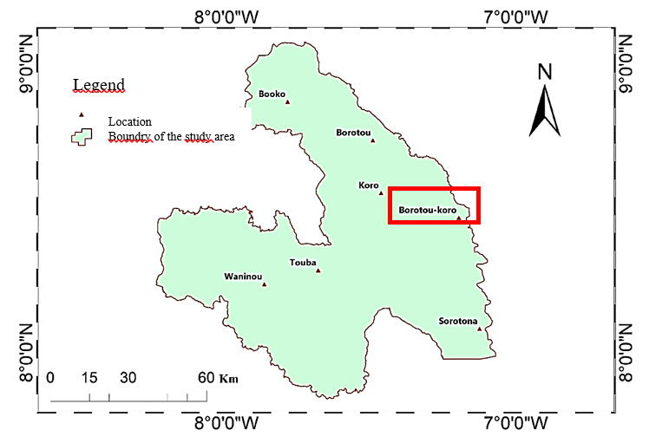
Figure 1 : location of the study site (red box) in the Woroba district (in green) (Auther : Lahouri, 2024)

2-2. Technical data
The Ivory Coast's sugar requirements are estimated at 200,000 tonnes, with annual production estimated at between 150,000 and 180,000 tonnes per year ([11]. To make up for this shortfall and ensure sustainable sugar production, Ivorian sugar companies have opted to expand production areas from 25,400 ha to 61,400 ha [11]. However, the sugar cane industry is facing the thorny issue of climate change, which requires improvements in production factors such as water management. With an average temperature of 27°C, the production area enjoys a monomodal climate characterised by a dry season (November to March) and a rainy season (April to October). Monthly rainfall averages range from 102 to 258 mm, with an annual average of around 1,334 mm [11], while sugarcane requires between 1,500 and 2,500 mm of water for optimal yield. To bridge the gap, a pivot irrigation system has been installed and must undergo periodic evaluation tests to maintain its performance. Although the topography is moderate, the clay-sandy soils are vulnerable to erosion and can therefore be a source of soil pollution in the pumped water, with the immediate consequence of increased turbidity. These soil and climate conditions led to the choice of a pivot system with an average length of 500 m and an average of 8 spans. The average flow rate is 250 m3/h, covering an area of 70 ha in rotation for an average of 20 hours. The average pressure is set at 2,50 bar to prevent excessive soil erosion, which causes nozzle clogging that affects the system's performance, resulting in lower sugar cane yields.
2-3. Study data
The volume of water collected in the collectors at different distances from the pivot constitute the data used to calculate the uniformity test.

2-4. Technical equipment
It onsists of data collection equipment that can be used to calculate the uniformity coefficient (Figure 2) :
➢ Tape measure, to determine the positioning of the ‘water collectors’ from the central pivot (image A);
➢ Pegs, to mark the positioning of the ‘rain collectors’ (image B);
➢ ‘Water collector with funnel’ (in blue), to collect irrigation water from the pivot ramps (image C);
➢ Graduated cylinder, to measure the height of the water collected in the ‘rain collector’ (image D).
➢ Pegs, to mark the positioning of the ‘rain collectors’ (image B);
➢ ‘Water collector with funnel’ (in blue), to collect irrigation water from the pivot ramps (image C);
➢ Graduated cylinder, to measure the height of the water collected in the ‘rain collector’ (image D).
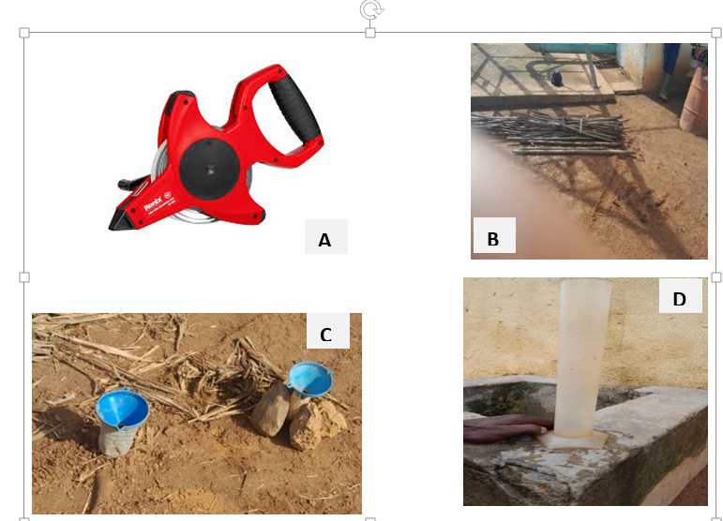
Decameter
Stakes
Collector
Graduated cynlinder
Figure 2 : Some of the technical equipment used to collect field data (A-décameter ; B Stakes ; C- rain collector; D- Graduated cylinder) (Auther : Lahouri, 2024)

2-5. Study data collection
The experimental device is a fixed unit, known as a central pivot, which supports a rotating structure composed of several spans equipped with pipes and nozzles, allowing the pivot to cover the plot by forming concentric arcs. Water is pumped from a river and transported along the pipes to the nozzles, which spray the water in the form of droplets. The layout of the water collectors in relation to the pivot and how they work are shown in Figures 3 and 4. Figure 4 shows a gauge for measuring the volume of water collected.
In practice, the “water collectors” were placed at regular intervals along the line of stakes. Their number varies depending on the range of the pivot. The first “water collector” is placed 15 meters from the central unit. The distance between the two “water collectors” on lines 1 and 2 is 90 cm. The interval between two consecutive collectors on the same line is 10 m. The assembly forms a cone around the central pivot. The last stakes are separated from neighboring lines by a distance of 10 to 50 m. At the end of this operation, the irrigation pivot is run at maximum capacity (100%) for a specified period. The flow rate is low near the pivot and maximum at the end. At the end, the amount of water collected by the “rain collector” is measured in a graduated cylinder. The calculation of efficiency takes into account the height of the water, the distance between the water collectors and the center of the pivot, and the average height of the water collected. The area covered by each “water collector” is proportional to the radius of the spacing between the collectors.
. 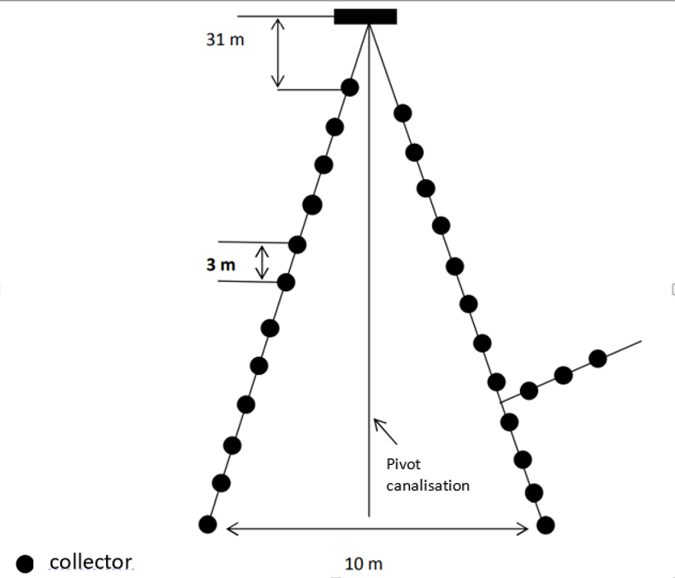
Figure 3. Schematic diagram of the experimental setup of a center pivot irrigation system (black dots represent water collectors).”
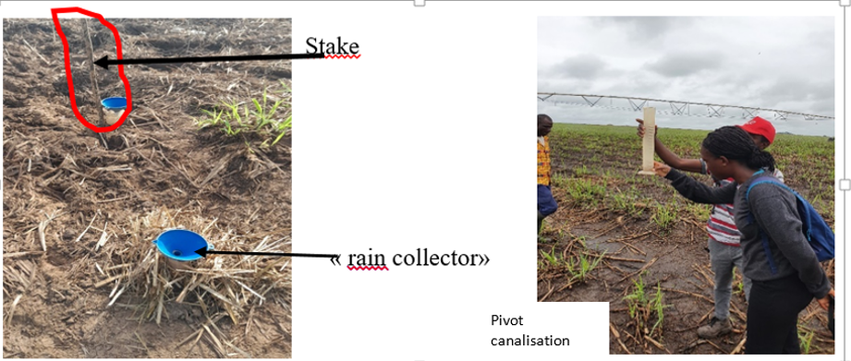
Figure 4. Stake and rain collector Figure 5. Water level reading
(auther : E. Lahouri, 2024)
2-6. Uniformity coefficient estimate
The uniformity of irrigation from the pivoting ramp is obtained using a water distribution test. In this work, [13] attributes the best yields to the uniformity of water distribution in the irrigation systems used. The uniformity coefficient (UC) of the system is calculated from the amount of water collected in each collector. The method used to calculate this coefficient is that of ‘Heermann and Hein’ based on the American standard [141 and defined by :
$CU =100×\left[1-\frac{\sum_{i=1}^{i=n}{\left(Si.\left[Di-\overline{D}p\right]\right)}}{\sum_{i=1}^{i=n}{Si.Di}}\right]$ Equation 1; Where,
CU= Uniformity Coefficient, n = is the water collector in question, Di = water depth or volume of water collected in the collectors, D ̅p = average volume of water collected , Si =Interception area of the collector

3. RESULTS AND DISCUSSION
The results obtained from the analysis of 59 pivots, including 42 in Sector B and 17 in Sector C, revealed two highly significant classes (p < 0.00001), indicating low variability and, therefore, homogeneous data. The uniformity coefficient (UC, %) is thus stable and well controlled within this class. Class 1, comprising 52 observations, exhibited a mean uniformity coefficient of 91.01% ± 1.637, whereas Class 2, with 7 observations, showed lower and more variable values, with a mean of 81.72% ± 1.899 (Table 1). This difference may be attributed to nozzle malfunctions, such as leaks or blockages.).

Table 1: Descriptive analysis
Variable | SC Inter |  | Dl | SC Intra | DI | F | Signif p
Classe UC (%) | 312,033 |  | 1 | 110,063 | 40 | 113,403 | ˂0,00001
UC (%)  Class 1 |  | Descriptive statistics for 52 observations
 |  | Average |  | Standard deviation |  | Variance
 |  | 91,01% |  | 1,637% |  | 2,682%
UC (%)  Class 2 |  | Descriptive statistics for 07 observations
 |  | Average |  | Standard deviation |  | Variance
 |  | 81,72% |  | 1,899% |  | 3,609%
SC Inter: sum of inter-class squares; SC Intra: sum of intra-class squares; Dl: degrees of freedom; F: Fisher's statistic; p: probability associated with the test.; UC (%) : uniformity coefficient class.
In addition, the analysis of the results of uniformity tests for sectors B and C of the complex splot (Table 2 and 3) shows that :
➢ 64 ,3% of pivots in sector B, and 58,8% of those in sector C had an excellent uniformity coefficient (UC) of over 90%, while
➢ 26,2% of the pivots in sector B, and 3,.3% of those in sector C gave a good uniformity coefficient (UC) (value between 85 and 90%)
. Table 2: Efficiency rate of the uniformity coefficients of the various pivots in sector B
Sector B | Excellent | good | fair | poor | Total
Number of pivot | 27 | 11 | 03 | 01 | 42
UC | +90% | 90% | +80% | -80%
rate (%) | 64,3 | 26,2 | 7,1 | 2,4 | 100

Table 3 : Efficiency rate of the uniformity coefficients of the various pivots in sector C
Sector C | Excellent | good | fair | poor | Total
Number of pivot | 10 | 06 | 01 | 00 | 17
UC | +90% | 90% | +80%
rate (%) | 58,8 | 35,3 | 5,9 | 00 | 100

The results obtained for these two sectors indicate good to excellent uniformity coefficients, reflecting the satisfactory performance of the irrigation system implemented within these areas of the complex. These findings are consistent with those reported by [15], as cited in [16]. In that study, the author stated that uniformity coefficient values exceeding the threshold of 80% are considered good to excellent in terms of system performance and efficiency. Nevertheless, this does not preclude the need for regular monitoring in order to detect potential malfunctions and ensure proper system maintenance. In the present study, it appears that
- 7,1% of pivots in sector B, and 5 ;9% of pivots in sector C have a uniformity coefficient (UC) between 80 and 85%, which means that more than 90% of pivots in both sectors have a uniformity coefficient of more than 90%; evidence that irrigation is acceptable, but control needs to be strengthened.
- 2,4% of pivots in sector B alone have a uniformity coefficient (UC) of less than 80%, which could be the cause of poor water distribution uniformity.These observations are consistent with those of [17] , who classify networks in good condition as those with a UC above the 80% threshold, networks requiring cleaning as those with a uniformity coefficient between 70% and 90%, and clogged networks as those with a UC below 70%. Overall, 97.6% (i.e. 40 pivots) of the pivots in Sector B exhibited a uniformity coefficient (UC) above 90%, whereas only 2.4% (i.e. 2 pivots) recorded a UC below 80%. In Sector C, all 17 pivots achieved good to excellent UC values, corresponding to a rate of 100%. These results demonstrate that the irrigation system implemented ensures adequate water distribution across the plots. According to [18], inspection of nozzle condition can facilitate the detection of clogging, leaks, blockages, or wear, thereby enabling timely maintenance to sustain system efficiency. Consequently, such diagnostic assessments should be conducted at least once annually to ensure the proper functioning of mechanised sprinkler irrigation systems. Furthermore, soil characterisation—particularly in terms of permeability—should be incorporated into irrigation efficiency studies, as this parameter directly influences water availability for plant uptake.

4. CONCLUSION
This study shows that the irrigation system deployed in sectors B and C is generally effective in terms of uniformity coefficients, which are good to excellent (above 90%) according to the data collected. The results reveal some weaknesses attributable either to leaks or to nozzle clogging. Maintenance operations are aspects that need to be integrated into the process in order to maintain the performance of the irrigation system. In addition, it is important to include factors such as wind and soil permeability, which affect irrigation, in future studies evaluating irrigation performance.
Disclaimer (Artificial intelligence)

The authors hereby declare that NO generative AI technology, such as large language models (ChatGPT, COPILOT, etc.) or text-to-image generators, was used in the drafting or revision of this manuscript. Only the English translation of the document made use of DePL and AI.

5. REFERENCES
[1] MARE-DGGRRE (Ministry of Agriculture and Water Resources, General Directorate for Rural Engineering and Water Resources), (2017). Preparation report for the investment project in the water sector, 25p.
https://planbleu.org/sites/default/files/upload/files/Rapport_national_Eau_TN.pdf
[2] M’Sadak Y., Douh B., Hamza M. E., (2012). Functional diagnosis of pivot sprinkler systems used on a large irrigated farm in central Tunisia. Larhyss Journal (11): 97-107.
https://www.google.com/url?sa=t&source=web&rct=j&opi=89978449&url=https://www.asjp.cer232ist.dz/en/downArticle/11/7/1/40094&ved=2ahUKEwiD6tfT5vyHAxWgRaQEHbwaJkYQFnoEC234 BMQAQ&usg=AOvVaw3V0DHOf4c7AvmrxJIvoTmZ
[3] Kambou D., Xanthoulis D., Ouattara K., Degre A. (2014). Concepts of water efficiency and productivity (bibliographical synthesis), BASE, Université de Liège, V 18 No 1, p.
108-120.https://popups.uliege.be/1780-4507/index.php?id=16825&file=1&pid=10862
[4] Dunglas J. (2014). Irrigation techniques. Water Group Working Notes No. 6, French Academy of Agriculture, 6 p. https://www.asjp.crist.dz.
[5] Ciheam B. (2020). focuses on addressing water scarcity in the Mediterranean through improved agricultural water management,, sustainable irrigation, and innovative techniques to tackle climate change, https://www.ciheam.org/wp-content/uploads/2023/02/Water-Management-and-Irrigation-in-the-Mediterranean.pdf?utm_source=chatgpt.com
[6] Abla K., Ali H., Abdelilah T.and Marcel K. L’(2020). Expérience de l’irrigation par aspersion dans les secteurs collectifs de la Grande Hydraulique du Maroc. Revue Marocaine des Sciences Agronomiques et Vétérinaires, 2020, 8 (4), pp.399-410, https://hal.science/hal-04561263
[7] Phocaides A. (2008). Manual / Handbook on Pressurized / Food and Agriculture Organization of the United Nations, ISBN : 978-92-5-105817-6
https://www.fao.org/4/a1336e/a1336e.pdf?utm_source=chatgpt.com
[8] Valín, M.I.; Cameira, M.R.; Teodoro, P.R.; Pereira, L.S. Depivot (2012): A model for centerpivot design and evaluation. Computers and Electronics in Agriculture, New York, v. 87, p. 159- 70, 2012. VALIPOU, DOI: 10.1016/j.compag.2012.06.004
[9] Aït H. A., Bouslama A., Baraka M., El Midaoui, M. and Benbella M. (2009). The use of pivot centers for irrigation: Experience of Agricultural Estates of Morocco, Technology Transfer in Agriculture. Monthly Liaison and Information Bulletin of the PNTTA, N°177.
https://www.agrimaroc.net/bulletins/btta_177.pdf?utm_source=chatgpt.com
[10] Luis S. P. Richard G. A, Paula P, Ramón L U., Dirk R, Martin S, Ayse K and Maher S, (2025). Crop evapotranspiration Second edition, revised 2025 Guidelines for computing crop water requirements , Food and Agriculture Organization of the United Nations Rome, 2025 https://agrhysmo.agr.unipi.it/wp-content/uploads/2025/09/FAO56%202025.pdf
[11] Sinali D, Arsène K², Fidèle Y, Benjamin K, Kouakou K³, Adama Di Arona D (2023).. Influence of Climate on Sugarcane Yield in Côte d’Ivoire: Case of the Ferkessédougou Region, Atmospheric and Climate Sciences > Vol.13 No.4, Oct 2023, https://doi.org/10.4236/acs.2023.134032
[12] ANSI/ASAE S436.1 DEC01 (2003). Test Procedure for Determining the Uniformity of Water Distribution of Center Pivot and Lateral Move Irrigation Machines Equipped with Spray or Sprinkler Nozzles,,https://www.canr.msu.edu/uploads/235/67987/ASAE_S436.1.pdf?utm_source=chatgpt.com*
[13] Food and Agriculture Organization (2019). Participatory Irrigation Management: Guidelines and Best Practices, https://openknowledge.fao.org/handle/20.500.14283/ca6030en
[14] Richard M. P. S., van der G. &. van den Berg H. R (1989). The working equations of a vibrating wire viscometer. Physica A: Statistical Mechanics and its Applications, 156(3), 909–920. https://doi.org/10.1016/0378-4371(89)90027-7
[15] Bergeron D. (2010). Management of drip irrigation in the production of day-neutral strawberries in Quebec, Symposium on irrigation in horticulture. What if irrigation were ‘metered’», https://www.agrireseau.net/petitsfruits/documents/bergeron_resume.pdf
[16] Alper B.Yeşim B. Ç., Cenk K. and Burak D. (2025) Evaluation of Hydraulic and Irrigation Performances of Drip Systems in Nectarine Orchards (Prunus persica var. nucipersica) in The Mediterranean Region, Water 2025, 17(5), 758; https://doi.org/10.3390/w17050758
[17] Douh B., Chehaibi S. and Zouaghi M., (2012). Diagnostic Analysis of the Maintenance of Mechanised Sprinkler Irrigation Systems Using a Frontal Boom in the Debousselem Region, Tunisia. Larhyss Journal, ISSN 1112-3680, n° 11, November 2012, pp. 47-61© 2012 All rights reserved ,https://www.researchgate.net/publication/275582059_Analyse_diagnostique_du_mainTien_En_Etat_De_Fonctionnement_Des_Systemes_D'irrigation_Mecanisee_par_aspersion_cas_d'une_rampe_frontale_dans_la_region_de_bousselem_tunisie#fullTextFileContent

