Use of oil palm male inflorescence and sawdust as substrate in soilless bell pepper (Capsicum annuum L.) cultivation

ABSTRACT
Faced with increasing demographic pressure and rampant urbanization, soilless farming appears as a sustainable solution for intensifying agricultural production in spaces restricted. This study aims to evaluate the effect of plant residues as an alternative substrate in soilless cultivation of pepper (Capsicum annuum L.). The evaluation of physical parameters Chemical analysis of the substrates was performed using dosages. Monitoring of agronomic parameters was done through observations and measurements. The results obtained show that the inflorescence The male oil palm and the ash tested possess physicochemical properties. Favorable to soilless cultivation. The inflorescence of the oil palm, amended by the solutions of Ash and NPK (nitrogen, phosphorus and potassium) yielded significant results on fruit growth and number. pepper. Thus, these locally available plant residues constitute an alternative promising and economical compared to imported substrates, contributing to waste recovery organics in urban and peri-urban agriculture.
Keywords : Soilless culture, plant residues, pepper, agriculture, NPK, ash.

- INTRODUCTION
Rapid population growth in Africa leads to an urgent need to maximize the agricultural production to feed a constantly growing population (Saleh Mahamat and al., 2025). The strong demographic pressure and the accelerated pace of urbanization in Africa call for agricultural solutions adapted to limited spaces. This development makes necessary development of compact, sustainable agricultural production systems and autonomous, especially in urban areas. With advances in science and technology, it It has become possible to replace soil with other supports or even to cultivate without support (FAO, 2024). Soilless cultivation is relatively one of the most efficient means for solve the problems of agricultural product quality, out-of-season production and the economy of water and inputs (Elmhirst, 2005 ; Demirsoy et al., 2010). It has become the the most efficient production method in the current agricultural industry (Dorais et al., 2000). The production of quality seedlings is a guarantee of success for their transplanting [1]. It calls for the establishment of specialized spaces, such as nurseries, which constitute the place recommended to produce vigorous and better quality seedlings (Wigthman., 1999 ; M'Sadak., 2012a). Plant residues constitute the ideal substrates for the production of plants in soilless culture (M'Sadak., 2013a ; M'Sadak., 2015., M'Sadak., 2015a). However, despite the availability of these residues, they are not used as a basis The substrate for vegetable plant production is not applicable. In order to put to the point of substrates having the claimed physical, chemical and agronomic requirements for plant production. This study aims to evaluate the effect of plant residues as alternative substrates in soilless cultivation of pepper (Capsicum annuum L.).

- MATERIAL AND METHODS
  - Plant material
The plant material consisted of pepper (Capsicum annuum L.) of the variety Narwhal and the male inflorescence of the oil palm, and sawdust as substrates (Figure 1).
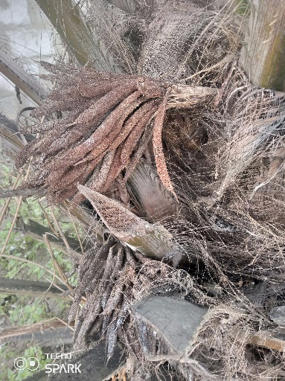  a | 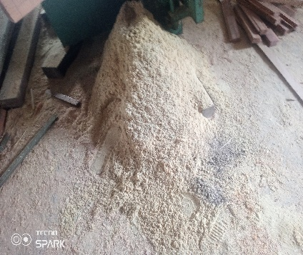  b
Figure 1. Male inflorescence of the oil palm (a) and sawdust (b)
  - Methods
    - Evaluation of the physicochemical parameters of the substrates
      - Preparing the solution
10 g of the male inflorescence of the oil palm and sawdust were macerated b separately in 50 mL of distilled water, under magnetic stirring at room temperature for 15 minutes. The solutions obtained allowed for the direct reading of the pH, of the electrical conductivity as well as the mass concentration of N, P and K.
      - Evaluation of the physical parameters of the substrates
        - Porosity
The substrates were filled separately into a cylinder. Each cylinder was saturated with water. then let it drain. The volume of water drained divided by the volume of the cylinder, multipliedby 100, gave us given the porosity :
PT [%] = [[void volume / volumes total] X 100
        - Apparent density (AD)
The substrates were slightly moistened and placed in cylinders. The contents of the The cylinders were oven-dried at a temperature of 70°C for 24 hours. After the process of After drying, the substrates were weighed. The weight was divided by the volume of the cylinder used for each substrate.
$$DA(\%)= ( \frac{PSsub}{Vc} )×100$$
DA : apparent density
PSsub : dry weight of the substrate contained in the volume
Vc : volume of the cylinder
      - Evaluation of the chemical parameters of the substrates
        - Electrical conductivity (CE)
Electrical conductivity was obtained by direct reading of the EC value using a multiparameter pH meter.
        - Mass concentration of nitrogen (N), phosphorus (P) and potassium (K)
For mass concentration, they were obtained by direct reading on the multiprobe of the N, P and K.
    - Cultivation technique
      - Setting up a plant nursery
NARVAL variety pepper (Capsicum annuum) seeds were broadcast sown in 25-liter drums with side cuts (Figure 2). These drums were filled with black soil and regular monitoring was maintained until the transplanting stage.

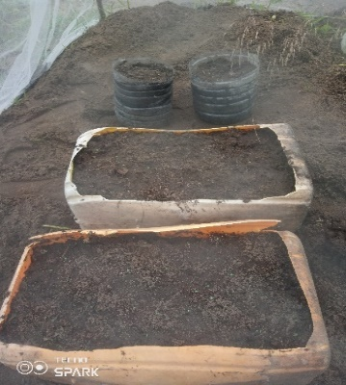
Figure 2. Containers of black soil used as a nursery
      - Preparation of plant substrates and experimental setup
        - Preparation of plant substrates
The male inflorescence of the oil palm and the sawdust were sorted by separating them at foreign matter or bodies, then disinfected with 10% sodium hypochlorite for eliminate crop pests (figure 3).
Following these steps, the substrates were placed separately in cut-off 10L containers. in two equal parts.
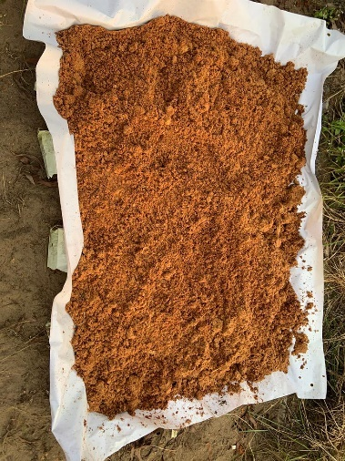  a | 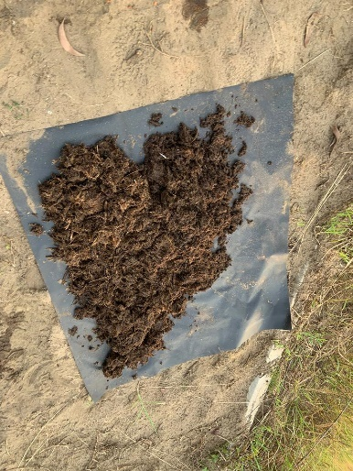  b
Figure 3. Plant residues left to dry in the sun : sawdust (a) ; male inflorescence of the oil palm (b)

        - Experimental setup and preparation of nutrients
The study was conducted using a Tree-by-Tree experimental design. 9 g of NPK (15.15.15) and 50 g of ash were homogenized separately in 1000 mL of tap water for 15 minutes.
Transplanting pepper seedlings
Transplanting was carried out on the 30th day after sowing; the selected plants showed between 5 and 9 Perfectly developed leaves. Each selected plant was carefully transplanted. In 10 L containers previously cut and filled with the specific substrate (inflorescence) male oil palm or sawdust). For this, 1000 mL of NPK and NPK solutions The ash was added separately by pot at 15-day intervals. Regarding the contribution 1000 mL of each solution was used, combining the NPK solution and the ash solution. alternately after 6 days in some pots, making sure to alternate with a clear watering between Each application was made with 1000 mL of tap water. This factorial approach allowed to constitute six distinct treatments obtained by crossing the variables : substrate inflorescence/NPK solution ; substrate inflorescence/ash solution ; substrate inflorescence/ NPK solution + ash solution ; sawdust substrate/NPK solution ; sawdust substrate/ash solution and sawdust substrate/NPK solution + ash solution. Each of these six treatments was replicated eight times, representing 48 experimental units. Two control treatments were added to this main sample: male inflorescence of oil palm (T1) and sawdust (T2), each repeated three times, contributing 6 additional units. The entire experimental setup therefore focused on 54 separate units, each unit corresponding to an individual pepper plant grown in controlled and specific conditions (figure 4).

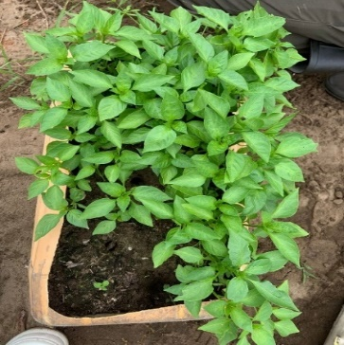  a | 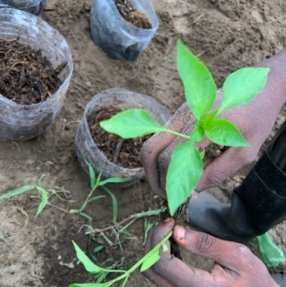  b | 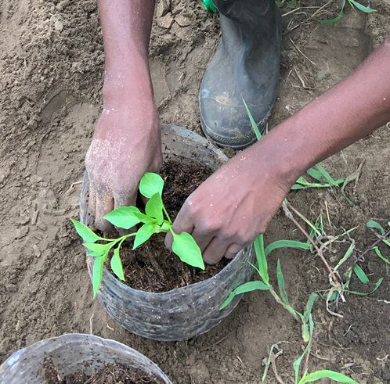  c
Figure 4. Plants transplanted into pots: plants after 10 days in nursery (a); selected plant (b);
selected plant transplanted into pots (c).
    - Maintance
Each container has been carefully perforated at its base to ensure efficient drainage and prevent water stagnation was addressed, while adaptive shading with mosquito nets was installed. To protect the plants from insects. Regular manual weeding helped eliminate the competitive weeds, thus preserving essential nutrient and light resources to plant development. These meticulous cultivation practices, combined with a constant monitoring maintained optimal conditions for reliable assessment of different experimental treatments throughout the study.
    - Monitoring of agronomic variables
Phenological observations and measurements were taken every 7 days from transplanting until stage of commercial fruit maturity, in order to collect data related to the various organs (flowers and fruits). The collected parameters were recorded for height and diameter of the stem at the collar, and this data was supplemented by manually counting the number of leaves, flowers and fruit. The diameter of the stem at the base was measured using calipers. Digital measurement just above the area where the roots emerge and the height using a meter ribbon from the base of the plant to the highest point of the stem. All these observations and Measurements were taken between 06 hour and 10 hour
    - Data analysis
SPSS software, version 22.0, was used to analyze the collected data. The averages Concentrations were first compared using a one-way ANOVA test. Then, when Differences were detected, and comparisons were made using Student's t-test. Newman. The significance level was set at p < 0.05.
- RESULTS
  - Physicochemical parameters of the male inflorescence of the oil palm and of sawdust
    - Physical parameters of the male inflorescence of the oil palm and of sawdust
Table 1 presents the physical parameters of the sawdust and the male inflorescence. Of the oil palm. These results show that the sawdust has a higher porosity than that of the male inflorescence of the oil palm with a porosity of 88 % versus a porosity of 65 % for the male inflorescence of the oil palm. Regarding the apparent density Sawdust has a low apparent density compared to that of the male inflorescence of the oil palm with respectively 0.38 and 0.669 g/cm³.
Table 1. Paramètres physique des deux résidus végétaux
Physical parameters | Substrates
Physical parameters | SB | IMPH
PT (%) | 88.00 | 65.00
DA(g/cm3) | 0.38 | 0.669

Notes: SB : Sawdust ; IMPH : Male inflorescence of oil palm ; PT : Total porosity ; DA : Apparent density.

    - Chemical parameters of the male inflorescence of the oil palm and of sawdust
Table 2 presents the chemical parameters of the male inflorescence of the oil palm and of sawdust. The results show that sawdust (SB) has a pH of 6.96, while that of the male inflorescence of the oil palm is 7.32. The electrical conductivity is 0.20 and 1.54 respectively for sawdust (SB) and male palm inflorescence oil (IMPH). Regarding the mass concentration of N, P and K, the sawdust presents a mass concentration of 2, 4 and 9 respectively for N ; P and K against 32 ; 26 and 87 for the male inflorescence of the oil palm with respective N, P and K.
Table 2 : Chemical parameters of plant residues
Substrates | Paramètres chimiques
Substrates | pH | CE  (mS/cm) | N  (mg/kg) | P  (mg/kg) | K  (mg/kg)
SB | 6.96 | 0.20 | 2 | 4 | 9
IMPH | 7.32 | 1.54 | 32 | 26 | 87

Notes: SB : Sawdust ; IMPH : Male inflorescence of the oil palm ; pH : potential of hydrogen ; CE : electrical conductivity ; N : Nitrogen ; P : Phosphorus ; and K : Potassium
  - Phenological monitoring
During the seven weeks following transplanting, regular visual observation of the crops has has been carried out. Regarding recovery, all the plants transplanted into the different environments show a 100% success rate. Visually, it was observed that the plants grown in the NPK-enriched media (B2, B3, B5, and B6) did not show any signs of yellowing. Foliar (figure 5b). In contrast, yellowing of the leaves was observed on the plants evolving in environments not enriched in NPK (B1, B4, T1 and T2) figure 5a.
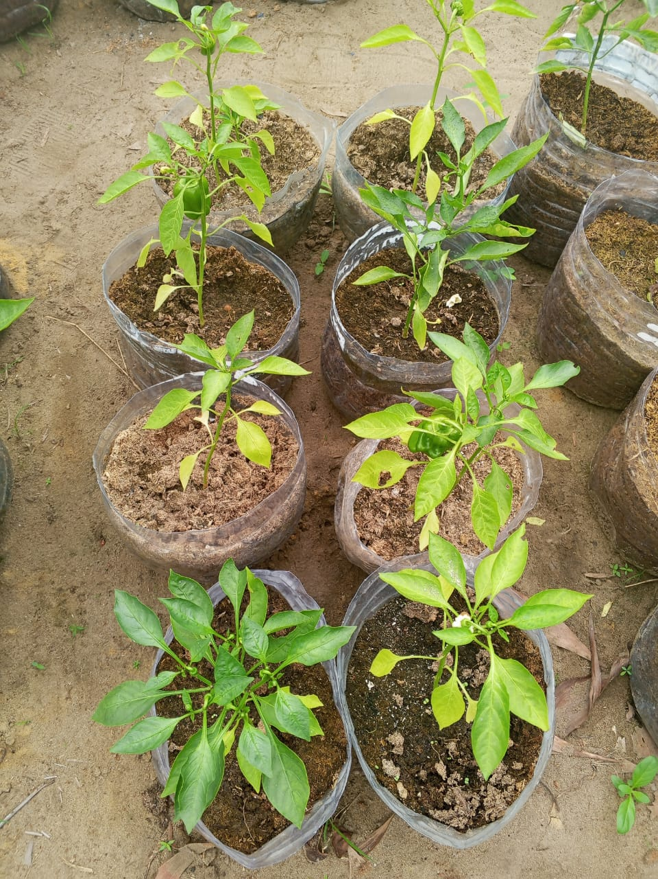  a | 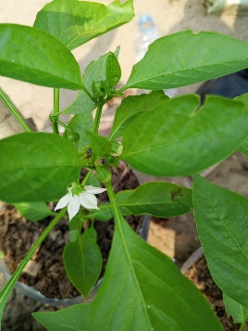  Figure 5. General appearance of the plants 7 weeks after transplanting  b

    - Effect of male oil palm inflorescence and sawdust amended with ash and NPK on pepper stem height
Table 3 shows the variations in average pepper stem height in the Soilless substrates amended with or without NPK and ash during the experiment. results show that the average stem height of plants grown in the media, B1 ; B2 ; B3 ; B4 ; B5 ; B6 ; T1 and T2 increased significantly (p < 0.001) during the experiment. At week 7, the results revealed four homogeneous groups (a, b, c and d) observed. This is group a, composed of the height of the plants in environments B5 and T2, all the two marked by the lowest average heights. Group b includes the middle B4, B6, and T1. Group c is formed by the midpoints B1 and B2. Finally, group d, represented exclusively by plants of the B3 medium, distinguished by the highest average height raised at this stage of experimentation. Finally, it is noted that from the first to the last week of the experiment, the plants of middle B3 has the highest height (Table 3).
Table 3 : Classification of substrates according to pepper stem height (cm)
Time  (week) | Growing environments
Time  (week) | B1 | B2 | B3 | B4 | B5 | B6 | T1 | T2
S1 | 9.20 ª | 7.93 ª | 11.32 ª | 10.92 ª | 10.17 ª | 10.72 ª | 10.27 ª | 10.47 ª
S2 | 11.73 ^{b} | 9.47 ª | 15.88 ^{c} | 12.97 ^{b} | 11.58 ^{b} | 12.2 ^{b} | 11.70 ^{b} | 12.17 ^{b}
S3 | 14.42 ª | 12.42 ª | 19.53 ^{b} | 15.07 ª | 12.30 ª | 13.10 ª | 12.50 ª | 12.37 ª
S4 | 19.83 ^{c} | 16.18 ^{b} | 25.72 ^{d} | 16.45 ^{b} | 12.82 ª | 16.63 ^{b} | 15.30 ^{b} | 14.03 ^{b}
S5 | 24.05 ^{c} | 20.75 ^{c} | 32.37 ^{d} | 21.17 ^{c} | 14.85 ª | 20.17 ^{b} | 18.43 ^{c} | 16.10 ^{b}
S6 | 28.02 ^{c} | 25.05 ^{c} | 3818 ^{d} | 21.70 ^{b} | 15.03 ª | 21.40 ^{b} | 20.43 ^{b} | 16.47 ª
S7 | 33.08 ^{c} | 28.33 ^{c} | 38.80 ^{d} | 22.52 ^{b} | 15.92 ª | 24.08 ^{b} | 24.50 ^{b} | 16.60 ª
Notes :
B1 : male inflorescence of oil palm + wood ash solution ; B2 : inflorescence + NPK solution ; B3 : inflorescence + ash solution + NPK solution ; B4 : sawdust + ash solution ; B5 : sawdust + NPK solution ; B6 : sawdust + ash solution + NPK solution ; T1 : inflorescence control and T2 : sawdust control.
Comparison of classes between rows. The same letters are not significantly different at the 5% level according to the test of Student Newman.
    - Effect of male oil palm inflorescence and sawdust amended with ash and NPK on stem diameter at the crown of pepper
The diameter of the stem at the crown of peppers in substrates amended with NPK and ash at The course of the experiment is illustrated in Table 4. The results recorded in this The table shows that the diameter of the stem at the collar of plants grown in B1 media, B2, B3, B4, B5, B6, T1 and T2 increase significantly (p < 0.001) during the experiment. Finally, at week 7, the results confirmed a significant variation (p-value < 0.05) of the stem diameters at the collar between these different media. Three groups homogeneous media (a, b, and c) are identified. Group a is formed by media B5, T2, and B2, which exhibit the lowest average stem diameters. Group b includes the midpoints B1, B4, B6, and T1. Group c is represented only by midpoint B3, still in head with the highest stem diameter at the collar (Table 4).
Table 4. Substrate classification according to stem diameter at the crown of pepper plants (mm)
Time (week) | Growing environments
Time (week) | B1 | B2 | B3 | B4 | B5 | B6 | T1 | T2
S1 | 0.12 ª | 0.11 ª | 0.21 ^{b} | 0.11 ª | 0.09 ª | 0.13 ª | 0.20 ^{b} | 0.13 ª
S2 | 0.15 ª | 0.14 ª | 0.30 ^{b} | 0.15 ª | 0.12 ª | 0.14 ª | 0.20 ª | 0.13 ª
S3 | 0.21 ª | 0.16 ª | 0.40 ^{b} | 0.23 ª | 0.21 ª | 0.19 ª | 0.28 ª | 0.14 ª
S4 | 0.33 ª | 0.21 ª | 0.43 ^{b} | 0.24 ª | 0.20 ª | 0.21 ª | 0.28 ª | 0.16 ª
S5 | 0.38 ª | 0.25 ª | 0.54 ^{b} | 0.23 ª | 0.20 ª | 0.22 ª | 0.34 ª | 0.16 ª
S6 | 0.49 ^{b} | 0.31 ª | 0.54 ^{b} | 0.30 ª | 0.21 ª | 0.25 ª | 0.31 ª | 0.24 ª
S7 | 0.57 ^{b} | 0.35 ª | 1.27 ^{c} | 0.32 ª | 0.21 ª | 0.34 ª | 0.36 ª | 0.25 ª
Notes :
B1 : Male inflorescence of oil palm + wood ash solution ; B2 : Inflorescence + NPK solution ; B3 : Inflorescence + ash solution + NPK solution ; B4 : Sawdust + ash solution ; B5 : Sawdust + NPK solution ; B6 : Sawdust + ash solution + NPK solution ; T1 : Inflorescence control and T2 : Sawdust control. Comparison of classes between rows. The same letters are not significantly different at the 5% level according to the Student's t-test
    - Effect of male inflorescence and sawdust amended with ash and NPK on the number of pepper leaves
The number of leaves on pepper plants growing in different growing environments, at knowing B1, B2, B3, B4, B5, B6, T1 and T2 during the experiment, is illustrated in the figure 6. It shows that in the first week, the number of leaves on the plants does not vary in a way significant between the environments. The values are relatively low and close, ranging between 6 (B6) and 9 leaves (B3). Throughout the experiment, the number of leaves gradually increased in all culture media. In the 3rd week, a first Differentiation: middle B3 already shows a clear lead with 20 sheets, followed by B1 (14 leaves), while the other environments record between 10 and 11 leaves. This evolution becomes more pronounced from the 5th week onwards, where the B3 middle reaches 40 leaves, compared to 32 leaves (B1), 22 leaves (B2), 17 leaves (B4), and only 13 leaves in B5, which has the lowest value. By week 7, the discrepancies are confirmed: the number of leaves reaches its maximum in the middle B3 with 61 leaves, followed by B1 (54), B2 (38), B6 (23), T1 (24), B4 (19), while media B5 and T2 recorded the lowest values with respectively 15 and 12 leaves.

Figure 6. Number of pepper leaves during the experiment
Notes :
B1 : male inflorescence of oil palm + wood ash solution ; B2 : inflorescence + NPK solution ; B3 : inflorescence + ash solution + NPK solution ; B4 : sawdust + ash solution ; B5 : sawdust + NPK solution ; B6 : sawdust + ash solution + NPK solution ; T1 : inflorescence control and T2 : sawdust control.
    - Effect of male inflorescence and sawdust amended with ash and NPK on the number of pepper flowers
The number of flowers on pepper plants growing in different growing environments, at knowing B1, B2, B3, B4, B5, B6, T1 and T2 during the experiment, is illustrated in the figure 7 corresponding. It shows that flowering began in the fourth week. A first Flowering is observed only on plants in medium B3, with a value of 1 flower, while that the plants in the other media did not flower. As the experiment progressed, the number of flowers gradually increased in some culture media. By the seventh week, the The highest value is recorded on the plants in medium B3, with a total of 7 flowers. It is followed by plants from environments B6 (5 flowers), B2 (4 flowers), B5 (4 flowers), B1 (2 flowers), and B4 (2 flowers). Environments T1 and T2 did not flower during the same week.

Figure 7. Number of pepper flowers during the experiment
Notes :
B1 : male inflorescence of oil palm + wood ash solution ; B2 : inflorescence + NPK solution ; B3 : inflorescence + ash solution + NPK solution ; B4 : sawdust + ash solution ; B5 : sawdust + NPK solution ; B6 : sawdust + ash solution + NPK solution ; T1 : inflorescence control and T2 : sawdust control.
Comparison of classes between rows. The same letters are not significantly different at the 5% level according to the Student-Newman test
    - Effect of male inflorescence and sawdust amended with ash and NPK on the number of pepper fruits
The number of fruits on pepper plants growing in different growing environments, at knowing B1, B2, B3, B4, B5, B6, T1 and T2 during the experiment, is illustrated in the figure 8. It shows that in the first, second, third, and fourth weeks, no fruit was observed in all culture media. It was in the fifth week that there was formation of the first fruit on the plant in the middle B3 (figure 8). A change is noted at the sixth week, where B3 records 3 fruits, followed by B1 and B6, which each have 1 fruit. The other areas remain unfruited. By the seventh week, the trend. Diversifies: middle B3 has a total of 2 fruits, B1 also has 2 fruits, B2 and B6 have each have 1 fruit, while environments B4, B5, T1 and T2 do not yet have any fruit.
Figure 8. Number of pepper fruits during the experiment
Notes :
B1 : male inflorescence of oil palm + wood ash solution ; B2 : inflorescence + NPK solution ; B3 : inflorescence + ash solution + NPK solution ; B4 : sawdust + ash solution ; B5 : sawdust + NPK solution ; B6 : sawdust + ash solution + NPK solution ; T1 : inflorescence control and T2 : sawdust control.
- Discussion
Evaluation of the apparent density and porosity of the male inflorescence of the oil palm and ash components of the substrate revealed the important values of these parameters. Regarding apparent density, sawdust has a lower apparent density than that of The male inflorescence of the oil palm. The value observed on the male inflorescence of the palm the oil content is within the range mentioned by FAC (1995). This author showed that for the case of a substrate intended for use in soilless cultivation, its apparent density must be understood between 0.434 and 0.836 g/cm3. This value represents the apparent density of the male inflorescence of the Oil palm could address the root anchorage problems of plants in the case of Soilless cultivation. Total porosity assesses a substrate's ability to retain water while ensuring good ventilation. The results observed, in particular, were 65% and 88% respectively for The male inflorescence of the oil palm and sawdust, these results could thus affirm that these two residues will be favorable to better root growth and better aeration of the root environment, approaching in accordance with the range of values mentioned by Schafer and Lerner (2022). Regarding pH, the results show that the male inflorescence of the Oil palm and sawdust have a pH close to neutral. These results confirm the pH criterion for a good pepper growing substrate. Similar results were obtained by COOK, (2020). The analyses show a high richness of The male inflorescence of the oil palm is rich in NPK, suitable for pepper cultivation as described by Cook (2020). Conversely, sawdust is found to be low in NPK, which may This can be attributed to the non-ionic organic composition of wood, such as cellulose. hemicellulose and lignin, which release very few ions into available NPK solution for plants. Furthermore, the absence of soluble minerals and the slow decomposition of matter Lignocellulosic materials further limit the release of nutrients into the substrate (Van Der Sloot et al., 2022). During the seven weeks following subculturing, a visual observation Regular crop management was carried out. All seedlings transplanted into the different environments have demonstrated satisfactory recovery, with a 100% recovery rate. Visually, the plants cultivated in media enriched with NPK (B2, B3 and B6) generally did not show any Signs of yellowing leaves indicate good nutrient absorption. Essential nutrients, particularly nitrogen. However, yellowing of the leaves was observed in the unenriched media (B1, B4) as well as in controls T1 and T2, probably due to a nutrient deficiency, as indicated by the study by Mahmud et al. (2020), which associates the Leaf yellowing is caused by nitrogen deficiency in vegetable crops. It is also It is important to note that medium B5, although enriched with NPK, showed signs of yellowing, which can be explained by a nutritional imbalance or a lack of organic support (water retention, structure) due to its substrate, while the addition of ash (middle B6) would have slightly corrected this imbalance through its amending effect, but without to completely compensate for the absence of structural organic matter in the containing environment sawdust. These results are consistent with those obtained by Abdourahamane Issa et al. (2020), which demonstrated the beneficial effect of a combined supply of organic matter and ash on the growth and productivity of millet, thus confirming the agronomic interest of this type of fertilization. Regarding flowering, medium B3 produced the first flower as early as the fourth week after transplanting, indicating an early maturity that is favorable to productivity. Media B1 and B2 showed their first flowers in the fifth week, while the Media B4, B5, and B6 showed flowering in the sixth week. These differences in the Early flowering can be attributed to the quality of the substrate and its ability to release quickly delivers the nutrients necessary for floral induction. This interpretation aligns with the work by Alkharpotly (2018), which showed that enriched substrates promote significantly early flowering of sweet peppers, improving availability immediate and progressive delivery of nutrients necessary for floral metabolism. Furthermore, according to, Oil palm residues are rich in easily digestible organic elements biodegradable (Zulkefli, 2023), promoting the release of nutrients into the substrate. On the other hand, raw sawdust is low in nitrogen and contains phenolic compounds which can inhibit growth, as highlighted by Nitu (2016), which justifies its Lower performance when not previously composted. Plant residues, associated with these amendments, have had an overall positive effect on growth, height, the Flowering and fruiting of the plants. The substrate component of the combined male inflorescence The ash and NPK mixture (medium B3) gave the best results, with high averages. Of the height of the stem diameter at the collar, of the foliage, of the flowering and of the fruiting. These performances can be explained by the synergy between the amending properties of the ash and the organic structure of the inflorescence, favorable to nutrient retention and absorption. Conversely, the unenriched control T1 showed reduced height growth, diameter, number of leaves, and no flowers or fruit. The results obtained in this study are consistent with the work of Harjoko et al., (2017), which highlighted the interest of a organo-mineral combination to stimulate the growth of Capsicum annuum in system hydroponics. The superior performance of substrate B3 is therefore explained by a synergy Favorable nutritional and physical conditions. Furthermore, Casique-Valdés et al., (2024) emphasize that Slow-degrading residues, such as sawdust, can limit the availability of nitrogen and... other essential nutrients, which is observed in substrates B4 to B6. These results confirm that the inflorescence can be used in agriculture as described by Pelaez and al. (2024). This comparison clearly highlights the superiority of the male inflorescence oil palm as an organic substrate for soilless pepper cultivation. Thus, the good agronomic performance observed with the male inflorescence of the oil palm during Experimentation confirms the results of laboratory analysis. This substrate offers both a high nutrient content and a chemical environment favorable to the growth of plants, unlike sawdust, which requires additional inputs of elements fertilizers.
- CONCLUSION
With the aim of utilizing plant residues as a substrate in soilless cultivation of the Capsicum annuum, the objective of this study was to evaluate the effect of plant residues such as Alternative substrates for growing peppers other than bell peppers. The use of the male inflorescence of the palm tree. oil and sawdust as a substrate, amended with NPK and ash, have effects significantly positive on the growth, flowering and fruiting of Capsicum annuum. The male inflorescence substrate of the oil palm amended by the combination of Wood ash and NPK gave the best results, with a height, a stem diameter at collar, a number of leaves, a number of flowers and a number of fruits significantly greater to that of other treatments. The specific substrate/amendment combination allows to obtain optimal growth and production of Capsicum annuum in soilless culture. This study sheds light on the use of the male inflorescence of the oil palm as a substrate in soilless cultivation of Capsicum annuum.

Disclaimer (Artificial intelligence)

Author(s) hereby declare that NO generative AI technologies such as Large Language Models (ChatGPT, COPILOT, etc.) and text-to-image generators have been used during the writing or editing of this manuscript.

REFERENCES
Saleh Mahamat Alhassan, Amadou Sandra, Mahamat Djourabi, (2025). Impact des
investissements agricole sur la croissance économique au Tchad, 12(1), 78-88.
DOI : https://doi.org/10.20431/2349-0381.1201009.
FAO. (2024). Growing without soil – Hydroponics fundamentals – pros and cons.
Elmhirst, J. (2005). Profil de la culture de la fraise au Canada. Agriculture et
Agroalimentaire Canada, Centre sur la lutte antiparasitaire. Agri-Réseau. 60 P.
Demirsoy, L., Demirsoy, H., Ersoy, B., Balci, G., & Kizilkaya, R. (2010). Seasonal variation
of N, P, K and Ca content of leaf, crown and root of ‘Sweet Charlie’ strawberry under
different irradiation. Zemdirbyste-Agriculture, 97(1), 23–32.
Abdourahamane Issa, M. Nourou, Kiari, S. A., Aissata, M. I., Amadou Oumani, A., & Aune, J.
B. (2020). Effets combinés des doses croissantes de fientes de poules associées à la cendre,
des placements et sarclage mécaniques et de traitements de semences sur la performance
du mil au Niger. Afrique SCIENCE – Revue Internationale des Sciences et Technologie,
17(2), 67–82. DOI : https://www.researchgate.net/publication/3441655
Alkharpotly, A. (2018). Growth and yield responses of sweet pepper (Capsicum annum L.) to
organic and NPK mineral fertilization under plastic houses conditions at arid regions.
Journal of Plant Production, Egypt’s Presidential Specialized Council for Education and
Scientific Research, 299-305. DOI : https://www.academia.edu/85081288
Casique-Valdés, R., Tovar, L. E., & Garcia Hernández, R. (2024). Bagasse of Dasylirion spp.
as an alternative substrate for Capsicum annuum soilless cultivation. Asian Journal of
Plant Sciences, 23(1), 123–131.
Cook, C. (2020). List of pH & EC Levels for 65+ Hydroponic Vegetables & Herbs.
FAC (1995). Compost and sewage sludge: guidelines and recommendations of the research
centre for agricultural chemistry and environmental science with respect to waste
fertilisers. Edmzart.-nr. 730.920.
Harjoko, D., Samanhudi, S., Dewi, W., & Pujiasmanto, B. (2017). The effects of substrate and
nutrition on chili (Capsicum annuum) hydroponic. Communication présentée au
Indonesian Biotechnology Conference, Surakarta, Indonésie. Sebelas Maret
University. 9 p.
Mahmud, Md. K., Hossain, T., Mou, T. H., Ali, A., & Islam, M. (2020). Effect of nitrogen on
growth and yield of chili (Capsicum annuum L.) in roof top garden. ResearchGate,
8(1), 246‑251. DOI : https://doi.org/10.24925/turjaf.v8i1.246-251.2763
M’Sadak Y., Elouaer M.A. et Dhahri M (2012a). Croissance comparée des plantes de gombo
en culture de pleine terre selon les modes semis direct et repiquage. Algerian Journal
of Arid Environment, 2(2), 62-70.
M’Sadak Y., Elouaer M.A. et Dhahri M (2013a). Production et croissance des plants de gombo
(Abelmoschus esculentus L.) sur substrats de culture issus d’un mélange de tourbe et
de compost dans une pépinière maraîchère hors sol en Tunisie. Rev. Mar. Sci. Agron.
Vét., 2, 5-11.
M’Sadak Y. and Bouallegue A (2015). Study of opportunities of use of composts cunicoles for
the aboveground production of tomato plants in Tunisia. J. Fundam. Appl. Sci., 7(2),
244-259.
M’Sadak Y. et Fhima F (2015). Potentialités de substitution de la tourbe importée par un
substrat à base de compost ou co-compost en pépinière maraîchère hors sol
(Tunisie). Revue Agriculture Sétif (RAS), 10, 31-37.
Nitu Falasi, J. R., Lumpungu, C. K., Bienayaku, V., & Mufwaya, C. K. (2016). La sciure de
bois, un déchet à valoriser pour l’agriculture en R.D. Congo. Congo Sciences,
4(1), 58–61.
Pelaez, R. D. R., Oliveira, M. E. C., Miller, R. N. G., de Almeida, J. R. M., & de Siqueira, F.
G. (2024). Biotechnological valorization of lignocellulosic residues from the oil palm
industry: status and perspectives. Biomass Conversion and Biorefinery,
14(3), 3077‑3099. DOI : https://doi.org/10.1007/s13399-022-02637-4
Schafer, G., & Lerner, B. L. (2022). Physical and chemical characteristics and analysis of plant
substrate. Ornamental Horticulture, 28, 81‑192.
DOI : https://doi.org/10.1590/2447-536X.v28i2.2496
Helder B. E. Sales, Adriano De S. Carolino, Ronald Z. De A. Nunes, Célio M. A. Macalia, Camila M.
Ruzo, Camila Da C. Pinto, Jaqueline De A. Bezerra, Pedro H. Campelo, Ștefan Țălu, Luiz K.
C. De Souza, Edgar A. (2024). Sanches, Advances in Agricultural Technology: A Review of
Slow- Release Nanofertilizers and Innovative Carriers Communications in Soil Science and
Plant Analysis, 55(2), 1849–1882,
DOI : 10.1080/00103624.2024.2326145.

Țălu, Ș. (2024). Insights on Hydroponic Systems: Understanding Consumer Attitudes in the Cultivation
of Hydroponically Grown Fruits and Vegetables. HIDRAULICA, 1, 56-67.

Van Der Sloot, M., Kleijn, D., De Deyn, G. B., & Limpens, J. (2022). Carbon to nitrogen ratio
and quantity of organic amendment interactively affect crop growth and soil mineral
N retention. Crop and Environment, 1(3), 161‑167.
DOI : https://doi.org/10.1016/j.crope.2022.08.001
Wigthman K.E (1999). Bonnes pratiques de culture en pépinière forestière : directives pratiques
pour les pépinières communautaires. Manuel technique, n°2, 95 p.
Zulkefli, M. H. H., Jamian, S., Ismail, S. I., Adam, N. A., Jalinas, J., & Mohd Masri, M. M.
(2024). Nutritional composition of anthesising male inflorescence of oil palm
(Elaeis guineensis) essential for development of Elaeidobius kamerunicus Faust : First
report. Journal of Oil Palm Research, 36(2), 254–266.
DOI : https://doi.org/10.21894/jopr.2023.0027.

