Paget’s Disease of the Breast with Underlying Invasive Ductal Carcinoma in a 64-Year-Old Woman: A Case Report

ABSTRACT
Introduction: Paget’s disease of the breast is a rare manifestation of breast carcinoma involving the nipple–areolar complex and accounts for approximately 1–4% of all breast cancers ¹. It is frequently associated with underlying ductal carcinoma in situ (DCIS) or invasive carcinoma ². Its resemblance to benign dermatologic conditions often leads to delayed diagnosis. The Aim of this article is to highlight diagnostic delay and barriers to care.
Case Presentation: A 64-year-old multiparous, postmenopausal woman presented with a right nipple–areolar ulcer. Histopathology revealed Paget’s disease with an invasive ductal carcinoma component. There was no evidence of distant metastasis at diagnosis. She was subsequently counselled for neoadjuvant chemotherapy and modified radical mastectomy.
Discussion: Paget’s disease is strongly associated with underlying carcinoma, most commonly invasive ductal carcinoma ^{2,3}. Clinical features often resemble benign dermatologic conditions, leading to diagnostic delay¹⁰. Due to the presence of an eczematous lesion, the main differential diagnosis of Paget's disease is nipple eczema, but the unilateral nature, progressive nature and lack of response to corticosteroid therapy make it possible to diagnose the disease. Though like the index case majority of the patients has had to be on prolonged non proper oncological evaluation. Diagnosis is histological, and management depends on the presence and extent of invasive disease. Mastectomy remains an appropriate treatment modality when invasive carcinoma is identified, breast conservation is not an appropriate option because of location of the lesion. Radical treatment (mastectomy) has long been considered the appropriate treatment for Paget's disease of the nipple, due to its frequent association with multifocal or multicentric breast cancer.
Conclusion: Persistent nipple ulceration in elderly women warrants prompt biopsy to exclude malignancy. Early recognition and surgical intervention improve outcomes. Increased awareness is required to improve survival in this oncological condition resembling dermatological pathology.
Keywords: Paget’s Diseas, nipple ulceration, Ductal Carcinoma, awareness

1. INTRODUCTION
Paget’s disease of the breast is an uncommon form of breast carcinoma characterized by malignant glandular epithelial cells infiltrating the epidermis of the nipple and areola. It accounts for approximately 1–4% of all breast malignancies ¹. In 80–90% of cases, it is associated with underlying ductal carcinoma in situ (DCIS) or invasive carcinoma, most commonly invasive ductal carcinoma ². The clinical presentation frequently mimics eczema or chronic dermatitis, contributing to delayed diagnosis ^{2,3}. Thus high index of suspicion is required for diagnosis of Paget’s disease which presents as a persistent one-sided ulceration of the nipple-areolar region especially in postmenopausal women. The Aim of this article is to highlight diagnostic delay and barriers to care. This is to improve the survival outcome in this category of patients as well as to further create awareness regarding the presentation of Paget’s disease and management, owing to the fact that it can pose a diagnostic dilemma to clinicians at all levels of care.

2. CASE PRESENTATION
A 64-year-old female trader, para 4 (all children breastfed for one year each), presented with a progressively enlarging ulcer involving the right nipple–areolar complex. Menarche was attained at 13 years of age and menopause at 56 years. There was no family history of breast cancer and no other identifiable risk factors. There was no history suggestive of distant spread.
Examination revealed a centrally located ulcerative lesion involving the right nipple–areolar complex with irregular margins and a raw erythematous base. Surrounding skin showed hyperpigmentation and thickening. No clinical evidence of distant metastasis was noted. A wedge biopsy was performed.

Histopathology Findings: Microscopy demonstrated, Epidermal ulceration, Large malignant intraepidermal cells with abundant pale cytoplasm and prominent nucleoli (Paget cells), Dermal desmoplasia, Malignant cuboidal cells forming ductal structures, Intense lymphocytic infiltrates
Final Diagnosis: Paget’s disease of the breast with invasive ductal carcinoma component.
Staging investigations showed no radiological evidence of distant metastasis
The patient was subsequently counselled for neoadjuvant chemotherapy and modified radical mastectomy. However, patient declined treatment and decided to resort to alternative care due to believe it is not a malignancy. Efforts are still underway to encourage patient to accept appropriate treatment for her condition.
3. Discussion
Paget’s disease typically affects women in the fifth to seventh decades of life ^{1,3}. The epidermotropic theory, which proposes migration of malignant ductal cells into the nipple epidermis, is widely accepted, particularly in cases where invasive carcinoma is present ². Paget's disease of the breast may be associated with ipsilateral breast cancer in 82 to 100% of cases, of which 13.3 to 52% are carcinoma in situ and 30 to 60% are invasive, or it may be isolated, including 1.4 to 13.3% ^{4,5}.
Most cases of carcinoma in situ are associated, with multifocal disease in 42 to 63% of cases. Paget's disease has been explained by several theories, of which two main theories are often described: The 1st theory maintains that luminal lactiferous duct epithelial cells give rise to Paget's cells, which migrate retrogradely into the overlying epidermis; The second theory suggests that Paget's cells transform in-situ and are derived from cells of the terminal lactiferous duct at its junction with the epidermis. This can explain situations in which Paget’s Disease is not associated with an underlying carcinoma or is anatomically distant from an underlying carcinoma^{6,7}.
Diagnosis is often delayed, with constant involvement of the nipple in the initial stage, notably with the presence of pruritus and a nipple that becomes red and shiny; in the intermediate stage, the nipple becomes thick, reddened and scaly; and in the late stage, erosion and indurated crusting with clear boundaries appear, extending very slowly and centrifugally from the nipple towards the areola. Bloody or serous discharge from the nipple is present in 30-60% of cases, with a palpable mass which may be distant from the nipple in 30-50% of cases ⁸. All of these stages of progression and evolution of the disease were noticed by this index case and of the initial suspicion was never thought of as being a carcinoma.
In the presence of an eczematous lesion, the main differential diagnosis of Paget's disease is nipple eczema, but the unilateral nature, progressive nature and lack of response to corticosteroid therapy make it possible to diagnose the disease. The index case as reported had prolonged and chronic use of topical medication of which steroid is a major component. Other differential diagnoses, such as psoriasis, superficial basal cell carcinoma and melanoma, may also be considered, but only histology can confirm the diagnosis. However, the decision to do a biopsy is often delayed as the initial presentation is to non-specialist and in some cases to non-medical professionals as in the index case. This approach will surely influence prognosis and survival of patients. Hence serious efforts should be made to mitigate these deficiencies through health promotion and health education.
Whenever Paget's disease is suspected, mammography is performed to detect heterogeneous, poorly defined microcalcifications with suspicious opacities. The sensitivity of mammography to detect a tumour is 97% in the presence of a palpable mass, whereas it is only 50% in the absence of a palpable mass ⁸. Breast ultrasound is routinely performed to find formations that attenuate ultrasound and to aid biopsy. Additionally, imaging techniques such as MRI can be used to show further images of the breast and to determine if a lesion is present^{3,9}.
Paget's disease is diagnosed with certainty either by cytological scraping of the nipple or, at best, by nipple-areolar biopsy.
Clinical features often resemble benign dermatologic conditions, leading to diagnostic delay ¹⁰. Persistent unilateral nipple-areolar lesions unresponsive to treatment should prompt biopsy. This as was in this case where she presented with unilateral nipple-areolar lesion. She had applied series of topical agents, enteral medications as well as herbal mixtures with no remission. Thus, presented following advice to seek medical care. It is imperative to state that Paget’s disease although a rare condition will require community and stakeholders’ education to enhance prompt specialist consultation in patients when faced with a suspected lesion especially in the nipple areolar region. These measures will go a long way to prevent or reduce rates of decline in acceptance of appropriate care due to false perception as was seen in the present case. The attitude towards accepting treatment for paget’s disease and other malignancies will no doubt increase cancer related morbidity and mortality especially in sub-saharan African. Further buttressing the for more enlightenment campaign and health education.
Histologically, this lesion is characterised by the presence of pagétic cells in the epidermis of the nipple. These are large cells with clear cytoplasm and a large irregular hyperchromatic nucleus, the site of mitosis ⁹. It is important to biopsy not only the superficial lesion, but also any underlying abnormalities detected on physical examination or imaging. This is to ensure the inclusion of adequate pathologic specimen for proper histological evaluation.
Radical treatment (mastectomy) has long been considered the appropriate treatment for Paget's disease of the nipple, due to its frequent association with multifocal or multicentric breast cancer. In their study of 70 patients with Paget's disease of the nipple, Kothari et al. found that 60% had invasive carcinoma, more than a third of which was palpable ⁹. Forty-one percent (41%) of this group had multifocal breast cancer and 30% multicentric. In the group with underlying non-palpable breast cancer, multifocality and multicentricity were found in 60% of cases.
Currently, the majority of teams adopt conservative treatment. This treatment consists of performing a central lumpectomy removing the nipple-areolar plate, followed by radiotherapy ^{4,10}, even if there is a limited associated cancer proven by imaging ¹¹. However, several factors should be considered in breast conservative surgeries in the tropics especially availability and affordability of radiotherapy and accessibility of such care. It also includes patients’ eligibility for breast conservative surgery.
The evaluation of lymph node involvement (sentinel lymph node technique) in cases of Paget's disease of the nipple is not yet clear. This would be considered in cases of association with radiologically and histologically proven invasive cancer ¹².
Currently no data are available to support the use of endocrine therapy in the management of paget’s diseases without an associated DCIS or invasive carcinoma ¹³.
Post-treatment surveillance is correlated with that of the breast carcinoma with which it is associated, and the prognosis of Paget's disease of the nipple is conditioned by the association with an underlying cancer ¹¹

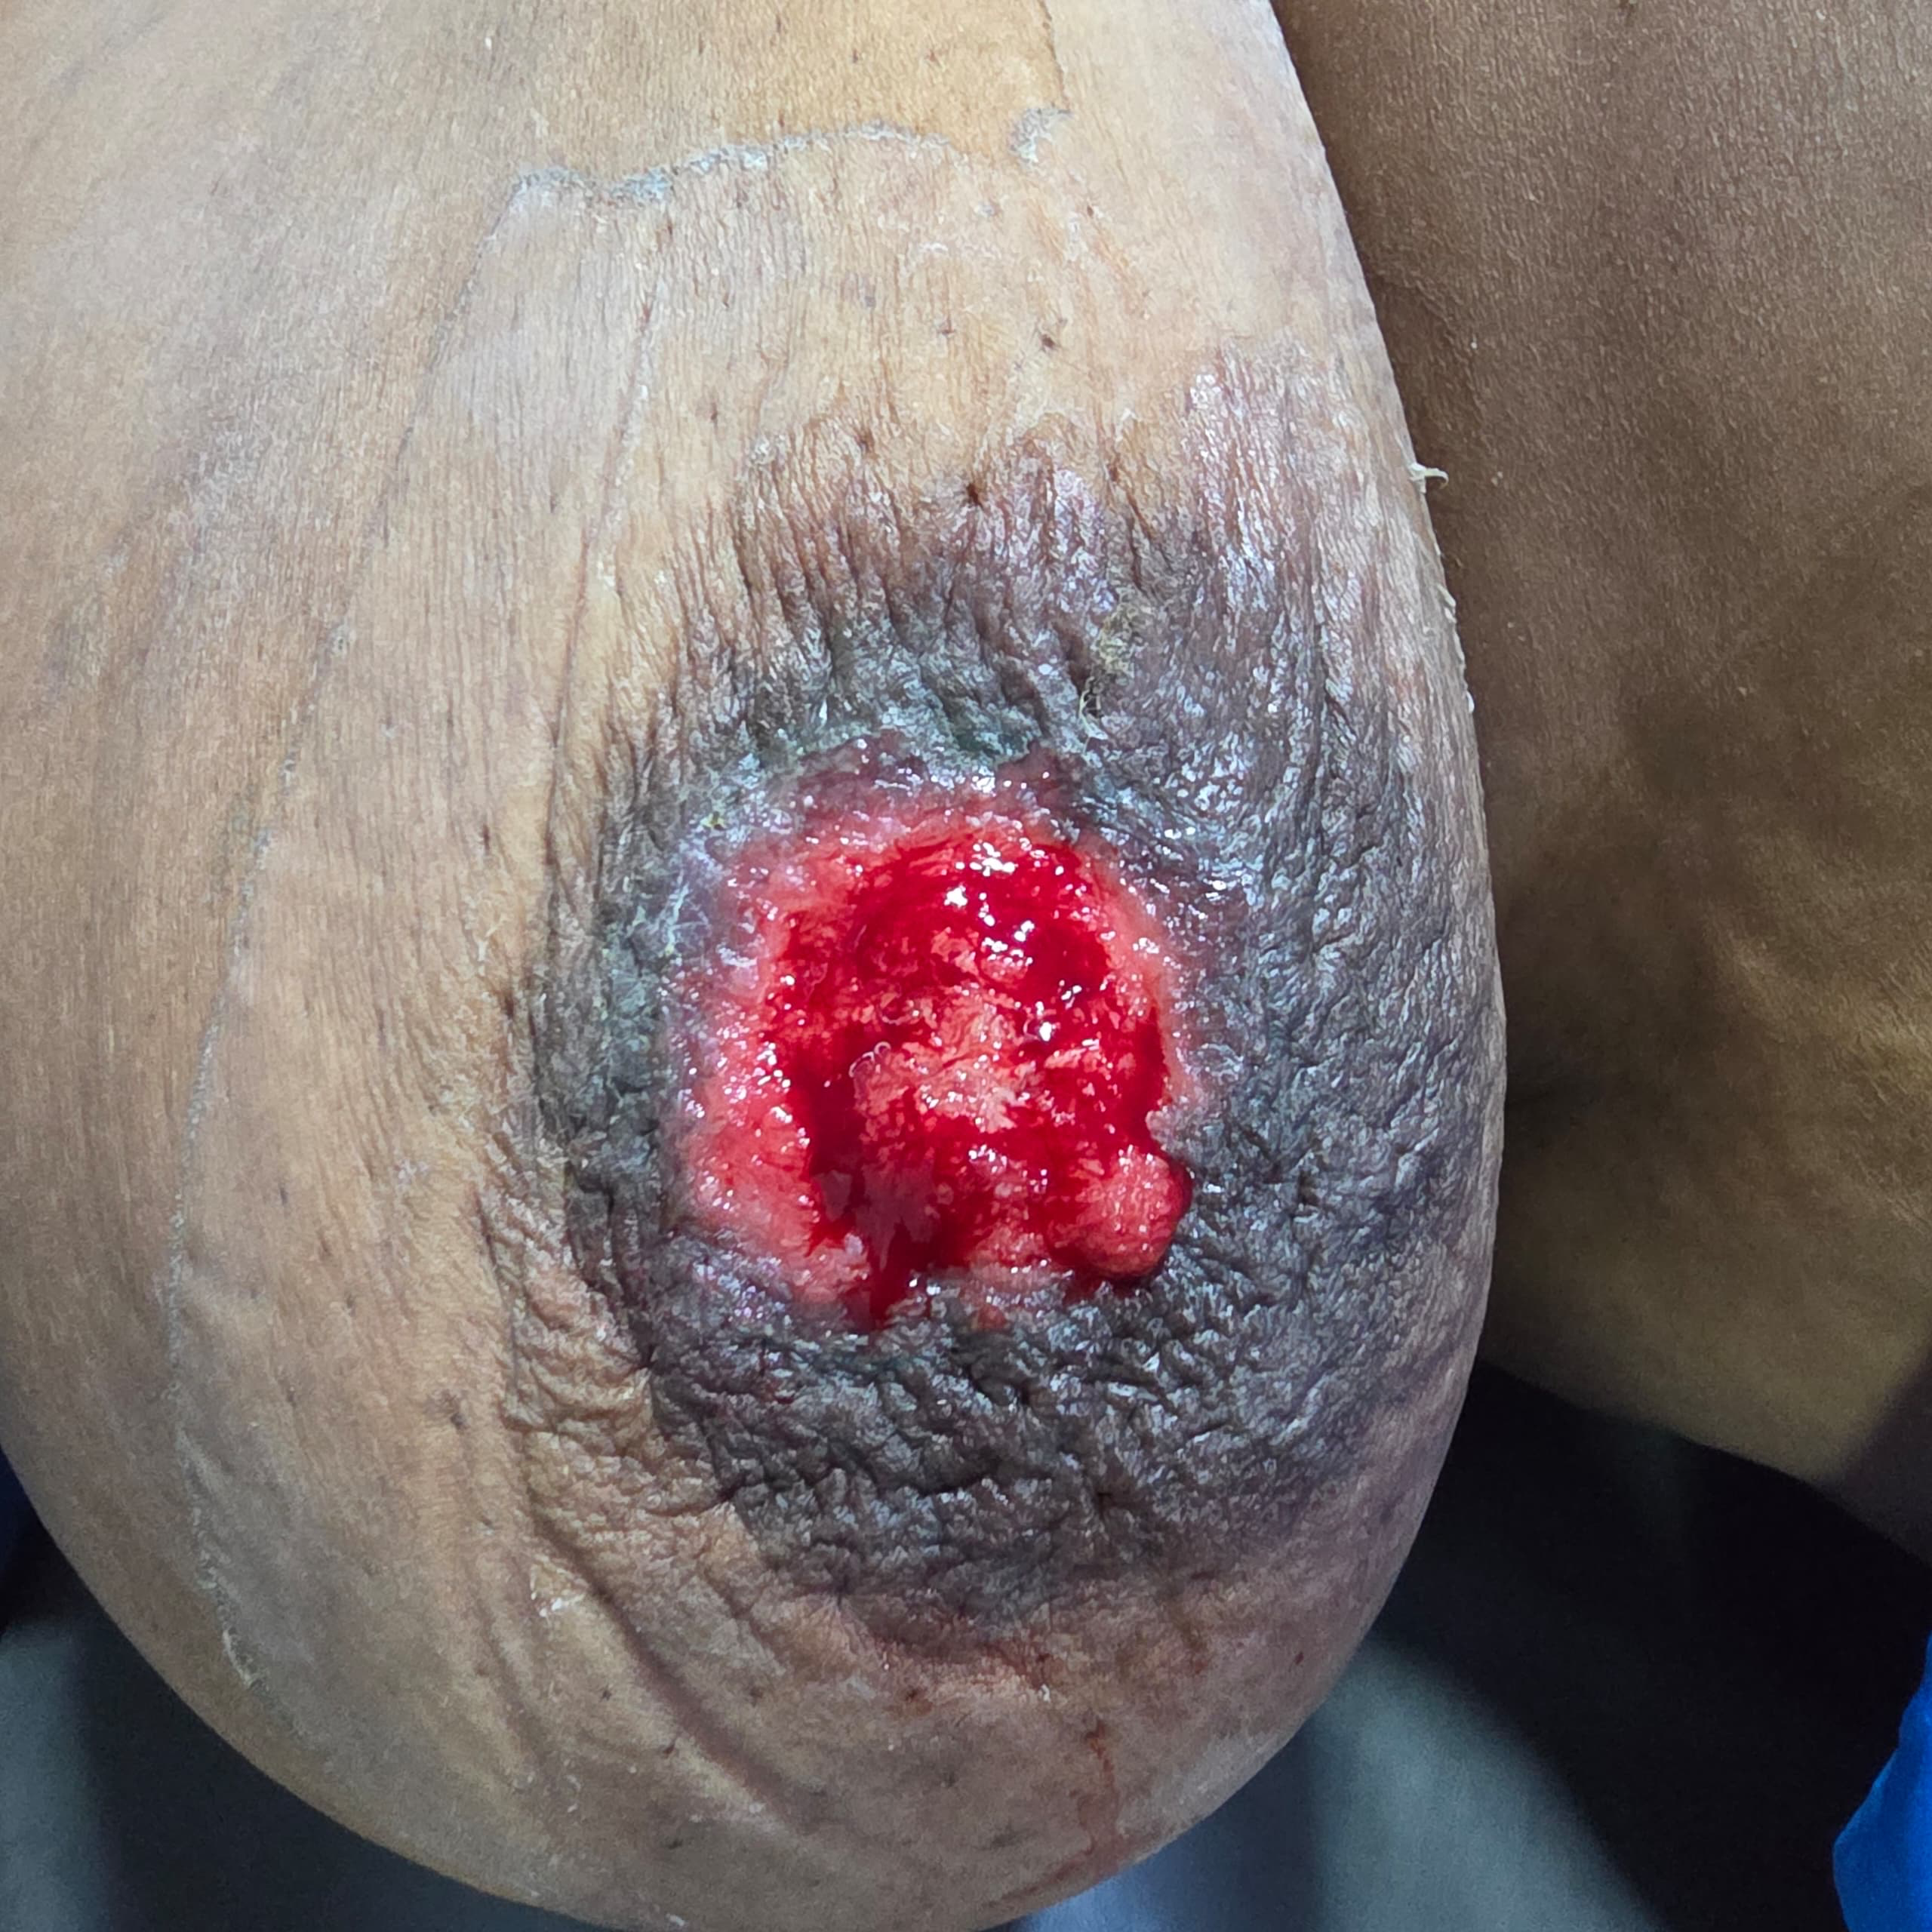
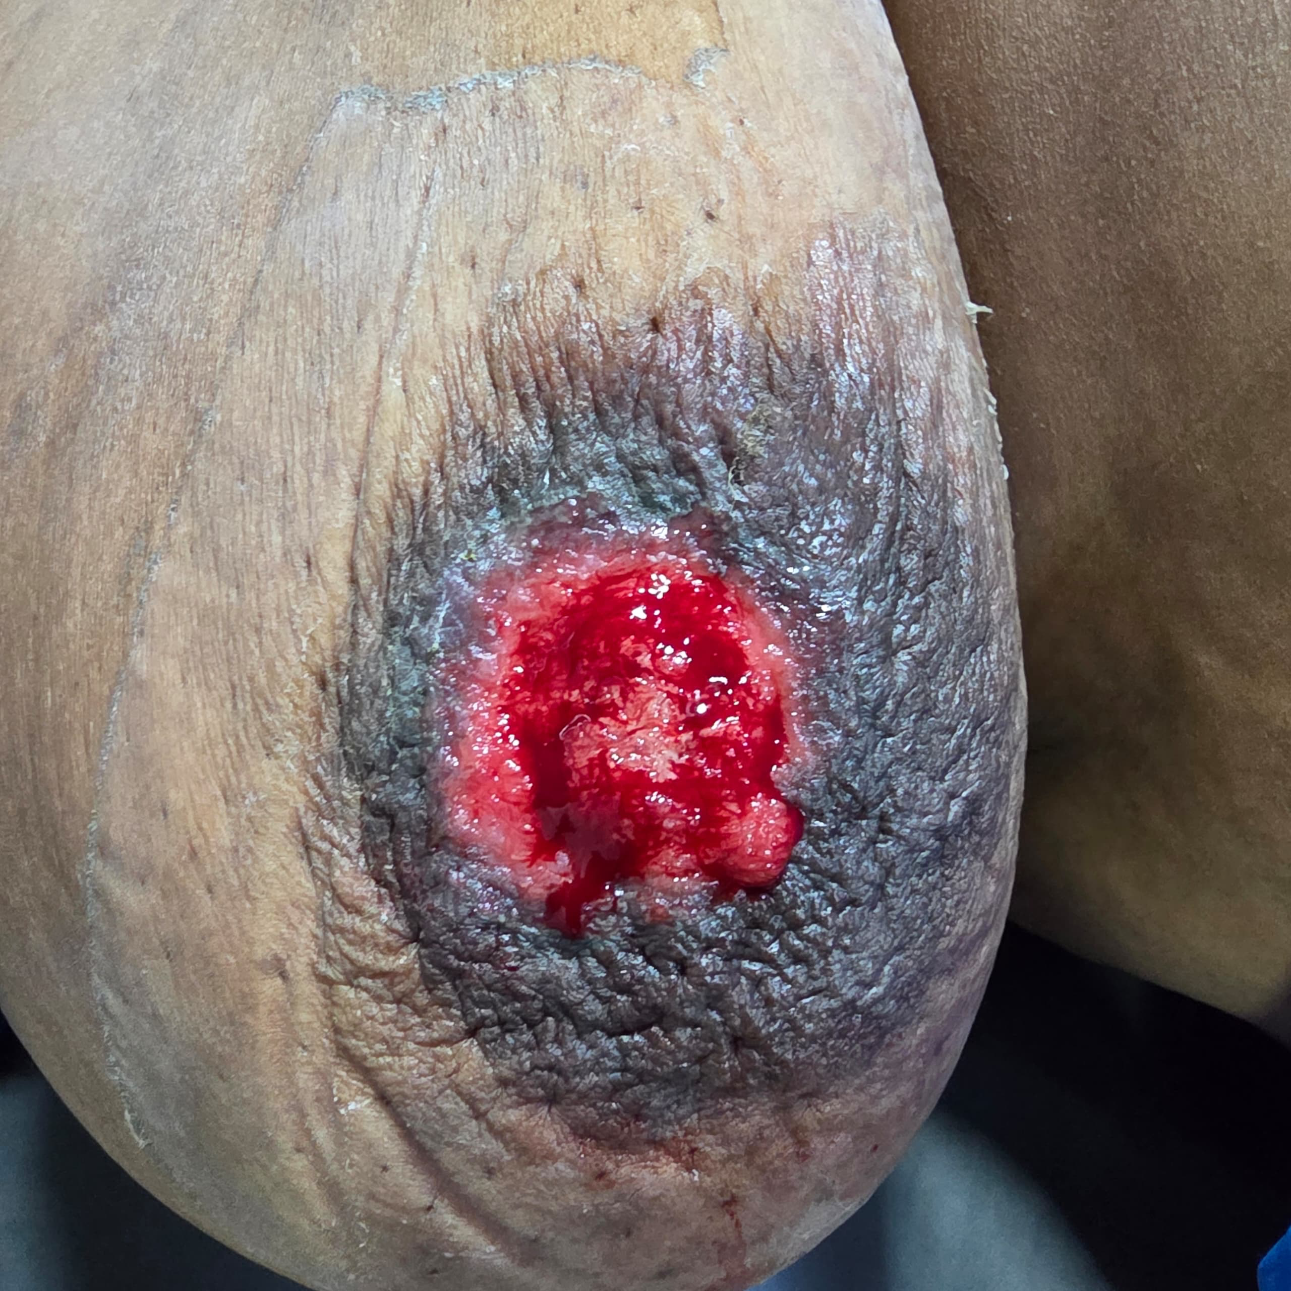
Management also depends on the extent of underlying carcinoma. While breast-conserving surgery may be considered in selected non-invasive cases, mastectomy

Fig 1 and Fig 2: Clinical photograph of the breast lesion involving nipple-areolar complexes in the index case

remains appropriate when invasive ductal carcinoma is identified ^{13,14}. Prognosis is determined primarily by the stage of the underlying carcinoma rather than the Paget component itself ¹³.

4. CONCLUSION
Paget’s disease of the breast is a rare but important manifestation of underlying breast carcinoma. Chronic unilateral nipple ulceration in postmenopausal women should raise suspicion for malignancy. Early biopsy is essential to avoid delayed diagnosis and to improve treatment outcomes.
Limitation:
This study is limited by the patient’s refusal to undergo standard treatment despite late presentation, and by the fact that it represents a single case report, which restricts the generalizability of the findings.
Ethical Approval:
As per international standards or university standards written ethical approval has been collected and preserved by the author(s).
Consent
As per international standards or university standards, patient(s) written consent has been collected and preserved by the author(s).

Disclaimer (Artificial intelligence)

Author(s) hereby declare that NO generative AI technologies such as Large Language Models (ChatGPT, COPILOT, etc.) and text-to-image generators have been used during the writing or editing of this manuscript.

References
- Chen CY, Sun LM, Anderson BO. Paget disease of the breast: changing patterns of incidence, clinical presentation, and treatment. J Surg Oncol. 2006;93(6):472–477.
- Sandoval-Leon AC, Drews-Elger K, Gomez-Fernandez C, Yepes MM, Lippman ME. Paget's disease of the nipple. Breast Cancer Res Treat. 2013;141(1):1–12.
- Dalberg K, Hellborg H, Wärnberg F. Paget's disease of the nipple in a population-based cohort. Breast Cancer Res Treat. 2008;111(2):313–319.
- Khothari AS, Beechey-Newman N, Hamed H, Fentiman IS, D’Arrigo C, et al. Paget disease of the nipple: a multifocal manifestation of higher-risk disease. Cancer. 2002;95(1):1-7.
- S Dubar., M Boukrid., Jean Bouquet de Joliniere., L Guillou., Quoc Duy., et al. Paget’s Breast Disease. A Case Report and Review of the Literature. 2017;4:51.
- Rubina Maharjan., Suraj Shrestha., Prafulla Shakya., Sanjeev Kharel., Aagon Krishna Shrestha. Moushami SinghPaget's disease of nipple with dermal invasion: A case report. Cancer Rep 2022;5(8):e1572.
- Canso K. Paget’s disease of the breast. J Carcinog. 2011;10:31.
- Capobianco G., Spaliviero B., Dessole S., Cherchi PL., Marras V., et al. Paget’s disease of the nipple diagnosed by MRI. Arch Gynecol Obstet. 2006;274(5):316-8.
- Geffroy D., Doutriaux-Dumoulins I., Labbe-Devilliers C., Meingan P., Houdebine S., et al. Maladie de Paget du mamelon et principaux diagnostics différentiels. J Radiol. 2011;92:889-98.
- Dalberg K., Hellborg H., Warnberg F. Paget’s disease of the nipple in a population based cohort. Breast Cancer Res Treat. 2008;111:313-9. [PubMed]
- Dominici LS., Lester S., Liao GS., Guo L., Specht M., et al. Current surgical approach to Paget’s disease. Am J Surg. 2012;204:18-22.
- Trebska-Mc Gowan KP., Terracina K., Takabe K. Update on the surgical management of Paget’s disease. Gland Surg. 2013;2(3):137-42.
- Caliskan M, et al. Paget's disease of the breast: the experience of 20 years. Breast. 2008;17(5):468–471.
- Sarah Hudson-Phillips., Kofi Cox., Puja Patel., Wail Al/Sarakbi. Paget's disease of the breast: diagnosis and management. PMID: 3670833.2023;84(1):1-8.

