Comparison of the effect on the postoperative pain between infiltration between the popliteal artery and capsule of the knee block and local infiltration anesthesia, in combination with femoral nerve block, after total knee arthroplasty.

.
ABSTRACT

Aims: Infiltration between the popliteal artery and capsule of the knee (IPACK) block is useful for analgesia after total knee arthroplasty (TKA) in the posterior compartment of the knee without compromising foot strength. This study was conducted to determine whether the IPACK block, in combination with femoral nerve block (FNB), improves the analgesia provided by local infiltration analgesia (LIA) with FNB.
Study design: Prospective, randomized, open-label trial
Place and Duration of Study: Department of Anesthesia, Nagasaki Rosai Hospital, Sasebo, Japan, from April 2020 to November 2021.
Methodology: We studied 50 patients who underwent TKA under total intravenous propofol anesthesia. All patients underwent ultrasound-guided FNB with 30 mL of 0.25% levobupivacaine before the operation. In addition, 250 μg of fentanyl was intravenously administered at the beginning of surgery and before the end of surgery, and 1000 mg of acetaminophen was intravenously administered before the end of surgery. Patients were randomly allocated to one of two groups: Group I (n = 25), which received local infiltration anesthesia with 30 mL of 0.25% levobupivacaine into the posterior capsule of the knee before cementing and Group B (n = 25), which received an ultrasound-guided IPACK block with 30 mL of 0.25% levobupivacaine immediately after the FNB. Patients were administered 1000 mg of acetaminophen or 15 mg of pentazocine as rescue analgesics, if needed. The primary outcome was postoperative pain evaluated by the nursing staff using a numerical rating scale (NRS) at 0, 1, 3, 6, 12, and 24 h postoperatively.
Results: No significant differences in patient characteristics and NRS scores were observed between the groups. In addition, no significant differences in the frequency of rescue analgesic use were observed between the groups during the study period.
Conclusion: We concluded that IPACK with FNB and LIA with FNB have an equivalent analgesic effect after TKA.

Keywords: [total knee arthroplasty, infiltration between the popliteal artery and capsule of the knee, femoral nerve block, local infiltration anesthesia, postoperative pain)

1. INTRODUCTION

Total knee arthroplasty (TKA) is an effective surgical treatment for end-stage joint diseases such as osteoarthritis. However, postoperative pain remains a significant challenge that hinders early recovery and rehabilitation and necessitates effective pain management strategies. Proper postoperative analgesia improves postoperative prognosis by preventing pain-related complications [1]. Acute pain following TKA significantly affects functional recovery and patient satisfaction. Multimodal analgesia, including femoral nerve block (FNB) and local infiltration anesthesia (LIA), is effective in ameliorating early postoperative pain after TKA [2, 3].
Recently, injection of local anesthetics into the interspace between the popliteal artery and the capsule of the knee (IPACK block) has gained attention for its ability to reduce posterior knee pain while preserving motor function [4,5]. The IPACK block involves injecting local anesthetic around the popliteal artery to target the posterior knee nerves, potentially improving postoperative pain management [4,5]. This technique offers several advantages, including preservation of quadriceps muscle strength, which facilitates early mobilization and reduces fall risk. Additionally, the IPACK block minimizes the need for systemic analgesics, including opioids, thereby reducing potential side effects, such as nausea and sedation.
Local Infiltration Analgesia (LIA), performed by orthopedic surgeons, is a common technique that involves injecting anesthetics around the joint during surgery to alleviate postoperative pain [6, 7]. LIA has been reported to contribute to lower postoperative pain scores and reduced opioid consumption [6,7].
Therefore, local anesthesia via IPACK block and LIA are two options for fore supplementing to FNB to relief pain and keep safe after TKA. Furthermore, the optimal combinations of analgesic interventions remain unclear. This prospective, randomized, open-label study aimed to determine whether the IPACK block in combination with FNB improves the analgesia provided by LIA in combination with FNB.

2. material and methods
2.1 Patients
This single-center, open-label, randomized clinical trial adhered to the principles of the Declaration of Helsinki. This study was approved by the Institutional Ethics Committee of Nagasaki Rosai Hospital (IRB No. 01029; Approval date: March 16, 2020) and written informed consent was obtained from all patients. The trial was registered with the University Hospital Medical Information Network (ID: UMIN 000040124) on April 13, 2020. It included 50 patients with an American Society of Anesthesiologists physical status of 1 or 2 who underwent TKA under general anesthesia at the Nagasaki Rosai Hospital between April 2020 and November 2021. The exclusion criteria were as follows: hepatic and renal dysfunction, local anesthetic allergy, weight < 50 kg, and medical history of peptic ulcers and asthma. None of the patients received preanesthetic medication.
2.2 Study protocol
To achieve the desired effect-site concentration, the patients received a continuous infusion of remifentanil 0.5 μg/kg/min and propofol 3 μg/mL via a target-controlled infusion (TCI) system (TCI pump, Terumo, Tokyo, Japan). Rocuronium (0.8 mg/kg) was administered to facilitate tracheal intubation after the loss of consciousness. The effect-site concentrations of propofol and remifentanil were titrated to maintain a bispectral index score of 40–60 after tracheal intubation. All patients underwent ultrasound-guided FNB with 30 mL of 0.25% levobupivacaine before the operation. In addition, 250 μg of fentanyl was intravenously administered at the beginning of surgery and 15 min before the end of surgery, and 1000 mg of acetaminophen was intravenously administered 15 min before the end of surgery. Patients were randomly allocated to one of two groups using the sealed envelope method. Group I (n = 25) received local infiltration anesthesia with 30 mL of 0.25% levobupivacaine into the posterior capsule of the knee before cementing the components by the surgeon. Group B (n = 25) received an ultrasound-guided IPACK block with 30 mL of 0.25% levobupivacaine immediately after FNB. Patients were administered 1000 mg of acetaminophen or 15 mg of pentazocine as rescue analgesics, if needed. Prior to surgery, both nerve blocks were performed in the supine position by experienced anesthesiologists using high-frequency linear ultrasonography. In FNB, the ultrasound probe was placed in a transverse orientation on the upper thigh, just inferior to the inguinal ligament. After skin disinfection, a 23-gauge needle was inserted from the outside to the inside toward the femoral nerve using an in-plane technique. In the IPACK block, an ultrasound probe was placed at the junction of the femoral condyles and the femoral shaft. The popliteal artery tibial, and peroneal nerves were visualized, and the space between the femur and popliteal artery was determined. A 22-gauge needle, called the IPACK, was advanced into this area using the medial-to-lateral in-plane technique. Real-time imaging confirmed that the local anesthetic had spread.
The nursing staff evaluated postoperative pain using a numerical rating scale (NRS; 10 points from 0 to 10) at rest at 0, 1, 3, 6, 12, 18, and 24 h postoperatively. At 12 and 24 h postoperatively, the number of analgesics required and the incidence of postoperative nausea and vomiting (PONV) 24 h after surgery were recorded.
2.3 Measurement
The primary outcome was the NRS at rest at 0, 1, 3, 6, 12, 18, and 24 h postoperatively, and the secondary outcomes were the number of required analgesic at 12 and 24 h postoperatively and the incidence of PONV 24 h after surgery.
2.4 Statistical Analysis
The results are expressed as median (interquartile range). To analyze the interaction between time and the two groups, a two-way repeated-measure analysis of variance was conducted. A post hoc comparison between groups at each time point and among the repeated measures in each group was conducted using the Bonferroni–Dunn test, if appropriate. Continuous data for patient characteristics were analyzed using the Mann–Whitney U test. Dichotomous variables were analyzed using the chi-square test. Statistical significance was set at P-value of < .05.
Sample size was determined based on the previous study [8] (standard deviation, 2.4), which indicated that with 23 patients in each group, a power of 80% would be required to detect a difference of 2 in the NRS value between the two groups at a 5% significance level.

3. results
Table 1 shows that no significant differences in the patient characteristics were observed between the groups.
Table 1 Patients characteristics
 | iPACK group | LIA group | p
Patients (n) | 25 | 25
Age (years) | 77 (71, 82) | 77 (73, 82) | 0.91
Height (cm) | 154 (148, 155) | 153 (146, 158) | 0.89
Weight (kg) | 60 (58, 71) | 60 (54, 69) | 0.27
BMI (kg/m²) | 26.2 (24.9, 30.0) | 25.6 (24.0, 27.4) | 0.20
Male gender | 5 | 7 | 0.74
Anesthetic time (min) | 168 (149, 191) | 175 (157, 195) | 0.59
Operative time (min) | 91 ( 80, 112) | 103 (86, 120) | 0.35
Operative blood loss (g) | 10 (5, 16) | 5 (5, 13) | 0.55
Values are median (IQR) or number. iPACK, The infiltration between the Popliteal Artery and Capsule of the Knee; LIA, local infiltration anesthesia; BMI, body mass index; n, number;
Values are median (IQR) or number. iPACK, The infiltration between the Popliteal Artery and Capsule of the Knee; LIA, local infiltration anesthesia; BMI, body mass index; n, number;
Repeated-measures ANOVA revealed no significant differences in the NRS scores between the groups during the study period (Fig. 1). The NRS score at 18h postoperatively was higher in Group I than that at 0 h in Group B.
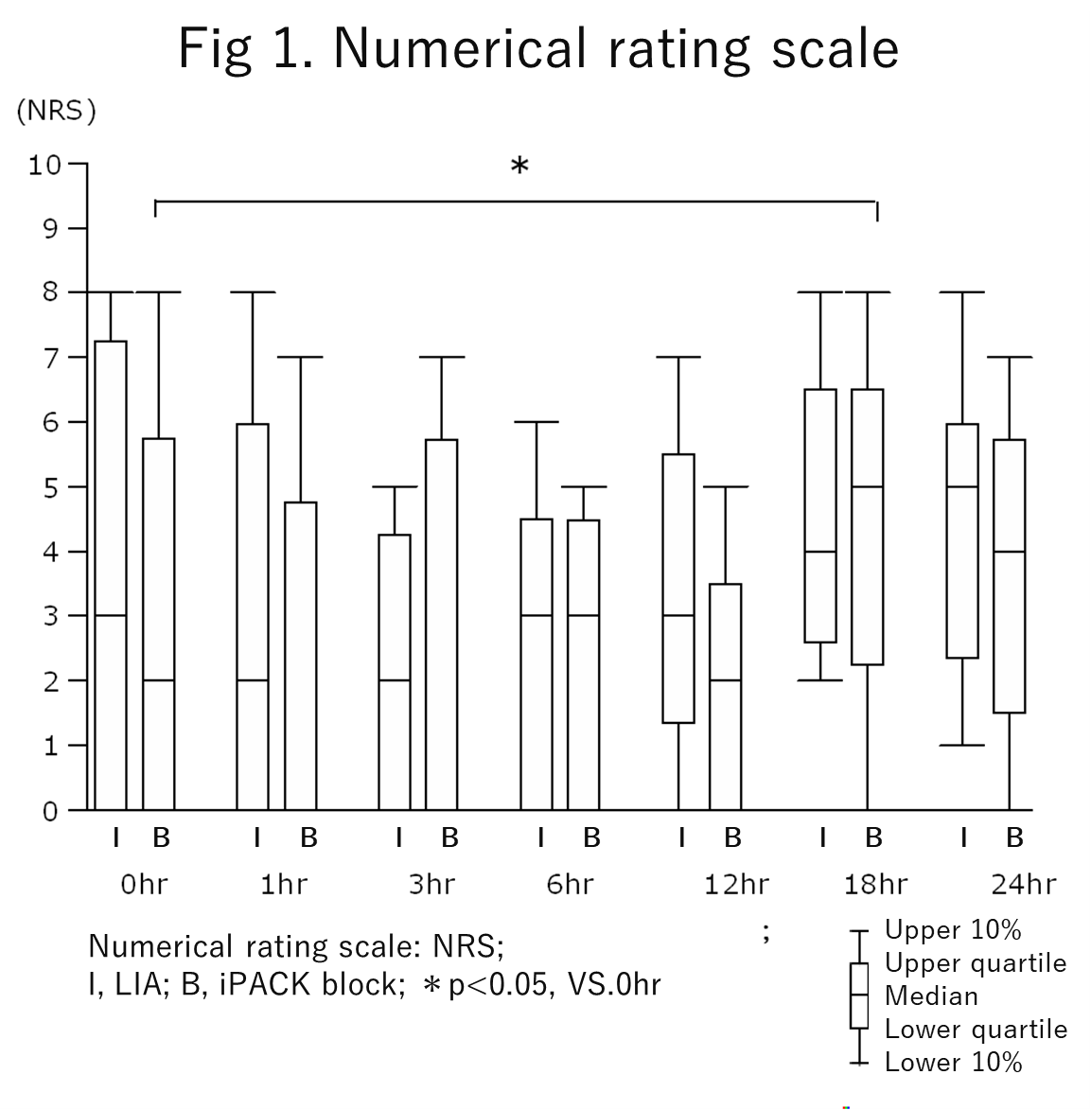
Table 2 shows that no significant differences in the frequency of rescue analgesics and PONV incidence was observed between the groups during the study period.
Table 2. Postoperative valuables
 | iPACK group | LIA group | p
PONV (n) | 15 | 10 | 0.99
Rescue analgesics for 12 hr (n) | 1 (0, 1) | 1 (0, 1) | 0.72
Rescue analgesics for 24 hr (n) | 2 (1, 3) | 2 (1, 3) | 0.76
Values are median (IQR) or number. iPACK, The infiltration between the Popliteal Artery and Capsule of the Knee; LIA, local infiltration anesthesia; n, number; PONV, postoperative nausea and vomiting;

4. DISCUSSION
This study showed that the combination of FNB and IPACK block did not reduce the NRS scores or the frequency of rescue analgesics compared with those of the FNB and LIA combination. This study showed that the IPACK block and LIA were equivalent and effective adjuvants for FNB after TKA.
The IPACK block is a motor-sparing posterior knee analgesic technique designed to reduce posterior knee pain after TKA while preserving motor function. Evidence from randomized trials and meta-analyses [8,9] shows that adding an IPACK block to multimodal analgesia, particularly when combined with an adductor canal block (ACB) or FNB, improves pain control without impairing quadriceps strength. The IPACK block targets the terminal sensory branches of the tibial and obturator nerves that innervate the posterior knee capsule. Therefore, this block reduces posterior knee pain, which is often inadequately controlled using FNB alone. A meta-analysis [8] of randomized controlled trials found that adding the IPACK block to multimodal analgesia for primary TKA significantly reduces postoperative pain scores and improved analgesic outcomes. A randomized trial [9] comparing ACB + IPACK and ACB + selective tibial nerve block showed that the IPACK combination provides effective posterior knee analgesia and supports functional recovery. Yin et al. [10] found that combining adductor canal block (ACB) with IPACK significantly reduced the incidence of chronic postoperative pain. Jiang et al. [11] reported that continuous ACB with popliteal plexus block (PPB), which targets the same posterior compartment as IPACK, improved analgesic outcomes. These findings are reinforced by Chia et al. [12], who showed that adding IPACK to an adductor canal catheter enhanced early postoperative pain control. Upshaw et al. [13] provided a comprehensive review supporting IPACK’s efficacy in posterior knee analgesia.
Local anesthetic infiltration into the posterior capsule during TKA provides a significant reduction of posterior knee pain, particularly during the early postoperative period. However, its analgesic effect is limited in duration, and the precision of infiltration is variable. The posterior capsule is a major source of postoperative pain because it is stretched during knee extension, manipulated during bone cuts, and contains sensory branches from the tibial, common peroneal, and sciatic nerves. Posterior capsular LIA reduces posterior knee pain compared with no infiltration, although sciatic nerve block provides stronger analgesia [3]. LIA improves early postoperative pain (24–48 h), reduces opioid consumption, and supports early mobilization [6]. LIA, including posterior infiltration, provides analgesia comparable to epidural analgesia with faster mobilization [7]. Simon et al. [14] demonstrated that continuous LIA provides analgesia comparable to femoral and sciatic nerve blocks, supporting its role in multimodal pain management. However, its analgesic effect is limited in duration, and the precision of infiltration is variable.
5. Conclusion

We conclude that the IPACK block and LIA are equivalent and effective adjuvants for FNB after TKA. LIA is a simple and straightforward method, and if its analgesic effect is comparable to IPACK, it is presumed to be a useful method.This should briefly state the major findings of the study. If you are using copy-paste option then select ‘match destination formatting’ in paste option OR use ‘paste special’ option and select ‘unformatted Unicode text’ option]

AcknowledgEments

This research was supported by research funds to promote the hospital functions of the Japan Organization of Occupational Health and Safety.

Competing interests

The authors declare that they have no competing interests.

Authors’ Contributions

Yuya Komatsu and Yoshiaki Terao carried out all parts of this study. Natsuko Oji, Makito Oji, Hiroshi Aoki、and Ekuko Fujimoto collected the clinical data. Testuya Hara revised the presentation and the manuscript. All authors read and approved the final manuscript.

Consent (where ever applicable)

The study protocol was approved by the Institutional Research and Ethics Committee of Nagasaki Rosai Hospital on March 16, 2020 (No. 01029). Written informed consent was obtained from all participants.
Ethical approval (where ever applicable)

All authors hereby declare that all experiments have been examined and approved by the appropriate ethics committee and have therefore been performed in accordance with the ethical standards laid down in the 1964 Declaration of Helsinki.

References

1) Amar S, Chitranjan S. Pain management and accelerated rehabilitation for total hip and total knee arthroplasty. J Arthroplasty. 2007; 22: 12-5. [PMID: 17919586 DOI: 10.1016/j.arth.2007.03.034]
2) Terkawi AS, Mavridis D, SEssler DI, Nunemaker MS, Doais KS, Terkawi RS, et al. Pain management modalities after total knee arthroplasty. A network meta-analysis of 170 randomized controlled trial. Anesthesiology. 2017; 126: 923-37. [PMID: 28383323 DOI: 10.1097/ALN.0000000000001607]
3) Gi Eri, Yamauchi M, Yamakage M, Kikuchi C, Shimizu H, Okada Y, et al. Effects of local infiltration analgesia for posterior knee pain after total knee arthroplasty: comparison with sciatic nerve block. J Anesth 2014; 28: 696-701. [PMID: 24744168 DOI: 10.1007/s00540-014-1800-4]
4) Ohgoshi Y, Ikari K, Ando A, Kawamata N, Fujiki S, Nagamoto S, et al. Comparison of IPACK block and selective tibial nerve block combined with continuous femoral triangle block for analgesia after total knee arthroplasty: a randomized control trial. Masui. 2023;72(2):102–107.
5) Kertkiatkachorn W, Kampitak W, Tanavalee A, Ngarmukos S..Adductor Canal Block Combined With iPACK Block vs Periarticular Injection for Analgesia After Total Knee Arthroplasty: A Randomized Noninferiority Trial. Journal of Arthroplasty. 2021;36(1):122–129.e1. [PMID: 32713730 DOI: 10.1016/j.arth.2020.06.032]
6) Seangleulur A, Vanasbodeekul P, Prapaitrakool S, Worathongchai S, Anothaisintawee T, Vanasbodeekul SP, et al. The efficacy of local infiltration analgesia in the early postoperative period after total knee arthroplasty: A systematic review and meta-analysis. Eur J Anaesthesiol. 2016;33(11):816–831. [PMID: 27500950 DOI: 10.1097/EJA.0000000000000492]
7) Hidaka M, Nakagawa I, Okada Y, Kuwahara Y, Yokota M, Narasaki S, et al. Intra-articular and local analgesia for total knee arthroplasty: Comparison with epidural analgesia. Masui. 2020;69(8):844–850.
8) Tang X, Lai Y, Du S, Ning N. Analgesic efficacy of adding the IPACK block to multimodal analgesia protocol for primary total knee arthroplasty: a meta-analysis of randomized controlled trials. J Orthop Surg Res. 2022；17(1): 429. [PMID: 36175927 DOI: 10.1186/s13018-022-03266-3]
9) Abogabal MA, Zahra SW, Abdel-Elsalam WM, Abdelwahed WM. A randomized clinical trial of addition of IPACK block or selective tibial nerve block to adductor canal block for postoperative pain management after total knee arthroplasty. Anaesthesia, Pain & Intensive Care. 2023; 27(5): 567-574. [DOI: 10.35975/apic.v27i5.2313]
10) Yin W, Luo D, Xu W, Zhang L, Chen Y, Li H, et al. Effect of adductor canal block combined with IPACK block on chronic pain after total knee arthroplasty: a randomized, double-blind controlled trial. BMC Anesthesiol. 2024; 24: 320.[ PMID: 38410234 DOI: 1186/s12871-024-02234-3].
11) Jiang B, Guo Y, Yang M, Zhang X, Liu Y, Chen H, et al. Continuous adductor canal block combined with popliteal plexus block for total knee arthroplasty: a randomized controlled trial. Sci Rep. 2024; 14: 27757. [PMID: 38310290 DOI: 1038/s41598-024-27757-1].
12) Chia PA, Boyd EK, Naim N, Tan J, Ong J, Lim Y. The effect of iPACK block combined with adductor canal catheter versus catheter alone for postoperative analgesia in total knee arthroplasty: a randomized controlled trial. Anesth Pain Res. 2024; 8(3): 1–5. [PMID: 38499812 DOI: 1097/APR.0000000000000123]
13) Upshaw WC, Richey JM, Tassin JP, Delgado A, Freeman J, Patel V. Efficacy of the IPACK block for acute pain after total knee arthroplasty: a narrative review. Curr Pain Headache Rep. 2024; 28: 673–679. [PMID: 38511245 DOI: 1007/s11916-024-01023-5]
14) Simon C, Schwab M, Ackermann H, Müller T, Weber J, Lang S. Continuous local infiltration analgesia versus femoral and sciatic nerve block for postoperative pain after total knee arthroplasty: a randomized controlled trial. Arch Orthop Trauma Surg. 2025; 145: 136. [PMID: 39500482. DOI: 1007/s00402-024-05012-9]

Abbreviations
TKA: total knee arthroplasty; FNB: femoral nerve block; LIA: local infiltration anesthesia; iPACK: infiltration between the popliteal artery and capsule of the Knee; PONV: postoperative nausea and vomiting; I: local infiltration anesthesia; B; infiltration between the popliteal artery and capsule of the knee block; TCI: target-controlled infusion; NRS: numerical rating scale; ANOVA: A factorial analysis of variance; ACB: adductor canal block; ASA: American Society of Anesthesiologists;

