Original Research Article

MORPHOMETRIC ANALYSIS OF PROXIMAL FEMORAL DIMENSIONS ON PLAIN RADIOGRAPHS AMONG ADULTS IN SOKOTO, NORTH-WESTERN NIGERIA: A CROSS-SECTIONAL STUDY

ABSTRACT
Background:
The geometry of the proximal femur, particularly the neck-shaft angle (NSA), femoral neck width (FNW), and femoral neck axis length (FNAL), plays an essential role in orthopedic diagnosis, prosthetic design, and forensic identification. However, morphometric data for the proximal femur among populations in North-Western Nigeria remain limited.
Objective:
This study aimed to determine baseline values of NSA, FNW, and FNAL among adults in Sokoto, North-Western Nigeria, and to evaluate differences across sex, age groups, and laterality.
Methods:
A retrospective cross-sectional study was conducted using 277 normal pelvic radiographs obtained from the Sokoto State Advanced Diagnostic Centre between January 2022 and August 2023. Radiographs were analyzed digitally using Image Byte PACS Software (v4.9.3.25) and Radiant DICOM Viewer (2024.1). The NSA, FNW, and FNAL were measured bilaterally, and demographic data (age and sex) were recorded. Statistical analysis was performed using SPSS version 25. Independent sample t-tests and one-way ANOVA were used to compare mean values, with significance set at p < 0.05.
Results:
The mean NSA values were 121.48° ± 4.06 (right) and 124.38° ± 4.00 (left). The mean FNW values were 3.71 ± 0.52 cm (right) and 3.75 ± 0.49 cm (left), while the mean FNAL values were 10.31 ± 0.98 cm (right) and 10.30 ± 0.94 cm (left). Males demonstrated significantly higher values than females across all parameters (p < 0.05). Age groups showed no significant variation in any of the measured parameters (p > 0.05). Side differences were statistically significant for NSA and FNW but not for FNAL.
Conclusion:
This study established baseline femoral morphometric values for adults in Sokoto, revealing sexual dimorphism and mild bilateral asymmetry. These findings highlight the importance of population-specific reference values for orthopedic surgical planning, implant design, and forensic applications in Nigeria.
Keywords:
Femur, Neck-shaft angle, Femoral neck width, Femoral neck axis length, Radiographic morphometry, Nigeria

1. Introduction
Bone morphometry plays a critical role in understanding variations in skeletal structure and their implications in clinical practice, anthropology, and forensic science¹. The femur, the longest and strongest bone in the human body, is fundamental to weight-bearing and locomotion². The morphology of its proximal region, particularly the neck-shaft angle (NSA), femoral neck width (FNW), and femoral neck axis length (FNAL), significantly influences hip biomechanics, load distribution, and fracture susceptibility³.
The neck-shaft angle represents the inclination between the femoral neck and the shaft⁴. This anatomical parameter is crucial in determining hip alignment and stability and is frequently considered in orthopedic procedures such as total hip arthroplasty, corrective osteotomy, and fracture fixation. Variations in NSA may influence joint biomechanics and predispose individuals to certain musculoskeletal conditions⁵.
Similarly, FNW and FNAL are important indicators of bone strength and structural stability⁶. A narrow femoral neck has been associated with increased risk of proximal femoral fractures, whereas a longer femoral neck axis may increase bending moments across the hip joint, potentially increasing mechanical vulnerability⁷. These morphometric parameters are also critical in designing orthopedic implants tailored to specific populations⁸.
Several studies have reported proximal femoral morphometric parameters across different populations worldwide⁹⁻¹². However, marked inter-population variations have been documented due to differences in ethnicity, lifestyle, and environmental influences. In Nigeria, most previous studies have been conducted in the southern and central regions, leaving a gap in data from the North-Western region^{13,14}.
Although advanced imaging modalities such as CT and MRI provide high-resolution anatomical data, plain radiography remains a reliable and cost-effective tool for skeletal morphometric analysis, especially in resource-limited settings^{15,16}. Establishing normative radiographic data for proximal femoral parameters in the Sokoto population will therefore contribute to improved clinical decision-making, orthopedic implant design, and forensic identification.
This study was designed to evaluate the femoral morphometric parameters—NSA, FNW, and FNAL—using plain radiographs among adult individuals in Sokoto, North-Western Nigeria. Specifically, the study aimed to:
- Establish baseline reference values for proximal femoral parameters.
- Compare these parameters across sex, age groups, and sides.
- Assess correlations between femoral parameters and demographic variables.

2. Materials and Methods

2.1 Study Design and Setting
This study adopted a retrospective cross-sectional design to evaluate femoral morphometric parameters among adults in Sokoto, North-Western Nigeria. The research was conducted in the Department of Anatomy, Faculty of Basic Medical Sciences, Usmanu Danfodiyo University Sokoto, in collaboration with the Department of Diagnostic Radiology of Usmanu Danfodiyo University Teaching Hospital and the Sokoto State Advanced Diagnostic Centre.

2.2 Sample Size and Sampling Technique
A random sampling technique was used to select eligible digital pelvic radiographs from the diagnostic center archive.
The sample size was calculated using the formula by Lwanga and Lemeshow¹⁷:
n = (1.96² × P × Q) / E²
Where:
- P = prevalence of neck-shaft angle (20.9%)
- Q = 1 − P
- E = margin of error (5%)
The minimum sample size obtained was 254, but 277 radiographs were included to increase statistical reliability.

2.3 Inclusion Criteria
Radiographs included in the study met the following criteria:
- Digital AP pelvic radiographs showing both hip joints and proximal femora
- Proper patient positioning with clear visualization
- Radiographs reported as normal by a radiologist
- Complete demographic data (age and sex)
- Subjects aged 18 years and above

2.4 Exclusion Criteria
- Poorly positioned radiographs
- Radiographs with fractures, deformities, or pathology
- Images with incomplete demographic information
- Blurred or low-quality radiographs

2.5 Materials and Software
The following tools were used:
- Digital pelvic radiographs
- Desktop computer
- Image Byte PACS Software (version 4.9.3.25)
- Radiant DICOM Viewer (version 2024.1)

2.6 Measurement Procedures

Neck-Shaft Angle (NSA)
The NSA was measured as the angle between the longitudinal axis of the femoral neck and that of the femoral shaft.

Femoral Neck Width (FNW)
FNW was measured as the shortest distance across the narrowest region of the femoral neck.

Femoral Neck Axis Length (FNAL)
FNAL was measured from the base of the greater trochanter through the center of the femoral head passing through the fovea centralis.
All measurements were taken bilaterally and recorded to the nearest 0.01 cm or degree. All measurements were according to the method used by Tuck et. al. 2015 and Johnny et. Al. 2018. To ensure measurement reliability, each parameter was measured twice and the mean value recorded.
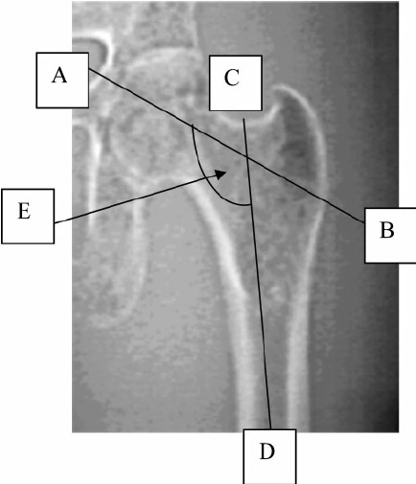
Fig .1: Measurement of NSA (Tuck et al., 2011)

Figure 1 showed the points that were focused on during the measurement of NSA.
A$=$ Fovea Centralis.
B$=$ Point Just below the greater trochanter.
C$=$ Piriformis fossa.
D$=$ line intersecting a line drawn from just below lesser trochanter to meet lateral border of the femoral shaft.
E$=$ Neck Shaft Angle.
AB: Represents the Longitudinal axis of the femoral neck
CD: Represents the Longitudinal axis of the femoral shaft.

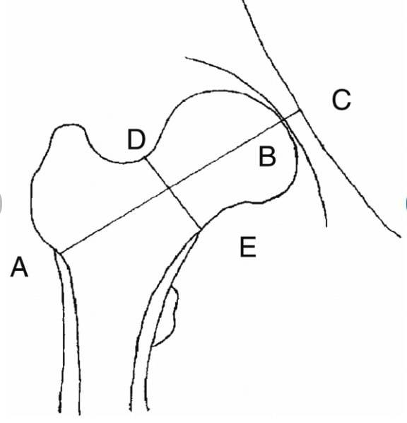
Figure 2: Measurement of Femoral Neck Axis (Fajar et. al. 2018)

AB =FEMORAL NECK AXIS LENGTH
DE= FEMORAL NECK WIDTH

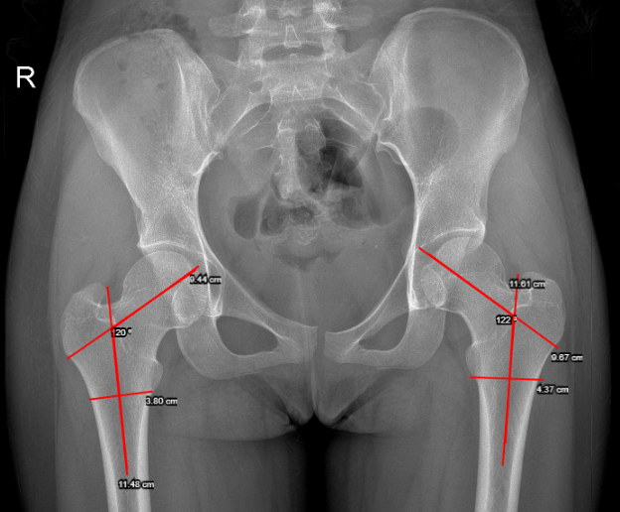Figure 3: An Anterio-Posterir (AP) Pelvic digita radiograph of a 19 years old Female.
Figure 3 showed how Femoral Neck Shaft angle was measured.

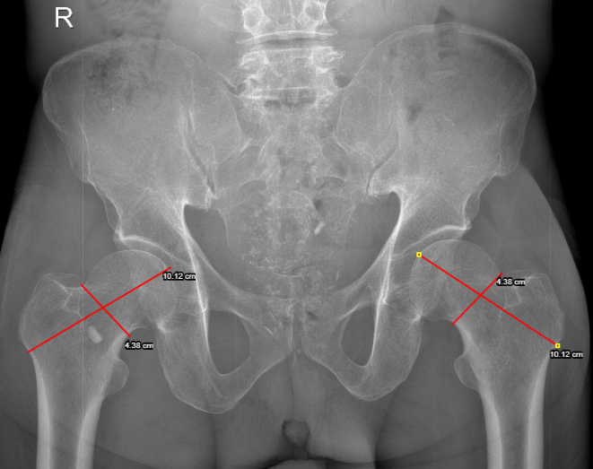
Figure 4: An Anterio-Posterir (AP) Pelvic digita radiograph of a 46 years old Male.
Figure 4 Showed how Femoral neck axis Length(FNAL)and Femoral neck width(FNW)were measured.

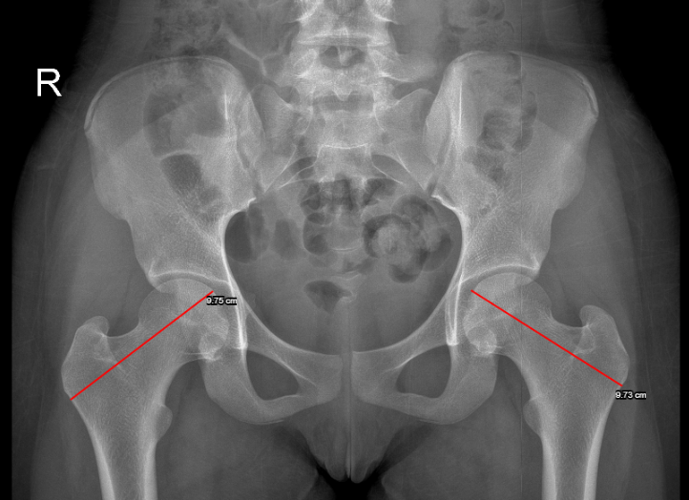

Figure 5: An Anterio-Posterir (AP) Pelvic digita radiograph of a 19 year-old female.
Figure 5 Showed how Femoral neck axis Length(FNAL) was measured seperately.

2.7 Data Analysis
Data were analyzed using SPSS version 25.
The following analyses were performed:
- Descriptive statistics (mean ± standard deviation)
- Independent t-test for sex comparison
- One-way ANOVA for age group comparisons
- Paired t-test for side differences
- Pearson correlation for relationship between variables
Statistical significance was set at p < 0.05.

3. Results
A total of 277 digital pelvic radiographs were analyzed.

Socio-Demographic Characteristics
The study population consisted of:
- 168 males (60.6%)
- 109 females (39.4%)
Participants were aged 18–67 years.
The highest proportion (22.4%) belonged to the 18–27 year age group.
Table 1: Socio-demographic Data of the Respondents
Variable(s) | Frequency | Percentage
Female | 109 | 39.4
Male | 168 | 60.6
Total | 277 | 100.0
Age Group (years)
18–27 | 62 | 22.4
28–37 | 53 | 19.1
38–47 | 57 | 20.6
48–57 | 55 | 19.9
58–67 | 50 | 18.1
Total | 277 | 100.0

Baseline Measurements of Neck-Shaft Angle (NSA)
The mean right NSA was 121.48° ± 4.06°, ranging from 110° to 142°, while the mean left NSA was 124.38° ± 4.00°, ranging from 114° to 137°. The modal NSA values were 120° (right) and 122° (left), indicating slightly higher inclination angles on the left side.
Table 2: Baseline Measurement of NSA
Parameter | N | Minimum (°) | Maximum (°) | Modal Value (°) | Mean ± SD (°)
Right NSA | 277 | 110 | 142 | 120 | 121.48 ± 4.06
Left NSA | 277 | 114 | 137 | 122 | 124.38 ± 4.00

Baseline Measurements of Femoral Neck Width (FNW)
Right FNW ranged from 0.85 cm to 8.49 cm (mean = 3.70 ± 0.52 cm), while the left FNW ranged from 2.01 cm to 8.27 cm (mean = 3.75 ± 0.50 cm).
Table 3: Baseline Measurement of FNW
Parameter | N | Minimum (cm) | Maximum (cm) | Modal Value (cm) | Mean ± SD (cm)
Right FNW | 277 | 0.85 | 8.49 | 4.02 | 3.70 ± 0.52
Left FNW | 277 | 2.01 | 8.27 | 3.21 | 3.75 ± 0.50

Baseline Measurements of Femoral Neck Axis Length (FNAL)
The right FNAL ranged from 4.41 cm to 12.82 cm (mean = 10.31 ± 0.98 cm), while the left FNAL ranged from 4.10 cm to 12.52 cm (mean = 10.30 ± 0.94 cm).
Table 4: Baseline Measurement of FNAL
Parameter | N | Minimum (cm) | Maximum (cm) | Modal Value (cm) | Mean ± SD (cm)
Right FNAL | 277 | 4.41 | 12.82 | 10.27 | 10.31 ± 0.98
Left FNAL | 277 | 4.10 | 12.52 | 9.30 | 10.30 ± 0.94

Comparison of NSA between Males and Females
Significant sex differences were observed in both right and left NSA. Males exhibited higher mean NSA values (p < 0.05).
Table 5: Comparison between NSA of Males and Females
Sex | Right NSA (Mean ± SD) | t | p | Left NSA (Mean ± SD) | t | p
Female | 120.81 ± 3.63 | -2.139 | 0.033 | 123.50 ± 3.69 | -2.966 | 0.003
Male | 121.92 ± 4.26 |  |  | 124.94 ± 4.10

Comparison of FNW between Males and Females
Statistically significant differences were also observed in FNW between sexes, with males having higher mean values on both sides (p = 0.001).

Table 6: Comparison between FNW of Males and Females
Sex | Right FNW (Mean ± SD) | t | p | Left FNW (Mean ± SD) | t | p
Female | 3.45 ± 0.42 | -7.436 | 0.001 | 3.50 ± 0.43 | -7.420 | 0.001*
Male | 3.89 ± 0.51 |  |  | 3.91 ± 0.47

Comparison of FNAL between Males and Females
FNAL showed significant sexual dimorphism, with males having longer femoral neck axis lengths on both sides (p = 0.001).
Table 7: Comparison between FNAL of Males and Females
Sex | Right FNAL (Mean ± SD) | t | p | Left FNAL (Mean ± SD) | t | p
Female | 9.91 ± 0.64 | -5.772 | 0.001 | 9.82 ± 0.74 | -7.600 | 0.001
Male | 10.57 ± 1.07 |  |  | 10.62 ± 0.92

Comparison among Age Groups
One-way ANOVA revealed no statistically significant differences in NSA, FNW, or FNAL across age groups (p > 0.05), indicating stability of these morphometric parameters with age.

Table 8: Comparison of NSA, FNW, and FNAL among Age Groups
AGE CAT |  | Right NSA | Left NSA | Right FNW | Left FNW | Right FNAL | Left FNAL
18-27 | MEAN | 121.21±3.663 | 124±4.17 | 3.62±0.59 | 3.69±0.49 | 10.09±1.17 | 10.19±0.89
8-37 | MEAN | 121.42±4.97 | 124.28±3.86 | 3.75±0.36 | 3.74±0.38 | 10.39±0.72 | 10.34±0.71
38-47 | MEAN | 121.21±4.15 | 124.04±4.27 | 3.64±0.35 | 3.73±0.33 | 10.45±0.68 | 10.39±0.82
48-57 | MEAN | 121.89±3.91 | 124.71±3.36 | 3.73±0.39 | 3.81±0.40 | 10.40±0.80 | 10.48±0.78
58-67 | MEAN | 121.76±3.58 | 124.96±4.30 | 3.85±0.78 | 3.78±0.79 | 10.19±1.34 | 10.11±1.36
F |  | 0.332 | 0.606 | 1.755 | 0.485 | 1.438 | 1.456
p values |  | 0.856 | 0.659 | 0.138 | 0.747 | 0.222 | 0.216
NSA-Neck Shaft Angle, FNW- Femoral Neck Width, FNAL- Femoral Neck Axis Length
One way ANOVA (F).
Statistical Significance was set at p-value < 0.05.

Comparison between Sides (Right and Left)
Paired t-test revealed significant side differences for NSA (p = 0.001) and FNW (p = 0.040), with higher values on the left side. FNAL showed no significant side difference (p = 0.914).

Table 9: Comparison of NSA, FNW, and FNAL between Right and Left Sides
Parameter | Right (Mean ± SD) | Left (Mean ± SD) | p-value
NSA | 121.48 ± 4.06 | 124.38 ± 4.00 | 0.001
FNW | 3.71 ± 0.52 | 3.75 ± 0.49 | 0.040
FNAL | 10.31 ± 0.99 | 10.30 ± 0.94 | 0.914

Correlation between Age and Femoral Parameters
Pearson’s correlation analysis indicated weak correlations between age and all femoral parameters (NSA, FNW, FNAL), suggesting minimal age-related changes.
Table 10: Correlation between NSA, FNW, FNAL, and Age
Parameter | Right (r) | Left (r) | p-value (Right) | p-value (Left)
NSA | 0.077 | 0.098 | 0.201 | 0.105
FNW | 0.128 | 0.075 | 0.380 | 0.216
FNAL | 0.012 | -0.018 | 0.842 | 0.076

Correlation between Sex and Femoral Parameters
Sex showed fair correlations with FNW and FNAL on both sides, but weak correlation with NSA, reaffirming observed sexual dimorphism in width and axis length.
Table 11: Correlation between Sex and Femoral Parameters
Parameter | Right (r) | Left (r) | p-value (Right) | p-value (Left)
NSA | 0.128 | 0.176 | 0.333 | 0.003
FNW | 0.410 | 0.410 | 0.001 | 0.001
FNAL | 0.329 | 0.417 | 0.001 | 0.001
Overall, the results indicate statistically significant differences in femoral dimensions between sexes and sides, while age-related variations were minimal. These findings provide essential baseline morphometric data for the population in Sokoto, North-Western Nigeria.

4. DISCUSSIONS
The present study assessed proximal femoral morphometric parameters among adults in Sokoto using digital radiographic analysis. Establishing population-specific skeletal parameters is important because femoral geometry shows considerable variation across ethnic groups and geographical populations^{9,11,20}.
The mean neck-shaft angle (NSA) values obtained in this study are slightly lower than those reported in several European and Asian populations, where values around 125°–135° are commonly documented¹⁸⁻²¹. These differences further confirm that proximal femoral geometry varies significantly across populations due to genetic, environmental, and biomechanical factors²²⁻²⁴.
Similarly, studies conducted in Turkish and Middle Eastern populations demonstrated gender differences in proximal femoral parameters, although some reported minimal side-to-side variation^{25,26}. The FNW and FNAL values observed in this study are consistent with findings from other African populations but differ from those reported in Asian and European cohorts^{7,13,23}.
Sex-based analysis revealed significantly higher values for NSA, FNW, and FNAL in males compared to females. This observation is consistent with previous studies demonstrating sexual dimorphism in skeletal anatomy, which is often attributed to differences in body size, muscle mass, and hormonal influences during growth and development^{18,19,23,24}.
Age-related analysis showed no statistically significant variation in femoral parameters across adult age groups. This aligns with findings from previous studies suggesting that proximal femoral geometry remains relatively stable after skeletal maturity²⁵⁻²⁷.
Bilateral comparison revealed mild but statistically significant asymmetry between the right and left femur. Although small, such differences may reflect limb dominance and habitual mechanical loading patterns during daily activities^{13,28}.
Correlation analysis demonstrated weak relationships between age and femoral parameters, supporting the notion that these anatomical features are largely determined during skeletal development and remain relatively constant in adulthood^{26,29,30}.
The clinical relevance of these findings lies in their application to orthopedic surgery, particularly in hip arthroplasty and fracture fixation. Studies have shown that mismatches between implant design and native femoral geometry may affect surgical outcomes^{13,16,31,32}. Therefore, the use of population-specific morphometric data is essential for improving implant fit and reducing complications.
Furthermore, these findings have important implications in forensic anthropology and biomechanical modelling, where accurate skeletal measurements are required for identification and functional analysis³³⁻³⁵.
Overall, this study contributes valuable baseline data for the North-Western Nigerian population and reinforces the importance of developing regional anatomical databases for clinical and research applications.

5. CONCLUSIONS
This study established baseline radiographic measurements of proximal femoral parameters among adults in Sokoto, North-Western Nigeria. Significant sexual dimorphism was observed, with males exhibiting larger femoral dimensions. Mild bilateral asymmetry was also identified, particularly in NSA and FNW, while age-related variations were minimal.
The findings provide valuable reference data for orthopedic surgeons, forensic anthropologists, and biomedical engineers involved in prosthetic design and skeletal analysis within Nigeria.

RECOMMENDATIONS
- Orthopedic implant manufacturers should incorporate African morphometric data in prosthesis design.
- Nationwide multicenter studies should be conducted to establish comprehensive Nigerian femoral morphometric databases.
- Advanced imaging techniques such as CT-based morphometry should be explored in future research.
- The findings should be integrated into forensic anthropology databases for skeletal identification.
- Medical education programs should incorporate localized anatomical data for improved clinical training.

Ethical Approval
Ethical approval for this study was obtained from the institutional ethics committee of Usmanu Danfodiyo University Sokoto and the Sokoto State Advanced Diagnostic Centre. The Ethical approval number is NHREC/UDUTH-HREC/30/03/2023.

Disclaimer (Artificial intelligence)

Author(s) hereby declare that NO generative AI technologies such as Large Language Models (ChatGPT, COPILOT, etc.) and text-to-image generators have been used during the writing or editing of this manuscript.

REFERENCES
- Peres LR, Marchiori E, Souza AS. Anatomical variations of the proximal femur. Radiol Bras. 2015;48(2):89–93.
- Sameh Doss. (2015). Professor of Anatomy Faculty of Medicine Cairo University. (2015). Anatomy Hand out (lower limb). Darul-Kitab Publisher, pg. 10-11.
- Yorkum Ik, Gbeneol JT & Adewunmi RO. (2020) “Angular and Linear Morphometry of the Proximal Femur: An Aid to Surgical Reconstruction”. International Journal of Science and Research. 9:9.
- Standring S, editor. Gray’s Anatomy: The Anatomical Basis of Clinical Practice. 41st ed. London: Elsevier; 2016.
- Cornellus S Fischer, Jens-Peter K, Henry V, Till ittermann, Denis G, Richard K, Lyubomir H, Rene L, Peter H, & Jorn L(2020).J. Act ortho, 91(1): 53-57.
- Bassem H, Mohammad H, Mohammad A, Osama A, Mohammad A.A, Abdurrahman M.K, Maayad I.A, Anas A.R & Muntaser A.S. (2022). Femoral neck shaft angle measurement on plain radiography is standing or supine radiograph a reliable template for contralateral femur. J BMC Musculoskeletal Disorders, 23; 1092.
- Angel-Mary C, Anakwue, Felicitas U, Idigo, Uloma B. Nwogu & Beatrice U. M. (2019). Femoral Neck Shaft Angle in an adult Population in Southeast Nigeria. African Journal of Health Sciences and technology, 1(1); 24-28.
- Adekoya-Cole TO, Akinmokun OI, Enweluzo GO, Badmus TA. Radiological anthropometry of the femoral neck-shaft angle in Nigerians. West Afr J Med. 2016;35(2):91–96.
- Shrestha R, Guppa HK, Hama RR & Pandit R. (2018). Radiographic Anatomy of Neck Shaft angle of femur in Napalese People Correlation with its Clinical implication. kathmandu University Medical Journal (KUMJ), 16(62): 124-128.
- Muhammad K, Hussain S. Radiographic analysis of femoral morphometry in South Indian population. J Clin Diagn Res. 2015;9(6):AC01–AC04.
- Isaac B, Vettivel S, Prasad R, Chandi G. Prediction of femoral neck-shaft angle from femoral length. J Anat Soc India. 1997;46(2):123–128.
- Altubasi I.M (2020). The association between Femoral Neck Shaft Angle and Aging, and its influence on performance of functional Activity: A Cross-Sectional investigation. Journal of Aging Phys. Act.28(2):250-254.
- Akinmokun, O.I., Ibeabuchi. N.M., Oyebiyi. O.A., Akinde.O.A., Hussein. I.S., Thomas. O.O & Duro-Emmanuel. S.A. (2021). Proximal Femoral Bone Morphological Measurements: Relevance in Orthopaedic and Forensic Medicine. J East African Orthopaedic,15(2), 91-100.
- Haddad B, Hamdan M, Al Nawaiseh M, Aldowekat O, Alshrouf MA, Karam AM, Azzam MI, ArAltamimi A & Abu Shokor M. (2022). Femoral neck-shaft angle measurement on plain radiography: is standing or supine radiograph a reliable template.
- Wei Q, Han J, Jia Y, Zhu L, Zhang S, Lu Y, Yang B & Tang S. (2020). An approach for fully automatic femoral neck-shaft angle evaluation on radiographs. Rev SciInstrum, 91(1):013706.
- Yorkum Ik, Gbeneol JT & Adewunmi RO. (2020) “Angular and Linear Morphometry of the Proximal Femur: An Aid to Surgical Reconstruction”. International Journal of Science and Research. 9:9
- Lwanga SK, Lemeshow S. (1991). Sample Size Determination in Health Studies. A Practical Manual. Geneva. WHO. 1991.
- Pećina M, Bojanić I. Radiographic analysis of proximal femoral anatomy in Croatian population. Coll Antropol. 2020;44(1):23–29.
- Nissen N, Hansen TB, Stilling M. Proximal femoral geometry in adult Danes. Acta Orthop. 2019;90(4):364–369.
- Chawla S, Jain S, Gupta M. Morphometric analysis of femoral neck and shaft angle. J Clin Orthop Trauma. 2013;4(2):72–76.
- Gilligan I, Chandraphak S, Mahakkanukrauh P. Femoral neck-shaft angle in humans: Variation and implications. J Anat. 2013;223(5):536–545.
- Centre JR, Nguyen TV, Pocock NA. Femoral geometry and risk of hip fracture. J Bone Miner Res. 1998;13(7):1223–1231.
- Lakati KC, Olabu BO, Kinyanjui PK, Munguti J. Proximal femur geometry in a Kenyan population. East Afr Orthop J. 2018;12:45–50.
- Meriç NA, Acar N, Yörük A. Radiological evaluation of proximal femoral geometry in Turkish population. Med J Suleyman Demirel Univ. 2017;24(2):45–52.
- Bushra M, El-Bassyouni HT, El-Hawary G. Femoral neck-shaft angle variation in Egyptian population. Egypt J Radiol Nucl Med. 2021;52:45.
- Barbosa F, de Souza AC, Nogueira-Barbosa MH. Radiographic study of proximal femur in Brazilian adults. Skeletal Radiol. 2015;44(9):1315–1320.
- Rubin PJ, Leyvraz PF, Aubaniac JM, Argenson JN, Esteve P, de Roguin B. The morphology of the proximal femur: A three-dimensional radiographic analysis. J Bone Joint Surg Br. 1992;74(1):28–32.
- Kanezaki S, Matsuda S, Miura H. Variation in proximal femoral morphology. J Orthop Sci. 2014;19(2):290–296.
- Ali M, Ahmad S, Khan MA. Radiological anthropometry of femoral neck-shaft angle. J Popul Ther Clin Pharmacol. 2020;27(2):e1–e7.
- Yörük İK, Acar N, Yörük A. Proximal femur morphometry and its clinical significance. Acta Orthop Traumatol Turc. 2016;50(4):394–399.
- Acar N, Yörük İK. Radiographic assessment of proximal femur parameters. Eur J Orthop Surg Traumatol. 2016;26(5):523–528.
- Husmann O, Rubin PJ, Leyvraz PF. Proximal femoral geometry and its implications in hip arthroplasty. Clin Orthop Relat Res. 1997;(341):148–157.
- Pathak SK, Kumar A, Verma A. Evaluation of femoral neck-shaft angle on plain radiographs and its clinical implications. Int J Res Orthop. 2017;3(3):512–516.
- Singh JA. Epidemiology of hip arthroplasty. Nat Rev Rheumatol. 2011;7(6):345–354.
- Gilligan I. Climatic adaptation and femoral morphology. Am J Phys Anthropol. 2007;132(3):469–480.
- Fajar JK, Taufan T, Syarif M, Azharuddin A. Hip geometry and femoral neck fractures: A meta-analysis. Journal of orthopaedic translation. 2018 Apr 1;13:1-6.
- Tuck SP, Rawlings DJ, Scane AC, Pande I, Summers GD, Woolf AD, Francis RM. Femoral neck shaft angle in men with fragility fractures. Journal of osteoporosis. 2011;2011(1):903726.

