Original Research Article

THREE-YEAR SEROPREVALENCE OF HEPATITIS B, HEPATITIS C, AND HIV AMONG SOUTH INDIAN DENTAL PATIENTS: A RETROSPECTIVE STUDY AT A TERTIARY CARE DENTAL INSTITUTION

Abstract
Background: Hepatitis B virus (HBV), Hepatitis C virus (HCV), and Human Immunodeficiency Virus (HIV) are major blood-borne pathogens posing significant occupational risks to dental professionals. These infections share common routes of transmission, including exposure to blood, saliva, and contaminated instruments, making dental settings highly vulnerable. Understanding their prevalence among dental outpatients is essential for strengthening infection control policies and minimising cross-transmission.
Aim: The study aims to determine the seroprevalence of HBV, HCV, and HIV among patients attending a tertiary care dental institution in South India over a 3-year period and to analyse trends based on gender and time.
Methods: This retrospective study was conducted using serological records of patients screened between January 2013 and December 2015. Detection of HBV (HBsAg), HCV (anti-HCV antibodies), and HIV (anti-HIV antibodies) was performed using rapid immunochromatographic assays following standard protocols. Data were analysed using descriptive statistics, and prevalence rates were expressed as percentages. Year-wise trends and gender distribution were evaluated.
Results: Out of 480 individuals screened for HBV, 12 (2.5%) tested positive. Among 430 individuals screened for HCV, 3 (0.7%) were positive, while 3 out of 660 individuals (0.45%) tested positive for HIV. HBV showed a gradual increase in prevalence from 2.0% in 2013 to 2.9% in 2015. In contrast, HCV and HIV prevalence remained relatively stable throughout the study period. Males constituted a higher proportion of positive cases across all three infections. The highest seropositivity was observed in the 30–40-year age group.
Conclusion: HBV remains the most prevalent blood-borne infection among dental outpatients in South India, while HCV and HIV show comparatively lower prevalence. Despite low rates, the potential risk of transmission in dental settings necessitates strict adherence to infection control protocols. Routine screening, vaccination programs, and increased awareness are essential to prevent occupational exposure and ensure patient and healthcare worker safety.
Keywords: Seroprevalence, Hepatitis B, Hepatitis C, HIV, Dental patients, Blood-borne infections, South India, Infection control

Introduction

Blood-borne viral infections continue to represent a significant global public health concern, contributing substantially to morbidity and mortality worldwide. Among these, Hepatitis B virus (HBV), Hepatitis C virus (HCV), and Human Immunodeficiency Virus (HIV) are of particular importance due to their chronic nature, potential for severe complications, and shared modes of transmission. These infections are primarily transmitted through exposure to infected blood and body fluids, including routes such as blood transfusion, unsafe injection practices, needle-stick injuries, and unprotected sexual contact.

Dental professionals are considered a high-risk group for occupational exposure to these pathogens due to the nature of their clinical work. Routine dental procedures frequently involve contact with blood, saliva, and sharp instruments, along with the generation of aerosols that may contain infectious particles. Accidental percutaneous injuries, mucocutaneous exposures, and improper handling of contaminated instruments further increase the risk of cross-infection in dental settings. Therefore, dental clinics represent a critical interface for both potential transmission and prevention of these infections.

Among the three infections, HBV is known to be highly infectious, with a transmission risk significantly greater than that of HIV following exposure. It can lead to both acute and chronic liver disease, including cirrhosis and hepatocellular carcinoma. HCV, although less efficiently transmitted than HBV, is a leading cause of chronic liver disease and often remains asymptomatic until advanced stages. HIV, on the other hand, primarily affects the immune system, leading to progressive immunodeficiency and increased susceptibility to opportunistic infections and malignancies. The co-existence of these infections further complicates clinical outcomes and management.

In the Indian context, the burden of these infections varies widely across regions due to differences in healthcare access, awareness, vaccination coverage, and socioeconomic factors. The prevalence of HBV in India is estimated to range between 2% and 8%, classifying the country as an intermediate endemic zone. HCV prevalence is comparatively lower, ranging from 0.3% to 1%, while HIV prevalence is estimated to be around 0.2% to 0.5% in the general population. Despite relatively lower HIV prevalence, the risk of occupational exposure remains significant due to the lifelong nature of the infection and lack of definitive cure.

An important challenge in dental practice is that a large proportion of infected individuals remain asymptomatic and unaware of their infection status. This silent carrier state increases the risk of unintentional transmission, especially in settings where routine screening is not universally implemented. Although standard precautions recommend treating all patients as potentially infectious, knowledge of seroprevalence within a specific population helps in risk assessment, planning preventive strategies, and improving clinical preparedness.

Over the years, several studies have emphasised the importance of routine screening and strict adherence to infection control protocols in dental and surgical settings. However, there is still limited data regarding the prevalence and trends of HBV, HCV, and HIV among dental outpatients in many parts of South India. Local epidemiological data are essential for developing targeted public health strategies and ensuring effective implementation of biosafety measures.

In this context, the present study was undertaken in a tertiary care dental teaching institution in South India to evaluate the seroprevalence of HBV, HCV, and HIV over three years (2013–2015). The study aims not only to determine the prevalence rates but also to analyse trends over time, thereby contributing to the existing body of knowledge and aiding in the formulation of effective infection control policies.

Materials and Methods

Study Design and Setting

The present study was designed as a retrospective cross-sectional analysis conducted in a tertiary care dental teaching institution in South India. The study period extended from January 2013 to December 2015. The institution caters to a large and diverse patient population, providing a suitable base for evaluating the seroprevalence of blood-borne viral infections among dental outpatients.

Study Population

The study population comprised dental outpatients referred for routine pre-procedural or diagnostic serological screening for Hepatitis B virus (HBV), Hepatitis C virus (HCV), and Human Immunodeficiency Virus (HIV). These included individuals scheduled for invasive dental procedures, minor oral surgeries, or baseline screening as per institutional protocols.

All available records of screened patients during the study period were reviewed. Only cases with complete serological data were included, while records with missing or incomplete information were excluded to maintain data integrity.

Sample Collection and Testing Procedure

Venous blood samples were collected under aseptic conditions by trained personnel and processed in the institutional laboratory following standard biosafety guidelines.

Serological testing included:
- HBV: Detection of Hepatitis B surface antigen (HBsAg)
- HCV: Detection of anti-HCV antibodies
- HIV: Detection of anti-HIV antibodies

All tests were performed using rapid immunochromatographic assay kits, commonly used for initial screening due to their rapid turnaround time and cost-effectiveness. Testing procedures were carried out according to manufacturer instructions and standard laboratory protocols, with quality control measures ensured throughout.

Data Collection

Data were retrieved from laboratory records and patient registers, including:
- Age and gender
- Year of testing
- Serological status for HBV, HCV, and HIV

All data were systematically recorded and organised for analysis.

Statistical Analysis

Data were analysed using descriptive statistics. Seroprevalence was calculated as percentages of the total individuals tested. Year-wise trends and gender distribution were evaluated.

The chi-square test for trend was applied to assess statistical significance, with a p-value of ≤0.05 considered significant.

Results

A total of 480 patients were screened for Hepatitis B virus (HBV), 430 patients for Hepatitis C virus (HCV), and 660 patients for Human Immunodeficiency Virus (HIV) over the three-year study period from 2013 to 2015. The variation in sample size across the three infections was attributed to differences in clinical indications, patient consent, and institutional screening protocols during the study period.

Seroprevalence of Hepatitis B Virus (HBV)

Out of the 480 patients screened for HBV, 12 individuals tested positive, resulting in an overall seroprevalence of 2.5%. When analysed year-wise, a gradual increase in prevalence was observed over the three years. In 2013, 3 out of 150 patients (2.0%) were found to be positive. This increased to 4 out of 160 patients (2.5%) in 2014 and further to 5 out of 170 patients (2.9%) in 2015.

Although this pattern suggests a rising trend in HBV seropositivity, statistical analysis using the chi-square test for trend revealed that the increase was not statistically significant (χ² = 0.45; p = 0.50). This indicates that the observed variation may be due to random fluctuations rather than a true increasing trend in the population.

Gender-wise distribution demonstrated a higher prevalence among male patients, with 9 out of 280 males (3.2%) testing positive, compared to 3 out of 200 females (1.5%). This male predominance may reflect greater exposure to risk factors such as occupational hazards, behavioural practices, or differences in healthcare utilisation.

Seroprevalence of Hepatitis C Virus (HCV)

Among the 430 patients screened for HCV, 3 individuals were found to be seropositive, corresponding to an overall prevalence of 0.7%. Year-wise analysis showed no positive cases in 2013 (0/130), followed by the detection of one case in 2014 (0.7%; 1/140) and two cases in 2015 (1.25%; 2/160).

Although there appears to be a slight increase in HCV prevalence over time, the small number of positive cases limits the ability to draw statistically significant conclusions regarding trends. The low prevalence observed is consistent with the relatively lower transmission efficiency of HCV compared to HBV.

All HCV-positive cases were identified in male patients, with a prevalence of 1.03% (3/290), while no cases were reported among females (0/140). This exclusive male occurrence may again be attributed to higher exposure to risk factors such as invasive procedures, unsafe injections, or lifestyle-related behaviours.

Seroprevalence of Human Immunodeficiency Virus (HIV)

A total of 660 patients were screened for HIV, among whom 3 individuals tested positive, yielding an overall prevalence of 0.45%. Unlike HBV and HCV, the prevalence of HIV remained relatively stable throughout the study period.

The year-wise distribution showed 1 positive case each year: 0.47% (1/210) in 2013, 0.45% (1/220) in 2014, and 0.43% (1/230) in 2015. This consistent pattern suggests a stable prevalence of HIV within the studied population over time.

All HIV-positive cases were detected among male patients, with a prevalence of 0.65% (3/460), whereas none of the female patients tested positive. This gender disparity may be influenced by sociocultural and behavioural factors contributing to differential exposure risks.

Overall Trends and Comparative Findings

When comparing the three infections, HBV emerged as the most prevalent blood-borne viral infection among the screened dental outpatient population, followed by HCV and HIV. HBV demonstrated a gradual, though statistically non-significant, increase over the study period, whereas HCV showed a minimal rise with very low absolute numbers. HIV prevalence remained consistently low and stable.

The overall findings indicate that while the prevalence of HCV and HIV is relatively low, the presence of HBV at a higher rate underscores the need for continued vigilance, especially considering its higher infectivity and potential for occupational transmission in dental settings.

.

Infection | Total Tested | Total Positive | Cumulative Prevalence (%) | Year-wise Distribution | Male : Female Positivity
Hepatitis B | 480 | 12 | 2.5 | 2013 – 3/150 (2.0%) • 2014 – 4/160 (2.5%) • 2015 – 5/170 (2.9%) | M – 9/280 (3.2%) F – 3/200 (1.5%)
Hepatitis C | 430 | 3 | 0.7 | 2013 – 0/130 (0%) • 2014 – 1/140 (0.7%) • 2015 – 2/160 (1.25%) | M – 3/290 (1.03%) F – 0/140 (0%)
HIV 1 & 2 | 660 | 3 | 0.45 | 2013 – 1/210 (0.47%) • 2014 – 1/220 (0.45%) • 2015 – 1/230 (0.43%) | M – 3/460 (0.65%) F – 0/200 (0%)
Table 1. Seroprevalence of Hepatitis B virus (HBV), Hepatitis C virus (HCV), and Human Immunodeficiency Virus (HIV) among dental outpatients in South India (2013–2015), showing total tested, total positive cases, cumulative prevalence, year-wise distribution, and gender-wise positivity
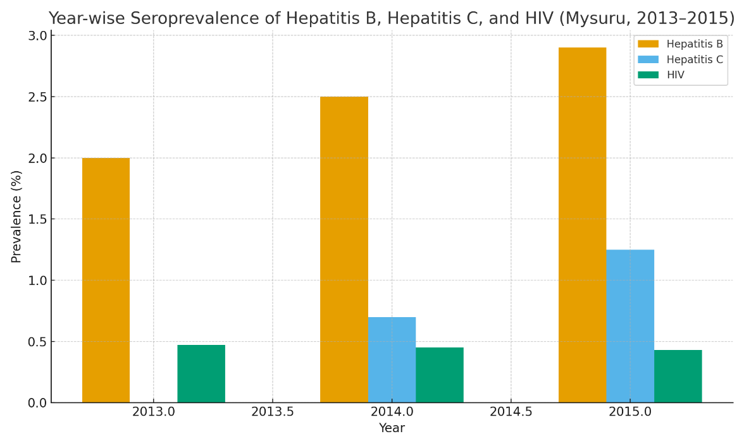

Figure 1. Year-wise seroprevalence of Hepatitis B virus (HBV), Hepatitis C virus (HCV), and Human Immunodeficiency Virus (HIV) among dental outpatients at a tertiary care institution in South India (2013–2015). HBV showed a gradual increase over the study period, while HCV and HIV remained low with minimal year-to-year variation
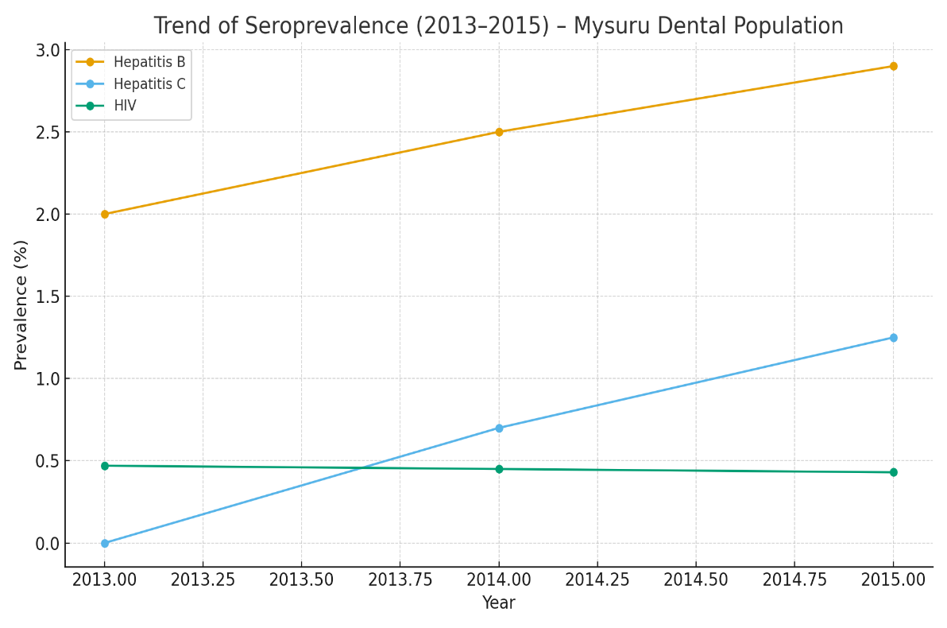

Figure 2. Temporal trends in seroprevalence of Hepatitis B virus (HBV), Hepatitis C virus (HCV), and Human Immunodeficiency Virus (HIV) among the dental outpatient population in South India, from 2013 to 2015. HBV demonstrated a steady upward trend, HCV showed a mild increase over the study period, while HIV prevalence remained low with minimal fluctuation.

Statistical Analysis:
- Chi-square test for trend (HBV): χ² = 0.45, p = 0.50 → Not statistically significant.
- Confidence intervals:
  - HBV: 2.5% (95% CI: 1.1–4.5%)
  - HCV: 0.7% (95% CI: 0.1–2.0%)
  - HIV: 0.45% (95% CI: 0.09–1.3%)

Discussion
The HBV seroprevalence of 2.5% observed in the present study is in accordance with previously reported data from South India, which categorises the region under intermediate endemicity.⁽⁴,⁵⁾ This finding reflects the persistent burden of HBV infection despite the availability of effective vaccination programs, suggesting possible gaps in immunisation coverage, awareness, or access to healthcare services. The comparatively lower prevalence of HCV (0.7%) and HIV (0.45%) aligns with national estimates, where both infections fall within the low-prevalence spectrum.⁽⁶⁻⁸⁾ These observations may be indicative of improved public health interventions, better screening strategies, and increased awareness regarding transmission routes.
A notable finding in the present study is the consistent male predominance across all three infections. This pattern has been reported in several epidemiological studies and may be attributed to higher exposure to risk factors among males, including occupational hazards, increased likelihood of engaging in high-risk behaviours, and greater mobility. Additionally, sociocultural factors and differences in healthcare-seeking behaviour between genders may also contribute to this disparity.
The relatively stable prevalence of HIV over the three-year study period suggests the effectiveness of ongoing national programs such as those implemented under the National AIDS Control Organisation (NACO), along with state-level awareness and prevention initiatives. These programs have significantly contributed to early detection, counselling, and reduction in transmission rates, thereby stabilising the disease burden within the population.
The findings of this study underscore the critical importance of routine preoperative screening for HBV, HCV, and HIV in dental settings, particularly before invasive procedures. Given the asymptomatic nature of many infected individuals, reliance solely on patient history or self-reported status may lead to underdiagnosis and increased risk of cross-infection. Therefore, universal screening protocols serve as an essential adjunct to standard precautions.
Furthermore, Hepatitis B vaccination remains one of the most effective preventive measures, especially for healthcare workers who are at increased occupational risk. Strengthening vaccination coverage, along with strict adherence to infection control practices such as sterilisation, use of personal protective equipment, and safe handling of sharps, is imperative.
Compliance with established standards, including ISO 15189:2022 for medical laboratories and the Clinical Establishments (Registration and Regulation) Act, 2010, ensures quality assurance, patient safety, and reliability of diagnostic services. Collectively, these measures play a crucial role in minimising the transmission of blood-borne infections and enhancing overall healthcare outcomes.
Altimary and Abduljaleel (2026) evaluated the seroprevalence of HBV, HCV, and HIV among patients undergoing preoperative assessment for urological surgeries. The study reported an overall infection rate of 8.7%, with a higher prevalence of HBV compared to HCV, while no HIV cases were detected. Significant associations were found with risk factors such as blood transfusion, dialysis, and prior dental procedures. The findings highlight the importance of routine preoperative screening and preventive strategies to reduce transmission risk.
Sukegawa et al. (2022) evaluated the effectiveness of preoperative screening for HBV, HCV, and HIV in patients undergoing oral and maxillofacial surgery. The study reported low prevalence rates of HBV (0.39%), HCV (0.76%), and HIV (0.07%). Self-reported history was found to be less reliable compared to serological screening. The findings emphasise the importance of routine preoperative testing despite associated costs to ensure accurate detection of viral infections¹⁰.
Kak et al. (2021) conducted an 8-year retrospective study to assess the seroprevalence of HBV, HCV, and HIV among dental patients. The study reported an overall increase in prevalence over time, with higher seropositivity noted in the 30–40 years age group and significant gender differences. The findings highlight a considerable burden of blood-borne infections, particularly among rural populations. The study emphasises the need for proper screening, history taking, and strict sterilisation protocols to prevent cross-infection¹¹.
Al-Amad SH (2018) conducted a 7-year retrospective study to determine the prevalence of hepatitis B virus (HBV), hepatitis C virus (HCV), and human immunodeficiency virus (HIV) among patients attending a teaching dental hospital in the United Arab Emirates. The study analysed patient records over an extended period to assess the burden of these blood-borne viral infections in a dental care setting. The results demonstrated a relatively low prevalence of HIV, whereas HBV and HCV infections were observed more frequently among the study population. The study emphasised the importance of routine screening, strict infection control measures, and adherence to universal precautions in dental practice to prevent cross-infection. Furthermore, the findings highlighted the need for increased awareness and early detection strategies, particularly in healthcare environments where the risk of transmission is significant¹².
Kalyani et al. (2017) evaluated the seroprevalence of HBV, HCV, and HIV and their transmissibility following occupational exposure in a dental setting. The study reported 3.8% HCV positivity and 2.2% HBV positivity, with no cases of HIV detected. Despite the presence of infected patients, no seroconversion was observed among dental personnel during follow-up. The findings suggest low transmissibility with adequate vaccination and infection control practices¹³.

Conclusion
The 3-year retrospective data (2013–2015) from a tertiary dental institution in South India demonstrate:
- Controlled but persistent HBV prevalence (2–3 %)
- Very low HCV and HIV prevalence (≤1 %)
- Male predominance across infections
Continued vigilance through screening, vaccination, and universal precautions remains crucial to maintain low endemicity levels in the dental community and safeguard healthcare workers.
Summary
- This is a three-year retrospective study (2013–2015) at South Indian Private Dental College
- Hepatitis B prevalence rose slightly from 2.0% in 2013 to 2.9% in 2015.
- Hepatitis C prevalence remained low, ranging from 0% to 1.25%.
- HIV prevalence was steady between 0.43% and 0.47%.
- All infections showed low endemicity, highlighting effective screening and infection-control measures in the South Indian dental population.

Limitations
The study is predominantly on recorded data, which would likely be called a retrospective study design. The data was extracted from a single tertiary care centre using only a rapid screening test without a confirmatory test like ELISA, PCR, raising the possibility of false positives. Therefore, future studies could adopt a more prospective multicentric design involving diverse geographic regions and use a confirmatory diagnostic test to enhance the accuracy.
Ethical approval
Ethical approval was obtained from the Institutional Ethics Committee. Patient identifiers were anonymized in accordance with the HIV & AIDS (Prevention and Control) Act, 2017. All procedures for sample handling and disposal followed the Biomedical Waste Management Rules, 2016.

Disclaimer (Artificial intelligence)

Author(s) hereby declare that NO generative AI technologies such as Large Language Models (ChatGPT, COPILOT, etc.) and text-to-image generators have been used during the writing or editing of this manuscript.

References
- World Health Organization. Global hepatitis report 2022. Geneva: WHO; 2022.
- National AIDS Control Organisation (NACO). Annual report 2023–24. Ministry of Health & Family Welfare, Govt of India; 2024.
- Indian Council of Medical Research (ICMR-NIMS). Population-based serosurvey for hepatitis B and C in India. New Delhi: ICMR; 2023.
- NagpalB, HegdeU, KulkarniM.Seroprevalence of hepatitis B antigenemia among dental students in a private South Indian dental institution.Int J Res Med Sci.2015;3:3543-7.
- Kumar S, et al. Prevalence of Hepatitis B infection in a tertiary care hospital in South India. Indian J Public Health. 2020;64(4):315-318.
- Thomas DL. Global control of hepatitis C: Where challenge meets opportunity. Nat Med. 2018;24(9):1204-1211.
- Gupta N, et al. Epidemiology of HIV in India: A steady decline. Indian J Med Res. 2022;155(3):281-288.
- NACO Karnataka State AIDS Control Society. HIV surveillance report 2024. Bengaluru: KSACS; 2024.
- Altimary AY, Abduljaleel NK. Study of seroprevalence of viral hepatitis B, C and HIV in preoperative assessment for urological surgeries. Indones J Health Sci Med. 2026;3(1):397.
- Sukegawa S, Sukegawa Y, Hasegawa K, Ono S, Nakamura T, Fujimura A, Fujisawa A, Nakano K, Takabatake K, Kawai H, et al. The effectiveness of pre-operative screening tests in determining viral infections in patients undergoing oral and maxillofacial surgery. Healthcare. 2022;10(7):1348.
- Kak MM, Jyoti A, Nath A, Rastogi P, Kumar S. Seroprevalence of hepatitis B, C and HIV among patients attending a multispecialty hospital: an 8-year retrospective study. Int J Appl Dent Sci. 2021;7(4):174-176.
- Al-Amad SH. Prevalence of hepatitis B, C, and HIV among patients attending a teaching dental hospital: a 7-year retrospective study from the United Arab Emirates. Saudi Med J. 2018;39(5):500-505. doi:10.15537/smj.2018.5.22116.
- Kalyani CS, Lakshmi N, Lakshmi KR, Kumar VA, Cheemala SS. Seroprevalence of hepatitis B virus and hepatitis C virus co-infection in human immunodeficiency virus infected patients at a tertiary care hospital in South India. Int J Res Med Sci. 2017;3(8):2041-2045.

.

