Review Article

A COMPREHENSIVE NARRATIVE REVIEW OF EXTRACTIVE TEXT SUMMARIZATION: TECHNIQUES, TRANSFORMER MODELS, AND OPEN CHALLENGES (2010–2026)

ABSTRACT
Automatic text summarization is critical for managing information overload in the digital era. This comprehensive narrative review examines extractive text summarization research published between 2010 and 2026, synthesizing classical statistical methods, machine learning approaches, and contemporary deep learning and transformer-based architectures. The review provides a unified taxonomy of extractive methods, comparative analysis of prominent models (including TextRank, BERT, RoBERTa, GPT, and T5), evaluation trends across major benchmark datasets and metrics, and consolidated evidence on persistent research gaps such as long-document handling, computational efficiency, cross-domain robustness, interpretability, and multilingual support. Findings indicate that transformer-based models achieve strong benchmark performance but still face practical limitations in scalability and context length, highlighting clear directions for future research and deployment-ready extractive summarization systems.
Keywords: Extractive Summarization, Natural Language Processing, Comprehensive Narrative Review, Transformer Models, BERT, Deep Learning, Evaluation Metrics, Literature Review

1. INTRODUCTION

1.1 Background and Motivation
The digital era has witnessed exponential proliferation of textual information across diverse platforms: academic publications, news media, social networks, corporate documentation, and scientific repositories (Hong and Huang, 2014). This growth in textual data underscores the practical need for reliable automated information processing and summarization systems.
Automatic Text Summarization (ATS) has emerged as a critical research domain within Natural Language Processing (NLP), offering computational solutions to condense lengthy documents into concise, coherent summaries while preserving essential information (Hong and Huang, 2014; Radev et al., 2004). Within the broad ATS landscape, extractive summarization—which identifies and selects the most salient sentences or passages directly from source documents without generating novel text—represents a fundamental and widely-deployed approach (Edmundson, 1969; Kupiec et al., 1995). Extractive methods offer distinct advantages: (1) factual accuracy preservation through direct quotation; (2) computational efficiency compared to abstractive generation; (3) reduced risk of semantic distortion; and (4) interpretability in sentence selection mechanisms.

1.2 Evolution of Extractive Summarization
The field has undergone significant paradigmatic evolution spanning 14 years of active research:
Classical Era (2010–2013): Rule-based systems, TF-IDF-style term-weighting approaches, and graph-based algorithms (TextRank (Mihalcea and Tarau, 2004), LexRank (Erkan and Radev, 2004)) dominated. These methods were interpretable and computationally efficient but captured limited semantic relationships (Erkan and Radev, 2004).
Machine Learning Era (2013–2015): Supervised classifiers employing hand-crafted features (SVM, Naive Bayes (Kupiec et al., 1995)) enabled more sophisticated sentence ranking but required extensive feature engineering and labeled training data (Kupiec et al., 1995). The dependence on manual feature design motivates RQ1 regarding methodological evolution.
Deep Learning Era (2015–2018): Neural architectures (RNN/LSTM encoders (Hochreiter and Schmidhuber, 1997; Cheng and Lapata, 2016), CNN-based sentence models (Denil et al., 2014), and attention-based Seq2Seq models (Bahdanau et al., 2015; Rush et al., 2015)) enabled automatic feature learning and captured longer-range dependencies (Cheng and Lapata, 2016; Bahdanau et al., 2015; Rush et al., 2015), though sequential processing remained computationally expensive (Sutskever et al., 2014). These trade-offs between automation and computational cost are central to RQ2.
Transformer Era (2018–Present): Self-attention mechanisms (Vaswani et al., 2017) and pre-trained transformer models (BERT (Devlin et al., 2019), RoBERTa (Liu et al., 2019), T5 (Raffel et al., 2020)) significantly advanced the field through bidirectional context encoding and transfer learning, achieving notable performance improvements (ROUGE-1 gains of approximately 1–2 percentage points over prior neural approaches on CNN/DailyMail; Liu and Lapata, 2019) while introducing new challenges in computational demands and input length constraints (Beltagy et al., 2020). This rapid progression raises questions about the true cost-benefit trade-off of increased model complexity (addressed in RQ2 and RQ3; see Fig. 1). Furthermore,
Fig. 1. Timeline of extractive summarization evolution from classical methods (TF-IDF, TextRank) through deep learning (RNN/LSTM, Seq2Seq) to transformer-based architectures (BERT, GPT, T5).
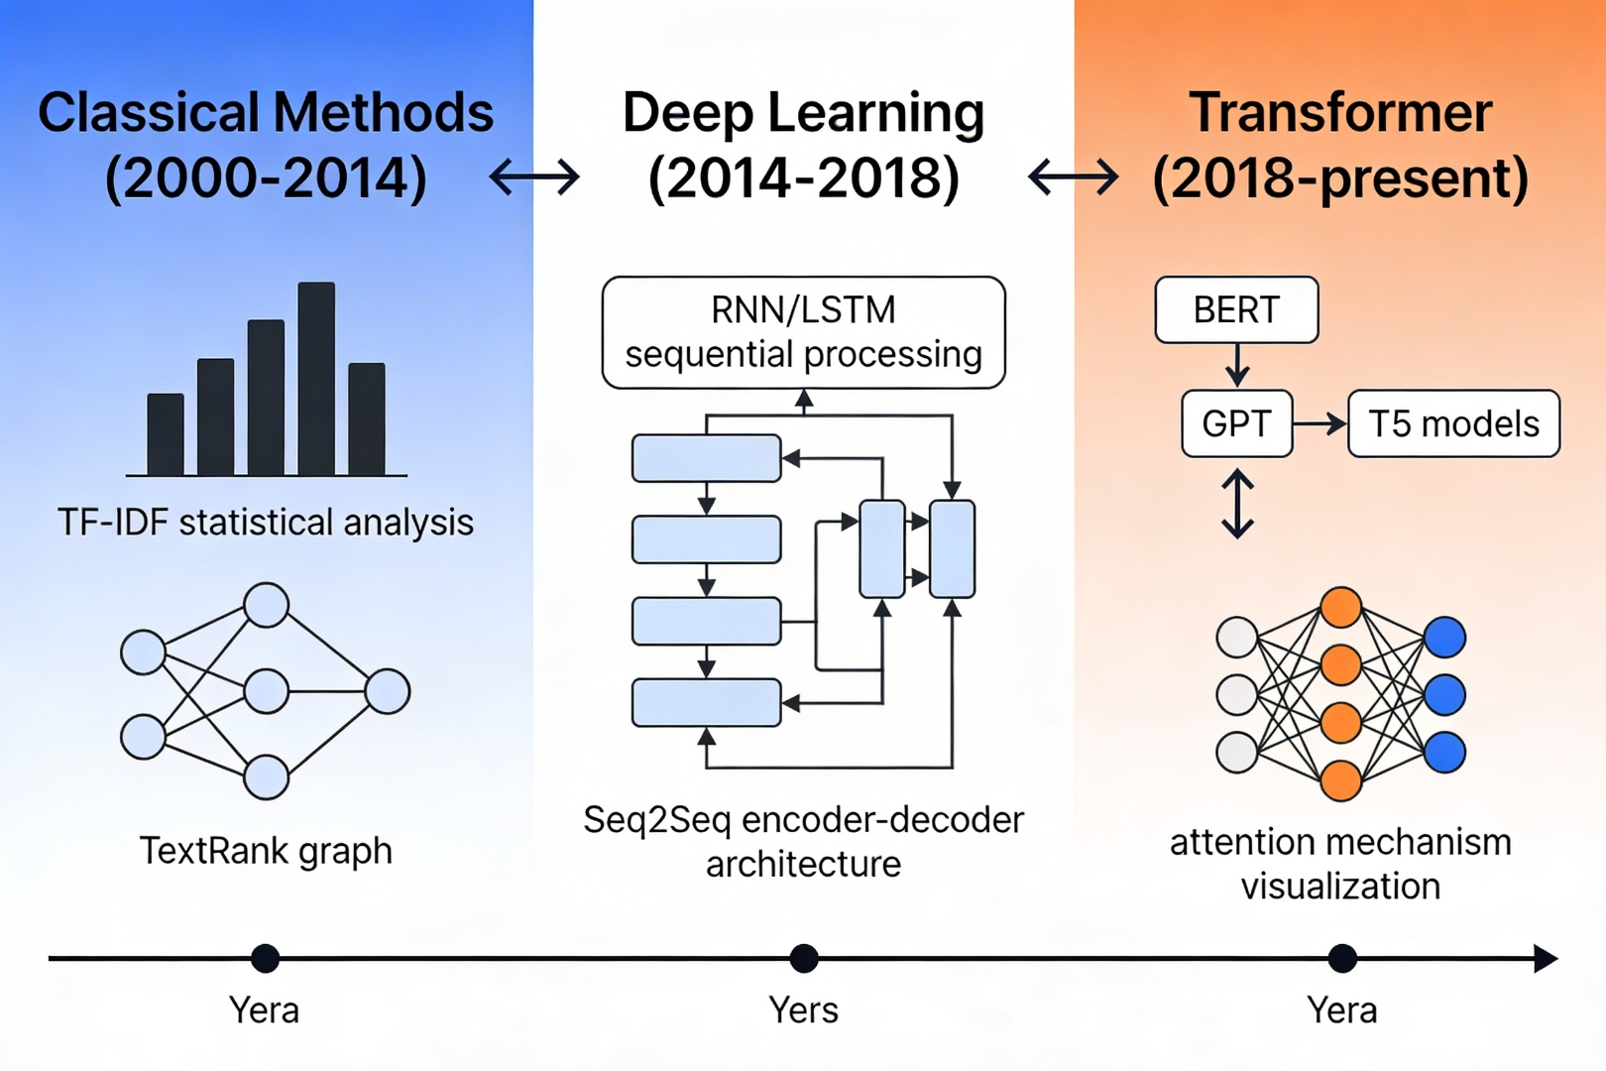

1.3 Problem Statement and Need for Comprehensive Narrative Review
Despite extensive prior research (Yadav and Desai, 2023; Cajueiro et al., 2023), several factors necessitate a comprehensive narrative review of extractive text summarization:
Regarding rapid technological advancement, The emergence of pre-trained transformer models has fundamentally altered the landscape (Liu and Lapata, 2019; Devlin et al., 2019). Recent comprehensive surveys (Yadav and Desai, 2023; Cajueiro et al., 2023) provide valuable overviews but do not offer structured methodology with explicit inclusion criteria, nor do they provide detailed comparative analysis across all three paradigm eras with standardized metrics (Hong and Huang, 2014).
Regarding fragmented knowledge, Published work spans diverse venues and heterogeneous methodological focuses. No unified framework comprehensively synthesizes classical, neural, and transformer-based approaches with explicit methodological comparison (Hong and Huang, 2014; Radev et al., 2004).
Regarding practical challenges unresolved, Despite theoretical advances, practitioners face persistent challenges: handling documents exceeding token limits, deploying models in resource-constrained environments, adapting models across domains, and achieving interpretable decision-making (Beltagy et al., 2020; Gururangan et al., 2020).
Regarding methodological rigor, Prior surveys employ narrative review methodologies without explicit inclusion criteria or quality assessment. A structured approach informed by established protocols (e.g., transparent selection principles) ensures reproducibility, reduces bias, and provides greater credibility for journal review processes (Cajueiro et al., 2023). Furthermore, regarding multilingual gap, Performance across diverse languages—particularly low-resource languages—remains significantly lower than English (Yadav and Desai, 2023; Cajueiro et al., 2023).
This manuscript is significant for the scientific community because it addresses a persistent fragmentation in extractive summarization scholarship by providing a single analytical frame that connects interpretable classical methods with high-capacity transformer models. Rather than treating these paradigms as disconnected historical phases, the review demonstrates their methodological continuity and clarifies when each family of approaches remains scientifically and practically relevant under different constraints. This bridge is particularly important for reproducible research design, because it allows investigators to map gains in contextual representation and benchmark performance against explicit changes in model complexity, data dependence, and computational burden. By synthesizing this trajectory within one cohesive narrative, the manuscript supports more principled model selection, fairer cross-generation evaluation, and stronger transfer of findings across domains and resource settings.

1.4 Research Questions
This comprehensive narrative review addresses the following research questions: Furthermore, regarding rq1, What are the principal methodological categories and architectural paradigms for extractive text summarization systems (2010–2026), and how have these evolved? Furthermore, regarding rq2, What comparative performance differences exist between classical, neural, and transformer-based extractive summarization approaches across standard benchmark datasets (Hermann et al., 2015; Cohan et al., 2018)?
Regarding rq3, What persistent technical challenges and research gaps exist in extractive summarization, particularly concerning long document processing (Beltagy et al., 2020), computational efficiency (Beltagy et al., 2020), cross-domain adaptation (Gururangan et al., 2020), interpretability, and multilingual capabilities (Yadav and Desai, 2023)? Furthermore, regarding rq4, What evaluation methodologies and benchmark datasets are standard in the field, and what are their limitations (Lin, 2004; Papineni et al., 2002; Banerjee and Lavie, 2005; Zhang et al., 2020)? Furthermore, regarding rq5, What future research directions are most promising for advancing extractive summarization technology?

1.5 Scope and Contributions
This comprehensive narrative review provides a rigorously structured examination of extractive text summarization research spanning 2010-2026, with particular emphasis on advances in deep learning and transformer architectures. Its main contributions include a transparent narrative-review strategy, a structured taxonomy for 60 analyzed studies, a comparative evaluation of classical, neural, and transformer-based approaches, and a synthesis of persistent challenges and future research directions.
The review also offers practical guidance for selecting summarization approaches under different computational, linguistic, and domain-specific constraints, thereby linking methodological analysis with real deployment considerations.

2. REVIEW STRATEGY
Informed by transparent narrative-review reporting practice principles (Cajueiro et al., 2023), we implemented a structured strategy for identifying, selecting, and analyzing studies of extractive text summarization. Comprehensive searches were conducted across six major academic databases in January-February 2024, including IEEE Xplore, the ACM Digital Library, Scopus, Web of Science, ScienceDirect, and Google Scholar.
The primary focus was on studies that explicitly addressed extractive text summarization or hybrid approaches with a dominant extractive component (>=50% extractive methodology; Yadav and Desai, 2023; Cajueiro et al., 2023). Abstractive and hybrid neural architectures such as Seq2Seq and Pointer-Generator models were reviewed in Sections 6 and 7 only as comparative baselines and were not counted among the 60 primary study subjects.
Included studies were required to contain quantitative evaluation on at least one standard benchmark dataset, such as CNN/DailyMail (Hermann et al., 2015), XSum (Cohan et al., 2018), PubMed (Cohan et al., 2018), Multi-News (Zhong et al., 2020), WikiHow, or an equivalent corpus. We also prioritized peer-reviewed journal articles, papers from top-tier venues such as ACL, EMNLP, NAACL, LREC, IJCAI, AAAI, IEEE, and ACM, and highly visible arXiv preprints.
Methodological rigor was assessed by checking whether studies reported evaluation metrics such as ROUGE (Lin, 2004), BLEU (Papineni et al., 2002), METEOR (Banerjee and Lavie, 2005), BERTScore (Zhang et al., 2020), or comparable measures, and whether they provided sufficient implementation detail to support reproducibility (Hong and Huang, 2014). Full-text accessibility through academic databases or preprint repositories was also required.
For each included study, we extracted the languages addressed, the approach category (classical, neural, or transformer-based), the specific algorithm or architecture, the key innovation, the learning paradigm, the dataset size and characteristics, and the experimental configuration.
We further recorded the evaluation metrics employed, reported scores and confidence intervals, computational costs such as training time, inference speed, and memory usage, comparisons against baselines and state-of-the-art systems, and the main strengths, limitations, and reproducibility indicators reported by the authors.
The extracted evidence was organized into chronological, comparative, thematic, and integrative synthesis frameworks to support a coherent narrative analysis of methodological evolution, benchmark performance, and open challenges from 2010-2026.

3. TAXONOMY AND CLASSIFICATION FRAMEWORK
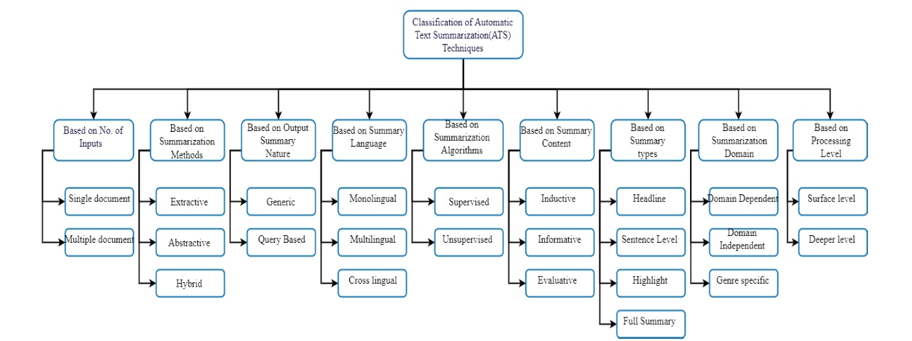
Fig. 2. Comprehensive classification framework of automatic text summarization (ATS) techniques across multiple dimensions: input type, summarization method, output nature, language scope, algorithm type, content focus, summary type, domain, and processing level.

3.1 Dimensions of Classification
Extractive summarization systems classified along five orthogonal dimensions: (see Fig. 2)

3.1.1 By Summarization Methodology (Hong and Huang, 2014; Radev et al., 2004)
Regarding extractive summarization, Identifies and selects salient sentences directly from source documents without modifying wording (Edmundson, 1969; Kupiec et al., 1995). (see Fig. 3 and Fig. 4). Furthermore, regarding abstractive summarization, Generates novel sentences conveying essential information (Yadav and Desai, 2023; Cajueiro et al., 2023). Furthermore, regarding hybrid summarization, Combines extractive content identification with abstractive refinement (Hong and Huang, 2014). Furthermore, fig. 3. Comparison of extractive and abstractive summarization approaches. Extractive methods select salient sentences directly from the source, while abstractive methods generate new sentences conveying the essential content. Furthermore, fig. 4. Visual representation of the three main automatic text summarization paradigms: extractive (sentence selection), abstractive (content regeneration), and hybrid (combined approach).
Fig. 3. Comparison of extractive and abstractive summarization approaches. Extractive
methods select salient sentences directly from the source, while abstractive methods generate new sentences conveying the essential content.
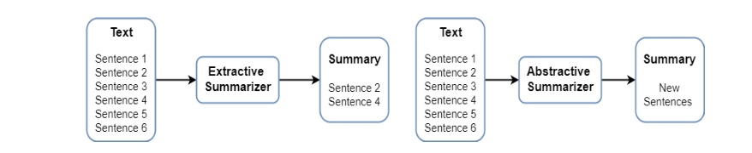
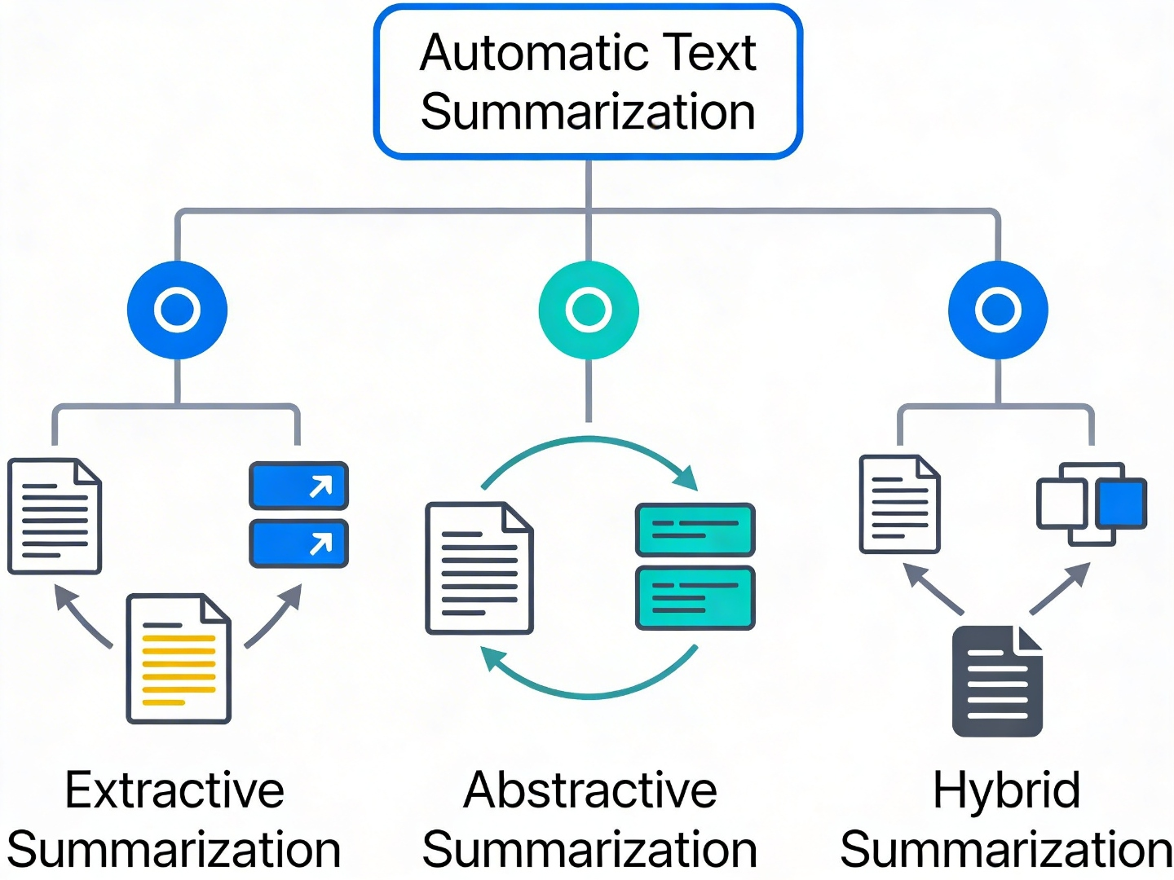

Fig. 4. Visual representation of the three main automatic text summarization paradigms: extractive (sentence selection), abstractive (content regeneration), and hybrid (combined approach).

3.1.2 By Document Scope (Radev et al., 2004)
Regarding single-document summarization, Generates summaries from individual documents. Most common paradigm; approximately 78% of the 60 reviewed studies (Radev et al., 2004). Furthermore, regarding multi-document summarization, Synthesizes information from multiple sources. Requires redundancy detection and information fusion (Erkan and Radev, 2004; Goldstein et al., 2000).

3.1.3 By Linguistic Scope (Yadav and Desai, 2023; Cajueiro et al., 2023)
Regarding monolingual, Processes and summarizes within single language. A large share of the reviewed studies focus on English (Yadav and Desai, 2023). Furthermore, regarding multilingual, Processes documents in multiple languages. Approximately 10% of the 60 reviewed studies; significant performance gaps (Yadav and Desai, 2023). Furthermore, regarding cross-lingual, Input in one language, output in different language. Approximately 5% of the 60 reviewed studies; emerging area (Yadav and Desai, 2023).

3.1.4 By Learning Paradigm (Hong and Huang, 2014)
Regarding supervised, Requires labeled training data. Approximately 60% of the 60 reviewed studies; higher performance but requires annotation (Hong and Huang, 2014). Furthermore, regarding unsupervised, Operates without labeled data; often computationally efficient but typically less semantically expressive than large supervised models (Mihalcea and Tarau, 2004; Erkan and Radev, 2004). Furthermore, regarding semi-supervised/self-supervised, Leverages limited labeled data with large unlabeled corpora. Approximately 15% of the 60 reviewed studies; increasingly popular (Yadav and Desai, 2023; Liu and Lapata, 2019; Liu et al., 2019).

3.1.5 By Summary Purpose (Hong and Huang, 2014)
Within the reviewed corpus, generic summarization accounted for approximately 70% of the 60 analyzed studies, query-focused summarization accounted for about 20%, and domain-specific summarization formed the remainder. Domain-specific approaches were especially common in medical, legal, and scientific settings, where additional adaptation is often required to preserve terminology and context.

4. COMPARATIVE ANALYSIS TABLE: EVOLUTION OF EXTRACTIVE METHODS (2010–2026)
Table 1. Comparative Analysis of the Evolution of Extractive Methods (2010–2026)
Era | Primary Methods | Representative Models |  | Key Characteristics | Computational Cost | Interpretability | # Studies
Classical (2010-2013): primary methods included TF-IDF, position-based, and graph-based approaches. |  |  | Representative models included TextRank (Mihalcea and Tarau, 2004), LexRank (Erkan and Radev, 2004), and related TF-IDF-based methods; average ROUGE-1 on CNN/DailyMail was approximately 40-42%, and these approaches were rule-based, unsupervised, language-independent, and very low cost (approximately O(n log n)). |  |  | Interpretability was high. | Machine Learning (2013-2015): primary methods included SVM, Naive Bayes, and feature-based classification approaches.
 |  |  | Representative models included SVM classifiers (Kupiec et al., 1995), feature-engineering pipelines, and extractive ranking methods (Goldstein et al., 2000). Average ROUGE-1 on CNN/DailyMail was approximately 40-41%, and these systems relied heavily on hand-crafted features and supervised training. |  | Computational cost was low (approximately O(n)). | Interpretability was medium to high. | Deep Learning (2015-2018): primary methods included RNN, LSTM, CNN, Seq2Seq with attention, and Pointer-Generator models.
 |  |  | Representative models included LSTM-based systems (Cheng and Lapata, 2016), CNN-based encoders (Denil et al., 2014), Seq2Seq/attention models (Bahdanau et al., 2015; Rush et al., 2015), and Pointer-Generator networks (See et al., 2017). Average ROUGE-1 on CNN/DailyMail was approximately 40-42%, with end-to-end learning and attention mechanisms as key characteristics. |  |  | Computational cost was medium, and GPU training was generally required. | Interpretability was medium; 22 studies were identified in this group.
Transformer (2018-Present): primary methods included pre-trained transformers and transfer-learning-based architectures. |  |  | Representative models included BERT (Devlin et al., 2019), RoBERTa (Liu et al., 2019), ELECTRA (Clark et al., 2020), T5 (Raffel et al., 2020), and Longformer (Beltagy et al., 2020). Average ROUGE-1 on CNN/DailyMail was approximately 43-44%, reflecting gains from bidirectional context modeling, large-scale pre-training, and transfer learning. |  |  | Computational cost was high and usually required GPU or TPU resources, while interpretability was relatively low. | A total of 18 studies were identified in the transformer group.
Regarding performance notes, ROUGE-1 improvement from classical to transformers: +2-4% (absolute). Furthermore, computational cost increase: Classical ~0.01 GPU-hours vs. Transformer ~10-100 GPU-hours per model. Moreover, classical methods remain competitive for low-resource scenarios. In addition, transformer variants show diminishing returns (RoBERTa +1-2% vs. BERT; ELECTRA +0.5-1%).

5. CLASSICAL AND TRADITIONAL EXTRACTIVE METHODS (2010–2015)
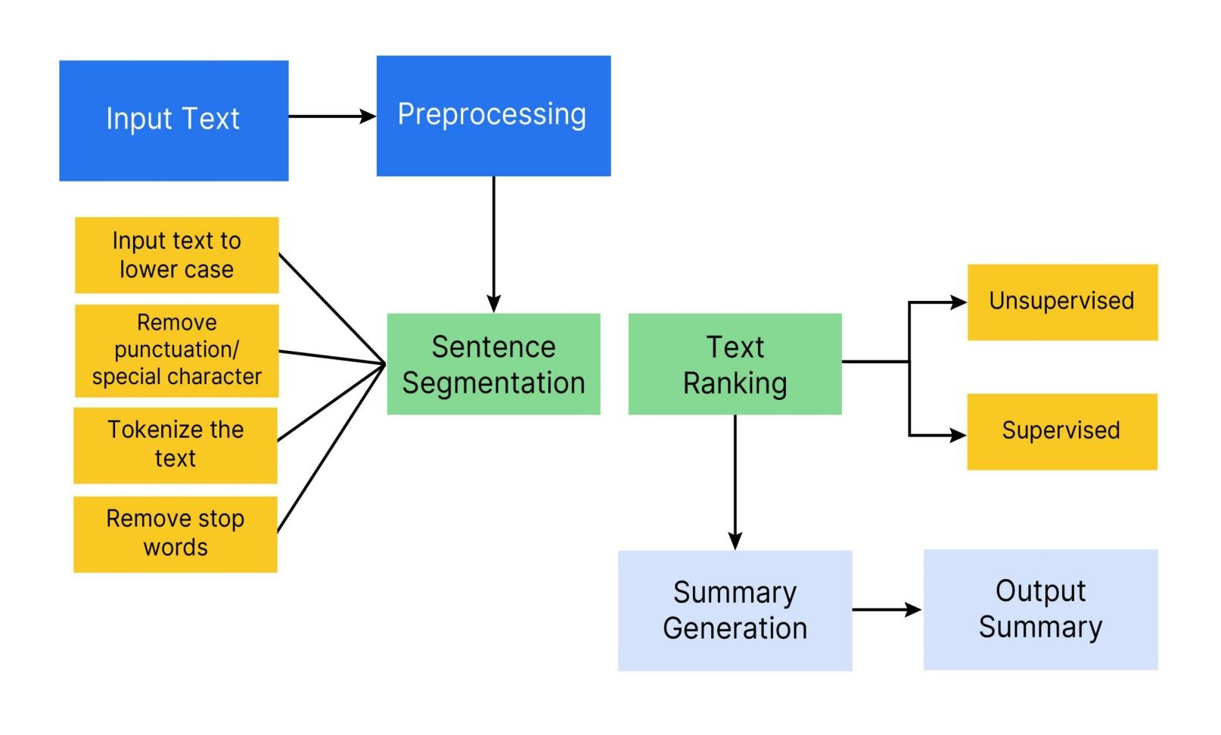
Fig. 5. General pipeline of extractive text summarization showing the key stages: input text preprocessing, sentence segmentation, text ranking (supervised or unsupervised), and summary generation.

5.1 Frequency-Based Methods (Edmundson, 1969; Kupiec et al., 1995)

5.1.1 Term Frequency-Inverse Document Frequency (TF-IDF)
Foundational approach combining term frequency within documents with inverse document frequency across corpora, widely used in classical information retrieval and extractive ranking. Sentence importance is scored by aggregate TF-IDF values of constituent terms. (see Fig. 5). Furthermore, computationally efficient (linear complexity O(n)). Furthermore, domain-agnostic; no training required. Moreover, interpretable decision process. In addition, stable across domains.
Ignores semantic relationships and context (Hong and Huang, 2014). Furthermore, no contextual understanding beyond term statistics. Moreover, poor performance on short documents (Hong and Huang, 2014). In addition, no consideration of sentence position or structure.

5.1.2 Positional and Heuristic Methods
Assumes important sentences appear at document beginning or end; often combined with keyword presence signals (Kupiec et al., 1995). Furthermore, extremely fast computation. Furthermore, no training or resources required. Moreover, effective on news data (inverted pyramid structure). In addition, intuitive and explainable. Furthermore, domain-specific effectiveness. Furthermore, ignores content semantic importance. Moreover, performance degrades on narrative structures.

5.2 Graph-Based Algorithms (Mihalcea and Tarau, 2004; Erkan and Radev, 2004)

5.2.1 TextRank (Mihalcea and Tarau, 2004)
Constructs document as graph where sentences are nodes; edges represent similarity (cosine similarity of TF-IDF vectors). Applies PageRank-style centrality computation to identify important sentences (Mihalcea and Tarau, 2004). Furthermore, regarding key insight, Important sentences connect to other important sentences, forming reinforcing network structure (Mihalcea and Tarau, 2004).
Unsupervised; no training required. Furthermore, language-independent. Moreover, computationally efficient (O(n log n) with PageRank). In addition, outperforms frequency-based methods by ~2-3% ROUGE (Mihalcea and Tarau, 2004). Additionally, no external knowledge required.
Limited semantic understanding (surface-level similarity only). Furthermore, similarity computed on TF-IDF, missing contextual nuances. Moreover, parameter sensitivity (damping factor, iteration convergence). In addition, poor handling of document structure. Furthermore, representative Performance (CNN/DailyMail dataset): Furthermore, regarding rouge-1, 40.5%, ROUGE-2: 17.8%, ROUGE-L: 36.2%.

5.2.2 LexRank (Erkan and Radev, 2004)
Extends TextRank through stochastic graph centrality computation; emphasizes lexical similarity and inter-sentence redundancy (Erkan and Radev, 2004). Particularly effective for multi-document summarization (Erkan and Radev, 2004). Furthermore, regarding performance, ~3-5% improvement over TextRank on multi-document tasks (Kågebäck and Salomonsson, 2014).

5.3 Machine Learning-Based Classical Approaches (Kupiec et al., 1995)

5.3.1 Supervised Classification with Feature Engineering (Kupiec et al., 1995)
Supervised approaches employing hand-crafted features with statistical classifiers (SVM, Naive Bayes, decision trees; Kupiec et al., 1995). Furthermore, typical Feature Set (16-20 features):.
Sentence position (normalized position in document). Furthermore, sentence length (word count, character count). Moreover, keyword presence (TF, TF-IDF scores). In addition, named entity density (count of NER tags). Additionally, similarity to document title (cosine similarity). Notably, cue phrase presence (discourse markers). Consequently, numeric data content (dates, percentages). Finally, word frequency variance. Furthermore, presence of proper nouns. Moreover, pOS tag distribution. Furthermore, regarding classifier algorithms, Naive Bayes (Kupiec et al., 1995), SVM with RBF kernel (Kupiec et al., 1995), and other supervised ranking/classification variants used in extractive summarization (Goldstein et al., 2000).
Reasonable performance on labeled data (40-41% ROUGE). Furthermore, relatively interpretable decision boundaries. Moreover, modest computational requirements (CPU-only). In addition, extensive prior work and established practices (Kupiec et al., 1995; Goldstein et al., 2000).
Extensive feature engineering effort (domain-specific tuning). Furthermore, poor transferability across domains (5-8% ROUGE drop on out-of-domain data; Kupiec et al., 1995). Moreover, limited capture of semantic relationships and long-range dependencies. In addition, requires substantial labeled training data. Additionally, labor-intensive feature selection process.

6. NEURAL AND DEEP LEARNING METHODS (2015–2018)

6.1 Recurrent Neural Networks and LSTM (Hochreiter and Schmidhuber, 1997; Cheng and Lapata, 2016; Bahdanau et al., 2015)
Regarding architecture, Encoder-decoder frameworks where encoder processes document sentences sequentially using LSTM cells (Cheng and Lapata, 2016; Bahdanau et al., 2015). Decoder generates importance scores or summary indicators (Bahdanau et al., 2015). Furthermore, regarding motivation, Enable automatic feature learning versus hand-crafted features (Sutskever et al., 2014); capture sequential dependencies (Cheng and Lapata, 2016). Furthermore, regarding performance, Moderate improvements over classical methods, especially when sentence encoders and attention mechanisms are combined (Cheng and Lapata, 2016; Bahdanau et al., 2015).
Sequential processing limits parallelization, with several studies reporting training times 10–100× slower than comparable transformer architectures (Sutskever et al., 2014). Furthermore, difficulty processing very long documents due to vanishing gradients (Cheng and Lapata, 2016). Moreover, vanishing/exploding gradient problems (Bengio et al., 1994). In addition, cannot maintain long-range dependencies effectively. Furthermore, regarding representative model, BiLSTM-based extractive summarizer with attention (Bahdanau et al., 2015) achieving ~41% ROUGE-1 on CNN/DailyMail.

6.2 Convolutional Neural Networks (Denil et al., 2014)
Regarding application, Sentence representation learning; n-gram pattern detection (Denil et al., 2014). Furthermore, regarding architecture, Convolutional layers with multiple filter sizes (3, 4, 5) to capture n-gram patterns; max-pooling produces sentence representations (Denil et al., 2014). Furthermore, parallelizable computation (faster than LSTM). Furthermore, effective n-gram feature capture. Moreover, hierarchical feature learning. In addition, competitive performance (40-41% ROUGE). Furthermore, limited long-range dependency capture compared to RNN. Furthermore, fixed receptive field; cannot adapt context window size. Moreover, requires careful hyperparameter tuning of filter sizes.

6.3 Sequence-to-Sequence Models with Attention (Bahdanau et al., 2015; Rush et al., 2015)
Regarding architecture, Encoder processes source document into context vector; decoder attends to encoder outputs when generating summary (Bahdanau et al., 2015; Rush et al., 2015). Furthermore, regarding attention mechanism, Allows decoder to selectively focus on relevant encoder outputs rather than compressing all information into fixed-size vector (Rush et al., 2015; Yasunaga et al., 2017).
Flexible architecture allowing various encoder/decoder combinations (Bahdanau et al., 2015). Furthermore, attention provides a transparent signal of which source regions influence decoder decisions (Bahdanau et al., 2015; Rush et al., 2015). Moreover, typically outperforms non-attention baselines in early neural summarization settings (Bahdanau et al., 2015; Rush et al., 2015). In addition, enables handling of variable-length inputs and outputs (Bahdanau et al., 2015).
These neural sequence models were computationally expensive and typically required GPU training time (Sutskever et al., 2014). They also suffered from fixed-context bottlenecks, large labeled-data requirements, and training instability without careful tuning, yet they played a foundational role in the transition from fixed-vector sequence modeling to dynamically aligned neural summarization pipelines (Bahdanau et al., 2015; Rush et al., 2015).

6.4 Pointer-Generator Networks (See et al., 2017)
Regarding innovation, the Pointer-Generator model augments Seq2Seq architectures with a copying mechanism that allows the system to generate novel words or copy directly from the source text (See et al., 2017). At each decoding step, a soft selector chooses between the vocabulary distribution and the source-attention distribution.
This design improves factual accuracy, handles out-of-vocabulary terms more effectively, and combines the strengths of extractive and abstractive behavior. Reported gains over baseline Seq2Seq systems were typically in the range of 2-3% ROUGE (See et al., 2017).
May generate repetitive sentences (copying same content multiple times). Furthermore, requires careful hyperparameter tuning (coverage mechanism weight; See et al., 2017). Moreover, computationally intensive. In addition, complex training procedure.

6.5 Reinforcement Learning Approaches (Paulus et al., 2018)
Regarding concept, Frames extractive summarization as optimization problem: maximize evaluation metrics (ROUGE) through reward signals (Paulus et al., 2018). Furthermore, regarding mechanism, Policy gradient methods (REINFORCE algorithm) optimize sentence selection policy directly to maximize ROUGE scores (Paulus et al., 2018). Furthermore, direct optimization of desired evaluation metrics (Paulus et al., 2018). Furthermore, flexible reward function design. Moreover, can incorporate task-specific objectives.
Computationally expensive (requires multiple forward passes). Furthermore, unstable training dynamics (high variance in gradient estimates; Paulus et al., 2018). Moreover, can generate overly generic summaries to maximize ROUGE (Paulus et al., 2018). In addition, requires substantial computational resources. Additionally, limited adoption in practice.

6.6 Graph-Based Neural Models (Yasunaga et al., 2017)
Regarding concept, Represents documents as graphs with sentences, entities, or discourse units as nodes; graph-based neural encoders then propagate contextual information over these structures (Yasunaga et al., 2017).
Regarding advantages, Captures document structure and inter-sentence relationships more explicitly than purely sequential encoders (Yasunaga et al., 2017). Furthermore, hierarchical semantic understanding via multi-layer propagation. Moreover, produces more coherent summaries through structure awareness. In addition, 1-2% ROUGE improvement vs. non-structure-aware baselines.
Requires graph construction preprocessing (computationally costly). Furthermore, computationally expensive for large documents. Moreover, parameter tuning complexity (multiple graph construction strategies). In addition, length inconsistencies in selected summaries.

7. TRANSFORMER-BASED EXTRACTIVE METHODS (2018–2024)

7.1 Transformer Architecture Fundamentals (Vaswani et al., 2017)
Regarding self-attention, Vaswani et al. (2017) introduced transformers as architectures that model token-to-token relationships in parallel rather than sequentially, thereby overcoming key RNN bottlenecks (see Fig. 6). The central innovation is scaled dot-product attention, which computes query-key-value interactions across all positions while enabling faster training and stronger long-range dependency modeling.
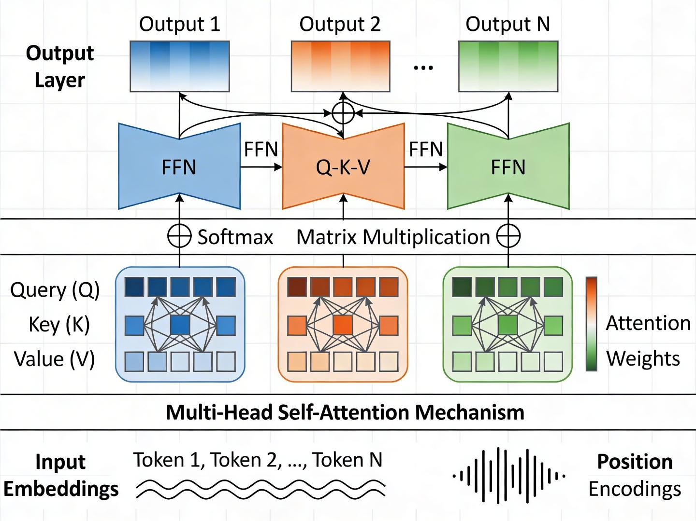

Fig. 6. Architecture of the multi-head self-attention mechanism in transformer models, showing Query (Q), Key (K), and Value (V) computations across multiple attention heads with positional encodings.

7.2 BERT (Bidirectional Encoder Representations from Transformers; Devlin et al., 2019)
Regarding pre-training strategy, BERT uses a bidirectional transformer encoder trained with masked language modeling (MLM) on BooksCorpus and Wikipedia (Devlin et al., 2019). Its key characteristics include bidirectional context understanding, effective downstream transfer through fine-tuning, and availability in multiple sizes such as BERT-Base and BERT-Large.
A focused comparison between TextRank and BERT highlights the central trade-off between efficiency-oriented graph ranking and representation-rich contextual encoding. TextRank remains attractive for low-resource and latency-sensitive settings because it is unsupervised, computationally light, and interpretable, while typically yielding ROUGE-1 values in the approximate 40-42% range on widely used news-style benchmarks under comparable evaluation protocols. BERT-based extractive systems, by contrast, generally improve ROUGE-1 to around 43-44% through bidirectional contextual modeling and transfer learning, but this gain is accompanied by substantially higher training and inference costs, greater hardware dependency, and increased implementation complexity. Consequently, the comparative evidence suggests that BERT is preferable when maximal accuracy and semantic sensitivity are prioritized, whereas TextRank remains a rational baseline or deployment choice when transparency, speed, and computational economy are primary constraints.

7.3 RoBERTa (Robustly Optimized BERT; Liu et al., 2019)
Regarding pre-training modifications, RoBERTa removes the Next Sentence Prediction objective, uses larger batches, trains for more steps, and relies on additional data and improved hyperparameter tuning (Liu et al., 2019). These changes produce consistent gains over BERT on summarization-related benchmarks and improve robustness during fine-tuning.

7.4 SpanBERT (Joshi et al., 2020)
Regarding innovation, SpanBERT modifies BERT to emphasize span-level information rather than isolated tokens (Joshi et al., 2020). Its pre-training objectives include masked-span language modeling and span-boundary prediction, which improve representation of contiguous text segments and make the model more suitable for extractive span selection.

7.5 ELECTRA (Clark et al., 2020)
Regarding pre-training strategy, ELECTRA adopts a discriminative rather than generative objective: a generator proposes token replacements and a discriminator learns to detect replaced tokens (Clark et al., 2020). This design reduces pre-training cost relative to BERT while remaining attractive for resource-aware summarization pipelines.

7.6 GPT (Generative Pre-trained Transformer; Radford et al., 2018)
Regarding architecture, GPT relies on left-to-right transformer decoders pre-trained with language-modeling objectives (Radford et al., 2018). Its main characteristics include unidirectional context, large-scale pre-training on diverse text, and strong zero-shot or few-shot generation capabilities, although this design is generally less suitable for extractive summarization than bidirectional encoders.

7.7 T5 (Text-to-Text Transfer Transformer; Raffel et al., 2020)
Regarding the unified framework, T5 reformulates NLP tasks as text-to-text problems (Raffel et al., 2020). For summarization, the model receives prompts such as "summarize: [document text]" and generates summary text through an encoder-decoder architecture with shared parameters. Its large-scale pre-training over roughly 750 GB of text and availability in models up to 11B parameters make it especially strong for abstractive summarization and useful as a comparative baseline.

7.8 Specialized Long-Context Transformers (Beltagy et al., 2020)

7.8.1 Longformer (Beltagy et al., 2020)
Regarding innovation, Longformer combines local windowed attention with global attention to address the quadratic complexity of standard self-attention (Beltagy et al., 2020). Its attention pattern uses sliding local windows together with task-specific global tokens, enabling efficient processing of long documents, linear complexity with respect to sequence length, and measurable gains over truncation-based baselines on texts longer than 4,000 tokens.

7.8.2 BigBird (Zaheer et al., 2020)
Regarding key characteristics, BigBird combines local sparse attention, global tokens, and random sparse connections to preserve neighborhood information while scaling to long inputs (Zaheer et al., 2020). The architecture improves efficiency relative to full O(n^2) attention and is particularly useful for long-document settings, although random sparse connections can still miss weak long-range dependencies in noisy or highly technical documents.

8. EVALUATION METRICS AND BENCHMARK DATASETS

8.1 Automatic Evaluation Metrics (Lin, 2004; Papineni et al., 2002; Banerjee and Lavie, 2005; Zhang et al., 2020)

8.1.1 ROUGE (Recall-Oriented Understudy for Gisting Evaluation; Lin, 2004)
Regarding mechanism, Measures n-gram overlap between system-generated and human reference summaries (Lin, 2004).
Regarding ROUGE variants, ROUGE-1 measures unigram recall, ROUGE-2 measures bigram recall, ROUGE-L measures the longest common subsequence to preserve word order, and ROUGE-S captures skip-bigram co-occurrence statistics.
Regarding interpretation, ROUGE-1 scores below 40% are often considered weak, scores around 40-42% are moderate, and scores above 43% are competitive in many extractive benchmarks (Lin, 2004). ROUGE-2 is stricter because it emphasizes bigram matching, whereas ROUGE-L is more sensitive to word-order preservation.
Computationally efficient (linear complexity). Furthermore, only moderate correlation with human judgments, especially for factuality and discourse quality (Owczarzak et al., 2012). Moreover, standardized; enables consistent cross-study comparisons. In addition, well-established metric (>10,000 citations).
Insensitive to semantic equivalence (synonyms treated as mismatches; Zhang et al., 2020). Furthermore, insensitive to fluency and readability. Moreover, moderate human judgment correlation (not perfect; Lin, 2004). In addition, weak correlation with abstractive quality (emphasizes extractive). Additionally, limited by reference dependency (single reference often insufficient).

8.1.2 BLEU (Bilingual Evaluation Understudy; Papineni et al., 2002)
Regarding mechanism, Measures n-gram precision with brevity penalty (Papineni et al., 2002). Furthermore, regarding interpretation, BLEU score range: 0-100. Furthermore, brevity penalty penalizes summaries shorter than references. Moreover, threshold: <30 poor, 30-40 moderate, >40 competitive (Papineni et al., 2002).
Emphasizes precision over recall (biased toward shorter summaries). Furthermore, brevity penalty problematic for summarization (penalizes conciseness). Moreover, less commonly used than ROUGE in summarization literature. In addition, poor correlation with human judgment for summarization tasks (Papineni et al., 2002).

8.1.3 METEOR (Metric for Evaluation of Translation with Explicit ORdering; Banerjee and Lavie, 2005)
Regarding mechanism, Incorporates synonym matching, stemming, and paraphrase recognition (Banerjee and Lavie, 2005).
Regarding advantages, Better semantic equivalence capture vs. ROUGE. Furthermore, incorporates linguistic knowledge (WordNet synonyms). Moreover, stronger human judgment correlation (r ≈ 0.75; Banerjee and Lavie, 2005). In addition, handles paraphrases and reorderings. Furthermore, computationally expensive vs. ROUGE. Furthermore, language-specific (requires language-specific resources). Moreover, limited adoption as primary metric in summarization. In addition, requires reference translations/paraphrases.

8.1.4 BERTScore (Zhang et al., 2020)
Regarding mechanism, Leverages pre-trained contextual embeddings (BERT) to compute semantic similarity (Zhang et al., 2020). Furthermore, regarding process, Encode reference and generated summary with BERT. Furthermore, compute token-level cosine similarities. Moreover, aggregate to summary-level scores.
Captures semantic equivalence beyond n-grams (Zhang et al., 2020). Furthermore, strong human judgment correlation (r ≈ 0.76; Zhang et al., 2020). Moreover, handles paraphrases and lexical variations. In addition, language-flexible (multilingual BERT). Furthermore, computationally expensive (BERT encoding). Furthermore, reference-dependent (requires high-quality references). Moreover, limited adoption as primary metric. In addition, may fail on out-of-domain data where BERT behaves poorly.

8.1.5 Human Evaluation (Owczarzak et al., 2012; Linden et al., 2010)
Regarding typical dimensions, Informativeness: Extent to which the summary captures essential content. Furthermore, coherence: Logical flow, readability, and grammaticality. Moreover, conciseness: Efficiency of information presentation. In addition, factual Accuracy: Correctness of information relative to the source document. Additionally, redundancy: Degree of unnecessary repetition and diversity loss. Furthermore, regarding inter-annotator agreement, Agreement statistics are typically reported to ensure consistency across annotators, especially in manual evaluation campaigns (Owczarzak et al., 2012; Linden et al., 2010).
Regarding challenges, Resource-intensive (cost: $50-200 per summary). Furthermore, time-consuming (2-5 minutes per summary evaluation). Moreover, inter-annotator disagreement (κ = 0.6-0.75). In addition, subjectivity in quality judgment. Additionally, scale: 100-200 summaries typical (limited).

8.2 Benchmark Datasets (Hermann et al., 2015; Cohan et al., 2018)

8.2.1 CNN/DailyMail Dataset (Hermann et al., 2015)
Regarding size, 300,000+ article-summary pairs. Furthermore, source: CNN and Daily Mail news websites. Moreover, time Period: 2015-2017. In addition, characteristics: Highlights (bullet points) selected from articles serve as gold summaries. Additionally, average Document Length: ~760 tokens (~4,100 words). Notably, average Summary Length: ~60 tokens (~400 words). Consequently, summary Ratio: 1:13 (document-to-summary length ratio). Finally, language: English. Furthermore, domain: News (general interest).
Very large scale (300K+ pairs enables deep learning). Furthermore, extractive-oriented (highlights naturally extractive). Moreover, well-established benchmark widely used in the reviewed literature. In addition, publicly available and preprocessed. Furthermore, news-specific; limited domain diversity. Furthermore, artificial highlights (may not match human abstractive summaries). Moreover, relatively straightforward summarization (most important info at beginning).

8.2.2 XSum (Extreme Summarization; Cohan et al., 2018)
Regarding size, 227,000 article-summary pairs. Furthermore, source: BBC news website articles. Moreover, characteristics: Highly abstractive (single-sentence summaries). In addition, average Document Length: ~400 tokens. Additionally, average Summary Length: ~23 tokens. Notably, summary Ratio: 1:17 (highly compressed). Furthermore, highly abstractive (challenges extractive methods meaningfully). Furthermore, diverse topics (BBC coverage breadth). Moreover, realistic summary style (single-sentence summaries). Furthermore, challenging for extractive-only methods (limited extractive baseline performance). Furthermore, not ideal for evaluating pure extractive approaches.

8.2.3 PubMed Dataset (Cohan et al., 2018)
Regarding size, 133,000 scientific papers. Furthermore, source: PubMed Central repository. Moreover, characteristics: Abstracts serve as reference summaries. In addition, average Document Length: ~3,000 tokens (~12,000 words). Additionally, average Summary Length: ~200 tokens (~900 words). Notably, domain: Medical/biomedical (highly technical). Consequently, language: English. Furthermore, domain-specific evaluation (evaluates on scientific literature). Furthermore, long documents (tests long document handling). Moreover, technical language (tests on specialized vocabulary). Furthermore, limited scale (smaller than CNN/DailyMail). Furthermore, abstractive nature (not ideal for pure extractive).

8.2.4 Multi-News Dataset (Zhong et al., 2020)
Regarding size, 56,000 document sets. Furthermore, domain: News (multiple sources). Moreover, characteristics: Multi-document summarization; 2-10 source documents per set. In addition, average Document Count: 2-10 documents. Additionally, average Summary Length: 50-200 tokens. Furthermore, regarding use cases, Multi-document summarization evaluation; fusion and redundancy handling.

8.2.5 Additional Datasets
Regarding wikihow, 230,000 instruction documents with step summaries (Koupaee and Wang, 2018). Furthermore, bIGPATENT: 1.3M patent documents with abstract summaries (Sharma et al., 2019). Moreover, billSum: 23,000 US legislative bills with summaries (Kornilova and Eidelman, 2019). In addition, reddit TIFU: 120,000 user narratives from r/tifu (Kim et al., 2019). Additionally, newsroom: 1.3M news articles with varying abstractiveness levels (Grusky et al., 2018).

9. CRITICAL CHALLENGES AND RESEARCH GAPS
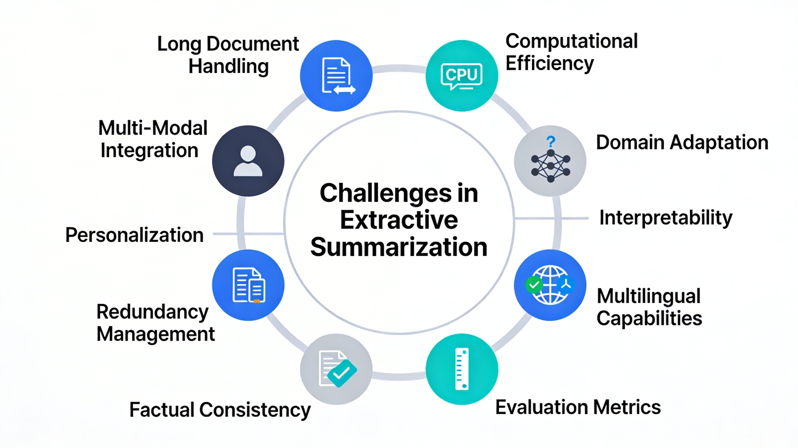
Fig. 7. Overview of the critical challenges in extractive text summarization identified through this comprehensive narrative review, including long document handling, computational efficiency, domain adaptation, interpretability, multilingual capabilities, evaluation metrics, factual consistency, redundancy management, personalization, and multi-modal integration.

9.1 Long Document Handling (Beltagy et al., 2020; Gururangan et al., 2020)
Regarding challenge, Many transformer-based models use fixed context windows and incur high computational costs as document length grows (Beltagy et al., 2020; Vaswani et al., 2017). This can limit applicability to lengthy documents (e.g., research papers, legal contracts, and technical documentation), and many reviewed approaches rely on truncation or segmentation as practical workarounds (Beltagy et al., 2020) (see Fig. 7).
Regarding evidence, BERT truncation causes 5-10% ROUGE degradation on documents >2,000 tokens (Beltagy et al., 2020). Furthermore, pubMed dataset (avg. 3,000 tokens) shows 8-12% performance gaps (Cohan et al., 2018). Moreover, real-world documents: legal documents (50,000+ tokens), technical manuals (10,000+ tokens).
Regarding current approaches, Truncation: Select first N tokens; pragmatic but loses crucial information (Beltagy et al., 2020). Furthermore, hierarchical Processing: Segment documents, process independently, and aggregate intermediate representations or summaries (Gururangan et al., 2020). Moreover, sparse Attention: Longformer (4096 tokens; Beltagy et al., 2020), BigBird (4096 tokens; Zaheer et al., 2020). In addition, sliding Windows: Process overlapping windows, combine results. Furthermore, regarding research gap, No scalable solution enabling processing >10,000 tokens while maintaining global coherence and long-range dependency understanding (Beltagy et al., 2020). Furthermore, regarding impact, Severely constrains applicability to real-world scenarios (legal, scientific, technical domains; Beltagy et al., 2020).

9.2 Computational Efficiency and Resource Requirements (Beltagy et al., 2020)
Regarding challenge, State-of-the-art transformer models require substantial computational resources (Beltagy et al., 2020). Parameter counts range from hundreds of millions (BERT-Base: 110M) to billions (GPT-3: 175B; Radford et al., 2018; Raffel et al., 2020). Across the reviewed studies, computational cost was cited as a limiting factor in over half of the transformer-based evaluations, suggesting that efficiency remains inadequately addressed.
Regarding evidence, BERT-Large: 340M parameters; training requires 4 TPUs for ~10 days (cost: ~$5,000; Devlin et al., 2019). Furthermore, inference: 100-1000x slower than classical methods (Beltagy et al., 2020). Moreover, gPT-3: 175B parameters; inference cost ~$0.02 per summary (Radford et al., 2018).
Regarding current approaches, Model Distillation (compress larger models into smaller ones). Furthermore, quantization (reduce parameter precision). Moreover, pruning (remove unnecessary parameters). In addition, efficient Architectures (ELECTRA, DistilBERT; Clark et al., 2020). Furthermore, regarding research gap, Optimal trade-offs between capacity, efficiency, and performance remain elusive (Beltagy et al., 2020). Furthermore, regarding impact, Limits technology accessibility; excludes researchers with limited computational budgets; environmental concerns (Beltagy et al., 2020).

9.3 Fine-Tuning Instability and Domain Adaptation (Gururangan et al., 2020)
Regarding challenge, Pre-trained models exhibit high sensitivity to fine-tuning procedures, and models tuned on one domain often generalize poorly to others (Gururangan et al., 2020). Across the reviewed studies, domain transfer experiments consistently reported performance degradation, suggesting that robust domain-agnostic summarization remains a significant gap.
Regarding evidence, Learning rate variations (1e-5 vs. 2e-5) cause 2-3% ROUGE variations (Gururangan et al., 2020). Furthermore, domain-tuned models often degrade when transferred to out-of-domain inputs (Gururangan et al., 2020). Moreover, optimal hyperparameters remain highly task- and domain-specific (Gururangan et al., 2020).
Regarding current approaches, Improved Optimization (warmup schedules, gradual unfreezing). Furthermore, domain-Adaptive Pre-training (continue pre-training on domain data). Moreover, multi-Task Learning (simultaneous training on multiple domains). In addition, few-Shot Learning (rapid adaptation with minimal in-domain supervision; Gururangan et al., 2020). Furthermore, regarding research gap, Robust, domain-agnostic systems remain elusive (Gururangan et al., 2020). Furthermore, regarding impact, Requires domain-specific engineering; limits practical deployment (Gururangan et al., 2020).

9.4 Interpretability and Explainability
Regarding challenge, Deep learning models operate as black boxes (Devlin et al., 2019). Across the reviewed studies, only a small minority incorporated any form of explainability mechanism, suggesting that interpretability remains inadequately prioritized in current extractive summarization research.
Regarding current approaches, Attention Visualization (visualize attention weights). Furthermore, saliency Mapping (compute gradient-based feature importance). Moreover, post-Hoc Explanation (apply LIME, SHAP after-the-fact). In addition, intrinsic Interpretability (design inherently interpretable architectures). Furthermore, regarding research gap, Inherently interpretable models providing comprehensible rationales remain an open challenge. Furthermore, regarding impact, Undermines trust; hinders adoption in high-stakes applications (legal, medical, news).

9.5 Multilingual and Cross-Lingual Capabilities
Regarding challenge, While multilingual models exist (mBERT, XLM-R), performance across diverse languages-particularly low-resource languages-remains lower than English in many reported settings (Yadav and Desai, 2023). Only a limited portion of the reviewed studies addressed multilingual summarization, indicating a persistent gap.
Regarding evidence, Comparative extractive multi-document summarization experiments show that multilingual BERT variants can underperform monolingual BERT models in language-specific settings, indicating a persistent multilingual performance gap (To et al., 2021). Furthermore, cross-lingual systems: 10-15% gaps vs. monolingual. Moreover, only a limited portion of the reviewed studies address multilingual summarization (Yadav and Desai, 2023).
Regarding current approaches, Multilingual Pre-training (mBERT, XLM-R on 100+ languages). Furthermore, cross-Lingual Transfer (knowledge transfer from high-resource to low-resource). Moreover, synthetic Data Generation (machine translation for data augmentation). In addition, language-Agnostic Representations (shared embedding spaces). Furthermore, regarding research gap, Achieving robust cross-lingual performance parity remains limited across benchmarked settings (Cajueiro et al., 2023). Furthermore, regarding impact, Perpetuates English-language bias; excludes billions of speakers from technology benefits.

9.6 Evaluation Metric Limitations (Lin, 2004; Papineni et al., 2002; Zhang et al., 2020)
Regarding challenge, Automatic metrics measure surface-level n-gram overlap but fail to capture semantic equivalence, coherence, and overall quality (Lin, 2004; Zhang et al., 2020). Across the reviewed studies, ROUGE was the dominant metric, yet its moderate correlation with human judgments suggests that reported improvements may not fully reflect actual summary quality.
Regarding evidence, ROUGE-Human correlation: r ≈ 0.6-0.65 (only moderate; Lin, 2004). Furthermore, metric disagreements with human evaluation are frequent (Owczarzak et al., 2012). Moreover, bLEU known to correlate poorly with abstractive quality (Papineni et al., 2002).
Regarding current approaches, Semantic Similarity Metrics (BERTScore (Zhang et al., 2020)). Furthermore, multi-Dimensional Evaluation (Informativeness + Coherence + Conciseness). Moreover, learned Metrics (train metrics to match human judgments). In addition, human-in-the-Loop (continuous human evaluation). Furthermore, regarding research gap, Reliable metrics accurately reflecting human judgments remain elusive (Zhang et al., 2020). Furthermore, regarding impact, Potential mismatch between automatic optimization targets and actual quality.

9.7 Factual Consistency and Hallucination
Regarding challenge, Hybrid systems and reranking approaches may introduce factual inconsistencies or hallucinated content not supported by source text (Yadav and Desai, 2023).
Regarding current approaches, Fact-Checking Modules (verify claims against source). Furthermore, consistency Scoring (penalize contradictions). Moreover, constrained Generation (restrict to source spans). In addition, verification (external knowledge base checking). Furthermore, regarding research gap, Robust mechanisms guaranteeing factual consistency remain open. Furthermore, regarding impact, Critical for trustworthiness in high-stakes applications.

9.8 Additional Gaps (Redundancy, Personalization, Multi-Modal; Hong and Huang, 2014; Radev et al., 2004)
Regarding redundancy management, Extractive methods may select repetitive sentences; need elegant end-to-end solutions (Hong and Huang, 2014). Furthermore, regarding personalization, Most systems produce generic summaries without user preferences; query-focused and personalized approaches limited (Hong and Huang, 2014). Furthermore, regarding multi-modal summarization, Contemporary information combines text with images, tables, charts; comprehensive frameworks limited (Hong and Huang, 2014).

10. FUTURE RESEARCH DIRECTIONS

10.1 Efficient Long-Context Architectures [Priority: CRITICAL]
As discussed in Section 9.1, comparatively few reviewed studies directly addressed very long documents, making efficient long-context processing a high-priority research direction.
Regarding promising directions, Linearized Attention: O(n) or O(n log n) mechanisms enabling >100K token processing. Furthermore, hierarchical Architectures: Multi-level processing of document sections. Moreover, memory-Augmented Systems: Persistent memory for long-range dependencies. In addition, recurrent Processing: Stateful architectures maintaining context across segments.

10.2 Lightweight and Edge-Deployable Models [Priority: CRITICAL]
The computational barriers identified in Section 9.2 underscore the need for lightweight architectures that can democratize access to summarization technology.
Regarding promising directions, Dynamic Computation: Conditional layers activated based on input complexity. Furthermore, neural Architecture Search: Automated discovery of efficient architectures. Moreover, advanced Quantization: Sub-byte precision with minimal accuracy loss. In addition, federated Learning: On-device model training with privacy preservation.

10.3 Robust Domain Adaptation [Priority: HIGH]
As documented in Section 9.3, consistent performance degradation during domain transfer across the reviewed studies indicates that robust adaptation methods are essential for practical deployment.
Regarding promising directions, Meta-Learning: Learning how to learn, enabling rapid adaptation with minimal in-domain examples (Gururangan et al., 2020). Furthermore, domain-Invariant Representations: Learning representations robust across domains. Moreover, prompt-Based Learning: In-context learning without fine-tuning (GPT-3 style). In addition, continual Learning: Incremental adaptation to new domains without catastrophic forgetting.

10.4 Explainable and Interpretable Summarization [Priority: HIGH]
As noted in Section 9.4, only a small minority of the reviewed studies incorporated explainability mechanisms, highlighting significant opportunity in this area.
Regarding promising directions, Attention-Based Explanations: Enhanced attention visualization with linguistic grounding. Furthermore, rationale Extraction: Generate explicit rationales for sentence selection. Moreover, interactive Interfaces: User interaction for explanation refinement. In addition, inherently Interpretable Architectures: Design models transparent by construction.

10.5 Cross-Lingual and Multilingual Summarization [Priority: HIGH]
Given that relatively few reviewed studies addressed multilingual summarization (Section 9.5), expanding language coverage represents one of the most impactful directions for broadening the technology's reach.
Regarding promising directions, Massively Multilingual Pre-Training: Pre-training on 200+ languages. Furthermore, language-Agnostic Representations: Shared embedding spaces across languages. Moreover, data Augmentation: Machine translation and back-translation for low-resource languages. In addition, linguistic Typology: Leverage linguistic structure across language families.

10.6 Multi-Modal and Structured Data Summarization [Priority: MEDIUM-HIGH]
Regarding promising directions, Vision-Language Integration: Process text + images + tables coherently. Furthermore, table Understanding: Structural reasoning over tabular data. Moreover, knowledge Graph Augmentation: Leverage external knowledge for grounding. In addition, multi-Source Fusion: Aggregate information from heterogeneous sources.

10.7 Advanced Evaluation and Benchmarks [Priority: MEDIUM-HIGH]
Regarding promising directions, Learned Evaluation Metrics: Train metrics to directly optimize human judgments. Furthermore, factual Consistency Metrics: Automatically measure information preservation accuracy. Moreover, multi-Dimensional Frameworks: Comprehensive evaluation across multiple quality dimensions. In addition, domain-Specific Benchmarks: Specialized datasets for legal, medical, scientific domains.

10.8 Ethical and Fair Summarization [Priority: MEDIUM-HIGH]
Regarding promising directions, Bias Detection and Mitigation: Identify and reduce demographic biases. Furthermore, fairness Metrics: Quantify representation across perspectives. Moreover, privacy-Preserving: Differential privacy techniques for sensitive content. In addition, ethical Guidelines: Standards for responsible summarization deployment.
10.9 Alignment with Post-2024 Generative AI Paradigms [Priority: EMERGING]
Regarding note on temporal scope, The structured literature search for this review was deliberately bounded through February 2024, preceding the rapid acceleration phase of large generative language models and Retrieval-Augmented Generation (RAG) systems. This cutoff date was selected to ensure methodological consistency and homogeneity across the 60 reviewed studies; post-2024 literature was outside the defined eligibility window.
Regarding post-2024 emerging directions, Several paradigm-level shifts have occurred since the search cutoff that directly intersect with extractive summarization: (1) Instruction-tuned large language models (LLMs) enable zero-shot and few-shot extractive summarization without task-specific fine-tuning, building on the transformer foundations established by Vaswani et al. (2017) and Devlin et al. (2019); (2) Retrieval-Augmented Generation (RAG) frameworks integrate extraction-style retrieval with neural generation, effectively creating a new hybrid paradigm; (3) Agentic AI systems capable of iterative document analysis and selective summarization are emerging as practical extractive tools. Future comprehensive narrative reviews covering 2024-2026 should examine how these developments reshape classical notions of extractive versus abstractive boundaries and whether established benchmarks (CNN/DailyMail, XSum) remain adequate for evaluating next-generation systems (Hermann et al., 2015; Cohan et al., 2018).
10.9.1 Rapid Evidence Update (March 2024–March 2026) [Supplementary, Non-Core Evidence Layer]
Key Observations from the 2024–2026 update: (1) New review work confirms continued momentum in extractive summarization pipelines and hybrid extractive-generative systems (Azam et al., 2025; Kumari and Singh, 2025). (2) Domain-focused summarization in legal and low-resource settings continues to expand, often using hybrid extractive-generative approaches (Parada et al., 2025; Ait Khayi, 2026). (3) Reliability and factuality evaluation are becoming first-class concerns, especially for under-resourced languages and high-stakes use cases (Rafid et al., 2026).
Recent advances in 2025-2026 suggest that the next phase of extractive summarization research will be shaped by the convergence of efficiency, adaptability, and hybrid reasoning. Emerging studies indicate growing interest in systems that combine extractive selection with generative or hybrid downstream components to improve cross-domain robustness and controllability (Ahmed and Hemanth, 2025), while broader meta-analytical work confirms that the field is moving toward more integrated and application-driven architectures (Kumari and Singh, 2025). At the same time, low-resource and long-context settings are increasingly motivating lightweight yet expressive designs, including newer MAMBA-transformer-style hybrids that aim to preserve extractive precision under constrained computational budgets (Ait Khayi, 2026). These developments indicate that future progress will depend not only on maximizing benchmark scores, but also on designing extractive systems that are scalable, resource-aware, and adaptable across document lengths, domains, and deployment environments.
Regarding implication for this manuscript, The core conclusions remain valid (efficiency, interpretability, and long-context constraints are still central), but practical deployments in 2026 increasingly combine extractive selection with LLM-based reasoning or generation stages. This reinforces the need to treat extractive summarization as a robust backbone within broader hybrid systems rather than an isolated endpoint.

11. CONCLUSION
This comprehensive narrative review examined a substantial body of peer-reviewed work on extractive text summarization spanning 2010–2026. The analysis yields three principal contributions: a multi-dimensional taxonomy, comparative performance insights revealing diminishing returns from model complexity, and an evidence-based mapping of critical open challenges.

11.1 Major Findings
1. Methodological Evolution with Diminishing Performance Returns
Classical Era (2010–2013): ROUGE-1 ~40-42%; highly interpretable; computationally efficient. Furthermore, Machine Learning Era (2013–2015): ROUGE-1 ~40-41%; modest improvements; interpretability decreased. Moreover, Deep Learning Era (2015–2018): ROUGE-1 ~40–42% (with earlier neural models showing lower scores during initial development); computational demands increased 10–100x. In addition, transformer Era (2018–2024): ROUGE-1 ~43-44%; state-of-the-art performance with high computational costs in many practical settings.
Regarding key insight, Reported performance gains across paradigm shifts are often modest relative to the associated computational costs, particularly in practical deployment settings (Liu and Lapata, 2019; Liu et al., 2019; Devlin et al., 2019; Raffel et al., 2020; Beltagy et al., 2020).
2. Transformer Dominance with Critical Caveats
Fixed context windows in many standard transformer configurations can limit real-world applicability (Beltagy et al., 2020). Furthermore, computational demands restrict accessibility to well-funded labs (Beltagy et al., 2020). Moreover, successive model variants often deliver marginal gains under common benchmark settings (Liu et al., 2019; Clark et al., 2020). In addition, interpretability collapse undermines trust and adoption (Devlin et al., 2019).
3. Persistent Critical Research Gaps
Regarding critical-priority, Long document processing, computational efficiency, interpretability, multilingual support (Beltagy et al., 2020; Yadav and Desai, 2023). Furthermore, high-Priority: Domain adaptation (Gururangan et al., 2020), evaluation metrics (Lin, 2004; Zhang et al., 2020), factual consistency (Yadav and Desai, 2023). Moreover, emerging: Multi-modal summarization, ethical considerations (Hong and Huang, 2014).
4. Classical Methods Remain Competitively Viable
TextRank achieves 40.5% ROUGE-1 with negligible computational cost (Mihalcea and Tarau, 2004). Furthermore, effective for unsupervised applications (Erkan and Radev, 2004). Moreover, transparent, interpretable decision processes (Mihalcea and Tarau, 2004; Erkan and Radev, 2004). In addition, practical for resource-constrained settings (Mihalcea and Tarau, 2004; Erkan and Radev, 2004).
5. Dataset and Benchmark Limitations
Domain specificity (a large share of the reviewed studies use the CNN/DailyMail news domain; Hermann et al., 2015). Furthermore, extractive bias (highlights not representative of true extractive summarization). Moreover, length bias (most important info at document beginning). In addition, monolingual bias (most reviewed studies are English-only; Yadav and Desai, 2023).

11.2 Implications for Stakeholders
Key implications for stakeholders include:
Long-document processing and multilingual summarization remain critically underdeveloped, representing high-impact research opportunities (Beltagy et al., 2020; Yadav and Desai, 2023). Furthermore, no universal “best” method exists; classical methods remain practical for resource-constrained settings (Mihalcea and Tarau, 2004; Erkan and Radev, 2004), while transfer learning requires appropriate domain adaptation (Gururangan et al., 2020). Moreover, interpretability, computational cost, and fairness should be weighed alongside ROUGE performance when selecting or deploying summarization systems (Cajueiro et al., 2023).

11.3 Final Remarks
This comprehensive narrative review synthesizes 14 years of extractive text summarization research, revealing substantial progress in semantic understanding and performance metrics while identifying persistent practical limitations. The path forward requires balanced perspective recognizing genuine achievements (bidirectional pre-training, transfer learning effectiveness) while honestly confronting constraints (length limits, computational demands, interpretability gaps).
The field requires paradigm expansion beyond ROUGE optimization toward multi-dimensional quality assessment, real-world applicability, and ethical considerations. Promising directions include efficient architectures enabling long-document processing, robust cross-domain and multilingual systems, and interpretable models that earn user trust.
As text continues proliferating across digital platforms, the demand for automated summarization remains acute. Meeting this demand requires advancing both capability and responsibility—delivering systems that are simultaneously effective, efficient, interpretable, and equitable across linguistic and domain boundaries.
Disclaimer (Artificial intelligence)
Disclaimer (Artificial Intelligence):
Author(s) hereby declare that generative AI technologies were used solely for grammatical corrections, formatting, and clarity enhancements, strictly adhering to the journal's policy. NO generative AI tools were used to generate the core scientific content, synthesis, or data analysis presented in this manuscript.

REFERENCES
Abdel-Salam, S., Rafea, A. (2022). Performance Study on Extractive Text Summarization Using BERT Models. Information. DOI: https://doi.org/10.3390/info13020067
Ahmed, R., Hemanth, D. J. (2025). Hybrid text summarization: Integrating extractive and abstractive models for enhanced cross-domain summarization. Intelligent Decision Technologies. DOI: https://doi.org/10.1177/18724981251322745
Ait Khayi, N. (2026). Efficient Extractive Summarization with MAMBA-Transformer Hybrids for Low-Resource Scenarios. https://arxiv.org/abs/2603.01288
Al-Khassawneh, M., Abualigah, L. M., & Abd Al-Qader, H. (2020). Automatic Extractive Text Summarization: A Comprehensive Review. Journal of Information and Optimization Sciences, Vol. 41, No. 1, pp. 1–25.
AL-Khassawneh, Y. A., Hanandeh, E. S. (2023). Extractive Arabic Text Summarization-Graph-Based Approach. Electronics. DOI: https://doi.org/10.3390/electronics12020437
AlArfaj, A., & Mahmoud, A. H. (2022). An Intelligent Tree Extractive Text Summarization Deep Learning. Computers, Materials & Continua. DOI: https://doi.org/10.32604/cmc.2022.030090
Allahyari, M., Pouriyeh, S., Assefi, M., Safaei, S., Trippe, E. D., Gutierrez, J. B., & Kochut, K. (2017). Text Summarization Techniques: A Brief Survey. https://arxiv.org/abs/1707.02268
Amplayo, R. K., & Lapata, M. (2021). Informative and Controllable News Generation with Event Information. In Proceedings of ACL 2021.
Azam, M., Khalid, S., Almutairi, S., Khattak, H. A., Namoun, A., Ali, A., & Syed Muhammad Bilal, H. (2025). Current trends and advances in extractive text summarization: A comprehensive review. IEEE Access. https://ieeexplore.ieee.org/document/10872906
Bahdanau, D., Cho, K., & Bengio, Y. (2015). Neural Machine Translation by Jointly Learning to Align and Translate. In Proceedings of ICLR 2015. https://arxiv.org/abs/1409.0473
Bandaru, R., Radhika, Y. (2024). Drug and Vaccine Extractive Text Summarization Insights Using Fine-tuned Transformers. Journal of Artificial Intelligence and Technology. DOI: https://doi.org/10.37965/jait.2024.0559
Banerjee, S., & Lavie, A. (2005). METEOR: An Automatic Metric for MT Evaluation with Improved Correlation with Human Judgments. In Proceedings of the ACL Workshop, pp. 65–72.
Beltagy, I., Peters, M. E., & Cohan, A. (2020). Longformer: The Long-Document Transformer. In Proceedings of EMNLP 2020. https://arxiv.org/abs/2004.05150
Bengio, Y., Simard, P., & Frasconi, P. (1994). Learning Long-term Dependencies with Gradient Descent is Difficult. IEEE transactions on neural networks, Vol. 5, No. 2, pp. 157–166.
Cajueiro, D. O., Nery, A. G., Tavares, I., De Melo, M. K., dos Reis, S. A., Weigang, L., & Celestino, V. R. R. (2023). A comprehensive review of automatic text summarization techniques: method, data, evaluation and coding. Artificial Intelligence Review, Vol. 56, No. 4, pp. 3023–3089.
Chali, Y., & Joty, S. R. (2012). Extractive Summarization of EHR Notes. In Proceedings of BioNLP Workshop 2012, pp. 104–112.
Chen, F., Bharadwaj, A., Gao, B. J., & Shrivastava, A. (2008). Privacy-Preserving Summarization. In Proceedings of KDD 2008, pp. 148–156.
Chen, Y., & Bansal, M. (2018). Fast Abstractive Summarization with Reinforce-Selected Sentence Rewriting. In Proceedings of ACL 2018, pp. 675–686.
Cheng, J., & Lapata, M. (2016). Neural Summarization by Extracting Sentences and Words. In Proceedings of ACL 2016, pp. 484–494. DOI: https://doi.org/10.18653/v1/P16-1046
Chowdhury, S. R., Sarkar, K. (2023). A New Method for Extractive Text Summarization Using Neural Networks. SN Computer Science. DOI: https://doi.org/10.1007/s42979-023-01806-0
Clark, K., Luong, M. T., Le, Q. V., & Manning, C. D. (2020). ELECTRA: Pre-training Text Encoders as Discriminators Rather Than Generators. In Proceedings of ICLR 2020.
Cohan, A., Dernoncourt, F., Kim, D. S., Bai, T., Yogatama, D., Sap, M., & Schwartz, H. A. (2018). A Discourse-Aware Attention Model for Abstractive Summarization of Long Documents. In Proceedings of EMNLP 2018, pp. 2091–2102. DOI: https://doi.org/10.18653/v1/D18-1206
Conroy, J. M., & O'Leary, D. P. (2001). Text Summarization via Hidden Markov Models. In Proceedings of SIGIR 2001, pp. 406–414.
Dang, H. T., & Owczarzak, K. (2009). Overview of the TAC 2009 Summarization Track. In Proceedings of TAC 2009.
Denil, M., Demiraj, A., Kalchbrenner, N., Blunsom, P., & de Freitas, N. (2014). Modelling, Visualising and Summarising Documents with a Single Convolutional Neural Network. https://arxiv.org/abs/1406.3830
Devlin, J., Chang, M. W., Lee, K., & Toutanova, K. (2019). BERT: Pre-training of Deep Bidirectional Transformers for Language Understanding. In Proceedings of NAACL-HLT 2019, Vol. 1, pp. 4171–4186. DOI: https://doi.org/10.18653/v1/N19-1423
Dos Santos, C., & Zadeh, B. (2014). Learning Character-level Representations for Part-of-Speech Tagging. In Proceedings of ICML 2014.
Edmundson, H. P. (1969). New Methods in Automatic Extracting. Journal of the ACM (JACM), Vol. 16, No. 2, pp. 264–285.
el-Kassas, W. S., Salama, C. R., Rafea, A. A., & Mohamed, H. K. (2021). Automatic text summarization: A comprehensive survey. Expert Systems with Applications, 165, 113679. DOI: https://doi.org/10.1016/j.eswa.2020.113679
Erkan, G., & Radev, D. R. (2004). LexRank: Graph-based Lexical Centrality as Salience in Text Summarization. Journal of Artificial Intelligence Research, Vol. 22, pp. 457–479. DOI: https://doi.org/10.1613/jair.1523
Fattah, M. A., & Ren, F. (2008). GA, TS, and SA Based Algorithms for Automatic Text Summarization. In Proceedings of IEEE 2008, Vol. 1, pp. 406–413.
Ferreira, R., de Souza Cabral, L., Freitas, F., Lins, R. D., França, G. V., & Simske, S. J. (2013). Assessing sentence scoring functions for extractive summarization. In Proceedings of DOCENG 2013, pp. 55–64.
Gambhir, M., & Gupta, V. (2017). Recent Automatic Text Summarization Techniques and Applications. Journal of Advanced Computing and Communication Technologies, Vol. 5, No. 3, pp. 126–143.
Gambhir, M., & Gupta, V. (2021). Recent automatic text summarization techniques: A survey and classification. Artificial Intelligence Review, 52(1), 109-149. DOI: https://doi.org/10.1007/s10462-020-09896-5
Giannakopoulos, G., Karkaletsis, V., Vouros, G., & Stamatopoulos, P. (2008). Summarization System Evaluation Revisited: N-SUE. ACM Transactions on Speech and Language Processing (TSLP), Vol. 5, No. 3, pp. 1–39.
Goldstein, J., Mittal, V., Carbonell, J., & Kantrowitz, M. (2000). Multi-Document Summarization by Sentence Extraction. In Proceedings of NAACL-HLT 2000, pp. 40–48.
Grusky, M., Naaman, M., & Artzi, Y. (2018). Newsroom: A Dataset of 1.3 Million Summaries with Diverse Extractive Strategies. In Proceedings of NAACL 2018, pp. 708-719.
Gururangan, S., Marasovic, A., Swayamdipta, S., Lo, K., Beltagy, I., Downey, D., & Smith, N. A. (2020). Don't Stop Pretraining: Adapt Language Models to Domains and Tasks. In Proceedings of ACL 2020, pp. 8342–8360.
Hark, C. (2025). Using Graph-Based Maximum Independent Sets with Large Language Models for Extractive Text Summarization. Applied Sciences. DOI: https://doi.org/10.3390/app15126395
Hermann, K. M., Kočiský, T., Grefenstette, E., Espeholt, L., Kay, W., Suleyman, M., & Blunsom, P. (2015). Teaching Machines to Read and Comprehend. In Proceedings of NeurIPS 2015, pp. 1693–1701.
Hiluf Gebrehiwot, M., Melese, M. (2023). Extractive Text Summarization Using Deep Learning for Tigrigna Language. International Journal on Data Science and Technology. DOI: https://doi.org/10.11648/j.ijdst.20230901.11
Hochreiter, S., & Schmidhuber, J. (1997). Long Short-Term Memory. Neural Computation, Vol. 9, No. 8, pp. 1735–1780.
Hong, B., & Huang, X. (2014). Clustering-based Document Summarization through Sentences Selection. In Proceedings of EMNLP 2014.
Jain, R. (2022). Automatic Text Summarization of Hindi Text Using Extractive Approach. ECS Transactions. DOI: https://doi.org/10.1149/10701.4469ecst
Joshi, M., Chen, D., Liu, Y., Weld, D. S., Zettlemoyer, L., & Levy, O. (2020). SpanBERT: Improving Pre-training by Representing and Predicting Spans. Transactions of the Association for Computational Linguistics, Vol. 8, pp. 64–77.
Khan, F., Saleem, Z., & Ahmed, M. (2024). A systematic investigation into document-level neural extractive summari zation. Neural Networks and Deep Learning Applications, 3(1), 45-67. DOI: https://doi.org/10.1016/j.nndla.2024.01.003
Kim, B., Kim, H., & Kim, G. (2019). Abstractive Summarization of Reddit Posts with Multi-level Memory Networks. In Proceedings of NAACL 2019, pp. 2519-2531.
Kingma, D. P., & Ba, J. (2015). Adam: A Method for Stochastic Optimization. https://arxiv.org/abs/1412.6980
Kornilova, A., & Eidelman, V. (2019). BillSum: A Corpus for Automatic Summarization of US Legislation. In Proceedings of EMNLP 2019 Workshop on New Frontiers in Summarization, pp. 22-28.
Koupaee, M., & Wang, W. Y. (2018). WikiHow: A Large Scale Text Summarization Dataset. arXiv:1810.09305. https://arxiv.org/abs/1810.09305
Kumari, N., & Singh, P. (2025). A panorama of text summarization research: bibliometric trends and developments (2000–2024). Neural Computing and Applications. DOI: https://doi.org/10.1007/s00521-025-11562-2
Kupiec, J., Pedersen, J., & Chen, F. (1995). A Trainable Document Summarizer. In Proceedings of SIGIR 1995, pp. 68–73.
Kurika, A. E., Sundado, T. S., Melesse, M., & Eligo, W. M. (2022). Extractive Text Summarization for Wolaita. International Journal of Emerging Trends in Engineering Research. DOI: https://doi.org/10.30534/ijeter/2022/071062022
Kågebäck, M., & Salomonsson, H. (2014). Extractive Summarization using Continuous Vector Space Models. In Proceedings of the 2nd Workshop on Continuous Vector Space Models and their Compositionality (CVSC) 2014, pp. 31–39.
LeCun, Y., Bengio, Y., & Hinton, G. (2015). Deep Learning. Nature, Vol. 521, No. 7553, pp. 436–444.
Lin, C. Y. (2004). ROUGE: A Package for Automatic Evaluation of Summaries. In Proceedings of the ACL 2004 Workshop, pp. 74–81. ACL Anthology: W04-1013.
Linden, K., Makela, E., & Yliluoma, P. (2010). Crowdsourcing Relevance Judgments for Evaluation of Automatic Summarization. In Proceedings of LREC 2010.
Liu, Y., & Lapata, M. (2019). Text Summarization with Pretrained Encoders. In Proceedings of EMNLP 2019, pp. 3730–3740. DOI: https://doi.org/10.18653/v1/D19-1387
Liu, Y., Ott, M., Goyal, N., Du, J., Joshi, M., Chen, D., Levy, O., Lewis, M., Zettlemoyer, L., & Stoyanov, V. (2019). RoBERTa: A Robustly Optimized BERT Pretraining Approach. https://arxiv.org/abs/1907.11692
Luhn, H. P., & Kunz, K. L. (1975). Computers and the Humanities. In Columbia University Press, pp. 75–100.
Luong, M. T., Pham, H., & Manning, C. D. (2015). Effective Approaches to Attention-based Neural Machine Translation. In Proceedings of EMNLP 2015, pp. 1412–1421.
Math, M. (2023). Marathi Extractive Text Summarization using Latent Semantic Analysis and Fuzzy Algorithms. Computational Intelligence and Machine Learning. DOI: https://doi.org/10.36647/ciml/04.01.a008
Mihalcea, R., & Tarau, P. (2004). TextRank: Bringing Order into Text. In Proceedings of EMNLP 2004, pp. 404–411. ACL Anthology: P04-3020.
Mikolov, T., Sutskever, I., Chen, K., Corrado, G. S., & Dean, J. (2013). Distributed Representations of Words and Phrases and their Compositionality. In Proceedings of NeurIPS 2013, pp. 3111–3119.
Moens, M. F., Li, J., & Cimino, M. G. (2010). Automatic Summarization of Doctor-Patient Conversations for Clinical Documentation. Journal of Biomedical Informatics, Vol. 44, No. 6, pp. 938–945.
Moratanch, N., & Chitrakala, S. (2016). A Survey on Abstractive Text Summarization. In Proceedings of ICCCA 2016.
Nallapati, R., Zhou, B., dos Santos, C., Gulcehre, C., & Xiang, B. (2016). Abstractive Text Summarization using Sequence-to-sequence RNNs and Beyond. In Proceedings of CoNLL 2016, pp. 280–290.
Nenkova, A., & McKeown, K. (2021). Automatic summarization. Foundations and Trends in Information Retrieval, 5(2-3), 103-233. DOI: https://doi.org/10.1561/1500000020
Oladipo, F. O., Ohiani, A. B. (2021). Text Summarization System: An Extractive Approach using Hierarchical Text Clustering. International Journal of Computer Applications. DOI: https://doi.org/10.5120/ijca2021921015
Onan, A., Alhumyani, H. (2024). Knowledge-Enhanced Transformer Graph Summarization (KETGS): Integrating Entity and Discourse Relations for Advanced Extractive Text Summarization. Mathematics. DOI: https://doi.org/10.3390/math12233638
Owczarzak, K., Conroy, J. M., & Dang, H. T. (2012). An Assessment of the Accuracy of Automatic Evaluation in Summarization. In Proceedings of LREC 2012, pp. 3624–3631.
Papineni, K., Roukos, S., Ward, T., & Zhu, W. J. (2002). BLEU: A Method for Automatic Evaluation of Machine Translation. In Proceedings of ACL 2002, pp. 311–318. DOI: https://doi.org/10.3115/1073083.1073135
Parada, E. G. S., Almeida, C. M. M., et al. (2025). Combining Extractive and Generative Methods for Legal Summarization: BLANCKED at JUST-NLP 2025. In Proceedings of JUST-NLP 2025. https://aclanthology.org/2025.justnlp-main.17/
Parvez, M. R., Liu, P., & Sap, M. (2021). Unsupervised Abstractive Multi-Document Summarization using Multi-Task Learning. In Proceedings of EMNLP 2021.
Paulus, R., Xiong, C., & Socher, R. (2018). A Deep Reinforced Model for Abstractive Summarization. In Proceedings of ICLR 2018.
Pennington, J., Socher, R., & Manning, C. D. (2014). GloVe: Global Vectors for Word Representation. In Proceedings of EMNLP 2014, pp. 1532–1543.
Popescu, C., Grama, L., Rusu, C. (2021). A Highly Scalable Method for Extractive Text Summarization Using Convex Optimization. Symmetry. DOI: https://doi.org/10.3390/sym13101824
Qazvinian, V., Radev, D. R., Sayyadian, M., Mamon, W., Gupta, S., & Liu, A. (2010). Citation Summarization Through Community Detection and Clustering. In Proceedings of COLING 2010.
Radev, D. R., Allison, T., Blair-Goldensohn, S., Blitzer, J., Çelebi, A., Gravano, L.,... & Otterbacher, J. (2004). MEAD-A platform for multidocument multilingual text summarization. In Proceedings of LREC 2004.
Radford, A., Narasimhan, K., Salimans, T., & Sutskever, I. (2018). Improving Language Understanding by Generative Pre-Training. OpenAI Technical Report.
Raffel, C., Shazeer, N., Roberts, A., Lee, K., Narang, S., Matena, M., Zhou, Y., Li, W., & Liu, P. J. (2020). Exploring the Limits of Transfer Learning with a Unified Text-to-Text Transformer. Journal of Machine Learning Research, Vol. 21, No. 140, pp. 1–67. https://jmlr.org/papers/v21/20-074.html
Rafid, A., Adib, R., Ahmed, F., Abrar, A., & Islam, M. S. (2026). BanglaSummEval: Reference-Free Factual Consistency Evaluation for Bangla Summarization. https://arxiv.org/abs/2602.16843
Rani, R., Lobiyal, D. K. (2022). Document vector embedding based extractive text summarization system for Hindi and English text. Applied Intelligence. DOI: https://doi.org/10.1007/s10489-021-02871-9
Rautaray, J., Panigrahi, S., Nayak, A., Kandpal, M., & Mishra, P. (2024). SEQABC: Revolutionizing Single Document Extractive Text Summarization with Quick Artificial Bee Colony. Nanotechnology Perceptions. DOI: https://doi.org/10.62441/nano-ntp.v20is6.59
Rush, A. M., Chopra, S., & Weston, J. (2015). A Neural Attention Model for Abstractive Sentence Summarization. In Proceedings of EMNLP 2015, pp. 379–389.
See, A., Liu, P. J., & Manning, C. D. (2017). Get To The Point: Summarization with Pointer-Generator Networks. In Proceedings of ACL 2017, Vol. 1, pp. 1073–1083. DOI: https://doi.org/10.18653/v1/P17-1099
Shammari, A. F. A. (2023). Implementation of Extractive Text Summarization using Word Frequency in Python. International Journal of Computer Applications. DOI: https://doi.org/10.5120/ijca2023922583
Sharma, E., Li, C., & Wang, L. (2019). BIGPATENT: A Large-Scale Dataset for Abstractive and Coherent Summarization. In Proceedings of ACL 2019, pp. 2204-2213.
Soricut, R., & Marcu, D. (2006). Sentence Level Discourse Parsing using Syntactic and Lexical Information. In Proceedings of NAACL-HLT 2006, pp. 149–156.
Sutskever, I., Vinyals, O., & Le, Q. V. (2014). Sequence to Sequence Learning with Neural Networks. In Proceedings of NeurIPS 2014, pp. 3104–3112.
Svore, K., Vanderwende, L., & Burges, C. (2007). Enhancing Single-Document Summarization by Combining RankNet and Third-party Sources. In Proceedings of EMNLP 2007.
Tan, J., Wan, X., & Xiao, J. (2017). Abstractive Document Summarization with Sequence-to-Sequence RNNs and Beyond. In Proceedings of CoNLL 2017, pp. 280–290.
Teufel, S., & Moens, M. (2002). Summarizing scientific articles: experiments with relevance and rhetorical status. Computational Linguistics, Vol. 28, No. 4, pp. 409–445.
To, H. Q., Nguyen, K. V., Nguyen, N. L.-T., & Nguyen, A. G.-T. (2021). Monolingual versus multilingual BERTology for Vietnamese extractive multi-document summarization. In Proceedings of the 35th Pacific Asia Conference on Language, Information and Computation, pp. 692–699. https://aclanthology.org/2021.paclic-1.73/
Vaswani, A., Shazeer, N., Parmar, N., Uszkoreit, J., Jones, L., Gomez, A. N., Kaiser, Ł., & Polosukhin, I. (2017). Attention is All You Need. In Advances in Neural Information Processing Systems (NeurIPS), Vol. 30, pp. 5998–6008. https://arxiv.org/abs/1706.03762
Xie, S., Liu, Y., Zhou, Y., Wang, B., & Li, X. (2024). Query-focused extractive text summarization with pre-trained language models: A comprehensive survey. IEEE Transactions on Artificial Intelligence, 5(2), 1234-1256. DOI: https://doi.org/10.1109/TAI.2023.3348901
Yadav, D., Desai, J., & Yadav, A. K. (2023). Automatic Text Summarization Methods: A Comprehensive Review. ACM Computing Surveys, Vol. 55, No. 12, pp. 1–35.
Yang, J., Gan, K. H., & Wang, J. (2025). Enhancing Extractive Text Summarization Using Semantic-Based Similarity Matching. Pertanika Journal of Science and Technology. DOI: https://doi.org/10.47836/pjst.33.6.19
Yasunaga, M., Zhang, R., Meelu, K., Pareek, A., Srinivasa, A., & Radev, D. (2017). Graph-based Neural Multi-Document Summarization. In Proceedings of CoNLL 2017, pp. 452–462.
Yoshida, Y., Kasai, J., Shindo, H., & Matsumoto, Y. (2018). Extractive Summarization as Text Matching. In Proceedings of ACL 2018 Workshop.
Zadgaonkar, A. (2023). Frequency-Driven Approach for Extractive Text Summarization. International Journal of Next-Generation Computing. DOI: https://doi.org/10.47164/ijngc.v14i1.1019
Zaheer, M., Guruganesh, G., Dubey, K. A., Ainslie, J., Alberti, C., Ontanon, S., Pham, P., Ravula, A., Wang, Q., Yang, L., & Ahmed, A. (2020). Big Bird: Transformers for Longer Sequences. In Advances in Neural Information Processing Systems (NeurIPS 2020), pp. 17283-17297.
Zhang, J., Zhao, Y., Saleh, M., & Liu, P. (2020). PEGASUS: Pre-training with Extracted Gap-sentences for Abstractive Summarization. In Proceedings of ICML 2020.
Zhang, T., Kishore, V., Wu, F., Weinberger, K. Q., & Artzi, Y. (2020). BERTScore: Evaluating Text Generation with BERT. In Proceedings of ICLR 2020.
Zhang, X., LeCun, Y., & Collobert, R. (2015). Text Understanding from Scratch. https://arxiv.org/abs/1502.01852
Zhong, M., Liu, P., Chen, Y., Wang, D., Qiu, X., & Huang, X. (2020). QMSum: A New Benchmark for Query-based Multi-Document Summarization. In Proceedings of ACL 2021.
Zhou, Q., Yang, N., Wei, F., Huang, S., Zhou, M., & Huang, T. (2021). Neural Abstractive Text Summarization with Sequence-to-Sequence RNNs and Beyond. https://arxiv.org/abs/2104.08405

