Modified Logistic Growth Model Incorporating Water Quality Dynamics for Sustainable Tilapia Harvesting: A Case Study of Aquasamaki Farm, Mogotio, Kenya

.
ABSTRACT

Aquaculture plays an increasingly important role in food security, nutrition, and income generation in Kenya. However, sustainable fish production remains constrained by poor harvesting strategies and fluctuating environmental conditions. This study develops a modified logistic growth model for tilapia harvesting at Aquasamaki Farm, Mogotio, Kenya, by incorporating a dynamic environmental quality factor into the classical logistic framework. The environmental quality factor is modelled as a function of pH, alkalinity, and ammonia oxygen balance, thereby allowing the intrinsic growth rate of the fish population to vary with water quality conditions. The resulting model is further extended to include harvesting, and equilibrium analysis is undertaken to determine sustainable population levels under different environmental regimes. Numerical results show that under optimal water quality conditions, the fish population stabilizes near its carrying capacity, supporting sustainable harvesting. Under moderate environmental stress, the equilibrium population declines substantially, indicating reduced resilience and increased vulnerability to overharvesting. Under severe stress, no biologically feasible equilibrium exists, implying that population collapses will occur if harvesting is maintained. Graphical simulations further demonstrate that worsening water quality shifts the equilibrium population downward and may eliminate it. The study concludes that sustainable tilapia harvesting depends jointly on harvesting pressure and environmental quality. It therefore recommends adaptive harvesting policies, supported by real-time water quality monitoring, to improve sustainability and productivity in aquaculture systems.

Keywords: Logistic growth model, Water quality dynamics, Sustainable Tilapia Harvesting, aquaculture systems

1. INTRODUCTION

Mathematical modelling utilises a differential equation, either a partial differential equation or an ordinary differential equation, to depict physical scenarios, such as Tilapia harvesting strategies and other population dynamics models. Fish farming constitutes the cornerstone of the Kenyan economy, notably in Baringo, where it serves as the primary economic activity. Additionally, it holds significance in the health sector due to the nutritious protein provision derived from the harvested fish (Nugroho et al., 2023). Aquaculture has emerged as a vital sector in enhancing food security, nutritional health, and economic development in many developing countries, including Kenya. In the Mogotio Sub-County of Baringo County, tilapia farming has gained prominence due to its high market demand, nutritional value, and potential to support household incomes. Despite this growth, many fish farms continue to face serious challenges, including inconsistent yields, environmental degradation, and suboptimal harvesting strategies.
Mathematical modeling has long been recognized as an important tool for understanding population dynamics and guiding sustainable resource management. The logistic growth model is a cornerstone of fisheries science, providing a mathematical framework for understanding population dynamics and optimizing harvesting rates. Recent advancements in modeling techniques and data analytics have enhanced the model's applicability to Tilapia aquaculture (Chahid et al., 2021; Nugroho et al., 2023). The logistic growth model, originally proposed by Verhulst, provides a useful framework for describing how populations grow under limited resources. It has been widely applied in fisheries and aquaculture to estimate carrying capacity, growth dynamics, and maximum sustainable yield. Nevertheless, many existing logistic-based harvesting models assume constant environmental conditions and a fixed intrinsic growth rate, assumptions that rarely hold in practical aquaculture systems. As commercial fish production continues to increase, its effects and reliance on protein sources provided by ocean fisheries are likely to expand. Adequate growth models are relevant for efficient aquaculture management to mitigate these effects because they provide an optimized protocol for feeding and monitoring fish welfare throughout the grow-out cycle from stocking through harvesting (Aljehani et al., 2023).
A field visit conducted by the researchers to Aquasamaki Farm in Mogotio revealed that water quality parameters, including pH, dissolved oxygen, alkalinity, and ammonia concentration, are central determinants of tilapia growth, survival, and overall productivity. Variations in these parameters were observed to influence stocking efficiency, feeding response, and mortality patterns. Such observations support previous studies showing that water quality is one of the most significant drivers of aquaculture performance.
The main limitation of most classical harvesting models is that they neglect this environmental variability. Consequently, such models may overestimate sustainable yields and recommend harvesting levels that are not feasible under changing pond conditions. This disconnect between theory and practice motivates the present study.
To address this limitation, this work develops a modified logistic growth model in which the effective growth rate is adjusted by a dynamic environmental quality factor, denoted by Q(t). This factor depends on key water quality variables, namely pH, alkalinity, and ammonia oxygen balance. The study then incorporates harvesting into the model and investigates how equilibrium population levels vary under optimal, moderate-stress, and severe-stress water quality conditions.
The study contributes to the literature by linking mathematical population dynamics with practical aquaculture management. In particular, it provides a framework for predicting sustainable harvesting windows, identifying environmentally induced population stress, and supporting adaptive decision-making for harvesting, feeding, and aeration. The findings are expected to inform sustainable tilapia production at Aquasamaki Farm and similar aquaculture systems.

2. LITERATURE REVIEW

The logistic growth model has been extensively used in biological and resource management studies to explain population growth under environmental constraints. Verhulst introduced the model to account for the fact that population growth slows as the population approaches the carrying capacity. This framework has since become one of the most widely used models in population dynamics.
In fisheries and aquaculture, logistic-type models have been applied to determine harvesting strategies, estimate carrying capacity, and identify maximum sustainable yield. Pan (2021) discussed yield optimization in fishery systems and emphasized the importance of balancing biological sustainability with harvesting intensity. Similarly, Okeri, Wesley, and Cleophas (2025) applied the logistic growth model to sustainable tilapia harvesting at Omega Farm and found that periodic harvesting could improve sustainability under controlled assumptions [1].
Although these studies provide valuable insights, they commonly assume constant intrinsic growth and stable environmental conditions. In practice, aquaculture systems are highly sensitive to changes in water quality. Devi, Padmavathy, Aanand, and Aruljothi (2017) reviewed freshwater cage fish culture and observed that dissolved oxygen, ammonia concentration, pH, and temperature are among the key parameters affecting fish health and productivity [2]. Mariu et al. (2023) further showed that fluctuations in temperature, pH, salinity, and dissolved oxygen significantly influence fish survival and physiological performance [3].
The broader aquaculture literature also stresses the importance of water quality management for sustainable production. Boyd et al. (2020) argued that long-term aquaculture sustainability depends not only on harvesting and feeding strategies but also on sound environmental management[4]. Mahmoud (2015) demonstrated that pond management practices substantially affect both water quality and fish productivity[5]. Ruiz-Vanoye et al. (2025) emphasized the growing need for integrated monitoring and adaptive management in aquaculture systems[6].
From a modeling perspective, environmentally responsive modifications to classical biological models have been shown to improve realism and predictive performance. Clark (2010) and Lopatkin & Collins Murray (2020) both emphasized that ecological models become more useful when they incorporate environmental feedback mechanisms[7] [8]. However, relatively few studies have explicitly embedded water quality factors into a logistic harvesting model for tilapia aquaculture in a farm-specific context.
This study addresses that gap by developing a modified logistic model that incorporates a dynamic environmental quality factor based on pH, alkalinity, and ammonia oxygen balance. In doing so, it extends previous harvesting models and provides a more practical tool for supporting sustainable aquaculture management.
3. methodology

  - Model Formulation
We begin with the classical exponential growth model describing the evolution of the tilapia population T (t)
$\frac{dT}{dt}=kT, k>0$ (3.1)
where k denotes the intrinsic growth rate. Equation (3.1) implies unbounded exponential growth, which is unrealistic in a finite pond environment.
To account for resource limitation, the model is extended to the logistic growth equation

$\frac{dT}{dt}=kT\left(1-\frac{T}{N}\right)$ (3.2)
where N is the carrying capacity of the pond, t is the period. Equation (3.2) captures density-dependent regulation.
  - Incorporation of Environmental Effects
In practical aquaculture systems, fish growth depends strongly on water quality conditions. To account for this, we introduce a time-dependent environmental quality factor Q(t), defined by
$Q\left(t\right)=f\left(pH\left(t\right)\right). f\left(Alk(t)\right).f\left(\frac{NH_{3}}{O_{2}}\left(t\right)\right)$ (3.3)
where each component function takes values in the interval [0, 1], with 1 representing optimal conditions and 0 representing lethal conditions.
The pH modifier is defined as
$f_{pH}\left(pH\right)=e^{\left(-{\left(\frac{pH-8}{1.0}\right)}^{2}\right)}$ (3.4)
The alkalinity modifier is defined as
$f_{Alk}\left(Alk\right)=\frac{Alk}{Alk+50}$ (3.5)
The ammonia oxygen balance modifier is defined as
$f_{\frac{NH_{3}}{O_{2}}}=e^{\left(-2.\frac{NH_{3}}{O_{2}}\right)}$ (3.6)
Substituting (3.3) into the logistic model yields the environmentally modified logistic equation:
$\frac{dT}{dt}=k.Q\left(t\right).T\left(1-\frac{T}{N}\right)$ (3.7)
Where $0≤Q(t)≤1$
  - Harvesting Model
To account for fish removal from the pond, a harvesting term H(t) is introduced. The resulting model becomes:
$\frac{dT}{dt}=k.Q\left(t\right).T\left(1-\frac{T}{N}\right)-H\left(t\right)$ (3.8) where;
k is the intrinsic growth rate,
N is the carrying capacity,
Q(t) is the environmental quality factor,
H(t) is the harvesting rate.
  - Equilibrium Analysis
At equilibrium, the population remains constant, so
$\frac{dT}{dt}=0$ (3.9)
Substituting (3.8) into (3.9) gives
$0 =k.Q.T\left(1-\frac{T}{N}\right)-H$ (3.10)
Hence,
$k.Q.T\left(1-\frac{T}{N}\right)=H$ (3.11)
Expanding (3.11) yields
$kQ.T-\frac{kQ}{N}.T^{2}=H$ (3.12)
Rearranging gives the quadratic equilibrium equation
$\frac{kQ}{N}.T^{2}-kQ.T+H=0$ (3.13)
The equilibrium population levels are obtained by solving (3.13).
  - Parameterization and Simulation
Based on field observations at Aquasamaki Farm and standard aquaculture guidelines, environmental conditions were grouped into three categories, as shown in Table 1.
Table 1: Environmental condition categories and corresponding quality factors

Condition | Water quality range | Typical Q  range
Optimal conditions | pH: 6.5 9.0; Alkalinity: 100 200 mg/L; Dis-  solved oxygen: >5 mg/L; Ammonia: <0.05 mg/L; Temperature: 25-32◦C | 0.8 ≤ Q ≤  0.9
Moderate stress | pH fluctuations >1 unit/day; Alkalinity: 50 99  mg/L; Dissolved oxygen: 4 5 mg/L; Ammonia: 0.05 0.1 mg/L; Temperature: 32-34◦C | 0.4 ≤ Q ≤  0.6
Severe stress | pH <6.5 or >9.5; Alkalinity <50 mg/L; Dis-  solved oxygen <4 mg/L; Ammonia >0.1 mg/L; Temperature >34◦C | Q ≈ 0.2

The model was evaluated using the parameter values
$k=0.5, N=1000, H=50$ (3.14)

4. results and discussion

4.1 Optimal Conditions: Q = 0.9
Under optimal conditions, equation (3.13) becomes
$\frac{0.45}{1000}.T^{2}-0.45T+50=0$ (4.1)
Multiplying through by 1000 gives
$0.45T^{2}-450T+50000=0$ (4.2)
Solving (4.2) yields
$T=\frac{450±\sqrt{(450)²-4(0.45)(50000)}}{2(0.45)}$ (4.3)
Hence,
$T_{1}≈872$ $T_{2} ≈127$ (4.4)
The higher equilibrium is stable and lies close to the carrying capacity, while the lower equilibrium serves as a threshold. This indicates that a harvesting rate of 50 fish per unit time is sustainable when water conditions are favorable.
Under optimal water quality conditions, the system exhibits two equilibria: a lower unstable threshold at approximately 127 fish and a higher stable equilibrium near 872 fish. The stable equilibrium lies close to the carrying capacity, indicating that the population can withstand a harvest rate of 50 fish per unit time without collapsing. This resilience arises because biological growth exceeds harvest pressure, allowing the population to recover after disturbances.
The lower equilibrium functions as a critical threshold. If the population falls below this level, natural growth cannot compensate for harvesting, and the system risks sliding toward extinction. Conversely, populations above this threshold are drawn toward the stable equilibrium, ensuring long-term sustainability. This dual equilibrium structure reflects the nonlinear dynamics of logistic growth under harvesting, where stability depends not only on carrying capacity but also on the balance between harvest intensity and environmental quality.

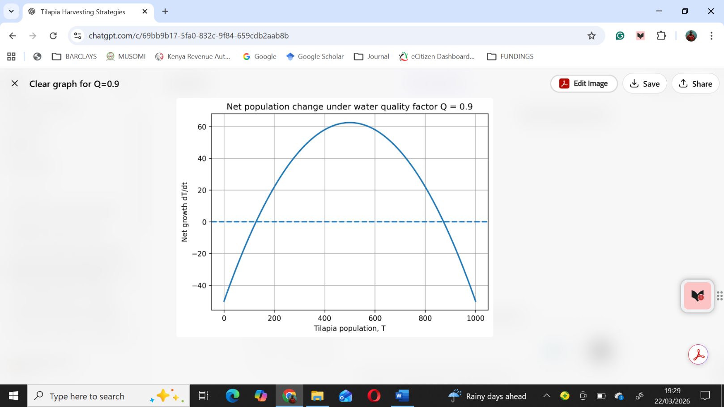

Fig 1: Net population change under water quality factor Q=0.9
Figure 1 shows that the net growth function intersects the horizontal axis at two points. The upper equilibrium near 872 fish is the biologically desirable stable state, while the lower equilibrium highlights the danger zone. The result implies that under good water quality, the fish population remains strong enough to recover from harvesting and stabilize at high levels, underscoring the importance of maintaining optimal environmental conditions.
  - Moderate Stress: Q = 0.5
Under moderate stress, equation (3.13) becomes
$\frac{0.25}{1000}.T^{2}-0.25T+50=0$ (4.5)
Multiplying through by 1000 gives
$0.25T^{2}-250T+50000=0$ (4.6)
Solving (4.6) gives
$T_{1}≈724$ $T_{2}≈276$ (4.7)
The stable equilibrium decreases from approximately 872 fish to about 724 fish. This indicates that the system becomes less resilient as water quality declines.
When water quality declines to moderate stress levels, the equilibria shift to 276 fish (threshold) and 724 fish (stable equilibrium). The reduction in the stable equilibrium from 872 to 724 fish demonstrates that the system becomes less resilient as environmental quality deteriorates. Biological growth slows, and harvest pressure becomes relatively greater, narrowing the margin of safety.
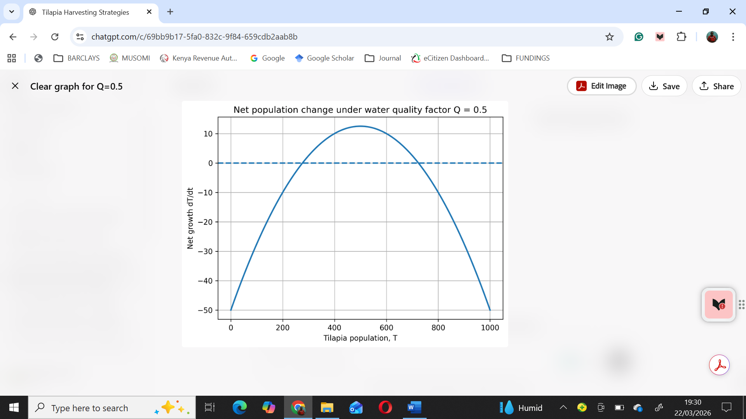

Fig 2: Net population change under water quality factor Q=0.5
Figure 2 shows that the growth curve shifts downward under moderate stress. The harvest rate of 50 fish per unit time, which was sustainable under optimal conditions, now exerts a heavier burden on the population. Although harvesting remains possible, the reduced equilibrium implies that the system is more vulnerable to shocks such as disease outbreaks, sudden drops in dissolved oxygen, rise in ammonia levels, pH fluctuations from the optimal or mismanagement of feeding regimes. If the population dips below the threshold of 276 fish, recovery becomes impossible, and collapse ensues.
This result highlights the sensitivity of aquaculture systems to environmental stressors. Even moderate declines in water quality significantly reduce resilience, meaning that managers must adjust harvest strategies accordingly. In practice, this could involve reducing harvest frequency, lowering harvest quotas, or implementing rotational harvesting to allow recovery periods. The findings on Aquasamaki Farm emphasize that sustainability is not a fixed property of the system but a dynamic balance that shifts with environmental conditions.
Severe Stress: Q = 0.2
Under severe stress, equation (3.13) becomes
$\frac{0.10}{1000}.T^{2}-0.10T+50=0$ (4.8)
Multiplying through by 1000 gives
$0.10T^{2}-100T+50000=0$ (4.9)
The discriminant is
$∆={(-100)}^{2}-4\left(0.10\right)\left(50000\right)=-1000<0$ (4.10)
Since the discriminant is negative, equation (4.9) has no real solution. Therefore, no biologically feasible equilibrium exists under severe environmental stress.
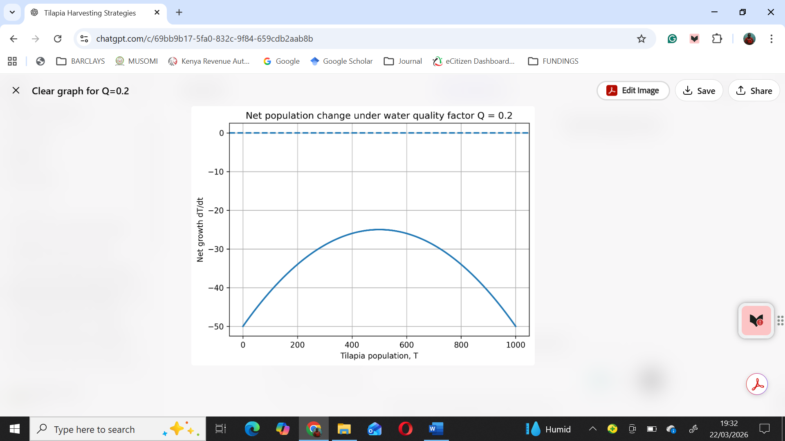

Figure 3 indicates that the net growth remains negative for all population sizes.

Fig 3: Net population change under water quality factor Q=0.2
Figure 3 shows negative growth rate on all population sizes under severe stress.
Under severe stress, the discriminant of the equilibrium equation becomes negative, indicating that no real equilibrium exists. Figure 3 confirms that net growth remains negative across all population sizes, meaning that biological growth cannot balance harvest pressure under such conditions. Continued harvesting would drive the population toward collapse, regardless of initial population size.
This scenario represents a critical failure point. When water quality deteriorates to such an extent, the system loses its capacity to sustain harvesting altogether. The absence of equilibrium implies that the population cannot stabilize, and any removal of fish accelerates decline. The only viable management strategy under severe stress is to suspend harvesting entirely until water quality improves.
From a practical perspective at Aquasamaki Farm, this finding underscores the importance of real-time monitoring of water quality parameters. Severe stress conditions may arise from acute events such as algal blooms, pH changes from the optimal, ammonia spikes, or prolonged oxygen depletion. Detecting these changes early allows managers to halt harvesting before irreversible damage occurs. The model demonstrates that once environmental quality falls below a critical threshold, collapse becomes inevitable, regardless of harvest rate.
  - Key Insight
The relationship between environmental quality and equilibrium population is summarized in Figure 4.
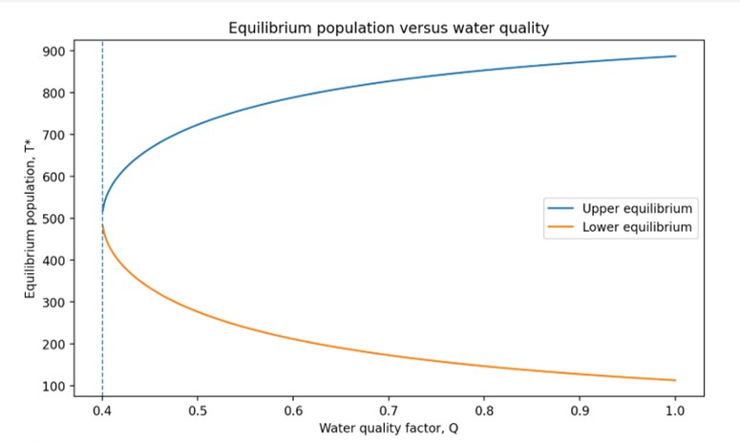
Fig 4: Equilibrium population versus water quality
Figure 4 demonstrates that the equilibrium population depends jointly on environmental quality and harvesting pressure. As Q decreases, the upper stable equilibrium shifts downward, indicating that deteriorating water quality reduces the system's capacity to sustain harvesting. Once Q falls below a critical threshold, no equilibrium exists, and collapse becomes inevitable.
Figure 4 summarizes the relationship between environmental quality (Q) and equilibrium population (T*). The bifurcation at Q ≈ 0.4 marks a critical threshold where the system transitions from having two equilibria (upper stable and lower unstable) to having none. Above this threshold, populations can stabilize at a biologically desirable level, provided harvesting is managed appropriately. Below it, collapse is unavoidable.
The blue curve (upper equilibrium) shows that as Q increases, the stable equilibrium rises toward carrying capacity, reflecting greater resilience under favorable conditions. The orange curve (lower equilibrium) demonstrates that the threshold declines as Q increases, meaning that the danger zone shrinks under good water quality. Together, these curves illustrate the joint dependence of sustainability on environmental quality and harvest pressure.
This result highlights a central finding of the study: sustainable harvesting cannot be determined solely by harvest rate. Instead, it must be dynamically adjusted in response to environmental conditions. A fixed harvest quota may be sustainable under optimal conditions but unsustainable under moderate or severe stress. In practical terms, harvesting at Aquasamaki Farm should be linked to real-time monitoring of pH, alkalinity, ammonia, dissolved oxygen, and temperature. Thus, adaptive management, informed by continuous monitoring, is therefore essential.
The results align with ecological theory on population resilience and bifurcation dynamics. The presence of two equilibria under favorable conditions reflects a saddle-node bifurcation, where stability depends on initial population size relative to the threshold. As environmental quality declines, the stable equilibrium shifts downward, and the threshold rises, narrowing the safe operating space. Eventually, the equilibria vanish, signaling a catastrophic regime shift.
Conclusion

This study developed and analyzed a modified logistic growth model for sustainable tilapia harvesting by incorporating a dynamic environmental quality factor into the classical logistic framework. The analysis showed that water quality has a significant effect on population growth, equilibrium levels, and harvesting sustainability. Under optimal conditions, the fish population stabilizes near the carrying capacity, making harvesting sustainable. Under moderate stress, the equilibrium population declines substantially, indicating reduced resilience and increased risk of overharvesting. Under severe stress, no real equilibrium exists, implying population collapses if harvesting continues.
The study therefore establishes that sustainable tilapia harvesting depends jointly on biological growth, harvesting pressure, and environmental quality. By integrating environmental feedback into the population model, the work offers a more realistic and practically useful framework for fish farm management.

Definitions, Acronyms, Abbreviations
Tilapia population, T (t): The number of tilapia fish in the pond at time t.
Intrinsic growth rate, k: The natural rate at which the fish population grows under ideal conditions.
Carrying capacity, N: The maximum population size that the pond can sustainably support.
Environmental quality factor, Q(t): A dimensionless quantity between 0 and 1 representing the suitability of water quality conditions for fish growth.
Harvesting rate, H(t): The number of fish removed from the pond per unit time.
Equilibrium population: A population size at which growth exactly balances harvesting, so that the population remains constant over time.
Sustainable harvesting: A harvesting regime that allows continued fish production without causing long-term population decline or collapse

Disclaimer (Artificial intelligence)

Author(s) hereby declare that NO generative AI technologies such as Large Language Models (ChatGPT, COPILOT, etc.) and text-to-image generators have been used during the writing or editing of this manuscript.

References

1] Okeri, D., K. Wesley, and K. Cleophas, Using the Logistic Growth Model to Assess Fishing Techniques for Sustainable Tilapia Catch and Management at Omega Farm. Pure and Applied Mathematics Journal, 2025. 14(1): p. 1–7.
[2] Devi, P.A., et al., Review on water quality parameters in freshwater cage fish culture. International Journal of Applied Research, 2017. 3(5): p. 114–120.
[3] Mariu, A., et al., Effect of temperature, pH, salinity and dissolved oxygen on fishes. Journal of Zoology and Systematics, 2023. 1(2): p. 1–12.
[4] Boyd, C.E., et al., Achieving sustainable aquaculture: Historical and current perspectives and future needs and challenges. Journal of the world aquaculture society, 2020. 51(3): p. 578–633.
[5] Mahmoud, A., Effect of Different Management of Fish Ponds on Fish Productivity and Water Quality. Benha University, 2015.
[6] Ruiz-Vanoye, J.A., et al., A comprehensive review of quality of aquaculture services in integrated multi-trophic systems. Fishes, 2025. 10(2): p. 54.
[7] Clark, C.W., Mathematical bioeconomics: the mathematics of conservation. 2010: John Wiley & Sons.
[8] Lopatkin, A.J. and J.J. Collins, Predictive biology: modelling, understanding and harnessing microbial complexity. Nature Reviews Microbiology, 2020. 18(9): p. 507–520.
9. Nugroho, E., Kristanto, A. H., Pamungkas, W., Dewi, R. R., & Rifaldi, M. (2023). Optimizing tilapia biofloc technology systems and its economic profitability on industrial scale in Indonesia. IOP Conf. Series: Earth and Environmental Sceince, 1137(2023), 012061.
https://doi.org/10.1088/1755-1315/1137/1/012061
10. Aljehani, F., N’Doye, I., & Laleg-Kirati, T. M. (2023). Model-based versus model-free feeding control and water-quality monitoring for fish-growth tracking in aquaculture systems. IFAC Journal of Systems and Control, 26, 100226.
11. Chahid, A., N’Doye, I., Majoris, J. E., Berumen, M. L., & Laleg-Kirati, T. M. (2021). Model predictive control paradigms for fish growth reference tracking in precision aquaculture. Journal of Process Control, 105, 160-168.

