An h-Adaptive Finite Element Approach for Efficient Thermal Analysis of Microchip Cooling Systems
Abstract
Advancements in semiconductor technology have increased integration density and performance but created significant thermal challenges due to high power densities and localized hotspots. Computational methods, particularly the Finite Element Method (FEM), are essential for accurately modeling heat transfer and optimizing cooling strategies in microelectronic systems. This paper presents an h-adaptive finite element method (FEM) for solving the two–dimensional Poisson equation arising in steady-state thermal analysis of microelectronic chips. The model represents localized heat generation from high-power components, with Dirichlet boundary conditions simulating heat dissipation through heat sinks. An a posteriori error estimator based on element residuals is employed to guide adaptive mesh refinement in regions of steep temperature gradients. The numerical scheme uses linear triangular $P_{1}$ finite elements and local mesh refinement to accurately resolve thermal hotspots while minimizing computational cost. Numerical experiments demonstrate rapid error reduction under adaptive refinement: the $L^{2}$ error decreases from 0.68996580 to $6.6114× {10}^{-4}$ , the energy norm decreases from 4.67326795 to $2.16660×{10}^{-2}$ ,and Maximum error decreases from 2.117184686 to $2.3829128×{10}^{-2}$ within five refinement steps while the mesh concentrates elements around the heat source. The results confirm that the adaptive strategy significantly improves efficiency compared with uniform mesh discretization, making the method suitable for high-resolution thermal analysis in microchip design and cooling optimization.

1. Introduction
The continuous evolution of semiconductor technology has enabled remarkable improvements in computational performance and device miniaturization. Modern microelectronic systems now integrate billions of transistors on a single chip, enabling complex functionalities in applications ranging from high-performance computing to embedded and mobile systems. However, this remarkable increase in integration density has also introduced significant thermal management challenges. As device dimensions shrink and operating frequencies increase, power densities within integrated circuits have risen substantially, leading to the formation of localized thermal hotspots that can compromise both performance and reliability of microelectronic devices [1,2,3].
In contemporary processors, graphics processing units (GPUs), and system-on-chip (SoC) architectures, heat generation is highly non-uniform due to uneven computational workloads and localized switching activity within transistor clusters. Regions such as processor cores, cache memories, and power delivery networks often dissipate significantly more heat than surrounding areas, resulting in steep temperature gradients across the chip surface [4,5]. Excessive temperatures in these regions may cause increased leakage currents, timing violations, and accelerated material degradation. Over extended operational periods, thermal stresses can also induce mechanical deformation, delamination of packaging layers, or permanent device damage [6,7]. Consequently, effective thermal management has become a critical aspect of modern microelectronic design.
To mitigate these issues, engineers have developed various cooling strategies, including heat spreaders, microchannel heat sinks, liquid cooling systems, and phase-change materials. The effectiveness of these techniques depends strongly on accurate prediction of temperature distributions within the chip and its surrounding packaging structures. Experimental testing alone is often insufficient due to high fabrication costs and limited accessibility to microscale thermal measurements. As a result, computational thermal modelling has emerged as an indispensable tool for evaluating cooling strategies and optimizing electronic system designs before physical prototypes are constructed [10,11,12].
Among available computational approaches, the Finite Element Method (FEM) has proven to be particularly effective for modelling heat transfer in microelectronic systems. FEM offers significant flexibility in representing complex geometries, heterogeneous material properties, and mixed boundary conditions commonly encountered in electronic packaging and cooling structures [8,9]. Additionally, FEM provides a systematic framework for solving the governing partial differential equations of heat conduction with high numerical accuracy. Consequently, FEM-based thermal analysis has become a standard methodology in the design of electronic cooling systems, including microchannel heat sinks and advanced packaging configurations [17,22,27].
Despite its versatility, conventional FEM simulations typically rely on uniform mesh discretization, where the computational domain is divided into elements of approximately equal size. While such meshes are straightforward to generate, they often lead to inefficient use of computational resources when modelling microchip thermal behavior. In practical microelectronic systems, temperature gradients are highly localized near active components or heat sources, whereas large regions of the chip experience relatively smooth temperature distributions. Uniform meshes therefore allocate unnecessary computational effort to regions with minimal thermal variation, significantly increasing the overall simulation cost.
To address this limitation, adaptive mesh refinement techniques have been widely investigated in computational mechanics and thermal engineering. Adaptive methods dynamically modify the computational mesh based on estimates of the local discretization error, enabling higher resolution only in regions where the solution exhibits strong gradients or complex features. Such techniques allow numerical simulations to achieve higher accuracy while maintaining computational efficiency [13,14]. The concept of adaptive error control has been extensively studied in the finite element literature, with classical contributions by Zienkiewicz and Zhu introducing practical error estimation techniques for engineering analysis [9], and subsequent developments providing rigorous theoretical foundations for adaptive refinement strategies [13,14].
Recent research has demonstrated the growing importance of adaptive methods in thermal and multiphysics simulations relevant to microelectronics. Adaptive finite element approaches have been successfully applied to conjugate heat transfer problems in microchannel heat sinks and microscale cooling devices, where strong coupling between fluid flow and heat conduction creates highly localized thermal gradients [22,27]. In electronic packaging, a posteriori error estimators have been used to improve the accuracy of thermal stress and temperature predictions while reducing computational cost [23]. Moreover, advances in high-performance computing have enabled the development of GPU-accelerated adaptive finite element solvers capable of performing large-scale thermal simulations for integrated circuits in near real time [21,24].
In addition to classical numerical approaches, recent studies have explored hybrid modelling techniques that combine adaptive discretization with reduced-order modelling and machine learning. These approaches aim to accelerate thermal simulations while maintaining predictive accuracy, particularly for complex systems such as multi-core processors and microscale cooling structures [26,29]. Adaptive mesh refinement has also been integrated into simulations of advanced manufacturing processes and thermal–mechanical coupling in additive manufacturing, highlighting its importance in multiscale thermal analysis problems [25,30].
Despite these advances, relatively few studies have focused specifically on adaptive finite element frameworks tailored for localized thermal hotspot resolution in microchip cooling simulations. Many existing models either rely on uniform meshes or employ reduced-order approximations that may not capture steep thermal gradients with sufficient accuracy. Consequently, there remains a need for computational frameworks that combine robust error estimation with efficient mesh refinement strategies to accurately resolve localized heating phenomena while minimizing computational cost.
Motivated by this need, the present work develops an h-adaptive finite element solver for steady-state heat conduction problems relevant to microchip cooling applications. The proposed approach incorporates localized heat generation within a two-dimensional chip domain and simulates the thermal behavior of the system under fixed boundary temperature conditions representing heat sink attachment. An a posteriori error estimation strategy based on nodal variation is used to identify regions requiring refinement, and adaptive mesh subdivision is applied iteratively to improve solution accuracy.
The numerical framework employs linear triangular ($P_{1}$) finite elements due to their simplicity and computational efficiency. The adaptive algorithm dynamically refines the mesh in regions exhibiting steep temperature gradients, particularly near localized heat sources. This strategy enables accurate resolution of thermal hotspots while maintaining a manageable number of elements, thereby significantly improving computational efficiency compared with uniform discretization approaches.
The main contributions of this study can be summarized as follows:
- Development of an h-adaptive finite element framework for thermal analysis of microchip cooling systems.
- Implementation of a physically motivated heat source model representing localized power dissipation within a chip.
- Integration of a computationally efficient a posteriori error estimator for guiding adaptive mesh refinement.
- Demonstration of improved convergence and computational efficiency compared with uniform mesh refinement strategies.
- Visualization of mesh evolution and temperature distributions, illustrating the ability of the adaptive method to accurately capture localized thermal hotspots.
The numerical experiments presented in this work demonstrate that adaptive mesh refinement significantly improves solution accuracy while maintaining acceptable mesh quality and computational efficiency. The resulting framework provides a practical and scalable tool for thermal analysis in microelectronic system design and cooling optimization.
The remainder of the paper is organized as follows. Section 2 presents the mathematical formulation of the steady-state heat conduction problem relevant to microchip thermal analysis. Section 3 describes the finite element discretization and weak formulation of the governing equations. Section 4 outlines the MATLAB implementation of the adaptive finite element solver. Section 5 presents numerical experiments illustrating mesh evolution, convergence behavior, and temperature distribution within the simulated microchip domain. Finally, Section 6 summarizes the main findings of the study and discusses potential directions for future research.

2 Mathematical Model: Steady-State Heat Conduction
We consider the steady-state heat conduction problem governed by the Poisson equation:
$-∇^{2} u = f\left(x, y\right), ∈Ω = {\left[0,1\right]}^{2}$ (1)
subject to Dirichlet boundary conditions:
$u = 0 on ∂Ω$ (2)
where:
$u(x,y)$ represents the temperature distribution across the microchip surface,
$f(x,y)$ denotes the volumetric heat generation rate caused by localized power dissipation.
To represent a localized heat source, we consider a Gaussian function,
$f(x, y) = Ae^{\left(-a\left({\left(x -x_{0}\right)}^{2} + {\left(y - y_{0}\right)}^{2}\right)\right) }$ (3)
where $A$ represents the heat intensity and $(x_{0},y_{0})$ denotes the location of the hotspot on the chip.
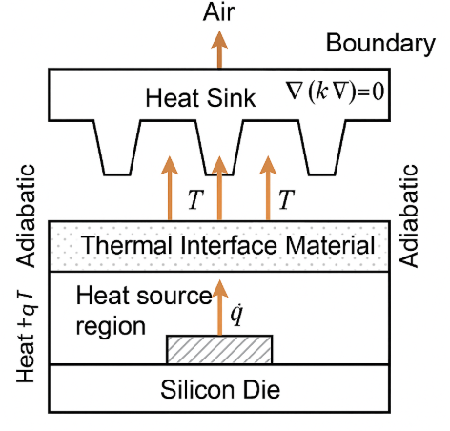
Fig 1: Steady-state heat conduction in Microelectronic Chips
This setup models a simplified but realistic scenario of a microchip with a central high-power component, such as a processor core or GPU unit. Efficient and accurate resolution of the resulting thermal profile is critical for designing optimal cooling strategies and preventing overheating failures [12]. We employ a simple residual-based error estimator:
$η_{K} =\max_{i∈nones(K)}\left|u_{i}\right|-\min_{i∈nodes\left(K\right)}\left|u_{i}\right|$, (4)
and refine any triangle $K$ for which $η_{K} >τ$ , where $τ$ is a user-defined tolerance.
This strategy ensures that the mesh adapts dynamically to capture the steep temperature gradient around the heat source, providing high-resolution results exactly where they are most needed [14].

3. Numerical Method
This section presents the mathematical formulation and implementation details of the h-adaptive finite element method (FEM) for solving the 2D elliptic Poisson equation (1), with associated Dirichlet boundary conditions. We solve this PDE numerically using linear triangular ($P_{1}$) finite elements with adaptive mesh refinement based on a posteriori error estimation.

3.1 Weak Formulation
To apply the finite element method, we derive the weak form of the problem. Multiply both sides of the equation by a test function $v∈ H_{0}^{1}(Ω)$, integrate over the domain $Ω$, and apply integration by parts:
$\int_{Ω}{∇ u⋅∇ v}dΩ =\int_{Ω}{ f v} dΩ$ (5)

This leads to the variational problem:
Find $u∈ H_{0}^{1}(Ω)$ such that $a\left(u, v\right)=l\left(v\right), ∀ v∈ H_{0}^{1}\left(Ω\right)$
where the bilinear form $a: H_{0}^{1}\left(Ω\right)× H_{0}^{1}\left(Ω\right)→ R$ and linear functional $l: H_{0}^{1}\left(Ω\right)→ R$ are defined as:
$a\left(u, v\right)=\int_{Ω}{∇ u⋅∇ v}dΩ, l(v) =\int_{Ω}{f v } dΩ$ (6)
The Lax–Milgram Theorem guarantees the existence and uniqueness of the solution $u∈ H_{0}^{1}(Ω)$ under standard assumptions on $f$ and the domain $Ω$.

3.2 Discretization with Linear Triangular Elements
Let $T_{h}$ be a triangulation of the domain $Ω$ into non-overlapping triangles $K$. We define the finite-dimensional space $V_{h}⊂ H_{0}^{1}(Ω)$ consisting of continuous piecewise linear functions over $T_{h}$,
$V_{h} = \{v_{h}∈ C^{0}\left(\overset{⃐}{Ω}\right): v_{h}{\left.​\right|}_{K}∈P_{1}\left(K\right), ∀ K∈T_{h} \}$ (7)
Here, $P_{1}\left(K\right),$ denotes the space of linear polynomials on triangle $K$.
The discrete Galerkin approximation is,
Find $u_{h}∈ V_{h}$ such that:
$a\left(u_{h}, v_{h}\right)=l\left(v_{h}\right), ∀ v_{h}∈ V_{h}$ (8)
Let $ϕ_{i} ∈ V_{h}$ denote the nodal basis functions associated with each vertex node $i$ . Then, the approximate solution can be expressed as:
$u_{h}\left(x, y\right)=\sum_{j=1}^{N}{U_{j} ϕ_{j}(x, y)}$ (9)
where $N$ is the number of nodes in the mesh and $U_{j}$ are the unknown coefficients.
Substituting $u_{h}$ into the weak form and choosing $v_{h} =ϕ_{i}$ for $i = 1$, $…, N$ , we obtain the linear system:
$KU = F$ (10)

where:
$K_{ij} = a\left(ϕ_{j}, ϕ_{i}\right)=\int_{Ω}{∇ ϕ_{j}⋅∇ ϕ_{i}} dΩ$ (11)
$F_{i} =l(ϕ_{i}) =\int_{Ω}{f ϕ_{i} } dΩ$ (12)

This system is solved numerically to compute the nodal values $U_{j}$.

3.3 Local Element Matrices
For each triangle $K$ with vertices $A, B, C$ , we compute the gradients of the shape functions and assemble local stiffness matrices and load vectors.
Let $x_{A} = \left(x_{1}, y_{1}\right), x_{B} = \left(x_{2}, y_{2}\right), x_{C} = (x_{3}, y_{3})$ be the coordinates of the triangle’s vertices. Define:
$b=\left[\begin{matrix}y_{2} - y_{3} \\ y_{3} - y_{1} \\ y_{1} - y_{2}\end{matrix}\right] , c=\left[\begin{matrix}x_{3} - x_{2} \\ x_{1} - x_{3} \\ y_{2} - y_{1}\end{matrix}\right]$ (13)
Then the gradient matrix is given by:
$B=\frac{1}{2\left|Ω_{K}\right|}\left[\begin{matrix}b_{1} & b_{2} & b_{3} \\ c_{1} & c_{2} & c_{3}\end{matrix}\right]$ (14)
where $|Ω_{K}|$$ is the area of triangle $K$.
The local stiffness matrix is:
$K_{e} = B^{⊤}B⋅ |Ω_{K}|$ (15)
The local load vector is approximated using the centroid rule:
$F_{e} = f\left(x_{c}\right)⋅\frac{\left|Ω_{K}\right|}{3}⋅\left[\begin{matrix}1 \\ 1 \\ 1\end{matrix}\right]$ (16)
where $x_{c}$ is the centroid of triangle $K$.
These local contributions are assembled into the global stiffness matrix and load vector.

3.4 Imposition of Dirichlet Boundary Conditions
Dirichlet boundary conditions $u = 0$ are enforced strongly by modifying the global system. For each boundary node $i$, we set:
$K_{i,j} = 0 (∀ j), K_{i,i} = 1, F_{i} = 0$ (17)

This enforces $U_{i} = 0$ exactly at all Dirichlet nodes.

3.5 Error Estimation and Adaptive Refinement
An essential component of any adaptive algorithm is the error estimator, which guides where and how refinement should occur.
In our implementation, an element-wise residual-type error indicator is used:
$η_{K} = \max_{(i∈nodes(K))}{|u_{i}|} -\min_{(i∈nodes(K))}{|u_{i}|}$ (18)
Elements with $η_{K} >τ$ , where $τ$ is a specified tolerance, are marked for refinement.
3.5.1 Refinement Strategy
If refinement is required, selected elements are split into four smaller triangles by inserting midpoints along edges:
Let
$\left\{\begin{matrix}m_{AB}=\frac{x_{A}+ x_{B}}{2} \\ m_{BC}=\frac{x_{B}+ x_{C}}{2} \\ m_{CA} =\frac{x_{C}+ x_{A}}{2}\end{matrix}\right.$ (19)
Each triangle is then subdivided into four sub-triangles using these midpoints:
1. $A, m_{AB}, m_{CA}$
2. $B, m_{BC}, m_{AB}$
3. $C, m_{CA}, m_{BC}$
4. $m_{AB}, m_{BC}, m_{CA}$

After refinement, the entire mesh is regenerated using Delaunay triangulation to maintain conformity and avoid hanging nodes.

3.6 Convergence Analysis
Under suitable regularity assumptions on the exact solution $u∈ H^{2}(Ω)$ , it is known that the finite element solution converges optimally in the energy norm:

${\left\|u - u_{h}\right\|}_{H^{1}\left(Ω\right)}≤ C h {\left\|u \right\|}_{H^{2}\left(Ω\right)}$ (20)
where $h$ is the maximum element diameter.
With adaptive mesh refinement, the convergence rate can be improved significantly in regions of high solution variation, even when uniform meshes would fail to capture sharp gradients efficiently.
Moreover, the adaptive strategy ensures that:
${\left\|u - u_{h}\right\|}_{H^{1}\left(Ω\right)}≤C{\left(\sum_{K∈T_{h}}{η_{K}^{2}}\right)}^{\frac{1}{2}}$ (21)
which justifies the use of the element-wise error indicators to drive refinement.

4. Implementation Details
The algorithm is implemented in MATLAB to simulate the temperature distribution on a microchip surface subjected to localized heat generation. The computational framework employs an adaptive finite element method (FEM), which dynamically refines the mesh in regions exhibiting steep temperature gradients near heat sources.
The implementation consists of the following key components:
- generateInitialMesh – Constructs the initial triangular mesh.
- assembleFEM2D – Assembles the global stiffness matrix and load vector for the 2D problem.
- applyBoundaryConditions – Enforces Dirichlet boundary conditions on the domain.
- localElementMatrices – Computes element-level stiffness and load contributions.
- estimateError – Evaluates element-wise error indicators to guide refinement.
- refineMesh_hAdaptive – Performs h-refinement by subdividing selected elements based on the error estimate.
The solver operates iteratively according to the following procedure:
- Solve the FEM system to obtain the current temperature field.
- Estimate the discretization error across all elements.
- Refine elements where the error exceeds a prescribed threshold.
- Repeat until the solution converges or the maximum number of refinement steps is reached.
This adaptive strategy offers several advantages:
- Enhanced accuracy in resolving thermal hotspots generated by high-power microelectronic components.
- Efficient computational use, concentrating elements only in critical regions with steep gradients.
- Realistic modeling of steady-state heat conduction in microchip cooling systems.
The sequence of numerical approximations generated by this method converges in the energy norm, ensuring reliable and robust predictions for practical thermal analysis and microchip cooling system design.

5. Results and Discussion
This section presents the numerical results obtained using the proposed h-adaptive finite element method for solving the steady-state heat conduction problem in microchip cooling applications. The objective of the experiments is to evaluate the accuracy, convergence behavior, and computational efficiency of the adaptive mesh refinement strategy when resolving localized thermal hotspots.
The computational domain is the unit square $Ω=\left[0,1\right]×[0,1$], representing the surface of a microchip. A Gaussian heat source located near the center of the domain models localized power dissipation from an active electronic component. Dirichlet boundary conditions are imposed along the chip boundaries to simulate heat removal through cooling structures such as heat sinks or spreaders.
The function $f(x, y)$ from equation (3) is defined as,
$f\left(x, y\right)= \left(4a - 4a^{2}\left[{\left(x - c\right)}^{2} + {\left(y - b\right)}^{2}\right]\right)e^{\left(-a\left({\left(x - c\right)}^{2} + {\left(y - b\right)}^{2}\right)\right) },$ (22)

with constants $a = 1000, b = c = 0.5$. This corresponds to a Gaussian power source cantered at $(0.5, 0.5)$ , mimicking a high-power CPU/GPU core on a chip.
The exact solution:
$u\left(x, y\right)= e^{-α \left({\left(x - c\right)}^{2}+ {\left(y - b\right)}^{2}\right)},$ (23)
describes the resulting temperature field, sharply peaked around the centre, representing a thermal hotspot that must be accurately captured in simulations.
5.1 Adaptive Mesh Evolution

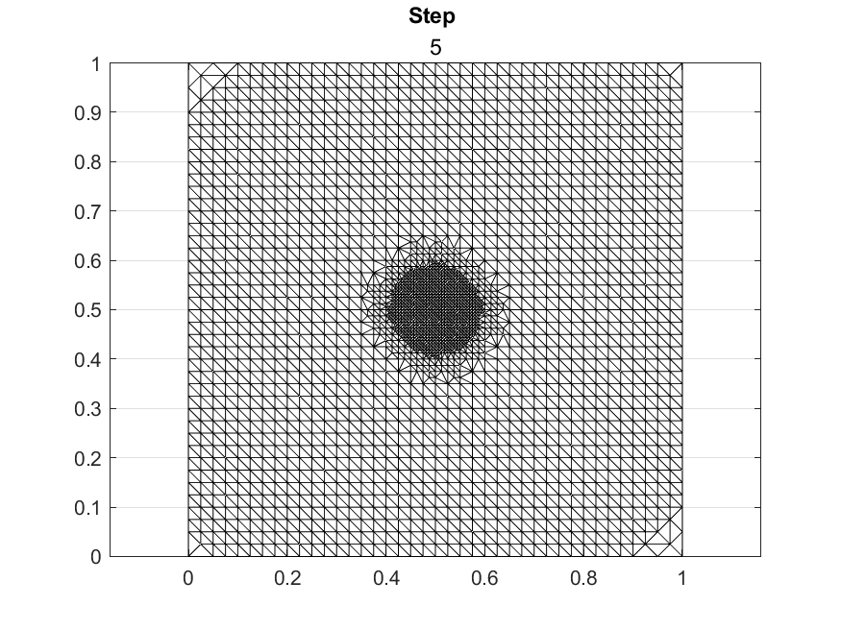
Figure 2: Step 5 of the evolution of the adaptive mesh during successive refinement steps, showing increased mesh density near the Gaussian heat source.
Figure 2 illustrates the evolution of the computational mesh during successive refinement steps. Initially, the mesh is relatively coarse and uniformly distributed across the domain. As the adaptive process proceeds, refinement becomes concentrated near the heat source where the temperature gradient is highest.
This behavior highlights one of the key advantages of adaptive finite element methods: computational resources are allocated preferentially to regions where the solution exhibits strong variations. Consequently, the adaptive strategy significantly reduces the number of elements required to achieve a desired accuracy compared with uniform mesh refinement.
The resulting mesh structure clearly shows a high density of elements around the hotspot region, while regions with smooth temperature variations remain relatively coarse.

5.2 Temperature Distribution and Hotspot Resolution
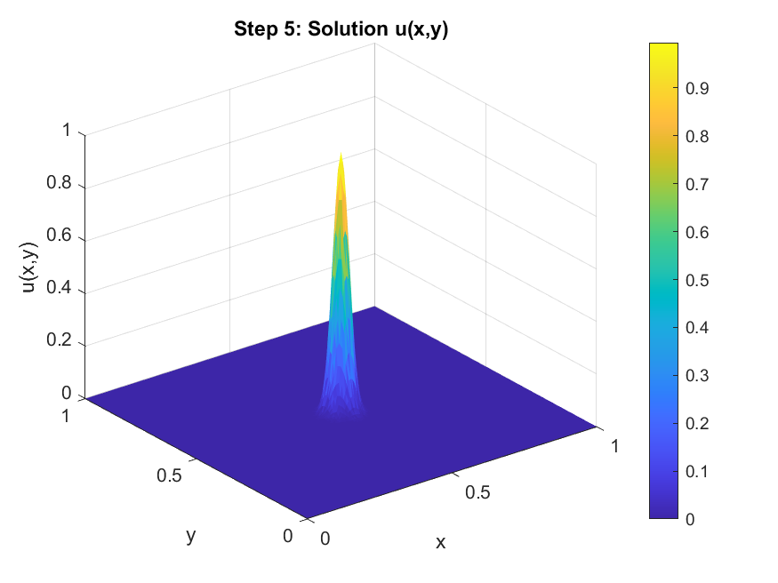
Figure 3: Temperature distribution over the microchip surface showing the thermal hotspot resolved by adaptive mesh refinement.
Figure 3 shows the computed temperature distribution over the microchip surface. The numerical solution accurately captures the localized temperature peak generated by the Gaussian heat source.
The adaptive mesh refinement ensures that the steep thermal gradients around the hotspot are well resolved. Without adaptive refinement, these gradients would require an extremely fine uniform mesh to achieve comparable accuracy.
The results demonstrate that the proposed method effectively captures localized heating effects, which are critical in the design of reliable microelectronic systems. Accurate prediction of hotspot temperatures enables engineers to evaluate cooling strategies, optimize component placement, and prevent thermal failure.

5.3 Error Convergence Analysis
To evaluate the convergence behavior of the adaptive method, the following error metrics are considered:
- $L^{2}$-norm error
- Energy norm error
- Maximum element-wise error indicator
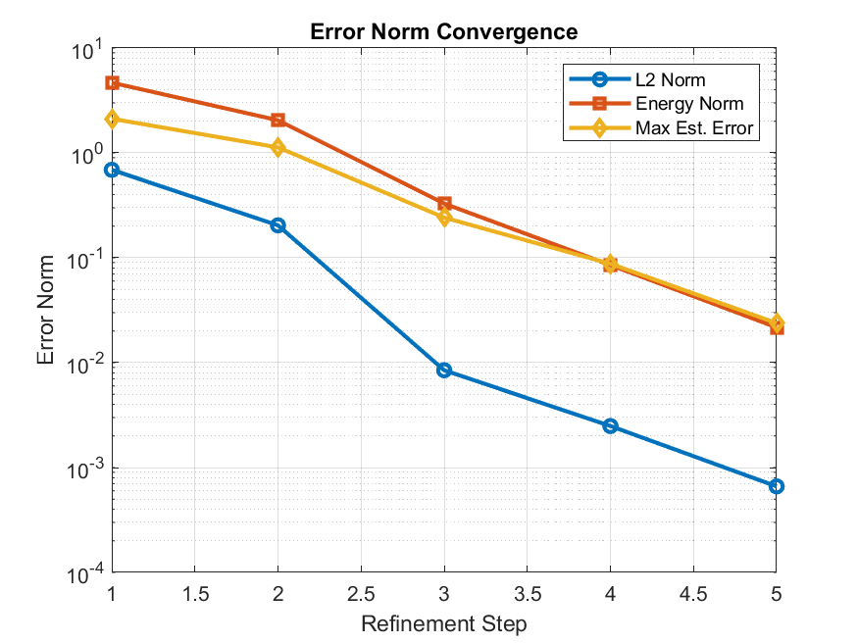
Figure 4: Error convergence under adaptive refinement, demonstrating rapid reduction in discretization error as the mesh evolves.
Figure 4 presents the decay of these error measures as the refinement level increases. The results show a rapid reduction in both the $L^{2}$ error and energy error, indicating that the adaptive algorithm efficiently improves solution accuracy.
The convergence behavior is significantly faster than that obtained using uniform mesh refinement. As refinement progresses, the mesh becomes increasingly aligned with the regions of largest error, leading to efficient error reduction with relatively few additional degrees of freedom.

5.4 Convergence Behavior
Table 1 summarizes the convergence behavior of the adaptive algorithm. The table reports the number of nodes, number of elements, and corresponding error measures for each refinement step.
Table 1: Convergence behavior under adaptive mesh refinement
Step | MaxError | L2Norm | Energy  Norm | Num  Elements | Num  Nodes | Worst  Min Angle
1 | 2.117184686 | 0.689965805 | 4.673267958 | 200 | 121 | 45
2 | 1.128614543 | 0.203758068 | 2.048092701 | 796 | 437 | 45
3 | 0.241701989 | 0.008462527 | 0.328639862 | 3180 | 1665 | 45
4 | 0.087665011 | 0.002488161 | 0.085184408 | 3724 | 1937 | 26.56505118
5 | 0.023829128 | 0.000661149 | 0.021666094 | 4812 | 2481 | 26.56505118
Table 1 indicates a substantial reduction in error across successive refinement levels. In particular, the $L^{2}$ and Energy errors decrease by several orders of magnitude while the mesh remains concentrated near the heat source.
During uniform refinements (Steps 1–3), all elements maintained excellent shape quality, with worst minimum angles of 45°. In the later adaptive refinement steps (4–5), the worst minimum angle decreased to approximately 26.57°, reflecting the creation of elongated triangles in regions of high error. Despite this decrease in element quality, the error norms continued to drop significantly, indicating that the adaptive strategy effectively targeted error-dense regions while maintaining an acceptable mesh quality.
These results confirm that the adaptive refinement strategy effectively targets regions of large discretization error, leading to rapid convergence while maintaining computational efficiency.

5.5 Mesh Growth and Computational Complexity
Let $N_{k}$ denote the number of elements at refinement step k. Under the adopted refinement strategy, the mesh size grows approximately according to
$N_{k+1}≈ 4N_{k}$ (24)
for refined regions, since each selected triangle is subdivided into four smaller elements. However, because refinement occurs only in localized regions with high error, the global mesh growth remains significantly low.
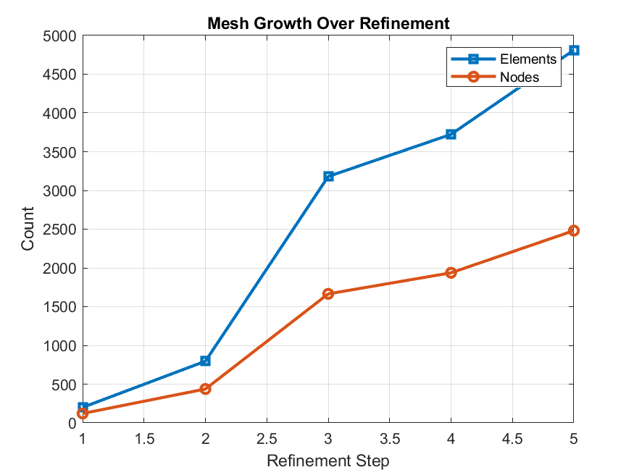
Figure 5: Growth of nodes and elements during successive adaptive refinement steps.
Figure 5 therefore provides insight into the computational cost associated with successive refinement levels. While the number of degrees of freedom increases with each iteration, the adaptive strategy ensures that this increase is concentrated only in regions where higher resolution is required.
This localized refinement strategy improves computational efficiency and allows accurate resolution of thermal gradients without excessive mesh growth across the entire computational domain.
These results demonstrate that adaptive mesh refinement provides an effective balance between numerical accuracy and computational efficiency, making it a valuable approach for high-resolution thermal analysis of microelectronic systems.

5.6 Comparison with Uniform Mesh Refinement
To further evaluate the efficiency of the adaptive method, a comparison was performed between adaptive mesh refinement and conventional uniform mesh refinement.
In the uniform refinement approach, the mesh is globally refined at each step regardless of the spatial distribution of the solution error. While this strategy improves accuracy, it also leads to a rapid growth in the number of elements across the entire domain.
In contrast, the adaptive method selectively refines only those elements where the error indicator is large. As a result, high resolution is achieved in critical regions without unnecessarily increasing the computational cost in smooth regions. This can be seen in both Table 1 and Figure 6.
Table 2: Comparison of Adaptive and Uniform FEM
Adaptive Elements | AdaptiveL2 | Adaptive  Energy | Uniform  Elements | UniformL2 | Uniform  Energy
200 | 0.68996580 | 4.67326795 | 200 | 0.68996580 | 4.67326795
796 | 0.20375806 | 2.04809270 | 800 | 0.20375823 | 2.04809270
3180 | 0.00846252 | 0.32863986 | 3200 | 0.00846252 | 0.32863986
3724 | 0.00248816 | 0.08518440 | 12800 | 0.00248819 | 0.08518492
4812 | 0.00066114 | 0.0216660 | 51200 | 0.00065085 | 0.02165739
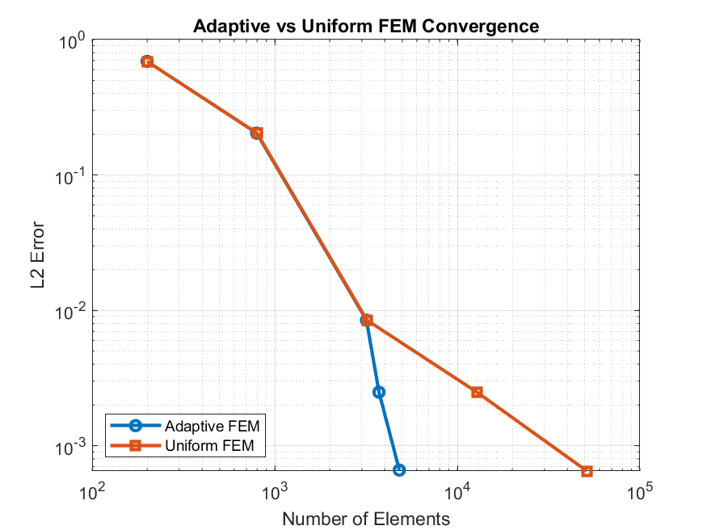
Figure 6: Comparison of the number of elements and error norms obtained using adaptive mesh refinement and uniform refinement. The adaptive strategy achieves lower error with significantly fewer elements, demonstrating improved computational efficiency.

The numerical experiments demonstrate that the adaptive method achieves comparable or better accuracy using significantly fewer elements than the uniform mesh approach. This confirms that adaptive FEM provides a more efficient framework for resolving localized thermal phenomena in microchip cooling simulations.

5.7 Computational Efficiency
One of the primary motivations for using adaptive finite element methods in thermal simulations is the reduction of computational cost. By refining the mesh only where necessary, the number of degrees of freedom grows much more slowly than in uniform refinement.
The simulations demonstrate that accurate hotspot resolution can be achieved using a relatively moderate number of elements compared with uniform meshes that would require significantly higher resolution throughout the domain.
This property makes adaptive FEM particularly suitable for high-resolution thermal analysis of microelectronic devices, where localized heating effects must be captured without incurring excessive computational expense.

6. Conclusion
This study presented an h-adaptive finite element method for the thermal analysis of microchip cooling systems. By applying local mesh refinement driven by an a posteriori error estimator, the method efficiently captures sharp temperature gradients produced by localized heat sources.
The numerical results demonstrate rapid error reduction and effective concentration of computational resources near thermal hotspots. Compared with uniform mesh discretization, the adaptive strategy achieves higher accuracy with significantly fewer elements.
The proposed framework provides a useful computational tool for microelectronic thermal design, enabling accurate prediction of hotspot temperatures and improved evaluation of cooling strategies.
Future work will consider transient thermal models, coupling with fluid-based cooling mechanisms, and extension to three-dimensional chip geometries.
Disclaimer for Preprint:

This paper is an extended version of a preprint document of the same author.
The preprint document is available in this link: https://assets-eu.researchsquare.com/files/rs-9156117/v1_covered_63e16482-fca5-4c32-9781-7c1c02379026.pdf?c=1775033303
[As per journal policy, preprint /repository article can be published as a journal article, provided it is not published in any other journal]

Disclaimer (Artificial intelligence)

Author(s) hereby declare that NO generative AI technologies such as Large Language Models (ChatGPT, COPILOT, etc.) and text-to-image generators have been used during the writing or editing of this manuscript.

References
[1] Kumari, N., Alam, T., Ali, M. A., Yadav, A. S., Gupta, N. K., Siddiqui, M. I. H., ... & Sharma, A. (2022). A numerical investigation on hydrothermal performance of micro channel heat sink with periodic spatial modification on sidewalls. Micromachines, 13(11), 1986.
[2] Xu, G. (2006, May). Thermal modeling of multi-core processors. In Thermal and Thermomechanical Proceedings 10th Intersociety Conference on Phenomena in Electronics Systems, 2006. ITHERM 2006. (pp. 96-100). IEEE.
[3] Garimella, S. V., Fleischer, A. S., Murthy, J. Y., Keshavarzi, A., Prasher, R., Patel, C., ... & Raad, P. E. (2008). Thermal challenges in next-generation electronic systems. IEEE Transactions on Components and Packaging Technologies, 31(4), 801-815.
[4] Adham, A. M., Mohd-Ghazali, N., & Ahmad, R. (2013). Thermal and hydrodynamic analysis of microchannel heat sinks: A review. Renewable and Sustainable Energy Reviews, 21, 614-622.
[5] Athia, D. (2017). Experimental and Numerical Thermal Analysis for Advanced Flip Chip Thermo-Compression Bonding via CMOS Microsensor Arrays and Finite Element Modelling.
[6] Fedorov, A. G., & Viskanta, R. (2000). Three-dimensional conjugate heat transfer in the microchannel heat sink for electronic packaging. International Journal of Heat and Mass Transfer, 43(3), 399-415.
[7] Markl, M., & Körner, C. (2016). Multiscale modeling of powder bed–based additive manufacturing. Annual Review of Materials Research, 46(1), 93-123.
[8] L. Chen, iFEM: An integrated finite element methods package in MATLAB, Technical Report, University of California at Irvine, 2009.
[9] O. C. Zienkiewicz and J. Z. Zhu, “A simple error estimator and adaptive procedure for practical engineering analysis,” International Journal for Numerical Methods in Engineering, vol. 24, no. 2, pp. 337–357, 1987.
[10] Yadroitsev, I., Yadroitsava, I., Bertrand, P., & Smurov, I. (2012). Factor analysis of selective laser melting process parameters and geometrical characteristics of synthesized single tracks. Rapid Prototyping Journal, 18(3), 201-208.
[11] Khairallah, S. A., Anderson, A. T., Rubenchik, A., & King, W. E. (2016). Laser powder-bed fusion additive manufacturing: Physics of complex melt flow and formation mechanisms of pores, spatter, and denudation zones. Acta Materialia, 108, 36-45.
[12] Zhang, T., Lin, X., Qin, Y., Zhu, D., Wang, J., Zhang, C., & Bai, Y. (2025). Multiphysics Modeling of Heat Transfer and Melt Pool Thermo-Fluid Dynamics in Laser-Based Powder Bed Fusion of Metals. Materials, 18(13), 3183.
[13] M. Ainsworth and J. T. Oden, “A posteriori error estimation in finite element analysis,” Computational Mechanics Advances, vol. 142, no. 1–2, pp. 1–88, 1997.
[14] R. Verfürth, A Review of A Posteriori Error Estimation and Adaptive Mesh-Refinement Techniques, Wiley–Teubner, 1996.
[15 Benatar, J. G. (2005). FEM implementations of magnetostrictive-based applications. University of Maryland, College Park.
[16] L. Chen, H. Wei, and M. Wen, “An interface-fitted mesh generator and virtual element methods for elliptic interface problems,” Journal of Computational Physics, vol. 334, pp. 327–348, 2017.
[17] Fathi, N., Pourghasemi, M., Aleyasin, S. S., Savoldi, L., & Rodriguez, S. (2024). On conjugate heat transfer in microchannel heat sinks. International Journal of Thermofluids, 22, 100658.
[18] Zorzetto, M., Torchio, R., Lucchini, F., Massei, S., Robol, L., & Dughiero, F. (2024). Reduced order modeling for thermal simulations of electric components with surface-to-surface radiation. IEEE Access, 12, 178117-178126.
[19] Le, P., Panagiotopoulos, D., & Deckers, E. (2025). A Non‐Intrusive Efficient Two‐Step Model Reduction Method for Large‐Scale Thin‐Walled Acoustic Indirect BEM Systems. International Journal for Numerical Methods in Engineering, 126(20), e70171.
[20] Chen, X., & Yang, V. (2014). Thickness-based adaptive mesh refinement methods for multi-phase flow simulations with thin regions. Journal of Computational Physics, 269, 22-39.
[21] Zhang, J., Hills, J., Zhong, Y., Shirinzadeh, B., Smith, J., & Gu, C. (2018). GPU-accelerated finite element modeling of bio-heat conduction for simulation of thermal ablation. Journal of Mechanics in Medicine and Biology, 18(07), 1840012.
[22] Xiao, H., Liu, Z., & Liu, W. (2021). Conjugate heat transfer enhancement in the mini-channel heat sink by realizing the optimized flow pattern. Applied Thermal Engineering, 182, 116131.
[23] Gong, Y., Li, S., Qin, F., & Xu, B. (2025). Virtual element method for thermomechanical analysis of electronic packaging structures with multi-scale features. Engineering with Computers, 41(6), 4799–4824.
[24] Dong, Z., Luo, Y., Meng, Y., Yan, C., Bi, Z., Zhu, K., ... & Zeng, X. (2025). LCTMwalk: GPU-accelerated transient thermal simulation for liquid-cooled 2.5D/3D ICs via random walks on circuit networks of modified compact thermal models. In Proceedings of the IEEE/ACM International Conference on Computer-Aided Design (ICCAD) (pp. 1–9). IEEE.
[25] Alimehr, A., Nikniazi, A., Jalali, A., Daymond, M. R., Pahlevani, M., & Fallah, V. (2025). Heat sink design investigation via CFD thermal analysis and additive manufacturing rapid prototyping. The International Journal of Advanced Manufacturing Technology, 141(7), 4473–4487.
[26] Dowling, A., Jiang, L., Cheng, M. C., & Liu, Y. (2025). Regulating CPU temperature with thermal-aware scheduling using a reduced order learning thermal model. Future Generation Computer Systems, 166, 107687.
[27] Ma, Y., Mohebbi, R., Yang, Z., & Sheremet, M. A. (2025). Numerical analysis of heat sink configurations and their impact on conjugate heat transfer in manifold systems. International Journal of Thermal Sciences, 218, 110145.
[28] Manoj, A., Goddumarri, U. V., & Chakraborty, S. (2023). Heat transfer and fluid flow characteristics of a microchannel heat sink with microplates: A computational study. Applied Thermal Engineering, 226, 120309.
[29] Đinh, N. (2021). Review of physics-based and data-driven multiscale simulation methods for computational fluid dynamics and nuclear thermal hydraulics. arXiv preprint.
[30] Hu, Y., Tang, D., Yang, L., Lin, Y., Zhu, C., Xiao, J., ... & Shi, Y. (2023). Multi-physics modeling for laser powder bed fusion process of NiTi shape memory alloy. Journal of Alloys and Compounds, 954, 170207.

