Predictive Analysis and Segmentation of Child Malnutrition by Machine Learning in the Health Zones of Kasongo-Lunda (DRC)

ABSTRACT

Child malnutrition remains a major public health challenge in the Democratic Republic of Congo (DRC), particularly in rural areas where access to adequate nutrition and quality healthcare remains limited. This study proposes a machine learning-based approach to model, segment, and predict the evolution of malnutrition in health zones of Kwango province, using data collected between 2015 and 2023. Four indicators were analysed: the number of moderately malnourished, severely malnourished, and severely malnourished children referred, and children aged five years and older. The K-Means classification algorithm identified two distinct groups: (i) a cluster with low prevalence and moderate progression, and (ii) a cluster with high prevalence dominated by the Kasongo Lunda area, representing the critical core of the phenomenon. The predictive phase, based on linear regression, made it possible to estimate trends up to 2026. The forecast results for the period 2024–2026 highlight an overall upward trend in child malnutrition across most health zones. Predictive modelling based on 2015–2023 trends reveals a near-linear progression of malnutrition in most areas. The projections indicate a sustained increase in malnutrition in several areas, with marked increases in Kasongo Lunda, Matamba Solo, Mahuangi and Muana Muyombo, while Kishiama and Mulundu show relatively stable levels. The areas show particularly alarming trajectories with an average annual growth rate of between 10% and 15%. The results demonstrate the relevance of machine learning techniques in nutritional surveillance. They offer a decision-making tool for planning health interventions, optimal resource allocation, and targeted prevention of nutritional crises at the community level. These results highlight the potential of data-driven health planning tools in supporting targeted, preventive, and resource-efficient nutritional interventions in rural areas of the DRC.

Keywords: Childhood malnutrition; Machine learning; K-Means; Linear regression; Prediction; Public health; Health zones

1. INTRODUCTION

The growing prevalence of noncommunicable diseases in Sub-Saharan Africa is partly driven by the nutrition transition. According to the report of the DRC National Nutrition Program published in 2019, half of all children younger than 5 years suffer from chronic malnutrition, available evidence indicates that the country is experiencing growing burdens of obesity, hypertension, diabetes mellitus, metabolic syndrome, and abdominal obesity in both urban and rural settings (Mwene-Batu et al., 2021; Luzingu et al., 2022). The Kwango province in the Democratic Republic of Congo, and more specifically the Kasongo-Lunda health zone, continues to face a major problem of child malnutrition, primarily affecting children aged 0 to 5 years and older. The three main forms observed are moderate malnutrition, severe malnutrition, and referred severe malnutrition, reflecting a worrying nutritional situation that has persisted for several years. Recent trends reveal a progressive deterioration of the nutritional situation, exacerbated by seasonality, precarious socio-economic conditions, and limited access to health services. The Kasongo-Lunda health zone does, however, possess comprehensive nutritional data covering all its health areas. This data, collected over several years, is stored in large files (Excel), containing thousands of observations.
However, the size and complexity of these datasets make manual processing difficult, limiting the ability of decision-makers to extract relevant information to effectively guide public health policies. This abundance of untapped information leads to a loss of decision-making knowledge, hindering the relevance and timeliness of responses to malnutrition.

To overcome this constraint, it becomes necessary to use modern data analysis methods, particularly those from Data Mining and Machine Learning. Increasingly plentiful data and powerful predictive algorithms heighten the promise of data science for humanitarian and development programming (McBride et al., 2022; Al-Ansi & Al-Maqaleh, 2022). These approaches make it possible to automatically analyse nutritional data, detect hidden structures, and predict the evolution of the phenomenon over time and space.

In this research, we propose to apply two complementary techniques:

- The K-Means classification algorithm, for segmenting health zones according to their malnutrition profiles,
- Linear regression, to predict the future trend in the number of malnourished children by 2026.

The main objective of this study is to transform raw nutritional data into strategic information to facilitate visualisation, understanding, and decision-making by local health system stakeholders. This work is thus part of a data-driven decision-making approach, contributing to improved planning of nutritional interventions in Kwango province.

2. Classification methods and machine learning
Automatic classification is a data analysis method that aims to structure a set of heterogeneous observations into homogeneous groups, called clusters. Its objective is to reduce data complexity while preserving its essential structure.
Unlike ranking, which relies on predefined categories, automatic classification creates groupings based on observed similarities between individuals. These approaches fall within the broader field of machine learning, a branch of artificial intelligence whose principle is to allow machines to learn from data without being explicitly programmed for each task.
Two main categories of models are distinguished:

- Supervised learning, where the data is labelled (used here for prediction via linear regression);
- Unsupervised learning, where the algorithm discovers latent structures on its own (used here for K-Means segmentation).

2.1. Conceptual Framework

Consider a dataset: $X=\left\{x_{1},x_{2},…,x_{n}\right\},$where each observation $x_{1}∈R^{p}$represents a health area described by $p=4$variables: $x_{1}=\left[x_{i1},x_{i2},x_{i3},x_{i4}\right]=\left[M_{i},S_{i},R_{i},A_{i}\right]$with:

- $M_{i}=$Number of moderately malnourished children,
- $S_{i}=$Number of severely malnourished children,
- $R_{i}=$Number of severely malnourished children referred,
- $A_{i}=$Number of children aged five and over.
This data comes from a time series covering the period. $tϵ\left[2015,2023\right].$The objective of the modelling is twofold:

- Segmenting health areas according to their nutritional profiles using K-Means,
- Predicting the temporal evolution of malnutrition via linear regression.

2.2. Unsupervised learning: K-Means segmentation model

To segment health zones according to their malnutrition profile, we used the K-Means algorithm (MacQueen, 1967), a partitioning method widely used in multivariate analysis. Its principle consists of grouping individuals in such a way as to minimise within-class variance and maximise between-class variance.
Each cluster is represented by its centre of gravity (centroid), recalculated at each iteration until stabilisation.

The algorithm follows these steps:

- Choose a number $k$of classes to create;
- Initialise $k$random centres;
- Assign each observation to the nearest centre (Euclidean distance);
- Recalculate the new centres.
- Repeat steps 3 and 4 until convergence.

a) Formalisation of the problem

We seek a partition $P=\{C_{1},C_{2},…,C_{k}\}$of $X$into $k$disjoint clusters such that: $C_{1}\bigcap{C_{1}}=∅$and $\bigcup_{k=1}^{k}{C_{k}}=X$Each cluster $C_{k}$is represented by its centroid (or centre of gravity).$g_{k}∈R^{p}.$

The algorithm aims to minimise the intra-class variance, also called intra-class inertia :
$$w=\sum_{k=1}^{k}{\sum_{x_{i}∈C_{k}}{{\left\|x_{i}-g_{k}\right\|}^{2}}}$$
Or$\left\|.\right\|$ denotes the Euclidean norm.
The between-class variance is given by:
$$B=\sum_{k=1}^{K}{n_{k}}{\left\|g_{k}-\overline{g}\right\|}^{2}$$
With $n_{k}$the number of observations in the cluster $C_{k}$and$\overline{g}$ the overall centre of gravity of the population. Huygens' theorem states that the total variance of the point cloud can be decomposed as follows:$I_{T}=W+B$

b) Algorithm

- Initialisation: choose $K$initial centers$g_{1},g_{2}, …., g_{k}$
- Assignment: each observation $x_{i}$is assigned to the cluster whose centroid is closest: $C_{k}=\left\{x_{i}:{\left\|x_{i}-g_{k}\right\|}^{2}≤{\left\|x_{i}-g_{j}\right\|}^{2},∀j≠k\right\}$.
- Update: Recalculate the centres of gravity:
$$g_{k}=\frac{1}{n_{k}}\sum_{x_{i}∈C_{k}}{x_{i}}$$
- Repeat steps (2) and (3) until convergence, that is, until the centroids no longer change:
$$g_{k}^{(t-1)}=g_{k}^{(t)}$$
c) Evaluation criteria
Two metrics were used to determine the optimal number of clusters $K$:
- Intra-class inertia $W$: decreases with $K$, but loses its discriminatory power beyond a certain threshold (elbow method).
- Silhouette score $S$:
$$S=\frac{b\left(i\right)-a(i)}{max⁡(a\left(i\right),b\left(i\right))}$$

where $a(i)$is the mean intra-class cohesion and $b(i)$the mean distance to the nearest cluster. The optimal value of $K$maximizes $S$. In our study, the maximum was obtained for $K=2$, with S=0.853.

2.3. Supervised Learning: Linear Regression Model

To predict malnutrition trends, we used a linear model linking time (years) to each nutritional indicator. For a given health area, the relationship between the dependent variable $y_{t}$(e.g., number of malnourished children) and the year $t$is written as:
$$y_{t}=α+βt+ε_{t}$$
Or :
- $α=$ constant (initial level of malnutrition),
- $β=$ slope representing the annual trend of change,
- $ε_{t}=$ assumed Gaussian error term,$ε_{t}\sim N\left(0,σ^{2}\right).$

The parameters $(α,β)$are estimated using the ordinary least squares method:
$$\min_{α,β}{\sum_{t=1}^{n}{{(y_{t}-α-βt)}^{2}}}$$

The predicted value for a future year $t'$is then:

$${\hat{y}}_{t^{'}}=\hat{α}+\hat{β}t^{'}$$

This equation was applied separately to each health area to project the values of the four malnutrition indicators up to the year 2026.

3. Presentation of the Kasongo-Lunda health zone

The Kasongo-Lunda Health Zone is limited:
- To the west by the Republic of Angola with the Kwango River as its border;
- To the north by the territory of Popokabaka;
- To the south by the Kitenda Health Zone.
- To the west by the Wambalwadi Health Zone.

3.1. Demographics

- Total population in 2021: 194,979 inhabitants (2020 projection)
- Area: 5285 km²
- Density: 34 inhabitants/km²
- Number of AS: 22 AS (including 5 CSR and 1 HGR)
- Number of villages: 267
- Supervision axis: 7 axes

3.2. Malnutrition

In Kwango province, the recurrence of nutritional crises is particularly alarming. Between 2016 and 2017, 10 of the 14 health zones were in a state of nutritional alert or confirmed crisis, with rates of acute malnutrition (AMG) reaching up to 16.4% in the Kahemba2 health zone and rates of severe malnutrition (SAM) reaching 6.5% in the Feshi3 health zone in 2016. In 2017, three-quarters of Kwango province were in a state of nutritional crisis.

3.3. Classification based on the weight/height indicator

Table 1: Classification based on the weight/height indicator

Weight/Height Compared to the reference average | Weight/Height compared to the reference average
- >100  - 85 to 80%  - 80 to 85%  - 70 to 80%  - 70% | obesity  Normal  Risk of malnutrition  Moderate malnutrition  Severe malnutrition

3.4. Causes of malnutrition

The three main underlying causes of malnutrition, as defined by UNICEF's conceptual framework, are:

- Insufficient access to food and nutrients or food insecurity.
- Inadequate care for children and women;
- Inadequate health services and an unhealthy environment;
- Insufficient access to food and nutrients or food insecurity;
- Artificial feeding too early, with improper use of powdered milk or poorly diluted sweetened condensed milk;
- Exclusive use of flour that is not or only slightly milky for the preparation of porridges, without enriching them with protein or energy;
- Prolonged exclusive breastfeeding;
- We do not encourage a child to eat when he has no appetite, and when he is sick, we only give him water or herbal teas.

3.5. Consequences of malnutrition

- Malnutrition increases poverty;
- It causes loss of human life and can also lead to psychomotor disorders.
- It causes school absenteeism;
- Promotes other complications (blindness, septicemia, etc.).

3.6. Moderate aspects of acute malnutrition

These conditions are very common. The clinical picture is straightforward, often described as hypotrophy: the child has weak muscle mass, particularly in the buttocks, inner thighs, and shoulders. The limbs are thin, and the abdomen is distended.
We observe:

- If it is on the path to kwashiorkor: psychomotor disorders, anorexia, and a change in the appearance of the hair.
- If it is on the path to decline: small size, very thin adipose tissue.

3.7. Complications

- Diarrhoea: It is one of the leading causes of death in children aged 0 to 5 years.
- Dehydration often complicates the situation when there is acute diarrhoea.
- Infections: These are frequent due to the immune deficiency caused by malnutrition. They manifest as bronchopneumonia, otitis, measles, whooping cough, tuberculosis, and septicemia.
- Other complications:
- Anemia
- Heart failure can occur in cases of kwashiorkor.
- Hypoglycemia
- Hypothermia
- Hypocalcemia
- Bone mineralisation disorders
- Sometimes eye damage occurs (especially in cases of associated vitamin A deficiency).

4. Data presentation

The data used in this study comes from nutritional monitoring reports collected in different health areas between 2015 and 2023. They concern the number of children affected by malnutrition, broken down according to four main indicators:

- Moderately malnourished children,
- Severely malnourished children,
- Severely malnourished children referred,
- and Children aged 5 and over.

These variables reflect different levels of malnutrition severity and allow us to understand both the extent of the phenomenon and its spatial and temporal distribution. The unit of observation is the health area, considered here as a homogeneous geographical and health entity.
Each record, therefore, corresponds to a given year for a specific health area, indicating the number of children counted in each of the four categories. The sample presented below illustrates the typical structure of the dataset:

4.1. Sample of malnutrition datasets.

Table 2: Samples of malnutrition datasets used

year | HEALTH AREA | Moderately Malnourished Children | Severely Malnourished Children | Severely malnourished children referred | Ages 5 and up
2017 | Mbangi | 32 | 12 | 4 | 12
2017 | Buka Lusengi | 2 | 11 | 2 | 10
2017 | Dibulu | 88 | 28 | 11 | 12
2017 | Kifuka | 312 | 105 | 10 | 15
2017 | Kikwati | 61 | 27 | 6 | 12
2017 | Kimbembo | 15 | 12 | 3 | 18
2017 | Kingunda | 21 | 15 | 10 | 11
2017 | Kipanzu | 10 | 9 | 10 | 12
2017 | Kishiama | 22 | 21 | 12 | 11
2017 | Madiadia | 45 | 25 | 3 | 15
2017 | Mahuangi | 73 | 12 | 4 | 10
2017 | Manzengele | 9 | 12 | 1 | 11
2017 | Matamba Solo | 61 | 4 | 3 | 13
2017 | Muana Muyombo | 163 | 18 | 3 | 4
2017 | Muela Mbwandu | 66 | 53 | 2 | 12
2017 | Mulundu | 58 | 11 | 21 | 11
2017 | Munganda | 28 | 2 | 11 | 9
2017 | Ntemo | 140 | 20 | 15 | 3
2017 | Nzakimwena | 21 | 19 | 10 | 17
2017 | Sacred Heart | 87 | 23 | 2 | 15
2017 | Zhinabunkete | 32 | 2 | 4 | 9
2017 | Kasongo Lunda | 48 | 41 | 9 | 2
2017 | Kasongo Lunda | 129 | 38 | 9 | 5
2017 | Kasongo Lunda | 97 | 48 | 10 | 7
2018 | Mbangi | 166 | 25 | 18 | 5
2019 | Buka Lusengi | 384 | 9 | 21 | 7
2019 | Dibulu | 251 | 54 | 19 | 3
2019 | Kifuka | 69 | 40 | 34 | 9
2019 | Kikwati | 104 | 45 | 27 | 5
2019 | Kimbembo | 59 | 5 | 34 | 33
2019 | Kingunda | 52 | 32 | 1 | 15
2019 | Kipanzu | 65 | 46 | 9 | 10
2019 | Kishiama | 73 | 32 | 32 | 11
2019 | Madiadia | 409 | 236 | 11 | 13
2019 | Mahuangi | 292 | 12 | 305 | 1
2019 | Manzengele | 72 | 25 | 78 | 12
2019 | Matamba Solo | 174 | 102 | 123 | 14
2019 | Muana Muyombo | 158 | 96 | 36 | 12
2019 | Muela Mbwandu | 63 | 22 | 1 | 10
2019 | Mulundu | 120 | 10 | 66 | 22
2019 | Munganda | 261 | 68 | 8 | 4
2019 | Ntemo | 140 | 46 | 68 | 15
2019 | Nzakimwena | 285 | 113 | 42 | 10
2019 | Sacred Heart | 99 | 54 | 40 | 11
2019 | Zhinabunkete | 88 | 113 | 27 | 13
2019 | Kasongo Lunda | 3181 | 1014 | 238 | 69
2019 | Mbangi | 787 | 373 | 2 | 10
2019 | Buka Lusengi | 449 | 99 | 61 | 4
2020 | Dibulu | 151 | 22 | 6 | 8
2020 | Kifuka | 283 | 4 | 12 | 6
2020 | Kikwati | 82 | 67 | 14 | 9
2020 | Kimbembo | 140 | 10 | 43 | 17
2020 | Kingunda | 59 | 42 | 10 | 2
2020 | Kipanzu | 173 | 57 | 8 | 9
2020 | Kishiama | 72 | 1 | 8 | 3
2020 | Madiadia | 130 | 1 | 32 | 4
2020 | Mahuangi | 261 | 28 | 3 | 13
2020 | Manzengele | 236 | 187 | 67 | 1
2020 | Matamba Solo | 277 | 222 | 289 | 11
2020 | Muana Muyombo | 182 | 94 | 1 | 4
2020 | Muela Mbwandu | 214 | 25 | 28 | 49
2020 | Mulundu | 147 | 4 | 2 | 3
2020 | Munganda | 380 | 119 | 89 | 6
2020 | Ntemo | 144 | 103 | 2 | 9
2020 | Nzakimwena | 106 | 31 | 42 | 11
2020 | Sacred Heart | 204 | 134 | 10 | 13
2020 | Zhinabunkete | 237 | 196 | 6 | 5
2020 | Kasongo Lunda | 4714 | 1653 | 495 | 100

4.2. Implementation

4.2.1. Execution environment: Anaconda and Jupyter Notebook

The implementation was carried out in an Anaconda development environment, widely used in scientific research and data science projects. More specifically, the Jupyter Notebook tool was used to run the Python code interactively, allowing the integration of code, graphs, and analytical interpretations within a single workspace.
The Python language was chosen for its wealth of scientific libraries and its ability to efficiently process large amounts of data.
a) Python libraries used

The implementation relied on several essential Python language libraries, each playing a specific role:
- os : Allows manipulation of directories and automatic saving of results.
- pandas (pd): Used to import, clean, transform and export data (CSV, Excel, etc.).
- matplotlib.pyplot (plt): Used to plot evolution curves, clusters and PCA projections.
- StandardScaler: Ensures that all variables have the same scale before the application of the K-Means model.
- KMeans: Performs automatic segmentation of health areas according to their similarities.
- silhouette_score: Allows you to measure the quality of the segmentation obtained.
- PCA (Principal Component Analysis): Facilitates the representation of clusters in two dimensions for better interpretation.
- LinearRegression: Used to estimate future values of malnutrition indicators.

b) Implementation itself

FIG 1. Malnutrition Data Analysis: K-Means Clustering and Linear Regression Setup

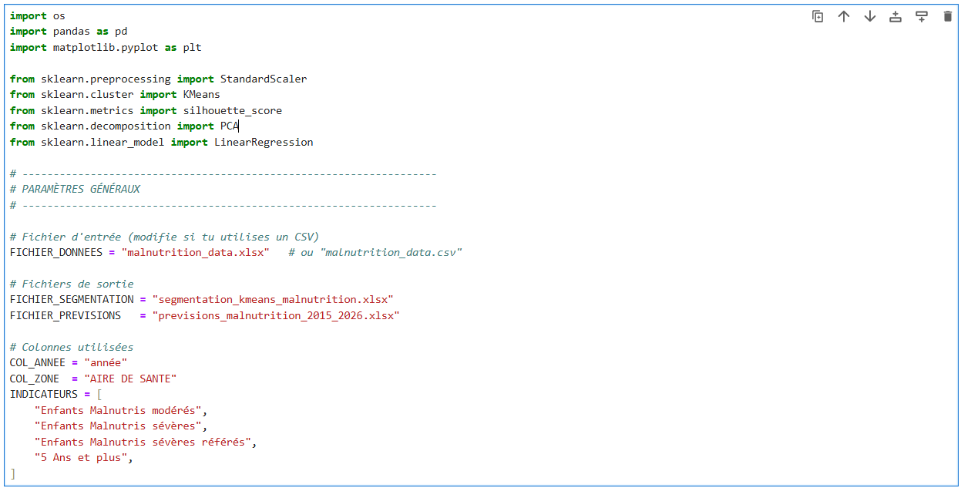

FIG 2. Malnutrition Data Loading and Initial DataFrame Preview

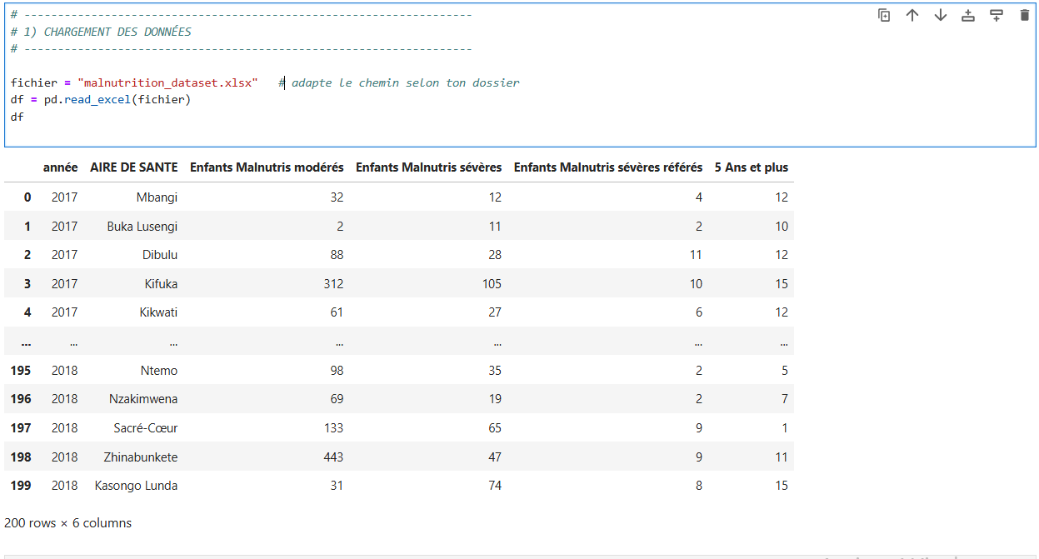

FIG 3: K-Means Clustering: Evaluating Optimal $k$ using Inertia and Silhouette Score
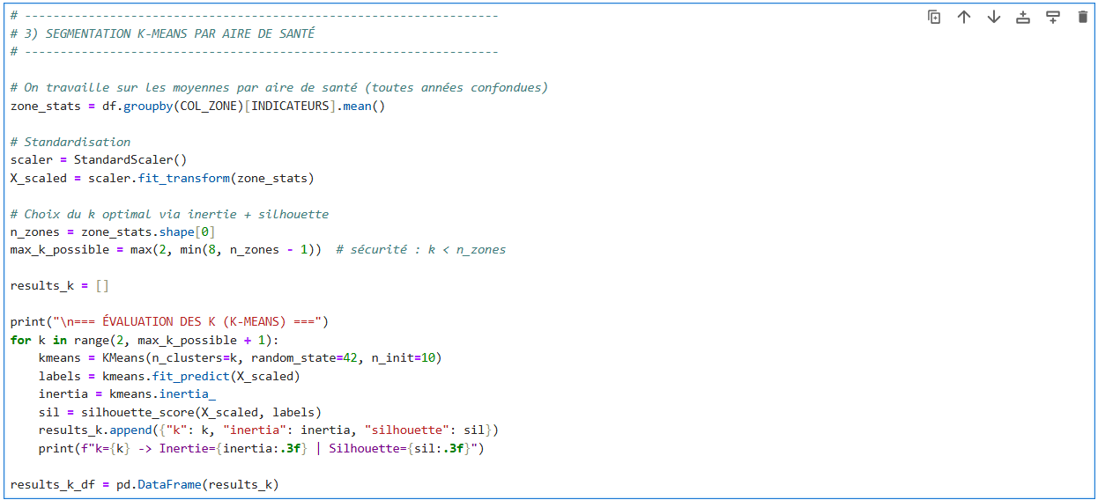
=== EVALUATION OF K (K-MEANS) ===
k=2 -> Inertia=13.443 | Silhouette=0.853
k=3 -> Inertia=6.181 | Silhouette=0.672
k=4 -> Inertia=3.809 | Silhouette=0.325
k=5 -> Inertia=2.800 | Silhouette=0.209
k=6 -> Inertia=2.247 | Silhouette=0.231
k=7 -> Inertia=1.737 | Silhouette=0.198
k=8 -> Inertia=1.262 | Silhouette=0.215

The K-Means algorithm requires determining in advance the number of groups ( k ) into which the data should be segmented. To identify the optimal value of k, two statistical indicators were used: intra-cluster inertia and silhouette score.

- Inertia measures the compactness of clusters: the lower it is, the closer the points are to the centre of their group. We observe that inertia decreases continuously as k increases, which is expected, since more clusters mean smaller and more precise groups.

- However, low inertia is not enough: the groups must also be well separated. The silhouette score (ranging from -1 to 1) assesses the quality of the separation between clusters. The closer the score is to 1, the clearer and more consistent the segmentation.

- In these results, the silhouette score reaches its maximum for k = 2 (0.853), then gradually decreases as the number of clusters increases.
This means that the K-Means model offers the best natural separation of data into two large groups. Beyond k = 2, the clusters become less distinct, resulting in a less stable and less interpretable segmentation.
FIG 4. Visualising K-Means Evaluation: Plotting the Elbow Curve and Silhouette Scores

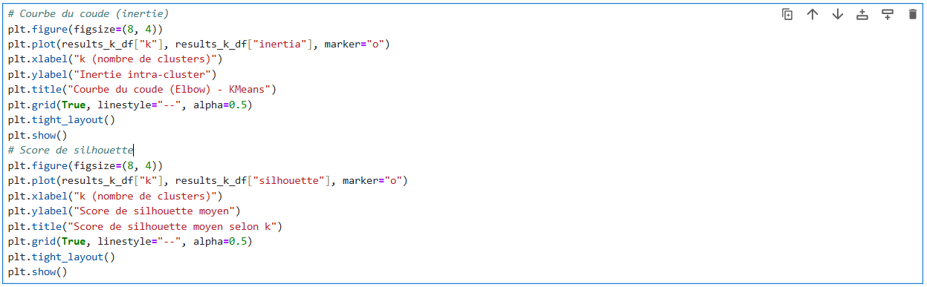

FIG 5. Elbow Curve Plot (Courbe du coude) for K-Means Clustering
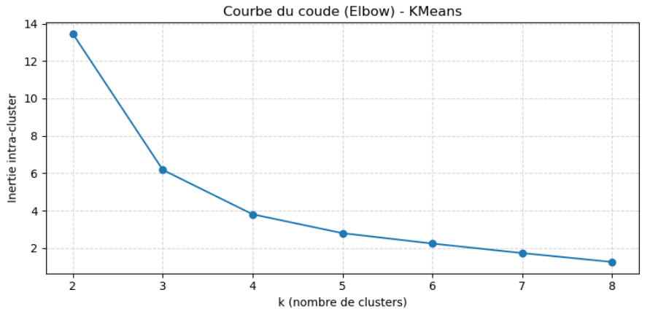
The elbow curve allows us to determine the optimal number of clusters (k) for the K-Means model.
The horizontal axis represents the number of clusters tested, while the vertical axis indicates the value of the intra-cluster inertia, that is, the sum of the distances between the points and their cluster centres. Observation of the graph shows a sharp decrease in inertia between k = 2 and k = 3, followed by a gradual stabilisation from k = 4 onwards.
The inflexion point visible around k = 2 constitutes the “elbow” of the curve, meaning that beyond this value, adding new clusters no longer significantly improves the quality of the segmentation.

Thus, this graph confirms that the optimal choice for k is 2, as it effectively reduces intra-cluster variance while preserving good interpretability of the model.

FIG 6. Average Silhouette Score Plot by Number of Clusters ($k$)
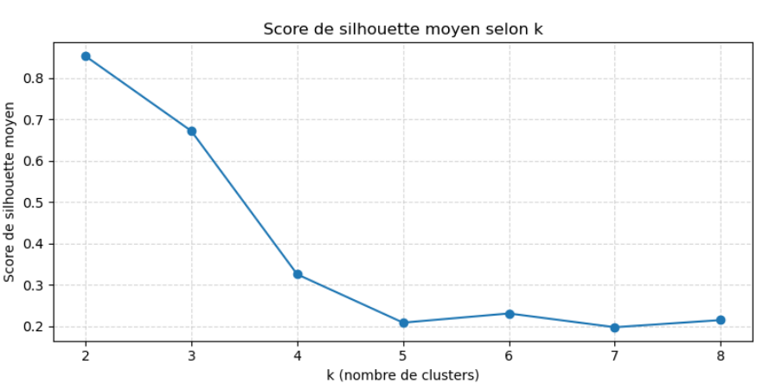
The graph shows the evolution of the average silhouette score as a function of the number of clusters (k) tested during segmentation. The silhouette score measures the quality of the data grouping: A value close to 1 indicates that the clusters are well separated and homogeneous, A value close to 0 means that the clusters overlap, and A negative value suggests poor grouping.

The analysis shows that the highest score (≈ 0.85) is obtained for k = 2, indicating very consistent segmentation when the data is divided into two groups. From k = 3 onwards, the score gradually decreases, reflecting a decline in the quality of separation between the clusters.

Thus, this graph confirms that the K-Means model reaches its optimal performance for k = 2, a value from which the internal consistency of the clusters remains maximal and the separation between groups is quite distinct.
FIG 7. Automatic Selection of Optimal $k$ and Final K-Means Clustering

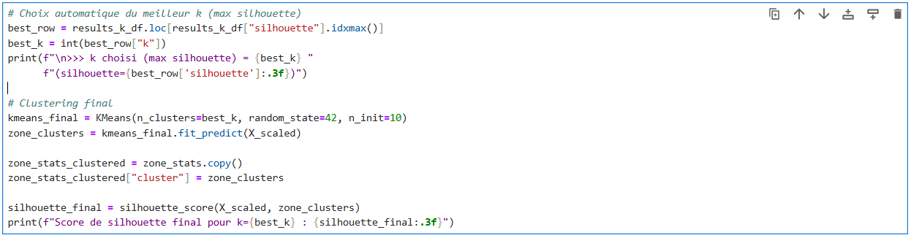
>>> k chosen (max silhouette) = 2 (silhouette=0.853)
Final silhouette score for k=2: 0.853

The final silhouette score obtained for the K-Means model with k = 2 is 0.853, which represents a very high value (close to 1). Such a score reflects excellent internal cohesion within the clusters and a clear separation between them.

In other words, the two groups identified by the model are very homogeneous within (the health zones of the same cluster have similar characteristics) and quite distinct from each other (the differences between the two groups are clearly marked).

Thus, the choice of k = 2 as the optimal number of clusters is statistically justified and confirms the relevance of the segmentation model applied to malnutrition data.

This result indicates the existence of two major nutritional profiles in the health zones studied: a first group with low or medium incidence of malnutrition, a second group with high prevalence of malnutrition, requiring priority attention in health interventions.

FIG 8. 2D Visualisation of K-Means Clustering Results using PCA

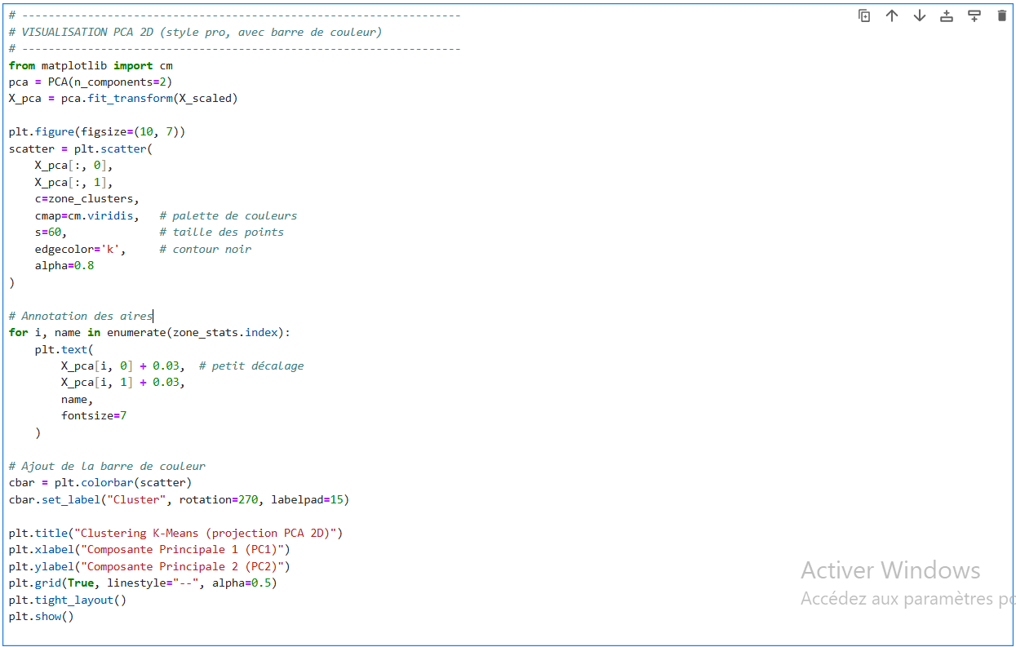

FIG 9. K-Means Clustering Visualization: 2D PCA Projection
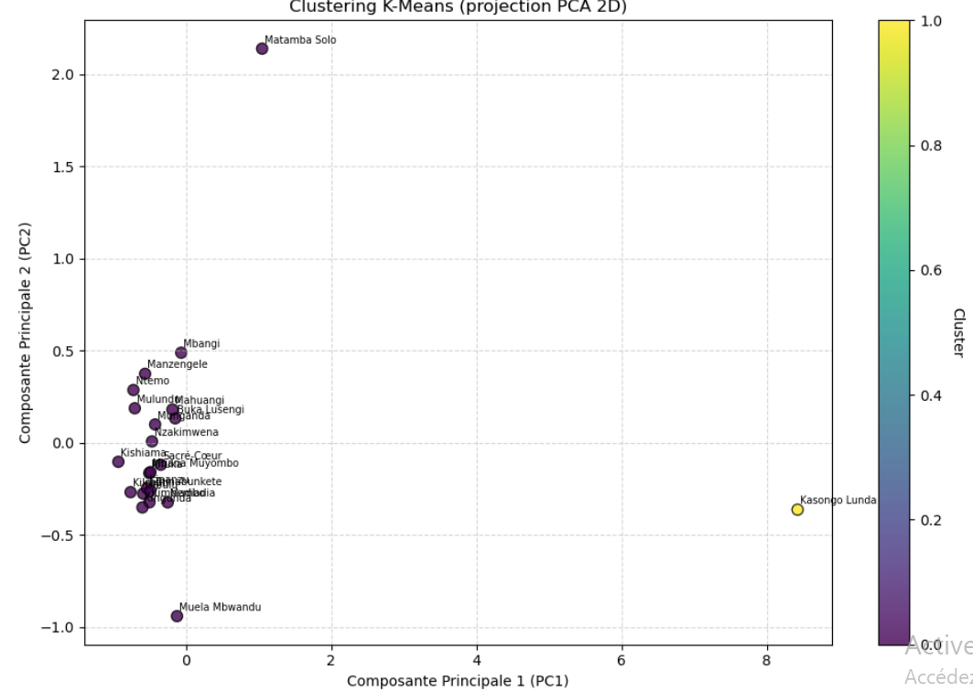
This two-dimensional representation allows us to project multivariate data (four malnutrition indicators) in order to observe the actual structure of the clusters. The interpretation of the graph highlights two major findings:

- The first cluster (in purple) includes the vast majority of health areas such as Mbangi, Madiadia, Mulundu, Ntemo, Mahuangi, etc. These areas show moderate and relatively homogeneous values on malnutrition indicators. They correspond to areas at medium risk, where malnutrition is present but manageable with targeted interventions.

- The second cluster (in yellow) consists almost exclusively of Kasongo Lunda, which stands out clearly from the other areas with extremely high values on the four malnutrition variables.

This isolated position on the factorial plane indicates a very critical nutritional situation, requiring absolute priority for health intervention. The significant distance between the two groups in the PCA space confirms good cluster separation, illustrating the relevance of the K-Means model in differentiating nutritional profiles.

FIG 10. Multi-Output Linear Regression for Malnutrition Forecasts (2024-2026)
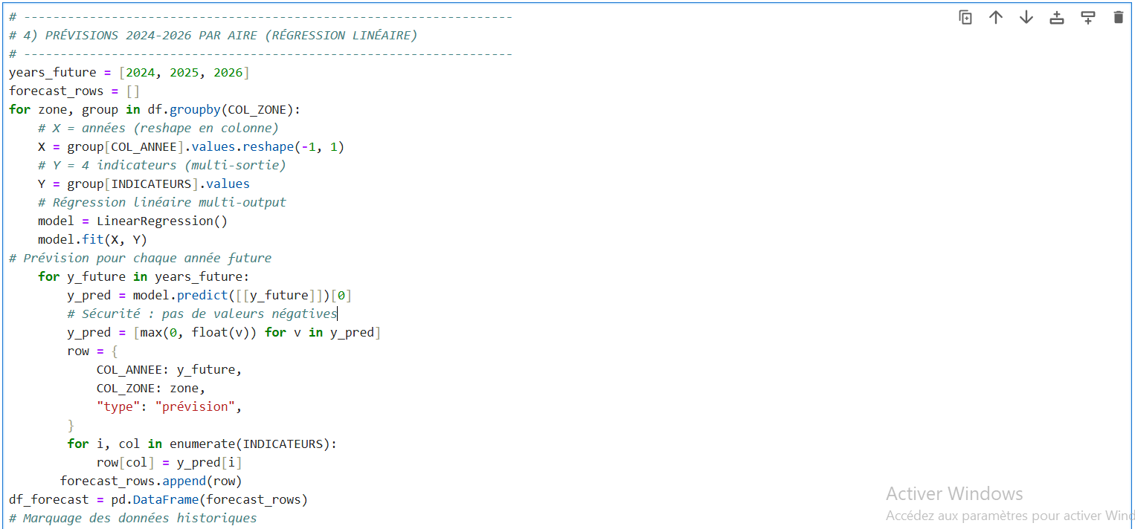

b) Presentation and interpretation of classification results

The chart below presents the final classification of health areas obtained from the K-Means model with k = 2 clusters.

Each line corresponds to a health area and indicates the average values observed for the four malnutrition indicators, namely: moderately malnourished children, severely malnourished children referred, and children aged 5 years and over.

In addition to these values, a cluster label (0 or 1) is automatically determined by the algorithm based on the similarity between observations. Analysis of the chart reveals two distinct groups:

Chart 1. Analysis of Malnutrition Indicators and K-Means Cluster Assignment by Health Area

HEALTH AREA | Moderately Malnourished Children | Severely Malnourished Children | Severely malnourished children referred | Ages 5 and up | cluster
Buka Lusengi | 283,66666667 | 234,4444444 | 26,44444444 | 8.111111111 | 0
Dibulu | 211 | 67.11111111 | 12,22222222 | 11,11111111 | 0
Kasongo Lunda | 3237,909091 | 1050,727273 | 186,3636364 | 45.09090909 | 1
Kifuka | 278,3333333 | 62.77777778 | 17,666666667 | 10.77777778 | 0
Kikwati | 110.7777778 | 45,44444444 | 10 | 10.88888889 | 0
Kimbembo | 196,6666667 | 29,22222222 | 16,66666667 | 13,33333333 | 0
Kingunda | 69.11111111 | 33,33333333 | 14.55555556 | 13,666666667 | 0
Kipanzu | 226,88888889 | 83.55555556 | 13,44444444 | 10.88888889 | 0
Kishiama | 87.88888889 | 23.88888889 | 11.55555556 | 9.111111111 | 0
Madiadia | 193,5555556 | 40.11111111 | 24,44444444 | 15.55555556 | 0
Mahuangi | 236 | 65,33333333 | 40 | 12,33333333 | 0
Manzengele | 157,7777778 | 69,33333333 | 34.55555556 | 8.222222222 | 0
Matamba Solo | 283,4444444 | 152,2222222 | 136,77777778 | 10.88888889 | 0
Mbangi | 282,4444444 | 152 | 46,66666667 | 9.111111111 | 0
Muana Muyombo | 480,2222222 | 82.22222222 | 13.22222222 | 8.444444444 | 0
Muela Mbwandu | 105,6666667 | 43 | 10.55555556 | 21 | 0
Mulundu | 82.33333333 | 23.88888889 | 28.55555556 | 9.777777778 | 0
Munganda | 276,2222222 | 37.77777778 | 30.66666667 | 10.77777778 | 0
Ntemo | 208,66666667 | 64.11111111 | 25,777777778 | 6.777777778 | 0
Nzakimwena | 185,7777778 | 100.1111111 | 23,33333333 | 10.11111111 | 0
Sacred Heart | 245,8888889 | 141,4444444 | 19,22222222 | 10.33333333 | 0
Zhinabunkete | 289,1111111 | 157,4444444 | 8 | 8.888888889 | 0

1) Interpretation of clusters

Cluster 0 (areas "normal" or moderate)
- Contains all areas except one (Kasongo Lunda).
- These areas have average values ranging from:

  - Moderately malnourished children: 80 to 300
  - Severely malnourished children: 20 to 150
  - Severe cases referred: 10 to 40
  - Ages 5 and up: 8 to 15

These values indicate a relatively controlled level of malnutrition, with some variations depending on the area (some more affected than others, such as Mbangi or Matamba Solo, but without being extreme). Cluster 0 includes areas where malnutrition remains moderate and manageable according to the observed indicators.

Cluster 1 (“critical” zone)

- Contains only one area: Kasongo Lunda.
- Its average values are:
  - Moderately malnourished children: 3,238
  - Severely malnourished children: 1,051
  - Severe referrals: 186
  - 5 years and over: 45

These figures are more than 10 to 15 times higher than the average for other areas!
This is a structural anomaly: Kasongo Lunda alone concentrates an exceptional nutritional burden, probably due to:

- a much higher population density,
- an underreporting in other areas,
- or a localised nutritional crisis.

In short, K-Means segmentation identified two distinct health zone profiles based on their average malnutrition levels. The model has a silhouette score of 0.85, confirming excellent intra-cluster cohesion and strong inter-cluster separation.

The Kasongo Lunda area, isolated within a unique cluster, stands out clearly due to extreme values across all malnutrition indicators. This atypical behaviour reflects a critical nutritional situation and highlights the need for targeted health prioritisation in this area.
Conversely, the other areas show homogeneous values and logically group together in a single cluster, reflecting a more stable situation.

These results demonstrate the relevance of the K-Means (k=2) model for segmenting health zones according to their malnutrition profiles, and confirm the validity of the segmentation process.

- Presentation and interpretation of classification results

The prediction phase was carried out using a linear regression model, applied to historical malnutrition data observed between 2015 and 2023. The objective was to estimate the future trend in the number of malnourished children in each health area, according to the four main indicators: Moderately malnourished children, Severely malnourished children, Severely malnourished children referred and Children aged 5 years and over.

This model is based on the principle of a linear relationship between time (years) and the observed level of malnutrition. Regression equations were used to project data over the next three years (2024, 2025, and 2026) for each health area. The results obtained are summarised in the table above, which is derived directly from the model.

Table 3: Presentation and interpretation of classification results

year | HEALTH AREA | kind | Moderately Malnourished Children | Severely Malnourished Children | Severely malnourished children referred | Ages 5 and up
2024 | Buka Lusengi | forecast | 611,0188679 | 0 | 58.2490566 | 3
2025 | Buka Lusengi | forecast | 675,0660377 | 0 | 64,47169811 | 2
2026 | Buka Lusengi | forecast | 739,1132075 | 0 | 70.69433962 | 1
2024 | Dibulu | forecast | 492.8333333 | 162.1111111 | 14.05555556 | 10.94444444
2025 | Dibulu | forecast | 549.2 | 181,1111111 | 14,42222222 | 10.91111111
2026 | Dibulu | forecast | 605.5666667 | 200.1111111 | 14.78888889 | 10.87777778
2024 | Kasongo Lunda | forecast | 10956,07923 | 3592,233607 | 558,1325137 | 123,9480874
2025 | Kasongo Lunda | forecast | 12395,06011 | 4066,07377 | 627,4453552 | 138,6502732
2026 | Kasongo Lunda | forecast | 13834,04098 | 4539,913934 | 696,7581967 | 153,352459
2024 | Kifuka | forecast | 585,4166667 | 101,3611111 | 27.08333333 | 14.69444444
2025 | Kifuka | forecast | 646,8333333 | 109.0777778 | 28.96666667 | 15,47777778
2026 | Kifuka | forecast | 708.25 | 116,7944444 | 30.85 | 16.26111111
2024 | Kikwati | forecast | 272.0277778 | 112,4444444 | 5 | 17.30555556
2025 | Kikwati | forecast | 304,2777778 | 125.8444444 | 4 | 18.58888889
2026 | Kikwati | forecast | 336.5277778 | 139,2444444 | 3 | 19.87222222
2024 | Kimbembo | forecast | 560.0833333 | 74.72222222 | 26.91666667 | 12.25
2025 | Kimbembo | forecast | 632.7666667 | 83.82222222 | 28.96666667 | 12.03333333
2026 | Kimbembo | forecast | 705.45 | 92.92222222 | 31.01666667 | 11.81666667
2024 | Kingunda | forecast | 166,4444444 | 68,33333333 | 13.97222222 | 23.83333333
2025 | Kingunda | forecast | 185.9111111 | 75,33333333 | 13.85555556 | 25.86666667
2026 | Kingunda | forecast | 205,3777778 | 82.33333333 | 13.73888889 | 27.9
2024 | Kipanzu | forecast | 668.9722222 | 228.3055556 | 20.52777778 | 11,47222222
2025 | Kipanzu | forecast | 757,3888889 | 257,2555556 | 21.94444444 | 11.58888889
2026 | Kipanzu | forecast | 845.8055556 | 286.2055556 | 23.36111111 | 11.70555556
2024 | Kishiama | forecast | 226,2222222 | 44.63888889 | 12.63888889 | 1.4444444444
2025 | Kishiama | forecast | 253,88888889 | 48.78888889 | 12.85555556 | 0
2026 | Kishiama | forecast | 281,5555556 | 52.93888889 | 13.07222222 | 0
2024 | Madiadia | forecast | 415,3055556 | 40.11111111 | 51,19444444 | 25,22222222
2025 | Madiadia | forecast | 459,6555556 | 40.11111111 | 56.54444444 | 27.15555556
2026 | Madiadia | forecast | 504,0055556 | 40.11111111 | 61.89444444 | 29.08888889
2024 | Mahuangi | forecast | 589,3333333 | 172.25 | 36.25 | 24
2025 | Mahuangi | forecast | 660 | 193,6333333 | 35.5 | 26,33333333
2026 | Mahuangi | forecast | 730,6666667 | 215.0166667 | 34.75 | 28,666666667
2024 | Manzengele | forecast | 372.0277778 | 152.75 | 60.72222222 | 6.888888889
2025 | Manzengele | forecast | 414,8777778 | 169,4333333 | 65.95555556 | 6.622222222
2026 | Manzengele | forecast | 457,7277778 | 186.1166667 | 71.18888889 | 6.355555556
2024 | Matamba Solo | forecast | 567,3611111 | 320,6388889 | 342,6944444 | 7.722222222
2025 | Matamba Solo | forecast | 624,1444444 | 354.3222222 | 383.8777778 | 7.088888889
2026 | Matamba Solo | forecast | 680.9277778 | 388,0055556 | 425,0611111 | 6.455555556
2024 | Mbangi | forecast | 670,3600746 | 441,7164179 | 169,2817164 | 8,429104478
2025 | Mbangi | forecast | 744,641791 | 497,1940299 | 192,761194 | 8.298507463
2026 | Mbangi | forecast | 818,9235075 | 552,6716418 | 216,2406716 | 8.167910448
2024 | Muana Muyombo | forecast | 1260,055556 | 198,9722222 | 17.97222222 | 3.1944444444
2025 | Muana Muyombo | forecast | 1416,022222 | 222,3222222 | 18.92222222 | 2.1444444444
2026 | Muana Muyombo | forecast | 1571,988889 | 245,6722222 | 19.87222222 | 1.0944444444
2024 | Muela Mbwandu | forecast | 242 | 74.5 | 20.38888889 | 23
2025 | Muela Mbwandu | forecast | 269,2666667 | 80.8 | 22.35555556 | 23.4
2026 | Muela Mbwandu | forecast | 296.5333333 | 87.1 | 24,32222222 | 23.8
2024 | Mulundu | forecast | 148.0833333 | 50.38888889 | 47.63888889 | 5.861111111
2025 | Mulundu | forecast | 161,2333333 | 55.68888889 | 51,45555556 | 5.077777778
2026 | Mulundu | forecast | 174,3833333 | 60.98888889 | 55.27222222 | 4.294444444
2024 | Munganda | forecast | 711,1388889 | 50.52777778 | 60.33333333 | 14,27777778
2025 | Munganda | forecast | 798,1222222 | 53.07777778 | 66.26666667 | 14.97777778
2026 | Munganda | forecast | 885.1055556 | 55.62777778 | 72.2 | 15.67777778
2024 | Ntemo | forecast | 537,3333333 | 148,2777778 | 36.11111111 | 3.777777778
2025 | Ntemo | forecast | 603.0666667 | 165.1111111 | 38.17777778 | 3.177777778
2026 | Ntemo | forecast | 668.8 | 181,9444444 | 40.24444444 | 2.5777777778
2024 | Nzakimwena | forecast | 474,8611111 | 245,9444444 | 45.91666667 | 4.777777778
2025 | Nzakimwena | forecast | 532,6777778 | 275,1111111 | 50.43333333 | 3.711111111
2026 | Nzakimwena | forecast | 590,4944444 | 304,2777778 | 54.95 | 2.6444444444
2024 | Sacred Heart | forecast | 637.1388889 | 365,6944444 | 34.05555556 | 5.833333333
2025 | Sacred Heart | forecast | 715,3888889 | 410.5444444 | 37.02222222 | 4.933333333
2026 | Sacred Heart | forecast | 793,6388889 | 455,3944444 | 39.98888889 | 4.033333333
2024 | Zhinabunkete | forecast | 708,77777778 | 411,8611111 | 8.25 | 3.388888889
2025 | Zhinabunkete | forecast | 792.7111111 | 462.7444444 | 8.3 | 2.288888889
2026 | Zhinabunkete | forecast | 876,6444444 | 513,6277778 | 8.35 | 1.188888889

1) Detailed interpretation of classification results

General observation on trends

In the majority of health areas, predicted values indicate a steady increase in the number of malnourished children between 2024 and 2026. This trend is particularly marked in the moderately malnourished and severely malnourished categories, reflecting a worrying trend of progressive worsening of the nutritional situation.

- Example: Kifuka: 2024: 585 moderate cases, 2025: 647, 2026: 708 and +20% in 3 years

This reflects a continued upward trend, which is consistent with a linear pattern and shows a likely worsening of the situation without intervention.

Most critical areas

The data from the prediction highlight a small group of health zones where malnutrition is reaching alarming levels and continues to increase steadily between 2024 and 2026. These zones constitute the critical core of the phenomenon and represent absolute priorities for nutritional intervention policies.

Table 4: Presentation of the most critical zones

Area | Moderate children (2024→2026) | Severely ill children (2024→2026)
Kasongo Lunda | 10,956 → 13,834 | 3,592 → 4,540
Muana Muyombo | 1260 → 1572 | 199 → 246
Mahuangi | 589 → 731 | 172 → 215
Matamba Solo | 567 → 681 | 321 → 388

Overall, these four areas represent critical hotspots of malnutrition where the situation tends to worsen year after year. They require targeted, urgent, and multidimensional interventions, combining food aid, intensive nutritional monitoring, health education, and local capacity building to reverse this worrying trajectory.

Areas with a stable or moderate trend

The health zones presented in this table are characterised by a slow and relatively controlled evolution of the number of moderately malnourished children between 2024 and 2026. Unlike the areas with high growth (such as Kasongo Lunda or Mbangi), these areas show moderate progression, reflecting a more stable nutritional situation.

Table 5: Presentation of areas with a stable or moderate trend

Area | Moderate children (2024→2026) | Observation
Kishiama | 226 → 282 | Slight increase, low values
Mulundu | 148 → 174 | Slight increase, low values
Ntemo | 537 → 669 | Moderate, stable increase
Muela Mbwandu | 242 → 297 | Slow growth

In general, these results indicate areas with low nutritional vulnerability, where malnutrition remains present but is under control. These areas represent examples of relative stability, which must be maintained through ongoing prevention policies, community awareness campaigns, and regular monitoring of at-risk children.

Areas in relative stabilisation

Some areas show indicators that are plateauing or slightly decreasing on certain criteria (notably “5 years and over”), which reflects saturation rather than real improvement.
Example:
- Buka Lusengi: the "5 years and older" will decrease from 3 to 1 between 2024 and 2026.
- This does not mean overall improvement; the number of "moderately" malnourished people is increasing in parallel, so the overall burden remains growing.

Quantitative interpretation (summary view)

This table presents a summary of the trends predicted from the linear regression model, allowing health zones to be classified according to their level of nutritional risk. This approach facilitates the strategic interpretation of the results and guides the prioritisation of interventions.

Table 6: Presentation of the Quantitative Interpretation (summary view)

Zone category | Examples | Predicted trend | Reading
Areas of extreme risk | Kasongo Lunda, Matamba Solo, Mahuangi | Strong increase across all indicators | Urgent intervention needed
High-risk areas | Mbangi, Kifuka, Munganda, Kipanzu | The increase continues, but is less pronounced. | Monitoring and strengthening of programs
Areas of medium/stable risk | Dibulu, Muela Mbwandu, Ntemo | Slow or stabilised growth | Maintaining current efforts
Low-risk areas | Kishiama, Mulundu | Low values, small variations | Situation under control

In short, this quantitative analysis provides a clear map of priorities for action. It highlights the diversity of nutritional dynamics between health zones and provides a solid empirical basis for planning short- and medium-term public health interventions.

Analytical Conclusion

The forecast results for the period 2024–2026 highlight an overall upward trend in child malnutrition across most health zones. Historically critical areas, such as Kasongo Lunda, Matamba Solo, and Mahuangi, are seeing sustained increases in their projected numbers, confirming the persistence of structural vulnerability. Conversely, some areas, such as Kishiama and Mulundu, show low and stable values, indicating a limited risk in the short term.

Overall, the projection reveals increasing territorial polarisation: already fragile areas remain so or worsen, while stable areas maintain their equilibrium. These results justify the need for targeted strengthening of nutritional and community interventions in areas identified as priorities.

Discussion of the results of malnutrition segmentation and prediction

The analysis of child malnutrition by health zone, combining unsupervised segmentation (K-Means) and predictive modelling (multi-output linear regression), has yielded several major insights into both the current structure of the phenomenon and its future evolution.

Structure of malnutrition profiles: two distinct groups

The results of the segmentation show that the health zones naturally fall into two distinct clusters.

- The first, encompassing almost all areas, corresponds to zones with low to moderate levels of malnutrition, characterised by annual averages of between 80 and 300 moderately malnourished children, and lower values for severe and referred cases.

- The second cluster, consisting solely of the Kasongo Lunda area, presents extremely high values (more than 3,200 moderately malnourished children on average and more than 1,000 severe cases).

The high silhouette score (0.85) and the clear separation observed on the PCA projection confirm the robustness and statistical validity of the K-Means model. The presence of a single cluster for Kasongo Lunda reflects a structural anomaly, indicating that this health area is subject to socio-economic, demographic, or health conditions that are radically different from the rest of the territory.

Projected evolution of malnutrition (2024–2026)

Predictive modelling based on 2015–2023 trends reveals a near-linear progression of malnutrition in most areas. Estimates indicate a continued rise in the number of malnourished children, both moderate and severe. Some areas, such as Kasongo Lunda, Mahuangi, Matamba Solo, Mbangi, and Kifuka, show particularly alarming trajectories with an average annual growth rate of between 10% and 15%.

Conversely, areas like Kishiama, Mulundu, and Muela Mbwandu show relatively low and stable values, indicating a situation that is under control or stabilising. However, even in these areas, indicators of severe malnutrition remain significant, suggesting that the problem is structural rather than cyclical.

The projections, therefore, highlight a risk of overall worsening of malnutrition by 2026 if no corrective action is taken.
This trend is particularly worrying in areas already classified as critical by segmentation, thus confirming the consistency between the descriptive model (K-Means) and the predictive model (linear regression).

Conclusion

This research has demonstrated the relevance of using machine learning techniques in the analysis and prediction of childhood malnutrition in the Democratic Republic of Congo. The combined application of K-Means clustering and linear regression made it possible to transform raw nutritional data into actionable information for decision-making.
The results revealed two distinct profiles of health zones: one characterised by a moderate and stable prevalence, and the other marked by an alarming concentration of cases, particularly in Kasongo Lunda, Matamba Solo, Mahuangi, and Muana Muyombo. These findings underscore the need for a prioritised and differentiated intervention, tailored to the risk level of each zone.

Methodologically, this study illustrates the effectiveness of K-means in segmenting multidimensional data and the ability of linear regression to provide reliable time projections in a health context. The integration of these approaches constitutes a robust analytical framework for nutrition planning and public health policy management.

Perspectives

Several improvements can be considered in the future:

- Temporal extension of the model by integrating advanced time series (ARIMA, Prophet, or recurrent neural networks) in order to obtain more accurate forecasts.
- Incorporation of exogenous variables, such as climatic conditions, food security, or socio-economic indicators, to better explain regional variations.
- Deployment of an interactive dashboard based on Python or Apache Superset, allowing decision-makers to visualise risk areas in real time.
- Application of the model to other provinces of the DRC for a national assessment of child malnutrition.
In summary, this study constitutes a first step towards data-driven health management, where artificial intelligence becomes a strategic lever to anticipate, target and prevent nutritional crises in the most vulnerable areas of the country.

Disclaimer (Artificial intelligence)
Option 1:
Author(s) hereby declare that NO generative AI technologies such as Large Language Models (ChatGPT, COPILOT, etc.) and text-to-image generators have been used during the writing or editing of this manuscript.
Option 2:
Author(s) hereby declare that generativ AI technologies such as Large Language Models, etc. have been used during the writing or editing of manuscripts. This explanation will include the name, version, model, and source of the generative AI technology and as well as all input prompts provided to the generative AI technology
Details of the AI usage are given below:
1.
2.
3.

References

[1] Rao, B., Rashid, M., Hasan, M.G., Thunga, G. (2025). Machine Learning in Predicting Child Malnutrition: A Meta-Analysis of Demographic and Health Surveys Data. : https://doi.org/10.3390/ijerph22030449

[2] Hendy, A., Kadri Ibrahim, R., Farghaly Abdelaliem, S., Zaher, A., Alkubati, SA, Gad Abd El-kader, R., … (2025). Supervised machine learning for classification and prediction of stunting among under-five Egyptian children.
[3] Sánchez-Martínez, LJ, … (2024). Using Machine Learning to Fight Child Acute Malnutrition and…: https://www.ncbi.nlm.nih.gov/pmc/articles/PMC11644603/
[4] Janssen, SMW, Bouzembrak, Y., Tekinerdogan, B. (2024). Artificial Intelligence in Malnutrition: A Systematic Literature Review.
[5] Tadesse, GA, Ferguson, L., Robinson, C., Kuria, S., Wanyonyi, H., Murage, S., … (2025). Forecasting acute childhood malnutrition in Kenya using machine learning and diverse sets of indicators.: https://doi.org/10.1371/journal.pone.0322959
[6] Shruthi, S., Govindarajan, P., Shalini, S. R., Antony, P. J., Uma, A. N., & Rangarajan, L. (2025). RISE: a novel unified framework for feature relevance in malnutrition analytics integrating statistical and expert insights. Frontiers in Public Health. https://doi.org/10.3389/fpubh.2025.1663373
[7] Hubert, V., … (2025). Food insecurity, feeding practices and associated factors of severe child malnutrition in a rural area of the Democratic Republic of Congo.
[8] Günal, A.M., Yılmaz, S., Arslan, S. (2025). Most vulnerable diet and health profiles: identifying countries at risk through a three-theme clustering. : https://doi.org/10.3389/fpubh.2025.1569755
[9] Aanjankumar, S., Sathyamoorthy, M., Dhanaraj, RK, Surjit Kumar, SR, Poonkuntran, S., Khadidos, AO, … (2025). Prediction of malnutrition in kids by integrating ResNet-50-based deep learning technique using facial images.
[10] Muala, MG, Mbuambua, ML, Dikabela, NA, Katalayi, KP, Ngalula, MR, Lungenyi, NA, … (2025). Evaluation of nutritional status and factors contributing to malnutrition in children aged 6 to 59 months in the Luiza Health Zone, DRC. : https://doi.org/10.4314/orapj.v6i7.70
[11] Sánchez-Martínez, L. J., Charle-Cuéllar, P., Gado, A. A., Ousmane, N., Hernández, C. L., & López-Ejeda, N. (2024). Using Machine Learning to Fight Child Acute Malnutrition and Predict Weight Gain During Outpatient Treatment with a Simplified Combined Protocol. Nutrients. https://doi.org/10.3390/nu16234213
[12] Janssen, SMW, Bouzembrak, Y., Tekinerdogan, B. (2024). Artificial Intelligence in Malnutrition: A Systematic Literature Review. : https://www.sciencedirect.com/science/article/pii/S216183132400098X
[13] Das, S., Basher, SA, Baffour, B., Godwin, P., Richardson, A., Rashid, S. (2024). Improved estimates of child malnutrition trends in Bangladesh using remote-sensed data. : https://link.springer.com/article/10.1007/s00148-024-01043-6
[14] Begashaw, G.B., Zewotir, T., Mekonnen Fenta, H. (2025). A deep learning approach for classifying and predicting children's nutritional status in Ethiopia using LSTM-FC neural networks. : https://biodatamining.biomedcentral.com/articles/10.1186/s13040-025-00425-0
[15] Hendy, A., Kadri Ibrahim, R., Farghaly Abdelaliem, S., Zaher, A., Alkubati, SA, Gad Abd El-kader, R., et al. (2025). Supervised machine learning for classification and prediction of stunting among under-five Egyptian children.
[16] Tadesse, GA, Ferguson, L., Robinson, C., Kuria, S., Wanyonyi, H., Murage, S., et al. (2025). Forecasting acute childhood malnutrition in Kenya using machine learning and diverse sets of indicators. : https://journals.plos.org/plosone/article?id=10.1371/journal.pone.0322959
[17] Mgomezulu, WR, et al. (2025). Advancing predictive analytics in child malnutrition. : https://www.sciencedirect.com/science/article/pii/S2666149725000441
[18] Reusken, M., et al. (2025). Identification of factors associated with acute malnutrition in children: a machine learning perspective.
[19] Rao, B., Rashid, M., Hasan, M.G., Thunga, G. (2025). Machine Learning in Predicting Child Malnutrition: A Meta-Analysis of DHS Data. : https://doi.org/10.3390/ijerph22030449
[20] Aanjankumar, S., Sathyamoorthy, M., Dhanaraj, RK, Surjit Kumar, SR, Poonkuntran, S., Khadidos, AO, et al. (2025). Prediction of malnutrition in kids by integrating ResNet-50-based deep learning technique using facial images.
[21] Mwene-Batu, P., Bisimwa, G., Ngaboyeka, G., Dramaix, M., Macq, J., Hermans, M. P., ... & Donnen, P. (2021). Severe acute malnutrition in childhood, chronic diseases, and human capital in adulthood in the Democratic Republic of Congo: the Lwiro Cohort Study. The American journal of clinical nutrition, 114(1), 70-79.
[22] Luzingu, J. K., Stroupe, N., Alaofe, H., Jacobs, E., & Ernst, K. (2022). Risk factors associated with under-five stunting, wasting, and underweight in four provinces of the Democratic Republic of Congo: analysis of the ASSP project baseline data. BMC Public Health, 22(1), 2422.
[23] McBride, L., Barrett, C. B., Browne, C., Hu, L., Liu, Y., Matteson, D. S., ... & Wen, J. (2022). Predicting poverty and malnutrition for targeting, mapping, monitoring, and early warning. Applied Economic Perspectives and Policy, 44(2), 879-892.
[24] Al-Ansi, Z. A. A., & Al-Maqaleh, B. M. (2022). Predicting malnutrition status of under-five children in Dhamar Governorate, Yemen using data mining techniques. Asian Journal of Research in Computer Science, 14(4), 107–118.

