Performance of Sexed Semen Artificial Insemination in Dairy Animals under Smallholder Farming Systems in India
Abstract
Sexed semen technology has emerged as an important reproductive tool for improving genetic progress and herd structure in dairy production systems. Field performance of sexed semen artificial insemination was evaluated in cattle (n = 840) and buffalo (n = 319) under smallholder dairy systems in Bareilly district, India. Pregnancy diagnosis at 80–90 days post-insemination revealed an overall conception rate of 46.7% in cattle (392/840) and 44.3% in buffalo (141/319), indicating moderate yet field-relevant fertility outcomes. In cattle, breed exerted a highly significant effect on conception (χ² = 21.07, df = 2, p < 0.0001), with indigenous animals showing superior fertility (52.1%; 294/564) compared to crossbred (37.3%; 59/158) and exotic animals (33.1%; 39/118). Odds ratio analysis confirmed higher likelihood of conception in indigenous cattle relative to crossbred (OR = 1.83; 95% CI: 1.28–2.62). Parity-wise analysis demonstrated peak fertility in mid parity animals (50.6%; 160/316), followed by heifers (46.0%; 23/50), early parity (44.7%; 168/376) and high parity animals (41.8%; 41/98). Interaction analysis highlighted the highest conception in indigenous mid parity animals (62.2%), indicating a strong combined effect of genetic adaptability and physiological maturity. Buffalo exhibited comparable conception; however, absence of detailed subgroup data restricted further evaluation. In conclusion, sexed semen represents a practical and effective reproductive strategy under smallholder dairy systems, enabling acceptable fertility outcomes while facilitating genetic improvement and targeted female calf production, with optimal results achieved in indigenous cattle and mid parity animals under field conditions. However, lack of calf sex ratio data at the time of analysis, incomplete recording of breed and parity in buffalo, variability in smallholder management practices and farmer-based estrus detection, absence of quantitative assessment of body condition, nutrition and environmental stress, and restriction to a specific geographical region may limit comprehensive evaluation and broader applicability of the findings.
Keywords: Artificial insemination; Conception rate; Dairy cattle; Sexed semen; Smallholder dairy systems.
Introduction
Artificial insemination (AI) represents a key reproductive biotechnology driving genetic improvement, disease control and reproductive efficiency in dairy animals (Foote et al., 2022). Advancement in reproductive technologies has led to the development of sexed semen, enabling control over offspring sex and accelerating genetic gain (Holden and Butler, 2018; Kumar et al., 2017; Sahu et al., 2025). Sexed semen technology operates through separation of X- and Y-chromosome bearing spermatozoa using flow cytometry based on differences in DNA content (Garner et al., 1983; Seidel, 2007), facilitating production of predominantly female offspring required for herd replacement and milk production (DeJarnette et al., 2009; Seidel, 2014). Global adoption of sexed semen has increased, particularly in dairy production systems, due to its ability to produce 85–90% female calves under field conditions (Seidel, 2007; Sharma et al., 2019). This technology contributes to improved herd structure, faster genetic progress and reduction of unwanted male calves, enhancing economic and ethical sustainability (Kumar et al., 2016; Patra et al., 2023). Integration with advanced reproductive techniques such as in vitro fertilization and embryo transfer further strengthens its role in rapid dissemination of superior genetics (Pellegrino et al., 2016).
Despite these advantages, reduced conception rate remains a major limitation. Sexed semen typically shows 10–30% lower conception rate than conventional semen due to reduced sperm dose, sorting-induced stress, and damage to sperm integrity (DeJarnette et al., 2009; Norman et al., 2010; Patra et al., 2023). Shorter lifespan of sorted sperm increases dependence on precise timing of insemination relative to ovulation (Schenk et al., 2009; Bombardelli et al., 2016). Conception rate under field conditions varies widely and depends on parity, breed, nutrition, environment and technician skill (Lu et al., 2015; Joshi et al., 2021; Joshi et al., 2023). In India, sexed semen holds strong potential due to large dairy population and increasing demand for milk. Its application supports production of quality replacement females and genetic improvement of indigenous and crossbred animals (Kumar et al., 2016). However, adoption remains constrained by high cost, limited technical expertise and variable field conditions, leading to moderate conception rates (~39–49%) under practical conditions (Joshi et al., 2021; Sharma et al., 2019; Patra et al., 2023).
Indian dairy production largely depends on smallholder farming systems characterized by limited resources, variable nutrition and inconsistent reproductive management. These factors strongly influence success of sexed semen AI. Field studies indicate significant effects of agro-climatic conditions, parity and season, with higher conception rates in heifers compared to multiparous animals (Joshi et al., 2023; Patra et al., 2023). Additional variation arises from body condition, estrus detection efficiency and semen handling practices (Bhagat et al., 2024). Buffaloes contribute substantially to milk production in India but present reproductive challenges including silent estrus, seasonal breeding and lower reproductive efficiency (Lu et al., 2015; Campanile et al., 2011; Sahu et al., 2024). Application of sexed semen in buffaloes demonstrates promising female calf production; however, conception rates remain variable, requiring further field-level validation (Lu et al., 2015; Bhagat et al., 2024). Existing studies largely remain region-specific or conducted under controlled conditions, limiting applicability to diverse smallholder systems.
However, comprehensive field-level evaluation of sexed semen performance across species under practical smallholder conditions remains limited, particularly with respect to breed- and parity-wise effects. Furthermore, comparative information between cattle and buffalo under such systems is inadequate. Therefore, the present study aims to evaluate the performance of sexed semen artificial insemination in cattle and buffalo under smallholder dairy farming systems in India, with emphasis on conception rate and assessment of breed and parity effects in cattle.
MATERIALS AND METHODS
Study area and project description
The present study was conducted under a field-based project entitled “Livelihood improvement of dairy farmers through input support and technological interventions”, initiated in August 2024 with financial support from Genus Breeding India Ltd. and implemented by ICAR–Indian Veterinary Research Institute, Izatnagar. The project aimed to improve reproductive efficiency and productivity of dairy animals through the application of advanced reproductive technologies, including artificial insemination using sexed semen, along with field-level capacity building and technical support to farmers. The study was carried out in selected villages of Bareilly district, Uttar Pradesh, India, under smallholder dairy farming systems. The operational area included blocks namely Bhojipura, Bithri Chainpur, Majhgawan and Aalam pur Zafarabad (Fig 1). Dairy animals (cattle and buffalo) maintained under these systems were characterized by small herd sizes, mixed feeding practices and variable reproductive management conditions, consistent with typical field situations reported earlier (Joshi et al., 2021; Kumar et al., 2016).
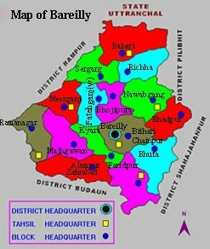
Fig. 1. Map of the study area showing selected villages under smallholder dairy farming systems in Bareilly district. The operational area covered four administrative blocks, namely Bhojipura, Bithri Chainpur, Majhgawan and Aalampur Zafarabad.
Estrus detection and insemination protocol
Estrus detection was carried out under field conditions based on visual observation of behavioral signs by farmers or herd persons. No vasectomized teaser bulls were employed. Animals suspected to be in estrus were further examined per rectally by trained artificial insemination (AI) technicians to confirm reproductive status, including uterine tone, cervical turgidity and other characteristic estrus signs. Artificial insemination was performed during mid to late estrus using frozen sexed semen. The semen was produced through flow cytometry-based sperm sorting technology, which separates X- and Y-chromosome bearing spermatozoa based on differences in DNA content (Garner et al., 1983; Seidel, 2007). Insemination was carried out by depositing semen at the mid-cervical region following standard field procedures.
Artificial insemination data and pregnancy diagnosis
A total of 840 artificial inseminations were performed in cattle and 319 in buffaloes under field conditions using sexed semen. Pregnancy diagnosis was carried out by per rectal examination at 80–90 days post-insemination by trained technicians. Animals were classified as pregnant or non-pregnant based on standard clinical findings, consistent with established field methodologies (Lu et al., 2015; Joshi et al., 2023).
Study variables and classification
Detailed animal-level records were available for cattle, and therefore, analysis was performed considering both breed and parity as major influencing factors. Animals were categorized into three breed groups, namely indigenous, crossbred and exotic (Holstein Friesian type). Based on reproductive status, animals were further classified into parity groups comprising heifers, early parity animals (1–2), mid parity animals (3–4) and high parity animals (≥5). These classifications were adopted in accordance with commonly used categories in field fertility studies (Joshi et al., 2021; Patra et al., 2023). In buffaloes, only overall insemination and conception data were available. Due to incomplete and inconsistent recording of detailed parameters such as breed and parity across field records, further stratified analysis was not performed. The primary outcome of the study was conception rate (CR), calculated as the proportion of animals that conceived out of the total number of inseminations performed.
Statistical analysis
The conception outcome was treated as a binary variable (conceived or non-conceived). Data analysis was carried out using GraphPad Prism (Version 11.0.0) (Sahu et al., 2026a). Descriptive statistics were used to estimate overall conception rates in both cattle and buffalo. For cattle, the association between conception rate and categorical variables such as breed and parity was evaluated using the chi-square (χ²) test (Kumar et al., 2025). In addition, interaction analysis between breed and parity was performed to assess their combined influence on conception outcome. Odds ratios (OR) along with 95% confidence intervals (CI) were calculated to determine the relative likelihood of conception among different groups. All statistical results, including p-values, chi-square statistics, odds ratios and confidence intervals, have been explicitly reported in the Results section to ensure clarity and transparency. Statistical significance was considered at p < 0.05. For buffalo, only descriptive analysis of overall conception rate was performed due to lack of complete subgroup data.
RESULTS
OVERALL, conception rate
A total of 840 artificial inseminations (AI) using sexed semen were performed in cattle under field conditions, of which 392 resulted in confirmed pregnancies, yielding an overall conception rate of 46.7%, while 448 animals failed to conceive (Fig. 2).
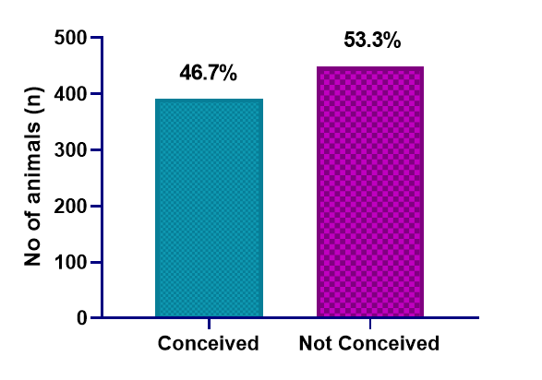
Fig. 2. Overall conception rate in cattle following artificial insemination using sexed semen
Effect of breed on conception rate
Conception rate varied significantly among different breed groups (Fig. 3). Indigenous animals exhibited the highest conception rate (294/564; 52.1%), followed by crossbred (59/158; 37.3%) and exotic (Holstein Friesian type) animals (39/118; 33.1%). Statistical analysis revealed a highly significant association between breed and conception outcome (χ² = 21.07, df = 2, p < 0.0001). Odds ratio analysis further indicated that indigenous animals had significantly higher odds of conception compared to crossbred animals (OR = 1.83; 95% CI: 1.28–2.62), whereas exotic animals showed comparatively lower odds of conception (OR = 0.83; 95% CI: 0.52–1.32).
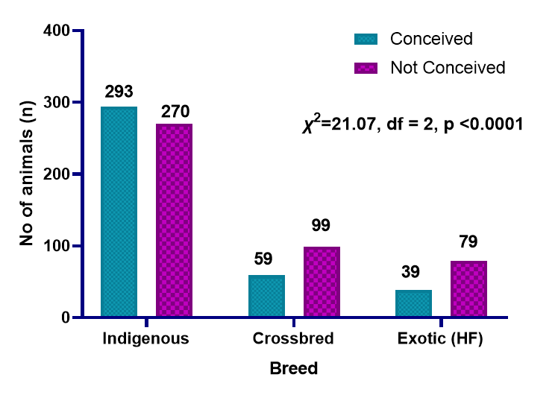
Fig. 3. Breed wise conception rate in cattle
Effect of parity on conception rate
Parity-wise analysis demonstrated variation in conception rate across different parity groups (Fig. 4). The study included 50 heifers, 376 early parity (1–2), 316 mid parity (3–4) and 98 high parity (≥5) animals. The highest conception rate was observed in mid parity animals (160/316; 50.6%), followed by heifers (23/50; 46.0%), early parity animals (168/376; 44.7%) and high parity animals (41/98; 41.8%). Although numerical variation existed among parity groups, the differences were less pronounced compared to breed-wise variation. Odds ratio analysis indicated relatively higher odds of conception in mid parity animals compared to early parity animals (OR = 1.27; 95% CI: 0.94–1.72). Heifers showed comparable odds (OR = 1.05; 95% CI: 0.58–1.88), whereas high parity animals exhibited slightly reduced odds (OR = 0.89; 95% CI: 0.56–1.42).
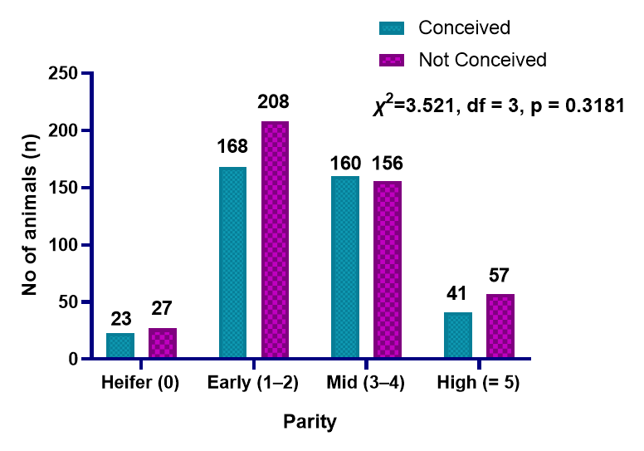
Fig. 4. Effect of parity on conception rate in cattle
Interaction effect of breed and parity on conception rate in cattle
The interaction between breed and parity revealed notable differences in reproductive performance (Fig. 5). Indigenous animals consistently showed higher conception rates across parity groups, with the highest value recorded in mid parity animals (62.2%). In contrast, crossbred and exotic animals demonstrated comparatively lower conception rates across all parity categories, with the lowest observed in exotic animals at early parity (30.6%). Interaction analysis indicated that indigenous animals in mid parity had significantly higher odds of conception compared to crossbred animals in early parity (OR = 2.79; 95% CI: 1.58–4.91), highlighting the combined influence of breed and parity on fertility outcomes.
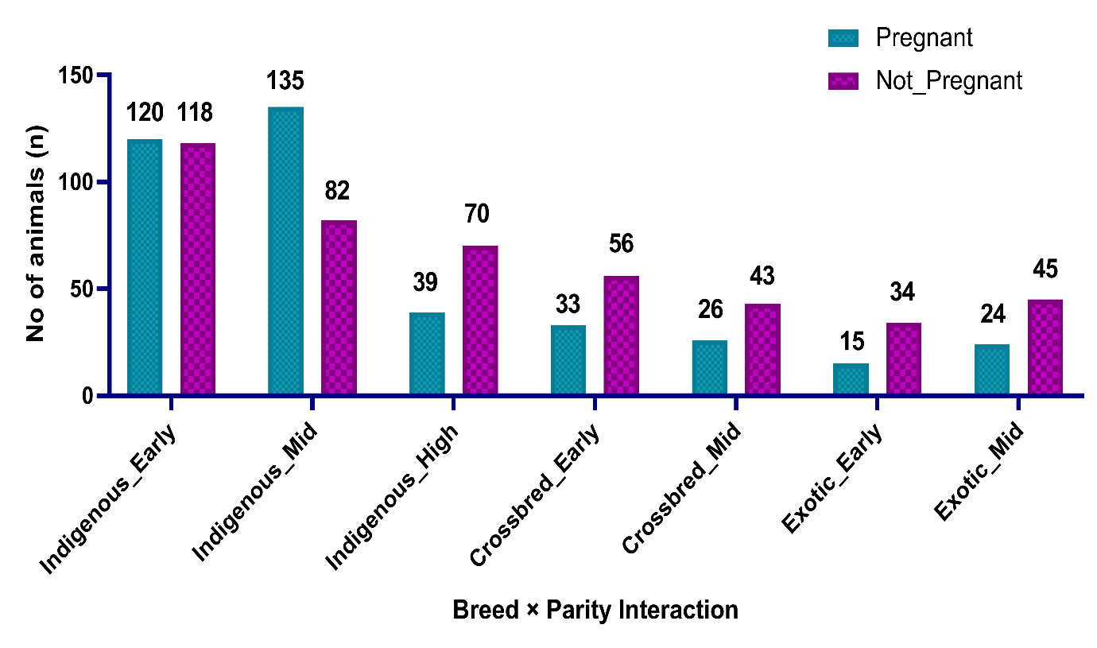
Fig. 5. Interaction effect of breed and parity on conception rate in cattle
Conception rate in buffalo
A total of 319 buffaloes were inseminated using sexed semen under field conditions, of which 141 animals conceived, resulting in an overall conception rate of 44.3% (Fig. 6). Due to limitations in complete and consistent recording of detailed animal-level parameters such as breed and parity, further stratified analysis was not performed. Therefore, only overall conception rate has been presented for buffalo in the present study.
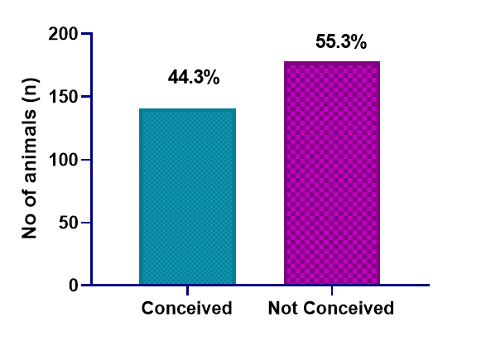
Fig. 6. Overall conception rate in buffalo following artificial insemination using sexed semen
DISCUSSION
The present study evaluated the field performance of sexed semen under smallholder dairy systems, yielding conception rates of 46.7% in cattle and 44.3% in buffalo. These findings align with previously reported field studies where conception rates with sexed semen ranged between 30% and 55% under practical conditions (Joshi et al., 2021; Joshi et al., 2023; Sharma et al., 2018; Sharma et al., 2019; Lu et al., 2015; Djedović et al., 2016; DeJarnette et al., 2011; Cerchiaro et al., 2007). Comparable results have also been reported under organized herd conditions, indicating improvements in semen processing and field application protocols over time (Seidel, 2007; Seidel, 2014; Pellegrino et al., 2016). Although direct comparison with conventional semen was not performed in the present study, existing literature consistently reports relatively lower conception rates with sexed semen compared to conventional semen, primarily due to reduced sperm concentration per dose and sorting-associated stress. The relatively lower conception rate associated with sexed semen has been attributed to reduced sperm concentration per dose, mechanical stress during sorting, and alterations in sperm physiology including membrane integrity and DNA stability (DeJarnette et al., 2009; Norman et al., 2010; Maxwell et al., 2004; Lu and Seidel, 2004; Loggan, 2019; Healy et al., 2013). Additionally, reduced lifespan and possible pre-capacitation of sorted sperm further contribute to variability in fertility outcomes (DeJarnette et al., 2008; Sá Filho et al., 2010; Bombardelli et al., 2016; Guner et al., 2020). Despite these limitations, the conception rates observed in the present study indicate satisfactory field performance of sexed semen under appropriate management conditions.
Breed-wise differences observed in the present study, with indigenous cattle showing significantly higher conception rates than crossbred and exotic animals, corroborate earlier reports highlighting the superior adaptability of indigenous breeds under tropical and resource-limited conditions (Joshi et al., 2021; Kumar et al., 2016; Sharma et al., 2019). Indigenous animals exhibit better thermotolerance, disease resistance and adaptability to fluctuating nutritional conditions, contributing to improved reproductive performance (Campanile et al., 2011; Seidel, 2014). In contrast, crossbred and exotic animals, particularly those with higher Holstein Friesian inheritance, often experience increased metabolic and environmental stress, resulting in reduced fertility under field conditions (Norman et al., 2010; Healy et al., 2013). Parity-wise analysis indicated relatively higher conception rates in mid parity animals compared to heifers and higher parity animals, consistent with previous studies reporting optimal reproductive efficiency during intermediate parities (Patra et al., 2023; DeJarnette et al., 2011; Djedović et al., 2016). Animals in mid parity generally possess better uterine health, hormonal balance and physiological maturity (Sahu et al., 2026b). In contrast, reduced fertility in higher parity animals may result from cumulative reproductive stress and metabolic burden (Norman et al., 2010; Healy et al., 2013; Yadav et al., 2024). Heifers showed comparable conception rates, although variability may occur depending on estrus detection and management conditions (DeJarnette et al., 2010; Joshi et al., 2023).
The significant interaction between breed and parity highlights the combined influence of genetic and physiological factors on fertility outcomes. Indigenous animals in mid parity exhibited the highest conception rates, indicating a synergistic effect of adaptability and physiological maturity. Similar patterns have been reported in earlier studies under field conditions (Joshi et al., 2021; Sharma et al., 2019). The conception rate observed in buffalo (44.3%) is comparable with earlier reports indicating moderate fertility following the use of sexed semen in this species (Lu et al., 2015; Bhagat et al., 2024). Buffalo reproduction is characterized by silent estrus, weak behavioral signs and seasonal breeding patterns, which complicate estrus detection and timing of insemination (Campanile et al., 2011; Lu et al., 2015). These constraints, along with reduced lifespan of sorted sperm, contribute to variability in conception outcomes (Maxwell et al., 2004; Lu and Seidel, 2004). Estrus detection and timing of insemination remain critical for optimizing conception rates with sexed semen. In the present study, inseminations were performed during mid to late estrus based on farmer observations and rectal confirmation, aligning with recommendations that insemination closer to ovulation improves fertility outcomes (Dransfield et al., 1998; Nebel et al., 2000; Schenk et al., 2009). Previous studies suggest optimal conception when insemination occurs between 16 and 24 hours after onset of estrus (Sá Filho et al., 2010; Bombardelli et al., 2016; Guner et al., 2020).
Despite these findings, certain limitations should be considered while interpreting the results. Data on calf sex were not available at the time of analysis and will be reported in future studies. In buffalo, incomplete recording of parity and breed restricted the analysis to overall conception rate. Variability in smallholder management practices and reliance on farmer-based estrus detection may have influenced outcomes. Additionally, factors such as body condition, nutrition and environmental stress were not quantitatively recorded. The study was confined to a specific geographical region, which may limit broader applicability.
CONCLUSION
The present study demonstrated that sexed semen can be effectively utilized under smallholder dairy farming systems, achieving conception rates of 46.7% in cattle and 44.3% in buffalo under field conditions. Indigenous cattle exhibited significantly higher conception rates compared to crossbred and exotic animals, indicating superior adaptability under field conditions. Parity-wise variation suggested relatively improved performance in mid parity animals, and the interaction between breed and parity further emphasized the combined influence of genetic and physiological factors. Overall, the findings support the practical applicability of sexed semen under field conditions and highlight the importance of appropriate breed selection and reproductive management practices to optimize fertility outcomes.

Conflict of Interest
The authors declare that there is no conflict of interest regarding the publication of this manuscript.
Ethical Approval
All procedures involving animals were carried out under routine field veterinary practices. The study did not involve any invasive experimental procedures and adhered to standard animal welfare guidelines.
Data Availability Statement
The data supporting the findings of this study are available from the corresponding author upon reasonable request.
Disclaimer (Artificial intelligence)
Author(s) hereby declare that NO generative AI technologies such as Large Language Models (ChatGPT, COPILOT, etc.) and text-to-image generators have been used during the writing or editing of this manuscript.

References
Bombardelli, G. D., Soares, H. F., Chebel, R. C., & Santos, J. E. P. (2016). Effect of timing of insemination on fertility of sexed semen in dairy cattle. Journal of Dairy Science, 99(7), 5934–5940. https://doi.org/10.3168/jds.2015-10593
Campanile, G., Neglia, G., Gasparrini, B., & Zicarelli, L. (2011). Embryonic mortality in buffaloes. Theriogenology, 75(2), 200–210. https://doi.org/10.1016/j.theriogenology.2010.09.002
Cerchiaro, I., Cassandro, M., Dal Zotto, R., Carnier, P., & Gallo, L. (2007). A field study on fertility and purity of sex-sorted cattle sperm. Theriogenology, 67(3), 513–519. https://doi.org/10.1016/j.theriogenology.2006.08.012
DeJarnette, J. M., Nebel, R. L., & Marshall, C. E. (2009). Evaluating the success of sex-sorted semen in US dairy herds from on-farm records. Theriogenology, 71(1), 49–58. https://doi.org/10.1016/j.theriogenology.2008.09.042
Djedović, R., Bogdanović, V., Perišić, P., & Petrović, M. (2016). Fertility of sexed semen in dairy cattle under field conditions. Biotechnology in Animal Husbandry.
Dransfield, M. B. G., Nebel, R. L., Pearson, R. E., & Warnick, L. D. (1998). Timing of insemination for dairy cows identified in estrus by a radiotelemetric estrus detection system. Journal of Dairy Science, 81(7), 1874–1882. https://doi.org/10.3168/jds.S0022-0302(98)75758-3
Foote, R. H. (2010). The history of artificial insemination: Selected notes and notables. Journal of Animal Science, 80, 1–10.
Garner, D. L., Gledhill, B. L., Pinkel, D., Lake, S., Stephenson, D., Van Dilla, M. A., & Johnson, L. A. (1983). Quantification of the X- and Y-chromosome-bearing spermatozoa of domestic animals by flow cytometry. Biology of Reproduction, 28(2), 312–321. https://doi.org/10.1095/biolreprod28.2.312
Guner, B., Erturk, M., Dursun, M., Ozturk, B., Yilmazbas-Mecitoglu, G., Keskin, A., Dikmen, S., & Gumen, A. (2023). Effect of oestrous expression prior to timed artificial insemination with sexed semen on pregnancy rate in dairy cows. Reproduction in Domestic Animals, 58(2), 342–348. https://doi.org/10.1111/rda.14293
Healy, A. A., House, J. K., & Thomson, P. C. (2013). Artificial insemination using sexed semen in dairy cattle. Theriogenology, 79(1), 76–81. https://doi.org/10.1016/j.theriogenology.2012.09.003
Holden, S. A., & Butler, S. T. (2018). Applications and benefits of sexed semen in dairy and beef herds. Animal, 12(S1), S97–S103. https://doi.org/10.1017/S1751731118000721
Joshi, S. A., Bhave, K. G., Gaundare, Y. S., & Pande, A. B. (2023). The benefits of sex-sorted semen for smallholder dairy farmers in India. In Case studies of the use of agricultural biotechnologies to meet the needs of smallholders in developing countries (p. 12).
Joshi, S., Bhave, K., Potdar, V., Gaundare, Y., Punde, N., Shirsath, T., & Swaminathan, M. (2021). Performance of sex-sorted semen under Indian smallholder dairy farming systems. International Journal of Current Microbiology and Applied Sciences, 10(2), 1335–1343. https://doi.org/10.20546/ijcmas.2021.1002.158
Kumar, D., Punetha, M., Dua, S., Kumar, P., & Yadav, P. S. (2022). Advancement in reproductive biotechnologies in livestock. In Genomic, proteomics, and biotechnology (215–230). CRC Press.
Kumar, M., Sahu, U. K., Kumar, T. S., Singh, K., Gopinathan, A., Singh, B. P., Rajput, P., Kumar, K. K. S., & Kumar, B. (2025). Evaluation of multimodal anesthesia using butorphanol–ketamine–diazepam with and without lumbosacral epidural block in cesarean sections in pigs. Uttar Pradesh Journal of Zoology, 46(11), 213–220. https://doi.org/10.56557/upjoz/2025/v46i115020
Kumar, S., Singh, R., & Kumar, A. (2016). Prospects and challenges of sexed semen technology in India. Veterinary World, 9(12), 1301–1307.
Loggan, B. (2019). Evaluating the success of female-selected sex-sorted semen at Western Kentucky University’s dairy farm.
Lu, Y., Liao, Y., Zhang, M., Yang, B., Liang, X., Yang, X., & Lu, K. (2015). A field study on artificial insemination of swamp and crossbred buffaloes with sexed semen from river buffaloes. Theriogenology, 84(6), 862–867.
Maxwell, W. M. C., Evans, G., Hollinshead, F. K., Bathgate, R., & de Graaf, S. P. (2004). Integration of sperm sexing technology into livestock breeding. Reproduction, Fertility and Development, 16(4), 437–444. https://doi.org/10.1071/RD03066
Nebel, R. L., Dransfield, M. G., Jobst, S. M., & Bame, J. H. (2000). Automated electronic systems for the detection of oestrus and timing of AI in cattle. Animal Reproduction Science, 60, 713–723. https://doi.org/10.1016/S0378-4320(00)00090-7
Norman, H. D., Hutchison, J. L., & Miller, R. H. (2010). Use of sexed semen in Holsteins. Journal of Dairy Science, 93(8), 3880–3890. https://doi.org/10.3168/jds.2009-2781
Patra, M. K., Sasidharan, J. K., Rajput, A. S., Sharma, R., Reza, M. R. A., Das, G. K., Tomar, A. K. S., Ghosh, S. K., & Gaur, G. K. (2023). Evaluation of sexed semen in Tharparkar cattle. Reproduction in Domestic Animals, 58(11), 1622–1627. https://doi.org/10.1111/rda.14480
Pellegrino, C. A. G., Morotti, F., Untura, R. M., Pontes, J. H. F., Pellegrino, M. F. O., Campolina, J. P., & Henry, M. (2016). Use of sexed sorted semen for fixed-time artificial insemination or embryo transfer. Theriogenology, 86(3), 888–893.
Sá Filho, M. F., et al. (2010). Timing of insemination using sexed semen. Theriogenology, 74(9), 1561–1568. https://doi.org/10.1016/j.theriogenology.2010.06.004
Sahu, U. K., Gupta, A. K., Kumar, M., Sahu, L., & Sharma, R. (2025). Breeding the future: How sexed semen is transforming India’s dairy industry. The Scientific Frontiers, 1(1), 6–8. https://doi.org/10.5281/zenodo.14830174
Sahu, U. K., Kumar, B., Khan, M. H., Singh, M., Warghat, C., Kharayat, N. S., Reddy, A. L., Yadav, V., Chouhan, V. S., Sahu, L., Kumar, M., Rajput, P., Kumar, A., Kanaka, K. K., Singh, G., & Singh, S. K. (2026). Spectral Doppler assessment of middle uterine artery hemodynamics across the estrous cycle in Tharparkar cows. Frontiers in Animal Science, 7, 1740299. https://doi.org/10.3389/fanim.2026.1740299
Sahu, U. K., Kumar, B., Khan, M. H., Singh, M., Warghat, C., Vadera, V., Kumar, A., Reddy, A. L., Kharayat, N. S., Vandana, Chouhan, V. S., Rajput, P., Kumar, M., Sahu, L., Verma, H., Sahu, G., & Singh, S. K. (2026). Transrectal spectral Doppler reveals uterine hyperemia in Tharparkar cows with subclinical endometritis. Frontiers in Veterinary Science, 13, 1736926. https://doi.org/10.3389/fvets.2026.1736926
Sahu, U. K., Vadera, V., Mahala, P., Baghel, M. S., Kumar, M., & Muththuswamy, A. J. (2024). Per-vaginal relieving of dystocia due to Schistosoma reflexus in a cow. International Journal of Livestock Research, 14(11), 19–22.
Schenk, J. L., Cran, D. G., Everett, R. W., & Seidel, G. E. Jr. (2009). Pregnancy rates using sexed semen. Theriogenology, 71(1), 49–58. https://doi.org/10.1016/j.theriogenology.2008.09.023
Seidel, G. E. (2007). Overview of sexing sperm. Theriogenology, 68(3), 443–446. https://doi.org/10.1016/j.theriogenology.2007.04.005
Seidel, G. E. (2012). Sexing mammalian sperm—Where do we go from here? Journal of Reproduction and Development, 58(5), 505–509. https://doi.org/10.1262/jrd.2012-077
Seidel, G. E. (2014). Update on sexed semen technology in cattle. Animal, 8(S1), 160–164. https://doi.org/10.1017/S1751731114000202
Sharma, T., Gupta, R., Gautam, A., Giram, P., & Madan, J. (2019). Effectiveness and performance of “Sexcel”-ABS sexed semen in dairy animals under field conditions. Journal of Animal Research, 9(4), 499–504.
Yadav, B. K., Warghat, C., Kumar, B., Mehrotra, S., Sahu, U. K., Gawai, M., Donadkar, M., & Baghel, M. S. (2024). Successful management of dicephalus omphalo-ischiopagus tetrabrachius tripus fetal monster: A rare case report. International Journal of Advanced Biochemistry Research, 8(9 Suppl.), 1065–1067. https://doi.org/10.33545/26174693.2024.v8.i9Sm.2292

