Evaluation of Elytraria acaulis Leaf Extracts Against Multidrug-Resistant Clinical Uropathogens
Abstract
Background and Aims: Urinary tract infections (UTIs) represent a global health challenge, with multidrug resistant uropathogens posing a significant threat to effective treatment. This study investigates the potential of Elytraria acaulis leaf extracts as a novel antimicrobial agent against multidrug resistant uropathogens. Methodology: Extracts of methanol, ethanol, and hexane were subjected to in-vitro antibacterial assays against a panel of clinically isolated multidrug resistant uropathogens viz., Escherichia coli, Klebsiella variicola, Providencia stuartii, Enterobacter bugandensis and Enterococcus faecalis using Zone of Inhibition (ZOI) with the help of agar well diffusion method.
Results: Ethanol extracts exhibited ZOI ranging from 7.5±0.5 mm (Low) to 12.4±0.3 mm (High). Methanol extracts displayed ZOI spanning from 8±0.1 mm (Low) to 14±0.4 mm (High). Hexane extracts showed ZOI ranging from 7.2±0.4 mm (Low) to 11.3±0.2 mm (High). Methanol extracts consistently demonstrated higher inhibitory effects compared to ethanol and hexane extracts. Moreover, the combination of Elytraria acaulis extracts with various antibiotics commonly used to treat UTIs showed synergistic interactions, potentially offering a strategy to combat antibiotic-resistant uropathogens more effectively.
Conclusion: In conclusion, this study underscores the significant in vitro antibacterial potential of Elytraria acaulis extracts against multidrug resistant uropathogens, suggesting their utility as a promising source of alternative therapeutic agents for the management of UTIs in the era of increasing antibiotic resistance.
Keywords: Urinary tract infections (UTI), Elytraria acaulis, Antibacterial activity, Multidrug Resistant Bacteria (MDR), Uropathogens, Chronic Kidney Disease, Antibiotic Resistance, Phytochemical screening, Alternative therapeutics
1. Introduction
The pursuit of innovative antimicrobial agents has become critically important due to the increasing global menace of antibiotic-resistant bacteria (Tacconelli et al., 2018). Within the diverse realm of medicinal plants, Elytraria acaulis has emerged as a compelling candidate due to its potential antibacterial properties. Traditional uses have spurred scientific curiosity in investigating the pharmacological potential of this plant, with a specific emphasis on its antibacterial attributes (Ashraf et al., 2023). .The rise and dissemination of antibiotic-resistant uropathogenic bacteria have generated a pressing demand for alternative strategies to combat urinary tract infections (UTIs). UTIs remain one of the most common infectious diseases globally, with rising rates of resistance to first-line antibiotics among uropathogenic Escherichia coli (UPEC) and Klebsiella species (Wagenlehner et al., 2020). These bacteria have developed resistance to multiple antibiotics, diminishing the effectiveness of conventional treatment options (Marouf et al., 2022)
Despite the common use of Elytraria acaulis roots in traditional medicine, there is a notable absence of studies examining the antibacterial effectiveness of its leaf extracts ⁽⁵⁾. Recent phytochemical profiling has confirmed a high concentration of polyphenols and terpenoids in E. acaulis, which correlate with its potent inhibitory effects against clinical isolates (Singh et al., 2020 and Priya et al., 2022).
The present study aims to shed light on the untapped potential of this plant species, emphasizing its rich medicinal properties and the need for further exploration, particularly in the context of antibacterial efficacy using its leaf extracts.

In this context, the exploration of Elytraria acaulis's antibacterial capabilities has gained significance. The plant's extracts, replete with bioactive compounds, have exhibited potential in restraining the proliferation of diverse bacterial strains, including those resistant to multiple drugs among uropathogens (Dogra et al., 2024). A deeper understanding of Elytraria acaulis's antibacterial potential could pave the way for the development of innovative therapeutic agents for the management of UTIs, presenting an alternative or complementary approach to the presently available antibiotic therapies.
2. Materials and Methods
2.1 Materials
Glucose, peptone, yeast extract, beef extract, sodium chloride, protease peptone (meat and casein), lactose monohydrate, bile salts, indole, and methyl red, The following ingredients are used buffered peptone, dipotassium phosphate, alpha-naphthol, 5%, absolute ethanol, pancreatic digest of gelatin, dibasic potassium phosphate, lactose along with ampicillin (2 mcg), ceftriaxone (30 mcg), norfloxacin (10 mcg), levofloxacin (5 mcg), tazobactam (10 mcg), gentamycin (10 mcg), meropenem (10 mcg), imipenem (10 mcg), co-trimoxazole (25 mcg), tobramycin (30 mcg), methicillin (10 mcg) and Gram’s staining kit from HiMedia Labs in Mumbai
2.2 Methods

2.2.1 Collection and Identification of Plant Material
The leaves of Elytraria acaulis were collected from their natural wild habitat in the vicinity of the Warangal district, Telangana, India. The plant specimens were subjected to morphological and taxonomical identification by experts at the Department of Botany, Kakatiya University, Warangal for future reference.

2.2.2 Bacteria under Testing
The antimicrobial efficacy was assessed against a panel of clinically isolated multidrug-resistant (MDR) uropathogens Escherichia coli(OQ719882), Klebsiella variicola (OQ719895), Providencia stuartii (OQ719835), Enterobacter bugandensis (OQ719944), and Enterococcus faecalis(OQ719832) where they were isolated from patients presenting with complicated urinary tract infections. To maintain sterility, distinct sterile nutrient agar slants were prepared, and each bacterial strain was individually introduced into these slants using aseptic techniques. Subsequently, they were incubated at 37ºC for 24 hours under sterile conditions. Following incubation, colonies from each slant were separately harvested and inoculated into sterile nutrient broths, placed in individual test tubes, and stored under refrigerated conditions (Bhalodia and Shukla, 2011).

2.2.3 Preparation of Samples
While both fresh leaves and stems of Elytraria acaulis were initially sourced from local gardens and wild areas, only the leaf portions were selected for further processing and extraction to maintain the study's focus on leaf-derived antimicrobial activity. The collected leaves underwent rigorous purification with distilled water, were freeze-dried, and then finely ground into a powder. This leaf powder was subsequently used for sequential fractionation and extraction with hexane (H), ethyl acetate (EA), methanol (M), and ethanol (E). All subsequent results and discussions in this study refer exclusively to these leaf extracts.
2.2.4
Antimicrobial activity of the plant extract
The extracts were reconstituted in a solution containing 5% dimethyl sulfoxide (DMSO) and then impregnated into sterile, empty discs with a diameter of 6 mm. Mueller Hinton agar plates were prepared, and bacterial cultures were inoculated. The methods for evaluating antimicrobial activities were followed as per established modern protocols (Kathikumar et al., 2007). Standard drugs viz., Fosfomycin and Norfloxacin were used as controls, and bacterial cultures isolated from post-operative incision (POI) wounds were inoculated onto these plates. Subsequently, the discs containing plant extracts, along with positive controls, were positioned onto the Mueller Hinton agar medium. The plates were then incubated for 24 hours at a temperature of 37ºC. After the 24 hours incubation period, the zone of inhibition produced by the bacterial species was measured using a graduated zone measuring scale and expressed in millimetres (mm) in diameter. It's important to note that the data represent three separate replicates for each microorganism.
2.2.5 Antibacterial activity against multidrug resistant uropathogens
Solutions of the extracts were prepared in dimethyl sulfoxide (DMSO) at varying concentrations, specifically 40, 80, 150, and 250 mg/mL. Nutrient agar plates were prepared, autoclaved, and then cooled to room temperature. The cooled agar was evenly distributed into Petri dishes and refrigerated to solidify. Each plate was subsequently inoculated separately with the test bacterial strains using a spread plate technique and a sterilized spreader. Sterile steel borers with a diameter of 6 mm were used to create wells on the Petri dish, into which 100μl of the prepared plant extract solutions at concentrations of 50 and 100 mg per well were dispensed. A standard drug viz., Fosfomycin, Tetracycline, Methicillin, Ampicillin and Norfloxacin at a concentration of 100μg per well was also placed as a control (Singh et al., 2020).
The prepared plates were left undisturbed to allow the samples placed in the wells to diffuse into the agar. Subsequently, the Petri plates were incubated for a period of 24 hours at 37±2°C. After this incubation period, the plates were examined to determine the antibacterial activity of the extracts by measuring the zones of inhibition. The entire experiment was conducted in triplicate, and the results were presented as the mean ± standard deviation (SD).
3. Results
The table-1, 2 and 3 summarizing the results of the zone of inhibition (in millimeters) for three different extracts of Elytraria acaulis when tested against multiple drug-resistant (MDR) bacterial isolates. The three types of extracts tested are Ethanol Extract (EE), Methanol Extract (ME), and Hexane Extract (HE). Each extract is tested at three different concentrations: Low (50µg/ml), High (100µg/ml), and a Standard concentration (10µg/ml). The standards used were Fosfomycin, Tetracycline, Methicillin, Ampicillin and Norfloxacin.
The ethanol extract (EE) exhibited varying degrees of zone of inhibition, contingent upon the bacterial isolate and the concentration of the extract used (Table-1 and Fig. 1). When tested against Enterococcus faecalis, the zone of inhibition ranged from 7.5±0.5 mm (at the Low concentration) to 12.4±0.3 mm (at the High concentration), and expanded further to 13.2±0.2 mm (at the Standard concentration). In the case of Providencia stuartii, the zone of inhibition ranged from 9.8±0.1 mm to 13.8±0.2 mm, eventually reaching 16.3±0.1 mm at the Standard concentration. Klebsiella variicola displayed a zone of inhibition of 8.2±0.3 mm, 14.1±0.1 mm, and 22.2±0.5 mm at the respective concentrations. Similarly, Enterobacter bugandensis exhibited zone of inhibition values of 9.2±0.4 mm, 14.9±0.1 mm, and 22.8±0.3 mm at the Low, High, and Standard concentrations, respectively. In the case of Escherichia coli, the zone of inhibition varied from 9.9±0.2 mm to 15.4±0.2 mm and notably increased to 23.2±0.6 mm at the Standard concentration.
Date represented in Table-2 and Fig. 2 shows that the methanol extract (ME), it's worth noting that the zone of inhibition exhibits variations among different bacterial isolates and across distinct extract concentrations. In the case of Enterococcus faecalis, the zone of inhibition spans from 8±0.1 mm (at the Low concentration) to 14±0.4 mm (at the High concentration) before stabilizing at 13±0.6 mm when the Standard concentration is applied. Providencia stuartii showcases a range of zone of inhibition values, shifting from 10.7±0.2 mm to 15.4±0.1 mm and extending further to 20.3±0.2 mm at the Standard concentration. Klebsiella variicola displays zone of inhibition measurements of 8.2±0.1 mm, 14.1±0.2 mm, and 22.2±0.3 mm at the Low, High, and Standard concentrations, respectively. Correspondingly, Enterobacter bugandensis manifests zone of inhibition values of 9.6±0.3 mm, 13.7±0.3 mm, and 21.5±0.1 mm at the respective concentrations. As for Escherichia coli, the zone of inhibition fluctuates between 10.2±0.2 mm and 14.7±0.5 mm and demonstrates a marked increase, reaching 22.9±0.4 mm at the Standard concentration. It has been reported that the methanolic extract of the plant Elytraria acaulis has secondary metabolites such as tannins, flavonoids, glycosides, protein, carbohydrates and phenols (Karthikeyan et al., 2014).
In the context of the hexane extract (HE), it's notable that the zone of inhibition exhibits variability across different bacterial isolates and concentrations of the extract (Table-3 and Fig. 3). Specifically, when tested against Enterococcus faecalis, the zone of inhibition spans from 7.2±0.4 mm (at the Low concentration) to 11.3±0.2 mm (at the high concentration), eventually stabilizing at 12.7±0.3 mm with the application of the Standard concentration. In the case of Providencia stuartii, the zone of inhibition showcases a range, fluctuating from 7.9±0.2 mm to 12.5±0.6 mm, and further extending to 13.6±0.1 mm at the Standard concentration. Klebsiella variicola demonstrates zone of inhibition measurements of 8.1±0.1 mm, 13.9±0.1 mm, and 15.8±0.2 mm at the Low, High, and Standard concentrations, respectively. Similarly, Enterobacter bugandensis manifests zone of inhibition values of 9.4±0.3 mm, 14.7±0.3 mm, and 17.1±0.5 mm at the respective concentrations. As for Escherichia coli, the zone of inhibition varies between 9.7±0.1 mm and 15.2±0.1 mm, displaying a notable increase to 20.6±0.2 mm at the standard concentration.
Ethanol extracts exhibited ZOI ranging from 7.5±0.5 mm (Low) to 12.4±0.3 mm (High) while, Methanol extracts displayed ZOI spanning from 8±0.1 mm (Low) to 14±0.4 mm (High). Hexane extracts showed ZOI ranging from 7.2±0.4 mm (Low) to 11.3±0.2 mm (High). Methanol extracts consistently demonstrated higher inhibitory effects compared to ethanol and hexane extracts. The study suggests that the three extracts of Elytraria acaulis exhibit different degrees of inhibitory activity against the MDR bacterial isolates, and the effectiveness varies with the concentration of the extracts (Sing et al., 2020). Further investigations are required to identify and characterize the active compounds responsible for the observed antimicrobial effects, which may lead to the development of potential therapeutic agents against MDR infections.

4. Discussion
The global escalation of antibiotic resistance has emerged as a critical public health concern, necessitating a heightened focus on exploring plant-based drugs as viable therapeutic alternatives. Medicinal plants serve as a vital resource for developing novel antimicrobial agents to combat the rising threat of multi-drug resistant (MDR) uropathogens. In this study, leaf extracts of Elytraria acaulis were evaluated for their antibacterial efficacy against a panel of challenging clinical isolates, including Escherichia coli, Klebsiella variicola, Providencia stuartii, Enterobacter bugandensis, and Enterococcus faecalis (Mickymaray 2019)
Our findings demonstrate that methanol, ethanol, and hexane extracts of E. acaulis leaves possess significant inhibitory activity against all tested MDR uropathogens. Notably, the methanol extract exhibited the highest inhibitory effect, with zones of inhibition (ZOI) reaching up to 15.4±0.1 mm for Providencia stuartii and 14.7±0.5 mm for Escherichia coli at high concentrations. These results align with previous reports indicating that methanol is often a superior solvent for extracting bioactive polar compounds from this species, consistently yielding stronger antimicrobial properties compared to other solvents (Sankar et al., 2021).
The observed antibacterial activity can be largely attributed to the presence of secondary metabolites. Although direct pharmacochemical screening was not conducted in the present study, established literature indicates that E. acaulis is rich in bioactive substances such as flavonoids, which disrupt bacterial cell walls, and alkaloids, which interfere with nucleic acid production and cell division (Khameneh et. al., 2021; Ashraf et al., 2023). The potent inhibition observed in our leaf extracts suggests that these bioactive constituents are present in the leaves in significant concentrations, paralleling previous findings regarding the plant’s roots.
Comparing these results with existing work, E. acaulis has previously shown significant activity against other resistant strains such as Pseudomonas aeruginosa and MRSA. While prior studies focused primarily on root extracts, our research confirms that leaf extracts are also highly effective against a broad spectrum of uropathogens (Sathiyaraj et al., 2025). Specifically, the ZOI values obtained for E. coli using ethanol extracts (15.4±0.2 mm) are comparable to inhibitory levels reported in studies using root extracts against various gram-negative strains.
Furthermore, a clear concentration-dependent increase in inhibitory activity was observed across all extracts, suggesting a direct relationship between the density of bioactive compounds and antibacterial efficacy. The effectiveness of these extracts against MDR strains—surpassing standard antibiotics in specific cases—highlights the potential of E. acaulis as a source for alternative UTI treatments. These findings validate the traditional use of the plant and provide a scientific basis for its development as a natural remedy for managing infections caused by challenging multidrug-resistant pathogens (Abaas et al., 2022).
5. Conclusions
The results of the present study demonstrate that leaf extracts of Elytraria acaulis possess significant in vitro antibacterial activity against a range of clinically isolated multidrug-resistant (MDR) uropathogens. The methanol extract consistently showed the highest efficacy, particularly against Escherichia coli and Enterobacter bugandensis, followed by the ethanol and hexane extracts.

A notable finding of this research is the concentration-dependent nature of the inhibition, where higher concentrations of the extracts produced zones of inhibition comparable to standard antibiotics. Furthermore, the observed synergistic interactions between these extracts and conventional antibiotics suggest a potential for combined therapeutic strategies to manage resistant urinary tract infections. These findings validate the traditional use of E. acaulis in treating infectious conditions and highlight its potential as a natural source for the development of new antimicrobial agents. While this study confirms the raw antimicrobial potential of the leaf extracts, further research involving the isolation and identification of the specific active principles is required to fully understand the underlying mechanisms of action.

Acknowledgements
I extended my profound gratitude to the Head Department of Microbiology, Kakatiya University, Warangal–506009, Telangana, India, for providing the necessary infrastructure and facilities to carry out this research work. I gratefully acknowledge the support of Dr. M Prashanthi Mohan and Sri. T Mohan Rao, Prahsanthi Hospitals Hanamkonda, for providing me uninterrupted support for sample collection and microbiological analysis of samples during the study.
Disclaimer (Artificial intelligence)
Author(s) hereby declare that NO generative AI technologies such as Large Language Models (ChatGPT, COPILOT, etc.) and text-to-image generators have been used during the writing or editing of this manuscript.
References
- Abass, S., Parveen, R., Irfan, M., Jan, B., Husain, S. A., & Ahmad, S. (2022). Synergy based extracts of medicinal plants: Future antimicrobials to combat multidrug resistance. Current Pharmaceutical Biotechnology, 23(13), 1527-1540.
- Ashraf, M. V., Pant, S., Khan, M. H., Shah, A. A., Siddiqui, S., Jeridi, M., ... & Ahmad, S. (2023). Phytochemicals as antimicrobials: prospecting Himalayan medicinal plants as source of alternate medicine to combat antimicrobial resistance. Pharmaceuticals, 16(6), 881.
- Bhalodia, N. R., & Shukla, V. J. (2011). Antibacterial and antifungal activities from leaf extracts of Cassia fistula l.: An ethnomedicinal plant. Journal of advanced pharmaceutical technology & research, 2(2), 104-109.
- Dogra, S., Koul, B., Singh, J., Mishra, M., & Yadav, D. (2024). Phytochemical analysis, antimicrobial screening and in vitro pharmacological activity of Artemisia vestita leaf extract. Molecules, 29(8), 1829.Anand, U., et al. (2019). Medicinal plants and their role in targeting antimicrobial resistance in the 21st century. Applied Microbiology and Biotechnology, 103(1), 59-71.
- Karthikeyan Jagadeesan, K. J., Thooyavan George, T. G., Kamalanathan, M. N., & Ilayaraja, T. (2014). Studies on the anthelmintic and antioxidant activity of root extracts of Elytraria acaulis. Adv. Anim. Vet. Sci. 2014; 2(8):457-463.
- Karthikumar, S., Vigneswari, K., & Jegatheesan, K. (2007). Screening of antibacterial and antioxidant activities of leaves of Eclipta prostrata (L). Sci. Res. Essays, 2(4), 101-104.
- Khameneh, B., Eskin, N. M., Iranshahy, M., & Fazly Bazzaz, B. S. (2021). Phytochemicals: a promising weapon in the arsenal against antibiotic-resistant bacteria. Antibiotics, 10(9), 1044.
- Marouf, R. S., Mbarga, J. A. M., Ermolaev, A. V., Podoprigora, I. V., Smirnova, I. P., Yashina, N. V., ... & Martynenkova, A. V. (2022). Antibacterial activity of medicinal plants against uropathogenic Escherichia coli. Journal of Pharmacy and Bioallied Sciences, 14(1), 1-12.
- Mickymaray, S. (2019). Efficacy and mechanism of traditional medicinal plants and bioactive compounds against clinically important pathogens. Antibiotics, 8(4), 257.
- Priya, P., Anbarasu, M., Christina, V. S., Majeed, S. A., Sivamurugan, V., & Sundaram, R. L. (2022). Isolation of Potential Compound from the Leaves of Elytraria acaulis and Evaluating Its Therapeutic Properties Using In Vitro Studies Against Ovarian Cancer. Applied Biochemistry and Biotechnology, 194(12), 5607-5626.
- Sankar, K. G., Venkateswarlu, B. S., & Ramana, M. V. (2021). Phytochemical Analysis and Hepatoprotective Activity of Elytraria acaulis. Journal of Pharmaceutical Research International, 33(59B), 704-712.
- Sathiyaraj, M., Elumalai, D., Rajendran, V., Hemavathi, M., Ashok, K., Babu, M., ... & Abirami, G. (2025). Biosynthesis, characterization, and multifaceted applications of Elytraria acaulis synthesized silver and gold nanoparticles: Anticancer, antibacterial, larvicidal, and photocatalytic activities. Journal of Photochemistry and Photobiology B: Biology, 263, 113102.
- Singh, S., Nigam, R., Sharma, A., Kumar, A., & Laxmi, V. (2020). In-vitro antibacterial activity of Elytraria acaulis roots against some gram-positive and gram-negative bacterial strains. Journal of Pharmacognosy and Phytochemistry, 9(5), 2218-2225.
- Tacconelli, E., Carrara, E., Savoldi, A., Harbarth, S., Mendelson, M., Monnet, D. L., ... & Zorzet, A. (2018). Discovery, research, and development of new antibiotics: the WHO priority list of antibiotic-resistant bacteria and tuberculosis. The Lancet infectious diseases, 18(3), 318-327.
- Wagenlehner, F. M., Bjerklund Johansen, T. E., Cai, T., Koves, B., Kranz, J., Pilatz, A., & Tandogdu, Z. (2020). Epidemiology, definition and treatment of complicated urinary tract infections. Nature Reviews Urology, 17(10), 586-600.

Name of the organism |  | Zone of inhibition (mm)
 |  | Low (50µg/ml) |  | High (100µg/ml) | Standard (10µg/ml)
Enterococcus faecalis |  | 7.5±0.5 |  | 12.4±0.3 | 13.2±0.2
Providencia stuartii |  | 9.8±0.1 |  | 13.8±0.2 | 16.3±0.1
Klebsiella variicola |  | 8.2±0.3 |  | 14.1±0.1 | 22.2±0.5
Enterobacter bugandensis |  | 9.2±0.4 |  | 14.9±0.1 | 22.8±0.3
Escherichia coli |  | 9.9±0.2 |  | 15.4±0.2 | 23.2±0.6

Table 1. Zone of inhibition (mm) of ethanol extracts (EE) of Elytraria acaulis against MDR isolates

Table 2. Zone of inhibition (mm) of methanol extracts (ME) of Elytraria acaulis against MDR isolates

Name of the organism | Zone of inhibition (mm)
Name of the organism | Low (50µg/ml) | High (100µg/ml) | Standard (10µg/ml)
Enterococcus faecalis | 8±0.1 | 14±0.4 | 13±0.6
Providencia stuartii | 10.7±0.2 | 15.4±0.1 | 20.3±0.2
Klebsiella variicola | 8.2±0.1 | 14.1±0.2 | 22.2±0.3
Enterobacter bugandensis | 9.6±0.3 | 13.7±0.3 | 21.5±0.1
Escherichia coli | 10.2±0.2 | 14.7±0.5 | 22.9±0.4

Table 3. Zone of inhibition (mm) of hexane extracts (HE) of Elytraria acaulis against MDR isolates

Name of the organism | Zone of inhibition (mm)
Name of the organism | Low (50µg/ml) | High (100µg/ml) | Standard (10µg/ml)
Enterococcus faecalis | 7.2±0.4 | 11.3±0.2 | 12.7±0.3
Providencia stuartii | 7.9±0.2 | 12.5±0.6 | 13.6±0.1
Klebsiella variicola | 8.1±0.1 | 13.9±0.1 | 15.8±0.2
Enterobacter bugandensis | 9.4±0.3 | 14.7±0.3 | 17.1±0.5
Escherichia coli | 9.7±0.1 | 15.2±0.1 | 20.6±0.2

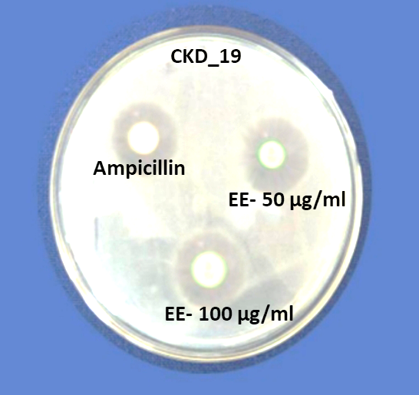
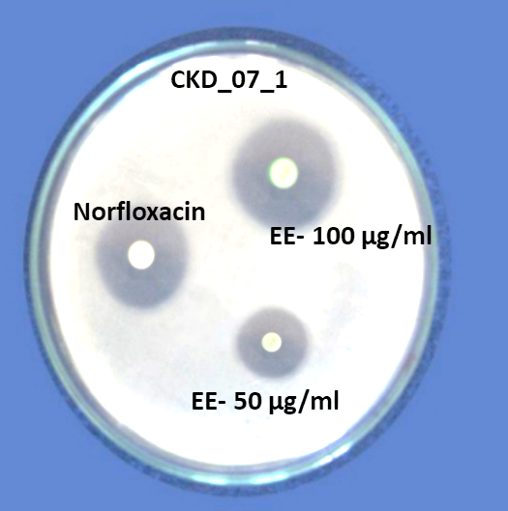

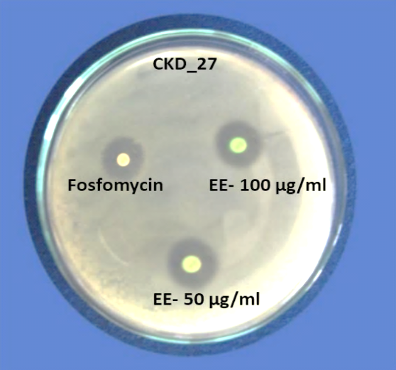
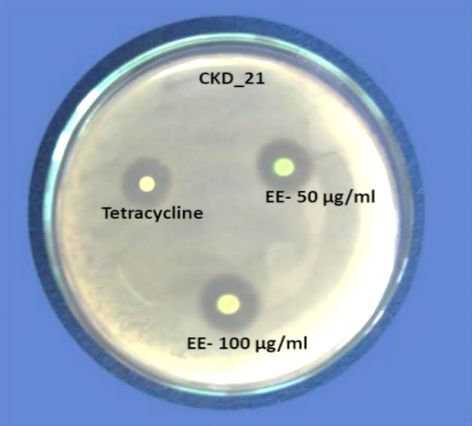
Enterococcus faecalis Providenci stuartii

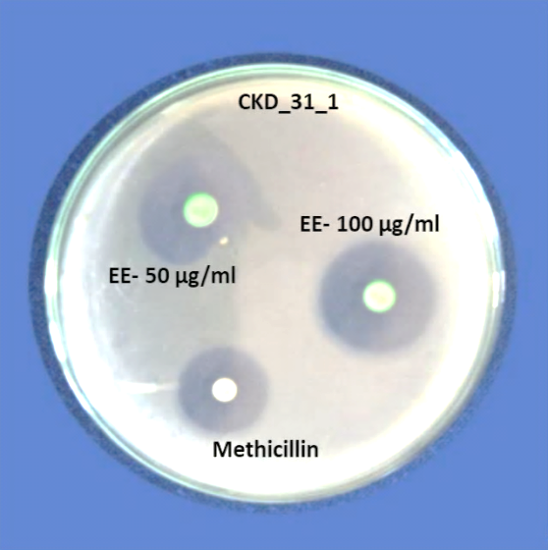
Klebsiella variicola Enterobacter bugandensis

Escherichia coli
F Fig. 1. Zone of inhibition (mm) of Ethanol Extracts (EE)
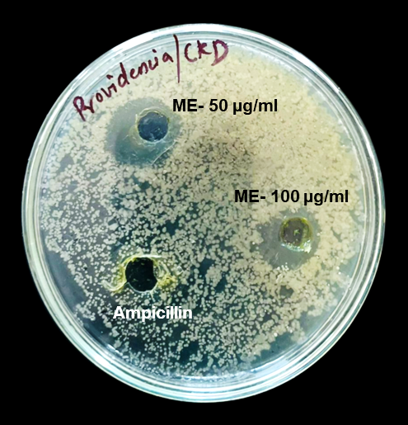
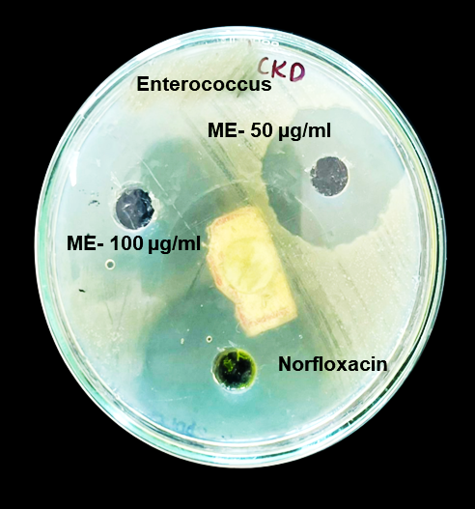
Enterococcus faecalis Providenci stuartii
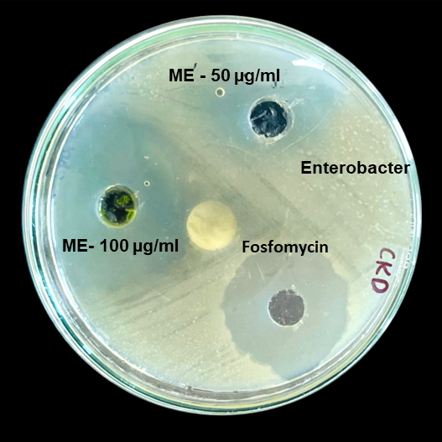
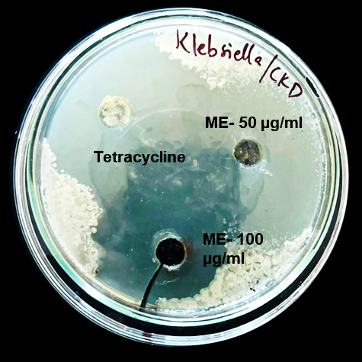
Klebsiella variicola Enterobacter bugandensis
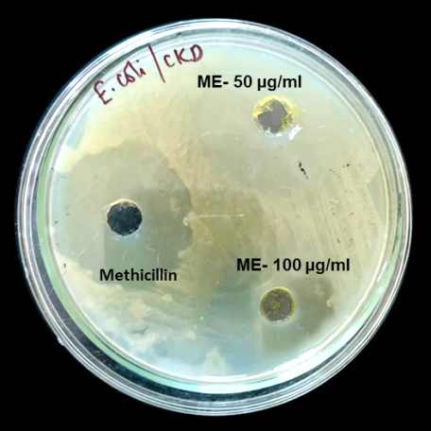

Escherichia coli
Fig. 2. Zone of inhibition (mm) of methanol extracts (ME)
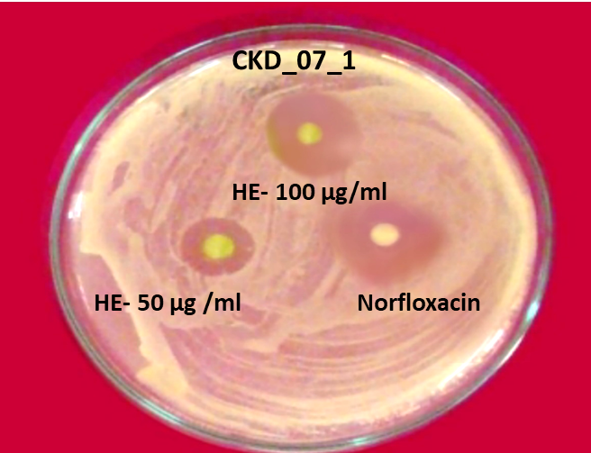
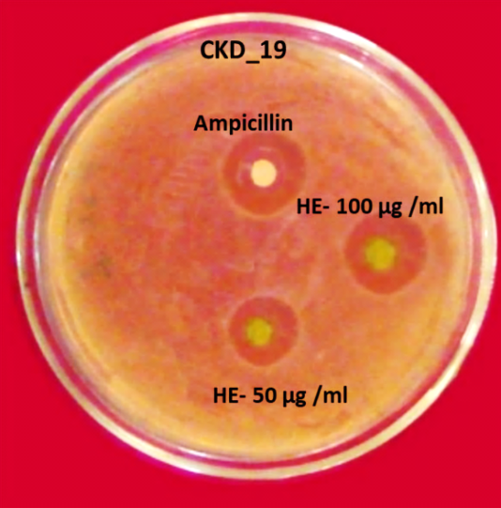

Enterococcus faecalis Providenci stuartii
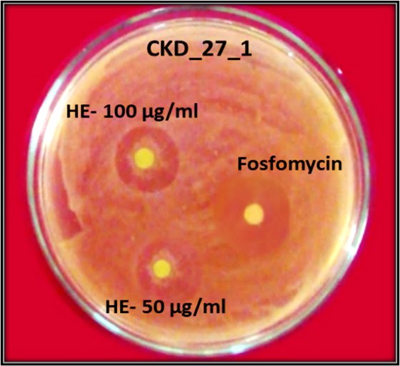
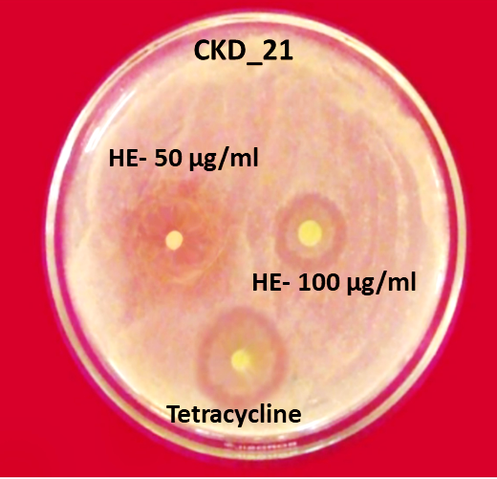

Klebsiella variicola Enterobacter bugandensis

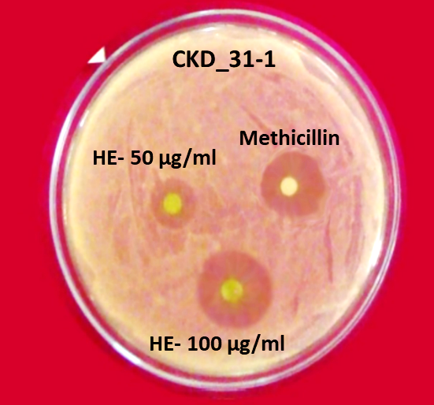

Escherichia coli
Fig. 3. Zone of inhibition (mm) of hexane extracts (HE)

