Original Research Article

Indigenous Knowledge and Medicinal Uses of Caesalpinia pulcherrima in Southern Benin.

.
ABSTRACT
In the context of biodiversity conservation and the search for bioactive compounds,documenting indigenous knowledge on medicinal plants is essential for their sustainable use and valorization. This study aimed to document local knowledge on the traditional use of Caesalpinia pulcherrima in southern Benin. This study is a descriptive ethnobotanical survey conducted using participatory research method.Data were collected throught semi-structured interviews and open discussions with 116 informants, including herbalists and traditional healers,across nine communes communes in southern Benin. A total of 116 individuals () were interviewed. The results showed that the respondents were predominantly women (83.6%) and Fon (81%), with a large proportion (69.8%) being illiterate. C. pulcherrima is used to treat around twenty ailments, with chronic infections (74.14%) being the most frequently cited, followed by ulcers (25%) and wounds (15.52%). The leaves (88.79%), roots (40.52%), and bark (32.76%) are the most commonly used parts, mainly in the form of decoctions (91.38%) and administered orally (98%) for the treatment of these various conditions. A Correspondence Analysis (CA) revealed a differentiation in uses of leaves, roots, and stems, which are associated with gastrointestinal and neurological disorders (e.g., constipation, epilepsy), while flowers, fruits, seeds, and bark are used more often for infections, skin conditions, and malaria. However, the intensive use of roots and bark poses a risk to the conservation of the species. This primary study is essential for better utilizing the genetic resources of C. pulcherrima.

Keywords: Ethnobotany, Caesalpinia pulcherrima, Traditional medicine. Southern-Benin

1. INTRODUCTION

Since ancient times, plants have always held an important place in human life for health, nutrition, and economic development. This is why, for centuries and even millennia, our ancestors used plants to relieve pain, heal ailments, and tend to wounds (Benkhnigue et al., 2011). Despite advances in modern medicine and the existence of healthcare facilities, more than 80% of the African population in general, and the Beninese population in particular, still rely on traditional medicine for treatment (WHO, 2002 and 2009).
Traditional medicine encompasses therapeutic practices passed down from generation to generation, long before the advent of modern medicine, and still widely used today (WHO, 1991 ; Bekele et al., 2022 ). However, the progressive loss of local knowledge, linked in particular to the decrease in the number of people possessing this knowledge, foreshadows a weakening of the practice of traditional medicine (Badiane et al., 2015). The ethnobotanical evaluation of medicinal plants aims to explore and document traditional knowledge relating to the medicinal use of plants in a given cultural context (Aththorick et al., 2008 ) in order to ensure its safeguarding and perpetuation. The flora of Benin is rich in 2,807 plant species (Akoègninou et al., 2006), and various ethnobotanical studies (Djègo et al., 2011 ; Houmenou et al., 2017; Akhenatonet al., 2019 ) were carried out with a view to enhancing the endogenous knowledge of the latter.
However, despite these numerous studies, very little ethnobotanical data is available on Caesalpinia pulcherrima in Benin. Caesalpinia pulcherrima, belonging to the Fabaceae family and the Caesalpinia genus, comprises over 500 species within the Caesalpiniaceae family. Caesalpinia pulcherrima is also known as an ornamental plant and is commonly used in gardens. Native to Central America, this plant is now widespread in tropical and subtropical regions of Africa, Asia, and Australia (Zanin et al., 2012). In traditional medicine, extracts from different parts of the plant are used as stimulants, emmenagogues, and abortifacients (Srinivas et al., 2003; Chiang et al., 2003). It is also recognized for the treatment of various pathologies and possesses strong antimicrobial and anti-inflammatory activity attributed to its richness in triterpenoids (Nasimul et al., 2003). However, specific data on the traditional uses of C. pulcherrima in Benin remain scarce, highlighting the need to conduct ethnobotanical studies on this species. This study aimed to promote local knowledge of C. pulcherrima in a context of progressive erosion of traditional knowledge.

2. material and methods

2.1. Study area and target groups
In this study, market herbalists, traditional healers, and users of traditional plants in nine communes located in the departments of Zou, Atlantique, Littoral, Ouémé, Plateau, Mono, and Couffo (Fig. 1) were surveyed. These communes are Abomey, Ouinhi, Ouidah, Abomey-Calavi, Cotonou, Porto-Novo, Pobè, Comè, and Aplahoué in southern Benin (Figure 1).
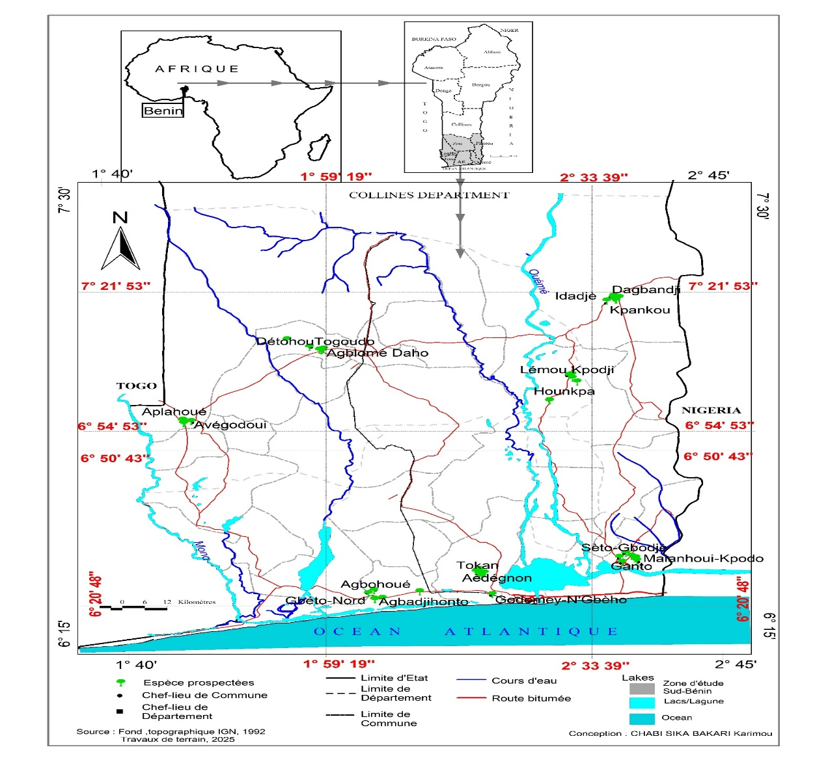
Figure 1: Map of the study area.

2.2 Data collection method - second level heading.
Data were collected from March to April 2025 using the methods described by Koudokpon et al. (2017), adapted to our research focus. Short, semi-structured interviews, using a data sheet, as well as occasional open discussions, were conducted with the target groups (market herbalists, traditional healers, and users of traditional plants) in our study area.To ensure the survey's reproducibility and transparency, the data sheet included a structured questionnaire divided into three sections: (i) sociodemographic characteristics (age, gender, education level, and primary occupation); (ii) traditional knowledge about the use of Caesalpinia pulcherrima; and (iii) sociocultural values of the species, such as pathologies treated, plant parts used, methods of preparation and administration, and dosage. Prior to main survey, the questionnaire was pre-tested to ensure its clarity,consistency,and cultural relevance,and any necessary changes were made.

The sample size was calculated using Dagnelie's (1998) binomial distribution formula, which is commonly used in ethnobotanical research to assure representativeness in groups with unevenly distributed knowledge. This approach is particulary appropriate in the current study area,where there are several groups of people, including herbalists, traditional healers, and experienced users.
Formula is expressed as:

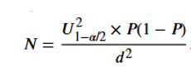

- U₁₋α/2: the value of the standard normal random variable corresponding to the probability of 1–α/2, which is 0.975; therefore, U₁₋α/2 = 1.96.
- p: the proportion of individuals who use C. pulcherrima in the study area, and d: the margin of estimation error, set at 5% in this study.”
Based on this technique, 116 respondents were questioned, taking into account the descriptive nature of the study and the focused selection of informed informants.This sample size was deemed sufficient to enable credible and representative documentation of indigenous knowledge on C.Pulcherrima in line with ethnobotanical research.
2.3 Data Analysis

The collected data were recorded in Excel 365. The graphs were also created using Excel 365. The collected data allowed for the calculation of the ethnic participation rate and the frequency of mention (of uses, organs used, and preparation methods). For the analysis of the quantitative data and the exploration of the relationships between the parts of Caesalpinia pulcherrima used and the pathologies treated by the respondents, a Correspondence Analysis (CA) was performed using R (v4.3.2). The resulting biplot from the CA was generated using R Markdown.

3. results and discussion

  - characteristics of respondents
The sociodemographic characteristics of the respondents were presented in Table I. Analysis of this table showed that the majority of respondents (83.6% on average) were women, compared to only 16.4% men. The dominant age group was between 30 and 59 years old (55.2% on average). Regarding education level, most were illiterate (69.8%). However, 23.3% had some education, either primary or secondary, while very few had reached a higher level (approximately 0.9%). The respondents belonged to four main ethnic groups (Fon, Adja, Mina, and Goun). The Fon were the largest group, with 94 individuals (81%), followed by the Adja with 15 (12.9%) individuals, and finally the Mina and Goun, who were poorly represented with 5 (4.3%) and 2 (1.7%) people respectively.
Table I : Sociodemographic characteristics of respondents.

Table 1. Sociodemographic characteristics of respondents.

Features | Modality | Percentage of respondents (%)
Sex | Female | 83.6
 | Male | 16.4
Age | < 30 years old | 2.6
 | 30–59 years old | 55.2
 | ≥ 60 years old | 10.3

*Moisture content on oven dry weight basis

  - Traditional Use of C. Pulcherrima in Southern Benin
Respondents have a good knowledge of the traditional medicinal use/pharmacopoeia of C. Pulcherrima in South Benin.
Figure 2 shows the distribution of plant parts of Caesalpinia pulcherrima utilized by respondents in southern Benin. Values show the percentage of respondents that mentioned each plant organ.
The parts of the plant used (Figure 2) in traditional medicine include the leaves (88.79% of respondents) followed by the roots (40.52% of respondents), the bark (32.76% of respondents), the stems (24.14% of respondents), the flowers (17.24% of respondents), the fruits (6.90% of respondents) and finally the seeds (3.45% of respondents).

Fig. 2 The parts of C. Pulcherrima used for the treatment of diseases.
Legend :
Leaf (FEU), Root (RAC), Stem (TIG), Flower (FLE), Fruit (FRU), Seed (GRA), Bark (ECO).

The organs of Caesalpinia pulcherrima were used by herbalists and traditional healers to treat more than twenty diseases (Figure 3). Extracts were administered orally or externally. Certain parts of the plant were used in combination to treat specific illnesses. Among the conditions most frequently treated with different organs, chronic infections were the most frequently cited (74.14% of respondents). It was also widely used in the treatment of ulcers (25.0%), chronic internal, oral, or cutaneous wounds (15.52% of respondents), coughs (13.04% of respondents), and measles (10.34% of respondents). The diversity of reported disease (>20) reflects the multipurpose nature of the species and suggests its importance in local pharmacopoeia.

Table 2: Parts used to treat pathologies with preparation method
Parts used | Conditions treated | Preparation methods
Leaves | Sore throat, Anemia, Asthma, Atita/Agnanma , Attracts good luck, Drives away evil spirits, Constipation, Body aches, Skin conditions, Diarrhea, Typhoid fever, Fever, Hemorrhoids, Jaundice, Infection/Any type of infection, Stomach aches, Bad breath, Lower abdominal pain, Liver problems, Malaria, Wounds, Common cold, Measles, High blood pressure, Cough, Ulcer, Epilepsy | Alcohol tincture + lemon, tincture, decoction
Flowers | Sore throat, Asthma, Dermatosis, Typhoid fever, Infection/Any type of infection, Malaria, Wound, Cough, Ulcer | Tincture + lemon, tincture, decoction, infusion
Fruits | Sore throat, infection/any type of infection, wound, high blood pressure, cough | Alcohol extract + lemon, tincture, decoction, infusion
Barks | Asthma, Atita/Agnanma , Dental caries, Dermatosis, Diarrhea, Typhoid fever, Fever, Infantile fever, Hemorrhoids, Jaundice, Infection/Any type of infection, Stomach pain, Malaria, Wound, Measles, Cough, Ulcer | Alcohol extract, alcohol extract + lemon, decoction, infusion
Seeds | Asthma, Infection/Any type of infection, Malaria, Wound, Cough | Alcohol extract, alcohol extract + lemon, decoction, infusion
Roots | Asthma, Atita/Agnanma, Dermatosis, Typhoid fever, Fever, Hemorrhoids, Jaundice, Infection/Any type of infection, Stomach pain, Lower abdominal pain, Liver pain, Malaria, Wound, Common cold, Measles, High blood pressure, Cough, Ulcer | Alcohol tincture + lemon, tincture, decoction, infusion
Stems | Asthma, Atita/Agnanma, Dental caries, Dermatosis, Diarrhea, Typhoid fever, Fever, Infection/Any type of infection, Bad breath, Malaria, Wound, Cough, Ulcer, Stomach pain | Alcohol extract + lemon, tincture, decoction, infusion

The figure 3 shows the distribution of pathologies treated using different parts of Caesalpinia pulcherrima.Values correspond to the percentage of respondents citing each pathology.The figure illustrates the dominance of infectious-related disease in traditional uses.The data from our study indicated the use of the different parts of the plant in the treatment of typhoid fever (8.62% of respondents), malaria (6.9% of respondents), dermatosis (3.45% of respondents), tooth decay (2.59% of respondents), stomach aches, and hemorrhoids (2.59% of respondents). Less frequently, the plant was mentioned in the management of conditions such as tonsillitis, high blood pressure, asthma, and the common cold (1.72% each), as well as for diarrhea, constipation, fever, bad breath, anemia, body aches, epilepsy, childhood fevers, jaundice, lower abdominal pain, and liver ailments (all at 0.86% or 0.87%). Finally, some ritual uses were also reported, notably to attract good luck or ward off evil spirits (0.86% each).

Fig.3 Pathologies treated by the different parts of Caesalpinia Pulcherrima
Legend :
Infection/Chronic infections (INF), Lower abdominal pain (MBV), Agnama (ATI/AGN), Anemia (ANE), Sore throat (ANG), Asthma (AST), Attracts luck (ritual use) (ATC), Tooth decay (CAD), Drives away evil spirits (ritual use) (CME), Constipation (CON), Aches and pains (CBT), Dermatosis (DER), Diarrhea (DIA), Epilepsy (EPS), Fever (FIV), Infantile fever (FII), Typhoid fever (FTY), Hemorrhoids (HEM), Jaundice (ICT), Bad breath (MAH), Liver problems (MAF), Abdominal pain (MAV), Malaria (PAL), Chronic wounds (internal, oral, cutaneous) (PLA), Common cold (RHU), Measles (ROU), High blood pressure (TEN), Cough (TOU), Ulcer (ULC).
Correspondence Analysis (CA) of the collected data allowed us to visualize the relationships between the parts of Caesalpinia pulcherrima used and the pathologies treated (Figure 4). The first two factorial axes explain 61.3% of the total inertia of the information, indicating that they capture a substantial proportion of the observed variability.
Axis 1 (Dimension 1), representing 36.3% of the inertia, highlights a marked opposition. On the one hand, parts such as the Leaf (V1), Root (V2), and Stem (V3) are frequently associated with pathologies such as Constipation (CON), Epilepsy (EPS), Lower Abdominal Pain (MBV), and Diarrhea (DIA). On the other hand, the Flowers (V4), Fruit (V5), Seed (V6), and Bark (V7) converge with a distinct set of pathologies including Chronic Wounds (PLA), Infections (INF), Malaria (PAL), and Infantile Fever (FII). This distinction suggests differentiated efficacy profiles and traditional uses depending on the plant part used. Axis 2 (Dimension 2), contributing 25% of the inertia, refines this opposition by revealing more specific associations. For example, it shows that the Fruit (V5) and the Seed (V6) are particularly closely associated with pathologies such as Sore Throat (ST) and High Blood Pressure (HBP). Conversely, the Bark (V7) tends to be associated with Infantile Fever (IFF) and Dental Caries (DC), while the Root (V2) and the Leaf (V1) are linked to conditions such as Hemorrhoids (HEM) and Measles (ROU). These two combined dimensions allow for the effective mapping of the complex relationships between the different parts of Caesalpinia pulcherrima and the range of pathologies they are believed to treat, thus highlighting potential specializations within local ethnobotanical knowledge.
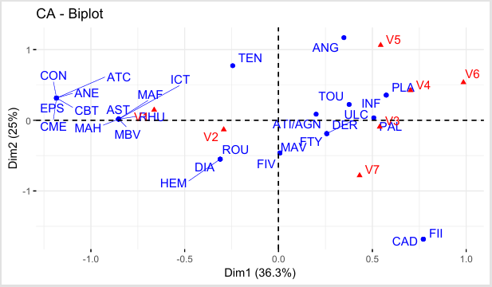
Fig.4 Biplot of the Correspondence Factor Analysis (CFA) between parts of Caesalpinia pulcherrima and the pathologies treated in South Benin.
Legend :
Parts used of C. pulcherrima (red triangles) : Leaf (V1), Root (V2), Stem (V3), Flower (V4), Fruit (V5), Seed (V6), Bark (V7). Treated pathologies (blue dots) : Infection/Chronic infections (INF), Lower abdominal pain (MBV), Agnama (ATI/AGN), Anemia (ANE), Sore throat (ANG), Asthma (AST), Attracts luck (ritual use) (ATC), Tooth decay (CAD), Drives away evil spirits (ritual use) (CME), Constipation (CON), Aches and pains (CBT), Dermatosis (DER), Diarrhea (DIA), Epilepsy (EPS), Fever (FIV), Infantile fever (FII), Typhoid fever (FTY), Hemorrhoids (HEM), Jaundice (ICT), Bad breath (MAH), Liver problems (MAF), Abdominal pain (MAV), Malaria (PAL), Chronic wounds (internal, oral, cutaneous) (PLA), Common cold (RHU), Measles (ROU), High blood pressure (TEN), Cough (TOU), Ulcer (ULC).

  - Preparation method
Figure 5 shows the preparation methods used for the recipes. Values represent the percentage of respondents citing each method.Analysis of this figure indicates that decoction is the most frequently used preparation method (91.38%) , while alcohol-based preparations and infusion are less common, with frequencies of 4.31% and 3.45%, respectively.

Fig.5 Recipe preparation method.
  - Administrative route
The methods of administration after the preparation of the different recipes were represented in Figure 6. This figure shows that the oral route was the route of administration used most frequently (98% of respondents) while the cutaneous, vaginal, and nasal routes were used at respective frequencies of 6%, 3%, and 1%.The predominance of oral route (98%) suggests that most remedies target systemic condition rather thant localized treatments.

Fig.6 Methods of revenue administration

  - Discussion

During our survey, we met with four ethnic groups, predominantly women, in the study area. These results corroborate those of Koudokpon et al. (2017), who found that 90% of market herbalists were women. This finding can be explained by the fact that in Benin, market sales activities are more often carried out by women. These results also highlight the preeminence of women in possessing indigenous knowledge related to the use and transmission of plants (Kouchade et al., 2017). The respondents were predominantly Fon. These results were similar to those of Dangnon et al. (2024), who found that more than 60% of market herbalists surveyed about plants used to treat gastric ulcers were Fon in southern Benin. This can be explained by the fact that the Fon are the majority ethnic group in southern Benin, but also that this ethnic group makes greater use of plants for the treatment of ailments.
The average age of the respondents was between 30 and 59 years, and the majority were illiterate. These results were similar to those of Koudokpon et al. (2017), who found that the average age of herbalists was 47 years and that most were illiterate in their ethnobotanical survey of plants used to treat infectious diseases in southern Benin. The high illiteracy rate (69%) and low representation of young people under 30 (2,6%) indicate a limited intergenerational transfer dynamic, which could lead to the gradual erosion of ethnobotanical knowledge, as has already been shown in Benin for other species (Nacoulma, 1996).Integrating this knowledge into community-based education or conservation projects may assist assure its sustainability..
Regarding the preparation of recipes, the data obtained indicates that herbalists in the market, traditional healers and users of traditional plants utilized various parts of Caesalpinia pulcherrima in their recipes, but the leaves are by far the most commonly used. The results of our studies were similar to those conducted in Benin and elsewhere, which reported the predominant use of leaves in traditional medicinal recipes. These observations were consistent with those of Chabi et al. (2013) and Sahli et al. (2010), who reported the frequent use of leaves in traditional medicine. Lagnika et al. (2016), in their studies on the use of medicinal plants in southern Benin against malaria, reported that leaves were the most frequently used (73.50%). Similarly, Azonbakin et al. (2021), in their study on plants used in the treatment of male infertility in Benin, showed that leaves were the most commonly used (35.77%). Catarino et al. (2016) in Guinea and Nduche et al. (2015) in Nigeria reported comparable results in their work. In Nigeria, Adebayo et al. (2011), as well as Fokou et al. (2015), noted that leaves constituted the most used parts in traditional recipes at 44.26% and 53%, respectively. Dougnon et al., (2018) in their study on the use of plants in southern Benin for the treatment of typhoid fever, they observed that the aerial parts, particularly the leaves, were the most frequently used at 47.37%. Our findings are similarly consistent with those of Koudokpon et al. (2017), who found that leafy stems were the most regularly used plant parts (70.20%) in their ethnobotanical survey on medicinal plants used to cure illnesses in southern Benin.. In contrast to the devastating effects that using roots and bark can have on plant biodiversity, the frequent use of leaves in recipes is a major asset for preserving plant biodiversity (Lagnika et al., 2016). Furthermore, using leaves is less harmful than using underground parts (roots, stem, bark) or whole plants (Giday et al., 2003; Zheng and Xing, 2009). Indeed, according to Azonbakin et al. (2021), the ease and speed of harvesting leaves could explain their increased use. The widespread use of roots (40.52%) and bark (32.76%) threatens the species' extinction, as warned by Akhénaton et al. (2019) in Benin.The predominant use of leaves is further supported by pharmacological evidence. Y.K. Rao et al.(2005) in their study conducted in Taiwan isolated five anti-inflammatory flavonoids from the aerial paerts (stems and leaves) of C.Pulcherrima and demonstrated their significant dose dependent inhibition of nitric oxide,tumor necrosis factor (TNF-α), and interleukin (IL-12) production in activated murine peritoneal macrophages. Similarly, Takawale et al. (2011) reported that hydroalcoholic and aqueous bark extracts exhibited significant antiulcer activity in aspirin-induced ulcer models, with 54.88% protection at 200 mg/kg, validating the traditional use of this species for ulcer treatment (25.0% of respondents in our study).
Our studies revealed that C. Pulcherrima is used to treat up to 29 diseases according to respondents in our study area. Our results are close to those obtained by Agoyi et al. (2024) in their ethnobotanical study of Moringa oleifera Lam. in southern Benin, which reported its use by the local population for the treatment of no fewer than 34 diseases.This wide range of therapeutic indications highlights the central role of medicinal plants in traditional healthcare systems,where a single species is often used to mange multiple ailments.such versability is commonly reported in ethnobotanical studies and reflects both the empirical knowledge of local populations and complex phytochemical composition of medicinal plants (Azonbakin et al.,2021) Previous studies on C. pulcherrima have led to the isolation of several diterpenoids and flavonoids (Che et al., 1986; Srinivas et al., 2003). Phytochemical studies by Sivasankarie et al. (2010) on C. pulcherrima extracts revealed the presence of alkaloids, tannins, flavonoids, and phenolic compounds.This phytochemical richness is further substantiated by Sirisarn et al. (2025), who conducted sequential solvent extraction of C.Pulcherrima yellow flowers and analyzed the extracts using GC-MS.Their study identified a wide range of bioactive compounds, including sesquiterpenes,furans, carboxylic acids, and esters.These findings align with previous reports bys Azevedo et al,(2018), Who indentified α-copaene (4.25%), γ-muurolene (2.41%), and caryophyllene oxide (49.13%) in the essential oil of yellow flowers, and by Ogunbinu et al. (2010),who detected monoterpenoids and sesquiterpenoids in the species. These compounds are known for their antioxidant, antimicrobial, and anti-inflammatory properties. Such chemical diversity may explain the broad therapeutic application reported by respondents,likely through complementary or synergistic biological effects.. These finding reinforce the scientific relevance of C. Pulcherrima and support its potential for further valorization.
Several preparation methodswere used, among which decoction (91.38%)was the most widespread as the main method. These results are similar to those of Chabi et al. (2013), where decoction was the most frequently used preparation method for cashew nuts in the treatment of various pathologies. Similar results
were reported by Diarrassouba et al. (2008). Our results were also close to those obtained by Lagnika et al. (2016), whose most frequently reported preparation method in their study was decoction (91.2%). The work carried out by Aboudou et al. (2021) on medicinal plants used in the traditional management of infectious diseases in the Lomé health region, Togo, also showed that decoctions are the most common (93.14%). This could be explained by the fact that decoctions can contain the most potent active ingredients and reduce, or even eliminate, the toxic effects of certain substances (Salhi et al., 2010).
During our field surveys, no respondents mentioned any difference in the plant's use based on flower color. This could be explained by the absence of a specific study designed to observe this variation. The lack of distinction between floral varieties could thus conceal different uses.However,the study by Sirisarn et al. (2025) focused specifically on the yellow flowers of C.Pulcherrima and revealed remarkable pharmacological properties.Further studies comparing different floral varieties (yellow, red,pink) would be necessary to determine whether color variations correspond to differences in phytochemical composition and biological activities.

4. Conclusion

This study has provided a comprehensive record of the ethnobotanical uses of Caesalpinia pulcherrima in southern Benin, highlighting its prominent role in local traditional medicine. Our findings have revealed a wealth of indigenous knowledge, particularly held by women. However, the high illiteracy rate and low youth involvement threaten the transmission of this knowledge. It is therefore imperative to implement strategies for conserving this knowledge and the species itself, notably by encouraging its cultivation and by conducting further phytochemical and pharmacological investigations to scientifically validate its therapeutic potential and ensure its sustainable use.

Disclaimer (Artificial intelligence)

Author(s) hereby declare that NO generative AI technologies such as Large Language Models (ChatGPT, COPILOT, etc.) and text-to-image generators have been used during the writing or editing of this manuscript.

References
Adjatin A., Dansi A, Badoussi E, Loko YL, Dansi M., Gbaguidi F, Azokpota P, Ahissou H., Akoègninou A., Akpagana K. and Sanni A.(2013). Phytochemical screening and toxicity studies of Crassocephalum rubens (Juss. ex Jacq.) S. Moore and Crassocephalum crepidioides (Benth.) S. Moore as consumed vegetables in Benin. Journal of Chemical and Pharmaceutical Research , , 5(6):160-167
Adebayo JO, Krettli AU. (2011). Potential antimalarials from Nigerian plants: a review. J Ethnopharmacol, 133: 289-302. DOI: 10.1016/j.jep.2010.11.024.
Aboudou AD & Koffi K. (2021). Ethnobotanical Survey of Medicinal Plants Used in the Traditional Management of Infectious Diseases in the Lomé-Commune Health Region of Togo. European Scientific Journal, ESJ, 17(21), 46. https://doi.org/10.19044/esj.2021.v17n21p46
Azonbakin S., P. Dangbemey, R. Osseni, SA Yaude, F. Kora, D. Adovoekpe, F. DJEGO, A. Laleye and B. Awede. (2021). Ethnobotanical survey of plants used in the treatment of male infertility in Benin. Int. J. Biol. Chem. Sci. 15(4): 1667-1677, 2021
Agoyi Eric E, Achille E. Assogbadjo, Gerard Gouwakinnou, Farris AY Okou, and Brice Sinsin.(2014). www.ethnobotanyjournal.org/vol12/i1547-3465-12-551.pdf
Akhénaton Adonaï Mahouklo BADA AMOUZOUN, Romaël Badjrêhou BADOU, Dègninou Yélognissè Innocent AHAMIDE and Cossi Aristide ADOMOU (2019). Ethnobotanical knowledge and conservation of uvariodendron angustifolium (engl. & diels) r. E. Fries (annonaceae) in the eweadakplame forest island in southeastern Benin, West Africa. Rev. Ivory. Sci. Technol., 34 (2019) 328 - 348 328 ISSN 1813-3290, http://www.revist.ci
Águida Maria Albuquerque Azevedo, Eriberto de Ponte Sá Junior, Mário Geraldo de Carvalho, Thiago Ferreira de Araújo & Francisco Eduardo Aragão Catunda Júnior (2018) Chemical Composition of Flowers Essential Oils of Four Varieties from Caesalpinia pulcherrima (L) W, Journal of Essential Oil Bearing Plants, 21:4, 987-993
Aththorick TA, Berutu L. (2018). Ethnobotanical study and phytochemical screening of medicinal plants on Karonese people from North Sumatra, Indonesia. In: Journal of physics: conference series 2018 Dec 1, vol. 1116, no. 5. IOPPublishing. p. 052008.
Bekele Melese, Feleke Woldeyes, Ermias Lulekal, Tamrat Bekele and Sebsebe Demissewet (2022). Ethnobotanical investigation of medicinal plants in buska mountain range, hamar district, southwestern ethiopia. Journal of Ethnobiology and Ethnomedicine https://doi.org/10.1186/s13002-022-00558-0
Benkhnigue O, Zidane L, Fadli M, Elyacoubi H, Rochdi A and Douira A. (2011). Ethnobotanical study of medicinal plants in the region of Mechraâ Bel Ksiri (Gharb Region of Morocco). Acta Bot. Barc.,53:191-216
Chabi Sika K, Adoukonou-Sagbadja H, Ahoton LE, Adebo I, Adigoun FA, Saidou A, Ahanchede A, Kotchoni SO, Baba-Moussa L (2015). Indigenous knowledge and traditional management of cashew (anacardiumouest l) genetic resources in Benin.
Catarino L, Havik P, Indjai B, Romeiras M. (2016). Ecological data in support of an analysis of Guinea-Bissau's medicinal flora. Data in Brief, 7: 1078-1097. DOI: https://doi.org/10.1016/j.dib.2016.03.077
Cotton CM. Ethnobotany: principles and applications. Chichester: Wiley; 1996.
Diarassouba N, Kouablan EK, N'Guessan KA, Patrick VD, Sangare A (2008) Local knowledge and its use in the management of shea parks in Côte d'Ivoire. Afrika focus 21: 77-96
DJEGO, JS DJEGO-DJOSSOU, Y. CAKPO, P. AGNANI and B. SINSIN. (2011). Evaluation of the ethnobotanical potential of rural populations in southern and central Benin, International Journal of Biological and Chemical Sciences, 5 (4) (2011) 1432 – 144
Dangnon, B., Dah Nouvlessounon, D., Hoteyi, SMI, Abdelrah man, A., Mahamat, MA, Chabi, NW, Haziz, S., Baba-Moussa, F., Adjanohoun, A. and Baba-Moussa, L. (2024).Gastrointestinal Ulcers Treatment: Plants and Recipes Used by Herbalists of Abomey-Calavi and Cotonou Districts, Southern Benin. American Journal of Plant Sciences, 15, 699-725. https://doi.org/10.4236/ajps.2024.159046
Dougnon V., Legba B., Yadouleton A., Agbankpe J., Koudokpon H., Hounmanou G., Amadou A., Fabiyi K., Assogba P., Hounsa E., Aniambossou A., Déguenon E., de Souza M., Bankolé HS, Dougnon J., Baba-Moussa L. (2018). Use of plants from Southern Benin in the treatment of typhoid fever: the role of herbalists. Ethnopharmacologia, No. 60, October 2018
Fokou P, Nyarko A, Appiah-opong R, Yamthe L, Addo P, Asante I, Fekam Boyom F. 2015. Ethnopharmacological reports on anti-Buruli ulcer medicinal plants in three West African countries. J Ethnopharmacol., 172: 297-311. DOI: 10.1016/j.jep.2015.06.024.
Harshada Takawale, Vaishali Mute, Deorao Awari, V.I. Hukkeri, Preeti Mehta and Pallavi Vawhal.(2011). Screening of Antiulcer Activity of Caesalpinia pulcherrima L. Bark. Against Aspirin Induced Ulcer in Rats. World Journal of Medical Sciences 6 (4): 168-172, 2011
K. Sivasankari, S. Janaky and T. Sekar, (2010), Evaluation of phytochemicals in select medicinal plants of the Caesalpinia species http://www.indjst.org
Koudokpon H, Dougnon TV, Bankolé HS, Fah L, Hounmanou YMG, Baba-Moussa L, Loko F. (2017). Ethnobotanical survey of plants used in the treatment of infections in southern Benin. Health Sci. Dis: Vol 18 (2) April – May – June 2017. www.hsd-fmsb.org
KOÈGNINOU A, WJ VAN DER BURG and LJG VAN DER MAESEN, Analytical Flora of Benin, Backhuys Publishers, Wageningen, (2006) 1034 p.
HOUMENOU, VA ADJATIN, MG TOSSOU, H. YEDOMONHAN, A. DANSI, J. GBENOU and A. AKOÈGNINOU. (2017). Ethnobotanical study of plants used in the treatment of female infertility in the Ouémé and Plateau departments of southern Benin, International Journal of Biological and Chemical Sciences, 11 (4) (2017) 1851 – 1871
Latifou Lagnika, Rock Djehoue, Hounnankpon Yedomonhan and Ambaliou Sanni.(2016). Ethnobotanical survey of medicinal plants used in malaria management in South Benin. Flight. 10(41), pp. 748-756, November 3, 2016 DOI: 10.5897/JMPR2016.6219
NACOULMA-OUÉDRAOGO OG, 1996. Medicinal plants and traditional medical practices in Burkina Faso: the case of the central plateau. Doctoral thesis, Faculty of Sciences and Techniques, University of Ouagadougou, Burkina Faso, volume 1, 320 p., volume 2, 285 p.
Nduche MU, Omosun G, Okwulehie IC. 2015. Ethnobotanical Survey of Plants Used as Remedy for Fertility Conditions in Ebonyi State of Nigeria. Sch Acad J Biosci., 3 (2B): 214-221.
AO Ogunbinu, S Okeniyi, G Flamini, PL Cioni and IA Ogunwande. Monoterpenoid constituents of the volatile oils of Cynometra megalophylla harms., Caesalpinia pulcherrima L. swartz and Pachylobus edulis G. Don., growing in Nigeria. Journal of Essential Oil Research 2010; 22(6),536-539
WHO, 2002. WHO Strategy for Traditional Medicine: WHO Geneva, 65p
WHO, 2009. Report of the WHO Interregional Workshop on the Use of Traditional Medicine in Primary Health Care. Ulaanbaatar, Mongolia, 23-26 August 2007; 94p.
Rao, Y. K., Fang, S. H., & Tzeng, Y. M. (2005). Anti-inflammatory activities of flavonoids isolated from Caesalpinia pulcherrima. Journal of ethnopharmacology, 100(3), 249-253.
Salhi, S., Fadli M., Zidane L., Douira A. (2010). Floristic and ethnobotanical studies of medicinal plants in the city of Kenitra (Morocco). Lazaroa, 31, 133-146.
Srinivas KVNS, Rao YK and Mahender I.(2003).Flavonoids from Caesalpinia pulcherrima. Phytochem. 63, 789-793.
World Health Organization. Traditional medicine and modern health care: progress report by the director general. Geneva: World Health Organization; 1991.
Wanchat Sirisarn,Auemphon Mordmuang,Yaowapa Sukpondma,Sumalee Obchoei,and Sompop Saeheng.(2025). Sequential Solvent Extraction of Caesalpinia pulcherrima Yellow Flowers Reveals Potent Antioxidant, Antimicrobial, and Anticancer Activities Against Various Human Cancer Cell Lines. ttps://doi.org/10.48048/tis.2025.9368. TRENDS IN SCIENCES 2025; 22(4): 9368

