Comparative Analysis of Sensory, Physical, Functional, and Nutritional Properties of Coconut and Brown Rice Based Curd and Paneer

ABSTRACT:
The present study evaluated the sensory, physical, functional, and nutritional properties of functional plant-based curds and paneers prepared from coconut and brown rice combinations with soy milk inclusion in both combinations. Sensory evaluation indicated that coconut-based formulations (coconut curd (CSC) and coconut paneer (CSP)) scored higher for appearance, color, flavor, taste, texture, and overall acceptability compared to brown rice-based products (brown rice curd (BSC) and brown rice paneer (BSP)), with overall acceptability ranging from 7.60 to 8.00 for curds and 7.92 to 8.00 for paneers. Colour analysis revealed that coconut-based samples exhibited higher lightness (L*) and lower redness (a*) and yellowness (b*), while brown rice-based formulations showed slightly darker and more yellowish hues. Physicochemical assessment demonstrated minor variations in pH (4.95–5.23), titratable acidity (0.117–0.486%), and total soluble solids (13.20–14.50 °Brix) among the formulations. Functional properties indicated that CSC showed higher syneresis (30.12 ± 5.33%) and lower viscosity (0.85 ± 0.07 Pa·s), whereas BSC exhibited lower syneresis (11.11 ± 3.76%) and higher viscosity (1.15 ± 0.09 Pa·s), highlighting the effect of substrate composition on gel strength and water retention. Texture Profile Analysis revealed that CSP had significantly higher hardness, cohesiveness, springiness, and chewiness compared to BSP, indicating a firmer, more elastic, and chewier product. Collectively, these findings suggest that coconut-based curds and paneers possess superior sensory attributes, desirable colour, and balanced textural properties, whereas brown rice incorporation improves gel stability and water-holding capacity. The study demonstrates the potential of coconut and brown rice-based formulations to produce functional, plant-based dairy alternatives with acceptable sensory quality and textural characteristics suitable for consumer preference and product development.

Keywords: sensory evaluation, physicochemical assessment, functional properties, texture profile, syneresis, protein, moisture.
- INTRODUCTION:
In recent years, the demand for plant-based dairy alternatives has grown rapidly, driven by consumer concerns over lactose intolerance, milk allergies, animal welfare, environmental sustainability, and metabolic health. Plant-based fermented and coagulated products aim to replicate traditional dairy items such as curd (yogurt) and paneer (cottage cheese) while providing unique nutritional and functional benefits. Nevertheless, challenges persist in formulation, particularly in achieving textures, creaminess, protein functionality, and shelf life comparable to conventional dairy products (Plamada, 2023).
Rice (Oryza sativa) and coconut (Cocos nucifera) are attractive raw materials for fermented and coagulated plant-based goods. According to earlier research, thickeners/stabilizers (like tapioca starch) or structuring agents can significantly improve texture and decrease syneresis in coconut-based fermented products. Coconut milk has a naturally rich lipid phase and distinctive sensory profile, but it is also relatively low in protein and prone to phase separation and off flavors unless stabilized (Pachekrepapol, 2021 and Rashwan, 2023).
Low in fat and high in carbohydrates, brown rice-derived beverages (whole-grain rice milks) can offer unique nutritional and sensory qualities (fiber, minerals, and certain amino acids). However, they need to be processed carefully or starters chosen carefully to achieve the proper gelation, firmness, and fermentation kinetics for yogurt and cheese substitutes. Rice-based yogurts can be fermented with the right lactic acid bacteria to improve their digestibility, apparent protein content, and sensory acceptability. However, coagulation from rice into firm paneer-like matrices necessitates attention to total solids, protein crosslinking, and texture-modifying ingredients (Hozzein, 2023).
Despite being used in very small amounts in current formulations, soy (Glycine max) milk is still the most researched plant base for dairy substitutes due to its complete amino acid profile and comparatively high protein content (3–4%). When compared to its coconut and rice counterparts, soy-based yogurts and paneer-like products usually have a firm texture and a good water-holding capacity; yet, if left unmasked, their distinctive beany flavor and occasionally gritty texture may make them less acceptable to consumers. It has been suggested that blending soy in tiny amounts with rice or coconut enhances protein density, gel structure, and overall nutritional balance while reducing sensory negative effects.
Functional qualities (syneresis, texture profile, viscosity), physicochemical measurements (pH, titratable acidity, total solids, moisture, color), nutritional composition (macronutrients, protein quality,), and sensory acceptance (appearance, aroma, flavor, and mouthfeel) are important quality attributes for curd (fermented product) and paneer (heat/coagulation-set product) analogues. Despite the growing market and the requirement for strong product design guidelines, there is still a lack of comparative, systematic evaluation of these qualities for coconut and brown rice as bases, both in fermented curd and coagulated paneer formats (Dhakal, 2023).
Therefore, the present study aims to characterize the sensory, physicochemical, functional and nutritional properties of curd (fermented) and paneer (coagulated) analogues developed from coconut and brown-rice beverages in a detailed, comparable framework, and identify formulation or process strategies that optimize acceptability and stability.
- MATERIALS AND METHODS
The products Coconut curd (CSC), Brown rice curd (BSC), Coconut paneer (CSP), and Brown rice paneer (BSP) were analysed for the following:
  - Sensory evaluation
Sensory attributes of the functional plant-based products were assessed by 25 semi-trained panelists using a 9-point hedonic scale (1 = dislike extremely, 9 = like extremely) for colour, appearance, flavour, taste, texture, and overall acceptability (Meilgaard, 1999). Prior informed consent was obtained from all panelists before participation in the sensory evaluation. Coded samples were presented in individual booths, and panelists rinsed their mouths between tastings to avoid flavor carryover.
2.2 Physical properties
2.2.1 Color
A Hunter Lab spectrophotometer (Gretag Macbeth, I-5, USA) calibrated with black and white standards was used to measure the color of the samples. To assess color intensity and quality, CIELAB coordinates L* (lightness), a* (red-green), and b* (yellow-blue) were noted. Chroma (C*) and hue angle (h*) were then computed (Granato, 2010 and Karaaslan, 2008). To measure color changes, the total color difference (ΔE) in comparison to the standard plate was calculated (Hunter lab, 2013).
2.2.2 pH
A calibrated digital pH meter (pH 700) was used to measure the pH of paneer and curd at room temperature. After centrifuging a 10 g sample with 100 mL of distilled water, the supernatant was used for measurement (Kathiravan, 2014).
2.2.3 TSS
A hand refractometer, the Atago 3849 PAL-MAPLE, was used to measure the total soluble solids (TSS) (0–85°Brix). One to two drops of the supernatant were put on the prism for reading after ten grams of the sample had been diluted to 100 milliliters and agitated (Kathiravan, 2014).
2.2.4 Titratable Acidity (TA)
By employing phenolphthalein as an indicator and titrating with 0.1 N NaOH, acidity was determined. After mixing 10 grams of the sample with 30 milliliters of warm water, the titration value was used to compute the TA (% lactic acid) (AOAC, 2000).
  - Functional Properties
2.3.1 Viscosity
The viscosity of curd was measured at room temperature (27 °C) using a Brookfield rotating viscometer with spindle LV-4 at 10 rpm. Approximately 50 mL of curd in a beaker was used for each measurement (Hadi, 2017).
2.3.2 Syneresis
Curd syneresis was evaluated by both drainage and centrifugation methods. In the drainage method, whey released after cutting the curd was measured, while in the centrifugation method, curd was centrifuged at 10,000 rpm and the whey volume quantified (Malaka, 2020).
Syneresis (%) = (Volume of whey / Volume of curd) × 100.
2.3.3 Texture Profile Analysis (TPA)
Paneer cubes (20 × 20 × 20 mm) were analyzed using a Brookfield Texture Analyzer. Samples were compressed to 50% of their height with a 35 mm probe under two consecutive cycles. Hardness, springiness, cohesiveness, and chewiness were recorded to simulate the chewing process (Dongare, 2019).
  - Nutritional Analysis
2.4.1 Moisture Content
Moisture was determined by drying 2 g of curd or paneer at 105 °C in a hot air oven until constant weight, followed by cooling in a desiccator (AOAC, 2005). Moisture (%) was calculated as:
Moisture (%) = | (W₂-W₁) - (W₃-W₁) | X 100
Moisture (%) = | (W₂-W₁) | X 100

W₁ = Initial weight of petri dish (g)
W₂ = Weight of the petri dish with sample before drying (g)
W₃ = Weight of the petri dish with sample after drying (g)
2.4.2 Protein Content
Crude protein was estimated using the micro-Kjeldahl method. Samples were digested with H₂SO₄ and catalysts, distilled with NaOH, and titrated against 0.1 N HCl. Protein (%) was calculated as nitrogen × 6.25 (AOAC, 2005).
2.4.2 Fat Content
Crude fat was determined by Soxtherm extraction using petroleum ether (40–60 °C) on 2 g of sample. Residue after solvent evaporation and drying was weighed to calculate fat (%)(AOAC, 2005).
Fat content (%) = | W₂ – W₁ | X 100
Fat content (%) = | Sample weight (g) | X 100

where W1​ = empty beaker, W2​ = beaker after fat extraction.
- RESULTS
  - Sensory evaluation
The sensory scores of curd samples indicated that both coconut curd (CSC) and brown rice curd (BSC) were well accepted by the panelists, with mean values ranging between 7.04 ± 0.80 and 8.32 ± 0.80 across different attributes (Figure 1). In CSC, the highest scores were recorded for appearance and color (8.32 ± 0.80 each), followed by texture (8.04 ± 0.84) and overall acceptability (8.00 ± 0.76). Similarly, BSC also showed favorable ratings, with appearance (7.80 ± 1.11) and color (7.72 ± 1.13) being the most appreciated attributes, while flavor and taste scored 7.04 ± 0.80 and 7.04 ± 0.94, respectively. Overall acceptability values were 8.00 ± 0.76 for CSC and 7.60 ± 0.43 for BSC, highlighting that both formulations were sensorially acceptable.
The sensory evaluation of paneer samples revealed that both coconut paneer (CSP) and brown rice paneer (BSP) scored consistently high across all attributes, indicating good consumer acceptability (Figure 2). For CSP, appearance (7.72 ± 0.45) and body & texture (7.44 ± 0.58) were rated positively, while flavor (7.92 ± 0.70) and taste (8.04 ± 0.61) received comparatively higher preference. Color (7.96 ± 0.67) and overall acceptability (8.00 ± 0.40) were also favorably judged, confirming its suitability as a functional paneer. Similarly, BSP was well appreciated by panelists, with appearance (7.76 ± 0.43) and body & texture (7.36 ± 0.56) showing good acceptance. Flavor (7.76 ± 0.52), taste (7.92 ± 0.64), and color (7.96 ± 0.67) recorded high scores, while overall acceptability (7.92 ± 0.27) remained consistent with CSP. The findings highlight that both CSP and BSP formulations were equally preferred, with only minor variations in attribute scores, indicating apreference for coconut-based and brown rice based formulations with minor soy inclusion.
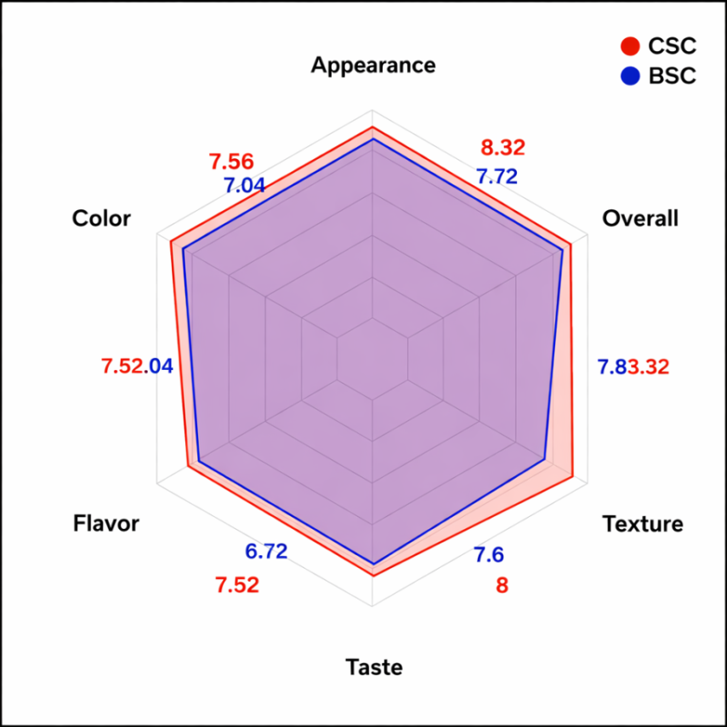

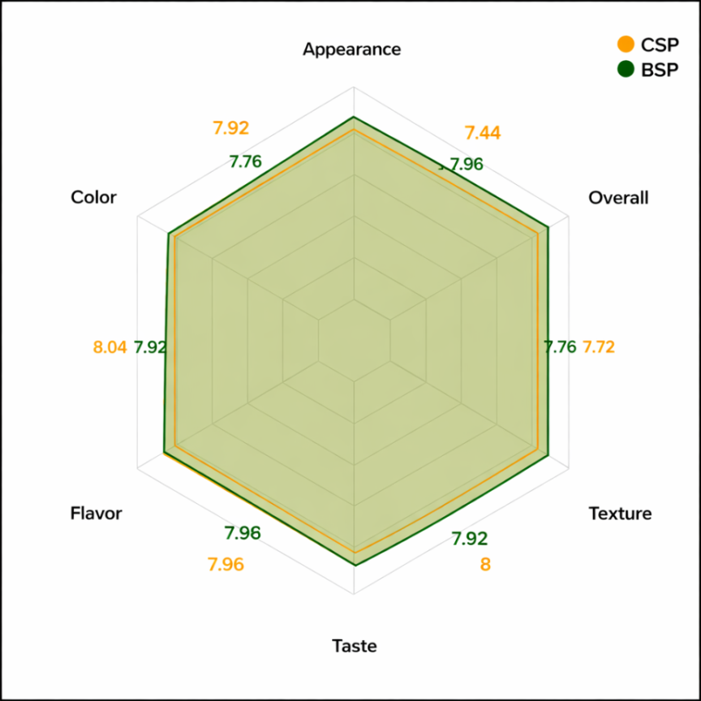
Figure 1: Sensory evaluation of curd samples

Figure 2: The sensory evaluation of paneer samples

  - Physical properties
3.2.1 Colour
For CSC, the L*, a*, and b* values were 79.10 ± 0.28, 0.35 ± 0.03, and 17.80 ± 0.20, respectively, indicating the brightest and lightly yellow-colored product(Table 1). CSP showed L* 77.20 ± 0.25, a* 0.42 ± 0.04, and b* 18.85 ± 0.22, reflecting slightly lower brightness with a mild increase in redness and yellowness (Table 2). BSC exhibited L* 76.20 ± 0.27, a* 0.52 ± 0.04, and b* 19.10 ± 0.22 (Table 1), while BSP had L* 75.30 ± 0.30, a* 0.58 ± 0.05, and b* 20.40 ± 0.24 (Table 2).
3.2.2 pH, TSS and Titrable acidity
The physicochemical properties of the curds and paneers showed variation among the different formulations. CSC exhibited the pH (5.23) and titratable acidity (0.486%), while BSC showed slightly lower pH (5.02) and acidity (0.288%). Correspondingly, the total soluble solids (TSS) ranged from 13.20°Brix in CSC to 14.50°Brix in BSC (Table 3). Among the plant-based formulations, CSP had a pH of 5.10 and titratable acidity of 0.117%, whereas BSP recorded a pH of 4.95 and acidity of 0.207% (Table 4). Overall, these results indicate minor variations in acidity and soluble solids across the coconut- and brown rice-based curds and paneers.
Table 1 L,a,b values of Curds
Sample | L* (Lightness) | a* (Red/Green) | b* (Yellow/Blue)
CSC | 79.10 ± 0.28ᵃ | 0.35 ± 0.03ᵃ | 17.80 ± 0.20ᵃ
BSC | 76.20 ± 0.27ᵃ | 0.52 ± 0.04ᵃ | 19.10 ± 0.22ᵃ
Note: Values are Mean±SD
Table 2 L,a,b values of paneer
Sample | L* (Lightness) | a* (Red/Green) | b* (Yellow/Blue)
CSP | 77.20 ± 0.25ᵃ | 0.42 ± 0.04ᵃ | 18.85 ± 0.22ᵃ
BSP | 75.30 ± 0.30ᵃ | 0.58 ± 0.05ᵃ | 20.40 ± 0.24ᵃ
Note: Values are Mean±SD
Table 3 pH, Titratable Acidity and TSS of Curds
Sample | pH | Titratable Acidity | TSS (°Brix)
CSC | 5.23 ± 0.05ᵃ | 0.486 ± 0.05ᵃ | 13.20 ± 0.50ᵃ
BSC | 5.02 ± 0.06ᵇ | 0.288 ± 0.02ᵇ | 14.50 ± 0.60ᵇ

Note: Values are Mean±SD
Sample | pH | Titratable Acidity
CSP | 5.10 ± 0.04ᵃ | 0.117 ± 0.01ᵃ
BSP | 4.95 ± 0.05ᵇ | 0.207 ± 0.01ᵇ
Table 4 pH, and Titratable Acidity of Paneer

Note: Values are Mean±SD
  - Functional Properties
3.3.1 Viscosity and Syneresis
The syneresis and viscosity of the coconut- and brown rice-based curds were measured to assess water-holding and flow properties. CSC exhibited a syneresis of 30.12 ± 5.33% (Figure 4) and a viscosity of 0.85 ± 0.07 Pa·s (Figure 3), while BSC recorded a syneresis of 11.11 ± 3.76% (Figure 4) and a viscosity of 1.15 ± 0.09 Pa·s. (Figure 3).
3.3.2 Texture Profile Analysis (TPA)
The Texture Profile Analysis revealed that CSP had significantly higher Hardness (9.10 ± 0.22 N), Cohesiveness (0.30 ± 0.03), Springiness (0.59 ± 0.18 mm), and Chewiness (2.70 ± 0.20 N) compared to BSP, which showed values of 8.20 ± 0.24 N, 0.28 ± 0.02, 0.54 ± 0.14 mm, and 2.30 ± 0.18 N, respectively (p<0.05). These results indicate that CSP exhibits a firmer, more cohesive, and chewier texture than BSP (Figure 5).
Figure 3 Viscosity of Curds
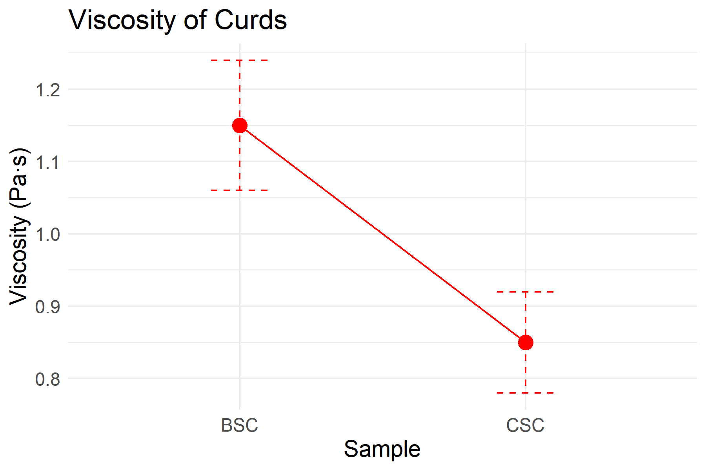

Figure 4 Syneresis of Curds
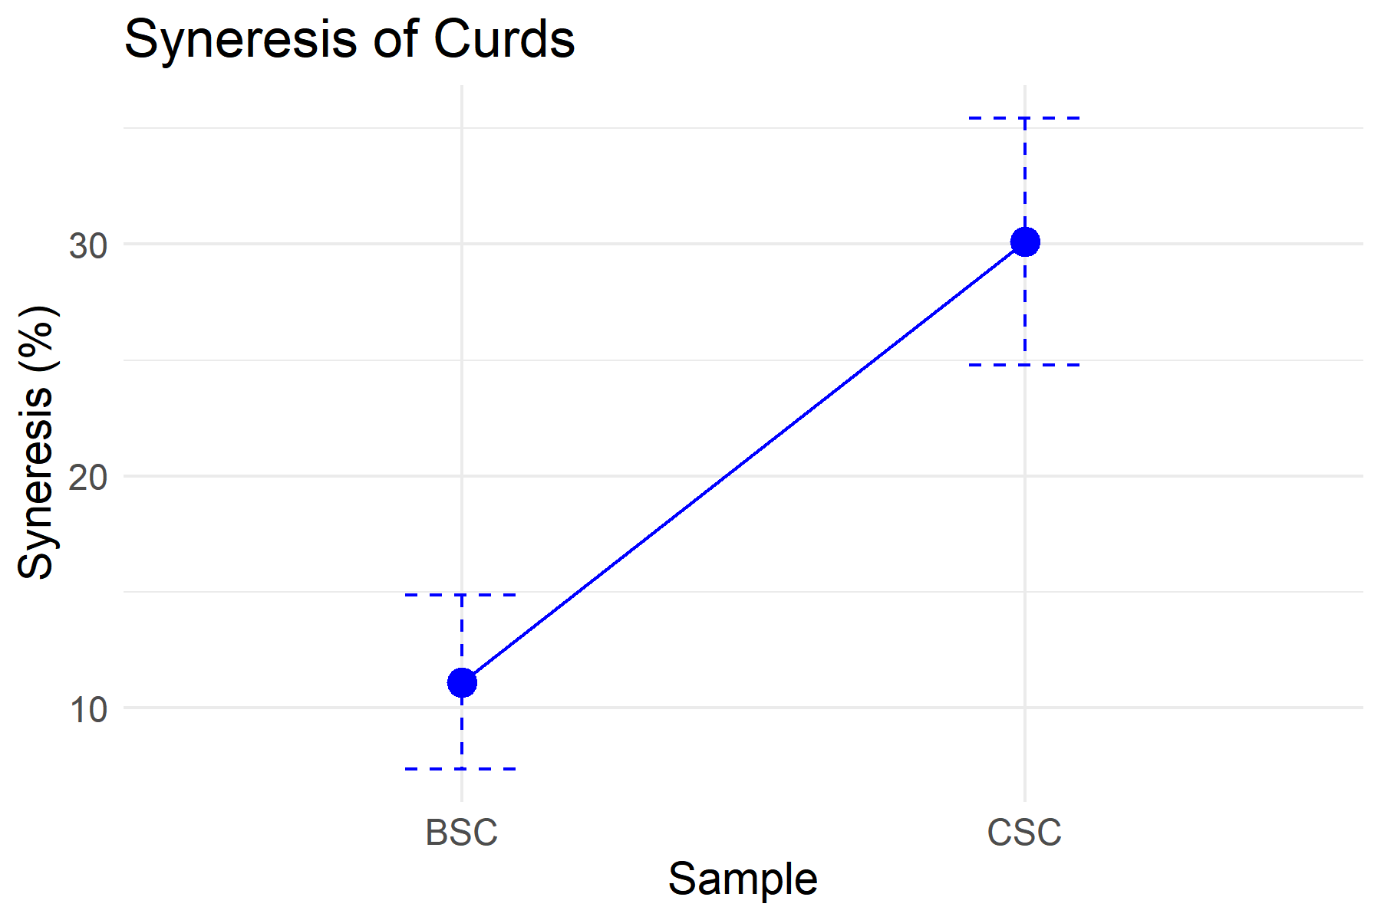

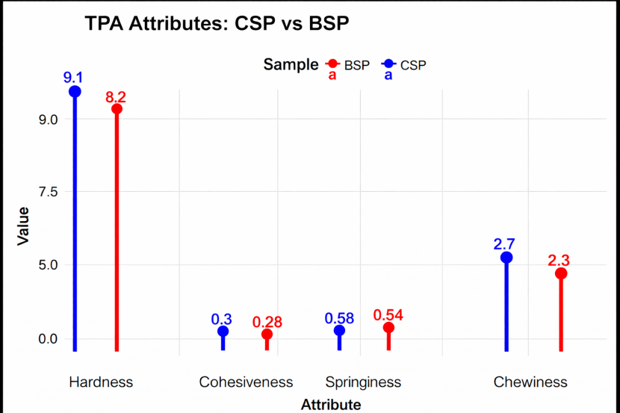
Figure 5 Texture Profile Analysis of Paneer

  - Nutritional analysis
The proximate composition of the samples revealed significant differences (p<0.05) in moisture, fat, and protein contents between CSC and BSC formulations (Figure 6) as well as between CSP and BSP formulations (Figure 7).
The BSC sample recorded the highest moisture content (85.63 ± 0.06), while CSC showed comparatively lower moisture (83.03 ± 4.02). The BSP sample recorded the highest moisture content (58.00 ± 2.23%), while CSP showed comparatively lower moisture (55.55 ± 5.57%).
3.4.2 Fat
In contrast, fat content was significantly higher in CSC (3.64 ± 0.07) compared to BSC (1.95 ± 0.01), reflecting the contribution of coconut milk to the formulation. Fat content was slightly higher in CSP (11.9 ± 3.10%) compared to BSP (11.05 ± 0.51%), reflecting the contribution of coconut milk to the blend.
3.4.3 Protein
Protein content was highest in CSC (5.30 ± 0.12), followed by BSC (4.55 ± 0.10), which may be attributed to differences in the proportion of plant-based raw materials used. Protein content was highest in CSP (8.23 ± 2.12%), followed by BSP (5.91 ± 0.53%), which may be attributed to the relatively greater protein contribution of soy milk in the coconut–soy formulation compared to the brown rice–soy formulation
Figure 6 Nutritional analysis of Curds
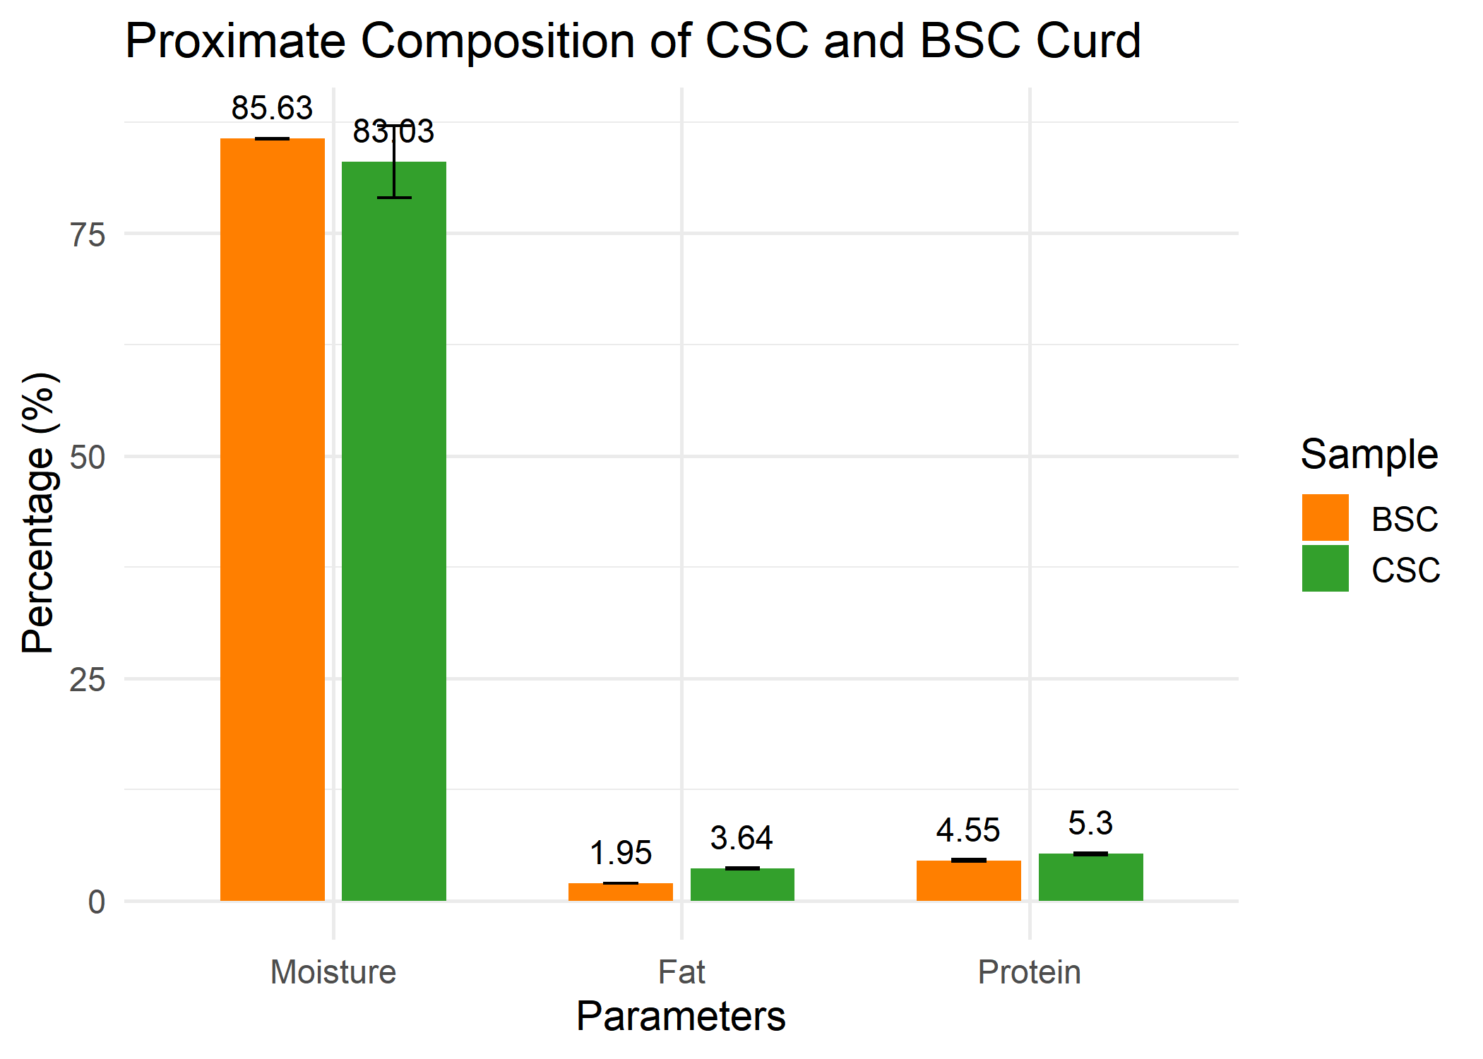

Figure 7 Nutritional analysis of Paneer
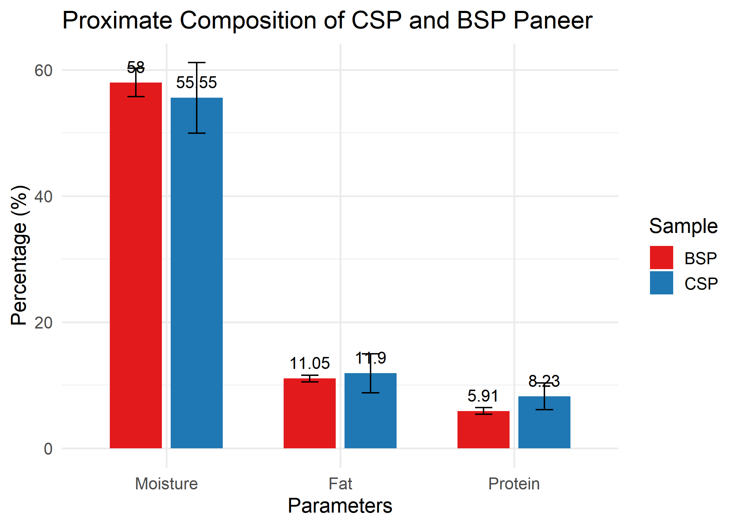

- DISCUSSION
In the present study, both CSC and BSC formulations showed high sensory scores across all attributes, with overall acceptability values of 8.00 ± 0.76 and 7.60 ± 0.43, respectively, while CSP and BSP also recorded comparable overall acceptability scores (8.00 ± 0.40 and 7.92 ± 0.27). These findings are in agreement with earlier reports on plant-based fermented products, where blends of plant-derived ingredients such as soybean and millets were found to compete favorably with conventional formulations in terms of color, texture, flavor, and overall acceptability (16). In the cited study, although soybean-based yogurts exhibited slightly lower scores due to beany notes, they still demonstrated the potential of plant-based systems to provide acceptable sensory characteristics. Similarly, in the present work, incorporation of coconut milk and brown rice beverage not only maintained sensory attributes above 7.5 for all parameters but also achieved overall acceptability scores above 7.9, indicating strong consumer preference.
The colour analysis revealed that CSC exhibited the highest lightness among the studied samples, coupled with relatively low redness and moderate yellowness, indicating a bright, lightly yellow product. CSP showed slightly lower lightness with a mild increase in a* and b*, while BSC and BSP demonstrated further reductions in lightness alongside increasing redness and yellowness. These observations suggest that cow milk products tend to retain superior brightness and more balanced colour compared to plant-based formulations, likely due to the intrinsic composition of milk proteins and fat globules that influence light scattering and pigment retention.Comparable trends have been reported in previous studies. For instance, cow’s cheese was reported to have higher lightness (L = 82.6 ± 9.2) with moderate redness and yellowness (a = 0.3 ± 9.1; b = 17.4 ± 10.0), confirming that cow milk products generally maintain better whiteness and balanced colour than plant-based alternatives (17). Similarly, in soy-based products, soy tofu exhibited L*, a*, and b* values of 75.51 ± 0.02, 0.18 ± 0.05, and 23.75 ± 0.01, respectively, reflecting a darker, more yellowish appearance, which aligns with the higher b* values observed in BSC and BSP in the present study (18). These comparisons underscore that plant-based formulations often exhibit reduced lightness and elevated yellowness, attributable to natural plant pigments and lower protein-induced light scattering, while cow milk products maintain a brighter and more uniform colour profile.
The physicochemical analysis showed slight variations in pH, titratable acidity, and total soluble solids (TSS) across the curds and paneers. Among the coconut- and brown rice-based formulations, CSC exhibited relatively higher pH and acidity compared to BSC, while CSP and BSP recorded slightly lower values. These differences likely reflect the intrinsic composition of the substrates, including their buffering capacity and soluble solids content.Comparable trends have been reported in earlier studies. Marlapati et al., (2024) observed that commercial coconut curd had a pH of 4.2 ± 0.1 and acidity of 0.3 ± 0.0, indicating that coconut-based products generally maintain moderate acidity suitable for consumption (19). Similarly, TSS levels in the current study (13.20–14.50 °Brix) align with those reported by Naz et al., (2023), who recorded 12.26–17.50 °Brix in non-dairy yogurts made from alternative substrates, reflecting the contribution of soluble sugars from coconut milk and proteins from soy or rice to total solids (20). These observations are consistent with the findings of Cáceres et al., (2019), who reported TSS values of 14.93–15.23 °Brix in yogurt-like products prepared from germinated brown rice (20).
The water-holding capacity and flow properties of the coconut- and brown rice-based curds, as reflected by syneresis and viscosity, demonstrate the impact of substrate composition on gel structure. CSC exhibited higher syneresis (~30%) and lower viscosity (~0.85 Pa·s), indicating weaker gel formation and reduced water retention, which is consistent with observations in coconut-based fermented systems where whey separation is a common challenge unless stabilizers are added (21,22). Similar high syneresis values have been reported in soy yogurt systems (~34–43%) depending on formulation , suggesting that plant-based proteins alone may not fully prevent whey separation (23).
In contrast, BSC showed significantly lower syneresis (~11%) and higher viscosity (~1.15 Pa·s), reflecting improved gel strength and water retention. This aligns with findings from cereal-based yogurt studies, where rice or starch incorporation enhances gel network formation, reducing whey separation (24). The increased viscosity observed in BSC is consistent with reports that cereal/starch additions elevate yogurt viscosity via higher consistency coefficients (25). Comparatively, the viscosity of CSC (~850 cP) falls within typical ranges for plant-based yogurts measured under similar low-shear conditions (26), whereas BSC approaches the viscosity of conventional dairy yogurts (1,180–1,380 cP) reported using Brookfield viscometry (27) .Overall, these results suggest that brown rice incorporation enhances gel strength and viscosity, improving water-holding capacity and texture in plant-based curds, while coconut-based systems remain more prone to syneresis unless formulation adjustments or stabilizers are applied.
The Texture Profile Analysis demonstrated that CSP exhibited higher hardness, cohesiveness, springiness, and chewiness compared to BSP, indicating a firmer and more elastic gel structure. These results are consistent with observations from studies on fermented rice milk-based paneers, where inclusion of rice fractions slightly reduces hardness and chewiness due to altered gel network formation (28).
Comparative studies with other plant-based protein systems further contextualize these findings. Pea paneer, while achieving higher firmness, displayed reduced elasticity and chewiness, suggesting that pea proteins contribute to a dense gel at the cost of springiness (29). Tofu similarly forms a very firm and compact gel, but its reduced tenderness highlights the trade-off between gel density and palatability. Soy paneer formulations also show that increasing soy content enhances hardness but may compromise cohesiveness and chewiness, with pure soy gels being firmer yet less elastic.
In comparison, the coconut paneer in the present study balanced firmness with improved elasticity and chewiness, likely due to the presence of coconut milk fat, which softens the protein network and contributes to creaminess. This combination results in a gel matrix that is sensory-acceptable, with sufficient firmness to maintain structure while retaining chewiness and springiness, making it superior to purely soy-based or pea-based gels in terms of overall textural quality.
In the present study, the coconut:soy curd (CSC, 60:40) contained 83.03 ± 4.02% moisture, 3.64 ± 0.07% fat, and 5.30 ± 0.12% protein, while the brown rice:soy curd (BSC, 60:40) showed 85.63 ± 0.06% moisture, 1.95 ± 0.01% fat, and 4.55 ± 0.10% protein. These values fall within the ranges reported for plant-based yoghurts in earlier studies. For example, coconut yoghurt, tiger nut yoghurt, and their composite blends exhibited moisture contents of 83.52–83.80%, fat contents of 3.35–4.18%, and protein values of 4.87–6.67% (30). Similarly, soymilk, cow–soy composite, and commercial yoghurts recorded protein levels of 6.23–7.09% and fat contents of 3.59–4.79% (Stephen, 2017), while brown rice beverages were reported to have only 0.37–0.54% fat and 0.8–0.9% protein (31).
The proximate composition of coconut paneer in the present study was 55.55 ± 5.57% moisture, 11.9 ± 3.10% fat, and 8.23 ± 2.12% protein, which closely aligns with the Coconut Development Board report of 56.2% moisture, 12.2% fat, and 9.43% protein for coconut–soy paneer (50:50), indicating consistency across coconut-based formulations. Similarly, the brown rice–soy paneer (60:40) showed 58.0 ± 2.23% moisture, 11.05 ± 0.51% fat, and 5.91 ± 0.53% protein, results that are in agreement with earlier studies on plant-based paneers. For instance, coconut–soy paneer values of 55.5% moisture, 11.9% fat, and 8.2% protein observed in the present work also matched those of the Coconut Development Board (56.2% moisture, 12.2% fat, 9.4% protein) (32). Compared to these reports, the brown rice–soy paneer exhibited slightly higher moisture and reduced protein, reflecting the naturally low protein contribution of rice, while maintaining fat levels similar to coconut-based formulations. Overall, the results confirm that both coconut- and brown rice–soy paneer formulations fall within the proximate ranges previously reported for plant-based dairy alternatives, supporting their nutritional viability.
The study was limited on using coconut and brown rice as plant substrates, providing a strong foundation, while future research can further expand the scope by exploring additional plant sources such as almond, oat, and millet for broader comparative insights. The nutritional evaluation was limited to proximate composition, offering essential baseline information, and can be further strengthened in future studies through detailed profiling of micronutrients, amino acids, and bioactive compounds.
- CONCLUSION
The present study confirms that coconut–soy and brown rice–soy composite formulations are highly suitable for the development of plant-based curd and paneer with excellent sensory quality, desirable physicochemical properties, and satisfactory nutritional composition. All formulations achieved high overall acceptability scores, reflecting strong consumer preference. Brown rice–soy systems demonstrated enhanced gel strength, viscosity, and water-holding capacity, while coconut-based formulations contributed desirable textural attributes, including firmness, elasticity, and chewiness. The colour characteristics of the plant-based products were stable and visually appealing, consistent with their natural ingredient composition. Proximate analysis further established that both curd and paneer formulations possessed moisture, fat, and protein contents within acceptable ranges for plant-based dairy alternatives. Overall, the findings validate the technological feasibility and consumer acceptability of coconut- and brown rice–soy composites, supporting their potential for wider application as nutritious and functional plant-based alternatives to conventional dairy products.

DECLARATION OF CONFLICT OF INTERESTS
The author(s) declared no potential conflicts of interest with respect to the research, authorship, and/or publication of this article.

Disclaimer (Artificial intelligence)

Author(s) hereby declare that NO generative AI technologies such as Large Language Models (ChatGPT, COPILOT, etc.) and text-to-image generators have been used during the writing or editing of this manuscript.

REFERENCES
- Plamada, D., Teleky, B. E., Nemes, S. A., Mitrea, L., Szabo, K., Călinoiu, L. F., ... & Nitescu, M. (2023). Plant-based dairy alternatives—A future direction to the milky way. Foods, 12(9), 1883.
- Pachekrepapol, U., Kokhuenkhan, Y., & Ongsawat, J. (2021). Formulation of yogurt-like product from coconut milk and evalua
- Rashwan, A. K., Osman, A. I., & Chen, W. (2023). Natural nutraceuticals for enhancing yogurt properties: a review. Environmental Chemistry Letters, 21(3), 1907-1931.
- Hozzein, W. N., Hisham, S. M., & Alkhalifah, D. H. M. (2023). A sustainable method: Production of the fermented rice milk yogurt by using three efficient lactic acid bacteria. Applied Sciences, 13(2), 907.
- Dhakal, D., Younas, T., Bhusal, R. P., Devkota, L., Henry, C. J., & Dhital, S. (2023). Design rules of plant-based yoghurt-mimic: Formulation, functionality, sensory profile and nutritional value. Food Hydrocolloids, 142, 108786.
- Meilgaard, M., Civile, G. V and Carr, B.T. 1999. Sensory Evaluation Technique. 3rd Ed.CRC press, Boca Raton.
- Granato, D., Ribeiro, J.C.B., Castro, I.A and Masson, M.L. 2010. Sensory evaluation and physicochemical optimisation of soy-based desserts using response surface methodology.Food Chemistry.121(3): 899-906.
- Karaaslan, S. N and Tuncer, I. K. 2008. Development of a drying model for combined microwave–fan-assisted convection drying of spinach.Biosystems Engineering. 100 (1): 44-52.
- Hunter lab 2013. Hunter Associate Laboratory. Manual version – 2.1. 60: 1014-1593
- Kathiravan, T., Nadanasabapathi, S. and Kumar, R. 2014. Standardization of process condition in batch thermal pasteurization and its effect on antioxidant, pigment and microbial inactivation of Ready to Drink (RTD) beetroot (Beta vulgaris L.) juice. International Food Research Journal. 21(4): 1305-1312.
- AOAC. 2000. Official method of analysis, Association of Official Analysis Chemists. 17th Edition. Washington DC. USA.
- Hadi, A. D and Norrakiah, A. S. (2017). The Interaction Effect of Mixing Starter Cultures on Homemade Natural Yogurt's pH and Viscosity. International Journal of Food Studies. 6: 152-158.
- Malaka, R., Murphi Ningrum, E., & Hajrawati, H. (2020). Yoghurt Syneresis with Addition of Agar as Stabilizer. Hasanuddin J. Anim. Sci. 2(1): 43-51.
- Dongare, S. A., Dige, Y. P. and Syed, H. M. (2019). Storage study and textural profile analysis of paneer at different temperature. Journal of Pharmacognosy and Phytochemistry. 8(2): 864 868.
- AOAC. 2005. Determination of Moisture, Ash, Protein and Fat. Official method of analysis. Association of Official Analysis Chemists. 18th Edition. Washington DC. USA.
- Stephen, E. C., Silas, T. V., & Iorlumun, I. (2017). Comparative studies on the nutritional and physicochemical properties of yoghurts.
- Milovanovic, B., Djekic, I., Miocinovic, J., Djordjevic, V., Lorenzo, J. M., Barba, F. J., ... & Tomasevic, I. (2020). What is the color of milk and dairy products and how is it measured?. Foods, 9(11), 1629.
- De, B., Shrivastav, A., Das, T., & Goswami, T. K. (2022). Physicochemical and nutritional assessment of soy milk and soymilk products and comparative evaluation of their effects on blood gluco-lipid profile. Applied Food Research, 2(2), 100146.
- Marlapati, L., Basha, R. F., Navarre, A., Kinchla, A. J., & Nolden, A. A. (2024). Comparison of physical and compositional attributes between commercial plant-based and dairy yogurts. Foods, 13(7), 984.
- Naz, H., Raza, N., Murtaza, S., Naz, A., & Farooq, U. (2023). Development and Quality Evaluation of Non-Dairy Yogurts: Evaluation of Non-Dairy Yogurts. DIET FACTOR (Journal of Nutritional and Food Sciences), 06-12.
- Mauro, C. S. I., Fernandes, M. T. C., Farinazzo, F. S., & Garcia, S. (2022). Characterization of a fermented coconut milk product with and without strawberry pulp. Journal of Food Science and Technology, 59(7), 2804-2812.
- Rana, M. R., Babor, M., & Sabuz, A. A. (2021). Traceability of sweeteners in soy yogurt using linear discriminant analysis of physicochemical and sensory parameters. Journal of Agriculture and Food Research, 5, 100155.
- COSTA, K. K. F. D., PERTUZATTI, P. B., OLIVEIRA, T. F. D., CALIARI, M., & SOARES, M. S. (2017). Syneresis and chemical characteristics of fermented rice extract with probiotic bacteria and waxy maize starch. Food Science and Technology, 37(4), 640-646.
- Saleh, A., Mohamed, A. A., Alamri, M. S., Hussain, S., Qasem, A. A., & Ibraheem, M. A. (2020). Effect of different starches on the rheological, sensory and storage attributes of non-fat set yogurt. Foods, 9(1), 61.
- Izadi, Z., Nasirpour, A., Garoosi, G. A., & Tamjidi, F. (2015). Rheological and physical properties of yogurt enriched with phytosterol during storage. Journal of Food Science and Technology, 52(8), 5341-5346.
- Kaur, R., & Riar, C. S. (2020). Sensory, rheological and chemical characteristics during storage of set type full fat yoghurt fortified with barley β-glucan. Journal of food science and technology, 57(1), 41-51.
- Amini, R. K., Islam, M. Z., Kitamura, Y., & Kokawa, M. (2019). Utilization of fermented rice milk as a novel coagulant for development of paneer (soft cheese). Foods, 8(8), 339.
- Yeshfeen, A., Roy, K., Nayak, M., Gurikar, C., & KN, H. (2025). Vegan Paneer–A Dairy-Free Alternative. International Journal of Environment, Agriculture and Biotechnology, 10(3), 617428.
- Punoo, H. A., Shafi, M., & Baba, W. N. (2017). Textural, Physico-chemical, Micro-structural and Antioxidant Properties of Soy Paneer prepared from admixtures of Skim cow milk and Soymilk. Int. J. Adv. Res. Sci. Eng, 6, 387-400.
- Ezeonu, C. S., Tatah, V. S., Nwokwu, C. D., & Jackson, S. M. (2016). Quantification of physicochemical components in yoghurts from coconut, tiger nut and fresh cow milk. Advances in Biotechnology and Microbiology, 1(5), 555573.
- Cáceres, P. J., Peñas, E., Martínez-Villaluenga, C., García-Mora, P., & Frías, J. (2019). Development of a multifunctional yogurt-like product from germinated brown rice. Lwt, 99, 306-312.
- Director, C. P. C. R. I., Kumar, N., Rath, B., Bhat, R., Hubballi, V. N., Das, S. S., ... & John, S. S. (2021). Kochi-11 Advisory Board.

