Original Research Article

AFLP Analyses of Genetic Divergence in Indian Potato Varieties

.
ABSTRACT
Potato (Solanum tuberosum L.) has a narrow genetic base due to limited parental diversity, posing challenges for crop improvement and stress resilience. Molecular marker techniques like AFLP offer a powerful approach to assess genetic diversity and support effective breeding strategies in potato. The objective of this study was to assess genetic diversity among Indian potato cultivar using AFLP markers. Twenty commercial Indian potato varieties analysed using semi-automated AFLP revealed moderately wide genetic base (similarity index range 0.54-0.74). Three AFLP primer pairs analyzed (MseI CAG x EcoRI ACT-FAM, MseI CAG x EcoRI AAC-NED, MseI CAG x EcoRI ACG-JOE) amplified a total of 346 alleles of which 96 were highly informative, 19 unique and 6 were monomorphic alleles. On average there were 163 alleles per genotype, ranging from 136 in Gulabia to 215 alleles in Kufri Chipsona2. Dendrogram analysis revealed four clusters with three microclusters with single variety each (Kufri Sindhuri, Kufri Chipsona2 and Kufri Dewa), and a megacluster comprising of rest all cultivars studied. Within this megacluster, a separate sub-cluster was represented by varieties released during 1958-1971, from Solanum demissum, R-gene-derived late blight resistance programme. In 2D PCO scatter plot, four varieties (Kufri Sindhuri; Kufri Chipsona2; Kufri Dewa and Kufri Safed) were very distinct from rest defined by first component. Kufri Safed derived from landrace Phulwa (S. tuberosum ssp. andigena), was distinct along both components of scatter plot analysis. In addition, neotubersum cultivars, Kufri Chipsona1, Kufri Kanchan, Kufri Anand, Kufri Swarna and landrace Gulalbia also exhibited significant divergence. Overall, the late blight resistance programme varieties showed narrow genetic base, while most of the recent neotubersum cultivars and those of ssp. andigena landraces showed higher diversity.

Keywords: Solanum tuberosum L., AFLP Analyses, Genetic Divergence, crop improvement

1. INTRODUCTION

The cultivated potato, Solanum tuberosum, is a tetraploid species comprising two principal subspecies, namely ssp. tuberosum, which is adapted to long-day photoperiods, and ssp. andigena, which is suited to short-day conditions. The majority of contemporary potato (Solanum tuberosum L.) cultivars have been developed through hybridisation and selection involving a limited number of andigena-derived parental lines that were introduced into temperate regions approximately three centuries ago. Consequently, the modern cultivated gene pool is characterised by a relatively narrow genetic base, which has important implications for breeding, adaptability, and resilience (Bhardwaj et al., 2023; Spanoghe et al., 2022).
The introduction of potato into India occurred roughly four decades after its initial dissemination in Europe (Singh & Dutt, 2024). Early introductions included several European cultivars belonging to ssp. tuberosum, particularly in the temperate hill regions where agro-climatic conditions were favourable. Over time, however, these initial cultivars have been largely superseded by improved varieties developed through systematic breeding efforts, notably by the Central Potato Research Institute, Shimla. To date, this institute has released approximately 35 improved cultivars with enhanced agronomic performance and adaptability.
At present, India is a major global producer of potato, cultivating the crop over an area of approximately 1.3 million hectares and achieving an annual production of around 24 million tonnes. This positions the country fourth in terms of cultivated area and third in overall potato production worldwide, underscoring its significant role in global potato agriculture.
The genetic base of Indian potato cultivars developed over the past five decades can be traced to approximately 70 parental lines. Notably, the majority of these progenitors comprise tetraploid cultivars, with only minimal representation from Solanum tuberosum ssp. andigena and other wild or primitive cultivated species (Chaudhary et al., 2024). This restricted utilisation of diverse germplasm has contributed to a relatively narrow breeding base. In this context, there is a clear need to enhance the incorporation of S. tuberosum ssp. andigena, which is inherently adapted to short-day conditions and is therefore particularly suitable for cultivation in the subtropical plains.
Recent advances in molecular biology have provided valuable insights into the adaptive potential of andigena germplasm. Comparative transcriptome analyses of Andigenum varieties have demonstrated rapid up-regulation of abscisic acid (ABA)-responsive genes in tolerant genotypes, thereby elucidating a potential molecular mechanism underpinning drought tolerance. These findings offer a promising foundation for the development of climate-resilient potato cultivars tailored to water-limited subtropical environments (Ponce et al., 2022). Nevertheless, the limited exploitation of wild and primitive cultivated species in breeding programmes remains a significant constraint, largely due to the extended time required to develop agronomically desirable parental lines from such genetic resources.
Potato breeding is inherently complex, owing to several biological and genetic constraints, including cytoplasmic–nuclear sterility, tetrasomic inheritance, and pronounced inbreeding depression. Consequently, conventional breeding approaches rely heavily on the careful identification of suitable parental lines for hybridisation, followed by the generation of genetic variability through controlled crosses. Subsequent selection of superior recombinants is undertaken through rigorous evaluation, with promising genotypes propagated vegetatively to maintain genetic fidelity.
Molecular markers have contributed extensively in understanding basic aspects of genome organization, genetic divergence and function during last two decades being simple, quick and informative. AFLP has become the main tool in molecular marker technology due to its capacity to reveal a high number of polymorphic alleles in a single reaction. In addition, AFLP involves use of a set of generic primers without any prior knowledge of the origin and complexity of the genome sequence. It is primarily dominant (co-dominant if band intensity is compared) with good reproducibility which are distributed throughout the genome. AFLP markers have successfully been used for analyzing genetic diversity in many crop plant species; with these studies indicating that the AFLP technique is highly applicable for molecular discrimination at the species level. In Indian potato, few reports have been published on the analysis of the diversity viz., RAPD (Chakrabarti et al., 2001; Chimote et al., 2007), microsatellite (Chimote et al., 2004; Chimote et al., 2007, Bhardwaj et al., 2023), organelle genome specific (Chimote et al., 2008) and morphological characters (Gaur et al., 1978; Chimote et al., 2007). But no work has been reported using AFLP molecular techniques for evaluating genetic diversity in Indian potato. The present study was undertaken to evaluate the genetic diversity and relationships among Indian potato cultivars using AFLP marker technology, with the aim of supporting future breeding strategies.
2. material and methods

2.1 Plant DNA material: CTAB method (Doyle & Doyle; 1987) was used to isolate genomic DNA from fresh leaves of each of 20 Indian potato varieties grown from disease-free tubers in glasshouse under long summer days of Shimla (Latitude: 31.60-N, Longitude: 77.13-E, Altitude: 2202 msl). The amount of DNA was quantified by spectrophotometry and quality was checked by absorbance ratio at A260/280 and also by gel-electrophoresis. The varieties consisted of 1 local landrace; 1 exotic and 18 Indian potato varieties (Table 1).
Table 1. Potato varieties used in the study and their parentage.
SN | Variety | Female Parent | Male Parent | Year of release
Clonal selections
 | Kufri Safed | Clonal selection of Phulwa |  | 1958
Half sibs involving different common parents
 | Kufri Kundan | Ekishirazu | Katahdin | 1958
 | Kufri Dewa | Craig’s Defiance | Phulwa | 1973
 | Kufri Sindhuri | Kufri Red | Kufri Kundan | 1967
 | Kufri Muthu (SLB/Z785) | 3046 (1) | M109-3 | 1971
 | Kufri Swarna | Kufri Jyoti | (VTn)² 62.33.3 S.verneipedigree | 1985
 | Kufri Lauvkar | Serkov | Adina | 1972
 | Kufri Sherpa | Ultimus | Adina | 1983
 | Kufri Badshah | Kufri Jyoti | Kufri Alankar | 1979
 | Kufri Sutlej | Kufri Bahar | Kufri Alankar | 1996
Grand Half sibs (2182EF (7) and M 109-3 derived)
 | Kufri Jyoti (SLB/Z389) | 3069d (4) (2182EF (7) x M109-3) | 2814a (1) | 1968
Varieties with distinct parents
 | Kufri Chandramukhi | Sd. 4485 | Kufri Kuber | 1968
 | Kufri Megha | SLB/K-37 | SLB/Z-73 | 1989
 | Kufri Chipsona 1 | MEX.750826 | MS/78-79 (Kufri Jyoti x EM/H-1601) | 1998
 | Kufri Chipsona 2 | F-6 (C 2346) | QB/B 92-4 (Kufri Red x Navajo) | 1998
 | Kufri Anand | Kufri Ashoka | PH/F-1430 | 1999
 | Kufri Kanchan | SLB/Z-405(a) | Pimpernel | 2000

2.2 AFLP analysis: The AFLP reactions (Vos et al; 1995) were carried out following the instructions supplied with the ABI AFLP kit system (PE Applied Biosystems). Simultaneous restriction-ligation reactions were performed overnight at 25°C by double digesting genomic DNA (250 ng) with MseI and EcoRI restriction enzymes (1.0 unit each); EcoRI and MseI adapters were ligated to the digested DNA samples by T4 DNA ligase (0.25 unit) to generate template DNA for amplification. A fraction of the digested DNA was checked on a 1.5% (w/v) agarose gel to ensure check for complete DNA digestion. The restricted-ligated samples were incubated at 75ºC for 15 min to inactivate the restriction endonucleases.
Pre-selective amplification was carried out with adapters +1- primers each carrying one selective nucleotide (EcoRI adapter+A and MseRI adapter+C) in a thermocycler for 20 cycles set at 94ºC denaturation (30 sec), 56ºC annealing (30 sec), and 72ºC extension (30 sec). The initial denaturation was done at 94ºC for 30 sec and the final extension at 72ºC for 8 min. The pre-amplification products were diluted 20-fold in TE buffer and stored at -20ºC; and a fraction of each sample was checked on a 1.5% (w/v) agarose gel to check for pre-selective amplification.
Selective amplified fragment length polymorphism (AFLP) analysis was performed using 5′ fluorescently labelled EcoRI adapter–primer combinations alongside unlabelled MseI adapter–primer combinations. Specifically, three EcoRI primers—6-FAM–EcoRI ACT, NED–EcoRI AAC, and JOE–EcoRI ACG—were employed in conjunction with the MseI CAG primer. The selective amplification utilised 5 µL of diluted PCR product obtained from the pre-amplification step. Based on their previously reported informativeness in solanaceous crops, three primer pair combinations (MseI CAG × EcoRI ACT; MseI CAG × EcoRI AAC; and MseI CAG × EcoRI ACG) were selected from the AFLP Selective Amplification Kit developed by Applied Biosystems.
Polymerase chain reaction (PCR) amplification was conducted using a touchdown protocol to enhance specificity. The initial phase comprised 13 cycles, during which the annealing temperature was progressively reduced by 0.7°C per cycle, starting from 65°C and reaching a final touchdown temperature of 56°C. Each cycle consisted of denaturation at 94°C for 30 seconds, annealing at the specified temperature for 30 seconds, and extension at 72°C for 1 minute. Following attainment of the touchdown annealing temperature, an additional 20 amplification cycles were performed under conditions consistent with those used in the pre-amplification step.
Post-amplification processing involved differential dilution of fluorescently labelled products to facilitate multiplexing. JOE-labelled reactions were diluted 100-fold, FAM-labelled reactions 5-fold, while NED-labelled reactions were used without dilution. For fragment analysis, a mixture containing 12 µL of deionised formamide, 0.4 µL of GeneScan™ 500 ROX size standard (Applied Biosystems), and 1 µL of each appropriately diluted sample was prepared in PCR tubes. Capillary electrophoresis was subsequently carried out using the ABI Prism 310 Genetic Analyzer (Applied Biosystems), following established protocols (Chimote et al., 2004).
2.3 Diversity analysis of AFLP data: The AFLP fragments scored after Diversity Database analysis and the peak positions of AFLP alleles identified using Genotyper ® 2.5 were recorded as 1 (band/peak present) and 0 (band/peak absent). All AFLP reactions were performed in duplicate, and only clear, reproducible peaks observed across replicates were considered for analysis to ensure data reliability. The binary data were analyzed under the SIMQUAL module of NTSYSpc version 2.02e (Rohlf; 1998) using Dice coefficient (Nei & Li; 1979). A peak threshold of ≥50 RFU and fragment size of 50–400 bp were scored and skipped low-intensity peaks. SAHN module based on UPGMA clustering method (Sneith & Sokal; 1973) was used to generate a tree (dendrogram).

3. results and discussion

AFLP analysis of the genomic DNA of twenty potato cultivars, with three AFLP markers, produced a total of 346 peaks/ alleles ranging in size from 50 to 400 bp. The mean number of alleles per variety was 163, ranging from a least of 136 alleles in oldest landrace Gulabia to a maximum of 215 alleles in processing variety Kufri Chipsona-2. The number of alleles detected by individual AFLP marker varied from- 134with MseI CAG x EcoRI AAC-NED, 116 alleles with MseI CAG x EcoRI ACG-JOE and 96 alleles with MseI CAG x EcoRI ACT-FAM. Out of them, 96 alleles (27.7%) were highly polymorphic (present in 40-60% samples), and 187 alleles were moderately polymorphic (present/absent in 10-40% samples). Out of the 83 (18.2%) less polymorphic alleles (Present/absent in <10% samples), 6 (1.73%) were monomorphic, and 19 (5.49 %) were unique in their profile.
All AFLP markers were highly informative, capable of distinguishing all varieties studied. All twenty varieties could be clearly grouped into 1 major and three minor clusters on the dendrogram (Figure 1), with similarity values ranging from 0.54-0.74. Kufri Chipsona2 (202 alleles), Kufri Sindhuri (144 alleles), and Kufri Dewa (171 alleles), were the most distinct potato cultivars with each forming single mono-genotype clusters. These cultivars have andigena pedigree (Glendinning, 1975). The large mega cluster (SI =0.67-0.74) had closely grouped cultivars released between 1958 and 1971 (except Kufri Sherpa released in 1983) with British pedigree. All these varieties (except Kufri Safed and Kufri Kundan) have Solanum demissum derived R gene from Scottish Crop Research Institute, UK (SLB series). Rest of varieties formed divergent minor clusters and are of neotuberosum type (except landrace Gulabia) released in between 1985 and 2000.
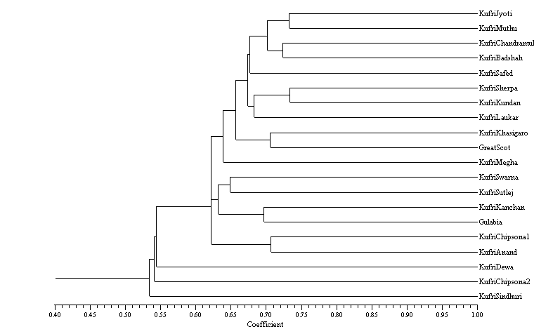Fig. 1. Dendrogram illustrating the genetic relationships among 20 Indian potato cultivars (Solanum tuberosum) based on AFLP marker analysis, generated using the UPGMA clustering method.

The present findings are consistent with earlier observations reported by Chimote et al. (2007), wherein Indian potato cultivars were categorised into three distinct genetic groups. Varieties possessing late blight resistance derived from Solanum demissum were clustered closely, reflecting their relatively narrow genetic background. In contrast, andigena-type varieties released prior to the initiation of organised late blight resistance breeding programmes exhibited a comparatively broader genetic diversity. A third group, comprising traditional tuberosum cultivars as well as more recently developed neotuberosum lines, displayed an overlapping pattern, indicative of shared ancestry and genetic admixture.
Furthermore, most of the older andigena-type varieties—such as Kufri Red, Kufri Safed, Kufri Lalima, Kufri Sindhuri, Kufri Bahar, Kufri Dewa, Kufri Sheetman, and Kufri Chamatkar—are known to include local cultivars within their pedigree, with the notable exception of Kufri Kuber. This highlights the historical incorporation of indigenous germplasm in early breeding efforts.
A substantial number of varieties released since the late 1960s possess late blight resistance introgressed from S. demissum and are largely derived from a relatively limited germplasm pool sourced from the Scottish Crop Research Institute (SCRI), United Kingdom. These include cultivars belonging to the SLB series, such as Kufri Jyoti and Kufri Muthu, as well as their derivatives, including Kufri Swarna, Kufri Badshah, Kufri Megha, and Kufri Kanchan. Additionally, certain varieties—such as Kufri Badshah and Kufri Sutlej—trace their pedigree to the cultivar Kennebec, further illustrating the reliance on a restricted set of parental lines in Indian potato improvement programmes.
These studies have increased the understanding of the relatedness of potato cultivars. Cultivated potato has high level of heterozygosity thereby allows the distinction of the most cultivars by using almost any molecular marker technique. As expected from earlier reports, limited kinship/ parent–progeny relationship was observed in potato may be due complex genetic nature of potato.
Clear tuberosum varieties were placed in the same quarter of 2D-Scatter plot (positive half of both axis) forming two subgroups with first group comprising Kufri Badshah, Kufri Jyoti, Kufri Chandramukhi and KufriMuthu; while second subgroup comprised of Kufri Sherpa, Great Scot, Kufri Megha, Kufri Laukar, Kufri Kundan and partially to some extent Kufri Khasi Garo and Kufri Sutlej (Figure 2).
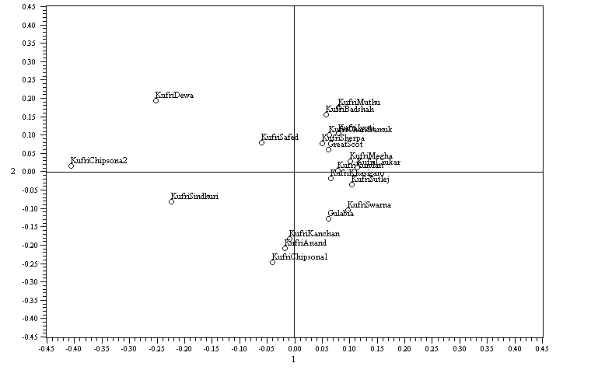 Fig. 2. Two-dimensional principal coordinate (PCO) scatter plot showing genetic relationships among 20 Indian potato cultivars (Solanum tuberosum) based on AFLP marker data.
There was a fringe group comprising Kufri Swarna (with S. vernei in paternal pedigree); Gulabia (Local red tuber landrace); with neo-tuberosum type Kufri Anand, Kufri Kanchan and Kufri Chipsona1 placed in 2D scatter plot quarter exactly opposite to clear tuberosum quarter. Most of the recently developed andigena-type cultivars are likely to represent neo-tuberosum clones, which have been derived through hybridisation between andigena and tuberosum, followed by intensive selection (Singh and Dutt, 2024; Simmonds et al., 1966). These genotypes exhibit several morphological traits that were historically characteristic of Indian tuberosum-type varieties, including resistance to late blight, early tuberisation, and the presence of shallow (‘fleet’) eyes. Such convergence in phenotypic traits reflects the outcomes of targeted breeding aimed at combining desirable agronomic attributes.
However, morphological similarity does not necessarily imply underlying genetic uniformity. Genotypes originating from distinct gene pools may display comparable phenotypes as a consequence of parallel selection pressures and breeding strategies. The observed lack of strong concordance between morphological classification and genotypic characterisation suggests that, despite apparent phenotypic similarities, the genetic base of recently released varieties may be more heterogeneous than previously assumed. This indicates that the gene pool utilised in contemporary potato breeding programmes is not as narrowly confined as morphological assessments alone might suggest.

Processing varieties studied i.e. Kufri Chipsona1 and Kufri Chipsona2, were most far placed along X and Y axis respectively. In our previous studies (Chimote et al., 2004) both were found to have andigena maternal parents; while later one has the same also from paternal side pedigree QB/B 92-4 (Kufri Red x Navajo).
Clear segregation of andigena and tuberosum germplasm from India into distinct clusters has been consistently documented in earlier studies based on both morphological traits (Gaur et al., 1978; Chimote et al., 2007) and molecular markers (Chimote et al., 2007). These investigations further demonstrated that tuberosum × andigena hybrids exhibit greater genetic divergence than tuberosum-derived exotic or Indian varieties and hybrids. This finding substantiates the premise that introgression from andigena into tuberosum significantly enhances the genetic variability of the breeding pool. In addition, simple sequence repeat (SSR) analyses have revealed that Indian potato cultivars tend to cluster with Chilean landraces, whereas Andean andigena types form a distinct and more genetically diverse group (Chimote et al., 2004).
In the present study, amplified fragment length polymorphism (AFLP) markers provided superior resolution for assessing genetic diversity. The high level of polymorphism and the ability to detect multiple allelic variants underscore the effectiveness of AFLP markers as robust tools for diversity analysis. Furthermore, the integration of automated fragment analysis platforms facilitates high-throughput and precise allele detection, thereby enabling the full potential of AFLP technology to be realised in molecular breeding programmes (Figure 3).
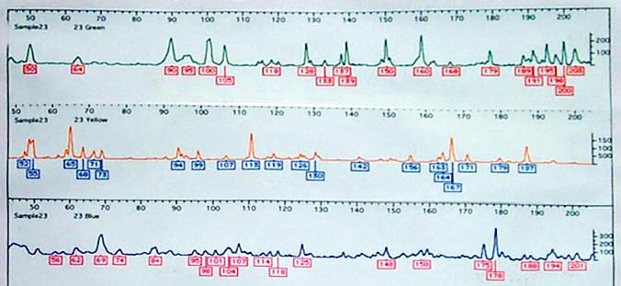
Fig. 3. Representative AFLP (Amplified Fragment Length Polymorphism) electropherogram showing the molecular "fingerprinting" to identify genetic variation.

The present study sought to evaluate the extent of genetic diversity and to elucidate the inter-relationships among Indian potato cultivars using the amplified fragment length polymorphism (AFLP) approach. The results underscore the limitations associated with reliance on a narrow range of resistance sources, particularly Solanum demissum, in breeding programmes aimed at developing late blight-resistant varieties. Accordingly, the utilisation of more diverse germplasm resources, beyond S. demissum, is recommended to broaden the genetic base and enhance the durability of resistance.
The systematic characterisation and documentation of genetic diversity among Indian potato cultivars generated in this study provide a valuable framework for the identification of genetically divergent parental lines. Such information is expected to support the design of more effective hybridisation strategies and contribute to the long-term sustainability of potato improvement programmes in India.
Nevertheless, while the present investigation offers important insights, a more comprehensive representation of the genetic diversity of Indian potato germplasm would require the inclusion of a larger number of cultivars and a wider array of molecular markers. Furthermore, the application of co-dominant marker systems would be advantageous, as these enable discrimination between homozygous and heterozygous loci, thereby providing a more refined understanding of genetic structure and allelic variation.

4. Conclusion
AFLP analysis of Solanum tuberosum revealed moderate genetic diversity among Indian cultivars, with clustering patterns reflecting pedigree and breeding history of limited usage of parental line. Varieties derived from Solanum demissum (incorporating resistance) showed a narrow genetic base. While, neotuberosum and andigena-derived types exhibited greater genetic divergence suggesting the contribution of diverse parental backgrounds. The study confirms the effectiveness of AFLP markers and highlights the need to broaden germplasm to strengthen future potato breeding programs.
Disclaimer (Artificial intelligence):

Author(s) hereby declare that NO generative AI technologies such as Large Language Models (ChatGPT, COPILOT, etc.) and text-to-image generators have been used during the writing or editing of this manuscript.

References
Bhardwaj, V., Kumar, A., Sharma, S., Singh, B., Poonam, Sood, S., Dipta, B., Singh, R., Siddappa, S., Thakur, A.K. & Dalamu, D. (2023). Analysis of genetic diversity, population structure and association mapping for late blight resistance in potato (Solanum tuberosum L.) accessions using SSR markers. Agronomy, 13(2), p.294.
Chakrabarti, S. K., Pattanayak, D., & Naik, P. S. (2001) Fingerprinting Indian potato cultivars by random amplified polymorphic DNA (RAPD) markers." Potato research 44(4), p.375-387.
Chaudhary, B., Gupta, V., Luthra, S. and Kumar, M. (2024). Morphological characterization of indigenous potato (Solanum tuberosum) genotypes. https://agris.fao.org/search/en/providers/122648/records/667195bc75507fed3402ca1e
Chimote, V. P., Chakrabarti, S. K., Pattanayak, D., & Naik, P. S. (2004). Semi-automated simple sequence repeat analysis reveals narrow genetic base in Indian potato cultivars. Biologia plantarum, 48(4), 517-522.
Chimote, V. P., Chakrabarti, S. K., Pattanayak, D., Pandey, S. K., & Naik, P. S. (2008). Molecular analysis of cytoplasm type in Indian potato varieties. Euphytica, 162(1), 69-80.
Chimote, V. P., Pattanayak, D., & Naik, P. S. (2007). Molecular and morphological divergence studies in Indian potato varieties. Indian Journal of Biotechnology, 6(2), 216.
Doyle, J. J., & Doyle, J. L. (1987). A rapid DNA isolation procedure for small quantities of fresh leaf tissue. Phytochemical bulletin, 19(1), p.11-15.
Gaur, P. C., Gupta, P. K., & Kishore, H. (1978). Studies on genetic divergence in potato. Euphytica, 27(2), 361-368.
Nei, M., & Li, W. H. (1979). Mathematical model for studying genetic variation in terms of restriction endonucleases. Proceedings of the National Academy of Sciences, 76(10), 5269-5273.
Ponce, O. P., Torres, Y., Prashar, A., Buell, R., Lozano, R., Orjeda, G. & Compton, L. (2022) Transcriptome profiling shows a rapid variety-specific response in two Andigenum potato varieties under drought stress. Front. Plant Sci. 13: 1003907.doi: 10.3389/fpls.2022.1003907
Rohlf, F. J. (1998). NTSYSpc numerical taxonomy and multivariate analysis system version 2.0 user guide. New York
Simmonds, N. W. (1966). Studies of the tetraploid potatoes. III. Progress in the experimental re-creation of the Tuberosum Group. Botanical Journal of the Linnean Society, 59(379), 279-288.
Singh, B. & Dutt, S. (2024). Seventy-five years of potato in India. Indian Farming; Vol. 74 No. 5 (2024): World Potato Day; 03-08, 0019-4786
Sneath, P. H. A., & Sokal, R. R. (1973). Numerical Taxonomy Freeman. The Principles and Practice of Numerical Classification. 1-573.
Spanoghe, M., Marique, T., Nirsha, A., Esnault, F. & Lanterbecq, D. (2022). Genetic diversity trends in the cultivated potato: a spatiotemporal overview. Biology, 11(4), p.604.
Vos, P., Hogers, R., Bleeker, M., Reijans, M., Lee, T. V. D., Hornes, M., ... & Zabeau, M. (1995). AFLP: a new technique for DNA fingerprinting. Nucleic acids research, 23(21), 4407-4414.

