Original Research Article

Bio-efficacy of Different Herbicides Against Cyperus spp. in Wet-Seeded Rice (WSR) and Their Effect on Rice Growth Parameters

Abstract
Direct-seeded rice (DSR) is emerging as a promising alternative to conventional puddled transplanted rice due to its lower labour, water, and energy requirements. However, severe weed infestation, particularly by Cyperus rotundus and other sedges, remains a major constraint limiting productivity under DSR systems. A field experiment was conducted at the Faculty of Agriculture, Wadura, SKUAST-Kashmir, to evaluate the bio-efficacy of different herbicides against Cyperus spp. and their influence on rice growth parameters and economic returns. The experimental soil was slightly acidic (pH 5.9), medium in available nitrogen (327 kg ha⁻¹), phosphorus (17.3 kg ha⁻¹), and potassium (248 kg ha⁻¹), with high organic carbon content (0.98%). The study was laid out in a randomized block design with nine treatments, comprising various pre- and post-emergence herbicides along with weedy check and weed-free controls, each replicated thrice. The treatments included halosulfuron (75 WG) @ 35 g ha⁻¹, bensulfuron-methyl (60 DF) @ 60 g ha⁻¹, cyhalofop-butyl (10 EC) @ 100 g ha⁻¹, bispyribac-sodium (10 SC) @ 30 g a.i. ha⁻¹, ethoxysulfuron (15 WDG) @ 45 g ha⁻¹, pretilachlor @ 700 g ha⁻¹, and pendimethalin (30 EC) followed by 2,4-D (58 SL) (0.75 + 1.0 kg ha⁻¹). Results revealed that weed management treatments significantly influenced crop growth parameters, except at early growth stages. Among the herbicidal treatments, post-emergence application of bispyribac-sodium @ 30 g a.i. ha⁻¹ proved most effective in suppressing mixed weed flora, including sedges, grasses, and broad-leaved weeds. This resulted in significantly higher plant height, leaf area index (LAI), and dry matter accumulation compared to other treatments. The weed-free treatment recorded the highest growth values; however, it was less economical due to higher labour costs. Economic analysis indicated that bispyribac-sodium @ 30 g a.i. ha⁻¹ achieved the highest net returns and benefit–cost ratio (1.49), demonstrating superior economic efficiency among herbicidal treatments. In contrast, the weedy check recorded the lowest growth and economic performance due to severe crop–weed competition. Overall, the study highlights that appropriate selection and timely application of herbicides, particularly bispyribac-sodium, can effectively manage Cyperus spp. and associated weed flora, improve crop growth, and enhance economic returns, thereby contributing to sustainable rice production under labour- and water-limited conditions.

Keywords: Cyperus spp., direct-seeded rice, herbicide efficacy, sedge control, weed management

1. Introduction
Rice (Oryza sativa L.) is one of the most important cereal crops and serves as the staple food for more than half of the world’s population. In India, rice is cultivated over approximately 43 million hectares, with an annual production of about 150 million tonnes and an average productivity ranging from 3.2 to 3.7 t ha⁻¹ (Singh and Ranguwal, 2024). Given its central role in ensuring food and nutritional security, sustaining rice productivity under changing climatic and resource-constrained conditions has become a major challenge. Conventionally, rice is grown under puddled transplanted rice (PTR) systems, which involve intensive tillage and continuous flooding. Although PTR ensures effective weed suppression and stable yields, it is increasingly considered unsustainable due to its excessive consumption of water, labour, and energy. Moreover, repeated puddling adversely affects soil physical properties, leading to deterioration in soil structure and reduced productivity of succeeding crops (Ojha and Kwatra, 2014). In recent years, direct-seeded rice (DSR) has emerged as a viable alternative to PTR, offering several advantages such as reduced labour requirement, lower water consumption, early crop maturity, reduced production costs, improved soil health, and decreased methane emissions (Kaur and Singh, 2017).
The adoption of DSR is particularly beneficial for small and marginal farmers, who often face constraints related to labour availability and rising input costs. Additionally, erratic monsoon patterns and delayed rainfall frequently disrupt transplanting operations, further encouraging the shift towards direct seeding (Singh and Singh, 2010). Depending on field conditions and water availability, rice can be established either through dry direct seeding or wet seeding methods. However, despite its advantages, DSR is highly susceptible to severe weed infestation due to the absence of standing water during early crop growth stages, which otherwise suppresses weed emergence in conventional systems. Weed infestation is one of the most critical constraints in direct-seeded rice, often resulting in yield losses ranging from 50 to 90%, and in extreme cases, complete crop failure (Kaur et al., 2024). The extent of yield reduction largely depends on the severity and duration of crop–weed competition during the growing season (Sardana et al., 2017). In DSR systems, the critical period of weed competition generally extends from 2 to 12 weeks after sowing, which is considerably longer than in transplanted rice systems (Singh et al., 2014). Among different weed groups, sedges, particularly Cyperus rotundus and related Cyperus species, pose a serious threat due to their aggressive growth, underground propagation, and persistence under diverse environmental conditions.
Traditionally, weed management in rice has relied heavily on manual weeding; however, this practice has become increasingly impractical due to labour scarcity and rising wage rates. Manual weed control is not only labour-intensive but also economically unviable under large-scale production systems (Rao et al., 2007). In contrast, chemical weed management through herbicides offers an efficient, cost-effective, and scalable alternative. Herbicides provide timely and selective control of weeds, reduce labour dependency, and ensure better crop establishment, thereby contributing to higher productivity (Chauhan, 2012).
A wide range of pre-emergence and post-emergence herbicides are currently available for weed management in direct-seeded rice. Among these, pendimethalin is commonly used as a pre-emergence herbicide that inhibits cell division and prevents early weed establishment (Pathak et al., 2011). Ethoxysulfuron, applied at the early post-emergence stage, is particularly effective against sedges and broad-leaved weeds due to its systemic mode of action (Pathak et al., 2011). Bispyribac-sodium has gained considerable importance as a post-emergence herbicide owing to its broad-spectrum activity against grasses, sedges, and broad-leaved weeds. It acts by inhibiting the enzyme acetolactate synthase (ALS), thereby disrupting amino acid biosynthesis and ultimately leading to plant death (Vencill, 2002). Its effectiveness under diverse agro-ecological conditions has been well documented (O’Barr et al., 2003).
Halosulfuron, a relatively newer herbicide, has shown promising results in controlling Cyperus rotundus and other sedge species, making it particularly useful in DSR systems characterized by mixed weed flora (Gianessi et al., 2002). Furthermore, sequential application of herbicides, such as cyhalofop-butyl followed by 2,4-D, has been reported to provide effective control of complex weed populations under Indian conditions (Angiras and Attri, 2002). Despite the availability of these herbicides, their comparative efficacy against Cyperus spp. and their influence on crop growth parameters under temperate agro-climatic conditions remain inadequately explored. Therefore, keeping in view the above facts, the present investigation was undertaken to evaluate the bio-efficacy of different herbicides against Cyperus spp. in direct-seeded rice and to assess their effect on crop growth parameters.

2. Materials and Methods
2.1 Experimental Site and Climatic Conditions
A field experiment was conducted during the Kharif season of 2019 at the Faculty of Agriculture, Sher-e-Kashmir University of Agricultural Sciences and Technology (SKUAST-Kashmir), Wadura. The experimental site is located at 34°34′ N latitude and 74°40′ E longitude, at an elevation of 1584 m above mean sea level, and falls under the mid-altitude temperate agro-climatic zone of the region.
The climate of the area is characterized by warm summers and severe winters. Based on long-term meteorological records (20 years), the region receives an average annual precipitation of approximately 812 mm, with the major share occurring between December and April in the form of rainfall and snowfall. During the cropping season, meteorological observations recorded at the Meteorological Observatory, Kupwara (Figure 1) indicated that the mean maximum and minimum temperatures were 33.34°C and 5.34°C, respectively. The total precipitation received during the crop growth period was 355.2 mm. The mean maximum relative humidity was 87.29%, while the mean minimum relative humidity remained around 44%.
2.2 Soil Characteristics
The soil of the experimental field was slightly acidic in reaction (pH 5.9), medium in available nitrogen (327 kg ha⁻¹), phosphorus (17.3 kg ha⁻¹), and potassium (248 kg ha⁻¹), and high in organic carbon content (0.98%). These soil conditions were considered suitable for evaluating herbicide performance and crop growth under direct-seeded rice conditions.
2.3 Experimental Design and Treatments
The experiment was laid out in a randomized block design (RBD) with nine treatments replicated three times. The treatments consisted of seven herbicidal treatments along with a weedy check and a weed-free control.
The herbicidal treatments included:
- Halosulfuron (75 WG) @ 35 g ha⁻¹
- Bensulfuron-methyl (60 DF) @ 60 g ha⁻¹
- Cyhalofop-butyl (10 EC) @ 100 g ha⁻¹
- Bispyribac-sodium (10 SC) @ 30 g a.i. ha⁻¹
- Ethoxysulfuron (15 WDG) @ 45 g ha⁻¹
- Pretilachlor @ 700 g ha⁻¹
- Pendimethalin (30 EC) followed by 2,4-D (58 SL) @ 0.75 + 1.0 kg ha⁻¹
In addition, two control treatments, namely weedy check and weed-free, were included for comparison.
2.4 Crop Establishment and Agronomic Practices
Pre-germinated rice seeds were manually sown in puddled soil by spot seeding at a spacing of 15 × 15 cm during the first week of May 2019. Standard agronomic practices were followed throughout the crop growth period. Fertilizers were applied as per the recommended dose of 80 kg nitrogen, 40 kg phosphorus (P₂O₅), and 40 kg potassium (K₂O) per hectare, using urea, diammonium phosphate (DAP), and muriate of potash (MOP) as nutrient sources, respectively. Nitrogen was applied in split doses, while phosphorus and potassium were applied as basal.
Irrigation was scheduled at 7-day intervals to maintain a shallow water depth of 3–5 mm, depending on rainfall conditions, up to the grain-filling stage.
2.5 Herbicide Application
Weed management treatments were applied as per the treatment schedule. Pendimethalin followed by 2,4-D (0.75 + 1.0 kg ha⁻¹) was applied as a pre-emergence treatment at 3 days after sowing (DAS). Post-emergence herbicides, including cyhalofop-butyl (100 g a.i. ha⁻¹), bispyribac-sodium (30 g a.i. ha⁻¹), ethoxysulfuron (45 g a.i. ha⁻¹), and halosulfuron (35 g a.i. ha⁻¹), were applied at 25 DAS. All herbicides were applied using a knapsack sprayer fitted with a flat-fan nozzle, maintaining a spray volume of 500 L ha⁻¹. Spraying was carried out under moist soil conditions to ensure effective herbicide activity and uniform coverage.

2.6 Observations Recorded
Observations on crop growth parameters were recorded at 20-day intervals throughout the crop growth period. The parameters included plant height, leaf area index (LAI), and dry matter accumulation.
2.7 Economic Analysis
Economic evaluation of the treatments was carried out based on grain and straw yield on a per hectare basis. The cost of cultivation and gross returns were computed using prevailing market prices of inputs and produce. Net returns were calculated by subtracting the total cost of cultivation from gross returns.
The benefit–cost (B:C) ratio was calculated using the following formula:
B:C ratio= Net returns​/ Total cost of cultivation
2.8 Statistical Analysis
The experimental data were statistically analyzed using analysis of variance (ANOVA) appropriate for a randomized block design, following the procedure described by Cochran and Cox (1963). The significance of treatment effects was tested at the 5% level of probability. When the F-test was found to be significant, treatment means were compared using the critical difference (CD) at p ≤ 0.05. Statistical analysis was performed using the OPSTAT software package.
3. Results and Discussion
3.1 Effect of Weed Management Practices on Plant Height
Weed management treatments exerted a significant influence on plant height of rice at different growth stages, except at 20 days after sowing (DAS), where the differences among treatments were found to be non-significant (Table 1; Figure 2). The non-significant variation at early growth stages may be attributed to the relatively low intensity of crop–weed competition during initial establishment. At later growth stages and at crop maturity, significant differences among treatments were observed. The weed-free treatment recorded the tallest plants (121.70 cm), clearly demonstrating the beneficial effect of complete weed suppression on crop growth. Among the herbicidal treatments, post-emergence application of bispyribac-sodium @ 30 g a.i. ha⁻¹ resulted in significantly higher plant height (118.66 cm) compared to other weed control treatments and was found to be statistically at par with pendimethalin followed by 2,4-D. This was followed by bensulfuron-methyl @ 60 g a.i. ha⁻¹.
In contrast, the weedy check recorded the lowest plant height (98.21 cm), which may be attributed to severe competition from weeds for essential resources such as nutrients, moisture, light, and space throughout the crop growth period. The superior performance of bispyribac-sodium may be due to its effective suppression of mixed weed flora, which enhanced nutrient availability and uptake by the crop, thereby promoting better vegetative growth. Similar findings have also been reported by Kumar and Rana (2013).
3.2 Effect on Leaf Area Index (LAI)
Leaf area index (LAI) was not significantly influenced by weed management treatments at 20 DAS; however, significant differences were observed at subsequent growth stages (40, 60, 80, 100, and 120 DAS) (Table 2; Figure 3). The LAI increased progressively from 20 DAS to 80 DAS, reached its peak at 80 DAS, and declined thereafter towards harvest. This pattern reflects active leaf expansion during the vegetative phase followed by senescence of older leaves during the reproductive stage. The highest LAI at 80 DAS was recorded under the weed-free treatment (5.22), indicating enhanced canopy development in the absence of weed competition.
Among herbicidal treatments, bispyribac-sodium @ 30 g a.i. ha⁻¹ recorded significantly higher LAI compared to pendimethalin followed by 2,4-D and halosulfuron, although it remained statistically comparable with some treatments at certain stages. In contrast, the weedy check consistently recorded the lowest LAI throughout the crop growth period due to intense crop–weed competition. Since LAI is directly related to photosynthetic surface area, its increase up to 80 DAS may be attributed to vigorous leaf development, whereas the subsequent decline was due to senescence and drying of lower leaves (Gomez, 1972). The improved LAI under bispyribac-sodium treatment can be attributed to efficient weed control, which reduced shading and competition, thereby improving light interception and resource availability. These results are in agreement with the findings of Dangol et al. (2020), Sangra et al. (2018), and Bhurer et al. (2012).
3.3 Effect on Dry Matter Accumulation
Dry matter accumulation was significantly influenced by different weed management treatments at all growth stages except 20 DAS (Table 3; Figure 4). The weed-free treatment recorded the highest dry matter accumulation throughout the crop growth period and at maturity (155.16 q ha⁻¹), whereas the weedy check recorded the lowest value (96.34 q ha⁻¹). Among herbicidal treatments, bispyribac-sodium @ 30 g a.i. ha⁻¹ resulted in significantly higher dry matter accumulation (147.03 q ha⁻¹ at maturity) compared to pendimethalin followed by 2,4-D and halosulfuron, and was statistically superior to most treatments. This was closely followed by pendimethalin fb 2,4-D.
The higher dry matter production under bispyribac-sodium treatment may be attributed to effective weed suppression during the critical period of crop–weed competition, which enhanced the availability of essential resources such as light, nutrients, and moisture. Dry matter accumulation is closely linked with photosynthetic efficiency and assimilate partitioning within the plant, which ultimately determines yield potential (Arnon, 1972). The reduced dry matter in the weedy check was primarily due to severe competition from weeds, which restricted crop growth and assimilate accumulation. Similar trends have also been reported by Sangra et al. (2018) and Bhurer et al. (2012).
3.4 Economic Analysis of Weed Management Treatments
Economic evaluation of different weed management treatments revealed significant variation in profitability (Table 4). The weed-free treatment recorded the highest gross returns (₹132,978 ha⁻¹) and net returns (₹71,913 ha⁻¹); however, it exhibited a comparatively lower benefit–cost (B:C) ratio (1.17) due to the high labour cost associated with repeated manual weeding. Among herbicidal treatments, bispyribac-sodium @ 30 g a.i. ha⁻¹ recorded the highest net returns (₹74,261 ha⁻¹) and benefit–cost ratio (1.49), indicating its superior economic efficiency. This may be attributed to its effective control of mixed weed flora during critical growth stages, resulting in enhanced crop productivity with relatively lower input costs.
Pendimethalin followed by 2,4-D also recorded a relatively higher B:C ratio (1.25), indicating its economic viability as a sequential herbicide application strategy. In contrast, the weedy check recorded the lowest economic returns and B:C ratio (0.38), primarily due to substantial yield losses caused by unchecked weed competition. These findings are in close agreement with earlier reports by Mahajan et al. (2009), Hussain et al. (2008), Subramanian et al. (2006), and Yadav et al. (2009), who also observed higher economic returns with effective herbicide-based weed management in rice.
4. Future Perspectives
Despite the promising results, long-term and location-specific studies are required to further validate the consistency of bispyribac-sodium performance under diverse agro-climatic conditions. Future research should focus on integrated weed management (IWM) approaches that combine herbicides with cultural and mechanical practices to enhance sustainability and reduce reliance on chemical control. In addition, continuous use of herbicides with similar modes of action may lead to the development of herbicide-resistant weed biotypes, particularly in problematic species such as Cyperus rotundus. Therefore, studies on herbicide rotation, mixtures, and resistance management strategies are essential. Further investigation is also needed to quantify weed control efficiency, particularly for Cyperus spp., and to evaluate the environmental impact and residual effects of herbicides on soil health and succeeding crops. Advancements in precision agriculture, including site-specific herbicide application and sensor-based weed detection, may provide new opportunities for improving weed management efficiency while minimizing input use. Overall, integrating chemical control with sustainable agronomic practices will be crucial for achieving long-term productivity and environmental sustainability in direct-seeded rice systems.
5. Conclusion
Based on the present investigation, it can be concluded that among the evaluated weed management practices, post-emergence application of bispyribac-sodium @ 30 g a.i. ha⁻¹, apart from the weed-free treatment, proved to be the most effective in suppressing a broad spectrum of weeds, including Cyperus spp., under direct-seeded rice conditions. This treatment significantly improved crop growth parameters such as plant height, leaf area index, and dry matter accumulation, indicating enhanced crop vigour and resource use efficiency. Furthermore, bispyribac-sodium @ 30 g a.i. ha⁻¹ recorded the highest net returns and benefit–cost ratio among the herbicidal treatments, demonstrating its economic superiority and practical feasibility for farmers. Although the weed-free treatment resulted in maximum growth and yield attributes, its lower economic efficiency due to higher labour requirements limits its adoption under field conditions. Therefore, bispyribac-sodium can be recommended as an effective and economically viable option for weed management in direct-seeded rice systems.
Disclaimer (Artificial intelligence)
Author(s) hereby declare that NO generative AI technologies such as Large Language Models (ChatGPT, COPILOT, etc.) and text-to-image generators have been used during the writing or editing of this manuscript.

References
Angiras, N. N., & Attri, S. P. (2002). Efficacy of herbicide mixture to control mixed weed flora in direct seeded puddled rice. Indian Journal of Weed Science, 34, 42–45.
Arnon. (1972). Crop production in dry regions. Leonard Hill Books.
Bana, R. S., Singh, D., Nain, M. S., Kumar, H., Kumar, V., & Sepat, S. (2020). Weed control and rice yield stability studies across diverse tillage and crop establishment systems under on-farm environments. Soil and Tillage Research, 204, 104729. https://doi.org/10.1016/j.still.2020.104729
Bhurer, K. P., Yadav, D. N., Ladha, J. K., Thapa, R. B., & Pandey, K. (2012). Efficacy of various herbicides to control weeds in dry direct-seeded rice (Oryza sativa L.). Global Journal of Research and Education, 2(4), 205–212.
Chauhan, B. S. (2012). Weed ecology and weed management strategies for dry-seeded rice in Asia. Weed Technology, 26(1), 1–13. https://doi.org/10.1614/WT-D-11-00105.1
Dangol, R., Pandey, S. R., Shrestha, B., Thapa Magar, D. B., & Bhattarai, N. (2020). Effects of different weed management practices on growth and yield of direct-seeded spring rice in Jhapa, Nepal. Cogent Food & Agriculture, 6(1), 1825040. https://doi.org/10.1080/23311932.2020.1825040
Gianessi, L. P., Silvers, C. S., Sankula, S., & Carpenter, J. E. (2002). Plant biotechnology: Current and potential impact for improving pest management in U.S. agriculture—An analysis of 40 case studies (Herbicide tolerant rice). National Center for Food and Agriculture Policy.
Hussain, S., Ramzan, M., Akhter, M., & Aslam, M. (2008). Weed management in direct seeded rice. Journal of Animal and Plant Sciences, 18(2–3), 86–88.
Jat, M. L., Singh, R. G., Sidhu, H. S., Singh, U., Malik, R., Kamboj, B. R., & Gupta, R. K. (2010). Resource conserving technologies in South Asia: Frequently asked questions. CIMMYT.
Kaur, J., & Singh, A. (2017). Direct seeded rice: Prospects, problems/constraints and researchable issues in India. Current Agriculture Research Journal, 5(1), 13–32. https://doi.org/10.12944/CARJ.5.1.03
Kaur, S., Ahmed, S., Awan, T. H., Ali, H. H., Singh, R., Mahajan, G., & Chauhan, B. S. (2024). Adoption pattern of direct-seeded rice systems in three South Asian countries during COVID-19 and thereafter. Crops, 4(3), 324–332. https://doi.org/10.3390/crops4030021
Kumar, S., & Rana, S. S. (2013). Bioefficacy of bispyribac-sodium for weed control in direct seeded rice. Pesticide Research Journal, 25(2), 123–127.
Mahajan, G., Chauhan, B. S., & Johnson, D. E. (2009). Weed management in aerobic rice in north-western Indo-Gangetic Plains. Journal of Crop Improvement, 23(4), 366–382. https://doi.org/10.1080/15427520902969958
Mohammad, A., Sudhishri, S., Das, T. K., Singh, M., Bhattacharyya, R., Dass, A., & Kumar, M. (2018). Water balance in direct-seeded rice under conservation agriculture in north-western Indo-Gangetic Plains of India. Irrigation Science, 36(6), 381–393. https://doi.org/10.1007/s00271-018-0592-9
O’Barr, J. H., Chandler, J. M., & McCauley, G. N. (2003). Pre- vs. post-flood applications of Regiment in rice. Proceedings of the Southern Weed Science Society, 56, 52.
Ojha, P., & Kwatra, S. (2014). Analysis of different paddy transplanting methods in northern India: Ergo-economical study. Journal of Applied and Natural Science, 6(2), 654–658.
Pathak, H., Tewari, A. N., Sankhyan, S., Dubey, D. S., Mina, U., Singh, V. K., Jain, N., & Bhatia, A. (2011). Direct-seeded rice: Potential, performance and problems. Current Advances in Agricultural Sciences, 3, 77–88.
Rao, A. N., Johnson, D. E., Sivaprasad, B., Ladha, J. K., & Mortimer, A. M. (2007). Weed management in direct-seeded rice. Advances in Agronomy, 93, 153–255. https://doi.org/10.1016/S0065-2113(06)93004-1
Sandhu, N., Sagare, D. B., Singh, V. K., Yadav, S., & Kumar, A. (2021). Environment-friendly direct seeding rice technology to foster sustainable rice production. In Scaling-up solutions for farmers (pp. 279–305). Springer. https://doi.org/10.1007/978-3-030-03822-9_12
Sangra, R., Singh, N., Singh, A. P., Devendra, & Mahajan, R. (2018). Evaluation of different weed management practices on growth and yield attributes of rice under direct-seeded system. Journal of Pharmacognosy and Phytochemistry, Special Issue 1, 454–458.
Sardana, V., Mahajan, G., Jabran, K., & Chauhan, B. S. (2017). Role of competition in managing weeds: An introduction to the special issue. Crop Protection, 95, 1–7. https://doi.org/10.1016/j.cropro.2016.06.011
Singh, G., & Ranguwal, S. (2024). Resource conservation through direct seeded rice: Evidence from Indian Punjab. Agro International Journal, 9(1), 5–15.
Singh, M., Bhullar, M. S., & Chauhan, B. S. (2014). The critical period for weed control in dry-seeded rice. Crop Protection, 66, 80–85. https://doi.org/10.1016/j.cropro.2014.08.012
Singh, R. G., Singh, S., Singh, V., & Gupta, R. K. (2010). Efficacy of azimsulfuron applied alone and tank-mixed with metsulfuron + chlorimuron (almix) in dry direct seeded rice. Indian Journal of Weed Science, 42(3–4), 168–172.
Subramanian, E., Martin, G. J., & Balasubramanian, R. (2006). Effect of integrated weed management practices on growth and yield of wet-seeded rice (Oryza sativa L.) and residual effect on succeeding pulse crop. Indian Journal of Agronomy, 51(2), 93–96.
Vencill, W. K. (Ed.). (2002). Herbicide handbook (8th ed.). Weed Science Society of America.
Yadav, D. B., Yadav, A., & Punia, S. S. (2009). Evaluation of bispyribac-sodium for weed control in transplanted rice. Indian Journal of Weed Science, 41(1–2), 23–27.

Table 1. Effect of different weed control treatments on plant height (cm) in direct seeded rice (DSR) at different intervals after sowing
Treatments | 20 DAS | 40 DAS | 60 DAS | 80 DAS | 100 DAS | 120 DAS | At Maturity
Halosulfuron (35 g a.i ha⁻¹ ) | 16.22 | 22.01 | 51.95 | 90.95 | 108.63 | 113.50 | 115.54
Bensulfuronmethyl (60 g a.i ha⁻¹) | 16.20 | 21.52 | 51.80 | 88.25 | 105.16 | 111.25 | 113.96
Cyhalofopbutyl (100 g a.i ha⁻¹) | 16.20 | 21.00 | 51.46 | 87.68 | 104.88 | 109.63 | 111.73
Bispyribacsodium (30 g a.i ha⁻¹) | 16.25 | 23.76 | 54.46 | 95.14 | 111.69 | 116.10 | 118.66
Ethoxysulfuron (45 g a.i ha⁻¹) | 16.10 | 20.58 | 50.99 | 85.32 | 104.70 | 108.25 | 110.82
Pretilachlor (700 g a.i ha⁻¹) | 16.00 | 20.03 | 50.54 | 82.62 | 102.08 | 106.30 | 108.40
Pendimethalin fb 2,4-D (0.75 kg ha-1+1.0 kg ha⁻¹ | 16.07 | 22.51 | 52.58 | 92.52 | 109.80 | 114.69 | 116.77
Weedy check | 15.67 | 19.23 | 39.87 | 72.34 | 100.66 | 95.43 | 98.21
Weed free | 17.27 | 24.25 | 56.02 | 97.87 | 113.11 | 118.15 | 121.70
SE(m)± | 0.55 | 0.97 | 0.70 | 1.17 | 2.05 | 1.97 | 1.11
CD(p≤0.05) | NS | 2.93 | 2.12 | 3.55 | 6.22 | 5.96 | 3.38

Table 2. Effect of different weed control treatments on Leaf area index (LAI) in direct seeded rice (DSR) at different intervals after sowing
Treatments | 20 DAS | 40 DAS | 60 DAS | 80 DAS | 100 DAS | 120 DAS
Halosulfuron (35 g a.i ha-1 ) | 0.24 | 1.84 | 2.87 | 4.66 | 3.77 | 3.35
Bensulfuronmethyl (60 g a.i ha-1 ) | 0.22 | 1.82 | 2.37 | 4.47 | 3.61 | 3.21
Cyhalofopbutyl (100 g a.i ha-1 ) | 0.20 | 1.80 | 2.14 | 4.32 | 3.46 | 3.15
Bispyribacsodium (30 g a.i ha-1 ) | 0.27 | 2.18 | 3.24 | 4.96 | 4.18 | 3.49
Ethoxysulfuron (45 g a.i ha-1 | 0.17 | 1.75 | 2.03 | 4.26 | 3.36 | 3.04
Pretilachlor (700 g a.i ha-1 | 0.15 | 1.36 | 1.98 | 4.15 | 3.26 | 2.72
Pendimethalin fb 2,4-D (0.75 kg ha-1+1.0 kg ha⁻¹ | 0.26 | 1.86 | 3.00 | 4.76 | 3.90 | 3.44
Weedy check | 0.12 | 1.10 | 1.86 | 3.82 | 3.10 | 2.45
Weed free | 0.28 | 2.49 | 3.58 | 5.22 | 4.34 | 3.54
SE(m)± | 0.05 | 0.19 | 0.32 | 0.21 | 0.03 | 0.04
CD(p≤0.05) | N.S | 0.58 | 0.96 | 0.63 | 0.11 | 0.13

Table 3. Effect of different weed control treatments on dry matter accumulation (qha⁻¹) in direct seeded rice (DSR) at different intervals after sowing
Treatments | 20 DAS | 40 DAS | 60 DAS | 80 DAS | 100 DAS | 120 DAS | At Maturity
Halosulfuron (35 g a.i ha-1 ) | 1.17 | 5.25 | 34.37 | 94.87 | 115.76 | 131.84 | 136.58
Bensulfuronmethyl (60 g a.i ha-1 ) | 1.14 | 4.75 | 31.26 | 91.77 | 110.52 | 126.13 | 131.85
Cyhalofopbutyl (100 g a.i ha-1 ) | 1.09 | 4.25 | 26.40 | 88.85 | 107.280 | 122.61 | 127.99
Bispyribacsodium (30 g a.i ha-1 ) | 1.21 | 6.42 | 40.54 | 100.69 | 124.83 | 142.58 | 147.03
Ethoxysulfuron (45 g a.i ha-1 | 1.07 | 4.00 | 23.32 | 85.03 | 105.98 | 118.95 | 123.67
Pretilachlor (700 g a.i ha-1 | 1.00 | 3.92 | 21.71 | 82.03 | 103.87 | 114.74 | 116.95
Pendimethalin fb 2,4-D (0.75 kg ha-1+1.0 kg ha⁻¹ | 1.21 | 5.74 | 37.70 | 97.81 | 120.55 | 136.26 | 141.97
Weedy check | 0.94 | 3.08 | 17.52 | 56.21 | 76.21 | 93.13 | 96.34
Weed free | 1.22 | 6.92 | 43.15 | 103.32 | 131.14 | 150.10 | 155.16
SE(m)± | 0.07 | 0.36 | 1.17 | 1.81 | 1.54 | 1.75 | 2.15
CD(p≤0.05) | N. S | 1.09 | 3.54 | 5.48 | 4.66 | 5.31 | 6.52

Table 4. Effect of different Treatment control on Relative economics ₹ (ha⁻¹) in direct seeded rice (DSR) at different intervals after sowing.
Treatments | Total cost of cultivation (Rs.) | Gross returns from grain yield (Rs. | Gross returns from straw yield (Rs.) | Total returns (Rs.) | Net returns (Rs.) | B:C ratio
Halosulfuron (35 g a.i ha-1 ) | 48608 | 75660 | 25350 | 101010 | 52402 | 1.07
Bensulfuronmethyl (60 g a.i ha-1 ) | 49475 | 72995 | 24789 | 97784 | 48309 | 0.97
Cyhalofopbutyl (100 g a.i ha-1 ) | 49395 | 65000 | 24729 | 89729 | 40334 | 0.81
Bispyribacsodium (30 g a.i ha-1 ) | 49640 | 96382 | 27519 | 123901 | 74261 | 1.49
Ethoxysulfuron (45 g a.i ha-1 | 49365 | 63050 | 24300 | 87350 | 37985 | 0.76
Pretilachlor (700 g a.i ha-1 | 47742 | 59540 | 24150 | 83690 | 35948 | 0.75
Pendimethalin fb 2,4-D (0.75 kg ha-1+1.0 kg ha-1 | 49190 | 84630 | 26100 | 110730 | 61540 | 1.25
Weedy check | 45065 | 41626 | 20568 | 62194 | 17129 | 0.38
Weed free | 61065 | 104130 | 28848 | 132978 | 71913 | 1.17
Labour @ Rs.400/day; Seed @ Rs.25/kg;Urea @ Rs.5.50/kg; DAP @ Rs.26.00/kg; MOP @ Rs.19/kg; ZnSo4 @ Rs.72/kg;
Halosulfuron@Rs1943/kg;Bensulfuronmethyl@Rs.2810/kg;Cyhalofopbutyl@Rs.2730/kg; Bispyribacsodium@Rs2975
/kg.Ethoxysulfuron@Rs2700/kgPretilachlor@Rs1077/LPendimethalin@Rs1620/L;.2,4-D@Rs905/L.CostofManual weeding (4
times), 1 labour/2 kanal @ Rs. 400/labour. Rice @ 1300/q; Straw @ Rs 27/bundle (9 kg).

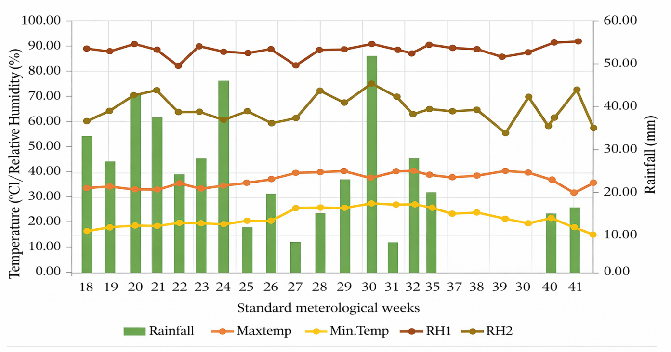
Figure 1: Meteorological data during the cropping season at Meteorological Observatory, Kupwara

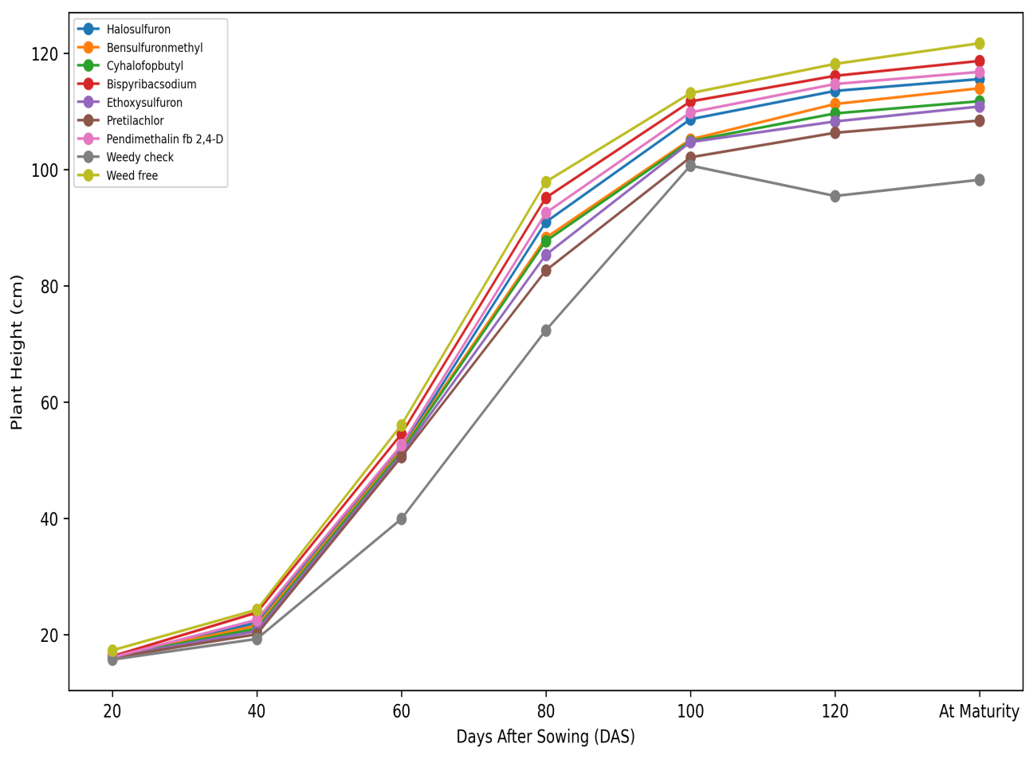
Figure 2. Effect of different weed control treatment on Plant height at different growth intervals

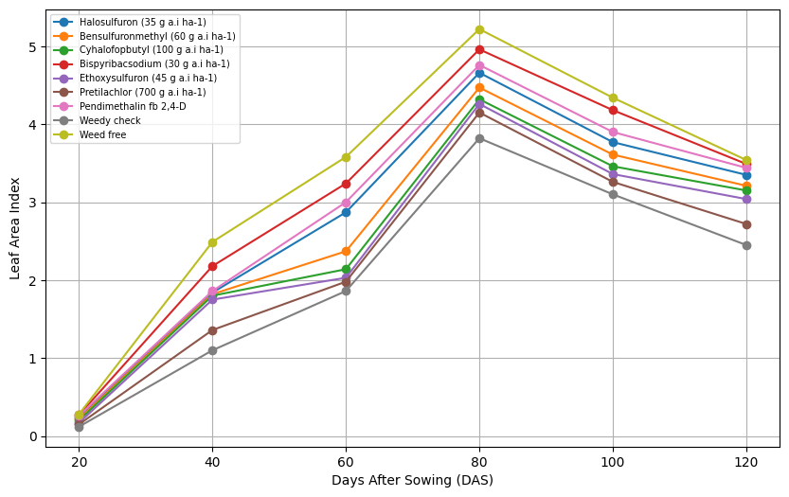
Figure 3. Effect of different weed control treatment on Leaf area index at different growth intervals

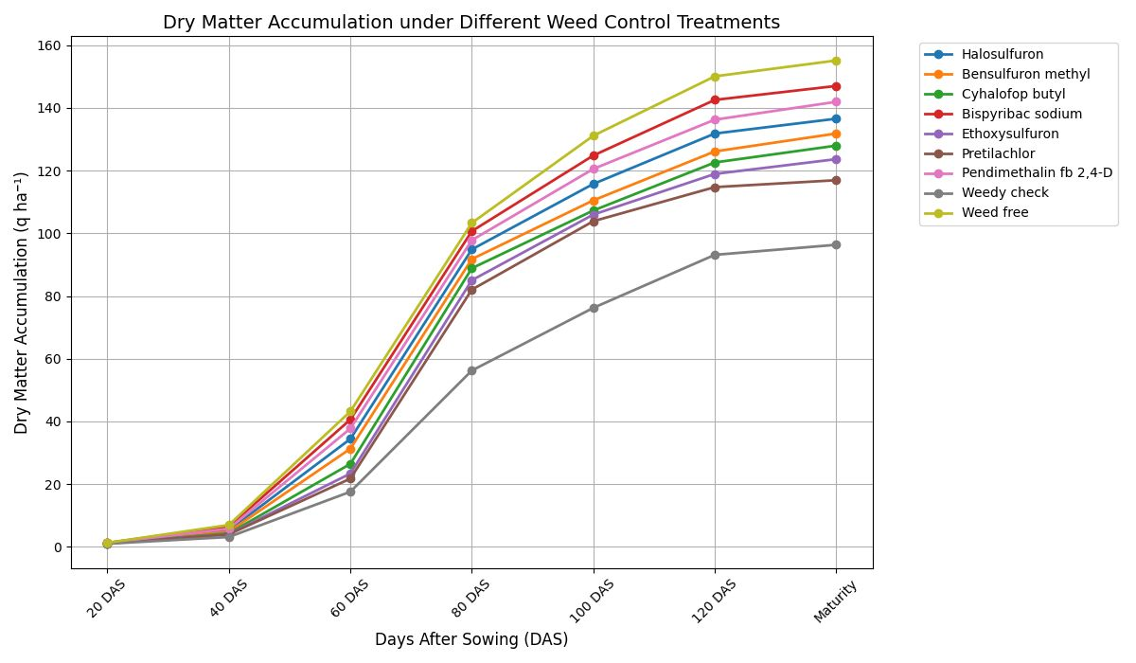
Figure 4. Effect of different weed control treatment Dry matter accumulation (qha-1) at different growth intervals

