Original Research Article

Bio-efficacy and Economic analysis of Novel Insecticide Molecules against Rice Leaf Folder Complex under Odisha Conditions

.
ABSTRACT

“A field experiment was conducted during the Kharif season of 2022 at the research plot of the Entomology department, Odisha University of Agriculture and Technology (OUAT), Bhubaneswar, to evaluate the bio-efficacy and economics of novel insecticide molecules against rice leaf folder, Cnaphalocrocis medinalis (Guenee), and its natural enemies. The study utilized a Randomized Complete Block Design with eight treatments and three replications using the variety ‘Swarna.’ Evaluated insecticides include lamba-cyhalothrin 2.5%EC, flubendiamide 20%WG, flonicamid 50%WG, indoxacarb 15.8%EC, cartap hydrochloride 50%SP, emamectin benzoate 5SG, and chlorantraniliprole 18.5%SC. Flubendiamide 20%WG @125g/ha demonstrated superior bio-efficacy, recording the lowest leaf damage (1.09%) and the least larval population (0.20 larvae/hill) after two sprays. This was followed by indoxacarb 15.8%EC, which recorded 4.55% leaf damage and 0.41 larvae/hill. Safety assessments revealed that chlorantraniliprole 18.5% SC was the most compatible with natural enemies, supporting the highest predatory spider population (0.70 spiders/hill) 14 days after the second spray. Economic analysis showed that flubendiamide treated plots registered the maximum grain yield (49.24 q/ha), which was statistically at par with indoxacarb (48.92 q/ha). However, indoxacarb 15.8%EC achieved the highest incremental benefit-cost ratio (ICBR) of 1:2.06), compared to 1:1.67 for flubendiamide. While flubendiamide provided maximum knockdown, its higher toxicity to spiders (89.36% reduction) makes it less ideal for integrated pest management. Consequently, indoxacarb 15.8%EC is recommended for sustainable rice cultivation as it provides the optimal technical balance between high pest control efficacy, moderate safety to predatory spiders (0.45 spiders/hill), and maximum economic profitability.”

Keywords: Bio-efficacy; Cnaphalocrocis medinalis; Diamides; ICBR; Kharif; Odisha; Oryza sativa; predatory spiders.

1. INTRODUCTION

Rice, Oryza sativa L., is the most widely distributed dietary staple food in the world (Khush, 1997). It is the most significant grain crop in Asian agricultural history and dates back thousands of years. Half of the world's population still depends on rice as their staple food (Themuhi et al., 2025; Muthayya et al., 2014). At global level milled rice production is forecasted at 543.6 Mt in 2024-25, with an increase of 1.5% over previous years due to expansion of cultivated area in Asia. India’s output is expected to rise from 137.8 Mt (2023-24) to 145 Mt (2024-25) (Chandra et al 2025). In Odisha, rice is considered the fundamental food and is grown on an area of 3.94 million hectares, producing 9.14 million tons of grain per year with an average productivity of 2318 kg/ha (Seni et al., 2025).
The main reason for the low productivity of rice in Odisha is due to natural calamities and pest occurrences on a regular basis. An abundance of biotic, abiotic, and socio-economic constraints hinders the increase in rice production. In all rice ecosystems, insect pests are regarded as the primary biotic challenge among various factors. Major pests infesting the paddy include stem borer, leaf folder, leafhoppers, plant hoppers, and bugs. Among different pests, the paddy leaf folder is one of the most important foliage-feeding pests of rice. During epidemics, yield loss by leaf folder ranged from 30 to 80 percent (Nanda and Bisoi, 1990). Cnaphalocrocis medinalis (Guenee) stands out as the foremost and most extensively distributed species among the eight discovered species of leaf folders (Kumar and Kumar, 2017).
The population buildup and subsequent resurgence of C. medinalis are increasingly linked to the excessive use of nitrogenous fertilizers, which enhances host plant suitability, and shifting climactic patterns characterized by cloudy weather and reduced sunlight. Even now, insecticides are considered as the first line of defense among the different tactics used to battle rice pests. Numerous insecticides have been recognized as efficient for controlling leaf folders, yet it is claimed that certain previously effective insecticides may be accountable for the resurgence of this pest. To mitigate pest resurgence and the development of chemical resistance, there is a critical need to transition toward modern insecticide molecules with diverse and novel modes of action. Previous studies have highlighted the potential of combining bacterial toxins and botanicals to disrupt the gut enzymes and behavioral responses of C. medinalis, offering a foundation for more specialized control strategies (Nathan et al., 2004;2006)
Considering these conditions, the current study was focused on the evaluation of the efficacy of various insecticides against rice leaf folders as well as their detrimental effects on natural enemies, especially on spiders in rice under Bhubaneswar conditions. By clearly connecting the productivity issues in Odisha with the conservation of predatory spiders, this study justifies the necessity of evaluating both economic viability and environmental safety. This study also emphasizes the estimation of the grain yield and economics of paddy after the adoption of management practices against the rice leaf folder to provide a sustainable and profitable framework for pest management.

2. material and methods

The experiment was conducted in the experimental block of Entomology at the Central Research Station of the Odisha University of Agriculture and Technology, Bhubaneswar, (20° 15" North latitude and 85° 52" East longitude) during Kharif, 2022. The experiment was laid out in a Randomized Complete Block Design (RCBD) consisting of eight treatments and three replications. The field layout comprised 24 subplots, each subplot has an area of 5.5m × 4.5m.The variety ‘Swarna’ was utilized in this field trail with an equal spacing of 20×10cm² .The evaluated insecticides included Lambda-cyhalothrin 2.5%EC @500ml/ha, Flubendiamide 20%WG @125g/ha, Flonicamid 50%WG@100g/ha, Indoxacarb 15.8%EC @200ml/ha, Cartap hydrochloride 50%SP @1000g/ha, Emamectin benzoate 5SG @220g/ha, and Chlorantraniliprole 18.5%SC @200ml/ha were field evaluated against leaf folder of rice and natural enemies.
The first spray of insecticides was administered based on the ETL level of the pest (10% damaged leaves at the vegetative phase and 5% of flag leaf damage at flowering stage). A second spray followed 15 days later. We administered insecticides using a hand-operated, high-volume knapsack sprayer with 500 liters of spray solution per hectare. We computed Leaf folder damage was computed by counting the number of infested leaves to the total number of leaves from 10 randomly selected hills per plot in each replication. The infested leaves per hill were determined 1 day before, and 3, 7, and 14 days after each spray.
The following equation was used to calculate the percentage of leaf damage:

Per cent leaf damage = (No of damaged leaves per hill / Total no of leaves per hill) × 100

To assess environmental safety, we recorded the spider and coccinellid population (number/hill) was recorded from 10 randomly selected hills in each treatment before and after the sprays.
The crop was harvested at maturity, and weights were taken. A pedal thresher was used to thresh the grain. The grains were sun-dried separately before the final dry weight was determined. We recorded treatment-wise grain yield, which was standardized to quintals per hectare (q/ha) to ensure statistical consistency. The per cent improvement of yield over untreated control was computed by the following formula,

Yield improvement over control = [(Yield obtained from treated plot -Yield obtained from untreated plot) / Yield obtained from untreated plot] × 100
We performed an integrated economic profitability analysis by estimating the incremental cost-benefit ratio (ICBR) for all the treatments to identify cost-effective management options while evaluating their balance with environmental safety for natural enemies. The data was interpreted by using online OP STAT software. Additionally, we performed correlation analysis between meteorological variables (gathered from the meteorological station of OUAT, Bhubaneswar) and seasonal pest/predator occurrences to clarify the statistical relationship between effective pest control and increased grain production. All scientific visualizations, including the Cost-benefit Quad plot and the population dynamics heatmap, were generated using R software to ensure high-resolution data representation.

3. results and discussion

3.1 Effect of insecticides on the incidence of leaf damage by rice leaf folder during Kharif, 2022

The first spray results indicated that all the insecticidal treatments found significantly superior to the untreated control. The lowest (7.02 % leaf damage) C. medinalis incidence after 14DAS was found in the plots treated with Flubendiamide 20 %WG @ 125 g / ha followed by Indoxacarb 15.8%EC @ 200ml /ha (8.90 % leaf damage). The highest percentage of leaf damage among insecticidal treatments was shown by treatment with Chlorantraniliprole 18.5%SC @200ml/ha) (10.60% DL), which was at par with the treatment Lambda-cyhalothrin 2.5%EC @500ml/ha (10.42% DL).
After 15 days of the first spray a second spray was given. Leaf damage after 14DAS showed similar pattern with Flubendiamide showing the lowest per cent leaf damage (1.09%), followed by Indoxacarb (4.55% DL). Maximum leaf damage percentages were observed in Chlorantraniliprole treated plot (10.16% DL) and Lambda-cyhalothrin treated plot (10.10%) among chemical treatments, and they were at par with each other. The sequence in which the insecticides resulted in percentage reduction in leaf damage over control, after fourteen days of their second spraying, was as follows, from highest to lowest: Flubendiamide (92.56%)> Indoxacarb (68.94%)> Cartap hydrochloride (61.23%)> Emamectin benzoate (41.70%) > Flonicamid (38.84%)> Lambda-cyhalothrin(31.06%) > Chlorantraniliprole (30.65%) (Table 1)
Our results are in accordance with several authors' findings, including those of Jaglan and Chaudhary (2021) who reported that foliar sprays of Flubendiamide effectively reduced the infestation of rice leaf folder without causing any phytotoxicity symptoms. Zala and Sipai (2021) also provided strong support for this conclusion. Soomro et al. (2020) also disclosed that during their experiment, Belt 480SC showed the maximum superiority over the control (with 3.76% damaged leaves). The results were also in line with the findings of Raju et al. (2018) who noticed that pooled data on leaf damage percentage revealed the supremacy of flubendiamide 480 SC @ 0.2 ml/l with 4.93% leaf damage and a 63.20% reduction over control.
The superior technical efficacy of flubendiamide (92.56% damage reduction) is primarily attributed to its anthranilic diamide mechanism, which causes the uncontrolled release of calcium ions in insect musculature, leading to rapid larval knockdown. However, despite this high biological performance, flubendiamide proved less cost-effective than indoxacarb due to its higher market price per unit of application. Indoxacarb, acting through the metabolic blocking of activated sodium channels, recorded a slightly lower but highly competitive efficacy (68.94% reduction). The significant difference in the final cost-input ratio (ICBR 2.06 for indoxacarb vs. 1.67 for flubendiamide) justifies the selection of indoxacarb as a more economically sustainable option for small-scale farmers in Odisha.
3.2 Effect of different insecticides on the incidence of rice leaf folder larval population

With the lowest mean of leaf folder larvae per hill (0.20) and a significant difference between all treatments, the most effective treatment was Flubendiamide 20%WG @125g/ha when accounting for both the sprays. Flubendiamide achieved higher larval control through its modulation of ryanodine receptors leading rapid paralysis and death. This treatment reduced larval population by up to 49.12% and 83.47% over the untreated control after the first spray and second spray, respectively. Our results are in concordance with the findings of Rao et al. (2018), who reported that in the dry direct sowing method of rice cultivation, Flubendiamide showed a 63.71 percent reduction over control, proving to be the most efficient insecticide in controlling the leaf folder larval population. Following Flubendiamide, “Indoxacarb 15.8% EC @ 200 ml/ha” took place as the second-best effective treatment, in which a mean of 0.41 leaf folder larvae per hill was observed (Khajuria et al., 2022). This treatment reduced larval population by up to 35.96% and 66.12% over the untreated control after the first spray and second spray, respectively (Table 2)

3.3 Natural enemies

The effect of insecticides on spider populations showed that Chlorantraniliprole 18.5%SC @200g/ha had no adverse effect on predatory spiders, which resulted in the lowest population reduction over control (36.36%) with an average number of 0.7spiders per hill. The high selectivity of chlorantraniliprole towards predatory spiders serves as a cornerstone for Integrated Pest Management (IPM) in rice ecosystems, as it selectively targets lepidopteran insects while sparing spiders. Following that, was indoxacarb 15.8% EC@ 200ml/ha (59.09%) with an average number of 0.45 spiders per hill, which shows moderate safety via slower metabolism in spiders. this predator resilience, coupled with the moderate safety of indoxacarb, allows for the maintenance of natural biological control agents even during chemical intervention. In contrast, Flubendiamide harms natural enemies due to its broader ryanodine receptor binding, despite of its high pest control (Reddy et al., 2025). These findings emphasize the necessity of using molecules that spare arthropod diversity to prevent secondary pest outbreaks. This conclusion agrees with the findings of Rana et al. (2017) who recorded the highest overall mean population of spiders in untreated check (2.33 and 3.24/hill), followed by Chlorantraniliprole 0.4% GR (1.85 and 2.09/hill) during the first and second foliar applications (Table 3).

No. | Treatments | Dose  (g or  ml /ha) | First Spray  Damaged leaf (%)* |  |  |  | Reduction over control after first spray  (%) | Second Spray  Damaged leaf (%)* |  |  | Reduction over control after second spray (%)
No. | Treatments | Dose  (g or  ml /ha) | 1DBS | 3DAS | 7DAS | 14DAS | Reduction over control after first spray  (%) | 3DAS | 7DAS | 14DAS | Reduction over control after second spray (%)
T₁ | Lambda-cyhalothrin 2.5%EC | 500ml | 9.99  (3.31) | 9.78  (3.28) | 9.61  (3.26) | 10.42  (3.38) | 29.10 | 10.22  (3.35) | 10.08  (3.33) | 10.10  (3.33) | 31.06
T₂ | Flubendiamide 20%WG | 125g | 12.60  (3.69) | 10.48  (3.39) | 6.05  (2.65) | 7.02  (2.83) | 51.59 | 4.97  (2.47) | 2.19  (1.79) | 1.09  (1.44) | 92.56
T₃ | Flonicamid 50 %WG | 100g | 10.99  (3.44) | 9.73  (3.27) | 9.58  (3.25) | 10.12  (3.33) | 30.21 | 8.88  (3.14) | 8.75  (3.12) | 8.96  (3.16) | 38.84
T₄ | Indoxacarb15.8%EC | 200ml | 13.41  (3.79) | 11.36  (3.51) | 8.17  (3.02) | 8.90  (3.14) | 38.62 | 7.55  (2.92) | 4.01  (2.19) | 4.55  (2.36) | 68.94
T₅ | Cartap hydrochloride 50%SP | 1000g | 12.81  (3.71) | 11.43  (3.53) | 8.74  (3.12) | 9.24  (3.20) | 36.28 | 7.98  (2.99) | 5.28  (2.48) | 5.68  (2.58) | 61.23
T₆ | Emamectin benzoate 5SG | 220g | 10.56  (3.40) | 10.40  (3.37) | 9.10  (3.18) | 9.88  (3.29) | 31.86 | 9.72  (3.27) | 8.22  (3.04) | 8.54  (3.15) | 41.70
T₇ | Chlorantraniliprole 18.5%SC | 200ml | 11.28  (3.50) | 11.19  (3.48) | 9.96  (3.31) | 10.60  (3.40) | 26.90 | 10.52  (3.39) | 9.96  (3.21) | 10.16  (3.34) | 30.65
T₈ | Untreated control |  | 12.24  (3.64) | 13.80  (3.85) | 14.02  (3.88) | 14.50  (3.94) | - | 14.60  (3.95) | 14.71  (3.96) | 14.65  (3.95) | -
 | SE(m)± |  | 0.117 | 0.101 | 0.066 | 0.071 | - | 0.053 | 0.031 | 0.033 | -
 | CD(P=0.05) |  | NS | 0.31 | 0.20 | 0.22 | - | 0.16 | 0.09 | 0.10 | -
Table 1. Evaluation of various insecticides against leaf damage by rice leaf folder during Kharif, 2022 at Bhubaneswar
*Mean of three replications
Figures in parentheses are $\sqrt{x+1}$ transformed values DBS =Days before spraying, DAS=Days after spraying, NS= non-significant

Table 2. Evaluation of various insecticides against rice leaf folder larval population during Kharif, 2022 at Bhubaneswar

No. | Treatments | Dose  (g or  ml /ha) | First Spray  No. of larvae/hill* |  |  |  | Reduction over control after first spray  (%) | Second Spray  No. of larvae/hill* |  |  | Reduction over control after second spray (%)
No. | Treatments | Dose  (g or  ml /ha) | 1DBS | 3DAS | 7DAS | 14DAS | Reduction over control after first spray  (%) | 3DAS | 7DAS | 14DAS | Reduction over control after second spray (%)
T₁ | Lambda-cyhalothrin 2.5%EC | 500ml | 0.81  (1.34) | 0.71  (1.21) | 0.66  (1.29) | 0.84  (1.36) | 26.32 | 0.72  (1.31) | 0.65  (1.28) | 0.75  (1.32) | 38.02
T₂ | Flubendiamide 20%WG | 125g | 1.09  (1.44) | 0.69  (1.30) | 0.50  (1.22) | 0.58  (1.26) | 49.12 | 0.23  (1.11) | 0.15  (1.07) | 0.20  (1.09) | 83.47
T₃ | Flonicamid 50 %WG | 100g | 0.92  (1.38) | 0.76  (1.33) | 0.71  (1.31) | 0.80  (1.34) | 29.82 | 0.64  (1.28) | 0.58  (1.26) | 0.72  (1.31) | 41.32
T₄ | Indoxacarb15.8%EC | 200ml | 1.13  (1.46) | 0.85  (1.36) | 0.68  (1.30) | 0.73  (1.31) | 35.96 | 0.48  (1.22) | 0.31  (1.14) | 0.41  (1.19) | 66.12
T₅ | Cartap hydrochloride 50%SP | 1000g | 1.08  (1.44) | 0.88  (1.37) | 0.72  (1.31) | 0.79  (1.34) | 30.72 | 0.58  (1.26) | 0.42  (1.19) | 0.49  (1.22) | 59.50
T₆ | Emamectin benzoate 5SG | 220g | 0.89  (1.37) | 0.74  (1.32) | 0.67  (1.29) | 0.81  (1.35) | 28.95 | 0.68  (1.30) | 0.54  (1.24) | 0.70  (1.30) | 42.15
T₇ | Chlorantraniliprole 18.5%SC | 200ml | 0.95  (1.40) | 0.86  (1.36) | 0.76  (1.33) | 0.85  (1.36) | 25.43 | 0.79  (1.34) | 0.61  (1.27) | 0.76  (1.33) | 37.19
T₈ | Untreated control |  | 1.05  (1.43) | 1.09  (1.45) | 1.12  (1.46) | 1.14  (1.46) | - | 1.20  (1.48) | 1.25  (1.50) | 1.21  (1.49) | -
 | SE(m)± |  | 0.034 | 0.008 | 0.005 | 0.006 | - | 0.004 | 0.002 | 0.003 | -
 | CD(P=0.05) |  | NS | 0.03 | 0.02 | 0.02 | - | 0.01 | 0.01 | 0.01 | -
*Mean of three replications

Figures in parentheses are$\sqrt{x+1}$ transformed values DBS =Days before spraying, DAS=Days after spraying, NS= non-significant

Table 3. Effect of various insecticides on the spider population during Kharif, 2022 at Bhubaneswar
No. | Treatments | Dose  (g or  ml /ha) | First Spray  No. of spiders/hill* |  |  |  | Second Spray  No. of spiders/hill* |  |  | Reduction over control after second spray (%)
No. | Treatments | Dose  (g or  ml /ha) | 1DBS | 3DAS | 7DAS | 14DAS | 3DAS | 7DAS | 14DAS | Reduction over control after second spray (%)
T₁ | Lambda-cyhalothrin 2.5%EC | 500ml | 0.47  (1.21) | 0.32  (1.15) | 0.22  (1.10) | 0.33  (1.15) | 0.23  (1.11) | 0.20  (1.09) | 0.24  (1.11) | 78.18
T₂ | Flubendiamide 20%WG | 125g | 0.30  (1.14) | 0.20  (1.09) | 0.05  (1.02) | 0.12  (1.06) | 0.08  (1.04) | 0.02  (1.01) | 0.15  (1.07) | 86.36
T₃ | Flonicamid 50 %WG | 100g | 0.58  (1.26) | 0.43  (1.20) | 0.32  (1.15) | 0.42  (1.19) | 0.32  (1.15) | 0.29  (1.14) | 0.35  (1.16) | 68.18
T₄ | Indoxacarb15.8%EC | 200ml | 0.66  (1.29) | 0.55  (1.24) | 0.45  (1.20) | 0.58  (1.26) | 0.48  (1.22) | 0.41  (1.19) | 0.45  (1.20) | 59.09
T₅ | Cartap hydrochloride 50%SP | 1000g | 0.35  (1.16) | 0.21  (1.10) | 0.08  (1.04) | 0.15  (1.07) | 0.10  (1.05) | 0.05  (1.02) | 0.19  (1.09) | 82.73
T₆ | Emamectin benzoate 5SG | 220g | 0.52  (1.23) | 0.35  (1.16) | 0.25  (1.12) | 0.35  (1.16) | 0.27  (1.13) | 0.24  (1.11) | 0.28  (1.13) | 74.54
T₇ | Chlorantraniliprole 18.5%SC | 200ml | 0.74  (1.32) | 0.56  (1.25) | 0.73  (1.31) | 0.79  (1.34) | 0.69  (1.30) | 0.64  (1.28) | 0.70  (1.30) | 36.36
T₈ | Untreated control |  | 0.54  (1.24) | 0.70  (1.30) | 0.85  (1.36) | 0.90  (1.38) | 0.92  (1.39) | 0.96  (1.40) | 1.10  (1.45) | -
 | SE(m)± |  | 0.018 | 0.014 | 0.009 | 0.010 | 0.004 | 0.002 | 0.002 | -
 | CD(P=0.05) |  | NS | 0.04 | 0.03 | 0.03 | 0.01 | 0.01 | 0.01 | -
*Mean of three replications
Figures in parentheses are $\sqrt{x+1}$transformed values DBS =Days before spraying, DAS=Days after spraying, NS= non-significant

Table 4. Effect of various insecticides on grain yield of rice during Kharif , 2022 at Bhubaneswar
No. | Treatment | Dose  (g/ml per ha) | Mean yield *  (q/ha) | Increased yield over control  (%)
T₁ | Lambda-cyhalothrin 2.5%EC | 500ml | 43.80 | 19.22
T₂ | Flubendiamide 20%WG | 125g | 49.24 | 34.02
T₃ | Flonicamid  50 % WG | 100g | 45.47 | 23.76
T₄ | Indoxacarb15.8%EC | 200ml | 48.92 | 33.15
T₅ | Cartap hydrochloride 50%SP | 1000g | 47.19 | 28.44
T₆ | Emamectin benzoate 5SG | 220g | 45.79 | 24.63
T₇ | Chlorantraniliprole 18.5%SC | 200ml | 43.10 | 17.31
T₈ | Untreated control | - | 36.74 | -
 | SE(m)± | - | 1.346 | -
 | CD(P=0.05) | - | 4.12 | -
*Mean of three replications

Table 5. Effect of various insecticides on ICBR of Rice leaf folder
Treatment no | Dose  g/ml  per ha | Quantity of chemical required for 2sprays  g /ml/ha | Cost of chemical for 2 sprays (Rs.) | Labor  charges for 2 sprays  (Rs. /ha) | Total  Expenditure  (Rs.)  [A] | Yield  (q/ha) | Increase in yield over  Control  (q/ha) | Value of  Increased  Yield  (Rs. /ha)  [B] | Incremental  Benefit  [C=B-A]  (Rs. /ha) | ICBR  1: [C/A]
T₁(Lambda-cyhalothrin 2.5%EC) | 500ml | 1000ml | 800 | 3450 | 4250 | 43.80 | 7.06 | 9884 | 5634 | 1:1.32
T₂(Flubendiamide 20%WG) | 125g | 250g | 3090 | 3450 | 6540 | 49.24 | 12.50 | 17500 | 10960 | 1:1.67
T₃(Flonicamid 50%WG) | 100g | 200g | 2670 | 3450 | 6120 | 45.47 | 8.73 | 12222 | 6102 | 1:0.99
T₄(Indoxacarb 15.8%EC) | 200ml | 400ml | 2120 | 3450 | 5570 | 48.92 | 12.18 | 17052 | 11482 | 1:2.06
T₅(Cartap hydrochloride  50%SP) | 1000g | 2000g | 3000 | 3450 | 6450 | 47.19 | 10.45 | 14630 | 8180 | 1:1.27
T₆(Emamectin benzoate  5SG) | 220g | 440g | 2200 | 3450 | 5650 | 45.79 | 9.05 | 12670 | 7020 | 1:1.24
T₇(Chlorantraniliprole 18.5%SC) | 200ml | 400ml | 6850 | 3450 | 10300 | 43.10 | 6.36 | 8904 | -1396 | 1: -0.13
T₈ (Untreated control) |  |  |  |  |  | 36.74
Labor charge – Rs. 345/- per man day Sale price of paddy Rs. 1,400/- per quintal
Five casual laborers were engaged for spraying one ha of crop field twice (Rs.3450/-)

Table 6. Seasonal incidence of leaf folder and spider population of rice during Kharif, 2022
Standard week | Months and dates | Leaf folder  population per hill | Spider  population per hill
32nd | August08-14 | 0.00 | 0.00
33rd | August15-21 | 0.37 | 0.10
34th | August22-28 | 0.53 | 0.26
35th | August 29- September 04 | 0.75 | 0.35
36th | September05-11 | 0.98 | 0.48
37th | September12-18 | 1.22 | 0.50
38th | September19-25 | 1.40 | 0.55
39th | September 26-October 02 | 1.45 | 0.70
40th | October03-09 | 1.47 | 0.85
41st | October10-16 | 1.15 | 0.90
42nd | October17-23 | 1.02 | 0.96
43rd | October24-30 | 0.90 | 1.10
44th | October 31-November 06 | 0.67 | 0.75
45th | November07-13 | 0.53 | 0.64
46th | November14-20 | 0.23 | 0.45
47th | November21-27 | 0.00 | 0.32
Max. – Maximum, Min. – Minimum

Table 7. Relationship between weather parameters as prevailed during incidence of leaf folder and spider population
Variables | Kharif,2022
Variables | Degrees of freedom | Correlation coefficient (r )
Variables | Degrees of freedom | Leaf folder population per hill | Spider population per hill
Max temperature (ºC) | 14 | 0.460^{NS} | 0.224 ^{NS}
Min temperature (ºC) | 14 | 0.547* | -0.070 ^{NS}
RH forenoon (%) | 14 | 0.563* | 0.056 ^{NS}
RH Afternoon (%) | 14 | 0.462^{NS} | -0.087 ^{NS}
Rainfall(mm) | 14 | 0.137^{NS} | -0.327 ^{NS}
*‛r’ is significant at the P=0.05 level, NS-Non significant
3.4 Yield and Economics

The insecticidal treatments and the untreated control showed a significant difference in grain yield. Flubendiamide 20%WG @125g/ha recorded the highest yield of 49.24 q/ha, which was at par with Indoxacarb 15.8%EC @200ml/ha (48.92 q/ha). The superiority in yield correlates with its larval control and reduction in leaf damage that is carried through ryanodine receptor modulation and sodium channel blockade respectively. The lowest yield was obtained from the untreated control (36.74 q/ha). The increased rice yield over the untreated control ranged from 6.36 to 12.50 q/ha among different treatments. The maximum increased rice yield over the untreated control plot was recorded in T2 (Flubendiamide) (34.02%)), followed by T4 (Indoxacarb) (33.15%). The lowest increase in rice yield over control was observed in T7 (chlorantraniliprole) (17.31%) (Table 4)
The treatment “Indoxacarb 15.8%EC @200ml/ha” recorded the highest incremental cost-benefit ratio of 1:2.06 and an incremental benefit of Rs.11482/-.The treatment that followed was “Flubendiamide 20%WG @125g/ha”which had an ICBR of 1:1.67 and an incremental profit was Rs.10960/-. Indoxacarb’s superior economic efficiency stems from a strategic balance where lower essential input costs (Rs. 5570/ha) meet high yield gains (48.92 q/ha). While flubendiamide achieved the absolute maximum yield, the lower total expenditure for indoxacarb resulted in a higher net incremental benefit, making it the most profitable treatment evaluated in the study. Consequently, a lower benefit cost ratio and a higher incremental benefit may result from differences in essential input costs and grain yield between treatments, and vice versa (Table 5)
These outcomes are in accordance with the results of Gupta et al. (2021), who stated that a maximum yield of 31.50 q/ha was obtained in flubendiamide 480SC @3ml/l with a maximum cost-benefit ratio of 2.08. Also, these outcomes match the findings of Raju et al. (2018) who recorded the highest 44.15q/ha yield and a C: B ratio of 1:42 on a plot treated with Flubendiamide 480SC @0.2ml/l. The economic efficiency of the evaluated insecticides is further illustrated in the Cost-Benefit Quad Plot (Figure 2). This visualization categorizes treatments based on their performance across yield and costs gradients, highlighting Indoxacarb and Flubendiamide in the high-yield quadrants. While Flubendiamide achieved the highest absolute yield, Indoxacarb emerged as the most efficient option due to its lower total expenditure (Rs. 5570/ha), resulting in the superior Incremental Benefit-Cost Ratio (ICBR) of 1.2.06. Conversely, Chlorantraniliprole demonstrated the lowest economic efficiency, plotted in the high cost, low yield quadrant.

3.5 Seasonal incidence of leaf folder and spider population of rice

The various weather parameters like mean maximum and minimum temperature, relative humidity (RH) at forenoon and afternoon and rainfall as prevailed during the period of larval incidence on rice crop during Kharif, 2022 were correlated with larval density of the pest. Under minimum temperatures and morning humidity leaf folder thrives, which favors egg hatching, larval survival, and its leaf webbing behavior. Results revealed that leaf folder population had a significant positive correlation with minimum temperature (r = 0.547) and morning relative humidity (r = 0.563). All other parameters, such as maximum temperature (0.460), evening relative humidity (0.462), and rainfall (0.137), showed a nonsignificant positive correlation. This agrees with the findings of Seni and Naik (2018), who reported that per cent leaf damage had a substantial positive correlation with minimum temperature (r = 0.654), and other parameters such as rainfall (r = 0.216), morning (r = -0.365), and evening relative humidity (r =0.150) had no significant relationship with leaf folder incidence.
In a similar way, meteorological variables such as mean maximum and minimum temperature, relative humidity (RH) at forenoon and afternoon and rainfall as prevailed during the period of study Kharif, 2022 were correlated with the spider adult population in the rice field. Spiders exhibited weaker weather correlations since their predation behavior remains consistent within the temperature and humidity ranges prevailing in Kharif season. Correlation analysis indicated that weather parameters such as maximum temperature (r = 0.224) and morning relative humidity (r = 0.056) showed a non-significant positive relationship, whereas minimum temperature (r = 0.070), evening relative humidity (r = -0.087), and rainfall (r = -0.327) showed a nonsignificant negative correlation with spider population. This result is well supported by the findings of Ravi et al. (2021), who also reported nonsignificant relationships among the spider population with weather variables during their study period in both years (Table 6,7). As illustrated in Figure 1, the population dynamics show a distinct peak in C. medinalis during the 40th standard week (1.47 larvae/hill) followed by a predatory spider peak in the 43rd week (1.10 spiders/hill), indicating a natural predator-prey lag. The accompanying heatmap further quantifies these relationships, visually confirming that while the pest is significantly driven by minimum temperature (r = 0.547) and morning humidity (r + 0.563), the spider population remains ecologically resilient with no significant reliance on the recorded abiotic factors.
The robust statistical foundation provided by the correlation analysis confirms that while C. medinalis incidence is significantly driven by abiotic factors like morning humidity (r=0.563) and minimum temperature (R=0.547), predatory spider populations remain ecologically resilient. This lack of significant reliance on the recorded weather parameters indicates that spiders can maintain consistent predation pressures across varying kharif conditions, further justifying their conservation within a sustainable pest management framework.

4. Conclusion

The results of this experiment indicate that (T₂) flubendiamide 20%WG @125g/ha was the most effective treatment against the rice leaf folder Cnaphalocrocis medinalis , recording the lowest percentage of damaged leaves (1.09%), the lowest larval population (0.20 larvae/hill), and the highest grain yield (49.24 q/ha) However, to optimize agricultural recommendations, we must prioritize the balance between technical efficacy and economic viability. While flubendiamide offers superior pest suppression, Indoxacarb 15.8% EC @ 200 ml/ha (T₄) stands out as the strongest all-around recommendation due to its superior cost-effectiveness (ICBR 1:2.06) and moderate safety profile for natural enemies. This study emphasizes a focus on Integrated Pest Management (IPM) by explicitly identifying chlorantraniliprole 18.5% SC @200 ml/ha (T₇) as the most biodiversity-friendly option, showing the highest predatory spider resilience (36.36% reduction). By integrating the role of these modern molecules, farmers in the Odisha region can adopt a sustainable pest management strategy that balances knockdown efficacy with the preservation of beneficial fauna. Ultimately, we suggest that rice growers in Odisha priorities the adoption of these modern insecticide molecules not only for their immediate impact on C. medinalis but also for their efficient return on investment and partial preservation of natural biological control agents. Specifically, indoxacarb 15.8% EC is suggested as the most viable option for achieving optimal grain yield and maximum profitability while maintaining ecological stability within the rice ecosystem.
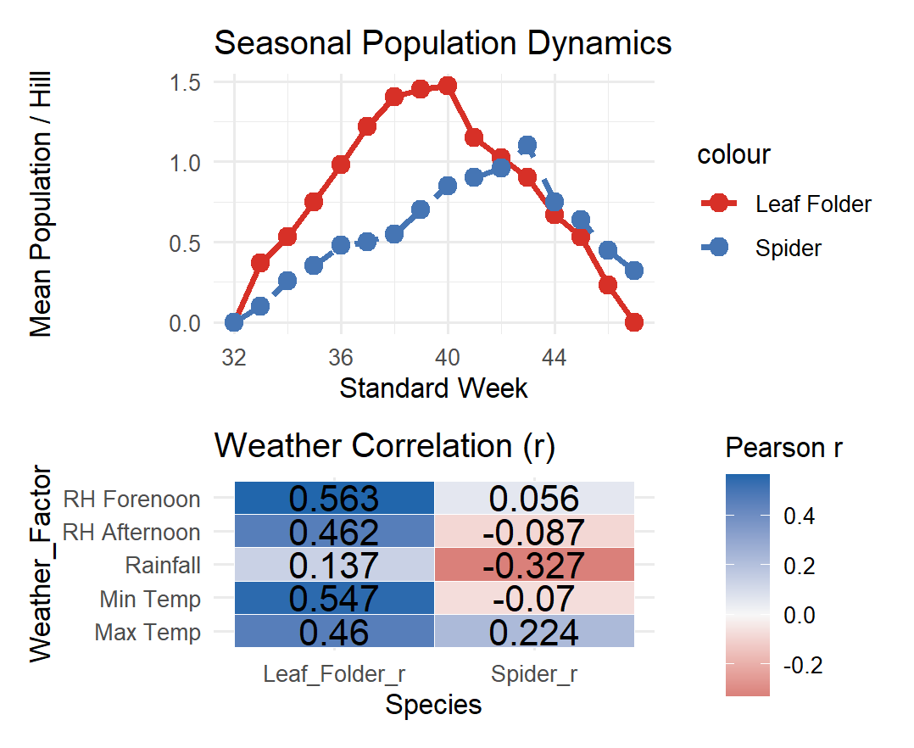
Figure 1: Seasonal population dynamics of rice leaf folder and spiders in relation to weather parameters during Kharif, 2022
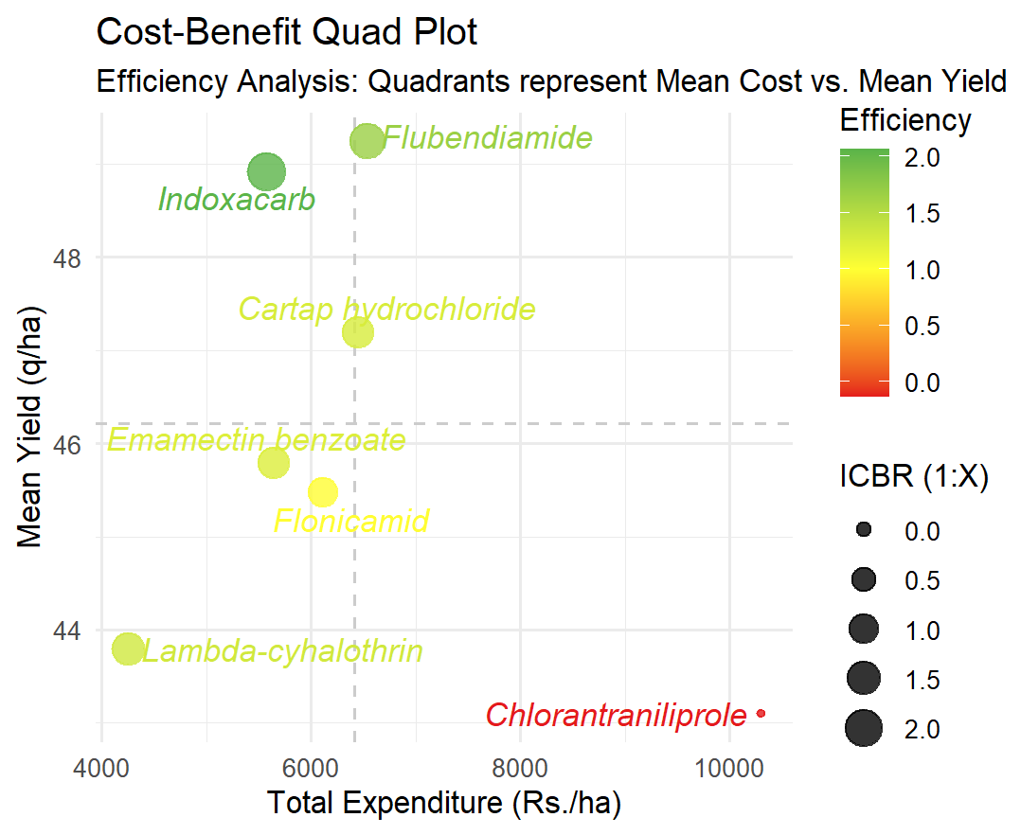
Figure 2: Efficiency analysis of insecticides based on mean yield (q/ha) and total expenditure (Rs./ha) during Kharif, 2022.

DISCLAIMER (ARTIFICIAL INTELLIGENCE)

author(s) hereby declares that no generative AI technologies such as Large Language Models (ChatGPT, COPILOT, etc.) and multilingual models have been used during writing or editing of this manuscript.

References
Chandra, K. B., Paul, V., Pandey, R., Upadhyay, P. K., & Meena, R. C. (2025). Evaluation of Nano-Urea Application on Growth and Yield Performance of Basmati Rice under Flooded Conditions. International Journal of Plant & Soil Science, 37(10), 506-526. https://doi.org/10.9734/ijpss/2025/v37i105807
Gupta, S., AmrishVaid, V. G., Sinha, A. K., & Sinha, A. K. (2021). New Insecticide Proved Very Effective for Management of Leaf Folder in Paddy. Journal of Krishi Vigyan, 9(2), 151-153. 10.5958/2349-4433.2021.00051.9
Jaglan, M. S., & Chaudhary, O. P. (2021). Field efficacy of flubendiamide 20WG against rice leaf folder, Cnaphalocrocis medinalis (Guenee) and yellow stem borer, Scirpophaga incertulas (Walker) in basmati rice. Journal of Cereal Research, 13(3), 305-312.
Karthikeyan, K. (2017). Efficacy of new insecticide molecules against major pests of rice. J of Rice Res, 10(2), 60-65.
Khajuria, S., Rai, A. K., & Lata, K. (2022). Impact of frontline demonstrations in transfer of technology for management of paddy leaf folder. Gujarat Journal of Extension Education, 34(2), 124-127. https://doi.org/10.56572/gjoee.2022.34.2.0027
Khush, G. S. (1997). Origin, dispersal, cultivation and variation of rice. Plant molecular biology, 35(1), 25-34. https://doi.org/10.1023/A:1005810616885
Kumar, V., & Kumar, S. (2017). Evaluation of novel groups of insecticides against leaf folder, Cnaphalcrocis medinalis (Guenee) in Rice crop. International Journal of Current Microbiology and Applied Sciences, 6(9), 442-448.
Muthayya, S., Sugimoto, J. D., Montgomery, S., & Maberly, G. F. (2014). An overview of global rice production, supply, trade, and consumption. Annals of the new york Academy of Sciences, 1324(1), 7-14.
Nanda, V. K., & Bisoi, R. C. (1990). Bionomics of rice leaf folder, Cnaphalocrocis medinalis. Orissa Journal of Agricultural Research, 3(2), 130–135.
Nathan, S. S., Chung, P. G., & Murugan, K. (2004). Effect of botanical insecticides and bacterial toxins on the gut enzyme of the rice leaf folder Cnaphalocrocis medinalis. Phytoparasitica, 32(5), 433-443.
Nathan, S. S., Kalaivani, K., & Murugan, K. (2006). Behavioural responses and changes in biology of rice leaf folder following treatment with a combination of bacterial toxins and botanical insecticides. Chemosphere, 64(10), 1650-1658.
Raju, K. A., Krishnayya, P. V., Sai Ram Kumar, D. V., Krishnaveni, B., & Kumar, V. M. (2018). Evaluation of certain newer insecticides against rice leaf folder, (Cnaphalocrosis medinalis) Guenee (Lepidoptera: Pyralidae). The Andhra Agricultural Journal, 65(1), 132–137.
.Ramesha, T. J., Mallikarjuna, L., Biradar, V., Rashmi, R., Chethan, N., Shenoy, H., ... & Kumar, J. T. (2025). Efficacy of technologies on management of rice leaf folder and yield. International Journal of Economic Plants, 12(2).
Rana, R., Singh, G., & Dhaka, S. S. (2017). Safety of novel insecticides to natural enemies in basmati rice ecosystem of western Uttar Pradesh. Journal of Plant Development Sciences, 9(2), 145–148.
.Rao, P. C., Rao, C. V. R., Ram Kumar, D. V. S., & Prasanna Kumari, V. (2018). Evaluation of newer insecticide molecules against rice leaf folder, Cnaphalocrosis medinalis Guenee in dry direct sowing method of rice cultivation. The Andhra Agricultural Journal, 65(4), 902–907.

Ravi, G., Mohapatra, L. N., Charati, P. K., & Rahman, S. M. (2021). Occurrence of spider fauna in relation to biotic and abiotic factors in rice eco system. The Pharma Innovation Journal, 10(9), 579–583.
Reddy, Y., Kumari, B., Mahalaksmi, M., & Rao, C. H. (2025). Balancing pest control and biodiversity: Differential impacts of insecticides on arthropod diversity in direct-sown rice ecosystem. International Journal of Agriculture and Food Science, 7(12), 356–359. https://doi.org/10.33545/2664844X.2025.v7.i12e.1062
Seni, A., & Naik, B. (2018). Influence of different abiotic factors on the incidence of major insect pests of rice (Oryza sativa L.). Journal of Agrometeorology, 20(3), 256–258.
Seni, A., Pal, R., Mohapatra, S., Mandal, D., Bansude, S. K., Seth, P., ... & Sahu, J. (2025). Pesticidal plant extract effect against major lepidopteran insect pests and their natural enemies in rice Oryza sativa L. Frontiers in Insect Science, 4, Article 1500542.
Soomro, A. S., Mazari, S. N., Hulio, M. H., Soomro, J. A., & Junejo, G. Q. (2020). Efficacy of different insecticides against rice leaf folder (Cnaphalorosis medinalis) under field conditions. International Journal of Applied Sciences and Biotechnology, 8(2), 211–215.
.Themuhi, M., Das, D., Rajeshwaran, B., Gayithri, M., & Narmadha, K. (2025). Resistance mechanisms in Oryza species against Meloidogyne graminicola: Insights into nematode penetration and reproduction. Physiological and Molecular Plant Pathology, Article 102733.
Zala, M. B., & Sipai, S. A. (2021). Efficacy of insecticides against rice leaf folder, Cnaphalocrocis medinalis (Guenee). The Pharma Innovation Journal, 10(12), 874–879.

