Original Research Article

In Vitro Callogenesis in Safflower (Carthamus tinctorius L.) Genotypes from Leaf, Hypocotyl, and Floral Bud Explants Under Differential Phytohormone Regimes

ABSTRACT :
Safflower (Carthamus tinctorius L.) is widely recognized for its pharmacologically active metabolites; however, its seasonal cultivation restricts consistent extraction of bioactive compounds. Plant tissue culture presents a sustainable strategy by enabling continuous and standardized metabolite production independent of field constraints. This study optimized callus induction from leaf, hypocotyl, and floral bud explants of two safflower genotypes, GMU-7931-1 and GMU-7923, using Murashige and Skoog (MS) medium supplemented with differential concentrations of NAA, BAP, 2,4-D, and TDZ. Marked explant and genotype specific responses were observed. In leaf explants, GMU-7931-1 exhibited the highest callus induction (86.66%) at 3.0 mg/L NAA + 1.0 mg/L BAP, while GMU-7923 responded maximally (90.00%) at 4.0 mg/L NAA + 1.0 mg/L BAP. Hypocotyl-derived callus was optimal at 2.0 mg/L NAA + 1.0 mg/L BAP for GMU-7931-1 (90%) and 3.0 mg/L NAA + 1.0 mg/L BAP for GMU-7923 (86.66%), whereas higher auxin levels (≥5.0 mg/L) suppressed callogenesis. For 2,4-D, peak responses were recorded at 5.0 mg/L in GMU-7931-1 (90%) and 3.0 mg/L in GMU-7923 (86.66%), with lower and higher levels resulting in reduced callus proliferation. Floral bud explants demonstrated robust callus formation and biomass accumulation on 0.5 mg/L NAA + 5.0 mg/L TDZ in both genotypes, with GMU-7923 showing superior performance. Notably, successful bud-derived callus induction reported here represents a novel addition to safflower tissue culture literature. Collectively, these findings establish remarkable response of NAA (2.0–4.0 mg/L) with BAP (1.0 mg/L) for leaf and hypocotyl and 0.5 mg/L NAA + 5.0 mg/L TDZ for bud followed by GMU-7923 (10–12 day remarkable response at 3.0 mg/L 2,4-D). Across explants, leaf tissues consistently displayed superior callus induction, while GMU-7931-1 showed the earliest visible callus formation (8–10 days) under optimal 2,4-D treatments (5.0 mg/L) as highly effective regimes for efficient and reproducible callus induction, supporting their application in scalable metabolite and pigment production in Carthamus tinctorius.

Keywords: 2,4-D; BAP; bud explants; callus induction; Carthamus tinctorius; genotype specificity; hypocotyl; leaf; metabolite production; NAA; TDZ.

1. INTRODUCTION
The genus Carthamus comprises nearly 25 species, with Carthamus tinctorius L. (2n = 24) being the only domesticated and economically cultivated member. Commonly known as safflower, it is an important oilseed crop ranking eighth among the world’s major oilseed crops., it is a thistle-like annual crop of the Asteraceae, adapted to arid and semi-arid climates through a deep taproot system. Plants generally grow 30–150 cm tall, producing globular capitula with yellow, orange, or red florets, and smooth, largely pappus-less achenes (Dajue and Mundel, 1996). Floret pigmentation transitions from orange to red over a four-week flowering period, with plant clusters sometimes reaching over 2 m (Delshad et al., 2022). Its resilience to drought and marginal soils positions safflower as a promising oilseed under conditions of water scarcity and climate variability (Yeilaghi et al., 2012).

Safflower cultivation is concentrated in South Asia, Mexico, and North America (Mandal et al., 1995; Yeung et al., 2011). India contributes close to 60% of global production, although
national output dropped from 57,000 MT in 2023 to ~50,000 MT in 2024 (Economic Survey of Maharashtra, 2023–24). Total Indian oilseed production was estimated at 41.9 million MT in 2024, slightly lower than the 42.7 million MT projected for 2025 (USDA, 2025; statista.com; apps.fas.usda.gov). China also maintains extensive acreage devoted primarily to medicinal flower harvesting, yet research on its cultivation remains limited outside the region (Emongor, 2010; Hussain et al., 2016).

Field cultivation of safflower is constrained by seasonal growth cycles, land allocation, and inconsistent yield, whereas plant tissue culture enables year-round controlled biomass and metabolite production (Caretto et al., 2004; Savitha et al., 2006). Callus induction the formation of an undifferentiated cell mass is central to regeneration, somaclonal variation, and secondary metabolite synthesis (Ikeuchi et al., 2013; Larkin and Scowcroft, 1981). Dedifferentiation is typically triggered by auxins such as 2,4-D and NAA, often combined with cytokinins including BAP; morphogenesis is guided by the auxin-to- cytokinin ratio (Skoog and Miller, 1957; Ignacimuthu et al., 1997). Rising demand for safflower pigments and bioactive metabolites underscores the need for sustainable production systems.

Previous studies have reported successful callus and shoot regeneration from hypocotyl, cotyledon, leaf, and root explants, with young seedling tissues showing superior regeneration and even capitulum formation (Mendhe, 2025). Doubled haploid production via anther culture has also been established using TDZ, BAP, and IBA (Kassa et al., 2024). In vitro safflower cultures synthesize water-soluble yellow and water-insoluble red pigments for pharmaceutical, textile, and cosmetic applications, with yields further enhanced through precursor feeding, elicitation, and media optimization (Brown et al., 1986; Hanagata et al., 1992, 1993 and 1994; Yeoman and Yeoman, 1996; Whitmer et al., 1998; Zhao et al., 2010).

Despite these advances, limited studies have compared responses across genotypes, explants, and hormone combinations, particularly using floral buds a potentially rich but understudied source of proliferative tissue. Establishing optimized callogenesis systems will support reproducible regeneration, accelerate genetic improvement, and enable scalable pigment and metabolite production independent of environmental constraints.

2. MATERIALS AND METHODS
2.1 Plant Material
For callus culture initiation in safflower (Carthamus tinctorius L.), young leaf, hypocotyl, and bud tissues were used as explants from two genotypes, GMU-7931-1 and GMU-7923. Young leaf and hypocotyl explants were excised from 14–16-day-old in vivo–grown seedlings, while bud explants were collected 10–12 days after their first appearance from actively growing apical or axillary meristems of the mother plant. Buds were harvested prior to floret opening to ensure high meristematic activity and cellular totipotency, a stage considered optimal for efficient callus induction and regeneration. All explants were surface sterilized before culture.

2.2 Culture Media and Growth Regulators
All cultures were established on Murashige and Skoog (MS) basal medium (Murashige and Skoog, 1962) fortified with 30 g/L sucrose and solidified using 8 g/L agar. The medium pH was adjusted to 5.8 prior to autoclaving (121°C, 15 psi, 20 min). Stock solutions of BAP, NAA, 2,4-D, and TDZ were prepared at 1 mg/mL using minimal NaOH, sterilized by filtration, and stored at 4°C. Hormones were added aseptically to cooled media prior to dispensing.

2.3 Hormonal Treatment
Leaf and hypocotyl explants were cultured on MS medium supplemented with NAA (1.0–6.0mg/L) + BAP (0.5–1.0mg/L) combinations. While, 2,4-D (1.0–7.0 mg/L) as a single auxin source used for only leaf explant. And for flower bud explants, MS medium was supplemented with 0.5 mg/L NAA combined with TDZ ranging from 1.0 to 7.0 mg/L.

2.4 Explant Sterilization
All explants were initially washed under running tap water, followed by 0.1% Bavistin for 5 min. Surface sterilization was conducted inside a laminar airflow hood. Leaf and hypocotyl segments were sequentially treated with 0.1% HgCl₂ (45 s), 70% ethanol (30 s), and rinsed three to four times in sterile distilled water. Bud explants received an additional pre-treatment in Tween-80 and 0.1% sodium hypochlorite (2 min) prior to surface sterilization.

2.5 Inoculation and Culture Conditions
Sterilized tissues were sectioned using flame-sterilized scalpel blades (1–2 cm segments) and inoculated individually on culture media in sterile glass jars . Cultures were incubated at 25 ± 2°C, under a 16 h photoperiod generated by cool fluorescent lamps.

2.6 Observation and Data Recording
Cultures were monitored every 3–4 days for contamination, callus emergence, morphology, and rate of proliferation. Callus induction frequency was recorded once explants produced visible proliferating tissue masses. Callus initiation latency (days to first appearance) and explant response per genotype and treatment were documented. The analysis of variance was conducted using OPSTAT software and the significance of differences between the pair of means was evaluated at the 5 % level of significance by Duncan’s multiple range test (DMRT) and expressed as the mean ± standard error.

3. RESULT AND DISCUSSION
Safflower (Carthamus tinctorius L.) is an important oilseed crop, and callus culture is a crucial biotechnological approach for secondary metabolite and pigment production, as well as for genetic improvement. In this study, callus induction responses of two safflower genotypes, GMU-7931-1 and GMU-7923, were evaluated using leaf and hypocotyl explants from 14–16-day-old seedlings cultured on Murashige and Skoog (MS) medium supplemented with different plant growth regulators (PGRs). PGRs play a vital role in enhancing callus induction and pigment synthesis (Chavan et al., 2010), with 2,4-D and BAP reported as particularly effective in safflower and other plant species (Junairiah et al., 2023; Hussein et al., 2024), although responses often vary due to explant sensitivity and hormone concentration (Baldi and Dixit, 2008). Sixteen hormone treatments of NAA+BAP and 2,4-D were evaluated using a Completely Randomized Factorial Design with three replications (RI, RII and RIII), and observations were recorded on days to callus initiation, callus induction frequency, and callus fresh and dry weight. Similar criteria of evaluation were applied for flower bud explant to identify combined effect of constant NAA concentration (0.5 mg/L) with varying TDZ levels (1-7 mg/L) on callus induction from floral bud explant of safflower genotypes. The study further compares the effectiveness of NAA+BAP, 2,4-D and NAA+TDZ treatments to identify optimal conditions for efficient and consistent callus induction in both safflower genotypes.

NAA + BAP Concentration (mg/L)  Table 1. Effect of NAA and BAP on Callus Induction From Leaf Explants | No. of Leaf Explants Producing Callus |  | Mean of Callus Induction |  | Callus Induction Frequency (%) |  | Wet Weight (g) |  | Dry Weight (g) |  | Nature of Callus
 | GMU-7931-1 | GMU-7923 | GMU-7931-1 | GMU-7923 | GMU-7931-1 | GMU-7923 | GMU-7931-1 | GMU-7923 | GMU-7931-1 | GMU-7923 | GMU-7931-1 | GMU-7923
3.0+0.5 | 19 | 20 | 6.33 | 6.67 | 63.33 | 66.66 | 1.39±0.08 | 1.84±0.31 | 0.13±0.01 | 0.11±0.02 | Callus response | Callus response
4.0+0.5 | 20 | 22 | 6.66 | 7.33 | 66.66 | 73.33 | 1.33±0.05 | 2.08±0.02 | 0.14±0.00 | 0.14±0.01 | Callus response | Good callus response
5.0+0.5 | 23 | 24 | 7.66 | 7.67 | 76.66 | 76.66 | 1.42±0.10 | 2.17±0.09 | 0.16±0.03 | 0.14±0.01 | Good callus response | Good callus response
1.0+1.0 | 23  Each value is the average 30 replicate and repeated three times. Mean separation was performed using Duncan’s Multiple Range Test (DMRT). Means within the same row significantly different at 5% level of significance (P ≤ 0.05). | 19 | 7.66 | 6.33 | 76.66 | 63.33 | 1.44±0.08 | 1.73±0.13 | 0.16±0.02 | 0.11±0.01 | Good callus response | Callus response
2.0+1.0 | 25 | 23 | 8.33 | 7.67 | 83.33 | 76.66 | 1.65±0.07 | 2.28±0.08 | 0.25±0.03 | 0.11±0.00 | Good callus response | Good callus response
3.0+1.0 | 26 | 25 | 8.66 | 8.33 | 86.66 | 83.33 | 1.76±0.12 | 2.37±0.28 | 0.34±0.10 | 0.11±0.00 | Highest rate of callus induction | Good callus response
4.0+1.0 | 24 | 27 | 8.00 | 9.00 | 80.00 | 90.00 | 1.63±0.05 | 3.02±0.26 | 0.23±0.05 | 0.20±0.00 | Good callus response | Highest rate of callus induction
5.0+1.0 | 18 | 26 | 6.00 | 8.67 | 60.00 | 86.66 | 0.08±0.37 | 2.49±0.31 | 0.10±0.02 | 0.14±0.02 | Callus response | Good callus response
6.0+1.0 | 17 | 17 | 5.66 | 5.67 | 56.66 | 56.66 | 0.55±0.16 | 1.36±0.36 | 0.07±0.02 | 0.05±0.01 | Callus response | Callus response

3.1 Effect of NAA and BAP on Callus Induction From Leaf Explants

Leaf explants of both safflower genotypes, GMU-7931-1 and GMU-7923, showed effective callus induction on MS medium supplemented with different NAA and BAP combinations, producing compact calli with colors ranging from light green and cream to light yellow (Fig. 1 a. and b.), similar to earlier reports of greenish and granular callus in safflower (Ali and Afrasiab, 2014). In GMU-7931-1, callus initiation occurred within 9–10 days, and the highest callus induction frequency (86.66%) along with maximum biomass (wet weight 1.765 ± 0.125 g; dry weight 0.349 ± 0.105 g) was recorded on MS + 3.0 mg/L NAA + 1.0 mg/L BAP (Table 1), followed by 2.0–4.0 mg/L NAA + 1.0 mg/L BAP (80.00–83.33%). Excessive auxin (6.0 mg/L NAA + 1.0 mg/L BAP) significantly reduced callus induction (56.66%) and biomass, indicating an inhibitory effect at higher. In GMU-7923, callus initiation occurred slightly later (10–12 days), with the optimal response observed on MS + 4.0 mg/L NAA + 1.0 mg/L BAP, which produced the highest callus induction frequency (90.00%) and biomass (wet weight 3.022 ± 0.260 g; dry weight 0.200 ± 0.008 g) (Table 1). Lower or higher NAA levels resulted in moderate to poor responses, with the least induction (56.66%) and biomass at 6.0 mg/L NAA + 1.0 mg/L BAP. Overall, a balanced auxin–cytokinin interaction was critical for efficient callus induction, and the results corroborate earlier findings highlighting the effectiveness of NAA and BAP combinations in safflower leaf explants (Rani et al., 1996; Ghasempour et al., 2014; Ali and Afrasiab, 2014).

2,4-D Concentration (mg/L) | No. of Leaf Explants Producing Callus |  | Mean of Callus Induction |  | Callus Induction Frequency (%) |  | Wet Weight (g) |  | Dry Weight (g) |  | Nature of Callus
2,4-D Concentration (mg/L) | GMU-7931-1 | GMU-7923 | GMU-7931-1 | GMU-7923 | GMU-7931-1 | GMU-7923 | GMU-7931-1 | GMU-7923 | GMU-7931-1 | GMU-7923 | GMU-7931-1 | GMU-7923
1.0 | 12 | 19 | 4.00 | 6.33 | 40.00 | 63.33 | 0.96±0.03 | 0.84±0.02 | 0.10±0.00 | 0.09±0.00 | Callus response | Callus response
2.0 | 15 | 21 | 5.00 | 7.00 | 50.00 | 70.00 | 1.21±0.02 | 1.98±0.00 | 0.13±0.01 | 0.19±0.00 | Callus response | Good callus response
3.0 | 19 | 24 | 6.33 | 8.67 | 63.33 | 86.66 | 2.03±0.37 | 3.13±0.02 | 0.19±0.00 | 0.22±0.02 | Good callus response | Highest rate of callus induction
4.0 | 22 | 25 | 7.33 | 8.33 | 73.33 | 83.33 | 2.34±0.32 | 2.70±0.31 | 0.20±0.00 | 0.18±0.00 | Good callus response | Good callus response
5.0 | 27 | 23 | 9.00 | 7.67 | 90.00 | 76.66 | 2.83±0.05 | 2.59±0.23 | 0.31±0.03 | 0.16±0.02 | Highest rate of callus induction | Good callus response
6.0  Table 2. Effect of 2,4-D on Callus Induction From Leaf Explants | 23 | 22 | 7.66 | 7.33 | 76.66 | 73.33 | 2.36±0.22 | 2.00±0.34 | 0.21±0.01 | 0.17±0.00 | Good callus response | Good callus response
7.0  Each value is the average 30 replicate and repeated three times. Mean separation was performed using Duncan’s Multiple Range Test (DMRT). Means within the same row significantly different at 5% level of significance (P ≤ 0.05). | 13 | 20 | 4.33 | 6.67 | 43.33 | 66.66 | 0.12±0.01 | 0.93±0.36 | 0.03±0.00 | 0.17±0.00 | Callus response | Callus response

3.2 Effect of 2,4-D on Callus Induction From Leaf Explants
The response of leaf explants of safflower genotypes GMU-7931-1 and GMU-7923 to varying concentrations of 2,4-D demonstrated a strong, concentration-dependent effect on callus induction, biomass accumulation, and callus quality (Tables 2 ; Fig.1 c. and d.). In GMU-7931-1, callus initiation occurred within 8–10 days, and the MS medium supplemented with 5.0 mg/L 2,4-D was most effective, recording the highest callus induction frequency (90%) and maximum biomass (wet weight: 2.835 ± 0.059 g; dry weight: 0.310 ± 0.039 g), producing soft, friable, and morphogenic callus. Moderate to high responses were observed at 4.0 and 6.0 mg/L 2,4-D (73.33–76.66%), while lower concentrations (1.0–2.0 mg/L) resulted in reduced induction (40–50%) and compact callus, and excessive 2,4-D (7.0 mg/L) markedly inhibited callogenesis (43.33%) with minimal biomass. In GMU-7923, callus initiation occurred within 9–10 days, with MS + 3.0 mg/L 2,4-D showing superior performance, achieving the highest callus induction (86.66%) and biomass accumulation (wet weight: 3.131 ± 0.021 g; dry weight: 0.222 ± 0.021 g), followed closely by 4.0 and 5.0 mg/L 2,4-D, while both lower (1.0–2.0 mg/L) and higher (6.0–7.0 mg/L) concentrations produced comparatively weaker responses. The present findings are in agreement with earlier reports by Kumari and Pandey (2010), Pawar et al. (2019), Ghasempour et al. (2014), and Kumari et al. (2015), who highlighted the effectiveness of 2,4-D in inducing callus from safflower leaf explants within an optimal concentration range, thereby validating the genotype-specific yet consistent callogenic responses observed in this study.
NAA + BAP  Concentration (mg/L) | No. of Hypocotyl Explants Producing Callus |  | Mean of Callus Induction |  | Callus Induction Frequency (%) |  | Wet Weight (g) |  | Dry Weight (g) |  | Nature of Callus
NAA + BAP  Concentration (mg/L) | GMU-7931-1 | GMU-7923 | GMU-7931-1 | GMU-7923 | GMU-7931-1 | GMU-7923 | GMU-7931-1 | GMU-7923 | GMU-7931-1 | GMU-7923 | GMU-7931-1 | GMU-7923
3.0+0.5 | 22 | 22 | 7.33 | 7.33 | 73.33 | 73.33 | 0.67±0.02 | 1.15±0.11 | 0.05±0.00 | 0.05±0.01 | Callus response | Callus response
4.0+0.5 | 23 | 23 | 7.66 | 7.67 | 76.66 | 76.66 | 0.85±0.02 | 1.17±0.30 | 0.06±0.00 | 0.07±0.00 | Callus response | Good Callus response
5.0+0.5 | 24 | 24  Each value is the average 30 replicate and repeated three times. Mean separation was performed using Duncan’s Multiple Range Test (DMRT). Means within the same row significantly different at 5% level of significance (P ≤ 0.05). | 8.00 | 8.00 | 80.00 | 80.00 | 0.87±0.01 | 1.21±0.30 | 0.07±0.00 | 0.07±0.00 | Good callus response | Good Callus response
1.0+1.0 | 25 | 20 | 8.33 | 6.67 | 83.33 | 66.66 | 0.79±0.02 | 1.29±0.19 | 0.06±0.002 | 0.03±0.00 | Good callus response | Callus response
2.0+1.0 | 27 | 25 | 9.00 | 8.33 | 90.00 | 83.33 | 1.20±0.08 | 1.46±0.23 | 0.09±0.00 | 0.07±0.00 | Highest rate of callus induction | Good Callus response
3.0+1.0 | 26 | 26 | 8.66 | 8.67 | 86.66 | 86.66 | 0.79±0.00 | 1.77±0.06 | 0.07±0.00 | 0.08±0.00 | Good callus response | Highest rate of callus induction
4.0+1.0 | 23 | 23 | 7.66 | 7.67 | 76.66 | 76.66 | 0.74±0.02 | 1.59±0.09 | 0.04±0.00 | 0.04±0.00 | Good callus response | Good Callus response
5.0+1.0 | 21 | 22 | 7.00 | 7.33 | 70.00 | 73.33 | 0.72± 0.02 | 1.24±0.13 | 0.06±0.00 | 0.04±0.00 | Callus response | Callus response
6.0+1.0 | 19 | 19 | 6.33 | 6.33 | 63.33 | 63.33 | 0.70± 0.00 | 1.04±0.13 | 0.06±0.00 | 0.01±0.00 | Callus response | Callus response
Table 3. Effect of NAA and BAP on Callus Induction from Hypocotyl Explants

3.3 Effect of NAA and BAP on Callus Induction from Hypocotyl Explants
The effect of different concentrations of NAA and BAP on callus induction and regeneration from hypocotyl explants revealed clear genotype-specific responses in safflower. In GMU-7931-1, callus initiation occurred within 10–11 days, and the MS medium supplemented with 2.0 mg/L NAA + 1.0 mg/L BAP proved most effective, recording the highest callus induction frequency (90%), maximum biomass accumulation (wet weight: 1.203 ± 0.086 g; dry weight: 0.095 ± 0.003 g), and healthy, friable callus morphology, indicating an optimal auxin–cytokinin balance (Table 3; Fig.1 e.). Comparable but slightly lower responses were observed with 3.0 mg/L NAA + 1.0 mg/L BAP (86.66%) and 1.0 mg/L NAA + 1.0 mg/L BAP (83.33%), while moderate induction (73.33–80.00%) occurred at 3.0 + 0.5 and 5.0 + 0.5 mg/L NAA and BAP. Higher auxin concentrations (5.0–6.0 mg/L NAA with 1.0 mg/L BAP) resulted in reduced callus induction (63.33–70.00%) and lower biomass, suggesting inhibitory effects of excess auxin. In GMU-7923, callus initiation occurred within 10–12 days, producing greenish, highly proliferative callus (Fig.1 f.), with the highest induction frequency (86.66%) and biomass (wet: 1.771 ± 0.066 g; dry: 0.085 ± 0.002 g) observed on MS + 3.0 mg/L NAA + 1.0 mg/L BAP (Table 3). The treatment 2.0 mg/L NAA + 1.0 mg/L BAP also showed promising results (83.33%) with substantial biomass, while other combinations exhibited moderate to lower responses, particularly at very high auxin levels. These findings are consistent with earlier reports by Rani et al. (1996), who demonstrated increasing callus induction with rising NAA levels in combination with BAP, and by Motamedi et al. (2011), who reported up to 94–97% callus induction in safflower hypocotyls using balanced NAA and BAP concentrations. Overall, the results emphasize the critical role of optimized auxin–cytokinin balance in achieving efficient callus induction and regeneration in safflower hypocotyl explants, with 2.0 mg/L NAA + 1.0 mg/L BAP being optimal for GMU-7931-1 and 3.0 mg/L NAA + 1.0 mg/L BAP for GMU-7923.
NAA + TDZ  Table 4. Effect of NAA and TDZ on Callus Induction from Flower Bud Explants  Concentration (mg/L) | No. of Flower bud Explants Producing Callus |  | Mean of Callus Induction |  | Callus Induction Frequency (%) |  | Wet Weight (g) |  | Dry Weight (g) |  | Nature of Callus
 | GMU-7931-1 | GMU-7923 | GMU-7931-1 | GMU-7923 | GMU-7931-1 | GMU-7923 | GMU-7931-1 | GMU-7923 | GMU-7931-1 | GMU-7923 | GMU-7931-1 | GMU-7923
0.5+1 | 17 | 19 | 5.66 | 6.33 | 56.66 | 63.33 | 0.56±0.27 | 0.78±0.27 | 0.03±0.00 | 0.07±0.01 | Callus response | Callus response
0.5+2 | 19 | 20 | 6.33 | 6.66 | 63.33 | 66.66 | 1.16±0.36 | 1.78±0.01 | 0.05±0.00 | 0.09±0.01 | Callus response | Callus response
0.5+3 | 21 | 22 | 6.66 | 7.33 | 66.66 | 73.33 | 2.08±0.12 | 2.78±0.38 | 0.10±0.03 | 0.23±0.03 | Good callus response | Good callus response
0.5+4 | 22 | 23 | 7.33 | 7.66 | 73.33 | 76.66 | 3.25±0.19 | 4.53±0.46 | 0.15±0.01 | 0.23±0.02 | Good callus response | Good callus response
0.5+5 | 23 | 26 | 7.66 | 8.66 | 76.66 | 86.66 | 4.32±0.17 | 8.62±0.58 | 0.20±0.00 | 0.70±0.13 | Highest rate of callus induction | Highest rate of callus induction
0.5+6 | 20 | 24 | 6.66 | 8.00 | 66.66 | 80.00 | 2.57±0.29 | 3.76±0.46 | 0.12±0.02 | 0.41±0.06 | Good callus response | Good callus response
0.5+7 | 18 | 23 | 6.00 | 7.66 | 60.00 | 76.66 | 1.66±0.36 | 2.83±0.44 | 0.092±0.020 | 0.24±0.05 | Callus response | Good callus response
Each value is the average 30 replicate and repeated three times. Mean separation was performed using Duncan’s Multiple Range Test (DMRT). Means within the same row significantly different at 5% level of significance (P ≤ 0.05).

3.4 Effect of NAA and TDZ on Callus Induction from Flower Bud Explants
The combined effect of a constant NAA concentration (0.5 mg/L) with varying TDZ levels (1–7 mg/L) on callus induction from floral bud explants of safflower genotypes GMU-7931-1 and GMU-7923 showed a clear dose-dependent response (Tables 4 ; Fig.1 g. and h.). In GMU-7931-1, callus initiation occurred within 20–23 days and all treatments induced callus formation; however, the highest response was obtained with 0.5 mg/L NAA + 5 mg/L TDZ, where 8 explants responded across three replications, resulting in the maximum callus induction frequency (76.66%) and the highest callus biomass (wet weight: 4.321 ± 0.172 g; dry weight: 0.203 ± 0.005 g) with highly proliferative creamish callus. In GMU-7923, callus initiation occurred within 21–23 days, with callus induction increasing progressively from 1 to 5 mg/L TDZ and peaking at 0.5 mg/L NAA + 5 mg/L TDZ, which recorded the highest number of responding explants (9), maximum callus induction frequency (86.66%), and greatest biomass accumulation (wet weight: 8.625 ± 0.589 g; dry weight: 0.707 ± 0.136 g), producing greenish, highly proliferative callus. In both genotypes, intermediate TDZ concentrations (3–5 mg/L) produced good-quality callus, while lower (1–2 mg/L) and higher (6–7 mg/L) concentrations resulted in reduced biomass and diction frequency, indicating inhibitory effects of supra-optimal TDZ levels, consistent with reports by Murthy et al. (1998) and the requirement for optimal auxin–cytokinin synergy as described by Shirin et al. (2007). Importantly, this study reports for the first time a successful and reproducible protocol for high-frequency callus induction from safflower floral bud explants, filling a critical gap in the literature and providing a novel platform for future applications in callus induction, genetic transformation, and metabolic engineering in safflower.
In this study, leaf, hypocotyl, and bud explants of two safflower genotypes (GMU-7931-1 and GMU-7923) were evaluated for callus induction under different hormonal regimes (2,4-D, NAA+BAP, and NAA+TDZ), revealing clear explant- and genotype-specific responses. Among the explants tested, leaf explants were the most responsive in both genotypes, with GMU-7931-1 showing the earliest callus initiation (8–10 days) and the highest induction frequency on 2,4-D (5 mg/L), while GMU-7923 responded optimally to 2,4-D at 3 mg/L but required a longer initiation period. Although bud explants produced comparatively higher callus biomass, their delayed initiation (21–23 days) reduced their overall efficiency. Notably, hypocotyl explants cultured on MS medium supplemented with 1.0 mg/L NAA + 1.0 mg/L BAP not only produced friable callus but also exhibited shoot regeneration, indicating a favorable hormonal balance for organogenesis (Fig.1 i.). In contrast, leaf explants of GMU-7931-1 cultured on 2.0 mg/L 2,4-D showed rhizogenic responses instead of undifferentiated callus formation, suggesting tissue-specific sensitivity to auxin and differential developmental competence (Fig.1 j.). Collectively, these results highlight the critical interaction between explant type and hormonal composition, demonstrating that tailored growth regulator combinations can effectively direct callogenesis and organogenesis in safflower, with leaf explants on 2,4-D and hypocotyl explants on NAA+BAP emerging as particularly promising systems. While the study demonstrates the effectiveness of selected explants and growth regulator combinations in safflower, it is limited to specific experimental conditions. Responses may vary with different genotypes and environments; therefore, further studies are needed to broaden the applicability of the findings.

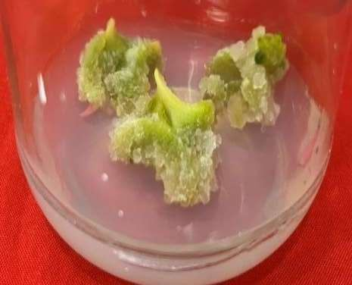
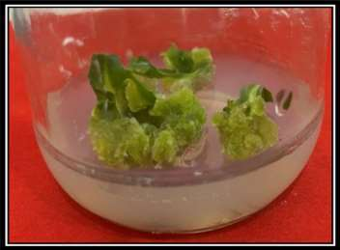
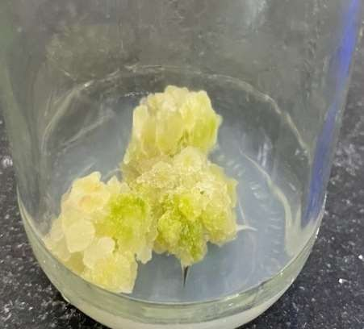
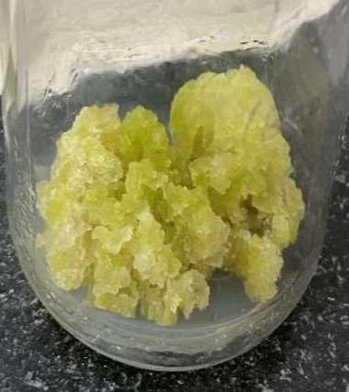
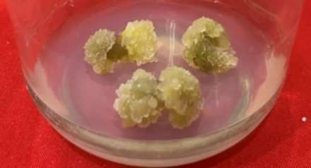
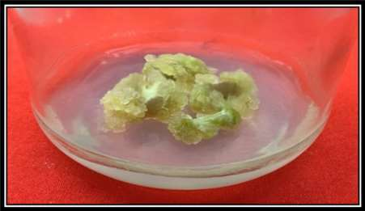
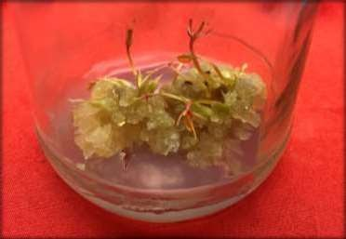
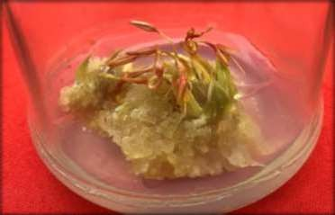
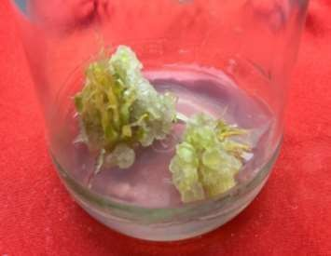
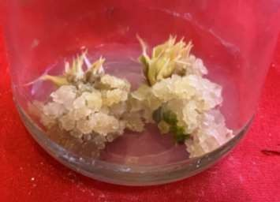
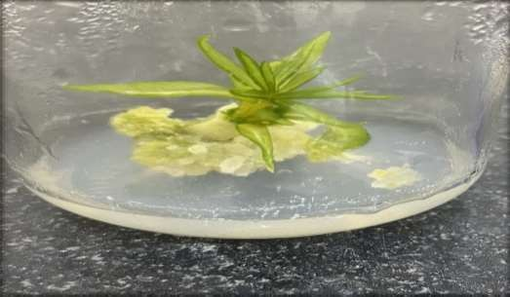
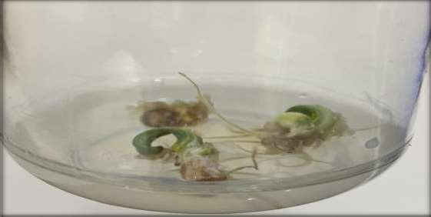
a.
b.
c.
d.
e.
f.
g.
h.
i.
j.

Fig. 1. Effects of genotype, explant type, and culture media hormonal composition on callogenesis, shoot regeneration, and root induction. a. Callus induction from GMU 7931-1 on 3mg/L NAA and 1mg/L BAP using leaf explant. b. Callus induction from GMU 7923 on 4mg/L NAA and 1mg/L BAP using leaf explant. c. Callus induction from GMU-7931-1 on 5mg/L 2,4-D using leaf explant. d. Callus induction from GMU-7923 on 3mg/L 2,4-D using leaf explant. e. Callus induction from GMU-7931-1 on 2mg/L NAA + 1mg/L BAP using Hypocotyl explant. f. Callus induction from GMU-7923 on 3mg/L NAA+1mg/L BAP using hypocotyl explant. g. Callus induction from GMU-7931-1 on 0.5 mg/L NAA+ 5mg/L TDZ using flower bud explant. h. Callus induction from GMU-7923 on 0.5 mg/L NAA+ 5mg/L TDZ using flower bud explant. i. Shoot induction from developing callus of GMU- 7931-1 on 1mg/L NAA+1mg/L from hypocotyl explant. j. Root induction from developing callus of GMU-7931-1 on 2mg/L 2,4-D from leaf explant.

4. CONCLUSION
This study establishes a reliable and reproducible in vitro callus induction protocol for safflower (Carthamus tinctorius L.), demonstrating the significant influence of explant type, genotype, and growth regulator combinations on morphogenic responses. Leaf explants cultured on MS medium supplemented with 2,4-D (5.0 mg/L) showed the highest callus induction among all explants, with GMU-7931-1 exhibiting superior in vitro response; this combination proved most effective among all hormone–explant combinations in the study, based on reduced duration for callus induction and the production of healthy, well-developed callus. While optimized auxin–cytokinin combinations (NAA + BAP) in leaf explants, GMU-7931-1 exhibited the highest callus induction at 3.0 mg/L NAA + 1.0 mg/L BAP, while GMU-7923 responded maximally at 4.0 mg/L NAA + 1.0 mg/L BAP. Hypocotyl-derived callus was optimal at 2.0 mg/L NAA + 1.0 mg/L BAP for GMU-7931-1 and 3.0 mg/L NAA + 1.0 mg/L BAP for GMU-7923 , whereas higher auxin levels (≥5.0 mg/L) suppressed callogenesis . Importantly, this study reports for the first time the successful induction of callus from floral bud explants in safflower using a TDZ-based regime (0.5 mg/L NAA + 5.0 mg/L TDZ for both the varieties), thereby filling a critical research gap in safflower tissue culture and expanding the range of responsive explants. The development of high-biomass, regenerable callus cultures across multiple explants provides a robust, season independent platform for large scale in vitro biomass production and offers significant potential for the sustainable and year round production of valuable secondary metabolites, particularly quinone-based pigments such as carthamin and cearthamidin, with established medicinal and pharmaceutical relevance.

DISCLAIMER (ARTIFICIAL INTELLIGENCE)
Authors hereby declare that NO generative artificial intelligence tools including large language models (e.g., ChatGPT, Google Gemini, Microsoft Copilot) or text-to-image generators were used in the writing, editing, data analysis, or figure preparation for this manuscript. All content is the original work of the authors.

COMPETING INTERESTS
Authors declare that there are no competing interests or potential conflicts of interest related to the content of this manuscript.

REFERENCES

Ali, N., & Afrasiab, H. (2014). Effect of TIBA and other plant growth regulators on callogenic response from different explants of safflower (Carthamus tinctorius). International Journal of Agriculture and Biology, 16(6).
Baldi, A., & Dixit, V.K. (2008). Enhanced artemisinin production by cell cultures of Artemisia annua. Curr Tre Biotech Phar. 2 (2), 341-348.
Brown, J. T., & Charlwood, B. V. (1986). The control of callus formation and differentiation in scented pelargoniums.Journal of Plant Physiology. 123(5), 409-417.
Caretto, S., Speth EB., Fachechi C., Gala R., Zacheo G & Giovinazzo, G. (2004). Enhancement of vitamin E production in sunflower cell cultures. Plant Cell Rep,23, 174–179.
Chavan, S.P., Lokhande, V.H., Nitnaware, K.M., & Nikam, T.D. (2010). Influence of growth regulators and elicitors on cell growth and α -tocopherol and pigment productions in cell cultures of Carthamus tinctorius L., Appl Microbiol Biotechnol.10, 3014-4.
Dajue, L., & Mündel, H. H. (1996). Safflower, Carthamus tinctorius L (Vol. 7).Bioversity International.9-10.
Delshad, E., Yousefi, M., Sasannezhad, P., Rakhshandeh, H., & Ayati, Z. (2022) Medical uses of Carthamus tinctoriusL. (Safflower): A comprehensive review from Traditional Medicine to Modern Medicine.Electron.Physician.7(2), 6672-6681.
Emongor, V. (2010). Safflower (Carthamus tinctorius L.) the under-utilized and neglected crop: A review. Asian J.Plant Sci,(9), 299-306.
Ghasempour, H., Soheilikhah, Z., Zebarjadi, A. R., Ghasempour, S., & Karimi, N., (2014). In vitro micro propagation, callus induction and shoot regeneration in safflower L. cv. Lesaf, Iranian Journal of Plant Physiology. 4(2), 999-1004.
Hanagata N., Ito A & Uehara H. (1993). Behavior of cell aggregate of Carthamus tinctorius L. cultured cells and correlation with red pigment formation. Journal of Biotechnology,30(3), 259–269.
Hanagata N., Ito A., Fukuju Y & Murata, K. (1992). Red pigment formation in cultured cells of Carthamus tinctorius L. Biosci Biotechnol Biochem, 56(1): 44-47.
Hanagata, N., & Karube, I. (1994). Red pigment production by Carthamustinctorius cells in a two stage culture system. Journal of Biotechnology,31(1):59-65.
Hussain, M.I., Lyra, D.-A., Farooq, M., Nikoloudakis, N., Khalid, N. (2016). Salt and drought stresses in safflower: A review. Agron. Sustain. Dev, (36): 4.

Hussein, H. F., El-Mezien, A. E., El-Shabrawi, H. M., & Elkafafi, E. H. (2024). Plant growth regulators promoting callus induction and antioxidant activity in white sapote (Casimiroa Edulis).Al-AzharJournal of Agricultural Research. 49(1), 51-58.

Ignacimuthu, S. (1997). Plant biotechnology. New Delhi, India: Oxford and IBH Publishing Co.
Ikeuchi, M., Sugimoto, K., & Iwase, A. (2013). Plant callus: mechanisms of induction and repression. The plant cell, 25(9), 3159-3173.
Junairiah, J., Zuraidassanaaz, N. I., & Sulistyorini, L. (2023). Effect of plant growth regulators on callus induction in Piper betle L. var. Nigra. Journal of Pharmacy and Science. 8(1), 7-13.
Kassa, B. A., Mekbib, F., & Assefa, K. (2024). Effects of plant hormones and genotypes on anther culture response of safflower (Carthamus tinctorius L.). Scientific African, 26, e02367.)
Kumari, S., & Pandey, R. (2010). In vitro germination and callus induction from seeds of Carthamus tinctorius L. The Bioscan. 5(2), 247-250.
Kumari, S., Pandey, R. K., & Uttam, K. (2015). In vitro callus induction from two different explants stem and leaf in Carthamus tinctorius Linn. European Journal of Experimental Biology. 5(2), 1-4.
Larkin, P.J. and Scowcroft, W.R. (1981). Somaclonal variation - a novel source of variability from cell cultures for plant improvement. Theoretical and Applied Genetics, 60(4):197- 214.
Mandal, A.K.A., Chatterji, A.K., & Gupta, S.D. (1995). Direct somatic embryogenesis and plantlet regeneration from cotyledonary leaves of safflower. Plant Cell, Tissue and Organ Culture. 43, 287-289.
Mendhe, S. (2025). In vitro propagation, callus induction and regeneration of shoot from first leaf of Carthamus tinctorius L. Research Journal of Pharmaceutical, Biological and Chemical Sciences, 16(3S), 1–8.
Motamedi, J., Zebarjadi, A., Kahrizi, D., & Salmanian, A. H. (2011). In vitro propagation and agrobacterium-mediated transformation of safflower (Carthamus tinctorius L.) using a bacterial mutated aroA gene. Australian Journal of Crop Science.5(4), 479- 486.
Murashige, T., & Skoog, F. (1962). A revised medium for rapid growth and bioassays with tobacco tissue cultures. Physiology of Plants. 15: 473-497.
Murthy, B. N. S., Murch, S. J., & Saxena, P. K. (1998). Thidiazuron: a potent regulator of in vitro plant morphogenesis. In Vitro Cellular & Developmental Biology-Plant, 34, 267-275.
Pawar, N. S., Rathod, B. U., Majhi, P. K., & Gotamwad, V. E. (2019).In vitro callus induction of safflower (Carthimus tinctorius L.) International Journal of Molecular Biology and Biochemistry,1(2), 11-12.
Rani, K. J., Rao, T. N., Raghunatham, G., & Rao, P. V. (1996). Studies on callus growth and differentiation in safflower.Indian Journal of Genetics and Plant Breeding. 56(04), 458-461.
Savitha, B.C.,Thimmaraju, R., Bhagyalakshmi, N., & Ravishnkar, G.A. (2006). Different biotic and abiotic elicitors influence betalain production in hairy root cultures of Beta vulgaris in shake flask and bioreactor. Process Biochem, 41(1), 50–60.
Shirin, F., Hossain, M., Kabir, M.F., Roy, M. & Sarker, S.R. (2007). Callus induction and plant regeneration from internodal and leaf explant of four potato (Solanum tuberosum L.) Cultivars.World Journal of Agricultural Sciences, 3(1), 1-6.
Skoog, F., & Miller, C. O. (1957). Chemical regulation of growth and organ formation in plant tissues cultured in vitro. Symposia of the Society for Experimental Biology, 11, 118–130.
Statista & USDA Foreign Agricultural Service. (2025). Data retrieved from https://www.statista.com, https://apps.fas.usda.gov (Accessed March 5, 2025).
Whitmer, S., Verpoorte, R., & Canel, C. (1998). Influence of auxins on alkaloid accumulation by a transgenic cell line of Catharanthus roseus. Plant Cell, Tissue and Organ Culture. 53, 135-141.
Yeilaghi, H., Arzani, A., Ghaderian, M., Fotovat, R., Feizi, M., & Pourdad, S. S. (2012).Effect of salinity on seed oil content and fatty acid composition of safflower (Carthamus tinctorius L.) genotypes.Food Chemistry.130(3), 618 625.
Yeoman, M.M., & Yeoman, C.L. (1996). Tansley review no. 90, manipulating secondary metabolism in cultured plant cells. The New Phytologist, 134(4),553–569.
Yeung, E. C., Oinam, G. S., Yeung, S. S., & Harry, I. (2011).Anther, pollen and tapetum development in safflower, Carthamus tinctorius L. Sexual Plant Reproduction. 24, 307-317.
Zhao, J.L., Zhou, L.G., & Wu J.Y., (2010). Effects of biotic and abiotic elicitors on cell growth and tanshinone accumulation in Salvia miltiorrhiza cell cultures.Appl Microb Biotechnol. 87,137–144.

