Field evaluation of fungicides for management of leaf blight of tuberose caused by Alternaria alternata

Abstract:
Background: Tuberose (Polianthes tuberosa L.) is an economically important ornamental crop widely cultivated for its fragrant flowers. However, leaf blight caused by Alternaria alternata has emerged as a major constraint, leading to significant yield reduction under favourable environmental conditions.
Aims: The present study aimed to evaluate the efficacy of selected fungicides in managing leaf blight of tuberose under field conditions.
Place and Duration of Study: The experiment was conducted during Kharif 2024 and Rabi 2025 under farmers’ field conditions at Huskuru, Doddaballapura taluk, Karnataka.
Methodology: Seven fungicides comprising contact, systemic, and combination products were evaluated in a randomized complete block design with three replications using cv. Arka Prajwal. Treatments were applied as foliar sprays at 15-day intervals starting from disease onset. Disease severity was assessed using a 0–5 scale, and percent disease index (PDI) and flower stalk yield (number m⁻²) were recorded.
Results: All fungicides significantly reduced disease severity compared to the untreated control (73.46% PDI). Captan + hexaconazole (0.1%) was the most effective, recording the lowest mean PDI (25.05%) with maximum disease reduction (66.28%). This treatment also resulted in the highest flower stalk yield (31.01 m⁻²) and benefit–cost ratio (4.07).
Conclusion: Captan + hexaconazole proved highly effective and economically viable for managing leaf blight of tuberose and can be recommended as part of integrated disease management strategies.
Keywords: Alternaria alternata, tuberose, leaf blight, fungicides, field evaluation, disease management
Introduction
Tuberose (Polianthes tuberosa L.), belonging to the family Amaryllidaceae, is a perennial bulbous ornamental crop valued for its fragrance and aesthetic appeal. Originating in Mexico, it is now widely cultivated across India, which accounts for about 70 % of global production, with Tamil Nadu and Karnataka contributing nearly 40 % of the world’s cultivated area (Kumar, 2020). Tuberose thrives in warm, humid climates with temperatures between 16 °C and 30 °C and can grow in sandy loam to clay loam soils, including mildly saline or alkaline conditions (Karihaloo, 2019). Major producing states are Tamil Nadu, Karnataka, West Bengal, Andhra Pradesh, Maharashtra, Uttar Pradesh, and Telangana (Fatmi, 2024). The area under tuberose cultivation in India during 2024-25 was 25.96 thousand hectares, producing 111.38 thousand metric tonnes of loose flowers with a productivity of 4.29 t/ha, and 107.02 thousand metric tonnes of cut flowers with a productivity of 4.12 t/ha. In Karnataka, tuberose was cultivated on 1.22 thousand hectares during the same period, yielding 9.19 thousand metric tonnes of loose flowers with a productivity of 7.53 t/ha (Anonymous, 2025). Tuberose is extensively used for garlands, bouquets, and perfumery due to its long vase life and strong fragrance (Vimal et al., 2024). Its essential oil is utilized in cosmetics, aromatherapy, and traditional medicine (Valli et al., 2014; Muthukumar et al., 2007). Common commercial varieties include Arka Prajwal, Suvasini, Arka Nirantara, Phule Rajani, Shrinagar, Vaibhav, Swarna Rekha, Rajat Rekha, and Pearl Double. However, tuberose cultivation is increasingly constrained by fungal diseases such as stem rot caused by Sclerotium rolfsii (Singh et al., 2006), foot and tuber rot by Fusarium oxysporum (Mahinpoo et al., 2013), peduncle blight by Lasiodiplodia theobromae (Durgadevi et al., 2012), blossom blight by Fusarium equiseti (Rahman et al., 2012), and anthracnose by Colletotrichum truncatum (Mahadevakumar et al., 2019). Among these, leaf blight caused by Alternaria spp. has emerged as a major constraint to tuberose production. The disease was first reported from Coimbatore, Tamil Nadu (Mariappan, 1977). Alternaria leaf blight is characterized by reddish-brown spots with concentric rings along the leaf margins and midrib, which enlarge and coalesce, leading to drying, defoliation, and reduced photosynthetic activity (Mahalakshmi et al., 2023). Severe infections can cause 20-60 % yield losses depending on environmental conditions. Fungicides such as chlorothalonil, mancozeb and carbendazim have shown efficacy against the disease, particularly when applied at the initial stages of infection or during high disease pressure (Abdel-Ghany & Bakri, 2019). Previous studies revealed that four foliar sprays of azoxystrobin (0.1 %) at 15-day intervals, initiated at the onset of disease symptoms, resulted in the lowest disease severity (Mazumder et al., 2016). However, continuous use of fungicides with a single mode of action may lead to resistance development and increased chemical residues in harvested flowers. Hence, the adoption of fungicide rotation strategies is essential. Despite the availability of several fungicides, their efficacy against Alternaria spp. on tuberose remains inadequately explored. Although several studies have evaluated fungicides against Alternaria spp. in different crops, limited information is available on field-level evaluation under natural conditions in tuberose, particularly under Karnataka agro-climatic conditions. Furthermore, comparative evaluation of systemic, contact and combination fungicides under field conditions is scarce. Therefore, the present study was undertaken to assess the efficacy of fungicides under field conditions for effective management.
Materials and methods
Field evaluation of fungicides
A field evaluation was conducted in Kharif 2024 and Rabi 2025 under natural field conditions to evaluate promising fungicides against leaf blight of tuberose caused by Alternaria alternata. Experiment was laid out in Randomized Complete Block Design (RCBD) with three replications and eight treatments in the farmer’s field at Huskuru, Doddaballapur taluk, Bengaluru Rural district, Karnataka. Tuberose bulbs cv. Arka Prajwal was planted at spacing 45 cm x 30 cm. The plants were sprayed with fungicides three times at an interval of fifteen days starting from the first appearance of the disease symptoms, mostly at flower stalk initiation stage. Percent disease intensity was recorded one week after the last spray. Ten plants in each sub plot were scored for disease by following 0-5 scale (Narayanppa and Chandra, 1984). Further, Percent Disease Index (PDI) was calculated using the following formula (Wheeler, 1969). Flower stalk (no. / m2) was also recorded. Original percent data was converted into angular transformation before analysis following the table (Snedecor and Chocran, 1989).
Table 1: Disease rating scale to assess the severity of Alternaria leaf blight of tuberose
Grade | Description
0 | No visible symptoms
1 | 1-5 % leaf area infected
2 | 6-10 % leaf area infected
3 | 11-25 % leaf area infected
4 | 26-50 % leaf area infected
5 | More than 50 % leaf area infected

$$Percent disease index= \frac{Sum of the numerical ratings}{Total no. of leaves examined ×Maximum disease grade}×100$$

Table 2: Treatment details
Sl. No. | Treatments | Concentration %
Contact fungicides
1 | Metiram 70 % WG | 0.2
2 | Mancozeb 75 % WP | 0.2
Systemic fungicides
1 | Propiconazole 25 % EC | 0.1
2 | Hexaconazole 5 % SC | 0.1
Combi fungicides
1 | Metiram 55 % + Pyraclostrobin 5 % WG | 0.1
2 | Boscalid 25.2 % + Pyraclostrobin 12.8 % WG | 0.1
3 | Captan 70 % + Hexaconazole 5 % WP | 0.1
Control |  | -

Results
Field evaluation of fungicides
Foliar application of fungicides significantly reduced the incidence of leaf blight in tuberose compared with the untreated control (mean PDI 73.46%). During the Rabi season, the lowest disease intensity (19.42%) was recorded with captan + hexaconazole (0.1%), followed by metiram + pyraclostrobin (23.14%) and propiconazole (28.26%). During the Kharif season, captan + hexaconazole again recorded the lowest PDI (30.68%), followed by metiram + pyraclostrobin (35.61%) and boscalid + pyraclostrobin (38.67%). The untreated control recorded the highest disease severity in both seasons, with 68.04% in Rabi and 78.89% in Kharif, resulting in a mean of 73.46%. Captan + hexaconazole (0.1%) recorded the highest reduction in disease over control, with 71.45% in Rabi and 61.11% in Kharif, with a mean reduction of 66.28%, followed by metiram + pyraclostrobin (65.99% in Rabi and 54.86% in Kharif) and boscalid + pyraclostrobin (54.77% in Rabi and 50.98% in Kharif), while the lowest disease reduction was observed in metiram (44.04% in Rabi and 37.45% in Kharif) (Table 3 and 4). Captan + hexaconazole recorded the highest number of flower stalks per square metre, with 24.04 in Rabi and 37.98 in Kharif (mean 31.01), followed by boscalid + pyraclostrobin (21.63 in Rabi and 36.25 in Kharif) and metiram + pyraclostrobin (22.08 in Rabi and 35.58 in Kharif), whereas the untreated control recorded the lowest stalk production (17.59 in Rabi and 25.67 in Kharif). The highest increase in flower stalk yield over control was recorded with captan + hexaconazole (36.66% in Rabi and 47.95% in Kharif), with a mean increase of 42.30%, followed by boscalid + pyraclostrobin (32.08%) and metiram + pyraclostrobin (32.06%), while metiram recorded the lowest increase (12.82%). Captan + hexaconazole recorded the highest benefit–cost ratio of 3.66 in Rabi and 4.79 in Kharif, with a mean of 4.07, followed by hexaconazole (3.70) and mancozeb (3.24), whereas the untreated control recorded the lowest B:C ratio (1.55) (Table 5).
Table 3: In vivo evaluation of fungicides against leaf blight and yield of tuberose (Kharif, 2024)
Treatments | Dosage | PDI | Reduction of disease over control (%) | No of flower stalk/m² | Increase in No of flower stalk over control
T1: Metiram 70 % WP | 0.2% | 49.34 %  *(44.60) | 37.45  (37.72) | 29.67 | 15.58
T2: Mancozeb 75 % WP | 0.2% | 48.06%  (43.87) | 39.07  (45.54) | 33.33 | 29.84
T3: Metiram 55 % + Pyraclostrobin 5% WG | 0.1% | 35.61%  (36.62) | 54.86  (47.77) | 35.58 | 38.6
T4: Boscalid 25.2 % + Pyraclostrobin 12.8 % WG | 0.1% | 38.67%  (38.43) | 50.98  (38.67) | 36.25 | 41.21
T5: Captan 70 % + Hexaconazole 5 % WP | 0.1% | 30.68%  (33.62) | 61.11  (51.40) | 37.98 | 47.95
T6: Propiconazole 25 % EC | 0.1% | 41.02%  (39.81) | 48  (43.84) | 35.17 | 37
T7: Hexaconazole 5 % SC | 0.1% | 44.86%  (42.03) | 43.13  (41.03) | 32.00 | 24.65
T8: Untreated control | - | 78.89%  (62.62) | 0.00  (0.00) | 25.67 | -
S. Em± |  | 0.621 |  | 0.251
C. D. at 5 % |  | 1.87 |  | 0.769
C. V |  | 2.36 |  | 1.35
*Figures in parenthesis are arcsine transformed values, PDI-Percent Disease Index

Table 4: In vivo evaluation of fungicides against leaf blight and yield of tuberose (Rabi, 2025)
Treatments | Dosage | PDI | Reduction of disease over control (%) | No of flower stalk/m² | Increase in No of flower stalk over control
T1: Metiram 70 % WP | 0.2% | 38.07%  (38.08) | 44.04 (41.56) | 19.36 | 10.06
T2: Mancozeb 75 % WP | 0.2% | 33.45%  (35.32) | 50.83 (45.46) | 21.11 | 20.01
T3: Metiram 55 % + Pyraclostrobin 5% WG | 0.1% | 23.14%  (28.74) | 65.99 (54.30) | 22.08 | 25.52
T4: Boscalid 25.2 % + Pyraclostrobin 12.8 % WG | 0.1% | 30.77%  (33.67) | 54.77 (47.72) | 21.63 | 22.96
T5: Captan 70 % + Hexaconazole 5 % WP | 0.1% | 19.42%  (26.14) | 71.45 (57.68) | 24.04 | 36.66
T6: Propiconazole 25 % EC | 0.1% | 28.26%  (32.10) | 58.46 (49.85) | 22.00 | 25.07
T7: Hexaconazole 5 % SC | 0.1% | 31.60%  (34.19) | 53.55 (47.02) | 21.05 | 19.67
T8: Untreated control | - | 68.04%  (55.55) | 0.00 | 17.59 | -
S. Em± |  | 2.56 |  | 0.31
C. D. at 5 % |  | 7.66 |  | 0.929
C. V |  | 12.71 |  | 2.48
*Figures in parenthesis are arcsine transformed values, PDI-Percent Disease Index

Table 5: In vivo evaluation of fungicides against leaf blight and yield of tuberose (kharif 2024 and Rabi 2025)
Treatments | Dosage | PDI(%) |  |  | Reduction of disease over control (%) |  |  | No of flower stalk/m² |  |  | Increase in No of flower stalk over control |  |  | B:C Ratio
Treatments | Dosage | Rabi | Kharif | Mean | Rabi | Kharif | Mean | Rabi | Kharif | Mean | Rabi | Kharif | Mean | B:C Ratio
T1: Metiram 70 % WP | 0.2 % | 38.07  (38.08) | 49.34  (44.60) | 43.70  (41.34) | 44.04 (41.56) | 37.45 (37.72) | 40.74 (39.64) | 19.36 | 29.67 | 24.51 | 10.06 | 15.58 | 12.82 | 2.85
T2: Mancozeb 75 % WP | 0.2 % | 33.45  (35.32) | 48.06  (43.87) | 40.75  (39.59) | 50.83 (45.46) | 39.07 (45.54) | 44.95 (45.5) | 21.11 | 33.33 | 27.22 | 20.01 | 29.84 | 24.92 | 3.24
T3: Metiram 55 % + Pyraclostrobin 5% WG | 0.1 % | 23.14  (28.74) | 35.61  (36.62) | 29.37  (32.68) | 65.99 (54.30) | 54.86 (47.77) | 60.42 (51.03) | 22.08 | 35.58 | 28.83 | 25.52 | 38.6 | 32.06 | 2.45
T4: Boscalid 25.2 % + Pyraclostrobin 12.8 % WG | 0.1 % | 30.77  (33.67) | 38.67  (38.43) | 34.72  (36.05) | 54.77 (47.72) | 50.98 (38.67) | 52.87 (43.19) | 21.63 | 36.25 | 28.94 | 22.96 | 41.21 | 32.08 | 2.40
T5: Captan 70 % + Hexaconazole 5% WP | 0.1 % | 19.42  (26.14) | 30.68  (33.62) | 25.05  (29.88) | 71.45 (57.68) | 61.11 (51.40) | 66.28 (54.54) | 24.04 | 37.98 | 31.01 | 36.66 | 47.95 | 42.30 | 4.07
T6: Propiconazole 25 % EC | 0.1 % | 28.26  (32.10) | 41.02  (39.81) | 34.64  (35.95) | 58.46 (49.85) | 48 (43.84) | 53.23 (46.84) | 22.00 | 35.17 | 28.58 | 25.07 | 37 | 31.03 | 3.21
T7: Hexaconazole 5 % SC | 0.1 % | 31.60  (34.19) | 44.86  (42.03) | 51.51  (45.85) | 53.55 (47.02) | 43.13 (41.03) | 48.34 (44.02) | 21.05 | 32.00 | 26.52 | 19.67 | 24.65 | 22.16 | 3.70
T8: Control | - | 68.04  (55.55) | 78.89  (62.62) | 73.46  (59.28) | 0.00 (0.00) | 0.00 (0.00) | 0.00 (0.00) | 17.59 | 25.67 | 21.63 | - | - | - | 1.55
S. Em± |  | 2.56 | 0.621 | 1.59 |  |  |  | 0.31 | 0.251 | 0.56
C. D. at 5 % |  | 7.66 | 1.87 | 4.76 |  |  |  | 0.929 | 0.769 | 0.84
*Figures in parenthesis are arc sine transformed values, PDI- Percent disease index

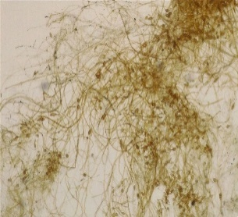
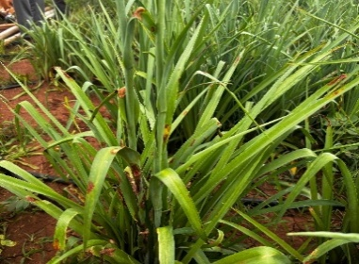
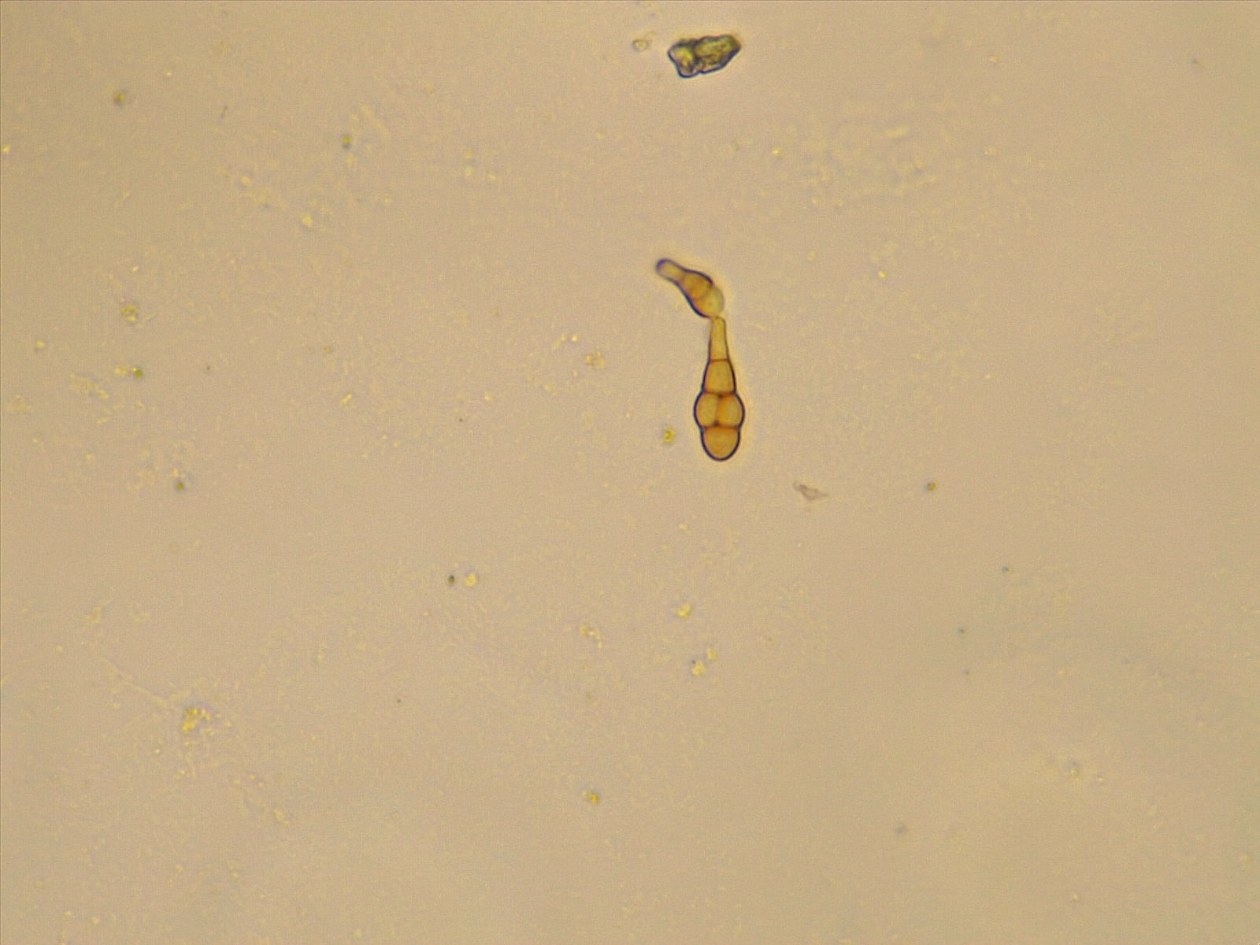
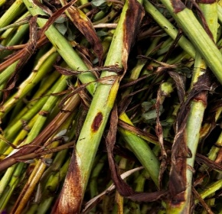

Fig .1: Alternaria alternata symptoms on leaf and tuberose stalk, conidia (10 and 40X)

Discussion
Leaf blight symptoms were first observed at the flower stalk initiation stage and progressed with advancing crop growth, indicating a close association between host phenology and disease development. The disease, initially reported by Mariappan et al. (1977), typically begins at the leaf tips and extends along the leaf blade, forming necrotic lesions that coalesce into typical blight symptoms. Under severe infection, leaves become flaccid, droop, and undergo premature senescence, resulting in reduced photosynthetic efficiency and yield losses. Similar symptom development and disease progression have been reported in recent studies on Alternaria alternata in ornamental crops (Mishra et al., 2022; Karthik et al., 2023).
The results of the present study clearly demonstrated that foliar application of fungicides significantly reduced disease severity compared to the untreated control across both kharif and Rabi seasons. Among the treatments evaluated, captan + hexaconazole (0.1%) consistently recorded the lowest disease intensity, indicating its superior efficacy under varying environmental conditions. These findings are in agreement with recent reports where triazole fungicides such as difenconazole, tebuconazole, and propiconazole effectively reduced Alternaria leaf blight severity and improved crop yield (Patel et al., 2022; Sonavane, 2024; Reddy et al., 2023). Combination fungicides have also been reported to provide enhanced disease control compared to single-site fungicides due to their broader spectrum of activity (Sharma et al., 2022; Gupta et al., 2024).
The superior performance of captan + hexaconazole can be attributed to its dual mode of action. Hexaconazole, a systemic triazole fungicide, inhibits ergosterol biosynthesis, thereby disrupting fungal cell membrane formation, while captan acts as a multi-site contact fungicide providing a protective layer on leaf surfaces. This complementary interaction enhances fungicidal efficiency and reduces pathogen proliferation. Similar findings have been reported by Kumar et al. (2023) and Singh et al. (2022), who emphasized the importance of combining systemic and contact fungicides for effective management of Alternaria diseases.
Environmental conditions significantly influenced disease development and treatment performance. The higher disease intensity observed during the kharif season may be attributed to favourable conditions such as high humidity and intermittent rainfall, which promote spore germination and disease spread. In contrast, relatively lower disease pressure during the Rabi season enhanced the effectiveness of fungicidal treatments. Comparable seasonal variations in disease incidence have been reported by Verma et al. (2023) and Rao et al. (2024), who highlighted the role of climatic factors in influencing Alternaria alternata epidemiology.
Reduction in disease severity was directly associated with increased crop productivity. The highest number of flower stalks per square metre was recorded in plots treated with captan + hexaconazole, reflecting improved plant vigour and reduced physiological stress. In contrast, the untreated control recorded the lowest yield, demonstrating the adverse effects of leaf blight on photosynthesis and assimilate partitioning. Similar positive correlations between effective disease management and yield improvement have been reported by Patel et al. (2022) and Sonavane (2024).
Recent studies have also highlighted the potential of integrated disease management approaches involving biological agents, plant extracts, and novel compounds in controlling Alternaria diseases. For instance, bio-based treatments and plant-derived extracts have shown promising antifungal activity against Alternaria alternata (Kumar et al., 2024; Devi et al., 2023). Additionally, emerging approaches such as nanoparticle-based disease management have demonstrated significant inhibitory effects on fungal pathogens, offering new avenues for sustainable agriculture (Ramesh et al., 2023; Chauhan et al., 2024).
However, continuous use of single-site fungicides may lead to the development of resistance in pathogen populations. Therefore, the use of fungicide combinations, rotation of active ingredients with different modes of action, and integration with non-chemical approaches are essential for sustainable disease management. Recent studies strongly advocate integrated disease management (IDM) strategies to ensure long-term effectiveness and environmental safety (Gupta et al., 2024; Rao et al., 2024).
Overall, the present study confirms that captan + hexaconazole is an effective, economically viable, and field-reliable option for managing leaf blight of tuberose caused by Alternaria alternata. Its consistent performance across seasons, combined with its dual mode of action, supports its inclusion in integrated disease management strategies. Further research should focus on integrating chemical control with host resistance, biological control agents, and eco-friendly approaches to develop a comprehensive and sustainable disease management strategy for tuberose cultivation.
Conclusion
Three applications of captan + hexaconazole (0.1 %) at 15-day intervals, sprayed at the first appearance of disease symptoms, were found to be the most effective, resulting in the lowest disease intensity (25.05 % PDI) compared with the untreated control (73.46 % PDI). This treatment also recorded a favourable benefit-cost ratio of 4.07. Economic evaluation further indicated that hexaconazole and mancozeb, each applied at 0.1 percent, were also economically efficient. These treatments achieved high B:C ratio of 3.70 and 3.24 respectively, along with disease reductions of 51.51 percent and 40.75 percent.
Disclaimer (Artificial intelligence)

Author(s) hereby declare that NO generative AI technologies such as Large Language Models (ChatGPT, COPILOT, etc.) and text-to-image generators have been used during the writing or editing of this manuscript.

References

Abdel-Ghany TM, Bakri MM. 2019. Effectiveness of a biological agent (Trichoderma harzianum) and fungicide on Alternaria solani. BioResources. 14(1):1591–1602. https://doi.org/10.15376/biores.14.1.1591-1602
Anonymous. 2025. INDIASTAT – Statistical database of India. Available: https://www.indiastat.com
Chauhan R, Singh A, Kumar P. 2024. Nanotechnology-based approaches for management of fungal plant pathogens. Journal of Plant Protection Research. 64(1):1–12. Available: https://journals.pan.pl/jppr
Devi S, Patel RK, Singh V. 2023. Evaluation of plant extracts against Alternaria alternata causing leaf blight in ornamental crops. Indian Phytopathology. 76(2):345–352. https://doi.org/10.1007/s42360-023-005xx-x
Dhaval P, Shete PP, Kasal YG, Dholu D. 2023. Efficacy of fungicides against early blight of tomato caused by Alternaria solani. Ecology, Environment and Conservation. 29:158–163. http://doi.org/10.53550/EEC.2023.v29i01s.024
Durgadevi D, Sankaralingam A. 2012. First report of peduncle blight of tuberose caused by Lasiodiplodia theobromae in India. New Disease Reports. 26:5. http://dx.doi.org/10.5197/j.2044-0588.2012.026.005
Fatmi U. 2024. Varietal performance of tuberose (Polianthes tuberosa L.) under Prayagraj agro-climatic conditions. International Journal of Environment and Climate Change. 14(4):481–486.
Gupta S, Verma RK, Sharma N. 2024. Integrated disease management strategies for Alternaria diseases in horticultural crops. Crop Protection. 178:106567. https://doi.org/10.1016/j.cropro.2024.106567
Karihaloo JL. 2019. Cytological and hybridization studies in tuberose (Polianthes tuberosa L.). Cytologia. 84(1):47–52. https://doi.org/10.1508/cytologia.84.47
Karthik P, Ramesh V, Kumar S. 2023. Epidemiology and management of Alternaria alternata in ornamental crops. Journal of Applied Horticulture. 25(2):150–156. Available: https://jhorticulture.com
Kumar A. 2020. Management of leaf blight disease caused by Alternaria polianthi in tuberose. Current Journal of Applied Science and Technology. 39(8):1–8. https://doi.org/10.9734/cjast/2020/v39i830587
Kumar S, Devi P, Sharma L. 2024. Bio-based approaches for management of fungal diseases in ornamental crops. Biological Control. 186:105345. https://doi.org/10.1016/j.biocontrol.2023.105345
Kumar S, Singh R, Patel N. 2023. Comparative efficacy of fungicides against Alternaria leaf blight in horticultural crops. Indian Journal of Plant Protection. 51(2):123–129. Available: https://www.ippindia.org
Mahadevakumar S, Chandana C, Janardhana GR. 2019. First report of anthracnose of tuberose caused by Colletotrichum truncatum. Crop Protection. 118:1–5. https://doi.org/10.1016/j.cropro.2018.12.006
Mahalakshmi P, Ayyandurai M, Mareeswari P. 2023. Management of leaf spot (Alternaria polianthi) of tuberose using bioagents and plant extracts. Biological Forum – An International Journal. 15(6):142–147.
Mahinpoo V, Nejad RF, Memari HR, Cheraghi A, Bahmani Z. 2013. Genetic diversity of Fusarium oxysporum isolated from tuberose based on RAPD analysis and VCG groups. Journal of Plant Pathology and Microbiology. 4(1). http://doi.org/10.4172/2157-7471.1000158
Mariappan V, Babu K, Kandasamy TK. 1977. A leaf spot disease of tuberose caused by a new species of Alternaria. Madras Agricultural Journal. 64:123–126.
Mazumder N, Borah SK, Hatibarua PH. 2016. Management of leaf spot (Alternaria polianthi) of tuberose through fungicides. Agricultural Science Digest. 36(3):214–217. https://doi.org/10.18805/asd.v36i3.11454
Mishra R, Singh D, Yadav A. 2022. Disease development and management of Alternaria alternata in floricultural crops. Indian Journal of Agricultural Sciences. 92(5):600–605. Available: https://epubs.icar.org.in
Muthukumar A, Bhaskaran R, Eswaran A, Kumar MR. 2007. Biochemical properties of healthy and leaf spot infected tuberose plants. Indian Journal of Horticulture. 46:190–193.
Narayanappa M, Chandra JK. 1984. Fungicidal control of leaf spot of marigold caused by Alternaria tagetica. Indian Journal of Agricultural Sciences. 54(5):691–692.
Patel RB, Singh AK, Yadav PK. 2022. Evaluation of fungicides against Alternaria leaf blight in horticultural crops. Journal of Plant Protection. 30(2):89–95. Available: https://jppindia.org
Rahman MT, Bhuiyan MAHB, Bhuiyan MKA, Khandaker MM. 2012. Integrated management of blossom blight of tuberose caused by Fusarium equiseti. Pakistan Journal of Phytopathology. 24(1):48–52.
Ramesh K, Chauhan S, Verma A. 2023. Application of nanotechnology in plant disease management: A review. Journal of Plant Pathology. 105(2):321–335. https://doi.org/10.1007/s42161-023-013xx-x
Rao MS, Reddy PP, Kumar V. 2024. Influence of climatic factors on epidemiology of Alternaria alternata. Journal of Agrometeorology. 26(1):45–52. Available: https://agrimetassociation.org
Reddy PP, Kumar V, Singh R. 2023. Management of fungal diseases in ornamental crops using systemic fungicides. Journal of Mycology and Plant Pathology. 53(1):89–96. Available: https://www.jmpp.org.in
Sharma N, Gupta S, Verma RK. 2022. Role of combination fungicides in managing fungal plant diseases. Indian Phytopathology. 75(3):567–574. https://doi.org/10.1007/s42360-022-004xx-x
Singh AK. 2006. Flower crops: Cultivation and management. New India Publishing Agency.
Singh R, Kumar S, Verma P. 2022. Advances in fungicide resistance management in plant pathogens. Indian Journal of Plant Protection. 50(4):210–218. Available: https://www.ippindia.org
Snedecor GW, Cochran WG. 1989. Statistical methods. 8th ed. Iowa State University Press, Ames, Iowa.
Sonavane P. 2024. Management of Alternaria leaf blight of tuberose (Agave amica). Journal of Horticultural Sciences. 19(2):1–8. https://doi.org/10.24154/jhs.v19i2.2118
Valli G, Perlina R, Anusuya M. 2014. Biogenic synthesis and antibacterial activity of silver nanoparticles using tuberose extract. CAB International.
Verma RK, Gupta S, Sharma N. 2023. Seasonal incidence and management of Alternaria diseases in crops. Plant Disease Research. 38(2):210–216. Available: https://www.pdrjournal.org
Vimal S, Deivamani M, Sudha A, Vennila MA, Indhumathi K. 2024. Economic impact and management of blossom and peduncle blight in tuberose: A review. Plant Science Today. https://doi.org/10.14719/pst.4039
Wheeler BEJ. 1969. An introduction to plant diseases. John Wiley and Sons.

