GENETIC VARIABILITY, CHARACTER ASSOCIATION AND GENETIC DIVERSITY ANALYSIS IN BRINJAL (Solanum melongena L.) GENOTYPES

ABSTRACT
Brinjal (Solanum melongena L.) is a key vegetable in India, yet productivity is below potential, necessitating a better understanding of genetic variability and trait interrelationships for effective selection. During Kharif, 2023 at CSK HPKV, Palampur, 11 genotypes were evaluated using a randomized block design, recording 10 horticultural traits. ANOVA revealed significant differences among all traits studied, confirming the presence of sufficient genetic variability. The narrow range between the PCV and GCV values indicates a limited influence of environmental factors. High heritability coupled with high genetic gain was observed for the majority of traits that displayed additive gene action, indicating that direct selection of genotypes would be effective. The genotypes such as Utkal Anushree followed by Utkal Tarini, Konkan Prabha, Arka Nidhi, Arka Neelkanth, and Surya showed higher fruit yield per plant when compared against standard check variety, Hisar Shyamal. Fruit yield per plant showed a strong positive correlation with fruits per plant and a moderate correlation with harvest duration. Divergence analysis grouped genotypes into four distinct clusters; Utkal Anushree and Konkan Prabha were notably divergent, supporting their use in hybridization with Hisar Shyamal and/or Arka Neelkanth to generate superior recombinants. PCA emphasized fruit yield per plant and fruit number as major contributors to variation, reinforcing their value in brinjal improvement. These findings highlight the potential of exploiting this diversity in breeding. Hybridization programs involving genetically distant genotypes such as Utkal Anushree, Konkan Prabha, Hisar Shyamal, and Arka Neelkanth are recommended to develop high-yielding brinjal varieties adapted to the region.
Keywords: Genetic variability, character association, genetic diversity, yield, heritability

1. INTRODUCTION
Brinjal (Solanum melongena L.), commonly known as eggplant, aubergine, or king of vegetables, is widely cultivated in tropical and subtropical areas. It is highly valued for its nutritional content, which includes vitamins, minerals, dietary fiber, and secondary metabolites [1]. India is regarded as the primary center of origin of brinjal, possessing massive variability in morphotypes [2]. In India, it is grown in an area of 688.86 thousand hectares with annual production of 13130.73 thousand metric tonnes [3]. Brinjal offers promising applications in food processing, including pickles and dehydration. The often-overlooked peel, which is rich in anthocyanins, can be extracted and used as a natural preservative and colorant in food products [4]. Additionally, brinjal is used to treat respiratory ailments, such as bronchitis and asthma, as well as gastrointestinal issues, such as dysentery, stomach pain, toothaches, and burns [5]. Brinjal yield is a complex quantitative trait governed by multiple genes and is influenced by environmental factors [6]. Therefore, yield improvement programs need a complete understanding of the nature and magnitude of the genetic variability present in the available germplasm.
Assessment of genetic variability using parameters such as the phenotypic coefficient of variation (PCV), genotypic coefficient of variation (GCV), heritability, and genetic advance as a percentage of the mean (genetic gain) provides valuable information about the extent of variation and scope for selection [7], [8]. For instance, high heritability coupled with high genetic advancement indicates the predominance of additive gene action and offers better prospects for genetic improvement through selection. Character association helps determine the degree and direction of the association between yield and its component traits [9]. In addition, the estimation of genetic diversity among genotypes makes it easy to obtain superior recombinants and transgressive segregants [6].
Keeping these aspects in view, our work (a) estimates genetic variability, character association, and path coefficients among yield and its contributing traits; (b) assesses genetic diversity among brinjal genotypes to identify suitable parents for future breeding programs; and (c) identifies the best-performing genotypes against the standard check variety (SC) Hisar Shyamal.
2. MATERIALS & METHODS
2.1 Experimental Site
The experiment was conducted during Kharif, 2023 at the Experimental Farm, Department of Vegetable Science and Floriculture, CSKHPKV, Palampur, Himachal Pradesh, India. It is situated at an altitude of approximately 1300 m above sea level, with coordinates of 32.1° north latitude and 76.5° east longitude. The experimental site experiences harsh winters and mild summers with heavy rainfall during the monsoon season. Agro-climatically, it falls within the mid-hill zone of Himachal Pradesh, which is marked by a humid sub-temperate climate. The region receives an annual rainfall of 2500 mm, with 80% occurring from June to September. The soil is acidic with a pH between 5.0 to 5.6 and has a silty clay loam texture.
2.3 Experimental material and Design
The experimental material comprised 11 genotypes of brinjal collected from diverse agro-climatic regions to ensure adequate genetic variability (Table 1). The experimental field was prepared by ploughing with a disc plough followed by harrowing to achieve a fine soil tilth. The experiment was laid out in a Randomized Block Design (RBD) with three replications with a spacing of 60 × 45 cm. Standard agronomic practices, including irrigation, weed control, and other cultural practices, were followed as per the Package of Practices for Vegetable Crops by CSK HPKV, Palampur, to ensure healthy crop growth.
2.4 Observations Recorded
Observations were recorded on five randomly chosen competitive plants from each genotype across each replication. Observations were made of 10 horticultural traits: days to 50% flowering (DFF/days), days to first harvest (DFH/days), fruit length (FL/cm), fruit diameter (FD/cm), average fruit weight (AFW/g), number of fruits per plant (FPP/number), plant height (PH/cm), number of primary branches per plant (BPP/number), harvest duration (HD/days), and fruit yield per plant (FYPP/g).
2.5 Statistical Analysis
The experimental data recorded for various quantitative traits were subjected to analysis of variance (ANOVA), following the procedure described in [10], to test the significance of the differences among genotypes. PCV and GCV were computed according to the method suggested in [11]. Broad-sense heritability and genetic gain were estimated as previously described [12]. Genotypic and phenotypic correlation coefficients were calculated as previously described [13]. The PCV, GCV, and genetic gain were classified as low (<10%), moderate (10–20%), and high (>20%). Broad-sense heritability was categorized as low (<30%), moderate (30–60%), and high (>60%). Path coefficient analysis was performed according to the technique developed by [14] and later described by [15] to partition the correlation coefficients into direct and indirect effects. Genetic divergence among genotypes was estimated using Mahalanobis’ D² statistics, as proposed by [16], and genotype clustering was performed following Tocher’s method, as described by [17]. All statistical analyses were performed using R software [18].
3. RESULTS AND DISCUSSION
3.1 Analysis of variance
The analysis of variance revealed highly significant differences (p ≤ 0.01) among genotypes for all the traits studied, indicating the presence of substantial genetic variability in the experimental material (Table 2). Traits such as fruit length, fruit diameter, average fruit weight, number of fruits per plant, plant height, harvest duration, and fruit yield per plant exhibited a very high mean sum of squares for treatments, confirming the existence of considerable variability among genotypes. The highly significant variation observed in fruit yield per plant and its contributing traits suggests ample scope for selection and genetic improvement. Similar findings of significant variability in brinjal genotypes have been reported by [19] and [20], indicating that yield and its components are largely influenced by genetic factors.
3.2 Descriptive statistics
The estimates of the variability parameters revealed a wide range of variation for all traits studied. The phenotypic coefficient of variation (PCV) was slightly higher than the genotypic coefficient of variation (GCV) for all traits, indicating a minor influence of the environment on trait expression (Table 3).
Table 1. List of genotypes with their source of collection used in present investigation
S. No. | Genotypes | Name | Source
01 | Genotype – 1 | Arka Nidhi | IIHR, Bangalore, Karnataka
02 | Genotype – 2 | Arka Keshav | IIHR, Bangalore, Karnataka
03 | Genotype – 3 | Hisar Shyamal | CCSHAU, Hisar, Haryana
04 | Genotype – 4 | Utkal Anushree | OUAT, Bhubaneswar, Odisha
05 | Genotype – 5 | KKM-1 | TNAU, Tirunelveli, Tamil Nadu
06 | Genotype – 6 | Konkan Prabha | DBSKKV, Dapoli, Maharashtra
07 | Genotype – 7 | Utkal Tarini | OUAT, Bhubaneswar, Odisha
08 | Genotype – 8 | Surya | KAU, Vellanikkara, Thrissur, Kerala
09 | Genotype – 9 | BR-112 | CCSHAU, Hisar, Haryana
10 | Genotype – 10 | CO2 | TNAU, Coimbatore, Tamil Nadu
11 | Genotype – 11 | Hisar Shyamal (SC) | CCSHAU, Hisar, Haryana

Table 2. Analysis of variance for experimental design for fruit yield and related traits in brinjal
S. No. | Source of variation/  Characters | Mean sum of square |  |  |  | F value
S. No. | Source of variation/  Characters |  | Replication | Treatments | Error | Replication | Treatments
 |  | df | 2 | 10 | 20 | 2 | 10
1. | DFF |  | 0.21 | 17.62** | 2.67 | 0.079 | 6.57
2. | DFH |  | 8.21 | 8.05** | 4.24 | 1.93 | 1.89
3. | FL |  | 3.49 | 56.24** | 0.060 | 58.23 | 937.85
4. | FD |  | 0.499 | 6.07** | 0.01 | 42.260 | 514.10
5. | AFW |  | 104.54 | 732.56** | 1.960 | 53.32 | 373.63
6. | FPP |  | 31.98 | 198.86** | 1.90 | 16.79 | 104.43
7. | PH |  | 20.88 | 232.22** | 2.64 | 7.88 | 87.70
8. | BPP |  | 2.63 | 1.60** | 0.183 | 14.371 | 8.76
9. | HD |  | 0.951 | 108.15** | 1.04 | 0.913 | 103.81
10 | FYPP |  | 347307.15 | 322125.56** | 3961.27 | 87.675 | 81.318
** Significant at p ≤ 0.01
Days to 50% flowering (DFF/days), Days to first harvest (DFF/days), Fruit length (FL/cm), Fruit diameter (FD/cm), Average fruit weight (AFW/g), Number of fruits per plant (FPP/number), Plant height (PH/cm), Number of primary branches per plant (BPP/number), Harvest duration (HD/days), and Fruit yield per plant (FYPP/g)
Table 3. Descriptive statistics, estimates of PCV, GCV, heritability and genetic gain for fruit yield and related traits in brinjal
S. No. | Trait | Minimum | Maximum | Range | Mean ±  SE (m) | PCV  (%) | GCV  (%) | Heritability  (h²bs; %) | Genetic gain (%)
1. | DFF | 49.33 | 57.00 | 7.67 | 53.84 ± 0.944 | 5.139 | 4.145 | 65.03 | 6.88
2. | DFH | 68.33 | 74.33 | 6.00 | 71.06 ± 1.189 | 3.304 | 1.585 | 23.02 | 1.56
3. | FL | 6.11 | 19.86 | 13.75 | 10.75 ± 0.14 | 40.299 | 40.235 | 99.68 | 82.75
4. | FD | 2.55 | 7.06 | 4.51 | 4.79 ± 0.062 | 29.732 | 29.646 | 99.42 | 60.89
5. | AFW | 40.72 | 85.04 | 44.32 | 59.42 ± 0.80 | 26.368 | 26.263 | 99.20 | 53.88
6. | FPP | 6.98 | 32.84 | 25.86 | 6.47 ± 0.79 | 49.884 | 49.176 | 97.18 | 99.86
7. | PH | 74.16 | 100.5 | 26.34 | 84.72 ± 0.93 | 10.502 | 10.325 | 96.66 | 20.91
8. | BPP | 4.467 | 6.77 | 2.30 | 5.37 ± 0.24 | 15.071 | 12.799 | 72.13 | 22.39
9. | HD | 33.66 | 54.70 | 21.04 | 50.33 ± 0.589 | 12.042 | 11.870 | 97.16 | 24.10
10 | FYPP | 500.68 | 1606.81 | 1106.13 | 920.12 ± 36.33 | 36.048 | 35.393 | 96.40 | 71.58

Days to 50% flowering (DFF/days), days to first harvest (DFF/days), fruit length (FL/cm), fruit diameter (FD/cm), average fruit weight (AFW/g), number of fruits per plant (FPP/number), plant height (PH/cm), number of primary branches per plant (BPP/number), harvest duration (HD/days), and fruit yield per plant (FYPP/g).

High PCV and GCV values were observed for the number of fruits per plant (49.88% and 49.17%, respectively), fruit length (40.29% and 40.23%, respectively), fruit yield per plant (36.05% and 35.39%, respectively), fruit diameter (29.73% and 29.64%, respectively), and average fruit weight (26.36% and 26.26%, respectively), suggesting substantial variability and scope for improvement through selection. Moderate variability was recorded for plant height, harvest duration, and number of primary branches per plant, whereas low variability was observed for days to first harvest and days to 50% flowering. Heritability estimates were very high for most traits, except for days to first harvest (23.02%). In particular, fruit length (99.68%), fruit diameter (99.42%), average fruit weight (99.20%), number of fruits per plant (97.18%), harvest duration (97.16%), plant height (96.66%), and fruit yield per plant (96.40%) displayed the highest heritability. High heritability indicates that the observed variation is largely governed by genetic factors and is less influenced by environmental conditions. The results were in close proximity to the findings of [21]. High heritability coupled with high genetic advance as a percentage of the mean was observed for the number of fruits per plant (99.86%), fruit length (82.75%), fruit yield per plant (71.58%), fruit diameter (60.89%), average fruit weight (53.88%), harvest duration, number of primary branches per plant (22.39%), and plant height (20.91%), suggesting the predominance of additive gene action and effectiveness of selection for these traits in brinjal. On the other hand, traits such as days to first harvest exhibited low heritability and genetic advance, indicating greater environmental influence and limited scope for direct selection in brinjal. Similar results for brinjal have been reported by [22] and [23], which can be utilized for crop improvement programs through direct selection.
Table 4. Mean performance of brinjal genotypes for fruit yield and related traits in brinjal
Genotypes | DFF | DFH | FL | FD | AFW | FPP | PH | BPP | HD | FYPP
Arka Nidhi | 57.00 | 74.33 | 16.71 | 3.27 | 53.01 | 21.01 | 95.03 | 4.92 | 52.00 | 1116.30
Arka Keshav | 55.33 | 71.33 | 19.87 | 2.55 | 46.05 | 17.05 | 93.93 | 4.73 | 49.00 | 791.88
Arka Neelkanth | 49.33 | 68.33 | 12.61 | 3.72 | 61.47 | 16.40 | 100.50 | 4.70 | 54.00 | 1011.44
Utkal Anushree | 53.67 | 69.67 | 7.86 | 4.63 | 41.01 | 32.84 | 74.17 | 5.18 | 53.00 | 1606.82
KKM-1 | 51.00 | 71.67 | 6.11 | 5.33 | 51.01 | 13.08 | 82.43 | 4.47 | 54.67 | 675.67
Konkan Prabha | 54.33 | 72.67 | 12.53 | 3.86 | 40.73 | 27.94 | 77.80 | 6.10 | 51.00 | 1141.28
Utkal Tarini | 55.00 | 71.67 | 8.77 | 5.42 | 71.76 | 16.50 | 77.07 | 5.25 | 52.67 | 1189.85
Surya | 56.33 | 69.67 | 8.21 | 5.08 | 68.40 | 12.00 | 85.20 | 6.77 | 52.00 | 823.86
BR-112 | 52.33 | 70.33 | 8.13 | 7.06 | 82.34 | 6.98 | 88.40 | 6.29 | 47.00 | 576.77
CO2 | 52.00 | 70.33 | 10.65 | 4.84 | 52.80 | 9.43 | 75.20 | 5.60 | 33.67 | 500.68
Hisar Shyamal (SC) | 56.00 | 71.67 | 6.86 | 7.02 | 85.05 | 8.02 | 82.20 | 5.17 | 54.70 | 686.84
Mean | 53.85 | 71.06 | 10.76 | 4.80 | 59.42 | 16.48 | 84.72 | 5.38 | 50.34 | 920.12
C.D. (5%) | 2.79 | 3.52 | 0.42 | 0.19 | 2.39 | 2.35 | 2.78 | 0.73 | 1.74 | 107.40
C.D. (1%) | 3.80 | 4.79 | 0.57 | 0.25 | 3.25 | 3.21 | 3.78 | 0.99 | 2.37 | 146.21
SE(m) | 0.94 | 1.19 | 0.14 | 0.06 | 0.81 | 0.80 | 0.94 | 0.94 | 0.25 | 0.25
C.V. | 3.04 | 2.90 | 2.28 | 2.27 | 2.36 | 8.38 | 1.92 | 7.96 | 2.03 | 86.84
Days to 50% flowering (DFF/days), Days to first harvest (DFF/days), Fruit length (FL/cm), Fruit diameter (FD/cm), Average fruit weight (AFW/g), Number of fruits per plant (FPP/number), Plant height (PH/cm), Number of primary branches per plant (BPP/number), Harvest duration (HD/days), and Fruit yield per plant (FYPP/g)

3.3 Mean Performance
The mean performance of genotypes was evaluated by comparing them with the standard check Hisar Shyamal (SC) using the critical difference (CD) at the 5% level, and genotypes exceeding the sum of the check mean and CD were considered significantly superior except for earliness traits i.e., for days to 50% flowering, days to first harvest and harvest duration significantly less values as compared to standard check are desirable (Table 4). For fruit yield per plant, the check recorded 686.84 g with a threshold value of 794.24 g, and genotypes namely Utkal Anushree (1606.82 g), Utkal Tarini (1189.85 g), Konkan Prabha (1141.28 g), Arka Nidhi (1116.30 g), Arka Neelkanth (1011.44 g) and Surya (823.86 g) were found to be significantly superior and consistently matched the findings of [24]. In case of number of fruits per plant, genotypes such as Utkal Anushree, Konkan Prabha, Arka Nidhi, Arka Keshav, Arka Neelkanth and Utkal Tarini exhibited significantly superior performance as compared to standard check, Hisar Shyamal. For fruit length, all genotypes, except KKM-1, were significantly superior to SC. These results were in close proximity to the findings of [25]. For plant height, Arka Neelkanth, Arka Nidhi, Arka Keshav, BR-112 and Surya were significantly taller than the SC, while for number of primary branches per plant, Surya, BR-112 and Konkan Prabha showed significant superiority. Similarly, the findings of [26] were in close proximity to our results for plant height. With respect to earliness, Arka Neelkanth followed by KKM-1, CO2 and BR-112 were significantly earlier for days to 50% flowering, whereas Arka Neelkanth, Utkal Anushree, and Surya significantly superior for days to the first harvest, as reported by [27]. Overall, genotypes Utkal Anushree, Utkal Tarini, Konkan Prabha and Arka Nidhi emerged as promising for higher yield and associated traits.
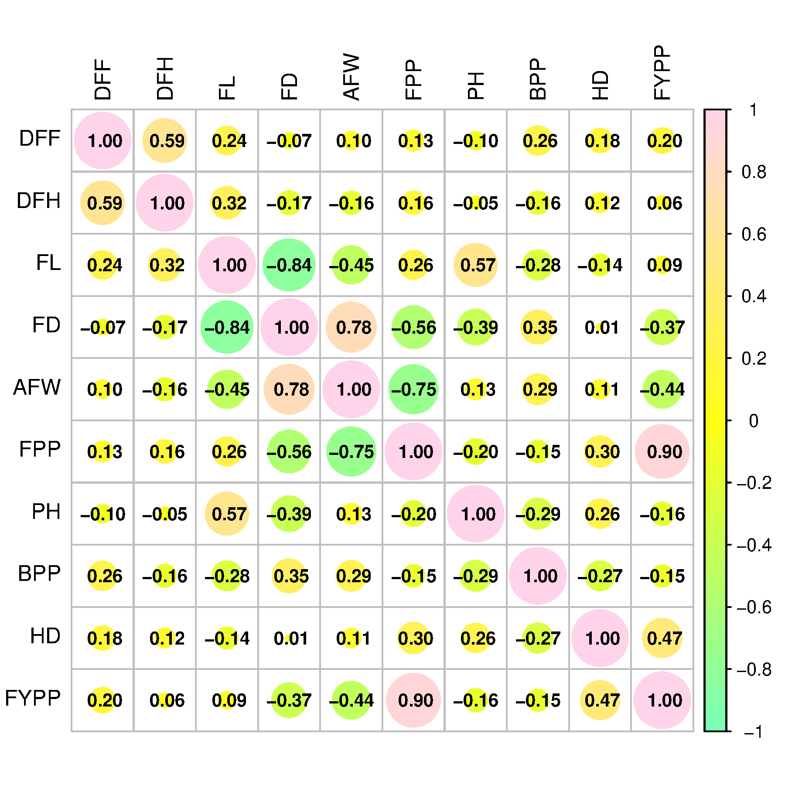

Fig. 1. Character association for fruit yield per plant and related traits in brinjal
3.4 Character association
The correlation analysis revealed the nature and magnitude of association among yield and its component traits in brinjal. Fruit yield per plant exhibited a strong positive correlation with the number of fruits per plant (0.90), indicating that fruit number was the most important contributor to yield (Figure 1). A moderate positive association was also observed with harvest duration (0.47), suggesting that genotypes with longer harvesting periods tended to produce higher yields. On the other hand, fruit yield per plant showed a negative correlation with average fruit weight (−0.44) and fruit diameter (−0.37), indicating a possible trade-off between fruit size and fruit number. A weak negative association was also observed with plant height (−0.16) and the number of primary branches per plant (−0.15), suggesting a limited contribution of these traits to yield improvement. Among the component traits, fruit length exhibited a strong negative correlation with fruit diameter (−0.84), indicating an inverse relationship between these two fruit size attributes. Similarly, average fruit weight showed a strong positive correlation with fruit diameter (0.78) and a strong negative correlation with the number of fruits per plant (−0.75), suggesting that genotypes producing larger fruits tend to bear fewer fruits. Days to 50% flowering and days to first harvest were positively correlated (0.59), indicating that late-flowering genotypes tend to mature later. Overall, the results suggest that selection based on the number of fruits per plant and harvest duration would be effective for improving fruit yield, while simultaneous improvement of fruit size traits may require careful consideration due to their negative association with yield. The results for character association for horticultural traits were reported in close proximity with the findings of several researchers such as [28], [29], [30], and [31].
3.5 Genetic diversity
Genetic divergence among the brinjal genotypes was assessed through hierarchical clustering and visualized using a dendrogram and clustered heatmap, which revealed substantial variability among the genotypes. The dendrogram grouped the genotypes into four distinct clusters, indicating considerable genetic diversity in the experimental material (Figure 2a). A similar result was obtained by [32], who reported four distinct clusters in the experimental material studied. Notably, genotypes such as Utkal Anushree and Konkan Prabha were positioned in distinct clusters, exhibiting greater divergence from the standard check Hisar Shyamal (SC), whereas genotypes such as CO2 and BR-112 showed closer association, suggesting genetic similarity. The clustered heatmap further supported the dendrogram results by depicting the variation in trait expression through contrasting color intensities (Figure 2b). Traits such as the number of fruits per plant, fruit yield per plant, and fruit size parameters contributed significantly to the observed divergence, as reflected in the clustering pattern. The wide distribution of genotypes across clusters indicates the existence of broad genetic variability that can be effectively exploited in breeding programs. From a breeding perspective, hybridization between genetically distant genotypes such as Utkal Anushree, Konkan Prabha, and Hisar Shyamal (SC) or Arka Neelkanth is likely to produce superior recombinants and transgressive segregants due to the accumulation of favorable alleles. Therefore, the identified diverse genotypes can be utilized as potential parents in future breeding programs aimed at improving yield and associated traits in brinjals.
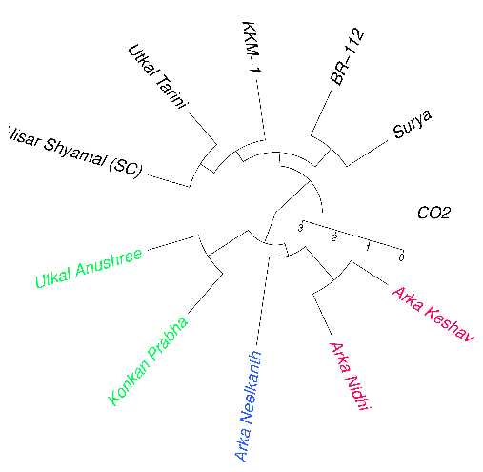
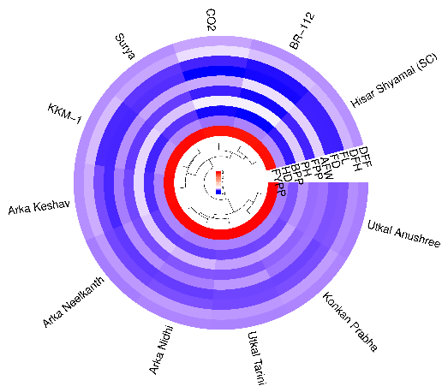

Fig. 2. Diversity pattern of different genotypes of brinjal studied a) Clustering dendrogram; b) Clustered heatmap
3.6 Principal Component Analysis
Principal component analysis was employed to elucidate the pattern of variation and relationships between yield and its contributing traits in the brinjal genotypes (Figure 3a, b). PC1 (35.10%) and PC2 (19.50%) accounted for a major proportion of the total variability, indicating their adequacy in explaining the observed variation. The PCA biplot revealed that fruit yield per plant and fruits per plant exhibited strong positive loadings on PC1 and were closely associated with harvest duration and days to first harvest, suggesting their significant contribution to yield performance. The acute angles among these vectors indicated a strong positive correlation, highlighting their importance as key selection criteria for yield improvement. In contrast, plant height and fruit length were positioned in opposite directions, indicating a negative or weak association with yield-related traits and suggesting their involvement in different components of variability.
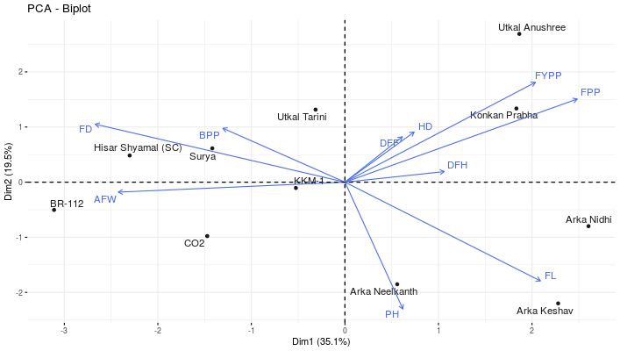

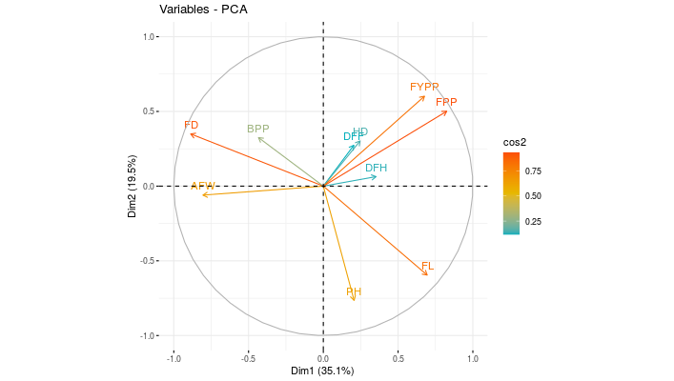
Fig. 3. Principal component analysis for different horticultural traits in brinjal a) PCA-biplot; b) Variable plot PCA
Traits such as fruit diameter and number of primary branches per plant formed a separate cluster, reflecting a moderate association among themselves but limited contribution to yield. Genotypes located in the direction of the FYPP and FPP vectors were identified as high-performing, whereas those positioned opposite these traits were comparatively inferior in yield potential. Overall, the PCA results emphasize that FYPP and FPP are the most influential traits governing variability and can be effectively utilized as selection indices for improving brinjal yield. Principal component analysis (PCA) and correlation assessment were conducted to elucidate the relationships among traits and their contribution to the total variability in the brinjal genotypes (Figure 4a). The screen plot indicated that the first two principal components accounted for the majority of the variation, with a sharp decline in eigenvalues thereafter, justifying the use of PC1 and PC2 for interpretation (Figure 4b).

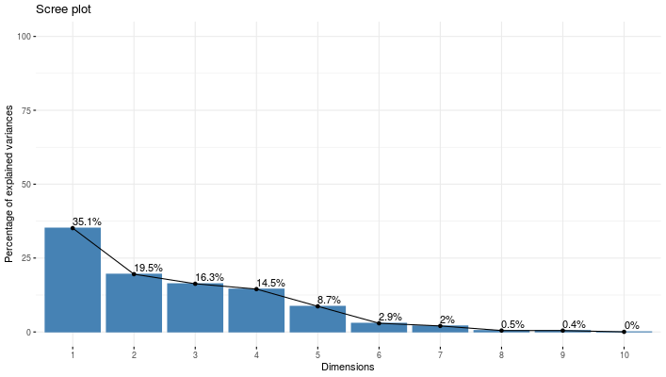
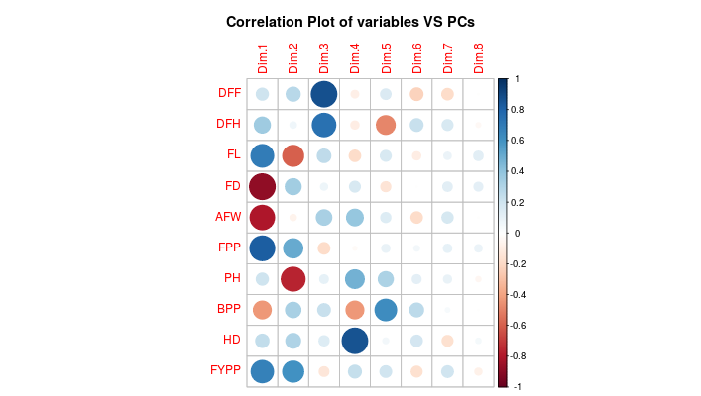
Fig. 4. Principal component analysis using a) interrelationship between principal components; b) Screen plot showing contribution of each principal component
The correlation matrix of variables with principal components revealed that fruit yield per plant and fruits per plant were strongly and positively associated with PC1, along with harvest duration and days to first harvest, indicating their major contribution to yield-related variability. Conversely, traits such as plant height and average fruit weight were negatively associated with PC1, suggesting an inverse relationship with yield components. Days to 50% flowering and days to first harvest showed strong intercorrelations, reflecting their close developmental linkage. The number of primary branches per plant and fruit diameter displayed moderate associations, contributing to the secondary variation captured by subsequent components. The overall pattern suggests that yield improvement in brinjal is primarily governed by FYPP, FPP, and HD, whereas other traits contribute to auxiliary variation. These findings highlight the effectiveness of PCA in identifying key selection traits and simplifying complex trait relationships in breeding programs. A list of studies on brinjal, such as [33], [34], [35], and [36], was consistent with the reliability of our findings.
However, our study deals with a small subset of genotypes that need to be updated with more number of genotypes in future. Additionally, multi-location/ multi-year yield trials are required to further elucidate the stability of genotypes. Future studies must incorporate molecular markers to further enhance the current understanding of this crop improvement aspects.

4. CONCLUSION
This study investigated the genetic variability, character associations, and genetic diversity among 11 brinjal genotypes, identifying superior lines and potential parents for future breeding. High heritability with high genetic advancement for these traits, especially fruit yield per plant and fruit per plant, indicates additive genetic action, suggesting effective direct selection. Notably, Utkal Anushree was the highest yielding genotype, with Utkal Tarini, Konkan Prabha, Arka Nidhi, Arka Neelkanth, and Surya also showing higher yields. Character association analysis showed a strong positive correlation between fruit yield and fruits per plant, highlighting fruit number as the primary selection criterion. Genetic diversity analysis, supported by hierarchical clustering and PCA, grouped genotypes into four distinct clusters, confirming broad genetic variability. Genotypes such as Utkal Anushree and Konkan Prabha were notably divergent from Hisar Shyamal and Arka Neelkanth. These findings highlight the potential of exploiting this diversity in breeding. Hybridization programs involving genetically distant genotypes such as Utkal Anushree, Konkan Prabha, Hisar Shyamal, and Arka Neelkanth are recommended to develop high-yielding brinjal varieties adapted to the region.
DISCLAIMER (ARTIFICIAL INTELLIGENCE)
The authors hereby declare that no generative AI technologies such as Large Language Models (ChatGPT, COPILOT, etc.) and text-to-image generators have been used during writing or editing of this manuscript.
COMPETING INTERESTS
The authors declare that no competing interests exist.
References
1. Sahana, K., Kattegoudar, J., Lingaiah, H., Sangeetha, C., Prashanth, S., Padmanabha, K., & Ugalat, J. (2019). Performance of advanced breeding lines of green-long brinjal for resistance to bacterial wilt disease resistance, yield and quality attributes. Vegetable Science, 46(1 & 2), 145–147. https://doi.org/10.61180/51s0j023
2. Singh, S. (2025). An investigation on the genetic variability, heritability, and genetic advancement of traits related to yield and quality in brinjal (Solanum melongena L.). International Journal of Environmental Sciences, 3910–3913. https://doi.org/10.64252/70q5cp33
3. Anonymous. 2024. Area and production of horticulture crops, National Horticulture Board, Ministry of Agriculture and Farmers Welfare, Government of India, New Delhi.
4. Lazăr N, Râpeanu G and Iticescu C. 2024. Mitigating eggplant processing waste's environmental impact through functional food developing. Trends in Food Science and Technology 147: 1-11.
5. Yadav B, Soni A, Yadav SK, Yadav MM and Yadav GL. 2019. Performance of NPK with vermicompost and boron on growth and quality attributes of brinjal (Solanum melongena L.). International Journal of Current Microbiology and Applied Sciences 8: 1265-1271.
6. Yasaswini, M., Chetariya, C. P., Delvadiya, I. R., & Anvesh, S. (2025). Inheritance pattern of yield and its components in brinjal (Solanum melongena L.) through generation mean analysis. Indian Journal Of Agricultural Research, Of. https://doi.org/10.18805/ijare.a-6419
7. Maxted, N., Hunter, D., & Ríos, R. (2020). Genetic Diversity Measurement (pp. 114–132). Cambridge University. https://doi.org/10.1017/9781139024297.007
8. Teja, B.L., Sadhu, S., Hijam, L., Roy, S.K., Chatterjee, R. and Chakraborty, M., 2025. Exploring genetic variability and cause-effect relationship for yield and its contributing traits in brinjal (Solanum melongena L.). International Journal of Bio-resource and Stress Management, 16(4), 01–10.
9. Srivastava, S., Shivraj, N., Saidaiah, P., & Reddy, K. (2021). Correlation and path analysis studies on yield and yield components in brinjal (Solanum melongena L.). Electronic Journal of Plant Breeding, 12(1). https://doi.org/10.37992/2021.1201.038
10. Panse and Sukhatme (1967). Statistical Methods for Agricultural Workers (2nd ed.). ICAR, New Delhi.
11. Burton and DeVane (1953). Estimating heritability in tall fescue (Festuca arundinacea) from replicated clonal material. Agronomy Journal, 45, 478–481.
12. Johnson et al. (1955). Estimates of genetic and environmental variability in soybeans. Agronomy Journal, 47, 314–318.
13. Al-Jibouri et al. (1958). Genotypic and environmental variances and covariances in an upland cotton cross of interspecific origin. Agronomy Journal, 50, 633–636.
14. Sewall Wright (1921). Correlation and causation. Journal of Agricultural Research, 20, 557–585.
15. Dewey and Lu (1959). A correlation and path-coefficient analysis of components of crested wheatgrass seed production. Agronomy Journal, 51, 515–518.
16. P. C. Mahalanobis (1936). On the generalized distance in statistics. Proceedings of the National Institute of Sciences of India, 2, 49–55.
17. Rao (1952). Advanced Statistical Methods in Biometrical Research. John Wiley and Sons, New York.
18. R Core Team (2024). R: A language and environment for statistical computing. R Foundation for Statistical Computing, Vienna, Austria. Available at: https://www.R-project.org/
19. Uddin, M. S., Billah, M., Afroz, R., Rahman, S., Jahan, N., Hossain, M. G., Bagum, S. A., Uddin, M. S., Khaldun, A. B. M., Azam, M. G., Hossain, N., Akanda, M. A. L., Alhomrani, M., Gaber, A., & Hossain, A. (2021). Evaluation of 130 eggplant (Solanum melongena L.) genotypes for future breeding program based on qualitative and quantitative traits, and various genetic parameters. Horticulturae, 7(10), 376. https://doi.org/10.3390/horticulturae7100376
20. Unnam, S., Mamatha, A., Sanganamoni, M., Suresh, V., & Devaraju, D. (2025). Assessment of genetic variability and identification of promising genotypes for yield and quality traits in brinjal (Solanum melongena L.). Plant Archives, 25(2), 1471–1476. https://doi.org/10.51470/plantarchives.2025.v25.no.2.212
21. Chithra, K., Devaraju, M., Srinivasa, V., Varalakshmi, B., & Asha, A. B. (2021). Genetic investigation in segregating generation of brinjal (Solanum melongena L.). National Academy Science Letters, 45(1), 5–8. https://doi.org/10.1007/s40009-021-01070-x
22. Ramani, P. S., Vaddoria, M. A., Mehta, D. R., & Ukani, J. D. (2017). Combining ability and gene action for fruit yield and its attributes in brinjal (Solanum Melongena L.). Indian Journal Of Agricultural Research, 51(06). https://doi.org/10.18805/ijare.a-4466
23. Nagar, K. L., Rana, D. K., Barela, A., & Rahangdale, S. (2024). Study of genetic diversity and genetic advance in brinjal for morpho-economic traits (Solanum melongena L.). International Journal of Environment and Climate Change, 14(3), 437–444. https://doi.org/10.9734/ijecc/2024/v14i34054
24. Tabasum, S., Nazir, G., Hussain, K., Manzoor, N., R, Y. J. M., Mushtaq, F., & Bashir, B. (2024). Mean performance and correlation analysisfor yield and yield contributing traits in brinjal (Solanum melongena L.) genotypes. International Journal of Research in Agronomy, 7(8), 283–289.
https://doi.org/10.33545/2618060x.2024.v7.i8d.1236
25. Arti, D., Sharma, A., & Kumar, R. (2020). Performance evaluation of different genotypes of brinjal (Solanum melongena L.) under mid hill conditions of Himachal Pradesh. Electronic Journal Of Plant Breeding, 11(02). https://doi.org/10.37992/2020.1102.071
26. Verma, A. K., Mishra, A. C., & Tripathi, P. K. (2023). Evaluation of brinjal genotypes (Solanum melongena L.) for growth, yield and quality characters in Bundelkhand region of U.P, India. International Journal of Plant &amp; Soil Science, 35(18), 1690–1699. https://doi.org/10.9734/ijpss/2023/v35i183444
27. Lahon, G., Buragohain, N., Goswami, R. K., Bora, B., Gogoi, K., Chetia, D., Konwar, B., & Mishra, R. (2026). Evaluation of some brinjal (Solanum melongena L.) cultivars of Karbi Anglong district, Assam for growth, yield and profitability. International Journal of Economic Plants, 13(Mar, 2), 01–06. https://doi.org/10.23910/2/2026.6869b
28. Desai1, G. (2023). Correlation and path analysis in brinjal (Solanum melongena L.) for yield and yield related traits. Electronic Journal of Plant Breeding, 14(4). https://doi.org/10.37992/2023.1404.169
29. Sivakumar, V., Jyothi, K. U., Venkataramana, C., Paratparao, M., Rajyalakshmi, R., & Umakrishna, K. (2016). Character association and path co-efficient analysis studies on yield and attributing characters in brinjal (Solanum melongena L.). Electronic Journal of Plant Breeding, 7(3), 692. https://doi.org/10.5958/0975-928x.2016.00089.2
30. Mangi, V., Patil, H. B., Mallesh, S., Karadi, S. M., & Satish, D. (2017). Character association and path analysis studies in brinjal (Solanum melongena L.) genotypes. Journal of Applied and Natural Science, 9(1), 29–33. https://doi.org/10.31018/jans.v9i1.1143
31. Nazir, G., Hussain, K., Zehra, S. B., Masoodi, U. H., & Tabassum, S. (2022). A study on correlation and path coefficient analysis of brinjal (Solanum melongena L.) for yield and yield contributing traits. International Journal of Plant &amp; Soil Science, 763–768. https://doi.org/10.9734/ijpss/2022/v34i2131330
32. Basavaraj, Basavaraj, N., Hanchinamani C. N., Laxman, K., Sandhyarani, N., Sumangal, K., & Mallikarjun, A. (2024). Genetic diversity analysis in brinjal (Solanum melongena L.) for yield and its attributing traits. International Journal of Research in Agronomy, 7(11S), 554–558. https://doi.org/10.33545/2618060x.2024.v7.i11sh.2056
33. Shanmugasundaram, K., Muthuvel, I., & Kousalya, R. (2024). Delineating the genetic variability, correlation, path and principal component analysis in brinjal genotypes. Plant Science Today, 11(sp4). https://doi.org/10.14719/pst.5756
34. Singh, B., Chaubey, T., Singh, R. K., Upadhyay, D. K., Jha, A., & Pandey, S. (2024). Genetic variation in phenatic traits of extant varieties of brinjal (Solanum melongena L.). The Journal of Applied Horticulture, 26(01). https://doi.org/10.37855/jah.2024.v26i01.20
35. Chaudhary, A. K., Kumar, L., Kumar, S., Maurya, R. K., & Kumar, R. (2023). Estimates of contribution, claustration and principal component analysis in different genotype of brinjal (Solanum melongena L.). International Journal of Plant and Soil Science, 35(22), 725–730. https://doi.org/10.9734/ijpss/2023/v35i224184
36. Shilpa, B. M., Dheware, R. M., & Kolekar, R. B. (2018). Variability studies in brinjal (Solanum melongena L.). International Journal of Bio-Resource and Stress Management, 9(5), 576–579. https://doi.org/10.23910/ijbsm/2018.9.5.1865d

