Original Research Article

Performance Evaluation for Yield Traits in Garden Pea (Pisum sativum L.) Genotypes Across Differential Thermal Environments

.
ABSTRACT

The present study was undertaken to examine garden pea (Pisum sativum L.) genotypes for yield and its associated traits under varying thermal conditions, with the objective of identifying stable and heat-tolerant lines. The field experiment was laid out in an Augmented Block Design at the Vegetable Research Centre, Govind Ballabh Pant University of Agriculture and Technology, Pantnagar, Uttarakhand, India, during the rabi season of 2024–2025. A total of 72 diverse test genotypes along with two standard check varieties (PM-128 and PSM-3) were evaluated under three different thermal regimes, namely pre-flowering heat stress (Environment 1), optimum conditions (Environment 2), and terminal heat stress (Environment 3). Heat stress conditions were imposed through staggered sowing dates, with early sowing exposing the crop to higher temperatures during the vegetative stage and late sowing subjecting the crop to elevated temperatures during the reproductive phase. Observation were recorded on important phenological and yield-related traits. Pre-flowering heat stress (Environment 1) led to accelerated flowering and reduced vegetative growth, with comparatively moderate effects on yield traits relative to terminal heat stress. The crop performed best under optimal conditions (Environment 2), whereas a marked decline in yield attributes was evident under terminal heat stress (Environment 3), particularly for pod number, seed set, and overall pod yield. Among the entries, PSM-151, PM-128, PSM-3, PSM-166 and PSM-221 consistently exhibited better and consistent performance across environments, indicating their relative tolerance to heat stress. On the other hand, genotypes such as PSM-152 and PSM-202 were found to be more susceptible, especially under late-season heat stress. The findings indicate that heat stress imposed during the reproductive phase has a pronounced adverse effect on yield in garden pea. Genotypes demonstrating consistent performance across environments, such as PSM-3, PM-128 and PSM-151 may serve as promising material for breeding programmes aimed at developing heat-resilient cultivars. However, further evaluation across locations and seasons would be necessary to confirm their wider adaptability.

Keywords: Garden Pea; Heat Stress; Genotypic Performance; Early flowering

1. INTRODUCTION
Garden pea (Pisum sativum L., 2n = 2x = 14) is among the earliest domesticated grain legumes, with a cultivation history extending thousands of years. It is an important cool-season crop widely grown in temperate regions, contributing over 35 million tonnes to global production. In addition to its economic significance, pea serves as a valuable nutritional source due to its high protein content (21–33%) and richness in essential amino acids such as lysine, making it an effective complement to cereal-based diets (FAOSTAT, 2019). In India, pea is cultivated on approximately 567 thousand hectares, yielding an annual production of around 5,846 thousand metric tons (Rawat et al., 2024), though its productivity remains variable, largely due to its narrow optimal temperature range of 10–18°C, which makes it sensitive to environmental fluctuations (Kumar and Choudhary, 2014). Prominent early varieties in Uttarakhand's Tarai region include Arkel, introduced from England, Pant Sabji Matar-3 from Pantnagar, and VL-7 from VPKAS, which is commonly grown in the hilly areas (Singh et al., 2012).
Pea is particularly vulnerable to heat stress, especially during the reproductive phase. Temperatures above 25°C can severely reduce yield, and exposure to temperatures approaching or exceeding ~30°C during flowering and pod filling often accelerates development, shortens the grain-filling period, and results in reduced seed size and poorly developed pods (Guilioni et al., 2003; Jiang et al., 2019). Elevated temperatures not only affect reproductive success but also impair vegetative growth; high temperature reduces net photosynthetic rate, increases photorespiration, and disrupts carbon assimilation, leading to slower growth, reduced biomass, and lower plant height (Haldimann & Feller, 2005; Vijaylaxmi, 2013). High temperature also alters membrane stability and enzyme activities, further limiting assimilate production and transport (Devi et al., 2022). During reproductive development, heat stress impairs pollen viability and pollen tube growth, increases flower and pod abortion, and leads to poor fertilization, which together contribute to significant reductions in pod number, seed set, and final yield (Jeuffroy et al., 1990; Susmita et al., 2020; Devi et al., 2022).
With the anticipated rise in global temperatures by 2–4°C, terminal heat stress is expected to intensify, especially in the North Indian plains where flowering often coincides with increasing temperatures during March–April (IPCC, 2014). Even a slight increase of 1°C during the flowering stage has been shown to significantly reduce yield by 0.7–0.8 t/ha, underscoring the crop’s sensitivity to thermal stress during critical growth periods (Lamichaney et al., 2021). Given the complexity of genotype × environment interactions, selection of stable and high-yielding cultivars under heat stress is challenging, because tolerance is governed by multiple interacting traits and physiological mechanisms (Yan et al., 2007; Kumar et al., 2020).
Several studies have attempted to screen pea genotypes for heat stress tolerance under both controlled and field conditions. Screening approaches have included greenhouse imposition of elevated temperatures and late or staggered sowing to expose plants to high temperatures during flowering and pod development. Susmita et al., (2020) reported variation among garden pea lines for heat tolerance under off-season high temperature conditions. Similarly, Tafesse et al., (2019) and Lamichaney et al., (2021) documented significant differences among genotypes for heat stress responses in terms of yield and reproductive traits. These studies consistently indicate that the reproductive stage is the most sensitive to elevated temperature and that heat stress leads to significant reductions in yield components such as number of pods, seeds per pod, and pod weight (Sadras et al., 2013; Bueckert et al., 2015). However, most earlier investigations have been limited either to a relatively small number of genotypes or to a single stress environment, and comprehensive evaluation under contrasting thermal regimes reflecting both pre-flowering and terminal heat stress is still limited.
Therefore, systematic screening under both stress and non-stress environments is essential to distinguish true heat tolerance from general environmental effects and to identify genotypes with stable performance. Given the limited availability of studies evaluating a large and diverse set of genotypes under multiple heat stress scenarios, particularly those that distinguish between early (pre-flowering) and late (terminal) heat stress, a more thorough assessment is required.
In this context, the present study evaluates 74 diverse garden pea genotypes under three thermal regimes, namely high temperature during the early vegetative and pre-flowering stages, optimal cool-season conditions, and terminal heat stress during pod development and seed maturation, to identify promising lines for developing climate-resilient pea cultivars.
2. MATERIAL AND METHODS
2.1 Experimental Site

A field experiment was carried out at the Vegetable Research Centre, G. B. Pant University of Agriculture and Technology, Pantnagar (Uttarakhand), during the rabi season of 2024–2025 with the aim of assessing the response of seventy-two genotypes of garden pea (Pisum sativum L.) to different thermal regimes. Pantnagar is located at 29°0′ N latitude and 79°3′ E longitude, at an altitude of 243.8 m above mean sea level. The experiment was designed to generate comprehensive data on genotype performance under varying temperature conditions, providing insights for future breeding and management strategies in pea cultivation.

2.2 Experimental Design and Layout

The experiment was conducted using an Augmented Block Design (ABD) comprising four blocks in each environment. A total of 74 garden pea genotypes (Table 1) were evaluated, which included 72 test genotypes and two standard check varieties (PM-128 and PSM-3). The study was carried out across three different thermal environments where each environment was represented by a single sowing and was not replicated. Within each environment, the test genotypes were grown without replication, whereas the check varieties were replicated once in each block to provide a basis for adjustment of block effects. Sowing was carried out in rows, maintaining a spacing of 30 cm between rows and 10 cm between plants.

Table 1: Garden Pea (Pisum sativum L.) Genotypes Used for Evaluation in the current
Investigation

Test Genotypes*
PSM-151 | PSM-152 | PSM-153 | PSM-154 | PSM-155 | PSM-156 | PSM-157 | PSM-158
PSM-159 | PSM-160 | PSM-161 | PSM-162 | PSM-163 | PSM-164 | PSM-165 | PSM-166
PSM-167 | PSM-168 | PSM-169 | PSM-170 | PSM-171 | PSM-172 | PSM-173 | PSM-174
PSM-175 | PSM-176 | PSM-177 | PSM-178 | PSM-179 | PSM-180 | PSM-181 | PSM-182
PSM-183 | PSM-184 | PSM-185 | PSM-186 | PSM-187 | PSM-188 | PSM-189 | PSM-190
PSM-191 | PSM-192 | PSM-193 | PSM-194 | PSM-195 | PSM-196 | PSM-197 | PSM-198
PSM-199 | PSM-200 | PSM-201 | PSM-202 | PSM-203 | PSM-204 | PSM-205 | PSM-206
PSM-207 | PSM-208 | PSM-209 | PSM-210 | PSM-211 | PSM-212 | PSM-213 | PSM-214
PSM-215 | PSM-216 | PSM-217 | PSM-218 | PSM-219 | PSM-220 | PSM-221 | PSM-222
Check Cultivars
PSM-3 |  |  |  | PM-128
*All test genotypes were sourced from GBPUA&T, Pantnagar, Uttarakhand, India.

2.3 Soil Characteristics and Field Preparations

The experimental soil was sandy loam in texture. The soil maintains a pH of 5.5–6.0 throughout the period of investigation which is favourable for the growth of the plant.

The field was ploughed and harrowed twice followed by planking to bring the soil to a fine tilth. All weeds and leftover crop residues were removed from the field. Whole plot was divided into four blocks as per the requirement. Standard recommended cultural practices were followed during the entire crop period.

2.4 Agronomic Practices and Fertilizer Application

The experimental site was kept weed-free throughout the cropping season by periodical hand weeding. Preventive plant care measures were taken to manage insect-pest and disease incidence at regular intervals. The experimental site was kept weed-free throughout the cropping season by periodical hand weeding. All recommended agronomic practices were applied uniformly throughout the growing period to ensure proper crop establishment and to reduce the influence of extraneous variability.

Well rotten farm yard manure and recommended dose of fertilizers (RDF), i.e., 20:40:40 kg/ha NPK were applied at the time of land preparation. Application of small quantity of N (10 kg/ha) as top dressing was applied after picking. The crop was watered after the top dressing was applied.

2.5 Environmental Conditions and Thermal Screening
The crop season at the experimental site was characterized by pronounced temperature fluctuations, which facilitated the creation of distinct thermal regimes for stress evaluation. Three staggered sowing dates were used to expose the genotypes to contrasting thermal conditions.
Environment I, sown on October 24, 2024, experienced relatively high temperatures during early vegetative and pre-flowering stages. In October, daily temperatures ranged from a minimum of 18.2°C to a maximum of 34.2°C, with an average of 25.1°C, exposing the crop to early-season heat stress. Environment II, sown on November 15, 2024, coincided with the normal growing season and served as the control. November–January temperatures gradually declined, with November minimums of 11.9°C and maximums of 32.6°C (average 22.0°C), December minimums of 7.0°C to maximums of 25.8°C (average 16.0°C), and January minimums of 7.2°C to maximums of 25.5°C (average 16.8°C), reflecting cool-season conditions favourable for optimal growth. Environment III, sown on February 5, 2025, was designed to subject the crop to terminal heat stress during reproductive and pod-filling stages. February temperatures ranged from 7.0°C to 27.0°C (average 16.2°C), gradually increasing toward the reproductive phase in March–April. March maximum temperatures reached 36.5°C, with average daily temperatures of 22.5°C, while April temperatures peaked near 39.6°C, exposing the crop to significant heat stress during pod development and seed maturation. Temperature prevailing throughout the crop trial are presented in Fig. 1.
These sequential changes in temperature effectively resulted in three distinct environmental conditions for screening the genotypes:
- Environment I: High-temperature exposure during the early vegetative and pre-flowering stages.
- Environment II: Optimal cool-season conditions during critical growth stages.
- Environment III: Terminal heat stress (post-flowering) during pod development and seed maturation.
2.6 Data Collection and Observations
Observations on various growth and yield parameters were recorded from five randomly selected and tagged plants in each plot. Days to 50% flowering were recorded as the number of days taken from sowing to the stage when 50% of the plants in a plot exhibited flowering, and the mean value was expressed in days. Plant height was measured at 60 and 90 DAS from the base of the plant to the apex using a standard meter scale, and the average height was calculated and expressed in centimetres.
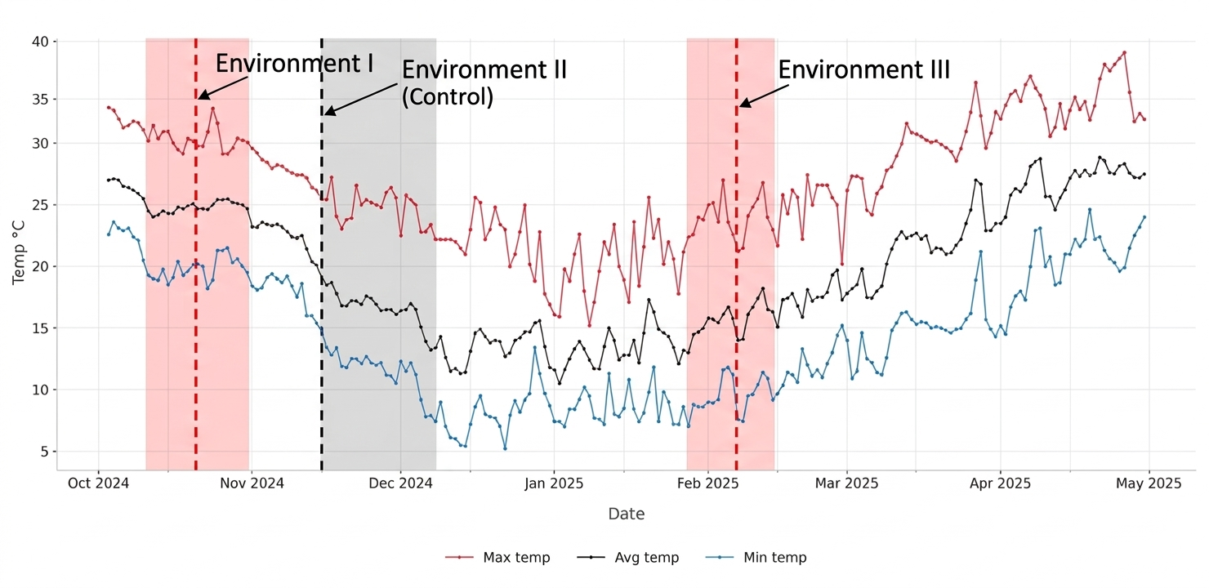Fig. 1: Weather data prevailed during Environment - I, II, III garden pea production in the year 2024-25.
For yield attributes, the number of pods per plant was recorded by counting the total number of pods harvested from each tagged plant across all pickings, and the mean value was computed at the end of the season. The number of seeds per pod was determined by counting seeds from randomly selected pods of each tagged plant and averaging the values. Pod length and pod diameter were measured from a representative sample of pods collected from the tagged plants using a scale/vernier calliper, and their mean values were expressed in centimetres. Average pod weight was calculated by recording the weight of pods harvested from the tagged plants at each picking and computing the mean, which was expressed in grams.
2.7 Statistical Analysis

An independent Analysis of Variance (ANOVA) was performed for yield traits across each of the three thermal environments (I, II, and III) following the Augmented Block Design (ABD) proposed by Federer (1955). To ensure a valid comparison among the unreplicated test genotypes, adjusted means were calculated by utilizing the performance of the repeated check varieties to account for intra-block environmental heterogeneity. Differences between treatment means were tested for significance using the Critical Difference at a 5% level of probability (P = .05).
3. RESULTS AND DISCUSSION

3.1 Survival and Phenological Progress of Genotypes Under Different Sowing Conditions

Marked differences in survival and reproductive progression were observed across environments, indicating a strong influence of temperature regimes on crop establishment and reproductive success. In the pre-flowering heat stress environment (E1), only 41 genotypes reached 50% flowering, of which 39 completed seed set (Table 2). In contrast, all 74 genotypes successfully completed their life cycle under the optimal conditions of E2, reflecting the suitability of moderate temperatures for growth and reproduction. Under terminal heat stress (E3), although germination was unaffected, only 38 genotypes reached flowering and just 22 completed reproductive development, indicating severe impairment during the reproductive phase. This severe loss reflects reproductive organ dysfunction driven by high temperature, where heat interferes with gamete development, pollen viability, fertilization, and pod set, leading to abortion of reproductive structures. Such reproductive failure under high temperatures has been widely documented in pea, where exposure to temperatures above ~30°C during critical reproductive windows reduces seed set and pod formation (Jeuffroy et al., 1990; Guilioni et al., 1997).

To ensure uniform comparison, only 22 genotypes (Table 3) that consistently completed their life cycle across all environments were considered for further analysis. Mean performance and variability of yield and its component traits under heat stress and normal conditions are provided in Table 4.

Table 2. List of garden pea genotypes reaching seed set stage under Environment I

PSM-3* | PM-128* | PSM-151 | PSM-152 | PSM-153 | PSM-154 | PSM-157
PSM-159 | PSM-160 | PSM-162 | PSM-164 | PSM-165 | PSM-166 | PSM-167
PSM-168 | PSM-169 | PSM-170 | PSM-176 | PSM-182 | PSM-183 | PSM-194
PSM-197 | PSM-198 | PSM-199 | PSM-201 | PSM-202 | PSM-203 | PSM-210
PSM-212 | PSM-213 | PSM-214 | PSM-215 | PSM-216 | PSM-217 | PSM-218
PSM-219 | PSM-220 | PSM-221 | PSM-222
*PM-128 and PSM-3 are standard check cultivars.

Table 3. List of 22 common garden pea genotypes that successfully completed the reproductive cycle across all three thermal environments

PSM-151 | PSM-152 | PSM-153 | PSM-154 | PSM-160 | PSM-164 | PSM-165
PSM-166 | PSM-167 | PSM-169 | PSM-170 | PSM-197 | PSM-198 | PSM-199
PSM-201 | PSM-202 | PSM-212 | PSM-214 | PSM-215 | PSM-221 | PM-128*
PSM-3*
*PM-128 and PSM-3 are standard check cultivars.

Table 4: Mean performance and variability of yield and its component traits across all three thermal environments

 | APW |  |  | DFF |  |  | NPP |  |  | NSP
 | E1 | E2 | E3 | E1 | E2 | E3 | E1 | E2 | E3 | E1 | E2 | E3
Mean ± SE | 8.52 ±0.14 | 9.93 ±0.15 | 3.39 ±0.14 | 44.41 ±0.84 | 56.68 ±1.07 | 48.18 ±0.96 | 14.27 ±0.27 | 17.11 ±0.37 | 3.66 ±0.21 | 8.56 ±0.16 | 10.39 ±0.14 | 4.77 ±0.15
CD (5%) | 1.03 | 0.53 | 0.42 | 4.49 | 3.5 | 4.66 | 1.19 | 0.5 | 0.4 | 1.05 | 0.64 | 0.39
CV (%) | 2.7 | 1.19 | 2.53 | 2.35 | 1.44 | 2.18 | 1.89 | 0.66 | 2.2 | 2.77 | 1.41 | 1.79

 | PD |  |  | PH |  |  | PL |  |  | PWP
 | E1 | E2 | E3 | E1 | E2 | E3 | E1 | E2 | E3 | E1 | E2 | E3
Mean ± SE | 6.16 ±0.09 | 7.20 ±0.13 | 3.95 ±0.09 | 72.79 ±1.34 | 106.98 ±2.84 | 59.87 ±1.68 | 9.83 ±0.12 | 11.11 ±0.15 | 6.51 ±0.09 | 61.78 ±0.67 | 68.88 ±0.66 | 7.20 ±0.33
CD (5%) | 0.66 | 0.5 | 0.22 | 4.13 | 5.1 | 4.85 | 0.39 | 0.5 | 0.51 | 2.54 | 2.57 | 1
CV (%) | 2.44 | 1.58 | 1.17 | 1.3 | 1.1 | 1.8 | 0.92 | 1.05 | 1.73 | 0.93 | 0.84 | 2.83

APW: Average Pod Weight; DFF: Days to 50% Flowering; NPP: Number of Pods per Plant; NSP: Number of Seeds per Pod; PD: Pod Diameter; PH: Plant Height; PL: Pod Length; PWP: Pod Weight per Plant; E1 (Environment I); E2 (Environment II); E3 (Environment III)

3.2 Days to 50% Flowering
Days to 50% flowering was significantly influenced by environmental conditions. The mean value was 44.41 days in E1, with 12 genotypes performing above the mean. A significant reduction in days to flowering was observed under pre-flowering heat stress compared to the control (E2), where the mean increased to 56.68 days and 11 genotypes recorded values above the mean, indicating prolonged vegetative growth under favourable conditions. Under terminal heat stress (E3), the mean was 48.18 days with 11 genotypes above the mean, showing an intermediate response. The comparative response of genotypic stature to different heat stress timings is depicted in Fig. 2.
Days to 50% flowering decreased by approximately 21.65% in E1 and 15.00% in E3 compared to the control (E2), indicating accelerated phenological development under heat stress conditions. The greater reduction under pre-flowering stress suggests that elevated temperature during early growth stages hastens the transition from vegetative to reproductive phase, primarily due to faster accumulation of thermal units and increased metabolic activity. High temperature is known to shorten crop duration by accelerating physiological processes and reducing the time available for vegetative growth. Although the reduction was comparatively lower under terminal heat stress, the overall trend confirms that temperature stress induces earliness as a stress escape mechanism, which may ultimately compromise biomass accumulation and yield potential. These findings are consistent with earlier reports in pea by Susmita et al., (2020), Tafesse et al., (2019), Jiang et al., (2019), and Guilioni et al., (1997), who also observed shortened flowering time and crop duration under elevated temperature conditions.

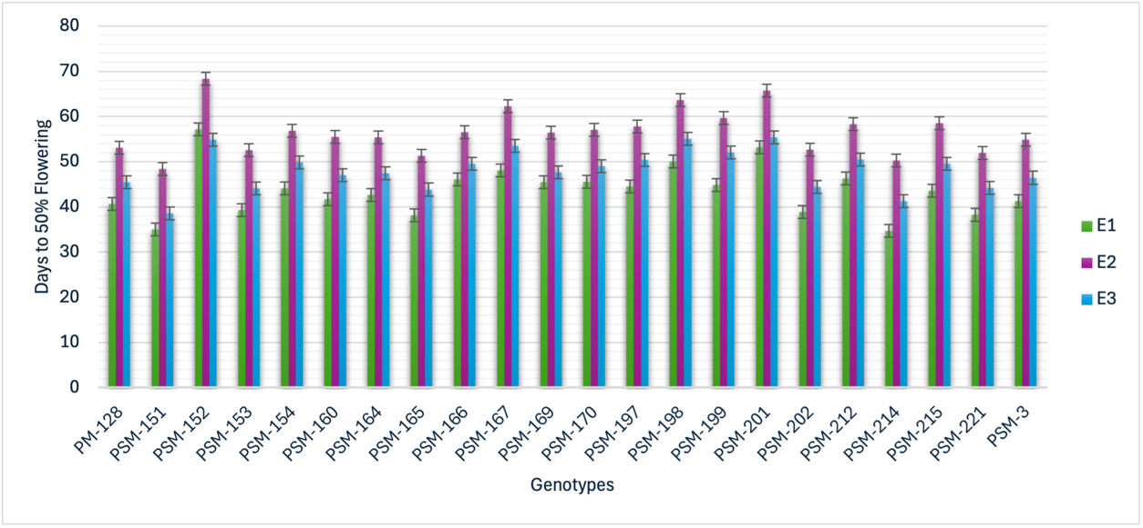
Fig. 2: Adjusted mean performance of 22 garden pea genotypes for Days to 50%
flowering across Environment I (E1), Environment II (E2), and Environment III (E3). Error bars represent ± Standard Error (SE).
3.3 Plant Height (cm)
Plant height varied significantly across environments. The mean plant height was 72.79 cm in E1, with 10 genotypes exceeding the mean. Under optimal conditions (E2), the mean increased significantly to 106.98 cm, with 10 genotypes above the mean, reflecting enhanced vegetative growth. In E3, the mean decreased to 59.87 cm, with 13 genotypes above the mean, indicating a stronger inhibitory effect of terminal heat stress. The comparative response of genotypic stature to different heat stress timings is depicted in Fig. 3.
Compared to E2, plant height decreased by about 31.96% in E1 and 44.03% in E3, showing that the effect of heat stress was more severe under terminal conditions. Heat stress impairs vegetative growth primarily through reductions in net photosynthesis, decreased stomatal conductance, and increased leaf senescence, limiting overall biomass accumulation. Furthermore, high temperature disrupts key enzymes and membrane stability, reducing carbon assimilation and plant vigor (Haldimann & Feller, 2005; Vijaylaxmi, 2013; Devi et al., 2022). The more pronounced reduction under terminal heat stress suggests that sustained high temperatures during later growth stages further restrict cell division and elongation. Similar reductions in plant height and biomass under heat stress in pea have also been documented by Vijaylaxmi (2013) and Tafesse et al., (2019).

3.4 Number of Pods per Plant
Number of pods per plant was significantly affected by environmental conditions. The mean was 14.27 in E1, with 15 genotypes exceeding the mean. Under E2, the mean increased significantly to 17.11, with 11 genotypes above the mean. However, under terminal heat stress (E3), the mean sharply declined to 3.66, with 10 genotypes above the mean. The comparative response of genotypic stature to different heat stress timings is depicted in Fig. 4.
Number of pods per plant decreased by approximately 16.60% in E1 and 78.61% in E3 compared to the control (E2), clearly showing that terminal heat stress had a much stronger
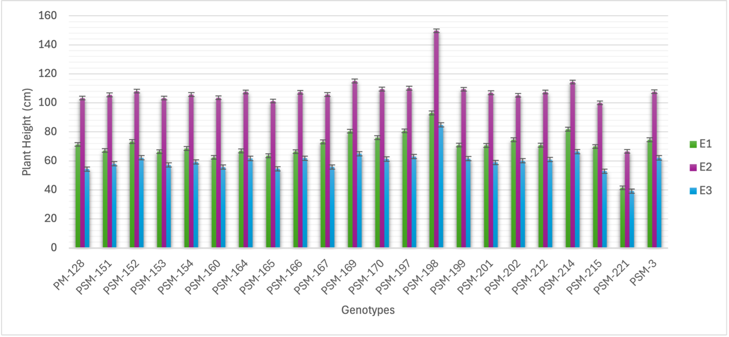
Fig. 3: Adjusted mean performance of 22 garden pea genotypes for Plant Height across Environment I (E1), Environment II (E2), and Environment III (E3). Error bars represent ± Standard Error (SE).

impact on reproductive performance. Heat stress during reproductive stages adversely affects pollen viability, pollen germination and fertilization, leading to higher rates of flower and pod abortion (Mohapatra et al., 2020; Tafesse et al., 2019; Guilioni et al., 1997). Additionally, disruption of assimilate supply due to reduced photosynthetic capacity limits resources available for pod set. These mechanisms explain the much stronger reduction under terminal heat stress.
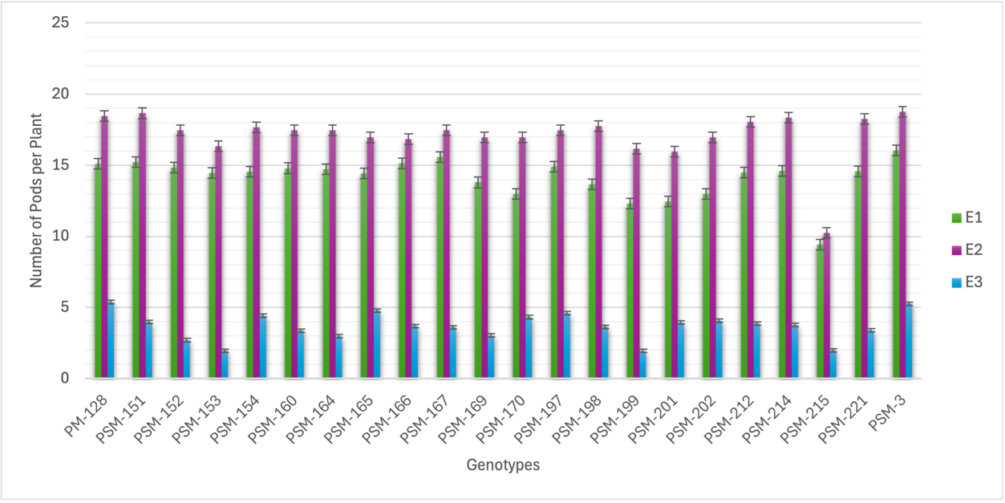

Fig. 4: Adjusted mean performance of 22 garden pea genotypes for Number of pods per plant across Environment I (E1), Environment II (E2), and Environment III (E3). Error bars represent ± Standard Error (SE).
3.5 Number of Seeds per Pod
Number of seeds per pod showed significant variation across environments. The mean was 8.56 in E1, with 10 genotypes performing above the mean. Under E2, the mean increased to 10.39, with 11 genotypes above the mean. In contrast, E3 recorded a significant reduction with a mean of 4.77 and 11 genotypes above the mean. The comparative response of genotypic stature to different heat stress timings is depicted in Fig. 5.
Number of seeds per pod decreased by approximately 17.61% in E1 and 54.10% in E3 compared to the control (E2), indicating a much stronger impact of terminal heat stress on seed setting. Elevated temperatures are known to reduce pollen tube growth and ovule viability, impairing fertilization and leading to fewer seeds per pod — particularly when heat coincides with early seed developmental processes (Jeuffroy et al., 1990; Jiang et al., 2015; Jiang et al., 2017). Heat exposure also reduces assimilate remobilization to developing seeds, further limiting seed set (Larmure & Munier-Jolain, 2019; Devi et al., 2022).
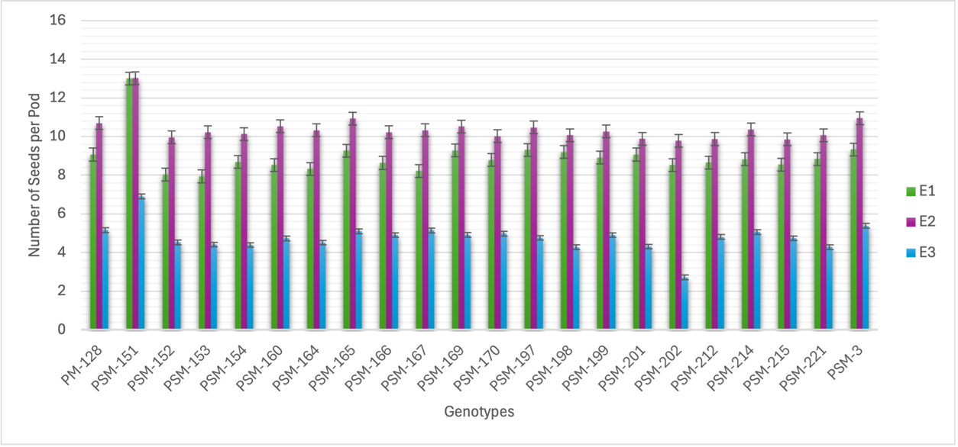

Fig. 5: Adjusted mean performance of 22 garden pea genotypes for Number of seeds per pod across Environment I (E1), Environment II (E2), and Environment III (E3). Error bars represent ± Standard Error (SE).

3.6 Pod Diameter (mm)
Pod diameter was significantly influenced by environmental conditions. The mean value in E1 was 6.16 mm, with 14 genotypes above the mean. Under E2, the mean increased to 7.20 mm, with 11 genotypes exceeding the mean. In E3, the mean declined to 3.95 mm, with 12 genotypes above the mean. The comparative response of genotypic stature to different heat stress timings is depicted in Fig. 6.
Pod diameter decreased by approximately 14.44% in E1 and 45.14% in E3 compared to the control (E2), indicating that terminal heat stress had a much stronger effect on pod development. Reduced pod diameter under heat stress is attributable to reduced assimilate availability and impaired pod filling, as high temperature limits photosynthetic carbon fixation
and disrupts source–sink relationships (Guilioni et al., 2003; Haldimann & Feller, 2005; Devi et al., 2022). The much greater decline under terminal stress indicates that reproductive heat stress more severely compromises assimilate partitioning into developing pods.
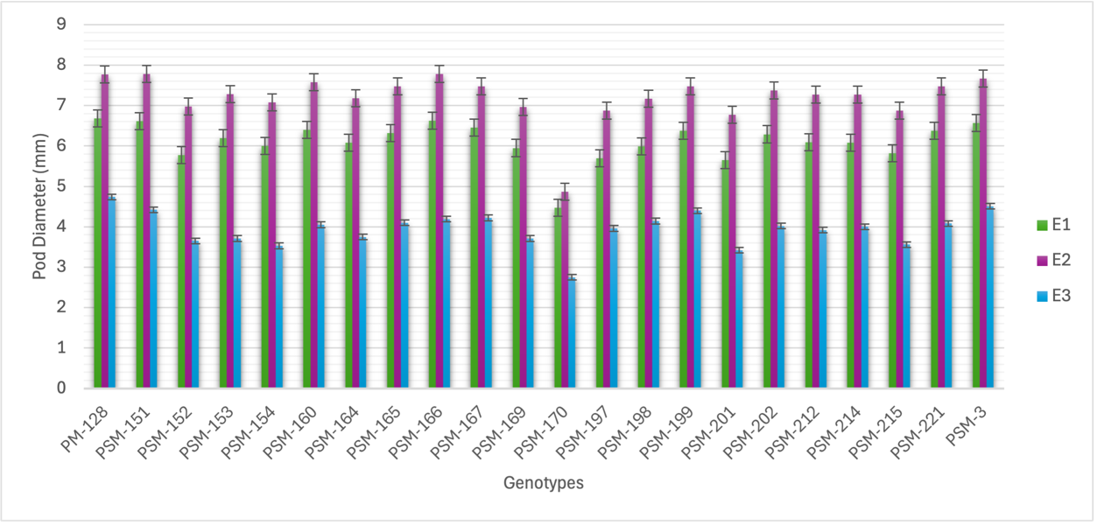
Fig. 6: Adjusted mean performance of 22 garden pea genotypes for Pod Diameter across Environment I (E1), Environment II (E2), and Environment III (E3). Error bars represent ± Standard Error (SE).

3.7 Pod Length (cm)
Pod length differed significantly across environments. The mean was 9.83 cm in E1, with 7 genotypes above the mean. Under E2, the mean increased to 11.11 cm, with 9 genotypes exceeding the mean. In E3, the mean decreased to 6.51 cm, with 11 genotypes above the mean. The comparative response of genotypic stature to different heat stress timings is depicted in Fig. 7.
Pod length decreased by approximately 11.53% in E1 and 41.40% in E3 compared to the control (E2), indicating that terminal heat stress had a more pronounced effect on pod growth. High temperature reduces cell expansion and division during pod development through impaired carbon availability and disrupted internal hormonal signalling, resulting in shorter pods (Jiang et al., 2015; Jiang et al., 2017; Devi et al., 2022). Again, the larger reduction under terminal stress reinforces the sensitivity of pod elongation processes to reproductive stage heat. In contrast, the relatively smaller reduction under pre-flowering stress indicates that plants are able to recover to some extent before pod formation begins.

3.8 Average Pod Weight (g)
Average pod weight was significantly affected by environmental conditions. The mean value was 8.52 g in E1, with 9 genotypes above the mean. Under E2, the mean increased to 9.93 g, with 10 genotypes exceeding the mean. In E3, the mean declined sharply to 3.39 g, with 13 genotypes above the mean. The comparative response of genotypic stature to different heat stress timings is depicted in Fig. 8.
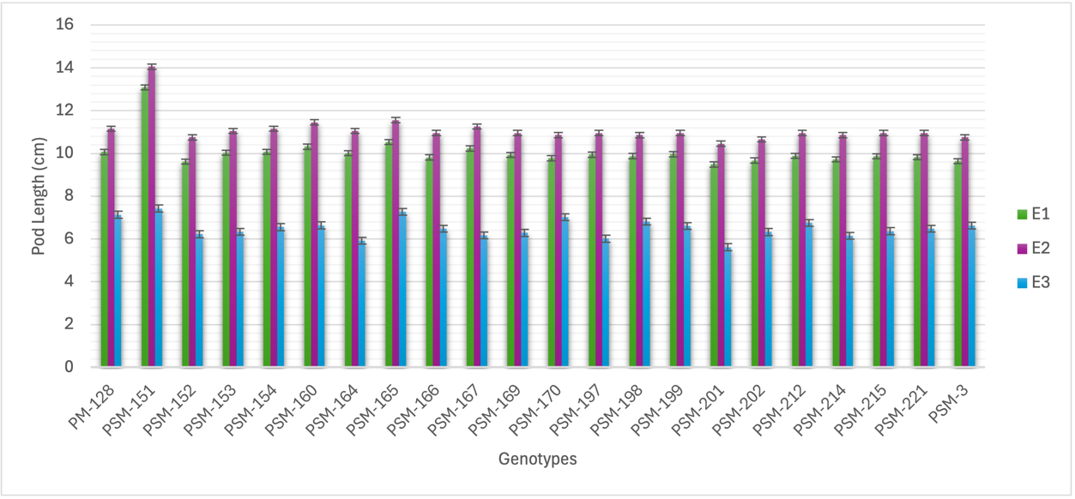

Fig. 7: Adjusted mean performance of 22 garden pea genotypes for Pod Length across Environment I (E1), Environment II (E2), and Environment III (E3). Error bars represent ± Standard Error (SE).

Average pod weight decreased by approximately 14.20% in E1 and 65.86% in E3 compared to the control (E2), showing that terminal heat stress had a much stronger effect on pod filling and weight. High temperature reduces net photosynthetic rate and increases photorespiration, leading to lower carbohydrate production and partitioning to pods. Heat stress also triggers altered membrane integrity and enzyme activity, further limiting assimilate flow to reproductive sinks (Haldimann & Feller, 2005; Guilioni et al., 2003; Devi et al., 2022). This explains the larger decline under terminal stress. In contrast, the relatively smaller reduction under pre-flowering stress suggests some recovery before the onset of pod development.
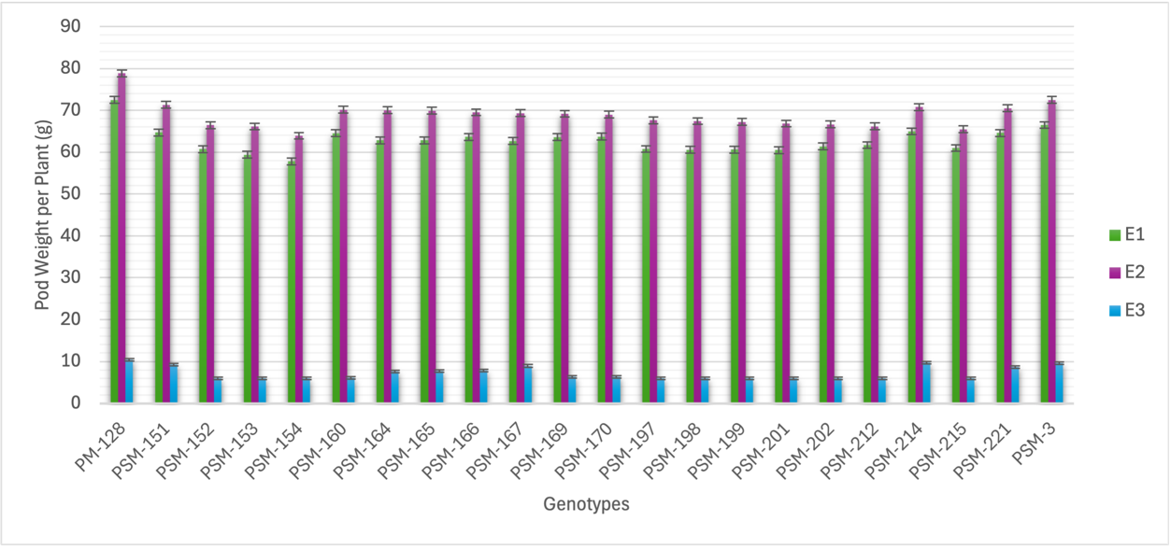
Fig. 8: Adjusted mean performance of 22 garden pea genotypes for Average Pod Weight across Environment I (E1), Environment II (E2), and Environment III (E3). Error bars represent ± Standard Error (SE).

3.9 Pod Weight per Plant (g)
Pod weight per plant was significantly influenced by environmental conditions. The mean value was 63.36 g in E1, with 9 genotypes exceeding the mean. Under favourable conditions (E2), the mean increased to 69.11 g, with improved biomass partitioning towards pods. In contrast, under terminal heat stress (E3), the mean declined sharply to 7.19 g, with 10 genotypes performing above the mean. The comparative response of genotypic performance under different heat stress regimes is depicted in Fig. 9.
Pod weight per plant decreased by approximately 8.32% in E1 and 89.60% in E3 compared to the control (E2), clearly indicating that terminal heat stress had a drastic impact on overall productivity. The dramatic reduction under terminal heat stress reflects compounding effects of reduced pod set, lower seed numbers, and impaired assimilate translocation under high temperatures. These processes are known to be particularly sensitive during reproductive development due to disrupted pollination, reduced seed filling, and metabolic depression (Mohapatra et al., 2020; Lamichaney et al., 2021; Devi et al., 2022). In contrast, the relatively smaller reduction under pre-flowering stress indicates that plants are able to partially recover before the onset of reproductive development.
Fig. 9: Adjusted mean performance of 22 garden pea genotypes for Pod weight per plant across Environment I (E1), Environment II (E2), and Environment III (E3). Error bars represent ± Standard Error (SE).

4. CONCLUSIONS
The study clearly demonstrated that the timing of heat stress plays a decisive role in determining the performance of garden pea genotypes. Pre-flowering heat stress (E1) primarily accelerated phenological development, leading to a reduction in days to 50% flowering and moderate decreases in vegetative growth and yield-related traits. In contrast, terminal heat stress (E3) during pod development and seed maturation caused severe reductions across all reproductive traits, including number of pods per plant, number of seeds per pod, pod size, average pod weight, and overall pod yield per plant, highlighting the reproductive stage as the most sensitive phase to elevated temperatures.
Among the 22 genotypes that successfully completed their life cycle across all three environments, PSM-151, PM-128, PSM-3, PSM-166, and PSM-221 consistently exhibited superior performance and stability under both early vegetative/pre-flowering and terminal heat stress conditions. These genotypes maintained relatively higher reproductive efficiency and yield components under stress, indicating their potential for use in heat-tolerant breeding programs aimed at improving climate resilience in garden pea.
The findings underscore that terminal heat stress is the most critical factor limiting productivity, while early vegetative and pre-flowering stress has moderate but still significant effects on plant development. Therefore, selection of genotypes capable of sustaining reproductive efficiency under high temperature conditions is essential for enhancing yield stability under changing climatic scenarios.
Future research should focus on multi-location evaluation of these genotypes to capture broader environmental variability and confirm adaptability. Incorporating genotype × environment interaction analysis using AMMI models will allow for more reliable identification of stable and high-yielding genotypes. Additionally, molecular and genomic studies are warranted to elucidate the underlying physiological and genetic mechanisms of heat tolerance, supporting the development of improved breeding lines for climate-resilient pea cultivars.

Disclaimer (Artificial intelligence)

Author(s) hereby declare that NO generative AI technologies such as Large Language Models (ChatGPT, COPILOT, etc.) and text-to-image generators have been used during the writing or editing of this manuscript.

References

Bueckert, R. A., Wagenhoffer, S., Hnatowich, G., and Warkentin, T. D. (2015). Effect of heat and precipitation on pea yield and reproductive performance in the field. Canadian Journal of Plant Science, 95(4), 629–639.
Devi, M. J., Sinclair, T. R., and Jain, M. (2022). Heat stress effects on pea (Pisum sativum L.) and its mitigation strategies: A review. Frontiers in Plant Science, 13, 1108276. https://doi.org/10.3389/fpls.2022.1108276

FAOSTAT (2019). 2018 Food and Agriculture Data. Retrieved from http://www.fao.org/faostat/en/#home
Federer, W. T. (1955). Experimental Design: Theory and Application. Macmillan.
Guilioni, L., Wery, J., and Lecoeur, J. (2003). High temperature and water deficit may reduce seed number in field pea purely by decreasing plant growth rate. Functional Plant Biology, 30(11), 1151–1164.
Guilioni, L., Wery, J., and Tardieu, F. (1997). Heat stress-induced abortion of buds and flowers in pea: Is sensitivity linked to organ age or to relations between reproductive organs? Annals of Botany, 80(2), 159–168.
Haldimann, P., and Feller, U. (2005). Growth at moderately elevated temperature alters the physiological response of the photosynthetic apparatus to heat stress in pea (Pisum sativum L.) leaves. Plant, Cell and Environment, 28, 302–317. https://doi.org/10.1111/j.1365-3040.2005.01289.x
IPCC (2014). Climate Change 2014: Synthesis Report. Intergovernmental Panel on Climate Change.
Jeuffroy, M. H., Duthion, C., and Meynard, J. M. (1990). Effect of a short period of high day temperatures during flowering on the seed number per pod of pea (Pisum sativum L.). Agronomie, 10, 139–145.
Jiang, Y., Bueckert, R., Warkentin, T., and Davis, A. (2017). High temperature effects on in vitro pollen germination and seed set in field pea. Canadian Journal of Plant Science, 98, 71–80. https://doi.org/10.1139/CJPS-2017-0073
Jiang, Y. F., Davis, A. R., Vujanovic, V., and Bueckert, R. A. (2019). Reproductive development response to high daytime temperature in field pea. Journal of Agronomy and Crop Science, 205(4), 324–333.
Jiang, Y., Lahlali, R., Karunakaran, C., Kumar, S., Davis, A. R., and Bueckert, R. A. (2015). Seed set, pollen morphology and pollen surface composition response to heat stress in field pea. Plant, Cell and Environment, 38, 2387–2397. https://doi.org/10.1111/pce.12589
Jiang, Y., Lindsay, D. L., Davis, A. R., Wang, Z., MacLean, D. E., and Warkentin, T. D. (2020). Impact of heat stress on pod-based yield components in field pea (Pisum sativum L.). Journal of Agronomy and Crop Science, 206, 76–89. https://doi.org/10.1111/jac.12365
Kumar, A. and Choudhary, A. (2014) Scientific cultivation of vegetable pea. In: Scientific Cultivation of Vegetable Pea, pp. 45–51. ISBN: 978-93-83168-17-0.
Kumar, J., Sen Gupta, D., and Djalovic, I. (2020). Breeding, genetics, and genomics for tolerance against terminal heat in lentil: Current status and future directions. Legume Science, 2(3), 38.
Lamichaney, A., Parihar, A. K., Hazra, K. K., Dixit, G. P., Katiyar, P. K., Singh, D., et al. (2021). Untangling the influence of heat stress on crop phenology, seed set, seed weight, and germination in field pea (Pisum sativum L.). Frontiers in Plant Science, 12, 635868.
Larmure, A., and Munier-Jolain, N. G. (2019). High temperatures during the seed-filling period decrease seed nitrogen amount in pea (Pisum sativum L.): evidence for a sink limitation. Frontiers in Plant Science, 10, 1608. https://doi.org/10.3389/fpls.2019.01608
Mohapatra, C., Chand, R., Tiwari, J. K., and Singh, A. K. (2020). Effect of heat stress during flowering and pod formation in pea (Pisum sativum L.). Physiology and Molecular Biology of Plants, 26, 1119–1125. https://doi.org/10.1007/s12298-020-00803-4
Parihar, A. K., Kumar, J., Gupta, D. S., Lamichaney, A., Naik, S. J. S., Singh, A. K., et al. (2022). Genomics enabled breeding strategies for major biotic stresses in pea (Pisum sativum L.). Frontiers in Plant Science, 13, 861191.
Rawat, N., Raghav, M., Singh, D., Verma, A., Pareek, N., Kuriyal, H., and Shah, I. (2024). Effect of integrated weed management practices on growth parameters in vegetable pea (Pisum sativum L.). Journal name to be confirmed, 22.
Sadras, V. O., Lake, L., Leonforte, A., McMurray, L. S., and Paull, J. G. (2013). Screening field pea for adaptation to water and heat stress: Associations between yield, crop growth rate and seed abortion. Field Crops Research, 150, 63–73.
Singh, J. P., Singh, D., and Tewari, A. (2012). A comparative study on yield and contributing traits of vegetable pea varieties under Tarai region of Uttarakhand. Pantnagar Journal of Research, 10(2), 259–260.
Sita, K., Sehgal, A., Hanumantha Rao, B., Nair, R. M., Vara Prasad, P. V., Kumar, S., et al. (2017). Food legumes and rising temperatures: Effects, adaptive functional mechanisms specific to reproductive growth stage and strategies to improve heat tolerance. Frontiers in Plant Science, 8, 1658.
Susmita, C., Aghora, T. S., and Mohanty, N. B. R. (2020). Breeding for improvement of high temperature tolerance in garden pea (Pisum sativum L.) for off-season cultivation. Journal of Horticultural Science, 15, 62–66. https://doi.org/10.24154/JHS.2020.v15i01.008
Tafesse, E. G., Warkentin, T. D., and Bueckert, R. A. (2019). Canopy architecture and leaf type as traits of heat resistance in pea. Field Crops Research, 241, 107561. https://doi.org/10.1016/j.fcr.2019.107561
Vijaylaxmi (2013). Effect of high temperature on growth, biomass and yield of field pea. Legume Research, 36(3), 250–254.
Wang, D., Yang, T., Liu, R., Li, N., Ahmad, N., Li, G., et al. (2022). Large-scale heat-tolerance screening and genetic diversity of pea (Pisum sativum L.) germplasms. Plants, 11(19), 2473.
Yan, W., Kang, M. S., Ma, B., Woods, S., and Cornelius, P. L. (2007). GGE biplot vs. AMMI analysis of genotype-by-environment data. Crop Science, 47(3), 641–653.

