Case report
Cytomorphology of Canine Cutaneous Round Cell Tumours: Differentiating Histiocytoma from Mast cell Tumour– A case report

Abstract
Background: Cutaneous round cell tumours are among the most common skin neoplasms in dogs, with histiocytoma and mast cell tumours frequently encountered in clinical practice. Rapid and accurate diagnosis is essential for appropriate therapeutic management and prognosis.
Case Presentation: Two dogs, a Labrador and a Pug, were presented at the Department of Veterinary Surgery and Radiology, Institute of Veterinary Sciences and Animal Husbandry, SOA (Deemed to be University), Bhubaneswar, Odisha, India, with a history of nodular growth on the hind limb and skin. Fine needle aspiration biopsy (FNAB) was performed, and Giemsa-stained smears were examined. Cytological evaluation of one case revealed features consistent with histiocytoma, characterized by round to oval neoplastic cells with indented nuclei and abundant pale blue cytoplasm arranged in a discrete pattern. The second case showed typical features of mast cell tumour, including round neoplastic cells with distinct metachromatic intracytoplasmic granules.
Management and Outcome: Based on the cytological diagnosis, appropriate therapeutic management was initiated. Both cases responded well to treatment and showed a favourable clinical outcome without immediate complications.
Conclusion: This case report highlights the importance of FNAB cytology as a rapid, minimally invasive, and reliable diagnostic tool for differentiating cutaneous round cell tumours in dogs, thereby facilitating timely clinical intervention and improved prognosis.

Keywords: Canine, mast cell tumour, histiocytoma, FNAB, round cell tumour

1. Introduction
Skin and subcutis are the most common sites for neoplasms in dogs, accounting for 30-40% of all canine neoplasms (García-Reynoso et al., 2025).Common round cell tumours in dogs are mast cell tumours, histiocytoma, plasmacytoma, transmissible venereal tumour and lymphoma (Rissi and Oliveira, 2022).Cutaneous histiocytoma (CH) is a common benign skin tumour that usually appears as a solitary mass in young dogs under 4 years of age (Goldschmidt and Hendrick, 2002).The most common sites of involvement of histiocytoma include the head, neck and appendages. Mast cell tumour alone accounts for approximately one fourth of skin tumours in dogs (Welle et al., 2008). The most common sites for mast cell tumours include the ventral aspect of the neck, the lateral aspect of the thigh, thoracic and abdominal regions. Mast cell tumours represent approximately 7-21% of all cutaneous malignancies in canines (Gomez et al., 2020). It is frequently diagnosed in middle-aged to older-aged dogs such as Boxers, Labrador Retrievers, Boston Terriers and Pugs showing a significantly higher genetic predisposition (Warland and Dobson, 2013).Cytology offers a quick, minimally invasive screening method, and it is quite useful for round cell tumours like histiocytoma and mast cell tumour due to their high exfoliative capacity, whereas histopathology is still the gold standard for conclusive diagnosis, grading and evaluating the tissue architecture.The presented case report summarises the significance of cytological examination to differentiate between histiocytoma and mast cell tumour, as both are cutaneous round cell tumours.
2. Case presentation
2.1. Case History and Clinical Observation
A11 year old male Labrador dog and an 8-year-old female Pug dog were presented to the Department of Veterinary Surgery and Radiology, Institute of Veterinary Sciences and Animal Husbandry, SOA (Deemed to be University), Bhubaneswar, with a history of nodular growth on the hind limb and on the skin. Fine needle aspiration biopsy was performed from the mass and subjected to cytological examination. A Giemsa-stained smear was prepared from the collected tissue, air-dried and fixed with methanol. Cytological examination of histiocytoma revealed neoplastic cells that appeared round to spherical or oval in shape, arranged in a discrete pattern and contained a round, oval, indented nucleus with large pale blue cytoplasm (Figure 1). Mast cell tumour showed discrete round neoplastic cells containing metachromatic intracytoplasmic granules (Figure 2).
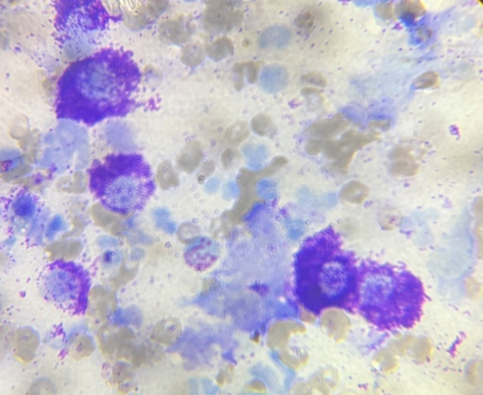
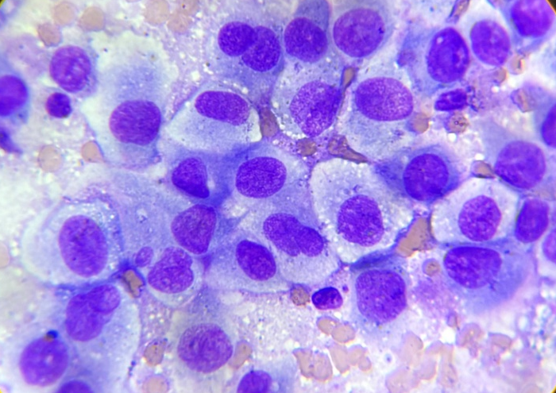
Pale blue cytoplasm

Cytoplasmic Granules

Figure 2: Mast cell tumour: Round cells containing round nucleus with metachromatic cytoplasmic granules. Giemsa, 100x
Figure 1: Histiocytoma: Round to spherical shape with indented nuclei, pale blue cytoplasm. Giemsa, 100x

3. Discussion
Cutaneous histiocytoma is the most common skin tumour of dogs (Goldschmidt and Hendrick, 2002), constituting around 18% of all canine skin tumours (Reddy et al., 2009). Histiocytoma can affect different age groups, but it ismost commonly seen in young dogs. Morris and Dobson (2001) reported that nearly 50% of histiocytoma cases are diagnosed in dogs less than two years of age. Meanwhile, the result of our case was in accordance with the findings of a previous worker (Subapriya et al., 2025) who reported histiocytoma in 12 year old male non-descript dog. Krithiga et al. (2005) and Subapriya et al. (2025) reported that male dogs are more susceptible to histiocytoma, which supports our findings. Previous findings exhibited that Scottish terriers, Bull terriers, Boxers, English cocker spaniels, Doberman pinschers and Shetland sheepdogs (Taylor et al., 1969). However, in the present study, the case was reported in the Labrador breed of dog.Cytological examination of histiocytoma revealed neoplastic cells that appeared round to spherical or oval in shape, arranged in a discrete pattern and contained a round, oval, indented nucleus with large pale blue cytoplasm. These findings are in support of the earlier work of Subapriya et al. (2025).
Mast cell tumours are the third most common canine malignant cutaneous tumours, which account for 5.55 to 22.4% of cutaneous tumours of dogs (Oliveira et al., 2020; Dadhich et al., 2022).Smiech et al. (2019) reported that prevalence was more common among the age group of 6 to 10 years, and this result was supported in this case. A certain breed of dogs with a higher incidence of mast cell tumour includes Boxers, Golden Retrievers and other larger breed types (White et al., 2011). However, only a few cases have been reported in the Pug breed of dog (White et al., 2011; McNiel et al., 2006). Some studies reported that females, particularly neutered females, have been associated with increased risk of mast cell tumour (O’ Connell and Thomson, 2013 and White et al., 2011). Cytological examination of the mast cell tumour revealed discrete round neoplastic cells containing metachromatic intracytoplasmic granules. These findings are in support ofthe earlier work of Ramesh et al. (2025).
4. Conclusion
The presented case report summarises the significance of cytological examination to differentiate between histiocytoma and mast cell tumour, as both are cutaneous round cell tumours. Cytology is a reliable, easy and non-invasive tool for the diagnosis of tumours in dogs. It helps us to identify disease process, neoplasia, inflammation or non-specific inflammation. Early diagnosis of tumours helps us to prevent delayed treatment, as the mass grows, it can become fixed to deeper tissues, making its complete removal much harder.Cytology is quite useful for round cell tumours like histiocytoma and mast cell tumour due to their high exfoliative capacity, whereas histopathology is still the gold standard for conclusive diagnosis, grading and evaluating tissue architecture.
Consent
The sample was collected from VCC, IVS & AH with consent from the animal owner for diagnostic purposes.

Disclaimer (Artificial intelligence)

Author(s) hereby declare that NO generative AI technologies such as Large Language Models (ChatGPT, COPILOT, etc.) and text-to-image generators have been used during the writing or editing of this manuscript.

References
- Dadhich, R., Dadhich, H., & Sharma, G.D. (2022). Pathological and haemato-biochemical studies of mastocytoma in dogs. Indian Journal of Canine Practice, 14(2), 146-148.
- García-Reynoso, I. C., Flores-Dueñas, C. A., Castro-Del Campo, N., Jácome-Ibarra, M., Herrera-Ramírez, J. C., Gómez-Gómez, S. D., Rodríguez-Gaxiola, M. Á., & Gaxiola-Camacho, S. M. (2025). Risk Factors for the Occurrence of Cutaneous Neoplasms in Dogs: A Retrospective Study by Cytology Reports, 2019-2021. Animals, 15(14), 2069.
- Goldschmidt,M.H.,& Hendrick, M.J. (2002). Tumors of the skin and soft tissues. In: Meuten DJ, editor. Tumors in Domestic Animals. Ames, Iowa, Iowa State University Press, 109- 111.
- Gómez, S., Ortega, J., Martín, E., Pérez, M., & Rodríguez, A. (2020). A retrospective study on the outcomes of canine mast cell tumors treated with surgery and adjuvant chemotherapy. Veterinary Comparative Oncology, 18(4), 554-562.
- Krithiga, K., Manohar, B. M., & Balachandran, C. (2005). Cytological and histopathological study on cutaneous round cell tumours in canines. Indian Journalof Veterinary Pathology, 29(1), 38-41.
- McNiel, E.A., PrinkA.L., & O’Brien, T.D. (2006). Evaluation of risk and clinical outcome of mast cell tumours in pug dogs. Veterinary Comparative Oncology, 4(1), 2–8.
- Morris, J., & Dobson, J. (2001). “Small Animal Oncology”, Blackwell Science Ltd, London.
- O’Connell, K., & Thomson, M. (2013). Evaluation of prognostic indicators in dogs with multiple, simultaneously occurring cutaneous mast cell tumours: 63 cases. Veterinary Comparative Oncology, 11(1), 51–62.
- Oliveira, M. T., Campos, M., Lamego, L., Magalhães, D., Menezes, R., Oliveira, R., & Ferreira, D. A. (2020). Canine and feline cutaneous mast cell tumor: a comprehensive review of treatments and outcomes. Topics in Companion Animal Medicine, 41, 100472.
- Ramesh, S., Kumar, S. D., Harish, L. J., Balakumar, A., Preetha, S., & Kumar, V. (2025). Cytological Diagnosis of Canine Cutaneous Mast Cell Tumour with Nodal Metastasis. Indian Journal of Veterinary Pathology, 49(3), 258-261.
- Reddy, G. M., Kumar, R., Kumar, P., Sharma, A. K., & Singh, N. D. (2009). Canine skin tumours: occurrence and histopathology. Indian Journal of Veterinary Pathology, 33(2), 200-203.
- Rissi, D. R., & Oliveira, F. N. (2022). Review of diagnostic histologic features of cutaneous round cell neoplasms in dogs. Journal of Veterinary Diagnostic Investigation, 34(5), 769–779.
- Śmiech, A., Łopuszyński, W., Ślaska, B., Bulak, K., & Jasik, A. (2019). Occurrence and distribution of canine cutaneous mast cell tumour characteristics among predisposed breeds. Journal of Veterinary Research, 63(1), 141.
- Subapriya, S., Vairamuthu, S., Sivasankar, R.,Bharathidasan, M., Vijay, A., & Shafiuzama, M. (2025). Histiocytoma in Dogs: Cytomorphological and Incidence based study of 162 cases.AMA, 56, 21323-21332.
- Taylor, D.O., Dorn, C.R., & Luis, O.H. (1969). Morphologic and biologic characteristics of the canine cutaneous histiocytoma. Cancer Research, 29, 83–92.
- Warland, J., & Dobson, J. (2013). Breed predispositions in canine mast cell tumor: A single-centre experience in the United Kingdom. Veterinary Journal, 197(2), 496-498.
- Welle, M. M., Bley, C. R., Howard, J., & Rüfenacht, S. (2008). Canine mast cell tumours: a review of the pathogenesis, clinical features, pathology and treatment. Veterinary Dermatology, 19(6), 321-339.
- White, C.R., Hohenhaus, A.E., Kelsey,J., & Procter-Gray, E. (2011). Cutaneous MCTs: associations with spay/neuter status, breed, body size, and phylogenetic cluster. Journal of American Animal Hospital Association, 47(3), 210–6.

