Original Research Article
SALIVARY CRYSTALLIZATION PATTERN: A PROBABLE INDICATOR OF ESTRUS IN LAKHIMI COWS

Abstract
Efficient and prompt estrus identification is very essential for better maintenance of fertility among animals. The present study was designed to assess the efficacy of characterization of different crystallization patterns of saliva at estrus in Lakhimi cows. Follicular diameters were measured at proestrus and estrus by using ultrasonography. Serum and saliva samples were also collected during proestrus and estrus stage of estrous cycle for determination of hormonal profile and salivary crystallization patterns, respectively by standard methods. The mean diameter of dominant follicles at estrus (1.04±0.02 cm) was significantly higher (p<0.05) than proestrus (0.82±0.01 cm). The serum progesterone profile had significant difference (p<0.05) between proestrus (1.12±0.04 ng/ml) and estrus (0.76±0.02 ng/ml). Again, the mean serum estrogen concentration during proestrus (27.38±0.27 pg/ml) was significantly lower than estrus (36.92±0.41 pg/ml). In the present study, higher incidence of typical salivary crystallization patterns (72.00 per ccent) was recorded at estrus than proestrus (48.00 per cent). From the study, it may be concluded that typical crystallization patten of saliva was predominant at estrus and determination of salivary crystallization pattern could be a reliable, cost-effective and non-invasive method of estrus detection in Lakhimi cows.
Key words: Crystallization pattern, estrus, Lakhimi cow, saliva, typical
- Introduction
Proper identification of estrus in non-conceived animals is very necessary for maintenance of fertility and productivity among animals (Fricke, 2002; Padodara et al., 2024). Lakhimi is an important newly registered dual-purpose cattle breed of Assam, India which has been registered in the year 2017 by National Bureau of Animal Genetics Resources (Kayastha et al., 2011; Savalia et al. 2019). The incidence of dairy cows at estrus that stand to be mounted and duration of standing estrus has been reduced (Dobson et al., 2008). Similarly, in indigenous cattle breeds estrus expression is weak and its duration becomes shorter in comparison to exotic cattle breeds leading to difficulties in proper detection of estrus (Layek et al., 2011). Therefore, to overcome this problem several methods have been developed by early researchers for better identification of estrus with various success rates. In recent studies, it has been observed that the salivary crystallization pattern during various reproductive stages of estrous cycle in bovines is similar to crystallization pattern of cervico-vaginal mucus (Cortes et al., 2014; Padodara et al., 2024). Saliva is one of the important and easily accessible non-invasive biological fluids of animals which depicts the pathological and physiological status of humans as well as animals (Surla et al., 2021). In animals, saliva is composed of variety of electrolytes viz. calcium, inorganic phosphorus, magnesium, potassium, sodium etc. which have been fluctuating during various stages of estrous cycle with the variation of ovarian steroid hormones (Devi et al., 2016). Limited information is available on salivary crystallization pattern and no such data is obtained in Lakhimi cattle breed. Hence, this study is undertaken to access the crystallization patterns of saliva during proestrus and estrus stage of estrous cycle in Lakhimi cows.
- Materials and methods
  - Selection of experimental animals
Fifty numbers of post-partum cyclic Lakhimi cows were selected based on the presence of functional corpus luteum (CL) at mid diestrus stage after clinico-gynaecological and ultrasonographic examination.
  - Induction of proestrus and estrus
Estrus was induced with PGF_{2ɑ} analogue Cloprostenol sodium (Vetmate®, Cargill India Pvt. Ltd. Bengaluru, India) @ 500 μg intra-muscular. All the animals were monitored carefully at every 12 hours interval for 5 consecutive days after the parenteral PGF_{2ɑ} analogue injection for the detection of proestrus and estrus (Bernardi et al., 2016).
2.3 Screening of follicular diameter of dominant follicle
Ultrasonographic observation of ovaries were carried out by a portable real time B-mode ultrasonographic machine (M-SONOSITE, FUJIFILM inc Bothwell, WA 98021-3904 USA) with linear transrectal probe of 5-10 MHz frequency for monitoring the follicular diameter of each experimental Lakhimi cows (Tom et al. (1998).

2.4 Estimation of serum hormonal profile
Blood was collected from jugular vein on the day of proestrus and estrus and serum was separated and stored at -40°C for further biochemical analysis. The serum progesterone concentration was estimated by enzyme linked immunosorbent assay (ELISA) technique as per manufacturer’s guideline with the help of commercially available ELISA kit (PROGESTERONE EIA, XEMA Co., Ltd., Moscow, Russia). The serum estrogen profile was also determined by ELISA technique as per manufacturer’s guideline with the help of commercially available ELISA kit (ESTRADIOL EIA, XEMA Co., Ltd., Moscow, Russia).
2.5 Collection of saliva samples and evaluation of crystallization patterns
Saliva samples were collected during the early morning (between 6.00 to 7.00 AM) before feeding at proestrus and estrus. Crystallization patterns of saliva samples were documented by placing 2-3 drops of non-foamy and dirt-free saliva sample on a clean uniform grease free glass slide. Then sample was spread uniformly with the help of another glass slide and permitted to air dry in room temperature for a duration of 5 to 10 minutes. The slide was examined under 10X and 40X magnification of microscope for observing the different crystallization patterns of the saliva samples (Ravinder et al. 2016).
  - Statistical analysis
All statistical analyses were carried out using software package SAS 9.3 version (SAS Institute, Cary, NC, USA). Student’s t-tests were utilized to compare means between two specific groups (estrus vs. proestrus).
- Results and discussion
  - Diameter of dominant follicle
In the present study, diameter of dominant follicles at estrus (1.04±0.02 cm) was significantly higher (p<0.05) than diameter of dominant follicles at proestrus (0.82±0.01 cm) as shown in Table 1 and Fig 1 and 2. The diameter of dominant follicle in estrus was correlated with the behavioural and physical signs of estrus following PGF_{2α} administration. The findings of diameter of dominant follicles were in accordance with Ramana et al. (2013), who recorded a dominant follicle (10.00±0.78 mm) after 3-4 days of PGF_{2ɑ} injection in lactating Ongole cows. Similarly, Ralte (2022) also observed the dominant follicles of similar diameter in two and three wave estrous cycle in Lakhimi cows. Moreover, recently Roy (2024), found the diameter of dominant follicle at 0-24, 24-48 and 48-72 hours of PGF_{2ɑ} administration as 7.31±0.39, 8.58±0.31 and 11.14±0.29 mm, respectively in postpartum Lakhimi cows.
3.2 Serum hormonal profile
The mean serum progesterone concentration (ng/ml) at proestrus and estrus were 1.12±0.04 and 0.76±0.02 respectively in induced Lakhimi cows following PGF_{2ɑ} based estrus induction (Table 1). In the present study, the serum progesterone profile had significant difference (p<0.05) between proestrus and estrus as shown in Table 1. In line to this study, Ralte (2022) and Roy (2024) obtained similar progesterone profile in Lakhimi cows during proestrus and estrus. The serum progesterone concentrations were lower at proestrus and estrus might be due to luteolysis of CL by the administration of PGF_{2ɑ} injection in Lakhimi cows. The lower level of serum progesterone concentration following PGF_{2ɑ} administration might helped in better response to onset of proestrus and estrus in Lakhimi cows.
In the present study, the mean serum estrogen concentration during proestrus and estrus were 27.38±0.27 and 36.92±0.41 pg/ml, respectively in Lakhimi cows after PGF_{2ɑ} based estrus induction (Table 1). In the current research, serum estrogen profile at estrus was significantly higher (p<0.05) than proestrus in Lakhimi cows (Table 1). The present findings were in collaboration with the reports of Bharali et al., (2020) in crossbred cows and Ralte (2022) in Lakhimi cows. The higher estrogen concentration at proestrus and estrus could be due to presence of growing and dominant follicles (Table 1) following luteolysis of CL by PGF_{2ɑ} administration. The changes in ovarian steroid hormones (estrogen and progesterone) in body could exert influence on various biochemical and physiological mechanisms in animals (Devi et al., 2016).
3.3 Incidence of salivary crystallization patterns
In the present study, the incidence of occurrence of different salivary crystallization pattern during proestrus and estrus stage of estrous cycle was presented in Table 2 and Fig. 3 and 4. At proestrus, the incidence of typical, atypical and nil salivary crystallization patterns were depicted as 48.00, 46.00 and 6.00 per cent, respectively in Lakhimi cows (Table 2). However, the typical, atypical and nil salivary crystallization patterns at estrus were recorded as 72.00, 28.00 and 0.00 per cent, respectively in Lakhimi cows (Table 2).
The present findings were in agreement with the findings of Surla et al., (2021) who recorded typical salivary crystallization pattern in 74.50 per cent buffaloes of first population sample at the end of proestrus or in the initiation of estrus. Similarly, Naidu et al., (2022) observed the incidence of typical salivary crystallization pattern as 70.00 per cent at estrus in crossbred cattle during winter season. Also, Skalova et al., (2013), Varra et al., (2022), Chavan et al., (2023) and Padodara et al., (2024) recorded the incidence of typical salivary crystallization pattern at estrus stage of estrous cycle in cattle and buffaloes.
In bovines, cervico-vaginal mucus revealed different crystallization patterns during various stages of estrous cycle based on the variable concentrations of ovarian steroid hormones and this crystallization patterns were visualized as a tool for detection of estrus (Kalita et al., 2022; Ramesh et al., 2024). Similar to cervico-vaginal mucus, saliva also showed various unique crystallization patterns during different reproductive stages of estrous cycle in animals (Surla et al., 2021; Chavan et al., 2023).
The crystallization pattern of saliva was mainly due to electrolytes concentration (principally sodium chloride, potassium chloride and calcium chloride) and physio-chemical properties of glycosylated protein viz. mucin (Pattanasuttinont et al., 2007; Alagendran et al., 2010; Kumar et al., 2024). The typical salivary crystallization patterns were generally recorded at early estrus or about 8-12 hours prior to the expression of behavioural signs of estrus (majority of the cases) when the serum estrogen profile was very high (Surla et al., 2021). In women, the crystallization pattern of saliva was the indicator of fertile period (Devi et al., 2016). The significant upraised of serum estrogen profile had positive impact on body’s salts concentrations in human and animals (Das et al., 2023; Devi et al., 2016). Besides, serum estrogen hormone had the capability to retain salts concentration and to alter ion transport in various other epithelial cells might be partially responsible for high salivary salts concentration observed during estrus stage (Devi et al. 2016). The crystallization pattern of saliva was mainly caused by the presence of increased concentration of salts like sodium chloride, potassium chloride, calcium chloride etc. due to elevated serum estrogen profile secreted from the dominant follicles as shown in Table 1. In agreement to our findings, previous studies also revealed increased plasma estradiol concentration caused increased activity of salivary electrolytes or minerals for confirmation of estrus in bovines (Alagendran et al., 2007; Devi et al., 2016). Hence, the elevated level of estrogen hormone at estrus than proestrus might help in better expression of behavioural and physiological signs of estrus as well as higher incidence of typical salivary crystallization pattern following PGF_{2ɑ} based estrus induction in Lakhimi cows.
- Conclusion
In recent years, proper estrus identification is very challenging for better achievement of fertility in dairy cows. Saliva is an important non-invasive biological fluid in animals and it can be easily collected by the farmers as it doesn’t require any especial technique. Exploration of salivary crystallization pattens might provide information related to fertility in farm animals. Present study confirmed typical salivary crystallization pattern predominated during estrus in induced Lakhimi cows. Hence, determination of salivary crystallization patterns could be a reliable, cost effective and non-invasive method of estrus identification in Lakhimi cows.
Ethical Approval
The study was conducted with the approval from the Institutional Animal Ethics Committee, Assam Agricultural University, Khanapara - 781022, Guwahati, Assam, India vide Approval No. 770/GO/Re/S/03/CPCSEA/FVSc/AAU/IAEC/2024/1188 dated 09.12.2024.
Disclaimer (Artificial Intelligence)
Author(s) hereby declare that NO generative AI technologies such as Large Language Models (ChatGPT, COPILOT, etc) and text-to-image generators have been used during writing or editing of this manuscript.

References
Alagendran, S.; Archunan, G and Achiraman, S. (2007). Prediction of ovulation in women through the occurrence of salivary fern type. The ICFAI Journal of Life Sciences, 1: 7-15.
Alagendran, S.; Devi, C.A.; Karthikeyan, K; Arulmozhi, N. and Pushpa, N. (2010). Evaluation of salivary electrolytes during normal menstrual cycle with special reference to ovulation. American Jornal of Applied Sciences, 7(8): 1066-1072.
Bernardi, S.; Rinaudo, A. and Marini, P. (2016). Cervical mucus characteristics and hormonal status at insemination of Holstein cows. Iranian Journal of Veterinary Research, 17(1): 45-49.
Bharali, D.; Deka, K.C.; Deka, B.C.; Nath, K.C.; Biswas, R.K.; Dutta, L.J.; Sarmah, B.K. and Saikia, B.N. (2020). Concentration of serum estradiol, progesterone and cortisol during biological stress period of normal cyclic and silent oestrous crossbred cows of Assam. International Journal of Chemical Studies, 8(2): 1668-1670.
Chavan, N.B.; Kumaresan, A.; Chhillar, S.; Nayak, S.; Prakash, M.A.; Lathika, S.; Baithalu, R.K.; Onteru, S.; Manimaran, A. and Kimothi, S.P. (2023). Salivary crystallization pattern: a possible unconventional tool for timing of insemination and early pregnancy diagnosis in zebu cows. Journal of Dairy Research, 90: 21-25.
Cortes, M.E.; Gonzalez, C. and Vigil, P. (2014). Crystallization of bovine cervical mucus at oestrus. An update. Revista de Medicina Veterinaria, 28: 103-116.
Das, R.; Belgaumi, U.I.; Vibhute, N.; Kadashetti, V. and Kamate, W. (2023). Evaluation of salivary ferning for predicting ovulation in menstruating women with a normal cycle: an easy, cost-effective and noninvasive approach. Journal of South Asian Federation of Obstetrics and Gynaecology, 15(3): 316-320.
Devi, I; Singh, P.; Lathwal, S.S.; Kumaresan, A. and Dudi, K. (2016). Evaluation of salivary electrolytes during estrous cycle in Murrah buffaloes with reference to estrus detection. Veterinary World, 9(10): 1157-1161.
Dobson, H.; Walker, S.L.; Morris, M.J.; Routly, J.E. and Smith, R.F. (2008). Why is it getting more difficult to successfully artificially inseminate dairy cows? Animal, 2:1104–1111.
Fricke, P.M. (2002). Scanning the future – ultrasonography as a reproductive management tool for dairy cattle. Journal of Dairy Science, 85: 1918-1926.
Kalita, B.; Sarma, D.K.; Ahmed, K.; Dutta, D.; Baruah, P.M. and Borpujari, D. (2022). Fertility status in relation to the physical characteristics of cervico-vaginal mucus in Lakhimi cattle. The Pharma Innovation Journal, SP-11(3): 1384-1386.
Kayastha, R.B.; Jaman, G.; Goswami, R.N. and Hauque, A. (2011). Physical and morphological characterization of indigenous cattle of Assam. Open Veterinary Journal, 1: 7-9.
Kumar, V.; Joshi, M.; Vats, A.; Kumar, L.K.; Verma, S.K.; Neeraj,; Baithalu, R.K.; Veerappa, V.G.; Singh, D. and Onteru, S.K. (2024). Mucin and salt combination stimulate typical fern-like pattern of buffalo saliva smear at estrus. Microscopy Research and Technique, 87: 1753-1765.
Layek, S.S.; Mohanty, T.K.; Kumaresan, A.; Behera, K. and Chand, S. (2011). Behavioural signs of estrus and their relationship to time of ovulation in Zebu (Sahiwal) cattle. Animal Reproduction Science, 129: 140-145.
Naidu, G.S.; Ramesh, P.; Sireesha, K.; Krishan. M.M. and Rao, P.K. (2022). Differential responses in estrus induced salivary ferning pattern vis-a-vis the ambient temperature - a comparative study in water buffaloes and crossbred cattle. Acta Scientific Veterinary Sciences, 4(5): 102-107.
Padodara, R.J.; Vijyeta, H.P.; Vasava, A.A.; Parikh, S.S. and Sharma, A.K. (2024). Studies on salivary fern pattern during estrous cycle in Gir cow and Jaffrabadi buffalo. The Indian Journal of Veterinary Sciences and Biotechnology, 20(6): 69-73.
Pattanasuttinont, S.; Sereepapong, W. and Suwajanakorn, S. (2007). The salivary ferning test and ovulation in clomiphene citrate-stimulated cycles. Journal of the Medical Association of Thailand, 90(5): 876-883.
Ralte, V. (2022). Ultrasonographic monitoring of ovarian follicular and luteal dynamics in cow. PhD. Thesis, Assam Agricultural University, Guwahati, Assam.
Ramana, K.V.; K. Rao, K.S.; Supriya, K. and Rajanna, N. (2013). Effect of prostaglandin on estrus response and conception rate in lactating Ongole cows, Veterinary World, 6(7): 413-415.
Ramesh, V.; Devi, L.S.; Joshi, V.; Hanah, S.S.; Khate, K. and Khan, M.H. (2024). Cervical mucus changes can predict ovulation time in Mithun. Indian Journal of Animal Sciences, 94(6): 527-531.
Ravinder, R.; Kaipa, O.; Baddela, V.S.; Sinha, E.S.; Singh, P.; Nayan, V.; Velagala, C.S.N.; Baithalu, R.K.; Onteru, S.K. and Singh, D. (2016). Saliva ferning, an unorthodox estrus detection method in water buffaloes (Bubalus bubalis). Theriogenology, 86: 1147-1155.
Roy, C. (2024). Profiling of proteins vis-à-vis cervico-vaginal mucus during follicular phase of estrous cycle in Lakhimi cow. M.V.Sc. Thesis, Assam Agricultural University, Guwahati, Assam.
Savalia, K.B.; Ahlawat, A.R.; Gamit, V.V.; Parikh, S.S. and Verma, A.D. (2019). Recently recognized indigenous cattle breeds of India: A review. International Journal of Current Microbiology and Applied Sciences, 8(12): 161-168.
Skalova, I.; Fedorova, T. and Brandlova, K. (2013). Saliva crystallization in cattle: New possibility for early pregnancy diagnosis? Agricultura Tropica Et Subtropica, 46(3): 102-104.
Surla, G.N.; Hebbar, A.; Kumar, V.; Nayan, V.; Vedamurthy, V.G.; Singh, D. and Onteru, S.K. (2021). Validation of salivary ferning based estrus identification method in a large population of water buffaloes (Bubalus bubalis) using foldscope. Reproductive Biology, 21: 100528.
Tom, J. W.; Pierson, R. A. and Adams, G. P. (1998). Quantitative echotexture analysis of bovine ovarian follicles. Theriogenology, 50: 339–346.
Varra, M.; Sundaresan, N.R.; Kumar, V.G.; Chandranaik, B.M.; Sejian, V.; Sudha, G. and Suchitra, B.R. (2023). Tamm-Horsfall protein expression in urine of buffaloes at the estrus and diestrus stages of estrous cycle. Agricultural Science Digest, 43(6): 858-863.

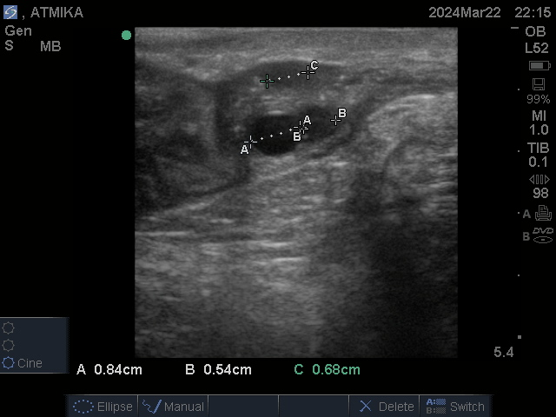
Fig. 1: Diameter of dominant follicle at proestrus in Lakhimi cow

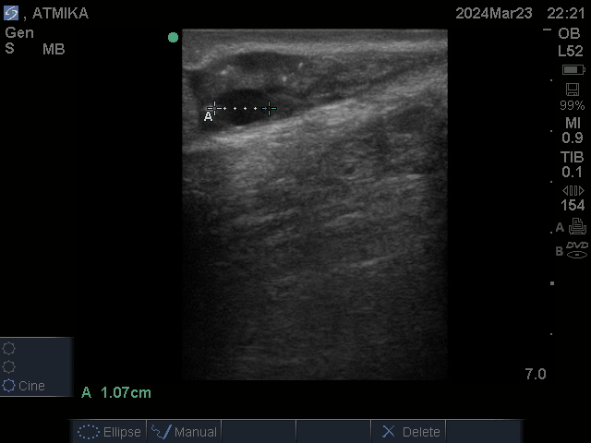
Fig. 2: Diameter of dominant follicle at estrus in Lakhimi cow
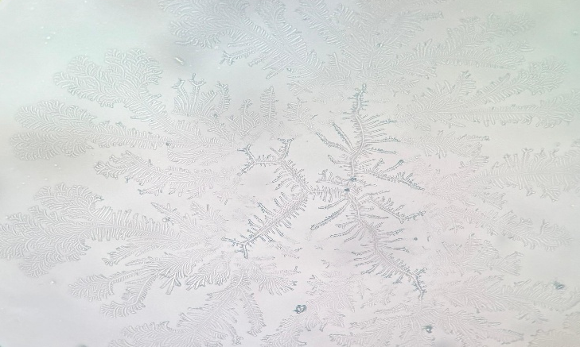
Fig. 3: Typical salivary crystallization pattern in Lakhimi cow
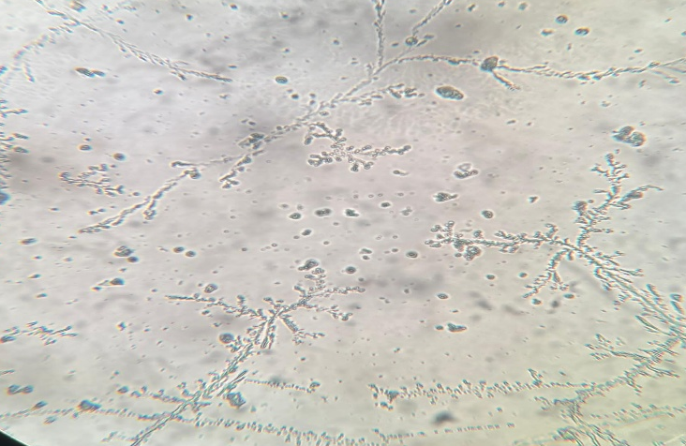
Fig. 4: Atypical salivary crystallization pattern in Lakhimi cow
TABLE 1 | DIAMETER OF DOMINANT FOLLICLE AND SERUM HORMONAL PROFILE AT PROESTRUS AND ESTRUS STAGE IN LAKHIMI COWS
Parameter |  | Stage of estrous cycle |  | p-value
 |  | Proestrus | Estrus | p-value
Diameter of dominant follicle (cm) |  | 0.82ª±0.01 | 1.04^{b}±0.02 | <0.0001*
Serum progesterone profile (ng/ml) |  | 1.12ª ±0.04 | 0.76^{b}±0.02 | <0.0001*
Serum estrogen profile (pg/ml) |  | 27.38ª±0.27 | 36.92^{b}±0.41 | <0.0001*
Means with different superscripts in a row differ significantly (*p<0.05)

TABLE 2 | SALIVARY CRYSTALLIZATION PATTERNS AT PROESTRUS AND ESTRUS STAGE IN LAKHIMI COWS
Parameter |  |  | Stage of estrous cycle
 |  |  | Proestrus | Estrus
Crystallization pattern (%) |  | Typical | 48.00 (24/50) | 72.00 (36/50)
 |  | Atypical | 46.00 (23/50) | 28.00 (14/50)
 |  | Nil | 6.00 (3/50) | 0.00 (0/50)

