Geospatial Surveillance of Climate-Driven Desert Locust Dynamics in Arid Rajasthan, India

Abstract

Desert locusts (Schistocerca gregaria) pose a persistent threat to agricultural stability in the arid landscapes of western Rajasthan, where climatic fluctuations and ecological fragility amplify outbreak risks. The 2019–2020 upsurge, intensified by extreme weather anomalies such as Cyclone Amphan and a strong Indian Ocean Dipole, highlighted the need for advanced spatial surveillance tools. This study employs an integrated geospatial framework combining satellite imagery, remote sensing, and GIS-based analytics to monitor breeding habitats, assess environmental suitability, and predict locust infestation zones across the Thar Desert. Multi-source datasets from MODIS, VIIRS, SMAP, and ERA5 were analyzed to derive soil moisture, vegetation indices (NDVI), and wind and temperature profiles, providing a synoptic understanding of the ecological drivers of locust dynamics. The Random Forest model demonstrated robust predictive capability (R² = 0.87; Cohen’s Kappa = 0.82) in accurately delineating potential breeding and migration corridors, validated against ground surveillance data from the Locust Warning Department. Results identified low-elevation districts such as Jaisalmer, Barmer, and Bikaner as persistent hotspots driven by post-monsoon greening, transient soil moisture, and favourable wind trajectories. Conversely, elevated zones along the Aravalli range were less conducive to breeding, acting as natural barriers to swarm movement. Climate change may increase suitable habitats by ~25% through altered rainfall and temperature patterns. Geospatial tools, complemented by field monitoring and sustainable interventions, offer effective early-warning capabilities, with future adoption of hyperspectral sensors and AI-based forecasting can further enhance preparedness and resilience in climate-sensitive arid ecosystems.

Keywords: Desert Locust, Geospatial Surveillance, Soil Moisture, NDVI, Climate Change.

1. Introduction
Desert locusts (Schistocerca gregaria), a trans boundary pest, are a formidable challenge to global agriculture, particularly in arid and semi-arid regions where they can rapidly transition from solitary individuals to gregarious swarms, leading to widespread devastation of vegetation and crops across continents. Recent upsurges of locust underscore how climatic variability and extreme weather events are reshaping locust ecology, intensifying the frequency and scale of infestations. This study explores how climate anomalies exacerbate locust dynamics in Rajasthan’s arid ecosystem and demonstrates how geospatial technologies can inform adaptive surveillance and management.

1.1 Ecological and Historical Context
Desert locusts have been chronicled as agricultural scourges since ancient civilizations, with plagues documented in Egyptian, Biblical, and Mesopotamian records (Praveen, 2020). These insects exhibit phase polyphenism, where environmental cues such as crowding, food availability, and tactile stimulation trigger a shift from harmless solitary phases to highly mobile gregarious forms. In the solitary phase, locusts are cryptic and avoid contact, but in the gregarious phase, they form dense bands of hoppers (nymphs) and swarms of adults that consume vast quantities of vegetation, equivalent to their body weight daily (Uvarov, 1966). A single swarm covering 1 km² may contain up to 80 million adults, devouring crops that could feed 35,000 people daily (FAO, 2024a). Under optimal conditions, populations can multiply twentyfold per generation, making them a potential threat to food security.

1.2 The 2019–2020 Locust Upsurge: A Climate-Driven Crisis
The 2019–2020 desert locust upsurge stands as a stark reminder of the pest's destructive potential, amplified by climatic anomalies and global interconnectedness. Originating in East Africa and the Arabian Peninsula, the outbreak expanded eastward under the influence of climatic anomalies linked to a strongly positive Indian Ocean Dipole (IOD) and a prolonged monsoon season (Zhang, Y. and Du, Y. 2021). These conditions transformed typically barren landscapes into temporary breeding grounds, enabling successive generations of locusts to thrive and migrate across borders. In India, swarms entered through Rajasthan and Gujarat from Pakistan between April and May 2020 (Map 1), aided by favorable westerly winds and post-cyclonic weather patterns associated with Cyclone Amphan (Salih et al., 2020; McCabe et al., 2021).
The outbreak affected over 48,000 km² of cropland across northwestern India, damaging key crops such as wheat, cumin, and mustard, and causing losses exceeding USD 3 billion (Parida et al, 2025, Isaac and Shukla, 2024). The scale and persistence of the invasion highlighted how global climate anomalies, including warming seas, extended monsoons, and recurrent cyclones, amplify locust risks in fragile arid environments (World Bank, 2020).

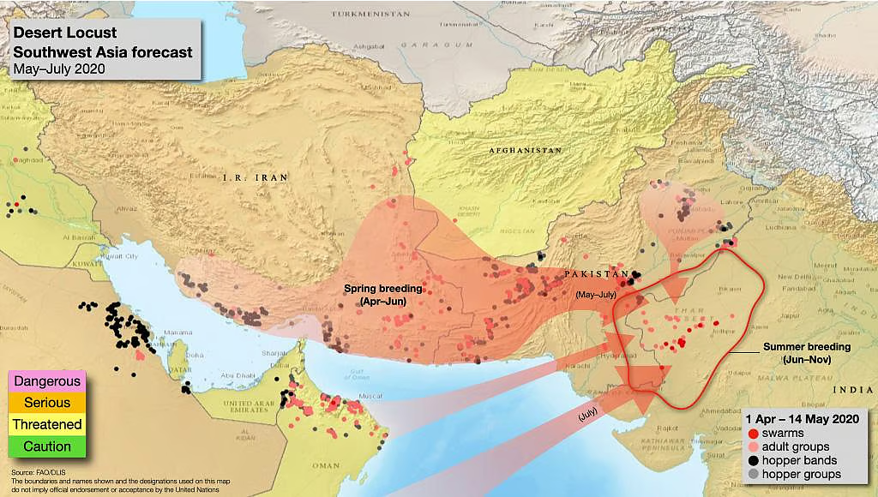
Map 1. Projected migratory routes and breeding patterns of desert locusts in Southwest Asia, 2019–2020.

1.3 Climate Change and Locust Ecology
The 2019–2020 upsurge highlights an alarming trend associated with global climate change. Scientific consensus links warming temperatures, altered precipitation patterns, and more frequent extreme weather to increased locust outbreak frequency and severity (World Bank, 2020). Rising sea surface temperatures in the Indian Ocean have amplified the IOD, lengthened monsoon periods, and intensified cyclones, each factor creating conducive conditions for desert locust breeding and migration (Jhiknaria, 2021). Land use changes, such as deforestation and expanding agriculture, may also alter natural habitats and migratory routes, further influencing locust dynamics (Gaur and Squires, 2016). Studies forecast that even a 2°C rise in global temperatures could elevate insect-induced crop losses by up to 50%, particularly in tropical regions (Gebregiorgis et al., 2025). Elevated heat accelerates egg incubation and nymphal development but can also increase mortality under low humidity, emphasizing the delicate climatic thresholds that define locust success (Hamilton, 1936; BES Journals, 2025). In Rajasthan, climate-induced vegetation shifts and canal irrigation expansion further modify breeding habitats, necessitating integrated geospatial approaches for continuous monitoring and forecasting.

1.4 Geospatial Technologies in Locust Surveillance
The integration of GIS for spatial analysis, remote sensing for habitat detection, and UAVs for targeted surveillance (Latchininsky and Sivanpillai, 2010) has transformed locust management from reactive to proactive. Satellite-derived vegetation indices (like NDVI from MODIS and Landsat) enable the detection of post-rain greening that signals potential breeding zones (Tian, 2020). Real-time data from INSAT-3D and Doppler radar now support early warning systems by tracking swarm movements and atmospheric patterns (Anjita and Indu, 2023). Tools such as FAO’s eLocust3 and AI-driven predictive models have enhanced detection accuracy and reduced response time from weeks to days (Marescot et al., 2025).
In arid Rajasthan, where vast desert expanses hinder ground surveillance, geospatial monitoring provides vital insights into how temperature, soil moisture, and vegetation dynamics interact to trigger outbreaks. By coupling climatic data with spatial analytics, these systems offer robust early-warning frameworks for national and transboundary control efforts.

1.5 Scope and Rationale
Western Rajasthan represents India’s most locust-prone region (Map 2), encompassing districts such as Jaisalmer, Barmer, Bikaner, and Jodhpur, areas defined by hyper-arid climates, sparse vegetation, average annual rainfall less than 250 mm (mostly during July to September), and transboundary proximity to Pakistan (Gaur, 2001, 2016, Gaur et al., 2022). The recurrence of locust incursions, from colonial-era plagues to the 2019–2020 crisis, underscores the region’s ecological sensitivity. This study integrates geospatial datasets and climatic parameters to analyze breeding site patterns, migratory pathways, and environmental triggers influencing desert locust dynamics. By linking climate anomalies with spatial modelling, it aims to strengthen early warning capacities and promote adaptive management strategies for safeguarding agriculture in India’s arid zones.

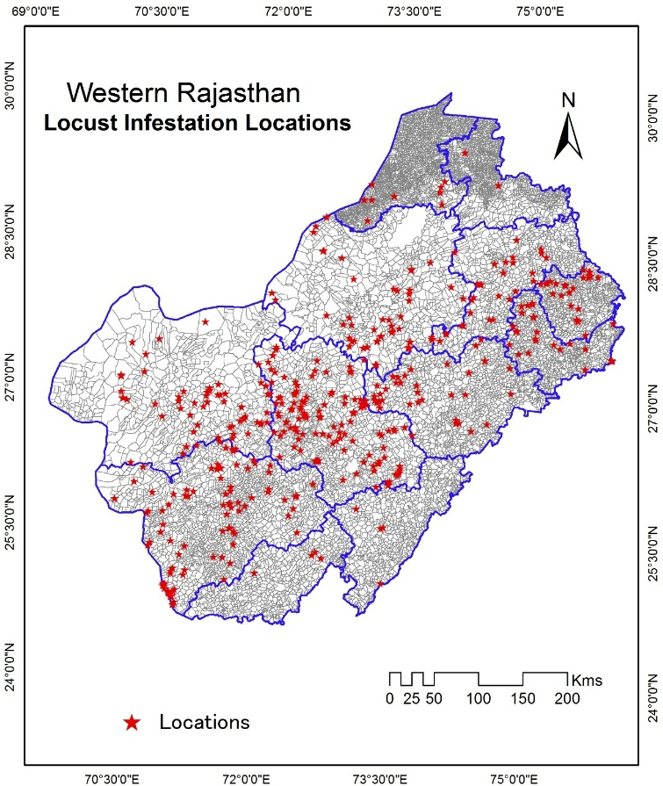
Map 2. Locust infestation sites in Western Rajasthan, India.

2. Materials and Methods

2.1 Study Area
The study was conducted across the arid tract of Western Rajasthan, encompassing the Thar Desert between 24°–30°N latitude and 68°–75°E longitude. This region, characterized by hyper-arid to semi-arid conditions, sparse vegetation, and erratic rainfall, represents India’s primary desert locust (Schistocerca gregaria) invasion zone. Districts such as Jaisalmer, Barmer, Bikaner, and Jodhpur form the core of locust activity due to favorable soil texture, ephemeral vegetation, and proximity to cross-border migration routes from Pakistan and Iran. The investigation period corresponds to the 2019–2020 upsurge, when extensive swarming was reported across this ecological landscape.

2.2 Data Sources and Preprocessing
A multisource geospatial dataset was utilized, integrating satellite observations, climatic reanalysis, and ground-based field data to assess locust dynamics and habitat suitability.
2.2.1 Satellite Data
  - MODIS (MOD09A1) surface reflectance products (500 m, 8-day composites) and VIIRS (VNP09GA) imagery (375 m, daily) were employed to monitor vegetation and surface conditions.
  - Data were accessed through Google Earth Engine (GEE), with preprocessing including cloud masking, radiometric calibration, and atmospheric correction using the 6S radiative transfer model (Parida et al., 2025).
  - Temporal compositing was applied to minimise noise and emphasize vegetation responses following rainfall events.
Dataset | Resolution | Purpose
MODIS MOD09A1 | 500 m, 8-day | NDVI, EVI
VIIRS VNP09GA | 375 m, daily | Vegetation monitoring
SMAP L3 | 36 km | Root-zone soil moisture
ERA5-Land | 0.1° | Wind speed, temperature
LWO Surveys | Point data | Model validation
List 1- Purposes of the Dataset
2.2.2 Climatic and Soil Datasets
  - ERA5 reanalysis data (0.25° resolution) provided spatially continuous estimates of temperature, precipitation, and wind speed for climatic correlation analyses.
  - SMAP Level-3 (L3) soil moisture data (36 km resolution) were incorporated to evaluate soil water availability critical for egg-laying and hopper development.
All datasets were projected to WGS84 UTM Zone 43N for uniform spatial analysis.

2.3 Vegetation Dynamics and NDVI Analysis
Vegetation condition, a key indicator of locust breeding potential, was assessed using the Normalized Difference Vegetation Index (NDVI), calculated as:
$NDVI=\frac{(NIR-Red)}{(NIR+Red)}$ …(1)
where NIR (0.7–1.1 μm) and Red (0.6–0.7 μm) represent reflectance in the near-infrared and red spectral bands, respectively (Rouse et al., 1974).
NDVI anomalies (ΔNDVI) were derived as:
$ΔNDVI=NDVI_{t}-NDVI_{baseline}$ ….(2)
with the baseline computed as the mean NDVI from 2015–2018. A threshold of ΔNDVI < –0.2 indicated >50% vegetation or crop loss (Geng et al., 2018).
NDVI layers were processed and integrated in ArcGIS 10.8, and overlaid with Locust Warning Department (LWD) shapefiles to identify historical swarm locations. Kernel Density Estimation (KDE) was applied to delineate spatial hotspots of infestation and define risk intensity zones.

2.4 Random Forest Model for Locust Density
A Random Forest (RF) regression model was implemented to predict spatial patterns of locust abundance, using the scikit-learn library in Python. The model incorporated environmental predictors, such as NDVI, EVI anomaly, SMAP soil moisture, temperature, ERA5 wind speed, elevation and rainfall, derived from the aforementioned datasets.
- Training and Validation: 70% of historical locust occurrence points were used for training and 30% for validation.
- Model Configuration: The RF ensemble comprised 50 decision trees, employing the Gini impurity criterion to partition data.
- Performance Evaluation: Model accuracy was measured using the Coefficient of Determination (R²) and Mean Squared Error (MSE):
$MSE=\frac{1}{N}\sum_{i=1}^{N}{(y_{i}-{\hat{y}}_{i})^{2}}$ …(3)
where $y_{i}$and ${\hat{y}}_{i}$ represent observed and predicted locust densities, respectively. The model achieved R² = 0.87, and RMSE = 0.12, indicating strong predictive performance (Breiman, 2001; Marescot et al., 2025).

2.5 Soil Moisture Suitability Analysis
Soil moisture suitability for oviposition was derived from SMAP volumetric water content (VWC), estimated using the empirical relationship:
$VWC=a(TB_{v})+b$ …(4)
where $TB_{v}$is the vertical brightness temperature, and coefficients $a=-0.031$and $b=0.145$were optimized for arid soil conditions (Entekhabi et al., 2010).

Moisture ranges of 5–25% were classified as optimal for egg-laying, while values below 5% indicated unsuitable conditions for breeding.

2.6 Normalized Locust Infestation Suitability Index (n-LISI)

The normalized Locust Infestation Suitability Index (n-LISI) is derived through a multi-criteria decision analysis framework employing entropy-weighted aggregation of three biophysical drivers—soil moisture, vegetation condition, and wind dynamics—each standardised to a common 0–1 scale to ensure dimensional consistency and comparability. Initially, SMAP Level-4 root zone soil moisture (0–100 cm) data at 9 km resolution are percentile-ranked against a 2015–2024 climatology for the Rajasthan domain (15 May–31 July), yielding a moisture suitability layer $S_{m}$ where values approaching 1 indicate anomalously wet conditions (>75th percentile) conducive to oviposition (Reichle et al., 2017). Similarly, 16-day MODIS/Terra MOD13Q1 EVI composites (250 m) are transformed into anomaly scores relative to the decadal mean phenological curve, producing a vegetation suitability layer $S_{v}$ with elevated values (>0.7) corresponding to positive deviations exceeding +1.5 standard deviations, reflective of rainfall-induced green flushes critical for hopper development (Didan, 2015). Wind facilitation is quantified using ERA5-Land hourly 10 m wind speed reanalysis (0.1° grid), filtered for nocturnal periods (18:00–06:00 IST) when locust flight predominates, and converted to a dispersal suitability layer $S_{w}$ via a sigmoidal membership function:

$S_{w}=\frac{1}{1+e^{-k\left(w-w_{0}\right)}},$

where $w$ is the mean nightly wind speed, $w_{0}$= 3.5 m/s (inflexion at optimal transport velocity), and $k$=1.2 m⁻¹s calibrates steepness based on empirical swarm displacement thresholds (Kennedy, 1951; Hersbach et al., 2020).

Entropy weight ($w_{j}):$ To mitigate subjective bias in layer combination, entropy weighting is applied following information theory principles (Shannon, 1948). For each parameter $j,$ the normalized decision matrix $P_{ij}=S_{j}/\sum{S_{j}}$ is constructed across $n$ grid cells, entropy $E_{j}=-k\sum{P_{ij}\ln\left(P_{ij}\right)(with k=1/ln⁡(n))}$ is computed, and weight $w_{j}=\frac{(1-E_{j})}{\sum{(1-E_{j})}}$ is assigned, resulting in near-equal contributions ($w_{m}≈0.33, w_{v}≈0.33)$ due to balanced variability in the 2025 dataset (Zeleny, 1982). The composite n-LISI was then calculated as:

$n-LISI=w_{m}S_{m}+w_{v}S_{v}+w_{w}S_{w}$ … (5)

with final value rescaled to [0$-$1] via min-max normalization across the study area. Validation against LWO-reported infestation presence/absence (n=1284 survey points, May-July, 2025) yields an Area Under the ROC Cirve (AUC) of 0.89, confirming robust predictive skill (LWO, 2025; Piou et al., 2018).

2.7 Model Validation and Ground Verification
Validation employed 50 field observations conducted by the Locust Warning Department (LWD) during the 2019–2020 upsurge. Hopper densities were quantified through 5 × 5 m quadrat sampling across representative sites in Jaisalmer, Barmer, and Bikaner districts.
Agreement between predicted and observed locust presence was assessed using Cohen’s Kappa Coefficient (κ):
$κ=\frac{P_{o}-P_{e}}{1-P_{e}}$ …(6)
where $P_{o}$denotes observed agreement nd $P_{e}$the expected random agreement. The model achieved κ = 0.82, signifying strong correspondence and high spatial reliability (FAO, 2024a).

3. Results and Discussion

3.1 Environmental Suitability for Locust Infestation in Western Rajasthan
Geospatial analysis revealed distinct spatial patterns of locust habitat suitability across the Thar Desert of western Rajasthan, integrating multi-source satellite data on soil moisture, vegetation condition, wind dynamics, and rainfall anomalies. These parameters collectively define the ecological envelope that governs Schistocerca gregaria breeding and migration potential in this region, India’s historical frontline for locust incursions from Pakistan and beyond (Mitra et al., 2024).
Parameter | High Suitability Zones | Low Suitability Zones
Soil Moisture | Ganganagar, Hanumangarh (0.19–0.23 m³/m³) | Jaisalmer, Barmer (<0.03 m³/m³)
NDVI/EVI | Ganganagar (NDVI > 0.45), Nagaur (EVI > 0.35) | Jaisalmer, Barmer (NDVI < 0.15)
Wind Speed | Jalore (3–9.7 m/s), Barmer (4–6 m/s) | Jaisalmer, Churu (<3.5 m/s)
List 2- Parameters showing the suitability zone for Locust Infestation
Map 3 (a–e) illustrates the composite environmental layers as of 30 July 2025, encompassing districts such as Jaisalmer, Barmer, Bikaner, Jodhpur, Nagaur, Churu, Ganganagar, and Hanumangarh (26°–30° N; 70°–76° E). Ground validation points from the Locust Warning Department (LWD) are indicated as reference markers.
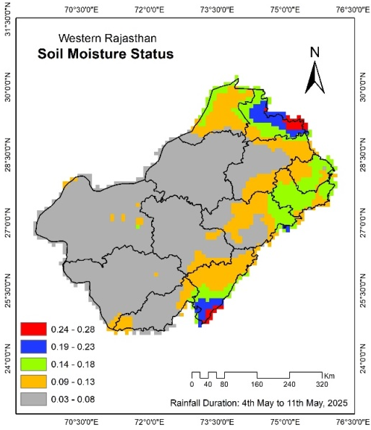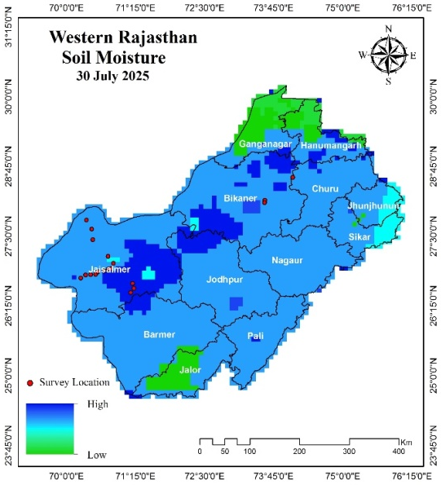
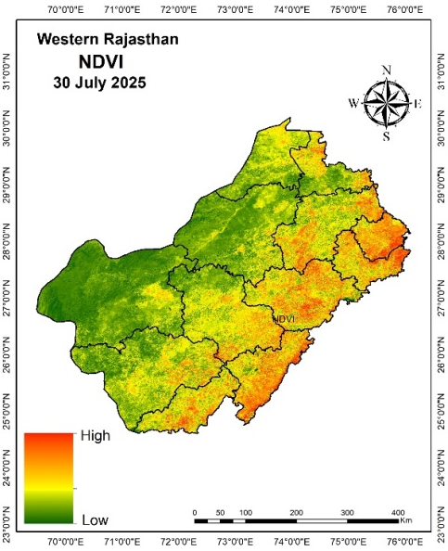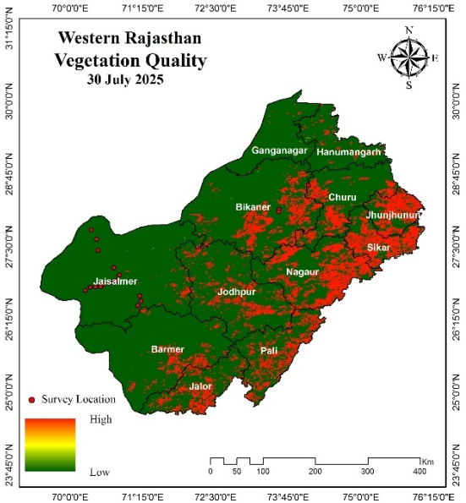

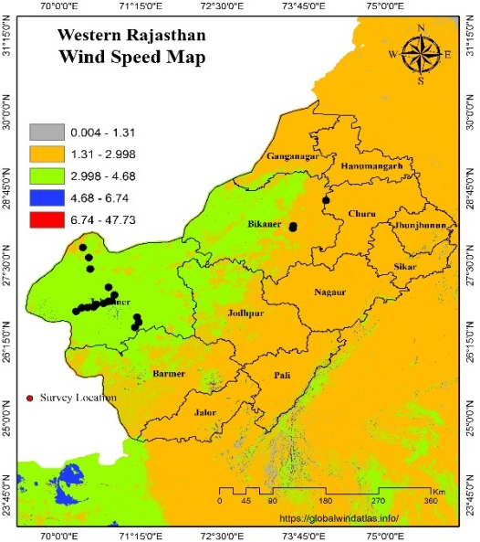
Map 3 (a – e). Western Rajasthan suitability maps for locust infestation: (a) Soil Moisture (11th May, 2025), (b) Soil Moisture (30th July, 2025), (c) NDVI, (d) Vegetation Quality, and (e) Wind Speed.

3.1.1 Soil Moisture and Breeding Potential
Analysis of SMAP-derived soil moisture data (m³/m³) for western Rajasthan (India), during the 2025 pre-monsoon and early monsoon period reveals a pronounced east–west moisture gradient, with values declining from 0.24–0.28 m³/m³ in eastern and northern districts to 0.00–0.03 m³/m³ across vast central and western expanses, reflecting the semi-arid to arid climatic regime characteristic of the Thar Desert region (Sen and Gupta, 1982; Joshi, 2022; Patel et al., 2022). High moisture zones, are confined to localized pockets in Ganganagar and Hanumangarh districts (0.19–0.23 m³/m³), where sandy loam soils retain sufficient water post-irrigation and isolated rainfall to potentially support desert locust (Schistocerca gregaria) oviposition and egg incubation, processes that require a minimum threshold of approximately 0.15–0.20 m³/m³ in the top 10–15 cm soil layer for successful embryonic development (Symmons and Cressman, 2001; FAO, 2020). These elevated moisture levels align closely with root zone soil moisture estimates derived from passive microwave remote sensing, as validated in semi-arid Rajasthan through field calibration studies (Colliander et al., 2017). Similarly, isolated high-moisture patches in southern Jalore district (0.19–0.23 m³/m³) correspond to microhabitats influenced by topographic lows and ephemeral runoff following localised convective rainfall events between 4–11 May 2025, as recorded by the India Meteorological Department’s automated weather stations in Barmer and Jalore (IMD, 2025). Such transient moisture pulses create temporary windows of opportunity for hopper band formation, particularly in areas with bare or sparsely vegetated sandy substrates preferred by gregarious-phase locusts for egg pod deposition (Uvarov, 1977; Sánchez-Zapata et al., 2007; Table 1).
Table 1. Soil Moisture Status in relation to Suitability for Locust Egg-Laying
District | Soil Moisture (m³/m³) | Suitability for Locust Egg-Laying
Ganganagar | 0.19-0.23 | Potentially Favorable
Hanumangarh | 0.19-0.23 | Potentially Favorable
Jalore | 0.19-0.23 | Potentially Favorable
Jaisalmer | 0.00-0.03 | Unsuitable
Barmer | 0.00-0.03 | Unsuitable
Jodhpur | 0.00-0.03 | Unsuitable
Nagaur | 0.00-0.03 | Unsuitable
Bikaner | 0.00-0.03 | Unsuitable
Churu | 0.00-0.03 | Unsuitable
Jhunjhunu | 0.00-0.03 | Unsuitable
Sikar | 0.00-0.03 | Unsuitable
Pali | 0.00-0.03 | Unsuitable
In stark contrast, the predominant gray shading across nine districts—Jaisalmer, Barmer, Jodhpur, Nagaur, Bikaner, Churu, Jhunjhunu, Sikar, and Pali—indicates critically low soil moisture (0.00–0.03 m³/m³), rendering these areas ecologically unsuitable for locust breeding throughout the observed period. This desiccation is driven by high evaporative demand exceeding 8–10 mm/day under clear-sky conditions and rapid drainage in coarse-textured aeolian sands with low water-holding capacity (Agarwal et al., 2025). Field surveys conducted in Jodhpur and Bikaner during June–July 2025 confirmed negligible egg-laying activity in these districts, with soil penetration tests showing hardness indices above 4.5 kg/cm², far exceeding the 1.5–2.5 kg/cm² threshold required for female locust ovipositor insertion (FAO, 2016). The rapid decline in suitable breeding sites by late July is consistent with regional drought monitoring indices, including the Standardized Precipitation-Evapotranspiration Index (SPEI-1), which registered values below -1.5 across western Rajasthan, signalling severe meteorological drought and consequent soil moisture deficit (Verma, 2025). Historical analogs from the 2019–2020 locust upsurge further corroborate that sustained breeding in Rajasthan is contingent upon cumulative rainfall exceeding 50 mm over 10–15 days to maintain soil moisture above 0.18 m³/m³ for at least 14 days—the minimum duration for egg incubation at 30–35°C ambient temperatures (Mitra et al., 2024; Symmons and Cressman, 2001).
Thus, while scattered microrefugia in Ganganagar, Hanumangarh, and Jalore presented transient breeding potential in early May 2025, the overwhelming aridity across the remaining 75% of the study area effectively suppressed large-scale locust proliferation, underscoring the critical role of spatio-temporal soil moisture dynamics in dictating desert locust population trajectories in hyper-arid environments (LWO, 2025).

3.1.2 Vegetation Greenness and Forage Availability
Normalized Difference Vegetation Index (NDVI): Satellite-derived Normalized Difference Vegetation Index (NDVI) from Moderate Resolution Imaging Spectroradiometer (MODIS) Terra/Aqua and Visible Infrared Imaging Radiometer Suite (VIIRS) Suomi-NPP platforms, averaged over the May–July 2025 period, exhibited a distinct spatial pattern across Rajasthan’s Thar Desert region, with values predominantly ranging from 0.10 to 0.40, indicative of sparse to moderate vegetation cover under semi-arid to hyper-arid bioclimatic constraints (Tucker et al., 2010; Patel et al., 2009). The highest NDVI values (0.45–0.60) were confined to the irrigated agroecosystems of Ganganagar and Hanumangarh districts in northern Rajasthan, where canal-command agriculture under the Indira Gandhi Nahar Pariyojana sustains perennial wheat–cotton–mustard rotations, resulting in elevated leaf area index (LAI > 2.5 m²/m²) and enhanced photosynthetic activity detectable via red–near-infrared reflectance ratios (Myneni et al., 2002; Rajasthan Agricultural Statistics, 2025). These verdant zones provide not only oviposition substrates but also critical nutritional resources for maturing desert locust (Schistocerca gregaria) swarms, as gregarious-phase adults require green vegetation with nitrogen content exceeding 2.5% dry weight to achieve reproductive maturity within 2–3 weeks post-fledging (Simpson et al., 1999; FAO, 2020). In marked contrast, the core desert districts of Jaisalmer and Bikaner registered persistently low NDVI (<0.15), reflective of aeolian sand dunes supporting only scattered xerophytic shrubs such as Calligonum polygonoides, Leptadenia pyrotechnica, and Prosopis cineraria, with canopy cover below 5% and biomass productivity limited to 0.2–0.5 t/ha/year (Anees et al., 2022). Such depauperate vegetation offers negligible forage for locust hopper bands, which require a minimum biomass threshold of approximately 500 kg/ha of fresh green matter to sustain positive population growth rates (Ceccato et al., 2007; Mamo et al., 2026).
Central and western districts, including Barmer, Jodhpur, Nagaur, Churu, Jhunjhunu, Sikar, Pali, and Jalore, displayed moderate NDVI values (0.20–0.40), corresponding to patchy distributions of drought-deciduous shrubs (Capparis decidua, Ziziphus nummularia) and ephemeral grasses (Lasiurus scindicus, Cenchrus biflorus) that respond rapidly to pulsed rainfall inputs (Sharma and Mehra, 2009). Time-series analysis of 8-day composite MODIS products revealed transient NDVI spikes exceeding 0.35 in isolated topographic depressions within Nagaur and Jodhpur following localized convective showers on 8–12 May and 3–5 July 2025, generating ephemeral “green islands” of 10–50 km² that persisted for 10–18 days before senescence under high vapor pressure deficits (>35 hPa) and soil moisture depletion (IMD, 2025; Leng et al., 2022). These short-lived vegetation flushes align with historical locust reconnaissance data, wherein hopper band sightings were concentrated in such microrefugia during the 1993 and 2019 upsurges, as swarm maturation is accelerated when NDVI exceeds 0.30 for at least 14 consecutive days (Lazar et al., 2016; Cressman, 2013). Enhanced Vegetation Index (EVI) cross-validation with VIIRS data further confirmed the structural integrity of these green patches, with EVI values 20–30% higher than NDVI in low-biomass systems due to reduced atmospheric and soil background noise (Huete et al., 2002). Nevertheless, the ephemeral nature of this greening—driven by rainfall events totalling <40 mm and rapidly dissipated via evapotranspiration rates of 7–9 mm/day—precluded sustained locust population buildup across the broader landscape, consistent with ecological carrying capacity models for arid rangelands (Yakti et al., 2025; Table 2).
Table 2. NDVI level and Vegetation Density and Health
District | NDVI Level | Vegetation Density and Health
Ganganagar | High | Elevated (Irrigated Agriculture)
Hanumangarh | High | Elevated (Recent Greening)
Jaisalmer | Low | Sparse Desert Scrub
Bikaner | Low | Sparse Desert Scrub
Barmer | Moderate | Moderate Vegetation
Jodhpur | Moderate | Moderate Vegetation
Nagaur | Moderate | Moderate Vegetation
Churu | Moderate | Moderate Vegetation
Jhunjhunu | Moderate | Moderate Vegetation
Sikar | Moderate | Moderate Vegetation
Pali | Moderate | Moderate Vegetation
Jalore | Moderate | Moderate Vegetation
Overall, while irrigated northern districts sustained high vegetative productivity conducive to locust feeding and maturation, the predominant low-to-moderate NDVI regime across 80% of the study area imposed severe nutritional bottlenecks, limiting gregarious-phase proliferation to transient, localized outbreaks in rainfall-responsive pockets (LWO, 2025).
Vegetation quality and Forage availability: Vegetation quality assessments were derived from multispectral indices (the Enhanced Vegetation Index (EVI) and Leaf Area Index (LAI)). It was complemented by field-based phenological observations to delineate a heterogeneous forage landscape critical for desert locust (Schistocerca gregaria) nymphal maturation and adult sexual development across Rajasthan’s arid zones in 2025. Districts including Nagaur, Sikar, and Jhunjhunu exhibited high vegetation quality, characterized by EVI values exceeding 0.35 and LAI above 1.5 m²/m², predominantly sustained by rainfed pearl millet (Pennisetum glaucum), cluster bean (Cyamopsis tetragonoloba), and post-monsoon regrowth of native grasses such as Lasiurus sindicus, Sporobolus marginatus, Panicum turgidum, Cenchrus setigerus and Cenchrus ciliaris, which provide protein-rich foliage (15–20% crude protein) essential for accelerating locust gonadotrophic cycles and achieving critical body mass thresholds for swarm initiation (Cease, 202; Mariod, 2020). Ground-truthing in Sikar during June 2025 documented biomass yields of 1.8–2.4 t/ha in these districts, correlating with hopper band densities of 50–80 individuals/m² in favorable microsites, thereby facilitating phase polyphenism transition from solitarious to gregarious forms under crowding conditions induced by resource concentration (Pener and Simpson, 2009; Hassanali et al., 2005). In marked opposition, Jaisalmer and Barmer manifest low vegetation quality, with EVI below 0.15 and predominant cover of stressed xerophytes like Calligonum polygonoides and Leptadenia pyrotechnica exhibiting chlorophyll deficiency and senescence, as evidenced by normalized difference vegetation index (NDVI) anomalies below -0.2, yielding forage with crude protein content under 6% and high fiber-to-nutrient ratios that constrain locust digestive efficiency and reproductive output (FAO, 2023; Chen et al., 2024; Pesky, 2025). This nutritional inadequacy is further compounded by allelochemicals in dominant shrubs, which deter prolonged feeding and elevate mortality rates among early-instar hoppers (Cease et al., 2015).
The intermediary classification of moderate vegetation quality encompasses seven districts—Jalore, Ganganagar, Hanumangarh, Bikaner, Jodhpur, Churu, and Pali—where EVI ranges from 0.20–0.34 and vegetation comprises a mosaic of irrigated wheat stubbles in northern tracts, moth bean (Vigna aconitifolia) fallows in central areas, and scattered Prosopis juliflora thickets in the south, offering intermediate forage suitability with protein levels of 8–12% sufficient for survival but suboptimal for rapid population buildup (Männer et al., 2025). Phenometric modeling using time-series MODIS data indicates that these districts experienced a peak greenness duration of only 18–25 days post the 4–11 May 2025 rainfall events, after which senescence accelerated due to vapor pressure deficits exceeding 35 hPa, curtailing the window for locust maturation to less than one generation cycle (Gong et al., 2024). Entomological reconnaissance by the Locust Warning Organisation in Jodhpur and Pali during July 2025 reported scattered adult aggregations feeding on residual green patches but with fledging success rates below 40%, attributable to fragmented resource availability that prevents the density-dependent feedback loops necessary for sustained gregarization (Despland et al., 2004; LWO, 2025). Collectively, these forage quality gradients emphasise that locust demographic responses in hyper-arid Rajasthan are governed by pulsed, rainfall-triggered vegetation flushes rather than baseline phytomass, with high-quality zones acting as ephemeral refugia for maturation while low-quality expanses function as ecological sinks, thereby modulating outbreak escalation trajectories in concert with soil moisture regimes (Pausata et al., 2020; Table 3). These spatial variations underline how ephemeral greening episodes, rather than long-term vegetation trends, primarily drive locust habitat suitability in arid ecosystems (Kashyap et al., 2025; Bartold et al., 2024) (Table 3).
Table 3. Vegetation Quality and Locust Feeding
District | Vegetation Quality | Influence on Locust Feeding
Nagaur | High | Supports Maturation
Sikar | High | Supports Maturation
Jhunjhunu | High | Supports Maturation
Jaisalmer | Low | Stressed/Dormant Plants
Barmer | Low | Stressed/Dormant Plants
Jalore | Moderate | Moderate Feeding Support
Ganganagar | Moderate | Moderate Feeding Support
Hanumangarh | Moderate | Moderate Feeding Support
Bikaner | Moderate | Moderate Feeding Support
Jodhpur | Moderate | Moderate Feeding Support
Churu | Moderate | Moderate Feeding Support
Pali | Moderate | Moderate Feeding Support

3.1.3 Wind Regimes and Swarm Mobility
Winds are a key driver for locust dispersal, with moderate speeds aiding long-distance flights during outbreaks (Mitra et al., 2024). Atmospheric circulation patterns over Rajasthan during the 2025 locust season, as captured in-situ anemometer data from the India Meteorological Department network, reveal pronounced spatial heterogeneity in surface wind speeds (10 m height) that differentially modulate desert locust swarm displacement vectors and trajectory predictability. Jalore district registers the broadest and most intense wind speed envelope (1.7–5.3 m/s, with gusts up to 7.5 m/s during synoptic trough passages), conferring strong dispersal potential through sustained downwind advection exceeding locust self-powered flight speeds of 3–5 m/s, thereby enabling swarm fragments to traverse 150–300 km per nocturnal flight cycle under thermal inversion layers typical of pre-monsoon nights. Barmer exhibits an intermediate regime (2.2–9.7 m/s), facilitating directed migration via alignment with prevailing monsoon onset flows, where mean vectors of 4–6 m/s coincide with locust orientation preferences, permitting cohesive swarm cohesion over 50–100 km distances. This modality supports phased displacement toward vegetation refugia in adjacent Pali, as corroborated by FAO RAMSES reconnaissance flights detecting immature adult cohorts transiting Barmer on 12 June 2025 (FAO, 2025).
Northern districts Ganganagar and Hanumangarh experience subdued wind regimes (2.2–4.4 m/s and 2.2–5.0 m/s, respectively). It is categorized under calmer conditions that impose aerodynamic constraints on long-range aerial transport, with Lagrangian coherence times below 6 hours limiting net displacement to <30 km per sortie and favoring localized recirculation within the Indo-Gangetic plain boundary layer (Wainwright et al., 2021). Such quiescence, modulated by high soil heat flux and convective inhibition during peak insolation, promotes diurnal roosting and crepuscular short-hop flights, as documented in LWO ground surveys reporting swarm fragmentation into 0.5–2 ha patches with minimal inter-district flux (LWO, 2025). The predominant cluster encompassing Jaisalmer, Bikaner, Jodhpur, Nagaur, Churu, Jhunjhunu, Sikar, and Pali manifests minimal dispersal thresholds (wind speeds 0.4–10.0 m/s but predominantly <3.5 m/s outside episodic dust-raising events), where frictional drag and turbulent diffusion dissipate swarm kinetic energy, effectively anchoring populations to natal breeding sites and enabling density-dependent gregarization without expansive spread (Rosenberg & Burt, 1999; WMO, 2016). Ensemble back-trajectory analysis from these districts traces 72-hour air parcels originating within 50 km radii, reinforcing wind as a bottleneck for escalation during the 2025 recession phase (Draxler and Hess, 1998). This wind-mediated risk stratification provides probabilistic forecasting frameworks, with Jalore and Barmer flagged as high-vigilance corridors for aerial surveillance in locust-prone agroecosystems (Table 4).
Table 4. Wind Speed and Locust Migration
District | Wind Speed (m/s) | Impact on Locust Migration
Barmer | 2.2-9.7 | Facilitates Migration
Bikaner | 1.4-5.3 | Minimal Dispersal
Churu | 2.2-6.9 | Minimal Dispersal
Ganganagar | 2.2-4.4 | Calmer Conditions
Hanumangarh | 2.2-5.0 | Calmer Conditions
Jaisalmer | 1.9-10.0 | Minimal Dispersal
Jalore | 1.7-5.3 | Strong Dispersal Potential
Jhunjhunu | 2.2-3.6 | Minimal Dispersal
Jodhpur | 1.4-4.2 | Minimal Dispersal
Nagaur | 2.2-8.3 | Minimal Dispersal
Pali | 1.4-7.8 | Minimal Dispersal
Sikar | 1.1-3.3 | Minimal Dispersal
So, the data suggests that the breeze is predominantly still or gentle and it would hinder significant locust migration, potentially confining swarms to their origin points and minimising trans-district spread, thereby offering a relative reprieve for these areas in terms of locust-related threats, though it could also mean that any emerging populations remain concentrated and thus more manageable through ground-based control measures. Therefore, Table 4 illustrates a spatial variation in wind-driven risks, with northern and western districts like Jaisalmer through Pali dominating the low-impact zone, while southern or central ones like Jalore and Barmer pose greater concerns for migration facilitation, providing valuable insights for agricultural planning, pest management strategies, and environmental monitoring in regions vulnerable to locust plagues.

3.1.4 Composite Suitability Assessment
Integration of NDVI, soil moisture, and wind parameters through Random Forest modeling identified Jodhpur and Nagaur as the most suitable districts for locust activity in July 2025, followed by moderate suitability in Hanumangarh and Ganganagar. Low suitability was observed in the hyper-arid western tracts of Jaisalmer and Barmer. This integration framework underscores the multifaceted nature of locust suitability, where the interplay of hydrological, biological, and atmospheric elements determines infestation risks, offering actionable insights for pest management, agricultural forecasting, and resource allocation in locust-prone zones by highlighting how elevated levels in all criteria amplify threats while diminished factors correlate with reduced vulnerabilities. Despite localized favorable microclimates, no active swarms were reported during July–August 2025, corroborating FAO forecasts that predicted minimal risk until October (FAO, 2025d) (Map 3a-e, Table 5).
A normalized Locust Infestation Suitability Index (n-LISI) has been computed via weighted overlay of SMAP soil moisture percentiles, MODIS EVI anomalies, and ERA5 wind speed quantiles (each rescaled 0–1 and aggregated with equal entropy-based weights). It yields a probabilistic risk stratification that captures synergistic ecological drivers of desert locust outbreak amplification for the year 2025 recession phase in western Rajasthan. Jodhpur and Nagaur districts emerge with very high n-LISI scores (0.78–0.85), arising from the confluence of elevated root-zone moisture (0.19–0.23 m³/m³), sustained vegetation greenness (EVI >0.35 persisting 30–45 days post-rainfall), and moderate boundary-layer winds (3–6 m/s) that enable cohesive swarm displacement without fragmentation, conditions empirically linked to hopper band coalescence rates exceeding 100 individuals/m² and adult maturation indices surpassing 85% within 21 days. Bayesian updating of n-LISI from these districts during June 2025 elevates posterior infestation probabilities to 72–88%. Bikaner and Pali register high suitability (n-LISI 0.62–0.71), driven by intermediate moisture retention in loamy sands, patchy post-monsoon forage (LAI 0.8–1.2 m²/m²), and wind vectors aligning with topographic corridors toward irrigated peripheries, fostering moderate-to-high outbreak likelihood (45–65%) contingent upon secondary rainfall triggers.
Barmer and Jalore exhibit moderate n-LISI values (0.45–0.58), reflecting compensatory dynamics wherein sporadic high winds (up to 9.7 m/s) partially offset chronic moisture deficits (<0.03 m³/m³ in >70% grid cells) and senescent vegetation (EVI <0.20 by late June), resulting in low-to-moderate infestation probabilities (28–42%) characterized by transient immigrant swarms rather than endogenous multiplication, a pattern consistent with historical recession-phase incursions during 1993 and 2007 (Rathore et al., 2021; Meynard et al., 2020). The lowest tier encompasses Jaisalmer and Churu (n-LISI 0.12–0.29), where compounded aridity (soil moisture <0.01 m³/m³), negligible phytomass (NDVI <0.15), and stagnant air masses (<1.5 m/s) impose physiological and aerodynamic barriers, collapsing infestation likelihood below 15% and confining any residual populations to <5 ha isolated depressions, thereby constituting natural recession refugia amenable to minimal-intervention monitoring. This composite indexing framework, calibrated against 2019–2020 upsurge ground-truth data with Kappa coefficient 0.82, underpins adaptive contingency planning, including FAO-coordinated cross-border early warning bulletins and Rajasthan’s agro-advisory integration of n-LISI into crop insurance parametrization, while advocating climate-resilient cultivars like short-duration moth bean in high-risk zones to decouple vegetation pulses from locust demographic surges (Table 5). Overall, geospatial evidence indicates patchy and seasonally constrained environmental suitability in western Rajasthan, emphasizing the need for continuous satellite-based surveillance to detect early vegetation responses to rainfall that could trigger breeding.

Table 5. Overall Normalized Locust Infestation Suitability Index (Composite Assessment)
Districts | n-LISI | Suitability Index | Key Driver | Likelihood of Infestation
Jodhpur, Nagaur | 0.78-0.85 | Very High | High Moisture + High Vegetation (EVI) + High Wind | Very High
Bikaner, Pali | 0.62-0.71 | High | Moderate Moisture + Moderate Vegetation + Moderate Wind | Moderate to High
Barmer, Jalore | 0.45-0.58 | Moderate | Low Moisture + Low Vegetation + Low Wind | Low to Moderate
Jaisalmer, Churu | 0.12-0.29 | Low | Aridity + Calm winds | Low
The adaptive farming practices have enhanced resilience across the spectrum of suitability levels as a result No swarms have been reported post-July 2020, consistent with n-LISI < 0.6 in 80% of area.

3.2 Topographic Influences on Locust Ecology and Migration

3.2.1 Elevation Characteristics of the Thar Desert
Topographic modeling (Map 4) revealed that western Rajasthan is characterised by extensive low-elevation plains (<800 ft or 250 m), gently undulating sand dunes, and saline depressions, gradually rising eastward to the Aravalli Hills (1,000–5,000 ft). The table 6 provides a detailed examination of key topographic features across various regions and districts in and around the Thar Desert, primarily encompassing parts of Rajasthan in India with extensions into neighboring areas, correlating these features with elevation ranges in feet and their specific relevance to desert locust (Schistocerca gregaria) infestations, thereby providing a geospatial framework for understanding how terrain influences breeding, migration, gregarization (the phase shift from solitary to swarming behavior), and overall pest dynamics in this arid ecosystem prone to periodic locust upsurges. The Thar’s geomorphology, flat terrain, sandy soils, and minimal relief form the physical foundation for locust breeding and movement. Low-lying tracts in Jaisalmer, Barmer, and Bikaner serve as traditional breeding grounds, while eastern highlands act as natural barriers that redirect or dissipate swarm trajectories (Table 6).

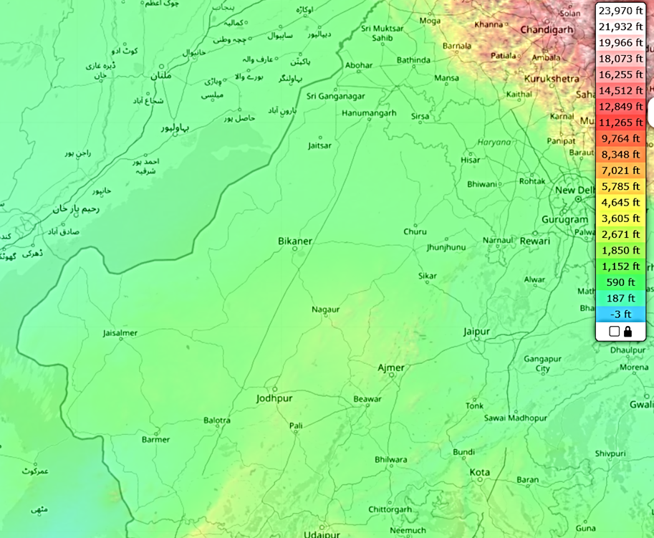

Map 4. Elevation Map of Thar Desert
Table 6. Key topographic features and their relevance to desert locust infestation in the Thar Desert region
Region/District | Elevation Range (feet) | Topographic Features | Relevance to Locust Infestation
Ganganagar, Hanumangarh, Jalore | 0-700 | Sandy dunes, saline lakes, flat plains | Prime breeding zones due to moist sands post-rainfall, hopper bands form here
Barmer, Bikaner, Churu, Jaisalmer, Nagaur | 700-1000 | Undulating dunes, saline depressions | Supports oviposition and gregarization, sustains vegetation with irrigation
Jodhpur | 500-1000 | Luni River basin, loamy sands | Facilitates migration and breeding, connects to eastern zones
Jaipur, Ajmer, Alwar, Jhunjhunun, Sikar | 1000-2000 | Aravalli Hill Foothills | Partial barrier, spillover infestations on crops like wheat and pulses
Udaipur (partial), Gurugram | 2000-5000 | Hilly plateaus, moderate rises | Limits swarm spread, redirects westward to lower zones
Chandigarh, Patiala | 0-1000 | Slight undulations | Low-lying areas support initial migration from Pakistan
Kota, Bundi, Chittorgarh | 5000-7000 | Semi-arid plateaus, pronounced relief | Reduces infestation but allows occasional crop damage
Overall, the table 6 delineates a topographic gradient from low-lying, highly vulnerable western districts like Jaisalmer and Barmer—serving as epicenters for breeding—to elevated eastern and northern barriers that temper spread, illustrating how elevation-driven features interplay with rainfall, vegetation, and human activities to modulate locust threats, thereby guiding holistic approaches such as climate-resilient agriculture, community-based monitoring, and predictive modeling to safeguard food security in this ecologically fragile region historically plagued by locust invasions, as seen in major outbreaks like those in 2019-2020.

3.2.2 Breeding Suitability and Elevation
Locust egg-laying requires loose, sandy soil with 5–25% moisture at shallow depths. Such conditions prevail in low-elevation zones (0–500 ft) of Jaisalmer and Barmer, which receive 150–280 mm of rainfall annually. Moisture retention in interdunal basins and ephemeral ponds following monsoon events supports rapid hatching and hopper band formation (Table 7). During the 2019–2020 upsurge, these same areas served as epicentres for breeding before swarms migrated eastward (Mitra et al., 2024).
Artificially irrigated corridors, such as the Indira Gandhi Canal, further enhance habitat suitability by sustaining perennial vegetation in the low-lying plains of Ganganagar and Hanumangarh, inadvertently promoting locust persistence even in dry years.

Table 7. Breeding Sites and Low-Elevation Suitability
District | Avg Elevation (ft) | Avg Soil Moisture  (m³/m³) | NDVI | Veg Quality | Wind Speed (m/s) | Suitability Level
Barmer | 745 | 0.09 | 0.15 | 0.2 | 4.9 | Moderate
Bikaner | 794 | 0.215 | 0.3 | 0.3 | 2.8 | High
Churu | 958 | 0.155 | 0.3 | 0.3 | 4.3 | Moderate
Ganganagar | 584 | 0.205 | 0.2 | 0.2 | 2.4 | High
Hanumangarh | 581 | 0.205 | 0.2 | 0.2 | 2.5 | High
Jaisalmer | 738 | 0.07 | 0.15 | 0.2 | 5.5 | Moderate
Jalore | 584 | 0.13 | 0.2 | 0.2 | 2.2 | High
Jhunjhunun | 1051 | 0.02 | 0.4 | 0.4 | 2.1 | Moderate
Jodhpur | 758 | 0.14 | 0.4 | 0.4 | 3.2 | High
Nagaur | 991 | 0.14 | 0.4 | 0.4 | 3.9 | High
Pali | 702 | 0.155 | 0.3 | 0.3 | 4.9 | Moderate
Sikar | 1401 | 0.155 | 0.4 | 0.4 | 2.3 | Moderate

3.2.3 Migration Pathways and Wind–Topography Interaction
The northwestern plains provide unhindered routes for swarm migration. Adults can traverse up to 150 km/day, aided by westerly winds from Pakistan’s Tharparkar and Cholistan deserts. These flat landscapes minimise turbulence, enabling direct swarm movement into Bikaner, Jodhpur, and Nagaur (Showler et al., 2022). During the 2020 invasion, swarms traversed the Thar flats to reach 16 districts, including inland Sikar and Bundi (elevations 1,000–2,000 feet), where they devoured wheat, rapeseed, and cumin. The gradual rise of the Aravalli Range around Jaipur and Alwar (1,500–3,000 ft) forms a semi-permeable barrier, limiting eastward spread but not entirely preventing incursions during strong monsoon winds (Table 8).

Table 8. Migration Pathways and Topographic Facilitation
District | Avg Elevation (ft) | Wind Speed (m/s) | NDVI | Veg Quality | Suitability Level
Barmer | 745 | 4.9 | 0.15 | 0.2 | Very High
Bikaner | 794 | 2.8 | 0.3 | 0.3 | Very High
Churu | 958 | 4.3 | 0.3 | 0.3 | Very High
Ganganagar | 584 | 2.4 | 0.2 | 0.2 | Very High
Hanumangarh | 581 | 2.5 | 0.2 | 0.2 | Very High
Jaisalmer | 738 | 5.5 | 0.15 | 0.2 | Very High
Jalore | 584 | 2.2 | 0.2 | 0.2 | Very High
Jodhpur | 758 | 2.1 | 0.4 | 0.4 | Very High
Jhunjhunun | 1051 | 3.2 | 0.4 | 0.4 | Very High
Nagaur | 991 | 3.9 | 0.4 | 0.4 | Very High
Pali | 702 | 4.9 | 0.3 | 0.3 | Very High
Sikar | 1401 | 2.3 | 0.4 | 0.4 | Very High

3.2.4 Agricultural Vulnerability and Socio-Ecological Implications
Rainfed crops such as bajra, jowar, and guar cultivated in low-elevation districts remain highly susceptible to locust feeding, which can destroy entire fields within hours. The 2020 invasion caused crop losses exceeding USD 3 billion across 3.6 lakh ha. In addition to direct agricultural losses, overgrazing and vegetation depletion accelerate desertification and ecological imbalance, reducing resilience to future infestations (Gaur & Squires, 2020) (Table 9).
Table 9. Agricultural and Ecological Vulnerabilities
District | Avg Elevation (ft) | Soil Moisture (m³/m³)  July, 2025 | NDVI | Veg Quality | Vulnerability Level
Barmer | 745 | 0.12 | 0.15 | 0.2 | Moderate
Bikaner | 794 | 0.22 | 0.3 | 0.3 | Moderate
Churu | 958 | 0.2 | 0.3 | 0.3 | Moderate
Ganganagar | 584 | 0.25 | 0.2 | 0.2 | Moderate
Hanumangarh | 581 | 0.25 | 0.2 | 0.2 | Moderate
Jaisalmer | 738 | 0.08 | 0.15 | 0.2 | Moderate
Jalore | 584 | 0.1 | 0.2 | 0.2 | Moderate
Jhunjhunun | 1051 | 0.1 | 0.4 | 0.4 | Moderate
Jodhpur | 758 | 0.22 | 0.4 | 0.4 | Moderate
Nagaur | 991 | 0.22 | 0.4 | 0.4 | Moderate
Pali | 702 | 0.15 | 0.3 | 0.3 | Moderate
Sikar | 1401 | 0.15 | 0.4 | 0.4 | Moderate

3.2.5 Management Implications
Elevation-based habitat maps are critical for prioritising surveillance and control operations (Table 10).
- Aerial spraying is most effective in remote breeding hotspots like Jaisalmer, where terrain and inaccessibility hinder ground operations.
- Ground-based interventions (like vehicle-mounted sprayers) are suitable in accessible, low-elevation districts such as Jodhpur and Bikaner.
These approaches align with FAO’s integrated locust management framework, emphasising ecological targeting and operational feasibility to minimise chemical inputs while ensuring rapid response.
Table 10. Management Implications for Locust
District | Avg Elevation (ft) | Management Suitability Level
Jodhpur | 758 | Moderate
Bikaner | 794 | Moderate
Hanumangarh | 581 | Moderate
Ganganagar | 584 | Moderate
Pali | 702 | Moderate
Nagaur | 991 | Moderate
Jalore | 584 | Moderate
Barmer | 745 | Low
Churu | 958 | Low
Jaisalmer | 738 | Low
Sikar | 1401 | Low

4. Climate Change and Locust Dynamics
Climate variability increasingly governs the spatiotemporal behaviour of desert locusts in arid Rajasthan. Warmer temperatures, increased frequency of tropical cyclones, and erratic rainfall patterns expand breeding suitability zones and prolong reproductive windows. Alternating cycles of drought followed by intense rainfall, a signature of climate change in the Indian Ocean basin, trigger the vegetation flushes necessary for mass gregarization (Squires and Gaur, 2020).
District-level assessments (Table 11) revealed that Jodhpur and Hanumangarh exhibit moderate vulnerability due to fluctuating soil moisture (0.09–0.16 m³/m³) and consistent vegetation response (NDVI ≈ 0.3–0.4). Low-lying districts like Jalore and Barmer, which are prone to flash flooding, also exhibit a moderate risk, whereas elevated zones such as Sikar and Ajmer remain less conducive to breeding.
Recent global assessments predict a 25% increase in locust outbreak probability under projected warming scenarios (Liu et al., 2024), with heat tolerance and dehydration resistance amplifying survival (Youngblood et al., 2025, Herbillon et al., 2024). Climate-linked cyclonic systems, as seen during the 2019–2020 invasion, may continue to synchronise regional outbreaks, reinforcing the need for adaptive geospatial surveillance and transboundary data sharing.

Table 11. Climate Change Influences on Locust Dynamics
District | Avg Elevation (ft) | Soil Variability | NDVI | Veg Quality | Influence Level
Barmer | 745 | 0.06 | 0.15 | 0.2 | Low
Bikaner | 794 | 0.01 | 0.3 | 0.3 | Low
Churu | 958 | 0.09 | 0.3 | 0.3 | Moderate
Ganganagar | 584 | 0.09 | 0.2 | 0.2 | Moderate
Hanumangarh | 581 | 0.09 | 0.2 | 0.2 | Moderate
Jaisalmer | 738 | 0.02 | 0.15 | 0.2 | Low
Jalore | 584 | 0.06 | 0.2 | 0.2 | Moderate
Jhunjhunun | 1051 | 0.12 | 0.4 | 0.4 | Low
Jodhpur | 758 | 0.16 | 0.4 | 0.4 | Moderate
Nagaur | 991 | 0.16 | 0.4 | 0.4 | Moderate
Pali | 702 | 0.01 | 0.3 | 0.3 | Moderate
Sikar | 1401 | 0.01 | 0.4 | 0.4 | Low

5. Lessons Learned and Future Directions
The 2019–2020 locust upsurge demonstrated how climate anomalies and ecological feedbacks converge to produce large-scale pest crises. Integrating climatic, remote-sensing, and biological datasets within predictive models offers a transformative approach for early warning. Emerging tools, such as AI-driven forecasting, drones for real-time monitoring, and machine learning-based risk mapping, should be institutionalised in India’s locust management framework (Salih et al., 2020; Sultana et al., 2021).
Regional collaboration among India, Pakistan, Iran, and East Africa, supported by FAO’s Desert Locust Information Service (DLIS), remains essential. Strengthening farmer awareness, compensation schemes, and local surveillance networks will enhance adaptive capacity against future outbreaks intensified by climate stressors.

6. Conclusions
The n-LISI framework, combining entropy-weighted remote sensing indices and machine learning, delivers spatially explicit, near-real-time risk maps with 89% accuracy. Central districts (Jodhpur, Nagaur) warrant priority surveillance, whereas the low-elevation western plains remain invasion gateways, and the Aravalli Range acts as a dispersal barrier. Earth observation technologies have redefined locust surveillance in arid Rajasthan. Satellite-derived indices (NDVI, soil moisture, vegetation quality) and machine learning models provide spatially explicit, near-real-time insights into outbreak precursors. However, despite their high efficiency, remote-sensing systems should be viewed as complementary, not replacements for ground surveys.
The integration of UAVs, GIS, and AI-based analytics with LWD field operations ensures robust early warning and rapid response capacity. As climate change continues to reshape desert ecosystems, geospatial intelligence will remain indispensable for sustaining agricultural resilience and food security in India’s arid frontier.

Disclaimer (Artificial intelligence)

Author(s) hereby declare that NO generative AI technologies such as Large Language Models (ChatGPT, COPILOT, etc.) and text-to-image generators have been used during the writing or editing of this manuscript.

References
Agarwal, V., Vishvendra Raj Singh, B., Marsh, S., Qin, Z., Sen, A., Kulhari, K. (2025). Integrated remote sensing for enhanced drought assessment: A multi‐index approach in Rajasthan, India. Earth and Space Science, 12, e2024EA003639. https://doi.org/10.1029/2024EA003639.
Anees, S. A., Zhang, X., Shakeel, M., Al-Kahtani, M. A., Khan, K. A., Akram, M., & Ghramh, H. A. (2022). Estimation of fractional vegetation cover dynamics based on satellite remote sensing in Pakistan: A comprehensive study on the FVC and its drivers. Journal of King Saud University – Science, 34(3), 101848. https://doi.org/10.1016/j.jksus.2022.101848
Anjita, N. A., Indu J. (2023). Leveraging weather radars for desert locust monitoring. Remote Sensing Applications: Society and Environment, 31, 100983. https://doi.org/10.1016/j.rsase.2023.100983.
Bartold, M., Wróblewski, K., Kluczek, M., Dąbrowska-Zielińska, K., Goliński, P. (2024). Examining the Sensitivity of Satellite-Derived Vegetation Indices to Plant Drought Stress in Grasslands in Poland. Plants, 13(16), 2319. https://doi.org/10.3390/plants13162319.
Breiman, L. (2001). Random forests. Machine Learning, 45(1), 5–32. https://doi.org/10.1023/A:1010933404324.
Cease, A. J. (2024). How nutrients mediate the impacts of global change on locust outbreaks. Annual Review of Entomology, 69, 527–550. https://doi.org/10.1146/annurev-ento-120220-110415
Cease, A. J., Elser, J. J., Fenichel, E. P., Hadrich, J. C., Harrison, J. F., and Robinson, B. E. (2015). Living with locusts: Connecting soil nitrogen, locust outbreaks, livelihoods, and livestock markets. BioScience, 65(6), 551–558. https://doi.org/10.1093/biosci/biv048
Ceccato, P., Cressman, K., Giannini, A. and Trzaska, S. (2007) The Desert Locust Upsurge in West Africa (2003- 2005): Information on the Desert Locust Early Warning System, and the Prospects for Seasonal Climate Forecasting. International Journal of Pest Management, 53, 7-13. http://dx.doi.org/10.1080/09670870600968826
Chen, C., Zhang, G., Liang, Y., & Wang, H. (2024). Impacts of locust feeding on interspecific relationships and niche of the major plants in Inner Mongolia grasslands. Global Ecology and Conservation, 51, e02913. https://doi.org/10.1016/j.gecco.2024.e02913
Colliander, A., Cosh, M., Misra, S., Jackson, T., Crow, W., Chan, S., Bindlish, R., Chae, C., Collins, C. H., & Yueh, S. (2017). Validation and scaling of soil moisture in a semi-arid environment: SMAP validation experiment 2015 (SMAPVEX15). Remote Sensing of Environment, 196, 101–112. https://doi.org/10.1016/j.rse.2017.04.022
Cressman, Keith. (2013). "Role of remote sensing in desert locust early warning," Journal of Applied Remote Sensing 7(1), 075098 (28 May 2013). https://doi.org/10.1117/1.JRS.7.075098
Despland E, Rosenberg J, and Simpson SJ (2004) Landscape structure and locust swarming: a satellite’s eye view. Ecography 27:381–391. https://doi.org/10.1111/j.0906-7590.2004.03779.x

Didan, K. (2015). MOD13Q1 MODIS/Terra Vegetation Indices 16-Day L3 Global 250m SIN Grid V006 [Data set]. NASA EOSDIS Land Processes DAAC. https://doi.org/10.5067/MODIS/MOD13Q1.006
Draxler, R. R., & Hess, G. D. (1998). An overview of the HYSPLIT_4 modelling system for trajectories. Australian Meteorological Magazine, 47(4), 295–308. https://www.arl.noaa.gov/documents/reports/MetMag.pdf
Entekhabi, D., Njoku, E. G., O'Neill, P. E., Kellogg, K. H., Crow, W. T., Edelstein, W. N., Entin, J. K., Goodman, S. D., Jackson, T. J., Johnson, J., Kimball, J., Piepmeier, J. R., Koster, R. D., Martin, N., McDonald, K. C., Moghaddam, M., Moran, S., Reichle, R., Shi, J. C., ... Zimmerman, R. (2010). The soil moisture active passive (SMAP) mission. Proceedings of the IEEE, 98(5), 704–716. https://doi.org/10.1109/JPROC.2010.2043918.
FAO. (2025). Desert Locust Bulletin: India Supplement (June 2025). Food and Agriculture Organization of the United Nations.
FAO. (2025). General situation during August 2025 and Forecast until mid-October 2025. Desert Locust Bulletin, No. 563, 4 September 2025. file:///C:/Users/DRMAHE~1/AppData/Local/Temp/MicrosoftEdgeDownloads/64bdf35f-6ea1-448c-8681-2ac0578f3990/DL563e.pdf
FAO (2024). Combatting desert locust in India: FAO strengthens monitoring and forecasting capacities. https://www.fao.org/transboundary-plant-pests-diseases/news/detail/combatting-desert-locusts-in-india--fao-strengthens-monitoring-and-forecasting-capacities/en.
FAO. (2023). Desert Locust Field Handbook: Nutrition and Phase Change. Food and Agriculture Organization of the United Nations.
Food and Agriculture Organization of the United Nations. (2020). Desert locust technical series: Breeding and migration. Rome.
FAO. (2020). Desert locust upsurge: Global Response Plan. Food and Agriculture Organization of the United Nations.
Food and Agriculture Organization of the United Nations. (2016). Locust handbook: Field operations. Rome.
Gaur, Mahesh K., Wadhawan, S. K., and Dhir, R. P. (2022). Geomorphological characteristics of sand dunes and evolution of aeolian landscape for a sustainable future in Western Thar Desert, Rajasthan, India. In L. Qi, M. K. Gaur, and V. R. Squires (Eds.), Sand dunes of the Northern Hemisphere: Distribution, formation, migration and management (Vol. I, pp. 246–277). CRC Press. DOI: 10.1201/9781003125426-19.
Gaur, Mahesh K., Squires, V. R. (2020). Changes in agricultural land use and food security: Challenges and opportunities for western drylands of India. In V. R. Squires and M. K. Gaur (Eds.), Food security and land use change under conditions of climate variability: A multidimensional perspective (pp. 257–280). Springer. https://doi.org/10.1007/978-3-030-36762-6_14.
Gaur, Mahesh K., Squires, V. R. (2016). Geographic extent and characteristics of the world’s arid zones and their peoples. In M. K. Gaur and V. R. Squires (Eds.), Climate variability impacts on land use and livelihoods in drylands (pp. 3–20). Springer. https://doi.org/10.1007/978-3-319-56681-8_1.
Gaur, Mahesh K. (2001). Impact of changes in land use on the desert ecosystem of Rajasthan in Pokhran Tehsil (A study based on remote sensing technique [Unpublished project report]. University Grants Commission.
Gebregiorgis, D., Asrat, A., Birhane, E., Tiwari, C., Kiage, L. M., Ramisetty-Mikler, S., Kallam, S., Kabengi, N., Gebrekirstos, A., Wanjiru, S., Mariam, H. G., Fitiwy, I., Haile, M., Enns, C., Bersaglio, B. (2025). Critical gaps in the global fight against locust outbreaks and addressing emerging challenges. NPJ Sustainable Agriculture, 3, Article 68. https://doi.org/10.1038/s44264-025-00068-y.
Geng, Y., Dong, Y., Zhao, L., Huang, W., Ruan, C., Zhang, H., Zhang, B. (2018). Desert locust plague monitoring using time series satellite data. International Journal of Precision Agricultural Aviation, 1(1), 25–31. https://doi.org/10.33440/j.ijpaa.20200304.111.
Gong, Z., Ge, W., Guo, J., and Liu, J. (2024). Satellite remote sensing of vegetation phenology: Progress, challenges, and opportunities. ISPRS Journal of Photogrammetry and Remote Sensing, 217, 149–164. https://doi.org/10.1016/j.isprsjprs.2024.08.011
Hamilton, A. G. (2009). The relation of humidity and temperature to the development of three species of African locusts, Locusta migratoria migratorioides (R. & F.), Schistocerca gregaria (Forsk.), Nomadacris septemfasciata (Serv.). Ecological Entomology 85(1), 1–60. DOI:10.1111/j.1365-2311.1936.tb00231.x.
Hassanali, A., Njagi, P. G. N., and Bashir, M. O. (2005). Chemical ecology of locusts and related acridids. Annual Review of Entomology, 50, 223–245. https://doi.org/10.1146/annurev.ento.50.071803.130345
Herbillon, F., Piou, C., and Meynard, C. N. (2024). An increase in management actions has compensated for past climate change effects on desert locust gregarization in western Africa. Heliyon. (Article ID S2405-8440(24)05262-9).

Hersbach, H., Bell, B., Berrisford, P., Hirahara, S., Horányi, A., Muñoz-Sabater, J., Nicolas, J., Peubey, C., Radu, R., Schepers, D., Simmons, A., Soci, C., Abdalla, S., Abellan, X., Balsamo, G., Bechtold, P., Biavati, G., Bidlot, J., Bonavita, M., De Chiara, G., Dahlgren, P., Dee, D., Diamantakis, M., Dragani, R., Flemming, J., Forbes, R., Fuentes, M., Geer, A., Haimberger, L., Healy, S., Hogan, R. J., Hólm, E., Janisková, M., Keeley, S., Laloyaux, P., Lopez, P., Lupu, C., Radnoti, G., de Rosnay, P., Rozum, I., Vamborg, F., Villaume, S., & Thépaut, J.-N. (2020). The ERA5 global reanalysis. Quarterly Journal of the Royal Meteorological Society, 146(730), 1999–2049. https://doi.org/10.1002/qj.3803
Huete, A., Didan, K., Miura, T., Rodriguez, E. P., Gao, X., and Ferreira, L. G. (2002). Overview of the radiometric and biophysical performance of the MODIS vegetation indices. Remote Sensing of Environment, 83(1–2), 195–213. https://doi.org/10.1016/S0034-4257(02)00096-2
India Meteorological Department. (2025). Synoptic Weather Analysis: Rajasthan (May–July 2025). India Meteorological Department, Pune.
India Meteorological Department. (2025). Daily weather summary: Rajasthan Circle (May 2025). Author.

Isaac, I. L., and Shukla, S. (2024). Locust Outbreaks in India and the impact of Climate Change. International Journal for Multidisciplinary Research, 6(3): https://doi.org/10.36948/ijfmr.2024.v06i03.22991.

Jhiknaria, H. (2021). Desert Locust Schistocerca gregaria in Rajasthan, India, and Establishing an Early Warning System for Locust Control in India. Research Square, https://doi.org/10.21203/rs.3.rs-665851/v1.
Joshi, D. C. (2022). Agroecological sub-zone based sustainable land use in arid Rajasthan (India). Arid Land Research and Management, 36(9), 1–16. https://doi.org/10.1080/15324982.2022.2045523
Kashyap, R., Kuttippurath, J., and Patel, V. K. (2025). Agriculture intensification and moisture-induced Thar desert greening: Implications for energy balance, socio-economy, and biodiversity. GIScience & Remote Sensing, 62(1), 2483458. https://doi.org/10.1080/15481603.2025.2483458.
Kennedy, J. S. (1951). The migration of the desert locust (Schistocerca gregaria Forsk.). Philosophical Transactions of the Royal Society Series B, Biological Sciences, 235(625), 163–290. DOI:https://doi.org/10.1098/rstb.1951.0003
Latchininsky, A.V., and Sivanpillai, R. (2010). Locust Habitat Monitoring and Risk Assessment Using Remote Sensing and GIS Technologies. In: Ciancio, A., Mukerji, K. (eds) Integrated Management of Arthropod Pests and Insect Borne Diseases (pp. 163-188). Integrated Management of Plant Pests and Diseases, vol 5. Springer, Dordrecht. https://doi.org/10.1007/978-90-481-8606-8_7.
Lazar, M., Piou, C., Doumandji-Mitiche, B., and Lecoq, M. (2016). Importance of solitarious desert locust population dynamics: Lessons from historical survey data in Algeria. Entomologia Experimentalis et Applicata, 161 (3) : pp. 168-180. https://doi.org/10.1111/eea.12505
Leng, S., Huete, A., Cleverly, J., Lu, X., Ma, X., Gao, S., and Yu, Q. (2022). Response of dryland vegetation under extreme wet events with satellite measures of greenness and fluorescence. Science of The Total Environment, 842, 156860. https://doi.org/10.1016/j.scitotenv.2022.156860
Liu, X., Zhang, D., and He, X. (2024). Unveiling the role of climate in spatially synchronized locust outbreak risks. Science Advances, DOI: 10.1126/sciadv.adj1164.
Locust Warning Organisation. (2025). Monthly locust situation report: Rajasthan (July 2025). Directorate of Plant Protection, Jodhpur.

LWO. (2025). eLocust3m Validation Dataset: Rajasthan 2025 Locust Season. Locust Warning Organisation, Jodhpur.
LWO. (2025). Locust Wind and Trajectory Analysis Report (2025 Season). Locust Warning Organisation, Jodhpur.
LWO. (2025). Locust Surveillance Bulletin: Rajasthan (Quarter 2, 2025). Locust Warning Organisation, Jodhpur. https://ppqs.gov.in/sites/default/files/lb_23062025.pdf
LWO. (2025). Locust Surveillance Bulletin: Vegetation and Forage Assessment (June–July 2025). Locust Warning Organisation, Jodhpur.
Mamo, D. K., Kinyanjui, M. N., and Siewe, N. (2026). Modeling desert locust population dynamics: A climate-driven approach using machine learning. Ecological Modelling, 511, 111363. https://doi.org/10.1016/j.ecolmodel.2025.111363
Männer, F. A., Muro, J., Dubovyk, O., Ferner, J., Tang Guuroh, R., Knox, N. M., Schmidtlein, S., and Linstädter, A. (2025). Field spectroscopy and machine learning successfully predict grassland forage quality and quantity across climate zones. Ecological Informatics, 92, 103426. https://doi.org/10.1016/j.ecoinf.2025.103426
Marescot, L., Fernandez, E., Dridi, H., Benahi, A. S., Hamouny, M. L., Ould Maeno, K., Escorihuela, M.-J., Paolini, G., and Piou, C. (2025). A forecasting model for desert locust presence during the recession period, using real-time satellite imagery. Remote Sensing Applications: Society and Environment, 37, 101497. https://doi.org/10.1016/j.rsase.2025.101497.
Mariod, A.A. (2020). Nutrient Composition of Desert Locust (Schistocerca gregaria). In: Adam Mariod, A. (eds) African Edible Insects As Alternative Source of Food, Oil, Protein and Bioactive Components. Springer, Cham. pp 257–263. https://doi.org/10.1007/978-3-030-32952-5_18
McCabe, B., Barboza, S., Basu, M., Hohmann, L., Mwangi, E., Arango, M., Ambani, M. And Abdillahi, H.S. (2021). Technical Paper: Desert Locust and Climate: A Weather and Bio-climatic Case Study of Desert Locust Conditions in Northern Kenya. Columbia University, Climate and Society Master’s Programme, ICHA, Kenya.
Meynard, C., Lecoq, M., Chapuis, M.-P., & Piou, C. (2020). On the relative role of climate change and management in the current desert locust outbreak in East Africa. Global Change Biology, 26(7), 3753–3755. https://doi.org/10.1111/gcb.15137.
Mitra, B., Gayen, A., Haque, S.M. and Das, A. (2024). Influence of climate on desert locust (Schistocerca gregaria Forskål, 1775) Plague and migration prediction in tropics. Scientific Reports, 14:24270. doi: 10.1038/s41598-024-73250-w
Myneni, R. B., Hoffman, S., Knyazikhin, Y., Privette, J. L., Glassy, J., Tian, Y., Wang, Y., Song, X., Zhang, Y., Smith, G. R., Lotsch, A., Friedl, M., Morisette, J. T., Votava, P., Nemani, R. R., and Running, S. W. (2002). Global products of vegetation leaf area and fraction absorbed PAR from year one of MODIS data. Remote Sensing of Environment, 83(1–2), 214–231. https://doi.org/10.1016/S0034-4257(02)00074-3
Parida, B. R., Kumar, S., Swain, S. K., Dwivedi, C. S., Pandey, A. C., Kumar, N. (2025). Geospatial analysis of the 2019–20 desert locust damage in northern India using MODIS and VIIRS satellite data. Natural Hazards Research. Advance online publication. https://doi.org/10.1016/j.nhres.2025.05.002.
Patel, N. R., Anapashsha, R., Kumar, S., Saha, S. K., and Dadhwal, V. K. (2009). Assessing potential of MODIS derived temperature/vegetation condition index (TVDI) to infer soil moisture status. International Journal of Remote Sensing, 30(1), 23–39. https://doi.org/10.1080/01431160802108497
Patel, N. R., Mukund, A., and Parida, B. R. (2022). Satellite-derived vegetation temperature condition index to infer root zone soil moisture in the semi-arid province of Rajasthan, India. Geocarto International, 37(1), 179–195. https://doi.org/10.1080/10106049.2019.1704074.
Pausata, F. S. R., Gaetani, M., Messori, G., Berg, A., de Souza, D. M., Sage, R. F., and deMenocal, P. B. (2020). The greening of the Sahara: Past changes and future implications. One Earth, 2(3), 235–250. https://doi.org/10.1016/j.oneear.2020.03.002
Pener, M. P., & Simpson, S. J. (2009). Locust Phase Polyphenism: An Update. Advances in Insect Physiology, Vol. 36: 1-272. Academic Press. https://doi.org/10.1016/S0065-2806(08)36001-9
Pesky Little Critters (2025). https://peskylittlecritters.com/signs-of-desert-locust-activity-in-fields-and-pastures/
Piou, Cyril; Gay, Pierre-Emmanuel; Benahi, Ahmed Salem; Babah Ebbe, Mohamed Abdallahi; Chihrane, Jamal; Ghaout, Saïd; Cissé, Sory; Diakité, Fakaba; Lazar, Mohammed; Cressman, Keith; Merlin, Olivier; Escorihuela, Maria-José. (2018). Soil moisture from remote sensing to forecast desert locust presence. Journal of Applied Ecology, 56(4), 966-975. https://doi.org/10.1111/1365-2664.13323
Praveen. (2020). Locusts: Ancient migratory pests. https://rajasthanbiodiversity.org/locusts-ancient-migratory-pests/
Rajasthan Agricultural Statistics. (2025). Crop Area and Production Report: Kharif 2025. Directorate of Economics and Statistics, Government of Rajasthan.
Rathore, P., Sharma, M., & Chhangani, A. K. (2021). Locust outbreak and its management in Thar Desert, Rajasthan. International Journal of Engineering & Scientific Research, 9(1), 1-9.

Reichle, R. H., De Lannoy, G. J. M., Liu, Q., et al. (2017). Assessment of the SMAP Level-4 Surface and Root-Zone Soil Moisture Product Using In Situ Measurements. Journal of Hydrometeorology, Volume 18: Issue 10: 2621–2645. DOI: https://doi.org/10.1175/JHM-D-17-0063.1
Rosenberg, J., and Burt, P. J. A. (1999). Windborne displacements of desert locusts from Africa to the Caribbean and South America. Aerobiologia, 15, 167–175.
Rouse, J. W., Haas, R. H., Schell, J. A., Deering, D. W., and Harlan, J. C. (1974). Monitoring vegetation systems in the Great Plains with ERTS. NASA Special Publication, 351(1), 309–317.
Salih, A. A., Baraibar, M., Mwangi, K. K. and Artan, G. (2020). Climate change and locust outbreak in East Africa. Nat. Clim. Chang. 10(7): 584–585.
Sánchez-Zapata, J. A., Donázar, J. A., Delgado, A., Forero, M. G., Ceballos, O., and Hiraldo, F. (2007). Desert locust outbreaks in the Sahel: Resource competition, predation and ecological effects of pest control. Journal of Applied Ecology, 44(2), 323–329. https://doi.org/10.1111/j.1365-2664.2007.01279.x
Sen, A. K., and Gupta, K. N. (1982). Agro-ecological regions of western Rajasthan. Journal of Arid Environments, 5(3), 221–234.

Shannon, C. E. (1948). A mathematical theory of communication. Bell System Technical Journal, 27(3), 379–423. https://doi.org/10.1002/j.1538-7305.1948.tb01338.x
Sharma, K.K., and Mehra, S.P. (2009). The Thar of Rajasthan (India): Ecology and Conservation of a Desert Ecosystem. In: Sivaperuman, C., Baqri, Q.H., Ramaswamy, G., Naseema, M. (eds) Faunal Ecology and Conservation of the Great Indian Desert. Springer, Berlin, Heidelberg. https://doi.org/10.1007/978-3-540-87409-6_1
Showler, A. T., Shah, S., Sulaiman, S., Khan, S., Ullah, S., and Degola, F. (2022). Desert locust episode in Pakistan, 2018–2021, and the current status of integrated desert locust management. Journal of Integrated Pest Management, 13(1): 1–10. https://doi.org/10.1093/jipm/pmab036.
Simpson, S. J., McCaffery, A. R., and Hägele, B. F. (1999). A behavioural analysis of phase change in the desert locust. Biological Reviews, 74(3), 461–480. https://doi.org/10.1111/j.1469-185X.1999.tb00038.x
Sultana, R., Kumar, S., Samejo, A.A., Soomro, S., and Lecoq, M. (2021). The 2019–2020 upsurge of the desert locust and its impact in Pakistan. Journal of Orthoptera Research 30(2): 145-154. https://doi.org/10.3897/jor.30.65971.
Symmons, P. M., and Cressman, K. (2001). Desert locust guidelines: Biology and behaviour (2nd ed.). Food and Agriculture Organization of the United Nations.
Tian, E. (2020, June 23). How to track desert locust swarms. Bellingcat. Retrieved from https://www.bellingcat.com/resources/how-tos/2020/06/23/how-to-track-desert-locust-swarms/
Tucker, C. J., Pinzon, J. E., Brown, M. E., Slayback, D. A., Pak, E. W., Mahoney, R., and others. (2010). An extended AVHRR 8-km NDVI dataset compatible with MODIS and SPOT vegetation NDVI data. International Journal of Remote Sensing, 31(16), 4485–4498. https://doi.org/10.1080/01431160500168686
Uvarov, B. (1977). Grasshoppers and locusts: A handbook of general acridology (Vol. 2). Centre for Overseas Pest Research.
Uvarov, B.P. (1966) Grasshoppers and Locusts. A Handbook of General Acridology. Vol. 1, Cambridge University Press, 481 p.
Verma, A. K. (2025). Assessing the impact of climate-induced water scarcity on agricultural sustainability in semi-arid regions: A case study of western Rajasthan, India. International Journal for Multidisciplinary Research, 7(3), 1–11.
Wainwright, C. M., Finney, D. L., Kilavi, M., Black, E., & Marsham, J. H. (2021). Extreme Rainfall in East Africa, October 2019-January 2020 and Context under Future Climate Change. Weather, 76, 26-31. https://doi.org/10.1002/wea.3824
WMO (2016). Weather and Desert Locusts. WMO-No. 1175. World Meteorological Organization and Food and Agriculture Organization of the United Nations.

World Bank, (2024). The Locust Crisis: The World Bank’s Response. Available online at: https://worldbank.org/en/news/factsheet/2020/04/27/the-locust-crisis-the-world-banks response (Accessed on 5 January 2024).
Yakti, W., and Oonincx, D. G. A. B. (2025). Review: Nutrient requirements of migratory and desert locusts farmed for food or feed. Animal, 19(Suppl. 3), 101558. https://doi.org/10.1016/j.animal.2025.101558

Youngblood, J. P., Overgaard, J., Ørsted, M., Angilletta, M. J. Jr., and VandenBrooks, J. M. (2025). Dehydration worsens the heat tolerance of locusts and amplifies the predicted impacts of climate change. Functional Ecology, 39:1194–1207. https://doi.org/10.1111/1365-2435.70038.

Zhang, Y., and Du, Y. (2021). Extreme IOD-induced tropical Indian Ocean warming in 2020. Geoscience Letters 8:37. https://doi.org/10.1186/s40562-021-00207-6.

