Effects of potential weeds on the growth parameters and yield in rice-growing sites of Tillaberi-Niger.

Original Research Article
.
ABSTRACT
Rice is the staple food for many urban populations in Niger. However, its production is characterized by low yields due to several constraints, including high weed pressure. This study, carried out on three rice-growing sites in Tillabéri, aimed to: (i) identify the most harmful rice weeds, and (ii) determine their effects on growth parameters and grain yield. It used weed identification tools and an experimental design in complete blocks with four (4) repetitions corresponding to four farmers' plots, including two controls (weeded) and two experimental (unweeded). Two rice growth parameters (number of tillers per hill and plant height) and four yield characteristics (number of panicles per hill, number of infertile grains, number of fertile grains, and grain yield) were evaluated. Thirty (30) weed species, belonging to Poaceae (45.12%), Cyperaceae (18.29%), and broadleaf weeds families (36.59%), were recorded. The most harmful weed species are Marsilea quadrifolia, Juncus bufonius, Rotala indica, Ludwigia peploides, Cyperus difformis, Sphenoclea zeylanica, and Echinochloa crus-galli. The effect of weeds is significant (Fisher's test at the 5% significance level) on growth parameters and most yield characteristics. Thus, the effect of weeds on rice is characterized by a significant reduction in plant height (47.64%), the number of tillers per clump (56.32%), the number of panicles (65.38.5%), the number of fertile grains (58.71%), and yield in Kg/ha (45.09%). Additionally, a substantial increase in the number of infertile grains from the control (30 infertile grains) to the experimental plots (58 infertile grains) was observed. The harmful effects of these weeds warrant further confirmation during the rainy season, and incorporating the findings into rice production practices would help improve rice yields.

Keywords: Rice weeds, effects, growth parameters, grain yield characteristics, rice-growing sites, Tillabéri-Niger.

1. INTRODUCTION

Rice is the staple food for more than half of the world's population (Fall and Dieye, 2008). It is the most consumed cereal among the inhabitants of West Africa, both in rural and urban areas. The demand is increasing throughout the years especially in Africa where rice importations to meet domestic needs account for 30% of the global rice traded worldwide (Oladure and al., 2016).
In Niger, rice is the third cereal after millet and sorghum both in terms of cultivated area and production (Issaka, 2013). The country has developed extensive investment programs in irrigation to ensure agricultural production through water management, via irrigated areas operated by farmers organized into cooperatives. These irrigated areas have experienced different developments due to the management methods that have characterized them over time (Issaka et al., 2021; Malam et al., 2016). They hey face numerous constraints that prevent them from achieving the objectives of rice self-sufficiency and income production assigned to them (Sido, 2010).
Among the constraints are the unfavorable socio-economic environment and especially biotic factors. These include the rice yellow mottle caused by the Rice Yellow Mottle Virus (RYMV), and weeds (Issaka et al., 2021). Indeed, numerous rice weed species are present in Niger’s rice ecology (Issaka et al., 2025). They pose a crucial problem for the proper implementation of technical practices, and their control is a fundamental element for optimizing production factors (Johnson, 1997 ; Rodenburg and Johnson, 2009). Thus, some weeds are hosts or reservoirs of RYMV and they are potentially being a source of rice infection (Issaka et al., 2025). In fact, weeds compete with rice crops for water, nutrients, light, and space (Popp et al., 2012; Issaka et al., 2021) ; impacting severely the rice production.
The presence of weeds in rice fields thus leads to significant economic losses and represents a real threat to food security, due to the drastic reductions in rice production associated with low yields (FAO, 2011). It is precisely to better account for these reductions caused by rice weeds that this study was initiate to evaluate the effects of these weeds on rice yields in some irrigated areas of Niger. The objectives were to: (i) identify the most harmful and frequent rice weeds at the study sites, (ii) determine the effects of weeds on certain rice growth parameters, and (iii) assess the impact of these weeds on the yield parameters of rice production.

- material and methods

2.1. Study Area

The study was conducted at three rice-growing sites in the urban commune of Tillabéri, Niger, located 115 kilometers (km) from Niamey, in the western part of the country, between the coordinates 1°30’0’’E-1°45’0’’E (east longitude) and 14°00’0’’N-14°20’0’’N (north latitude). The sites concerned are perimeters of Toula, Daikaina, and Daibéri (Fig. 1), situated along the Niger River near the city of Tillabéri.

2.2. Material

The plant material used consists of the weeds found in the rice fields and the IR1529-680-3-1 variety that is sensitive to RYMV.
The chemical material consists of the N-P-K/15-15-15 and urea, two chemical fertilizers commonly used, and an herbicide called Londax (used to weed the control plot) ; these fertilizers are used for conducting experimental trials, in accordance with the application by Issaka (2013).
Other miscellaneous equipment was also used. This includes, among others: (i) an electronic scale (Fig. 2A) for weighing, (ii) a tape measure, a string, wooden stakes for setting up the experiments, and (iii) packaging bags (Fig. 2B) for sample collection.
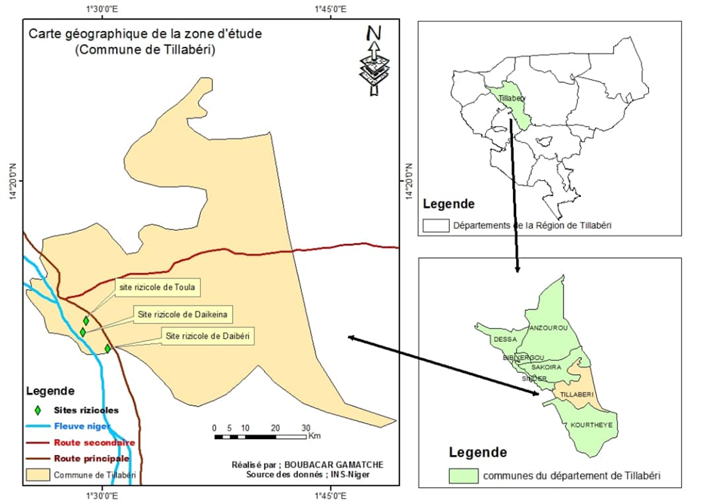
Fig. 1. Study area map (Municipality of Tillabéri)

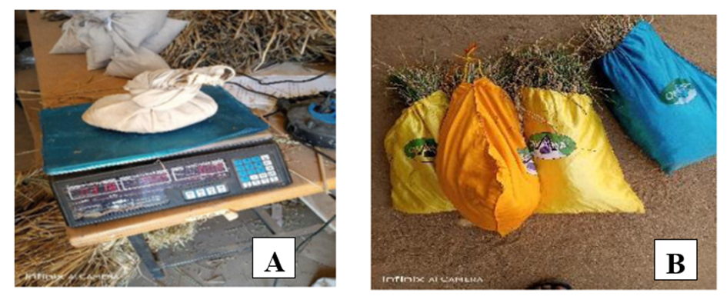
Fig. 2 : Other equipment used
A: Electronic scale; B: Packaging bags

2.3. Methodology

2.3.1. Identification of the most harmful rice weeds

Surveys were conducted in the study area to first collect and inventory the major rice weeds. Then, the most harmful weeds were identified and named using the Book «24-Weeds of Rice in West Africa» (Rodenburg and Johnson, 2009). A survey of farmers was used to list the weeds most detrimental to rice.

2.3.2. Experimental setup, fertilization, and trial maintenance

The study was conducted during the 2023 dry season, which is the least favorable season for weed growth. The experimental design of the trial was a single-factor randomized block design (Effects of weeds on rice growth and yield parameters), with 4 replicates (4 plots). A total of 4 farmer plots were selected for the trials, with each plot serving as a replicate. The basic plot area is 4 m², or (1 m x 1 m) × 4. There are two control plots (T1 and T2) and two experimental plots (E1 and E2). Each plot was planted with two 21-week-old seedlings per hole. The aisles between the blocks are 3 m wide, and those separating the plots are 2 m wide; T1 and T2 are control plots that received manual and chemical weeding (using Londax), and E1 and E2 are experimental plots that received no weeding. Yield squares were randomly placed within each farmer’s plot.
All plots were plowed, harrowed, leveled and irrigated under the same conditions to minimize potential variability. They were then fertilized by applying N-P-K fertilizer and urea in two applications, in accordance with the fertilizer rates recommended by research. Thus, for an area of (1 m × 1 m) × 4, a quantity of 0.02–0.04 kg/m² is required for NPK and urea, respectively. These quantities were subsequently adjusted to the area of the plots in the experimental design.

2.3.3. Determination of the effects of weeds on rice growth and yield parameters
Observations focused, on the one hand, on the number of tillers per hill and plant height, and on the other hand, on the number of panicles per hill, the number of fertile grains per panicle and the average grain yield from the production of yield squares.

2.3.3.1. Determination of the effects of weeds on rice growth parameters

Plant height was measured when 90% of the plants were between end of tillering and beginning of grain maturity. Measurements were taken in centimeters, from the base of the plant to the tip of the leaf or the highest panicle. Thus, the heights of plants from five (5) randomly chosen hills were measured in the experimental plots (E1 and E2) and the controls (T1 and T2). The average height per treatment was obtained by calculating the mean of the measurements from the five (5) random hills.
The number of tillers per clump was counted manually on five (5) clumps randomly selected from each sub-plot of the study at the end of tillering. The average number of tillers per treatment was obtained by calculating the mean of the numbers obtained from the 5 clumps. The number of panicles per clump was determined by manually counting the panicles on the tillers of five (5) randomly chosen clumps. Then, the number of fertile and sterile tillers was recorded. Finally, the average number of panicles was determined by calculating the mean of the values obtained from the five (5) clumps of each treatment.

2.3.3.2. Determination of the effects of weeds on rice yield parameters

The number of full and empty grains per panicle was counted manually at 50% maturity on 5 panicles randomly selected from 5 plots. The average number of fertile (full) and infertile (empty) grains was obtained by averaging the values from the 5 panicles.
The paddy yield was assessed in each of the yield plots at 85-90% maturity. It involved harvesting, drying, threshing the collected panicles, then winnowing and weighing the paddy obtained from the average harvests of the control and experimental plots, using an electronic scale with a capacity of 15 kg ± 0.2 g.
The percentage (%) of yield reduction and those of other parameters (height, number of tillers, number of fertile and infertile grains) under the effect of weeds were calculated using the following formula:

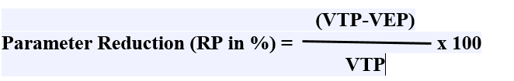
RP = Parameter Reduction; Parameter P = growth or yield parameter = height, number of tillers, number of fertile grains, number of infertile grains, and yield VT = control treatment value; VEP = experimental treatment value.

2.3.4. Data analysis

The data were collected manually in the field using a notebook. Microsoft Office 2016 Excel spreadsheet was used for entering the collected data and creating tables and graphs, and XLSTAT 2024.4.0.1424 software was used for statistical analyses (analysis of variance or ANOVA, Pearson correlation matrix at a 5% threshold, Biplot / Principal Component Analysis, Biplot-PCA).
The variations between control (weeded) and experimental (unweeded) plots were used to: (i) determine the effect of weeds on growth parameters, (ii) assess the effect of weeds on yield characteristics, and (iii) measure the reduction in rice yield due to these weeds. The average values of growth and yield parameters from the control and experimental treatments obtained allowed for the evaluation of the effects of these weeds.
The ANOVA was conducted on a single factor: the effect of weeds on growth parameters (plant height and number of tillers per hill) and yield characteristics (number of panicles, number of fertile grains, number of infertile grains, and grain yield) of rice.
The Pearson correlation matrix at the 5% significance level establishes relationships between variables related to treatment pairs. The Biplot-ACP plots the studied parameters along correlation axes and describes their relationships.

3. results and discussion

3.1. Results

3.1.1. Inventory of Major Rice Weeds

Eighty-two (82) weed samples were collected from the three rice-growing sites prospected. This includes 37 samples from Toula, 26 from Daikaina, and 19 collected in Daibéri (Table 1), comprising 45.12% Poaceae, 18.29% Cyperaceae, and 36.59% broadleaf weeds.
The identification of the collected weeds allowed for the inventory of 30 species across 12 families (Table 2). Among these families, eight (8) are predominant: Marsileaceae, Juncaceae, Lythraceae, Onagraceae, Cyperaceae, Sphenocleaceae, Asteraceae, and Poaceae. The most harmful species are mainly Marsilea quadrifolia, Juncus bufonius, Rotala indica, Ludwigia peploides, Cyperus difformis, Sphenoclea zeylanica, and Echinochloa crus-galli (Fig. 3).

Table 1. Inventory of weed samples from rice collected in the study area

S/N | Family | Sites | Ecology | Total samples | Proportion (%)
1 | Poaceae /Gramineae | Toula (15)  Daikaina (12)  Daibéri (10) | Irrigated rice fields and surroundings | 37 | 45,12
2 | Cyperaceae | Toula (7)  Daikaina (4)  Daibéri (4) | Irrigated rice fields and surroundings | 15 | 18,29
3 | Broadleaf weeds: Marsileaceae, Juncacceae, Lythraceae, Onagraceae, Sphenocleaceae, Asteracea, Convulvulacea Euphorbiaceae, Sphenocleaceae, Nymphaeceae | Toula (15)  Daikaina (10)  Daibéri (5) | Irrigated rice fields and surroundings | 30 | 36,59

Table 2. Number, families, and species of rice weeds identified

S/N | Family | Weed species | Site/species | Total species
1 | Poaceae /Gramineae | Echinochloa crus-galli, Cynodon dactylon, Eleusine indica, Glyceria declinata, Glyceria Maxima, Leersia hexandra, Leersia Oryzoides, Oryza barthii, Panicum repens L, Paspalum digitatum, Paspalum distichum, Paspalum scorbiculatum var., Cenchrus clandestinus, Setaria viridis | Toula (7)  Daikaina (4)  Daibéri (3) | 14
2 | Cyperaceae | Cyperus difformis, Cyperus eragrostis, Cyperus esculentus, Cyperus iria, Cyperus rotondus, Pycreus macrostachyos Lam, Pycreus lanceolatus, | Toula (3)  Daikaina (2)  Daibéri (2) | 7
3 | Broadleaf weeds : Marsileaceae, Juncacceae, Lythraceae, Onagraceae, Sphenocleaceae, Asteracea, Convulvulacea Euphorbiaceae, Sphenocleaceae, Nymphaeceae | Marsilea quadrifolia, Marsilea minuta, Juncus bufonius, Rotala Indica, Ludwigia pepploides, Sphenoclea zeylanica, Convulvulus arvensis, Nymphaea tetragona, Euphorbia hirta L. | Toula (5)  Daikaina (2)  Daibéri (2) | 9
Total |  |  |  | 30
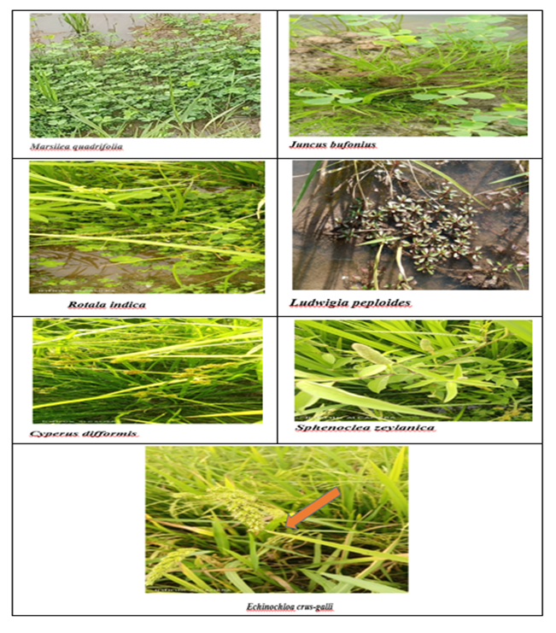

Fig. 3. The most harmful weed species for rice

3.1.2. Effect of weeds on rice growth parameters

The study focused on two growth parameters: the number of tillers and the average height of rice plants per treatment (control and experimental).
3.1.2.1. Interaction between treatments and growth parameters

The result of the analysis of variance (ANOVA) regarding the effect of weeds on plant height and the number of tillers per hill and per treatment is shown in Table 3, while Table 4 provides the Pearson correlation matrix for the interaction between the two (2) growth variables.

Table 3: ANOVA on the effect of weeds on growth parameters and their interaction

Contraste | Plant height | Number of tillers
Control 2 vs Experimental 2 | 36,600*** | 22,300***
Control 2 vs Experimental 1 | 34,700*** | 27,850***
Control 2 vs Control 1 | 1,250ns | 1,000ns
Control 1 vs Experimental 2 | 35,350*** | 26,850***
Control 1 vs Experimental 1 | 33,450*** | 21,300***
Experimental 1 vs Experimental 2 | 1,900ns | 5,550ns
Fisher test (LSD 5%) | 11,29 | 12,859

Table 4: Pearson correlation matrix (n) for growth and yield parameters
Variables | Number of tillers | Number of panicles | Sterile grains | Fertile grains | Yield (t/ha) | Plant height
Number of tillers | 1
Number of panicles | 0,991 | 1
Sterile grains | -0,970 | -0,962 | 1
Fertile grains | 0,975 | 0,993 | -0,973 | 1
Yield (t/ha) | 0,970 | 0,994 | -0,942 | 0,993 | 1
Plant height | 0,993 | 0,996 | -0,983 | 0,994 | 0,985 | 1
Values in bold are different from 0 at a significance level of alpha=0.05.

The analysis of Table 3 shows a significant difference (LSD 5%) in height and the number of tillers between control and experimental treatments. However, there is no significant difference in these growth parameters between the controls themselves or between the experimental treatments.
The analysis of Table 4 reveals a positive correlation between the average number of tillers per hill and the average plant height. The correlation is also positive between these two growth parameters and the number of panicles, the number of fertile grains, and grain yield (t/ha). However, the correlation is negative between the number of sterile grains and the two growth parameters.

3.1.2.2. Effect of weeds on plant height and the number of tillers

Fig. 4 below shows the average number of tillers per hill and the average height of rice plants in the control and experimental plots.

Fig. 4. Average number of tillers per hill and average height of rice plants in the control and experimental plots.
T1 and T2: controls, which received manual and chemical weeding; E1 and E2: experimental plots that did not receive any weeding.

Data analysis on the number of tillers per hill in Figure 3 shows that the experimental plots E2 and E1 had the lowest average number of tillers, with 16 and 22 tillers respectively, compared to 43 and 44 tillers in the control plots T1 and T2, corresponding to an average reduction of 21 to 28 tillers from the control treatments to the experimental ones.
Height data analysis in the same figure also shows that the average height of rice plants in the experimental treatments is lower than that of the controls. Thus, the average height ranges from 72.90 to 74.15 cm in the control treatments (T1 and T2) and from 37.55 to 39.45 cm for the experimental plots (E1 and E2), representing an average height reduction of about 34.7 to 36.60 cm from the control to the experimental treatments.

3.1.3. Effect of weeds on yield characteristics and their interaction

Four (4) yield parameters were evaluated. These are the number of panicles, fertile and infertile tillers per hill, and grain yield (t/ha) per treatment (control and experimental).

3.1.3.1. Interaction between treatments and yield characteristics

The result of the analysis of variance (ANOVA) regarding the effect of weeds on rice yield characteristics is shown in Table 5.

Table 5: ANOVA on the effect of weeds on yield parameters and their interaction

Contraste | Number of Panicles | Infertile Grains | Fertile Grains | Grains yield (Kg/m2) | Grains yield (t/ha)
Control 2 vs Experimental 2 | 28,650*** | 23,750*** | 45,750*** | 0,878*** | 5,250ns
Control 2 vs Experimental 1 | 26,800*** | 24,000*** | 49,750*** | 0,886*** | 5,458ns
Control 2 vs Control 1 | 4,200ns | 6,000ns | 4,500ns | 0,497ns | 1,258ns
Control 1 vs Experimental 2 | 24,450*** | 29,750*** | 41,250*** | 0,907*** | 3,992ns
Control 1 vs Experimental 1 | 22,600*** | 30,000*** | 45,250*** | 0,915*** | 4,200ns
Experimental 1 vs Experimental 2 | 1,85ns | 0,250ns | 4,000ns | 0,408ns | 0,208ns
Fisher test (LSD 5%) | 8,648 | 12,133 | 10,233 | 0,514 | 5,677

3.1.3.2. Effect of weeds on yield characteristics
The Fig. 5 (below) shows the average number of panicles, infertile grains, fertile grains and grains yield of rice plants (kg/m2 et t/ha) in the control and experimental plots.

Fig. 5: Average number of panicles, infertile grains, fertile grains and grains yield of rice plants (kg/m2 et t/ha) in the control and experimental plots.

The figure 5 shows that all yield characteristics, except for the average number of infertile tillers, are low in the experimental treatments and high in the control ones. In fact, in the experimental treatments (E1 and E2), the average numbers of panicles, fertile tillers per clump, and average grain yield range from 13-14, 30-34 and 5.65-5.86 t/ha to 37-41, 75-80, and 9.85-11.11 t/ha in the controls (T1 and T2), representing a potential reduction of approximately 23 to 28 panicles, 41 to 50 fertile grains, and 4.14 to 5.35 t/ha from the control treatments to the experimental treatments. However, more infertile grains were counted in the experimental plots than in the control ones. The number of infertile grains increased from 27-33 in the control (T1 and T2) to 57-58 in the experimental plots (E1 and E2), representing an increase of 25 to 31 infertile grains from the control plots to the experimental.

3.1.4. Biplot of parameters evaluated in PCA

The biplot of parameters evaluated in PCA (Fig. 6) summarizes the relationships between variables and observations (treatments) on the first two components (axes F1 and F2: 99.51%).

Fig. 6. Biplot-ACP of measured parameters

This figure shows that axis F1 is almost the sole source of variation, and the variables are strongly and positively correlated with each other and with axis F1 (98.40%). Indeed, the biplot shows a positive correlation between the two (2) growth parameters (plant height and tillers number per clump). This correlation is also positive between yield characteristics (number of panicles, number of fertile grains, and grain yield in t/ha). On the other hand, the correlation is negative between the number of infertile grains and all other yield characteristics, and between infertile grains and the two growth parameters.

3.1.5. Reduction rates for growth parameters and yield due to weeds

Table 5 shows the reduction rates for growth parameters and yield related to weeds.

Parameters | Treatments (Control T and Experimental E) |  |  |  | ValueTreatments |  | Difference between T and E | Weed-induced yield reduction (%)
Parameters | T1 | T2 | E1 | E2 | VTP | VEP | VTP-VEP | See Formula (section 2.2.2)
Nuumber of tillers | 43 | 44 | 22 | 16 | 43,5 | 19 | 24,5 | 56,32
Plants high (cm) | 72,9 | 74,15 | 39 | 38 | 73,52 | 38,5 | 35,025 | 47,64
Nmber of Panicules | 37 | 41 | 14 | 13 | 39 | 13,5 | 25,5 | 65,38
Number of infertiles grains | 27 | 33 | 58 | 57 | 30 | 57,5 | -27,5 | -91,67**
Number of fertiles grains | 75 | 80 | 30 | 34 | 77,5 | 32 | 45,5 | 58,71
Average of grains yield (t/ha) | 9,85 | 11,11 | 5,65 | 5,86 | 10,48 | 5,75 | 4,72 | 45,09
RP = Parameter Reduction; Parameter P = growth or yield parameter = height, number of tillers, number of fertile grains, number of infertile grains, and yield VT = control treatment value; VEP = experimental treatment value.
**Here, there is instead an increase in the number of infertile grains in the experimental plots (47.82%).

Analysis of Table 5 indicates that the rates of reduction in growth parameters and yield due to weeds are high between control and experimental plots, for all parameters, except the number of infertile grains. Thus, the number of tillers, plant height, number of panicles, number of fertile grains, and grain yield are 56.32%, 47.64%, 65.38%, 58.71%, and 45.09%, respectively. However, the number of infertile grains is higher in the experimental plots than in the control plots, resulting in an increase in the number of infertile grains in the experimental plots (47.82%).

3.2. Discussion

The results of this study show that weeds are a major constraint to the development of rice cultivation in Niger. They compete with cultivated rice for nutrients and are reservoirs of pathogens and crop pests.
The weeds identified in the study area include 30 species belonging to 12 families. These are characterized by the predominance of one family of Poaceae (45.12%), one of Cyperaceae (18.29%) and six families of broad-leaved weeds (Marsileaceae, Juncaceae, Lythraceae, Onagraceae, Sphenocleaceae, and Asteracea) representing 36.59% of the samples collected, suggesting the predominance of Poaceae over other families. These results differ from those of Issaka et al. (2025), who reported the presence of 37.34% Poaceae, 13. 33% Cyperaceae, and 49.33% broadleaf weeds in two of our sites (Toula and Daikaina), extended to the sites of Diambala and Namari-Goungou; results suggesting the predominance of broadleaf weeds in the study area. Our results also differ from those of the study by Mballo (2018) on the weed flora of irrigated rice in four experimental sites in the Senegal River valley, which identified 55 species in 22 families.
The results of the farmer survey on the nature of weeds revealed that the most harmful species are Marsilea quadrifolia, Juncus bufonius, Rotala Indica, Ludwigia pepploides, Cyperus difformis, Sphenoclea zeylanica, and Echinochloa crus-galli. The species Rotala indica, Cyperus spp., and Echinochloa spp. have already been identified as widespread in certain rice fields in Niger and as very harmful to rice cultivation (Issaka et al., 2025).
Ludwigia pepploides is a real limiting factor for rice cultivation. It is a weed that prefers very light environments, produces allopathic substances that inhibit the germination of other plants, and has a high capacity to adapt to the nutrients available in the water. These results are comparable to those obtained by Flora (2020), who reported that Ludwigia pepploides, thanks to the rapid growth of its long rhizomes and its great ability to adapt to water quality, strongly competes with cultivated rice by: (i) reducing water quality and dissolved oxygen concentration, (ii) slowing down the flow of irrigation channels by forming dams and various deposits, and (iii) gradually suffocating crops through the decomposition in winter of the significant biomass produced, and (iv) forming a dense, almost impenetrable weed bed both on the surface and at depth that completely covers the channels and drains.
Cyperus difformis is a major weed in rice fields; it prefers rich, fertile soils but can also grow in poor sandy soils. It forms a dense, compact mat in young rice plantations and competes with the rice for nutrients, water, and light (Issaka et al., 2012; ).
Echinochloa crus-galli is an invasive plant in rice fields that reduces crop yields by absorbing up to 80% of the nitrogen available in the soil and serves as a reservoir host for the rice yellow mottle virus (Issaka et al., 2021) and several other plant viruses. Similar results have shown that in dense stands, this species alone can remove 60 to 80% of the available nitrogen from the soil. This species can significantly reduce rice yields due to its highly invasive nature and high nutrient requirements (Issaka et al.,, 2012).
Statistical analyses performed on the various parameters studied show a significant difference (Fisher's test at the 5% significance level), on the one hand, in the height and number of tillers per plant/hole between the control (weeded) and experimental (unweeded) treatments, and on the other hand, in the number of panicles, fertile and infertile grains, and yield (kg/m²) between the same treatments. This suggests that weeds have a significant effect on height, number of tillers, number of fertile grains, number of infertile grains, and yield (kg/m²). However, the difference in terms of yield (t/ha) between the control and experimental treatments is not significant, indicating that weeds have no significant effect on grain yield. Thus, the results relating to rice growth and yield parameters show that the experimental plots recorded an average reduction of 21 to 28 tillers, 34.7 to 36.60 cm in height, 23 to 28 panicles, 41 to 50 fertile grains, and 4.14 to 5.35 t/ha, compared to the control treatments. A high proportion of infertile panicles was also observed in the experimental plots. This suggests that the parameters number of tillers per clump, plant height, number of panicles, number of fertile grains, and grain yield are all low in the experimental plots, under the effect of weeds, with, however, a large number of infertile grains.
These results indicate that the effect of weeds very damageable for rice produuction ; it is characterized, on the one hand, by a significant reduction in plant height, number of tillers, number of panicles, number of fertile grains, and yield (t/ha), and on the other hand, by a significant increase in the number of infertile grains; with reductions in number of tillers, plant height, number of panicles, number of fertile grains, and grain yield (t/ha) of 56.32%, 47.64%, 65.38%, 58.71%, and 45.09%, respectively, compared to the values recorded in the control plots. However, the number of infertile grains is higher in the experimental plots than in the control plots (48.82%)
Our results suggest that the effect of weeds is characterized by a decrease in height, which is also reflected in a reduction in the number of tillers, panicles, fertile grains, and grain yield in the experimental plots compared to the controls. However, the effect causes a sharp increase in the number of infertile grains in the experimental treatments compared to the controls. The reduction in plant height was attributed to the presence of weeds, which compete with rice for water, nutrients, sunlight, and space, thereby causing poor rice growth (Johnson, 1997). Our results are consistent with those of Uprety (2005), who reported in India and South Asia that early weeding improves the production of primary tillers, which ultimately produce numerous grain-laden panicles and yield high yields. Low panicle production in the experimental plots could be explained by competition with weeds. Regarding the number of fertile and sterile panicles, it appears that the control treatments recorded more fertile grains per cluster (78 fertile grains), while the experimental plots yielded more sterile grains (58 infertile grains) per cluster. In addition, the treatments that received weeding yielded the highest yield (10.58 t/ha), and the experimental plots (unweeded) recorded the lowest yield (5.75 t/ha). This is due to increased competition from weeds. Finally, the variability in plots results can be explained by the stark contrast between weeding and grassing conditions, rather than by internal differences within the control and experimental treatment groups.

CONCLUSION

Thirty (30) weed species, belonging to 12 families, were identified. Six (6) of these species were identified as highly harmful to rice. These are Marsilea quadrifolia, Juncus bufonius, Rotala Indica, Ludwigia pepploides, Cyperus difformis, Sphenoclea zeylanica, and Echinochloa crus-galli. Their effect on growth and yield parameters has been described and discussed; this effect is mainly expressed in the form of competition for nutrients, water resources, light, and space with rice.
The identified weed species affect significantly rice plant height (47.64%), number of tillers (56.32%), number of panicles per tiller (65.38%), number of fertile grains(58.71%)), and grain yield in paddy(45.09)). However, the effect of weeds is characterized by a sharp increase in the number of infertile grains in the experimental plots that were not weeded. The harmful effects of these weeds obtained during a dry season need to be confirmed during the rainy season, which is the period most conducive to weeds growth. The results obtained would then be incorporated into all technical guidelines and/or development plans for sustainable rice cultivation, both within the study area and beyond.

Disclaimer (Artificial intelligence)

Author(s) hereby declare that NO generative AI technologies such as Large Language Models (ChatGPT, COPILOT, etc.) and text-to-image generators have been used during the writing or editing of this manuscript.

References
FAO. 2011. The lurking menace of weeds. In: Food and Agriculture Organization of the United Nations. http://www.fao.org/news/story/0/item/29402/icode/en/.
Fall A. A., and Dieye P. N. (2008). Rice Farming Trends in Africa 2007 (5th Edition), WARDA. http://www.wadra.org.
Issaka S., Basso A., Sorho F., Onasanya A., Haougui A., Sido A.Y., Aké S., Fargette D., and Séré Y. 2012. Diagnosis and Importance of Rice Yellow Mottle Disease Epidemics in the Republic of Niger. Journal of Applied Biosciences 50: 3501–3511. ISSN 1997–5902.
Issaka S. 2013. Rice Yellow Mottle: Epidemiology, Distribution, Pathogenesis, and Diversity of RYMV (Rice Yellow Mottle Virus) in Niger. Doctoral Thesis in Agrophysiology, Félix Houphouët-Boigny University of Abidjan, Côte d’Ivoire, 156 pages.
Issaka S., Mariama A.M.S., and Adamou B. 2021. Rice Yellow Mottle Epidemic: A Major Biotic Constraint to Rice Production in the Irrigated Schemes of Niger. Int. J. Biol. Chem. Sci. 15(5): 1824–1841.
Issaka S., Habibou B. G., Seyni B. Z., and Illiassou B. (2025). Potential weed host-reservoirs of Rice Yellow Mottle Virus in irrigated rice fields of Niger. World Journal of Advanced Research and Reviews 27(01), 2349-2359. Doi : https:// doi.org/ 10.30574/ wjarr.2025.27.1.2723
Info Flora (2020): National Data and Information Centre on the Flora of Switzerland—*Ludwigia peploides*: Invasive Neophytes. https://www.infoflora.ch/fr/neophytes.html. 7 pages.
Johnson (1997). Weeds in rice cultivation in West Africa. WARDA (ADRAO), Imprint Design, United Kingdom, 312 p.
Malam Harouna Saâ, Guiella Narh, and Fodi Adamou (2017). Study on the experience of agricultural advisory services in new irrigation schemes (Kandadji, Famalé, and Gabou) and older ones (Namardé Goungou and Konni) in Niger. Final report of the study commissioned by ONAHA to CESAF Consult, conducted from June to August 2016. 71 pages.
Oludare, A., Tossou, H.T., Kini, K. and Silué, D. 2016.Diversity of Rice yellow mottle virus in Benin and Togo and Screening for Resistant Accessions. J. Phytopathol. 164 (11-12): 924 935. doi: 10.1111/jph.12512
Popp J., Petõ K., and Nagy J. 2012. Pesticide productivity and food security. Agronomy for Sustainable Development,33 (1), pp. 243–255. DOI: 10.1007/s13593-012-0105-x
Mballo R. 2018. Characterization of the weed flora in irrigated rice at four experimental sites in the Senegal River Valley.
Rodenburg J., and Johnson D.E. 2009. Weed management in rice-based cropping systems in Africa. Advances in Agronomy 103: 149–218. 14 pages. DOI: 10.1016/S0065-2113(09)03004-1
Sido Y. Amir. 2010. State of play of rice cultivation: The case of Niger. Report. 56 pages.
Uprety R. 2005. System of Rice Intensification (SRI) Performance in Morang district during: (http://www.ciifad.cornell.edu/sri/countries/Neppardy05.

