OPTIMIZATION OF SECONDARY HARDENING TECHNIQUES FOR EMBRYO RESCUED INTERSPECIFIC CROSSES IN CHILLI (Capsicum annuum L.)

Abstract
Secondary hardening plays a crucial role in acclimatizing tissue-cultured plantlets to natural environmental conditions by gradually exposing them to variations in humidity, light, and temperature. Therefore, the present study aims to optimize secondary hardening conditions by evaluating different substrate compositions, humidity regimes, and light intensities. A laboratory experiment was conducted at the Department of Horticulture, College of Agriculture, UAS, Raichur, during 2023–2024. The study was laid out in a Completely Randomized Design (CRD) with seven treatments : T₁: Cocopeat, T₂: Vermiculite, T₃: Vermicompost, T₄: Cocopeat: Vermiculite (1:1), T₅: Cocopeat: Vermicompost (1:1), T₆: Vermiculite: Vermicompost (1:1), and T₇: Cocopeat: Vermiculite: Vermicompost (1:1:1) to evaluate suitable secondary hardening media for 30-day-old embryo-rescued plantlets derived from the cross UARChH 42 (Capsicum annuum) × PBC 80 (Capsicum baccatum).Among the treatments, cocopeat (T₁) recorded significantly superior performance with maximum shoot length (11.41 cm), root length (13.18 cm), and higher chlorophyll content, leaf number, and biomass accumulation, along with the highest survivability (>90%). It also showed a 47.15% increase in shoot growth over other treatments. In contrast, vermicompost alone (T₃) resulted in complete mortality of plantlets. The findings indicate that cocopeat is an ideal medium for secondary hardening of embryo-rescued chilli plantlets. The standardized protocol developed can enhance plantlet survival and establishment, thereby supporting interspecific breeding programs and facilitating future research on large-scale propagation and development of stress-resilient chilli hybrids.
Key Words: Secondary hardening, embryo rescued interspecific plantlets, soilless media, standardized protocol
1.Introduction
Chilli (Capsicum annuum L.), commonly known as hot pepper, is an important vegetable and spice crop belonging to the family Solanaceae, which also includes economically significant crops such as potato, tomato, and eggplant (Knapp, 2002). The genus Capsicum comprises approximately 27 species, of which five are domesticated and the remaining are semi-domesticated or wild (Costa et al., 2006). Among these, Capsicum annuum is the most widely cultivated species globally.
Capsicum annuum, with an estimated genome size of 3.48 Gb, is cultivated over approximately 1.5 million hectares worldwide, with an annual production of around 7 million tonnes. The crop is valued not only for its culinary uses but also for its rich nutritional profile, particularly its high content of vitamin A and β-carotene in dried red chillies (Pundir et al., 2016).
Exploitation of genetic variability through the incorporation of resistance genes from wild relatives into cultivated varieties offers significant potential for improving disease resistance, reducing pesticide usage, lowering production costs, and minimizing environmental and health risks. However, interspecific hybridization in chilli is often constrained by cross-incompatibility barriers (Pickersgill, 1997), limiting the effective utilization of wild genetic resources.
Embryo rescue has emerged as a vital biotechnological tool to overcome such hybridization barriers, facilitating the development of viable interspecific hybrids with desirable traits such as disease resistance and abiotic stress tolerance. Nevertheless, the success of embryo rescue largely depends on efficient acclimatization of regenerated plantlets. The fragile nature of in vitro-derived embryos necessitates optimization of hardening protocols to ensure their survival and establishment under ex vitro conditions (Pramanik 2021, Bebbeli 2008).
Secondary hardening plays a crucial role in acclimatizing tissue-cultured plantlets to natural environmental conditions by gradually exposing them to variations in humidity, light, and temperature. Therefore, the present study aims to optimize secondary hardening conditions by evaluating different substrate compositions, humidity regimes, and light intensities. The ultimate goal is to develop a standardized protocol that minimizes plantlet mortality and enhances growth performance, thereby strengthening chilli breeding programs and contributing to the development of resilient, high-performing varieties.
2. Material and Methods:
The method of embryo rescue for interspecific hybridization was used as per the method given by Yoon et al. (2006). The other references (Bhattarai et al., 2009 and Walter et al., 2018) were utilized for further optimize the protocol. Interspecific cross between F₁ hybrid belongs to Capsicum annuum UARChH 42 and PBC 80 genotype belongs to Capsicum bacccatum were made. All the required plant protection measures were taken from time to time to maintain the healthy and optimum plant growth conditions were utilized for crossing and further rescuing embryo and placed in MS media containing glass jars and they were raised in Tissue-Culture Laboratory. The experiment was conducted under well-defined conditions of the culture room maintained at 25°-26°C. Uniform light (cal 1000 lux) provided by fluorescent tubes (7200°K) over a light/dark cycles of 16/8 hour.
Seven treatments and three replications by using different soilless medias like cocopeat, vermicompost and vermiculite and different compositions were taken i.e., T₁: Cocopeat, T₂: Vermiculite, T₃: Vermicompost, T₄: Cocopeat: Vermiculite (1:1), T₅: Cocopeat: Vermicompost (1:1), T₆: Vermiculite: Vermicompost (1 :1), T₇: Cocopeat: Vermiculite: Vermicompost (1:1:1). All the mentioned medias are represented in plate 2 (a).
The embryo rescued interspecific plantlets were hardened in above mentioned medias for 30 days. After transplanting, observations like shoot length, root length, per cent increase in root length, chlorophyll content, number of leaves, per cent of new leaves formation, seedling biomass, per cent increase in plantlet biomass, Survivability percentage was recorded at every 10th, 20th and 30th days after transplanting.
Per cent increase in shoot length (%)
Per cent increase in shoot length were calculated using plantlet shoot at initial day and before transplanting to pot.
Per cent  increase | = | Length at final day − Length at first day | × 100
Per cent  increase | = | Length at first day | × 100
Per cent increase in root length (%)
Per cent increase in root length were calculated using plantlet root at initial day and before transplanting to pot.
Per cent  increase | = | Length at final day − Length at first day | × 100
Per cent  increase | = | Length at first day | × 100

Per cent of new leaves formation (%)
Per cent of new leaves formation was recorded using below given formula for every 10th day upto 30th day.
Per cent  increase | = | New leaves formed after transplanting to media | × 100
 |  | Total number of leaves | × 100

Per cent increase in plantlet biomass (%)
Per cent increase in plantlet biomass were calculated using plantlet weight at intial day and before transplanting to pot.
Per cent  increase | = | Seedling biomass at final day − Seedling biomass at first day | × 100
Per cent  increase | = | Seedling biomass at first day | × 100
3.3.1.10 Survivability percentage (%)
Before transferring of plantlet to pot, number of plantlets that survived were counted and survivability percentage was calculated by using following formula
Survivability percentage = | Number of plantlets survived | × 100
Survivability percentage = | Total number plantlet transplanted | × 100

3. Result and Discussion
3.1 Shoot length (cm)
On the tenth day, vermiculite (T₄) and cocopeat (T₁) showed similar shoot lengths (7.95 cm and 7.39 cm, respectively), with cocopeat (T₁) displaying the longest shoot (9.15 cm). Among the plantlets that survived, cocopeat: vermiculite: vermicompost (T₆) had the shortest shoot length (1.23 cm). On the twentieth day, cocopeat (T₁) once more displayed the longest shoot length (10.82 cm), with T₄ and T₂ coming in second and third, respectively, with 9.02 and 8.18 cm. The lowest T₆ was still 1.53 cm. After 30 days, T₁ (cocopeat) continued to have the longest shoots at 11.42 cm, followed by T₄ (9.65 cm) and T₆ (1.83 cm).
Cocopeat provides a well-aerated, moisture-retaining environment conducive to root development, enhancing nutrient uptake and hydration. Vermiculite's structure supports water retention and aeration, promoting optimal root growth and nutrient absorption. The balanced physical properties of the cocopeat and vermiculite mix likely foster healthy shoot development, resulting in robust growth. These findings align with research on chilli by Uttekar et al. (2021), and studies on other crops by Nazki (2014) and Gowtam (2023).

3.2 Per cent increase in shoot length (%)
As demonstrated in Table 1 the plantlets placed at different hardening media was found significant difference in per cent increase in shoot length. The plantlets placed in cocopeat (T₁) showed highest percentage increase in shoot length (47.15 %) and it was on par with the cocopeat: vermiculite (T₄) and vermiculite (T₂) with the percentages of (40.51 %) and (38.86 %). There was no increase in shoot length percentage in vermicompost (T₃). The lowest percentage increase in shoot length was observed in cocopeat: vermiculite: vermicompost (T₆). With the increase in percentage of (0.29 %).
This can be attributed to the varying physical and chemical properties of the media and their effects on plant growth. Cocopeat, cocopeat: vermiculite, and vermiculite likely provided favourable conditions for shoot elongation due to their ability to retain moisture, aerate the root zone, and promote nutrient availability. These media may have facilitated optimal root development, leading to enhanced water and nutrient uptake, which in turn promoted shoot growth. These findings are in line with studies on chilli by Uttekar et al. (2021) and in other crops by Nazki (2014) and Gowtam (2023).
Table 1. Effect of different hardening media on shoot length and per cent increase in shoot length for embryo rescued interspecific F1 hybrid of chilli plantlets
Treatment | Shoot length (cm) |  |  | Per cent increase in shoot length
Treatment | Day 10 | Day 20 | Day 30 | Per cent increase in shoot length
T₁ | 9.15 | 10.82 | 11.41 | 47.15
T₂ | 7.39 | 8.18 | 8.69 | 38.86
T₃ | 0.00 | 0.00 | 0.00 | 0.00
T₄ | 7.95 | 9.02 | 9.65 | 40.51
T₅ | 3.11 | 1.95 | 2.02 | 1.41
T₆ | 1.23 | 1.53 | 1.83 | 0.29
T₇ | 3.23 | 3.25 | 4.55 | 18.55
Mean | 4.58 | 4.96 | 5.57 | 20.97
S.Em ± | 0.52 | 0.59 | 0.66 | 2.63
CD (0.01) | 2.07 | 2.36 | 2.03 | 10.56

T₁: Cocopeat
T₂: Vermiculite
T₃: Vermicompost
T₄: Cocopeat: Vermiculite (1:1)
T₅: Cocopeat: Vermicompost (1:1)
T₆: Vermiculite: Vermicompost (1:1)
T₇: Cocopeat: Vermiculite: Vermicompost (1:1:1)

3.3 Chlorophyll content (SPAD)
On 10th day, when compared to all other treatments, cocopeat (T₁) showed highest chlorophyll content (35.70) which was on par with cocopeat: vermiculite (T₄) and vermiculite (T₂) which showed chlorophyll content of 32.22 and 30.90, respectively. However, among the treatments in which plantlets survived lowest chlorophyll content (16.60) was observed in cocopeat: vermiculite: vermicompost (T₆).
On 20th day, when compared to all other treatments, cocopeat (T₁) showed highest chlorophyll content (38.40) which was on par with cocopeat: vermiculite (T₄) which showed chlorophyll content reading of 34.81. However, among the treatments in which plantlets survived lowest chlorophyll content (7.49) was observed in cocopeat: vermiculite: vermicompost (T₆).
On 30th day, when compared to all other treatments, cocopeat (T₁) showed highest chlorophyll content (41.80) which was on par with cocopeat: vermiculite (T₄) which showed chlorophyll content of 37.97. However, among the treatments in which plantlets survived lowest chlorophyll content (8.30) was observed in cocopeat: vermiculite: vermicompost (T₆).
The differences in chlorophyll content among treatments are likely due to variations in nutrient availability and soil conditions provided by different growth media. Cocopeat and cocopeat: vermiculite likely offered better nutrient retention and availability, promoting chlorophyll synthesis and photosynthetic activity, resulting in higher chlorophyll content. Therefore, selecting appropriate growth media is crucial for ensuring optimal nutrient availability and supporting healthy plant growth. These findings are in line with studies on chilli by Uttekar et al. (2021) and in other crops by Nazki (2014) and Gowtam (2023).
3.4 Root length (cm)
Root length is critical for plant life, and superior root growth makes the plant to acclimatise easily in field conditions and absorbs the water and nutrients easily. There was a significant difference in root length between the plantlets under different media, as evidenced by data in Table 2. Among different treatments, cocopeat (T₁) exhibited the highest root length (13.18 cm), which was on par with cocopeat: vermiculite (T₄) and vermiculite (T₂) with a root length of 11.83 cm and 11.07 cm, respectively. However, no survivability was observed in vermicompost (T₃). The lowest root length (2.26 cm) among the treatments in which root length was observed in cocopeat: vermiculite: vermicompost (T₆).
Cocopeat ensures effective nutrient uptake and hydration by providing an environment that is well-aerated and moisture-retaining for root development. Because of its special composition, vermiculite retains more water and allows for better aeration, which supports healthy root development and nutrient absorption. Furthermore, the balanced physical characteristics of the combination media probably encourage strong growth and elongation as well as healthy shoot development. Vermiculite and cocopeat work together to generate a perfect growing environment that encourages rapid branch growth in chili plantlets. These findings are consistent with studies by Uttekar et al. (2021) on chili, and Nazki (2014) and Gowtam (2023) on a variety of other crops.
3.5 Per cent increase in root length (%)
As demonstrated in Table 2 the plantlets placed at different hardening media was found significant difference in per cent increase in root length. The plantlets placed in cocopeat (T₁) showed highest percentage increase in root length (68.64 %) and it was on par with the cocopeat: vermiculite (T₄) with percentage increase in root length of (61.96 %) and it was followed by vermiculite (T₂) with percentage increase in root length of 48.81%. There was no increase in root length percentage in vermicompost (T₃). The lowest percentage increase in root length was observed in cocopeat: vermiculite: vermicompost (T₆) with the increase in percentage of (8.07 %).
Plantlets in various hardening media exhibit varying per cent increases in root length, which can be attributed to variances in their physical and chemical qualities. Cocopeat and cocopeat: vermiculite provides the right amount of moisture, oxygen, and nutrients to allow for root elongation, leading to significant percentage gains. These findings are in line with studies on chilli by Uttekar et al. (2021) and in other crops by Nazki (2014) and Gowtam (2023).

Table 2. Effect of different hardening media on chlorophyll content, root length and per cent increase in root length for embryo rescued interspecific F1 hybrid of chilli plantlets
Treatment | Chlorophyll content (SPAD) |  |  | Root length  (cm) | Per cent increase in root length
Treatment | Day 10 | Day 20 | Day 30 | Root length  (cm) | Per cent increase in root length
T₁ | 35.70 | 38.40 | 41.80 | 13.18 | 68.64
T₂ | 30.90 | 26.48 | 28.20 | 11.07 | 48.81
T₃ | 0.00 | 0.00 | 0.00 | 0.00 | 0.00
T₄ | 32.22 | 34.81 | 37.97 | 11.83 | 61.96
T₅ | 7.04 | 8.11 | 8.81 | 2.28 | 14.73
T₆ | 6.60 | 7.49 | 8.30 | 2.26 | 8.07
T₇ | 15.81 | 16.83 | 18.39 | 6.37 | 21.57
Mean | 18.33 | 18.87 | 20.49 | 6.71 | 31.96
S.Em ± | 2.06 | 2.14 | 2.33 | 0.76 | 3.79
CD (0.01) | 8.27 | 8.61 | 9.35 | 3.04 | 15.18
T₁: Cocopeat
T₂: Vermiculite
T₃: Vermicompost
T₄: Cocopeat: Vermiculite (1:1)
T₅: Cocopeat: Vermicompost (1:1)
T₆: Vermiculite: Vermicompost (1:1)
T₇: Cocopeat: Vermiculite: Vermicompost (1:1:1)

3.6 Number of leaves
10th day: Cocopeat (T₁) had the highest number of leaves (7.00), followed by cocopeat: vermiculite (T₄) at 6.28 and vermiculite (T₂) at 5.58. The lowest was in cocopeat: vermiculite: vermicompost (T₆) with 0.70 leaves.
20th day: Cocopeat (T₁) again had the highest number of leaves (9.50), followed by cocopeat: vermiculite (T₄) at 8.60 and vermiculite (T₂) at 6.05. The lowest was in cocopeat: vermiculite: vermicompost (T₆) with 0.93 leaves.
30th day: Cocopeat (T₁) had the highest number of leaves (13.25), followed by cocopeat: vermiculite (T₄) at 11.63 and vermiculite (T₂) at 10.46. The lowest was in cocopeat: vermiculite: vermicompost (T₆) with 0.93 leaves.
These differences in leaf production can be attributed to the substrates' ability to provide optimal conditions for root development, nutrient uptake, and overall plant vigour. Cocopeat and cocopeat-vermiculite mixtures generally supported the highest leaf production compared to vermicompost-containing substrates. These findings align with research on chili peppers by Uttekar et al. (2021) and other crops by Nazki (2014) and Gowtam (2023).
3.7 New leaf formation (%)
Table 3 shows significant differences in new leaf formation among plantlets in different hardening media. Plantlets in cocopeat (T₁) had the highest increase in leaf number (95.54%), followed by cocopeat: vermiculite (T₄) at 84.03% and vermiculite (T₂) at 81.24%. No increase was observed in vermicompost (T₃), and the lowest increase (8.07%) was in cocopeat: vermiculite: vermicompost (T₆).
Cocopeat retains moisture, while vermiculite ensures proper drainage and aeration, creating optimal conditions for root development and leaf formation. This combination likely led to the better results in new leaf formation. These findings align with studies on chili by Uttekar et al. (2021) and other crops by Nazki (2014) and Gowtam (2023), Krishna (2022).
3.8 Seedling biomass (g)
Table 3 shows significant differences in seedling biomass across various hardening media. Plantlets in cocopeat (T₁) had the highest biomass (2.50 g), followed by cocopeat: vermiculite (T₄) at 2.29 g and vermiculite (T₂) at 1.91 g. The lowest biomass was in cocopeat: vermiculite: vermicompost (T₆) at 0.46 g.
These differences are due to the varying physical and chemical properties of the media. Cocopeat's excellent water retention and aeration support robust root development and nutrient absorption, resulting in the highest biomass. Vermiculite and cocopeat: vermiculite mixtures also provide favourable conditions for seedling growth. These findings highlight the importance of selecting the right hardening media for healthy seedling growth, consistent with studies by Uttekar et al. (2021), Nazki (2014), and Gowtam (2023).
3.9 Per cent increase in plantlet biomass (%)
Table 3 shows significant differences in plantlet biomass increase across different hardening media. Plantlets in cocopeat (T₁) had the highest biomass increase (87.50%), followed by cocopeat: vermiculite (T₄) at 76.42% and vermiculite (T₂) at 74.60%. The lowest increase (12.62%) was in cocopeat: vermiculite: vermicompost (T₆).
The physical and chemical properties of the media explain these differences. Cocopeat's water retention and aeration promote strong root development and nutrient absorption, resulting in high biomass. Similar results were observed with vermiculite and cocopeat: vermiculite mixtures. These findings underscore the importance of selecting the appropriate hardening medium for healthy seedling growth, aligning with studies by Uttekar et al. (2021), Nazki (2014), and Gowtam (2023).
3.10 Survivability percentage (%)
The survivability percentages varied significantly, as shown in Table 3. Among all treatments, cocopeat (T₁) exhibited the highest survivability percentage (93.75%), comparable to cocopeat: vermiculite (T₄) at 81.25%. Vermiculite (T₂) followed with 62.50% survivability. No survivability was observed in vermicompost (T₃). The lowest survivability (12.50%) among surviving plantlets was in cocopeat: vermiculite: vermicompost (T₆).
Cocopeat and vermiculite likely showed high survivability due to their water retention and aeration properties, respectively, which create an optimal environment for plant growth. Additionally, both mediums retain nutrients, maintain pH balance, and prevent diseases, supporting plant survival. The lack of survivability in vermicompost alone may be due to nutrient imbalances, pH issues, presence of pathogens or toxins, poor drainage, or root damage. These factors made vermicompost unsuitable, resulting in the death of all plantlets. These findings align with studies on chilli by Uttekar et al. (2021) and other crops by Nazki (2014) and Gowtam (2023),
Table 3. Effect of different hardening media on number of leaves, biomass and per cent increase in number of leaves, biomass and survivability percentage for embryo rescued interspecific F1 hybrid of chilli plantlets
Treatment | Number of leaves |  |  | Per cent increase in number of leaves | Seedling biomass  (g) | Per cent increase in plantlet biomass | Survivability percentage (%)
Treatment | Day 10 | Day 20 | Day 30
T₁ | 7.00 | 9.50 | 13.25 | 95.54 | 2.50 | 87.50 | 93.75
T₂ | 5.58 | 6.05 | 10.46 | 81.24 | 1.91 | 74.60 | 62.50
T₃ | 0.00 | 0.00 | 0.00 | 0.00 | 0.00 | 0.00 | 0.00
T₄ | 6.28 | 8.60 | 11.63 | 84.03 | 2.29 | 76.42 | 81.25
T₅ | 1.86 | 1.40 | 1.86 | 7.75 | 0.48 | 23.94 | 43.75
T₆ | 0.70 | 0.70 | 0.93 | 7.75 | 0.46 | 12.62 | 12.50
T₇ | 3.02 | 3.95 | 5.12 | 9.30 | 1.29 | 62.21 | 56.25
Mean | 3.49 | 4.31 | 6.17 | 40.81 | 1.27 | 48.18 | 50.00
S.Em ± | 0.39 | 0.52 | 0.74 | 5.31 | 0.14 | 5.23 | 6.09
CD (0.01) | 1.59 | 2.08 | 2.96 | 21.23 | 0.57 | 20.95 | 24.42

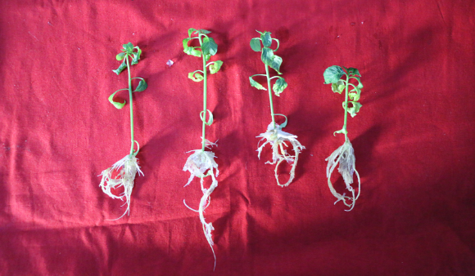
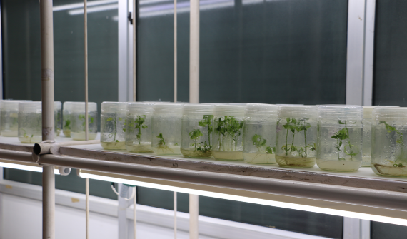

Embryo rescued tissue culture plants 30 days old plantlet
Plate 1: Embryo rescued interspecific plantlets before transplanting into different
hardening media

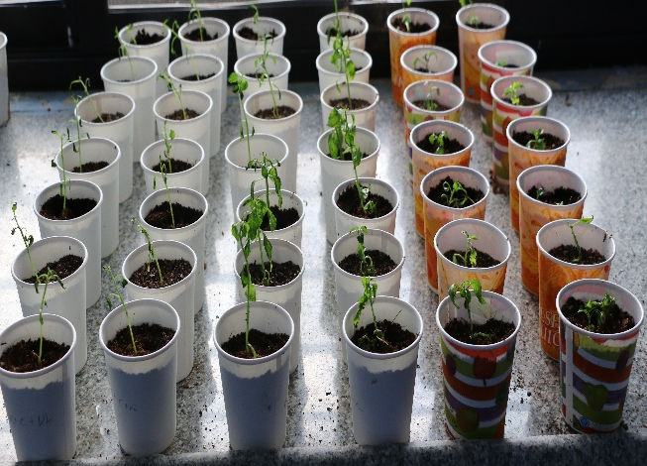
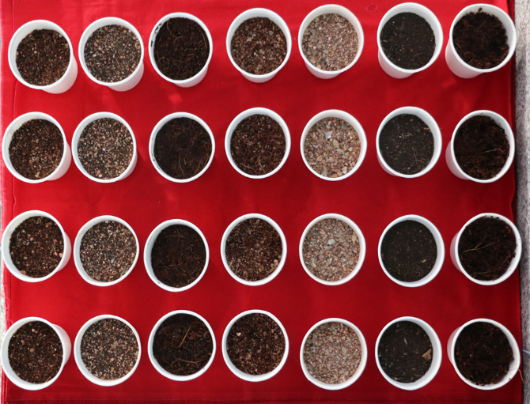

a. Different soilless media for hardening b. Transplanted interspecific plants to different hardening media

Plate 2: General view of Experiment 1 (a & b)

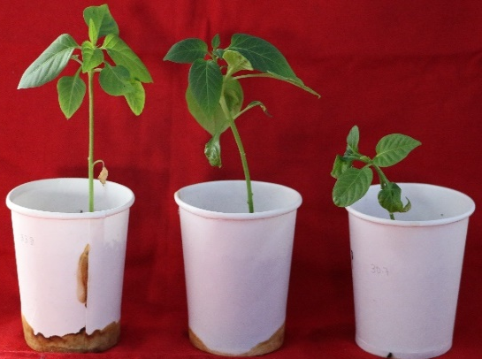
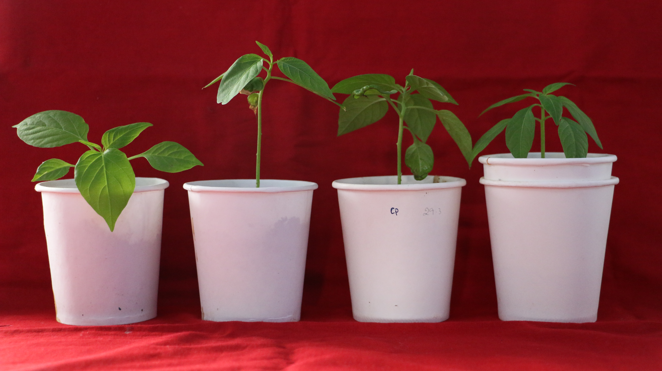
Cocopeat: Vermiculite
Cocopeat
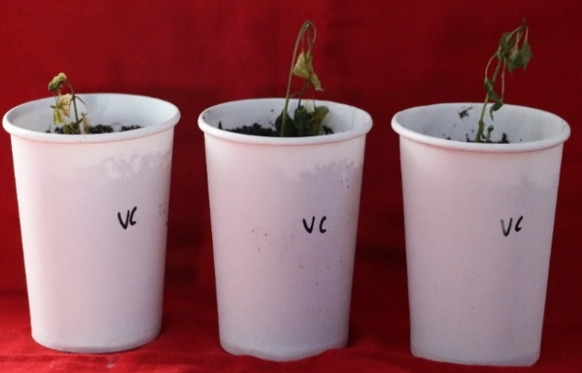
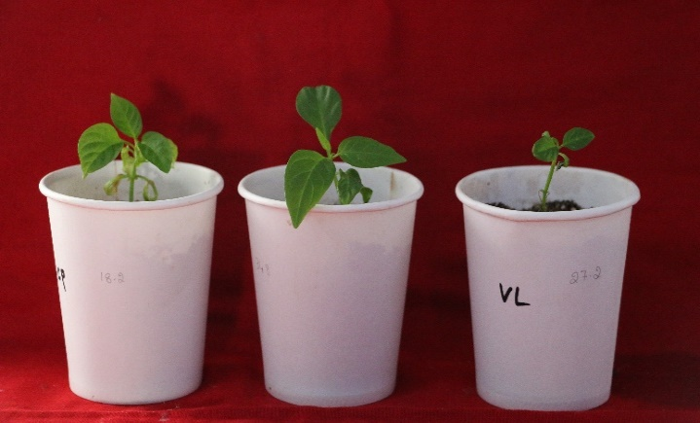
Vermiculite
Vermicompost

Plate3: Performance of different hardening media for embryo rescued interspecific hybrid in chilli
4. Conclusion
The study clearly shows that the choice of hardening media is vital for the successful acclimatization of embryo-rescued interspecific plantlets. Cocopeat proved to be the most effective medium, significantly improving growth, chlorophyll content, biomass, and survival rates. Plantlets hardened in cocopeat demonstrated the best shoot and root development and the highest survival. Vermiculite supported moderate growth but was less effective. A 1:1 mix of cocopeat and vermiculite was the second-best option, benefiting from better aeration and moisture balance. Vermicompost alone was unsuitable, causing complete plantlet mortality, and media containing vermicompost performed poorly, indicating its incompatibility during hardening. Overall, cocopeat-based media provide an optimal environment for acclimatization, making cocopeat the recommended hardening medium for interspecific embryo-rescued plantlets.
Acknowledgment
The authors are thankful to Department of Horticulture, Department of Genetics and Plant Breeding, University of Agricultural Sciences, Raichur, Karnataka.
Disclaimer (Artificial intelligence)

Author(s) hereby declare that NO generative AI technologies such as Large Language Models (ChatGPT, COPILOT, etc.) and text-to-image generators have been used during the writing or editing of this manuscript.

References:
Bebeli, P.J. and Mazzucato, A., 2008. The Solanaceae-a review of recent research on genetic resources and advances in the breeding of tomato, pepper and eggplant. Eur. J. Plant Biotechnol 2:3-30.
Bhattarai, A. 2009. Genetic Diversity and Agronomic performance of chili pepper (Capsicum spp.) varieties in Nepal. J. Agric. Sci. Technol., 12(3): 45-58.
Costa, F. R., Pereira, T. N. S., Vitoria, A. P., Campos, K. P., Rodrigues, R., Silvia, D. H. and Pereira, M. G. 2006. Genetic diversity among Capsicum accessions using RAPD markers. Crop Breeding and Applied Biotechnology., 6: 18-23.
Gautam, B., Sharma, P. and Gupta, Y.C., 2019. Studies on rooting and hardening of in vitro plantlets of carnation (Dianthus caryophyllus L.). IJCS., 7(5):3179-3182.
Knapp, S., Bohs, L., Nee M. and Spooner, D. M. (2004). Solanaceae-a model for linking genomics with biodiversity. Comparative and Functional Genomics., 5: 285-291.
Krishna, R., Khandagale, K., Benke, A.P., Soumia, P.S., Manjunathagowda, D.C., Ansari, W.A., Mokat, D.N., Gawande, S.J., Ade, A.B. and Singh, M., 2022. Embryo rescue: A potential tool for improvement of economically important crops. In Advances in plant tissue culture, Academic Press: 259-282.
Nazki, T., Siddique, M.A.A., Rather, Z.A., Mir, M.A. and Bhat, M.A., 2014, An improvised low-cost hardening protocol for in vitro raised plantlets of Gerbera jamesonii. Indian J. Agric. Sci., 5(1): 43-46.
Pickersgill, B., 1997, Genetic resources and breeding of Capsicum spp. Euphytica., 96(1): 129-133.
Pramanik, K.A.R.T.I.K., Sahoo, J.P., Mohapatra, P.P., Acharya, L.K. and Jena, C.H.I.N.M.A.Y.A., 2021. Insights into the embryo rescue—A modern in-vitro crop improvement approach in horticulture. Plant Cell Biotechnol. Mol. Biol, 22 :20-33.
Pundir, R., Rani, R., Tyagi, S. and Pundir, P., 2016, Advance review on nutritional phytochemical, pharmacological and antimicrobial properties of chilli. Int. J. Ayurveda Pharma Res.,4(4): 53-59.
Rogo, U., Fambrini, M. and Pugliesi, C., 2023. Embryo rescue in plant breeding. Plants, 12(17): 3106.
Uttekar, V. S., Gabhale, L. K., Parulekar, Y. R., Kadam, J. J. and Sanap, P. B., 2021, Effect of various potting media on growth and development of Chilli (Capsicum annuum L.) seedlings for grafting. Pharma Innov. J., 10(11): 800-803.
Walter, A. 2018. Genetic variation and environmental influence on yield and quality traits of chili pepper (Capsicum spp.). J. Agric. Sci., 45(2): 112-125.
Yoon, J. B., Yang, D. C., Do, J. W. and Park, H. G., 2006, Overcoming two post-fertilization genetic barriers in interspecific hybridization between C. annuum and C. baccatum for introgression of anthracnose resistance. Breed. Sci., 56(1): 31-38.

