Original Research Article
EFFECT OF CHITOSAN AND BIOCONTROL AGENTS IN THE MANAGEMENT OF FOOT ROT IN FINGER MILLET

Abstract
Foot rot of Finger millet caused by Sclerotium rolfsii is a leading constraint for the farmers under both irrigated and rainfed conditions. For the management of this problem an eco-friendly approach was taken up using chitosan and biocontrol agents, as they are known to have spin-off benefit of activating innate defense mechanisms and promoting higher yields. To evaluate the effect of chitosan and bio-agents on foot rot disease in ragi crop, a field experiment was taken up with 15 different treatments in combination of different chitosan (0.15%, 0.20% and 0.25%) concentration and bio-control agents and also chitosan alone with control. Chitosan @ 0.25% with bio-control agents, was proven effective in reducing the percent disease incidence. The disease incidence was 1% @ 30DAT, 2.68% @ flowering and 6.84% @ maturity stages. Among 15 different treatments, treatment T15 also promoted higher productivity with 41.33g seed weight/5 ear head. The results revealed that Chiotosan @ 0.25% with biocontrol agents can be one of the eco-friendly management practice’s for the control of Sclerotium rolfsii in Finger millet.
Key words: Chitosan, Foot rot, Biocontrol agents (Pseudomonas fluorescens and Trichoderma harzianum), Percent disease incidence (PDI).
Introduction
Finger Millet (Eleusine coracana L. Gaertn.) belongs to the family Poaceae. In India, Finger millet was grown under area of 1.19 m ha⁻¹ with production and productivity of 1.98 mt and 1662 kg ha⁻¹, respectively (India Agristat, 2017-18). Finger millet is also called as ragi, is known as hardiest crop, it is susceptible to many pathogenic diseases such as foot rot, blast, downy mildew, smut, blight, mosaic, and mottling mainly in high yielding verities (Govindu and Shivanandappa, 1967). Foot rot is caused by the fungi Sclerotium rolfsii sacc. it is predominantly in irrigated and high rainfall areas (Nagaraja and Reddy, 2009; Saccardo, 1913). Since the usage of chemical pesticides needs to be minimised, an environmental friendly approach such as microbial inoculants and some natural chemicals has to be explored for control and prevent the foot rot disease. It is reported that several species of bacteria and fungal are successful and serve as an antagonist against soil borne plant pathogens. For the successful management of soil borne plant diseases, biological control agents serve as viable and efficient alternatives compared to traditional chemicals for the effective control of soil borne plant diseases (Jeyarajan and Angappan, 1998). Bacterial isolates such as Pseudomonas fluorescens open the gates to integrated disease management component for sustainable agriculture (Mukhopadhyay et al., 1987). The isolates of Trichoderma harzianum are efficient in suppressing S. rolfsii (Manu et al., 2012; Patro and Madhuri, 2013). Chitosan is derived from the sea crustaceans, used as an eco-friendly biocontrol agent in agriculture for plant protection against harmful phyto-pathogens (Li et al., 2013). Chitosan molecules are primarily known for the induction of the host plant resistance (HPR). Chitosan treatment in plant tissues strengthens natural defence mechanism and enhances the plants physiological properties (Ghauoth et al., 1994). Since there are no literatures available to manage foot rot disease in ragi using bio-control agents and chitosan. The present study focused on combined effect of bio-control agents and chitosan to control Sclerotium rolfsi causing foot rot disease in Finger millet.
Methodology
Isolation of Pathogen
Isolation of the pathogen was made from the fresh samples collected from research farm at seedling and vegetative stage of the crop. The roots of the diseased plant showing typical foot-rot symptoms were washed thoroughly with water, small pieces of infected roots were cut into small pieces. These pieces were surface sterilized with 1:1000 mercuric chloride (Hgcl₂) for a minute followed by continuous three washings with sterilized water to remove the traces of Hgcl₂. The pieces were then transferred aseptically to Petri plates containing sterilized PDA and incubated at 25± 2 for three to five days and examined at frequent intervals to see growth of the fungus developing from different pieces. After repeated sub-culturing, the pathogen was purified and transferred into PDA slants for the further laboratory use.
Pathogenicity test:
The isolated Sclerotium rolfsii was proved for its pathogenicity through soil inoculation method under greenhouse conditions using sterilized soil in finger millet. The mass multiplication of the pathogen, Sclerotium rolfsii was done through sorghum grain giant culture. Initially the pathogen infestation was observed at the foot region of finger millet plants. Infected plants leaves turn pale green followed by yellowing. At the advance stages of plant infection, growth of the white mycelium was observed all around the collar region. The stem base was constricted and color was changed to brown in infected plants. The infected plant dried gradually and toppled. Sclerotial bodies were seen on infected plant parts and even on the surface of the soil. The reisolation of the fungus was done from such infected plant tissues and was compared with original culture of pathogen and thereby pathogenicity was proved, the work was previously done by Jabbar Sab (2013) and Nagamma and Nagaraja (2015) in barley, groundnut, chickpea and different field crops respectively.
Symptomology
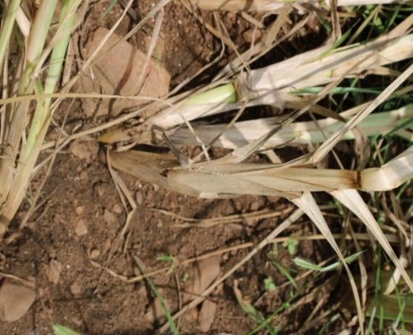
The pathogen, Sclerotium rolfsii Sacc. is soil inhabiting fungus causing the diseases in more than 500 crops (Desai and Schlosser, 1999). The symptomology varied among crops. The symptoms of the disease foot rot caused by Sclerotium rolfsii in finger millet displayed characteristic yellowing of the leaves accompanied by drooping and root decay (Fig 1) thereby leading to loss in seed vigor. The plants affected with Sclerotium rolfsii can be easily pulled from the soil. The infected plant had whitish mycelial growth developing gradually around the collar region and roots (Fig 2). On the infected plant parts, sclerotial bodies of white to cream color and round to spherical bodies were found. Highly infected plant showed the characters of tissue decay and soft rot were observed. At last, the plants die (Fig 3). These observations is in accordance with Nagaraja et al. (2007) and Nagamma and Nagaraja (2015).
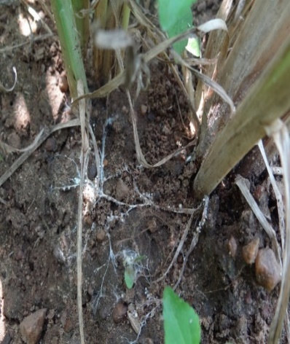
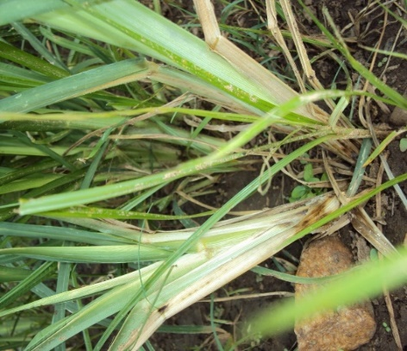
Fig 3: Drooping and Decay
Fig 2: White Mycelial on Soil
Fig 1: Foot Rot

Preparations of Chitosan solution
The stock solution of 10 mg/m L of chitosan was prepared by dissolving purified chitosan in glacial acetic acid under continuous stirring in mechanical shaker. Later the pH was adjusted to 5.5-6.0 using 2N sodium hydroxide, dialysed for 12 h against cold distilled water and autoclaved. Based on the laboratory experiments, the best three concentrations (0.15 %, 0.20 % and 0.25 %) of chitosan were prepared from the stock solutions and distilled water.
In vivo efficacy of Chitosan and bio-agents
The field experiment was conducted at Zonal Agriculture Research station, V.C Farm, Mandya, University of Agriculture Sciences, GKVK, Bengaluru during summer – 2020. The experiment was carried out in Randomized Complete Block Design (RCBD) with 15 treatments and three replications. Ragi crop was grown in summer season with the spacing of 30×10 cm , with the plot size of 3×2.25 sqm. Nursery raised finger millet seedlings were transplanted after 20 days during summer-2020 and fertilizer application was done according to standard UAS, Bengaluru package of practices followed for ragi crop.
Imposition of the treatments: Seedlings were dipped for 30 minutes in the diluted fungal and bacterial suspension of test isolates (Pseudomonas fluorescens, 2x10⁸ CFU mL⁻¹ and Trichoderma harzianum, 2x10⁶ cfu ml⁻¹) in treatments T2. T6, T7, T9, T10, T11, T13, T14 and T15. Thirty minutes after, the treatments T4, T8, T12 was treated with chitosan by dipping the seedlings in different concentration viz., 0.15 %, 0.20 %, 0.25 %, respectively for 30 minutes in a plastic containers and transplanted (Abdalla et al., 2017). Application of biocontrol agents to the soil after 30DAT, application of chemical fungicide, the combination of fungicide carboxin + thiram @ 0.3% was drenched to soil as per the standard agronomic practice (Nataraju, 2019).

Observations recorded
Assessment of percent disease incidence: The foot rot per cent disease incidence was recorded at tillering (30DAT), at flowering and maturity stages along with the basal lesion length(Trapero-Casas and Jimenez Diaz, 1985). Per cent disease incidence was calculated by the following formula.
Number of infected plants
Per cent disease incidence = × 100
Total number of plants
A composite surface (0-15cm) soil sample was drawn from the experimental site before initiation of experiment (before transplantation), at 30DAT and at 50 % flowering for microbial analysis. The enumeration of soil microbes viz., Total bacteria, total fungi, Trichoderma harzianum and Pseudomonas fluorescens was done through dilution plate technique (Warcup, 1955). Yield parameters like Panicle weight per 5 ear head and Seed weight per 5 ear head was measured after the harvest of the crop.
Results and discussion
Effect of Chitosan and biocontrol agents on Percent disease incidence of Finger millet
The field experiment results revealed that there was significantly less percent disease incidence in the treatment T15 i.e., 1 %, 2.68 % and 6.84 % at @ 30DAT, @ flowering and @ maturity stages, respectively. Whereas the percent disease incidence was more in case of control (T1) i.e., 8.78 %, 16.66% and 53.63 %. Treatment T15 was found superior when compared to recommended package of practices bio-agents and chemicals (Table 1, Fig 4).
El-Mohamedy et al. (2014) studied the effect of combination of chitosans and biocontrol agents in vitro on tomato and they reported that combination of T. harzianum and chitosan (1 g/ L) as root dipping treatment combined with chitosan (0.5 g/ L) as foliar spray reduced FCRR incidence and severity by 66.6 and 47.6 %, respectively. However, in their study, only chitosan treatments were least effective. The present findings are in line with these findings.

Palazzini et al., 2022 combined B. velezensis RC218 and chitosan resulted in a significant reduction in disease severity of 39% during the first trial and a 36.7% reduction in second trial.

The biocontrol efficacy of different treatments on tomato plants infested with F. solani was studied by Torres-Rodriguez et al., 2025. The treatment with the highest concentration of chitosan (3 g L⁻¹) showed the highest biocontrol efficacy, reaching 80% and showing significant differences (p < 0.05) with the 1 g L⁻¹ and the synthetic fungicide treatments.

Zúniga et al., 2026 recorded incidence of Rhizoctonia solani in rice and revealed significant differences (P ≤ 0.05). T2: (Trichoderma harzianum + Bacillus subtilis and Pseudomonas fluorescens) presented the lowest disease incidence, with 5%, 7.5%, and 5% at 20, 40, and 60 days after application, respectively.

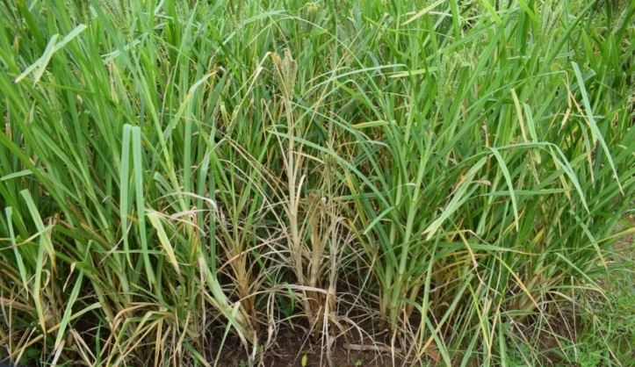

Fig 4: Field view indicating yellowing and rotting (in control plot)

Table 1: Effect of Chitosan and biocontrol agents on Percent disease incidence in Finger millet
Treatments | at 30 DAT  (Tillering stage) | at 50 DAT  (Flowering stage) | at 80 DAT  (Maturity stage)
T1 = Control | 8.78(17.22) | 16.66(24.07) | 53.63 (47.06)
T2 = Recommended package of practices (bio-agents) | 1.60 (7.26) | 3.13 (10.18) | 16.83 (24.20)
T3 =Recommended package of practices (chemicals) | 1.94 (8.00) | 3.88 (11.35) | 10.06 (18.48)
T4 =Chitosan (0.15%) | 2.20 (8.52) | 4.40 (12.09) | 14.51 (22.37)
T5 =Chitosan (0.15%) + P. fluorescens | 3.00 (9.97) | 6.03 (14.21) | 8.58 (17.02)
T6 =Chitosan (0.15%) + T. harzianum. | 2.00 (8.12) | 4.01 (11.54) | 9.12 (23.59)
T7 =Chitosan (0.15%) + P. fluorescens +T. harzianum | 2.10 (8.32) | 6.03 (14.21) | 8.58 (17.02)
T8 =Chitosan (0.20%) | 3.22(10.33) | 6.45 (14.70) | 16.03 (23.59)
T9 =Chitosan (0.20%) + P. fluorescens | 1.25 (6.41) | 4.01 (11.54) | 10.06 (18.48)
T10 =Chitosan (0.20%) + T. harzianum. | 1.91 (7.94) | 3.13 (10.18) | 16.83 (24.20)
T11 =Chitosan (0.20%) + P. fluorescens +T. harzianum | 2.4 (8.90) | 4.01 (11.54) | 6.84 (15.15)
T12 =Chitosan (0.25%) | 1.97 (8.06) | 4.40 (12.09) | 14.51 (22.37)
T13 =Chitosan (0.25%) + P. fluorescens | 1.34 (6.64) | 2.68 (9.41) | 9.12 (17.57)
T14 =Chitosan (0.25%) + T. harzianum. | 1.41 (6.81) | 3.88 (11.35) | 10.06 (18.48)
T15 =Chitosan (0.25%) + P. fluorescens +T. harzianum | 1.00 (5.73) | 2.68 (9.41) | 6.84 (15.15)
C.D (at 5%) | 3.36 | 3.85 | 7.20
S.Em± | 1.20 | 1.31 | 2.50
*Figures in parentheses are arc sin transformed values
Combined effect of chitosan and biocontrol agents on yield parameters of Finger millet
It is apparent from the data that there was a significant increase in the yield parameters with chitosan at 0.25% and consortium. The treatments with different concentrations of chitosan along with consortium recorded significantly higher yield. The yield in the control was lowest (Fig 4).
there has been increase in the yield, due to the lesser disease incidence in the plots with treatment chitosan and consortium.
Nusrat Jahan Nitu (2016) reported that the highest numbers of fruits and yield were observed in Trichoderma fortified compost + Seedling roots dipped in Trichoderma spore suspensions + seedling roots dipped in chitosan solution + Chitosan spray, where integrated treatments with T. harzianum pb27 spore suspension for root dipping, chitosan suspension for spray and root dipping along with Trichoderma-fortified poultry refuge compost were incorporated; the lowest was in control plots Control without Trichoderma or chitosan, where untreated tomato seedling were sown in field soil. Significantly the highest yield (50.99 %) was increased followed by 47.08 % increased yield.
The findings were in accordance with Isabel et al., 2019, the pot study was conducted with chitosan encapsulation on P. fluorescens for Tomato crop. The difference between the treated and control plants were observed based on the No. of fruits per plant. It was observed that the treated plants showed better growth than the control plants. This study reveals that encapsulation of bio-agent, will help to improve and promotes higher yield and productivity of the crops. Soil health and fertility also got improved.
Hamoda et al., 2026 stated Streptomyces inoculation and chitosan application interacted synergistically, significantly improving all yield-related and chemical parameters compared to their individual effects.

Fig 5: Effect of Chitosan and biocontrol agents on yield parameters in Finger millet

Total bacterial population
The total bacterial count was nearly same before application of treatments. But after application of treatments the total bacterial count varied significantly. The total bacterial count was maximum in T 15 due to the application of chitosan and consortium i.e., the total bacterial count varied from 10.18 x 10⁷ CFU/g and 5.98 x 10⁸CFU/g in before application of chitosan and consortium but after application of chitosan and consortium it varied. At 30DAT the total microbial count was 40.68 x 10⁷ CFU/mg of soil and 15.69 x 10⁸ CFU/g of soil and at flowering 66.27 x 10⁷CFU/g of soil and 30.55 x 10⁸ CFU/g of soil (Fig 6). Discussion

Fig 6: Effect of Chitosan and biocontrol agents on bacterial population in Finger millet
Total fungal population
The total fungal count was nearly same before application of treatments. But after application of treatments the total fungal count varied significantly. The total fungal count was maximum in T 15 due to the application of chitosan and consortium i.e., the total fungal count varied from 2 x 10³ CFU/g of soil and 1 x 10⁴ CFU/g of soil in before application of chitosan and consortium but after application of chitosan and consortium it varied. At 30DAT the total fungal count was 18 x10³ CFU/g of soil and 4.6 x 10⁴ CFU/g and at flowering 40 x 10³CFU/g of soil and 9.47x 10⁴ CFU/g of soil (Fig 7).

Fig 7: Effect of Chitosan and biocontrol agents on fungal population in Finger millet
Pseudomonas fluorescens and Trichoderma harzianum population
The total P. fluorescens count was nearly same before application of treatments. But after application of treatments the total P. fluorescens count varied significantly. The total P. fluorescens count was maximum in T 15 due to the application of chitosan and consortium i.e., the total count varied from 4×10⁷ CFU/g of soil before application of chitosan and consortium but after application of chitosan and consortium it varied. At 30DAT the total microbial count was 20.26×10⁷ CFU/g of soil and 31.33×10⁷ CFU/g of soil at flowering (Fig 8). The total T. harzianum count was nearly same before application of treatments. But after application of treatments the total T. harzianum count varied significantly. The total T. harzianum count was maximum in T15 due to the application of chitosan and consortium i.e., the total T. harzianum count varied from 9 CFU×10³/g of soil before application of chitosan and consortium but after application of chitosan and consortium it varied. At 30DAT the total T. harzianum count was 20×10³ CFU/g of soil and at flowering 30×10³ CFU/g of soil (Fig 8).

Fig 8: Effect of Chitosan and biocontrol agents on Pseudomonas fluorescens and Trichoderma harzianum population in Finger millet
Conclusion
The experiment was conducted with an objective of developing eco-friendly alternatives for the chemicals which are now a days used to control Sclerotium rolfsii using biocontrol agents and chitosan. The in vitro results revealed that the treatment with Chiotosan @ 0.15% and biocontrol agents showed maximum inhibition of Sclerotium rolfsii than control and other existing management practice, however in field the maximum inhibition of Sclerotium rolfsii was observed in the treatment with Chiotosan @ 0.25% and biocontrol agents.

Disclaimer (Artificial intelligence)

Author(s) hereby declare that NO generative AI technologies such as Large Language Models (ChatGPT, COPILOT, etc.) and text-to-image generators have been used during the writing or editing of this manuscript.

References
- Abdalla OA, Bibi S AND Zhang S, Integration of chitosan and plant growth-promoting rhizobacteria to control Papaya ringspot virus and Tomato chlorotic spot virus. Arch. Phytopathol. Pflanzenschutz., 2017, 50 (10): 997-1007.
- El-Mohamedy RS, Abdel-Kareem F and Daami-Remadi M, Chitosan and Trichoderma harzianum as fungicide alternatives for controlling Fusarium crown and root rot of tomato. Manag., 2014, 3 (4): 5-6.
- Ghauoth AE, Arul J, Grenier J, Benhamou N, Asselin A and Belanger G, Effect of chitosan on cucumber plants suppression of Pythium aphanidermatum and induction of defense reactions. Phytopathol., 1994, 84: 313-320.
- Govindu HC, and Shivanandappa N, Studies on an epiphytotic ragi disease in Mysore state. Mysore J. Agric. Sci., 1967,1: 34-67.
- Hamoda, A., Dabbour, M., Lamlom, S.F. and El-Akshar, E.A., 2026. Effectiveness of Streptomyces enissocaesilis and chitosan on agronomic, biochemical, and quality traits of soybean under different irrigation intervals. BMC Plant Biology.
- Isabel, B. S., Renuka devi, P., Balamurugan, P., Hemananthan, E., Vignesh kumar, S. AND Suriya, S.B., 2019, Encapsulation of Pseudomonas fluorescens for a slow release biofertilizer. I.C.A.M.I.B., 26: 22-23.
- Jabbar sab, Studies on collar rot of chickpea caused by Sclerotium rolfsii Sacc. M.Sc. (Agri) Thesis, Univ. Agric. Sci., Bangalore, 2013, 1-117 pp.
- Jeyarajan R and Angappan K, Mass production technology for fungal antagonists and field evaluation. Biological Suppression of Plant Diseases, Phytoparasitic Nematodes and Weeds (Singh, SP and Hussaini, SS) (Eds.). Project Directorate of Biological Control (ICAR), Bangalore, India, 1998, 48-56.
- Kulkarni SA and Kulkarni S, Biological control of Sclerotium rolfsii a causal agent of stem rot of groundnut. Karnataka J. Agric. Sci., 1994,7: 365-367.
- Li B, Wang X, Chen R, Huangfu W and Xie G, Antibacterial activity of chitosan solution against Xanthomonas pathogenic bacteria isolated from Euphorbia pulcherrima. Carbohydr. Polym., 2008,72 (2): 287-292.
- Manu TG, Nagaraja A, Chetan SJ and Vinayaka H, Efficacy of fungicides and biocontrol agents against Sclerotium rolfsii causing foot rot disease of finger millet, under in vitro conditions. G. J. B. A. H. S., 2012, 1(2): 46-50.
- Mirsha BK and Bais BS, Studies on seedling blight and foot rot of barley caused by Sclerotium rolfsii. Indian Phytopathol., 1987, 40: 161-167.
- Mukhopadhyay AN, Biological control of soil borne plant pathogens by Pseudomonas fluorescence. J. Mycol. Pl. Pathol., 1987, 17: 1-10.
- Nagaraja A, and Reddy AB, Foot rot of finger millet - an increasing disease problem in Karnataka. Crop Res, 2009, 38 (1): 224-225.
- Nagamma G and Nagaraja A, Variability and management of Sclerotium rolfsii sacc. causing foot rot disease in major field crops of Karnataka. Ph. D. Thesis, Univ. Agric. Sci., Bengaluru, 2015.
- Nagaraja A, Kumar J, Jain AK, Narasimhudu Y, Raghuchander T, Kumar B and Hanumanthe GB, Compendium of Small Millets Diseases (p. 80). Project Coordination Cell, All India Coordinated Small Millets Improvement Project, UAS, GKVK Campus, Bangalore, 2007.
- Nusrat Jahan Nitu, Md. Mahidul Islam Masum, Rayhanur Jannat, Salma Sultana and Md. Khurshed Alam Bhuiyan., Application of chitosan and Trichoderma against soil-borne pathogens and their effect on yield of tomato (Solanum lycopersicum L.). Int. J. Biosci., 2016, 9 (1): 10-24.
- Palazzini, Juan, Agustina Reynoso, Nadia Yerkovich, Vanessa Zachetti, María Ramírez, and Sofía Chulze. "Combination of Bacillus velezensis RC218 and chitosan to control fusarium head blight on bread and durum wheat under greenhouse and field conditions." Toxins 14, no. 7 (2022): 499.
- Saccardo PA, Sclerotium rolfsii. Sylloge Fungorum 22. Pavia, Italy, 1913, 1500.
- Torres-Rodriguez, Juan Antonio, Juan José Reyes-Pérez, Mercedes Susana Carranza-Patiño, Robinson J. Herrera-Feijoo, Pablo Preciado-Rangel, and Luis Guillermo Hernandez-Montiel. "Biocontrol of Fusarium solani: antifungal activity of chitosan and induction of defence enzymes." Plants 14, no. 3 (2025): 431.
- Trapero-casas A and Jimenez-diaz RM, Fungal wilt and root rot diseases of chickpea in southern Spain. Phytopathol., 1985, 75: 1146-1151.
- Warcup J H, Nature., 1950, 166: 117.
- Zúniga, H.J.O., Castillo-Arévalo, T. and Díaz, J.U.B., 2026. Management Strategies using Antagonistic Rhizobacteria against Pathogenic Fungi and Bacteria in Rice (Oryza sativa L.). European Journal of Agriculture and Food Sciences, 8(2), pp.9-19.

