Original Research Article
Correlation between Methylene Blue Reduction Test and Standard Plate Count of raw and pasteurized milk

Abstract
Milk is highly nutritive food containing all essential nutrient necessary for growth and development of children and adults. Milk is sterile at secretion, but it gets contaminated during milking, processing and storage with pathogenic bacteria which is of public health significance. Milk borne infection is an important constituent of food borne disease globally and responsible for approximately 4% of the food borne infection worldwide. The objective of study was to evaluation of the initial bacterial load of milk to determine whether to accept or reject the milk at farm level. A total of 100 milk samples (50 raw and 50 pasteurized milk) were collected from Ranchi, Jharkhand. Bacteriological analysis of milk was evaluated by Methylene Blue Reduction Test (MBRT) and Standard Plate Count (SPC). The MBRT result revealed that 10%, 40%, 42% and 08% of raw milk were of very good, good, fair and poor quality, respectively. While 16%, 52% and 32% of pasteurized milk were of very good, good and fair quality, respectively. SPC of raw milk ranged from 3.54 to 6.74 log₁₀CFU/ml and 82% were of very good quality, 14% were of good quality, 02% were of fair quality and 02% poor quality. The pasteurized milk was found to be within the acceptable limit. A correlation coefficient (r) was 0.875 (P<0.01) it showed a strong positive relationship between MBRT and SPC indicating that the microbial quality of raw milk can be assessed by MBRT. MBRT can be performed as it effective, economical, takes less time and not laborious as compared to other expensive and time taking microbiological methods.
Keywords: MBRT, SPC, milk, bacteriological quality, pasteurized milk, raw milk
1. INTRODUCTION
Milk is rich in nutritive value containing protein, carbohydrate, vitamins, minerals and considered to be a complete food. It can be consumed by all age groups from infant to senectitude and it is easily digestible. Milk when secreted from mammary gland is sterile but during milking it gets contaminated due to poor hygienic practices in the farm. Milk is an ideal medium for the growth of microorganism (Chatterjee et al., 2006). Pathogens can be introduced into milk directly or indirectly through various sources like environment, infected cow’s udder, dung, utensils or equipment and milker or handler (Anderson et al., 2011). Milk goes through various processes from farm to the consumer’s table. If the milk is not hygienically processed the milk and milk product may cause food borne illness in human (Kakati et al., 2021).
The incidence of food borne outbreaks had increased and more than 250 pathogens are identified for causing food borne poisoning worldwide (Abebe et al., 2024). Microbiological quality of milk is of public health importance because of zoonotic milk borne diseases like Campylobacter, Escherichia coli, Salmonella, Listeria monocytogenes, Staphylococcus aureus, Yersinia and Clostridium botulinum are transmitted through milk (Bindulekha, 2019).
Food borne campylobacteriosis occur due improper pasteurization or post pasteurization contamination of milk. It causes severe gastroenteritis, abdominal cramps, bloody diarrhoea, nausea, vomiting, dizziness, headache, malaise and fever (Khademi & Sahebkar, 2020).
E. coli commonly inhabits the gastrointestinal tract of both humans and warm-blooded animals (Obaidat and Stringer, 2019). E. coli is also a good hygienic indicator their presence reflects the feacal contamination of milk (Rios et al., 2019). Shiga toxin-producing Escherichia coli (STEC) can cause potential public health hazards globally. STEC causes severe enteritis, diarrhoea, dysentery, hemorrhagic colitis and hemolytic urinary syndrome in humans (Ullah et al., 2024).
Salmonella Typhimurium and Salmonella Enteritidis are the most common nontyphoidal Salmonella spp. prevalent in animals and humans causing septicaemia and gastroenteritis (Asefa et al., 2023). S. Typhi and S. Paratyphoid causes typhoid fever and paratyphoid fever, respectively in humans (Amsalu et al., 2021).
Listeria monocytogenes causes fatal food borne infection in humans worldwide. It is an intracellular and opportunistic pathogen affecting new born, pregnant women and immunocompromised individuals causing gastroenteritis, meningitis and abortion (Sathiesh et al., 2025).
Staphylococcus aureus mainly transmitted through milk and milk products causing food poisoning. Staphylococcal food poisoning occurs due to production of heat stable enterotoxins by S. aureus causing symptoms like nausea, vomiting, abdominal cramps and diarrhoea (Lin et al., 2025).
Yersinia is one of the enteric microorganisms transmitted by consumption of contaminated milk. Y. enterocolitica causes yersiniosis in human with the symptom showing gastroenteritis, abdominal pain and pseudoappendicitis (Eltoukhy et al., 2021).
C. botulinum causes food poisoning by producing neurotoxin The symptoms of botulism include nausea, vomiting and abdominal pain, followed by nervous system such as visual disturbances, swallowing difficulties, speech and breathing disorders (Bilska et al., 2024).
The bacteriological quality of milk can be assessed by methylene blue reduction test (MBRT) which can be easily performed on the reception dock to decide whether to accepted or rejected the milk. It is based on the principle of methylene blue dye colour reduces to colourless due to the microbial activity in the milk. Methylene blue is redox indicator which is blue in oxidised state but, as the number of bacteria grows and their metabolism activities deplete the oxygen thus the redox potential decreases turning blue colour of milk to colourless. The shorter the time of decolourization indicates the higher bacterial load. The assessment of bacteriological quality of milk was done by standard plate count (SPC). It gives the number of viable aerobic bacteria present in the milk sample.
2. MATERIALS AND METHODS
Collection of samples
The study was conducted in Ranchi, Jharkhand to conduct bacteriological analysis of fifty raw milk sample and fifty pasteurized milk sample. A total of hundred milk samples were collected from Ranchi in an ice box and send immediately for further analysis to the laboratory of Veterinary Public Health & Epidemiology, Ranchi College of Veterinary Science & Animal Husbandry, Kanke.
2.3. Bacteriological analysis of milk
Bacteriological analysis of milk was analyzed using Methylene Blue Reduction Test (MBRT) and Standard Plate Count (SPC).
2.3.1. Methylene Blue Reduction Test (MBRT) of milk sample
MBRT of the milk sample is conducted by adding 1 ml of methylene blue dye to 10 ml of milk sample. After mixing it the test tube is kept in water bath maintained in 37⁰C± 0.5⁰C (Marimuthu et al., 2013). The time taken for decolourization of milk from blue to white colour will indicate bacterial load in milk (ISI.1479, 1962). The milk is graded according to the time taken for decolourization (Table 1).
Table 1: Grading of milk
Methylene Blue Reduction Time in hours | Graded
5 h and above | Very good
3 to 4 h | Good
1 to 2 h | Fair
Within ½ h | Poor

2.3.2. Standard plate count (SPC)of milk sample
SPC of milk was carried out by pour plate technique using nutrient agar by serial dilution of milk in normal saline solution. After preparing serial dilution, 1 ml sample was poured in sterile petridish in duplicate and about 15-20 ml molten agar is poured into it and mixed thoroughly then allowed to solidify. After incubation for 24 h at 37⁰C the colonies were counted and results were interpreted according to IS:1479 (Part III), 1977 (Table 2).
Table 2: Bacteriological standard of raw milk (IS- 1479 PART III- 1997)
Grades | Standard Plate Count Per ml (lakhs)
Very good | Less than 2 lakhs
Good | 2-10
Fair | 10-50
Poor | More than 50
For pasteurized milk the standard plate count – maximum 4.47 log₁₀ cfu/ml
3. Statistical analysis
Analysis of data was done using SPSS version-20.0 software. Significant differences were mean were determined by Likelihood ratio (G test), Multinomial probability mass function, Odd’s Ratio, Mann-Whitney U test, Levene’s test for equality of variance, t-test (both student’s and Welch’s test).
4. RESULTS AND DISCUSSION
4.1 Methylene blue reduction test (MBRT) of milk
MBRT of raw milk revealed that 10% sample were of very good quality the decolourization time was more than 5.5 h, 40% sample were of good quality the dye reduction time was between 3 to 4 h, 42% of the sample were categorized under fair quality the time taken for decolourization was 1 to 2 h and 8% were of poor quality as it got decolourization within half an hour (Table 3). Similar results were obtained by Gurusaran et al., 2024; Gupta et al., 2020. The findings were in contrary to the results of Kakati et al., 2021 who revealed that more than 50% of the milk samples were of poor to very poor quality. MBRT for pasteurized milk showed that 16% sample were of very good quality the reduction time for decolourization was more than 5.5 h, 52% sample were of good quality decolourization time was 3 to 4 h, 32% sample were of fair quality the time taken for decolourization was 1 to 2 h (Table 4). The fair quality of pasteurized milk may be due to the storage temperature of milk was not maintained at lower temperature of 0-4⁰C (Fig. 1, 2).
Table 3: MBRT of raw milk
Time for decolourization | Grade | Percentage
More than 5 h | Very Good | 10%
3-4 h | Good | 40%
1-2 h | Fair | 42%
Less than 0.5 h | Poor | 08%

Table 4: MBRT of pasteurized milk
Time for decolourization | Grade | Percentage
More than 5 h | Very Good | 16%
3-4 h | Good | 52%
1-2 h | Fair | 32%
Less than 0.5 h | Poor | NIL

Table 5: Raw milk (Methylene Blue Reduction Test)
Time taken for decolorization | Grades | Percentage | Likelihood ratio (G test) | Multinomial probability mass function
More than 5 h | Very Good (n=5) | 10% | 22.307** | 0.0000034**
3-4 h | Good (n=20) | 40%
1-2 h | Fair (n=21) | 42%
Less than 0.5 h | Poor (n=4) | 08%
$$**Highly significant; P≤0.01$$
Raw milk quality follows significantly un-uniform distribution (Table 5). It may due to individual health status of cow, environment and hygienic condition of the farm like utensils used in milking. In a similar study Ahmed et al., 2020 suggested that the quality of milk depends upon various factors like animal hygiene, milking hygiene, equipment hygiene and processing hygiene.
Table 6: Raw milk Vs Pasteurized Milk (MBRT)
Quality of milk | Raw milk | Pasteurized milk | Odd’s Ratio | Mann-Whitney U test
Very good | 5 | 8 | 2.125 | U statistics ≈ 915;  p- value ≈ 0.036*
Good | 20 | 26
Fair | 21 | 16
Poor | 4 | 0
*Significant; P$≤$0.05
On the basis of Odd’s Ratio, pasteurized milk has over 2 times higher odds of being of acceptable quality compared to raw milk. On the basis of Mann-Whitney U test, pasteurized milk has significantly higher quality scores than raw milk (Table 6). In a similar survey Abhang et al., 2024 revealed that the pasteurized had lower microbial count as compared to raw milk.
4.2 Standard plate count (SPC) of given milk sample
SPC of raw milk revealed that 82% of milk samples were of very good quality and it ranges between 3.54 to 5.28 log₁₀ cfu/ml, 14% were of good quality and it ranges between 5.39 to 6.02 log₁₀ cfu/ml, 2% were of fair quality only one sample having SPC of 6.32 log₁₀ cfu/ml and 2% were of poor quality only one sample having SPC of 6.74 log₁₀ cfu/ml (Table 7). Similar results were obtained by Doot et al., 2026 who reported that SPC of raw milk ranged from 4.47 to 7 log₁₀ cfu/ml. The result was not according to Melese and Tesfaye (2015) who revealed the SPC was varying from 5.401 to 12.699 log₁₀ cfu/ml for the raw milk samples. The result was in concordance with Tamirat (2018) who reported the SPC of raw ranging from 5x10³ to 3.8x 10⁸ cfu/ml. The findings were in accordance with the result of Gurusaran et al., 2024 who reported that most of the raw milk samples in their study belonged to good and very good category.
SPC of all pasteurized milk were within the prescribed limit of 2.64 to 4.44 log₁₀ cfu/ml. The findings slightly vary from the report of Doot et al., 2026 who revealed the SPC of pasteurized milk ranged from 2.47 to 5.44 log₁₀ cfu/ml which was slightly higher than the acceptable limit. The findings were similar result of Tamirat (2018) who reported SPC of pasteurized milk ranged from 4.4x10¹ to 4.43x10⁵cfu/ml.
Limitation of MBRT and SPC that it gives estimate of total bacteria present in the milk it does not give the specific type of bacteria present whether pathogen or spoilage bacteria.
A correlation coefficient between the MBRT and SPC of pasteurized milk was calculated. A correlation coefficient (r) was 0.875 (P< 0.01) it showed a strong positive relationship between MBRT and SPC indicating that the microbial quality of pasteurized milk can be assessed by MBRT. Similar result was obtained by Gurusaran et al., 2024 who revealed a correlation coefficient of 0.82. The result was in line with Homhual and Jindal (2001) who reported a correlation coefficient of about 0.754. However, the correlation coefficient between the MBRT and SPC of raw milk was 0.551 (P< 0.01) which revealed it may be not so strongly significant depending upon metabolic activity of various types of bacteria.
Table 7: SPC of raw milk
Standard Plate count per ml (lakhs) | Grades | log₁₀ cfu/ml | Percentage
< 2 lakhs | Very Good | 3.54- 5.28 | 82%
2 – 10 lakhs | Good | 5.39- 6.02 | 14%
10- 50 lakhs | Fair | 6.32 | 02%
> 50 lakhs | Poor | 6.74 | 02%

Table 8: Least square mean± standard error of SPC (log₁₀ cfu/ml)
Milk status | N | Mean ± Std error mean | Range
Raw milk | 50 | 4.9071$±$0.9042 | 3.2 log₁₀ cfu/ml
Pasteurized milk | 50 | 3.7488 ± 0.7040 | 1.76 log₁₀ cfu/ml
Raw and pasteurized milk mean± SE of SPC is 4.9071± 0.9042 and 3.7488± 0.7040, respectively. The mean value of SPC of raw and pasteurized milk showed that their range are within the limit (Table 8).
Table 9: SPC for raw and pasteurized milk
 | Levene’s test for equality of variance |  | t-test (both student’s and Welch’s test)
 | F | Sig. | t | df | Sig. (2- tailed)
Equal variances assumed  (Student’s t-test) | .877 | .351 | 10.132** | 97 | .000  (5.306665E-18)
Equal variances not assumed  (Welch’s t-test) |  |  | 10.108** | 91.057 | .000  (1.18654E-17)
Pasteurized milk is significantly (**; P$≤0.01$) better than raw milk on the basis of standard plate count for both (Figure 4, Table 9).

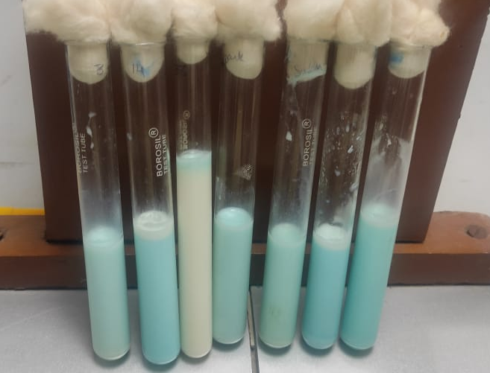
Figure 1: Tube with blue colour milk shows very good quality of milk (as it did not decolourized for more than 5.5 hrs) and white colour milk shows poor quality of milk (as it decolourized within 0.5 hr).

Figure 2: Comparison of raw and pasteurized milk based on MBRT.
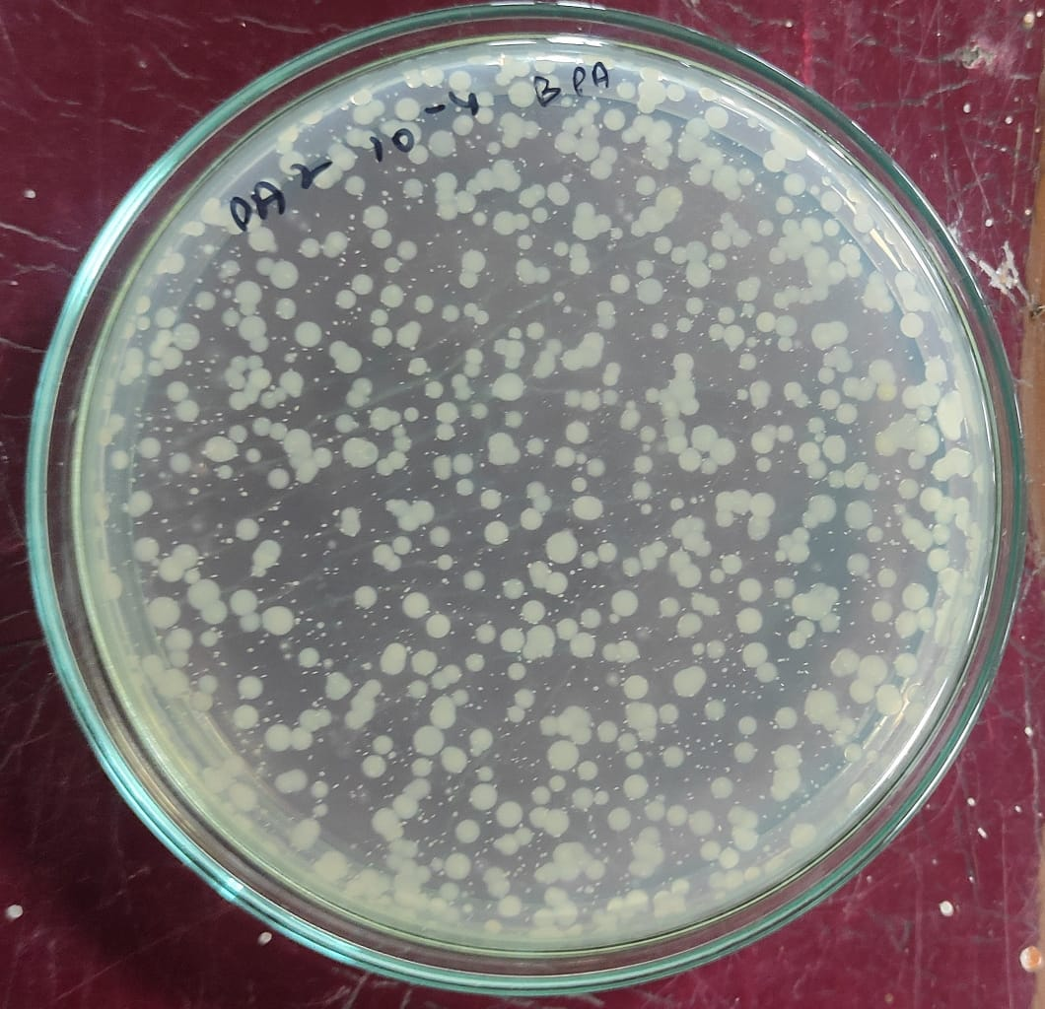
Figure 3. Standard plate count of milk

Figure 4: Comparison of SPC of raw and pasteurized milk

5. Conclusion
MBRT is easy to perform, takes less time, efficient and economical can be conducted at farm level as compared to SPC which is time consuming and tedious microbiological procedure. The farmer should be made aware to follow strict hygienic measures during milk production and maintain cleanliness required throughout processing of milk from the farm till it reaches the table of the consumer to prevent transmission of milk borne infection. The stored temperature of pasteurized milk should be maintained properly to avoid post pasteurization contamination and bacterial growth.

Ethical approval
The research was approved by the Institutional Animal Ethics Committee of Ranchi College of Veterinary Science and Animal Husbandry, BAU, Kanke, Ranchi. (V-11011(13)/12/2022-CPCSEA-DADF) dated 09.12.2022.

Disclaimer (Artificial intelligence)

Author(s) hereby declare that NO generative AI technologies such as Large Language Models (ChatGPT, COPILOT, etc.) and text-to-image generators have been used during the writing or editing of this manuscript.

References
Abebe, E., Gugsa, G., Ahmed, M., Awol, N., Tefera, Y., & Abegaz, S. (2024) Occurrence, associated risk factors and antimicrobial resistance patterns of Staphylococcus aureus and methicillin resistant S. aureus from foods of bovine origin in Dessie and Kombolcha towns, Ethiopia. Front. Sustain. Food Syst. 8:1422850. doi.org/10.3389/fsufs.2024.1422850
Abhang, P., Jadhav, D. M., & Pathade, A. (2024). Comparative Analysis of Raw and Pasteurized Milk from Various Milking Animals: A Comprehensive Study. Bulletin of Pure and Applied Sciences-Zoology, 43B (1s): 371-382
Ahmed, I., Kumar, S., & Aggarwal, D. (2020). Assessment of knowledge and practices of hygienic milk production among dairy farmworkers, Southwest Delhi. Indian J Community Med, 45: S26-30
Amsalu, T., Genet, C & Siraj, Y.A. (2021). Salmonella Typhi and Salmonella Paratyphi prevalence, antimicrobial susceptibility profile and factors associated with enteric fever infection in Bahir Dar, Ethiopia. Scientific Reports, 11:7359. doi.org/10.1038/s41598-021-86743-9
Anderson, M., Hinds, P., Hurditt, S., Miller, P., McGrowder, D. and Alexander-Lindo, R. (2011). The microbial content of unexpired pasteurized milk from selected supermarkets in a developing country. Asian Pac J Trop Biomed, 1(3): 205-211. doi:10.1016/S2221-1691(11)60028-2.
Asefa, I., Legabo, E., Wolde, T., & Fesseha, H. (2023). Study on Salmonella Isolates from Fresh Milk of Dairy Cows in Selected Districts of Wolaita Zone, Southern Ethiopia. International Journal of Microbiology, 6837797. doi.org/10.1155/2023/6837797
Bilska, A., Wochna, K, Habiera, M. & Serwanska-Leja, K. (2024). Health Hazard Associated with the Presence of Clostridium Bacteria in Food Products. Foods, 13, 2578. doi.org/10.3390/foods13162578
Bindulekha, D.S. (2019). Determination of Microbiological Quality of Milk from Different Breeds of Cattle Using Methylene Blue Reduction Test. Journal of Emerging Technologies and Innovative Research, 6(5): 613-618.
Chatterjee, S. N., Bhattacharjee, I., Chatterjee, S.K., & Chandra, G. (2006). Microbiological examination of milk in Tarakeswar, India with special reference to coliforms. African Journal of Biotechnology, 5(15):1383-1385, http://www.academicjournals.org/AJB.
Doot, M., Sain, M.L., Goklaney, D., Vaishali., Devender., Hemlata., Kalwaniya, M.K., & Lokendra. (2026). Assessment of bacteriological quality of milk and milk products sold at Bikaner city and its public health significance. International Journal of Advanced Biochemistry Research, 10(3): 468-472 DOI: https://www.doi.org/10.33545/26174693.2026.v10.i3f.7901
Eltoukhy, Marwa., El-Sayed, Mohammed., & Shoeib, Aisha. (2021) "Incidence of Yersinia enterocolitica in raw farm and market milk sample," Mansoura Veterinary Medical Journal, 22(3)7: doi.org/10.21608/mvmj.2021.69799.1049.
Gupta, P.K., Rai, D.C., Paswan, V.K., Panta, R. & Yadav, A.K. (2020). Study on Physico-Chemical and Microbial Quality of Raw Milk Collected from Different Places of Assi Region in Varanasi City, Varanasi. Asian Journal of Dairy and Food Research. 39(1): 1-9.
Gurusaran, S., Quintoil, M. N., Bhanu Rekha, V., Sivachandiran, R., & Indhu Prathibha, A. (2024). Quality Control Tests-Based Assessment of Raw Milk Samples Sold in Puducherry. International Journal of Livestock Research, 14 (8), 70-74.
Homhual, S., & Jindal, V. K. (2001). Simple Tests for Rapid Assessment of the Quality of Raw Milk. Journal of Food Protection, 64(12): 1996–2000.
Indian Standards Institution (ISI). (1977) Indian standard methods of test for dairy industry, Part III, Bacteriological analysis of milk, IS: 1479 (Part III)-1977, Manak Bhavan, New Delhi, India.
ISI.1479, Methods of Test for Dairy Industry. Part – III. Bacteriological analysis of milk. Indian Standards Institution, Manak Bhavan, New Delhi. (1962).
Kakati, S., Talukdar, A., Hazarika, R.A., Raquib, M., Laskar, S.K., Saikia, G.K., & Hussein, Z. (2021) Bacteriological quality of raw milk marketed in and around Guwahati city, Assam, India, Veterinary World, 14(3): 656-660.
Khademi, F., & Sahebkar, A. (2020). Prevalence of fluoroquinolone-resistant Campylobacter species in Iran: A systematic review and meta-analysis. International Journal of Microbiology, Article 8868197.
Lin, Y., Pan, M., Yang, Y., Ye, X., Xu, H., Lin, Y., & Niu, B. (2025). Exposure assessment of Staphylococcus aureus in fluid milk, International Dairy Journal, 169, 106334, https://doi.org/10.1016/j.idairyj.2025.106334.
Marimuthu, M., Sankar, N., Sathish, A., Vivek, S., & Mohan, R.N. (2013) Comparative study on physicochem ical quality of raw milk samples collected from different villages of Karur district, Tamil Nadu, India. Int. J. Pharm. Chem. Biol. Sci., 3(3): 635-638.
Melese, A. & Tesfaye, W. (2015). Bacteriological Quality and Safety of Raw Cow’s Milk in and around Jigjiga City of Somali Region, Eastern Ethiopia. International Journal of Research Studies in Biosciences, 3(5): 48-55.
Obaidat, M.M., & Stringer, A.P. (2019). Prevalence, molecular characterization, and antimicrobial resistance profiles of Listeria monocytogenes, Salmonella enterica, and Escherichia coli O157: H7 on dairy cattle farms in Jordan. J Dairy Sci. https://doi.org/10 .3168/jds.2019-16461.
Rios, E.A., Santos, J., Garcia-Menino, I., Flament-Simon, S.C., Blanco, J., Garcia-Lopez, M-L., et al. Characterisation, antimicrobial resistance and diversity of atypical EPEC and STEC isolated from cow’s milk, cheese and dairy cattle farm environments. LWT. https://doi.org/10.1016/j.lwt.2019.03.062.
Sathiesh, S., Rekha, V.B., Kumar, V.J.A., Thanislass, J., & Sivachandiran, R. (2025). Detection of Listeria monocytogenes from milk and milk products in Puducherry. International Journal of Agriculture and Food Science, 7(1): 205-209 doi.org/10.33545/2664844X.2025.v7.i1c.259.
Tamirat, T. (2018). Microbiological Quality Analysis of Raw and Pasteurized Milk Samples Collected from Addis Ababa and Its Surrounding in Ethiopia. Appro Poult Dairy & Vet Sci., 4(5). APDV.000598.2018. DOI: 10.31031/APDV.2018.04.000598
Ullah, S., Khan, S.U.H., Khan, M.J., Khattak, B., Fozia, F., Ahmad, I., Wadaan, M.A., Khan, M.F., Baabbad, A., & Goyal, S.M. (2024). Multiple-Drug Resistant Shiga Toxin-Producing E. coli in Raw Milk of Dairy Bovine. Trop. Med. Infect. Dis., 9, 64. https://doi.org/10.3390/ tropicalmed9030064.
Yingying, Lin., Mingjie, Pan., Yunfeng, Yang., Xiao, Ye., Huahu, Xu., Yikan, Lin., & Bing, Niu. (2025). Exposure assessment of Staphylococcus aureus in fluid milk. International Dairy Journal, 169, 106334, doi.org/10.1016/j.idairyj.2025.106334.

