Original Research Article
BIOCHEMICAL CHARACTERIZATION OF ROSA GENOTYPES: IDENTIFYING ELITE GENOTYPES FOR ENHANCED NUTRITION AND FUNCTIONAL FOOD DEVELOPMENT

Abstract
Rosaspp. represents a significant botanical taxon with both beauty and nutrition with a history spanning thousands of years inculinary and medicinal traditions. A study was conducted in Department of Floriculture and Landscaping, College of Agriculture, Vellanikkara, during the year 2023-2025 to biochemically characterisedifferent rose genotypes and evaluate total phenolic content, total flavonoid, carotenoid, anthocyanin, protein and Vitamin C. The results revealed significant diversity in their nutritional and phytochemical profiles. Among the studied accessions, KAU R 2 stands out as a highly potent genotype, containing the highest concentrations of protein (0.20 mg/100g), anthocyanins (400.07 mg/100g), and Vitamin C (48.11 mg/100g).Proteins remained generally low across all sampleswith KAU R 4 exhibiting the minimum. The secondary metabolite concentrations showed much wider variation. KAU R 26 was identified as the richest source of phenols at 86.40 mg GAE/g, whereas KAU R 10 possessed the superior flavonoid content at 425.07 mg QE/g. Additionally, Rock star reached the peak for carotenoids at 5.62 mg/100g. Conversely, KAU R 8 and KAU R 4 were notably lower in several categories, with KAU R 8 showing the lowest phenol content (50.54 mg GAE/g) and anthocyanin levels (48.33 mg/100g), and KAU R 4 yielding the lowest Vitamin C (18.00 mg/100g) and carotenoid (1.20 mg/100g) content.The results suggests that these rose genotypes possess significant potential as sustainable alternatives for functional food products. Owing to their high concentrations of bioactive compounds, these specific accessions are positioned as elite supplementary ingredients for the future of functional nutrition.
Keywords: Rose genotypes, bioactive compounds, nutrition, functional food
- INTRODUCTION
Modern roses (Rosa × hybrida) and their ancestral lineages represent some of the most economically significant taxa in global horticulture, functioning as extensive biological reservoirs for bioactive secondary metabolites. The rose, derived from the Latin word Rosa and belonging to the Rosaceae family, is classified as a flowering shrub. The Rosa extract can be used to prevent or treat various disorders (Wang, 2023; Angel et al., 2024).Historically, the integration of rose petals into the medicinal and culinary frameworks of ancient Roman, Greek, and Chinese civilizations underscores their long-standing utility as therapeutic agents and aromatic precursors in functional foods. From a biochemical perspective, the genus is characterized by a sophisticated profile of phenolic compounds, which serve as essential mediators of physiological processes including growth, reproductive signalling, and defence against ultraviolet radiation and pathogenic stress. This phytochemical matrix comprises a diverse array of flavonoidspredominantly anthocyanins and flavonolsalongside phenolic acids and carotenoids. Notably, many Rosa species exhibit ascorbic acid (vitamin C) concentrations that significantly exceed those identified in conventional dietary benchmarks such as Citrus and Brassica oleracea, highlighting their potential as potent sources of natural antioxidants (Simin et al., 2023).
The biochemical profiling of rose genotypes has emerged as a critical research focus due to its relevance in diverse industrial sectors such as pharmaceuticals, cosmetics, and functional foods, where the natural bioactive compounds extracted from roses are highly valued (Stamin et al., 2024; Bakhtiar et al., 2023). Rose petals, the colourful, vibrant and fragrant segments of the rose flower, serve as a storehouse of different phytochemicals that contribute to their probable health-enhancing characteristics (Patil et al., 2025). Over the past decade, advances in analytical chemistry and molecular techniques have enabled researchers to characterize in detail the proximate composition, mineral contents, and abundance of secondary metabolites including phenolics, flavonoids, carotenoids, anthocyanins, and volatile compounds across various rose cultivars (Sagbas, 2023; Kunc et al., 2023). There is growing recognition that the inherent genetic variability among different rose genotypes contributes to significant differences in their biochemical profiles, which can be exploited to breed new cultivars with enhanced nutritional, aesthetic, or therapeutic properties (Stamin et al., 2024; Pashaei and Hassanpour, 2024). In addition, the interplay between bioactive compounds and antinutrientssuch as tannins, alkaloids, saponins, and phytatesfurther complicates the overall nutritional evaluation and industrial application potential of these plants (Mallick et al., 2024).
The future of food security hinges on maximizing the nutritional value of every agricultural resource. Successfully tackling the complex challenges of food security and healthy nutrition, which are central to the United Nations Sustainable Development Goalsrequires strategically looking beyond conventional crops. This necessity compels the optimization of locally relevant, high-value plant resources. Within Indian agriculture and culture, rose petals are highly valued; they are an essential component of traditional health remedies and culinary items, including the popular conserve, Gulkand. This positions the rose petal not as a simple garnish, but as a high-potential source for modern functional foods. Rose petals are a biochemical powerhouse, naturally rich in significant concentrations of polyphenols, flavonoids, and potent antioxidants. These phytochemicals are directly linked to human health benefits, offering crucial functional properties that support health and wellness. Crucially, the quantity and profile of these health-promoting compounds can vary dramatically among different Rosa genotypes.
Phenolic compounds (PCs) are vital plant metabolites known for their critical activities, including antioxidant, anti-inflammatory, anti-tumour, and antimicrobial properties (De la Rosa et al., 2019; Luna-Guevara et al., 2018). PCs are characterised by at least one aromatic ring with one or more attached hydroxyl groups, and are the most widely distributed secondary metabolites. They have a broad range of physiological roles and are mainly synthesised by higher plants, especially horticultural crops (Xu & Wang, 2025). PCs regulate metabolism and decrease the risk of chronic diseases such as cardiovascular and neurodegenerative disorders (Perez-Jimenez et al., 2010). Their subclass, phenolic acids, counteract damage from reactive oxygen/nitrogen species (ROS/RNS) through free radical scavenging. Flavonoids (two-thirds of daily polyphenol intake) are strongly associated with preventing chronic diseases such as cancer, CVD, and diabetes (Lamport et al. 2012). Their benefits are often more pronounced when oxidative stress or inflammation is high (Bootset al., 2008).
Anthocyanins, a type of flavonoid pigment, are valued for therapeutic potential against diabetes, cancer, and cardiovascular/neurological pathologies. They manage cancer via anti-proliferation and pro-apoptosis (Chen et al., 2022). Anthocyanins also offer cardioprotective benefits by modulating lipid metabolism and endothelial function (Liu, 2015) and possess neuroprotective capabilities, improving cognition in older adults (Kent et al., 2022). Carotenoids are essential dietary pigments known for antioxidant, cytoprotective, and photoprotective properties (Bufka et al., 2024). They quench singlet molecular oxygen and scavenge free radicals, reducing the risk of degenerative disorders (Terao, 2023). Certain carotenoids (alpha-carotene, beta-carotene) act as provitamin A precursors to retinol (Bufka et al., 2024).
Vitamin C is a strong antioxidant and a cofactor for many enzymes, being involved in many biological functions, such as normal immune system functioning, carnitine and catecholamine metabolism, dietary iron absorption, and collagen biosynthesis (Alberts et al., 2025). Vitamin C is a critical water-soluble nutrient and a cofactor for iron-dependent dioxygenase enzymes necessary for collagen, hormone, neurotransmitter, and carnitine synthesis (Qi, 2020). It is vital for the immune system, supporting the differentiation and function of immune and epithelial barrier cells (Hemila, 2017). Protein is an indispensable macronutrient centered on body building, growth, and maintenance, providing components for muscle mass, immune responses, and cell repair.Protein also releases bioactive peptides upon hydrolysis, which exhibit numerous health-promoting effects (e.g., antitumor, hypoglycemic, antimicrobial) (Luna-Vital and de Mejía., 2018).
This study systematically quantifies and compares the essential nutritional and functional metabolites across a diverse range of commercially and locally important rose genotypes. This analysis moves beyond basic description, allowing for the scientific identification of elite linesthose genotypes that naturally accumulate the highest concentrations of desirable nutrients. Selecting varieties based on their functional chemistry, rather than just their appearance, enables the development of highly targeted breeding programs. These programs can focus on improving the yield and reliability of these essential chemical components, simultaneously ensuring the selected varieties are robust and adaptable for local sustainable agriculture practices.
- MATERIALS AND METHODS
2.1 Experimental site and planting materials
The present study was carried out at the Department of Floriculture and Landscaping, College of Agriculture, Vellanikkara, during the year 2023-2025 to biochemically profile various rose genotypes. Rose genotypes were collected from different regions of Kerala (Thrissur, Palakkad, Thiruvananthapuram). Fifteen rose genotypes (KAU R 2, KAU R 4, KAU R 5, KAU R 8, KAU R 10, KAU R 12, KAU R 13, KAU R 14, KAU R 26, Rock Star, Edward rose, Kashmiri rose, Seven day, Button rose and Andra Red) were planted and the petals were used for biochemical analysis.
2.2 Estimation of various biochemicals
Analysis for total phenols, flavonoids, carotenoids, proteins, anthocyanins, and vitamin C was done according to the specified procedures.

2.2.1 Estimation of total phenol content: The determination of total phenol content was achieved using the established Folin-Ciocalteu (FC) method. The protocol commenced with the combination of the sample extract and the Folin-Ciocalteu reagent). Subsequently, sodium carbonate was introduced to attain an alkaline environment, facilitating the reduction of the FC reagent by the phenolic compounds. This reaction yielded a blue chromophore whose intensity was directly proportional to the total phenolic concentration. The reaction mixture was then subjected to an incubation period of 60 minutes in the absence of light to ensure complete colour stabilization. The resulting absorbance was quantified spectrophotometrically at 760 nm. The total phenolic content was calculated against a gallic acid standard curve and expressed as mg Gallic Acid Equivalents per gram of sample (mg GAE/g).

2.2.2 Estimation of flavonoid: The determination of total flavonoid content was conducted using the aluminium chloride colorimetric assay. This procedure commenced with the reaction of a known volume of the sample extract with a solution of sodium nitrite. Following a brief incubation period, aluminium chloride was introduced. The aluminium chloride complexed specifically with the keto group at C-4 and the hydroxyl group at C-3 or C-5 of the flavonoids, resulting in the formation of a stable yellow-to-orange chromophore. Finally, sodium hydroxide was added to stabilize the colour, and the mixture's absorbance was quantified using a spectrophotometer at a wavelength of 510 nm. The total flavonoid content was then calculated against a standard curve prepared using quercetin and was expressed as milligrams of Quercetin Equivalents per gram of sample (mg QE/g).

2.2.3 Estimation of Vitamin C: The content of ascorbic acid (Vitamin C) was quantified using a titration method based on its immediate reaction with the oxidizing agent, 2,6-Dichlorophenolindophenol (DCPIP). The sample extract was first prepared and an aliquot was taken for analysis. The DCPIP solution, which is blue in an alkaline or neutral medium, was standardized and then used as the titrant. The sample was titrated against the standardized DCPIP until a faint, stable pink endpoint was observed. This endpoint signified that all the ascorbic acid in the sample had been oxidized by the DCPIP. The volume of titrant consumed was recorded, and the ascorbic acid content was calculated by comparing it against the titration value of a known standard, often expressed as milligrams of ascorbic acid per 100 g of fresh weight (mg AA/100 g FW).

2.2.4 Estimation of protein: The quantification of total soluble protein content was performed using the Lowry method. A measured aliquot of the prepared protein sample was initially incubated with Alkaline Copper Tartrate Reagent (Reagent C), which consists of copper sulphate and sodium-potassium tartrate in an alkaline solution. This step facilitated the chelation of copper ions by the protein’s peptide bonds, forming a complex. Subsequently, the Folin-Ciocalteu reagent was added. This reagent was reduced by the copper-peptide complex, the tyrosine and tryptophan residues within the protein structure, yielding a characteristic, intense blue colour. The reaction mixture was allowed to incubate in the dark at room temperature for a defined period (e.g., 30 minutes) to ensure complete colour development. Finally, the absorbance of the resulting solution was measured using a spectrophotometer at 660 nm against a reagent blank. The total protein concentration was determined by comparison to a standard curve generated using known concentrations of Bovine Serum Albumin (BSA) and was reported as milligrams of protein per gram of sample (mg protein/g).

Protein (mg/100g) = Absorbance of sample X 100
Absorbance of standard x Volume of sample

2.2.5 Estimation of anthocyanin: The total anthocyanin content was estimated using the spectrophotometric method described by Ranganna (1997). A known weight of the sample (approx. 2.0 g) was homogenized in an acidified ethanol solvent, consisting of 95% ethanol and 1.5 N HCl in a ratio of 85:15 (v/v). The mixture was allowed to stand overnight at 4°C to ensure complete extraction and then filtered through Whatman No. 1 filter paper. The filtrate was centrifuged at 5000 rpm for 10 minutes to obtain a clear supernatant. The absorbance of the extract was measured at 535 nm using a UV-Vis spectrophotometer against a blank of ethanolic HCl.

2.2.6 Estimation of carotenoids: Total carotenoids were estimated following the method described by Sadasivam and Manickam (1996). Fresh plant tissue (approx. 0.5 g) was homogenized in a pre-chilled mortar and pestle using 10 mL of 80% (v/v) acetone. The resulting homogenate was centrifuged at 3000 rpm for 10 minutes, and the supernatant was collected. This extraction process was repeated until the residue became completely colourless. The supernatants were pooled, and the final volume was made up to 25 mL with 80% acetone. The absorbance of the extract was recorded at 480 nm, 645 nm, and 663 nm using a UV-Vis spectrophotometer against an 80% acetone blank. The total carotenoid content was calculated using the formula:

Carotenoids (mg/g tissue) = A₄₈₀+ (0.114 x A₆₆₃) - (0.638 x A₆₄₅)1000 V
1000
x
W

  - Statistical analysis
Data obtained from the biochemical characterization of various rose genotypes were subjected to statistical analysis to determine significant differences. A one-way Analysis of Variance (ANOVA) was performed using the KAU-RAISINS (R and AI Solutions for InferencialStatistics) software package. The significance of treatments was tested using the F-test at a5% probability level (P < 0.05). To further distinguish between genotypic means, the Critical Difference (CD) was calculated where the F-test indicated significant results.
3. RESULTS AND DISCUSSION
Analysis of the selected rose genotypes revealed a broad diversity in their biochemical composition. The varying concentrations of anthocyanins and carotenoids directly correlated with the observed divergence in petal pigmentation, while the levels of phenols, flavonoids, and Vitamin C reflected the distinct antioxidant capacity of each variety. Furthermore, differences in protein content suggest unique metabolic strategies for development. Collectively, these parameters define a specific 'biochemical signature' for each genotype, influencing both its aesthetic value and functional resilience.

3.1 Total Phenol and Flavonoid Content
Analysis of the phytochemical profiles revealed a significant range of variability across the rose genotypes, particularly in total phenolic content (TPC). KAU R 26 emerged as the superior genotype with a TPC of86.80 mg GAE/g, which was significantly higher than the remaining cultivars. Conversely, KAU R 8 exhibited the lowest accumulation of phenols (49.37 mg GAE/g), representing nearly a two-fold difference compared to the former one.Earlier research on methanol extracts from R. brunonii, R. bourboniana, and R. damascena reported elevated phenolic levels, indicating that the genotype with highest phenolic content possess a moderate profile in contrast to these highly potent wild and oil-bearing species (Kumar et al., 2009). On the other hand, phenolic density of the genotype significantly exceeds the ranges observed in various R x hybrida ethanol extracts, which typically fall between 7.99 and 29.79 mg/g fresh weight (Yang and Shin, 2017).
The distribution of total flavonoid content (TFC) showed a distinct stratification among the rose genotypes. KAU R 10 exhibited the maximum mean value (423.10 mg QE/g), maintaining a narrow margin over KAU R 8 (399 mg QE/g). This was followed by next highest group including KAU R 4 (388.15 mg QE/g) and KAU R 14 (325.40 mg QE/g). Edward Rose recorded the significantly lowest TFC, suggesting it may lack the enzymatic efficiency in the chalcone synthase pathway compared to other genotypes.Also, the values of flavonoid content analysed in this study was higher than those studied by Choi et al., 2015 and Baibuch et al., 2024.Moreover, these significant variation in phenols and flavonoids between genotypes is in congruent with the findings of Simin et al. (2024), who similarly observed that specific genotypes consistently display superior phenolic and flavonoid accumulation compared to others.
The wide ranges observed in both total phenolic content and flavonoid concentrations underscored a profound genetic diversity within the studied rose genotypes. Such a broad spectrum suggested that the biosynthetic pathways for secondary metabolites are highly sensitive to genotypic architecture. The superior performance of KAU R 26 and KAU R 10 indicated an enhanced metabolic efficiency, likely driven by a higher expression of key enzymes such as phenylalanine ammonia-lyase (PAL) or chalcone synthase (CHS). The variation in the phenolic and flavonoid range suggested that while all genotypes maintain a baseline level of structural phenols and flavonoids, certain lines have evolved to store significantly higher concentrations. This high concentration of bioactive compounds makes these specific genotypes prime candidates for pharmaceutical extraction and breeding programs aimed at increasing the nutraceutical value of roses.

3.2 Anthocyanin and Carotenoid Content
The anthocyanin profile exhibited the most profound variation among all measured biochemical parameters, spanning an eight-fold difference across the germplasm. KAU R 2 was identified as the premier genotype, yielding a peak concentration of 400.15 mg/100g.This value was statisticallysignificant outperforming all other tested genotypes. Conversely, KAU R 8 represented the lower extreme of the spectrum with only 48.25 mg/100g.The exceptionally high anthocyanin concentration in KAU R 2 represents a level of pigment accumulation that far exceeds the ranges reported by Mallick et al. (2024), and Fascellaet al. (2022) which directly accounts for its deep red colouration. KAU R 2 may possess a highly efficient regulatory mechanism for anthocyanin synthesis, potentially driven by the upregulation of key enzymes such as chalcone synthase or dihydroflavonol 4-reductase. Conversely, the "pigment-poor" profile of KAU R 8 and KAU R 4 which recorded the lowest levels of both anthocyanins and carotenoids is consistent with their white floral phenotype.
The study identified a four-fold variation in carotenoid levels across genotypes. Rock Star (5.25 mg/100g), Kashmiri Rose, and KAU R 26 emerged as superior sources of carotenoid pigments, significantly outperforming the low-accumulation group led by KAU R 4 (1.25 mg/100g). These findings suggest that while genotypes like Rock Star are optimized for enhanced photoprotection and pigment-based traits, others like KAU R 4, R 8, and R 13 possess limited carotenoid biosynthetic capacity. The observed variation in total carotenoid content across the studied rose genotypes underscored the significant role of genetic background in determining pigment accumulation. The relatively higher concentrations found in Rock Star, Kashmiri Rose and KAU R 26were congruent with the findings of (Fascellaet al. 2022), who noted that reddish-coloured petals, such as those in cv. Rubra, naturally sequester higher levels of carotenoids compared to paler cultivars like cv. Alba. This alignment suggests a consistent relationship between visual colour intensity and biochemical pigment density. However, the absolute values recorded in this study appear significantly lower in magnitude when contrasted with the findings of Mallick et al., 2024, where the values reached the levels as high as 108 mg/100g.
The wide variation in anthocyanin and carotenoid content observed across the genotypes in this study aligns with the findings of Pourzarnegaret al. (2025), who also reported significant differences in pigment accumulation across different rose cultivars and confirm that anthocyanin and carotenoid levels are not uniform but are significantly influenced by the genetic background of the plant, showing a broad distribution range that highlights the diversity within the Rosa genus. Furthermore, the data aligns with Pourzarnegar’s observation that anthocyanin content tends to exhibit a much wider numerical spread compared to the relatively more constrained range of carotenoids.

3.3 Vitamin C and Protein Content
The distribution of Vitamin C content was highly stratified, with KAU R 2 reaching a peak of 47.50 mg/100g. This concentration was significantly greater than all other genotypes, highlighting its exceptional potential for antioxidant enrichment. In sharp contrast, KAU R 4 exhibited the minimum recorded value (17.50 mg/100g), differing significantly from the rest of the group.The analysis of Vitamin C revealed that rose petals serve as a significant source of antioxidants, with KAU R 2 emerging as the most potent accumulator. This superior performance is in congruence with the observations of Simin et al. (2024) and Prata et al. (2017), who both identified specific cultivars such as MF and New Fashion as being exceptionally rich in Vitamin C.However, the absolute values in this study were found to be lower than those reported earlier. The superior Vitamin C levels in KAU R 2 indicate a more robust antioxidant defence system and a highly active L-galactose pathway, which is the primary route for ascorbate biosynthesis in plants.
Analysis of total protein content revealed a narrow yet statistically significant range of variation among the rose genotypes. KAU R 2 distinguished itself as the premier genotype, recording the maximum protein mean of 0.20 mg/100g. This value was found to be statistically unique and significantly superior to all other entries, indicating a more robust protein expression profile. Conversely, the minimum protein accumulation was observed in KAU R 5, which grouped statistically with Kashmiri Rose and KAU R 26.The superior protein expression observed in KAU R 2 distinguishes it as a genetically distinct performer, indicating more robust metabolic activity or a higher density of enzymatic proteins. This trend of specific cultivar superiority is in congruence with Prata et al. (2017), who identified the Attaché cultivar as a high-protein accumulator.
Biochemical profiling of rose genotypes is essential for identifying elite cultivars; however, it is subject to several significant limitations that affect data reliability and reproducibility.Primarily, these profiles are highly sensitive to environmental and temporal variability; the chemical composition of a rose is not a static trait but rather a dynamic response to external factors such as soil pH, light intensity, and irrigation. A genotype that exhibits peak phenolic content in one geographical region may show significantly lower levels in another due to genotype environment interactions. Furthermore, the developmental stage of the flowerfrom bud to senescencedrastically shifts the concentration of metabolites like anthocyanins and volatile oils, making the timing of sampling a critical but often inconsistent variable.
- CONCLUSION
The comprehensive biochemical assessment of the investigated rose genotypes revealed a diverse and potent nutrient profile, transforming these floral genetic resources as significant functional ingredients for the modern food industry. The significant presence of phenolic compounds and flavonoids across the germplasm highlights the potential of specific cultivars to serve as natural antioxidant boosters. Furthermore, the substantial concentrations of anthocyanins and carotenoids suggest that these petals can act as dual-purpose additives, providing both health-promoting bioactive properties and stable, plant-based pigments to replace synthetic colorants. The variations observed in Vitamin C and protein content further emphasize that selected rose genotypes are not merely aesthetic elements but are dense sources of essential micronutrients and primary metabolites.
As the food industry shifts toward "clean-label" products and nutraceutical-grade ingredients, the high metabolic diversity found in these rose cultivars offers a sustainable pathway for the development of fortified beverages, gourmet confectioneries, and natural preservatives. Future exploration should focus on the stability of these nutrients during food processing to fully harness the culinary and therapeutic potential of these genotypes in large-scale commercial applications.
Disclaimer (Artificial intelligence)

Author(s) hereby declare that NO generative AI technologies such as Large Language Models (ChatGPT, COPILOT, etc.) and text-to-image generators have been used during the writing or editing of this manuscript.

Ethical approval
The study complies with all institutional and national ethical standards for plant research.

Acknowledgements
This work was supported by Kerala Agricultural University Doctoral Fellowship programme.

REFERENCES
Baibuch, S. Y., Schelegueda, L. I., Bonifazi, E., Cabrera, G., Mondragón Portocarrero, A. C., Franco, C. M., Malec, L. S., and Campos, C. A. 2024. Argentinian rose petals as a source of antioxidant and antimicrobial compounds. Foods, 13(7): 977.
Bakhtiar, Z., Eghlima, G., Hatami, M., andMirjalili, M. H. 2023. Quantification of fatty acids in seed oil and important bioactive compounds in Iranian Rosa canina L. ecotypes for potential cosmetic and medicinal uses. Sci. Rep., 13(1): 22721.
Boots, A. W., Haenen, G. R., and Bast, A. 2008. Health effects of quercetin: from antioxidant to nutraceutical. Eur.J Pharmacol., 585(2-3): 325-337.
Bufka, J., Vaňková, L., Sýkora, J., and Křížková, V. 2024. Exploring carotenoids: Metabolism, antioxidants, and impacts on human health. J.Funct. Foods, 118: 106284.
Chen, J., Xu, B., Sun, J., Jiang, X., and Bai, W. 2022. Anthocyanin supplement as a dietary strategy in cancer prevention and management: A comprehensive review. Crit. Rev. Food Sci.Nutr., 62(26): 7242-7254.
Choi, J. K., Lee, Y. B., Lee, K. H., Im, H. C., Kim, Y. B., Choi, E. K., Joo, S. S., Jang, S. K., Han, N. S., and Kim, C. H. 2015. Extraction conditions for phenolic compounds with antioxidant activities from white rose petals. J. Appl. Biol. Chem., 58(2): 117-124.
De La Rosa, L. A., Moreno-Escamilla, J. O., Rodrigo-García, J., and Alvarez-Parrilla, E. 2019. Phenolic compounds. In: Postharvest physiology and biochemistry of fruits and vegetables, Woodhead publishing. pp. 253-271.
Fascella, G., D’Angiolillo, F., Mammano, M. M., Granata, G., and Napoli, E. 2022. Effect of petal color, water status, and extraction method on qualitative characteristics of Rosa rugosa Liqueur. Plants, 11(14): 1859.
Hemila, H. 2017. Vitamin C and infections. Nutr., 9(4): 339.
Kent, K., Yousefi, M., do Rosario, V. A., Fitzgerald, Z., Broyd, S., Visentin, D., Roodenrys, S., Walton, K., and Charlton, K. E. 2022. Anthocyanin intake is associated with improved memory in older adults with mild cognitive impairment. Nutr. Res., 104: 36-43.
Kumar, N., Bhandari, P., Singh, B., and Shamsher, S.B. 2009. Antioxidant activity and ultra-performance LC-electrospray ionization quadrupole time-of-flight mass spectrometry for phenolics-based fingerprinting of Rose species: Rosa damascena, Rosa bourboniana and Rosa brunonii.Food Chem. Toxicol., 47: 361–367.
Kunc, N., Hudina, M., Osterc, G., Bavcon, J., Ravnjak, B., and Mikulič-Petkovšek, M. 2023. Phenolic compounds of rose hips of some rosa species and their hybrids native grown in the South-West of Slovenia during a two-year period (2020–2021). Foods, 12(10): 1952.
Lamport, D. J., Dye, L., Wightman, J. D., and Lawton, C. L. 2012. The effects of flavonoid and other polyphenol consumption on cognitive performance: a systematic research review of human experimental and epidemiological studies. Nutr. Aging, 1(1): 5-25.
Liu, Y., Tan, D., Shi, L., Liu, X., Zhang, Y., Tong, C., Song, D., and Hou, M. 2015. Blueberry anthocyanins-enriched extracts attenuate cyclophosphamide-induced cardiac injury. PloS one, 10(7): e0127813.
Luna-Guevara, M. L., Luna-Guevara, J. J., Hernández-Carranza, P., Ruíz-Espinosa, H., and Ochoa-Velasco, C. E. 2018. Phenolic compounds: A good choice against chronic degenerative diseases. Stud.Nat.Prod. Chem., 59: 79-108.
Luna-Vital, D., and de Mejía, E. G. 2018. Peptides from legumes with antigastrointestinal cancer potential: Current evidence for their molecular mechanisms. Curr.Opin. Food Sci., 20: 13-18.
Mallick, S. R., Hassan, J., Hoque, M. A., Sultana, H., Kayesh, E., Ahmed, M., Ozaki, Y., Al-Hasmi, A., and Siddiqui, M. H. 2024. Color, proximate composition, bioactive compounds and antinutrient profiling of rose. Sci. Rep., 14(1): 21690.
Pashaei, M., and Hassanpour, H. 2024. Phenolic, amino acids, and fatty acids profiles and the nutritional properties in the fresh and dried fruits of black rosehip (Rosa pimpinellifolia L.). Sci. Rep., 14(1): 19665.
Pérez-Jiménez, J., Neveu, V., Vos, F., andScalbert, A. 2010. Identification of the 100 richest dietary sources of polyphenols: an application of the Phenol-Explorer database. Euro.J. Nutr., 64(3): 112-120.
Pourzarnegar, F., Hashemabadi, D., andAllahyari, M. S. 2025. Nutrient-rich elegance: A comprehensive evaluation of garden and cut rose cultivars for culinary and nutritional significance. Ornam. Hortic., 31: e312776.
Prata, G. G. B., Oliveira de Souza, K., Lopes, M. M. A., Oliveira, L. S., Alves, R. E., and Silva, S. M. 2017. Nutritional characterization, bioactive compounds and antioxidant activity of brazilian roses (Rosa spp).J. Agr. Sci. Tech., 19: 929-941.
Qi, X., Xie, X., Zhong, C., and Li, D. 2020. The complete chloroplast genome of Actinidia latifolia, a species with high vitamin C content in fruit. Mitochondrial DNA Part B, 5(3): 3425-3426.
Ranganna, S. 1997. Handbook of analysis and quality control for fruit and vegetable products (2nd ed.). Tata McGraw Hill Publishing Company Limited, New Delhi. 1122p.

Sadasivam, S., and Manickam, A. 1996. Biochemical Methods (2nd ed.). New Age International, New Delhi. 286p.

Sagbas, H. I. 2023. Investigation of fruit quality and biochemical traits of rosehip (R. canina) ecotypes in the Aegean region of Türkiye. Hortic., 9(12): 1292.
Simin, N., Lesjak, M., Živanović, N., Božanić Tanjga, B., Orčić, D., and Ljubojević, M. 2023. Morphological characters, phytochemical profile and biological activities of novel garden roses edible cultivars. Hortic., 9(10): 1082.
Stamin, F. D., Vijan, L. E., Topală, C. M., andCosmulescu, S. N. 2024. The influence of genotype, environmental factors, and location on the nutraceutical profile of Rosa canina L. fruits. Agron., 14(12): 2847.
Terao, J. 2023. Revisiting carotenoids as dietary antioxidants for human health and disease prevention. FoodFunct., 14(17): 7799-7824.
Yang, H. and Shin, Y. 2017. Antioxidant compounds and activities of edible roses (Rosa hybrida spp.) from different cultivars grown in Korea. Appl. Biol. Chem., 60: 129–136.
Wang H. (2023). Beneficial medicinal effects and material applications of rose. Heliyon, 10(1), e23530. https://doi.org/10.1016/j.heliyon.2023.e23530
Patil, S. A., Pagariya, M. C., Kulkarni, A. J., Jadhav, P. R., Yadav, R. S., Kadam, G. B., Shabeer, T. P. A., Sharma, A. K., Banerjee, K., Prasad, K. V., & Kawar, P. G. (2025). Phytochemical insights and antioxidant capabilities of rose cultivars: implications for traditional medicine and modern industry. Discover Agriculture, 3(1). https://doi.org/10.1007/s44279-025-00171-1
Alberts, A., Moldoveanu, E.-T., Niculescu, A.-G., & Grumezescu, A. M. (2025). Vitamin C: A Comprehensive Review of Its Role in Health, Disease Prevention, and Therapeutic Potential. Molecules, 30(3), 748. https://doi.org/10.3390/molecules30030748
Xu, L., & Wang, X. (2025). A Comprehensive Review of Phenolic Compounds in Horticultural Plants. International journal of molecular sciences, 26(12), 5767. https://doi.org/10.3390/ijms26125767
Angel, Y., Jacqueline, J., Devaprabha, D., Pratiksha, U. J., & Ramasamy, R. (2024). Growth Performance and Instability in Area and Production of Cut Rose: A Survey . Journal of Experimental Agriculture International, 46(7), 177–181. https://doi.org/10.9734/jeai/2024/v46i72570

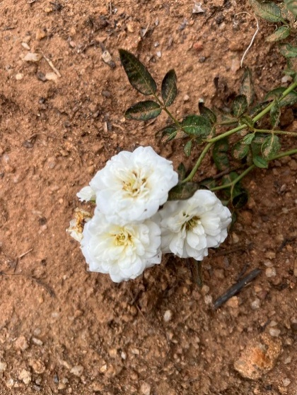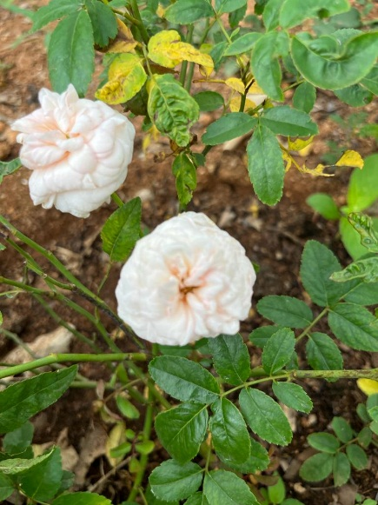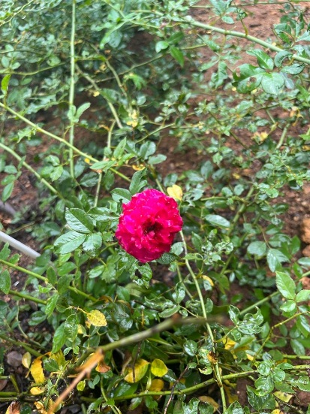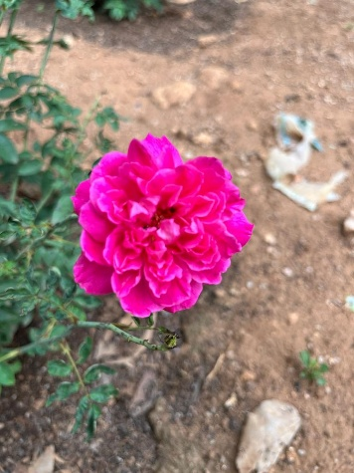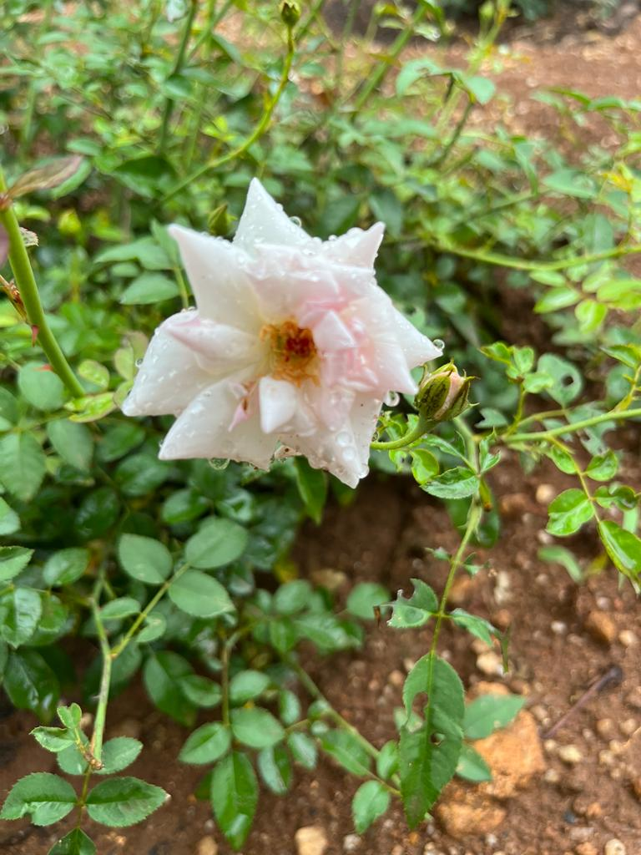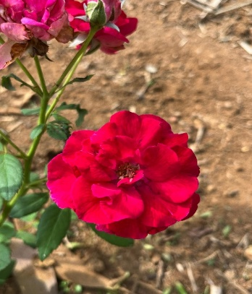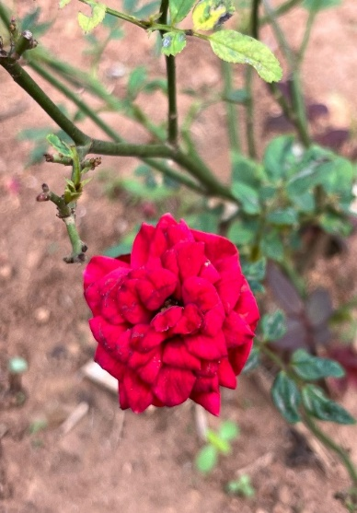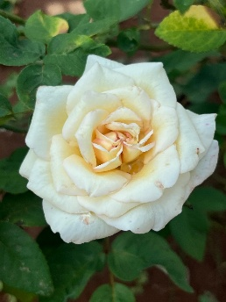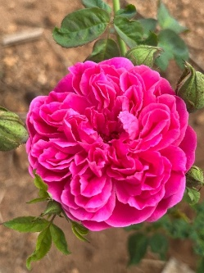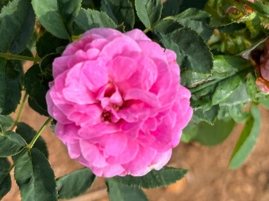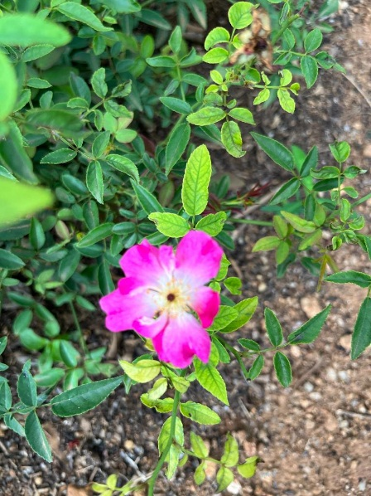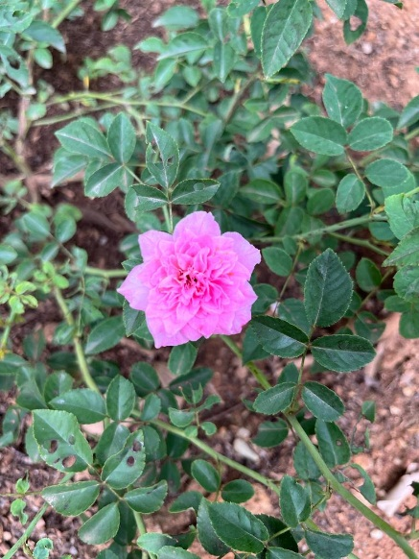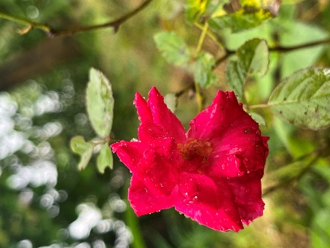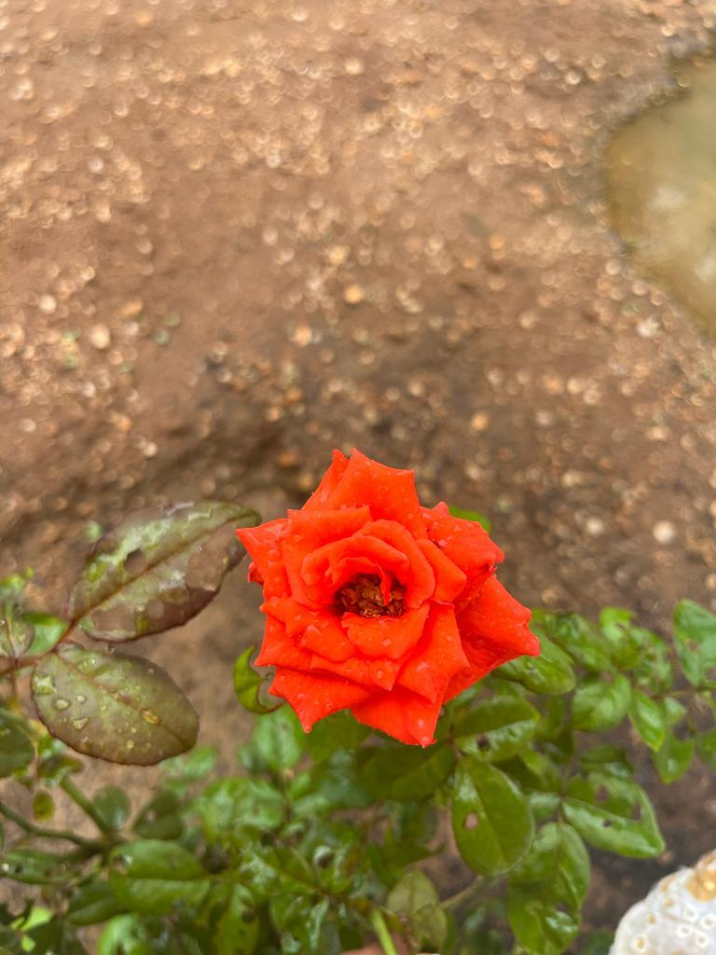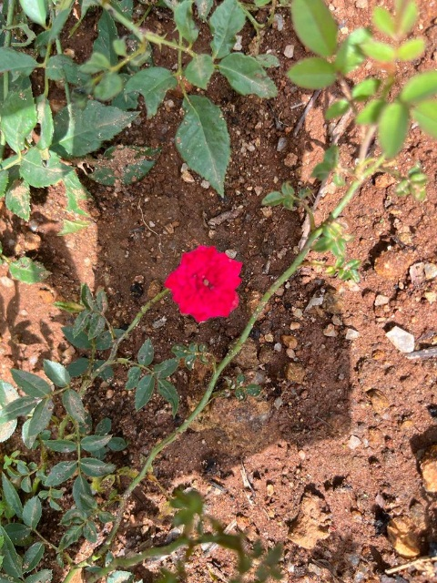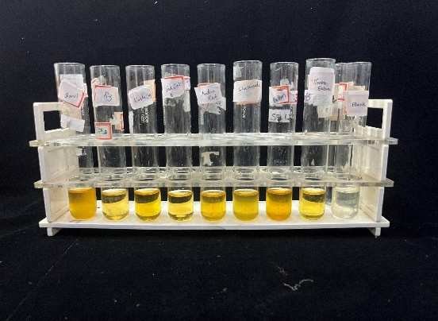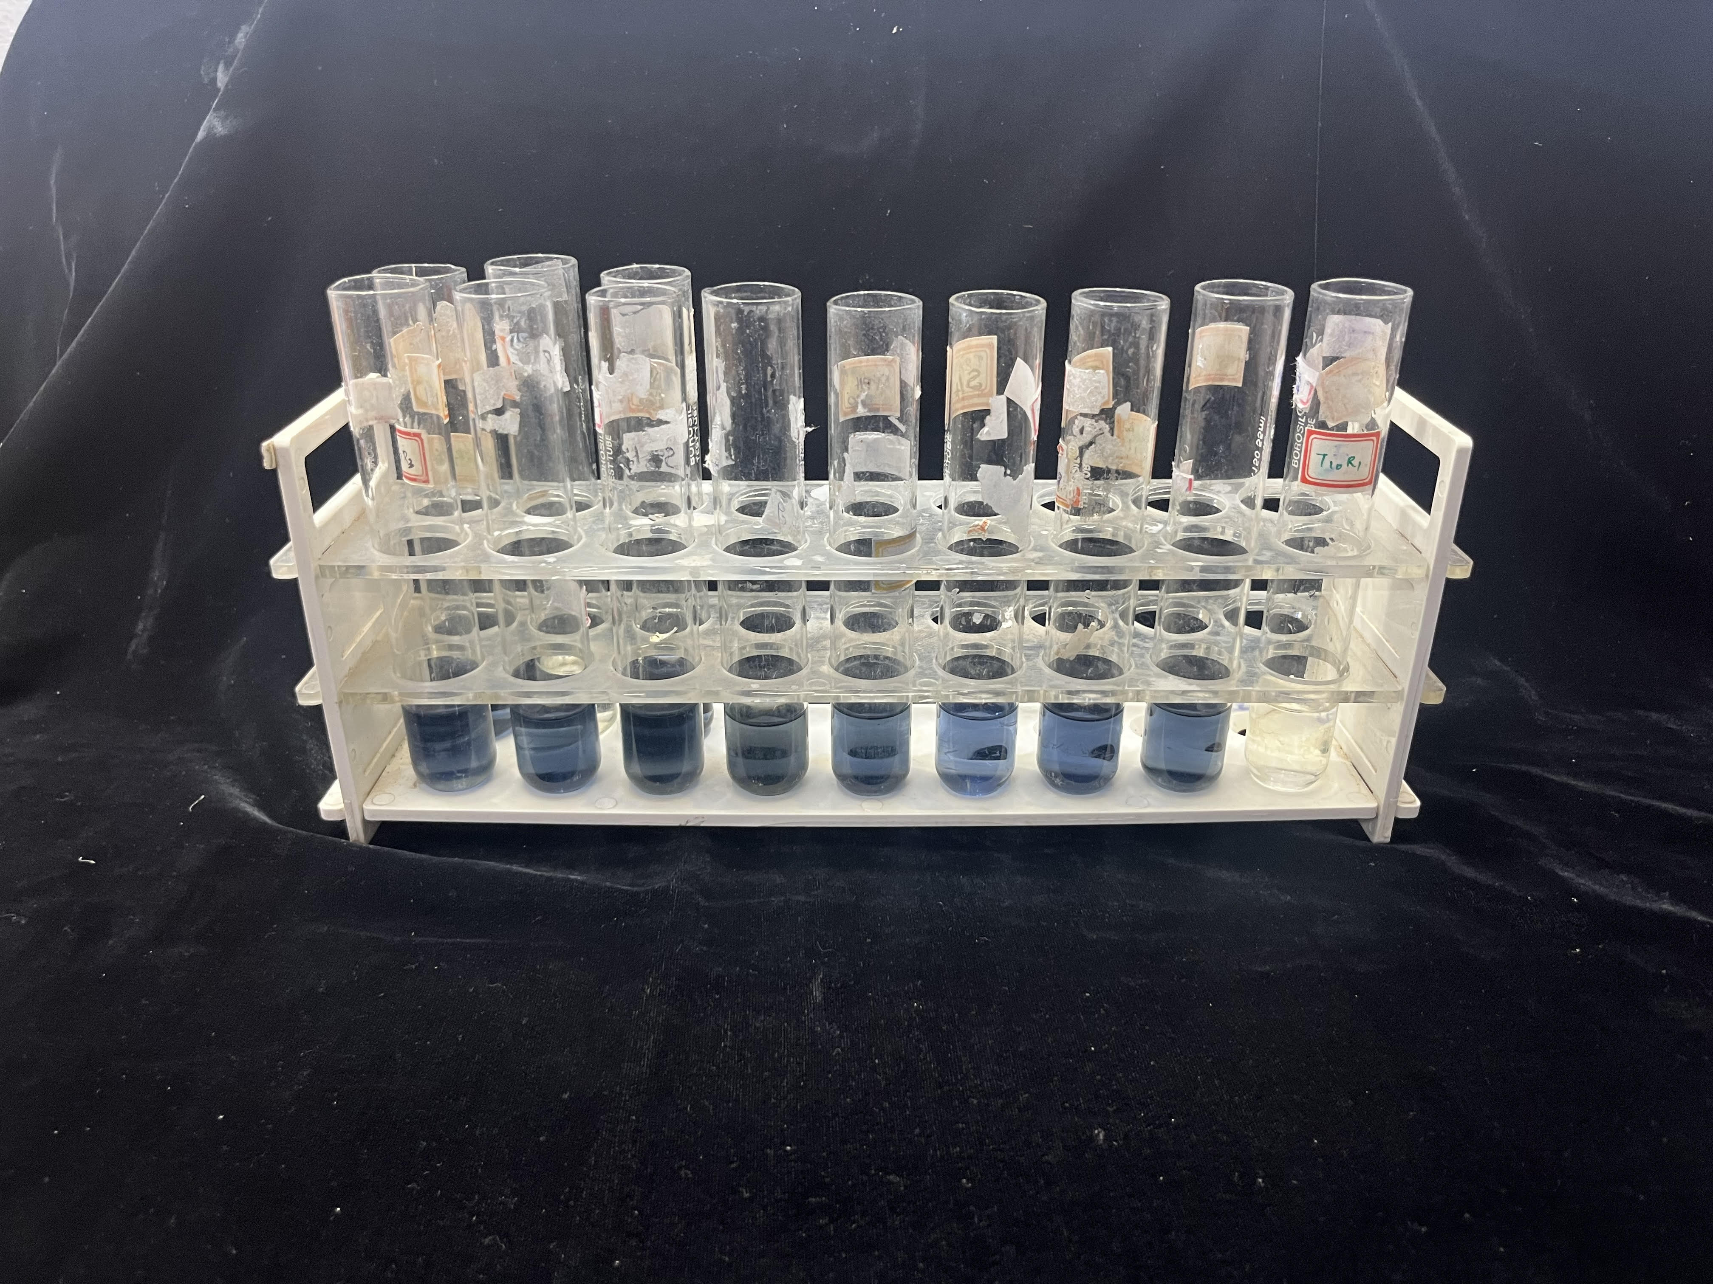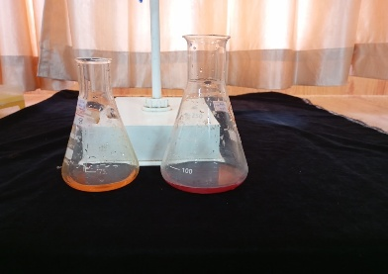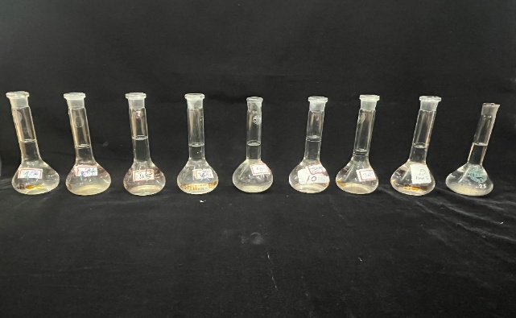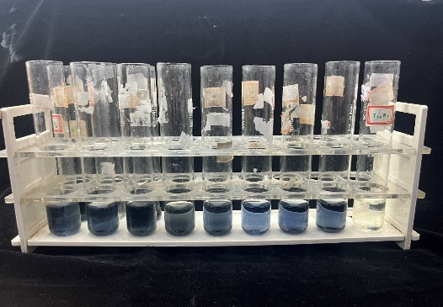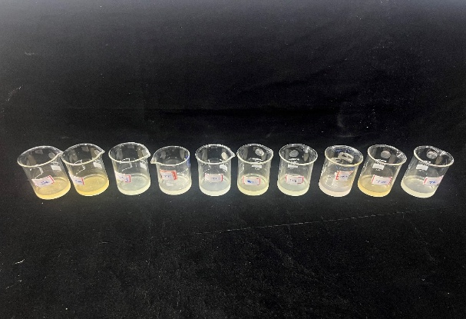Figure 1: Rose genotypes used in the study
Andra red
Seven day
Button rose
Edward rose
Kashmiri rose
KAU R 2
KAU R 4

KAU R 5

KAU R 8

KAU R 10

KAU R 12
KAU R 14
KAU R 13
KAU R 26
Rockstar
i
ii
iii
iv
v
vi

Figure 2: Estimation of biochemical characteristics: (i) Phenolic content (ii) Flavonoid (iii) Protein (iv) Vitamin C (v) Carotenoid and (vi) Anthocyanin

Rose genotypes | Proteins (mg/100g) | Phenol content (mg GAE/g) | Flavonoid (mg QE/g)
Andra Red | 0.16 ^{ab} | 74.66 ^{e} | 315.70 ^{ef}
Seven day | 0.12 ^{c} | 77.98 ^{d} | 297.10 ^{hi}
Button Rose | 0.13 ^{bc} | 81.70 ^{bc} | 299.25 ^{hi}
Edward Rose | 0.13 ^{bc} | 74.92 ^{e} | 122.50 ^{l}
Kashmiri Rose | 0.002 ^{e} | 83.44 ^{b} | 293.70 ^{ij}
KAU R 2 | 0.20 ª | 77.92 ^{d} | 320.15 ^{de}
KAU R 4 | 0.05 ^{d} | 53.97 ^{j} | 388.15 ^{c}
KAU R 5 | 0.001 ^{e} | 67.01 ^{g} | 289.00 ^{j}
KAU R 8 | 0.12 ^{c} | 49.37 ^{k} | 399.00 ^{b}
KAU R 10 | 0.14 ^{bc} | 63.20 ^{h} | 423.10 ª
KAU R 12 | 0.16 ^{b} | 65.76 ^{g} | 197.70 ^{k}
KAU R 13 | 0.15 ^{bc} | 56.92 ^{i} | 303.05 ^{gh}
KAU R 14 | 0.16 ^{b} | 80.98 ^{c} | 325.40 ^{d}
KAU R 26 | 0.003 ^{e} | 86.80 ª | 308.75 ^{fg}
Rock star | 0.13 ^{bc} | 70.08 ^{f} | 288.70 ^{j}
CD | 0.04 | 1.74 | 8.00
CV | 16.90 | 1.15 | 1.23
Table 1: Protein, phenol and flavonoid content of rose genotypes

Rose genotypes | Carotenoids mg/100g | Anthocyanin (mg/100g) | Vitamin C (mg/100g)
Andra Red | 4.25^{d} | 374.80 ^{c} | 44.50 ^{b}
Seven day | 3.85 ^{ef} | 257.35 ^{j} | 33.50 ^{ef}
Button Rose | 4.25 ^{d} | 342.00 ^{f} | 32.50 ^{f}
Edward Rose | 3.75 ^{f} | 310.10 ^{h} | 34.50 ^{e}
Kashmiri Rose | 5.15 ^{ab} | 354.95 ^{d} | 21.50 ^{gh}
KAU R 2 | 5.05 ^{b} | 400.15 ª | 47.50 ª
KAU R 4 | 1.25 ^{g} | 54.95 ^{l} | 17.50 ^{i}
KAU R 5 | 4.45 ^{c} | 355.95 ^{d} | 20.50 ^{h}
KAU R 8 | 1.25 ^{g} | 48.25 ^{m} | 34.50 ^{e}
KAU R 10 | 3.95 ^{e} | 320.05 ^{g} | 37.50 ^{d}
KAU R 12 | 4.45 ^{c} | 313.40 ^{h} | 40.50 ^{c}
KAU R 13 | 1.35 ^{g} | 62.00 ^{k} | 41.50 ^{c}
KAU R 14 | 4.45 ^{c} | 380.30 ^{b} | 44.50 ^{b}
KAU R 26 | 5.15 ^{ab} | 348.00 ^{e} | 22.50 ^{g}
Rock star | 5.25 ª | 300.90 ^{i} | 32.50 ^{f}
CD | 0.04 | 1.74 | 8.00
CV | 16.90 | 1.15 | 1.23
Table 2: Carotenoid, Anthocyanin and Vitamin C content of rose genotypes

S.No. | Elite rose genotypes | Dominant biochemical characteristics
1. | KAU R 26 | Phenolic content, Carotenoid
2. | KAU R 10 | Flavonoid
3. | KAU R 2 | Anthocyanin, Vitamin C, Protein
4. | Rock star | Carotenoid
5. | Kashmiri rose | Carotenoid
Table 3: Elite rose genotypes having promising biochemical profile

