Spatial Variability of Soil Properties in a Walnut Ecosystem of the Kashmir Himalaya

Abstract
Digital soil mapping has emerged as a powerful tool for generating detailed soil information in time and cost-efficient manner with better accuracy and higher spatial resolution. The present study was conducted during 2024–2025 at the Walnut Research Station, Kulangam, Kupwara district of Jammu and Kashmir, India, to assess the spatial variability of soil physico-chemical and biological properties for improving site-specific nutrient management in walnut (Juglans regia L.) growing soils. Despite the economic importance of walnut cultivation in the region, spatially explicit information on soil properties remains limited, constraining precision nutrient management. A total of 110 geo-referenced soil samples were collected on a 30 × 30 m grid and analyzed using standard laboratory procedures. Spatial interpolation and thematic map generation were carried out using ArcGIS software. The results revealed that soils were predominantly loam to clay loam in texture, with pH ranging from 6.13–7.49 and low electrical conductivity (0.05–0.15 dS m⁻¹), indicating non-saline conditions. Organic carbon ranged from 0.92–1.15% and cation exchange capacity from 17.02–21.14 cmol(p⁺) kg⁻¹. The available macronutrient contents (kg ha⁻¹) ranged from 220.12 to 410.04 for nitrogen, 8.98 to 37.13 for phosphorus, 140.27 to 457.28 for potassium, and 10.01 to 36.51 for sulphur. Exchangeable calcium and magnesium contents varied between 4.12–5.16 cmol(p⁺) kg⁻¹ and 2.36–2.62 cmol(p⁺) kg⁻¹, respectively, indicating adequate base saturation. Among DTPA-extractable micronutrients, iron (Fe), manganese (Mn) and copper (Cu) were found to be generally adequate across the study area. However, zinc (Zn) deficiency was observed in more than 50% of the sampling locations, highlighting it as a critical limiting nutrient for walnut productivity. Microbial populations followed the order: bacteria > actinomycetes > fungi, indicating biologically active soils. Overall, the study underscores the effectiveness of digital soil mapping in delineating spatial variability of soil properties. The generated nutrient maps provide a robust scientific basis for precision nutrient management, facilitating improved input-use efficiency and sustainable walnut production in temperate agro-ecosystems of Kashmir.
Keywords: Digital soil mapping, geostatistics, soil fertility, spatial variability, walnut orchards, Kashmir Himalaya

1. Introduction
Walnut (Juglans regia L.) is a member of the family Juglandaceae (Mukarram et al., 2024) and is one of the most economically important temperate nut crops worldwide (Sharma et al., 2022). The family consists of nearly 60 species, 21 of which belong to the genus Juglans (Sajjad et al., 2024). The crop is believed to have originated in Eastern Europe and Asia Minor but now it grows throughout the Himalayan region (Pollegioni et al., 2020; Li et al., 2023). Globally, walnut is cultivated in several countries but most of its production is concentrated in few major regions. China accounts for about 57% of global walnut production which is followed by the United States (24%) and Chile (6%), while India contributes nearly 1% of the global share as per USDA (2025). In India, walnut is grown over an area of approximately 97,284 hectares and with an annual production of about 317,776 tonnes (FAOSTAT, 2024). In India, Jammu and Kashmir region dominates walnut cultivation accounting for approximately 80.58% of the total area and 91.16% of production, thereby emerging as the leading walnut-producing region (Bhat et al., 2024). Among the major walnut-growing districts of the Kashmir Valley, Kupwara, Baramulla, Budgam, Srinagar, Pulwama and Anantnag hold particular significance (Sharma et al., 2022). The district Kupwara has been recognized under the One District One Product (ODOP) initiative as a leading walnut-producing region in Jammu and Kashmir (Government of Jammu & Kashmir, 2024). The district accounts for approximately 8,820 hectares under walnut cultivation, with an annual production of about 37,010 tonnes (Government of Jammu & Kashmir, 2024). Walnut cultivation in the Kashmir region is largely practiced on marginal lands with minimal external inputs which reflect its traditional and low-intensity management system (Lone et al., 2023). However, the productivity of walnuts in the Kashmir region remains highly variable and is strongly influenced by soil fertility, nutrient management and prevailing environmental conditions despite of this substantial potential (Yılmaz, 2021; Lone et al., 2023; Ramzan et al., 2025). The soil-related constraints such as suboptimal fertility, imbalanced pH, poor drainage and low organic matter content frequently limit growth and yield (Weil and Brady, 2016; Yan et al., 2024). Therefore, soil management practices are essential for enhancing productivity and ensuring sustainable livelihoods for farmers. Recognizing this need, the Centre for Excellence on Walnut Research was established at Kulangam by SKUAST-Kashmir to strengthen research efforts aimed at improving walnut cultivation in the region. A comprehensive understanding of the spatial variability of soil properties is fundamental for effective nutrient management and sustainable agricultural production (Vasu et al., 2017; Metwally et al., 2019). Conventional soil mapping approaches are often labor-intensive and may not adequately capture fine-scale variability as soils are typically represented as generalized mapping units (McBratney et al., 2003; Behrens and Scholten, 2006; Kempen et al., 2012). In contrast, recent advances in remote sensing, geographic information systems (GIS) and spatial statistical methods have significantly enhanced the assessment of soil variability. Digital Soil Mapping is a quantitative approach that integrates field observations and laboratory analyses with spatial environmental data to predict and map soil properties across landscapes (Adeniyi et al., 2024). Compared to conventional methods DSM provides spatially explicit, high-resolution information that is critical for site-specific nutrient management (Sharma et al., 2025). This approach is particularly valuable in heterogeneous landscapes such as the temperate Himalayan region (Kalambukattu et al., 2025) where soil properties exhibit significant variability over short distances. Despite the economic significance of walnut cultivation in Kashmir, the detailed and spatially explicit information on soil physical, chemical and biological properties in walnut orchards remains limited. Most earlier studies have primarily focused on general soil fertility status with relatively little emphasis on spatial variability. Therefore, the application of digital soil mapping techniques in walnut-based agroecosystems is essential to generate high-resolution insights into soil variability and nutrient distribution. For addressing this gap, the present study was undertaken to assess the spatial variability of soil physical, chemical and biological properties in a walnut-based ecosystem of the Kashmir Himalaya. The specific objectives were to (i) evaluate the status of major soil nutrients and microbial properties, (ii) analyze their spatial variability, and (iii) generate spatial distribution maps using digital soil mapping techniques for site-specific nutrient management. The findings are expected to provide a scientific basis for site-specific nutrient management and contribute to the sustainable intensification of walnut production systems in the temperate agro-ecosystems of Kashmir.
2. Materials and Methods
2.1 Study Site
Jammu and Kashmir represents the largest walnut-growing region in India. The district Kupwara is one of the most prominent areas for walnut cultivation. The present study was conducted at the Walnut Research Station, Kulangam, located in Kupwara district of Jammu and Kashmir. The research station is geographically situated at 34°25′20.78″ N latitude and 74°18′2.26″ E longitude, with an elevation of 1627 m above mean sea level. The region experiences temperate climatic conditions characterized by cold winters and mild summers. These agro-climatic conditions along with suitable soil characteristics contribute to the high productivity and quality of walnuts in the region.
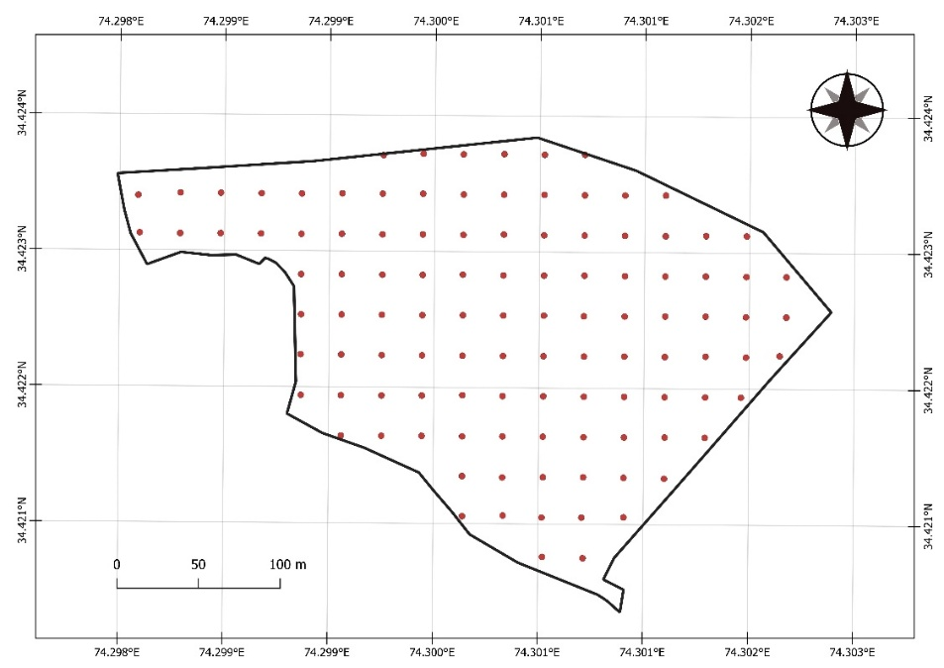
Fig. 1. Study area map showing the location of the Walnut Research Station, Kulangam
2.2 Collection and Processing of soil samples
The research station was divided into 110 grids with a spacing of 30 x 30 m, with the notations of P1-P110. The soil samples were collected from each grid separately at a depth of 0-30 cm using a Global Positioning System (GPS). The coordinates of all sampling points were entered into QGIS software to generate map of the study area (Fig. 1). A small portion of each soil sample was stored at 4℃ immediately after the collection of the samples for microbial analysis to avoid any possible contamination.
2.3 Soil Analysis
Soil samples were analyzed using standard laboratory procedures. Soil texture was determined by the hydrometer method (Bouyoucos, 1962) and textural classes were identified using the USDA textural triangle. Soil pH was measured in a 1:2.5 soil-water suspension using a digital pH meter, while electrical conductivity (EC) was determined using a conductivity meter (Jackson, 1973). Organic carbon was estimated by the rapid titration method (Walkley and Black, 1934), and cation exchange capacity (CEC) was determined by the ammonium acetate method (Jackson, 1973). Available nitrogen was determined by the alkaline potassium permanganate method using a Kjeldahl distillation apparatus (Subbiah and Asija, 1956). Available phosphorus was extracted with 0.5 M NaHCO₃ and determined spectrophotometrically (Olsen, 1954), while available potassium was extracted with neutral normal ammonium acetate and measured using a flame photometer (Jackson, 1973). Available sulphur was estimated by the turbidimetric method (Chesnin and Yien, 1951). Exchangeable calcium and magnesium were extracted using neutral normal ammonium acetate as described by Black et al. (1965). Available micronutrients (Zn, Cu, Fe and Mn) were determined by the DTPA extraction method (Lindsay and Norvell, 1978). The viable microbial populations (bacteria, fungi and actinomycetes) were enumerated using serial dilution and plate count techniques on selective media.
2.4 Mapping and Interpolation
Mapping the spatial distribution of soil properties requires spatial interpolation methods. Geographic coordinates along with associated soil attributes were imported into ArcGIS, where interpolation was performed using the Inverse Distance Weighting (IDW) method to generate spatial distribution maps for each soil parameter. IDW was selected due to the relatively low sampling density and the lack of strong spatial autocorrelation required for variogram-based kriging methods. In this approach, the influence of each sampled point on an unsampled location is determined by its distance, with nearer points exerting greater influence than those farther away. Points equidistant from the prediction location are assigned equal weights, highlighting the importance of spatial proximity (Burrough and McDonnell, 1998). The weight factor in this method is computed using the following equation:
$$λ_{i}=\frac{D_{i}^{-a}}{\sum_{i=1}^{n}{D_{i}^{-a}}}$$
where $λ_{i}$ represents the weight assigned to the $i^{th}$point, $D_{i}$is the distance between the sampled and prediction locations, and $a$is the power 10 of weight.
2.5 Data analysis
Descriptive statistical analysis of acquired results was done in accordance with the standard procedures as outlined by Gomez and Gomez (1984).
3. Results
3.1 Physical and chemical properties
Particle size distribution revealed that the soils of Walnut Research Station, Kulangam were predominantly classified as loam to clay loam with sand, silt and clay contents ranging from 22.94-46.98%, 26.04-49.81% and 15.13-30.96%, respectively, and corresponding mean values of 36.77%, 38.90% and 24.34% (Table 1, Fig. 2(a)). The coefficient of variation (CV) values indicated medium variability for sand (16.76%), silt (15.51%) and clay (18.85%), suggesting moderate spatial heterogeneity. The soil pH varied from 6.13 to 7.49 (mean 6.71) with low variability (CV 4.39%), indicating slightly acidic to slightly alkaline conditions (Table 1, Fig. 2(b)). The electrical conductivity ranged from 0.05–0.15 dS m⁻¹ (mean 0.07 dS m⁻¹), with high variability (CV 32.44%), yet all values were in non-saline range (Table 1, Fig. 2(c)). Organic carbon content ranged from 0.92–1.15% (mean 1.01%), showing low variability (CV 4.44%) and indicating a relatively uniform organic matter distribution across the station (Table 1, Fig. 2(d)). The cation exchange capacity varied from 17.02–21.14 cmol(p⁺) kg⁻¹, with a mean of 19.04 cmol(p⁺) kg⁻¹ (Table 1, Fig. 2(e)), and low variability (CV 6.35%).
The available nitrogen in the soils of Walnut Research Station, Kulangam ranged from 220.12–410.04 kg ha⁻¹ with a mean of 361.19 kg ha⁻¹ and low variability (CV 9.66%) (Table 2, Fig. 3 (a)). The available phosphorus varied from 8.98–37.13 kg ha⁻¹ (mean 20.53 kg ha⁻¹) with high variability (CV 33.17%), suggesting uneven distribution with localized deficiencies observed (Table 2, Fig. 3 (b)). Available potassium ranged from 140.27–457.28 kg ha⁻¹ (mean 323 kg ha⁻¹) and exhibited high variability (CV 24.99%) (Table 2, Fig. 3(c)). Exchangeable calcium (4.12–5.16 cmol(p⁺) kg⁻¹; mean 4.61 cmol(p⁺) kg⁻¹) and magnesium (2.36–2.62 cmol(p⁺) kg⁻¹; mean 2.49 cmol(p⁺) kg⁻¹) showed low variability (CV 6.34% and 3.28%, respectively), reflecting uniform distribution (Table 2, Fig. 3 (d) and (e)). Available sulphur ranged from 10.01–36.51 kg ha⁻¹ (mean 19.40 kg ha⁻¹) with very high variability (CV 30.66%) (Table 2, Fig. 3 (f)). Among micronutrients, iron (4.02–24.07 mg kg⁻¹; mean 14.36 mg kg⁻¹) and manganese (0.90–16.02 mg kg⁻¹; mean 7.70 mg kg⁻¹) (Table 2, Fig. 4 (a) and (b)), exhibited very high variability (CV 37.00% and 47.82%, respectively). Zinc (0.30–2.27 mg kg⁻¹; mean 0.76 mg kg⁻¹; CV 34.12%) emerged as the most limiting micronutrient, with more than half of the area categorized as low (Table 2, Fig. 4 (c)). The available copper ranged from 0.40–1.50 mg kg⁻¹ (mean 0.83 mg kg⁻¹) and despite of very high variability (CV 34.12%), remained sufficient in most parts of the station (Table 2, Fig. 4 (d)).
3.2 Biological properties
The total viable bacterial count in soils of Walnut Research Station, Kulangam ranged from 64.23 × 10⁶ to 98.99 × 10⁶ cfu g⁻¹ soil, with a mean of 81.44 × 10⁶ cfu g⁻¹ soil, indicating medium variability (CV 12.38%) and moderate spatial heterogeneity (Table 3, Fig. 5 (a)). The viable actinomycete count ranged from 44.87 × 10⁵ to 91.00 × 10⁵ cfu g⁻¹ soil, with a mean of 69.18 × 10⁵ cfu g⁻¹ soil, exhibiting medium variability (CV 18.97%) (Table 3, Fig. 5 (b)). The viable fungal population varied from 23.42 × 10⁴ to 48.90 × 10⁴ cfu g⁻¹ soil, with a mean of 35.58 × 10⁴ cfu g⁻¹ soil (Table 3, Fig. 5 (c)). The higher coefficient of variation (21.14%) reflected considerable spatial variability.
Table 1. Descriptive statistics of soil physical and chemical properties in the study area
Parameter | Mean | Range | CV (%) | 95% confidence interval
Sand (%) | 36.77 | 22.94–46.98 | 16.76 | 35.61–37.93
Silt (%) | 38.90 | 26.04–49.81 | 15.51 | 37.76–40.03
Clay (%) | 24.34 | 15.13–30.96 | 18.85 | 23.47–25.20
pH | 6.71 | 6.13–7.49 | 4.39 | 6.66–6.77
EC (dS m⁻¹) | 0.07 | 0.05–0.15 | 32.44 | 0.07–0.08
OC (%) | 1.01 | 0.92–1.15 | 4.44 | 1.00–1.02
CEC (cmol(p⁺) kg⁻¹) | 19.04 | 17.02–21.14 | 6.35 | 18.81–19.27
CV = Coefficient of Variation

Table 2. Descriptive statistics of soil available macro- and micronutrients in the study area
Parameter | Mean | Range | CV (%) | 95% confidence interval
Available N (kg ha⁻¹) | 361.19 | 220.12–410.04 | 9.66 | 354.60–367.78
Available P (kg ha⁻¹) | 20.53 | 8.98–37.13 | 33.17 | 19.24–21.81
Available K (kg ha⁻¹) | 323.00 | 140.27–457.28 | 24.99 | 307.75–338.26
Exchangeable Ca (cmol(p⁺) kg⁻¹) | 4.61 | 4.12–5.16 | 6.34 | 4.55–4.66
Exchangeable Mg (cmol(p⁺) kg⁻¹) | 2.49 | 2.36–2.62 | 3.28 | 2.48–2.51
Sulphur (mg kg⁻¹) | 19.40 | 10.01–36.51 | 30.66 | 18.28–20.53
Iron (mg kg⁻¹) | 14.36 | 4.02–24.07 | 37.00 | 13.35–15.36
Manganese (mg kg⁻¹) | 7.70 | 0.90–16.02 | 47.82 | 7.00–8.39
Zinc (mg kg⁻¹) | 0.76 | 0.30–2.27 | 68.22 | 0.66–0.86
Copper (mg kg⁻¹) | 0.83 | 0.40–1.50 | 34.12 | 0.77–0.88
CV = Coefficient of Variation
Table 3. Descriptive statistics of soil biological properties in the study area
Parameter | Mean | Range | CV (%) | 95% confidence interval
Bacterial Count (cfu ×10⁶ g⁻¹ soil) | 81.44 | 64.23–98.99 | 12.38 | 79.53–83.34
Actinomycete Count (cfu ×10⁵ g⁻¹ soil) | 69.18 | 44.87–91.00 | 18.97 | 66.70–71.66
Fungal Count (cfu ×10⁴ g⁻¹ soil) | 35.58 | 23.42–48.90 | 21.14 | 34.16–37.00
CV = Coefficient of Variation

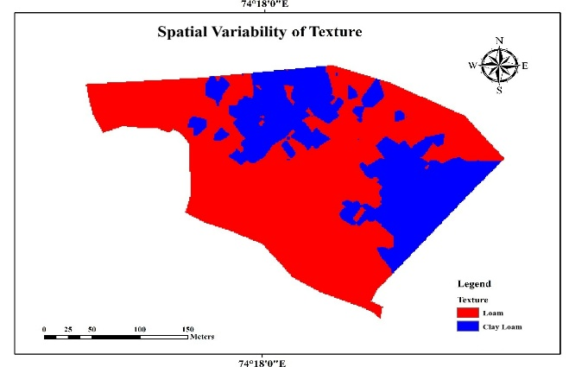
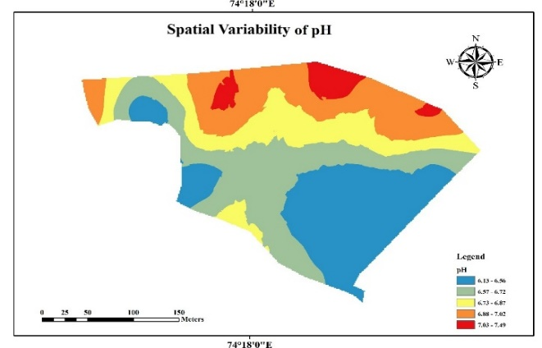
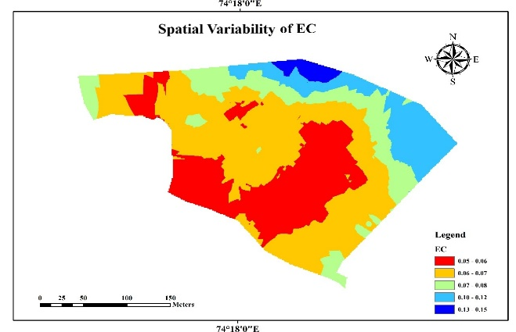
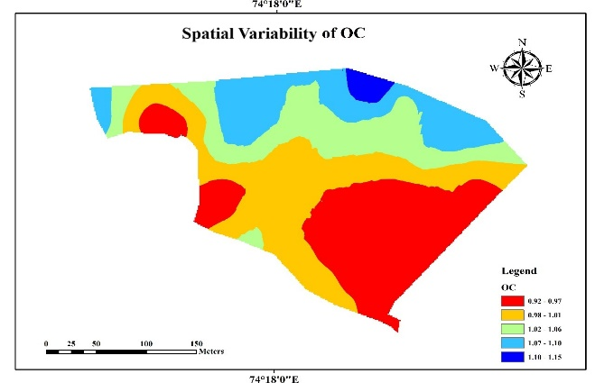
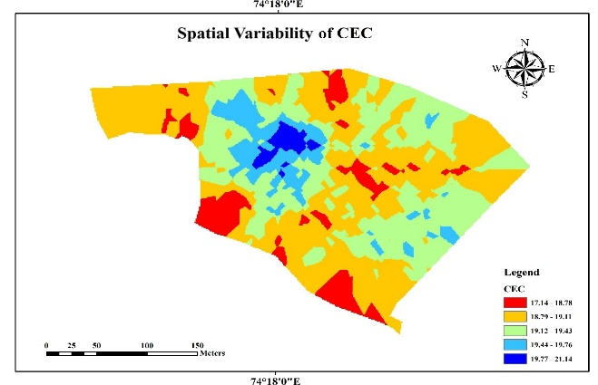
a)
b)
c)
d)
e)

Fig. 2. Thematic maps of a) Texture b) pH, c) EC, d) OC and e) CEC of soils of Walnut Research Station, Kulangam

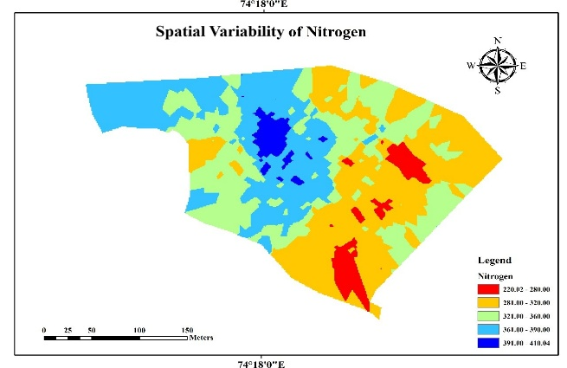
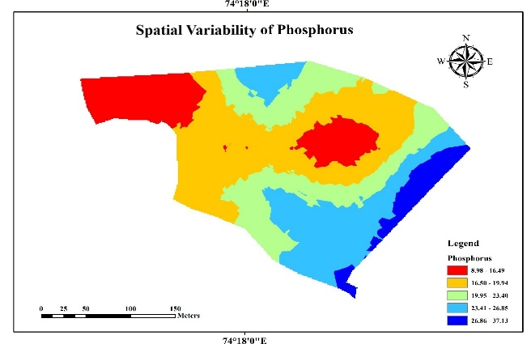
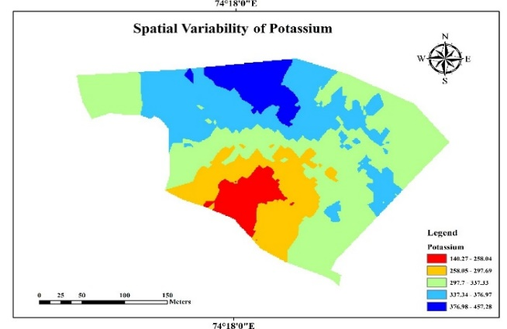
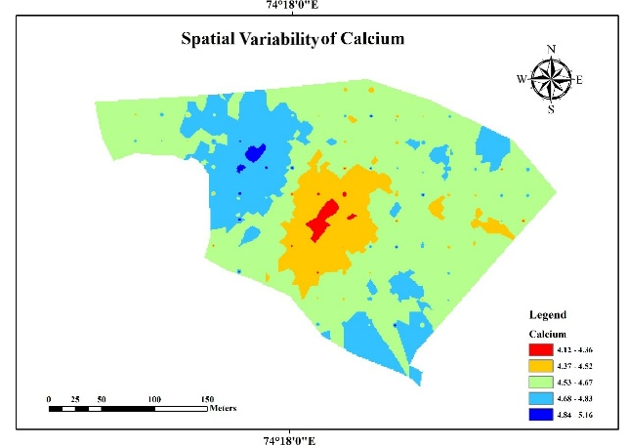
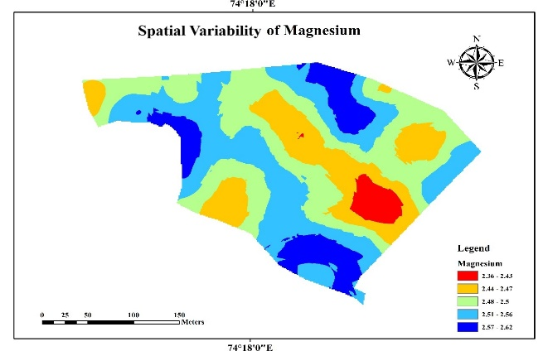
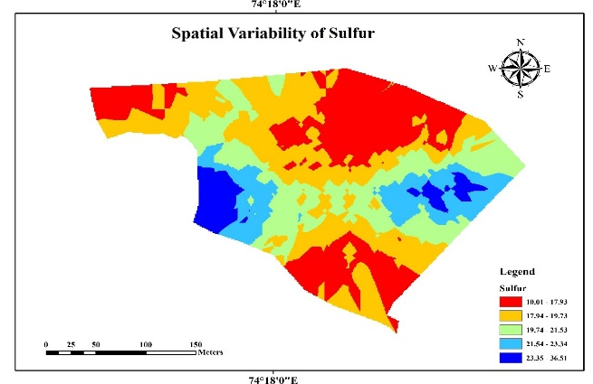
a)
b)
c)
d)
e)
f)

Fig. 3. Thematic maps of a) Av. N b) Av. P c) Av. K d) Ex. Ca e) Ex. Mg and f) Av. S of soils of Walnut Research Station, Kulangam

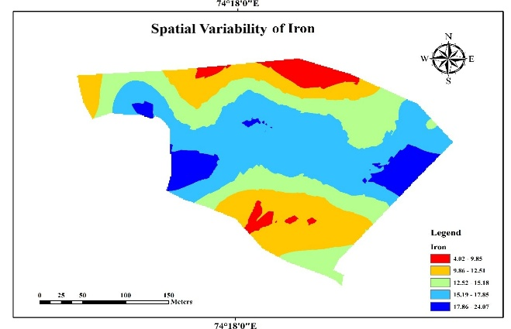
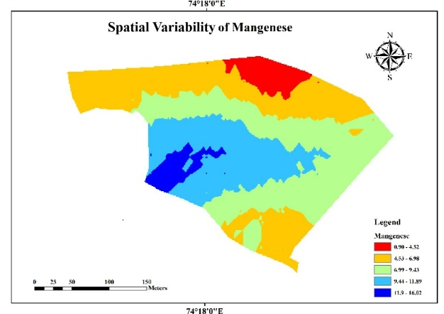
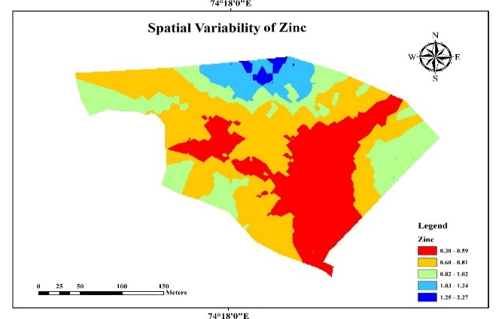
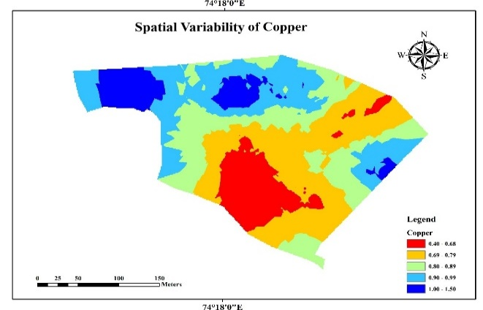
a)
d)
c)
b)

Fig. 4. Thematic maps of a) Av. Fe b) Av. Mn c) Av. Zn and d) Av. Cu of soils of Walnut Research Station, Kulangam

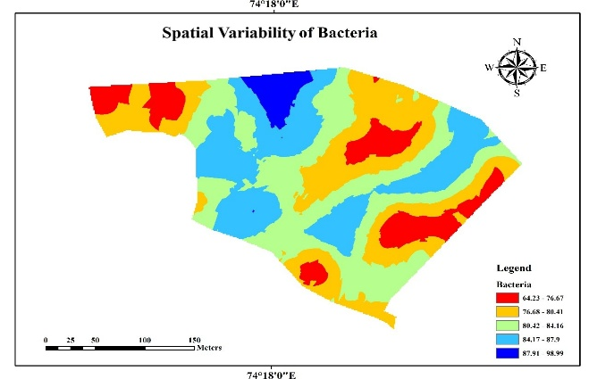
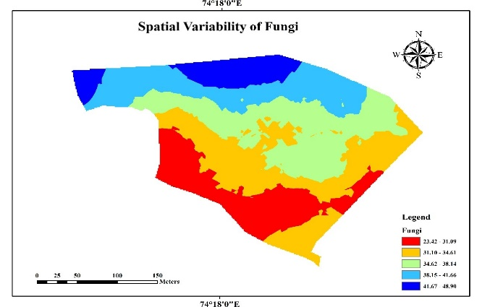
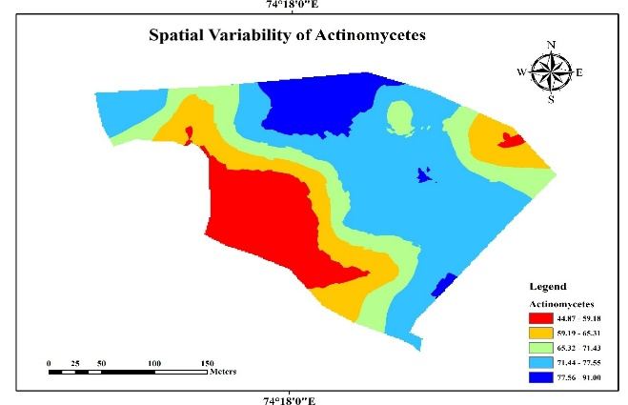
a)v
b)v
c)v

Fig. 5. Thematic maps of a) Bacterial count b) Actinomycetes and c) Fungal count of soils of Walnut Research Station, Kulangam
4. Discussion
4.1 Physical and chemical properties
The soils of Walnut Research Station, Kulangam were predominantly classified as loam to clay loam and such soils provide favourable conditions for moisture retention, aeration and nutrient availability. The moderate variability in particle size distribution reflects the influence of altitude and relief on pedogenic processes with finer particles accumulating in lower landscape positions and increasing clay content compared to upland soils. Similar trends have been reported in Kashmir soils where altitude and relief significantly influenced soil texture (Mahapatra et al., 2000; Arunkumar, 2002). Soil reaction ranged from slightly acidic to slightly alkaline with low spatial variability which indicates relatively stable pedogenic conditions that favor nutrient availability and microbial activity. The limited variability suggests uniformity in soil-forming factors across the study area while minor variations may be attributed to differences in parent material, organic matter decomposition, topography and drainage. Comparable pH ranges have been reported from the Kupwara region of Kashmir where soils under different land use systems also varied from slightly acidic to slightly alkaline (Shah et al., 2022). Similar trends have also been observed in other parts of Kashmir, including Ganderbal district, where soils range from acidic to slightly alkaline (Maqbool et al., 2017), and earlier studies have reported predominantly slightly acidic to neutral pH conditions with localized variations (Mahapatra et al., 2000; Bangroo et al., 2021). Electrical conductivity values indicated non-saline condition of soils suggesting favourable chemical conditions for crop growth. The low EC values reflect minimal accumulation of soluble salts, while minor variations may be attributed to differences in soil texture and leaching processes. Comparable observations have been reported for Kashmir soils where EC values generally remain within the normal range despite variations due to topographic factors and land use practices (Najar et al., 2009; Wani et al., 2009; Maqbool et al., 2017).Organic carbon levels were generally medium to high with low spatial variability which may be attributed to continuous litter deposition, root biomass accumulation, active microbial processes and low temperature that slows decomposition under the walnut ecosystem (Kumar et al., 2022). However, spatial variability in organic carbon may also be influenced by factors such as topography, soil texture, vegetation and management practices (Wani et al., 2023). Comparable organic carbon levels have been reported in soils of the Kupwara region including maize-growing soils of Handwara, suggesting similar soil fertility status under temperate conditions (Mansoor et al., 2022). The moderate to high cation exchange capacity reflects stable nutrient retention and this is largely governed by natural soil-forming factors (climate, hillslope position, parent material, organisms and soil development), soil components (clay minerals, soil organic matter) and land management practices in temperate and alpine regions (Ouyang et al., 2023). These findings are in agreement with previous studies conducted in Kupwara, where cation exchange capacity has been reported to be positively associated with organic carbon and clay content (Chesti et al., 2022). The soils exhibited medium nitrogen status with noticeable spatial variability which may be attributed to differences in organic matter mineralization, microbial activity and management practices such as manure application and fertilizer use. Variations in nitrogen concentration across the study area may also be influenced by prior cropping and soil management practices (Thomas et al., 2019, Bangroo et al., 2023). The soils exhibited medium phosphorus status with considerable spatial variability, which may be influenced by fertilizer inputs, organic matter and soil reaction. Greater phosphorus availability in certain areas may be attributed to the dissolution of calcium-bound phosphorus under near-neutral soil conditions (Penn & Camberato, 2019). Soil pH plays a critical role in phosphorus availability as under alkaline conditions (pH > 7) phosphorus tends to form insoluble compounds with calcium whereas under acidic conditions it becomes fixed with iron and aluminium oxides which reduces its availability (Rahman et al., 2018). Phosphorus availability is generally optimal within a pH range of 6.0–7.5 and is further influenced by factors such as organic matter content, fertilizer placement and losses through erosion and runoff. Potassium levels were generally high which may be likely due to the dominance of potassium-bearing illitic clay minerals and mineral weathering processes. Higher organic matter content may also contribute to increased potassium availability. Similar findings have been reported in Kashmir soils by Shah et al. (2022). Exchangeable calcium and magnesium showed generally high levels with relatively low spatial variability, indicating favourable base saturation and the influence of parent material. Similar trends have been reported where variations in Ca and Mg are influenced by organic matter and leaching processes (Gebrelibanos and Assen, 2013). The relatively high levels of calcium and magnesium may also be attributed to the calcareous nature of the soils as reported for Kashmir soils (Mahapatra, 2000; Sidhu and Surya, 2014; Wani et al., 2016). Available sulphur exhibited spatial variability with localized deficiencies which may be likely influenced by differences in organic matter content, parent material and sulphate leaching processes. Sulphur availability is closely associated with organic matter dynamics, as it is largely present in organic forms and released through mineralization. Variations in sulphur distribution may also be related to differences in sulphur fractions and soil processes governing its transformation and mobility. Similar observations have been reported in soils where sulphur accumulation is influenced by organic matter inputs and associated biogeochemical processes (Tanikawa et al., 2013; Dad and Abdollahi, 2021). Among micronutrients, iron and manganese exhibited considerable variability which may be attributed to their sensitivity to soil pH, redox conditions and interactions with organic matter (Aggarwal et al., 2025; Anas et al., 2026). Zinc emerged as the most limiting micronutrient due to its sensitivity to soil reaction and interactions with phosphorus. Copper also showed variability but remained sufficient in most areas which may be likely due to its strong association with organic matter (Wang et al., 2022). The availability of micronutrients is closely linked to organic matter content as it acts as a key source and regulator of micronutrient dynamics in soils and changes in organic matter can significantly influence their distribution and availability (Sheng et al., 2003; Sangha et al., 2005; Abbasi et al., 2010).
4.2 Biological properties
The microbial population analysis indicated biologically active soils with bacterial dominance and relatively stable actinomycete populations whereas fungal populations showed greater spatial variability associated with differences in organic substrates and microclimatic conditions. Microbial abundance is strongly influenced by organic matter inputs which serve as substrates for growth while variations in temperature, moisture and soil microclimate regulate microbial activity and distribution (Sharma & Mishra, 1992; Salam et al., 1998; Sahani & Behera, 2001; Abbasi et al., 2010).
The present study employed the Inverse Distance Weighting (IDW) method for spatial interpolation, which is a deterministic approach and does not explicitly account for spatial autocorrelation. The absence of variogram modelling and cross-validation may limit the precision and predictive accuracy of the generated spatial maps. Additionally, the study was conducted within a single research station, which may limit the generalization of the findings to other regions. Future studies should incorporate geostatistical methods such as kriging and advanced digital soil mapping approaches, including machine learning techniques, along with validation procedures to improve the robustness and accuracy of spatial predictions.
5. Conclusion
The study revealed that soils were predominantly loam to clay loam, slightly acidic to slightly alkaline in nature, with medium to high organic carbon. The macronutrient status showed low to medium nitrogen, low to high phosphorus and generally medium to high potassium concentration. The calcium and magnesium concentration was sufficient. The sulphur exhibited high variability and deficient in some areas. The micronutrients such as Fe, Mn and Cu were generally adequate, whereas Zn was found to be deficient in most of the areas. The soil microbial population followed the order bacteria > actinomycetes > fungi, indicating a balanced biological environment. The findings provide reliable baseline data for site-specific nutrient management and sustainable walnut cultivation of the Research Station. However, the results should be interpreted considering the limitations of the interpolation approach used. The present study employed the IDW method, which does not explicitly account for spatial autocorrelation and lacks model validation. Therefore, future studies should incorporate geostatistical techniques such as kriging and validation approaches to improve prediction accuracy.
Disclaimer (Artificial intelligence)

Author(s) hereby declare that NO generative AI technologies such as Large Language Models (ChatGPT, COPILOT, etc.) and text-to-image generators have been used during the writing or editing of this manuscript.

References
Abbasi, M. K., Zafar, M., & Sultan, T. (2010). Changes in soil properties and microbial indices across various management sites in the mountain environments of Azad Jammu and Kashmir. Communications in Soil Science and Plant Analysis, 41(6), 768-782.
Adeniyi, O. D., Bature, H., & Mearker, M. (2024). A systematic review on digital soil mapping approaches in lowland areas. Land, 13(3), 379.
Aggarwal, M., Anbukumar, S., & Kumar, T. V. (2025). The relationship between pH, organic matter and heavy metal concentrations in surface sediment of Ganga River, India. Water Environment Research, 97(8), e70160.
Anas, M., Khattak, W. A., Majeed, M., Hakki, E. E., & Fahad, S. (2026). Redox reactions and their influence on the nutrient availability of plants. In Sustainable Soil Chemistry and Plant Nutrition (pp. 195-218). Elsevier.
Arunkumar, V., Natarajan, S., & Sivasamy, R. (2002). Characterisation and classification of soils of Lower Palar-Manimuthar watershed of Tamil Nadu. Agropedology, 12, 97-103.
Bangroo, S. A., Bhat, M. I., Wani, J. A., Rasool, R., Madhi, S. S., Bashir, O., & Shah, T. I. (2023). Mapping soil properties using geostatistical methods for mid to high altitude temperate zone of Kashmir Himalayas. Journal of the Indian Society of Soil Science, 71(1), 1-12.
Bangroo, S. A., Sofi, J. A., Bhat, M. I., Mir, S. A., Mubarak, T., & Bashir, O. (2021). Quantifying spatial variability of soil properties in apple orchards of Kashmir, India, using geospatial techniques. Arabian Journal of Geosciences, 14(19), 2047.
Behrens, T., & Scholten, T. (2006). Digital soil mapping in Germany—a review. Journal of Plant Nutrition and Soil Science, 169(3), 434-443.
Bhat, F. J., Bhat, A., Sharma, P., Sharma, E., Kumar, R., & Deep, A. (2024). Market dynamics of walnut in Jammu and Kashmir. Economic Affairs, 69(4), 1643-1651.
Black, C. A., Evans, D. D., White, J. L., Ensminger, L. E., & Clarke, F. E. (1965). Methods of soil analysis. American Society of Agronomy. Madison, Wisconsin, 1, 1-770.
Bouyoucos, G. J. (1962). Hydrometer method improved for making particle size analyses of soils. Agronomy Journal, 54(5), 464-465.
Burrough, P. A., & McDonnell, R. A. (1998) Creating continuous surfaces from point data. In: Principles of Geographic Information Systems (P.A. Burrough and R.A. McDonnell, Eds.), pp 1–19. Oxford University Press, Oxford.
Chesnin, L., & Yien, C. H. (1951). Turbidimetric determination of available sulfates. Soil Science Society of America Journal, 15, 149-151.
Chesti, M. H., Mir, S. A., Khan, I. M., Baligah, H. U., Mir, A. H., Qadri, T. N., & Bhat, M. A. (2022). Potassium Forms in Brown Sarson Growing Soils in District Kupwara, Kashmir. Journal of Experimental Agriculture International, 44(9), 27-34.
Dad, J. M., & Abdollahi, L. (2021). Changes in soil organic carbon, nitrogen and sulphur along a slope gradient in apple orchard soils of Kashmir Himalaya. Journal of Mountain Science, 18(9), 2377-2387.
Food and Agriculture Organization of the United Nations. (2024). FAOSTAT: Crops and livestock products database. https://www.fao.org/faostat/
Gebrelibanos, T., & Assen, M. (2013). Effects of land-use/cover changes on soil properties in a dry land watershed of Hirmi and its adjacent agro ecosystem: Northern Ethiopia. International Journal of Geosciences Research, 1(1), 45-57.
Gomez, K.A. and Gomez, A.A. (1984) Statistical procedures for agricultural research. John Wiley and Sons
Government of Jammu & Kashmir. (2024). One District One Product (ODOP), Kupwara. https://kupwara.nic.in/odop/
Jackson, M. L. (1973). Soil chemical analysis, pentice hall of India Pvt. Ltd., New Delhi, India, 498, 151-154.
Kalambukattu, J. G., Kumar, S., Das, B., & Roy, T. (2025). Digital mapping of soil organic carbon in the hilly and mountainous landscape of Indian Himalayan region employing machine-learning techniques. Discover Soil, 2(1), 35.
Kempen, B., Brus, D. J., Stoorvogel, J. J., Heuvelink, G. B., & de Vries, F. (2012). Efficiency comparison of conventional and digital soil mapping for updating soil maps. Soil Science Society of America Journal, 76(6), 2097-2115.
Kumar, S. S., Mir, S. A., Wani, O. A., Babu, S., Yeasin, M., Bhat, M. A., ... & Dar, S. R. (2022). Land-use systems regulate carbon geochemistry in the temperate Himalayas, India. Journal of Environmental Management, 320, 115811.
Li, X., Wang, X., Cui, Z., Shi, W., Huang, J., & Wang, J. (2023). Development of polymorphic microsatellite markers and identification of applications for Wild Walnut (Juglans regia L.) in Middle Asia. Diversity, 15(10), 1073.
Lindsay, W. L., & Norvell, W. (1978). Development of a DTPA soil test for zinc, iron, manganese, and copper. Soil Science Society of America Journal, 42(3), 421-428.
Lone, F. A., Ganaie, M. I., Ganaie, S. A., Bhat, M. S., & Rather, J. A. (2023). Walnut cultivation in Kashmir Valley, India: An economic & profitability assessment. https://doi.org/10.21203/rs.3.rs-2257964/v1
Mahapatra, S. K., Walia, C. S., Sidhu, G. S., Rana, K. P. C., & Lal, T. (2000). Characterization and classification of the soils of different physiographic units in the subhumid eco-system of Kashmir region. Journal of the Indian Society of Soil Science, 48(3), 572-576.
Mansoor, M., Alaie, T. A., Hakeem, S. A., & Irshad, I. (2022). Fertility Assessment of Major Maize Growing Soils of Kupwara District, J and K, India. Agricultural Reviews, 43(4).
Maqbool, M., Rasool, R., & Ramzan, S. (2017). Soil physico-chemical properties as impacted by different land use systems in district Ganderbal, Jammu and Kashmir: India. International Journal of Chemical Studies, 5(4), 832-840.
McBratney, A. B., Santos, M. M., & Minasny, B. (2003). On digital soil mapping. Geoderma, 117(1-2), 3-52.
Metwally, M. S., Shaddad, S. M., Liu, M., Yao, R. J., Abdo, A. I., Li, P., ... & Chen, X. (2019). Soil properties spatial variability and delineation of site-specific management zones based on soil fertility using fuzzy clustering in a hilly field in Jianyang, Sichuan, China. Sustainability, 11(24), 7084.
Mukarram, S. A., Wandhekar, S. S., Ahmed, A. E. M., Pandey, V. K., Csaba, O., Lajos, D., ... & Bela, K. (2024). Exploring the ecological implications, gastronomic applications, and nutritional and therapeutic potential of Juglans regia L.(Green Walnut): a comprehensive review. Nutrients, 16(8), 1183.
Najar, G. R., Akhtar, F., Singh, S. R., & Wani, J. A. (2009). Characterization and classification of some apple growing soils of Kashmir. Journal of the Indian Society of Soil Science, 57(1), 81.
Olsen, S. R. (1954). Estimation of available phosphorus in soils by extraction with sodium bicarbonate. United States Department of Agriculture, 939.
Ouyang, N., Zhang, P., Zhang, Y., Sheng, H., Zhou, Q., Huang, Y., & Yu, Z. (2023). Cation exchange properties of subsurface soil in mid-subtropical China: Variations, correlation with soil-forming factors, and prediction. Agronomy, 13(3), 741.
Penn, C. J., & Camberato, J. J. (2019). A critical review on soil chemical processes that control how soil pH affects phosphorus availability to plants. Agriculture, 9(6), 120.
Pollegioni, P., Lungo, S. D., Müller, R., Woeste, K. E., Chiocchini, F., Clark, J., ... & Mattioni, C. (2020). Biocultural diversity of common walnut (Juglans regia L.) and sweet chestnut (Castanea sativa Mill.) across Eurasia. Ecology and Evolution, 10(20), 11192-11216.
Rahman, M. A., Lee, S. H., Ji, H. C., Kabir, A. H., Jones, C. S., & Lee, K. W. (2018). Importance of mineral nutrition for mitigating aluminum toxicity in plants on acidic soils: current status and opportunities. International Journal of Molecular Sciences, 19(10), 3073.
Sahani, U., & Behera, N. (2001). Impact of deforestation on soil physicochemical characteristics, microbial biomass and microbial activity of tropical soil. Land Degradation & Development, 12(2), 93-105.
Sajjad, S., Islam, M., Muhammad, K., Ghafoor, S. U., Ullah, I., Khan, A., ... & Ali, S. (2024). Comprehensive evaluation of cryptic Juglans genotypes: Insight from molecular markers and phylogenetic analysis. Genes, 15(11), 1417.
Salam, A. K., Katayama, A., & Kimura, M. (1998). Activities of some soil enzymes in different land use systems after deforestation in hilly areas of West Lampung, South Sumatra, Indonesia. Soil Science and Plant Nutrition, 44(1), 93-103.
Sangha, K. K., Jalota, R. K., & Midmore, D. J. (2005). Impact of tree clearing on soil pH and nutrient availability in grazing systems of central Queensland, Australia. Soil Research, 43(1), 51-60.
Shah, A. M., Nazir, S. H. A. I. S. T. A., Shah, T. I., Mir, Y. H., Wani, F., & Rai, A. P. (2022). Assessment of various land use systems on soil potassium fractions and soil properties under lesser Himalayas. Journal of Soil and Water Conservation, 21(4), 371-377.
Sharma, A., Chauhan, A., Sahoo, C., Saini, A., Shilpa, & Ameena, M. (2025). Advancing Soil Quality Assessment: Precision Mapping Through GIS Techniques for Sustainable Land Management. In Soil Degradation, Desertification and Restoration: Application of Geospatial Technology and Modeling (pp. 359-385). Cham: Springer Nature Switzerland.
Sharma, G. D., & Mishra, R. R. (1992). Soil microbial population numbers and enzyme activities in relation to altitude and forest degradation. Soil Biology and Biochemistry, 24(8), 761-767.
Sharma, M., Sharma, M., & Sharma, M. (2022). A comprehensive review on ethnobotanical, medicinal and nutritional potential of walnut (Juglans regia L.). Proceedings of the Indian National Science Academy, 88(4), 601-616.
Sheng, X. B., Sun, J. Z., & Liu, Y. X. (2003). Effect of land-use and land-cover change on nutrients in soil in Bashang area, China. Journal of Environmental Sciences (China), 15(4), 548-553.
Sidhu, G. S., & Surya, J. N. (2014). Soils of North-Western Himalayan eco-system and their land use, constraints, productivity potentials and future strategies. Agropedology, 24(01), 1-19.
Subbiah, B. V., & Asija, G. L. (1956). A rapid method for the estimation of nitrogen in soil. Current Science, 26(5), 259-60.
Tanikawa, T., Yamashita, N., Aizawa, S., Ohnuki, Y., Yoshinaga, S., & Takahashi, M. (2013). Soil sulfur content and its spatial distribution in a small catchment covered by volcanic soil in the montane zone of central Japan. Geoderma, 197, 1-8.
Thomas, C. L., Acquah, G. E., Whitmore, A. P., McGrath, S. P., & Haefele, S. M. (2019). The effect of different organic fertilizers on yield and soil and crop nutrient concentrations. Agronomy, 9(12), 776.
U.S. Department of Agriculture, Foreign Agricultural Service. (2025). Production – Walnuts. https://www.fas.usda.gov/data/production/0577901
Vasu, D., Singh, S. K., Sahu, N., Tiwary, P., Chandran, P., Duraisami, V. P., ... & Kalaiselvi, B. (2017). Assessment of spatial variability of soil properties using geospatial techniques for farm level nutrient management. Soil and Tillage Research, 169, 25-34.
Walkley, A., & Black, I. A. (1934). An examination of the Degtjareff method for determining soil organic matter, and a proposed modification of the chromic acid titration method. Soil Science, 37(1), 29-38.
Wang, S., Xu, L., & Hao, M. (2022). Impacts of long-term micronutrient fertilizer application on soil properties and micronutrient availability. International Journal of Environmental Research and Public Health, 19(23), 16358.
Wani, M. H., Baba, S. H., & Yousuf, S. (2009). Land-use dynamics in Jammu and Kashmir. Agricultural Economics Research Review, 22(1), 145-154.
Wani, O. A., Kumar, S. S., Hussain, N., Wani, A. I. A., Babu, S., Alam, P., ... & Mansoor, S. (2023). Multi-scale processes influencing global carbon storage and land-carbon-climate nexus: A critical review. Pedosphere, 33(2), 250-267.
Wani, S. A., Najar, G. R., Ali, T., & Akhtar, F. (2016). Morphology, genesis and classification of pear growing soils of Pulwama district in Lesser Himalayas of temperate Kashmir. Journal of Environmental Biology, 37(5), 1021.
Weil, R. R., & Brady, N. C. (2016). The nature and properties of soils, ed. Columbus, Ohio: Pearson, 910.
Yan, R., Xiang, F., Li, Y., Li, X., Zhang, Y., & Li, J. (2024). Study on Soil Fertility Characteristics of Walnut Orchards with Different Parent Materials and Soil Types in Gyaca County, Tibet. Agronomy, 14(7), 1496.
Yılmaz, C. H. (2021). Soil management and fertilization in walnut. In M. A. Gündesli (Ed.), Walnut. Iksad Publications.
Ramzan, S., Ashraf, I., Lone, B. A., Akram, I., Akhter, S., Nabi, A., … Farooq, I. (2025). Spatial Variability of Soil Chemical Properties within a KVK Farm of Budgam in Lesser Himalayas. Asian Journal of Soil Science and Plant Nutrition, 11(1), 472–481. https://doi.org/10.9734/ajsspn/2025/v11i1496

