Original Research Article

Evaluation of Rice (Oryza sativa L.) Genotypes for Iron Toxicity Tolerance under Hydroponic Conditions

.
ABSTRACT

Background: Iron toxicity is a major abiotic constraint limiting rice (Oryza sativa L.) productivity in lowland ecosystems, particularly under waterlogged acidic soil conditions. Identifying tolerant genotypes through efficient screening methods such as hydroponics is essential for developing sustainable, stress-resilient rice varieties.
Aim: The study aims to evaluate rice germplasm for iron toxicity tolerance under controlled hydroponic conditions to identify potential donor lines for breeding programs.
Study design: Completely randomized design (CRD) with three replications under hydroponic conditions.
Place and Duration of Study: Farming Systems Research Station, Sadanandapuram, Kollam, on March 2022
Methodology: A total of 106 rice genotypes, including traditional cultivars and released varieties, were evaluated for iron toxicity tolerance using hydroponic culture. The study employed a Completely Randomized Design with three replications, assessing genotypes under four iron concentrations: 0 (control), 500, 750, and 1000 mg L⁻¹. Growth parameters, including shoot and root length, total and fresh root count, number of leaves and leaf bronzing scores, were recorded to evaluate tolerance levels.
Results: Analysis of variance revealed highly significant differences among genotypes for all traits except number of leaves at 750 and 1000 mg L⁻¹ and leaf bronzing score under control conditions. Increasing iron concentrations led to a progressive decline in growth; mean shoot length decreased from 17.7 cm to 16.0 cm, and root length from 8.2 cm to 7.0 cm at 1000 mg L⁻¹. A drastic reduction was observed in the number of roots and fresh roots due to damages on root epidermis, while the mean leaf bronzing score rose to 6.1 under maximum stress. Based on the visual scoring, 30 tolerant and moderately tolerant genotypes were identified of which thirteen landraces and seventeen releases varieties with high growth maintenance and low leaf bronzing scores at highest iron concentration were identified as potential donors for developing iron toxicity tolerant rice varieties.
Conclusion: Hydroponic screening proved to be an efficient and reliable method for rapid and early stage evaluation of iron toxicity tolerance in rice. Several tolerant and moderately tolerant genotypes identified can serve as valuable donor parents in breeding programmes focused on developing high yielding, iron toxicity tolerant rice varieties.

Keywords: Rice, iron toxicity tolerance, hydroponics, leaf bronzing score, screening.

1. INTRODUCTION

Rice (Oryza sativa L.) is one of the most important staple food crops cultivated extensively in tropical and subtropical regions. Productivity of the crop is often constrained by various abiotic stresses, among which iron toxicity is a major limitation in lowland rice ecosystems (Becker & Asch, 2005). Iron toxicity primarily occurs in waterlogged acidic soils where ferric iron (Fe³⁺) is reduced to soluble ferrous iron (Fe²⁺), resulting in excessive uptake by plants (Dobermann and Fairhurst, 2000). This leads to physiological disorders such as leaf bronzing, impaired root development and reduced yield.
The severity of iron toxicity depends on several factors including genotype, soil conditions and crop management practices (Suma et al., 2022). Although soil amendments (such as liming) and improved drainage can alleviate iron toxicity, these methods are often economically and technically inaccessible for small-scale farmers. Therefore, breeding genetically tolerant rice varieties represents a more sustainable, cost-effective, and environmentally friendly strategy for long-term stress management (Aung & Masuda, 2020).
Screening of genotypes for iron toxicity tolerance has been carried out using field trials, pot culture and hydroponic techniques. Field screening reflects natural conditions but is influenced by environmental variability while pot culture studies are highly labour intensive. Hydroponic screening provides controlled conditions with uniform stress imposition favouring high throughput and rapid results. Hence, hydroponic methods are widely used for early stage screening of large germplasm collections (Sikirou et al., 2015).
In this context, the present study was undertaken to evaluate a diverse set of rice genotypes for iron toxicity tolerance using hydroponic screening and to identify promising lines for further breeding programmes.

2. material and methods

The laboratory screening experiment was conducted at the Farming Systems Research Station (FSRS), Sadanandapuram, Kollam, Kerala during march 2022. The experimental material consisted of 106 rice (Oryza sativa L.) genotypes (Appendix 1), including 60 traditional cultivars and 46 released varieties collected from different research stations under Kerala Agricultural University. The experiment was laid out in a completely randomized design with three replications and the genotypes were subjected to four iron concentrations, namely 0 mg L⁻¹ (control), 500 mg L⁻¹, 750 mg L⁻¹ and 1000 mg L⁻¹ Fe (Engel et al., 2012). Hydroponic screening was carried out using Yoshida nutrient solution, following standard procedures with slight modifications (Wu et al., 2014). Germinated seeds were supported on nylon-netted polystyrene floats within 10-litre plastic trays. Four day old seedlings were initially preconditioned in deionized water and subsequently transferred to nutrient solutions containing the respective iron concentrations. Iron was supplied in the form of Fe-EDTA to ensure the solubility of the iron ions throughout the screening period (Sahrawat, 2004). The pH of the nutrient solution was maintained at 5.0 throughout the experimental period by adjusting with 1N HCl and 1N NaOH. The nutrient solution was renewed at weekly intervals to ensure uniform nutrient availability. The experimental plants were maintained under controlled conditions for a period of 28 days.
Observations were recorded on shoot length (cm), root length (cm), total number of roots, number of fresh roots and number of leaves. Iron toxicity symptoms were assessed through visual scoring based on the Standard Evaluation System (SES) developed by the International Rice Research Institute (IRRI, 1996), using a scale of 0 to 9, where lower scores indicated tolerance and higher scores indicate susceptibility. The experimental data were subjected to analysis of variance (ANOVA) using GRAPES software (Gopinath et al., 2020) to determine the significance of differences among genotypes under different iron concentrations. Mean values were computed, and genotypes were classified into different tolerance categories based on their response to iron toxicity.

3. results and discussion

3.1 Analysis of variance
The analysis of variance revealed highly significant differences among the 106 rice genotypes for all the characters studied under different iron concentrations, except for number of leaves at 750 and 1000 mg L⁻¹ and leaf bronzing score under control conditions, indicating the presence of substantial genetic variability for iron toxicity tolerance among the genotypes (Table 1). The significant variation confirms the effectiveness of the hydroponic screening method for differentiating genotypes under controlled iron stress conditions. Similar observations of significant genotypic variation under iron toxicity have been reported by Rout et al. (2014) and Sitaresmi et al. (2021), emphasizing the existence of exploitable genetic diversity for tolerance breeding.

Table 1. Analysis of variance for completely randomized design at four different concentrations of iron in 106 rice genotypes

Characters | Concentration of iron (mg L⁻¹) | Mean Sum of Squares
Characters | Concentration of iron (mg L⁻¹) | Treatment | Error
Shoot length (cm) | 0 | 37.885** | 3.279
Shoot length (cm) | 500 | 66.288** | 2.130
Shoot length (cm) | 750 | 52.954** | 1.112
Shoot length (cm) | 1000 | 63.760** | 5.482
Root length (cm) | 0 | 5.631** | 0.898
Root length (cm) | 500 | 22.333** | 0.748
Root length (cm) | 750 | 20.027** | 3.659
Root length (cm) | 1000 | 18.560** | 3.865
Total number of roots | 0 | 10.905** | 2.211
Total number of roots | 500 | 14.589** | 1.748
Total number of roots | 750 | 17.751** | 2.858
Total number of roots | 1000 | 34.442** | 3.362
Number of fresh roots | 0 | 10.767** | 2.352
Number of fresh roots | 500 | 25.492** | 1.154
Number of fresh roots | 750 | 21.927** | 1.179
Number of fresh roots | 1000 | 33.772** | 1.780
Number of leaves | 0 | 0.241** | 0.082
Number of leaves | 500 | 0.059** | 0.031
Number of leaves | 750 | 0.035 | 0.044
Number of leaves | 1000 | 0.082 | 0.063
Leaf bronzing score (0–9) | 0 | 0 | 0
Leaf bronzing score (0–9) | 500 | 24.369** | 0.673
Leaf bronzing score (0–9) | 750 | 21.588** | 0.821
Leaf bronzing score (0–9) | 1000 | 18.526** | 0.730
** Significant at 1 percent level

3.2 Effect of iron toxicity on growth parameters
Iron toxicity had a pronounced effect on the growth parameters of rice seedlings. A progressive decline in growth parameters was observed with increasing iron concentration from control to 1000 mg L⁻¹ Fe (Table 2 and Plate 1), indicating the detrimental effect of excessive iron on plant development. Shoot length showed a subtle reduction under elevated iron levels from 17.7 cm at control to 16.0 cm at 1000 mg L⁻¹, which may be attributed to impaired physiological processes and nutrient imbalance caused by excessive Fe²⁺ accumulation in plant tissues. Similar reductions in shoot growth under iron toxicity have been reported by Fageria and Rabelo (1987), Onaga et al. (2012), Aung et al. (2018), Elango et al. (2022) and Aratani et al. (2025) confirming that shoot growth is positively sensitive to iron stress. Interestingly, mean shoot length of tolerant and moderately tolerant genotypes didn’t make a steep dive at higher iron concentrations which likely represents the ‘dilution effect’ described by Audebert and Fofana (2009), where rapid biomass accumulation serves to lower the internal concentration of toxic iron, a mechanism also supported by Onyango et al. (2019) in their assessment of stress-tolerant genotypes.
Similar results were observed for mean root length which declined from 8.2 cm at control to 7.0 cm at 1000 mg L⁻¹. Excess iron in the root zone induces oxidative stress, cellular damage and inhibition of root elongation, as earlier reported by Ponnamperuma et al. (1955), Crestani et al. (2009), Aung et al. (2018), Suma et al. (2022) and Nongbri et al. (2023). The browning and reduced elongation seen in susceptible lines are often due to the deposition of iron coatings on the root surface, which hinders nutrient absorption. Other root traits such as total number of roots and number fresh root were even more severely affected with increasing iron concentration. The total number of roots decreased from 10.4 (control) to 7.5 (1000 mg L⁻¹) and the number of fresh roots drastically declined from 10.4 (control) to 3 (1000 mg L⁻¹) under iron stress. The reduction in root number indicates inhibition of root initiation and branching under toxic conditions, which is consistent with findings of Onaga et al. (2013) and Onyango et al. (2019)
While shoot and root parameters showed high sensitivity, the number of leaves remained relatively stable across iron concentrations in several genotypes, showing no significant difference at 750 and 1000 mg L⁻¹. This suggest that at early seedling stages, leaf initiation might be less affected than expansion or chlorophyll health as reported by Onaga et al. (2012) and Oktatora et al. (2021).
Table 2. Overall mean performance for different characters at four different concentrations of iron in 106 rice genotypes

Characters | Concentration of iron (mg L⁻¹) | Mean | Minimum | Maximum | CD (5%) | SE(m)
Shoot length (cm) | 0 | 17.7 | 11.2 | 28.3 | 2.917 | 1.045
Shoot length (cm) | 500 | 17.8 | 10.6 | 32.6 | 2.351 | 0.843
Shoot length (cm) | 750 | 17.5 | 10.5 | 31.7 | 3.266 | 1.171
Shoot length (cm) | 1000 | 16 | 8.9 | 29.9 | 3.771 | 1.352
Root length (cm) | 0 | 8.2 | 4.5 | 11.5 | 1.526 | 0.547
Root length (cm) | 500 | 8.2 | 3.4 | 18.8 | 1.393 | 0.499
Root length (cm) | 750 | 8.1 | 3.6 | 17.1 | 3.081 | 1.104
Root length (cm) | 1000 | 7 | 2.6 | 14.4 | 3.166 | 1.135
Total number of roots | 0 | 10.4 | 6 | 14.3 | 2.395 | 0.858
Total number of roots | 500 | 10.3 | 4 | 16.3 | 2.13 | 0.763
Total number of roots | 750 | 8.4 | 1.7 | 14.3 | 2.723 | 0.976
Total number of roots | 1000 | 7.5 | 1.7 | 19.3 | 2.953 | 1.059
Number of fresh roots | 0 | 10.4 | 6 | 14.3 | 2.47 | 0.885
Number of fresh roots | 500 | 3.5 | 0 | 13.3 | 1.73 | 0.62
Number of fresh roots | 750 | 2.8 | 0.3 | 12.3 | 1.749 | 0.627
Number of fresh roots | 1000 | 3 | 0.3 | 13.7 | 2.149 | 0.77
Number of leaves | 0 | 3 | 2 | 4 | 0.461 | 0.165
Number of leaves | 500 | 3 | 2.3 | 3.7 | 0.286 | 0.102
Number of leaves | 750 | 3 | 2.7 | 3.3 | N/A | 0.121
Number of leaves | 1000 | 3 | 2.7 | 3.7 | N/A | 0.145
Leaf bronzing score (0–9) | 0 | 0 | 0 | 0 | 0 | 0
Leaf bronzing score (0–9) | 500 | 3.7 | 0.3 | 9 | 1.321 | 0.474
Leaf bronzing score (0–9) | 750 | 4.9 | 0.3 | 9 | 1.459 | 0.523
Leaf bronzing score (0–9) | 1000 | 6.1 | 1 | 9 | 1.376 | 0.493
C.D. (5%) - Critical difference at 5%, SE (m) - Standard error of mean
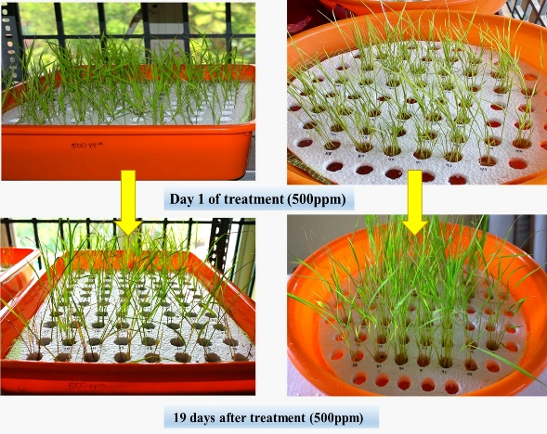
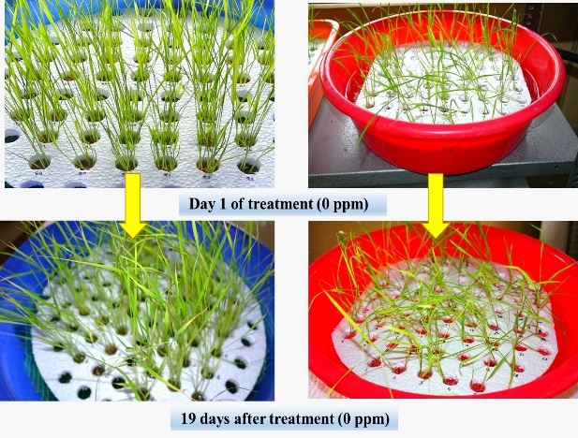
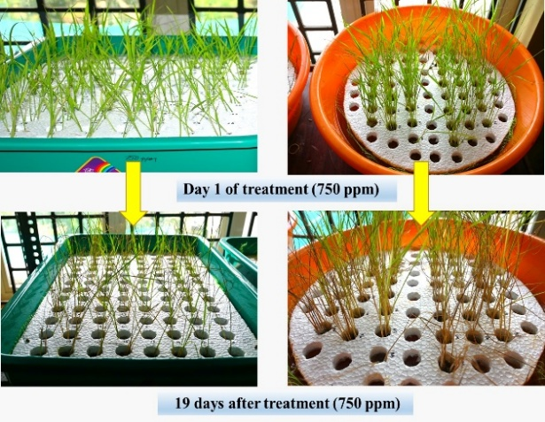
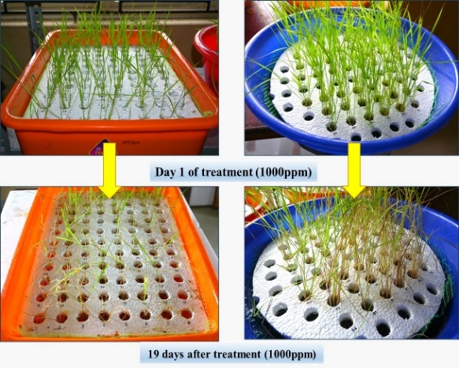

Plate 1. Reactions of 106 rice genotypes to different concentrations of iron

3.3. Visual scoring for iron toxicity symptoms
Leaf bronzing, evaluated using a 0-9 scale, is the most distinctive symptom of iron toxicity and served as a reliable indicator of stress severity in this study. Visual scoring for iron toxicity symptoms revealed a clear increase in leaf bronzing with increasing iron concentration. The mean value steadily increased from 0 (no symptoms) at control to 6.1 at 1000 mg L⁻¹.The symptoms appeared initially on older leaves and intensified over time, leading to severe discoloration and necrosis in susceptible genotypes. Based on the visual scoring (0-9) recorded by all the genotypes at highest iron concentration (1000 mg L⁻¹), they were classified as highly tolerant, tolerant, moderately tolerant, moderately susceptible, susceptible and highly susceptible. The use of leaf bronzing score (LBS) as a reliable indicator of iron toxicity has been well documented by Ponnamperuma et al. (1955), Yoshida (1981), Mandal et al. (2004), Diop et al. (2020) and Rosdianti et al. (2025).
Among the landraces studies, only Chenthadi achieved tolerant status with a LBS of 2.3 at 1000 mg L⁻¹. Among the released varieties, Pournami topped the tolerant list with a score of 1. Genotypes such as Karuna (1.7), Makom (1.7), Vytilla 9 (1.7), Bhadra (2.3), Panchami (2.3), Prathyasha (2.3), Vytilla 2 (2.3), Vytilla 3 (2.3), Vytilla 8 (2.3) and Vytilla 10 (2.3) also represented the tolerant relased varieties. Followed by a total of 18 genotypes scored between 3 and 5, making them moderately tolerant. The tolerant genotypes exhibited lower bronzing scores and maintained better growth. Similar observations were made by Mandal et al. (2004) and Bresolin et al. (2019).
The high scores in susceptible lines reflect the extensive oxidative damage to chlorophyll systems described by Pereira et al. (2013). After excluding the moderately susceptible, susceptible and highly susceptible genotypes, thirty tolerant and moderately tolerant genotypes were selected (Table 3) for further studies.
While this investigation provides a robust framework for early-stage selection, a primary limitation is that hydroponic screening in a controlled environment simplifies the complex soil-plant-microbe interactions and fluctuating redox potentials characteristic of lowland rice ecosystems, which may influence the expression of tolerance under actual field conditions (Sitaresmi et al., 2021).

Table 3. Selected genotypes based on visual scoring (0-9) in hydroponics experiment

Sl. No. | Genotype | Score | Reaction
Landraces
1 | Chenthadi | 2.3 | Tolerant
2 | Chenkayama | 3 | Moderately tolerant
3 | Chettivirippu | 3 | Moderately tolerant
4 | Nayarambalam Pokkali | 3 | Moderately tolerant
5 | Pokkali | 3 | Moderately tolerant
6 | Chellanum Chettivirippu | 3.7 | Moderately tolerant
7 | Karutha Kuruka | 3.7 | Moderately tolerant
8 | Kunjikayama | 3.7 | Moderately tolerant
9 | Kuthiru | 3.7 | Moderately tolerant
10 | Onamuttan | 3.7 | Moderately tolerant
11 | Punchaparuthi | 3.7 | Moderately tolerant
12 | Cheruvirippu | 4.3 | Moderately tolerant
13 | Traditional Virippu | 4.3 | Moderately tolerant
Released Varieties
14 | Pournami | 1 | Tolerant
15 | Karuna | 1.7 | Tolerant
16 | Makom | 1.7 | Tolerant
17 | Vytilla 9 | 1.7 | Tolerant
18 | Bhadra | 2.3 | Tolerant
19 | Panchami | 2.3 | Tolerant
20 | Prathyasha | 2.3 | Tolerant
21 | Vytilla 2 | 2.3 | Tolerant
22 | Vytilla 3 | 2.3 | Tolerant
23 | Vytilla 8 | 2.3 | Tolerant
24 | Vytilla 10 | 2.3 | Tolerant
25 | Ezhome 3 | 3 | Moderately tolerant
26 | Karthika | 3 | Moderately tolerant
27 | Vytilla 4 | 3 | Moderately tolerant
28 | Vytilla 7 | 3 | Moderately tolerant
29 | Vytilla 6 | 3.7 | Moderately tolerant
30 | Vytilla 1 | 4.3 | Moderately tolerant

4. Conclusion

The present investigation revealed significant genetic variability among rice genotypes for iron toxicity tolerance. Hydroponic screening was found to be an efficient and reliable method for rapid and early-stage evaluation. The study also emphasized the importance of shoot and root parameters and visual scoring as key indicators for screening and selection. Based on these hydroponics results, thirteen landraces and seventeen releases varieties with high growth maintenance and low leaf bronzing scores at 1000 mg L⁻¹ iron concentration were identified as potential donors among which Pournami (LBS-1) showed most potential. To ensure the practical utility of these identified donors, their genetic potential must be verified through field trials under actual iron-toxic stress before they are utilized in crop improvement programs.

Disclaimer (Artificial intelligence)

Author(s) hereby declare that NO generative AI technologies such as Large Language Models (ChatGPT, COPILOT, etc.) and text-to-image generators have been used during the writing or editing of this manuscript.

References
- Aratani, H., Fujimoto, R., Yamasaki, Y., Rumanti, I. A., Nugraha, Y., Kamiya, T. and Kato, Y. (2025). Genotypic variation in rice tolerance to Fe toxicity during germination and establishment. Journal of Plant Nutrition and Soil Science, 189(1): 27-35.
- Audebert, A. and Fofana, M. (2009). Rice yield gap due to iron toxicity in West Africa. Journal of Agronomy and Crop Science, 195(1): 66-76. https://doi.org/10.1111/j.1439-037X.2008.00339.x
- Aung, M. S., Masuda, H., Kobayashi, T., & Nishizawa, N. K. (2018). Physiological and transcriptomic analysis of responses to different levels of iron excess stress in various rice tissues. Soil Science and Plant Nutrition, 64(3), 370–385.
- Aung, M. S. and Masuda, H. (2020). How does rice defend against excess iron?: Physiological and molecular mechanisms. Frontiers in Plant Science, 11: 1102.
- Becker, M. and Asch, F. (2005). Iron toxicity in rice—conditions and management concepts. Journal of Plant Nutrition and Soil Science, 168(4): 558-573.
- Bresolin, A. P. S., dos Santos, R. S., Wolter, R. C. D., de Sousa, R. O., da Maia, L. C. and Costa de Oliveira, A. (2019). Iron tolerance in rice: an efficient method for performing quick early genotype screening. BMC Research Notes, 12(1): 362
- Crestani, M., Da Silva, J. A. G., de Souza, V. Q., Hartwig, I., de Souza Luche, H., de Sousa, R. O., De Carvalho, F. I. F., De Oliveira, A. C., Luche, H. D. S. and de Sousa, R. O. (2009). Irrigated rice genotype performance under excess iron stress in hydroponic culture. Crop Breeding and Applied Biotechnology, 9(1): 85-93.
- Diop, B., Wang, D. R., Drame, K. N., Gracen, V., Tongoona, P., Dzidzienyo, D., Nartey, E., Greenberg, A. J., Djiba, S., Danquah, E. Y. and McCouch, S. R. (2020). Bridging old and new: diversity and evaluation of high iron-associated stress response of rice cultivated in West Africa. Journal of Experimental Botany, 71(14): 4188-4200
- Dobermann, A. and Fairhurst, T. (2000) Rice: Nutrient Disorders & Nutrient Management. Handbook Series, Potash & Phosphate Institute (PPI), Potash & Phosphate Institute of Canada (PPIC) and International Rice Research Institute, Philippine, 191.
- Elango, D., Kanagaraj, P., Devi, J., Jeyaprakash, P. and Thiyagarajan, K. (2022). Biotechnological interventions for overcoming heavy metal constraints in crops. In: Heavy Metals in Plants: Physiological, Molecular and Genetic Aspects, CRC Press, Taylor & Francis Group, London: 245-268.
- Engel, K., Asch, F. and Becker, M. (2012). Classification of rice genotypes based on their mechanisms of adaptation to iron toxicity. Journal of Plant Nutrition and Soil Science, 175(6): 871-881.
- Fageria, N. K. and Rabelo, N. A. (1987). Tolerance of rice cultivars to iron toxicity. Journal of Plant Nutrition, 10(6): 653-661 (Nozoe et al., 2008).
- Gopinath, P. P., Parsad, R., Joseph, B. and Adarsh, V. S. (2021). grapesAgri1: Collection of Shiny Apps for Data Analysis in Agriculture (1.1.0). Zenodo, https://doi.org/10.5281/zenodo.5106216.
- International Rice Research Institute (IRRI). (1996). Standard evaluation system for rice (4th ed.). Los Baños: IRRI.
- Mandal, A. B., Pramanik, S. C., Chowdhury, B. and Bandyopadhyay, A. K. (2004). Balanced fertilization in rice (Oryza sativa L.) for sustaining higher yield and alleviating iron toxicity in acid soils of Andaman and Nicobar Islands. Indian Journal of Agricultural Sciences, 74(5): 242-245.
- Nongbri, E. L., Das, S., Bhutia, K. L., Momin, A. G., Rai, M. and Tyagi, W. (2023). Differential Expression of Iron Deficiency Responsive Rice Genes under Low Phosphorus and Iron Toxicity Conditions and Association of OsIRO3 with Yield in Acidic Soils. Rice Science, 30(1): 58-69.
- Oktatora, E., Setyowati, M., Susanto, U., Chozin, M. A. and Santoso, D. (2021). Selection of rice genotypes for iron toxicity tolerance based on morphological and physiological characters. Journal of Tropical Crop Science, 8(1): 24-32.
- Onaga, G., Edema, R. and Asea, G. (2012). Tolerance of rice germplasm to iron toxicity stress and the relationship between tolerance, Fe2+, P and K content in the leaves and roots. Archives of Agronomy and Soil Science, 59(2): 213-229
- Onaga, G., Egdane, J., Edema, R. and Abdelbagi, I. (2013). Morphological and genetic diversity analysis of rice accessions (Oryza sativa L.) differing in iron toxicity tolerance. Journal of Crop Science and Biotechnology, 16(1): 53-62
- Onyango, D. A., Entila, F., Dida, M. M., Ismail, A. M. and Drame, K. N. (2019). Mechanistic understanding of iron toxicity tolerance in contrasting rice varieties from Africa: 1. Morpho-physiological and biochemical responses. Functional Plant Biology, 46(1): 93-105.
- Pereira, E. G., Oliva, M. A., Rosello, A. A., Ribeiro, C., de Almeida, A. M. and Costa, A. C. (2013). Iron toxicity in rice: the role of antioxidative system and photosynthesis. Journal of Plant Nutrition and Soil Science, 176(2): 253-264.
- Ponnamperuma, F. N., Bradfield, R., & Peech, M. (1955). Physiological disease of rice attributable to iron toxicity. Nature, 175, 265–266. https://doi.org/10.1038/175265a0
- Rosdianti, I., Ueda, Y., Nakanishi, H., Utami, D. W., Yuriyah, S., Takanashi, H. and Wissuwa, M. (2025). Physiological insensitivity to an increase in leaf Fe constitutes a tissue-tolerance mechanism against Fe toxicity in rice. Plant and Soil, 515(1): 287-309. https://doi.org/10.1007/s11104-025-07587-0
- Rout, G. R., Sahoo, S., Das, A. B. and Das, S. R. (2014). Screening of iron toxicity in rice genotypes on the basis of morphological, physiological and biochemical analysis. Journal of Experimental Biology and Agricultural Sciences, 2(6): 567-582.
- Sahrawat, K. L. (2004). Iron toxicity in wetland rice and the role of other nutrients. Journal of Plant Nutrition, 27(8): 1471-1504.
- Sikirou, M., Saito, K., Achigan-Dako, E. G., Dramé, K. N., Ahanchédé, J. and Venuprasad, R. (2015). Genetic improvement of iron toxicity tolerance in rice-progress, challenges and prospects in West Africa. Plant Production Science, 18(4): 423-434.
- Sitaresmi, T., Dewi, K., Rumanti, I. A., Herlinda, S. and Nugraha, Y. (2021). Response of Indonesian rice varieties to iron toxicity under field and green house condition. E3S Web of Conferences, 306: 01012. https://doi.org/10.1051/e3sconf/202130601012
- Suma, A., Francies, R. M., Radhakrishnan, V. V., Sureshkumar, P. and Varghese, E. (2022). Elucidating the response of rice genotypes to iron toxicity through hydroponics. Indian Journal of Plant Genetic Resources, 35(1): 66-72.
- Wu, L. B., Shhadi, M. Y., Gregorio, G., Matthus, E., Becker, M. and Frei, M. (2014). Genetic and physiological analysis of tolerance to acute iron toxicity in rice. Rice, 7(1): 1-12. https://doi.org/10.1186/s12284-014-0008-3
- Yoshida, S. (1981). Fundamentals of rice crop science. Los Baños: International Rice Research Institute.

APPENDIX

Appendix 1. List of rice genotypes used for screening of iron toxicity tolerance
Sl. No. | Treatment | Name of genotype | Source
I. Traditional cultivars used
1 | T1 | Kokkan | RARS, Pattambi
2 | T2 | Palthondi | RARS, Pattambi
3 | T3 | Valichoori | RARS, Pattambi
4 | T4 | Karutha chitteni | RARS, Pattambi
5 | T5 | White mahsuri | RARS, Pattambi
6 | T6 | Chenkayama | RARS, Pattambi
7 | T7 | Thekkan cheera | RARS, Pattambi
8 | T8 | Thekkan chitteni | RARS, Pattambi
9 | T9 | Orkayama | RARS, Pattambi
10 | T10 | Mundakankutty | RARS, Pattambi
11 | T11 | Thavalakannan | RARS, Pattambi
12 | T12 | Kanali | RARS, Pattambi
13 | T13 | Ittikandan | RARS, Pattambi
14 | T14 | Kuttadan | RARS, Pattambi
15 | T15 | Kunnamkulamban | RARS, Pattambi
16 | T16 | Eravapandy | RARS, Pattambi
17 | T17 | Oorpandy | RARS, Pattambi
18 | T18 | Marathondi | RARS, Pattambi
19 | T19 | Chuvanna chitteni | RARS, Pattambi
20 | T20 | Chenthadi | RARS, Pattambi
21 | T21 | Thekkan | RARS, Pattambi
22 | T22 | Kochuvithu | RARS, Pattambi
23 | T23 | Vadakan vellarikayama | RARS, Pattambi
24 | T24 | Kunju kunju | RARS, Pattambi
25 | T25 | Cheruvellari | RARS, Pattambi
26 | T26 | Chenthady | RARS, Pattambi
27 | T27 | Kodukanni | RARS, Pattambi
28 | T28 | Chettivirippu | RARS, Pattambi
29 | T29 | Vellari | RARS, Pattambi
30 | T30 | Mullankayama | RARS, Pattambi
31 | T31 | Onamuttan | RRS, Moncompu
32 | T32 | Punchakayama | RRS, Moncompu
33 | T33 | Ambalavayal | RRS, Moncompu
34 | T34 | Aryan | RRS, Moncompu
35 | T35 | Kunjooty | RRS, Moncompu
36 | T36 | Kuravetty | RRS, Moncompu
37 | T37 | Ambalayavayal-1 | RRS, Moncompu
38 | T38 | Meter | RRS, Moncompu
39 | T39 | Kunjikayma | RRS, Moncompu
40 | T40 | Cherya aryan | RRS, Moncompu
41 | T41 | Syamala | RRS, Moncompu
42 | T42 | Chembavu | RRS, Moncompu
43 | T43 | Swarnamalli | RRS, Moncompu
44 | T44 | Jaduhallika | RRS, Moncompu
45 | T45 | Kuthiru | RRS, Moncompu
46 | T46 | Kalyanikutty | RRS, Moncompu
47 | T47 | Ambasamudram | RRS, Moncompu
48 | T48 | Punchaparuthy | RRS, Moncompu
49 | T49 | Edavaka | RRS, Moncompu
50 | T50 | Ponkuruka | RRS, Moncompu
51 | T51 | Chokiriyan | RRS, Moncompu
52 | T52 | Vyttila kuruka | RRS, Vytilla
53 | T53 | Pokkali | RRS, Vytilla
54 | T54 | Traditional virippu | RRS, Vytilla
55 | T55 | Rakthasali | RRS, Vytilla
56 | T56 | Chellanum chettivirippu | RRS, Vytilla
57 | T57 | Nayarambalam pokkali | RRS, Vytilla
58 | T58 | Cheruvirippu | RRS, Vytilla
59 | T59 | Kuthiru | RRS, Vytilla
60 | T60 | Karutha kuruka | RRS, Vytilla
II. Released varieties used
1 | T61 | Neeraja | RARS, Pattambi
2 | T62 | Akshaya | RARS, Pattambi
3 | T63 | Supriya | RARS, Pattambi
4 | T64 | Mangala mahsuri | RARS, Pattambi
5 | T65 | Karuna | RARS, Pattambi
6 | T66 | Nila | RARS, Pattambi
7 | T67 | Jyothi | RARS, Pattambi
8 | T68 | Matta triveni | RARS, Pattambi
9 | T69 | Harsha | RARS, Pattambi
10 | T70 | Bhadra | RRS, Moncompu
11 | T71 | Asha | RRS, Moncompu
12 | T72 | Pavizham | RRS, Moncompu
13 | T73 | Karthika | RRS, Moncompu
14 | T74 | Aruna | RRS, Moncompu
15 | T75 | Makom | RRS, Moncompu
16 | T76 | Remya | RRS, Moncompu
18 | T78 | Renjine | RRS, Moncompu
19 | T79 | Pavithra | RRS, Moncompu
20 | T80 | Panchami | RRS, Moncompu
21 | T81 | Remanika | RRS, Moncompu
22 | T82 | Uma | RRS, Moncompu
23 | T83 | Revathy | RRS, Moncompu
24 | T84 | Karishma | RRS, Moncompu
25 | T85 | Krishnanjana | RRS, Moncompu
26 | T86 | Gouri | RRS, Moncompu
27 | T87 | Prathyasha | RRS, Moncompu
28 | T88 | Sreyas | RRS, Moncompu
29 | T89 | Pournami | RRS, Moncompu
30 | T90 | Manuratna | ARS, Mannuthy
31 | T91 | Ezhome-1 | RARS, Pilicode
32 | T92 | Ezhome-2 | RARS, Pilicode
33 | T93 | Ezhome-3 | RARS, Pilicode
34 | T94 | Ezhome-4 | RARS, Pilicode
35 | T95 | Mithila | RARS, Pilicode
36 | T96 | Jaiva | RARS, Pilicode
37 | T97 | Vyttila-1 | RRS, Vytilla
38 | T98 | Vyttila-2 | RRS, Vytilla
39 | T99 | Vyttila-3 | RRS, Vytilla
40 | T100 | Vyttila-4 | RRS, Vytilla
41 | T101 | Vyttila-6 | RRS, Vytilla
42 | T102 | Vyttila-7 | RRS, Vytilla
43 | T103 | Vyttila-8 | RRS, Vytilla
44 | T104 | Vyttila-9 | RRS, Vytilla
45 | T105 | Vyttila-10 | RRS, Vytilla
46 | T106 | Vyttila-11 | RRS, Vytilla

