Assessment of SSR markers for verification of poplar (Populus deltoides) clones

Abstract
Poplar (Populus spp.) is an economically important forest tree widely cultivated in temperate regions, where genetically improved clones of Populus deltoides are extensively used for high-yield plantations. However, accurate clonal identification and assessment of genetic variation remain challenging using conventional methods, necessitating the application of reliable molecular tools such as SSR markers for efficient characterization and verification. The study aims to assess the effectiveness of Simple Sequence Repeat (SSR) markers for the molecular verification of Populus deltoides clones. The study was undertaken in the Department of Tree Improvement and Genetic Resources, Dr. Y.S. P. U. H. F., Nauni- Solan 173230 (H.P.). In this study, fifteen Poplar clones were collected from various research institutes across India. Molecular markers play an important role in breeding programs because they help in identifying and evaluating genetic differences within plant populations and germplasm collections. The modern trend in forest genetics focuses on developing reliable molecular marker systems that can help study genetic diversity, differentiation, and gene flow, especially in fragmented forest populations. Such genetic information is valuable for designing effective conservation and management plans. In this work, Simple Sequence Repeat (SSR) markers, also known as microsatellite markers, were used for genotyping through Polymerase Chain Reaction (PCR). The molecular results confirmed the identity of most clones as originally recorded. However, some minor genetic differences were observed within certain clones. Considering the ecological and commercial importance of Populus species in the Northern Hemisphere, the SSR marker set optimized in this study will be highly useful for breeding and selection programs, ecological landscape studies, and for ensuring the long-term conservation and sustainable management of Populus genetic resources.
Key words: Poplar, SSR, Molecular, Cluster, Dendrogram

Introduction
‘Poplar’ refers to species within the genus Populus, which belongs to the family Salicaceae, order Salicales, and group Amentiferae. The genus comprises approximately 35 recognised species (Dickmann and Stuart, 1984) and is widely distributed across warm temperate to cool temperate regions of the world. A notable biological feature of Populus species is their capacity for vegetative propagation, which facilitates rapid clonal multiplication and deployment (Dickmann, 2001). In India, genetically improved clones of Populus deltoides were introduced around 1950, primarily for short-rotation forestry systems aimed at maximising wood production and meeting industrial demands (Chaturvedi and Rawat, 1994).
Advances in molecular genetics have significantly enhanced the characterisation and improvement of Populus species. Notably, Smulders et al. (2001) isolated microsatellite repeats from black poplar (Populus nigra L.) and developed primer sets for microsatellite or Simple Sequence Repeat (SSR) marker analysis. Among these, ten primer pairs—predominantly targeting trinucleotide repeats—successfully amplified polymorphic DNA fragments in P. nigra. Furthermore, several of these primers demonstrated cross-species transferability, yielding reliable amplification in related taxa such as P. deltoides, P. trichocarpa, P. tremula, P. tremuloides, P. candicans, and P. lasiocarpa. From this set, six highly informative loci were subsequently selected and validated across 23 P. nigra genotypes originating from diverse European regions, highlighting their effectiveness in detecting genetic variability.
Molecular markers have proven particularly advantageous for studying genetic diversity in long-lived tree species, where conventional approaches, such as common garden experiments, are often labour-intensive, time-consuming, and influenced by environmental variability. In contrast, DNA-based markers enable rapid, precise, and environment-independent assessment of genetic variation, thereby accelerating breeding and conservation research.
A wide array of molecular marker systems—including Amplified Fragment Length Polymorphisms (AFLPs), Restriction Fragment Length Polymorphisms (RFLPs), nuclear and cytoplasmic SSRs, and Single Nucleotide Polymorphisms (SNPs)—have been employed to investigate genetic diversity (Krutovsky and Neale, 2006). Among these, SSRs and SNPs are currently regarded as the most informative due to their abundance in the genome, high reproducibility, and co-dominant inheritance. In Populus, extensive genomic resources have been developed, including a comprehensive database of thousands of SSR loci established by the International Populus Genome Consortium. Additionally, Expressed Sequence Tag (EST) collections have played a pivotal role in establishing Populus as a model organism in forest genomics. These large-scale EST datasets provide valuable insights into gene expression patterns, enabling both qualitative and quantitative analyses, as well as snapshots of tissue-specific and developmental-stage gene activity (Sterky et al., 2004; Kohler et al., 2003).
In this context, the present study aims to evaluate the efficacy of SSR markers for the molecular verification and genetic characterisation of Populus deltoides clones, thereby contributing to the accuracy of clonal identification and the advancement of breeding and conservation strategies.

Method and Materials
The present investigation was carried out in the Department of Tree Improvement and Genetic Resources, Dr. Y.S. Parmar University of Horticulture and Forestry, Nauni, Solan (H.P.). 15 clones were planted with three replications in randomized blocks design. Cuttings of 15 different clones were collected from various research institutes. To evaluate these clones, 18 Simple Sequence Repeat (SSR) markers were used (table 1). Fresh young leaves were taken from the field and used for DNA extraction. The nuclear DNA was isolated following the Doyle and Doyle (1987) method, with minor modifications. For SSR analysis, DNA amplification was performed using eighteen SSR primers that were procured from Bangalore Genei, India. Before running the final PCR reactions, optimization tests were carried out to determine the most suitable amplification conditions, particularly the annealing temperature. The annealing temperature for each primer pair was adjusted based on their calculated melting temperatures (Tm) to ensure proper amplification.
The amplified bands were scored in a binary format, assigning ‘1’ for the presence and ‘0’ for the absence of bands, to generate a data matrix for subsequent similarity analysis. The resulting binary matrix was analysed using the SIMQUAL programme implemented in NTSYS-pc (Version 2.2). Genetic similarity among the genotypes was estimated using the Jaccard similarity coefficient.
The coefficient was calculated according to the formula J = A / (N − D), where A represents the number of positive matches (i.e. bands present in both samples), D denotes the number of negative matches (i.e. bands absent in both samples), and N corresponds to the total number of observations, including both matched and unmatched instances. This approach ensures that shared absences are excluded from similarity estimation, thereby providing a more accurate representation of genetic relatedness among the genotypes.
Table 1: Nucleotide sequences of 18 SSR primers (Khasa et al. 2003, Tuskan et al. 2004, Peng et al. 2005 & Grewal et al. 2013)
S. No. | Primer names | Sequences
1. | PMGC- 571 | FP-CTGGTACCGATGGAGAAGAC
1. | PMGC- 571 | RP-CAAACCAACAACTCACCGTAC
2. | PMGC- 2163 | FP- CAATCGAAGGTAAGGTTAGTG
2. | PMGC- 2163 | RP- CGTTGGACATAGATCACACG
3. | PMGC- 333 | FP-CTTAGTGGTGAAGTATTC
3. | PMGC- 333 | RP-GAG TGG GTG CTGATTCATCC
4. | WPMS-05 | FP-TTCTTTTT CAA CTG CCT AACTT
4. | WPMS-05 | RP-TGATCCAATAACAGACAGAACA
5. | WPMS-03 | FP-TTTACATAGCATTTAGCCTTTAGA
5. | WPMS-03 | RP-TTATGATTTTGGGGGTGTTATGGA
6. | ORPM-28 | FP- GGATCGACTTCCAACCCATA
6. | ORPM-28 | RP-AATTCCCCAGATGAAGGCTGCTCA
7. | ORPM-026 | FP- GCTGCAGTCAAATTCCAAAA
7. | ORPM-026 | RP- CGAGCGTCTTCTTCATGGAT
8. | ORPM-190 | FP-CCCTGGTTTTCTCTTCTTGG
8. | ORPM-190 | RP-CCAGATTGGACTTGGGATTC
9. | ORPM-114 | FP-ATGAGCCACTGGTAGGGATG
9. | ORPM-114 | RP-CAAGTCAGACTGGGGAAGTGA
10. | ORPM-92 | FP-TGACTCTGAGTGGTCGTCGAGGA
10. | ORPM-92 | RP-GAGAATCCAACCCACTTCCA
11. | ORPM-137 | FP-CCGTGCATCTGCTCACTTTA
11. | ORPM-137 | RP-GCATTTGCAGATGAAATTGGT
12. | ORPM-149 | FP-GTCTCTGCCACATGATCCAA
12. | ORPM-149 | RP-CCCGAAATGGATCAAACAAG
13. | ORPM-166 | FP-TCATTGGAGCACAAGACACC
13. | ORPM-166 | RP-GGAGAAGCCTGTTTCCTCAA
14. | ORPM-029 | FP-TGGTGATCCAGTTTTGGTGA
14. | ORPM-029 | RP-GTCCTTGCAAGCCATGAA
15. | ORPM-186 | FP-GGCTAGTACCCTGGAGAA
15. | ORPM-186 | RP-AAGCCATCTCGACTATACACCA
16. | PTR 1 | FP-AGCGCGTGCGGATTGCCATT
16. | PTR 1 | RP-TTAGTTTCCCGTCACCTCCTGTTAT
17. | ORPM-177 | FP-TGCAGTAAACACAAAGTGTCGTC
17. | ORPM-177 | RP-CCATGGACTGCAAATGGTTA
18. | WPMS-07 | FP-ACTAAGGAGAATTGTTGACTAC
18. | WPMS-07 | RP-TATCTGGTTTCCTCTTATGTG

Result and Discussion

The clones were evaluated using SSR (Simple Sequence Repeat) markers. A total of eighteen SSR primers were used to verify the identity of the clones based on their banding patterns. After PCR amplification, the resulting SSR bands were analyzed to determine how genetically similar the clones were to each other. Each band was scored as ‘1’ if present and ‘0’ if absent for every clone, and this data was organized into a matrix. The matrix was then analyzed using the NTSYS-2.2 software to calculate the Jaccard’s similarity coefficient among the clones (Figure 1).
The clones studied for morphological characterization were tested using SSR markers. Among 18 SSR markers, fourteen markers PMGC-571, PMGC-2163, PMGC-333, ORPM- 028, ORPM-190, ORPM-114, ORPM-092, ORPM-137, ORPM-149, ORPM-166, ORPM- 029, ORPM-186, PTR-1, ORPM-177 and WPMS-07 showed polymorphic pattern while WPMS-05, WPMS-03, ORPM-026 and ORPM-114 showed monomorphic pattern. So, 14 polymorphic SSR’s were used for further analysis. A detailed examination of the SSR banding patterns obtained following the amplification of genomic DNA from the clones indicated that all clones conformed to their expected genetic identity, confirming their true-to-type status. The SSR profiles specific to each clone were evaluated using 3.5% agarose gel electrophoresis, which provided adequate resolution for band discrimination. The amplification products consistently exhibited either single bands or a combination of two distinct bands across all samples of Populus deltoides. This banding pattern is indicative of the co-dominant nature of SSR markers and reflects the underlying allelic composition of the analysed genotypes.

Dendrogram (Figure 2) showing different clusters were based on NTSYS-PC ver. 2.02. Similarity coefficient obtained by Jacquard coefficient was for UPGMA analysis of NTSYS. In the dendrogram (Figure 2) the 15 clones separated into two main clusters, ‘I’ and cluster ‘II’ at 64 % similarity. This revealed less similarity between cluster I and the member of cluster II. Cluster I was further subdivided into two clusters i.e. I1 and I2 at similarity value of 72.4 %. Also cluster I1 further dived into I1a and I1b with 77.8 % similarity. Cluster I1a was further divided to I1a1 and I1a2 which were 81.8% similar consisting of clone L-6105. However, I1a1 consist two clones L-30/06 and L-621/84 at 88% similarity. I1b was further divided into I1b1 and I1b2 at 82% similarity. Similarly, I1b1 again divided into I1b12’ and I1b22’ at 85.4 % similarity consisting clones G-48 and PL-3 respectively. I2 further divided into I2a and I2b at 85.4 % similarity with consisting clones PL-6 and PL-7.

Cluster II was further subdivided divided into two i.e. II1 and II2 at similarity of 70.5 %. II1 is further divided into II1a and II1b at 72.4 % similarity. II1a further divided into II1a1’ consist one clone i.e. S7C15 77.8 % similar and II1a2 consist of two clones namely WSL-22 and WSL-39 with 88% similarity. Also, II1b also divided into II21b1 and II21b1 with 81.8 % similarity. II21b1 consists of two clones namely 6503 and 5503 at 88% of similarity and II21b2 consist only one clone 1007 with 81.8 % similarity. II2 consist only one clone L-200/86. L-200/86 was less similar than other clones and having unique morphological characteristics with downward waviness. Molecular characterization of clones was obtained at very basic level due to small number of primers. Further investigation needed with larger number of trait specific primers to correlate morphological and molecular characterization of clones.
Khasa et al. (2003) reported the optimisation of 17 microsatellite or Simple Sequence Repeat (SSR) markers in the genus Populus across seven species, namely P. balsamifera, P. tremuloides, P. davidiana, P. alba, P. tremula, and P. nigra. Their findings indicated that 14 out of the 17 primer pairs successfully amplified SSR loci exhibiting varying levels of polymorphism among the species studied. Comparable results were documented by Rahman and Rajora (2002), who demonstrated reliable amplification across Populus species representing three taxonomic sections, namely Aigeiros, Tacamahaca, and Populus.
The present findings are in agreement with those of Grewal et al. (2013), who evaluated 32 SSR markers in Populus deltoides and observed that 22 markers displayed polymorphism, collectively amplifying a total of 102 alleles. Similarly, Singh et al. (2013) investigated 16 RAPD and 14 SSR primers in willow clones, generating 363 markers, of which 351 (96.7%) exhibited polymorphism, with 18 out of 30 primers showing complete (100%) polymorphism. In contrast, Dobhal (2016) assessed 18 primers in poplar and reported predominantly monomorphic patterns, with 15 primers producing monomorphic bands and only three exhibiting polymorphism, indicating variability in marker informativeness across studies.
Further supporting evidence is provided by Liu et al. (2016), who analysed 43 elite clones of Populus deltoides and identified 62 polymorphic bands, with an average of 10 alleles per locus. The number of alleles amplified per primer ranged from five (NJFUP-poly10) to sixteen (NJFUP-poly07), reflecting substantial allelic diversity. More recently, Gao et al. (2024) examined 188 genotypes of P. deltoides originating from six provenances and conducted genetic structure and association analyses using selected SSR markers. Their results revealed that 15 SSR primer pairs consistently amplified across all genotypes, with a mean of 7.33 alleles per locus. These markers were further employed in association studies targeting water-use efficiency (WUE) and nitrogen-use efficiency (NUE) using general linear model (GLM) and mixed linear model (MLM) approaches.
In addition, Cvrčková et al. (2025) investigated SSR markers in Populus nigra and Populus deltoides, reporting comparable outcomes. In their study, 378 poplar individuals were analysed using five diagnostic SSR markers with species-specific alleles for P. deltoides Bartr. ex Marsh., enabling the identification of 39 interspecific hybrids, which were clearly distinguished from native P. nigra. Collectively, these studies underscore the effectiveness and reliability of SSR markers in assessing genetic diversity, polymorphism, and species differentiation within the genus Populus.

Conclusion
Molecular markers are particular DNA sequences that show variation between individuals, allowing us to distinguish one organism from another. These variations arise due to changes in the nucleotide sequence of DNA, which may result in the creation or loss of restriction sites, random mutations, or alterations in simple repeat regions and their surrounding areas. Because these markers are highly abundant, show good levels of variation, and provide reliable results, they are widely preferred over other types of DNA markers. In this study, sixteen DNA markers that were previously identified and described in aspen (Populus tremuloides) and other poplar species (Populus spp.) were initially examined for their usefulness.
Acknowledgement
The authors are highly thankful to Department of Tree Improvement & Genetic Resources, COF, Dr. Y. S. Parmar University of Horticulture & Forestry, Nauni, Solan (H. P.) and Department of Science and Technology (INSPIRE Fellowship), New Delhi for financial support.

Disclaimer (Artificial intelligence)
Author(s) hereby declare that NO generative AI technologies such as Large Language Models (ChatGPT, COPILOT, etc.) and text-to-image generators have been used during the writing or editing of this manuscript.

References
Cvrčková, H., Máchová, P., Čížková, L., Vítová, K., Trčková, O., & Fulín, M. 2025. Microsatellite Markers as a Useful Tool for Species Identification and Assessment of Genetic Diversity of the Endangered Species Populus nigra L. in the Czech Republic. Forests, 16(9), 1389. https://doi.org/10.3390/f16091389

Dickmann D I and Stuart K W. 1984. The culture of poplars in Eastern North America. Michigan State Univiversity, 168p.
Dickman D I. 2001. An overview of genus Populus. In: Dickman D I, Isebrands J G, Eckenwalder J E, Richardson J (eds) Poplar culture in North America. Part A. NRC Research Press, Ottwa, Canada. 1-45.
Dobhal S. 2016. Line x tester analysis in Populus deltoides Bartr. Ph.D. Thesis. Department of Tree improvement and Genetic resources, Dr. Y. S. Parmar University of Horticulture and Forestry, Nauni, Solan. 121p.
Doyle J J and Doyle J J. 1987. A rapid DNA isolation procedure from small quantities of fresh leaf tissues. Phytochemistry Bulletin 19 : 11-15.
Smulders M J, Vander J S, Arens P and Vosman B. 2001. Tri-nucleotide repeat microsatellite markers for black poplar (Populus nigra L.). Molecular Ecology Notes 1 : 188-190.
Krutovsky K V and Neale D B. 2006. Forest genomics and new molecular genetic approaches to measuring and conserving adaptive genetic diversity in forest trees. In: Geburek T, Turok J (eds). Conservation and Management of Forest Genetic Resources in Europe. Arboreta Publishers, Zvolen, Slovakia. 369-390.
Kohler A, Delaruelle C, Martin D, Encelot N and Martin F. 2003. The poplar root transcriptome : Analysis of 7000 express sequence tags. FEBS Letters 542 : 37-41.
Sterky F, Bhalerao R R, Unneberg P, Segerman B, Nillson P, Brunner A M, Campa C L, Lindvall J J, Tandre K, Strauss S H, Gustaffson P, Uhlen M, Bhalerao R P, Nilsson O, Sandberg G, Karlsson J, Lundberg J and Jasson S.2004. A Populus EST resource for plant functional genomics. Proc. Natl. Acad. Sci. USA. 101 : 13951-13956.
Khasa D P, Nadeem S, Thomas B, Robertson A and Bousquet J. 2003. Application of SSR markers for parentage analysis of Populus clones. Forest Genetics 10 : 273-281.
Liu, H.,Yang, W., Hou, J., Hu, N., Yin, T. and Li, S . 2016. Genetic identification of 43 elite clonal accessions of Populus deltoides by SSR fingerprinting. Canadian Journal of Plant Science. 96(3): 494-502. https://doi.org/10.1139/cjps-2015-0272

Rahman, M. H. and Rajora O. P. 2002. Microsatellite DNA fingerprinting, differentiation and genetic relationships of clones, cultivars and varieties of six poplar species from three sections of the genus Populus. Genome 45 : 1083-94.
Gao, C., Chen, C., Liu, N., Liu, F., Su, X., Liu, C., & Huang, Q. 2024. Genetic Diversity and Association Analysis of Traits Related to Water-Use Efficiency and Nitrogen-Use Efficiency of Populus deltoides Based on SSR Markers. International Journal of Molecular Sciences, 25(21), 11515. https://doi.org/10.3390/ijms252111515

Grewal G K, Gill R I S, Dhillon G P S and Vikal. 2013. Molecular characterization and genetic diversity analysis of Populus deltoides Bartr. ex Marsh. clones using SSR markers. Indian Journal of Biotechnology 13 : 388-397.
Singh N B, Choudhary P and Joshi S. 2013. Molecular diversity in willow clones selected for commercial plantation. Indian Journal of Plant Genetic Resources 26 : 138-145

Figure 1: verification of clones using SSR primers

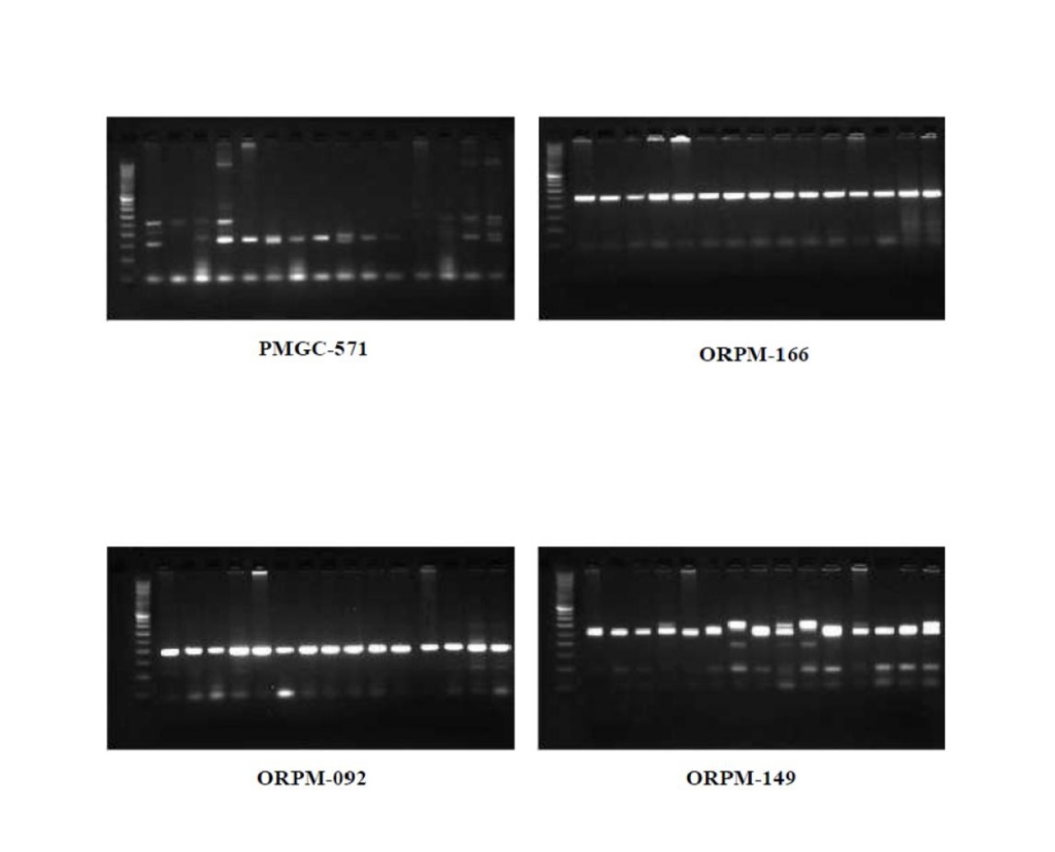

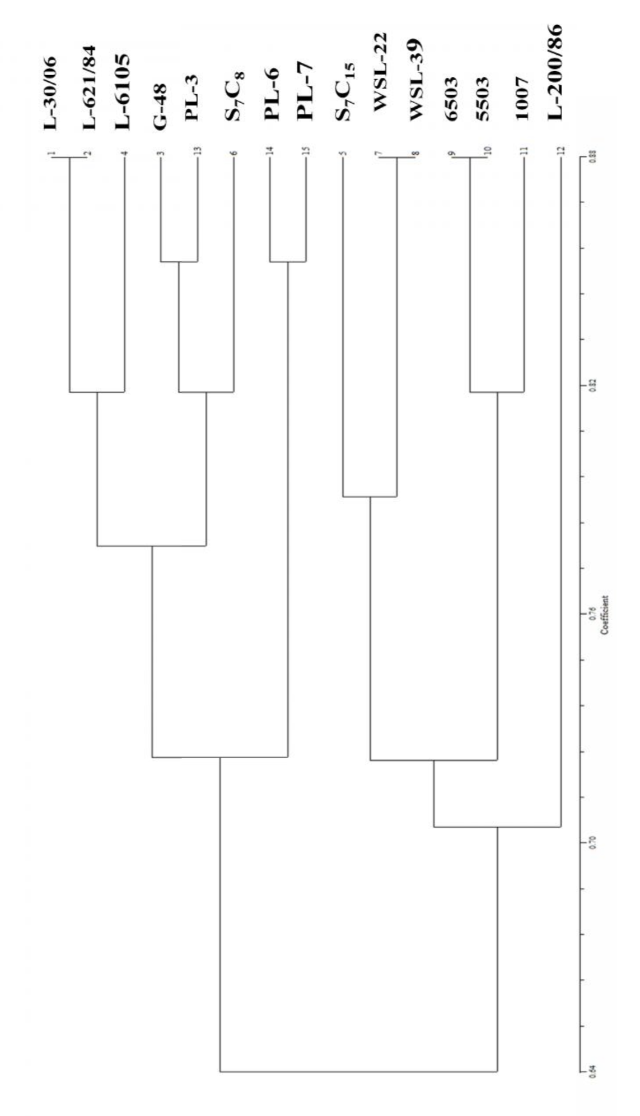
Figure 2: Dendrogram of 18 SSR primer for 15 poplar clones

