Identification of suitable plant geometry for different ages of single-node seedlings in eksali sugarcane

ABSTRACT
Plant geometry plays a significant role for optimization of rice yield due to efficient utilisation of solar radiation as well as nutrients in sugarcane. The plant geometry and spatial configuration exploit the initial vigor of the genotypes with enhanced soil aeration, creating congenial conditions for better establishment. A planting density that can bring down the seed requirement without sacrificing productivity would go a long way in popularising sugarcane cultivation. A field experiment was conducted at the Regional Sugarcane and Rice Research Station, Rudrur, during 2019-2022 to study the identification of suitable plant geometry for different ages of single-node seedlings in eksali sugarcane. The experiment was planted in split plot design with four row to row spacing of 90 x 30, 120 x 30, 150 x 30 and 180 x 30 cms as main plots and 30, 45 and 60 days old single-node seedlings as subplots. Sugarcane planting with 30-day-old seedlings at 150 × 30 cm spacing was found to be optimum for recording higher cane yield (154.2 t/ha) and commercial cane sugar (CCS% of 13.75), which was 13.2 % and 6 % more, respectively over 45-day-old seedlings. 60 days old seedling recorded the lowest cane yield (90.5 t/ha) and commercial cane sugar (9.97%) in all spacing. The 30-day-old seedlings planted at 150 × 30 cm spacing gave higher net returns of ₹. 1,81,151/ha over 45 days aged seedlings planted at 150 × 30 cm spacing (₹.1,65,018/ha) and 60 days old seedlings (₹.74,718/ha).
Keywords: Sugarcane, Single node seedlings, Plant geometry, Commercial Cane Sugar, cane yield

1. INTRODUCTION
Sugarcane is an important cash and high-value crop. However, the net returns retained through sugarcane cultivation are very low. Among several reasons for low net returns, high cost of seed material, inputs, poor management practices, and increased cost of labour play a major role (Mohanty Das P.P., Nanda S.S. 2019). Planting is an important and labour-intensive operation in sugarcane cultivation (Nalawade et al., 2018). Conventional planting of sugarcane with three budded setts requires about 8-10 t/ha seed material. There is a possibility of utilizing bud chips and single node settlings as seed material. Using bud chips and single-node settlings and raising seedlings in a nursery can save 80 per cent of the seed material compared to three budded setts. Bulk of the cane material could be reduced, eliminating about 80 to 90% cane, facilitating the transport and handling of seed material easily. Using single-node seedlings can avoid seed-transmitted disease and pest (Kierzkowski & Routier-Kierzkowska, 2019). This is relatively less expensive and labour-saving technology. Hence, in recent years sugarcane cultivation with single-node or bud-chip seedlings is gaining importance in order to reduce the cost of planting material. It was observed that, due to saving in seed material, the maximum net returns were obtained with bud chip-raised seedlings (Jain et al., 2009; Paulus, 2019). Planting of sugarcane either with bud chip or single node seedlings under wider spacing (120 to 150 cm) is also essential in order to facilitate mechanization in sugarcane to reduce the labour cost. The present study aims to identify of suitability of plant geometry for different ages of single-node seedlings in sugarcane.
2. MATERIAL AND METHODS
Regional Sugarcane and Rice Research Station, Rudrur (India) has conducted an experiment on the identification of suitable plant geometry for different ages of single-node seedlings in eksali sugarcane from 2019-2021 which is situated at an altitude of 286.3 m above mean sea level (amsl) at 18⁰ 49’41” N latitude and 78⁰56’45” E longitude. The experimental site is in Northern Telangana agro climatic zone of Telangana state, India and experiences semiarid climate. According to Trolls classification, the experimental site experiences semi-arid tropics (SAT). The long-term (2019-2021) temperature and precipitation data of the site, collected from the weather station (RS&RRS, Rudrur, station). The climate is subtropical-monsoonic with an average rainfall of 1059 mm, 70-80 per cent of which occurs during June to September. The summer months are very hot with maximum temperature ranging from 40.2 to 45.3 ⁰C in April and May whereas, whereas December and January are the coldest months (lowest January temperature as low as 13-15 ⁰C). The mean relative humidity ranged from 50.9 to 83.1 5 while average relative humidity was 72.5 %. Random soil sampling was done in the experiment field from 0-30 cm depth before initiation of the experiment. The soil samples were shade dried and passed through 2 mm sieve to make a composite sample which was later analyzed for physico-chemical and chemical properties. For analysis of nitrogen (N), phosphorus (P) and potash (K) soil sampling was done after the harvest of the crop. Texturally, the soil in the study site was heavy black soil in the 0–30 cm soil layer. The bulk density of the soil were determined by drying the samples in oven at 105 °C for 24 h and recorded 1.02. The pH of soil is 8.44 and the organic carbon 0.52% with EC of 0.179 d Sm⁻¹. The soil was medium (273.2 kg N ha⁻¹), high (52.07 kg P₂O₅ kg ha⁻¹) and high (310.8 kg K₂O ha⁻¹) in available nitrogen, phosphorus and potassium, respectively. The experiment was laid out ion Split plot Design with four main plot treatments viz., M₁:90 X30 cm, M₂:120 X30 cm, M₃:150 X30 cm, M₄:180 X30 cm and three different ages of single node seedlings viz., T₁- Transplanting single node seedlings 30 days old, T₂ -Transplanting single node seedlings 45 days old and T₃- Transplanting single node seedlings 60 days old. Each plot (8 x 8 m) was separated by 1m of transition zone while replication was demarcated by a buffer zone of 1.5 m in between. Recommended dose of fertilizers (RDF) were applied at the rate of 250:100:120 kg ha⁻¹ to the main crop. Except at basal application (broadcasted), top dressing was done by spot application of fertilizers at 5 cm below soil. The crop variety selected was ‘Co 86032’ which is having high profuse tillering nature. Tiller count was taken at 90 and 120 DAP. Cane length, single cane weight and cane yield was recorded at the time of harvest. The data were analyzed statistically by applying the technique of analysis of variance for split plot design and significance was tested by F-test. Critical difference for treatment means tested for their significance was calculated at 5% level of probability.
3. results and discussion
Data on the cane length recorded at harvest influenced by different ages of seedlings and geometry treatments are presented in Table. 1 The difference in cane length among the treatments were statistically significant. Cane length was recorded significantly higher in 150 x 30 cm plant geometry (3.16) and it was comparable with 180 x 30 cm (3.08). Among different age seedlings, 30 days old seedlings (3.15) recorded highest cane length (3.15). Lowest was recorded in 60 days old single node seedlings. de souza et al., (2022) found the relevant results with regard to cane length with increased spacing of 150 cm compared to 90 cm.
Tiller count (no.):
Data pertaining to tiller count at 90 and 120 DAP presented in table 1&2. At 90 days after planting, 90 x 30 cm plant geometry showed significantly highest number of tiller count and it was statistically on par with 150 x 30 cm. Lowest tiller count was showed in 120 x 30 cm geometry. Among different ages of single node seedlings, 30 days old seedlings (91.82) has recorded highest number of tillers than other ages of seedlings. At 120 days after planting, among plant geometry, 150x 30 cm showed significantly highest number of tiller (114.3) and it was followed by 90x 30 cm geometry (110.6). 30 days old single node seedlings showed statistically highest number of tillers (125.0) and it was followed by 45 days old seedlings. 30 days old seedlings with 150 x 30 cm recorded higher number of tillers at 120 DAP. These results are in coordination with Singh et al., 2002 where 30 days old seedlings with 150 cm spacing has recorded higher tiller count.
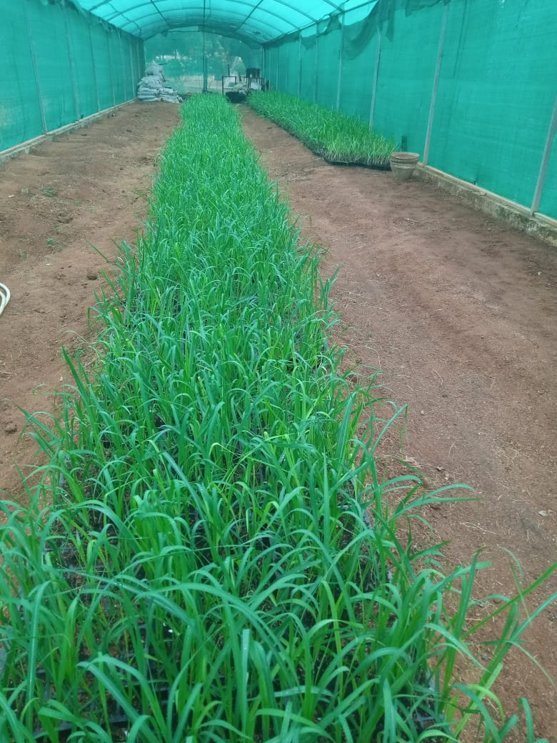 | 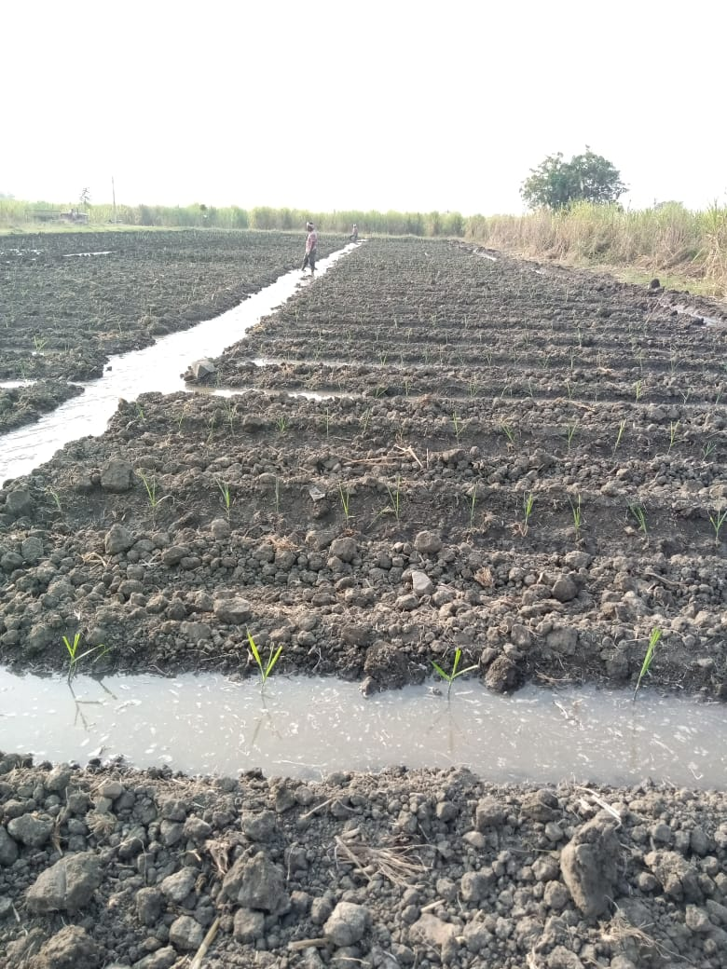
Fig 1: Rising of single node seedlings | Fig 2: Planting of single node seedlings

Table 1. Effect of plant geometry and different ages of seedlings on cane length and tiller count at 90 DAP in sugarcane
Treatments | Cane length  (m) |  |  |  |  |  | Tiller count at 90 DAP (000’/ha)
Treatments | 2019 | 2020 |  | 2021 |  | Pooled | 2019 | 2020 | 2021 | Pooled
 | Factor A (Geometry (cm))
M₁: 90x30 | 3.04 | 2.63 |  | 2.64 |  | 2.78 | 113.5 | 75.78 | 64.98 | 83.77
M₂:150x30 | 3.56 | 3.08 |  | 2.8 |  | 3.16 | 118.2 | 80.2 | 50.49 | 83.08
M₃:120x30 | 3.10 | 2.83 |  | 2.77 |  | 2.89 | 115.0 | 73.0 | 47.13 | 77.37
M₄:180x30 | 3.62 | 3.11 |  | 2.91 |  | 3.08 | 121.3 | 69.66 | 40.87 | 79.38
SEm (+) | 0.16 | 0.16 |  | 0.046 |  | 0.034 | 5.02 | 4.85 | 1.51 | 1.28
CD (p=0.05) | 1.42 | 1.42 |  | 0.164 |  | 0.12 | NS | 17.12 | 5.35 | 4.54
 | Factor B ( Age of seedlings)
S₁ : 30 days old | 3.46 | 3.03 |  | 2.97 |  | 3.15 | 133.3 | 153.0 | 93.0 | 91.81
S₂ : 45 days old | 3.09 | 2.86 |  | 2.82 |  | 2.92 | 121.1 | 125.0 | 86.3 | 82.4
S₃: 60 days old | 2.83 | 2.89 |  | 2.55 |  | 2.88 | 97.6 | 106.0 | 79.2 | 68.49
SEm (+) | 0.11 | 0.096 |  | 0.03 |  | 0.029 | 6.73 | 4.03 | 1.50 | 1.37
CD (p=0.05) | 0.34 | 0.34 |  | 0.09 |  | 0.089 | 20.34 | 12.19 | 4.54 | 4.17
Factor(B)at same level of A | NS | 0.34 | 0.16 | 0.08 | 0.21 | NS | NS | NS | NS | NS
Factor(A)at same level of B | NS | 0.42 | 0.12 | 0.07 | 0.23 | NS

NMC (Number of Milleable canes):
Comparison of data on number of milleable canes (Table 2) have shown variation in number of milleable canes due to different planting geometry and different ages of seedlings used. 30 days old age seedling with 150 x 30 cm spacing recorded significant number of milleable canes compared to other ages of seedlings it was followed by 45 days old seedling and 60 days seedlings. Natarajan (2011) observed that tillering under the conventional system is very low, the milleable canes resulting more from transplanting of cane seedlings. A sugarcane clump comprises of several cane stalks arising from subsurface sprouting of the underground buds in the form of tillers which develop into milleable canes (Subhashisa et al., 2017). Bhullar et al., (2008) concluded that a precise planting technique is important for improving sugarcane productivity as it plays a crucial role in sustaining a higher number of milleable canes.
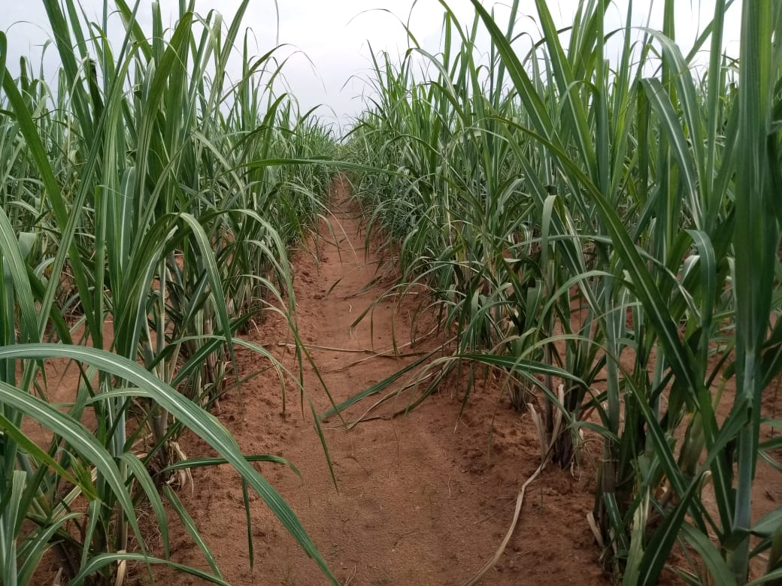
Fig 3: Sugarcane in 150*30 cm spacing

Table 2. Effect of plant geometry and different ages of seedlings on tiller count at 120 DAP and number of milleable canes in sugarcane
Treatments | Tiller count at 120 DAP (000’/ha) |  |  |  |  | Number of Milleable Canes (000’/ha)
Treatments | 2019 | 2020 | 2021 | Pooled |  | 2019 | 2020 | 2021 | Pooled
 | Factor A (Geometry (cm))
M₁: 90x30 | 128.3 | 121.67 | 81.73 | 110.6 |  | 82.0 | 79.4 | 92.11 | 78.93
M₂:150x30 | 135.1 | 132.0 | 75.84 | 114.3 |  | 99.2 | 81.56 | 82.78 | 86.66
M₃:120x30 | 121.0 | 121.0 | 74.76 | 105.5 |  | 79.0 | 77.11 | 80.67 | 77.96
M₄:180x60 | 130.2 | 127.4 | 65.36 | 107.5 |  | 84.5 | 64.2 | 71.67 | 79.15
SEm (+) | 4.85 | 2.12 | 1.37 | 1.71 |  | 1.51 | 1.35 | 2.08 | 1.11
CD (p=0.05) | 17.12 | 7.48 | 4.84 | 6.02 |  | 5.35 | 4.78 | 7.34 | 3.99
 | Factor B ( Age of seedlings)
S₁ : 30 days old | 153.1 | 139.25 | 81.8 | 125.0 |  | 93.3 | 83.33 | 93.91 | 89.83
S₂ : 45 days old | 125.2 | 124.25 | 76.05 | 108.4 |  | 86.5 | 76.08 | 81.91 | 80.5
S₃: 60 days old | 106.7 | 113.08 | 65.41 | 94.89 |  | 79.1 | 67.33 | 69.58 | 71.69
SEm (+) | 4.03 | 1.81 | 1.81 | 2.01 |  | 1.50 | 1.41 | 2.58 | 1.49
CD (p=0.05) | 12.19 | 5.71 | 1.19 | 6.08 |  | 4.54 | 4.27 | 7.83 | 4.52
Factor (B) at same level of A | NS | NS |  | 2.95 | 12.58 | NS | NS | NS | 1.94 | 9.30
Factor (A) at same level of B | NS | NS |  | 3.69 | 11.58 | NS | NS | NS | 2.69 | 8.34

Single cane weight (kg/cane):
Single weight directly influences the cane yield presented in table 3. Among seedling age, significantly higher single cane weight was recorded in 30 days old seedling (1.65). Among spacing in 150 x 30 cm spacing recorded significantly higher SCW (1.56) followed by 180 x 30 cm (1.39). Lowest cane weight was recorded in 60 days old seedling (1.21) and among geometry 90 x 30 cm (1.33) recorded lowest single cane weight. Ehsanullah et al., 2011 concluded that wider row spacing of 150 cm with double seed density increased the cane weight.
Cane yield (t/ha):
Cane yield varied significantly due to different planting geometry and different age single node seedlings was presented in table 3. Cane yield was recorded significantly superior in 30 days old seedlings in all geometry than the 45 and 60 days old seedlings. However, 30 days old seedling with 150 x 30 cm spacing recorded statistically higher yield (154.2) and it was followed by 180 x 30 cm spacing (133.7). Pannerselvam and Durai, 2011 reported that single-node seedlings raised in polythene bags and transplanted in the main field recorded higher cane and sugar yields.
Commercial cane sugar (%):
Commercial cane sugar was recorded significantly higher 150 x 30 cm with 30 days old seedling recorded a higher CCS % of 13.75 (Table 3). The lowest was recorded in 180x 30 cm spacing with 60 days old seedlings. Gouri et al., 2019 stated that sugar yield was higher in sugarcane planted with single-node seedlings of 30 days old under dual row planting.
Table 3. Effect of plant geometry and different ages of seedlings on single cane weight, cane yield and commercial cane sugar of sugarcane
Geometry (cm) | Single Cane Weight (kg/cane) |  |  |  | Cane yield (t/ha) |  |  |  | Commercial cane sugar (%)
Geometry (cm) | Age of Seedling (Days) |  |  |  | Age of Seedling (Days) |  |  |  | Age of Seedling (Days)
Geometry (cm) | 30 | 45 | 60 | Mean | 30 | 45 | 60 | Mean | 30 | 45 | 60 | Mean
M₁: 90x30 | 1.51 | 1.31 | 1.16 | 1.33 | 126.5 | 103.1 | 87.8 | 105.8 | 12.23 | 11.23 | 10.13 | 11.19
M₂:150x30 | 1.81 | 1.54 | 1.32 | 1.56 | 154.2 | 112.4 | 94.8 | 120.5 | 13.75 | 11.43 | 9.73 | 11.61
M₃:120x30 | 1.54 | 1.38 | 1.2 | 1.37 | 131.1 | 107.3 | 96.1 | 111.5 | 12.43 | 11.63 | 10.31 | 11.46
M₄:180x30 | 1.75 | 1.29 | 1.14 | 1.39 | 133.7 | 98.9 | 83.5 | 105.1 | 12.63 | 10.33 | 9.68 | 10.89
Mean | 1.65 | 1.38 | 1.21 |  | 136.4 | 105.4 | 90.5 |  | 12.75 | 11.16 | 9.97
 | Geometry | Age of seedling | Factor A at same level of B | Factor B at same level of A | Geometry | Age of seedling | Factor A at same level of B | Factor B at same level of A | Geometry | Age of seedling | Factor A at same level of B | Factor B at same level of A
SEm(+) | 0.025 | 0.043 | NS | NS | 2.42 | 8.52 | 2.42 | 8.52 | 0.245 | 0.32 | NS | NS
CD (p=0.05) | 0.089 | 0.129 | NS | NS | 0.089 | 0.129 | 2.92 | 5.81 | NS | 0.95 | NS | NS

Economics:
30 days old seedling with 150 x 30 cm (Rs. 1,81,151/-) spacing recorded higher net returns and B:C ratio (1.61). 30 days old seedling in all spacing recorded a higher B:C ratio compared to 45 and 60 days old age seedling. Nooli et al 2020 confirmed that economics worked out for single seedling technology with different planting geometry and conventional method of planting clearly indicated the higher monetary advantage in term of net returns [ 202880 ($ 3121.23) ha-1 ] and benefit cost ratio (2.68) with single eye bud seedling planted at 180 X 60 cm planting geometry and was on par with single eye bud seedling planted at 180 X 90 cm and 150 X 60 cm compared to conventional method of planting [ . 92528 ($ 1423.50) ha-1 and 1.83, respectively)].

Table 4. Effect of plant geometry and different ages of seedlings on net returns (₹/ha ) of sugarcane
Geometry (cm) | 30 days old seedling |  |  |  | 45 days old seedling |  |  |  | 60 days old seedling
 | 2019 | 2020 | 2021 | Mean | 2019 | 2020 | 2021 | Mean | 2019 | 2020 | 2021 | Mean
M₁: 90x30 | 1,62,095 | 1,01,020 | 1,58,604 | 1,40,573 | 1,56,860 | 1,13,956 | 1,16,121 | 1,28,979 | 1,06,460 | 97,683 | 86,662 | 96,935
M₂:150x30 | 1,99,770 | 1,50,268 | 1,93,415 | 1,81,151 | 1,92,790 | 1,47,875 | 1,65,018 | 1,68,561 | 93,280 | 58,108 | 72,767 | 74,718
M₃:120x30 | 1,76,905 | 1,02,996 | 1,66,550 | 1,48,817 | 2,41,165 | 1,04,339 | 1,18,386 | 1,54,630 | 89,160 | 53,100 | 50,981 | 64,414
M₄:180x30 | 1,60,299 | 1,29,396 | 1,44,734 | 1,44,810 | 2,60,789 | 93,212 | 1,12,124 | 1,55,375 | 87,748 | 41,847 | 41,095 | 56,897

Table5. Effect of plant geometry and different ages of seedlings on B:C ratio of sugarcane
Geometry (cm) | 30 days old seedling |  |  |  | 45 days old seedling |  |  |  | 60 days old seedling
 | 2019 | 2020 | 2021 | Mean | 2019 | 2020 | 2021 | Mean | 2019 | 2020 | 2021 | Mean
M₁: 90x30 | 1.68 | 1.21 | 1.54 | 1.48 | 1.23 | 1.20 | 1.39 | 1.27 | 1.04 | 1.16 | 1.11 | 1.08
M₂:150x30 | 1.70 | 1.52 | 1.61 | 1.61 | 1.65 | 1.34 | 1.52 | 1.50 | 1.21 | 1.23 | 1.24 | 1.22
M₃:120x30 | 1.56 | 1.35 | 1.50 | 1.47 | 1.48 | 1.15 | 1.35 | 1.33 | 1.19 | 1.14 | 1.09 | 1.11
M₄:180x30 | 1.21 | 1.46 | 1.48 | 1.38 | 1.32 | 1.32 | 1.37 | 1.34 | 1.15 | 1.06 | 1.07 | 1.09
4. Conclusion
The present study establishes that sugarcane single node seedling method could be a viable and economical alternative for reducing the cost of cultivation of sugarcane production. Sugarcane planting with 30 days aged seedlings at 150 × 30 cm spacing was found to be optimum for recording higher cane yield (154.2 t/ha) and commercial cane sugar (CCS% of 13.75) which was 13.2 % and 6 % more, respectively over 45 days aged seedlings. 60 days old seedling recorded lowest cane yield (90.5 t/ha) and commercial cane sugar (9.97%) in all spacing. The 30 days aged seedlings planted at 150 × 30 cm spacing gave higher net returns of ₹. 1,81,151/ha over 45 days aged seedlings planted at 150 × 30 cm spacing (₹.1,65,018/ha) and 60 days old seedlings (₹.74,718/ha).
Acknowledgement
The authors are very much thankful to the Director of Research, Professor Jayashankar Telangana Agricultural University, Hyderabad, Telangana for providing facilities for conducting the experiment and we would like to express our gratitude to everyone who contributed for the research.
COMPETING INTERESTS DISCLAIMER:
Authors have declared that they have no known competing financial interests OR non-financial interests OR personal relationships that could have appeared to influence the work reported in this paper.
Disclaimer (Artificial intelligence)

Author(s) hereby declare that NO generative AI technologies such as Large Language Models (ChatGPT, COPILOT, etc.) and text-to-image generators have been used during the writing or editing of this manuscript.

References
- Bhullar MS, Thind KS, Uppal SK, Singh K. (2008). Productivity, profitability and quality of sugarcane (Saccharum sp.) plant-ratoon system in relation to planting methods and seeding rate. Indian J. of Agron. 2008; 53(3): 195-199.
- de Souza FG, Alvarez RdF, Teodoro LPR. Planting Arrangement and Seedling Type Influence Yield and Quality of Ratoon Sugarcane. Sugar Tech. 2022, 1590–1596 (2022)
- Ehsanullah, Khawar Jabran,, Muhammad Jamil and Abdul Ghafar. Optimizing the row spacing and seeding density to improve yield and quality of sugarcane. Crop & Environment. 2011, 2(1): 1-5.
- Gouri V, Chitkala Devi T, Bharathalakshmi M. Influence of type of seedlings, planting methods and nitrogen levels on yield and quality of sugarcane under drip fertigation. Int. J. of Bio-resource and Stress Manag. 2019; 10(4):364-367.
- Mohanty Das PP, Nanda SS. Introducing SSI (Sustainable sugarcane initiative) technology for enhanced cane production and economic returns in real farming situations under east coast climatic conditions of India. Sugar Tech. 2019;17(2):116-120.
- Jain R, Solomon S, Lal P, Shrivastava AK. Nutrient application improves stubble bud sprouting under low temperature conditions in sugarcane. Sugar Tech. 2009; 11: 83–85.
- Nalawade SM, Mehta AK, Sharma AK. Sugarcane planting techniques: a review. In: Special Issue: National Seminar “Recent Trends in Plant Sciences and Agricultural Research. 2018; 98–104.
- Natarajan US. Tillering in SSI- emergence, factors affecting, constraints and solutions. First National Seminar on Sustainable sugarcane initiative, SSI. A methodology to improve cane Productivity dates 2425, August, Freemann Hall, TNAU, Coimbatore. 2011; 21–23.
- Nooli SS, Alagundagi SC, Patil MB, Wali SY, Sadashivangouda SNO. Influence of Planting Geometry in Single Eye Bud Seedling Planting Technique on Sugarcane Productivity and Profitability under Drip Irrigation in Karnataka, India. International Journal of Current Microbiology and Applied Sciences.2020; 9(7): 355-361.
- Pannerselvam R, Durai R. Studies on planting techniques and intercrops in sugarcane under levels and times of nitrogen application. Cooperative Sugar. 2011; 35 (11):857–860.
- Singh GB. Management of plant population in sugarcane for higher productivity and quality: Proceedings of International Symposium on Food, Nutrition and Economic Security through Diversification in Sugarcane Production and Processing Systems, IISR Lucknow, India. 2002;9–18.
- Subhashisa P, Singh DSK, Guru, Meena BR. Effect of Plant Growth Regulators on Tiller dynamics and Yield of Sugarcane (Saccharum officinarum L.) Int. J. of Bio-resource and Stress Manag. 2017; 8(1): 075–078
- Kierzkowski, D., & Routier-Kierzkowska, A. L. (2019). Cellular basis of growth in plants: geometry matters. Current Opinion in Plant Biology, 47, 56-63.
- Paulus, S. (2019). Measuring crops in 3D: using geometry for plant phenotyping. Plant methods, 15(1), 103.

