Molecular Characterization of Genetic Diversity and Trait Association Analysis for Yield Improvement in Maize (Zea mays L.) Using SSR Markers
Abstract
A total of 11 maize inbred lines were crossed with 4 testers in a line × tester mating design (Kempthorne, 1957), generating 44 F₁ test crosses. These, along with 11 lines, 4 testers, and 5 checks (64 genotypes), were evaluated in a simple lattice design with two replications during Rabi 2022–23 to assess genetic variability, trait associations, and yield components. Molecular diversity analysis was carried out on 15 inbred lines along with testers using 26 SSR markers, of which 11 markers exhibited clear and reproducible polymorphism, generating 22 alleles with an average of 2.0 alleles per locus. Polymorphic Information Content (PIC) values ranged from 0.12 to 0.64, indicating moderate genetic diversity; the most informative markers included umc2170 (0.64), phi080 (0.61), and bnlg1036 (0.58). UPGMA clustering based on Jaccard’s similarity coefficient grouped the 15 inbred lines into two major clusters, revealing substantial genetic divergence useful for heterotic grouping and parental selection. Correlation analysis indicated that plant height, ear length, ear girth, kernels per row, kernel rows per ear, and 100-kernel weight were positively associated with grain yield. Path coefficient analysis identified ear girth and kernels per row as the traits exerting the strongest positive direct effects on yield. The combined molecular and phenotypic findings provide a robust basis for selecting genetically diverse and agronomically superior parents for developing high-yielding maize hybrids.
Key words: Maize, Parental selection, Breeding potential and Genetic improvement

Introduction
Maize (Zea mays L.) is one of the most important cereal crops globally, serving as a staple food, animal feed, and a vital raw material for several agro-based industries. In India, maize is cultivated on about 12.09 million hectares with a production of 43.41 million tonnes and an average productivity of 3,590 kg ha⁻¹ during 2024–25, according to the estimates of the Department of Agriculture & Farmers Welfare (DA&FW).
Andhra Pradesh is also an important maize-growing state in southern India. During 2024–25, maize was cultivated on about 0.33 million hectares, producing approximately 2.15 million tonnes with an average productivity of about 6,510 kg ha⁻¹, contributing nearly 5% of the total maize production in India. Major maize-producing districts in the state include Guntur, West Godavari, Srikakulam, Vizianagaram and Kurnool, where favourable climatic conditions support large-scale maize cultivation.
Molecular markers have emerged as powerful tools in genetic analysis, especially for assessing diversity and facilitating selection in crop improvement programs. Among them, Simple Sequence Repeats (SSRs) are widely used due to their high polymorphism, co-dominant inheritance, reproducibility, and genome-wide coverage (Rakshit et al., 2021). SSR-based molecular characterization provides valuable insights into the genetic relationships and variability within maize germplasm, supporting informed decisions for heterotic grouping and hybrid development (Xie et al., 2017).
Alongside molecular data, correlation and path coefficient analyses play a crucial role in identifying key traits influencing grain yield. Correlation analysis reveals the strength and direction of relationships between traits, while path analysis partitions these into direct and indirect effects, thus identifying true yield contributors (Dewey and Lu, 1959; Esmail et al., 2023). Integrating molecular diversity analysis with trait association studies increases the precision of selecting genetically diverse and agronomically desirable parental lines for hybrid breeding (Prasanna, 2012).
Understanding the genetic and phenotypic determinants of yield in maize is critical, as emphasized in recent studies on maize inbred lines (Kumar et al., 2024; Mishra et al., 2024). The parental inbred lines used in this study comprised diverse maize genotypes, selected based on their genetic background, adaptability, and potential heterotic performance. These lines represent different heterotic groups and possess desirable agronomic and yield-related traits, making them valuable genetic resources for hybrid development. Accordingly, the present study was undertaken to assess the extent of genetic diversity among 15 maize inbred lines using SSR markers and to quantify the direct and indirect contributions of key yield-related traits to grain yield through correlation and path coefficient analysis, with the objective of enhancing the precision of parental selection for maize hybrid breeding programs.
Materials and Methods
The field experiment was conducted during Rabi 2022–23 at the Agricultural Research Station (ARS), Peddapuram. A total of 64 maize genotypes were evaluated for phenotypic analysis, comprising 44 test crosses (developed during Rabi 2021–22), 11 inbred lines, 4 testers, and 5 standard checks. For genotypic (molecular) analysis, a subset of 15 maize inbred lines (including inbred lines and testers) was used to assess genetic diversity using 26 SSR (Simple Sequence Repeat) markers distributed across the maize genome. The experiment was laid out in a simple lattice design with two replications. Standard agronomic practices and plant protection measures were followed throughout the crop growth period. Data were recorded on twelve quantitative traits, namely: days to 50% tasselling, days to 50% silking, days to maturity, plant height, ear height, ear length, ear girth, number of kernels per row, kernel rows per ear, grain yield per plant (g), 100-kernel weight (g), and protein content (%).
Genomic DNA was extracted from 15-day-old leaf tissue following the CTAB method described by Zheng et al. (1995) and Vivekananda et al. (2018) with minor modifications. Approximately 200 mg of leaf tissue was ground in preheated (65 °C) CTAB extraction buffer, treated with β-mercaptoethanol and SDS, and incubated at 65 °C for 45–60 min. The DNA was purified using phenol:chloroform:isoamyl alcohol, precipitated with chilled isopropanol, washed with 70% ethanol, treated with RNase, and finally dissolved in TE buffer (T10E1). DNA concentration and purity were determined using a NanoDrop™ 2000 spectrophotometer (Thermo Fisher Scientific, USA), and DNA integrity was verified on 0.8% agarose gel in 1× TAE buffer using a SYNGene GeneFlash (UK) gel documentation system.
PCR amplification was carried out using 26 SSR primers. Each PCR reaction (10 µl) was performed in a Prima 96™ thermocycler (HiMedia, India) with an initial denaturation at 94 °C for 5 min, followed by 35 cycles of 94 °C for 40 sec, 55 °C for 40 sec, and 72 °C for 1 min, with a final extension at 72 °C for 10 min. The amplified PCR products were separated on 3% agarose gel in 1× TAE buffer, visualized under UV light, and documented using the SYNGene GeneFlash gel documentation system. Details of the SSR primers including primer sequences, annealing temperatures, bin numbers, chromosome locations, and references are presented in Table 1. Protein content of maize grain was determined on dried kernels using the Kjeldahl method (AOAC, 2005).
Table 1. List of SSR primers used for PCR amplification in the present investigation
The below SSR primers are selected based on the earlier reports of Kumar et al. (2022) and Kiran K. K (2016)
S. No | Primer | F/R | Sequence
1 | Bnlg-1297 | F | GAAGCTTCTCCTCTCGCGTCTC
1 | Bnlg-1297 | r | CAGTCCCAGACCCTAGCTCAGTC
1 | Bnlg-1297 | R | CAGCCACAGTGAGGCACATC
2 | Bnlg-1036 | F | CAGAGACTCTCCATTATCCCTCCA
2 | Bnlg-1036 | R | TGGTTTGTGCAAGTGTCACC
3 | Phi-080 | F | ATGGTCAGGGGCTACGAGGAG
3 | Phi-080 | R | AGCGGGTCGATCTTTCTCTTAGTT
4 | umc-1627 | F | -CCTCTTTGCCTGTACCGTGTATTC
4 | umc-1627 | R | CTTAAACTTGTCGAGACGGTCCTG
5 | Umc-1786 | F | AACACCTGCTGGATATGGATCACT
5 | Umc-1786 | R | GGAAGAAAAATGTCGACCTGCTC
6 | Umc-1288 | F | GCTGGTAGCTTTCAGATGGC
6 | Umc-1288 | R | TGTCCCTCCTCCAGTTTCAC
7 | Umc-2069 | F | AAGAACAGAAGGCATTGATACATAA
7 | Umc-2069 | R | TGCAGGTGTATGGGCAGCTA
8 | Bnlg- 1185 | F | AGTACTTTCAGGCAGGGACCTTCT
8 | Bnlg- 1185 | R | AACGCACTTCTTGTAGCTGTAGGG
9 | Bnlg1520 | F | ACTTGCTTGCCTGCCGTTAC
9 | Bnlg1520 | R | CGCACACCACTTCCCAGAA
10 | Umc-2170 | F | GTATCCGTTTCTCATGCAACACAC
10 | Umc-2170 | R | GATCTCGATCTGCTTCATCATCTG
11 | Umc-21594 | F | AGATAGCCGCCGAGACCAAG
11 | Umc-21594 | R | ACTCACTCGACGGACTTCTCGAC
12 | Umc-1823 | F | ATGGCCCACTCATCATATCTCTGT
12 | Umc-1823 | R | TGTGTTGATTAGCAGCGGATAAAA
13 | Umc-1036 | F | CACCGGAACACCTTCTTACAGTTT
13 | Umc-1036 | R | CGAAACCTTCTCGTGATGAGC
14 | Umc-1063 | F | AAACTCACTGAACATGATCCTGGC
14 | Umc-1063 | R | CTGGTTCGGATGCAAGTAGTCAG
15 | Umc-1766 | F | CATGAAAGTTTTCCTGTGCAGATT
15 | Umc-1766 | R | GGGCAACTTTAGAGGTCGATTTATT
16 | Umc-1018 | F | CTTGCTAGAGTCGGTGAACAACAA
16 | Umc-1018 | R | AACCAAGCTCCTTAATGAGGTCAC
17 | Umc-1026 | F | CCATAAACTGTTCCTTTGGCACAC
17 | Umc-1026 | R | CTTTCACGTGTTAAGGGAGACACC
18 | UMC-1918 | F | ACTACTCCTCGGATAGCCACG
18 | UMC-1918 | R | GACGAGTAGAGGCTCTGGGAC
19 | Umc-1415 | F | CGGAACCTGCTGCAGTTAAT
19 | Umc-1415 | R | GAGATGCAGGAATGGGAAAA
20 | Umc-1708 | F | GTAAAGTACGATGCGCCTCCC
20 | Umc-1708 | R | CGGGGTAGAGGAGAGTTGTG
21 | Bnlg-1621 | F | AAGTCCAGCCAAGTTCATCAAAGA
21 | Bnlg-1621 | R | ACTGTAACTAAACTGGGTGTGCCC
22 | Bnlg-1306 | F | ACCCTTGCCTTTACTGAAACACAACAGG
22 | Bnlg-1306 | R | GCACACCGTGTGGCTGGTTC
23 | Bnlg-1056 | F | ACCCCCTGATTCTCTCTTACGTTT
23 | Bnlg-1056 | R | CTGGATGAGGAGGAAGAATACGAG
24 | Phi-129 | F | AGCAGAACGGCAAGGGCTACT
24 | Phi-129 | R | TTTGGCACACCACGACGA
25 | Phi-061 | F | CTTATTGCTTTCGTCATACACACACATTCAT
25 | Phi-061 | R | GAGCATGAGCTTGCATATTTCTTGTGG
26 | Phi-067 | F | AGAAAAGAGAGTGTGCAATTGTGATAGAG
26 | Phi-067 | R | AATGGGTGCCTCGCACCAAG
Tm – Annealing temperatures F – Forward sequence, R – Reverse sequence
RESULTS AND DISCUSSION
Molecular Diversity Among maize genotypes Using SSR Markers
In the present study, molecular diversity among 15 maize inbred lines was assessed using 26 SSR (Simple Sequence Repeat) primer pairs, of which 11 primers produced clear and reproducible polymorphic bands. A total of 22 alleles were detected across the polymorphic loci, with an average of 2.0 alleles per locus. The amplified fragment sizes ranged from 90 to 480 bp, indicating variation in the targeted genomic regions among the inbred lines.
The Polymorphic Information Content (PIC) values, which measure the informativeness and discriminatory power of molecular markers, ranged from 0.12 (umc2069) to 0.64 (umc2170), with an overall mean PIC value of 0.42. Among the SSR markers, umc2170 (0.64) and phi080 (0.61) were identified as highly informative markers, followed by bnlg1297 and bnlg1036 (0.58), and umc1027 (0.53) (Table 3). These markers proved effective in detecting genetic variability among the maize inbred lines and can be useful for genetic diversity assessment, genotype differentiation, and parental line selection in hybrid breeding programmes.
These findings are supported by recent studies such as Patel et al. (2024), who evaluated 96 maize inbred lines using 136 SSR markers and reported an average PIC value of 0.46, with highly informative markers such as umc2252 (0.58) and umc1060 (0.51). Similarly, Wende et al. (2018) and Kumar et al. (2022) reported mean PIC values of 0.44 and 0.49, respectively, indicating that SSR markers consistently provide reliable estimates of genetic variability in maize. Furthermore, Adu et al. (2019) reported a much higher level of diversity in South Sudan maize landraces, with an average of 7.4 alleles per locus and a mean PIC value of 0.69, suggesting that landraces possess substantial untapped genetic potential.
The genetic similarity matrix, computed using Jaccard’s coefficient, was used to construct a UPGMA dendrogram with DARwin 6.0 software. The analysis grouped the 15 maize inbred lines into two major clusters. Cluster I comprised 11 inbred lines, further divided into sub-clusters IA (8 lines), IB (1 line), IC (1 line), and ID (1 line), whereas Cluster II contained 4 inbred lines, subdivided into IIA (1 line) and IIB (3 lines). This clustering pattern indicates substantial genetic divergence among the parental lines, which can be effectively exploited to select genetically diverse parents for maize hybrid breeding programmes (Table 3). These results are consistent with previous reports by Ranatunga et al. (2009), Kanagarasu et al. (2013), and Mukri et al. (2022), who also grouped maize inbred lines into distinct clusters using SSR markers.
The highly polymorphic SSR markers identified in the present study, particularly umc2170, phi080, bnlg1297, bnlg1036, and umc1027, exhibited high PIC values and clear amplification patterns, indicating their suitability for genetic diversity analysis. These informative markers could also be employed in multiplex PCR assays, provided their annealing temperatures and amplicon size ranges are compatible. Multiplexing such markers would enhance the efficiency of genotyping and facilitate rapid screening of maize germplasm for parental selection in hybrid breeding programs.
Table 2: SSR Markers with PIC Values in 15 Maize Inbred Lines (Zea mays L.)
Marker Name | Fragment Size Range (bp) | PIC Value
umc2170 | 180–320 | 0.64
phi080 | 280–400 | 0.61
bnlg1297 | 100–150 | 0.58
bnlg1036 | 280–300 | 0.58
umc1027 | 100–120 | 0.53
umc2069 | 150–180 | 0.12

Table 3. Clustering pattern based on UPGMA dendrogram in 15 inbred lines of maize (Zea mays L.)
Cluster | Sub Cluster No | Inbred No. | Inbred names
Ⅰ | I A | 5, 6, 7, 8, 9, 10, 11, 15 | PI 14, PI 17, PI 21, PI 215, PI 287, PI 302, PI 303, CML581
Ⅰ | I B | 12 | LM13
Ⅰ | I C | 6 | PI 8
Ⅰ | I D | 4 | PI 9
Ⅱ | II A | 2 | PI 7
Ⅱ | II B | 1, 13, 14 | PI 4, CML451, CL02450
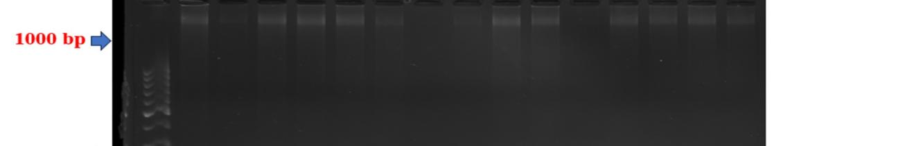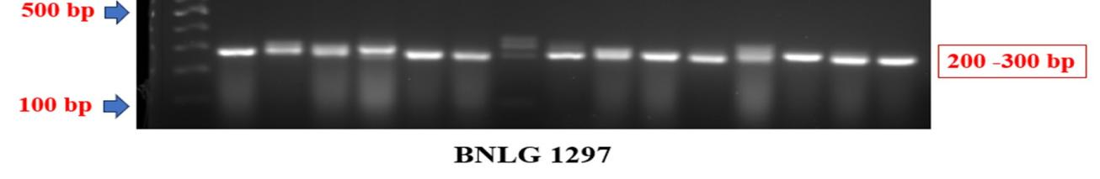
Plate.1. SSR marker profiles of generated by primer BNLG 1297 in maize
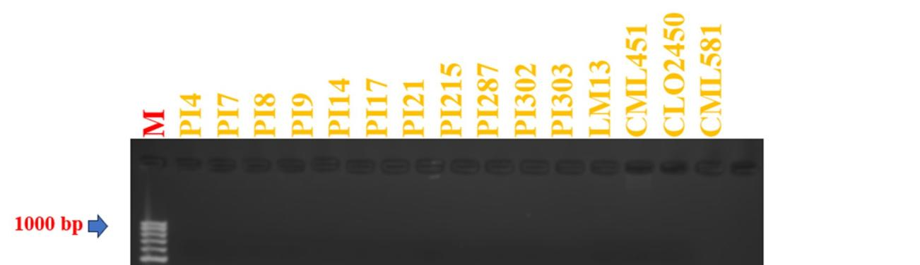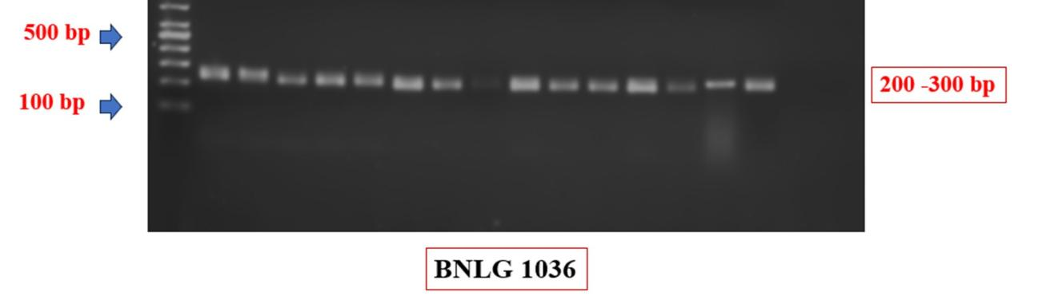
Plate 2. SSR marker profiles generated by primer BNLG 1036 in
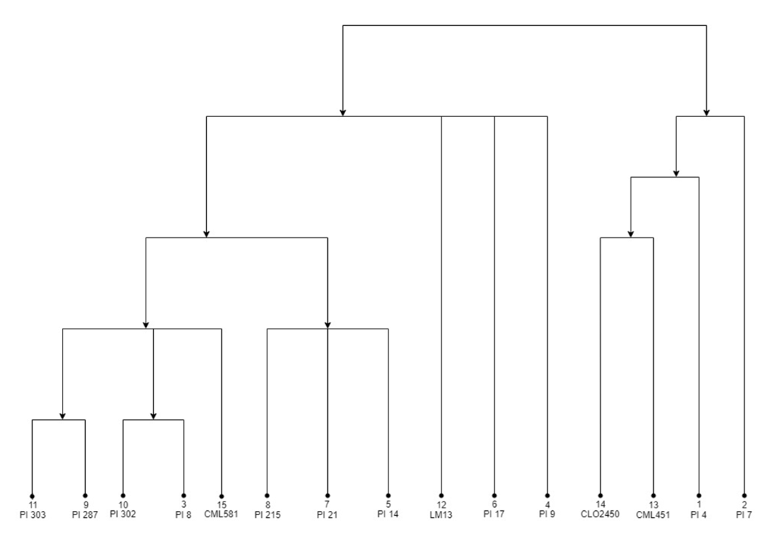
Fig. 1. UPGMA dendrogram generated based on Jaccards similarity index using SSR markers showing variability among 15 parental inbreds in maize (Zea mays L.)
CORRELATION ANALYSIS
The correlation analysis revealed that several morphological and yield-contributing traits had significant associations with grain yield at both phenotypic and genotypic levels, indicating their potential use in indirect selection. Ear girth (r = 0.715** P, 0.891** G), ear length (0.687** P, 0.755** G), plant height (0.608** P, 0.813** G), and 100-kernel weight (0.308** P, 0.367** G) showed strong positive correlations with grain yield, suggesting that these traits contribute directly or indirectly to yield enhancement and can be used as effective selection indices in breeding programs. Conversely, days to 50 % anthesis (-0.257* P; -0.513**, G), days to 50 % silking (-0.289* P; -0.560**, G), ** and days to maturity (-0.237* P; -0.616**, G) ** showed significant negative correlations with grain yield, indicating that genotypes that flower and mature earlier tend to be higher yielding. Therefore, these traits should be emphasized for early maturity breeding programs aimed at maintaining high yield.
Conversely, days to 50 % anthesis (-0.257* P; -0.513**, G), days to 50 % silking (-0.289* P; -0.560**, G), ** and days to maturity (-0.237* P; -0.616**, G) ** showed significant negative correlations with grain yield, indicating that genotypes that flower and mature earlier tend to be higher yielding. Therefore, these traits should be emphasized for early maturity breeding programs aimed at maintaining high yield. Additionally, a negative genotypic correlation was observed between protein content and yield (–0.576 G), indicating a potential trade-off that breeders must consider when aiming to improve both yield and nutritional quality (Table 3).
Overall, genotypic correlations were consistently higher than phenotypic correlations, signifying that the observed associations among traits are largely due to genetic factors rather than environmental influence. Consequently, breeders should prioritize ear length, ear girth, kernels per row, plant height, and 100-kernel weight for direct selection to improve yield, while maintaining earliness to enhance overall crop performance.

Table 4: Phenotypic and Genotypic correlation coefficients between grain yield and its contributing traits in maize (Zea mays L.)
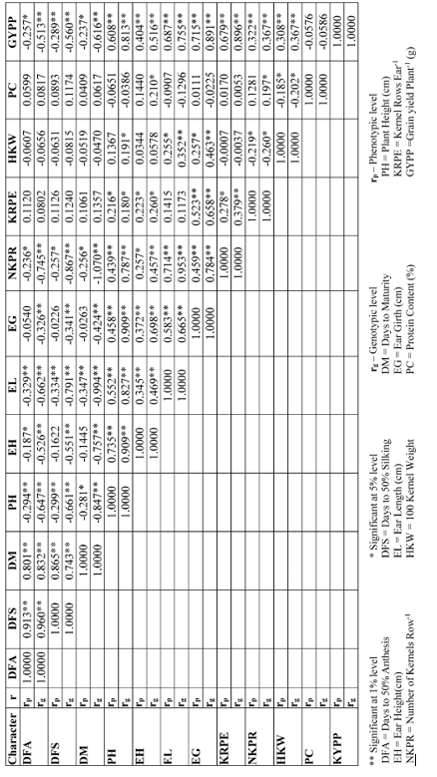
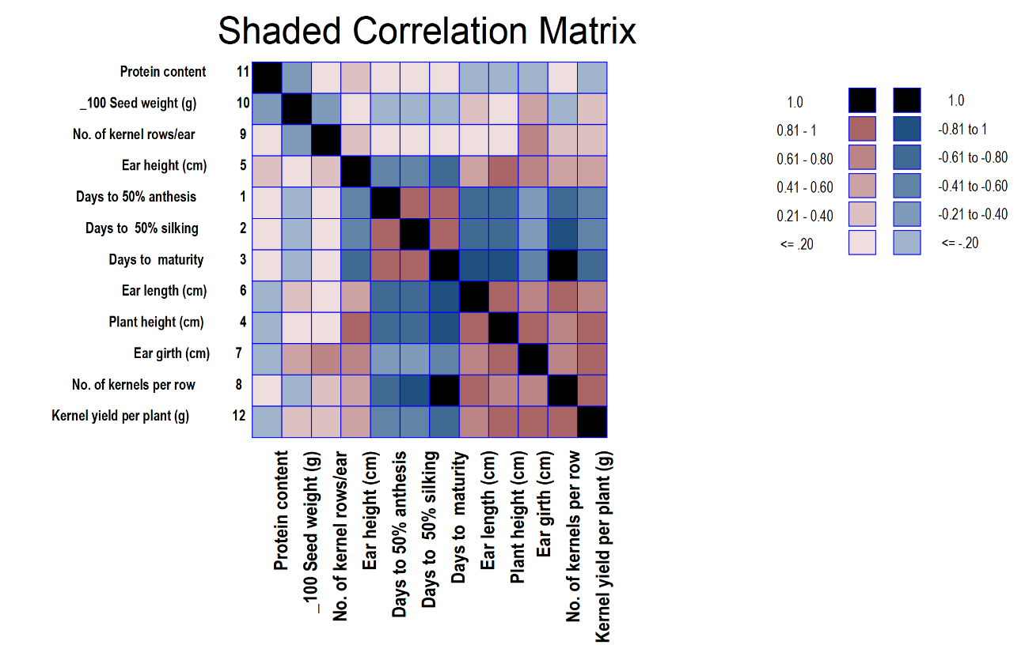
Fig. 2. Genotypic shaded correlation matrix for all the characters studied in maize (Zea mays L.)
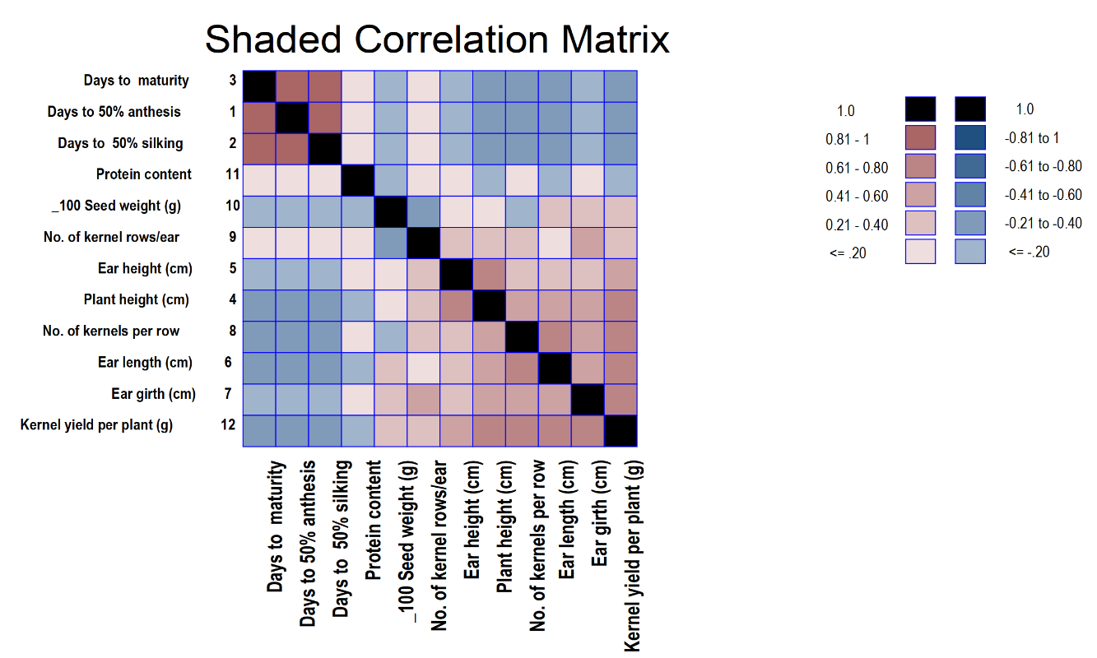
Fig. 3. Phenotypic shaded correlation matrix for all the characters studied in maize (Zea mays L.)
PATH ANALYSIS
At the genotypic level, traits with positive direct effects on grain yield per plant were ear girth (1.564), plant height (0.420), number of kernels per row (0.379), days to 50% anthesis (0.758), 100-kernel weight (0.019), and protein content (0.128), indicating their strong and favorable contribution to yield. At the phenotypic level, ear girth (0.405), plant height (0.227), number of kernels per row (1.341), and 100-kernel weight (0.170) also showed positive direct effects. These findings highlight that ear girth, plant height, and kernel number per row are the most influential traits for yield enhancement and can be prioritized in selection during breeding programs. While traits like 100-kernel weight and days to anthesis also contribute positively, their effects are relatively smaller, indicating that selection should focus primarily on traits with the highest direct contributions for maximum genetic gain (Table 4).
Traits with negative direct effects included days to 50% silking (-1.063), ear height (-0.722), ear length (-1.789), and kernel rows per ear (-0.799) at the genotypic level, and days to 50% silking (-0.348), ear height (-0.028), and ear length (-0.008) at the phenotypic level, their direct contribution to grain yield is unfavorable. However, the positive correlations of these traits with yield suggest that their influence is largely indirect, mediated through other yield-contributing traits such as ear girth, plant height, and number of kernels per row. This distinction is important in breeding programs because it demonstrates that selection based solely on direct effects may be misleading, whereas considering both direct and indirect effects allows breeders to exploit beneficial indirect pathways to enhance grain yield (Dewey & Lu, 1959; Yan et al., 2010).
Important positive indirect effects were observed for ear girth via plant height (1.422), ear length (1.040), and kernels per row (1.225); for plant height via ear girth (0.382) and ear length (0.347); and for 100-kernel weight via ear girth (0.009) and ear length (0.006) indicating that even if the direct contribution of ear girth is moderate, it enhances yield indirectly by influencing other yield-contributing traits. In contrast, days to 50% anthesis (0.758) and days to silking (-1.063) exerted negative indirect effects through ear height (-0.399), ear length (-0.502), and plant height (-0.490) suggesting that these phenological traits can reduce yield indirectly if they negatively influence the development of key yield components.
The residual effect was 0.42 at genotypic and 0.61 at phenotypic level, indicating that the studied traits explained 58% and 39% of the variation in grain yield, respectively. Overall, traits such as ear girth, plant height, number of kernels per row, and 100-kernel weight showed the most important direct and indirect positive effects, suggesting that selection for these characters would be effective in improving maize yield.
The comparison of genotypic and phenotypic path analyses shows both convergence and divergence in trait contributions to grain yield. Convergence is observed for traits such as ear girth, plant height, and number of kernels per row, which consistently exhibit strong positive direct and indirect effects at both levels, indicating their reliability as selection criteria. Divergence occurs in the magnitude of effects, with genotypic path coefficients generally higher, reflecting the masking influence of environmental variation on phenotypic expression. Some traits, such as days to silking and ear length, show negative genotypic direct effects but weak or variable phenotypic effects, emphasizing that environmental modulation can alter the apparent importance of these traits. These patterns suggest that while phenotypic observations provide valuable selection information, genotypic path analysis offers a more precise estimation of the genetic potential of yield-contributing traits, which is critical for efficient parental selection and hybrid development.

Table 5. Direct (diagonal) and indirect effects (above and below the diagonal) of different traits on grain yield per plant at genotypic and phenotypic level in maize (Zea mays L.)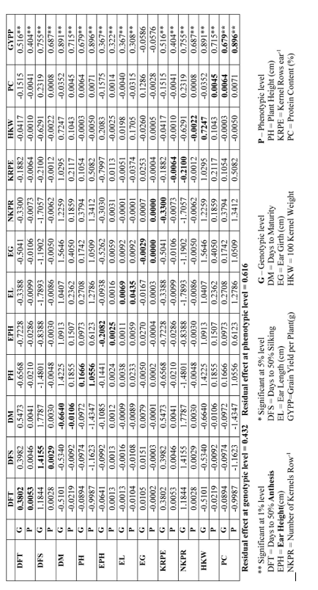
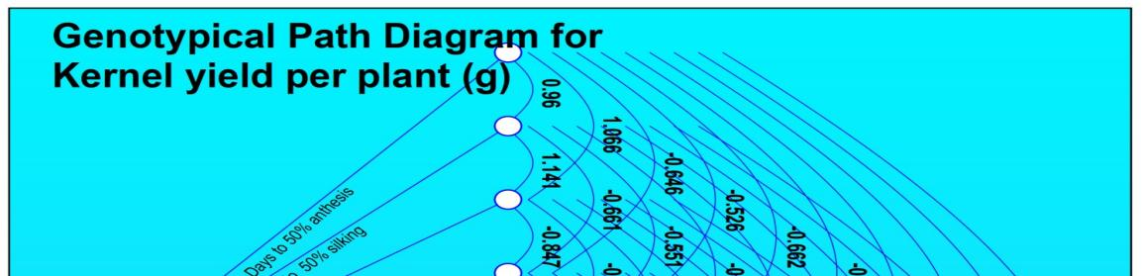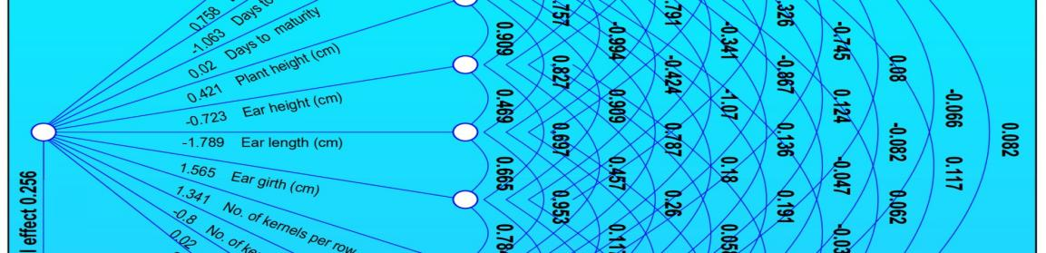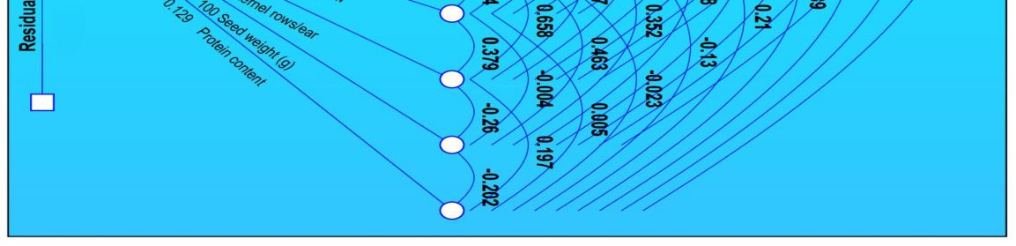 Fig. 4. Genotypic path diagram showing direct and indirect effects of yield components on grain yield in maize (Zea mays L.)

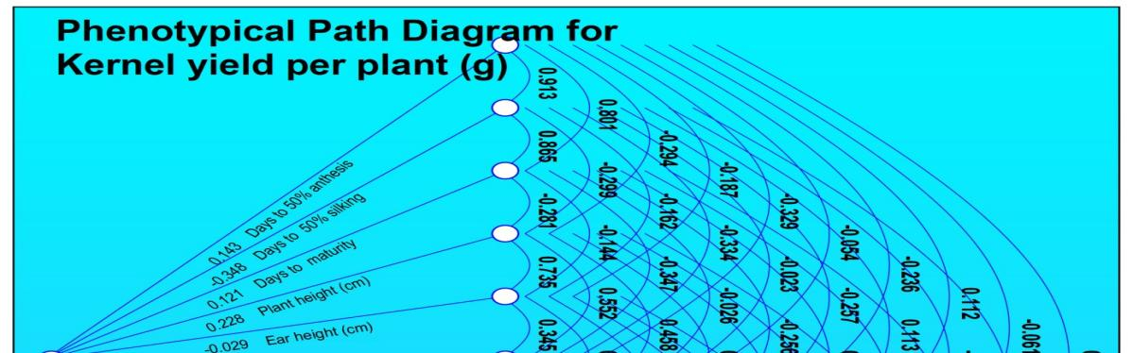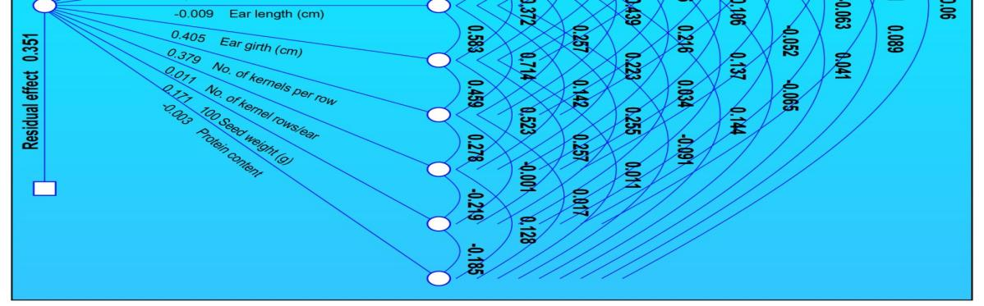
Fig.5. Phenotypic path diagram showing direct and indirect effects of yield components on grain yield in maize (Zea mays L.)

Conclusion
The present study revealed substantial genetic diversity among 15 maize inbred lines using 26 SSR markers, with umc2170, phi080, bnlg1297, and bnlg1036 exhibiting high polymorphism. UPGMA clustering classified the inbred lines into two distinct groups, facilitating the identification of complementary parents for hybrid development. Correlation and path coefficient analyses highlighted ear girth, plant height, number of kernels per row, and 100-kernel weight as the most influential traits directly and indirectly contributing to grain yield, whereas traits such as ear length and ear height primarily affected yield through indirect effects. These results provide valuable insights for targeted parental selection, trait-focused breeding strategies, and the application of marker-assisted selection in maize improvement programs.
Disclaimer (Artificial intelligence)
Author(s) hereby declare that NO generative AI technologies such as Large Language Models (ChatGPT, COPILOT, etc.) and text-to-image generators have been used during the writing or editing of this manuscript.

REFERENCE
Adu, G.B., Badu‐Apraku, B., Akromah, R. and Garcia‐Oliveira, A.L. (2019). Genetic diversity and population structure of early maturing maize inbreds using SNP markers. Plant Breeding, 138(2):159–169.
DA&FW. (2024). Third Advance Estimates of Foodgrains 2023–24. Department of Agriculture & Farmers Welfare, Ministry of Agriculture & Farmers Welfare, Government of India.
Dewey, D.R. and Lu, K.H. (1959). A correlation and path coefficient analysis of components of crested wheatgrass seed production. Agronomy Journal, 51:515–518.
Esmail, R.M., Abdelmula, A.A. and Ali, M.A. (2023). Correlation and path coefficient analysis for yield and its attributes in maize. Journal of Plant Breeding and Crop Science, 15(3):45–53.
Kanagarasu, S., Nallathambi, G. and Ganesan, K.N. (2013). Genetic diversity studies in maize (Zea mays L.) inbreds using SSR markers. Electronic Journal of Plant Breeding, 4(1):1067–1072.
Kumar, S., Singh, L., Yadav, R. K., Mishra, A., Babu, K., Dixit, R., & Kuswaha, C. (2024). Heterosis and inbreeding depression for yield and yield attributing traits of maize (Zea mays L.). International Journal of Plant & Soil Science, 36(10), 93–102.
Kumar, V., Singh, M., Yadav, R.K., Rani, R. and Kumar, N. (2022). Molecular diversity assessment of maize inbreds using SSR markers. Journal of Cereal Research, 14(1):58–65.
Mishra, D. K., Singh, B., Chakraborty, M., Verma, N., Surin, S. S., & Mishra, S. K. (2024). Combining ability and heterosis in maize (Zea mays L.) inbred lines. Journal of Scientific Research and Reports, 30(6), 943–954.
Mukri, G., Rajasekaran, S. and Manivannan, N. (2022). Molecular characterization and diversity analysis in maize inbred lines using SSR markers. Indian Journal of Genetics and Plant Breeding, 82(2):265–273.
Patel, R.K., Thakur, P. and Kumar, V. (2024). Assessment of genetic diversity among maize inbred lines using SSR markers. International Journal of Agriculture Sciences, 16(4):125–132.
Prasanna, B.M. (2012). Diversity in global maize germplasm: characterization and utilization. Journal of Biosciences, 37(5):843–855.
Rakshit, S., Sekhar, J.C. and Nath, R. (2021). Application of molecular markers in maize improvement. Maize Genetics and Genomics, 12:155–182.
Ranatunga, C.A., Prasanna, B.M. and Randles, C. (2009). Genetic diversity and population structure among maize inbreds revealed by SSR markers. Maydica, 54:113–123.
Vivekananda, A.K., Singh, V. and Singh, S.P. (2018). Standardized protocol for DNA extraction from maize. Journal of Plant Biotechnology, 15(2):87–93.
Wende, A., Hussein, S. and Derera, J. (2018). Genetic diversity assessment of quality protein maize inbred lines using SSR markers. Euphytica, 214:178.
Xie, C.X., Warburton, M.L. and Xia, X.C. (2017). Molecular marker applications in maize breeding. Molecular Breeding, 37:1–15.
Yan, W., Kang, M.S. and Ma, B. (2010). GGE biplot analysis: A graphical tool for breeders. Agronomy Journal, 102(6):1687–1694.
Zheng, X., Chen, L. and Li, X. (1995). A modified CTAB protocol for high-quality DNA extraction from maize. Plant Molecular Biology Reporter, 13:43–47.

