Short communication

Fluorescence microscopy based detection of phytoplasma infecting cherry plants in Himachal Pradesh, India

Abstract
Sweet cherry (Prunus avium L.), a major temperate fruit crop, is vulnerable to several diseases that significantly reduce yield, among which phytoplasma-associated disorders are increasingly emerging as a major concern. This study aimed to detect of phytoplasma infections in cherry orchards of Himachal Pradesh, India. Field surveys conducted in 2023–2024 across major cherry-growing areas, primarily in Shimla district, revealed typical symptoms of phytoplasma infection such as chlorosis, reduced leaf size, leaf reddening, dieback, and tree mortality. Disease incidence reached up to 40% in severely affected orchards. Symptomatic and asymptomatic samples were collected and subjected to histological analysis using DAPI (4’,6-diamidino-2-phenylindole) staining. Fluorescence microscopy revealed bright fluorescent particles in the phloem sieve tubes of symptomatic leaves, indicating the presence of phytoplasma, while healthy samples lacked such fluorescence. DAPI staining proved to be a simple, rapid, and cost-effective diagnostic tool for detecting phytoplasma in routine screening. However, confirmation of phytoplasma etiology in new diseases requires further validation via molecular techniques. This is the first report indicating potential phytoplasma presence—possibly of the 16SrV group—in cherry trees of Himachal Pradesh, highlighting the need for molecular characterization and management strategies to mitigate its spread and impact on cherry production.

Keywords: phytoplasma, detection, fluorescent microscopy
Introduction
Sweet cherry (Prunus avium L.) is an important temperate fruit crop belonging to the family Rosaceae, typically cultivated in cooler climates. Sweet cherry contributes to a global annual output of 2.76 million metric tons (Anonymous, 2022). In India, due to its climatic requirements, cherries are primarily grown in the states of Jammu and Kashmir, Himachal Pradesh, and Uttarakhand, with an annual production of 10.93 thousand metric tons (Anonymous, 2022). However, various diseases—including cherry leaf spots, bacterial canker, Prunus necrotic ringspot virus (PNRSV), and European Stone Fruit Yellows (ESFY)—pose significant threats to cherry cultivation and substantially reduce yield (Fiore et al, 2018). Phytoplasmas have been reported to cause several diseases in sweet cherry trees globally. These are wall-less prokaryotic organisms that colonize the phloem tissues of plants and disrupt phytohormone distribution (Gai et al., 2014). Major phytoplasma-associated diseases in cherry trees include: X-disease or Western X disease, caused by the 16SrIII group in North America (Wright et al., 2021), Molière decline or ESFY, caused by the 16SrX group in Europe (Bernhard, 1977), Cherry little leaf and decline, associated with the 16SrI group in Middle Eastern countries (Caglayan et al., 2013; Valiunas et al., 2005), Cherry virescence, caused by the 16SrV group in China (Wang et al., 2014).
In Himachal Pradesh phytoplasma infection have been previously reported to infect other stone fruits including peaches (Khan et al. 2013), almonds (Gupta et al. 2023) and plums (Thakur et al. 2025). However there were no reports of phytoplasma infection on cherry plants in Himachal Pradesh. Since cherry is an important stone fruit crop giving high economic returns to the growers, an organized and comprehensive surveys of orchards of cherry was required due to the observation of phytoplasma like symptoms on cherry plant. Systematic surveys were therefore conducted in cherry orchards to determine the severity of disease and to confirm the association of phytoplasma with infected plants by using fluorescence based detection technique. The present investigation thus aims to detect the presence of phytoplasma in infected cherry plants by using DAPI staining.
Material and Method
Survey of orchards
Surveys were conducted during the year 2023 and 2024 in different cherry growing areas of Himachal Pradesh which mainly include Shimla district. Each location was critically screened visually to distinguish phytoplasma infected trees. Based on the visual symptoms, per cent disease incidence was calculated by observing around 25 trees per orchard. During survey plants were selected based of the visual symptoms in different orchard at different locations. Trees were identified with mild to severe symptoms and all symptomatic and some asymptomatic trees were subjected to sampling. Six to eight samples included leaves, twigs and branches were collected from different branches of trees showing peculiar symptoms of phytoplasma infection. The collected samples were placed in plastic sample bags labelled with date of collection, location, symptoms and brought to laboratory in ice box. Apart from the symptomatic trees, samples were also collected from the healthy trees. The collected samples were placed at 4°C for short term storage and at -80°C in the laboratory for long term storage for further analysis.
Histological detection by using fluorescent microscopy
Fluorescence based detection by using the 4’,6-diamidino-2-phenylindole (DAPI) stain was used to confirm the presence of phytoplasma in symptomatic leaves by observing under fluorescence microscope (EVOS FL Cell Imaging System, Carlsbad, California, USA) following the protocol given by Andrade and Arismendi (2013). Infected leaf samples were stored at 4ºC were used for DAPI staining. Midrib portion and petiole of leaf sample was cut with a sharp blade up to a length of 1cm and placed in sterile distilled water to reduce dehydration of sample. The samples were immersed in 5 per cent glutraldehyde solution and were fixed for 20 minutes. The samples from the glutaraldehyde solution were removed, wash with 0.1 M phosphate buffer pH 6.9 for 5 min and transferred to fresh 0.1 M phosphate buffer. By using a sharp blade, sampled were further cut into thin transverse and longitudinal sections. Finally, sections were placed into 1X working solution of DAPI stain for 25 min for staining. After 25 minutes of staining, the sections were put in sterile distilled water to remove excess dye and immediately mounted on a slide and covered with coverslip. Sections were finally observed under fluorescence microscope with a range of objective lenses (10X and 40X).

Results

Survey
The systematic survey across major cherry-growing regions of Himachal Pradesh revealed a progressive range of symptoms in phytoplasma-infected cherry plants. The disease incidence of up to 40 percent was recorded in some of the severely infected cherry orchards. In the early stages of infection, when infection was less severe on plants, symptoms were restricted to a few branches causing partial infection on branches. Partially infected branches can be clearly distinguished from the healthy branches on a tree. The symptoms like chlorosis of leaf yellowing, reduced leaf size, leaf tattering and premature reddening of leaves were observed during August and September on partially infected branches. As the disease progressed for 2–3 years, the phytoplasma titer goes on increasing which ultimately leads to more pronounced symptoms such as rapid decline of infected branches, dieback and ultimately, the death of the entire tree (Figure 1).
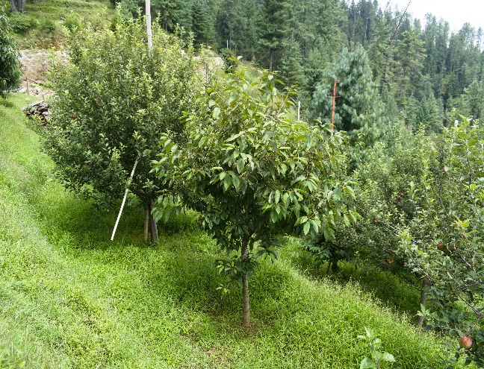
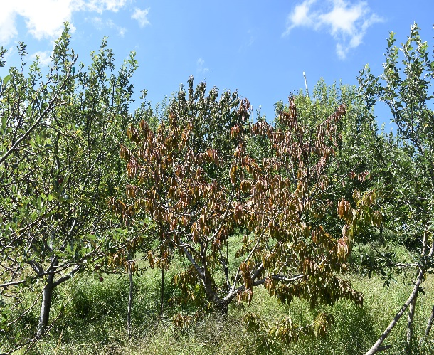
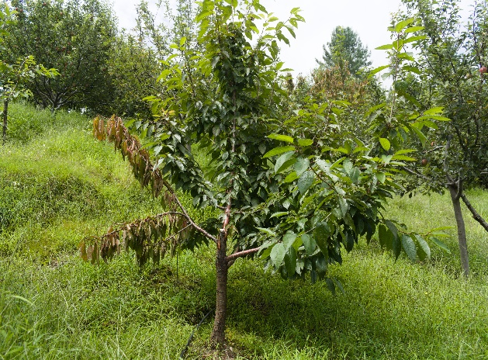
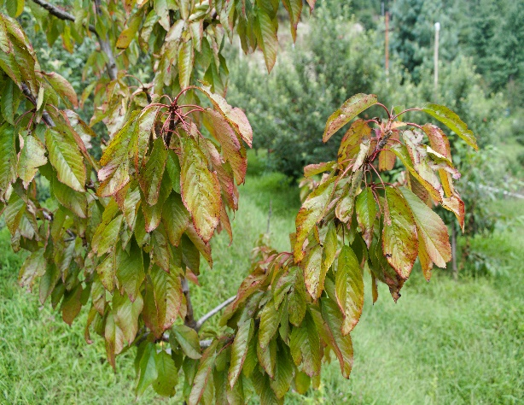
d
c
b
a
Figure 1: Symptoms of phytoplasma infection on cherry trees a) leaf reddening and tattering; b) partial infection; c) complete drying; d) healthy cherry plant

Detection by Fluorescence microscopy
Leaves of infected trees showing prominent phytoplasma symptoms were taken to laboratory in clean polyethene bags in an ice box. Fluorescent microscopy by using DAPI staining resulted in bright fluorescent spots in phloem cells of symptomatic leaves, while the bright fluorescent spots were not present in healthy leaf samples (Figure 2). Thus, the presence of fluorescent spots in sieve tubes of symptomatic leaves clearly indicates the association of phytoplasma with infected cherry plants, while no fluorescence was observed in the sieve tubes of healthy plants. The specificity of DAPI staining for phytoplasma detection is achieved by targeting phloem tissues, where the pathogen is localized. In longitudinal tissue sections, sieve tubes can be readily identified by their elongated shape and the presence of sieve areas in the radial cell walls and sieve plates. When fully mature, sieve tube elements are largely devoid of organelles, resulting in little to no background fluorescence in healthy plants. In contrast, phytoplasma-infected sieve tubes in the current season’s phloem exhibit small fluorescent particles, which can be observed in varying numbers. When phytoplasma concentrations are sufficiently high, infection can often be recognized immediately.
Discussion
Currently, PCR-based techniques are widely used for detection of phytoplasma. However, these techniques require high cost and are more time consuming. Due to this reason DAPI staining is commonly used for quick and less expensive technique for phytoplasma detection form infected plant parts like twigs, petioles, leaves and roots (Sinclair et al. 1992; Thomas and Balasundaran 1998; Arismendi et al. 2010). DAPI staining is preferentially used for phytoplasma detection as the genome of phytoplasma possess AT-rich region, with a corresponding low GC content ranging from 21 to 28 % (Hogenhout and Seruya 2010). Therefore, after passing through the cell membrane DAPI stain has the ability to strongly bind to the AT-rich region of DNA of phytoplasma. DAPI staining is low cost and rapid method for detection of phytoplasma bodies, however due to low specificity and ability of stain to bind with DNA of other microorganisms or cell organelles like mitochondria and chloroplast, the technique is mainly used as preliminary diagnostic tool for quick detection of phytoplasma in infected plant tissues.
Conclusion
DAPI staining is a simple, rapid, cost-effective, and versatile method for pathogen detection, offering sensitivity comparable to that of nucleic acid hybridization techniques. It is particularly suitable for the routine diagnosis of diseases with known etiology and for preliminary screening of plant materials for the presence of phytoplasmas. Nonetheless, to confirm phytoplasma as the causal agent of a new disease, DAPI-based observations must be validated using electron microscopy or molecular diagnostic methods.


c
b
a
Figure 2. Fluoroscent micrograph of a) Healthy b) Transverse-section of symptomatic leaf midrib c) Longitudinal-section of symptomatic leaf midrib

Disclaimer (Artificial intelligence)
Option 1:
Author(s) hereby declare that NO generative AI technologies such as Large Language Models (ChatGPT, COPILOT, etc.) and text-to-image generators have been used during the writing or editing of this manuscript.
Option 2:
Author(s) hereby declare that generative AI technologies such as Large Language Models, etc. have been used during the writing or editing of manuscripts. This explanation will include the name, version, model, and source of the generative AI technology and as well as all input prompts provided to the generative AI technology
Details of the AI usage are given below:
1.
2.
3.

References
Andrade, N. M. & Arismendi, N. L. (2013). DAPI staining and fluorescence microscopy techniques for phytoplasmas. p. 115-121. In: Phytoplasma: Methods and Protocols.
Annymous (2022). FAOSTATS. https://www.fao.org/faostat/en/#data/QCL [Accessed on 25th February 2025].
Arismendi, N. S., Andrade, N. S., Riegel, R.S. & Carrillo, R. L. (2010). Presence of a phytoplasma associated with witches’ broom disease in Ugni molinae Turcz. and Gaultheria phillyreifolia (Pers.) Sleumer determined by DAPI, PCR, and DNA sequencing. Chilean Journal of Agricultural Research. 70(1):26-33.
Bernhard, R., Marenaud, C., Sechet, J., Fos, A., & Moutous, G. (1977). A complex disease of certain Prunus: “Molieres decline”. Comptes Rendus des Seances de l’Academie d’Agriculture de France. 3:178–188.
Caglayan, K., Gazel, M., Kucukgol, C., Paltrineri, S., Contaldo, N. & Bertaccini, A. (2013). First report of ‘Candidatus Phytoplasma asteris’(group 16SrI-B) infecting sweet cherries in Turkey. Journal of Plant Pathology. 95(4): S4.77.
Fiore, N., Bertaccini, A., Bianco, P. A., Cieślińska, M., Ferretti, L., Hoat, T. X., & Quaglino, F. (2018). Fruit crop phytoplasmas. In: Rao G.P, Bertaccini A, Fiore N, Liefting LW, (eds) Phytoplasmas: plant pathogenic bacteria-I. Springer, Singapore, pp. 153-190. https://doi.org/10.1007/978-981-13-0119-3_6.
Gai, Y. P., Han, X. J., Li, Y. Q., Yuan, C. Z., Mo, Y. Y. & Guo, F. Y., 2014. Metabolomic analysis reveals the potential metabolites and pathogenesis involved in mulberry yellow dwarf disease. Plant Cell Environment 37, 1474–1490. doi: 10.1111/pce.12255.
Gupta, S., Handa, A., Brakta, A., Negi, G., Tiwari, R. K., Lal, M. K. & Kumar, R. (2023). First report of ‘Candidatus Phytoplasma asteris’ associated with yellowing, scorching and decline of almond trees in India. PeerJ, 11: e15926.
Hogenhout, S. A., & Šeruga, M. M. (2010). Phytoplasma genomics, from sequencing to comparative and functional genomics—what have we learnt? In: Weintraub PG, Jones P (eds) Phytoplasmas: genomes, plant hosts and vectors. CABI Publishing, Oxfordshire. pp 19–36.
Khan, J. A., Kumar, J., Thakur, P. D., Handa, A. & Jarial, K. (2013). First report of a 'Candidatus Phytoplasma ziziphi'-related strain associated with peach decline disease in India. S4.76.
Seemüller, E. & Kirkpatrick, B. C. (1996). Detection of phytoplasma infections in plants. Molecular and diagnostic procedures in mycoplasmology. 2, 299-311.
Sinclair, W. A., Griffiths, H. M., Davis, R. E. & Lee, I. M. (1992). Detection of ash yellows mycoplasmalike organisms in different tree organs and in chemically preserved specimens by a DNA probe vs. DAPI.
Thakur, A., Handa, A. & Chauhan, A. (2025). Emerging phytoplasma threat: Plum orchards under siege in Himachal Pradesh, India. Phytopathogenic Mollicutes. 15(1): 107-108.
Thomas, S. & Balasundaran, M. (1998). In situ detection of phytoplasma in spike-disease affected sandal using DAPI stain. Current Sciences. 74:989–993
Valiunas, D., Jomantiene, R. & Davis, R. E. (2005). A Candidatus Phytoplasma asteris related phytoplasma associated with cherry little leaf disease represents a new subgroup, 16SrI-Q. Phytopathology. 95: S106.
Wang, J. W., Zhu, D. Z, Liu, Q. Z., Davis, R. E. & Zhao, Y. (2014). First report of sweet cherry virescence disease in China and its association with infection by a ‘Candidatus Phytoplasma ziziphi’-related strain. Plant Disease. 98(3):419.
Wright, A. A., Shires, M. K., Beaver, C., Bishop, G., DuPont, S. T., Naranjo, R. & Harper, S. (2021). Effect of ‘Candidatus Phytoplasma pruni’ infection on sweet cherry fruit. Phytopathology. 111(12):2195-2202.

