Original Research Article
Electrochemical and Theoretical (DFT) Study
of the Complex between 2,2′-Bipyridine and
Dichlorodiphenylsilane (bipy·Ph₂SiCl₂) :
Structure, Redox Properties,
and Reactivity

Abstract
We report the in situ synthesis and reduction of the bipy·Ph₂SiCl₂ complex, combining cyclic voltammetry and DFT calculations (M06-2X/6-31+G(d,p)). The experimental reduction potential (Ep = −1.12 V vs SCE) is in excellent agreement with the theoretical value (−1.20 V vs SCE). The one-electron reduction induces a significant contraction of the N→Si bonds (2.051 → 1.960 Å) and an elongation of the Si–Cl bonds (2.295 → 2.363–2.372 Å). Global reactivity descriptors confirm the high reactivity of the neutral complex (hardness η = 2.030 eV, electrophilicity ω = 19 eV) and the good stability of the resulting radical anion. This work thus makes a significant contribution to the understanding of silicon–nitrogen coordination chemistry and provides new insights into the redox behavior of organosilicon complexes.
Keywords: 2,2'-bipyridine, dichlorodiphenylsilane, cyclic voltammetry, redox potential, radical anion, calculs DFT, reactivity descriptors.
1. Introduction
Organosilicon compounds have attracted continuously growing interest in organic and materials chemistry, particularly due to their structural versatility and high reactivity (Mollabagher, Mojtahedi, Hossein, & Mousavi, 2024; Zhihua Cai, 2025; Cazacu, Damoc, Stoica, Turcan-Trofin, & Dascalu, 2025). Among them, chlorosilanes occupy a central position as precursors for the formation of Si–N, (Soualmi, Dieng, Ourari, Gningue-Sall, & Jouikov, 2015), (Hreczycho, 2022) Si–O (Mendkovich, et al., 2020), (S. Kyushin, 2016) and Si–C, (Dieng, Simonet, & Jouikov, 2015; Lin, et al., 2025; Nakajima, et al., 2025) which are essential for the design of functional materials, catalysts, and hybrid systems in surface chemistry (Wang, Nie, Guo, Song, & Liu, 2022). The nature and number of substituents attached to the silicon atom play a decisive role in both the reactivity of these compounds and the properties of the resulting species. Dichlorodiphenylsilane (Ph₂SiCl₂), in particular, stands out for its good chemical stability and its ability to interact with various nitrogen-based ligands, thereby enabling the formation of coordination complexes. In this context, 2,2′-bipyridine (bipy), an aromatic nitrogen base widely used in coordination chemistry and biochemistry, (Constable & Housecroft, 2019; Kaes, Katz, & Hosseini, 2000; Ermakova, et al., 2025) constitutes a ligand of choice (Verma C. , et al., 2024). Its strong affinity for electrophilic centers, particularly tetracoordinate silicon, makes it a highly relevant candidate for the formation of stable complexes with chlorosilanes (Biradha, Sarkar, & Rajput, 2006; Kaes, Katz, & Hosseini, 2000; Tobias, et al., 2025). This coordinating ability has stimulated sustained interest in studying its interactions with halogenated derivatives of group 14 elements. In particular, numerous studies have focused on the isolation and characterization of complexes involving bipyridine and silicon or germanium centers, with the aim of better understanding the factors governing their stability and reactivity (Levason, Reid, & Zhang, 2011; Zhang, Lai, Deng, & Yang, 2026). Neutral complexes were first synthesized between 2,2′-bipy and triphenyliodosilanes or triphenylbromosilanes by Corey and West (Corey & West, 1963). Subsequently, other analogous complexes involving GeCl₄ (Willey, Somasunderam, Aris, & Errington, 2001), Si₂Cl₆ (Kummer, Balkir, & Koester, Chemistry of halogen-silane adducts. XV. 2,2 ′ -Bipyridine and 1,10-phenanthroline complexes of halodisilanes and octachlorotrisilane. ., 1979), Cl₃SiOSiCl₃ (Kummer, Chaudhry, Thewalt, & Debaerdemaeker, 1987) and chlorosilanes (RSiCl₃ (R = Me, Ph), SiCl₄) (Gerrit, et al., 2010; Davydova, Timoshkin, Sevast'yanova, Suvorov, & Schaefer, 2003) have also been reported. In this broader context, it is worth noting that bidentate N-donor ligands such as 2,2′-bipyridine are recognized as particularly effective at stabilizing hypercoordinate silicon complexes — a coordination mode that is exceedingly rare for lighter group 14 elements such as carbon but common for silicon (Yeong, Dongyoung , Jae, Yeongjun, & Seung, 2024). Similarly, recent work on six-coordinate silicon and germanium complexes bearing catecholate and N,N-bidentate ligands including 2,2′-bipyridine has demonstrated their redox-amphoteric character and confirmed, through electrochemical measurements and DFT calculations, that these donor–acceptor systems exhibit photoinduced interligand charge-transfer transitions ( Arsenyeva, et al., 2024). In parallel, extensive reviews of coordination complexes of bipyridines have underscored that electronic distribution, π-conjugation, and substituents significantly influence their coordination behavior, with applications spanning catalysis, materials science, and electrochemistry (Verma C. , et al., 2024). However, despite these advances, no stable neutral complex between bipy and a simple monochlorosilane has been isolated under similar experimental conditions. In contrast, electrochemical studies have evidenced the formation of complexes between bipy and chlorogermanes (Ph₃GeCl, Me₂GeCl₂, MeGeCl₃, GeCl₄) (Dieng, Gningue-Sall, & Jouikov, 2012) as well as chlorosilanes (Me₃SiCl, Et₃SiCl,) (Soualmi, Dieng, Ourari, Gningue-Sall, & Jouikov, 2015; Dieng, Simonet, & Jouikov, 2015). For all these systems, the newly observed electrochemical response has been attributed to the redox couple (bipy·RₙMCl₄₋ₙ)/(bipy·RₙMCl₄₋ₙ)•⁻, where M = Si or Ge. However, to the best of our knowledge, no study combining electrochemical reduction and DFT calculations on both neutral and anionic forms of the bipy·Ph₂SiCl₂ complex has been reported to date.
In this work, we report for the first time the in situ synthesis and reduction of the bipy·Ph₂SiCl₂ complex, combining cyclic voltammetry and DFT calculations in order to shed light on intramolecular coordination interactions, electronic structure, and the reactivity of such systems. These findings are expected to contribute to a better understanding of the reactivity of silicon derivatives in processes involving coordination expansion.

2. Experimental and computational methods

2.1 Materials and synthesis
Dichlorodiphenylsilane (Ph₂SiCl₂), a liquid (ABCR), was stored over magnesium turnings and distilled prior to use. 2,2′-bipyridine (2,2′-bipy) (Aldrich, Lyon, France) was freshly sublimed before use. Acetonitrile (CH₃CN), analytical grade (SDS), was distilled over calcium hydride (CaH₂) and then dried over 4 Å molecular sieves previously activated under vacuum by microwave heating. Bu₄NPF₆ (Fluka, Lyon, France) was dried at 80 °C for 10 hours and then stored over P₂O₅. The bipy·Ph₂SiCl₂ complex was synthesized in situ (Scheme 1) in the electrochemical cell by dropwise addition of Ph₂SiCl₂ into a cell containing acetonitrile (3 mL), tetrabutylammonium hexafluorophosphate (Bu₄NPF₆, 0.1 M), and 2,2′-bipyridine (9 mmol). All experiments were carried out under an inert atmosphere (argon-filled glovebox) due to the moisture sensitivity of the chlorosilane, and at a temperature of 21 °C.
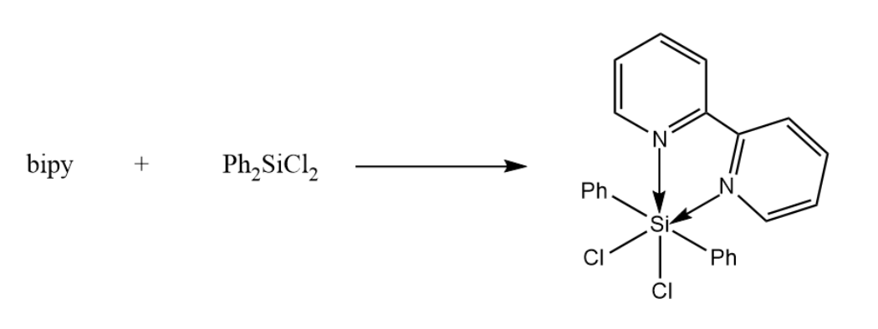
Scheme 1. In situ formation of the bipy•Ph₂SiCl₂ complex

2.2 Electrochemical study
Electrochemical measurements were performed using a PAR 2273 scanning potentiostat (Oak Ridge, TN, USA). A glassy carbon (GC) electrode (3 mm diameter) was used as the working electrode. Due to the rapid passivation of the electrode surface, it was carefully polished with Struers FEPA P 4000 abrasive paper, then successively rinsed with acetonitrile, ethanol, and diethyl ether before each measurement. A GC rod auxiliary electrode placed in a compartment separated by a fritted glass diaphragm and a polypyrrole reference electrode, obtained by coating a platinum electrode with a layer of polypyrrole (PPy), were used. All measurements were carried out in a CH₃CN solution containing 0.1 M Bu₄NPF₆. Potentials were corrected using the ferrocene/ferrocenium reversible redox couple, Fc/Fc⁺ (E° = 0.158 V vs. SCE) (Namazian, Lin, & Coote, 2010) as an internal standard for potential calibration. It is important to note that when N,N-dimethylformamide (DMF) was used as an alternative solvent, electrode passivation was observed, likely due to polymerization or deposition of reaction products on the electrode surface. Consequently, acetonitrile was selected as the preferred solvent for this study.
  - Computational details
Density Functional Theory (DFT) was used to investigate the neutral and reduced forms of the complex, with the aim of analyzing their structural and reactive properties. All calculations were performed using the M06-2X/6-31+G(d,p) method, as implemented in the Gaussian 16 software package (Frisch, et al., 2016). The choice of the M06-2X functional and the 6-31+G(d,p) basis set is justified by the fact that the M06-2X functional is particularly well suited for systems involving donor–acceptor type interactions, as well as for reaction energy calculations in solution. This method was employed both for the characterization of molecular structures and for the analysis of the reactivity of the complex and its radical anion. This approach is widely used for studying the oxidized and reduced states of coordination complexes (Rawas, et al., 2025). All calculations were carried out in solution (acetonitrile as the solvent in accordance with the experimental conditions) under standard temperature (298.15 K) and pressure (1 atm) conditions. Vibrational frequency calculations, performed at the DFT/M06-2X/6-31+G(d,p) level, were computed for all optimized structures to confirm that they correspond to true minima on the potential energy surface (no imaginary frequencies) (Lo, et al., 2025). Furthermore, the frontier molecular orbitals, namely the highest occupied molecular orbital (HOMO) and the lowest unoccupied molecular orbital (LUMO), as well as the energy gap (Egap, Equation 1), were determined for both studied forms. From the HOMO and LUMO energies, several chemical reactivity descriptors were calculated, including chemical hardness (η), electronegativity (χ), electrophilicity index (ω), and softness (σ), according to Equations (2) to (6) (Souza, Carvalho, Vieira, Silva, & Brasil, 2018; Dieng, et al., 2025; Dieng, et al., 2025)
E_{gap} = E_{LUMO} - E_{HOMO} (1)
$η= E_{LUMO} -\frac{E_{HOMO}}{2}$ (2)
$χ= {-E}_{HOMO}-\frac{E_{LUMO}}{2}$ (3)
$μ= - χ$ (4)
$ω= \frac{μ^{2}}{2 η}$ (5)
$σ= \frac{1}{η}$ (6)
Particular attention was paid to the theoretical prediction of redox potentials, with the aim of correlating the calculated results with the reduction peaks observed experimentally by cyclic voltammetry. In theory, the redox potential is directly related to the change in Gibbs free energy (ΔG) associated with the reduction reaction in solution, according to the following expression:
$E_{redox, calc}= \frac{{- ∆G}_{redox (sol)}}{n F}$$CITATION LoM25 \backslash l 1036 (Lo, et al., 2025)$ (7)
where ΔG_{redox (sol)} corresponds to the Gibbs free energy of reduction in solution, n is the number of electrons transferred, and F is the Faraday constant.
3. Results and discussion
  - Cyclic voltammetry behavior of bipy•Ph₂SiCl₂
The reduction of chlorosilanes has been widely studied in the literature (Jouikov, Biran, Bordeau, & Dunoguès, 1999; Eschwege & Conradie, 2022; Wang, Yuan, & Cabasso, 2005; Dieng, Gningue-Sall, & Jouikov, 2012). In particular, the reduction of diphenyldichlorosilane is irreversible and occurs at a very cathodic potential, on the order of −2.87 V vs SCE, and most often involves cleavage of the Si–Cl bond (Jouikov, Gostevskii, Kalikhman, & Kost, 2007). Regarding the reduction of bidentate aromatic nitrogen bases, and more specifically that of 2,2′-bipyridine, it occurs at a potential of about −2.23 V vs SCE. This reduction is also a one-electron, reversible process and leads to the formation of a relatively stable radical anion (Dieng, Gningue-Sall, & Jouikov, 2012). Figure 1A shows the reduction voltammograms of 2,2′-bipyridine and of the complex at a glassy carbon electrode (GC) in a medium containing CH₃CN/0.1 M Bu₄NPF₆. From this figure, it can be observed that, after successive additions of diphenyldichlorosilane to the bipy solution, a new redox system appears, whose reduction peak occurs at a less cathodic potential (by about 1 V) than those of bipy and Ph₂SiCl₂ (Figure 1A). This new redox system, with a reduction peak potential Eₚ ≈ −1.12 V vs SCE, reversible at high scan rate (v = 5 V·s⁻¹, Figure 1B), is attributed to the reduction of the bipy•Ph₂SiCl₂ complex formed in solution. The appearance of this new reduction peak, accompanied by a decrease in the intensity of the bipy reduction peak upon addition of Ph₂SiCl₂, further confirms the formation of the complex in solution. Similar results were obtained under the same conditions with the complexes bipy•Me₃SiCl (Dieng, Simonet, & Jouikov, 2015), bipy•Et₃SiCl (Soualmi, Dieng, Ourari, Gningue-Sall, & Jouikov, 2015) and bipy•Me₂GeCl₂ (Dieng, Gningue-Sall, & Jouikov, 2012), which are reduced at potentials of −1.12 V vs SCE, −1.17 V vs SCE, and −1.11 V vs SCE, respectively. The peak currents (iₚ) associated with the reduction of the complex vary linearly with the concentration of Ph₂SiCl₂. Likewise, the ratio iₚ/ν¹ᐟ² remains constant for scan rates between 0.2 and 20 V·s⁻¹. This result indicates that the formation of the complex is diffusion-controlled, with no kinetic limitation from preceding or subsequent steps of the reaction (Valencia & González, 2011; Bard & Faulkner, 1983). The one-electron reduction process of the complex is demonstrated by combining voltammetry and chronoamperometry data obtained with the same electrode (Dieng, Gningue-Sall, & Jouikov, 2012). This result is corroborated by comparing the reduction peak current (iₚ) of the complex with that of the oxidation of ferrocene, which proceeds via a one-electron transfer.
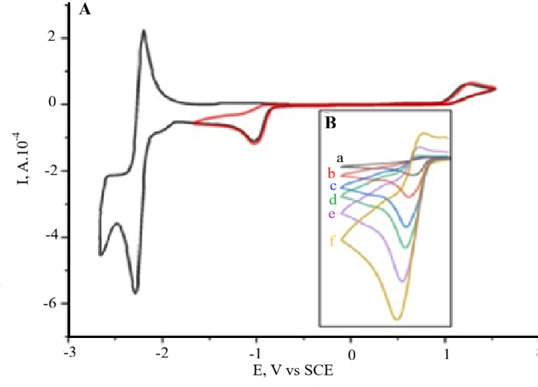
Figure 1. (A) Electroreduction of the bipy•Ph₂SiCl₂ complex (C = 3 × 10⁻³ M) on a GC electrode (Ø = 3 mm) in CH₃CN/0.1 M Bu₄NPF₆. (B) Same solution, at different scan rates: (a) 0.2 V.s⁻¹; (b) 1 V.s⁻¹; (c) 3 V.s⁻¹; (d) 5 V.s⁻¹; (e) 10 V.s⁻¹; (f) 20 V.s⁻¹. Temperature: 21 °C.

The theoretical prediction of the reduction potential was carried out using Equation 7, yielding a calculated potential of −1.20 V. Table 1 presents the theoretical and experimental reduction potentials of the bipy•Me₃SiCl, bipy•Et₃SiCl, and bipy•Ph₂SiCl₂ complexes. The excellent agreement between the calculated and experimental reduction potentials validates the computational methodology. The deviations |Ep_{theo} − Ep_{exp}| are all less than or equal to 80 mV. Such values are typical and expected for this type of calculation and further support the reliability of the theoretical results obtained. Table 1 also shows that the reduction potentials of the complexes are very close to each other, indicating that the silicon substituents have only a minor effect on the reduction potential of the complex. Similarly, all complexes exhibit positive shifts in their reduction peaks compared to that of bipy, reflecting the electron-withdrawing effect of coordination to silicon.

Table 1. Thermodynamic and Electrochemical Data of Complexes
Complex | ΔG | Ep_{theo}(V) | Ep_{exp}(V) | |Ep_{theo} − Ep_{exp}| (V) | Refs
bipy•Me₃SiCl | -77.836216 | -1.16 | -1.12 | 0.04 | (Dieng, Simonet, & Jouikov, 2015)
bipy•Et₃SiCl | -76.073544 | -1.24 | -1.17 | 0.07 | (Soualmi, Dieng, Ourari, Gningue-Sall, & Jouikov, 2015)
bipy•Ph₂SiCl₂ | -76.920053 | -1.20 | -1.12 | 0.08 | This work

3.2 Study of the geometric structure of the complex using the DFT method
The interaction of a bidentate Lewis base such as bipy with a chlorosilane of general formula RₙSiCl₄₋ₙ (n = 0–3) leads to the formation of two additional N→Si coordination bonds, giving silicon an octahedral geometry. This reorganization is accompanied by a transition from the initial tetrahedral geometry of the chlorosilane to a hypercoordinated structure, a phenomenon widely documented in the literature (Dieng, Simonet, & Jouikov, 2015; Jouikov, Gostevskii, Kalikhman, & Kost, 2007; Gao & Liang, 2007). These studies have shown that aromatic bidentate ligands coordinate to silicon through one axial bond and one equatorial bond. However, certain structural and electronic properties of these complexes cannot be fully elucidated by experimental methods alone, which justifies the use of theoretical calculations to complement and deepen experimental data (Irina V. Uvarova, 2023; Tetiana Sergeieva, 2021). The most stable optimized structure of the bipy•Ph₂SiCl₂ complex, obtained at the M06-2X/6-31+G(d,p) level of theory, is presented in Figure 2. The complex adopts a slightly distorted octahedral geometry around the silicon center, with bipy coordinating in a chelating manner through its two nitrogen atoms to Si. The key geometric parameters (bond lengths and angles) for the neutral complex and its reduced form, obtained using the same basis set, are summarized in Table 2. The N→Si bond lengths in the neutral complex (2.051 Å for N1→Si21 and N7→Si21) are consistent with dative N→Si coordination bonds. These values are typical for donor–acceptor (nitrogen–silicon) interactions and reflect the expansion of the silicon coordination sphere from tetrahedral to hexacoordinated. Moreover, these values are significantly shorter than the sum of the van der Waals radii of silicon (2.10 Å) and nitrogen (1.55 Å) (Bondi, 1964), which unambiguously confirms the hexacoordination of silicon. The one-electron reduction of the neutral complex, leading to the radical anion [bipy•Ph₂SiCl₂]•⁻, reveals a significant structural reorganization. The N→Si bond lengths decrease to approximately 1.960 Å (1.958 Å for N1→Si21 and 1.959 Å for N7→Si21), corresponding to a contraction of about 0.09 Å. This indicates stronger N→Si coordination in the reduced form, likely due to increased electron density on the bipyridine ligand. At the same time, the Si–Cl bond lengths, equal to 2.295 Å in the neutral form, increase in the radical anion to 2.363 Å (Si21–Cl22) and 2.372 Å (Si21–Cl23). This elongation of ~0.07 Å suggests a weakening of the Si–Cl bonds, consistent with increased electron density in antibonding orbitals. A slight increase in Si–C bond lengths is also observed, from 1.940 Å in the neutral form to approximately 1.96 Å in the reduced form. The N–Si–N bond angle slightly increases from 77.5° to 80.5°, indicating an opening induced by strong electronic repulsion. Similarly, the Cl–Si–Cl angle increases from 163.4° to 169.3°, approaching linearity and suggesting a shift toward a more ideal octahedral geometry. Overall, although most bond angles undergo only moderate variations upon reduction, the set of these changes reflects a significant redistribution of electron density within the complex. The additional electron mainly occupies the π* orbital of the bipyridine, which has an antibonding character with respect to the Si–Cl bonds and a bonding character with respect to the N→Si interactions. This interpretation is consistent with the observed changes in bond lengths.
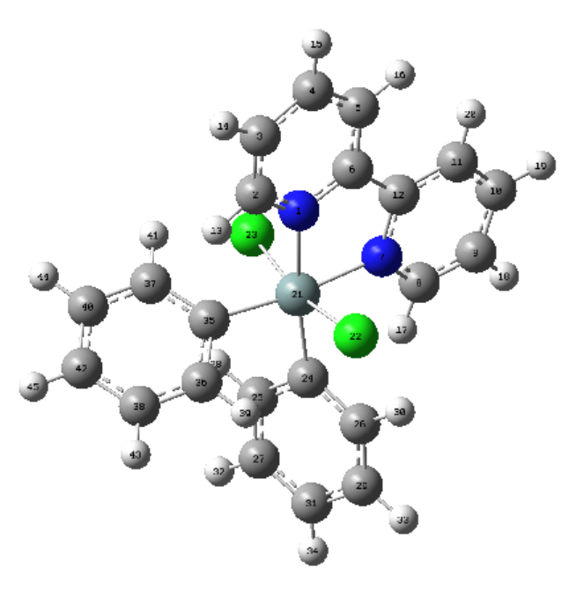
Figure 2. The optimized structure of the most stable bipy•Ph₂SiCl₂ molecule at M06-2X/6-31+G(d,p) with atom labeling scheme

Table 2. Bonds lengths (Å) and bonds angles (°) of the bipy•Ph₂SiCl₂ complex and its radical anion [bipy•Ph₂SiCl₂]•⁻
Bonds lengths | M06-2X/6-31+g(d,p) |  | Bonds angles | M06-2X/6-31+g(d,p)
Bonds lengths | bipy•Ph₂SiCl₂ | [bipy•Ph₂SiCl₂]•‒ | Bonds angles | bipy•Ph₂SiCl₂ | [bipy•Ph₂SiCl₂]•‒
Si21-N1 | 2.051 | 1.958 | Cl22-Si21- C24 | 94.9 | 92.7
Si21-N7 | 2.051 | 1.959 | Cl22-Si21- C35 | 96.3 | 94.9
Si21-C24 | 1.940 | 1.961 | Cl23-Si21- C24 | 96.3 | 94.8
Si21-C35 | 1.940 | 1.960 | Cl23-Si21- C35 | 94.9 | 92.4
Si21-Cl22 | 2.295 | 2.363 | C24-Si21-C35 | 95.0 | 94.1
Si21-Cl23 | 2.295 | 2.372 | N1-Si21-Cl22 | 81.6 | 83.4
 |  |  | N1-Si21- Cl23 | 85.5 | 88.4
 |  |  | N1-Si21- C35 | 93.8 | 93.7
 |  |  | N1-Si21-N7 | 77.5 | 80.5
 |  |  | N7-Si21- Cl22 | 85.5 | 88.9
 |  |  | N7-Si21- Cl23 | 81.6 | 83.0
 |  |  | N7-Si21- C24 | 93.8 | 93.9
  - Mulliken Charge

The analysis of Mulliken atomic charges provides a detailed description of the electronic distribution and the nature of bonding within the studied complex (Saleh, 2026).Table 3 compiles the Mulliken charges of selected atoms in the neutral complex as well as in its radical anion. First, a significant increase in the positive charge carried by the silicon atom (Si21) is observed, reflecting an enhanced polarization at the silicon center. In the neutral complex, silicon exhibits a moderate positive charge (+0.278), consistent with its role as an electron acceptor. After reduction, this charge increases sharply to +0.820. This behavior indicates that the additional electron is mainly localized on the bipyridine ligand rather than on the silicon, thereby strengthening the polarization of the N→Si bonds. Moreover, the nitrogen atoms show a shift in their charges from slightly positive values (+0.139 and +0.140) to slightly negative values (–0.040 and –0.033) upon reduction. This evolution demonstrates that a significant portion of the added electron density is localized on the nitrogen atoms, which is consistent with a reduction involving the π* orbital of bipyridine. Simultaneously, the chlorine atoms (Cl22 and Cl23) gain electron density and become more negative, with an increase of approximately 0.13 electrons each. This result agrees with the observed elongation of the Si–Cl bonds and suggests partial electron transfer from the reduced bipyridine toward the σ* orbitals of the Si–Cl bonds. Finally, the carbon atoms (C24 and C35) bonded to silicon show a decrease in their negative charge after reduction, indicating a redistribution of electron density within the π system of the complex. In conclusion, the radical anion is characterized by strong electron delocalization. The added electron is mainly distributed over the bipyridine ligand but also contributes to nitrogen–silicon interactions and, to a lesser extent, to the chlorine atoms. This electron delocalization plays a key role in stabilizing the reduced species.
Table 3. DFT-calculated Mulliken charges of the bipy•Ph₂SICl₂ complex and its radical anion [bipy•Ph₂SICl₂]•‒
Atoms | bipy•Ph₂SiCl₂ | [bipy•Ph₂SiCl₂]•‒ | Change
Si21 | 0.277834 | 0.819810 | +0,542
N1 | 0.139360 | -0.040333 | -0,179
N7 | 0.139785 | -0.032512 | -0,173
Cl22 | -0.282729 | -0.409029 | -0,126
Cl23 | -0.285904 | -0.417027 | -0,131
C24 | -1.815737 | -1.551744 | +0,264
C35 | -1.812591 | -1.451326 | +0,362

3.4 Frontier molecular orbitals and chemical reactivity
Frontier molecular orbitals, namely the HOMO (Highest Occupied Molecular Orbital) and the LUMO (Lowest Unoccupied Molecular Orbital), play a key role in understanding chemical reactivity and the electronic properties of molecules (Dieng, et al., 2025; Dieng, et al., 2025). Table 4 compiles the calculated energies of these orbitals as well as global reactivity descriptors for the bipy•Ph₂SiCl₂ complexes and the radical anion [bipy•Ph₂SiCl₂]•⁻. Analysis of the table reveals an energy gap of 5.955 eV for the neutral bipy•Ph₂SiCl₂ complex. After reduction of the complex, this gap increases to 6.342 eV, which is directly explained by the occupation of the former LUMO. Figure 3 illustrates the HOMO and LUMO orbitals of the bipy•Ph₂SiCl₂ complex as well as those of its radical anion. The HOMOs are mainly localized on the bipy ligand, indicating that this ligand is the primary electron donor. The LUMO of the neutral complex also shows a strong contribution from the bipy ligand, with some participation from the Ph₂SiCl₂ fragment, suggesting that electronic transitions mainly involve the π ligand system.
The energy gap (EHOMO–ELUMO) also allows the determination of global reactivity descriptors (GRDs), which are essential for interpreting the structural and reactive properties of the studied species. As shown in Table 4, the neutral bipy•Ph₂SiCl₂ complex exhibits the lowest hardness among the three neutral complexes, with a value of 2.030 eV. According to Pearson’s HSAB (Hard and Soft Acids and Bases) principle, this low hardness indicates relatively high reactivity. The radical anion, with a higher hardness value (η = 2.583 eV), is harder than the neutral complexes, which is consistent with LUMO occupation, making the species less reactive. The electronegativity of the bipy•Ph₂SiCl₂ complex (8.799 eV) reflects a moderate ability to attract electrons, while its chemical potential (–8.799 eV) reflects its tendency toward electron loss. This complex also exhibits the highest electrophilicity among the neutral species (ω = 19 eV), highlighting its pronounced electron-accepting character, in agreement with its observed behavior during electrochemical reduction. After reduction, the electrophilicity of the radical anion decreases significantly (ω = 12 eV), as expected following electron gain. Finally, the neutral complex shows a high dipole moment (12.070 D), reflecting charge separation between the electron-rich bipy ligand and the electron-deficient silicon center, substituted by chlorine and phenyl groups. Upon reduction, this dipole moment drops sharply to 3.343 D, as a consequence of electron density redistribution that reduces internal polarization. Overall, these results highlight the good stability of the neutral bipy•Ph₂SiCl₂ complex as well as its ability to be reduced to form the corresponding radical anion.
Table 4. DFT-calculated frontier orbital properties of the bipy•Ph₂SiCl₂ complex and its radical anion [bipy•Ph₂SiCl₂]•⁻
Properties | bipy•Ph₂SiCl₂ | [bipy•Ph₂SiCl₂]•‒
E_{HOMO} (eV) | -7.851 | -7.518
E_{LUMO} (eV) | -1.896 | -1.176
Dipole moment (debye) | 12.070 | 3.343
Energy gap (Egap) (eV) | 5.955 | 6.342
$η$(eV) | 2.029 | 2.583
$χ$(eV) | 8.799 | 8.106
$μ$(eV) | -8.799 | -8.106
$ω$(eV) | 19 | 12
σ (1/ $η)$ | 0.493 | 0.387

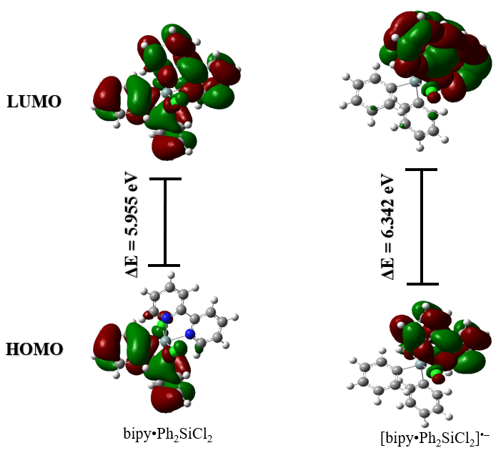
Figure 3. Schematic representations of the frontier molecular orbitals HOMO (Highest Occupied Molecular Orbital) and LUMO (Lowest Unoccupied Molecular Orbital) of the neutral Ph₂SiCl₂ complex and its radical anion, calculated at the M06-2X/6-31+G(d,p) level of theory.
4. CONCLUSION
This study provided a comprehensive understanding of the behavior of the bipy•Ph₂SiCl₂ complex through an integrated approach combining cyclic voltammetry and DFT calculations. The results show that the complex adopts a distorted octahedral geometry around silicon, with bipy acting as a bidentate ligand. The one-electron reduction process, reversible at high scan rates and diffusion-controlled, is accompanied by significant structural changes, notably a contraction of the N→Si bonds (from 2.051 Å to 1.960 Å) and an elongation of the Si–Cl bonds (from 2.051 Å to 1.960 Å), reflecting a marked redistribution of electron density. The excellent agreement between the experimental reduction potential (−1.12 V) and its theoretical prediction (−1.20 V) validates the computational methodology employed. Electronic structure analysis reveals that the reduction is mainly centered on the bipy ligand, with an extended electron delocalization that stabilizes the radical anion. The comparison with analogous complexes highlights consistent trends and underscores the influence of phenyl substitution on the frontier orbitals. In particular, the bipy•Ph₂SiCl₂ complex exhibits a HOMO–LUMO gap of 5.955 eV, slightly lower than that of some analogues, indicating greater electron delocalization. Furthermore, the orbital energies (E_{HOMO} = −7.851 eV and E_{LUMO} = −1.896 eV) confirm that phenyl substitution stabilizes the frontier orbitals while promoting electron localization on the bipy ligand. Overall, this work demonstrates the reliability and relevance of combining experimental and theoretical approaches for the study of silicon coordination complexes. The results obtained enhance the understanding of the redox chemistry of main-group elements and pave the way for the rational design of new complexes with controlled electronic and electrochemical properties, offering promising prospects in catalysis and materials science.

Disclosure statement

Conflict of interests: The authors declare that they have no conflict of interest.
Ethical approval: All ethical guidelines have been adhered.
Sample availability: Samples of the compounds are available from the author.

COMPETING INTERESTS
Authors have declared that no competing interests exist.

Disclaimer (Artificial intelligence)

Author(s) hereby declare that NO generative AI technologies such as Large Language Models (ChatGPT, COPILOT, etc.) and text-to-image generators have been used during the writing or editing of this manuscript.

Acknowledgement
The authors thank Prof. Viatcheslav JOUIKOV, from the laboratory of Molecular Chemistry and Photonics, University of Rennes, 35042 Rennes, France and Prof. Tore BRINCK, from the Department of Chemistry, CBH, KTH Royal Institute of Technology, SE-100 44 Stockholm, Sweden.

References
Arsenyeva, K. V., Klimashevskaya, A. V., Maleeva, A. V., Pashanova, K. I., Yakushev, I. A., & Dorovatovskii, P. V. (2024). Donor–acceptor chromophores based on coordination polymers of silicon(IV) and germanium(IV). Russian Journal of Coordination Chemistry, 50, 892–901. doi:https://doi.org/10.1134/S1070328424601183
Bard, A. J., & Faulkner, L. R. (1983). Electrochimie : Principes, méthodes et applications. Paris: MASSON,.
Biradha, K., Sarkar, M., & Rajput, L. (2006). Crystal engineering of coordination polymers using 4,49-bipyridine as a bond between transition metal atoms. Chemical Communications, 40, 4169–4179. doi:https://doi.org/10.1039/B606184B
Bondi, A. (1964). van der Waals Volumes and Radii. The Journal of Physical Chemistry, 68(3), 441–451. doi: https://pubs.acs.org/doi/10.1021/j100785a001
Cazacu, M., Damoc, M., Stoica, A.-C., Turcan-Trofin, G.-O., & Dascalu, M. (2025). Permethylated Silicon: A Structural Motif with a Critical Role in Shaping the Properties of Organic–Inorganic Compounds. Journal of Inorganic and Organometallic Polymers and Materials, 35, 8775–8787. doi:https://doi.org/10.1007/s10904-025-03868-4
Constable, E. C., & Housecroft, C. E. (2019). The Early Years of 2,2'-Bipyridine-A Ligand in Its Own Lifetime. Molecules, 24(21), 3951-3989. doi:https://doi.org/10.3390/molecules24213951
Corey, J. Y., & West, R. (1963). Triphenyl(bipyridyl)siliconium Ion. Journal of the American Chemical Society, 85(24), 4034 – 4035. doi:https://doi.org/10.1021/ja00907a031
Davydova, E. I., Timoshkin, A. Y., Sevast'yanova, T. N., Suvorov, A. V., & Schaefer, H. F. (2003). Quantum-Chemical Study of Adducts of Silicon Halides with Nitrogen-Containing Donors: V. Adducts with 2,2'-Bipyridine and 1,10-Phenanthroline. Russian Journal of General Chemistry, 73, 1742–1750. doi:https://doi.org/10.1023/B:RUGC.0000018651.55510.95
Dieng, M., Diop, C. A., Seye, D., Diaw, M., Fay, D., A. N., . . . Diop, C. A. (2025). Harnessing Weak and Hydrogen Bonding Interactions for Tailored Crystal Formation: A Case Study of Diisopropylammonium Phenylsulfonate. International Research Journal of Pure and Applied Chemistry, 26(4), 160-173. doi:https://doi.org/10.9734/irjpac/2025/v26i4938
Dieng, M., Faye, D., Diop, C. A., Diaw, M., Ngom, A., Diédhiou, I., . . . Diop, C. A. (2025). Crystallographic and Computational Insights into Hydrogen Bonding in Diisopropylammonium Hydrogenophthalate. Chemical Science International Journal, 34(5), 18-30. doi:https://doi.org/10.9734/CSJI/2025/v34i5987
Dieng, M., Gningue-Sall, D., & Jouikov, V. (2012). Complexes of germanium chlorides (RnGeCl4-n , n = 0-3; R = Me, Ph) with redox active N-hetero aromatic ligands: an electrochemical study. Main Group Metal Chemistry, 35(5), 141–151. doi:https://doi.org/10.1515/mgmc-2012-0059
Dieng, M., Simonet, J., & Jouikov, V. (2015). Silylation of carbon surfaces through the electrochemical reduction of 2,2′-bipy·R3SiCl adducts. Electrochemistry Communications, 53, 33–36. doi:https://doi.org/10.1016/j.elecom.2015.02.008
Ermakova, E. A., Smirnova, K. S., Klyushova, L. S., Chernov, I. S., Ostrovskii, V. A., & Lider, E. V. (2025). Structural Features of Copper(II) Complexes Based on 3-(5-phenyl-2H-tetrazol-2-yl)Pyridine and 2,2'-Bipyridine/1,10-Phenanthroline. Journal of Structural Chemistry, 66(4), 788-802. doi: https://doi.org/10.1134/S0022476625040146
Eschwege, K. G., & Conradie, J. (2022). Review of DFT-simulated and experimental electrochemistry properties of the polypyridyl Row-1 Mn, Fe & Co, and Group-8 Fe, Ru and Os MLCT complexes. Electrochemistry Communications, 136, 107225. doi:https://doi.org/10.1016/j.elecom.2022.107225
Frisch, M. J., Trucks, G. W., Schlegel, H. B., Scuseria, G. E., Robb, M. A., Cheeseman, J. R., . . . Fox, D. G. (2016). Gaussian 16. Revision C.01, [Logiciel], Gaussien, Inc.
Gao, G., & Liang, C. (2007). Electrochemical and DFT studies of β-aminoalcohols as corrosion inhibitors for brass. Electrochim Acta 52, 4554–4559. doi:https://doi.org/10.1016/j.electacta.2006.12.058
Gerrit, W. F., Eckstein, J., Daniela, G., Wagler, J., Brendler, E., & Kroke, E. (2010). Reactions of Hydridochlorosilanes with 2,2′-Bipyridine and 1,10-Phenanthroline: Complexation versus Dismutation and Metal-Catalyst-Free 1,4-Hydrosilylation. American Chemical Society Inorganic Chemistry, 49, 2667–2673. doi:https://doi.org/10.1021/ic901620e
Hoda, M., Mojtahedi, M. M., Hossein, S. A., & Mousavi, S. (n.d.).
Hreczycho, K. K. (2022). Silicon–nitrogen bond formation via dealkynative coupling of amines with bis(trimethylsilyl)acetylene mediated by KHMDS. Chemical Communications, 58, 11386-11389. doi:https://doi.org/10.1039/D2CC04413G
Irina V. Uvarova, A. A. (2023). Theoretical Study of Charge Mobility Properties of Complexes Si(DPP)(CH3)2 and Si(Bzimpy)(CH3)2. Eurasian Journal of Chemistry, 111(3), 129-136. doi:https://doi.org/10.31489/2959-0663/3-23-12
Jouikov, V., Biran, C., Bordeau, M., & Dunoguès, J. (1999). Homogeneous redox catalysed reduction of Chloromethyldimethylchlorosilane. Electrochimica Acta, 1015–1024. doi:https://doi.org/10.1016/S0013-4686(99)00311-4
Jouikov, V., Gostevskii, B., Kalikhman, I., & Kost, D. (2007). Donor-Stabilized Silyl Cations. 12.1 Electrochemical Evidence for Ionic Dissociation of Hexacoordinate Silicon Complexes. Organometallics, 26, 5791-5798. doi:https://doi.org/10.1021/om700687s
Kaes, C., Katz, A., & Hosseini, M. W. (2000). Bipyridine: The Most Widely Used Ligand. A Review of Molecules Comprising at Least Two 2,2‘-Bipyridine Units. Chemical Reviews, 100(10), 3553–3590. doi:https://doi.org/10.1021/cr990376z
Kaes, C., Katz, A., & Hosseini, M. W. (2000). Bipyridine: The Most Widely Used Ligand. A Review of Molecules Comprising at Least Two 2,2‘-Bipyridine Units. Chem. Rev., 100, 3553–3590. doi:https://doi.org/10.1021/cr990376z
Kummer, D., Balkir, A., & Koester, H. (1979). Chemistry of halogen-silane adducts. XV. 2,2 ′ -Bipyridine and 1,10-phenanthroline complexes of halodisilanes and octachlorotrisilane. . Journal of Organometallic Chemistry , 178, 29 – 54. doi:https://doi.org/10.1016/S0022-328X(00)83269-8
Kummer, D., Chaudhry, S. C., Thewalt, U., & Debaerdemaeker, T. (1987). Contributions to the chemistry of halosilane adducts. XVII. Preparation, crystal and molecular structure of (2,2 ′ -bipyridine) trichloro(trichlorosiloxo)silicon, Cl3SiOSiCl3. Zeitschrift für anorganische und allgemeine Chemie, 553 , 147 – 155.
Levason, W., Reid, G., & Zhang, W. (2011). Coordination complexes of silicon and germanium halides with neutral ligands. Coordination Chemistry Reviews, 255, 1319-1341. doi:https://doi.org/10.1016/j.ccr.2010.11.019
Lin, Q., Lin, L., Wang, J., Yu, D., Chen, Z., & Wang, Z.-X. (2025). Chemical Science. Manganese-mediated C(sp)–Si cross-electrophile coupling of alkynyl halides with chlorosilanes, 16, 14216–14224. doi:https://doi.org/10.1039/D5SC03449
Lo, M., Dieng, M., Seye, D., Faye, D., DIOP, C. A., Arona Ngom, . . . Fall, M. (2025). Electropolymerization by self-doping of 4-amino-3-hydroxynaphthalene sulfonic acid: spectroscopy characterization and DFT for growth mechanism. Journal of Molecular Structure, 143136. doi:https://doi.org/10.1016/j.molstruc.2025.143136
Mendkovich, A. S., Ngom, A., Kokorekin, V. A., Mikhailov, M. N., Sall, D. G., & Jouikov., V. ( 2020). Reversible dimerization of anion radicals of carbonyl compounds and the electrosynthesis of pinacols. The case of 9-ﬂuorenone. Electrochimica Acta, 358, 136903-136912. doi:https://doi.org/10.1016/j.electacta.2020.136903
Mollabagher, H., Mojtahedi, M. M., Hossein, S. A., & Mousavi, S. (2024). Recent progress of organosilicon compound: synthesis and applications. Journal of the Iranian Chemical Society, 21, 1795–1816. doi:https://doi.org/10.1007/s13738-024-03041-7
Nakajima, Y., Iizuka, K., Takeshita, T., Shiori, F., Yoshihiro, S., Kazuhiko, S., . . . Shigeyoshi, S. (2025). Si–Cl σ-Bond Cleavage by an Fe(0) Complex with Two Steps of One-Electron Transfer toward Hydrosilane Formation from Tetrachlorosilane. JACS, 5(4), 2033–2039. doi:https://doi.org/10.1021/jacsau.4c01248
Namazian, M., Lin, C. Y., & Coote, M. L. (2010). Benchmark Calculations of Absolute Reduction Potential of Ferricinium/Ferrocene Couple in Nonaqueous Solutions. Journal of Chemical Theory and Computation, 6, 2721–2725. doi:https://doi.org/10.1021/ct1003252
Rawas, H. K., Truong, D. H., Schell, E., Faust, J., Taamalli, S., Ribaucour, M., . . . Louis, F. (2025). A theoretical study on the environmental oxidation of fenpyrazamine fungicide initiated by hydroxyl radicals in the aqueous phase. Environmental Science: Processes & Impacts, 27, 211-224. doi:https://doi.org/10.1039/D4EM00606B
S. Kyushin. (2016). Efficient Methods for Preparing Silicon Compounds (chap. 37 - Organosilicon Synthesis for Construction of Organosilicon Clusters). Boston, : Academic Press. doi:https://doi.org/10.1016/B978-0-12-803530-6.00037-8
Saleh, A. M. (2026). Sonochemically synthesized Ag(I) and Ni(II) schiff base complexes as efficient visible-light photocatalysts for dye degradation with DFT insights. Scientific Reports, 16, 7181. doi:https://doi.org/10.1038/s41598-026-37498
Soualmi, S., Dieng, M., Ourari, A., Gningue-Sall, D., & Jouikov, V. (2015). Nucleophilic displacement versus electron transfer in the reactions of alkyl chlorosilanes with electrogenerated aromatic anion radicals. Electrochimica Acta, 158, 457-469. doi:https://doi.org/10.1016/j.electacta.2015.01.182
Souza, T. N., Carvalho, S. M., Vieira, M. G., Silva, M. G., & Brasil, D. d. (2018). Adsorption of basic dyes onto activated carbon: Experimental and theoretical investigation of chemical reactivity of basic dyes using DFT-based descriptors. Applied Surface Science, 448, 662-670. doi:https://doi.org/10.1016/j.apsusc.2018.04.087
Tetiana Sergeieva, D. M. (2021). Chemical Bonding in Silicon Carbonyl Complexes. Chemistry – A European Journal, 27, 10601 – 10609. doi:doi.org/10.1002/chem.202100493
Tobias, R., Morten, L., Elisabeth, I., Martin, K., Hendrick, K. F., & Martin, O. (2025). Isolation of halogen-substituted silylium ions. Nature Chemistry, 17, 1666–1672. doi:https://doi.org/10.1038/s41557-025-01880-2
Valencia, D. P., & González, F. J. (2011). Understanding the linear correlation between diffusion coefficient and molecular weight. A model to estimate diffusion coefficients in acetonitrile solutions. Electrochemistry Communications, 129., 129-132. doi:https://doi.org/10.1016/j.elecom.2010.11.032
Verma, C., Yaagoob, I. Y., Goni, L. K., Abdelkreem, S. S., Mubarak, S. A., Al-Mohsin, H. A., . . . Mazumder, M. A. (2024). Coordination complexes of bipyridines (CCBs): Chemistry, bonding and applications. Coordination Chemistry Reviews, 50, 892–901. doi:https://doi.org/10.1134/S1070328424601183
Wang, X., Yuan, Y., & Cabasso, I. (2005). Cyclic Voltammetric Study of Electroreduction of Dichlorosilanes. Journal of The Electrochemical Society, 152(8), 259-264. doi:https://doi.org/10.1149/1.1946427
Wang, Y., Nie, Z., Guo, Q., Song, Y., & Liu, L. (2022). Adsorption Behaviors of Chlorosilanes, HCl, and H2 on the Si(100) Surface: A First-Principles Study. ACS Omega, 7(46), 42105-42114. doi:https://doi.org/10.1021/acsomega.2c04502
Willey, G. R., Somasunderam, U., Aris, D. R., & Errington, W. (2001). Ge(IV)–citrate complex formation: synthesis and structural characterisation of GeCl4(bipy) and GeCl(bipy)(Hcit) (bipy=2,2′-bipyridine, H4cit=citric acid). Inorganica Chimica Acta, 315(2), 191-195. doi:https://doi.org/10.1016/S0020-1693(01)00358-9
Yeong, J. S., Dongyoung , K., Jae, W. P., Yeongjun, Y., & Seung, J. H. (2024). Coordination chemistry of ligands bearing heavy group 14 and 15 elements: Comparative analysis of their influence on transition metal chemistry. Coordination Chemistry Reviews, 526, 216317. doi:https://doi.org/10.1016/j.ccr.2024.216317
Zhang, Y., Lai, M., Deng, X., & Yang, Z. (2026). Recent advances in surface chemistry and applications of silicon and germanium nanocrystals. Materials Chemistry Frontiers, 10, 318–348. doi:https://doi.org/10.1039/D5QM00646E
Zhihua Cai, Q.-Q. B.-Y.-S. (2025). Recent advances and perspectives in synthetic applications of silylboronates as silyl radical precursors. Chemical Sciences, 16, 2154-2169. doi:https://doi.org/10.1039/D4SC06777K

