BIOACTIVE COMPONENTS AND ANTIOXIDATIVE ACTIVITY OF THE ROSAE PSEUDO–FRUCTUS

ABSTRACT

The fruit of Rosa canina (rosehip) has long been used in traditional medicine, and recent studies confirm its health benefits due to its content of flavonoids, carotenoids, fatty acids, and high vitamin C levels. This study examined three preparations: infusion, ultrasound-assisted extract, and traditional jam. Total phenols were measured using the Folin-Ciocalteu method, and antioxidant activity by the DPPH method. The highest total phenolic content was observed in the infusion of dried fruit (163.477 mg GAE/l), followed by the fruit extract (44.932 mg GAE/l), with the jam extract showing the lowest content (23.477 mg GAE/l). Antioxidant activity was assessed via DPPH inhibition percentage and IC50 values to identify the most effective form of compounds. The findings suggest that infusion of dried rosehip fruit provides the highest antioxidative capacity, highlighting its potential as a functional food ingredient.

Key terms: Rosae pseudo-fructus, extraction, bioactive components, antioxidative activity, DPPH

- INTRODUCTION

Thanks to numerous scientific studies, herbal medicines are increasingly recognized as potentially effective and natural alternatives to conventional therapy ^{1,2}. Rosa canina L., or wild rose, is widely spread in the area of Bosnia and Herzegovina ³ and belongs to the Rosa genus of the Rosaceae family and is growing wildly around the globe in areas such as Asia, North America, Europe, Middle East ^{4,5}.This herb has found its place in the pharmacopeia worldwide ⁶, and its medicinal effects are proven in numerous scientific papers ^{7,8}. The officinal part of this herb is Rosae pseudo-fructus, also known among people as “rosehip”. Rosa canina, or the wild rose, is also known among people as the dog rose, briar, and sweet briar ⁹. Figure 1 shows the fruit of the rosehip. As with any other plant, the chemical contents and concentration of biologically active substances are changed depending on the season.

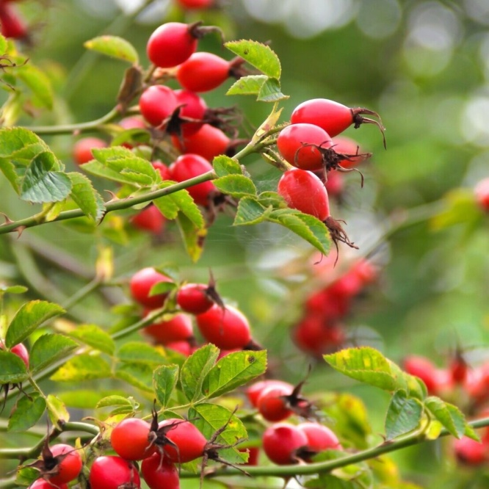
Figure 1. Fruit of the wild rose (rosehip)

Rosehips are also well-known to have the highest vitamin C content (300–4000 mg/100 g) among fruits and vegetables. In addition, rosehips contain other vitamins and minerals, carotenoids, tocopherol, bioflavonoids, fruit acids, tannins, pectin, sugars, organic acids, amino acids, and essential oils ^{10,11}.
The high levels of vitamin C in rosehips are important for collagen synthesis, which is essential for maintaining healthy skin ¹². It is well-known that the fruit of the wild rose is effective against cold and flu due to its high level of vitamin C ¹³. However, apart from this one, many other therapeutic administration options for wild rose fruit are possible. In folk medicine, rosehip is used as a substance that stops diarrhoea, ankle pain, cough, and general weakness. Recent studies show that the kaempferol derivative (tiliroside) found exclusively in the rosehip seeds has an important role in the prevention of obesity. Kaempferol (3,4′,5,7-tetrahydroxyflavone), a natural flavonol presented in different edible plants¹⁴, has been described to possess anti-inflammatory, anti-cancer, and notably cardiovascular protective properties ¹⁵. Figure 2 shows the kaempferol compound or tiliroside.
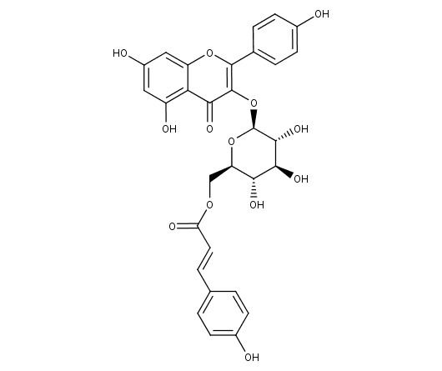
Figure 2. Kaempferol (tiliroside)

The research on fatty acids in the fruit of the wild rose led to significant findings. Namely, the fruit of the wild rose consists of galactolipid, linolenic acid, and alpha linolenic acid. These three bioactive compounds showed a significant anti-inflammatory capacity, and galactolipid showed additional and chondroprotective effects in in vitro studies ¹⁶. Galactolipid (2S)-1.2-di-O-[(9Z,12Z,15Z)-octadeca-9,12,15-trienoil]-3-O-β-D-galactopiranosile-glicerol, also known as GOPO, extracted from the herb Rosa canina (wild rose), showed an extreme anti-inflammatory effect. Because of that, a consumption of the powder obtained from seeds and husk of the wild rose fruit, which contains a combination of fatty acids and galactolipids, may significantly contribute to the improvement of conditions of the patients with inflammatory diseases. The general formula of galactolipids is shown in Figure 3.

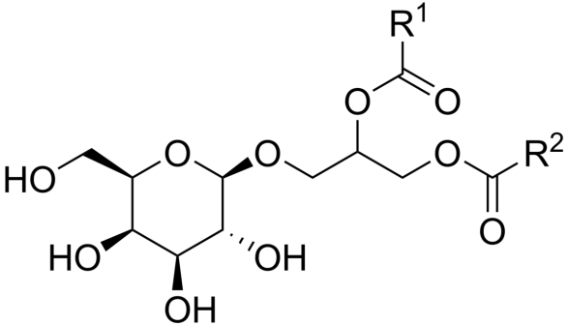

Figure 3. General structure of galactolipids

Polyunsaturated fatty acids, such as linoleic and alpha-linolenic acids, isolated from wild rose seeds, which are rich in oils, inhibit the enzyme cyclooxygenase (COX), thereby exerting anti-inflammatory activity. In many scientific studies, wild rose fruit also showed anticancerogenic activity. Its efficiency on macular degeneration, hyperlipidaemia, and obesity was also examined. The biological activity of wild rose fruit is influenced by many factors, such as the period of fruit collection, the method of processing the plant material, the type of extraction, and heat treatment. The World Health Organisation estimates that approximately four billion people in the world use herbal preparations as a primary form of health care ¹⁷. This entire structure represents a pseudo-fruit – Rosae pseudo-fructus ¹⁸. The current European pharmacopoeia contains a monograph available as DOG ROSE, Rosae pseudo-fructus. According to this pharmacopoeia, the content of the dried drug consists of at least 0.3% ascorbic acid. Identification is carried out microscopically and macroscopically, and by thin-layer chromatography ¹⁹. This experimental study analysed three forms of wild rose fruit preparations: infusion, decoction, and rosehip jam. The most accessible preparation of wild rose fruit (rosehip) is infusion, which is prepared from 2–2.5 g of dried fruit poured over with 200 mL of boiling water, left to stand for 10–15 minutes, and then strained. It is rich in vitamin C and phenols, and is used for colds, flu, hypovitaminosis C, and fatigue. Rosehip decoction, prepared by boiling 30–50 g of dried fruit in 1 litre of water, is used to treat diarrhoea due to its regenerative and antioxidant effect on the intestinal mucosa. Rosehip jam, known in nutrition, is obtained by boiling, pureeing, and adding sugar, and thanks to its antioxidant properties, it also has functional value. It is stored pasteurised, in dark and cool conditions ²⁰. The research also included the preparation of water extracts of wild rose fruit – infusion, decoction, and jam to determine the total amount of phenolic compounds (by Folin-Ciocalteu Method) and assess antioxidant activity by DPPH test administration. The obtained results were compared to overview the influence of the heat processing on the antioxidant potential, and they are analysed in comparison to the relevant data from the literature. The aim of the research is to select the most suitable method for preserving the beneficial properties of the Rosa Canina fruit, in order to maintain its stability and effectiveness.

- MATERIAL AND METHODS

The following reagents were used in this research:
- Distilled water
- Folin–Ciocalteu reagent for determination of polyphenols (Semikem, Bosnia and Herzegovina)
- Sodium carbonate (Semikem, Bosnia and Herzegovina)
- Methanol 96% (KEFO, Slovenia)
- Methanol 99.6% (KEFO, Slovenia)
- 2,2-difenyl-1-picrilhidrasil radical (Sigma, United States of America).

Procedure of sample preparation
- Dried fruits of the rosehip (Rosa canina L.), rosehip jam, and an infuse prepared from dried fruits were used for analysis. The fruits were collected on 31 October 2020 in the area of Banovići (Bosnia and Herzegovina), washed, cleaned, and dried in a dark, dry place at room temperature. Before the analysis, they were cleaned of seeds and ground.
- The jam was prepared on 11 October 2020 and stored pasteurised in a glass packaging in a cold and dark place.
- Aqueous extracts obtained by the extraction of 5 g of ground fruits or jam in 100 mL of distilled water for an hour in the ultrasound bath. After that, the samples were filtered, paired until dry, and stored for 24 hours in a desiccant. The aqueous extracts were prepared right before the analysis by dilution of dry extracts (5 mg/mL) and used for the determination of phenols and the DPPH test.
- Infusion was prepared on 20 May 2021 by pouring 50 mL of boiling water over 2.5 g of ground dry fruits. The beaker with the infuse is covered with a petri dish and left to stand for 15 minutes. After that, the infusion was filtered and used for further analysis.

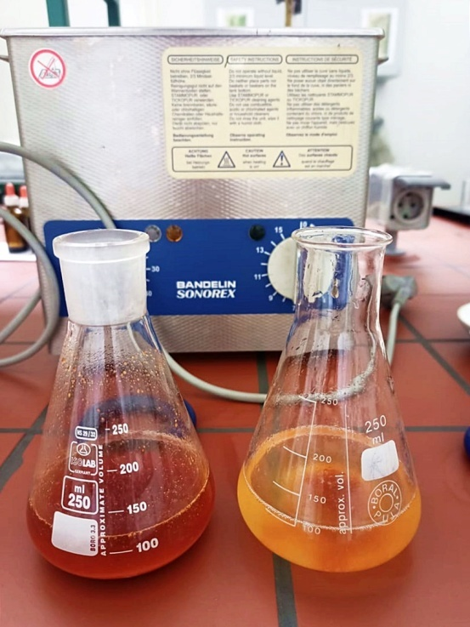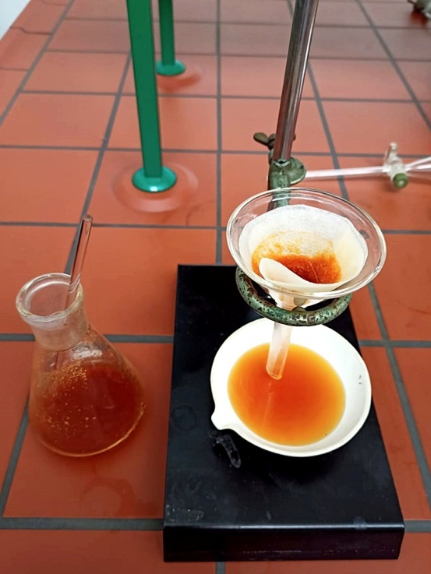
Figure 4. Preparation of aqueous extracts and filtration of extracts using an ultrasonic bath

  - Methods

Preparation of samples and extracts, as well as spectrophotometric measurements, were carried out using the following devices:
- Končar electric grinder (Slovenia)
- Kern KB laboratory scale (Germany)
- Bandelin Sonorex ultrasound bath (Germany)
- Mettler Toledo analytical scale (United States of America)
- UV/VIS spectrophotometer UV mini – 1240 Shimadzu (Japan)

Determination of the content of total phenolic compounds

The total phenol content in the extracts was determined spectrophotometrically at 765 nm after reaction with Folin–Ciocalteu’s phenol reagent according to the method of Tawah et al. (Tawah et al., 2007) ²¹.
A total of 450 µl of distilled water and 2.5 mL of 0.2 N Folin–Ciocalteu’s reagent were added to 50 µl of extract. After 5 minutes, 2 mL of saturated sodium carbonate solution (75 g/L) was added. The samples were incubated in a water bath at 30ºC for 1.5 hours with occasional stirring. The absorbance of the resulting blue-coloured liquids was measured at 765 nm. Quantitative measurements were performed based on a standard calibration curve of different concentrations of gallic acid (20, 100, 200, 300, 400, and 500 mg/L). All measurements were performed in triplicate. Results were expressed as GAE/L (gallic acid equivalent per liter solution.

Neutralisation of DPPH (2,2-diphenyl-1-picrylhydrazyl) radicals
Certain volumes of samples listed in the table were supplemented with methanol up to 2 mL, and 0.5 mL of 0.5 mM DPPH solution was added to that solution. After vigorous shaking, the mixture was incubated for 30 minutes in the dark at room temperature.
Absorbance is measured at 517 nm, and methanol is used as a blank. As a control, 1 mL of DPPH solution diluted with 4 mL of methanol was used. DPPH radical inhibition was calculated according to the equation:
Inhibition percentage = [(Ac – As) / Ac] x 100[%]
whereby As is the solution absorbance, which contains the sample at 517 nm, and Ac is the control absorbance. The results were expressed as the DPPH radical inhibition (%) and as Ic₅₀ value (mg/L), i.e., the extract concentration that leads to 50% neutralisation of DPPH radicals.

- RESULTS AND DISCUSSION
The obtained results indicate a significant influence of the preparation and processing method of wild rose fruit on the antioxidant properties of the analysed samples. The studies included three different forms of rosehip products: dried fruit infusion (sample 1), dried fruit extract (sample 2) and jam extract (sample 3), to determine their total phenolic content and DPPH free radical neutralisation ability. Analysis of the content of total phenols showed that the dried fruit infusion contained the highest number of phenolic compounds, expressed as 163.477 mg GAE/l, while the dried fruit extract contained 44.932 mg GAE/l, and the jam extract only 23.477 mg GAE/l. The results of total phenols in the samples are represented below (Chart 1).

Chart 1. Content of total phenols in the samples
These results clearly indicate that lower heat treatment, such as that used in the preparation of infusions, allows for better preservation of phenols, while higher heat treatment and the addition of sugar and water, which are inevitable in the preparation of jams, significantly reduce the concentration of these bioactive compounds. The results of the DPPH method further confirm these findings. The infusion showed the highest degree of neutralisation of DPPH radicals, even at the lowest analysed concentration (10 µL), achieving an inhibition of 40.23%, while at 90 µL it is achieved as much as 94.33% (Table 1). The dried fruit extract achieved a maximum inhibition of 91.56% (Table 2), while the jam extract, although at the highest concentration (200 µL), reached 90.17% inhibition (Table 3). Although all samples showed antioxidant potential, the infusion was already most effective at lower concentrations.

Table 1. Results of absorbance measurement and DPPH inhibition of radicals for infusion
Infusion
Volume (µL) | 10 | 30 | 50 | 70 | 90
Absorbance | 0.517 | 0.236 | 0.065 | 0.054 | 0.049
% Inhibition | 40.23% | 72.72% | 92% | 93.75% | 94.33%

Table 2. Results of absorbance measurements and DPPH radical inhibition for fruit extract
Fruit extract
Volume (µL) | 70 | 100 | 120 | 150 | 170
Absorbance | 0.330 | 0.172 | 0.113 | 0.081 | 0.073
% Inhbition | 61.84% | 80.11% | 86.93% | 90.63% | 91.56%

Table 3. Results of absorbance measurements and DPPH radical inhibition for jam extract
Jam extract
Volume (µL) | 100 | 130 | 150 | 170 | 200
Absorbance | 0.516 | 0.472 | 0.458 | 0.378 | 0.085
% Inhibition | 40.34% | 45.43% | 47.05% | 56.30% | 90.17%

When looking at the IC₅₀ – the concentration required to neutralise 50% of DPPH radicals – we see further confirmation of the previous results. The infusion has the lowest IC₅₀ value of 62.14 mg/L, making it the strongest antioxidant among the tested samples. Chart 2 shows the relationship between concentration and inhibition of DPPH radicals with the infusion as a sample. At a concentration of 250 mg/L, 92% of DPPH radicals were inhibited. Further increase in volume did not significantly increase DPPH neutralisation because saturation occurred in the reaction mixture. Therefore, further increase in concentration will not lead to better results. The same type of curve is repeated in the analysis of fruit extract and rosehip extract.
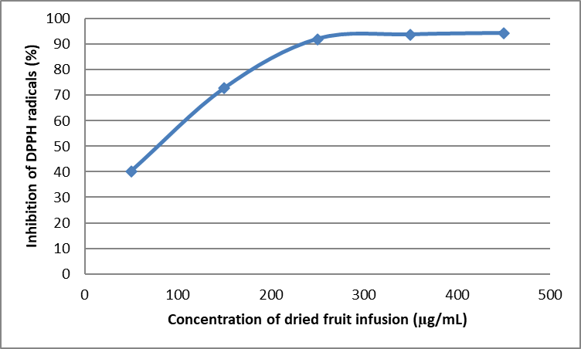
Chart 2. Dependence between concentration and neutralisation percentage of DPPH radicals
On the other hand, the fruit extract shows an IC₅₀ of 282.98 mg/L, and the jam extract has the highest value – 613.73 mg/L, which ranks it as the weakest in neutralising free radicals. This means that to achieve the same effect, a much larger amount of jam extract is needed compared to the infusion. The observed correlation between the content of total phenols and antioxidant capacity clearly indicates that phenolic compounds contribute significantly to the ability of the sample to neutralise free radicals. However, the antioxidant effect does not originate exclusively from phenols. In these studies, the sample quantities are limited (volume and concentration), which may affect the accuracy of the obtained IC₅₀ value. Rosehip fruit also contains other bioactive components such as ascorbic acid (vitamin C), fatty acids, and flavonoids, which synergistically contribute to the overall antioxidant effect. The results obtained are in line with previous research. Taneva et al. (2016), using 50% ethanol as a solvent, obtained an extract with a high content of phenolic compounds (69.4 mg GAE/L dry matter), which confirms that both the choice of solvent and the extraction method significantly affect the preservation of phenolic compounds. Latanzio et al. (2011) showed similar conclusions using a more complex extraction method with a water-ethanol mixture, percolation, and vacuum concentration, with the addition of maltodextrin and a spray drying technique, which resulted in an extract rich in phenols. Based on all that has been shown, it can be concluded that the infusion of dried wild rose fruit represents the most effective form for the consumption for intake of antioxidant components. It not only retains the highest number of phenols, but it also exhibits the strongest neutralising effect on free radicals, as confirmed by the results of both the DPPH method and the calculated IC₅₀ values. This confirms that mild processing (such as preparing tea) allows the preservation and utilisation of the medicinal properties of rosehips, unlike more thermally intensive forms such as jam, where there is a significant reduction in the content of bioactive compounds.

- CONCLUSION

Research results show that the correct choice of method for preparing pomegranate fruit has a great impact on the numerous positive properties it possesses. The dried rosehip fruit infusion showed the highest level of total phenols (163.477 mg GAE/L) and the lowest IC₅₀ value (62.14 mg/L), which makes it the strongest antioxidant among the analysed samples. The fruit extract and jam extract showed lower activity, which can be related to the intensity of heat processing with the addition of sugar and water. In this study, the results showed that the best way to consume the pomegranate fruit is in the form of an infusion (tea), as it allows for maximum use of its antioxidant and medicinal properties, with minimal loss of bioactive components. Considering its beneficial characteristics, the fruits of Rosa Canina are a frequent subject of research and are significant for use in the food and pharmaceutical industries.
Disclaimer (Artificial intelligence)
Author(s) hereby declare that NO generative AI technologies such as Large Language Models (ChatGPT, COPILOT, etc.) and text-to-image generators have been used during the writing or editing of this manuscript.

Competing Interests
Authors have declared that no competing interests exist.

REFERENCES

- Lobo, V., Patil, A., Phatak, A., & Chandra, N. (2010). Free radicals, antioxidants and functional foods: Impact on human health. Clinical Nutrition, 29(2), 129–136.

- Gossell-Williams M., Simon O.R., West M.E. (2006). The past and the present use of plants for medicines. West Indian Medical Journal, 55(4), 217–218.

- B. Sapkota, H.P. Devkota, A. Poudel, P. Poudel, R. Thapa, Rosa spp. (Rosa canina L., R. macrophylla Lindl., R. moschata Herrm., R. multiflora Thunb.). Himalayan Fruits and Berries, 2023, https://doi.org/10.1016/b978-0-323-85591-4.00006-4.

- S. Shameh, A. Alirezalu, B. Hosseini, R. Maleki, Fruit phytochemical composition and color parameters of 21 accessions of five Rosa species grown in North West Iran, J. Sci. Food Agric. 99 (2019), https://doi.org/10.1002/jsfa.9842.

- Nikolić, T., et al. (2013). Flora Croatica Database as a source of distribution data for vascular plants in Southeast Europe. Biodiversity and Conservation, 22, 2143–2163.

- European Pharmacopoeia (9th ed.). (2019). Rosae pseudo-fructus. Strasbourg: Council of Europe.

- Gülçin, İ., 2020. Antioxidant and therapeutic properties of Rosa canina L.: A comprehensive review. Phytotherapy Research, 34(6), 1234–1249.

- Chrubasik, C., Roufogalis, B. D., Müller-Ladner, U., & Chrubasik, S. (2008). A systematic review on the Rosa canina effect and efficacy profiles. Phytotherapy Research, 22(6), 725–733.

- Khazaei, M., Khazaei, M. R., & Pazhouhi, M. (2020). An overview of therapeutic potentials of Rosa canina: a traditionally valuable herb. WCRJ, 7, e1580.

- S. Weeks B, R. Fu, M. Zaidi, Vitamin C promotes wound healing: the use of in vitro scratch assays to assess Re-epithelialization. https://doi.org/10.5772/ intechopen.111517, 2023.

- J.T. Chai et al. (1995). Nutrients composition of Rosa laevigata fruits. Science Technology in Food Industry.

- Demir, F., Özcan, M., Haciseferoğulları, H., & Özgüven, F. (2001). Chemical and technological properties of rose (Rosa canina L.) fruits grown wild in Turkey. Journal of Food Engineering, 47(4), 333–336.

- Gil, M. I., Tomas-Barberan, F. A., Hess-Pierce, B., Holcroft, D. M., & Kader, A. A. (2002). Antioxidant activity of fruit and vegetables: Comparison of phenolic compounds and vitamin C in rosehips. Journal of Agricultural and Food Chemistry, 50(7), 2043–2049.

- Polyphenols: A concise overview on the chemistry, occurrence, and human health Alessandra Durazzo, Massimo Lucarini, Eliana B Souto, Carla Cicala, Elisabetta Caiazzo, Angelo A Izzo, Ettore Novellino, Antonello Santini, Phytother Res. 2019 Sep; 33(9): 2221-2243.

- Rajendran, P., Nandakumar,N., Rengarajan, T., Palaniswami,R., Gnanadhas, E.N., Laksminarasaiah, U., et. al (2014). Antioxidants and human diseases. Clinica Chimica Acta,436,332-347.

- Winther, K., Hansen, A. S. V., & Campbell-Tofte, J. (2016). Bioactive ingredients of rosehips (Rosa canina L) with special reference to antioxidative and anti-inflammatory properties: in vitro studies. Botanics: Targets and Therapy, 6, 11-23.

- Gossell-Williams, M., Simon, R. E., & West, M. E. (2006). The past and present use of plants for medicines. West Indian Med J, 55(4), 217-218.

- Altmeyers Encyclopedia – Department Phytotherapy. Rosae pseudo‑fructus cum fructibus. (2025).

- European Pharmacopeia (2019) Dog Rose, Rosae pseudo-fructus. 1510.

- Nađpal, J. D., Lesjak, M. M., Mrkonjić, Z. O., Majkić, T. M., Četojević‑Simin, D. D., & Mimica‑Dukić, N. M. (2018). Phytochemical composition and in vitro functional properties of three wild rose hips and their traditional preserves. Food Chemistry, 241, 290‑300.

- Tawaha, K., Alali, F.Q., Gharaibeh, M., Mohammad, M., and El-Elimat, T. Antioxidant activity and total phenolic content of selected Jordanian plant species (2007). Food Chemistry. (104) 1372-1378.

