Original Research Article
Optimization of The Extraction Method Of Vegetable Oil From Carapa procera Almonds Extracted Using a Hydraulic Press

.
ABSTRACT

Carapa procera (Meliaceae), known for its traditional therapeutic properties, was the subject of this study focused on optimizing the method of extracting oil from its kernels, a raw material of choice for cosmetic and pharmaceutical industries. Two extraction methods were compared (artisanal extraction and extraction using hydraulic press). The results showed that hydraulic press extraction gives better yields with yields ranging from 22.36 to 29.75%, while artisanal extraction gives yields ranging from 0 to 18.40%. Furthermore, the extraction method has no influence on the physico-chemical properties (acid, peroxide, refraction, and saponification index) of the oil. Nevertheless, it influences the chemical composition of the latter. Since the oil yields obtained by the hydraulic press extraction method were better, this method was chosen for optimization.
In order to evaluate the impact of process parameters on oil yield, two experimental designs were implemented : the two-level full factorial as well as Box-Behnken designs, and used Minitab 21 software for statistical analysis. The statistical analysis confirmed the relevance of the model used in accordance with the high values ​​of the coefficients of determination R² (0.9884) and adjusted R² (0.9651), close to unity, and p values (p<0.05). The results highlighted the significant influence of two factors on the yield : fermentation duration (A) and pressure (B). The oil yields ranged between 12.40 and 36.94% after optimization. In summary, the optimal conditions for improving yield are : an almond fermentation period of 21 days, a pressure of 300 bars, and a roasting duration of 7.5 minutes. Furthermore, in order for this method to be more profitable, this study recommends removing the shelf-life phase which has a negative influence on the oil yield.

Keywords: Carapa procera, Almonds, Extraction method, Vegetable oil, Optimization, Experimental plans

1. INTRODUCTION

Carapa procera, commonly referred to by the English name “crabwood”, is a tree native to the tropical regions of Africa and America (Weber et al., 2010; Sanogo et al., 2013). In Ivory Coast, its distribution is particularly vast, covering almost the entire territory. It is widely exploited for oil production (Sanogo et al., 2013). The oil from Carapa procera nuts is widely used in West African ethnopharmacy for the treatment of several pathologies, including inflammation (Weber et al., 2010 ; Gueye et al., 2010 ; Dioum et al., 2016). It is also effective as a mosquito repellent (Dioum et al., 2016). Despite its many virtues, the oil remains little known. It is produced in small production units and made in an artisanal manner. Moreover, production yields remain low (Guillemot, 2004). Oil yields are strongly linked to the extraction technique used. The so-called "traditional" or "artisanal" technique is by far the most used by the population. This oil extraction process has a low yield and requires a lot of human effort (N’Deye, 2001). Extraction using solvents such as hexane was initially developed for processing low-oil oilseeds. Nowadays, the combination of a screw press and solvent extraction is a well-established industrial technique used even for high-oil seeds (Azzaz, 2020). This operation is carried out in continuous percolation extractors in which the solvent is sprayed onto the cake and then recycled several times. The oils obtained in this way are generally not usable as is and must be refined before being offered to consumers (Azzaz, 2020 ; Evrard et al., 2007). We initiated this work in order to contribute to improving production yields. To do this, the parameters that could influence yields were researched. The objective of this study is to find the operating conditions that allow increasing the mass of oil that can be extracted from Carapa procera almonds.

2. material and methods

2.1 Material

2.1.1 Plant material

The plant material consisted of Carapa procera nuts. The nuts were collected in Toumodi in the “Belier region” (Ivory Coast) in February 2022. Botanical determination was performed by the botanist TEHE Henry of Centre Suisse de Recherche Scientifique (Ivory Coast) where a voucher specimen is deposited under the reference CP-MJ-Toumodi 2022-1.

2.1.2 Technical equipment

The technical equipment used is as follows: an electronic scale, a WARING COMMERCIAL brand Blender, a microwave, a hydraulic press, and a porcelain plate.

2.1.3 Computer hardware

The data were processed using an HP computer running Minitab 21 software.

2.2 Methods

2.2.1 Oil extraction

2.2.1.1 Extraction by hydraulic press

After harvesting, the Carapa procera nuts were sorted, cleaned manually to remove all impurities, boiled in water and shelled using a hammer to give the almonds and shells. The almonds were then fermented, oven-dried (45°C), ground using a WARING COMMERCIAL brand Blender, roasted, and extracted by hydraulic press to yield the oil. The extraction process is summarized in the diagram in Figure 1.
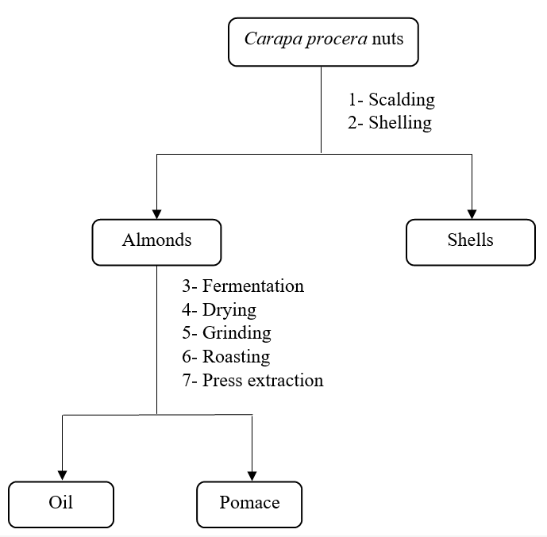
Fig. 1. Diagram of oil extraction by hydraulic press

2.2.1.2 Artisanal extraction

This method, described in Figure 2, follows almost the same steps as the hydraulic press extraction method. The difference here is that there is no fermentation step before drying. Furthermore, the oil is extracted by decoction. This technique is based on the principle of the immiscibility of water and oil.
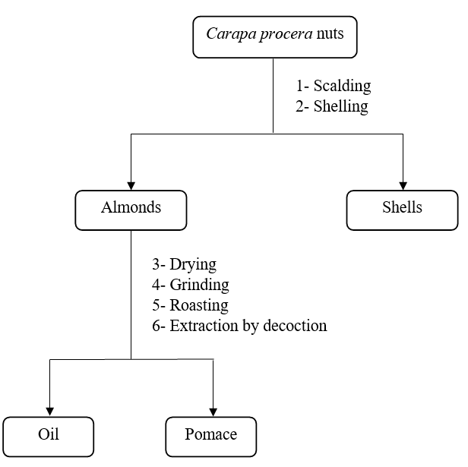
Fig. 2. Diagram of oil artisanal extraction

2.2.2 Experimental designs

The design of experiments methodology, recognized for its effectiveness in optimizing processes, was used in this study. By following a systematic approach, this method makes it possible to significantly reduce the number of experiments required while guaranteeing optimal quality of results. Experimental designs provide a rigorous framework for establishing mathematical models, generally of polynomial type, which describe the behavior of the system studied from a limited number of tests (Goupy et Creighton, 2006; Saidj, 2007; Pillet, 2011). Among the different types of designs, we focused on two-level full factorial designs, particularly suited to the study of main effects and interactions between factors, as well as Box-Behnken designs, recognized for their effectiveness in the overall understanding of processes (Goupy et Creighton, 2006).

2.2.2.1 Identification of parameters influencing oil yield: Two-level full factorial design

This work aims to contribute to the production of oil from Carapa procera kernels with better yields. It is therefore necessary to choose the factors capable of positively or negatively influencing this quantity in order to be able to modify them if necessary. The literature review allowed us to list a number of influencing factors ; these are : scalding duration, scalding temperature, granulometry (particle size), grinding duration, roasting duration, roasting temperature, fermentation, pressure, sample storage duration, work environment, extraction water volume, and drying duration. Four factors (Table 1) were deemed relevant following brainstorming : fermentation duration (A), pressure (B), roasting duration (C), and sample storage duration (D).
The two-level factorial design, also called the complete factorial design 2⁴, finds an application, very generally for the establishment of formal models. Indeed, a complete plan involves studying all possible combinations of the factors considered in the experiment. Such a design requires 2⁴ tests corresponding to the total combinations of the four variables (Goupy, 1990). In order to simplify the writing of all combinations, we define a new coordinate system which has as its origin the intersection of the average values ​​between the two levels of each variable. The 2⁴ tests provide 2⁴ values ​​of the parameter studied and allow the determination of the 2⁴ coefficients of the polynomial function which is in fact the desired model. Assigning the value (-1) to the low level of the factor and (+1) to the high-level (Table 1) amounts to a change in the unit of measurement and a change in the origin which allow all factors to be treated in the same way (Goupy et Creighton, 2006; Saidj, 2007). The other parameters were considered fixed.

Table 1. Factors that may influence extraction yield and their study area

Factor | Code | Low level (-1) | High-level (+1)
Fermentation duration (Days) | A | 0 | 21
Pressure (bar) | B | 150 | 300
Roasting duration (min) | C | 5 | 10
Sample storage duration (Days) | D | 0 | 14
The mathematical model considered here is a function of degree 1 for simplification. The polynomial model is: $Y=a_{0}+∑a_{i}X_{i}…+e$
Where :
Y : response or magnitude of interest ;
X_{i} : variable representing factors i and j ;
a₀ ; a_{i}: coefficients of the mathematical model ;
e : measurement error ;
The experiment matrix is ​​presented in Table 2.

Table 2. Two-level full factorial experimental design

Tests order | A | B | C | D
1 | - | - | - | -
2 | + | - | - | -
3 | - | + | - | -
4 | + | + | - | -
5 | - | - | + | -
6 | + | - | + | -
7 | - | + | + | -
8 | + | + | + | -
9 | - | - | - | +
10 | + | - | - | +
11 | - | + | - | +
12 | + | + | - | +
13 | - | - | + | +
14 | + | - | + | +
15 | - | + | + | +
16 | + | + | + | +

2.2.2.2 Optimization of oil yield: Box-Behnken design

The Box-Behnken design is a type of response surface design that does not contain a fractional factorial design; this is a second-degree plan. It imposes three levels on each factor, including the lower (-), median (0) and upper (+) levels (Goupy et Creighton, 2006). Box-Behnken designs for 3 factors involve three blocks, in each, a 2² factorial design that is represented by each treatment pair while the third factor remains fixed at 0. So, the 3-factor Box-Behnken design has 15 trials (Goupy et Creighton, 2006). The objective of this study is to improve the extraction yield with parameters already deemed relevant by the two-level full factorial design. The factors to be studied and their values ​​are recalled in Table 3.

Table 3. Factors and study area

Factor | Code | Low level (-1) | Median level (0) | High-level (+1)
Fermentation duration (Days) | A | 0 | 10,5 | 21
Pressure (bar) | B | 150 | 225 | 300
Roasting duration (min) | C | 5 | 7,5 | 10
The experiment matrix is ​​presented in Table 4.

Table 4. Box-Behnken experiment matrix

Tests | A | B | C
1 | - | - | 0
2 | + | - | 0
3 | - | + | 0
4 | + | + | 0
5 | - | 0 | -
6 | + | 0 | -
7 | - | 0 | +
8 | + | 0 | +
9 | 0 | - | -
10 | 0 | + | -
11 | 0 | - | +
12 | 0 | + | +
13 | 0 | 0 | 0
14 | 0 | 0 | 0
15 | 0 | 0 | 0

The mathematical model is given by the relation:

$$Y=a_{0}+\sum{a_{i}X_{i}+\sum{a_{ij}X_{ij}+\sum{a_{ii}X_{ii}^{2}}…….+e}}$$
Where :
Y : response or magnitude of interest ;
X_{i} : level of factor i ;
X_{j} : level of factor j ; (Goupy, 1990).
a₀ a_{j}, a_{ij}, a_{ii} : coefficients of the polynomial ; (Goupy et Creighton, 2006).
e : error ;

2.2.3 Acid index determination

Acid index is defined as the number of milligrams of potassium hydroxide required to neutralize the acidity of one gram of oil. The analysis is performed on the dried oil. The acid index was determined according to standard NFT 60 204 (AFNOR, 1981). The test consists of neutralizing free acids with an alcoholic solution of potassium hydroxide.

2.2.4 Peroxide index determination

The peroxide index is the number of milliequivalents of active oxygen per kilogram of fat. It was determined according to the protocol described by standard NFT 60 220 (AFNOR, 1981). The fats in solution in acetic acid and chloroform are treated with a potassium iodide solution. The iodine released is then titrated with a 0.01N sodium thiosulfate solution.

2.2.5 Saponification index determination

The saponification index corresponds to the number of milligrams of potassium required to saponify the fatty acids contained in one gram of fat. It was determined according to standard NFT 60 206 (AFNOR, 1981). The sample is subjected to reflux boiling with a potassium hydroxide solution and then titrated with hydrochloric acid (HCl) in the presence of a colored indicator (phenolphthalein).

2.2.6 Refraction index determination

The refraction index is defined as the ratio between the speed of light in a vacuum at a given wavelength and the speed of propagation in the substance. The wavelength chosen is that of the average of the D lines of sodium. The refraction index was determined according to standard NFT 60 212 (AFNOR, 1984).

2.2.7 Determination of fatty acid profile

The determination of the fatty acid profile of the oil was carried out according to the method used by Lacroux et al (2025) with slight modifications. Indeed, 15 mg of the oil was solubilized in 1 mL of tert-butyl methyl ester (TBME). A 100 µL fraction of this solution was methylated with 50 µL of 0.2 mol/L trimethylsulfonium hydroxide (TMSH) in methanol. The resulting fatty acid methyl esters were analyzed by gas chromatography (Varian 3900). 1 µL of the solution was injected into the chromatograph with the following parameters: Injector in split mode (ratio of 1/100, 250°C, 55 min); CP-Select CB for FAME fused silica WOCT column (50 m x 0.25 mm), film (0.25 µm); Carrier gas (helium, 1.2 mL/min); Oven temperature (initial 185°C for 40 minutes, then increased by 15°C/min up to 250°C, and maintained at 250°C for 11 min). The identification of fatty acid methyl esters is based on the retention times obtained for a methyl ester mixture from commercial standards (Mix 37, Sigma Aldrich).

3. results and discussion

3.1 Parameters influencing oil yield: Two-level full factorial design

The results of the 16 experiments are shown in Table 5. The order in which these different experiments were performed was based on random selection.

Table 5. Results of experiments according to the two-level full factorial design

Tests order | A | B | C | D | Yields (%)
1 | - | - | - | - | 7.50
2 | + | - | - | - | 12.35
3 | - | + | - | - | 18.24
4 | + | + | - | - | 23.61
5 | - | - | + | - | 19.08
6 | + | - | + | - | 20.08
7 | - | + | + | - | 22.36
8 | + | + | + | - | 29.75
9 | - | - | - | + | 6.01
10 | + | - | - | + | 7.03
11 | - | + | - | + | 8.7
12 | + | + | - | + | 14.65
13 | - | - | + | + | 8.59
14 | + | - | + | + | 12.45
15 | - | + | + | + | 10.65
16 | + | + | + | + | 17.35
(-) = Low level ; (+) = High level

3.1.1 Estimation of coefficients and effects of factors

Table 6 shows the coefficients and effects of the factors.

Table 6. Estimation of coefficients and effects of factors

Term | Effect | Coefficient | T | p
Constant |  | 14.909 | 46.21 | 0.000
Linear
Fermentation duration | 4.499 | 2.249 | 6.97 | 0.001
Pressure | 6.509 | 3.254 | 10.09 | 0.000
Roasting duration | 5.259 | 2.629 | 8.15 | 0.000
Storage duration | -8.461 | -4.231 | -13.11 | 0.000
Interactions
Fermentation duration*Pressure | 1.854 | 0.927 | 2.87 | 0.035
Fermentation duration*Roasting duration | 0.239 | 0.119 | 0.37 | 0.727
Fermentation duration* Storage duration | -0.116 | -0.058 | -0.18 | 0.864
Pressure*Roasting duration | -1.531 | -0.766 | -2.37 | 0.064
Pressure* Storage duration | -2.191 | -1.096 | -3.40 | 0.019
Roasting duration*Storage duration | -2.096 | -1.048 | -3.25 | 0.023
T = Student value ; p = Probability

Statistical analyses revealed that the four factors studied have a significant influence on the oil extraction yield. In particular, the storage duration factor (D) is distinguished by a zero value of p and a high absolute value of T, thus demonstrating its predominant effect on the process.

3.1.2 Analysis of variance

Variance reflects the reliability of the statistical model; it indicates whether the various factors studied have a significant impact on the result. For a factor or interaction to be considered important, its probability (p) must be less than 5%. This means that there is less than a 5% chance that the observed effect is due to chance.

Table 7. Analysis of variance of oil yield

Source | F | p
Model | 42.48 | 0.000
Linear
Fermentation duration | 48.60 | 0.001
Pressure | 101.73 | 0.000
Roasting duration | 66.41 | 0.000
Storage duration | 171.93 | 0.000
Interactions
Fermentation duration*Pressure | 8.25 | 0.035
Fermentation duration*Roasting duration | 0.14 | 0.727
Fermentation duration* Storage duration | 0.03 | 0.864
Pressure*Roasting duration | 5.63 | 0.064
Pressure* Storage duration | 11.53 | 0.019
Roasting duration*Storage duration | 10.55 | 0.023
F = Fischer constant; p = Probability

The results of the statistical analysis confirm the relevance of the model used. The high values ​​of the coefficients of determination R² (0.9884) and adjusted R² (0.9651), close to unity, demonstrate an excellent fit between the observed values ​​and those predicted by the model, as Rabier (2007) points out. This agreement constitutes further evidence of the robustness of the polynomial model. Furthermore, factors A, B, C, D as well as interactions AB, BD and CD associated with p values ​​less than 0.05, have a significant effect on the extraction yield, in accordance with the observations of the Pareto diagram (Fig. 3).

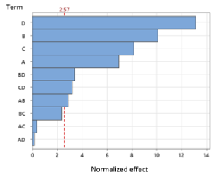

Fig. 3. Diagram of the different effects of factors
(A: Fermentation duration; B: Pressure; C: Roasting duration; D: Storage duration)

The effects diagram highlights the importance of factors D, B, C, A, BD, CD and AB, whose effects deviate significantly from the reference line. Since the other interactions were not significant, they were excluded from the final polynomial model, constructed from the analysis of the Pareto diagram and the calculation of the coefficients (Equation 1):

$$Y=14.909+2.249A+3.2254B+2.629C-4.231D-1.096BD-3.25CD+0.927AB$$

3.1.3 Main effects of factors

A main effect refers to the variation in the mean response between two factor levels. The values ​​are shown in Table 8.

Table 8. Average effects of factors on oil mass

 | A | B | C | D
Level (-1) | 12.64 | 11.64 | 12.26 | 19.12
Level (+1) | 17.16 | 18.16 | 17.54 | 10.68

The analysis of the main effects shown in Figure 4 reveals a significant influence of factors A, B, C and D on the oil yield. Factors A, B and C are positively correlated with oil yield while factor D has a negative effect on the yield. Thus, an increase in the pressure (B), fermentation duration (A), and roasting duration (C) of the sample leads to an increase in the oil yield. Conversely, an increase in stockage duration (D) leads to a decrease in yield, suggesting a negative effect on lipid release.

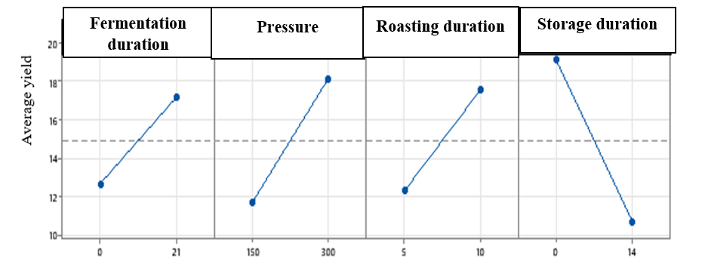
Fig. 4. Main effects diagram

3.1.4 Effects of interactions between factors

Figure 5 shows the interaction diagram, a graphical tool for visualizing the combined effects of two factors on the response variable.

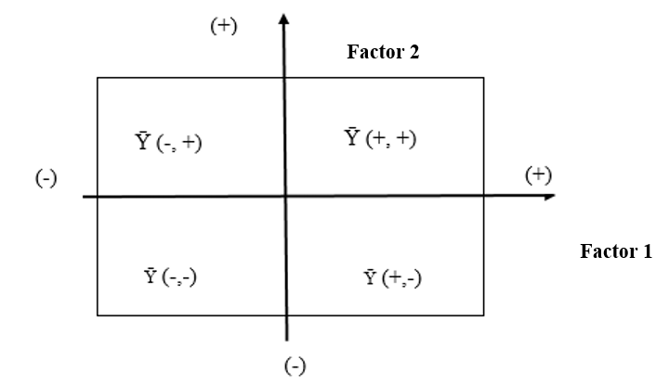
Fig. 5. Factor 2-Factor 1 interaction diagram

An interaction is characterized by a modification of the effect of one factor depending on the level of the other factor. This diagram is constructed by representing the average of the responses obtained for each combination of the low (-) and high (+) levels of the two factors considered.

3.1.4.1 Interaction effect: Fermentation duration-Pressure (AB)

The main effects of factors A (4.499) and B (6.509) are both positive (Table 6), indicating a favorable influence on the extracted oil yield. The AB interaction, characterized by a positive effect (1.854), highlights a synergistic effect between these two factors. Indeed, the increase in factor A, whether at the low (-1) or high (+1) level, leads to an increase in oil yield, and this effect is amplified when factor B is also at its high level (+1) (Fig. 6).

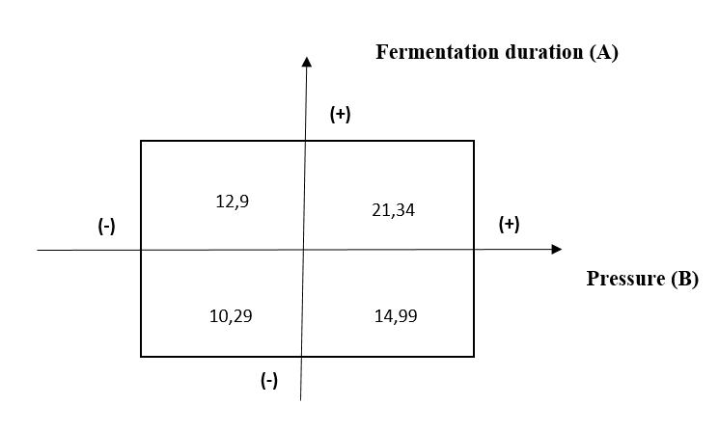
Fig. 6. Fermentation duration-Pressure interaction diagram

3.1.4.2 Interaction effect: Pressure-Storage duration (BD)

The interaction diagram (Fig. 7) and Table 6 reveal a negative main effect of factor D (-8.461) and a positive main effect of factor B (6.509) on oil yield. The BD interaction, on the other hand, exerts a negative effect (-2.191). Specifically, when factor B increases from its low level (-1) to its high level (+1), a significant increase in oil yield is observed, regardless of the value of factor D. However, the maximum yield is obtained when factor D is at its low level (-1) and factor B at its high level (+1).
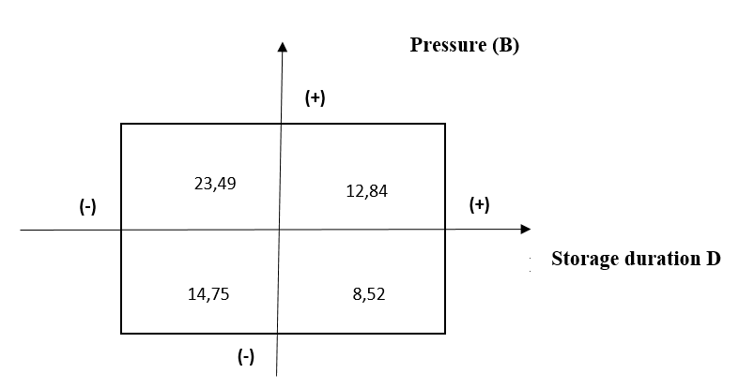
Fig. 7. Pressure-Storage duration interaction diagram

3.1.4.3 Interaction effect: Roasting duration- Storage duration (CD)

The interaction diagram (Fig. 8) and Table 6 reveal a negative main effect of factor D (-8.461) and a positive main effect of factor C (5.259) on oil yield. In addition, the CD interaction exerts a negative effect (-2.096). Indeed, when factor C increases from its low level (-1) to its high level (+1), a significant increase in oil yield is observed, regardless of the value of factor D. Finally, the maximum yield is obtained when factor D is at its low level (-1) and factor C at its high level (+1).
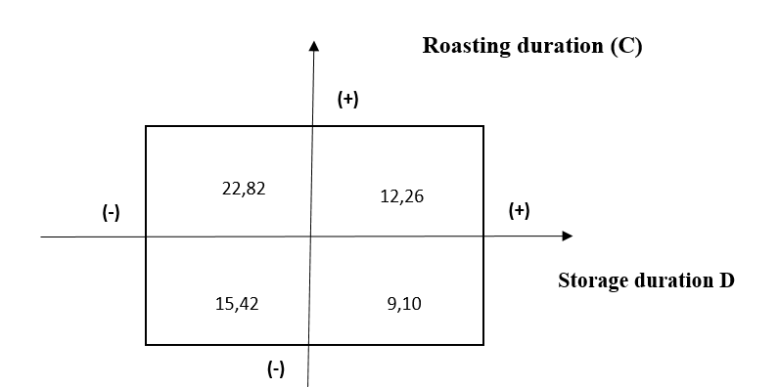
Fig. 8. Roasting duration-Storage duration interaction diagram

3.1.4.4 Summary of interaction effects

The effects of the interactions between the factors reveal that the combination of high levels of factors A and B (+1, +1) induces a significant increase in oil yield, of the order of 21.34%. Similarly, the combination of low level of D (-1) and high level of B (+1) as well as the combination of low level of D (-1) and high level of C (+1) leads to an increase in oil yield of 23.49% and 22.82% respectively. In order to optimize the extraction method, the full factorial design technique was used to identify the factors that influence the oil extraction method. For this purpose, the analysis of variance and the Pareto diagram showed us that this method depends on all the factors (A, B, C, and D), and the interactions AB, BD and CD. The main effects graph revealed that only three factors (A, B and C) have a positive influence on the oil yield. On the other hand, factor D has a negative effect on the yield. For the following, we will set factor D at its low level.

3.2 Optimization of Carapa procera oil extraction yield by Box-Behnken design

The results of the experiments are shown in Table 9. As a reminder, the meaning of the different codes is: A (Fermentation duration), B (Pressure), C (Roasting duration). For artisanal extraction, the fermentation time is replaced by sample storage duration.

Table 9. Experimental plan

 | Hyraulic press extraction |  |  |  | Artisanal extraction
Tests order | A | B | C | Yields (%) | Yields (%)
1 | 0 | - | - | 12.40 | 0
2 | 0 | 0 | 0 | 19.77 | 0.4
3 | + | 0 | - | 27.69 | 6.23
4 | 0 | 0 | 0 | 19.77 | 11.48
5 | 0 | + | - | 25.48 | 0
6 | - | 0 | - | 18.65 | 1.72
7 | 0 | 0 | 0 | 19.77 | 1.32
8 | - | - | 0 | 14.52 | 3.15
9 | + | - | 0 | 26.56 | 0.86
10 | + | + | 0 | 36.94 | 0
11 | - | + | 0 | 19.75 | 18.40
12 | 0 | - | + | 24.28 | 18.22
13 | + | 0 | + | 29.32 | 0.99
14 | 0 | + | + | 27.25 | 0.60
15 | - | 0 | + | 18.66 | 14.72
(-) = Low level ; (+) = High level ; (0) = Median level

The order in which these different manipulations are carried out is based on a random draw. Since the extraction yields by the artisanal method (0-18.40%) were lower than those obtained by hydraulic press, the hydraulic press method was chosen for optimization. The expected result is the oil yield obtained after extraction by the hydraulic press method.

3.2.1 Estimation of coefficients

Table 10 contains the estimation of the effects and coefficients of the factors.

Table 10. Estimation of the effects and coefficients of the factors

Term | Coefficient | T | p
Constant | 19.77 | 14.12 | 0.000
Fermentation duration | 6.116 | 7.13 | 0.001
Pressure | 3.957 | 4.62 | 0.006
Roasting duration | 1.911 | 2.23 | 0.076
Fermentation duration*Fermentation duration | 2.95 | 2.34 | 0.067
Pressure*Pressure | 1.72 | 1.36 | 0.231
Roasting duration*Roasting duration | 0.86 | 0.68 | 0.526
Fermentation duration*Pressure | 1.29 | 1.06 | 0.337
Fermentation duration*Roasting duration | 0.040 | 0.33 | 0.752
Pressure*Roasting duration | -2.53 | -2.08 | 0.092
T = Student value ; p = Probability

The results show that out of three factors only two (fermentation duration and pressure) have a significant influence on the oil yield. These results also show that the fermentation duration factor has a value of p = 0.001 < 0.05 lower than the pressure with p = 0.006 < 0.05. The roasting duration factor has a great influence on the oil yield followed by the pressure. These two factors have a synergistic effect on oil yield. Indeed, prolonged fermentation can weaken cellular structures, which facilitates the mechanical extraction of oil. Meanwhile, the pressure applied during mechanical extraction has a considerable influence on this same yield. This result is consistent with that of Baryeh (2001) in the context of mechanical palm oil extraction where a progressive increase in pressure leads to a notable improvement in yield.

3.2.2 Analysis of variance

The results of the analysis of variance of oil yield are shown in Table 11.

Table 11. Oil yield variance

Source | F | p
Model | 9.98 | 0.010
Linear
Fermentation duration | 50.88 | 0.001
Pressure | 21.30 | 0.006
Roasting duration | 4.97 | 0.076
Square
Fermentation duration* Fermentation duration | 5.49 | 0.067
Pressure*Pressure | 1.86 | 0.231
Roasting duration*Roasting duration | 0.46 | 0.526
Interaction
Fermentation duration*Pressure | 1.13 | 0.337
Fermentation duration*Roasting duration | 0.11 | 0.752
Pressure*Roasting duration | 4.34 | 0.092
F = Fischer's constant; p = Probability

The results of the variance analyses provide information on the relevance of the effects of the factors defined by the probability value p<0.05 and also on the validity of the model with the value of p=0.001<0.05 (Manohar et al., 2013). It is represented in the form of a Pareto diagram (Fig. 9) to visualize the effect of the factors and interactions on the response. The Pareto diagram classifies the factors and interactions according to their influences on the response. Figure 9 presents the effect of the different factors on the oil yield. A factor whose value exceeds the reference line (red dotted line on the diagram) is significant.
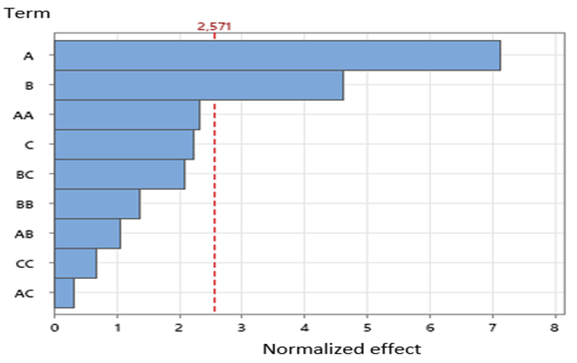
Fig. 9. Pareto diagram of factors and interactions effects

This diagram shows that the effects of A and B are significant in order of importance. On the other hand, the interactions AA, BC, BB, AB, CC, and AC, as well as the factor C do not reveal any significant effect.

3.2.3 Mathematical model

The results obtained are summarized in the form of a second-degree polynomial equation as follows: (Equation 2)

$$Y=19.77+6.116A+3.957B+1.911C+2.95AA+1.72BB+0.86CC+1.29AB+0.40AC-2.59BC$$

3.2.4 Coefficient of determination

R² is a factor that provides information on the validity of the model studied (Goupy et Creighton, 2006). The coefficients of determination are R² = 0.9475 and R²_{Aju} = 0.8523. The values ​​of R² and R²_{Aju} tend towards 1, which indicates that the model is relatively well explained. There is therefore a good correlation between the real values ​​and the predicted values ​​(Rabier, 2007).

3.2.5 Main effects diagram

The main effects diagram (Fig. 10) provides information on the simultaneous influence of all factors on oil yield.

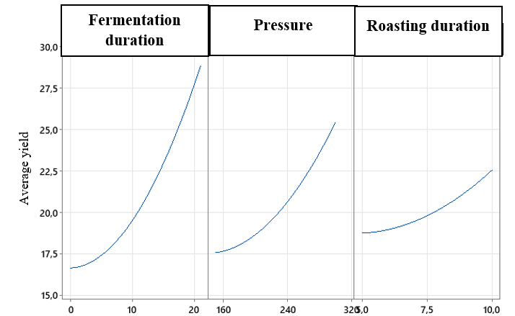
Fig. 10. Diagram of main effects of factors on oil yield

In this figure, fermentation duration and pressure have a significant influence on oil yield. On the other hand, roasting duration has an almost insignificant influence on the response.

3.2.6 Oil yield curve graphs

Using the validated mathematical model and Minitab 21 software, 2D contours are graphically created. These graphs allow to search for more desirable optimal solutions with greater precision and to better assess the results. Contour curves are generated using Minitab 21 software by combining the three factors (A, B and C). Two factors are chosen each time and plotted on the X and Y axes. The response value is represented by a shaded region in the 2D contour plot.

3.2.6.1 Oil yield curve graph: Pressure-Fermentation duration

Figure 11 represents the contour graph of factors A and B. Both factors provide information on the evolution of the response. The combination of the fermentation duration (A) and pressure (B) factors reveals a dark green region in which the yield is higher (> 35%) for a fermentation duration interval between 20 and 21 days.
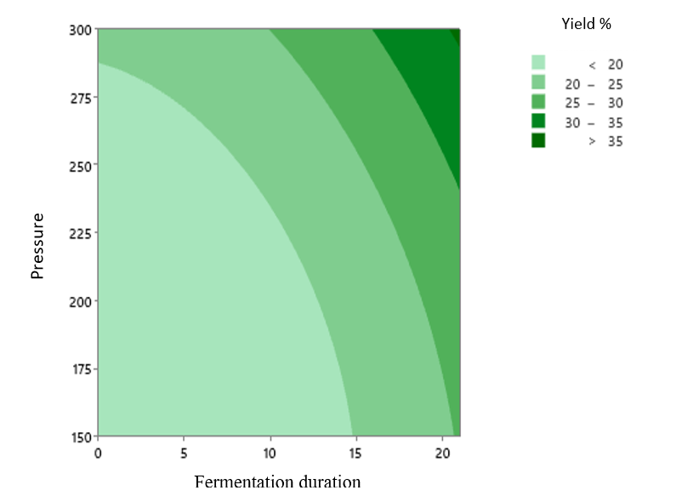
Fig. 11. Oil yield contour graph: Pressure-Fermentation duration

3.2.6.2 Oil yield curve graph: Fermentation duration-Roasting duration

Figure 12 represents the contour graph of fermentation duration (A) and roasting duration (C). The combination of these factors reveals a dark green region in which the yield is higher (> 32%) for a roasting duration range between 6.8 and 10 minutes.

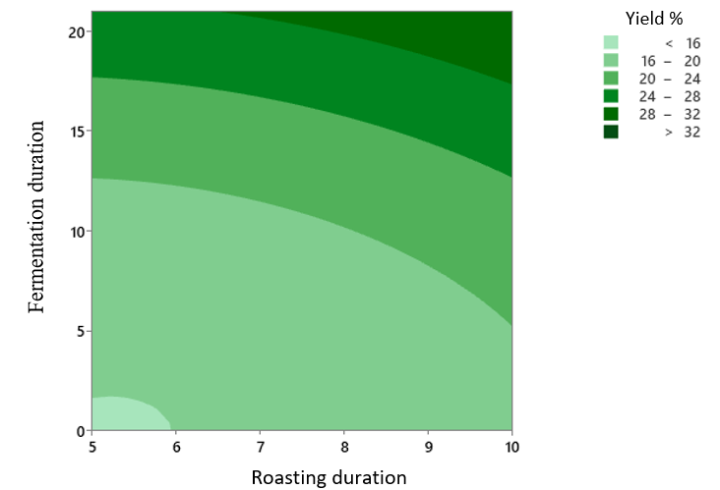
Fig. 12. Oil yield contour graph: Fermentation duration-Roasting duration

3.2.6.3 Oil yield curve graph: Pressure-Roasting duration

Figure 13 represents the contour graph of factors B and C. The combination of pressure and roasting duration factors reveals a dark green region in which the yield is higher (> 25%) for a roasting duration interval between 5 and 10 minutes.
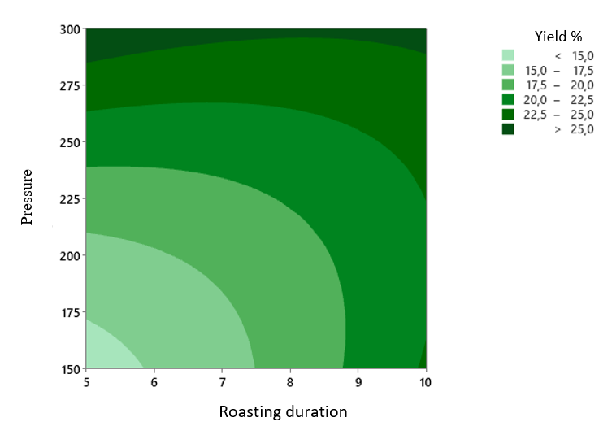
Fig. 13. Oil yield contour graph: Pressure-Roasting duration

3.2.7 Optimal settings

The optimal conditions proposed by the model are represented in Table 12.

Table 12. Optimal conditions for oil extraction

Parameters | Codes | Level
Fermentation duration | A | (+1)
Pressure | B | (+1)
Roasting duration | C | (0)

This table shows that to obtain the best oil extraction yield from Carapa procera almonds by hydraulic press, factors A (fermentation duration) and B (pressure) are the most important among the four studied. A level (+1) of these factors corresponds to the optimal oil yield.

3.3 Physico-chemical characterization of oils

The physicochemical parameters of the oil are recorded in Table 13. The refractive index is considered a criterion of oil purity. It varies according to the wavelength of the incident light and the temperature at which the analysis is carried out. This index is proportional to the molecular weight of the fatty acids and their degree of unsaturation. The refraction index value ​​of Carapa procera oil (1.46) for both traditional (AE) and press extraction (HPE) fall within the range established by Codex Alimentarius (2009). This value ​​is consistent with that found by Kan et al. (2020). Furthermore, it is close to that of Novidzro et al. (2019) on Griffonia simplicifolia seed oil obtained by Soxhlet extraction.

Table 13. Physicochemical parameters of Carapa procera oil

Physicochemical parameters | AE | HPE | Codex Alimentarius (2009)
Refraction index | 1.46 | 1.46 | 1.463-1.478
Saponification index (mgKOH/g) | 200.46 | 200.01 | 188-253
Peroxide index (meqO₂/Kg) | 0.65 | 0.65 | ≤15
Acid index (mgKOH/g) | 7.29 | 7.29 | ≤4
AE: Oil from artisanal extraction; HPE: Oil from hydraulic press extraction

The saponification index of a fat informs on the length of the carbon chain of the fatty acids that make up that fat. It is higher the shorter the carbon chain of the fatty acids (Azzaz et al., 2020). The saponification index of Carapa procera oil (200.46 mgKOH/g oil and 200.01 mg KOH/g oil) are close to that found by kan et al. (2020). The acid index of a fat is a good indicator for determining its level of spoilage. The Carapa procera oils studied here have an acid index of 7.29 mgKOH/g of oil. This acidity is higher than the maximum value recommended by the Codex Alimentarius (2009) (4 mg KOH/g). It should be noted that a low acid value characterizes good purity and better stability of an oil at room temperature. Since this criterion is not met for Carapa procera oil, it is therefore necessary that conditioning precautions be taken in order to limit a probable subsequent denaturation of this oil (Dahouenon-Ahoussi et al., 2012). The peroxide index is linked to storage conditions and extraction methods. It is a very useful criterion that allows to assess the early stages of oxidative deterioration (Mbaye et al., 2013). The peroxide index obtained (0.65 meqO₂/kg), is relatively low; this indicates a high resistance of the oil to oxidation. This value is lower than 15 meqO₂/kg, which characterizes most conventional edible oils such as soybean and corn oils (Codex Alimentarius, 2009). It is lower than that found by Kan et al. (2020) and higher than that of Novidzro et al. (2019) concerning Griffonia simplicifolia seed oil obtained by Soxhlet extraction. C. procera oil is therefore characterized by good stability against oxidation.

3.4 Chemical composition of Carapa procera oils

Fatty acids are considered a genetic code. They are the major constituents with which the oil’s nature is identified (Ollivier et al., 2015). The chemical composition of Carapa procera oils obtained using artisanal (AE) and hydraulic press (HPE) extraction methods is given in Table 14. Four (4) compounds were identified from AE and eleven (11) from HPE.

Table 14. Chemical composition of Carapa procera seed oil

Compounds | AE (%) | HPE (%)
Palmitic acid | 23.03-24.35 | 7.78
Oleic acid | 50.47-51.55 | 24.56
Stearic acid | 10.15-11.09 | -
Linoleic acid | 10.29-12.02 | 0.88
Nonadecane | - | 0.05
Ethyl palmitate | - | 0.95
Undecanoic acid | - | 0.76
Ethyl linoleate | - | 1.76
Ethyl elaidate | - | 1.86
Glycidyl oleate | - | 0.71
Heptacosane | - | 1.49
Cis-vaccenic acid | - | 2.48
AE: Oil from artisanal extraction; HPE: Oil from hydraulic press extraction

AE consists solely of fatty acids in higher proportions than those obtained in HPE. The results show that oleic acid is the major constituent of AE (50.47%–51.55%), followed by palmitic acid (23.03%–24.35%), linoleic acid (10.29%–12.02%), and stearic acid (10.15%–11.09%). These results are similar to those found by Bazongo et al. (2016). Their work showed a predominance of oleic acid (50%), followed by palmitic acid (22%), linoleic acid (17%), and stearic acid (9%). Furthermore, stearic acid is absent from HPE. In addition to fatty acids, other compounds in small proportions have been identified in HPE. These are hydrocarbons and fatty acid esters (Table 14). The presence of these compounds in HPE would be due to fermentation. In addition, the fatty acid contents of AE are higher than those of HPE. This result is partially in agreement with that of Ahmed et al. (2024) which states that the fermentation of almonds increases the content of oleic acid and reduces that of linoleic acid. Unlike the artisanal method, fermentation has a significant influence on the composition and fatty acid content of the oil obtained using hydraulic pressing.

4. Conclusion

This study aimed to optimize the yield of the oil extraction process from Carapa procera almonds by hydraulic press. To achieve this, an approach combining two robust statistical methodologies was implemented: full factorial designs and Box-Behnken designs. These methodological tools allowed for an in-depth investigation of the influence of the various process parameters and the identification of optimal extraction conditions. The full factorial design method allowed us to identify the factors influencing oil extraction yield. We demonstrated that factors fermentation duration (A), pressure (B), and roasting duration (C), as well as the interactions AB, BD, and CD, have a positive influence on oil yield. Conversely, factor storage duration (D) reduces the quantity of oil. The response surface method, on the other hand, was used to optimize oil yield. It was successfully used to evaluate the effects of fermentation duration, pressure, and roasting duration. To improve oil extraction yield, the following conditions must be met:
- An almond fermentation period of 21 days (+1),
- A pressure of 300 bar (+1), and
- A roasting duration of 7.5 minutes (0).
Although the extraction method has no effect on the physicochemical properties of the oil, it has a significant influence on its chemical composition due to fermentation for hydraulic press extraction.
Looking ahead, we plan to carry out the biological characterization of the oil.

Disclaimer (Artificial intelligence)

Author(s) hereby declare that NO generative AI technologies such as Large Language Models (ChatGPT, COPILOT, etc.) and text-to-image generators have been used during the writing or editing of this manuscript.

References

1. Weber, N., Birnbaum, P., Forget, P-M., Gueye, M., Kenfack, D. (2010). Carapa oil (Carapa spp., Meliaceae) in West Africa: uses and implications for the conservation of natural stands. Fruits, 65, 343-354.
2. Sanogo, S., Sacandé, M., Van Damme, P., Ndiaye, I. (2013). Characterization, germination, and conservation of Carapa procera DC. (Meliaceae) seeds, a species useful in human and animal health. Biotechnology, Agronomy, Society and Environment, 17 (2), 321-331.
3. Guèye, M., Kenfack, D., Forget, P-M. (2010). Socio-cultural importance, economic and therapeutic potential of Carapa (Meliaceae) in Senegal. Systematics and Conservation of African Plants, 359-367.
4. Dioum, M.D., Seck, M., Silvestre, V., Planchat, A., Loquet, D., Lohard, S., et al. (2016). A ring-D-Seco-tetranortriterpenoid from seeds of Carapa procera active against breast cancer cell lines. Planta Medica, 1-6.
http://dx.doi.org/ 10.1055/s-0042-107797
5. Guillemot, N. (2004). Carapa: a tropical tree with promising ecological and economic potential. Internship report, Institut National Agronomique Paris-Grignon, 1-22.
6. N’Deye, A.K. (2001). Study of the chemical composition and quality of artisanal vegetable oils consumed in Senegal. Doctoral Thesis, Cheik Anta Diop University of Dakar (Senegal).
7. Azzaz, R.A. (2020). Extraction and physicochemical characterization of sunflower oil grown in Algeria. Academic Master, Ibn Khaldoun-Tiaret University (People's Democratic Republic of Algeria).
8. Evrard, J., Pagès-Xatart-Pares, X., Argenson, C., Morin, O. (2007). Production methods and nutritional compositions of sunflower, olive and rapeseed oils. Cahiers de Nutrition et de Diététique, 42 (1), 13-23.
9. Goupy, J., Creighton, L. (2006). Introduction to Experimental Design (3rd Ed). DUNOD, Paris. ISBN 2100497448.
10. Saidj, F. (2007). Extraction of Thyme Essential Oil: Thymus numidicus kabylica. Doctoral Thesis, M’Hamed Bougara University–Boumerdes (People's Democratic Republic of Algeria).
11. Pillet, M. (2011). Experimental Design Using the Taguchi Method (2011 Edition). Editions d’Organisation. ISBN 978-2-9539428-0-4.
12. Goupy, J.L. (1990). Comparative Study of Various Experimental Designs. Revue de Statistique Appliquée, 38 (4), 5–44.
13. AFNOR, NFT 60 204. (1981). Determination of the acid index. French Standardization Association, Collection of French standards for fats, oilseeds, and derived products. 2nd Edition AFNOR, Paris, 438p.
14. AFNOR, NFT 60 220. (1981). Determination of the peroxide index. French Standardization Association, Collection of French standards for fats, oilseeds, and derived products. 2nd Edition AFNOR, Paris, 438p.
15. AFNOR, NFT 60 206. (1981). Determination of the saponification index. French Standardization Association, Collection of French standards for fats, oilseeds, and derived products. 2nd Edition AFNOR, Paris, 438p.
16. AFNOR, NFT 60 212. (1984). Determination of the refraction index. French Standardization Association, Collection of French standards for fats, oilseeds, and derived products. 2nd Edition AFNOR, Paris, 438p.
17. Lacroux, E., Nikiema, D., Cerny, M., Fabre, J-F., Mouloungui, Z., Koua, O.K., et al. (2025). Development of an eco-fractionation process for Ricinodendron heudelotii oil to obtain α-eleostearic acid and β-eleostearic acid, European, Food Research and Technology, 251, 87-98.
18. Rabier, F. (2007). Modeling the Dynamic Behavior of an IGBT Module Used in Railway Traction via Experimental Design Methods. Doctoral Thesis, National Polytechnic Institute of Toulouse (France).
19. Baryeh, E.A. (2001). Effects of Palm Oil Processing Parameters on Yield. Journal of Food Engineering, 48 (1), 1–6.
20. Manohar, M., Joseph, J., Selvaraj, T., Sivakumar, D. (2013). Application of Box-Behnken Design to Optimize Parameters for Turning Inconel 718 Using Coated Carbide Tools. International Journal of Scientific & Engineering Research, 4 (4), 620–642.
21. Codex Alimentarius (2009). Code of practice for reducing food contamination by polycyclic aromatic hydrocarbons (PAHs) from smoking and direct drying processes. 18.
22. Kan, K.G.S., Yapi, Y.G., Ama, I.B.V., Amon, A.M., Kouamé C.O., Allico D.J. (2020). Antifungal and antioxidant activities of Carapa procera oil and its physicochemical characteristics. GSC Biological and Pharmaceutical Sciences, 10, 130–137.
23. Novidzro, K.M., Wokpor, K., Fagla, B.A., Koudouvo, K., Dotse, K., Osseyi, E., Koumaglo, K.H. (2019). Study of some physicochemical parameters and analysis of mineral elements, chlorophyll pigments and carotenoids of Griffonia simplicifolia seed oil. International Journal of Biological and Chemical Sciences, 13 (4), 2360-2373.
24. Dahouenon-Ahoussi, E., Djenontin, T.S., Codjia, D.R.M., Tchobo, F.P., Alitonou, A.G., Dangou, A.F., et al. (2012). Morphologie des fruits et quelques caractéristiques physique et chimique de l’huile et des tourteaux de Irvingia gabonensis (Irvingiaceae). International Journal of Biological and Chemical Sciences., 6 (5), 2263-2273.
25. Mbaye, D.D., Seck, M., Sy, G.Y., Faye, J.M., Sarr, A., Faye, B., et al. (2013). Anti-inflammatory activity of Carapa procera seed (Meliaceae). Review CAMES - Sciences des structures de la matière, 1, 17-28.
26. Ollivier, V., Ollivier, D., Artaud, J. (2015). Lipid analysis: Extraction, physicochemical parameters, major constituents. Techniques de l’Ingénieur, 1-23.
27. Bazongo, P., Tiétiambou, F.R.S., Diallo, A., Dembele, U., Kouyaté, A.M., Lykke, A.M., et al. (2016). Production of Carapa procera oil. Technical Report, 1-2.
28. Ahmed, I.A.M., Aljuhaimi, F., Özcan, M.M., Uslu, N., Albakry, Z. (2024). The Effect of Fermentation on the Oil Content, Fatty Acid Profile and Bioactive Compounds of Fresh and Fermented Almond Kernels. Journal of oleo science, 73 (12), 1447-1455.

