Review Article
Digital Pathology and Artificial Intelligence in Resource-Limited Laboratories: A New Frontier for Cancer Diagnosis
Abstract
Cancer remains a major global health challenge, with a disproportionate burden in low and middle-income countries (LMICs), with lack of diagnostic services results in late diagnosis and poor outcomes. While histopathology is the standard for cancer diagnosis, its impact in low-resource settings is limited by lack of trained staff, limited resources, and long diagnostic times. These barriers suggest a need for better diagnostic solutions to increase access to timely and accurate cancer diagnosis in LMICs. In this review, we consider the use of digital pathology specifically whole-slide imaging and artificial intelligence (AI) technologies in cancer diagnosis. Results indicate that digital pathology increases access to expert care, facilitates telepathology and optimises diagnostic workflow. AI also assists in automatic tumour detection, tumour grading (such as Ki-67 indication), prediction of molecular biomarkers and prognosis. But reported accuracies are typically on curated data in controlled studies, restricting their broader clinical applicability. The challenges include limited data, algorithmic bias, infrastructural and regulatory hurdles. However, recent developments in federated learning, cost-effective computational models and telepathology integration can provide scalable solutions. But robust validation, workflow integration and continuing investment in digital pathology infrastructure will be needed to achieve this. In general, AI-enabled digital pathology may enhance diagnostic accuracy, efficiency, and global access to cancer care, especially in LMICs, if tailored to the right context and considering ethical aspects.
Keywords: Digital pathology, Artificial intelligence, Whole-slide imaging, Cancer diagnosis, Low- and middle-income countries, Deep learning, Telepathology, Computational pathology

1 Introduction
Cancer continues to be a major global burden of disease and death, with the greatest burden in low- and middle-income countries (LMICs), where close to 70% of cancer deaths take place. This is partly due to both resource deficits and inherent flaws in diagnostic processes that can slow down the detection of disease(1). Traditionally, microscopic examination of stained tissues (histopathology) is the gold standard for diagnosing cancer. But in LMICs, its utility is severely hampered by infrastructural and operational challenges(2). Limited numbers of pathologists result in delays in diagnosis and greater variability among observers; and infrastructural problems including deficiencies in laboratory infrastructure, power supply, availability of reagents, and quality assurance measures also contribute to poor diagnostic outcomes. Overall, these problems indicate that the bottleneck is not technological, but structural(3). To address this, digital pathology presents an opportunity to change the status quo. It transforms glass slides into whole-slide images, which can be stored, shared and discussed remotely, in turn delivering expert opinion regardless of geographical distance(4).
This review was conducted through a systematic search of online databases such as PubMed, Scopus and Google Scholar. We searched for studies using terms like "digital pathology", "whole-slide imaging", "artificial intelligence", "cancer diagnosis", and "low- and middle-income countries (LMICs)".
2 Digital Pathology: Current State
Digital pathology is a major innovation in diagnostic pathology, allowing the transformation of traditional glass slides into digital images for interpretation, archiving and sharing. Central to this revolution is whole-slide imaging, enabling the digitisation of whole histological sections and their review using electronic media(5). This has opened up new possibilities for remote diagnosis, consultation and training, and has the potential to streamline processes and eliminate geographical barriers to accessing specialist pathology services(6).
Several validation studies have shown high agreement between diagnoses made from whole-slide imaging and glass slide diagnoses made using conventional light microscopy, raising confidence in its diagnostic accuracy in controlled environments (7). However, these studies confirm its potential, such studies have typically been performed in high-resource settings, with its reproducibility in low-resource settings, where technical and infrastructure support may be less reliable, yet to be tested(8). In order to address the increase in acceptance, professional organizations such as the College of American Pathologists have produced standardized validation guidelines to ensure diagnostic safety and reproducibility during deployment(9).
Digital pathology not only facilitates digitization, but also the creation of large-scale quantitative image data, which can be used for computational analysis. These data can be used in conjunction with machine learning techniques to better identify complex patterns that may be difficult to discern by the human eye(10). However, the performance of such methods is heavily reliant on the quality of data, annotations and diversity of the population, all of which present challenges in clinical practice. Consequently, digital pathology serves not only as a diagnostic platform, but also as infrastructure enabling the development of artificial intelligence, albeit with variable translation to the clinic(11).

2.1. Whole-Slide Imaging
Digital pathology relies on whole-slide imaging (WSI) to generate high-resolution digital images of traditional glass slides that can be viewed, stored and analyzed. WSI starts with routine histological processing, which involves fixation of tissues in formalin, embedding tissues in paraffin, sectioning tissues into thin slices, and staining with histochemical or immunohistochemical techniques(12). These processes are critical for maintaining tissue structure and relevant diagnostic characteristics but variations in pre-analytical steps can introduce artefacts that may impact digital image quality and analysis(13).
Once prepared, slides are scanned with high-resolution scanners containing a motorized stage and sophisticated optics. These devices acquire numerous overlapping images at various magnifications that are digitally tiled to create a whole-slide image. While higher magnifications provide better resolution of cells, they also generate larger images and storage requirements, presenting a balance between diagnostic accuracy and technical practicality especially in low-resource contexts(14). Whole-slide images are then stored in digital archives, allowing for storage, retrieval, sharing, and telepathology consultation. Specialized software enables pathologists to browse, zoom and mark images in a manner similar to traditional microscopy. But the need for robust digital infrastructure, secure storage, and fast network connections are major constraints in resource-limited settings(15).
WSI also accommodates a range of imaging techniques, such as bright-field, fluorescence and multispectral imaging. Bright-field imaging remains the traditional method used for histopathology, and fluorescence and multispectral imaging further enhance molecular and multiplex biomarker analysis. While these latter two techniques provide additional analytical capabilities, they require additional hardware and training(16).

The sequential steps involved in whole-slide imaging and downstream analysis are illustrated in Figure 1.

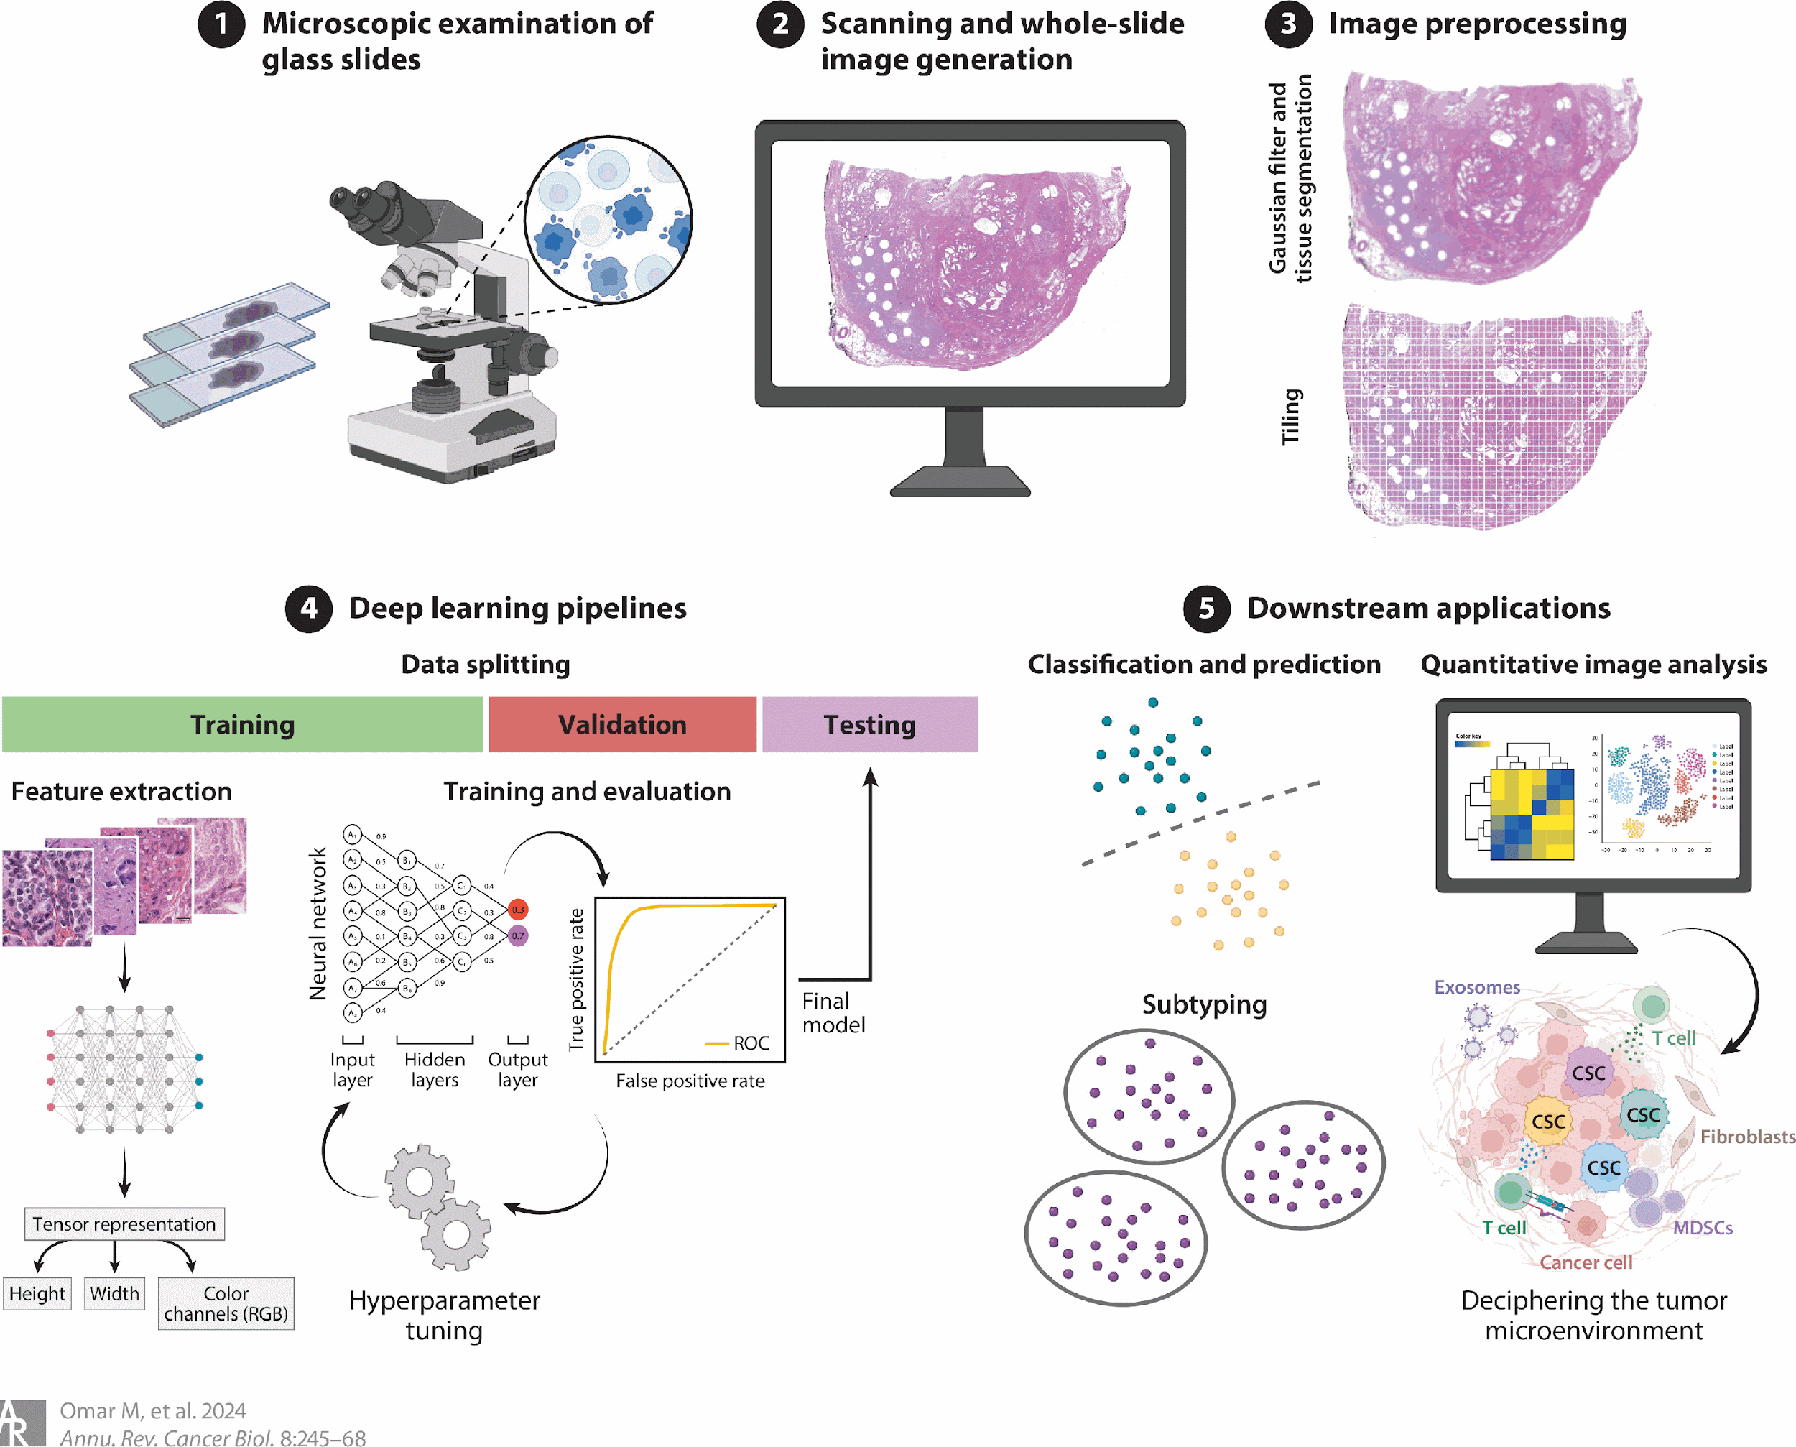

Figure 1. Workflow of whole-slide imaging in digital pathology, including tissue preparation, image acquisition, processing, and integration with artificial intelligence for diagnostic analysis(17)

2.2 Adoption of digital pathology in High-Income Countries

The adoption of digital pathology has progressed most rapidly in high-income countries, largely due to the presence of robust healthcare infrastructure, sustained funding, and well-defined regulatory frameworks(18). In these contexts, whole-slide imaging has been successfully incorporated into routine diagnostic workflows, supported by reliable high-speed connectivity, secure data storage systems, and access to advanced computational resources. However, this successful integration reflects not only technological readiness but also systemic capacity, suggesting that digital pathology functions optimally only when embedded within well-resourced healthcare ecosystems(19).

Within such settings, digital pathology has shown particular value in subspecialty practice, where diagnostic expertise is often concentrated in tertiary or reference centres. The ability to transmit whole-slide images enables remote consultation and multidisciplinary collaboration, which can improve diagnostic confidence and reduce turnaround time(20). At the same time, these advantages also highlight pre-existing inequalities in access to specialist expertise, which digital systems help mitigate rather than eliminate. Additional benefits, such as reduced risk of slide loss and improved case tracking, further enhance laboratory efficiency, although these gains are more pronounced in institutions already equipped with mature laboratory information systems(21).

The integration of artificial intelligence has further strengthened digital pathology workflows in high-income settings, with applications in tumour detection, grading, and biomarker quantification(22). These tools have demonstrated potential to improve reproducibility and reduce inter-observer variability, particularly in high-volume diagnostic environments. However, their performance is closely tied to the availability of large, well-annotated datasets and strong computational infrastructure, conditions that are not universally present(23). Consequently, while AI-enhanced digital pathology is advancing diagnostic precision in well-resourced systems, its broader applicability remains constrained by infrastructural and data-driven dependencies, reinforcing the uneven global translation of these technologies(24).
3. Artificial Intelligence in Pathology
Artificial intelligence is increasingly transforming the field of pathology by enabling automated, data-driven analysis of histopathological images. These technologies have the potential to improve diagnostic accuracy, enhance efficiency, and reduce variability in interpretation (25). Broadly, artificial intelligence approaches in pathology can be categorized into traditional machine learning and deep learning methods(26).
Machine learning methods rely on the extraction of predefined features from images, such as cell morphology, texture, and staining intensity. These features are then used to train algorithms, including support vector machines and decision trees, to perform classification or prediction tasks(27). While effective in certain applications, these approaches are limited by their dependence on manual feature engineering and their reduced ability to capture complex patterns in high-dimensional data(28).
In contrast, deep learning methods, particularly convolutional neural networks, learn features directly from raw image data without the need for manual feature selection. These models are capable of analyzing large and complex datasets, including whole-slide images, and can identify subtle morphological patterns associated with disease(29). As a result, deep learning has demonstrated superior performance in a wide range of pathology applications, including tumour detection, classification, and prognostic prediction(30).

3.1 Applications of Artificial Intelligence in Pathology
Artificial intelligence has demonstrated substantial potential across multiple domains in pathology, including tumour detection, grading, and biomarker prediction. These applications aim to improve diagnostic accuracy, reduce workload, and enhance reproducibility in clinical practice.

Tumour Detection
One of the most well-developed uses of artificial intelligence (AI) in pathology is the detection of tumours through the use of deep learning models to detect cancerous areas in pathology images(31). These models work by identifying visual features of malignant tissue and can quickly analyse whole-slide images to pinpoint regions of interest. This has potential to streamline the diagnostic process, assist triage in busy pathology departments, and help with the problem of a shortage of specialist pathologists, particularly in low-resource environments(32).
However, the performance of many tumour detection models needs to be interpreted with care. They are typically trained and evaluated on curated data sets that are well-controlled with consistent staining, scanning quality, and case selection(33). This can result in a performance drop when tested on clinical data, where inconsistencies in tissue fixation, staining protocols, scanning equipment and artefacts are frequent. These variations can lead to a decrease in sensitivity and specificity, which can impact on the effectiveness of AI-based tumour detection in routine practice(34). An example of an artificial intelligence workflow for tumour detection and tissue classification is shown in Figure 2.
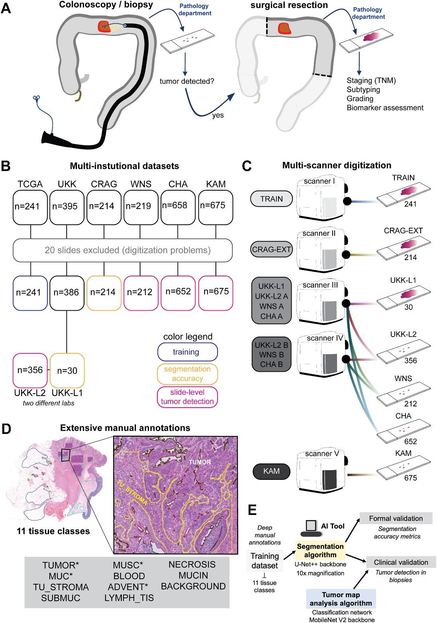
Figure 2. Workflow of an artificial intelligence model for tumour detection and tissue classification in histopathological images, including data acquisition, annotation, model training, and validation(35).
Tumour Grading and Proliferation Index Assessment
K-67 is a marker that measures the degree of cell division of cancer cells, and is important in grading tumours, such as neuroendocrine tumours. This marker is related to the presence of a protein known as Ki-67 in the nucleus of cells that are actively engaged in the cell cycle (i.e., proliferating). As such, Ki-67 is used as a surrogate for tumour growth and aggressiveness(36). It is measured using a technique called immunohistochemistry (IHC). A sample from a biopsy or surgical procedure is first subjected to routine histopathological preparation (fixation, embedding, sectioning and slide mounting)(37). The tissue is then stained with an antibody that recognises the Ki-67 protein. This antibody results in a stain (usually brown) in the nuclei of proliferating cells. This results in the staining of tumour cells undergoing proliferation, while those that are not proliferating are not stained(38).
The Ki-67 index is then calculated by counting the number of positively stained tumour cells as a percentage of the total number of tumour cells counted. If 30 of 100 tumour cells display nuclear staining, for instance, the Ki-67 index is 30%(39). This value is significant because it reflects tumour aggressiveness: low Ki-67 values usually correspond to slow-growing, low-grade tumours, whereas high values reflect rapid tumour growth and aggressiveness. For example, in neuroendocrine tumours, Ki-67 is used to grade tumours (G1, G2 and G3), which helps determine treatment options and outlook(40).Ki-67 is usually assessed manually by pathologists using a microscope. But this approach can be variable as different pathologists may choose different regions of the tumour to count or vary in their assessment of staining intensity. To address this, AI-based systems have emerged that automatically identify nuclei, separate stained and unstained cells, and accurately calculate the Ki-67 index(41). These approaches enhance consistency and minimise variability, particularly in large diagnostic workloads. The computational pipeline for automated Ki-67 assessment and spatial analysis is illustrated in Figure 3.
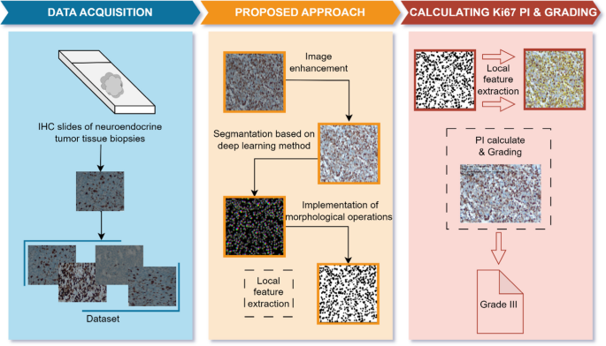
Figure 3. Computational pipeline for automated Ki-67 analysis, including nuclei detection, classification, heatmap generation, and spatial heterogeneity assessment(42)
Biomarker Prediction and Prognostic Modelling
Predicting biomarkers and outcomes in cancer with the help of artificial intelligence (AI) is the use of computational models to learn from tissue images, and associate these patterns with molecular features or patient outcomes(43). Rather than relying solely on the visual features that the eye can perceive, these tools quantify information in the tissue images that is invisible to the human eye and use it to predict disease behaviour(44). Typically, this involves digitized pathology slides from Whole-slide imaging, where images of tissue slices are captured. These images are then divided into smaller segments, in which AI systems particularly deep learning models - are used to evaluate the characteristics of the cells in the tissue, such as the shape of the nuclei, the arrangement of the tissue, the staining pattern and the relative positions of cells(45).
In biomarker prediction tasks, the AI is trained on a collection of samples where the true biomarker status is known (e.g., hormone receptor status, genetic mutations). It's trained to recognize subtle patterns in the tissue that correlate with these labels. It can then predict the biomarker status of new, unlabeled samples based on their image features alone(46). Also, in prognostic modelling, the AI extends this by associating image features with clinical outcomes like survival, recurrence or disease progression. It finds features associated with aggressive or benign disease behaviour and assigns a risk score to each patient. These predictions can help to determine the intensity of treatment or monitoring(47).
4. Limitations
Despite the significant promise of artificial intelligence in pathology, several critical limitations must be addressed before widespread clinical implementation can be achieved, particularly in resource-limited settings. One of the primary challenges is the scarcity of large, high-quality annotated datasets. Deep learning models require extensive, accurately labeled data to achieve reliable performance(48). However, in many healthcare systems, especially in low- and middle-income countries, digital pathology data are limited or unavailable. Even when datasets exist, annotation quality may vary due to inter-observer variability among pathologists. This inconsistency can negatively affect model training and reduce diagnostic accuracy. In addition, the process of generating detailed annotations is time-consuming and resource-intensive, further constraining dataset availability(49).
Algorithmic bias and limited generalizability represent another major concern. Many artificial intelligence models are developed using datasets derived from high-resource settings, which may not reflect the diversity of global patient populations or laboratory practices(50). Variations in tissue preparation, staining protocols, scanner types, and image resolution can lead to significant performance degradation when models are applied in different environments. This raises important concerns regarding equity, as biased models may produce less accurate results in underrepresented populations(51).
Regulatory and ethical challenges also complicate the integration of artificial intelligence into clinical workflows. The adaptive nature of many AI systems presents difficulties for regulatory approval, as models may evolve over time(52). In addition, questions regarding accountability in cases of diagnostic error remain unresolved. It is often unclear whether responsibility lies with developers, clinicians, or healthcare institutions. Data privacy is another critical issue, particularly when cloud-based systems are used for image storage and analysis, requiring strict compliance with data protection regulations(53)
Financial and infrastructural barriers further limit adoption. The implementation of digital pathology and artificial intelligence requires substantial investment in slide scanners, computing infrastructure, data storage systems, and software(54). Ongoing costs related to maintenance, system upgrades, and cybersecurity must also be considered. These financial requirements are often beyond the capacity of resource-limited healthcare systems(55).
Finally, unreliable power supply and limited digital infrastructure pose significant operational challenges in many settings. Frequent power outages can disrupt workflows, damage equipment, and result in data loss(56). In addition, limited internet connectivity can hinder the transfer of large image files and restrict access to cloud-based tools. These constraints must be addressed to enable the effective and sustainable deployment of artificial intelligence in pathology(57).

5. Discussion and Future Directions
The role of artificial intelligence (AI) in predicting cancer biomarkers and outcomes is the use of machine learning models to learn from tissue images, and link these patterns to molecular characteristics or clinical outcome(58). These tools do not only use the visual features that are visible to the human eye, but also quantify features in the tissue images that are not visible and use these to predict disease features(59). Usually this is done with digital pathology slides (Whole-slide imaging) that capture images of tissue sections. These images are then broken up into smaller pieces, in which AI systems (especially deep learning systems) are applied to assess the features of the cells in the tissue, including nuclear shape, tissue architecture, staining pattern and cell proximity(60). For tasks such as predicting biomarkers, AI systems are trained on a set of samples for which the biomarker status is known (e.g., hormone receptor status, genetic mutations). It's taught to identify tissue features that are associated with these labels. It can then classify unlabeled samples based on their image features(61). In the case of prognostic modelling, the AI takes this one step further, linking image features to patient outcomes, such as survival, recurrence or disease progression. It learns to identify features that are associated with high or low risk of disease and generates a risk score for the patient. It can be used to guide treatment or surveillance(62).
Future research should focus on the development of cost-effective and scalable artificial intelligence solutions tailored to resource-limited settings. Current digital pathology systems often require expensive hardware, high-performance computing, and proprietary software, which limit their accessibility(63). The development of lightweight algorithms capable of operating on lower-cost hardware or local servers may significantly reduce barriers to adoption and facilitate wider implementation. Emerging approaches such as federated learning offer promising solutions for collaborative model development while preserving data privacy(64). In this framework, models are trained across multiple institutions without the need to transfer raw patient data, thereby addressing regulatory and ethical concerns related to data sharing. This approach has the potential to improve model generalizability by incorporating diverse datasets from different geographic and clinical contexts(65). The integration of artificial intelligence with telepathology systems represents another important direction. In such models, digital slides can be transmitted to remote specialists, while artificial intelligence tools perform preliminary screening and highlight areas of concern. This combined approach may significantly improve access to diagnostic services in underserved regions where specialist expertise is limited(66).
Advances in real-time image analysis also present opportunities for improving clinical workflows. Future systems may provide rapid or near real-time diagnostic support during slide scanning, which could be particularly valuable in time-sensitive settings such as intraoperative consultations and cancer screening programs(67). Despite these advances, large-scale clinical validation remains essential and also, many artificial intelligence systems demonstrate strong performance in controlled research environments but require further evaluation in real-world clinical settings(68).
6. Conclusion
In conclusion, digital pathology and artificial intelligence (AI) are a significant step forward in the diagnosis of cancer, opening up potential to enhance diagnostic accuracy, efficiency, and access to expert opinion. Digital pathology, with technologies like Whole-slide imaging, can digitalize laboratory workflows, allowing for more efficient diagnosis and remote consultation. With the integration of artificial intelligence, these technologies can further support automatic tumour detection, grading, prediction of biomarkers and prognostication, which in turn supports more consistent and evidence-based diagnostic decision-making. Ultimately, the key to successful adoption of digital pathology and AI for cancer diagnosis will rest on careful validation and standardization of processes, infrastructure development and context-specific approaches. If these issues are overcome, such technologies can go a long way to bridging the gap in cancer diagnosis and care, and improve clinical outcomes, especially in the under-serviced world.

Disclaimer (Artificial intelligence)

Author(s) hereby declare that NO generative AI technologies such as Large Language Models (ChatGPT, COPILOT, etc.) and text-to-image generators have been used during the writing or editing of this manuscript.

Yes, NO generative AI technologies such as Large Language Models (ChatGPT, COPILOT, etc.) and text-to-image generators have been used during the writing or editing of this manuscript.
References
1. Elbarazi I, Ahmed LA. Alleviating the Global Burden of Cancer Through Prevention and Early Detection. Cancer Control J Moffitt Cancer Cent. 2025 Sep 12;32:10732748251378666. doi:10.1177/10732748251378666 PubMed PMID: 40939582; PubMed Central PMCID: PMC12432317.
2. Tseng LJ, Matsuyama A, MacDonald-Dickinson V. Histology: The gold standard for diagnosis? Can Vet J. 64(4):389–91. PubMed PMID: 37008634; PubMed Central PMCID: PMC10031787.
3. Zubair M, El Sharu H, Launico MV. Overview on Ordering and Evaluation of Laboratory Tests. In: StatPearls [Internet]. Treasure Island (FL): StatPearls Publishing; 2026 [cited 2026 Apr 27]. Available from: http://www.ncbi.nlm.nih.gov/books/NBK570615/ PubMed PMID: 34033377.
4. Fatima G, Alhmadi H, Ali Mahdi A, Hadi N, Fedacko J, Magomedova A, et al. Transforming Diagnostics: A Comprehensive Review of Advances in Digital Pathology. Cureus. 16(10):e71890. doi:10.7759/cureus.71890 PubMed PMID: 39564069; PubMed Central PMCID: PMC11573928.
5. Kiran N, Sapna F, Kiran F, Kumar D, Raja F, Shiwlani S, et al. Digital Pathology: Transforming Diagnosis in the Digital Age. Cureus. 15(9):e44620. doi:10.7759/cureus.44620 PubMed PMID: 37799211; PubMed Central PMCID: PMC10547926.
6. Anawade PA, Sharma D, Gahane S. A Comprehensive Review on Exploring the Impact of Telemedicine on Healthcare Accessibility. Cureus. 16(3):e55996. doi:10.7759/cureus.55996 PubMed PMID: 38618307; PubMed Central PMCID: PMC11009553.
7. Rizzo PC, Girolami I, Marletta S, Pantanowitz L, Antonini P, Brunelli M, et al. Technical and Diagnostic Issues in Whole Slide Imaging Published Validation Studies. Front Oncol. 2022 Jun 16;12:918580. doi:10.3389/fonc.2022.918580 PubMed PMID: 35785212; PubMed Central PMCID: PMC9246412.
8. Heidt B, Siqueira WF, Eersels K, Diliën H, van Grinsven B, Fujiwara RT, et al. Point of Care Diagnostics in Resource-Limited Settings: A Review of the Present and Future of PoC in Its Most Needed Environment. Biosensors. 2020 Sep 24;10(10):133. doi:10.3390/bios10100133 PubMed PMID: 32987809; PubMed Central PMCID: PMC7598644.
9. Antonini P, Santonicco N, Pantanowitz L, Girolami I, Rizzo PC, Brunelli M, et al. Relevance of the College of American Pathologists guideline for validating whole slide imaging for diagnostic purposes to cytopathology. Cytopathology. 2023 Jan;34(1):5–14. doi:10.1111/cyt.13178 PubMed PMID: 36082410; PubMed Central PMCID: PMC10087327.
10. Zhang XM, Gao TH, Cai QY, Xia JB, Sun YN, Yang J, et al. Artificial intelligence in digital pathology diagnosis and analysis: technologies, challenges, and future prospects. Mil Med Res. 2026 Jan 4;12(1):93. doi:10.1186/s40779-025-00680-6
11. Sebastian M, Batra H, Saini ML, Kearney S, Sherry L, Alexanian S, et al. Applications and challenges of utilizing digital pathology and AI-enabled workflows in clinical trials. J Pathol Inform. 2026 Jan 2;20:100542. doi:10.1016/j.jpi.2025.100542 PubMed PMID: 41631127; PubMed Central PMCID: PMC12861029.
12. Masjoodi S, Anbardar MH, Shokripour M, Omidifar N. Whole Slide Imaging (WSI) in Pathology: Emerging Trends and Future Applications in Clinical Diagnostics, Medical Education, and Pathology. Iran J Pathol. 2025;20(3):257–65. doi:10.30699/ijp.2025.2044210.3367 PubMed PMID: 40746923; PubMed Central PMCID: PMC12308189.
13. Chlipala EA, Butters M, Brous M, Fortin JS, Archuletta R, Copeland K, et al. Impact of Preanalytical Factors During Histology Processing on Section Suitability for Digital Image Analysis. Toxicol Pathol. 2021 Jun;49(4):755–72. doi:10.1177/0192623320970534 PubMed PMID: 33251977; PubMed Central PMCID: PMC8091422.
14. Omoush SA, Alzyoud JAM, El-Omari NKT, Alzyoud AJA. The Role of Whole Slide Imaging in AI-Based Digital Pathology: Current Challenges and Future Directions—An Updated Literature Review. J Mol Pathol. 2026 Mar;7(1):2. doi:10.3390/jmp7010002
15. Masjoodi S, Anbardar MH, Shokripour M, Omidifar N. Whole Slide Imaging (WSI) in Pathology: Emerging Trends and Future Applications in Clinical Diagnostics, Medical Education, and Pathology. Iran J Pathol. 2025;20(3):257–65. doi:10.30699/ijp.2025.2044210.3367 PubMed PMID: 40746923; PubMed Central PMCID: PMC12308189.
16. Kumar N, Gupta R, Gupta S. Whole Slide Imaging (WSI) in Pathology: Current Perspectives and Future Directions. J Digit Imaging. 2020 Aug;33(4):1034–40. doi:10.1007/s10278-020-00351-z PubMed PMID: 32468487; PubMed Central PMCID: PMC7522141.
17. Omar M, Alexanderani MK, Valencia I, Loda M, Marchionni L. Applications of Digital Pathology in Cancer: A Comprehensive Review. Annu Rev Cancer Biol. 2024 Jun 12;8(Volume 8, 2024):245–68. doi:10.1146/annurev-cancerbio-062822-010523
18. Valle AC del. Leveraging digital pathology and AI to transform clinical diagnosis in developing countries. Front Med. 2025 Sep 25;12:1657679. doi:10.3389/fmed.2025.1657679 PubMed PMID: 41080952.
19. Fatima G, Alhmadi H, Ali Mahdi A, Hadi N, Fedacko J, Magomedova A, et al. Transforming Diagnostics: A Comprehensive Review of Advances in Digital Pathology. Cureus. 16(10):e71890. doi:10.7759/cureus.71890 PubMed PMID: 39564069; PubMed Central PMCID: PMC11573928.
20. Kiran N, Sapna F, Kiran F, Kumar D, Raja F, Shiwlani S, et al. Digital Pathology: Transforming Diagnosis in the Digital Age. Cureus. 15(9):e44620. doi:10.7759/cureus.44620 PubMed PMID: 37799211; PubMed Central PMCID: PMC10547926.
21. Ahmed MM, Okesanya OJ, Olaleke NO, Adigun OA, Adebayo UO, Oso TA, et al. Integrating Digital Health Innovations to Achieve Universal Health Coverage: Promoting Health Outcomes and Quality Through Global Public Health Equity. Healthcare. 2025 May 5;13(9):1060. doi:10.3390/healthcare13091060 PubMed PMID: 40361838; PubMed Central PMCID: PMC12071628.
22. Zhang XM, Gao TH, Cai QY, Xia JB, Sun YN, Yang J, et al. Artificial intelligence in digital pathology diagnosis and analysis: technologies, challenges, and future prospects. Mil Med Res. 2026 Jan 4;12:93. doi:10.1186/s40779-025-00680-6 PubMed PMID: 41484927; PubMed Central PMCID: PMC12765299.
23. Quinn L, Tryposkiadis K, Deeks J, De Vet HCW, Mallett S, Mokkink LB, et al. Interobserver variability studies in diagnostic imaging: a methodological systematic review. Br J Radiol. 2023 Aug;96(1148):20220972. doi:10.1259/bjr.20220972 PubMed PMID: 37399082; PubMed Central PMCID: PMC10392644.
24. Ahuja S, Zaheer S. Advancements in pathology: Digital transformation, precision medicine, and beyond. J Pathol Inform. 2024 Nov 19;16:100408. doi:10.1016/j.jpi.2024.100408 PubMed PMID: 40094037; PubMed Central PMCID: PMC11910332.
25. Gaffney H, Mirza KM. Pathology in the artificial intelligence era: Guiding innovation and implementation to preserve human insight. Acad Pathol. 2025 Jan 1;12(1):100166. doi:10.1016/j.acpath.2025.100166
26. Försch S, Klauschen F, Hufnagl P, Roth W. Artificial Intelligence in Pathology. Dtsch Ärztebl Int. 2021 Mar;118(12):199–204. doi:10.3238/arztebl.m2021.0011 PubMed PMID: 34024323; PubMed Central PMCID: PMC8278129.
27. Ali M, Benfante V, Basirinia G, Alongi P, Sperandeo A, Quattrocchi A, et al. Applications of Artificial Intelligence, Deep Learning, and Machine Learning to Support the Analysis of Microscopic Images of Cells and Tissues. J Imaging. 2025 Feb 15;11(2):59. doi:10.3390/jimaging11020059 PubMed PMID: 39997561; PubMed Central PMCID: PMC11856378.
28. Li M, Jiang Y, Zhang Y, Zhu H. Medical image analysis using deep learning algorithms. Front Public Health. 2023 Nov 7;11:1273253. doi:10.3389/fpubh.2023.1273253 PubMed PMID: 38026291; PubMed Central PMCID: PMC10662291.
29. Wang X, Su C. Deep Learning for Cancer Detection Based on Genomic and Imaging Data: A Comprehensive Review. Cancer Manag Res. 2025 Sep 20;17:2089–125. doi:10.2147/CMAR.S533522 PubMed PMID: 41001156; PubMed Central PMCID: PMC12459622.
30. Ahmed AA, Abouzid M, Kaczmarek E. Deep Learning Approaches in Histopathology. Cancers. 2022 Oct 26;14(21):5264. doi:10.3390/cancers14215264 PubMed PMID: 36358683; PubMed Central PMCID: PMC9654172.
31. Wang J, Wang T, Han R, Shi D, Chen B. Artificial intelligence in cancer pathology: Applications, challenges, and future directions. CytoJournal. 2025 Apr 19;22:45. doi:10.25259/Cytojournal_272_2024 PubMed PMID: 40469709; PubMed Central PMCID: PMC12134795.
32. Bera K, Schalper KA, Rimm DL, Velcheti V, Madabhushi A. Artificial intelligence in digital pathology — new tools for diagnosis and precision oncology. Nat Rev Clin Oncol. 2019 Nov;16(11):703–15. doi:10.1038/s41571-019-0252-y PubMed PMID: 31399699; PubMed Central PMCID: PMC6880861.
33. Abdusalomov AB, Mukhiddinov M, Whangbo TK. Brain Tumor Detection Based on Deep Learning Approaches and Magnetic Resonance Imaging. Cancers. 2023 Aug 18;15(16):4172. doi:10.3390/cancers15164172 PubMed PMID: 37627200; PubMed Central PMCID: PMC10453020.
34. Chai B, Chen J, Cool P, Oumlil F, Tollitt A, Steiner DF, et al. Impact of tissue staining and scanner variation on the performance of pathology foundation models: a study of sarcomas and their mimics. J Pathol Clin Res. 2026 Feb 24;12(2):e70080. doi:10.1002/2056-4538.70080 PubMed PMID: 41735241; PubMed Central PMCID: PMC12932120.
35. Artificial Intelligence–Based Tool for Tumor Detection and Quantitative Tissue Analysis in Colorectal Specimens - Modern Pathology [Internet]. [cited 2026 Apr 27]. Available from: https://www.modernpathology.org/article/S0893-3952%2823%2900232-6/fulltext
36. La Rosa S. Diagnostic, Prognostic, and Predictive Role of Ki67 Proliferative Index in Neuroendocrine and Endocrine Neoplasms: Past, Present, and Future. Endocr Pathol. 2023;34(1):79–97. doi:10.1007/s12022-023-09755-3 PubMed PMID: 36797453; PubMed Central PMCID: PMC10011307.
37. Nielsen TO, Leung SCY, Rimm DL, Dodson A, Acs B, Badve S, et al. Assessment of Ki67 in Breast Cancer: Updated Recommendations From the International Ki67 in Breast Cancer Working Group. JNCI J Natl Cancer Inst. 2020 Dec 28;113(7):808–19. doi:10.1093/jnci/djaa201 PubMed PMID: 33369635; PubMed Central PMCID: PMC8487652.
38. Sun X, Kaufman PD. Ki-67: more than a proliferation marker. Chromosoma. 2018 Jun;127(2):175–86. doi:10.1007/s00412-018-0659-8 PubMed PMID: 29322240; PubMed Central PMCID: PMC5945335.
39. Nielsen TO, Leung SCY, Rimm DL, Dodson A, Acs B, Badve S, et al. Assessment of Ki67 in Breast Cancer: Updated Recommendations From the International Ki67 in Breast Cancer Working Group. JNCI J Natl Cancer Inst. 2020 Dec 28;113(7):808–19. doi:10.1093/jnci/djaa201 PubMed PMID: 33369635; PubMed Central PMCID: PMC8487652.
40. La Rosa S. Diagnostic, Prognostic, and Predictive Role of Ki67 Proliferative Index in Neuroendocrine and Endocrine Neoplasms: Past, Present, and Future. Endocr Pathol. 2023;34(1):79–97. doi:10.1007/s12022-023-09755-3 PubMed PMID: 36797453; PubMed Central PMCID: PMC10011307.
41. Narimani S, Pirenne S, Weynand B. Ki67 in cytological specimens of pancreatic neuroendocrine tumors: A literature review and validation of automated quantification. J Pathol Inform. 2025 Nov 7;19:100527. doi:10.1016/j.jpi.2025.100527 PubMed PMID: 41657846; PubMed Central PMCID: PMC12879570.
42. Thirunavu V, Drumm M, McCord M, Steffens A, Youngbloo MW, Nandoliya KR, et al. Optimizing the use of Ki-67 proliferative index as a prognostic biomarker in meningiomas using digital analysis. J Neurosurg. 2024 Dec 1;141(6):1644–54. doi:10.3171/2024.4.JNS232857 PubMed PMID: 38968615; PubMed Central PMCID: PMC12192485.
43. Bera K, Braman N, Gupta A, Velcheti V, Madabhushi A. Predicting cancer outcomes with radiomics and artificial intelligence in radiology. Nat Rev Clin Oncol. 2022 Feb;19(2):132–46. doi:10.1038/s41571-021-00560-7 PubMed PMID: 34663898; PubMed Central PMCID: PMC9034765.
44. Cheng CH, Shi S sheng. Artificial intelligence in cancer: applications, challenges, and future perspectives. Mol Cancer. 2025 Oct 30;24:274. doi:10.1186/s12943-025-02450-3 PubMed PMID: 41168799; PubMed Central PMCID: PMC12574039.
45. Elhaminia B, Alsalemi A, Nasir E, Jahanifar M, Awan R, Young LS, et al. From traditional to deep learning approaches in whole slide image registration: A methodological review. J Pathol Inform. 2025 Sep 16;19:100512. doi:10.1016/j.jpi.2025.100512 PubMed PMID: 41126805; PubMed Central PMCID: PMC12539322.
46. Ahn JS, Shin S, Yang SA, Park EK, Kim KH, Cho SI, et al. Artificial Intelligence in Breast Cancer Diagnosis and Personalized Medicine. J Breast Cancer. 2023 Oct 17;26(5):405–35. doi:10.4048/jbc.2023.26.e45 PubMed PMID: 37926067; PubMed Central PMCID: PMC10625863.
47. Tripathi S, Tabari A, Mansur A, Dabbara H, Bridge CP, Daye D. From Machine Learning to Patient Outcomes: A Comprehensive Review of AI in Pancreatic Cancer. Diagnostics. 2024 Jan;14(2):174. doi:10.3390/diagnostics14020174
48. Pallikkavaliyaveetil N, Chandrasekaran S. Small Data, Big Challenges: Machine- and Deep-Learning Strategies for Data-limited Drug Discovery. Adv Drug Deliv Rev. 2026 Feb;229:115762. doi:10.1016/j.addr.2025.115762 PubMed PMID: 41421504; PubMed Central PMCID: PMC13094559.
49. Wu B, Moeckel G. Application of digital pathology and machine learning in the liver, kidney and lung diseases. J Pathol Inform. 2023 Jan 3;14:100184. doi:10.1016/j.jpi.2022.100184 PubMed PMID: 36714454; PubMed Central PMCID: PMC9874068.
50. Cross JL, Choma MA, Onofrey JA. Bias in medical AI: Implications for clinical decision-making. PLOS Digit Health. 2024 Nov 7;3(11):e0000651. doi:10.1371/journal.pdig.0000651 PubMed PMID: 39509461; PubMed Central PMCID: PMC11542778.
51. Chai B, Chen J, Cool P, Oumlil F, Tollitt A, Steiner DF, et al. Impact of tissue staining and scanner variation on the performance of pathology foundation models: a study of sarcomas and their mimics. J Pathol Clin Res. 2026 Feb 24;12(2):e70080. doi:10.1002/2056-4538.70080 PubMed PMID: 41735241; PubMed Central PMCID: PMC12932120.
52. Mennella C, Maniscalco U, De Pietro G, Esposito M. Ethical and regulatory challenges of AI technologies in healthcare: A narrative review. Heliyon. 2024 Feb 15;10(4):e26297. doi:10.1016/j.heliyon.2024.e26297 PubMed PMID: 38384518; PubMed Central PMCID: PMC10879008.
53. Nouis SC, Uren V, Jariwala S. Evaluating accountability, transparency, and bias in AI-assisted healthcare decision- making: a qualitative study of healthcare professionals’ perspectives in the UK. BMC Med Ethics. 2025 Jul 8;26:89. doi:10.1186/s12910-025-01243-z PubMed PMID: 40629303; PubMed Central PMCID: PMC12235780.
54. Biswas N, Berg H, Shukla SK. Digital pathology: Barriers to transitioning to the digital age. Digit Health. 2026 Feb 12;12:20552076261418364. doi:10.1177/20552076261418364 PubMed PMID: 41696075; PubMed Central PMCID: PMC12901937.
55. Burke W, Stranieri A, Oseni T, Gondal I. The need for cybersecurity self-evaluation in healthcare. BMC Med Inform Decis Mak. 2024 May 23;24:133. doi:10.1186/s12911-024-02551-x PubMed PMID: 38783250; PubMed Central PMCID: PMC11118990.
56. Avordeh TK, Salifu A, Quaidoo C, Opare-Boateng R. Impact of power outages: Unveiling their influence on micro, small, and medium-sized enterprises and poverty in Sub-Saharan Africa - An in-depth literature review. Heliyon. 2024 Jun 27;10(13):e33782. doi:10.1016/j.heliyon.2024.e33782 PubMed PMID: 39040250; PubMed Central PMCID: PMC11261079.
57. Cheng CH, Wong CC. The role of artificial intelligence-based foundation models and “copilots” in cancer pathology: potential and challenges. J Exp Clin Cancer Res CR. 2025 Nov 28;45:2. doi:10.1186/s13046-025-03592-4 PubMed PMID: 41316486; PubMed Central PMCID: PMC12763834.
58. Cheng CH, Wong CC. The role of artificial intelligence-based foundation models and “copilots” in cancer pathology: potential and challenges. J Exp Clin Cancer Res CR. 2025 Nov 28;45:2. doi:10.1186/s13046-025-03592-4 PubMed PMID: 41316486; PubMed Central PMCID: PMC12763834.
59. Mezei T, Kolcsár M, Joó A, Gurzu S. Image Analysis in Histopathology and Cytopathology: From Early Days to Current Perspectives. J Imaging. 2024 Oct 14;10(10):252. doi:10.3390/jimaging10100252 PubMed PMID: 39452415; PubMed Central PMCID: PMC11508754.
60. Aeffner F, Zarella MD, Buchbinder N, Bui MM, Goodman MR, Hartman DJ, et al. Introduction to Digital Image Analysis in Whole-slide Imaging: A White Paper from the Digital Pathology Association. J Pathol Inform. 2019 Mar 8;10:9. doi:10.4103/jpi.jpi_82_18 PubMed PMID: 30984469; PubMed Central PMCID: PMC6437786.
61. Javaid H, Petrescu CC, Schmunk LJ, Monahan JM, O’Reilly P, Garg M, et al. The impact of artificial intelligence on biomarker discovery. Emerg Top Life Sci. 2025 Sep 9;8(2):89–105. doi:10.1042/ETLS20243003 PubMed PMID: 40924944; PubMed Central PMCID: PMC12802349.
62. Parvaiz A, Nasir ES, Fraz MM. From Pixels to Prognosis: A Survey on AI-Driven Cancer Patient Survival Prediction Using Digital Histology Images. J Imaging Inform Med. 2024 Mar 1;37(4):1728–51. doi:10.1007/s10278-024-01049-2 PubMed PMID: 38429563; PubMed Central PMCID: PMC11300721.
63. Makhlouf HR, Ossandon MR, Farahani K, Lubensky I, Harris LN. Digital pathology imaging artificial intelligence in cancer research and clinical trials: An NCI workshop report. J Pathol Inform. 2025 Nov 14;20:100531. doi:10.1016/j.jpi.2025.100531 PubMed PMID: 41476571; PubMed Central PMCID: PMC12753273.
64. Shah ST, Ali Z, Waqar M, Kim A. Federated Learning in Public Health: A Systematic Review of Decentralized, Equitable, and Secure Disease Prevention Approaches. Healthcare. 2025 Oct 30;13(21):2760. doi:10.3390/healthcare13212760 PubMed PMID: 41228128.
65. Shah ST, Ali Z, Waqar M, Kim A. Federated Learning in Public Health: A Systematic Review of Decentralized, Equitable, and Secure Disease Prevention Approaches. Healthcare. 2025 Oct 30;13(21):2760. doi:10.3390/healthcare13212760 PubMed PMID: 41228128; PubMed Central PMCID: PMC12607528.
66. Giansanti D. Advancements in Digital Cytopathology Since COVID-19: Insights from a Narrative Review of Review Articles. Healthcare. 2025 Mar 17;13(6):657. doi:10.3390/healthcare13060657 PubMed PMID: 40150507; PubMed Central PMCID: PMC11942033.
67. Masjoodi S, Anbardar MH, Shokripour M, Omidifar N. Whole Slide Imaging (WSI) in Pathology: Emerging Trends and Future Applications in Clinical Diagnostics, Medical Education, and Pathology. Iran J Pathol. 2025;20(3):257–65. doi:10.30699/ijp.2025.2044210.3367 PubMed PMID: 40746923; PubMed Central PMCID: PMC12308189.
68. Ogut E. Artificial Intelligence in Clinical Medicine: Challenges Across Diagnostic Imaging, Clinical Decision Support, Surgery, Pathology, and Drug Discovery. Clin Pract. 2025 Sep 16;15(9):169. doi:10.3390/clinpract15090169 PubMed PMID: 41002784; PubMed Central PMCID: PMC12468291.

