Prevalence of Cervical Cancer Among Women Aged 20–60 Years in Assam Using Liquid-Based Cytology

ABSTRACT
Cervical cancer is the leading cause of cancer death and the third most common cancer in women worldwide, the second most common cancer in India. Around 90% of cases of cervical cancer are found in low- and middle-income nations, and deaths from cervical cancer in high-income nations have more than halved. Objective: Prevalence of cervical cancer in women aged 20-60 years in Assam using Liquid Based Cytology (LBC) as a diagnostic tool. Methodology: This study was carried out in the Department of Pathology, Pratiksha Hospital, Guwahati,Assam, India, from 01.04.2023 to 15.09.2023. Around 150 pap smears were taken from women between the ages of 20 and 60 years using the Liquid Based Method (LBC). Results: All samples (n=150) received in the pathology department were processed for cytological investigation through LBC. It was observed that 62 patients had normal smear or NILM. 66 had inflammatory smears. 11 had ASCUS. 6 had LSIL. 4 had HSIL. 1 SCC was diagnosed. Conclusion: Pap smear testing is a very useful, simple, and safe tool for detecting precancerous cervical epithelial lesions. LBC can be a better alternative to conventional smear because of a lower rate of unsatisfactory smears. Every woman above the age of 30 years should undergo routine cervical cancer screening.
Keywords: Cervical Cancer, LBC, ASCUS, HSIL, LSIL, SCC

INTRODUCTION

Cervical cancer is the leading cause of cancer death in women worldwide(Liu et al 2019) and the third most common cancer in women worldwide. The second most common cancer in India (Saranath et al 2014). The gap in incidence between developing and developed countries has dramatically narrowed in recent years. On the other hand, due to inadequate or nonexistent screening programs, cervical cancer is still mostly uncontrolled in high-risk developing nations. Cervical cancer is still a major problem in underdeveloped nations like INDIA (Ullah et al.2021, Pankaj et al 2018 ). Around 90% of cases of cervical cancer are found in low- and middle-income nations where there are no organised screening or HPV immunization programmes. Since the implementation of formal screening programmes 30 years ago, the incidence and death of cervical cancer in high-income nations have more than halved (Cohen et al 2019). The death rate from cervical cancer is 18 times higher in low and middle-income countries than it is in wealthy nations, and over 85% of cervical cancer deaths globally take place in underdeveloped or developing nations (Small Jr et al 2017).Human papillomavirus (HPV) infection is believed to be an important cause of cervical cancer, Cervical cancer is caused by sexually transmitted human papillomaviruses (HPV), according to various studies, having several sexual partners, having poor personal and sexual hygiene, smoking, low socioeconomic position, and early sexual engagement are some of the risk factors for cervical cancer The primary aetiological factor in the development of cancer is human papilloma. Cervical cancer does not always result from HPV infections in women. High-Risk HPV genotypes cause a normal cell to progress into a pre-cancerous lesion and, later, into an invasive lesion (Jain et al (Jain et al 2022; Balasubramaniam et al 2019) these changes, especially in young women, usually revert to normal cells due to an intact immune response and rapid cell turnover in the cervix (Mello et al 2021). Cervical intraepithelial neoplasia (CIN) is widely recognised as a precursor lesion to invasive cervical cancer, representing a key stage in the continuum of cervical carcinogenesis. If these lesions indeed form part of a progressive biological spectrum, it is reasonable to expect that they share common epidemiological and aetiological characteristics. Factors implicated in the early phases of this process are likely to be consistent across different stages, whereas those influencing progression to invasive disease may diverge. Sexual and infectious determinants, particularly those related to human papillomavirus (HPV) transmission, have been strongly implicated as risk factors for both intraepithelial lesions and invasive cervical cancer. In contrast, certain reproductive and hormonal factors, such as high parity and prolonged oral contraceptive use, appear to be more closely associated with an increased risk of invasive neoplasia rather than with the initial development of CIN. Furthermore, the relationship between reproductive factors, behavioural exposures (including smoking), and other established or potential risk determinants may vary according to the severity of CIN. In particular, differential associations have been observed across grades of dysplasia, especially in mild to moderate lesions, suggesting that the contribution of these factors may change during disease progression (Parazzini et al., 1992). The Food and Drug Administration has approved two first-generation LBC technologies: SurePath and ThinPrep (Patel et al 2023). LBC is a type of cervical cancer screening test that uses a liquid medium to preserve and removes most of the debris, blood, and secretions either by filtration and a random sample is applied in a thin layer to a glass slide, avoiding overlapping cells density gradient centrifugation. It examine cervical cells for signs of precancerous and cancerous conditions greatly improve the diagnostic rate of related diseases, the sensitivity and specificity of cervical lesion screening, and overcome the high false negative rate of traditional diagnosis. It frequently serves as a cervical cancer screening tool. This is the first technical advance in cervical cytology in over 50 years (Banerjee et al 2022, Fahdi kanavati et al 2022, Li Ma et al 2019). LBC has the advantage of faster reporting, sofewer cases are missed (Shreya Raj et al 2022). It has also been shown to be more sensitive than conventional cytology in detecting atypical cells of undetermined significance (ASC-US) and squamous cells injury (SIL) Joseph Monsonege et al 2011).

REVIEW OF LITERATURES
In a study conducted by Sania S. Ullah et al. (2021) at Silchar Medical College and Hospital, a total of 1,714 cervical Pap smear tests were performed on women aged 18–80 years presenting with various gynaecological complaints between May 2018 and April 2020. Among these, 808 cases were reported as normal smears, while 636 cases showed inflammatory changes. Epithelial abnormalities included 22 cases of atypical squamous cells of undetermined significance (ASCUS), 80 cases of low-grade squamous intraepithelial lesions (LSIL), and 12 cases of high-grade squamous intraepithelial lesions (HSIL). Additionally, three cases of bacterial vaginosis and three cases of squamous cell carcinoma (SCC) were identified. The authors emphasised that the Papanicolaou (Pap) smear remains a widely accepted and effective screening tool for the early detection of cervical abnormalities. However, in countries such as India, where a substantial proportion of the population resides in rural areas with low socio-economic status, early age at marriage, and limited access to healthcare facilities, the implementation of large-scale screening programmes poses considerable challenges. The study highlighted the need for cost-effective and accessible screening strategies, including the training of medical and paramedical personnel at the primary healthcare level, and recommended the initiation of Pap smear screening from the age of 30 years.

Similarly, a study by Getnet Tesfaw et al. (2020) evaluated cervical cancer screening among women aged 21–65 years using liquid-based cytology (LBC) and visual inspection with acetic acid (VIA). A total of 448 participants were included, with 42% (n = 188) aged between 31 and 40 years, and only two participants aged above 60 years. Of the total cohort, 419 (93.5%) underwent LBC, 294 (65.6%) underwent VIA, and 272 (60.7%) were screened using both methods. Among women screened by LBC, 305 (72.8%) were negative for intraepithelial lesion or malignancy (NILM), 97 (23.2%) had LSIL, and 17 (4.1%) had HSIL. The prevalence of cervical lesions was generally lower in both younger and older age groups, with the highest burden observed among women aged 41–50 years, accounting for 40% of LSIL and 59% of HSIL cases. Furthermore, women aged 51–60 years exhibited a significantly higher likelihood of developing abnormal epithelial lesions compared to those aged 21–30 years (adjusted odds ratio = 20.9; 95% confidence interval: 7.2–60.9; p = 0.00). Among 47 (10.8%) HIV-positive participants, 14 (32.56%) had epithelial abnormalities, including 10 cases (23.3%) of LSIL and 4 cases (9.3%) of HSIL. In VIA screening, 18 (6.1%) women tested positive, while among those screened by both LBC and VIA, only 6 (2.2%) were positive on both tests. The agreement between LBC and VIA was found to be weak but statistically significant (kappa value = 0.155; p = 0.006). These findings underscore the variability in screening outcomes across different modalities and highlight the importance of optimising screening strategies for effective cervical cancer prevention.
A retrospective record-based study conducted by Nito Yepthomi et al. (2022) at the Christian Institute of Health Sciences and Research, India, evaluated cervical cytology findings over a two-year period from May 2019 to May 2021. The study included a total of 711 women whose specimens were processed using liquid-based cytology (LBC). Of these, 20 samples (2.81%) were deemed unsatisfactory and subsequently excluded from analysis. Among the remaining 691 evaluable samples, 16.35% (113/691) exhibited abnormal cytological findings. Within this subset, the most frequently observed abnormality was atypical squamous cells of undetermined significance (ASC-US), accounting for 48.67% (55/113) of cases. This was followed by atypical squamous cells—cannot exclude high-grade lesion (ASC-H) in 22.12% (25/113) of cases. High-grade squamous intraepithelial lesions (HSIL) comprised 17.69% (20/113), while low-grade squamous intraepithelial lesions (LSIL) accounted for 7.96% (9/113). In addition, a small proportion of cases included malignant lesions, with 2.65% (3/113) identified as spindle cell carcinoma and 0.88% (1/113) as adenocarcinoma. These findings highlight the spectrum of cytological abnormalities detected through LBC and underscore its utility as a reliable screening modality for the early detection of precancerous and malignant cervical lesions.
A retrospective record-based study conducted by Raushan Chaudhary et al. (2022) at Darbhanga Medical College and Hospital evaluated cervical cytological findings over a nine-month period. The study included 100 women who were referred from the Department of Obstetrics and Gynaecology for Pap smear examination in the pathology department. Among the study population, abnormal cytological findings were predominantly represented by atypical squamous cells of undetermined significance (ASC-US), accounting for 50% of cases. This was followed by atypical squamous cells—cannot exclude high-grade lesions (ASC-H) in 25% of cases, high-grade squamous intraepithelial lesions (HSIL) in 15%, and low-grade squamous intraepithelial lesions (LSIL) in 5%. Malignant lesions were relatively infrequent, with squamous cell carcinoma (SCC) reported in approximately 3% of cases and adenocarcinoma in 1%. Clinically, the most common presenting complaints among women with abnormal cytology were lower abdominal pain (25%) and vaginal discharge (20%). The mean age of women exhibiting abnormal cytological findings was 40 years, indicating a higher burden of disease in the middle-aged population. Notably, the study also highlighted that 20% of women with abnormal cytology had presented for routine cervical cancer screening rather than symptom-driven consultation. These findings underscore the importance of routine screening programmes in the early detection of cervical epithelial abnormalities, particularly in resource-limited settings, where opportunistic screening may play a crucial role in reducing the burden of cervical cancer.
A study conducted by Neha Bagga et al. (2019) at All India Institute of Medical Sciences Jodhpur evaluated cervical cytology using liquid-based cytology (LBC) over a period of one year. A total of 1,087 cervical smears were analysed, of which 999 (91.9%) were deemed satisfactory, while 88 (8.0%) were categorised as unsatisfactory. The predominant cause of unsatisfactory smears was inadequate squamous cellularity, observed in 70 cases (79.5%). Other contributing factors included dense inflammation obscuring the squamous epithelium in 8 cases (9.1%) and a combination of inflammation with reduced epithelial cellularity in 10 cases (11.4%). Among the 999 satisfactory smears, the majority, 959 cases (96%), were reported as negative for intraepithelial lesion or malignancy (NILM), whereas 40 cases (4%) demonstrated epithelial abnormalities. These abnormal cases constituted 3.6% (40/1,087) of the total smears examined. In addition to epithelial abnormalities, a range of infectious and reactive conditions was identified, including bacterial vaginosis in 209 cases (21.8%), Candida infection in 77 cases (8.0%), co-infection with bacterial vaginosis and Candida in 12 cases (1.2%), and Trichomonas vaginalis in one case. Reactive cellular changes were observed in 193 cases (20.1%), while altered or mixed microbial flora was reported in 112 cases (11.7%). Within the 40 cases exhibiting epithelial abnormalities, atypical squamous cells of undetermined significance (ASCUS) were the most common finding, accounting for 40% (16/40) of cases. This was followed by atypical squamous cells—cannot exclude high-grade lesion (ASC-H) in 20% (8/40), high-grade squamous intraepithelial lesions (HSIL) in 17% (7/40), low-grade squamous intraepithelial lesions (LSIL) in 10% (4/40), atypical glandular cells favouring neoplasia (AGC-FN) in 3% (1/40), and squamous cell carcinoma (SCC) in 10% (4/40). No cases of LSIL-ASCH overlap or secondary malignancy were identified. The authors concluded that liquid-based cytology is an effective method for both screening and diagnosing cervical abnormalities. Furthermore, they observed that the degree of concordance between cytological findings and histopathological diagnosis improved with increasing severity of lesions. Notably, this study represents one of the largest evaluations of LBC-based cervical screening conducted in Western Rajasthan.

MATERIAL AND METHOD
From the period of six months, an observational research study was conducted for a total number of 150 pap smears taken from women between the ages of 20 and 60 years using the Liquid Based Method (LBC) from Dept of Pathology, Pratiksha Hospital, Guwahati, ASSAM, INDIA, from 01.04.2023 to 15.09.2023
Trained staff collected Pap cervical smear samples in accordance with the manufacturer's instructions for using the Liquid Based Cytology (LBC) direct to slide method. The LBC approach improves visibility, evaluation, and cellular preservation by successfully capturing entire cellular samples within a consistent, limited area. Within 24 hours of receipt, the samples were processed and stained, and the pathologist reported the slides using the most recent Bethesda methodology. The pre-filled pro form was used to obtain information on the patient's age, marital status, religion, transitional area, reproductive history, present gynecological symptoms (if any), date of Pap smear, and results. All screened women received their results after the screening process, and those with abnormal cytology were sent to the Department of Obstetrics and Gynecology for further necessary examinations and treatment.

RESULTS

The results have been tabulated under the respective objectives.

Distribution of patients according to the PAP Smear
All samples (n=150) received in the pathology department were processed for cytological investigation through Liquid Based Cytology (LBC). Out of 150 cervical PAP smears that were received from 1April 2023 to 15 September 2023. It was observed that 62 patients had NILM. 66 had inflammatory smears.11 had ASCUS. 6 had LSIL. 4 had HSIL. 1 SCC was diagnosed. Show in (table no 1). The overall percentage of normal smear is 41.3%, Inflammatory smear is 44%, ASCUS 7.3%, LSIL 4%, HSIL 2.7%, and SCC 0.7%.
Table 1: Distribution of patient according to PAP smear finding.

Results | No. of Patients | Percentage
Normal smear | 62 | 41.3%
Inflammatory smears | 66 | 44%
ASCUS | 11 | 7.3%
LSIL | 6 | 4%
HSIL | 4 | 2.7%
SCC | 1 | 0.7%
Total | 150 | 100%

Distribution of patients according to age group and PAP smear finding, the

In a study, a total of 150 patients were examined across various age groups. Among the patients aged 20- 29, 6 patients had negative results, and 5 patients had an inflammatory smear. In the 30-39 age group, 3 patients tested LSIL, 25 patients had negative, and 21 tested inflammatory smear, while 2,1,2 patients tested ASCUS, LSIL, HSIL in the 40-49 age groups 21 and 29 patients tested negative and inflammatory smear, in 50-60 age groups, the patient had tested 9 ASCUS, 2 LSIL, 2 HSIL, 1 SCC, 10 negative, and 11inflammatory smear. A p-value of 0.005 < 0.05, corresponding to a chi-square test, indicates that there is a significant association between the age of patients and the result of the diagnosis.

Table2: Distribution of patients according to age group and PAP smear findings.

Age | NILM | Inflammatory smear | ASCUS | LSIL | HSIL | SCC | Percentage (%) | p value
20-29 | 6 | 5 | 0 | 0 | 0 | 0 | 7.33%
30-39 | 25 | 21 | 0 | 3 | 0 | 0 | 32.66% | 18.534
40-49 | 21 | 29 | 2 | 1 | 2 | 0 | 36.66% | (0.005)
50-60 | 10 | 11 | 9 | 2 | 2 | 1 | 23.33
Total | 62 | 66 | 11 | 6 | 4 | 1 | 100%

Distribution of patients by their religion.
In the study of the total number of positive cases, among Christian patients, 7 tested positive (4.66%), while 15 Hindu patients tested positive (10%). Among the total number of negative, in the Christian group, 15 patients tested negative (10%). Among Hindus, 44 patients tested negative (29.33%), and there were 3 negative cases among Islamic patients2%). Total number of Inflammatory Smears, Christian patients had 8 cases of inflammatory smears (5.33%), while Hindu patients had the highest number of such cases at 51 (34%). In the Islamic group, there were 7 cases of inflammatory smears(4.66%). There were a total of 22 positive cases, 62 negative cases, and 66 cases with inflammatory smears among all the patients, accounting for100% of the study population. A P-value of 0.103> 0.05, corresponding to a chi-square test, indicates that there is no significant association between the religion of patients and the result of the diagnosis.

Table3: Distribution of patients by religion.

Religion | Total. No of positive | Total. No of negative | Total. No of  Inflammatory smear | Percentage of attending different religions | P Value
Christian | 7 | 15 | 08 | 20%
Hindu | 15 | 44 | 51 | 73.33% | 7.710
Islam | 00 | 03 | 07 | 6.66% | (0.103)
Total | 22 | 62 | 66 | 100%

.

Distribution of patients by their marital status and their corresponding test results.
In the study, Patients are classified into two main groups: "Married" and "Unmarried."In total, No. of Positive Cases, Among married patients, 22 tested positive for a particular condition, while there were no positive cases among unmarried patients. In total, No. of Negative Cases, in the married group, 51patients tested negative (34%), while 11 unmarried patients tested negative (7.33%). Total No. of Inflammatory Smears, Among married patients, 53 cases (35.33%) of inflammatory smears were observed, while among unmarried patients, there were 13 such cases (8.66%). The overall percentage of married patients is 84%, and unmarried patients is 16%, accounting for 100% of the study population. A p-value of 0.041<0.05, corresponding to chi-square test, indicates that there is a significant association between the marital status of patients and the result of the diagnosis.

Table 4: Distribution of patients by material status.

Marital status | Total. no of  positive | Total. no of  negative | Total. no of  Inflammatory smear | Percentage (%) p value
Married | 22 | 51 | 53 | 84% 5.62
Un-married | 0 | 11 | 13 | 16% (0.041)
Total | 22 | 62 | 66 | 100%

Distribution of patients based on their transitional area (either rural or urban) and their corresponding test results.
In the study, Patients are divided into two categories: "Rural Area" and "Urban Area," representing their place of residence. total No. of Positive Cases, among patients living in rural areas, 9 tested positive(40.90%) for a particular condition, while 13 urban residents tested positive (59.09%). The overall percentage of positive cases is 14.66%. The total row at the bottom summarizes the combined figures for each transitional area category. There were a total of 22 positive cases among all the patients, accounting for 100% of the study population.

Table5: Distribution of patients by transitional area.

Transitional area | Total. no of positive | Percentage (%)
Rural area | 9 | 40.90 %
Urban area | 13 | 59..09%
Total | 22 | 14.66%

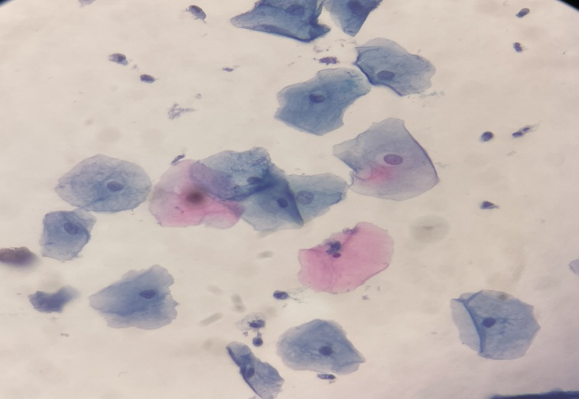

Fig 1: Negative For Intraepithelial lesion & Malignancy (NILM)

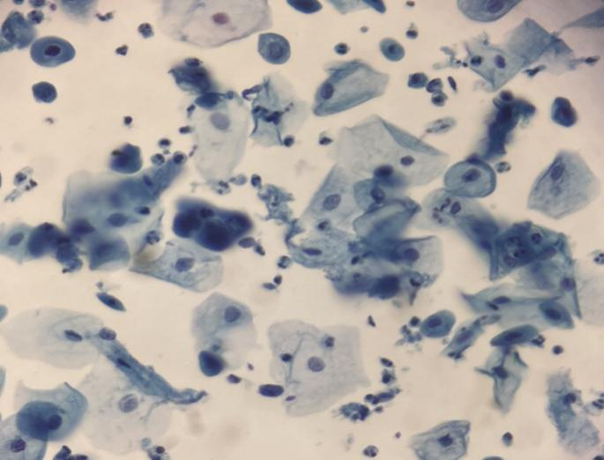

Fig 2: Atypical Squamous Cells of Undetermind Significance (ASCUS)

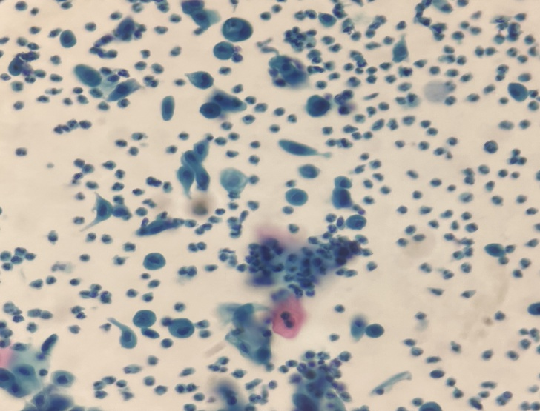
Fig 3: Low-Grade Squamous Intraepithelial Lesion (LSIL)

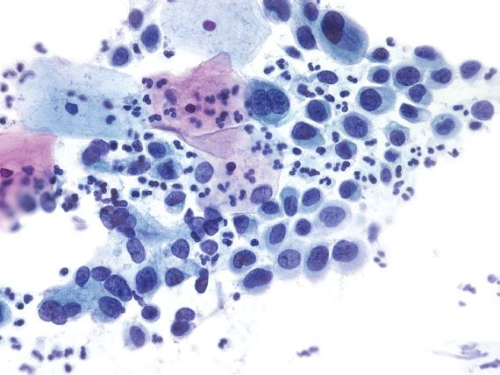

Fig 4: High-Grade Squamous Intaepithelial Lesion (HSIL)

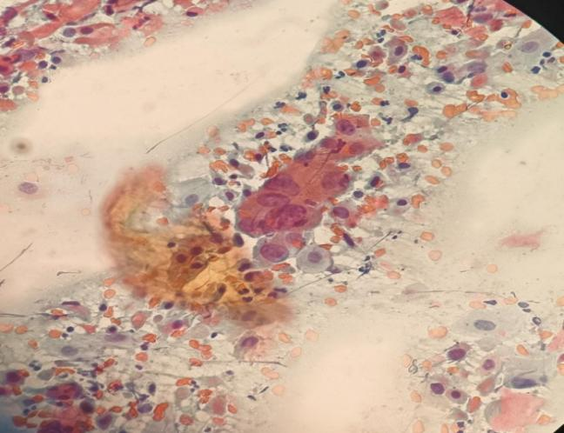

Fig 5: Squamous Cell Carcinoma (SCC)

DISCUSSION
Cervical cancer is a major public health problem worldwide, and Assam, India, is no exception to its impact on women's health. With changing lifestyles and population profiles in developing countries, non-communicable diseases are emerging as a major health problem that requires a proper control program before they become epidemics. Cancer was a major cause of morbidity and mortality. According to the National Cancer Registry program of India, cervical and breast cancer are the most common malignancies among women in India. For a certain age group, there should be an effective mass screening program to detect precancerous lesions before they develop into invasive cancer. This study aimed to investigate the prevalence of cervical cancer in women aged 20-60 years in Assam using liquid-based cytology (LBC) as a screening tool. Our results provide valuable information about the burden of cervical cancer in this region and the effectiveness of LBC as a diagnostic method. In our study, we collected 150 cervical screening samples, of which we have 11 patients aged 20-29,49 patients aged 30-39, 55 patients aged 40-49, and 35 patients aged 50-60, which revealed an alarming prevalence of cervical cancer among women aged 20 to 60 in Assam. The high incidence of cervical cancer in this region is consistent with global trends, where cervical cancer remains the leading cause of cancer mortality in women.
Our study showed that there were 41% patients were negative for intraepithelial lesion or malignancy (normal smear). 44% had an inflammatory smear. 14.66% had positive while 7.33% had atypical squamous cells of undetermined origin (ASCUS). 2.66% had low-grade squamous intraepithelial lesions (LSIL). 4% had high-grade squamous cell injury (HSIL). 0.66% are Squamous cell carcinoma (SCC ASCUS progresses to LSIL, HSIL & SCC. ASCUS was highest in the age group of 50- 60 years. LSIL and HSIL were scatteredly distributed amongst 40-60 years. Ullah et al. did a similar study in the Pathology Department of Silchar Medical College and Hospital, Assam, India, and had the followingfindings. They reported that 808 patients had an abnormal smear. 636had Inflammatorysmears.22 had Atypical Squamous Cell of Undetermined Significance(ASCUS). 80 had LSIL. 12 had HSIL. 3 had bacterial vaginosis .3 SCC were.^{[3]} . Nito Yepthomi, et al, 2022, they also did similar studied at the Christian Institute of Health Sciences and Research in Nagaland, India from May 2019 to May 2021, a retrospective record study was conducted on a total of 711 women, where 20 samples (2.81%) were rejected or discarded with unsatisfactory results. Of the remaining 691 samples, they were found that 16.35% (113/691) had abnormal results. It was observed that in women with abnormal cytology (16.35%), most cytology was presented in ASC-USA format, 48.67% (55/113), LSIL 7.96% (9/113), ASC-H 22.12% (25/113), 17.69% (20/113) were high-grade intrasquamous lesion (HSIL), while 2.65% (3/113) were spindle cells cancer and adenocarcinoma was 0.88% (1/113). Raushan Chaudhary, et al, 2022, similar study they done at Darbhanga medical college and Hospital, Darbhanga, Bihar, India From the period of nine months, a retrospective the record review were performed for a total of 100 women .They found that in women with abnormal cytology, the majority of cytology presented was shown ASC-US with 50% (50/100), LSIL 5% (5/100), ASC-H 25% (25/100), 15% (15/100) were High grade squamous intraepithelial lesion (HSIL), while 2.65% (3/113) were Squamous cell carcinoma and adenocarcinoma stood at1% (1/100).

CONCLUSION
This study underscores the significant prevalence of cervical cancer among women aged 20-60, as revealed through liquid-based cytology screening. Using liquid-based cytology, the incidence of cervical cancer in women aged 20 to 60 is as follows: 9% of women in their 20s and 29s, 31% of women in their 30 39s, 42% of women in their 40 49s, and 18% of women in their 50s and 60s. In this group of 20–60- year-olds, LBC detects cervical abnormalities and provides a promising option for early intervention and prevention. Pap smear testing is a very useful, simple, economical, and safe tool for detecting precancerous cervical epithelial lesions. It should be established as a routine screening procedure to reduce the treatment burden, morbidity, and mortality. LBC improves sample quality by collecting cervical cell samples in a liquid medium, reducing sample degradation, and increasing the likelihood of obtaining high-quality specimens for analysis. LBC minimizes the rate of inadequate samples and enhances the detection of abnormal cells by debris, improving the visibility of cellular morphology. The study consisted of a sample size of 150 participants. Every woman above the age of 30 years should undergo routine cervical cancer screening, even into the postmenopausal period. The Pap test has been regarded as the gold standard of cervical screening programs

Ethical approval and consent
The study was approved by the institution of ethics committee of GEA National College under the Shrimanta shanskardeva Uniersity of Health Sciences (SSUHS) and the study was conduct under Pratiksha Hospital, Guwahati, Assam. All participants provided written informed consent, and confidential of data was strictly maintain.
Acknowledgement
We would like to express our sincere gratitude to the department of Pathology at Pratiksha Hospitl and the faculity of GEA National College for providing the necessary resources and support. We appreciated of all the individuals who contributed their time and expertise to help me successfully complete this work.

Disclouser statement
No potential conflict of interest was reported by the authors.

Disclaimer (Artificial intelligence)
Author(s) hereby declare that NO generative AI technologies such as Large Language Models (ChatGPT, COPILOT, etc.) and text-to-image generators have been used during the writing or editing of this manuscript.

REFERENCE

- LiuZ, ShiH. Prognostic Role of Squamous Cell Carcinoma Antigenin Cervical Cancer : AMeta-analysis. Dis Markers. 2019;2019:6710352. Published 2019 Jun 2. doi:10.1155/2019/6710352
- Saranath, D., & Khanna, A. (2014). Current status of cancer burden: global and Indian scenario. Biomed Res J, 1(1),1-5.
- IOSR Journal of Dental and Medical Sciences (IOSR-JDMS) e-ISSN: 2279-0853, p-ISSN: 2279-0861.Volume 20, Issue 3 Ser.2 (March. 2021), PP 51-54 www.iosrjournals.org
- Pankaj, Sangeeta; Nazneen, Syed; Kumari, Simi; Kumari, Anjili; Kumari, Anita; Kumari, Jaya; Choudhary, Vijayanand1; Kumar, Shishir2. Comparison of conventional Pap smear and liquid-based cytology: A study of cervical cancer screening at a tertiary care center in Bihar. Indian Journal of Cancer 55(1):p 80-83, Jan–Mar 2018. | DOI: 10.4103/ijc.IJC_352_17
- Cohen, Paul A. Anjua Jhingran, Ana Oaknin ,and LynetteDenny."Cervicalcancer."TheLancet393,no.10167 (2019): 169-182.
- SmallJr,W.,Bacon,M.A.,Bajaj,A.,Chuang,L.T.,Fisher,B.J.,Harkenrider,M.M.,...&Gaffney,D.K. (2017). Cervical cancer: a global health crisis. Cancer, 123(13), 2404-2412.
- JainMA, Limaiem F. Cervical Squamous Cell Carcinoma. In: StatPearls. Treasure Island (FL): Stat Pearls Publishing; November 15, 2022.
- Balasubramaniam SD, Balakrishnan V, OonCE, Kaur G. Key Molecular Events in Cervical Cancer Development.
Medicina.2019;55(7):384

- Mello V, Sundstrom RK. Cervical Intraepithelial Neoplasia. [Updated 2023 Aug 8]. In: StatPearls [Internet]. Treasure Island (FL): StatPearls Publishing; 2026 Jan-. Available from: https://www.ncbi.nlm.nih.gov/books/NBK544371/

- Parazzini, F., Vecchia, C. L., Negri, E., Fedele, L., Franceschi, S., & Gallotta, L. (1992). Risk factors for cervical intraepithelial neoplasia. Cancer, 69(9), 2276-2282.

- Patel*, Nirali; Bavikar, Rupali; Buch, Archana; Kulkarni, Mayuri; Dharwadkar, Arpana; Viswanathan, Vidya. A Comparison of Conventional Pap Smear and Liquid-Based Cytology for Cervical Cancer Screening. Gynecology and Minimally Invasive Therapy 12(2):p 77-82, Apr–Jun 2023. | DOI: 10.4103/gmit.gmit_118_22

- Banerjee,D.,Mittal,S.,Mandal,R.,&Basu,P.(2022).Screening technologies for cervical cancer :Overview.

Cytojournal,19

- Kanavati, F., Hirose, N., Ishii, T., Fukuda, A., Ichihara, S., & Tsuneki, M. (2022). A deep learning model for cervical cancer screening on Liquid-Based cytology specimens in whole slide images. Cancers, 14(5), 1159
- Ma, L., Wang, Y., Gao, X., Dai, Y., Zhang, Y., Wang, Z., ... & Qiao, Y. (2019). Economic evaluation of cervical cancer screening strategies in urban China. Chinese Journal of Cancer Research, 31(6), 974
- Raj, S., & Srivastava, M. (2022). Comparative analysis of HPV DNA and LBC for screening of cervical cancer in women with unhealthy cervix. Age, 195, 38-50.
- Monsonego, J., Hudgens, M. G., Zerat, L., Zerat, J. C., Syrjänen, K., Halfon, P., ... & Smith, J. S. (2011). Evaluation of oncogenic human papillomavirus RNA and DNA tests with liquid‐based cytology in primary cervical cancer screening: the FASE study. International Journal of Cancer, 129(3), 691-701.
- Tesfaw G, Ahmed Y, Gedefaw L, et al. Liquid-based cytology for the detection of cervical intraepithelial lesions in Jimma town, Ethiopia. BMC Cancer. 2020;20(1):706. Published 2020 Jul 29. doi:10.1186/s12885-020-07201-9
- Yepthomi, N., Miachieo, N., Vise, E., Jamir, B., Momin, R., & Jimo, K. Cervical cancer screening using liquid-based cytology (LBC) in a secondary care hospital in Northeast India.
- International Journal of Pharmaceutical and Clinical Research 2022; 14(10); 537-541 Original Research Article A Retrospective Determination of a Fraction of Pap Cervical Smear Finding through LBC
- Bagga, N., Elhence, P., Rao, M., Nalwa, A., Khera, S., Bharti, J. N., ... & Shekhar, S. (2019). A prospective study of cervical lesions diagnosed by liquid based cytology in Western Rajasthan, India population. International Journal of Research in Medical Sciences, 7(12), 4573.

