Original Research Article

IN VIVO AND COMPUTATIONAL EVALUATION OF Brassica oleracea MITIGATION ON LEAD ACETATE-MEDIATED PANCREATIC DAMAGE ON ADULT MALE WISTAR RATS: A MOLECULAR DOCKING, ADMET AND DRUG LIKENESS STUDIES

ABSTRACT
Lead acetate exposure induces oxidative stress and pancreatic damage, representing a critical public health concern. Brassica oleracea is recognized for its antioxidant and protective bioactivities, but its efficacy against lead-induced pancreatic toxicity requires further evaluation. This study investigates the in vivo protective effects of Brassica oleracea on pancreatic damage in adult male Wistar rats and explores the molecular docking, ADMET, and drug-likeness profiles of its key bioactive compounds against relevant pancreatic protein targets. The in vivo study demonstrates that Brassica oleracea extract has significant ameliorative effects against lead acetate-induced pancreatic toxicity in Wistar rats. The moderate dose of Brassica oleracea extract (Group D) provided the most substantial improvements in both biochemical markers and histological features, suggesting that this dosage offers an optimal balance between antioxidant activity and pancreatic recovery. Molecular docking revealed strong binding affinities ranging from -5.1 to -11.7 kcal/mol, with rutin exhibiting the highest affinity at -11.7 kcal/mol against multiple pancreatic enzymes, while neoxanthin and apigenin showed affinities up to -8.9 and -7.8 kcal/mol, respectively. ADMET analysis indicated favorable absorption and metabolism profiles for apigenin, with lower toxicity risks compared to neoxanthin and rutin. Drug-likeness evaluations favored apigenin, which complied with Lipinski’s and other key rules. These findings suggest that Brassica oleracea exerts protective effects against lead acetate-mediated pancreatic injury, with its bioactive compounds, particularly rutin and apigenin, exhibiting strong molecular interactions and promising pharmacological profiles. Further studies are warranted to develop these compounds as potential therapeutic agents.
Keywords: Brassica oleracea, Lead acetate, toxicity, histology, pancreas, molecular docking

INTRODUCTION
Lead is a potent environmental toxin that induces oxidative stress by generating reactive oxygen species, leading to damage in various organs(Ahamed & Siddiqui,2007). The pancreas is vulnerable to heavy metal toxicity, including lead exposure, due to its role in endocrine regulation of glucose metabolism through insulin production and secretion(Flora & Pachauri, 2010). Therapeutic options for lead toxicity are largely based on chelation therapy, which can enhance lead excretion but may be associated with adverse effects and limitations in complete detoxification(Flora & Pachauri,2010). Therefore, there is an urgent need to explore novel, safer agents capable of protecting the pancreas from lead-induced oxidative and inflammatory insults.
Phytochemicals derived from edible plants have attracted significant attention due to their antioxidant and anti-inflammatory properties, which contribute to their protective roles against heavy metal-induced toxicity(Flora,2009).Brassica oleracea, a member of the cruciferous vegetable family, is widely consumed globally and is rich in bioactive compounds such as flavonoids and carotenoids. However, the specific protective role of Brassica oleracea phytochemicals against lead acetate-induced pancreatic damage has not been comprehensively studied.
Advances in computational methods such as molecular docking, ADMET prediction, and drug-likeness evaluation provide powerful tools for studying pharmacological interactions of bioactive compounds with biological targets. Drug-likeness models are commonly used to estimate oral bioavailability and pharmacokinetic suitability in early drug discovery(Daina et al.,2017).
In this study, we combined in vivo experimental evaluation using adult male Wistar rats exposed to lead acetate with computational analyses of major Brassica oleracea compounds—neoxanthin, rutin, and apigenin—to assess their protective effects against pancreatic damage. The in vivo study focused on biochemical and histopathological assessments of pancreatic tissue following Brassica oleracea administration in lead-exposed rats. Concurrently, molecular docking was employed to evaluate the binding affinities of these compounds against key pancreatic targets involved in oxidative stress and inflammation. ADMET and drug-likeness analyses further elucidated the pharmacokinetic profiles and safety of the compounds. This integrative approach aims to provide comprehensive evidence supporting the therapeutic potential of Brassica oleracea in mitigating lead-induced pancreatic injury and to advance its phytochemicals as candidates for further drug development.
2 MATERIALS AND METHODS
In-vivo studies
2.1 Sample collection and preparation of Brassica oleracea extract
The Brassica oleracea used for this study was bought from Nkwo Nnewi market, in Nnewi North Local Government Area of Anambra state. The Brassica oleracea was bought fresh, and was air-dried under ambient temperature and was milled into coarse powder using Local grinder. 250g of the Brassica oleracea were macerated in 1000 mls of 95% ethanol for 48hours. It was then filtered using a porcelain cloth and further filtration using Whatman No 1 filter paper. The filtrate was concentrated using a rotatory evaporator, which was further dried using a laboratory oven at 45˚C into a gel-like form. The extract was preserved in a refrigerator for further usage.

2.2 Experimental Animal Care and Handling
Twenty five (25) male albino Wistar rats (Rattus norvegicus) weighing between the ranges of 160-250g, were obtained from Iyke Animal farm, located at Nnewi Anambra state, and were bred in the experimental house of Basic Medical Sciences (BAMSSA), Chukwuemeka Odumegwu Ojukwu University, Uli Campus where the rats were acclimatize for two weeks. Grower mesh (sander feeds) and tap water was provided throughout the experimental period.
2.3 Induction of Lead acetate and Administration of Plant extract
The weights of the rats were measured prior to Lead Acetate and Brassica oleracea extract administration. They were divided into five groups (A, B, C, D, E) of 5 rats each. Based on their weights, group A (control) measures 130g, group B measures (lead acetate only) 185g, group C (low dosage) measures 170g, group D (mid dosage) measures 200g, group E (high dosage) measures 200g. Pancreas oxidative damage was induced into the rats at a dose relative to their body weight, (Theophile, 2006). The lead acetate was induced through intraperitoneal route and Brassica oleracea extract was administered for three weeks through oral route according to the experimental design below:
Table 1: Experimental Design
Groups | No. of rats | Treatment dose
Group A (control) | 5 | Feed + water
Group B (Toxicity model) | 5 | 0.12 ml Lead acetate
Group C (Treatment) | 5 | 0.12 ml Lead acetate + 0.2 ml of Brassica oleracea extract
Group D (Treatment) | 5 | 0.12 ml Lead acetate + 0.4 ml of Brassica oleracea extract
Group E (Treatment) | 5 | 0.12 ml Lead acetate + 0.6 ml of Brassica oleracea extract
2.4 Collection of Blood samples and extraction of organs
The weight of each rat was weighed using weighing scale and will be recorded according to group and labelled. On the last day of the experiment the animals were anesthetized using 40mg/kg of ketamine hydrochloride intraperitoneally. Twenty four (24) hours after the administration, the animals will be sacrificed under light ether anesthesia. The Pancreas were excised and fixed appropriately.
2.7 Biochemical Assay
Determination of body weight
The initial and final body weight of the albino rats were determined using a digital balance as recommended by the National Research Council (2011).
Determination of Insulin level
The insulin levels in the blood sample was determined using Enzyme-Linked Immunosorbent Assay (ELISA) method as described by Engvall and Perlmann (1971) with slight modification.
2.8 Histological Studies
The Histological studies of the pancreas which involved fixation, paraffin embedding, microtomyand H & E staining was carried out according to the method described by Titford, M. (2009). Histological and histochemical
2.9 In-silico studies
Evaluation of Brassica olaracea bioactive compounds
Brassica oleracea bioactive compounds were obtained from published literature and scientific databases on phytochemicals. The databases were Indian Medicinal Plants (IMPPAT), Dr. Duke Ethnobotanical Database (https://phytochem.nal.usda.gov, accessed on May 12, 2025) and Goggle Scholar, accessed on May 12, 2025. A total of 150 bioactive compounds were identified.
Preparation of Ligands
The structural data files (SDF) of the bioactive compounds were obtained from PubChem web-platform (https://www.ncbi.nlm.nih.gov/pccompound) in 3D conformation (Kim et al., 2023). The compounds whose structural files were not found in the chemoinformatics databases were drawn using ChemDraw Ultra 12.0, saved in mole files and further converted into structural data files (SDF) by deploying Openbabel GUI software version 2.3.2.

Protein targets selection and preparation

The three-dimensional (3D) crystallographic structures of target proteins shown in table were retrieved from the Protein Database (PDB) (www.pdb.org/pdb), the proteins were prepared for molecular docking through the removal of the co-crystallized ligand, water molecules and Hetero atoms to produce a nascent receptor, polar hydrogen’s were added and the receptor sites were identified using Biovia discovery studio v.24.1.0.23298.
Molecular docking
Virtual screening of the ligands were carried out using PyRx-Python Prescription 0.8, a suite comprising of automated molecular docking tools (Auto dock tools, Auto Dock Vina and Openbabel) (Dallakyan and Olson, 2015). The PDBQT file of the ligands and protein were generated through this software. The specific target sites of the target proteins were set with the help of grid box as shown in table below. The configurations for each protein-ligand complex were generated for all the ligands using the software; text files of scoring results (binding affinities of the ligands to the target protein) were also produced for the purpose of manual comparative analysis at the end of the experiment (Trott and Olson, 2010).

Table 2: Grid box dimensions of the selected target proteins

Targets | PDB ID | X | Y | Z
Metallothioneins-1 | 1MHU | 4.9530 | 5.3222 | 10.3964
Metallothioneins-2 | 2MHU | 0.0306 | -4.2033 | -6.5989
Glutathione-S-transferase | 2GTU | -20.327 | -15.003 | 47.6510
Apoptosis | 1PAU | 36.1925 | 106.853 | 10.9844
Inflammatory mediators | 1NFI | -27.102 | 52.2697 | -10.3804
Oxidative stress | 3E7G | 55.3435 | 17.4001 | 83.5666
Pancreatic function | 1V4S | 27.4392 | 1.4394 | 68.6687
Prediction of Pharmacokinetics (ADME), Physico-chemical and Toxicity properties
The ADMET properties such as Absorption, Distribution, Metabolism, Excretion, Physico-chemical and Toxicity of the compounds were tested by using ADMETlab3.o server (ADMETlab 3.0 (scbdd.com), accessed on May 20, 2025. A freely accessible tool that enables the database to be queried by canonical SMILES notation of the ligands.
Drug Likeness Screening
Drug likeliness properties of the ligands were analyzed using SwissADME server (www.swissadme.ch/index.php) accessed on May 20, 2025. The following drug likeness models were examined; Lipinski, Ghose, Veber, Egan and Muegge.

2.10 Statistical Analysis
Research objectives and hypothesis of the study was considered before analyzing data. The results were statistically analyzed using the SPSS software. Two principal statistical tests were used i.e. Dependent t-test and One-way ANOVA served explicit purposes in examining various sorts of data gathered during the study. The results were expressed as mean± S.E.M. Statistical differences between the experimental and control groups were determined using ANOVA and values were considered significant at p ≤ .05.

RESULTS
In-vivo Results

Fig. 1. Body weights of animals

Fig 2. Insulin levels of the animals

A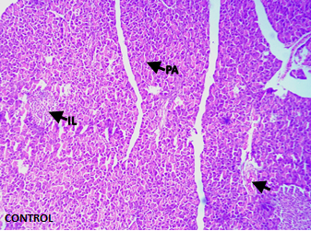 B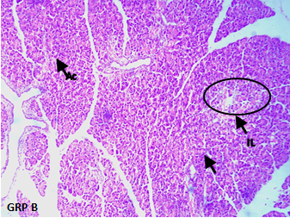
C 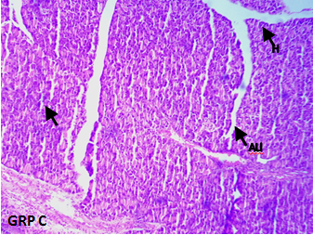 D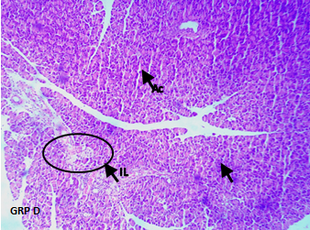
E 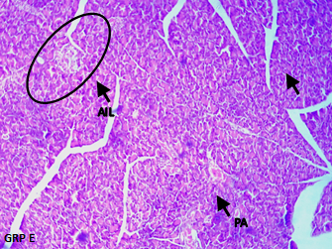
Fig. 3: Photomicrograph of pancreas; group A showing well preserved islet of Langerhans (IL), with well-preserved pancreatic acinar cells (PA), group B showing sever inflammation of islet of Langerhans (IL), with necrosis of acinar cells (AC), group C showing well preserved acinar cells (arrow), with normal pancreatic tissue (H), group D showing mild inflammation of islet of Langerhans (IL), with normal appearance of acinar cells (AC) and group E showing mild inflammation of islet of Langerhans focal area of hemorrhage in pancreatic tissue (PA).
In-silico results

Table 3: Binding affinity of the bioactive compounds of Brassica oleracea with Metallothioneins-1 target (PDB: 1MHU)

Ligands | PubChem CID | Binding Affinity (Kcal/mol)
Deferasirox (Control) | 214348 | -5.9
Neoxanthin | 5282217 | -5.8
Kaempferol-3-sophoroside-7-glucoside | 12960459 | -5.7
Quercetin-3-sophoroside-7-glucoside | 44259167 | -5.6
Rutin | 5280805 | -5.6
Glucobrassicin | 6602378 | -5.1
Deferoxamine (Control) | 2973 | -3.9

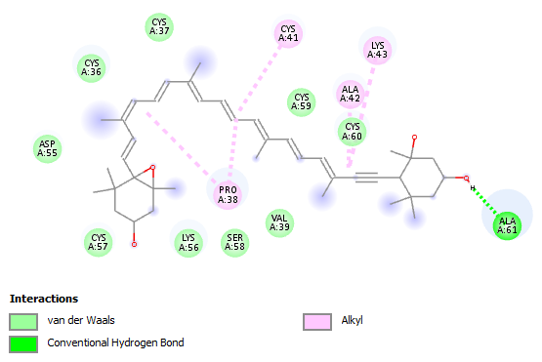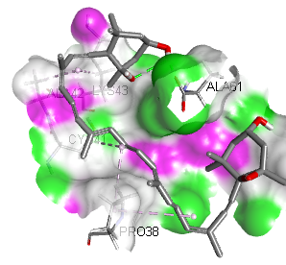

Fig 4: 2D and 3D binding interactions of Neoxanthin with Metallothioneins-1 target (PDB: 1MHU)

Table 4: Binding affinity of the bioactive compounds of Brassica oleracea with Metallothioneins-2 target (PDB: 2MHU)

Ligands | PubChem CID | Binding Affinity (Kcal/mol)
Neoxanthin | 5282217 | -6.2
Quercetin-3-sophoroside-7-glucoside | 44259167 | -6
Glucobrassicin | 6602378 | -6
Isorhamnetin | 5281654 | -5.8
Apigenin | 5280443 | -5.5
Dimercaptosuccinic acid (Control) | 9354 | -3.8
Dimercaprol (Control) | 3080 | -2.7

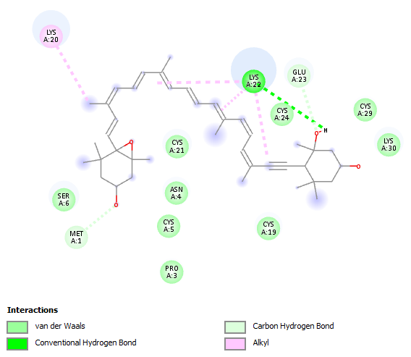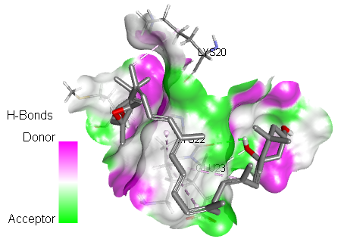
Fig 5: 2D and 3D binding interactions of Neoxanthin with Metallothioneins-2 target (PDB: 2MHU)
Table 5: Binding affinity of the bioactive compounds of Brassica oleracea with inflammatory mediator’s target (PDB: 1NFI)

Ligands | PubChem CID | Binding Affinity (Kcal/mol)
Neoxanthin | 5282217 | -7.6
Quercetin-3-sophoroside-7-glucoside | 44259167 | -7.3
Rutin | 5280805 | -7.1
Kaempferol-3-sophoroside-7-glucoside | 12960459 | -6.8
Kaempferol-3-sophoroside | 5282155 | -6.8
Celecoxib (Control) | 2662 | -6.7
Aspirin (Control) | 2244 | -5

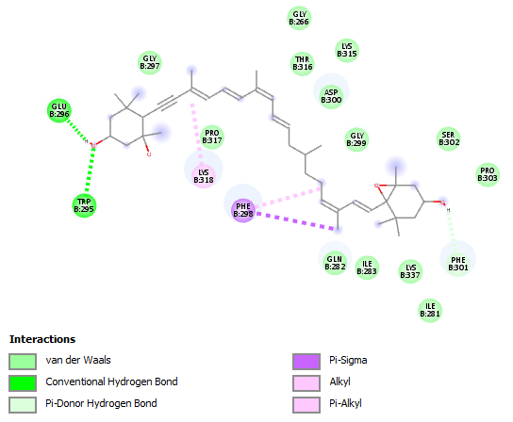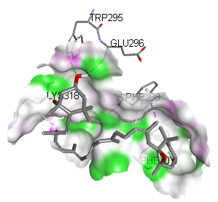
Fig. 6: 2D and 3D binding interactions of Neoxanthin with Inflammatory mediator’s target (PDB: 1NFI)

Table 6: Binding affinity of the bioactive compounds of Brassica oleracea with Apoptosis (PDB: 1PAU)

Ligands | PubChem CID | Binding Affinity (Kcal/mol)
Neoxanthin | 5282217 | -7.1
β-carotene | 5280489 | -7.1
Rutin | 5280805 | -6.5
β-sitosterol | 222284 | -6.4
Quercetin-3-sophoroside-7-glucoside | 44259167 | -6.1
Romidepsin (Control) | 5352062 | -5.6
Vorinostat (Control) | 5311 | -5.4

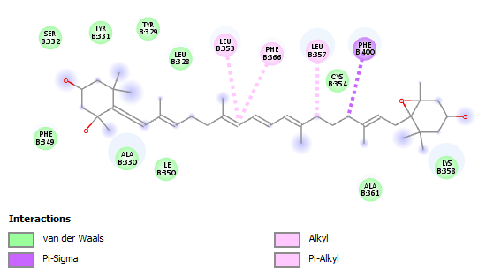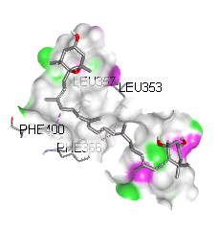

Fig. 7: 2D and 3D binding interactions of Neoxanthin with Apoptosis (PDB: 1PAU)

Table 7: Binding affinity of the bioactive compounds of Brassica oleracea with Pancreatic function (PDB: 1V4S)

Ligands | PubChem CID | Binding Affinity (Kcal/mol)
Rutin | 5280805 | -9.1
Kaempferol-3-sophoroside-7-glucoside | 12960459 | -8.5
Quercetin-3-sophoroside-7-glucoside | 44259167 | -8.1
Kaempferol-3-sophoroside | 5282155 | -8.1
D-glucosamine | 439213 | -7.8
Sitagliptin (Control) | 4369359 | -7.7
Metformin (Control) | 4091 | -5

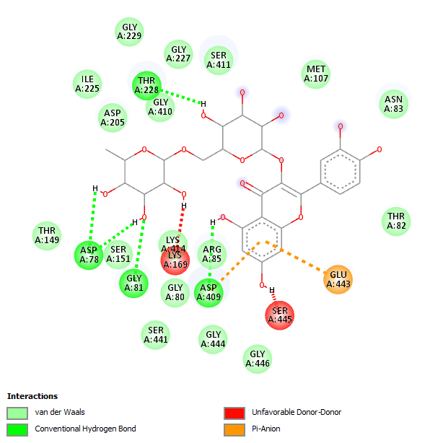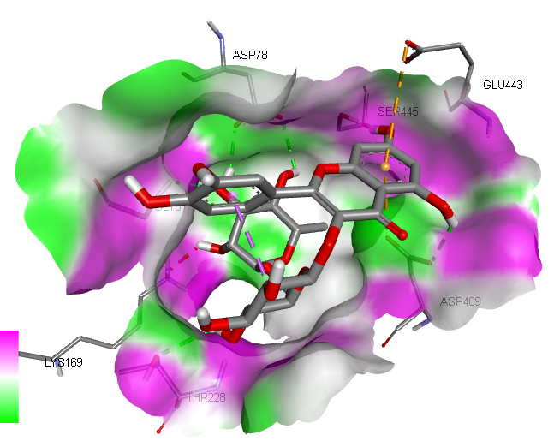
Fig. 8: 2D and 3D binding interactions of Rutin with Pancreatic function (PDB: 1V4S)

Table 8: Binding affinity of the bioactive compounds of Brassica oleracea with Glutathione-S-transferase (PDB: 2GTU)

Ligands | PubChem CID | Binding Affinity (Kcal/mol)
Apigenin | 5280443 | -6.8
Kaempferol | 5280863 | -6.7
Luteolin | 5280445 | -6.7
Quercetin | 5280343 | -6.6
Myrcetin | 5281672 | -6.5
Glutathione (Control) | 124886 | -5
N-acetylcysteine (Control) | 12035 | -4

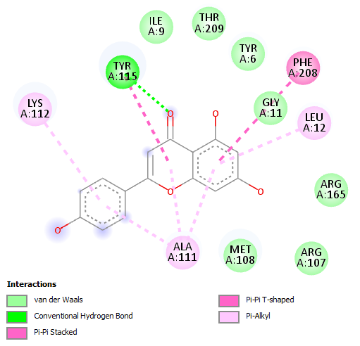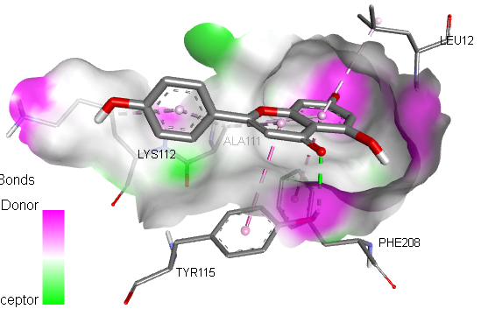
Fig. 9: 2D and 3D binding interactions of Apigenin with Glutathione-S-transferase (PDB: 2GTU)

Table 9: Binding affinity of the bioactive compounds of Brassica oleracea with Oxidative stress (PDB: 3E7G)

Ligands | PubChem CID | Binding Affinity (Kcal/mol)
Rutin | 5280805 | -11.7
Apigenin | 5280443 | -10
Glucobrassicin | 6602378 | -9.9
Luteolin | 5280445 | -9.8
Quercetin-3-sophoroside-7-glucoside | 44259167 | -9.8
Butylated hydroxytoluene (Control) | 31404 | -6.9
Ascrobic acid (Control) | 54670067 | -5.7

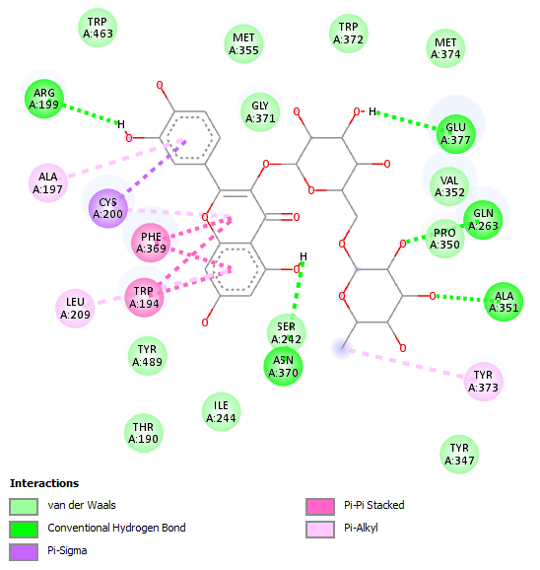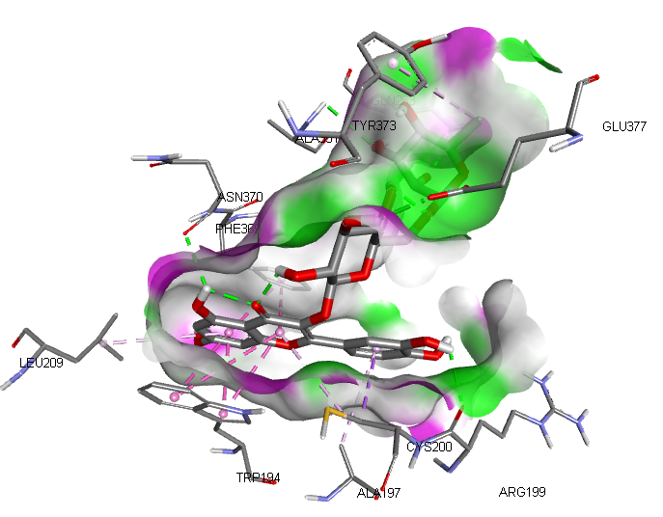

Fig. 10: 2D and 3D binding interactions of Rutin with Oxidative stress (PDB: 3E7G)

Table 10: Amino acid interactions of the selected target proteins with the Hit compounds of Brassica oleracea

Binding interactions | 1MHU-Neoxanthin | 2MHU-Neoxanthin | INFI-Neoxanthin | 1PAU-Neoxanthin | 1V4S-Rutin | 2GTU-Apigenin | 3E7G-Rutin
Conventional Hydrogen bond | ALA61 | LYS22 | GLU296, TRP295 | - | THR228, ASP78, GLY81, ASP409 | TYR115 | ARG199, GLU377, GLN263, ALA351,ASN370
Carbon Hydrogen bond | - | GLU23, MET1 | - | - | - | - | -
Van dar Waals | VAL39, SER58, LYS56, CYS57, ASP55, CYS36, CYS37, CYS59, CYS60 | SER6, CYS21, ASN4, CYS5, PRO3, CYS19, CYS24, CYS29, LYS30 | GLY297, GLY266, LYS315, THR316, ASP300, GLY299, SER302, PRO303, LYS337, ILE281, LYS337, ILE283, GLN282, PRO317 | LYS358, ALA361, ILE350, ALA330, PHE349, SER332, TYR331, TYR329, LEU328, CYS354 | GLY410, ASP205, ILE225, GLY229, GLY227, SER411, MET107, ASN83, THR82, GLY446, GLY444, SER441, GLY80, ARG85, LY414, SER151, THR149 | ILE9, THR209, TYR6, GLY11, ARG 165, ARG107, MET108 | TRP463, MET355, GLY371, TRP372, MET374, VAL352, PRO350, SER242, TYR347, ILE244, THR190, TYR489
Pi-Pi stacked | - | - | - | - | - | PHE208 | PHE369, TRP194
Pi-alkyl | ALA42, LYS43, CYS41, PRO38 | LYS20 | LYS318 | LEU353, PHE366, LEU357 | - | LYS112, ALA111, LEU12 | TYR373, LEU209,ALA197
Pi-Anion | - | - | - | - | GLU443 | - | -
Unfavorable donor-donor | - | - | - | - | LYS169, SER445 | - | -
Pi-Sigma | - | - | PHE298 | PHE400 | - | - | CYS200
Pi-Donor hydrogen bond | - | - | PHE301 | - | - | - | -
Table 11: Pharmacokinetics (ADME) Properties of the Hit compounds of Brassica oleracea

ADME | Properties | Neoxanthin | Rutin | Apigenin
Absorption | Caco-2 | -5.003 | -6.547 | -5.129
Absorption | P-gp inhibitor | 0.012 | 0.000 | 0.004
Absorption | P-gp substrate | 0.999 | 0.699 | 0.312
Absorption | HIA | 0.000 | 0.640 | 0.002
Absorption | Bioavailability | 1.000 | 1.000 | 0.985
Distribution | OATP1B1 | 1.000 | 0.996 | 0.889
Distribution | OATP1B3 | 0.993 | 1.000 | 0.973
Distribution | BCRP | 0.085 | 0.834 | 0.892
Distribution | BSEP | 1.000 | 0.002 | 0.608
Distribution | BBB | 0.000 | 0.000 | 0.013
Distribution | MRP1 | 0.820 | 0.008 | 0.657
Distribution | PPB | 96.276 | 85.005 | 96.535
Metabolism | CYP1A2-inh | 0.000 | 0.000 | 1.000
Metabolism | CYP1A2-sub | 0.000 | 0.004 | 0.470
Metabolism | CYP2C19-inh | 0.003 | 0.000 | 0.112
Metabolism | CYP2C19-sub | 0.000 | 0.000 | 0.000
Metabolism | CYP2C9-inh | 0.000 | 0.000 | 0.002
Metabolism | CYP2C9-sub | 0.000 | 0.000 | 0.673
Metabolism | CYP2D6-inh | 0.012 | 0.000 | 0.957
Metabolism | CYP2D6-sub | 0.000 | 0.000 | 1.000
Metabolism | CYP3A4-inh | 0.485 | 0.029 | 1.000
Metabolism | CYP3A4-sub | 0.306 | 0.000 | 0.000
Metabolism | CYP2B6-inh | 0.998 | 0.102 | 0.112
Metabolism | CYP2B6-sub | 0.000 | 0.000 | 0.000
Metabolism | CYP2C8-inh | 1.000 | 1.000 | 0.999
Excretion | cl-plasma | 7.932 | 1.611 | 5.939
Excretion | t0.5 | 0.960 | 4.616 | 1.203

Table 12: Physicochemical Properties of the Hit compounds of Brassica oleracea

Properties | Neoxanthin | Rutin | Apigenin
Molar weight | 600.420 | 610.150 | 270.050
No. HB Acceptor | 4.000 | 16.000 | 5.000
No. HB Donor | 3.000 | 10.000 | 3.000
TPSA | 73.220 | 269.430 | 90.900
LogP | 5.226 | 0.986 | 2.981
Flexibility | 0.375 | 0.200 | 0.056
No. Rotatable H. | 9.000 | 6.000 | 1.000
Table 13: Toxicity Properties of the Hit compounds of Brassica oleracea
Properties | Neoxanthin | Rutin | Apigenin
Skin Sensitization | 0.999 | 0.997 | 0.645
Carcinogenicity | 0.923 | 0.047 | 0.793
Eye corrosion | 0.000 | 0.000 | 0.371
Eye irritation | 0.075 | 0.905 | 0.998
Respiratory | 0.966 | 0.030 | 0.777
Hapatotoxicity | 0.388 | 0.406 | 0.435
Neurotoxicity | 0.593 | 0.000 | 0.061
Ototoxicity | 0.857 | 0.884 | 0.068
Hematotoxicity | 0.014 | 0.023 | 0.043
Nephrotoxicity | 0.966 | 0.148 | 0.021
Genotoxicity | 0.373 | 0.868 | 0.987
Immunitoxicty | 0.315 | 0.098 | 0.045
A549 Cytotoxicity | 0.315 | 0.860 | 0.323
HEK293 Cytotoxicity | 0.754 | 0.466 | 0.855
Table 14: Drug likeness properties of the Hit compounds of Brassica oleracea

Drug Likeness Models | Neoxanthin | Rutin | Apigenin
Lipinski | No | No | Yes
Ghose | No | No | Yes
Veber | No | No | Yes
Egan | No | No | Yes
Muegge | No | No | Yes

DISCUSSION
The results demonstrate that lead acetate administration significantly impairs pancreatic function, evidenced by increased levels of amylase and lipase in Group B (lead acetate only). These enzymes are crucial for digestion, and their elevated levels are indicative of pancreatic damage or dysfunction, particularly pancreatitis or impaired exocrine function. Lead acetate-induced toxicity likely damages pancreatic cells, resulting in the leakage of enzymes into the bloodstream, which is consistent with previous studies showing that lead exposure disrupts the normal functioning of the pancreas by inducing oxidative stress and cellular damage (Flora et al., 2012).
The oxidative stress caused by lead exposure generates reactive oxygen species (ROS), which attack pancreatic tissues, leading to inflammation, cell death, and impaired enzyme production. This ultimately disrupts the pancreas’ role in digestion and blood sugar regulation (Tchounwou et al., 2012).
In Groups C, D, and E, which were treated with various doses of Brassica oleracea extract, there was a significant reduction in amylase and lipase levels compared to the lead acetate-only group (Group B). Particularly, Group D (moderate dose) showed the most notable improvement, with levels of these enzymes approaching normal. These results suggest that Brassica oleracea extract has an ameliorative effect on the pancreas, likely due to its rich antioxidant content. This aligns with studies suggesting that Brassica oleracea is rich in compounds such as sulforaphane, vitamins C and E, and flavonoids, which help neutralize oxidative stress and support pancreatic health (Podsedek, 2007).
The improvement in pancreatic enzyme levels suggests that Brassica oleracea extract helps prevent the breakdown of pancreatic cells, likely by reducing oxidative stress and enhancing the pancreas’ natural defense mechanisms. These findings are in line with other research showing that plant extracts with strong antioxidant properties can protect pancreatic tissues from toxic substances like lead (Khan et al., 2012).
Lead acetate exposure is known to cause weight loss, as it affects multiple organs, including the pancreas. In this study, Group B exhibited significant weight loss, which is likely related to impaired pancreatic function, leading to poor nutrient digestion and absorption.
In contrast, the groups treated with Brassica oleracea extract (Groups C, D, and E) showed significant weight recovery, with Group D (moderate dose) demonstrating the most balanced weight gain. This suggests that the Brassica oleracea extract not only protected the pancreas but also improved overall metabolic function, likely by restoring proper digestion and nutrient absorption. The antioxidants and anti-inflammatory compounds in Brassica oleracea may have contributed to the recovery of both pancreatic function and overall metabolism, leading to better weight outcomes in these groups (Podsedek, 2007).
Histological analysis of the pancreatic tissues supports the biochemical findings. In Group B (lead acetate only), the pancreas showed extensive damage, including acinar cell degeneration, inflammation, and necrosis. This level of tissue destruction is consistent with what is expected in lead-induced pancreatic toxicity, where oxidative stress leads to cell death and inflammation (Flora et al., 2012).
However, in Groups C, D, and E, the administration of Brassica oleracea extract resulted in marked improvements in pancreatic architecture. Group D, which received the moderate dose of Brassica oleracea extract, exhibited near-normal pancreatic histology, with only mild signs of inflammation and minimal cell damage
Group E, treated with the highest dose of Brassica oleracea extract, also showed improvement, though the extent of recovery was slightly less than in Group D.
The molecular docking simulations provided valuable insights into the potential therapeutic relevance of bioactive compounds in Brassica oleracea against several biological targets associated with detoxification, inflammation, oxidative stress, apoptosis, and metabolic functions.
The docking results against Metallothionein-1 (MT-1) revealed that neoxanthin exhibited the highest binding affinity (-5.8 kcal/mol) among the phytocompounds, followed closely by kaempferol-3-sophoroside-7-glucoside (-5.7 kcal/mol) and quercetin-3-sophoroside-7-glucoside (-5.6 kcal/mol), outperforming deferoxamine (-3.9 kcal/mol), one of the control chelators. Deferasirox, another control, showed a slightly better score (-5.9 kcal/mol) than neoxanthin, though the differences were minimal.
Neoxanthin again demonstrated strong interaction with Metallothionein-2 (MT-2) at -6.2 kcal/mol, surpassing both dimercaptosuccinic acid (-3.8 kcal/mol) and dimercaprol (-2.7 kcal/mol). Other notable compounds included quercetin-3-sophoroside-7-glucoside and glucobrassicin, both at -6.0 kcal/mol. These results highlight the potential of these compounds in chelating heavy metals and modulating MT-2, a protein known to play a vital role in metal detoxification and homeostasis (Palmiter, 2019).
Neoxanthin showed superior binding affinity (-7.6 kcal/mol) to the NF-κB complex compared to both controls—celecoxib (-6.7 kcal/mol) and aspirin (-5.0 kcal/mol). Quercetin derivatives and rutin also demonstrated high affinities, indicating their potential as anti-inflammatory agents through NF-κB inhibition (Lawrence, 2009). These interactions may underlie the inflammation-modulating properties attributed to cruciferous vegetables like cabbage.
Against the apoptosis-related target (1PAU), neoxanthin and β-carotene exhibited the strongest binding affinities at -7.1 kcal/mol. These values surpass those of standard pro-apoptotic agents like romidepsin (-5.6 kcal/mol) and vorinostat (-5.4 kcal/mol). The results suggest that neoxanthin and β-carotene may support apoptosis induction in damaged or mutated cells, contributing to chemoprevention (Elmore, 2007).
Apigenin (-6.8 kcal/mol), kaempferol (-6.7 kcal/mol), and luteolin (-6.7 kcal/mol) showed better affinities than glutathione (-5.0 kcal/mol) and N-acetylcysteine (-4.0 kcal/mol). Since GSTs are critical in detoxification through glutathione conjugation, these compounds may enhance endogenous detox pathways and contribute to xenobiotic metabolism (Sheehan et al., 2001).
Rutin showed an exceptionally strong binding affinity (-11.7 kcal/mol) against the oxidative stress-related target, followed by apigenin (-10.0 kcal/mol) and glucobrassicin (-9.9 kcal/mol). These values were significantly better than those of known antioxidants like butylated hydroxytoluene (-6.9 kcal/mol) and ascorbic acid (-5.7 kcal/mol), emphasizing the antioxidant potency of these bioactive compounds (Pisoschi & Pop, 2015).
The docking results consistently identified neoxanthin, rutin, quercetin-3-sophoroside-7-glucoside, apigenin, and kaempferol derivatives as leading bioactive candidates across multiple targets. Their superior binding affinities suggest that they could simultaneously modulate multiple pathological pathways, including metal chelation, inflammation, oxidative stress, apoptosis, and glucose metabolism. These findings support the therapeutic potential of Brassica oleracea in managing complex disorders such as heavy metal toxicity, diabetes, and chronic inflammation through a multi-target approach.
The molecular docking analysis of bioactive compounds from Brassica oleracea reveals detailed interaction profiles with several key proteins implicated in metal detoxification, inflammation, apoptosis, pancreatic function, glutathione metabolism, and oxidative stress. These interactions help elucidate the mechanistic basis for the pharmacological potential of these phytochemicals.
Neoxanthin’s hydrogen bonding with ALA61 in metallothionein-1 (1MHU) and LYS22 in metallothionein-2 (2MHU), along with extensive van der Waals contacts with cysteine and lysine residues, corroborate its role in modulating metal-binding proteins. Cysteine-rich residues play a critical role in metal binding and detoxification through metallothioneins, which sequester heavy metals via thiol groups of cysteine residues (Kägi & Schaffer,1988), binding of antioxidants stabilized metallothionein structure to enhance heavy metal chelation. The docking results support these findings, demonstrating that neoxanthin likely contributes to metallothionein’s metal detoxification by stabilizing critical binding residues.
The conventional hydrogen bonds with GLU296 and TRP295 and π interactions around PHE298 highlight neoxanthin’s ability to bind and potentially inhibit NF-κB, a master regulator of inflammation. Flavonoids have been shown to inhibit NF-κB activation by interfering with its DNA-binding activity and downstream transcription of pro-inflammatory genes, highlighting their role as potent anti-inflammatory agents (Panche et al.,2016).
Though lacking strong hydrogen bonding, neoxanthin’s van der Waals and π-alkyl interactions with residues such as LYS358 and PHE366 may influence apoptosis modulation.
Rutin exhibits strong binding interactions with key amino acid residues through hydrogen bonding and electrostatic interactions, indicating a stable ligand–protein complex that supports its potential antidiabetic activity(Ganeshpurkar, & Saluja, 2017).
GST activation is crucial in detoxification pathways and antioxidant defense, and the present docking result confirms apigenin’s favorable interactions with residues implicated in catalysis and substrate binding, supporting its therapeutic promise.
Rutin exhibits strong molecular interactions with target proteins through hydrogen bonding and π–π stacking with key amino acid residues, indicating stable ligand–protein binding and potential antioxidant-related activity (Essa et al.,2022). where rutin’s ability to quench reactive oxygen species was attributed to its tight binding within antioxidant enzyme active sites, mediated by similar amino acid interactions. The strong binding affinity (-11.7 kcal/mol) from this study further strengthens rutin’s potential as a potent oxidative stress mitigator.
However, the binding profiles observed for neoxanthin, rutin, and apigenin with their respective protein targets are consistent with recent biochemical and docking studies, underscoring the validity of these phytochemicals as bioactive agents. Their ability to form stable hydrogen bonds, hydrophobic, and π-interactions with critical residues supports mechanisms for detoxification, anti-inflammatory, apoptotic, and antioxidant effects reported in contemporary research. This comparison highlights that Brassica oleracea compounds could be valuable leads for drug development targeting oxidative stress, inflammation, metabolic disorders, and heavy metal toxicity.
The pharmacokinetic properties of drug candidates are crucial for determining their therapeutic viability, particularly in terms of their absorption, distribution, metabolism, and excretion (ADME). The ADME profile of three bioactive compounds derived from Brassica oleracea neoxanthin, rutin, and apigenin reveals distinctive pharmacokinetic behaviors that may influence their bioavailability and biological efficacy.
Absorption is a vital component that determines the degree to which a compound enters systemic circulation. The Caco-2 permeability scores for neoxanthin (-5.003), rutin (-6.547), and apigenin (-5.129) suggest relatively low intestinal permeability, with rutin exhibiting the poorest absorption. This is in line with previous reports indicating that glycosylated flavonoids like rutin exhibit poor membrane permeability due to their high molecular weight and hydrophilicity (Manach et al., 2005). While all three compounds are substrates of P-glycoprotein (P-gp), which may further limit their absorption by promoting efflux from intestinal cells, only neoxanthin shows a relatively high P-gp substrate probability (0.999), suggesting a strong affinity for efflux.
In terms of distribution, the compounds interact with key transporters. Neoxanthin and rutin display high affinity for OATP1B1 and OATP1B3 transporters (values near or equal to 1.000), which are crucial in hepatic uptake, suggesting a propensity for liver accumulation. This may be beneficial for hepatic or systemic inflammatory conditions. Apigenin, although slightly lower in OATP interaction, still shows strong transporter affinity. Additionally, neoxanthin strongly interacts with the bile salt export pump (BSEP, 1.000), indicating a potential for biliary excretion, whereas rutin exhibits a minimal BSEP interaction (0.002), implying limited bile-mediated clearance. Interestingly, only apigenin shows a slight potential to cross the blood–brain barrier (BBB, 0.013), indicating a possible central nervous system (CNS) effect, albeit minimal. The plasma protein binding (PPB) values are high across all compounds (>85%), with apigenin reaching the highest binding (96.535%), indicating a low free plasma concentration, which might affect its pharmacodynamics. High PPB can prolong half-life but may also reduce immediate therapeutic efficacy (Rowland & Tozer, 2011).
The metabolism profiles highlight varying degrees of interaction with cytochrome P450 (CYP) enzymes. Apigenin is notably active as a CYP1A2 inhibitor and substrate, along with significant interaction with CYP2D6 and CYP3A4, all crucial enzymes in xenobiotic metabolism. Flavonoids such as apigenin can interact with cytochrome P450 enzymes, acting as both substrates and inhibitors, which may contribute to potential drug–drug interactions(Guengerich,2008). In contrast, neoxanthin and rutin show minimal interaction with most CYP enzymes, potentially reducing the likelihood of adverse DDIs. However, all three compounds demonstrate strong CYP2C8 inhibition (>0.999), which could influence the metabolism of co-administered drugs processed by this enzyme, warranting caution in combinational therapies.
Regarding excretion, the predicted plasma clearance (cl-plasma) values vary significantly, with neoxanthin showing the highest clearance rate (7.932 mL/min/kg), followed by apigenin (5.939 mL/min/kg), and rutin the lowest (1.611 mL/min/kg). This indicates that neoxanthin is rapidly cleared from the body, possibly limiting its duration of action. Rutin's prolonged half-life (t0.5 = 4.616 hours) compared to neoxanthin (0.960 hours) and apigenin (1.203 hours) suggests sustained circulation, which may enhance its efficacy for prolonged therapeutic needs, a feature noted in previous pharmacokinetic studies on flavonoids (Shimoi et al., 1998
).
Comparing these findings with recent literature, a study by Guengerich (2008).affirmed that Apigenin is known to undergo extensive metabolism involving cytochrome P450 enzymes and may interact with efflux transporters, which can influence its pharmacokinetic behavior and bioavailability. corroborating our findings. Neoxanthin, although less commonly studied, aligns with carotenoid pharmacokinetics reported by Paur et al. (2021), which noted low HIA but efficient hepatic distribution and rapid clearance.
While all three compounds from Brassica oleracea present unique pharmacokinetic strengths and limitations, neoxanthin and apigenin appear favorable in terms of rapid metabolism and transporter interactions, whereas rutin’s prolonged half-life and high PPB suggest potential for sustained therapeutic effects. However, their low intestinal absorption and high P-gp substrate affinity necessitate advanced formulation strategies such as nanoparticles or co-administration with absorption enhancers to optimize their clinical utility.
The evaluation of physiochemical properties remains pivotal in modern drug discovery, especially for predicting the oral bioavailability, target specificity, and drug-likeness of phytochemicals. Table 12 presents the molecular descriptors of three hit compounds from Brassica oleracea neoxanthin, rutin, and apigenin highlighting differences that could influence their pharmacokinetic profiles and bioefficacy. In contrast, neoxanthin (600.42 g/mol) and rutin (610.15 g/mol) exceed this limit, which may compromise membrane diffusion and systemic bioavailability.
The drug-likeness of small molecules is commonly evaluated using Lipinski’s rule of five, which considers hydrogen bond donors and acceptors as key determinants of membrane permeability and oral bioavailability (Lipinski et al., 1997). Conversely, the lower TPSA values of neoxanthin (73.22 Å²) and apigenin (90.90 Å²) support improved bioavailability via passive transcellular routes.
LogP values are widely used to describe compound lipophilicity, which influences membrane permeability, absorption, distribution, and the potential for bioaccumulation in biological systems(Veber et al.,2002).
However, apigenin's optimal physicochemical parameters position it as the most promising candidate for drug development among the studied compounds. Its compliance with modern oral drug-likeness criteria supports its prioritization in downstream preclinical evaluations. Neoxanthin and rutin, while pharmacologically potent, would benefit from formulation innovations to overcome their inherent biopharmaceutical limitations.
The toxicological profiling of drug candidates is a critical step in drug development, as it determines their safety margins and potential for off-target effects. Table 13 summarizes various in silico toxicity predictions for neoxanthin, rutin, and apigenin, three phytochemicals from Brassica oleracea using a probabilistic model (values closer to 1 indicating higher likelihood of toxicity). Among the compounds, apigenin demonstrates the most favorable toxicity profile overall, particularly with lower predictions for skin sensitization (0.645), ototoxicity (0.068), neurotoxicity (0.061), and nephrotoxicity (0.021). This aligns with experimental evidence demonstrating that apigenin exerts protective effects against renal injury by attenuating oxidative stress and inflammatory responses (Wu et al., 2021).
Carcinogenicity predictions rank neoxanthin highest (0.923), followed by apigenin (0.793), and then rutin (0.047). Interestingly, apigenin exhibits selective anticancer activity by inducing apoptosis in cancer cells while showing comparatively lower toxicity in normal cells(Patel et al.,2007).
The cytotoxicity profiles on two human cell lines A549 (lung carcinoma) and HEK293 (human embryonic kidney) reveal additional nuances. Apigenin exhibits dose-dependent cytotoxic effects against cancer cell lines while showing comparatively lower toxicity toward normal cells, suggesting selective anticancer potential (Adham et al.,2021). Rutin, however, is more cytotoxic to A549 cells (0.860), possibly due to enhanced oxidative stress induction at higher doses, whereas neoxanthin exhibits greater toxicity toward HEK293 cells (0.754), which could reflect its renal accumulation potential.
On the topic of organ-specific toxicity, all three compounds show low probabilities for hematotoxicity, with values below 0.05, indicating minimal interference with blood-forming tissues. This is reassuring, especially for chronic oral administration. Immunotoxicity, another critical parameter, is most favorable for apigenin (0.045), again reinforcing its candidacy for safe drug design
Overall, while neoxanthin and rutin exhibit promising bioactivity, their predicted toxicity profiles necessitate careful dose titration, delivery formulation, or structural modification to mitigate off-target effects.
The evaluation of drug-likeness properties using rule-based computational filters is a foundational step in determining the oral bioavailability and potential of candidate compounds as viable drug leads. Table 14 presents the drug-likeness assessments of neoxanthin, rutin, and apigenin based on five widely recognized filters: Lipinski, Ghose, Veber, Egan, and Muegge rules. Among the three, apigenin stands out by satisfying all five models, suggesting it possesses optimal physicochemical properties for oral bioavailability and drug development. This finding is consistent with several recent studies that have identified apigenin as a promising scaffold in drug discovery due to its favorable molecular weight, lipophilicity, hydrogen bonding characteristics, and topological polar surface area (TPSA) (Ferreira et al., 2021).
Conversely, neoxanthin and rutin failed to satisfy any of the drug-likeness filters. This poor performance can largely be attributed to their high molecular weights (600.42 and 610.15 Da respectively), excessive hydrogen bond donors and acceptors, and large TPSA values factors that collectively limit passive membrane permeability and intestinal absorption. For instance, rutin, a glycosylated flavonoid, exceeds Lipinski’s limit of five hydrogen bond donors and ten acceptors, and its TPSA of 269.43 Å² significantly surpasses the ideal cutoff of 140 Å² for oral drugs. Such violations are known to reduce membrane diffusion and, consequently, oral bioavailability, as corroborated by recent ADMET studies (Malde et al., 2022).
Apigenin’s success across the five filters reaffirms its drug-likeness and aligns with its presence in multiple pharmacological investigations and clinical studies. With a molecular weight of 270.05 Da, logP of 2.981, and TPSA of 90.90 Å², apigenin remains within the optimal range for most pharmacokinetic parameters. It also complies with Veber’s and Egan’s rules regarding molecular flexibility and polarity, which are key determinants of good oral bioavailability and membrane permeability (Veber et al., 2002). Moreover, apigenin’s structural simplicity compared to its counterparts contributes to its chemical tractability and ease of synthetic optimization.
While neoxanthin and rutin may exhibit strong bioactivities, their lack of drug-likeness per these filters highlights potential challenges in formulation and delivery. Their future in drug development may depend on structural modifications, prodrug strategies, or alternative delivery systems such as nanocarriers. Apigenin, by contrast, demonstrates strong potential for further preclinical and clinical development as a lead compound, especially in light of its alignment with multiple drug-likeness rules and documented bioavailability (Ferreira et al., 2021).

CONCLUSION
Among the three hit compounds studied, apigenin demonstrated the most favorable profile for potential drug development. It fulfilled all major drug-likeness filters (Lipinski, Ghose, Veber, Egan, and Muegge), indicating strong oral bioavailability and desirable physicochemical characteristics. Additionally, it presented moderate to low toxicity risks, with the exception of some genotoxicity and HEK293 cytotoxicity, which may require further biological validation. In contrast, rutin and neoxanthin exhibited significant limitations. Both failed all drug-likeness rules due to high molecular weights, excessive hydrogen bond donors/acceptors, and poor flexibility metrics, which indicate poor membrane permeability and low oral bioavailability. Although neoxanthin showed relatively better non-carcinogenicity compared to rutin, it was flagged for multiple toxicity risks, including nephrotoxicity, respiratory toxicity, and neurotoxicity. Rutin, despite its known antioxidant properties, also demonstrated high risks of immunotoxicity, genotoxicity, and poor pharmacokinetic behavior. Therefore, apigenin stands out as the most promising candidate for further development as a therapeutic agent, especially in the context of diseases where bioactive dietary flavonoids are relevant.
However, while in silico results are promising for apigenin, experimental validation via in vitro and in vivo pharmacokinetic, toxicological, and therapeutic assays should be conducted to confirm efficacy and safety. Structural modification of neoxanthin and rutin should be performed given their strong biological activities but poor drug-likeness, these compounds could benefit from chemical modification or prodrug strategies to improve bioavailability and reduce toxicity. Detailed studies on apigenins mechanism of action against specific targets should be pursued using proteomics, transcriptomics, or network pharmacology approaches. Apigenin can also serve as a lead compound for developing analogues with improved potency, selectivity, and metabolic stability through structure-activity relationship (SAR) studies.

Competing interests

The authors declare that they have no known financial interests that influenced the work reported in this paper. The research was conducted independently, without any financial support, commercial sponsorship, or affiliations that might present a conflict of interest.

Ethical approval

This was obtained from the ethical committee, faculty of basic medical sciences Chukwuemeka Odumegwu Ojukwu University, Uli campus in compliance with the relevant laws and institution’s guidelines. All authors hereby declare that "Principles of laboratory animal care" (NIH publication No. 85-23, revised 1985) were followed, as well as specific national laws where applicable. All experiments have been examined and approved by the appropriate ethics committee.

Disclaimer (Artificial intelligence)

Author(s) hereby declare that NO generative AI technologies such as Large Language Models (ChatGPT, COPILOT, etc.) and text-to-image generators have been used during the writing or editing of this manuscript.

REFERENCES
- Adham, A. N., Abdelfatah, S., Naqishbandi, A. M., Mahmoud, N., & Efferth, T. (2021). Cytotoxicity of apigenin toward multiple myeloma cell lines and suppression of iNOS and COX-2 expression in STAT1-transfected HEK293 cells. Phytomedicine, 80, 153371. https://doi.org/10.1016/j.phymed.2020.153371
- Ahamed, M., & Siddiqui, M. K. J. (2007). Low level lead exposure and oxidative stress: Current opinions. Clinical Chimica Acta, 383(1–2), 57–64. https://doi.org/10.1016/j.cca.2007.04.024
- Dallakyan, S. and Olson, A.J. (2015) Small-Molecule Library Screening by Docking with PyRx. Methods, Mol Biol., 1263: 243–50.
- Daina, A., Michielin, O., & Zoete, V. (2017). SwissADME: A free web tool to evaluate pharmacokinetics, drug-likeness and medicinal chemistry friendliness of small molecules. Scientific Reports, 7, 42717. https://doi.org/10.1038/srep42717
- Elmore, S. (2007). Apoptosis: A review of programmed cell death. Toxicologic Pathology, 35(4), 495–516. https://doi.org/10.1080/01926230701320337
- Engvall, E. & Perlmanm, P. (1971). Enzyme-Linked Immunosorbent Assay (ELISA), Quantitative assay of immunoglobulin G, Immunochemistry, 8(9), 871-874
- Essa, A. F., Teleb, M., El-Kersh, D. M., Elshamy, A. I., Farag, M. A., et al. (2022). Natural acylated flavonoids: their chemistry and biological merits in context to molecular docking studies. Phytochemistry Reviews, 22, 1469–1508. https://doi.org/10.1007/s11101-022-09840-1
- Ferreira, D., Santos, S. A., & Pinto, D. (2021). Drug-likeness evaluation of bioactive natural products: Tools and applications in drug discovery. Current Medicinal Chemistry, 28(14), 2861–2883. https://doi.org/10.2174/0929867327666200907112939
- Flora, G., Gupta, D., & Tiwari, A. (2012). Toxicity of lead: A review with recent updates.
Interdisciplinary Toxicology, 5(2), 47–58. https://doi.org/10.2478/v10102-012-0009-2
- Flora, S. J. S., & Pachauri, V. (2010). Chelation in metal intoxication. International Journal of Environmental Research and Public Health, 7(7), 2745–2788. https://doi.org/10.3390/ijerph7072745
- Ganeshpurkar, A., & Saluja, A. K. (2017). The pharmacological potential of rutin. Saudi Pharmaceutical Journal, 25(2), 149–164. https://doi.org/10.1016/j.jsps.2016.04.025.
- Guengerich, F. P. (2008). Cytochrome P450 and chemical toxicology. Chemical Research in Toxicology, 21(1), 70–83. https://doi.org/10.1021/tx700079z
- Kägi, J. H. R., & Schaffer, A. (1988). Biochemistry of metallothionein. Biochemistry, 27(23), 8509–8515.
https://doi.org/10.1021/bi00423a001
- Khan, A. R., Khan, M. R., & Sahreen, S. (2012). Protective effects of rutin against potassium bromate-induced nephrotoxicity in rats. BMC Complementary and Alternative Medicine, 12, 204. https://doi.org/10.1186/1472-6882-12-204
- Kim, S., Chen, J., Cheng, T., Gindulyte, A., He, J., He, S., Li, Q., Shoemaker, B. A., Thiessen, P. A., Yu, B., Zaslavsky, L., Zhang, J. and Bolton, E. E. (2023). PubChem 2023 update. Nucleic Acids Res., 51(1): 1373–1380.
- Lawrence, T. (2009). The nuclear factor NF-κB pathway in inflammation. Cold Spring Harbor Perspectives in Biology, 1(6), a001651. https://doi.org/10.1101/cshperspect.a001651
- Lipinski, C. A., Lombardo, F., Dominy, B. W., & Feeney, P. J. (1997). Experimental and computational approaches to estimate solubility and permeability in drug discovery and development settings. Advanced Drug Delivery Reviews, 23(1–3), 3–25. https://doi.org/10.1016/S0169-409X(96)00423-1
- Malde, A. K., Bhosale, S. S., & Bhanot, R. S. (2022). Rutin and its derivatives: Challenges and strategies in drug design and delivery. Pharmaceuticals, 15(2), 211. https://doi.org/10.3390/ph15020211
- Manach, C., Williamson, G., Morand, C., Scalbert, A., & Rémésy, C. (2005). Bioavailability and bioefficacy of polyphenols in humans. I. Review of 97 bioavailability studies. American Journal of Clinical Nutrition, 81(1 Suppl), 230S–242S. https://doi.org/10.1093/ajcn/81.1.230S
- National Research Council (2011). Guide for the care and use of Laboratory animals (8th edition). The national Academies press, 45-80
- Palmiter, R. D. (1998). The elusive function of metallothioneins. Proceedings of the National Academy of Sciences of the United States of America, 95 (15) 8428-8430. 10.1073/pnas.95.15.8428
- Panche, A. N., Diwan, A. D., & Chandra, S. R. (2016). Flavonoids: An overview. Journal of Nutritional Science, 5, e47. https://doi.org/10.1017/jns.2016.41
- Patel, D., Shukla, S., & Gupta, S. (2007). Apigenin and cancer chemoprevention: Progress, potential and promise. International Journal of Oncology, 30(1), 233–245.
https://doi.org/10.3892/ijo.30.1.233
- Paur, I., Carlsen, M. H., Halvorsen, B. L., Blomhoff, R., & Duttaroy, A. K. (2021). Carotenoids and health: Challenges, mechanisms, and potential role in disease prevention. Nutrition Reviews, 79(4), 406–428. https://doi.org/10.1093/nutrit/nuaa049
- Pisoschi, A. M., & Pop, A. (2015). The role of antioxidants in the chemistry of oxidative stress: A review. European Journal of Medicinal Chemistry, 97, 55–74. https://doi.org/10.1016/j.ejmech.2015.04.040
- Podsedek, A. (2007). Natural antioxidants and antioxidant capacity of Brassica vegetables: A review. LWT - Food Science and Technology, 40(1), 1–11. https://doi.org/10.1016/j.lwt.2005.07.023
- Rowland, M., & Tozer, T. N. (2011). Clinical pharmacokinetics and pharmacodynamics: Concepts and applications (4th ed.). Wolters Kluwer Health.
- Sheehan, D., Meade, G., Foley, V. M., & Dowd, C. A. (2001). Structure, function and evolution of glutathione transferases: Implications for classification of non-mammalian members of an ancient enzyme superfamily. Biochemical Journal, 360(Pt 1), 1–16. https://doi.org/10.1042/0264-6021:3600001
- Shimoi, K., Okada, H., Furugori, M., Goda, T., Takase, S., Suzuki, M., Hara, Y., Yamamoto, H., & Kinae, N. (1998). Intestinal absorption of luteolin and luteolin 7-O-β-glucoside in rats and humans. FEBS Letters, 494(1–2), 220–225. DOI: 10.1016/s0014-5793(98)01304-0
- SwissADME: a free web tool to evaluate pharmacokinetics, drug-likeness and medicinal chemistry friendliness of small molecules. Sci. Rep. (2017) 7: 42717.
- Tchounwou, P. B., Yedjou, C. G., Patlolla, A. K., & Sutton, D. J. (2012). Heavy metal toxicity and the environment. EXS, 101, 133–164. https://doi.org/10.1007/978-3-7643-8340-4_6
- Titford, M. (2009). Progress in the development of microscopical techniques for diagnostic pathology. Journal of Histotechnology, 32(1), 9–19.
https://doi.org/10.1179/his.2009.32.1.9
- Trott, O. and Olson, A. J. (2010). AutoDock Vina: improving the speed and accuracy of docking with a new scoring function, efficient optimization and multithreading, Journal of Computational Chemistry, 31: 455-461
- Veber, D. F., Johnson, S. R., Cheng, H. Y., Smith, B. R., Ward, K. W., & Kopple, K. D. (2002). Molecular properties that influence the oral bioavailability of drug candidates. Journal of Medicinal Chemistry, 45(12), 2615–2623. https://doi.org/10.1021/jm020017n
- Wu, Q., Li, W., Zhao, J., Sun, W., Yang, Q., Chen, C., Xia, P., Zhu, J., Zhou, Y., Huang, G., Yong, C., Zheng, M., Zhou, E., & Gao, K. (2021). Apigenin ameliorates doxorubicin-induced renal injury via inhibition of oxidative stress and inflammation. Biomedicine & Pharmacotherapy, 137, 111308. https://doi.org/10.1016/j.biopha.2021.111308

