Review Article
Polycystic Ovarian Syndrome: A Leading Cause of Female Infertility

.
Abstract
In India, infertility has traditionally been linked to women; though, interestingly, infertility impacts both genders almost equally. The aim of the current study is to explore Polycystic Ovary Syndrome (PCOS) as a significant contributor to female infertility, focusing on its clinical characteristics, associated risk factors, diagnostic standards, and contemporary treatment approaches. There are several reasons for female infertility, which include ovulatory dysfunction, endometriosis, reproductive tract infections, diminished ovarian reserve, lifestyle factors and exposure to endocrine-disrupting chemicals, and environmental pollutants. PCOS is the prime cause of infertility due to anovulation in reproductive-age women, affecting more than one in ten women (~11–13%) worldwide and in India. Among women with a PCOS diagnosis, it is estimated that 70% to 80% individuals face infertility problems. Women with PCOS show a combination of three clinical features. irregular or missing ovulation, high androgen (male hormone) levels, and polycystic ovaries. Although PCOS is mainly recognized for affecting female fertility, it also has additional metabolic and psychological side effects. These include insulin resistance, dyslipidemia, endometrial cancer, eating disorders, and mood disorders, including anxiety and depression. Timely detection and treatment of PCOS are crucial for lowering reproductive health threats. Clinical diagnosis usually adheres to the Rotterdam Criteria, requiring at least two of three diagnostic criteria to be present in adult women, namely hyperandrogenism, ovulatory dysfunction, and polycystic ovarian morphology. There has been no one-size-fits-all treatment for PCOS. However, modern PCOS management has evolved from merely controlling symptoms to a precision medicine approach that addresses multisystem symptoms, incorporating three essential therapeutic strategies: structured metabolic rehabilitation, pharmacotherapy for hyperandrogenism/insulin resistance. In conclusion, PCOS represents a significant factor in female infertility, linked to various reproductive and metabolic issues. Timely identification and a comprehensive, personalized treatment strategy are crucial for enhancing reproductive quality.

Keywords: Female Infertility, India, PCOS, Lifestyle, Treatment.

1. INTRODUCTION

Infertility is a prominent reproductive health issue which affects nearly 27.5 million reproductive-age couples in India (Vander Borght & Wyns, 2018) and around 17.5% of the adult population worldwide. Infertility is defined as the inability of an individual or a couple to attain a clinical pregnancy following 12 months of consistent, unprotected sexual activity (Brugo-Olmedo et al., 2001; Awonuga et al., 2025). In India, infertility has traditionally been linked to women, and social stigma continues to unfairly blame women as the sole cause of a couple's inability to have a child (Gupta, 2026); scientific data show that infertility impacts both genders almost equally (Vander Borght & Wyns, 2018). One-third of infertility cases are caused by male factors, one-third by female factors, and one-third by both or unknown causes (Manimekalai et al., 2020). There are multiple causes of female infertility, which include ovulatory dysfunction, endometriosis, reproductive tract infections (RTIs), diminished ovarian reserve (DOR), etc. (Vander Borght & Wyns, 2018). Female fertility is also influenced by various lifestyle factors, such as stress, unhealthy eating habits, delays in beginning a family, and unintended exposure to environmental toxicants such as endocrine-disrupting chemicals (EDCs) (Gothwal et al., 2026).

Polycystic Ovary Syndrome (PCOS) is one of the most common (30%) causes of female infertility (Liang et al., 2025) (Figure 1). Ultrasound shows indications of hyperandrogenism or polycystic ovaries. PCOS is associated with a marked increase in ovarian androgen production and is characterized by an accumulation of anovulated, underdeveloped follicles in the ovaries. Clinical characteristics consist of obesity, irregular or absent menstruation, and signs of excess androgens. Higher prevalence of PCOS is often linked to primary infertility (37%) compared to secondary infertility (17%). It disrupts female reproductive health through several key mechanisms. One of them is ovulatory dysfunction, which leads to irregular ovulation (oligo-ovulation) or a total lack of ovulation (anovulation), making natural conception difficult (Yang & Chen, 2024; Dharani et al., 2025). It also has additional metabolic and psychological side effects, such as skin alterations (Acne). Numerous individuals with PCOS exhibit insulin resistance, which is believed to be one of the causative factors of PCOS development and enhances the risk of the establishment of type 2 diabetes (Brassard et al., 2008). Other metabolic issues include dyslipidemia, endometrial cancer, and eating and mood disorders, including anxiety and depression (Lee et al., 2025).

The current study aims to explore PCOS as a significant contributor to female infertility, focusing on its clinical characteristics, associated risk factors, diagnostic standards, and contemporary treatment approaches. A comprehensive computer-assisted literature review across all primary databases, including MEDLINE, PubMed, ScienceDirect, ISI Web of Knowledge, Embase, Google Scholar, and Wiley, was conducted. The following keywords along with their MesH (Medical Subject Headings) terms were used for the search: Population or PCOS or Polycystic Ovarian Syndrome or Polycystic Ovary Disease or Polycystic Ovary Disorder or PCOD or Intervention or Management or Treatment or Therapy or Drugs or Diet or Exercise or Habit or Surgery or Lifestyle or Disease Managements or Therapeutic or Therapies or Treatments or Medicine or Physical Activity or Yoga or Surgical Procedure or Metformin or Gonadotrophins or In vitro fertilization or IVF or symptoms or pathophysiology or prevalence or epidemiology or reproductive age. To ensure thoroughness, references from the selected studies were examined to identify relevant supplementary literature.
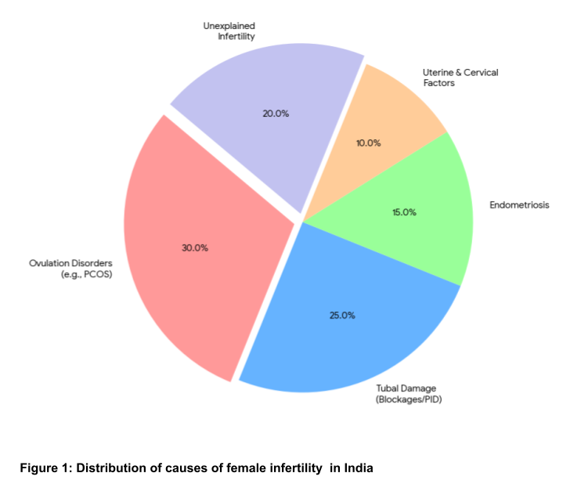
2. Contribution of PCOS to female infertility

PCOS affects more than one in ten reproductive-age females (~11–13%) worldwide (Parua et al., 2025). Among women with a PCOS diagnosis, it is estimated that 70% to 80% face infertility issues (Jiang, 2025; Neven et al., 2026). The prevalence of PCOS in Indian women varies greatly (Ganie et al., 2024; Neven et al., 2026). Women in urban areas encounter a much greater risk, with certain studies indicating an 18% prevalence in cities versus only 6% in rural regions. This is frequently linked to inactive habits and shifts in diet and lifestyle (Joshi & Dube, 2025). Regional variations in prevalence have been reported for PCOs in India (Figure 2). Elevated incidence rates have been noted in Maharashtra (22.5%) and the Delhi NCR area (17.4%). It is estimated that about one in five teenage girls in India has PCOS (Sharma et al., 2025).
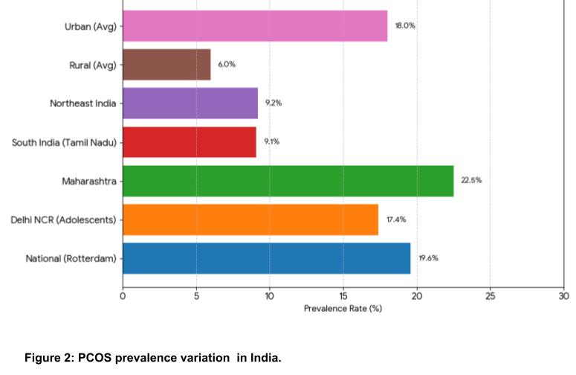
3. Typical menstrual cycle and atypical PCOS cycle

PCOS is the prime causes of female infertility due to the absence of regular ovulation (anovulation) or infrequent ovulation (oligo-ovulation). It is a chronic disturbance of reproductive hormone levels that affects ovarian function in women with PCOS, resulting in an inconsistent menstrual cycle and ovulation.

A typical menstrual cycle is a recurring process that lasts about 28 days (Figure 3 A), regulated by the Hypothalamic-Pituitary-Ovarian (HPO) axis, which utilizes GnRH pulses from the hypothalamus of the brain to regulate fluctuations in four crucial reproductive hormones, viz. LH (Luteinizing Hormone), FSH (Follicle-Stimulating Hormone), estrogen and progesterone (Williams & Cardoso, 2021). It starts with the menstrual phase (Days 1–5), which is characterized by a significant decrease in estrogen and progesterone, prompting the shedding of the uterine lining, indicating the hypothalamus to initiate a new cycle. In the follicular phase (Days 1–13), the selection of the dominant follicle takes place. Initially, an increase in FSH promotes the development of a cluster of ovarian follicles. As these follicles develop, they produce estrogen and inhibin, which provide negative feedback to the pituitary gland, resulting in reduced FSH levels. Due to this decrease in FSH, only the follicle that has more FSH receptors and has a superior blood supply can keep growing, making it more responsive to the lower hormone levels. This follicle evolves into the dominant follicle and also gains LH receptors, allowing it to maintain further development (Findlay et al., 2019). This subsequently releases higher levels of estrogen to enhance the thickness of the uterine lining. The continued increase in estrogen ultimately triggers a significant spike in LH, which specifically signals the follicle to break apart and release the egg (Figure 3 A). LH surge triggers the ovulatory phase (Day 14), which is the rupture of the dominant follicle to release a mature egg. This is the fertile window in the menstrual cycle when the likelihood of conception is greatest, usually covering approximately five days leading up to ovulation and including the day of ovulation. In this period, increasing estrogen levels cause physiological alterations like the thinning of cervical mucus, enhancing the conditions for sperm transport and longevity. The fertile window holds significant reproductive importance, as it marks the ideal time for conception (Mihm et al., 2011). Ultimately, the cycle moves into the luteal phase (Days 15–28), where the vacant follicle converts into the corpus luteum and generates elevated progesterone levels to maintain the uterus (Figure 3 A); progesterone stabilizes the uterus and gives negative feedback to the brain to inhibit additional FSH and LH; if pregnancy does not happen, levels of estrogen and progesterone decrease, the uterine lining is discarded, and GnRH pulses restart the cycle for the upcoming month (Itriyeva, 2022).

The ovaries in PCOS produce excess androgens like testosterone, which is associated with symptoms such as acne, excessive body or facial hair (named as hirsutism), and hair thinning in a male pattern. However, not all individuals with PCOS possess ovarian cysts (Figure 3 B). PCOS women are generally characterized by a combination of three clinical features, i.e. irregular or absent ovulation, high androgen (male hormone) levels, and polycystic ovaries, identifiable on ultrasound. Additionally, an elevated Anti-Mullerian Hormone (AMH) level has generally been included as an alternative blood test pointer for polycystic ovaries (Sivanandy & Ha, 2023).
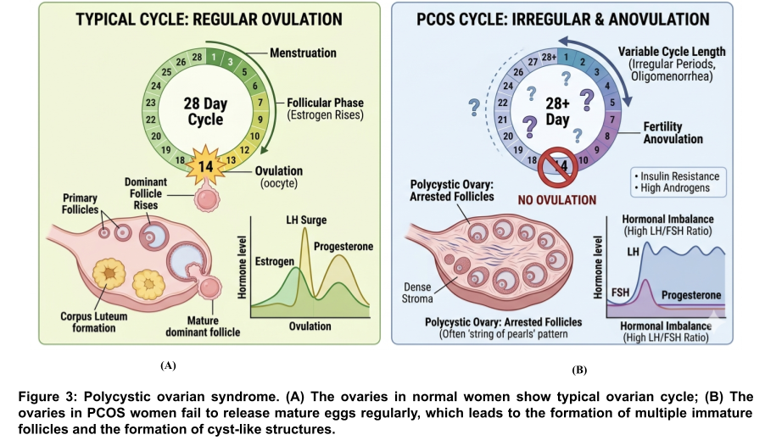
4. Pathophysiological mechanism of the origin of PCOS

The exact mechanism of PCOS development is not well understood. Scientific and clinical data suggest that PCOS originates due to a combined impact of hormonal fluctuations and genetic aspects that affect ovarian function (Khan et al., 2019). In women with PCOS, hormones like insulin, growth hormones (GH), ghrelin, LEAP-2, GnRH, insulin, the luteinizing hormone/follicle-stimulating hormone (LH/FSH) ratio, androgens, and estrogens are all irregular. These hormones are associated with metabolic issues, including diabetes and insulin resistance, obesity and excess weight, infertility, and irregular menstrual cycles in patients with PCOS (Yang & Chen, 2024). (Figure 3). Some of the key factors of this mechanism are discussed as follows:

4.1 Insulin resistance

Clinical data show that women with PCOS frequently show insulin resistance, a condition in which body cells do not respond to insulin. This activates the pancreas to produce excess insulin (hyperinsulinemia), which in turn stimulates the thecal cells (TCs) in ovaries to secrete elevated amounts of androgen (androstenedione and 17-hydroxyprogesterone) by increasing their sensitivity to LH and directly stimulating steroidogenic pathways (Rambaran & Islam, 2025). This hyperandrogenemia leads to clinical manifestations of irregular ovulation and symptoms like acne or hirsutism (Moghetti, 2016).

4.2 Hormonal disruption

A key abnormality in PCOS is the occurrence of hormonal imbalances, such as hyperandrogenemia, hyperinsulinemia, and excessive secretion of LH. Natural ovulation depends on a sensitive equilibrium of reproductive hormones. Ovarian androgens are produced by TCs under LH stimulation, whereas estrogen is synthesized in granulosa cells (GCs) in response to FSH. In women with PCOS, this equilibrium is disrupted due to elevated androgen, insulin, and LH levels, resulting into the failure of ovulation. Multiple studies have demonstrated that TCs in women with PCOS generate more androgens due to overactive and overexpressed steroidogenic enzymes (Wang et al., 2023). As described earlier, the FSH hormone is required for egg maturation, which is often found in insufficient amounts in women with PCOS (Dewailly et al., 2016). Increased production of androgens in PCOS women disrupts the normal growth and development of follicles and ovulation in the ovary (Figure 3 B). Many studies have shown that elevated androgen levels disrupt the immune response in the ovaries, resulting in high inflammatory cytokine production and altered immune cell activity, which, in turn, alters the expression of steroidogenic genes and triggers a sequence of physiological processes in theca-interstitial cells (Wang et al., 2023). On an ultrasound, the immature follicles frequently manifest as small fluid-filled sacs or "cysts." Consequently, there is no egg available for fertilization by sperm. It has been observed that people with PCOS exhibit mild inflammation in their bodies (Rudnicka et al., 2021). This inflammation might lead to elevated androgen production and is linked to a greater risk of cardiovascular problems and insulin resistance (Zeng et al., 2020).

Steroidogenesis in the ovaries is dependent on the collaborative functions of GCs and TCs (Figure 4). When stimulated by LH, TCs transform cholesterol into androgens like testosterone and androstenedione. These androgens subsequently migrate into the neighboring GCs, which are activated by FSH. GCs contain the enzyme aromatase, responsible for converting these androgens into estrogens, mainly estradiol. Consequently, TCs supply the androgen substrate, while GCs finalize estrogen synthesis, rendering their cooperation vital for proper follicular growth and hormonal equilibrium. Androgens produced by the ovarian theca cells contribute to around 50% of overall physiological androstenedione secretion (Magoffin, 2005). The excess androgen synthesis found within PCOS is thought to relate to excess ovarian biosynthesis, and although the exact underlying etiology of PCOS remains unexplained, significant evidence suggests that an excess of ovarian androgen production is central to the condition (Cadagan et al., 2016). Three possible mechanisms for androgen hypersecretion have been proposed (Cadagan et al., 2016). These include: an intrinsic functional thecal defect, hyperinsulinemia resulting from insulin resistance, or pituitary LH hypersecretion resulting in excessive thecal stimulation (Balen, 1993; Wang et al., 2023). Several publications exist showing the effects of insulin on thecal function in normal and polycystic ovaries (Franks et al., 1999; Rambaran & Islam, 2025). However, the combined influence of both insulin and LH is yet to be examined in PCOS, and as both hormones are increased in PCOS, understanding their influence and cellular mechanism is of great importance (Cadagan et al., 2016).

4.3 Effects on Egg and Endometrial Quality

In addition to anovulation, PCOS can influence other critical factors required for conception. Chronic hormonal imbalances in women with PCOS may lead to a decrease in the quality of the eggs produced. Studies show that exposure to excess androgens elevates oxidative stress levels in oocytes within a PCOS mouse model. This impacts mitochondrial energy metabolism and cause DNA damage and apoptosis in oocytes (Danfeng et al., 2023). Research indicates that the hormonal and metabolic disturbances linked to PCOS can modify the uterine lining (endometrium) by alterations in the levels of endometrial steroid receptors and coactivators (Hosseinzadeh et al., 2021). Therefore, women with PCOS show decreased endometrial receptivity and increased estrogen activity, which may interfere with implantation of a fertilized egg (Fatima et al., 2025).

4.4 Genetic influence

Studies indicate that PCOS has a significant genetic influence, frequently manifesting in family groups. Hague et al demonstrated the important role of diagnostic criteria in genetic studies by using ultrasound criteria along with either hyperandrogenemia or LH hypersecretion to assess the frequency of PCOS among relatives of affected individuals. PCOS was identified in 45 out of 52 (87%) sisters of probands and in 24 out of 36 (67%) mothers. In this research, the occurrence of affected relatives was significantly greater than the 50% anticipated for either autosomal dominant or X-linked dominant inheritance (HAGUE et al., 1988). Recent Genome-Wide Association Studies (GWAS) have identified around 30 genetic loci that play a role in its development (Louwers et al., 2025). Metabolic and steroidogenic irregularities are a key feature of PCOS. Researchers have extensively explored connections or relationships between PCOS and the different genes that play roles in androgen biosynthesis, insulin function, and chronic inflammation (Diamanti-Kandarakis et al., 2006). However, how gene variants contribute to PCOS risk and the relationship between the genetic components associated with PCOS still need to be established.

4.5 Prenatal exposure to hormones

Maternal glucocorticoids significantly elevate during pregnancy, reaching concentrations up to 20 times higher by mid-pregnancy. Simultaneously, another steroid hormone, progesterone, rises (Solano & Arck, 2020). Progesterone plays a crucial role in the initiation and maintenance of pregnancy, and it is widely recognized for fostering maternal immune tolerance towards fetal alloantigens via numerous immunomodulatory processes. Although glucocorticoids have strong immunomodulatory abilities, their function during pregnancy remains largely unclear (Solano & Arck, 2020). Disruptions in maternal-fetal insulin, androgens, glucocorticoids, and thyroid hormone are recognized factors that contribute to either adaptive or maladaptive developmental programming (Hakim et al., 2017). Several studies indicate that continued exposure to high androgen levels during the gestational period could affect fetal development in ways that increase the chance of the development of PCOS in adulthood (Abbott et al., 2025).

4.6 Lifestyle factors

These include stress, irregular sleep, increased weight (obesity) or insufficient exercise, which do not independently lead to PCOS but can worsen insulin resistance and hormonal irregularities, amplifying symptoms and long-term reproductive health risks (Zeng et al., 2020). Prenatal stress is recognized to change the activity of the hypothalamic-pituitary-adrenal axis, and recent findings indicate that it could also influence androgen activity in females (Barrett & Swan, 2015).

4.7 Exposure to environmental toxicants

Many environmental toxicants such as bisphenol A (BPA) and phthalates, are classified as endocrine-disrupting chemicals (EDCs). These toxicants impact human reproductive health in daily industrialized life (Rutkowska & Diamanti-Kandarakis, 2016). It has been established that fetuses, infants, and young children are the most vulnerable populations, particularly during the initial stages of development. Exposure to EDCs that imitate natural hormones during prenatal development may influence fetal programming and subsequently result in PCOS (Rozati & Fatima, 2019). EDCs can affect the ovarian reserve during early development, its maintenance during adulthood and the establishment of the hypothalamic-pituitary control of puberty and ovulation (Parent et al., 2025).

It is obvious now that there is a strong relationship between PCOS and insulin resistance, obesity, and elements of metabolic syndrome; the connection among these conditions is complicated and frequently bidirectional; insulin resistance worsens hyperandrogenism and ovulatory issues, while PCOS raises the likelihood of developing glucose intolerance and type 2 diabetes mellitus (Prosperi & Chiarelli, 2025).

5. Clinical manifestation and complications of PCOS

The symptoms of PCOS vary among individuals, yet the majority of symptoms arise from hormonal imbalances, especially increased androgens and irregular ovulation. Symptoms can start during puberty or emerge later, particularly following considerable weight gain (Hsu, 2013). Typical symptoms of PCOS (Figure 4) include:

- Irregular or skipped periods: Women with PCOS due to disturbed ovulation frequently experience infrequent, unpredictable, or extended menstrual cycles. Some individuals may have fewer than 9 menstrual periods annually or experience cycles that exceed 35 days.
- Excessive hair growth (hirsutism): Elevated androgen levels may lead to thick, dark hair developing on the face, chest, abdomen, or back, impacting around 70–80% of females with PCOS.
- Acne and oily skin: Androgens can excessively activate oil glands, resulting in chronic or intense acne, especially on the face, chest, and upper back.
- Hair loss or male-pattern baldness: Certain people might observe hair thinning at the crown or around the hairline, resembling androgenic alopecia.
- Weight increase or challenges in shedding pounds: Numerous individuals with PCOS encounter weight gain (obesity) issues.
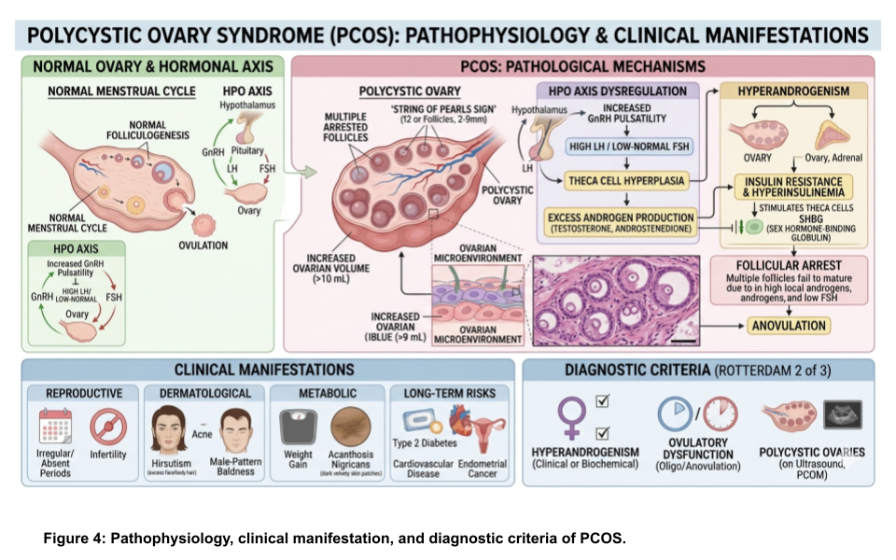
PCOS goes beyond just a hormonal imbalance; if not addressed, it could result in serious long-term health issues. The impacts might not be apparent right away, but over time, the condition can disrupt a woman’s reproductive, metabolic, and emotional health. Among the main effects are:
- Infertility problems: Irregular or lack of ovulation (anovulation) can hinder conception, positioning PCOS as a major contributor to primary infertility.
- Risk of type 2 diabetes: The development of insulin resistance in PCOS greatly increases the chances of developing type 2 diabetes earlier in life.
- Endometrial cancer: An extended lack of menstruation may cause the uterine lining to thicken (endometrial hyperplasia), which elevates the cancer risk over time.
- Pregnancy complications: Women with PCOS have a higher likelihood of developing gestational diabetes, preeclampsia, experiencing preterm birth, and miscarriage.
- Cardiovascular disease: PCOS is associated with high cholesterol, blood pressure, and cardiovascular problems, even in women who seem otherwise healthy, as PCOS is a significant risk factor for metabolic syndrome.
- Obesity: PCOS women struggle with shedding pounds, and a propensity to gain weight quickly can continue, heightening the likelihood of obesity-related problems.

6. Diagnosis criteria for PCOS

PCOS is a complicated endocrine malfunctioning condition. Its definition has transitioned from solely structural assessments (polycystic ovaries) to a clinical diagnosis usually adhering to the Rotterdam Criteria, requiring at least two of three diagnostic criteria to be present in adult women, viz., hyperandrogenism, ovulatory dysfunction, and polycystic ovarian morphology (Peña & Witchel, 2025). It is advised to rule out thyroid disorders (thyroid-stimulating hormone, TSH), elevated prolactin levels, and nonclassic congenital adrenal hyperplasia (17-hydroxy progesterone screening). Further, evaluation is recommended for individuals facing amenorrhea or other atypical features, with a focus on assessing for hypogonadotropic hypogonadism or Cushing's disease, and in cases where there is a significant androgenic pattern, screening for tumors that produce androgens should be considered (Abdelazim et al., 2020).

7. Management and treatment of PCOS

There has been no one-size-fits-all treatment for PCOS. However, modern PCOS management has evolved from merely controlling symptoms to a precision medicine approach that addresses multisystem symptoms, incorporating three fundamental therapeutic strategies, viz., planned metabolic rehabilitation, targeted pharmacotherapy for hyperandrogenism/insulin resistance, and assisted reproductive technologies (T. Wang et al., 2026). PCOS necessitates ongoing focus not only to address the symptoms but also to prevent associated complications. By implementing an appropriate care plan, numerous risks can be minimized or prevented. Management of PCOS hinges on particular issues, such as irregular menstrual cycles, acne, fertility problems, weight concerns, or prolonged metabolic health (Savita, 2025).

While various pharmacological treatments exist to reduce the symptoms of PCOS and aspects of the related metabolic syndrome, lifestyle changes such as diet and exercise are the most effective and should be prioritized as the initial intervention (Cowan et al., 2023). Obesity plays a key role in the development of the PCOS condition. Therefore, proactive measures for diagnosing and treating obesity should be taken before its emergence in adolescence and establishment in adulthood. The primary therapeutic alternatives for the majority of people with PCOS consist of lifestyle changes (Costello et al., 2012). Modifications in lifestyle can greatly enhance hormonal equilibrium, insulin responsiveness, menstrual consistency, and reproductive health. Weight reduction up to 5–10% of body weight in PCOS women may aid in reinstating ovulation, lowering androgen levels, and normalizing menstrual cycles (Smyka et al., 2018). A balanced diet, which features a low-glycemic index, improves blood sugar regulation. Consistent physical activity of moderate-intensity workouts (such as walking, cycling, or swimming) aids in lowering insulin resistance and keeping a healthy weight (Bird & Hawley, 2017). Stress management through yoga, mindfulness, and sufficient sleep can help maintain hormonal balance and mental health. Medications or hormone management, cycle regulation can minimize metabolic risks. Combined oral contraceptives (COCs) are frequently recommended for managing menstrual cycles, decreasing acne, and controlling excessive hair growth. Pills containing only progestin, hormonal patches, or IUDs might also be options. Metformin is widely acknowledged as the first-choice pharmacological therapy for type 2 diabetes mellitus (T2DM). It is appreciated for its effectiveness in reducing blood sugar levels, and occasionally weight-loss effects. Metformin is commonly recommended to enhance insulin sensitivity, reduce androgen levels, and encourage more consistent ovulation. It might also enhance hyperandrogenic effects in certain individuals (Genazzani et al., 2010). Inositol supplements, myo-inositol and D-chiro-inositol, are becoming increasingly popular to enhance insulin sensitivity and regulate menstrual cycles, although they are not as effective as metformin. Studies on inositols, however, indicate that an appropriate myo-Ins to D-chiro-Ins ratio regulates the health of organs and tissues, whereas an imbalance in inositol levels or depletion in peripheral tissues could lead to disease states (Lete et al., 2024). Anti-androgen drugs such as spironolactone can assist with issues like hirsutism and acne.

8. RESEARCH GAPS

Despite notable progress in the exploration of PCOS, several research gaps remain. Longitudinal studies are urgently required to fully grasp the long-term reproductive, metabolic, and cardiovascular outcomes in women with PCOS, particularly regarding the impact on menopause and post-menopausal health. Further, although the connection between PCOS and infertility is well-known, the exact ways in which PCOS impacts fertility are not fully understood. The impact of environmental components, including EDCs and lifestyle factors, on the onset and advancement of PCOS is another field that requires further investigation. Ultimately, while the psychological weight connected to PCOS is gaining acknowledgment, a considerable gap exists in creating and confirming effective interventions.

9. Conclusion

Polycystic ovary syndrome (PCOS) is a complex endocrine condition characterized by the Rotterdam Criteria for diagnosing PCOS, encompassing both clinical and morphological characteristics. The pathophysiology is mainly influenced by hyperinsulinemia caused by insulin resistance, which increases androgen production in ovarian theca cells and interferes with the function of the hypothalamic–pituitary–ovarian axis, resulting in follicular arrest and anovulation. Due to its varied causes related to both genetic and environmental influences, prompt diagnosis and personalized treatment are crucial. Therapeutic approaches must focus on lifestyle changes to enhance insulin sensitivity, along with supplementary medications like combined oral contraceptives to manage menstrual irregularities and hyperandrogenism symptoms.

10. References

Abbott, D. H., Levine, J. E., Dumesic, P. A., Padmanabhan, V., & Dumesic, D. A. (2025). Gestational anti-Müllerian hormone and testosterone excess combined with maternal adiposity program for polycystic ovary syndrome. Reproduction, 170, e250120.
Abdelazim, I., Alanwar, A., AbuFaza, M., Amer, O., Bekmukhambetov, Y., Zhurabekova, G., Shikanova, S., & Karimova, B. (2020). Elevated and diagnostic androgens of polycystic ovary syndrome. Menopause Review/Przegląd Menopauzalny, 19(1), 1–5.
Awonuga, A. O., Camp, O. G., Biernat, M. M., & Abu-Soud, H. M. (2025). Overview of infertility. Systems Biology in Reproductive Medicine, 71(1), 116–142.
Balen, A. H. (1993). Hypersecretion of luteinizing hormone and the polycystic ovary syndrome. Human Reproduction, 8(suppl_2), 123–128.
Barrett, E. S., & Swan, S. H. (2015). Stress and androgen activity during fetal development. Endocrinology, 156(10), 3435–3441.
Bird, S. R., & Hawley, J. A. (2017). Update on the effects of physical activity on insulin sensitivity in humans. BMJ Open Sport & Exercise Medicine, 2(1).
Brassard, M., AinMelk, Y., & Baillargeon, J.-P. (2008). Basic infertility including polycystic ovary syndrome. Medical Clinics of North America, 92(5), 1163–1192.
Brugo-Olmedo, S., Chillik, C., & Kopelman, S. (2001). Definition and causes of infertility. Reproductive BioMedicine Online, 2(1), 173–185. https://doi.org/10.1016/S1472-6483(10)62193-1
Cadagan, D., Khan, R., & Amer, S. (2016). Thecal cell sensitivity to luteinizing hormone and insulin in polycystic ovarian syndrome. Reproductive Biology, 16(1), 53–60.
Costello, M. F., Misso, M. L., Wong, J., Hart, R., Rombauts, L., Melder, A., Norman, R. J., & Teede, H. J. (2012). The treatment of infertility in polycystic ovary syndrome: a brief update. Australian and New Zealand Journal of Obstetrics and Gynaecology, 52(4), 400–403.
Cowan, S., Lim, S., Alycia, C., Pirotta, S., Thomson, R., Gibson-Helm, M., Blackmore, R., Naderpoor, N., Bennett, C., & Ee, C. (2023). Lifestyle management in polycystic ovary syndrome–beyond diet and physical activity. BMC Endocrine Disorders, 23(1), 14.
Danfeng, D., Ke, D., Dengxuan, F., Xuelian, L., & Congjian, X. (2023). Oocyte quality is impaired in a hyperandrogenic PCOS mouse model by increased Foxo1 expression. Reproductive Biology, 23(4), 100812. https://doi.org/https://doi.org/10.1016/j.repbio.2023.100812
Dewailly, D., Robin, G., Peigne, M., Decanter, C., Pigny, P., & Catteau-Jonard, S. (2016). Interactions between androgens, FSH, anti-Müllerian hormone and estradiol during folliculogenesis in the human normal and polycystic ovary. Human Reproduction Update, 22(6), 709–724.
Dharani, V., Nishu, S., & Hariprasath, L. (2025). PCOS and genetics: Exploring the heterogeneous role of potential genes in ovarian dysfunction, a hallmark of PCOS–A review. Reproductive Biology, 25(2), 101017.
Diamanti-Kandarakis, E., Piperi, C., Spina, J., Argyrakopoulou, G., Papanastasiou, L., Bergiele, A., & Panidis, D. (2006). Polycystic ovary syndrome: the influence of environmental and genetic factors. Hormones (Athens, Greece), 5(1), 17–34. https://doi.org/10.14310/horm.2002.11165
Fatima, F., Gul, R., Imrana, S., Awais, A., Mustanser, M., Mahmood, N., Sardar, S., & Nisar, R. (2025). Comparison of Embryo and Egg Quality in Polycystic Ovary Syndrome Patients Having Regular vs Irregular Menstrual Patterns. Cureus, 17(12).
Findlay, J. K., Dunning, K. R., Gilchrist, R. B., Hutt, K. J., Russell, D. L., & Walters, K. A. (2019). Follicle selection in mammalian ovaries. In The Ovary (pp. 3–21). Elsevier.
Franks, S., Gilling-Smith, C., Watson, H., & Willis, D. (1999). Insulin action in the normal and polycystic ovary. Endocrinology and Metabolism Clinics of North America, 28(2), 361–378.
Ganie, M. A., Chowdhury, S., Malhotra, N., Sahay, R., Bhattacharya, P. K., Agrawal, S., & Jabbar, P. K. (2024). Prevalence , Phenotypes , and Comorbidities of Polycystic Ovary Syndrome Among Indian Women. 7(10), 1–15. https://doi.org/10.1001/jamanetworkopen.2024.40583
Genazzani, A. D., Ricchieri, F., & Lanzoni, C. (2010). Use of metformin in the treatment of polycystic ovary syndrome. Women’s Health, 6(4), 577–593.
Gothwal, M., Singh, P., Agrawal, N., Ghuman, N. K., Yadav, G., Gupta, M. K., Sharma, C., & Kathuria, P. (2026). The Influence of Proximate Determinants on Fertility Awareness among Women Seeking Care at Infertility Clinic in Western India. Indian Journal of Community Medicine, 51(1).
Gupta, P. C. (2026). Female Reproductive Disorders : A Review on Causes and Reproductive Health Management in India. International Journal of Advanced Multidisciplinary Research, 13(3), 77–87. https://doi.org/10.22192/ijamr
HAGUE, W. M., ADAMS, J., REEDERS, S. T., PETO, T. E. A., & JACOBS, H. S. (1988). Familial polycystic ovaries: a genetic disease? Clinical Endocrinology, 29(6), 593–605.
Hakim, C., Padmanabhan, V., & Vyas, A. K. (2017). Gestational hyperandrogenism in developmental programming. Endocrinology, 158(2), 199–212.
Hosseinzadeh, P., Barsky, M., Gibbons, W. E., & Blesson, C. S. (2021). Polycystic ovary syndrome and the forgotten uterus. F&S Reviews, 2(1), 11–20. https://doi.org/https://doi.org/10.1016/j.xfnr.2020.12.001
Hsu, M.-I. (2013). Changes in the PCOS phenotype with age. Steroids, 78(8), 761–766.
Itriyeva, K. (2022). The normal menstrual cycle. Current Problems in Pediatric and Adolescent Health Care, 52(5), 101183.
Jiang, B. (2025). The Global Burden of Polycystic Ovary Syndrome in Women of Reproductive Age: Findings from the GBD 2019 Study. International Journal of Women’s Health, 17, 153–165. https://doi.org/10.2147/IJWH.S490836
Joshi, M., & Dube, S. (2025). Comprehensive study of Dietary and Lifestyle Factors contribute Polycystic Ovarian Disease (PCOD): A Survey Based Study.
Khan, M. J., Ullah, A., & Basit, S. (2019). Genetic basis of polycystic ovary syndrome (PCOS): current perspectives. The Application of Clinical Genetics, 249–260.
Lee, I. T., Rees, J., King, S., Kim, A., Cherlin, T., Hinkle, S., Mumford, S. L., & Dokras, A. (2025). Depression, anxiety, and risk of metabolic syndrome in women with polycystic ovary syndrome: a longitudinal study. The Journal of Clinical Endocrinology & Metabolism, 110(3), e750–e756.
Lete, I., Martínez, A., Lasaga, I., Centurión, E., & Vesga, A. (2024). Update on the combination of myo-inositol/d-chiro-inositol for the treatment of polycystic ovary syndrome. Gynecological Endocrinology, 40(1), 2301554.
Liang, Y., Zhong, K., Huang, Z., Shi, W., & Ou, Y. (2025). Global, regional, and national burden of infertility attributable to polycystic ovary syndrome, 1990–2021: results from the Global Burden of Disease Study 2021. Frontiers in Public Health, 13, 1693486.
Louwers, Y. V, Visser, J. A., Dunaif, A., & Laven, J. S. E. (2025). Polycystic ovary syndrome: origins and implications: genetics of polycystic ovary syndrome (PCOS). Reproduction, 170(5).
Magoffin, D. A. (2005). Ovarian theca cell. The International Journal of Biochemistry & Cell Biology, 37(7), 1344–1349.
Manimekalai, P. K., Poulpunitha, S., & Veeramani, P. (2020). Infertility : An Alarming Situation In India. 9(02), 2606–2609.
Mihm, M., Gangooly, S., & Muttukrishna, S. (2011). The normal menstrual cycle in women. Animal Reproduction Science, 124(3–4), 229–236.
Moghetti, P. (2016). Insulin resistance and polycystic ovary syndrome. Current Pharmaceutical Design, 22(36), 5526–5534.
Neven, A. C. H., Forslund, M., Ranasinha, S., Sethi, P., Dhungana, R. R., Mousa, A., Tay, C. T., Teede, H., & Boyle, J. A. (2026). Prevalence of polycystic ovary syndrome: a global and regional systematic review and meta-analysis. Human Reproduction Update, dmaf030.
Parent, A.-S., Damdimopoulou, P., Johansson, H. K. L., Bouftas, N., Draskau, M. K., Franssen, D., Fudvoye, J., van Duursen, M., & Svingen, T. (2025). Endocrine-disrupting chemicals and female reproductive health: a growing concern. Nature Reviews Endocrinology, 21(10), 593–607.
Parua, S., Purkait, M. P., Bhattacharjee, A., Thangarajan, R., Rammohan, S., Islam, K., Bhattacharya, K., & Syamal, A. K. (2025). Exploring female infertility: A comprehensive review of polycystic ovary syndrome (PCOS) and its impact on reproductive health. Obesity Medicine, 55, 100619.
Peña, A. S., & Witchel, S. F. (2025). Update on diagnosis of polycystic ovary syndrome during adolescence. Fertility and Sterility.
Prosperi, S., & Chiarelli, F. (2025). Insulin resistance, metabolic syndrome and polycystic ovaries: an intriguing conundrum. Frontiers in Endocrinology, 16, 1669716.
Rambaran, N., & Islam, M. S. (2025). Decoding androgen excess in polycystic ovary syndrome: Roles of insulin resistance and other key intraovarian and systemic factors. World Journal of Diabetes, 16(7), 108789.
Rozati, R., & Fatima, S. (2019). Etiological role of environmental toxicants in polycystic ovarian syndrome. Hormones, 6, 533–544.
Rudnicka, E., Suchta, K., Grymowicz, M., Calik-Ksepka, A., Smolarczyk, K., Duszewska, A. M., Smolarczyk, R., & Meczekalski, B. (2021). Chronic low grade inflammation in pathogenesis of PCOS. International Journal of Molecular Sciences, 22(7), 3789.
Rutkowska, A. Z., & Diamanti-Kandarakis, E. (2016). Polycystic ovary syndrome and environmental toxins. Fertility and Sterility, 106(4), 948–958.
Savita, S. (2025). The Effectiveness of Personalized Medicine in Managing Polycystic Ovary Syndrome (PCOS). Scholar’s Digest: Journal of Gynecology and Obstetrics, 1(1), 56–62.
Sharma, A., Sarwal, Y., Devi, N. K., & Saraswathy, K. N. (2025). Polycystic Ovary Syndrome prevalence and associated sociodemographic risk factors: a study among young adults in Delhi NCR, India. Reproductive Health, 22(1), 61.
Sivanandy, M. S., & Ha, S. K. (2023). The role of serum anti-mullerian hormone measurement in the diagnosis of polycystic ovary syndrome. Diagnostics, 13(5), 907.
Smyka, M., Grzechocińska, B., & Wielgoś, M. (2018). The role of lifestyle changes in the treatment of polycystic ovary syndrome. 38(8), 521–527.
Solano, M. E., & Arck, P. C. (2020). Steroids, pregnancy and fetal development. Frontiers in Immunology, 10, 3017.
Vander Borght, M., & Wyns, C. (2018). Fertility and infertility: Definition and epidemiology. Clinical Biochemistry, 62(February), 2–10. https://doi.org/10.1016/j.clinbiochem.2018.03.012
Wang, K., Li, Y., & Chen, Y. (2023). Androgen excess: a hallmark of polycystic ovary syndrome. Frontiers in Endocrinology, 14, 1273542.
Wang, T., Zhang, T., Wang, J., & Lu, T. (2026). Evolving PCOS Management: From Symptom Control to Phenotype-Targeted Therapy. Diabetes, Metabolic Syndrome and Obesity, 1–11.
Williams, G. L., & Cardoso, R. C. (2021). Neuroendocrine control of estrus and ovulation. Bovine Reproduction, 269–291.
Yang, J., & Chen, C. (2024). Hormonal changes in PCOS. Journal of Endocrinology, 261(1).
Zeng, X., Xie, Y., Liu, Y., Long, S., & Mo, Z. (2020). Polycystic ovarian syndrome: correlation between hyperandrogenism, insulin resistance and obesity. Clinica Chimica Acta, 502, 214–221.

